BEFORE THE FLORIDA PUBLIC SERVICE COMMISSION

|  |  |
| --- | --- |
| In re: Commission approval of Florida Telecommunications Relay, Inc.'s fiscal year 2024-2025 proposed budget. | DOCKET NO. 20240056-TP  ORDER NO. PSC-2024-0200-PAA-TP  ISSUED: June 20, 2024 |

The following Commissioners participated in the disposition of this matter:

MIKE LA ROSA, Chairman

ART GRAHAM

GARY F. CLARK

ANDREW GILES FAY

GABRIELLA PASSIDOMO

NOTICE OF PROPOSED AGENCY ACTION

ORDER GRANTING APPROVAL OF FLORIDA TELECOMMUNICATIONS RELAY, INC’S FISCAL YEAR 2024-2025 PROPOSED BUDGET

BY THE COMMISSION:

NOTICE is hereby given by the Florida Public Service Commission that the action discussed herein is preliminary in nature and will become final unless a person whose interests are substantially affected files a petition for a formal proceeding, pursuant to Rule 25-22.029, Florida Administrative Code (F.A.C.).

Background

The Telecommunications Access System Act of 1991 (TASA) established a statewide telecommunications relay system. Section 427.704(1), Florida Statutes (F.S.), provides that the Florida Public Service Commission (Commission) shall establish, implement, promote, and oversee the administration of the statewide telecommunications access system to provide access to telecommunications relay services by persons who are deaf, hard of hearing, or speech impaired. TASA provides for the purchase and distribution of specialized telecommunications devices as defined in Section 427.703(11), F.S. As defined by Section 427.703(16), F.S., this system is to provide telecommunications service for deaf or hard of hearing persons that is functionally equivalent to the service provided to hearing persons.

The telecommunications access system provides deaf or hard of hearing persons access to basic telecommunications services by using a specialized Communications Assistant that relays information between the deaf or hard of hearing person and the other party to the call. The primary function of the telecommunications access system is accomplished through the use of a Telecommunications Device for the Deaf (TDD). The person using the TDD types a message to the Communications Assistant who in turn voices the message to the other party or types the message to a Captioned Telephone that displays real-time captions of the conversation.

Florida Telecommunications Relay, Inc. (FTRI), a non-profit corporation formed by the local exchange telephone companies, was selected by us to serve as the telecommunications access system administrator. FTRI is primarily responsible for the purchase and distribution of specialized telecommunications equipment. As part of this process, FTRI contracts with other organizations to assist in the distribution of equipment and provide customer training on the proper use of the equipment and the relay service. FTRI also conducts marketing to raise awareness of available specialized equipment and related relay service. Finally, FTRI pays the relay services provider that is selected by us through a request for proposals process. The current relay service provider is T-Mobile USA, Inc. (T-Mobile).

FTRI, as the TASA Administrator, is funded through the Telecommunications Relay Service (TRS) surcharge. This surcharge was capped by the Florida Legislature at a maximum of $0.25 per switched access line (landline) per month, with a limit of 25 lines per account billed. Only local exchange telecommunications companies are required to collect and remit this surcharge to FTRI. The initial TRS surcharge was set at $0.05 per access line per month.[1] We have changed the surcharge through the years to meet FTRI’s budgetary needs. The monthly surcharge is currently $0.09 per access line.

As part of OUR oversight responsibilities of the telecommunications access system, we review and approve a budget submitted by FTRI on an annual basis. On May 6, 2024, FTRI submitted its Fiscal Year 2024/2025 budget for our consideration, which is included as Attachment A.[2] FTRI also compared its proposed budget to our approved 2023/2024 budget, as well as the estimated revenue and expenses. FTRI’s estimated revenue and expenses were based on actual data from the first two quarters and estimated data for the third and fourth quarters of the current fiscal year. On May 13, 2024, FTRI filed third quarter financial information. With this updated information, we formulated our own estimated expenses for Fiscal Year 2023/2024, which is reflected in Attachment B.

This order addresses FTRI’s proposed budget and approved TRS surcharge for Fiscal Year 2024/2025. The TRS surcharge is the only rate we establish for telecommunications companies. We are vested with jurisdiction pursuant to Chapter 427, F.S.

Decision and Analysis

I. FTRI's proposed Fiscal Year 2024/2025

A. Traditional Telecommunications Relay Service

The traditional TRS cost to FTRI as approved in the T-Mobile contract is currently $1.60 per session minute. T-Mobile’s projections indicate that traditional TRS minutes of use during Fiscal Year 2024/2025 will decrease by 25 percent from the current fiscal year. It has been observed that traditional relay users are transitioning to the following services:

* IP Relay
* VRS
* IP CTS
* Wireless Service

B. CapTel Service

The CapTel cost to FTRI as approved in the T-Mobile contract is currently $1.67 per session minute. CapTel service uses a specialized telephone that provides captioning of the incoming call for a deaf or hard of hearing person. T-Mobile’s projections show that CapTel minutes of use during Fiscal Year 2024/2025 will decline by 45 percent from the current fiscal year. CapTel users are also transitioning to other forms of advanced services as listed above.

C. Florida Telecommunications Relay, Inc. Budget

Attachment A reflects FTRI’s Fiscal Year 2024/2025 proposed budget, which was reviewed and adopted by FTRI’s Board of Directors prior to filing with us. FTRI’s proposed budget projects total expenses of $3,286,708. FTRI also proposed we reduce the current $.09 surcharge to $.08 per line, which would result in total surcharge revenue of $2,349,642. FTRI projects $1,099,754 in interest income during Fiscal Year 2024/2025 through investments in its Investment Trust Money Market account and 3-month T-bills. As a result, FTRI’s total operating revenue is estimated to be $3,449,396.

T-Mobile’s forecasted Fiscal Year 2024/2025 traditional TRS minutes of use are 487,992, while its forecasted CapTel minutes of use are 84,435. FTRI’s proposed TRS and CapTel service provider expense for Fiscal Year 2024/2025 is $921,793. For comparison, our approved budget for the current fiscal year reflected traditional TRS minutes of 651,963 and CapTel minutes of 153,345, with a total TRS and CapTel service provider expense of $1,299,227.

D. FTRI Budget Expense

We developed an estimate of FTRI’s final expenses for Fiscal Year 2023/2024, which is presented in Attachment B. We used actual data from the first three quarters and took an average of those three quarters to estimate the fourth. Our estimates were then used as one element in evaluating FTRI’s proposed budget, along with analyzing our past approved FTRI budgets to identify and evaluate ongoing cost reduction measures.

Below is our review of selected items from FTRI’s proposed budget expense by category.

1. Category I – Relay Services

Category I captures Dual Party Relay (DPR) provider expenses for traditional TRS and CapTel service currently provided by T-Mobile. In Fiscal Year 2023/2024, basic TRS and CapTel minutes of use decreased from the prior fiscal year. Based on continued advancements in technology, along with the expansion of consumer choice, it appears that minutes of use for these services will continue to decline.

The relay service expenses are calculated using the minutes of use forecasted by T-Mobile and the relay service contract rates. The current T-Mobile contract rates are $1.60 for TRS and $1.67 for CapTel, which when applied to the forecasted minutes of use results in FTRI’s proposed $921,793 total relay service expense. We approve $921,793 for DPR provider expenses.

2. Category II – Equipment & Repairs

Category II expenses reflect the purchase of equipment to be distributed to clients and the repairs that FTRI must make to keep the equipment in working order. FTRI has requested $465,154 for Fiscal Year 2024/2025. FTRI’s proposed budget represents a $63,696 increase in expense from our current approved budget.

The proposed increase in equipment and repairs expense is largely associated with increased demand for VCP Hearing Impaired phones and In-Line Amplifier equipment, in addition to replacement of legacy equipment with more advanced devices, such as the new XLC8GLT Deluxe captioning device. FTRI explained that it no longer purchases traditional CapTel devices associated with CapTel service. The XLC8GLT Deluxe device connects to the current XLC8 and provides a large captioning screen that only works with landlines and allows the customer to view larger captions on the screen via an installed application. FTRI further proposes that, going forward, the Caption Call Equipment line item be renamed Caption Devices to more accurately reflect the advanced technology. We approve the proposed $465,154 for equipment and repairs expense.

3. Category III – Equipment Distribution & Training

Category III reflects the cost of distributing equipment throughout the state and the training of consumers in the use of that equipment. FTRI’s proposed budget requests $262,000 for distribution and training, which reflects a $53,766 decrease from our current approved budget.

Expenses related to Regional Distribution Centers (RDCs) are the largest component of Category III expenses. FTRI’s proposed budget for RDCs is $200,000, which is $49,291 lower than our current approved budget. FTRI proposes no increase in Fiscal Year 2024/2025 to the fees paid per service provided by RDCs. FTRI is hopeful that the increase in these fees made in Fiscal Year 2023/2024 will continue to incent RDCs to provide more services. FTRI stated that it has seen a small increase in services provided by RDCs in the current Fiscal Year. We approve FTRI’s $262,000 proposed budget for Category III expenses.

4. Category IV – Outreach

Outreach efforts are designed to promote FTRI’s equipment distribution services and to raise awareness about Florida relay service. FTRI’s proposed Fiscal Year 2024/2025 Outreach budget increases expense by $16,873.

FTRI employs various forms of communication in its outreach strategy. FTRI plans to continue advertising in newspapers using free-standing insert ads (flyers) in markets where effective. However, FTRI acknowledges that it has witnessed rapid changes in the newspaper industry. In response, FTRI will continue to utilize other print tools such as direct mail post cards and coupon book advertisements. FTRI also plans to continue expanding its digital marketing campaign, including increased use of banner ads on websites, as well as targeted email and social media campaigns.

We have encouraged FTRI to research and consider more technologically advanced and cost-effective forms of outreach. For example, we encouraged FTRI to consider adding an online chat function to help with customer inquiries. FTRI implemented the chat function, termed “FTRI Chat,” in its Fiscal Year 2022/2023 budget. We approve FTRI’s proposed budget for Category IV expenses.

5. Category V – General & Administrative

Category V reflects expenses associated with FTRI’s operations, such as office and furnishings, employee compensation, contracted services (auditors, attorney and computer consultants), computers, and other operating expenses. FTRI is proposing $1,058,455 for Fiscal Year 2024/2025, which represents a $35,624 decrease in Category V expense from our current approved budget. We approve FTRI’s Category V expenses.

E. Conclusion

We approve FTRI’s proposed budget expenses of $3,286,708 for Fiscal Year 2024/2025, effective upon issuance of the consummating order.

III. TRS surcharge for Fiscal Year 2024/2025

Based on current industry trends, FTRI estimates that access lines will decrease at the rate of approximately nine percent from the current fiscal year as more consumers transition away from landline phones. Holding the TRS surcharge constant, a decrease in access lines results in a decrease in revenues to support FTRI’s activities. FTRI’s proposal to reduce the TRS surcharge from $0.09 to $0.08 per access line places further downward pressure on revenues. If approved, the lower surcharge of $0.08 is expected to generate $2,349,642 in surcharge revenue.

FTRI also maintains a reserve account with a current balance of approximately $20 million. The reserve account represents funds that were originally set aside in anticipation that the Federal Communications Commission (FCC) might delegate intrastate costs associated with Video Relay Service (VRS) and Internet Protocol Caption Telephone Service (IP-CTS) to states. Though conversations continue, there remains no clear indication that the FCC will delegate VRS and IP-CTS authority to states in the foreseeable future. FTRI currently invests the reserve account in three-month treasury bills and money market accounts to generate interest income. FTRI estimates interest income for Fiscal Year 2024/2025 will be $1,099,754, representing a $417,714 increase from Fiscal Year 2023/2024.

The sum of the surcharge revenue, $2,349,642, with the estimated interest income, $1,099,754, results in the total operating revenue of $3,449,396. Even with a decrease in the surcharge, FTRI’s proposed budget will result in an estimated surplus for Fiscal Year 2024/2025 of $162,688.[3]

We support the reduction to $0.08 because it balances the budget more precisely compared to maintaining the current $0.09 surcharge.

Conclusion

We approve FTRI’s proposal to reduce the TRS surcharge from $0.09 to $0.08. We order all local exchange companies to bill the $0.08 TRS surcharge for Fiscal Year 2024/2025, effective September 1, 2024.

Based on the foregoing, it is

ORDERED by the Florida Public Service Commission that Florida Telecommunications Relay Inc.’s proposed budget expenses of $3,286,708 for Fiscal Year 2024/2025, effective upon issuance of the consummating order. Its is further

ORDERED that Florida Telecommunications Relay Inc’s proposal to reduce the TRS surcharge from $0.09 to $0.08 is approved. We order all local exchange companies to bill the $0.08 TRS surcharge for Fiscal Year 2024/2025, effective September 1, 2024. It is further

ORDERED that the provisions of this Order, issued as proposed agency action, shall become final and effective upon the issuance of a Consummating Order unless an appropriate petition, in the form provided by Rule 28-106.201, Florida Administrative Code, is received by the Commission Clerk, 2540 Shumard Oak Boulevard, Tallahassee, Florida 32399-0850, by the close of business on the date set forth in the “Notice of Further Proceedings” attached hereto. It is further

ORDERED that in the event this Order becomes final, this docket shall be closed.

By ORDER of the Florida Public Service Commission this 20th day of June, 2024.

|  |  |
| --- | --- |
|  | /s/ Adam J. Teitzman |
|  | ADAM J. TEITZMAN  Commission Clerk |

Florida Public Service Commission

2540 Shumard Oak Boulevard

Tallahassee, Florida 32399

(850) 413‑6770

www.floridapsc.com

Copies furnished: A copy of this document is provided to the parties of record at the time of issuance and, if applicable, interested persons.

JDI

NOTICE OF FURTHER PROCEEDINGS OR JUDICIAL REVIEW

The Florida Public Service Commission is required by Section 120.569(1), Florida Statutes, to notify parties of any administrative hearing that is available under Section 120.57, Florida Statutes, as well as the procedures and time limits that apply. This notice should not be construed to mean all requests for an administrative hearing will be granted or result in the relief sought.

Mediation may be available on a case-by-case basis. If mediation is conducted, it does not affect a substantially interested person's right to a hearing.

The action proposed herein is preliminary in nature. Any person whose substantial interests are affected by the action proposed by this order may file a petition for a formal proceeding, in the form provided by Rule 28-106.201, Florida Administrative Code. This petition must be received by the Office of Commission Clerk, 2540 Shumard Oak Boulevard, Tallahassee, Florida 32399-0850, by the close of business on July 11, 2024.

In the absence of such a petition, this order shall become final and effective upon the issuance of a Consummating Order.

Any objection or protest filed in this/these docket(s) before the issuance date of this order is considered abandoned unless it satisfies the foregoing conditions and is renewed within the specified protest period.

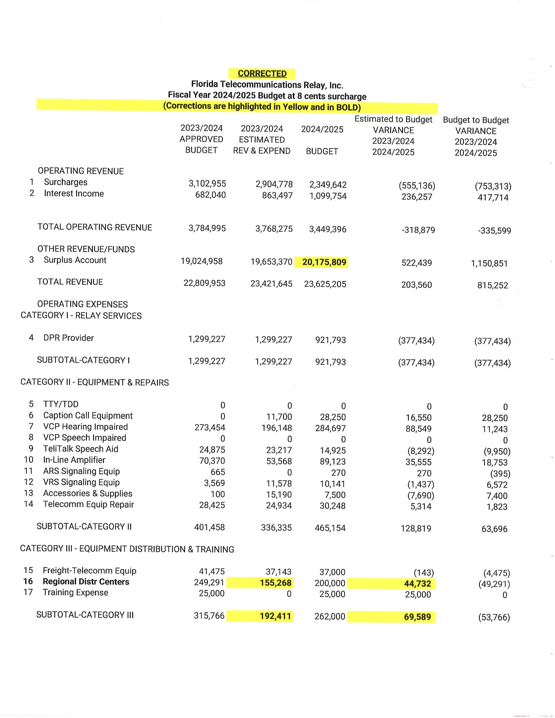

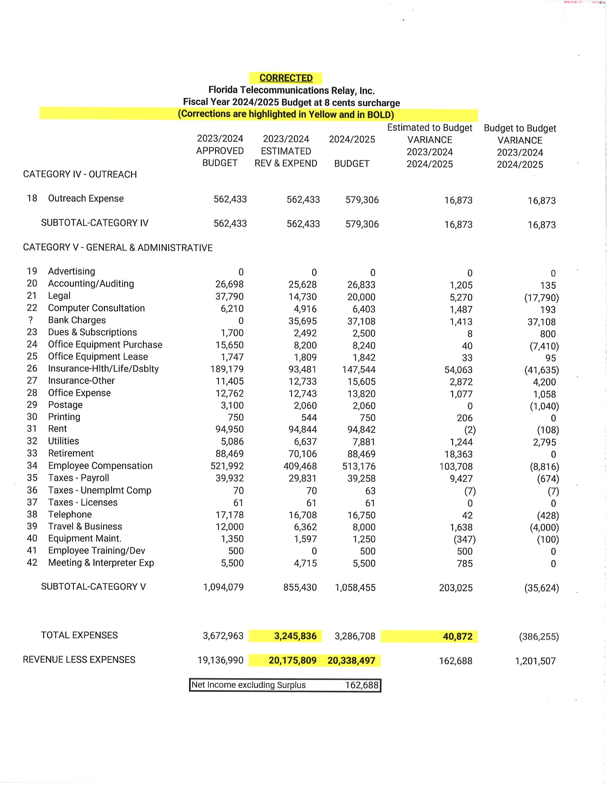

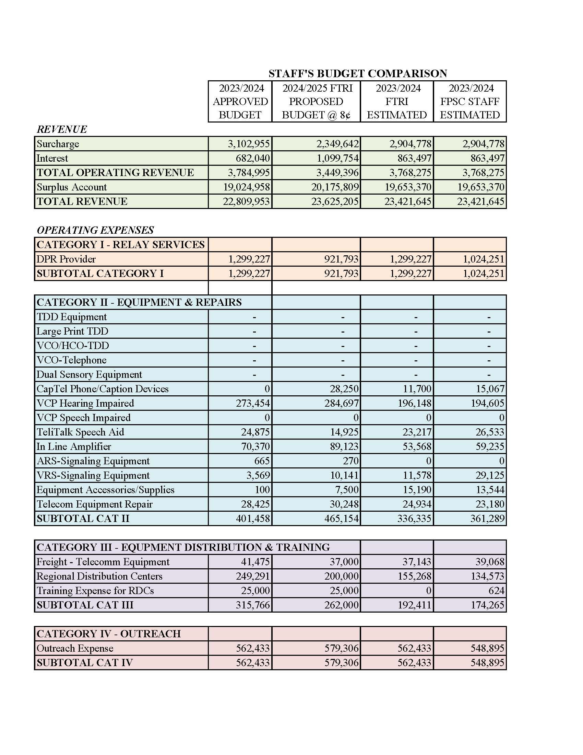

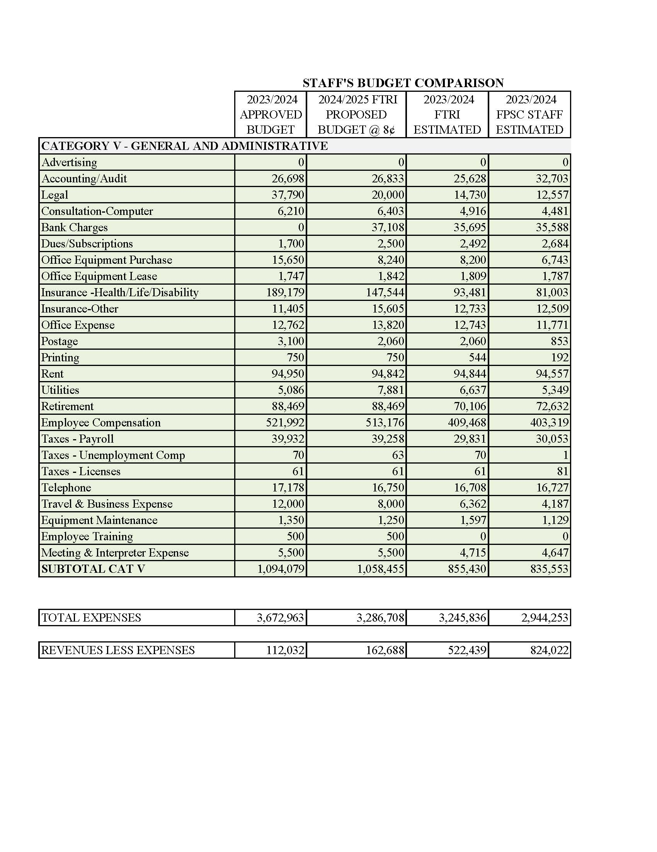

1. Order No. 24581, issued May 24, 1991, in Docket No. 910496-TP, *In re: Implementation of Florida Telecommunications Access System Act of 1991*.
2. On April 1, 2024, FTRI submitted a proposed Fiscal Year 2024/2025 budget. Our staff found errors and inconsistencies in the budget. FTRI resubmitted its corrected budget on May 6, 2024. For purposes of this recommendation, the corrected budget filed on May 6, 2024.
3. Budget surplus and shortfalls for each TRS surcharge are calculated using our staff’s recommended budget expense amounts.