BEFORE THE FLORIDA PUBLIC SERVICE COMMISSION

|  |  |
| --- | --- |
| In re: Application for designation as an eligible telecommunications carrier in the State of Florida for the limited purpose of offering lifeline service to qualified households, by DISH Wireless L.L.C. d/b/a Gen Mobile. | DOCKET NO. 20240070-TP  ORDER NO. PSC-2024-0208-PAA-TP  ISSUED: June 20, 2024 |

The following Commissioners participated in the disposition of this matter:

MIKE LA ROSA, Chairman

ART GRAHAM

GARY F. CLARK

ANDREW GILES FAY

GABRIELLA PASSIDOMO

NOTICE OF PROPOSED AGENCY ACTION

ORDER GRANTING ELIGIBLE TELECOMMUNICATIONS CARRIER DESIGNATION

BY THE COMMISSION:

NOTICE is hereby given by the Florida Public Service Commission that the action discussed herein is preliminary in nature and will become final unless a person whose interests are substantially affected files a petition for a formal proceeding, pursuant to Rule 25-22.029, Florida Administrative Code (F.A.C.).

Background

DISH Wireless L.L.C. d/b/a Gen Mobile (DISH or Company) seeks designation as an eligible telecommunications carrier (ETC) for the sole purpose of providing Lifeline service to qualifying consumers throughout Florida. DISH is a provider of commercial mobile radio service (CMRS) and offers prepaid wireless telecommunications services to consumers using its own facilities, along with resale agreements with T-Mobile USA, Inc. (T-Mobile) and AT&T Mobility (AT&T). DISH is currently designated as an ETC providing Lifeline service in 29 other states.

As a CMRS provider, DISH is regulated as a common carrier pursuant to 47 U.S.C. § 153(11).[1] DISH is a Colorado Limited Liability Company (LLC) authorized to do business as a foreign LLC in the state of Florida. DISH asserts in Florida it will be operating under its authorized fictitious name “Gen Mobile.” DISH is a wholly owned subsidiary of DISH Network Corporations.

DISH asserts that it meets all applicable federal requirement for designation as a Lifeline only ETC in Florida pursuant to 47 U.S.C. § 214(e) and 47 C.F.R. § 54.201. DISH acknowledges and asserts that, if approved, it will comply with Sections 364.10 and 364.105, Florida Statutes (F.S.) and Rule 25-4.0665, Florida Administrative Code (F.A.C.), which govern Lifeline service and provide for a transitional discount for customers who no longer qualify for Lifeline. In addition to the federal rules and statutes discussed above, we have jurisdiction in this matter pursuant to Section 364.10, F.S.

Section 214(e)(2) of the Telecommunications Act of 1996 (the Act) provides state public utility commissions with “primary responsibility” for the designation of ETCs. We initially exercised this authority to designate both wireline and wireless carriers as ETCs. In 2011, the Florida Legislature removed the FPSC authority to designate wireless ETC providers.[2] However, the Florida Legislature amended Section 364.10, F.S., in 2024 to specifically grant us jurisdiction to address wireless ETC petitions for Lifeline purposes only.[3]

Decision

1. Requirements for ETC Designation

This Order addresses whether DISH qualifies for ETC designation to provide Lifeline service throughout the State of Florida. ETC designation is necessary for telecommunications companies to participate in the federal Lifeline program.[4] Section 364.10, F.S., allows us to approve wireless Lifeline ETC petitions for requesting carriers. Specifically, subsections 364.10(1)(a) and (3)(a) F.S., provide us with the authority to designate a commercial mobile radio service provider as an ETC for the limited purpose of providing Lifeline service.

Federal rules outline the requirements for ETC designation.[5] To obtain ETC designation to provide Lifeline services, federal rules require that carriers:

1. Be a common carrier;
2. Offer the services that are supported by the federal universal support mechanisms either using its own facilities or a combination of its own facilities and resale of another carrier’s services;
3. Advertise the availability of its Lifeline service through a media of general distribution;
4. Provide voice grade access to the public switch network or its functional equivalent;
5. Offer minutes of use for local service at no additional charge to end users;
6. Provide access to the emergency services available by local government or other public safety organizations;
7. Provide Broadband Internet Access Service;[6]
8. Demonstrate financial and technical capability to provide Lifeline service; and
9. Not charge Lifeline customers a monthly number-portability charge.

In addition, Florida law requires ETCs to:

1. Offer a discounted transitional basic telecommunications service;[7] and
2. Participate in the Lifeline Promotion Process.[8]

DISH plans to offer all of the supported services listed under Section 254(c) of the Act through a combination of its own facilities and resale agreements with T-Mobile and AT&T. Because DISH meets the facilities requirement, it is not required to obtain an approved FCC compliance plan in accordance with the 2012 Lifeline Reform Order. However, DISH has agreed to comply with the additional requirements for those granted ETC status by the FCC, which include the following:[9]

1. Provide the supported services throughout the carriers’ designated areas;
2. Remain functional in emergency situations;
3. Comply with the Cellular Telecommunications and Internet Association's Consumer Code for Wireless Service;
4. Demonstrate that it is financially and technically capable of providing the Lifeline service in compliance with federal rules; and
5. Describe the terms and conditions of the broadband Internet access service plans offered to Lifeline subscribers.

Because DISH will offer the supported services and is compliant with the FCC requirements pursuant to 47 U.S.C. § 214(e) and 47 C.F.R. § 54.201, as well as the Florida specific requirements, DISH is eligible for designation as a Lifeline only ETC in Florida.

1. Financial, Managerial, and Technical Capabilities

As noted in its petition, DISH has offered service since 2020 and has not filed for any form of bankruptcy relief. The Company has operated as an ETC in 37 states and has not been subject to any ETC revocation proceedings. While DISH has only been a CMRS provider for four years, its parent company, DISH Network Corporation has over 20 years of technical and managerial experience. DISH asserts that it does not rely exclusively on Lifeline reimbursements for its operating revenues and it has access to additional capital resources from its parent and affiliate companies. DISH has not been involved in any FCC or USAC enforcement actions related to the Lifeline program. However, USAC issued DISH a Notice of Determination of Amounts Owed and intent to recoup regarding the Emergency Broadband Program. DISH is currently disputing these allegations in a pending case before the FCC.[10] After reviewing this Notice, we determine that there is nothing significant in the findings that should prevent DISH from being granted ETC designation in Florida.

1. Public Interest

State commissions are required to find that ETC designation is in the public interest.[11] DISH asserts granting its ETC designation will bring Lifeline eligible consumers more choice in providers. In Florida, consumers are currently limited to three wireless Lifeline providers. These three companies represent 98 percent of the Lifeline market in Florida.[12] However, the FPSC’s estimated Lifeline participation rate for the last two years has hovered around 18 percent.[13] The increase in carriers servicing this market may increase participation through additional marketing and would serve the public interest.

1. Conclusion

We have reviewed DISH’s petition for ETC designation in Florida. DISH meets all the requirements for designation as an ETC. Additionally, the Company has demonstrated sufficient financial, managerial, and technical capabilities. Therefore, we Grant DISH ETC designation throughout the State of Florida as identified in Attachment A of this Order. We further order that if there is a future change of Company ownership, the new owners shall be required to file a petition with us to demonstrate that it is in the public interest to maintain the Company’s ETC designation.

Based on the foregoing, it is

ORDERED by the Florida Public Service Commission that DISH Wireless L.L.C. d/b/a Gen Mobile’s Petition for Designation as an Eligible Telecommunications Carrier throughout the State of Florida is GRANTED. It is further

ORDERED that DISH Wireless L.L.C. d/b/a Gen Mobile is designated an eligible telecommunications carrier for the sole purpose of providing Lifeline service to qualifying consumers in the State of Florida. It is further

ORDERED that if there is a future change in DISH Wireless L.L.C. d/b/a Gen Mobile’s ownership, the new owners shall file a petition with the Commission to demonstrate that it is in the public interest to maintain the ETC designation. It is further

ORDERED that the provisions of this Order, issued as proposed agency action, shall become final and effective upon the issuance of a Consummating Order unless an appropriate petition, in the form provided by Rule 28-106.201, F.A.C., is received by the Commission Clerk, 2540 Shumard Oak Boulevard, Tallahassee, Florida 32399-0850, by the close of business on the date set forth in the “Notice of Further Proceedings or Judicial Review” attached hereto. It is further

ORDERED that in the event this Order becomes final, this docket shall be closed.

By ORDER of the Florida Public Service Commission this 20th day of June, 2024.

|  |  |
| --- | --- |
|  | /s/ Adam J. Teitzman |
|  | ADAM J. TEITZMAN  Commission Clerk |

Florida Public Service Commission

2540 Shumard Oak Boulevard

Tallahassee, Florida 32399

(850) 413‑6770

www.floridapsc.com

Copies furnished: A copy of this document is provided to the parties of record at the time of issuance and, if applicable, interested persons.

SF

NOTICE OF FURTHER PROCEEDINGS OR JUDICIAL REVIEW

The Florida Public Service Commission is required by Section 120.569(1), Florida Statutes, to notify parties of any administrative hearing that is available under Section 120.57, Florida Statutes, as well as the procedures and time limits that apply. This notice should not be construed to mean all requests for an administrative hearing will be granted or result in the relief sought.

Mediation may be available on a case-by-case basis. If mediation is conducted, it does not affect a substantially interested person's right to a hearing.

The action proposed herein is preliminary in nature. Any person whose substantial interests are affected by the action proposed by this order may file a petition for a formal proceeding, in the form provided by Rule 28-106.201, Florida Administrative Code. This petition must be received by the Office of Commission Clerk, 2540 Shumard Oak Boulevard, Tallahassee, Florida 32399-0850, by the close of business on July 11, 2024.

In the absence of such a petition, this order shall become final and effective upon the issuance of a Consummating Order.

Any objection or protest filed in this/these docket(s) before the issuance date of this order is considered abandoned unless it satisfies the foregoing conditions and is renewed within the specified protest period.

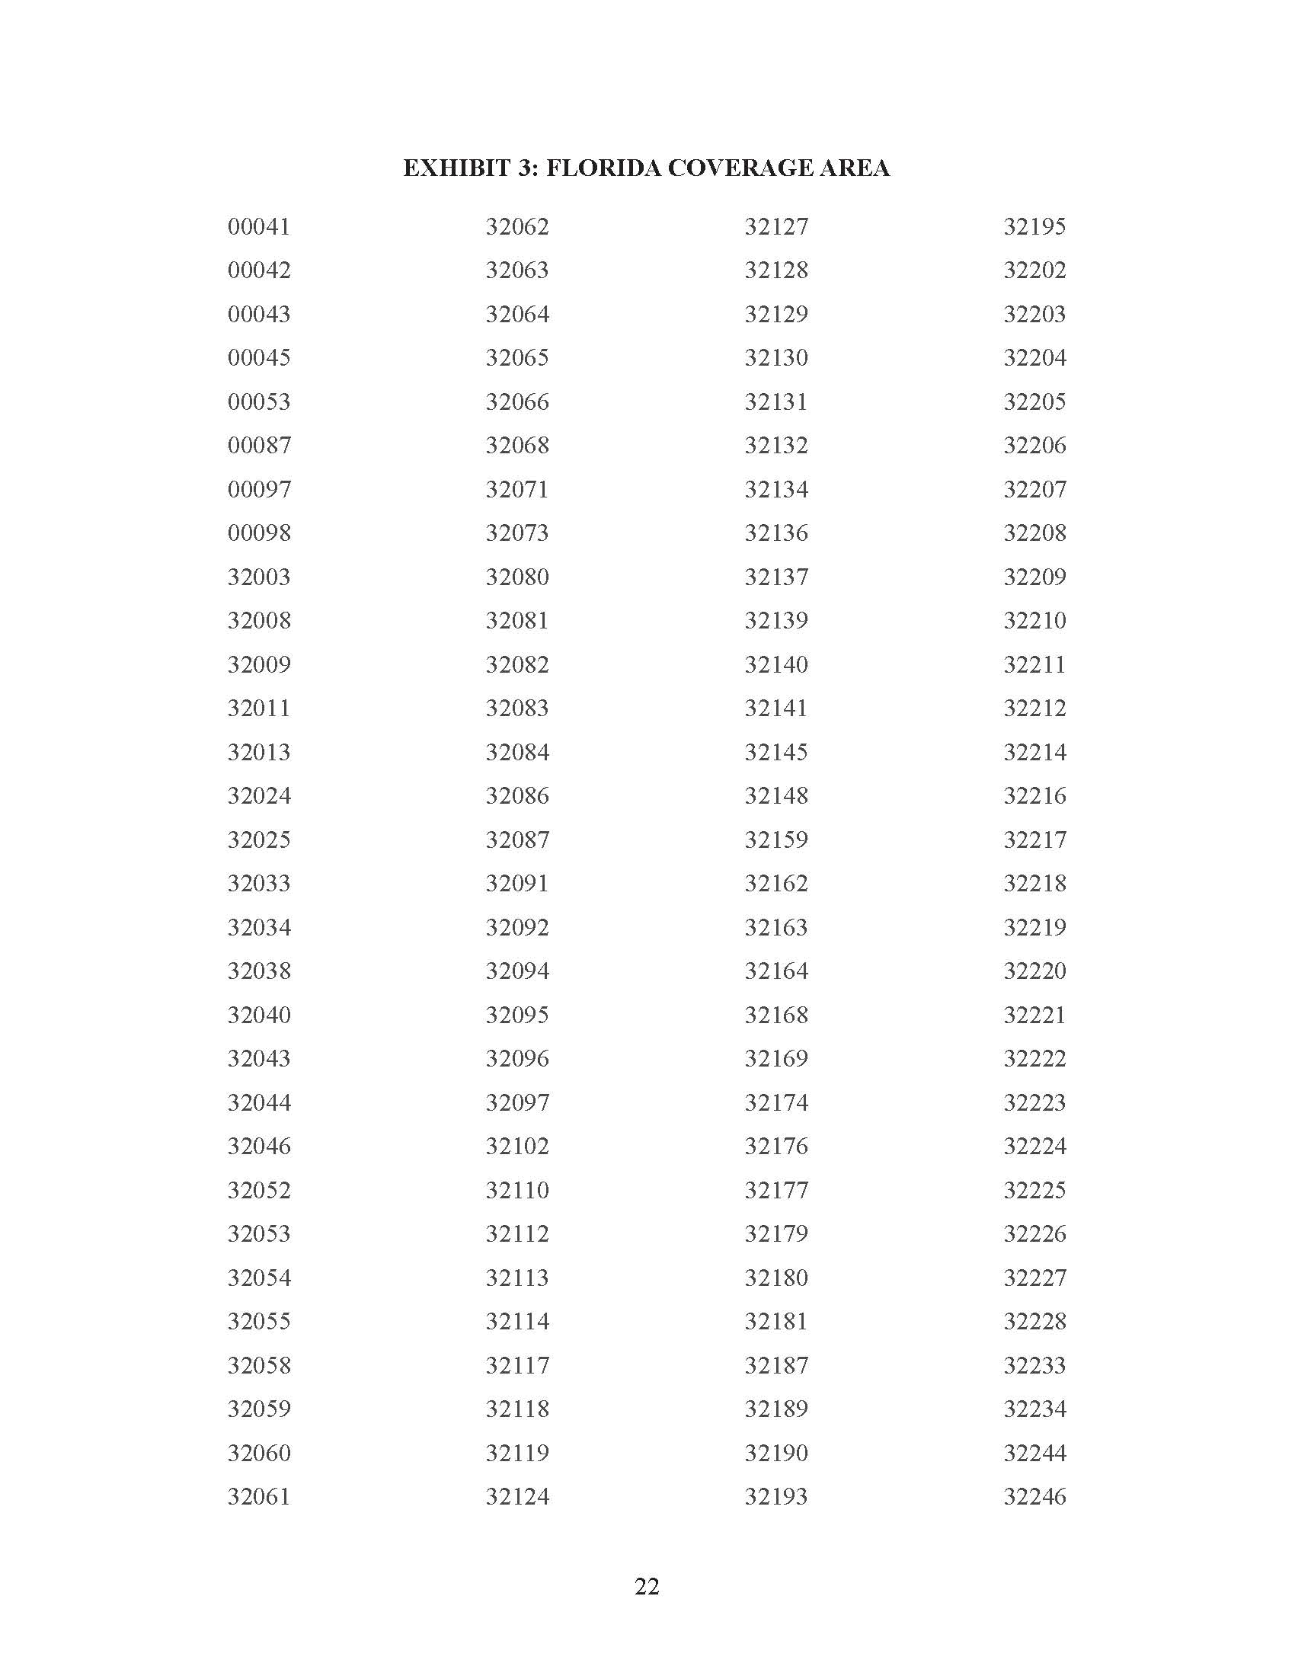



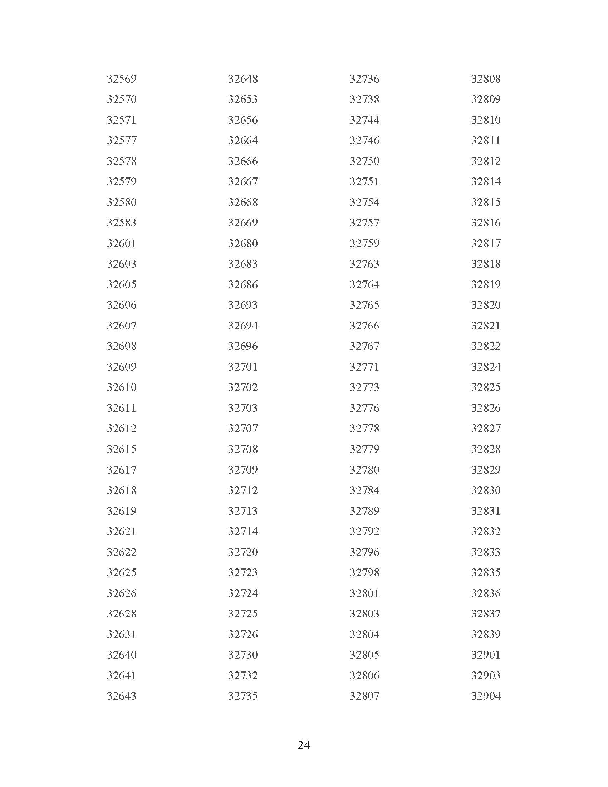







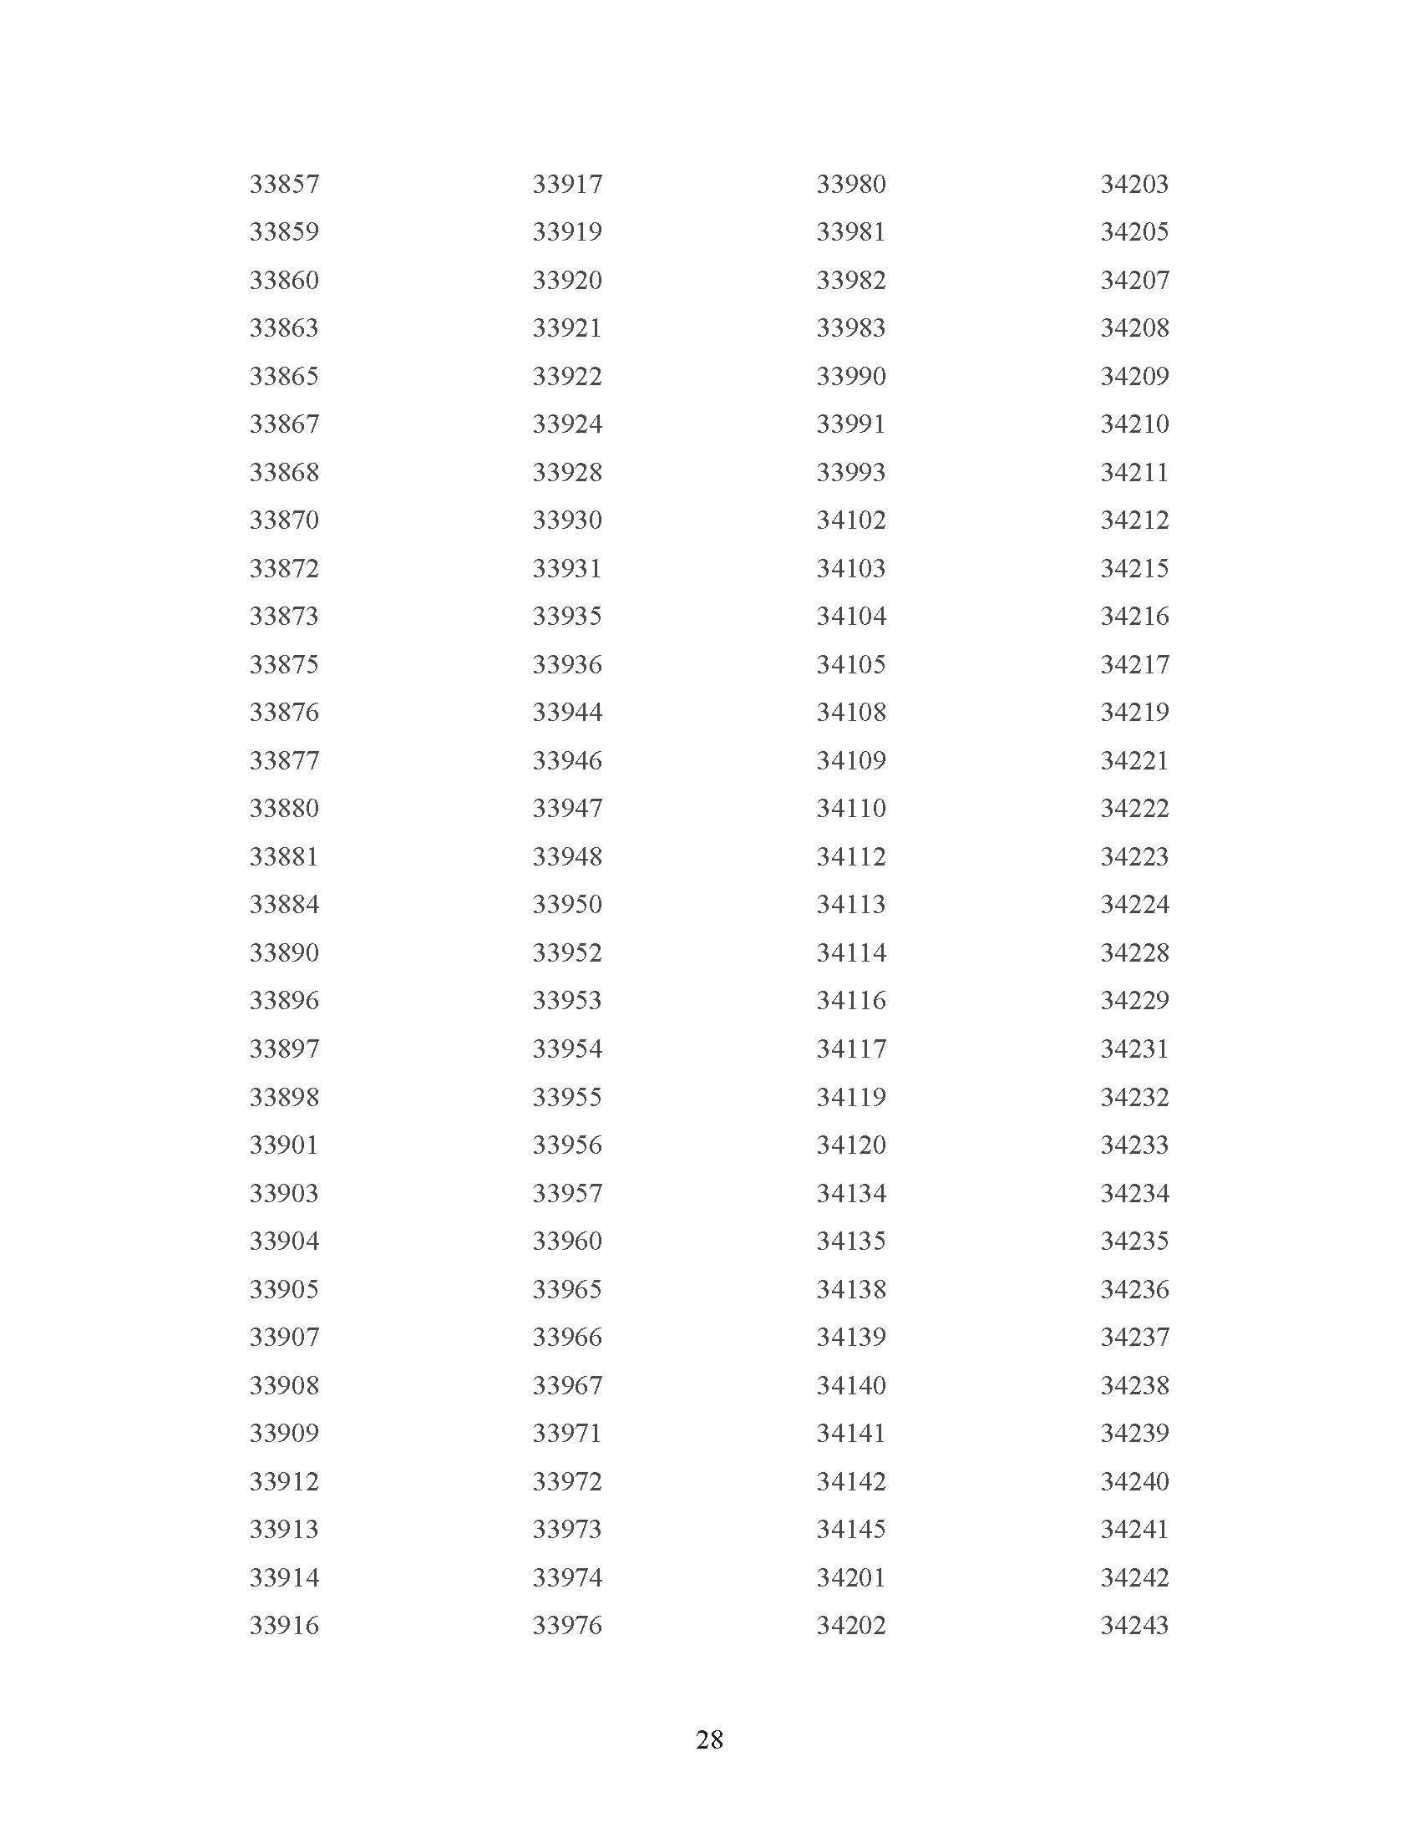

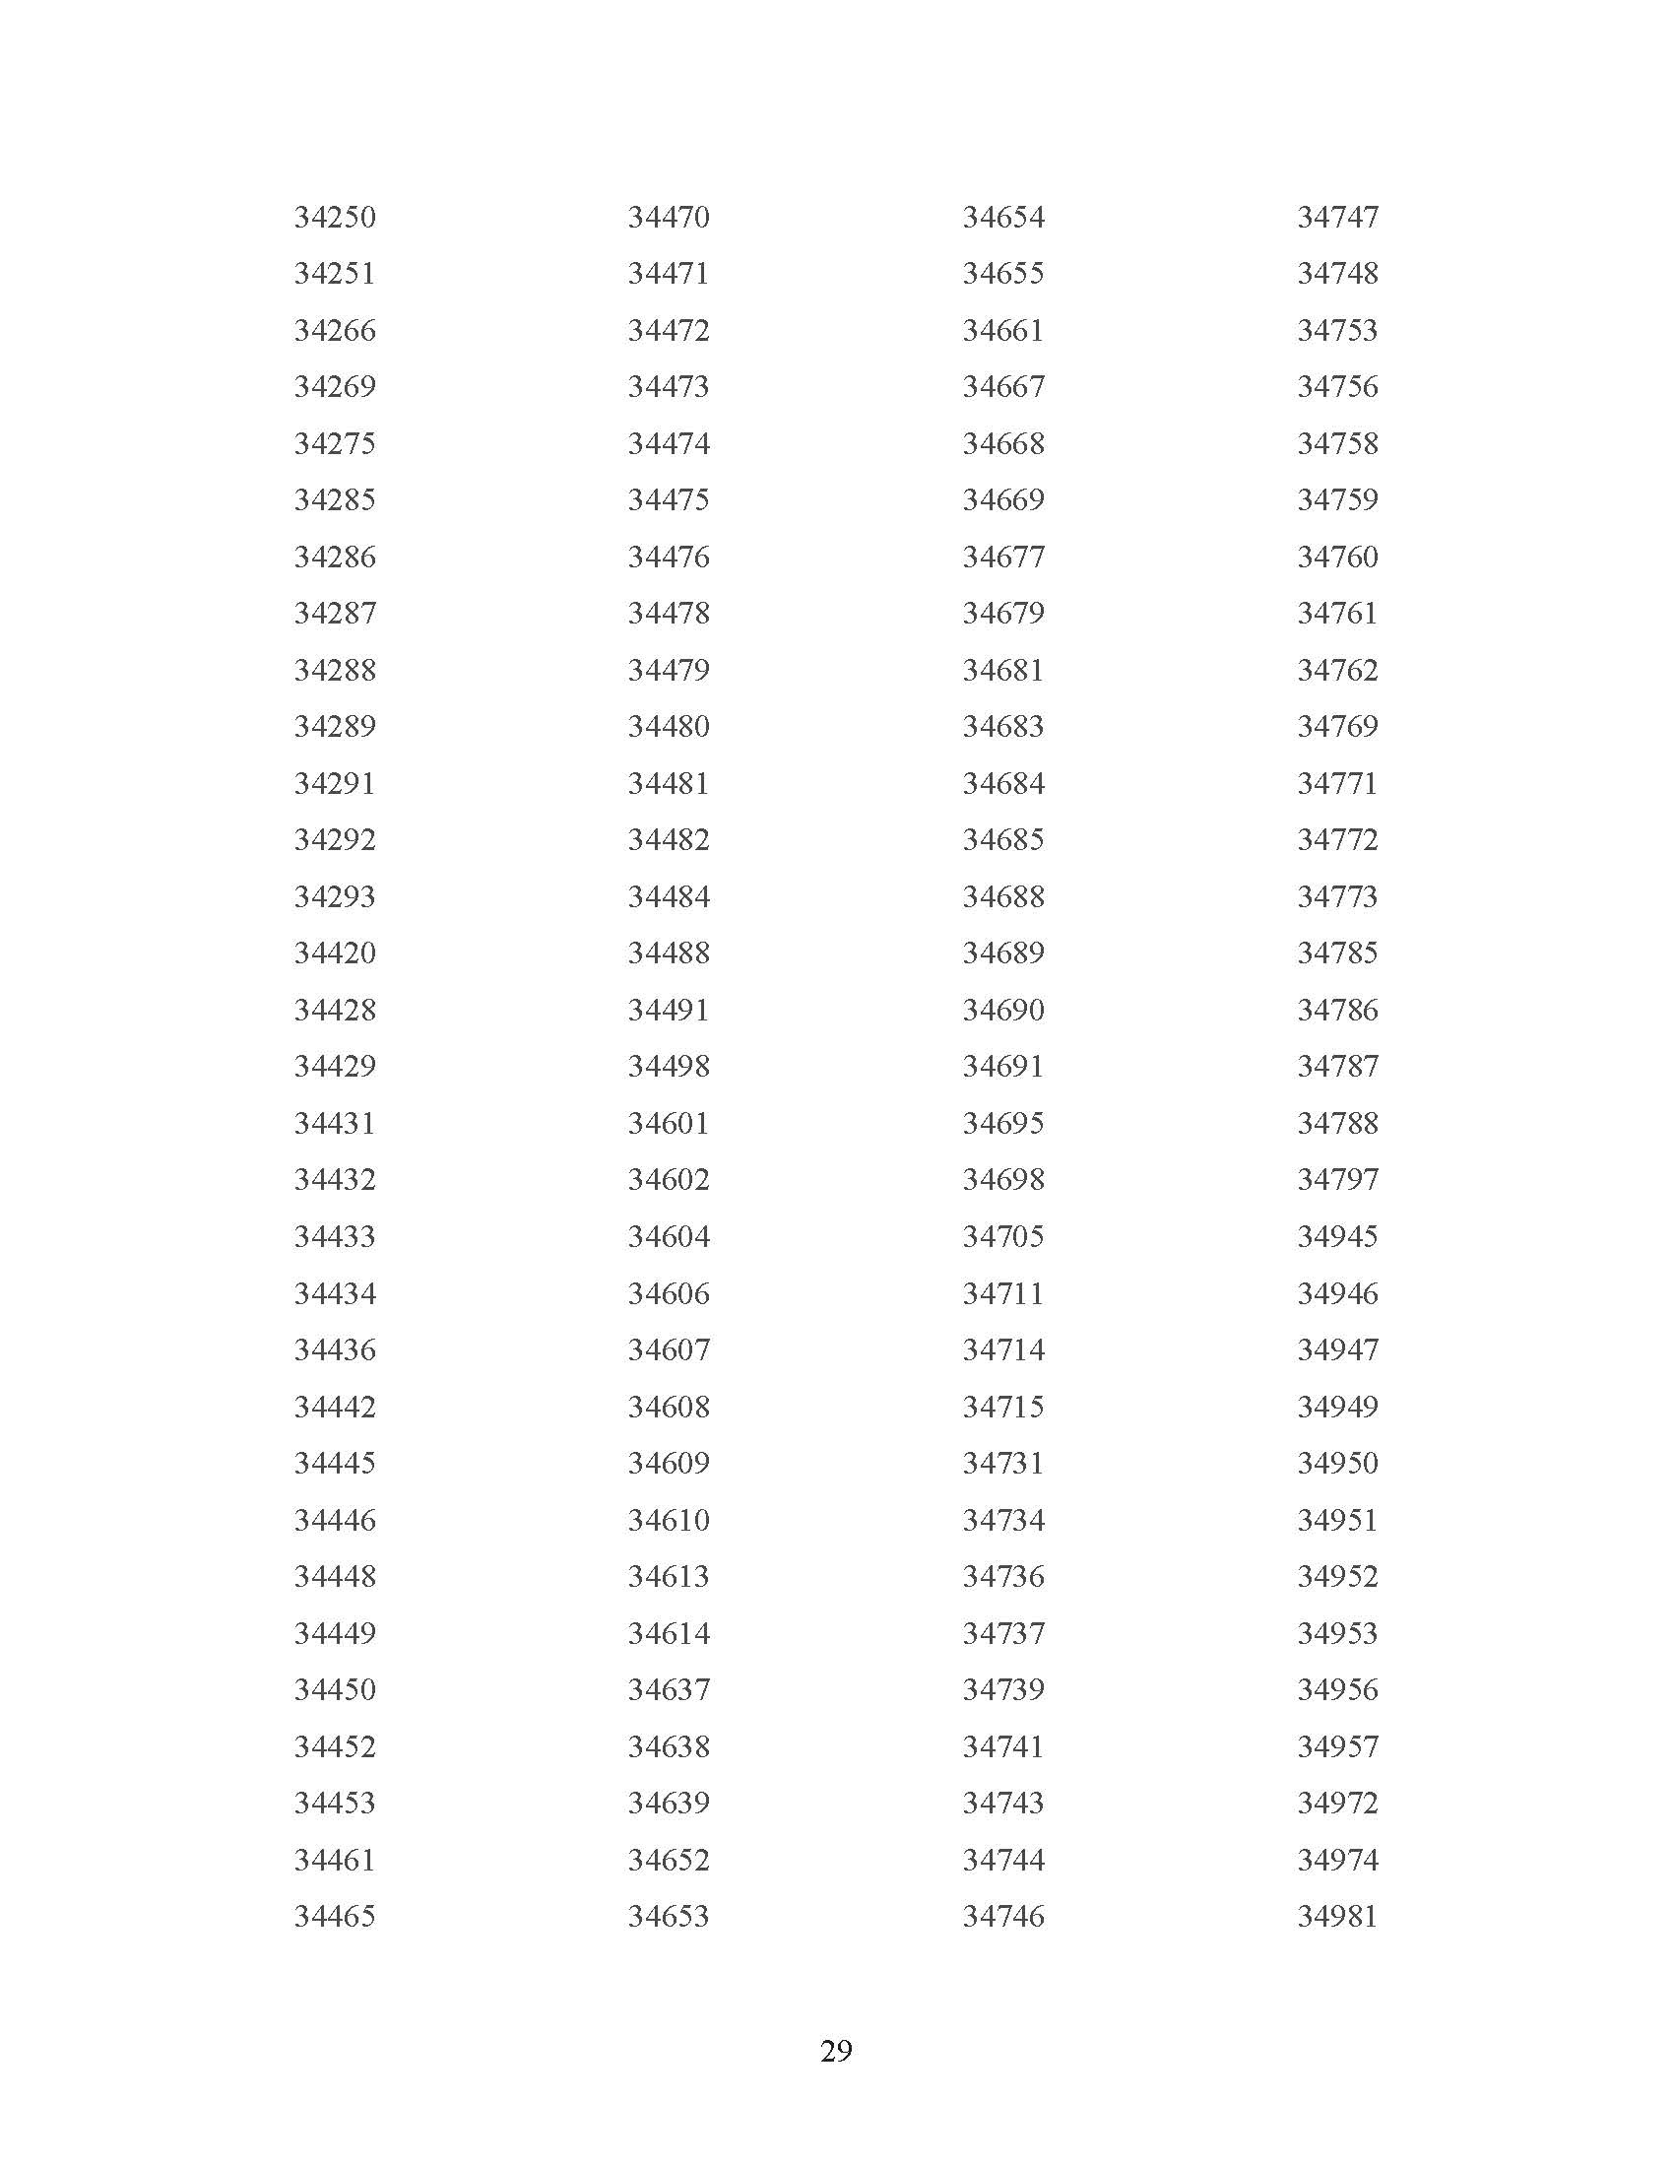



1. 47 U.S.C. § 153(11) (defining a common carrier as “any person engaged as a common carrier for hire, in interstate or foreign communications by wire or radio . . . .”; 47 U.S.C. § 332(c)(1)(A) (treating commercial mobile service providers as common carriers).
2. House Bill 1231 (2011), effective July 1, 2011.
3. Senate Bill 478 (2024), effective April 15, 2024.
4. 47 C.F.R. § 54.201(a).
5. 47 U.S.C. § 214(e)(1), 47 C.F.R. § 54.101, 47 C.F.R. § 54.201, and 47 C.F.R. § 54.401; While Section 47 C.F.R. § 54.101(a) also includes requirements addressing toll limitation services to qualifying low-income consumers, the FCC in its 2012 Lifeline and Link Up Reform Order (FCC 12-11) stated that: “ETCs are not required to offer toll limitation service to low-income consumers if the Lifeline offering provides a set amount of minutes that do not distinguish between toll and non-toll calls.”
6. Broadband Internet Access Service (BIAS) is defined as a mass-market retail service that provides the capability to transmit and receive data, but excluding dial-up service.
7. Section 364.105, F.S states that each ETC shall offer a residential basic local telecommunications service at 70 percent of the residential local telecommunications service rate for any Lifeline subscriber who no longer qualifies for Lifeline for a period of 1 year after the date the subscriber ceases to qualify for Lifeline .
8. Rule25-4.0665(3), F.A.C. The Lifeline Promotion Process is an electronic system developed in collaboration with the Florida Department of Children and Families, ETCs and the FPSC. This system helps assist ETCs and the FPSC in providing information on how to apply for Lifeline assistance to eligible customers.
9. 47 C.F.R. § 54.202(a)
10. Request for Review by DISH Wireless L.L.C. of the Decision of the Universal Service Administrator, WC Docket No. 20-445, December 11, 2023, available at <https://www.fcc.gov/ecfs/search/searchfilings/filing/12>.
11. 47 U.S.C. § 214(e)(2).
12. 2023 Florida Lifeline Assistance Report, December 2023, Appendix C, p 24.
13. Ibid, p 13.