State of Florida   |  | Public Service Commission  Capital Circle Office Center ● 2540 Shumard Oak Boulevard  Tallahassee, Florida 32399-0850  -M-E-M-O-R-A-N-D-U-M-
DATE: | June 27, 2024
TO: | Office of Commission Clerk (Teitzman)
FROM: | Division of Economics (Guffey)  Office of the General Counsel (Stiller)
RE: | Docket No. 20240039-GU – Petition for approval of transportation service agreements between Peninsula Pipeline Company, Inc. and Pivotal Utility Holdings, Inc. d/b/a Florida City Gas.
AGENDA: | 07/09/24 – Regular Agenda – Proposed Agency Action – Interested Persons May Participate
COMMISSIONERS ASSIGNED: |  |  | All Commissioners
PREHEARING OFFICER: |  |  | Fay
CRITICAL DATES: |  |  | None
SPECIAL INSTRUCTIONS: |  |  | None

Case Background
On February 29, 2024, Peninsula Pipeline Company, Inc. (Peninsula) filed a petition seeking approval of three firm transportation service agreements (Transportation Agreements) between Peninsula and Pivotal Utility Holdings, Inc. d/b/a Florida City Gas (FCG), collectively the Parties. The Parties state the purposes of the Transportation Agreements are to diversify and introduce additional gas supply sources, enhance transmission access, and increase system resiliency to address increased interest in gas service from customers in the project areas. The Parties state that the three proposed projects would introduce supply from locally produced alternative natural gas sources and expand FCG’s distribution system in Brevard, Indian River, and Miami-Dade Counties. The sources of the renewable natural gas (RNG) are landfills located in Cocoa, Vero Beach, and Medley.
Peninsula, a wholly owned subsidiary of Chesapeake Utilities Corporation (CUC), operates as an intrastate natural gas transmission company as defined by Section 368.103(4), Florida Statutes (F.S.). FCG, which recently became a subsidiary of CUC, is a local distribution company subject to the regulatory jurisdiction of the Commission pursuant to Chapter 366, F.S. FCG provides natural gas service to residential, commercial, and industrial customers in Brevard, Indian River, and Miami-Dade Counties, and receives deliveries of natural gas to serve these customers over the interstate transmission pipelines owned by Florida Gas Transmission Company, LLC (FGT).
By Order No. PSC-07-1012-TRF-GP, Peninsula received approval of an intrastate gas pipeline tariff that allows it to construct and operate intrastate pipeline facilities and to actively pursue agreements with natural gas customers. Peninsula provides gas transportation service only; it does not engage in the sale of natural gas to customers. Pursuant to the Order, Peninsula is allowed to enter into certain gas transmission agreements without prior Commission approval. However, Peninsula is requesting Commission approval of the proposed firm Transportation Agreements as they do not fit any of the criteria enumerated in the tariff for which Commission approval would not be required. The Parties are subsidiaries of CUC, and agreements between affiliated companies must be approved by the Commission pursuant to Section 368.105, F.S.
Pursuant to the proposed Transportation Agreements and project maps (Attachments A, B, and C to this recommendation), Peninsula would construct, own, and operate the new gas pipelines allowing for the delivery of natural gas purchased by FCG via interconnection agreements with third party gas producers. The interconnection agreements were entered into between FCG and the RNG producers prior to FCG being acquired by CUC.
Regarding the commodity purchase agreements between FCG and the RNG producers, pursuant to response 1 in staff’s fourth data request, to date, only the Indian River County commodity purchase agreement (confidential) has been finalized for gas supply. The Parties state that the commodity purchase agreements for Brevard and Miami-Dade Counties are expected to be finalized pending the approval of the proposed Transportation Agreements by the Commission. FCG should provide a status update of the commodity purchase agreements for Brevard and Miami-Dade counties in the upcoming PGA docket.
For all three firm Transportation Agreements, the Parties assert that it is beneficial to the customers having the affiliated Peninsula construct, own, and operate the new natural gas pipeline because of timing, cost, business corporate structure, administrative and operational coordination efficiencies.
During the evaluation of the petition, staff issued four data requests to the Parties for which responses were received on April 9th, April 11th, May 13th, and on June 10th, 2024. The Commission has jurisdiction over this matter pursuant to Sections 368.104 and 368.105, F.S.

Discussion of Issues

Issue 1:
Should the Commission approve the proposed firm Transportation Agreement dated February 26, 2024, between Peninsula and FCG in Brevard County?

Recommendation:
Yes, the Commission should approve the proposed Transportation Agreement associated with the Brevard County project dated February 26, 2024, between Peninsula and FCG. The Transportation Agreement, which sets rates for Peninsula’s charges to FCG, is reasonable and meets the requirements of Section 368.105, F.S. The approval of this Transportation Agreement does not reflect approval of future cost recovery of the monthly reservation charges FCG will incur. The Commission will have the opportunity to review FCG’s request for cost recovery of the charges pursuant to the Transportation Agreement in its annual Purchased Gas Adjustment (PGA) proceeding. FCG should provide a status update of the commodity purchase agreement for Brevard County in the upcoming PGA docket. (Guffey)

Staff Analysis:

Proposed Transportation Service Agreement in Brevard County
The Parties have entered into the proposed firm Transportation Agreement that they describe as enabling FCG to reinforce its Brevard County distribution system and meet the increased demand for natural gas from population growth and large industrial customers related to the space and cruise industries. The Parties state that the proposed Transportation Agreement has the added benefit of providing FCG with an additional source of gas (via the Peninsula pipeline) and installing a city gate.
The proposed Transportation Agreement specifies an initial term of 20 years with automatic extensions on an annual basis, unless either party gives no less than 90 days of written notification of termination. If either party desires to negotiate modifications to the rates or terms of this Transportation Agreement, they may do so no less than 120 days prior to expiration of the current active term, subject to Commission approval of the amendment.

Brevard County Expansion Project
For the Brevard County expansion project, as shown by the blue line on Map A, Peninsula will construct an approximately five mile, 12-inch Medium Density Polyethylene (MDPE) pipeline, sized to meet FCG’s supply needs. It should be noted that the Transportation Agreement refers to steel pipelines; however, the Parties confirmed that the pipeline will be built from MDPE as stated in paragraph 12 of the petition. The starting point of the new pipeline is near Adamson Road and Sorrel Drive at a new gate station near the landfill located in Cocoa and owned by Brevard County. The new pipeline will terminate at a new interconnection near SR 524 and Cox Road and tie in with FCG’s distribution system.
In response to staff’s first data request, the Parties stated that the alternative natural gas will be treated and converted by the associated producer, who has the responsibility of developing and owning the gas production facilities, to meet Peninsula’s tariff pipeline standards. Peninsula will analyze the gas quality in real time in five-minute intervals to assure specifications are met. FCG will purchase the gas from the third party gas producer. The proposed Brevard County Expansion Project is estimated to be completed in the third quarter of 2024.
The estimated total cost for the Brevard County project is $6.1 million of which FCG’s portion is $1.54 million. The remainder of the total cost will be borne by the RNG producer as it has the ability to receive RNG credits. Of the total cost, 33 percent is for materials and equipment and 67 percent is labor related costs. In paragraph 23 of the petition, Parties state that in the event circumstances arise that make the project uneconomical to Peninsula, the Parties will endeavor to negotiate a revised rate and acknowledge that the revised rate would require Commission approval as an amendment to the Transportation Agreement.
FCG states that its distribution system in Brevard County would receive additional reinforcement by having two sources of gas supply. In paragraph 14 of the petition, the Parties assert that the proposed project would ensure that FCG will have sufficient capacity and supply to meet the increasing future demand in the Brevard County. The Parties assert that Brevard County has been experiencing an average growth rate of 2 percent mostly driven by the expansion of the aerospace industry. Additionally, they state the project would alleviate constraints and allow FCG to make flow design changes to their system when needed.

Monthly Reservation Payments to Peninsula
In paragraph 10 of the petition, the Parties expressed that the rates contained in the proposed Transportation Agreement are consistent with market rates, because the rates are substantially the same as rates set forth in similar agreements as required by Section 368.105(3)(b), F.S. The Parties explained that Peninsula would recover the pipeline construction costs through the monthly reservation charge from FCG, as shown in Exhibit A to the proposed Transportation Agreement. The monthly reservation charge is designed to recover costs such as, but not limited to, engineering, permitting (Florida Department of Environmental Protection, Florida Department of Transportation, Brevard County, and the City of Cocoa) acquiring land use permits and rights of way, materials, installation costs associated with the pipeline and related facilities, ongoing maintenance including Pipeline and Hazardous Materials Safety Administration compliance, safety requirements, property taxes, gas control, and Peninsula’s return on investment.
Pursuant to Article III of the Transportation Agreement, the monthly reservation charge will be paid by FCG to Peninsula as shown in Exhibit A of the Transportation Agreement. Peninsula will charge FCG beginning on the In-Service Date (when Peninsula has commenced commercial operations). The project costs are exclusive to facilities needed for the receipt and transportation of the gas. If Peninsula were to incur new taxes or capital expenditures after the execution of this agreement, then FCG’s monthly reservation charge will be adjusted accordingly. The revised reservation charge shall be subject to Commission approval.
FCG asserts that it will be only purchasing the gas commodity at market rate and that the environmental attributes which make RNG “renewable” will be managed by the producer of the natural gas and sold on the secondary market. FCG states it intends to file for cost recovery for its payments to Peninsula and to the gas producer through the PGA mechanism.
FCG states that it will be purchasing the natural gas at parity to other gas flows out of Florida Zone 3 and that the gas commodity costs are expected to be equivalent to that of out of state gas supply. The Parties further assert that purchasing locally sourced gas is less expensive compared to purchasing out of state gas as capacity costs on FGT are being avoided. In response to staff data requests, the Parties provided an analysis (confidential) showing that the estimated cost of gas supply provides savings compared to the estimated cost of traditional supply.

Conclusion
Based on the petition and the Parties’ responses to staff’s data requests, the Commission should approve the proposed firm Transportation Agreement associated with the Brevard County project dated February 26, 2024, between Peninsula and FCG. The Transportation Agreement, which sets rates for Peninsula’s charges to FCG, is reasonable and meets the requirements of Section 368.105, F.S. The approval of this Transportation Agreement does not reflect approval of future cost recovery of the monthly reservation charges FCG will incur. The Commission will have the opportunity to review FCG’s request for cost recovery of the charges pursuant to the Transportation Agreement in its annual PGA proceeding. FCG should provide a status update of the commodity purchase agreement for Brevard County in the upcoming PGA docket.

Issue 2:
Should the Commission approve the proposed firm Transportation Agreement dated February 26, 2024, between Peninsula and FCG in Indian River County?

Recommendation:
Yes, the Commission should approved the proposed firm Transportation Agreement associated with the Indian River County project dated February 26, 2024, between FCG and Peninsula. The Transportation Agreement, which sets rates for Peninsula’s charges to FCG, is reasonable and meets the requirements of Section 368.105, F.S. The approval of this Transportation Agreement does not reflect approval of future cost recovery of the monthly reservation charges FCG will incur. The Commission will have the opportunity to review FCG’s request for cost recovery of the charges pursuant to the Transportation Agreement in its annual PGA proceeding. (Guffey)

Staff Analysis:

Proposed Transportation Service Agreement in Indian River County
The Parties have entered into the proposed firm Transportation Agreement that they describe as enabling FCG to reinforce its Indian River County distribution system and meet the significant increased natural gas demand due to population growth.
This agreement consolidates two existing agreements (entered into in 2012 and 2021) and two amendments (2021, 2023), which were entered into by Peninsula and FCG when FCG was a non-affiliated separate entity. As stated in paragraph 18 of the petition, with the new pipeline project, Peninsula and FCG entered into this new agreement reflecting the Parties’ prior agreements and understandings. Pursuant to Sections 9.3 and 9.13, this Transportation Agreement, including exhibits attached, supersedes and replaces two prior agreements and the two amendments. The Parties explained that the above referenced pipeline projects did not require Commission approval at the time contracts were entered into because FCG and Peninsula were not affiliates at that time. The new consolidated Transportation Agreement will ensure that the agreement term lengths are aligned for the projects and that all the projects are covered by this single agreement.
The proposed Transportation Agreement specifies an initial term of 30 years with automatic extensions on an annual basis, unless either party gives no less than 90 days of written notification of termination. If either party desires to negotiate modifications to the rates or terms of this Agreement, they may do so no less than 120 days prior to expiration of the current active term, subject to Commission approval of the amendment.

Indian River County Expansion Project
As shown on the map in Attachment B to this recommendation, Peninsula will begin the expansion project from a new interconnect near Oslo Road, where the landfill/gas producer is located. From the interconnect, Peninsula will construct approximately 14 miles of 6-inch steel pipeline along 82nd Avenue, and terminate at a new district regulator station which will directly interconnect with three existing portions of Peninsula’s system in the area of 77th Street. The pipeline will terminate at a district regulator and tie in with FCG’s distribution system. The estimated total cost for the project is $17.75MM and is being paid for by FCG through the reservation charge. Of the total cost, materials and equipment account for approximately 24 percent and labor costs account for approximately 76 percent. The proposed Indian River County gas supply project is estimated to be completed in the third quarter of 2024.
In response to staff’s data request, the Parties stated that additional capacity is needed to meet the demand associated with the Beachside Expansion project on the barrier island. Data indicates that FCG has experienced a 12 percent growth in customers in the last three years and expects this trend to continue. As stated in paragraph 17 of the petition, the proposed Indian River County project would interconnect three existing systems in the area; two segments of FCG’s distribution system and a separate Peninsula pipeline project. These projects did not require Commission approval as FCG and Peninsula were not affiliates at that time. The proposed Transportation Agreement has the added benefit of providing FCG with an additional source of capacity and supply (via the Peninsula pipeline). The additional supply obtained from the landfill owned by the City of Vero Beach, will allow FCG to meet the expected future demand for natural gas.

Monthly Reservation Payments to Peninsula
In paragraph 10 of the petition, the Parties expressed that the negotiated monthly reservation charge contained in the proposed Agreement is consistent with market rates, because the rates are substantially the same as rates set forth in similar agreements as required by Section 368.105(3)(b), F.S. The Parties explained that Peninsula would recover the pipeline construction costs through the monthly reservation charge from FCG, as shown in Exhibit A to the proposed Agreement. The monthly reservation charge is designed to recover costs such as, but not limited to, engineering, permitting, materials, installation costs associated with the pipeline and related facilities, ongoing maintenance including Pipeline and Hazardous Materials Safety Administration compliance, safety requirements, property taxes, gas control, and Peninsula’s return on investment.
Pursuant to Article IV of the Transportation Service Agreement, the monthly reservation charge will be paid by FCG to Peninsula as shown in Exhibit A of the Agreement. Peninsula will charge FCG beginning on the In-Service Date (Peninsula has commenced commercial operations). If Peninsula were to incur new taxes or capital expenditures after the execution of this agreement, then FCG’s monthly reservation charge will be adjusted accordingly. The revised reservation charge shall be subject to Commission approval.
FCG asserts that it will be only purchasing the gas commodity at market rate and that the environmental attributes which make RNG “renewable” will be managed by the producer of the natural gas and sold on the secondary market. FCG states it intends to file for cost recovery for its payments to Peninsula and to the gas producer through the PGA mechanism.
FCG states that it will be purchasing the natural gas at parity to other gas flows out of Florida Zone 3 and that the gas commodity costs are expected to be equivalent to that of out of state gas supply. The Parties further assert that purchasing locally sourced gas is less expensive compared to purchasing out of state gas as capacity costs on FGT are being avoided. In response to staff data requests, the Parties provided an analysis (confidential) showing that the estimated cost of gas supply provides savings compared to the estimated cost of traditional supply.

Conclusion
Based on the petition and the Parties’ responses to staff’s data requests, staff recommends that the Commission should approved the proposed firm Transportation Agreement associated with the Indian River County project dated February 26, 2024, between FCG and Peninsula. The Transportation Agreement, which sets rates for Peninsula’s charges to FCG, is reasonable and meets the requirements of Section 368.105, F.S. The approval of this Transportation Agreement does not reflect approval of future cost recovery of the monthly reservation charges FCG will incur. The Commission will have the opportunity to review FCG’s request for cost recovery of the charges pursuant to the Transportation Agreement in its annual PGA proceeding.

Issue 3:
Should the Commission approve the proposed firm Transportation Agreement dated February 26, 2024, between Peninsula and FCG in Miami-Dade County?

Recommendation:
Yes, the Commission should approve the proposed firm Transportation Agreement associated with the Miami-Dade County project dated February 26, 2024, between FCG and Peninsula. The Transportation Agreement, which sets rates for Peninsula’s charges to FCG, is reasonable and meets the requirements of Section 368.105, F.S. The approval of this Transportation Agreement does not reflect approval of future cost recovery of the monthly reservation charges FCG will incur. The Commission will have the opportunity to review FCG’s request for cost recovery of the charges pursuant to the Transportation Agreement in its annual PGA proceeding. FCG should provide a status update of the commodity purchase agreement for Miami-Dade County in the upcoming PGA docket. (Guffey)

Staff Analysis:

Proposed Transportation Service Agreement for Miami-Dade County
The Parties have entered into the proposed firm Transportation Agreement on February 26, 2024, to enable FCG (the shipper) to serve customers within its service area. The proposed Agreement specifies an initial period of 20 years from the In-Service Date (Initial Term) and thereafter shall be extended on a year-to-year basis, unless either party gives no less than 90 days of prior written notification of termination. If either party desires to negotiate modifications to the rates or terms of this Agreement, they may do so no less than 120 days prior to expiration of the current active term, subject to Commission approval of the amendment.

Miami-Dade County Project
The Miami-Dade County project will include Peninsula extending steel pipelines, one from a new interconnect with local alternated natural gas supply, and another from a district regulator station, to connect with the shipper’s (FCG’s) local distribution system. As shown on the map on Attachment C to this recommendation, from a new interconnect at NW 93rd Street, near the landfill in Medley, Peninsula will extend approximately eight miles of 8-inch steel pipe along NW 87th Avenue and NW 72nd Avenue and will terminate at NW 12th Street at a new district regulator station connecting to FCG distribution system. The estimated total cost of the project is $22MM of which the allocated cost to FCG is $8.33MM. The remainder of the cost will be borne by the producer of the RNG. FCG’s portion of the cost is for facilities necessary for receipt and transportation of the alternative gas. As in the Indian River County project, materials and equipment account for 24 percent of the total cost while labor accounts for 76 percent of the total cost. Pursuant to paragraph 21 of the petition, the new pipeline is sized to meet future demands without having to make additions in the near term.
FCG states the Miami-Dade County project would reinforce and enhance gas supply to FCG’s distribution system through a direct interconnection enabling FCG to bring another source of gas to Miami-Dade County which is experiencing capacity and supply constraints as there is only one transmission line supplying to Miami-Dade County. The proposed project is in area of Miami-Dade County that features multiple high usage commercial and industrial customers. The Parties assert that the project directly driven by the need to serve new growth and demand.

Monthly Reservation Payments to Peninsula
The Parties assert that the negotiated monthly reservation charge is consistent with the market rate and is within the range of rates set forth in similar agreements as required by Section 368.105(3)(b), F.S. The Parties explained that Peninsula would recover the pipeline construction costs through the monthly reservation charge from FCG, as shown in Exhibit A to the proposed Agreement. The monthly reservation charge is designed to recover costs such as, but not limited to, engineering, permitting, materials, installation costs associated with the pipeline and related facilities, ongoing maintenance including Pipeline and Hazardous Materials Safety Administration compliance, safety requirements, property taxes, gas control, and Peninsula’s return on investment
Pursuant to Article IV of the Transportation Agreement, the monthly reservation charge will be paid by FCG to Peninsula as shown in Exhibit A of the Agreement. Peninsula will charge FCG beginning on the In-Service Date (Peninsula has commenced commercial operations). If Peninsula were to incur new taxes or capital expenditures after the execution of this agreement, then FCG’s monthly reservation charge will be adjusted accordingly. The revised reservation charge shall be subject to Commission approval.
FCG asserts that it is only purchasing the gas commodity at market rate and that the environmental attributes which make RNG “renewable” will be managed by the producer of the natural gas and sold on the secondary market. FCG states it intends to file for cost recovery for its payments to Peninsula and to the gas producer through the PGA mechanism.
FCG states that it will be purchasing the natural gas at parity to other gas flows out of Florida Zone 3 and that the gas commodity costs are expected to be equivalent to that of out of state gas supply. The Parties further assert that purchasing locally sourced gas is less expensive compared to purchasing out of state gas as capacity costs on FGT are being avoided. In response to staff data requests, the Parties provided an analysis (confidential) showing that the estimated cost of gas supply provides savings compared to the estimated cost of traditional supply.

Conclusion
Based on the petition and the Parties’ responses to staff’s data requests, staff recommends that the Commission should approve the proposed the Transportation Agreement, which sets rates for Peninsula’s charges to FCG, is reasonable and meets the requirements of Section 368.105, F.S. The approval of this Transportation Agreement does not reflect approval of future cost recovery of the monthly reservation charges FCG will incur. The Commission will have the opportunity to review FCG’s request for cost recovery of the charges pursuant to the Transportation Agreement in its annual PGA proceeding. FCG should provide a status update of the commodity purchase agreement for Miami-Dade County in the upcoming PGA docket.

Issue 4:
Should this docket be closed?

Recommendation:
Yes. If no protest is filed by a person whose substantial interests are affected within 21 days of the issuance of the Order, this docket should be closed upon the issuance of a Consummating Order. (Stiller)

Staff Analysis:
If no protest is filed by a person whose substantial interests are affected within 21 days of the issuance of the Order, this docket should be closed upon the issuance of a Consummating Order.

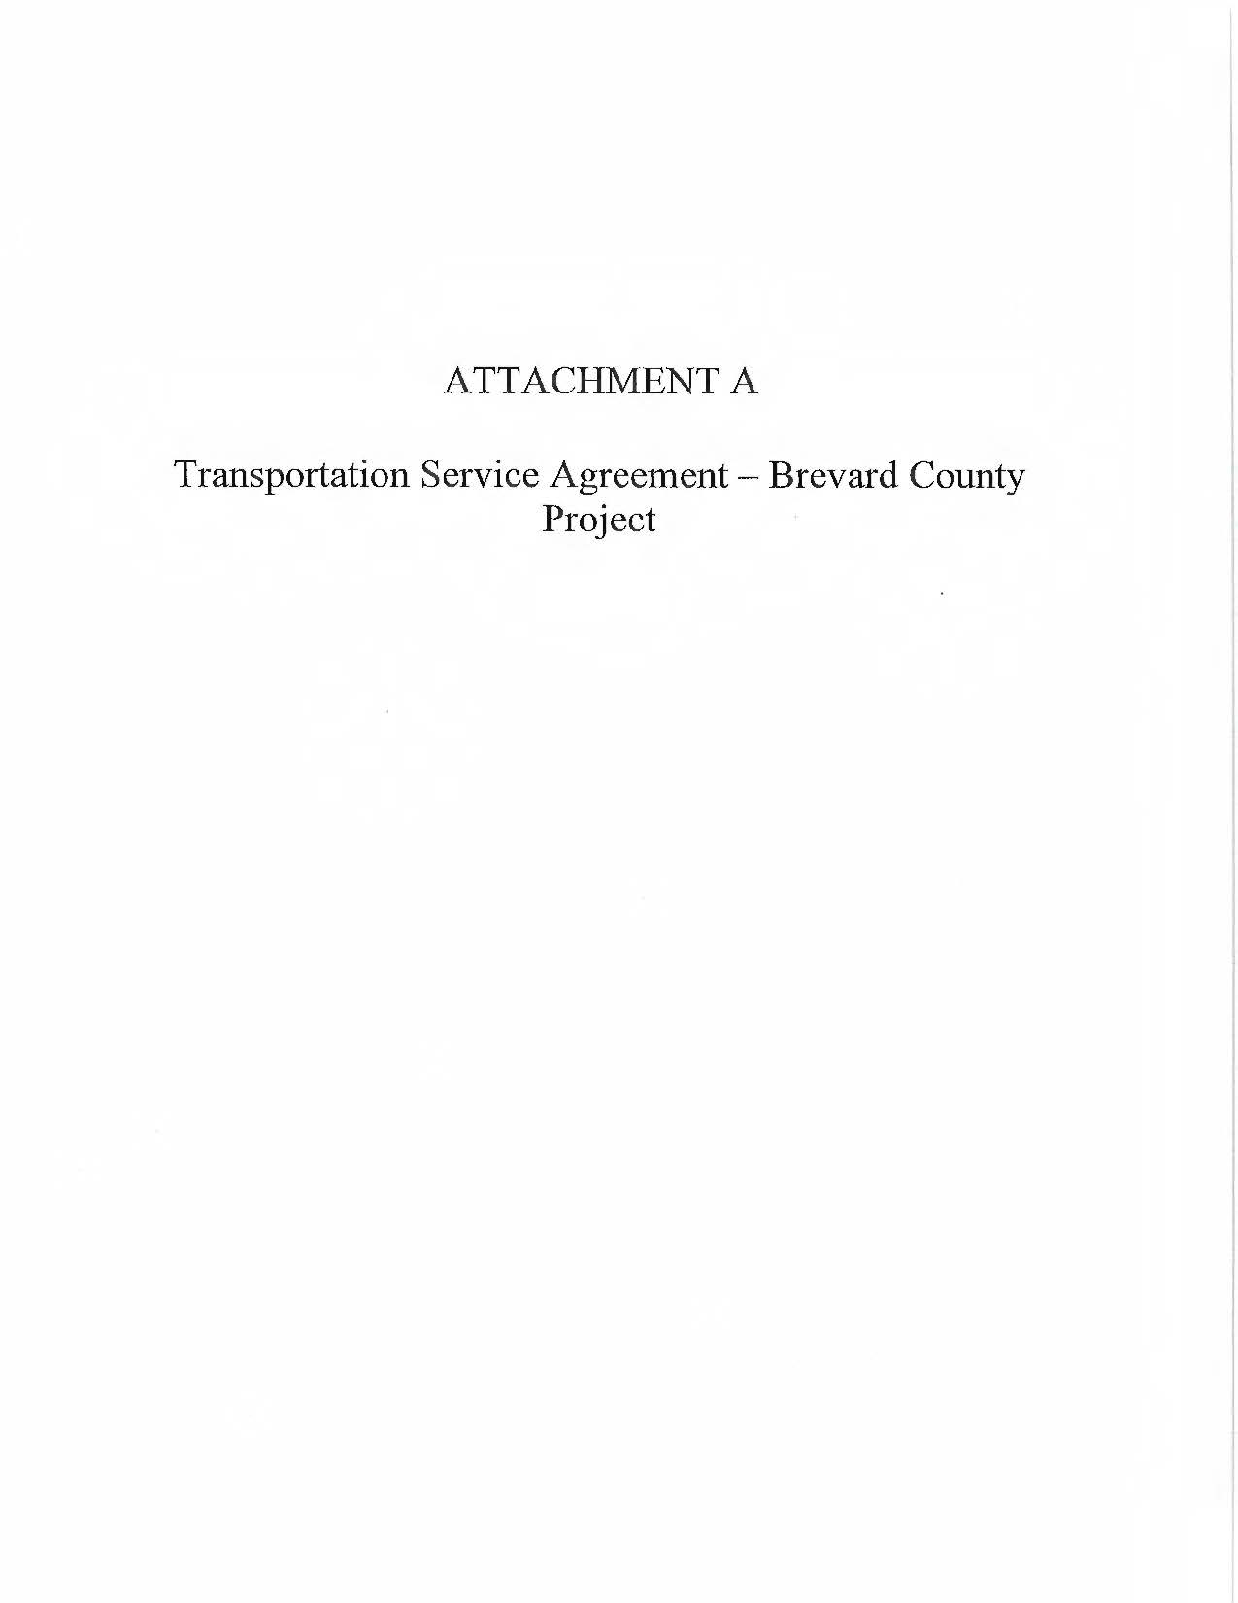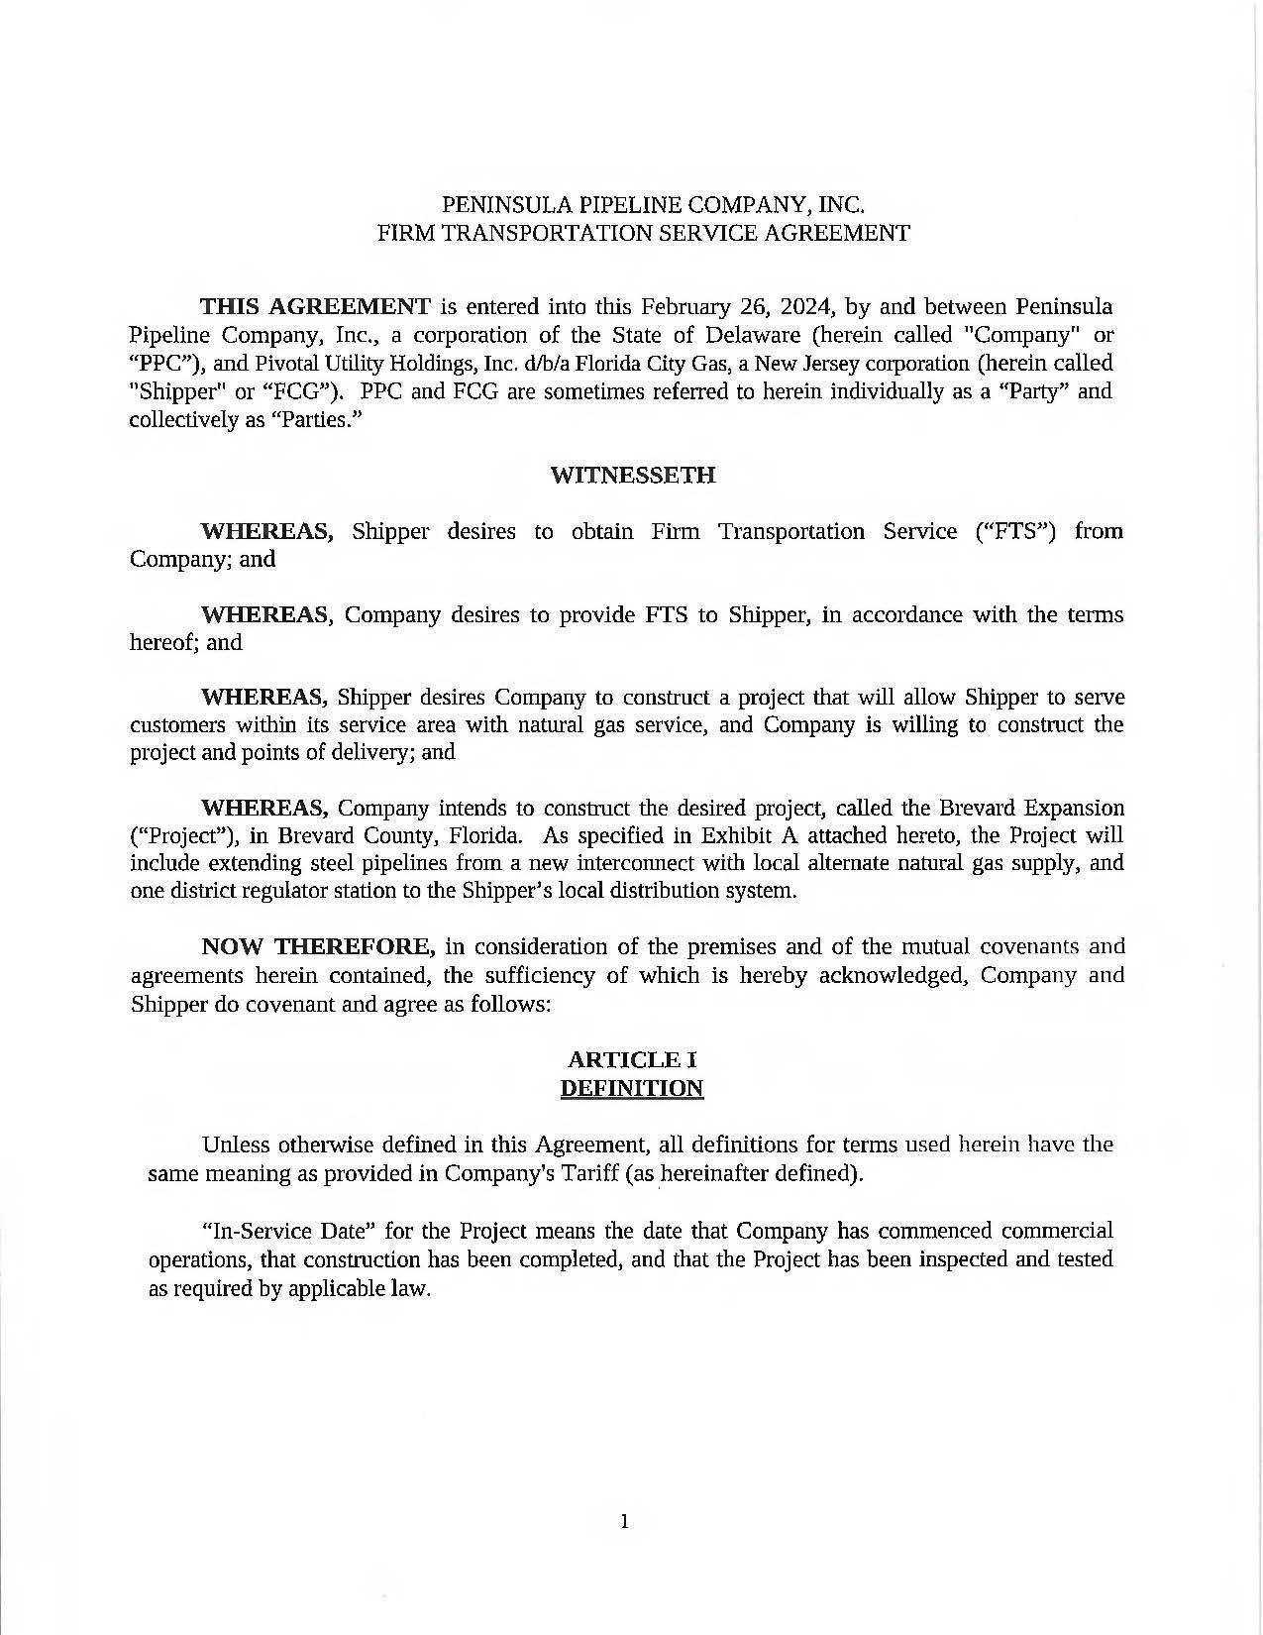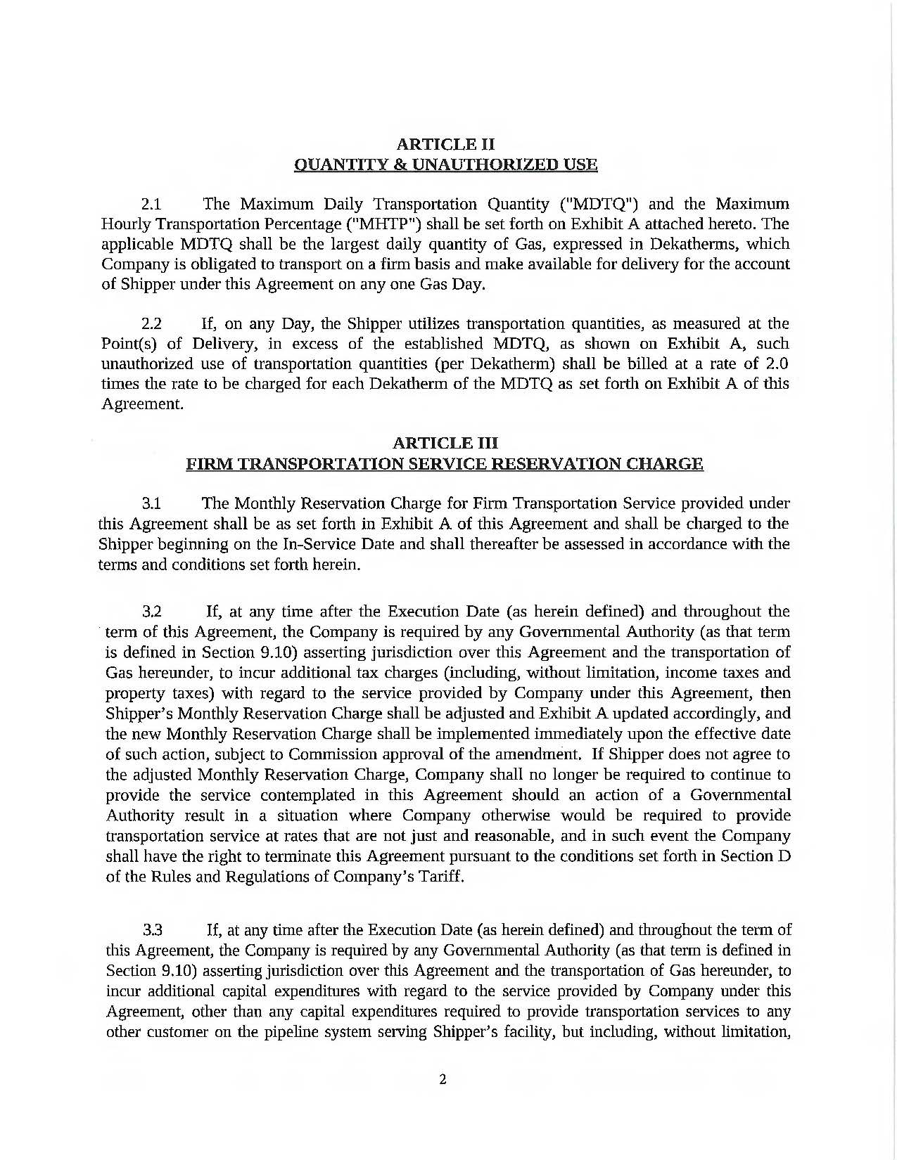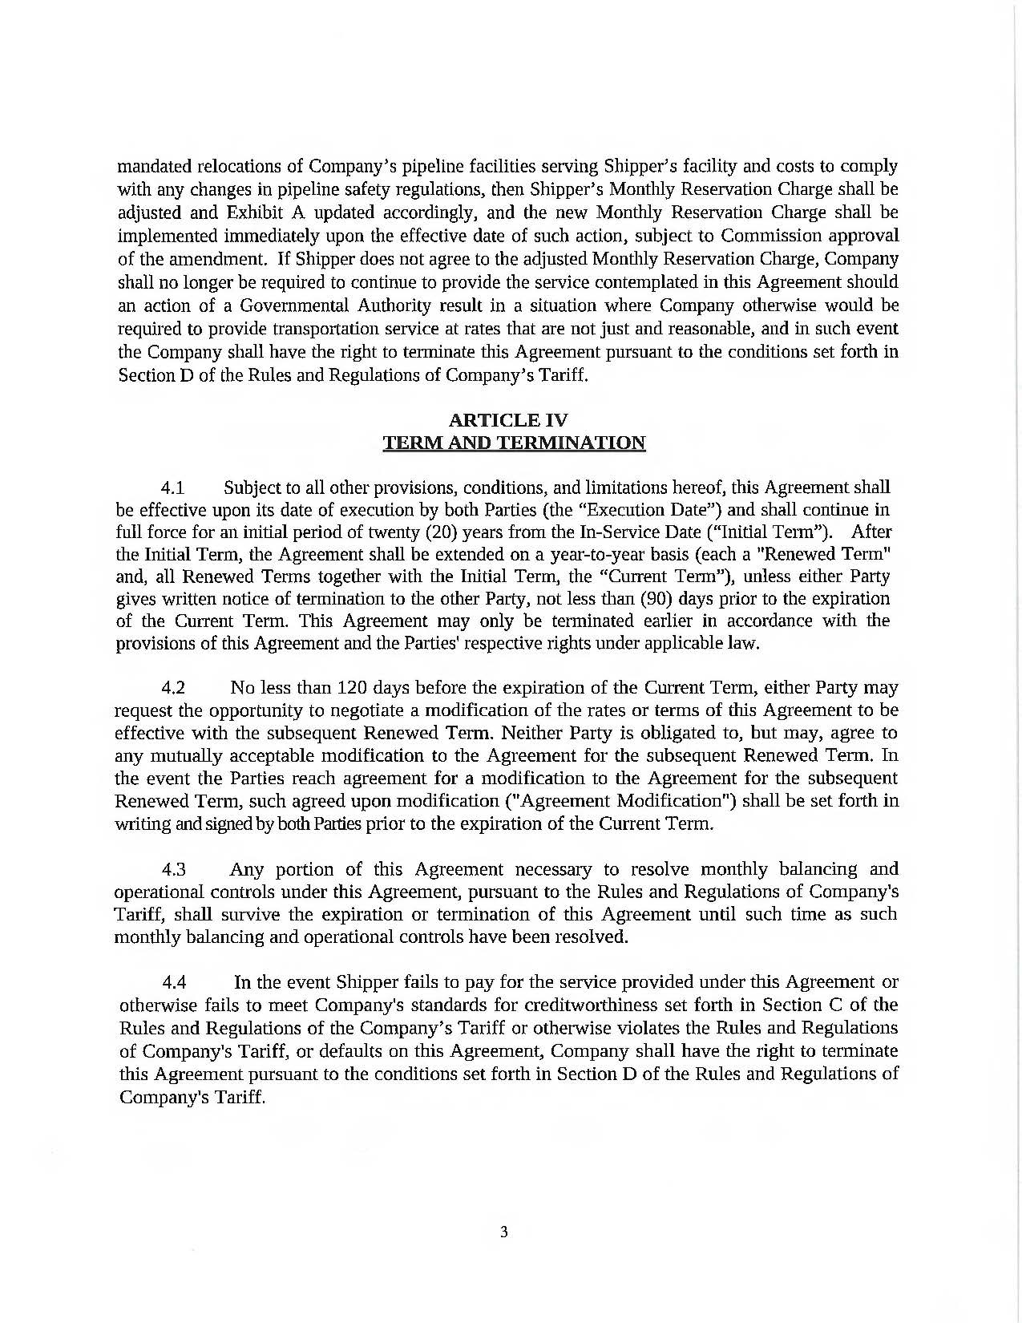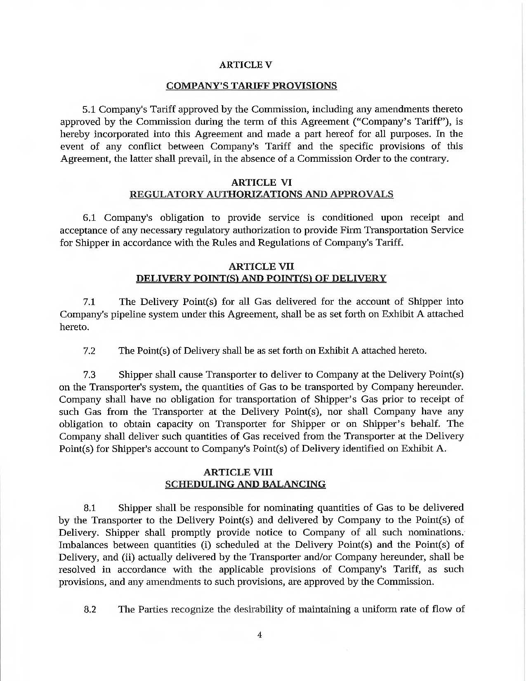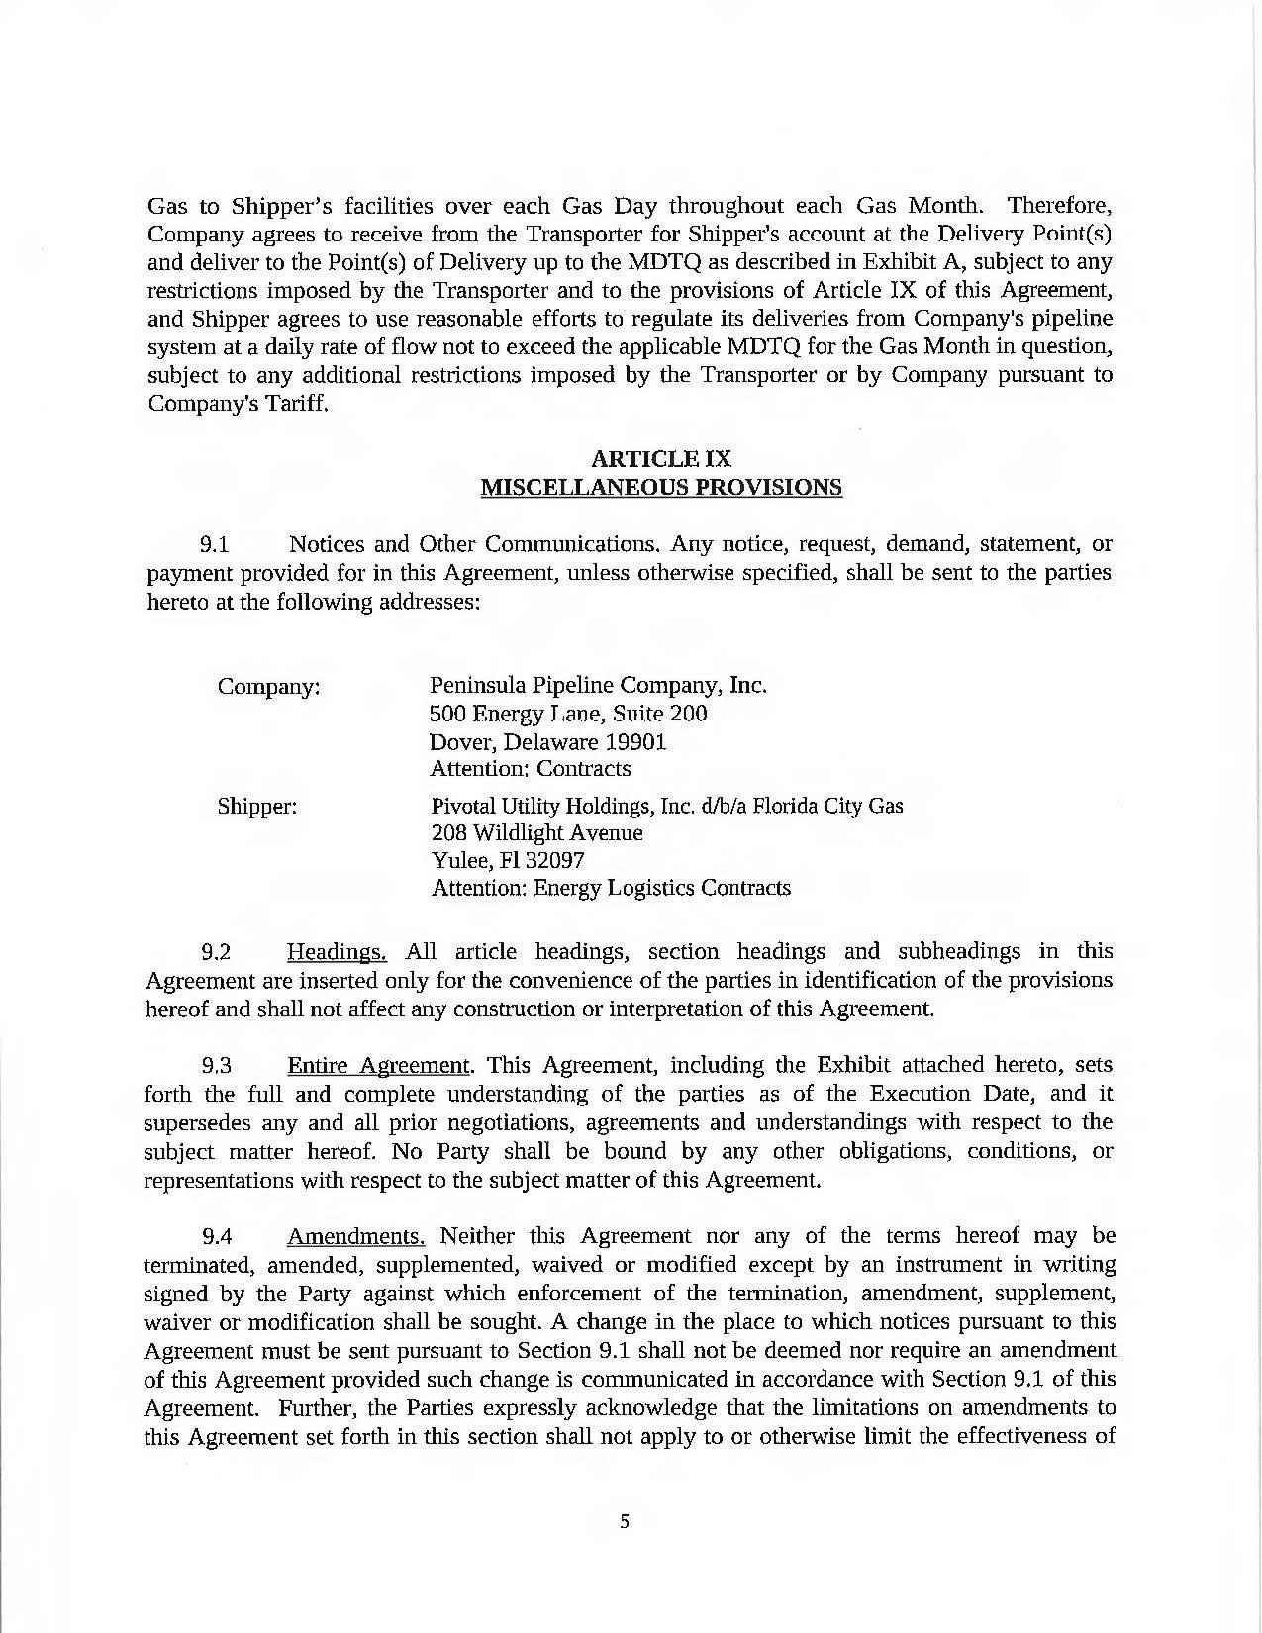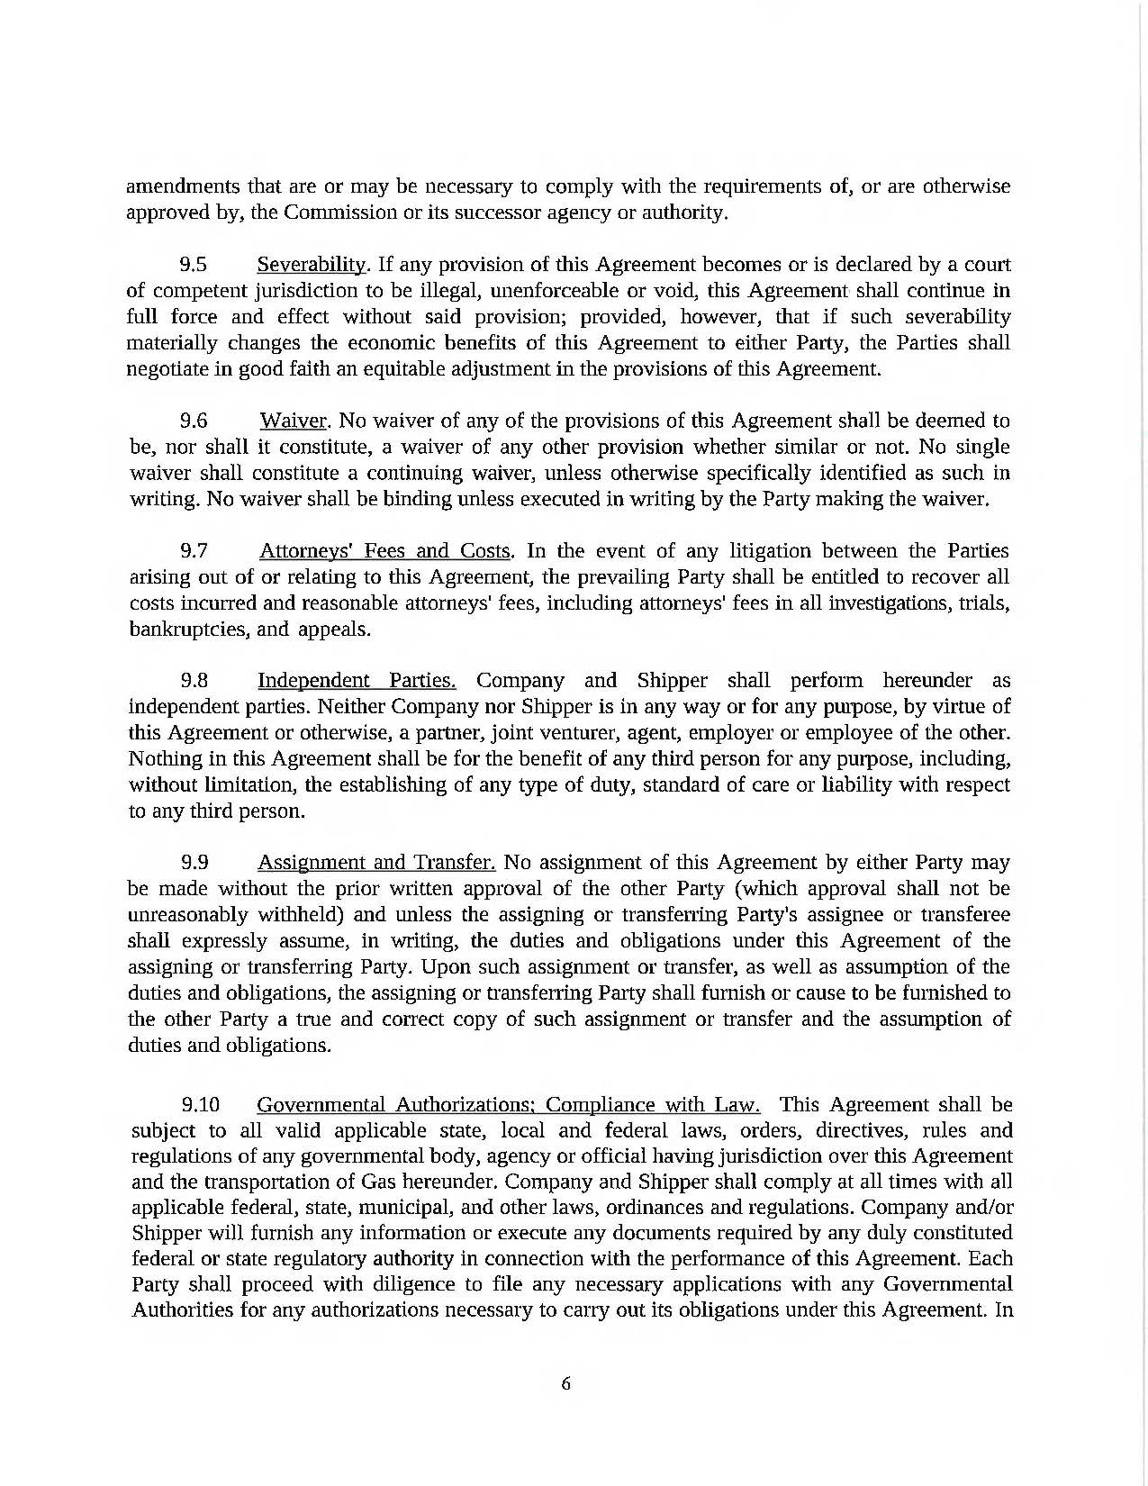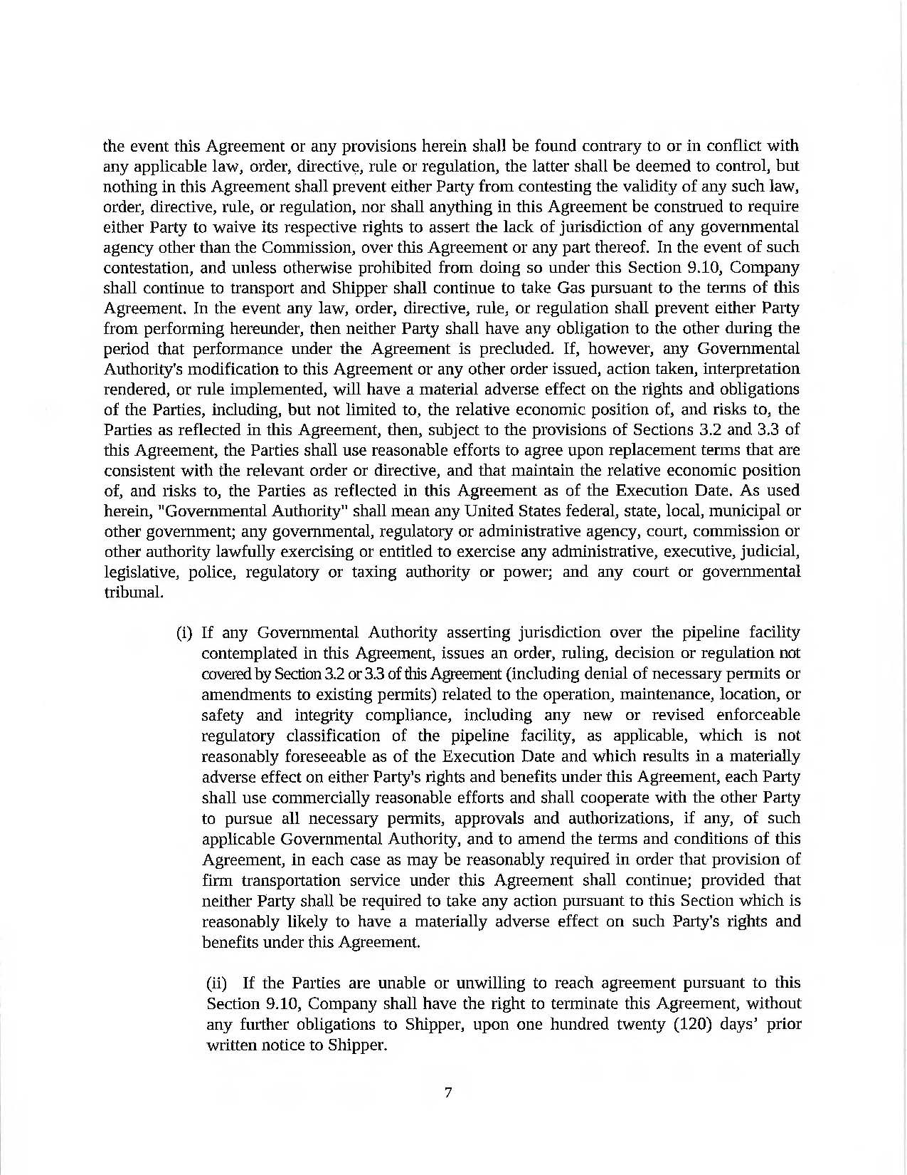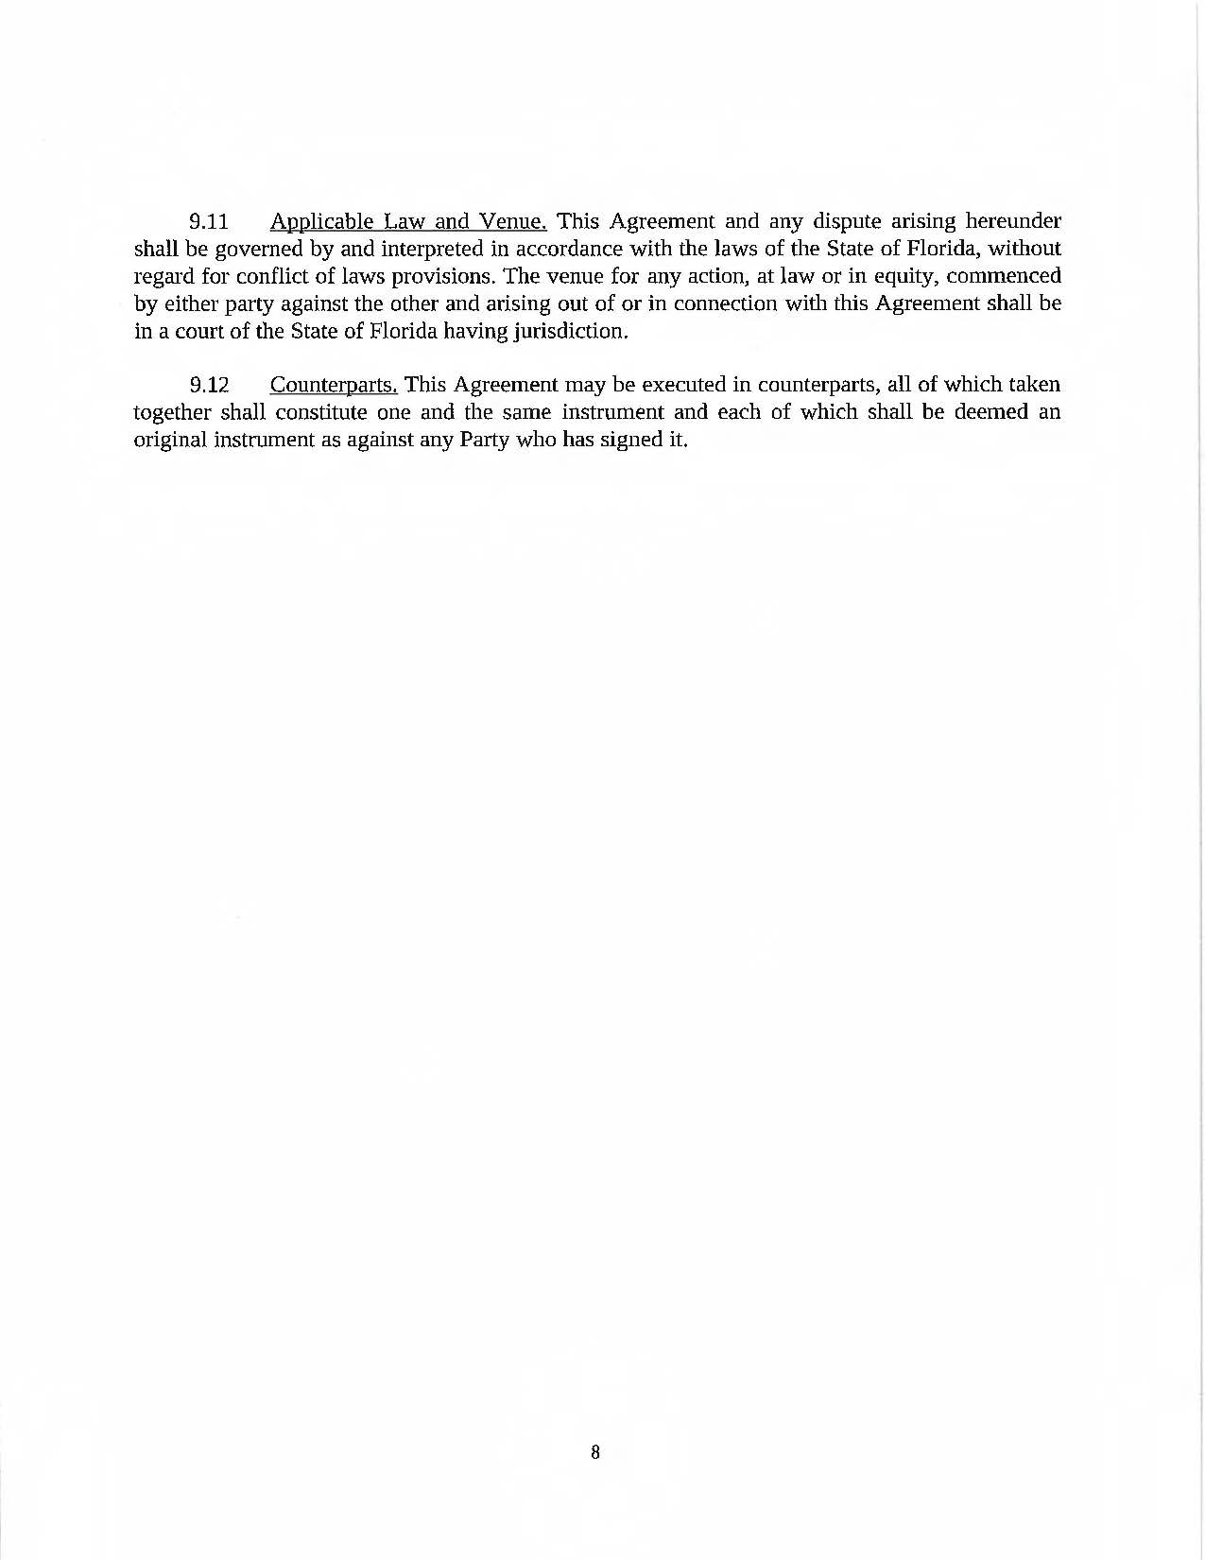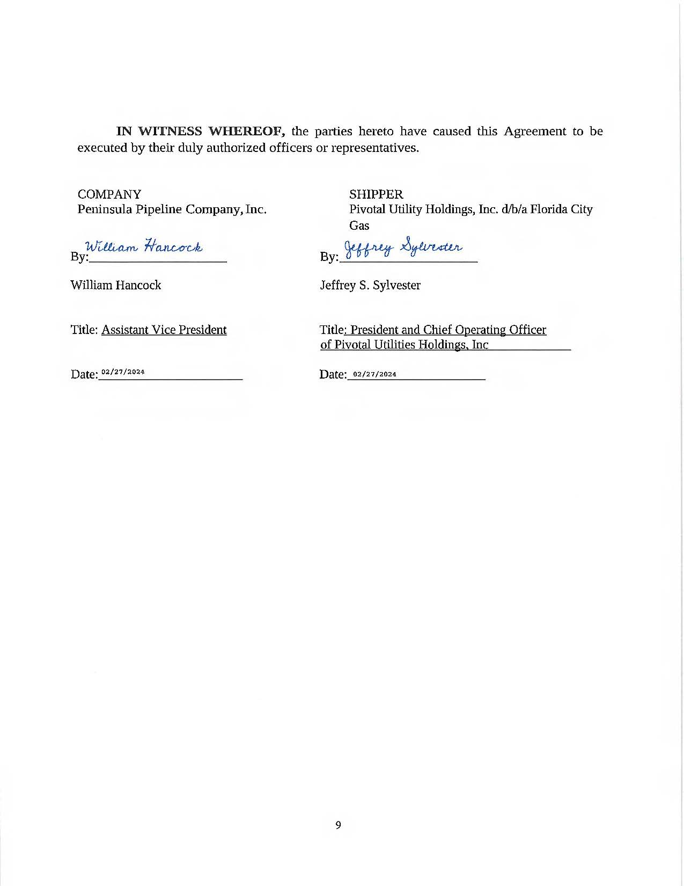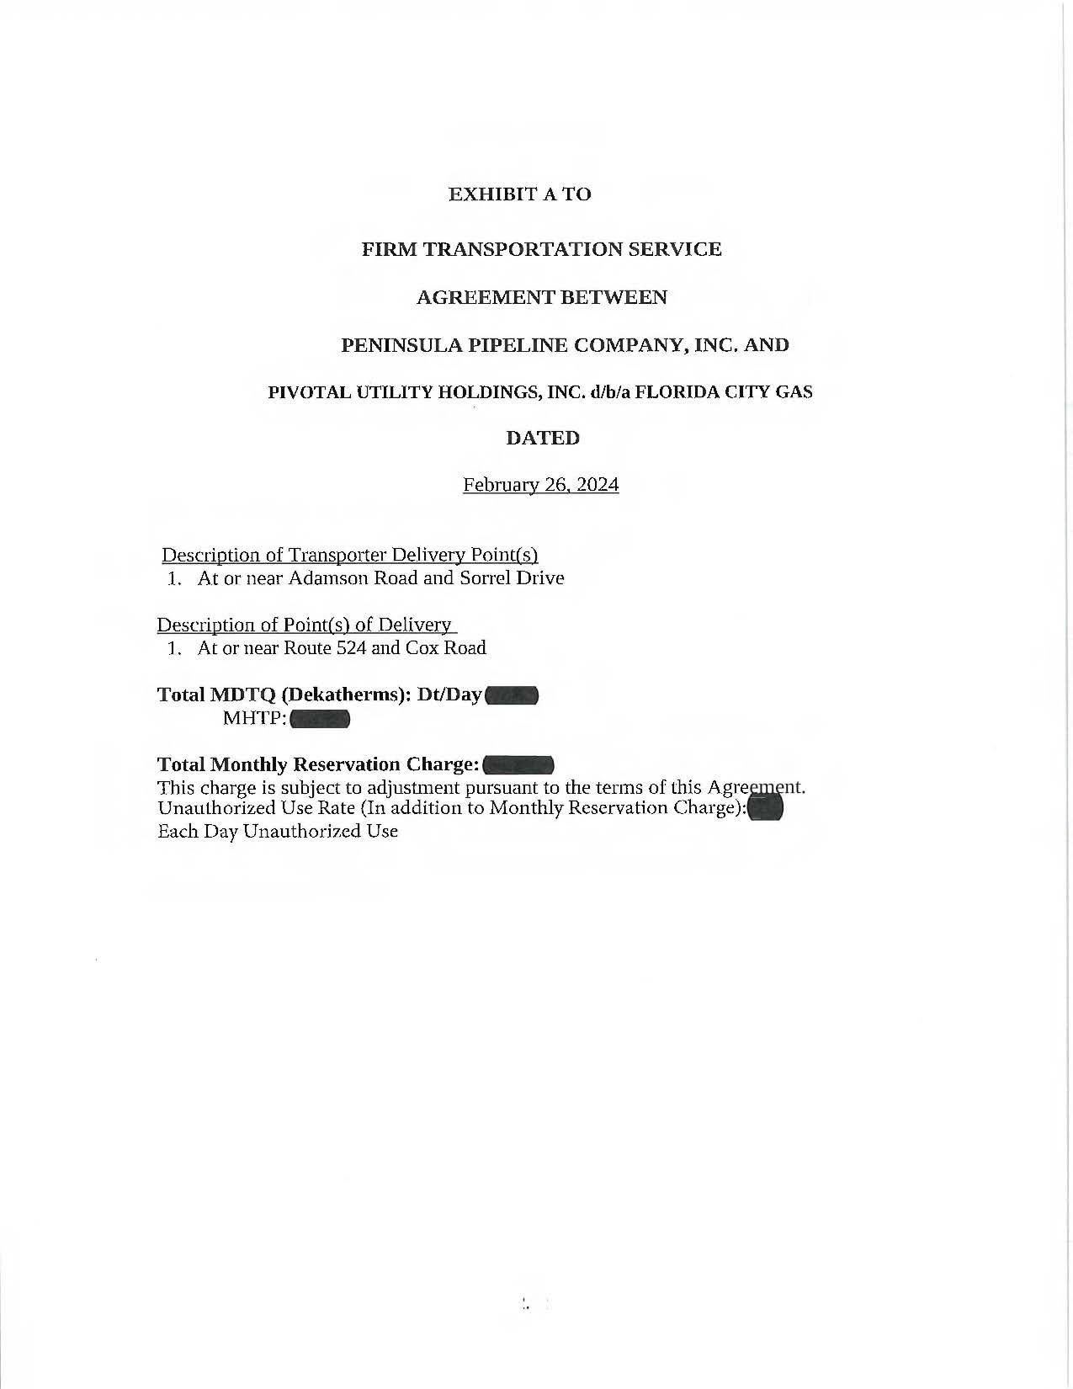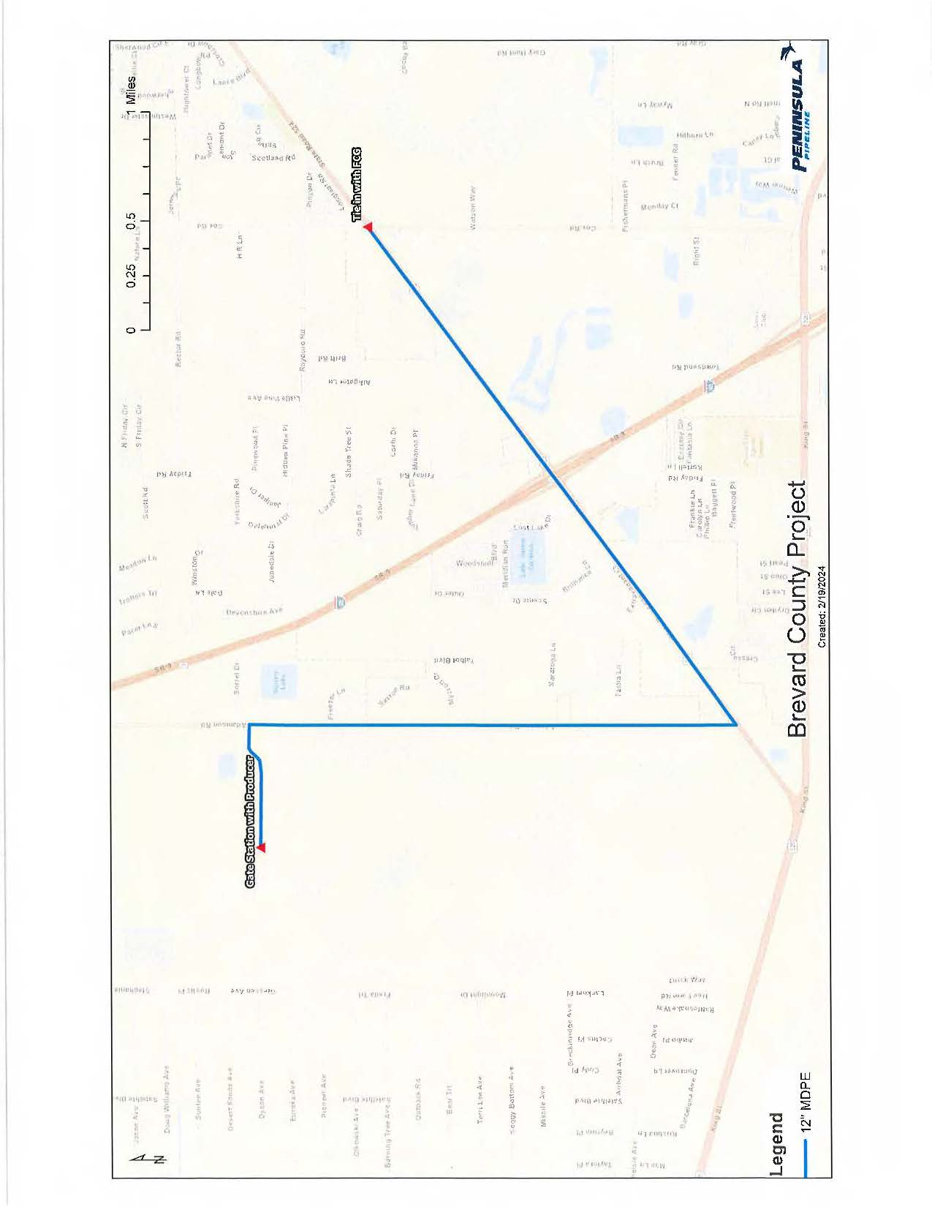

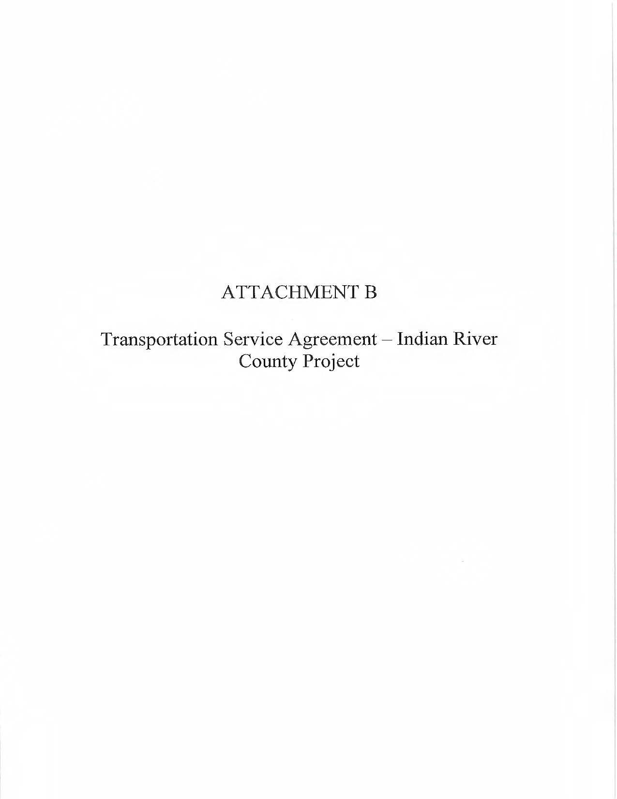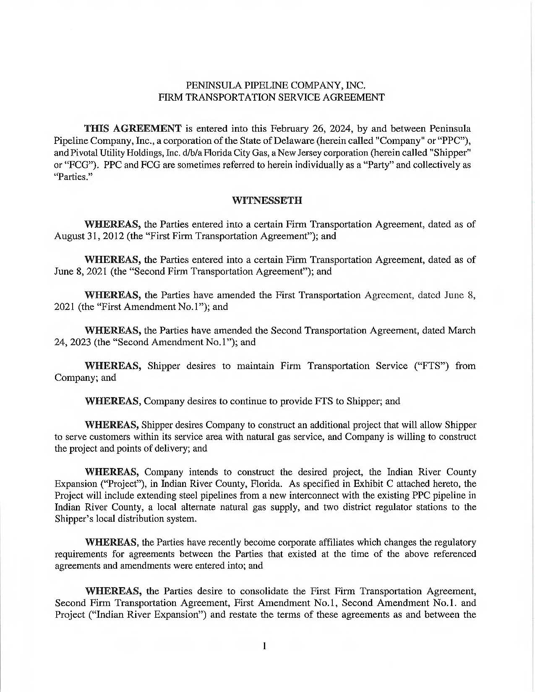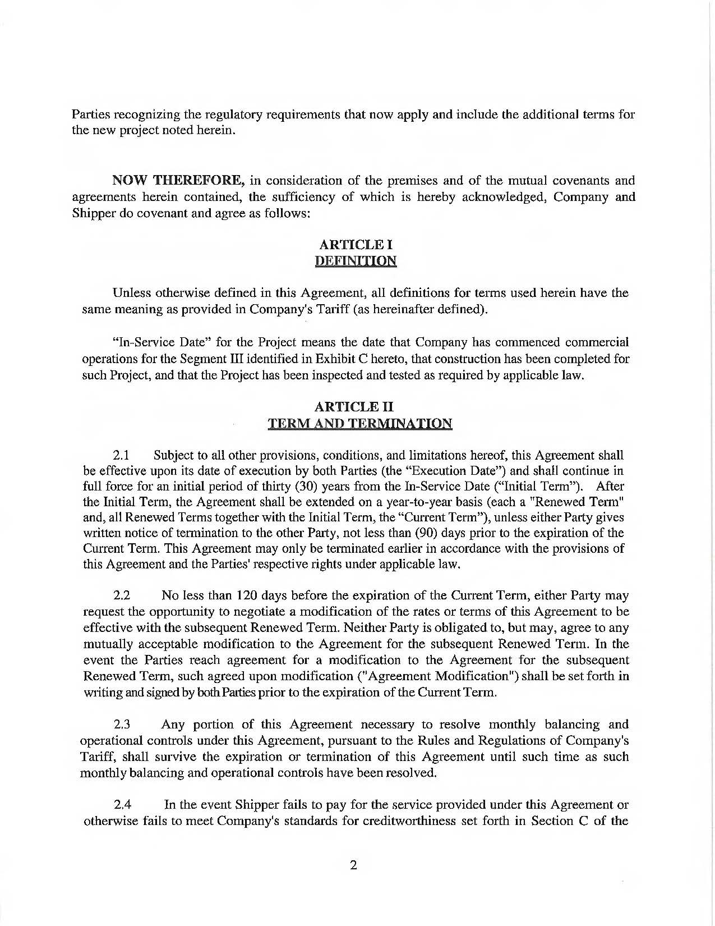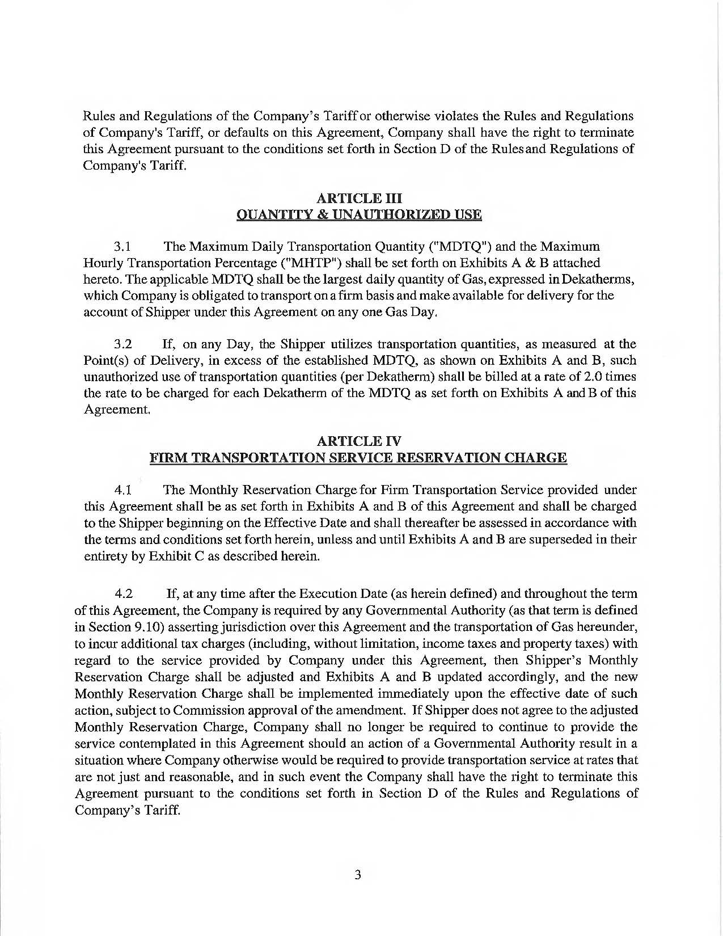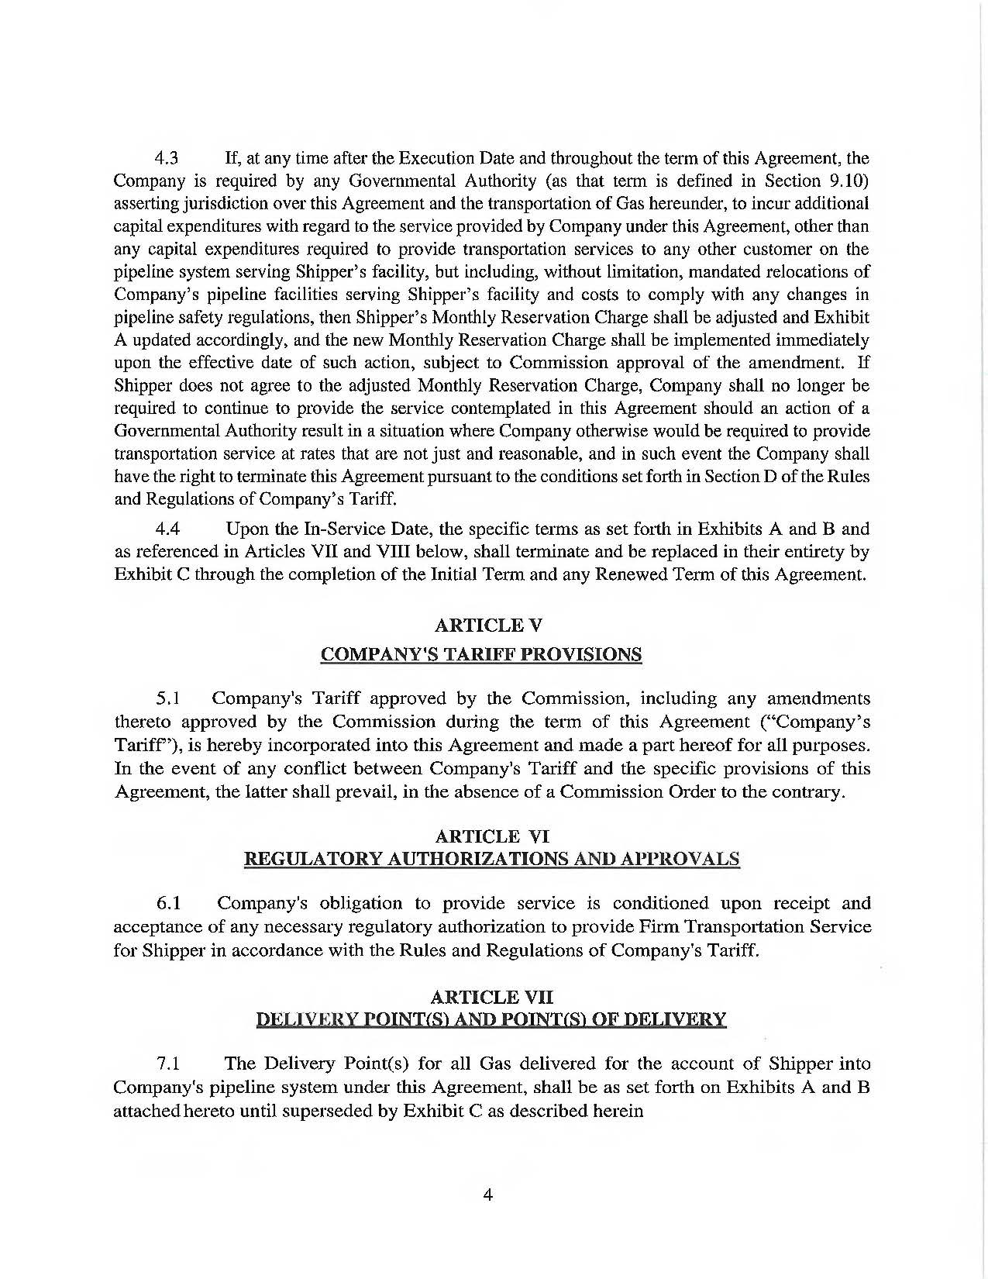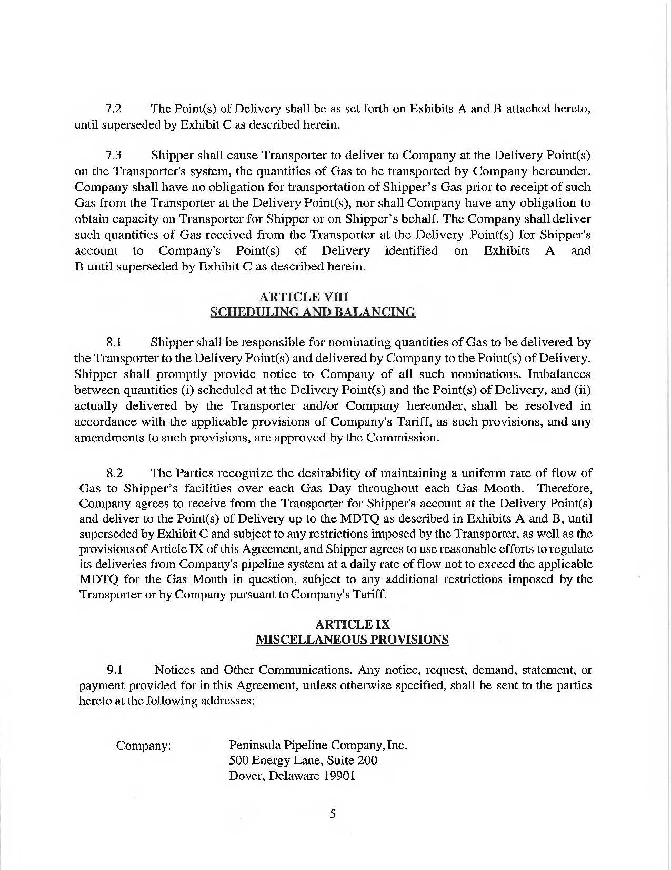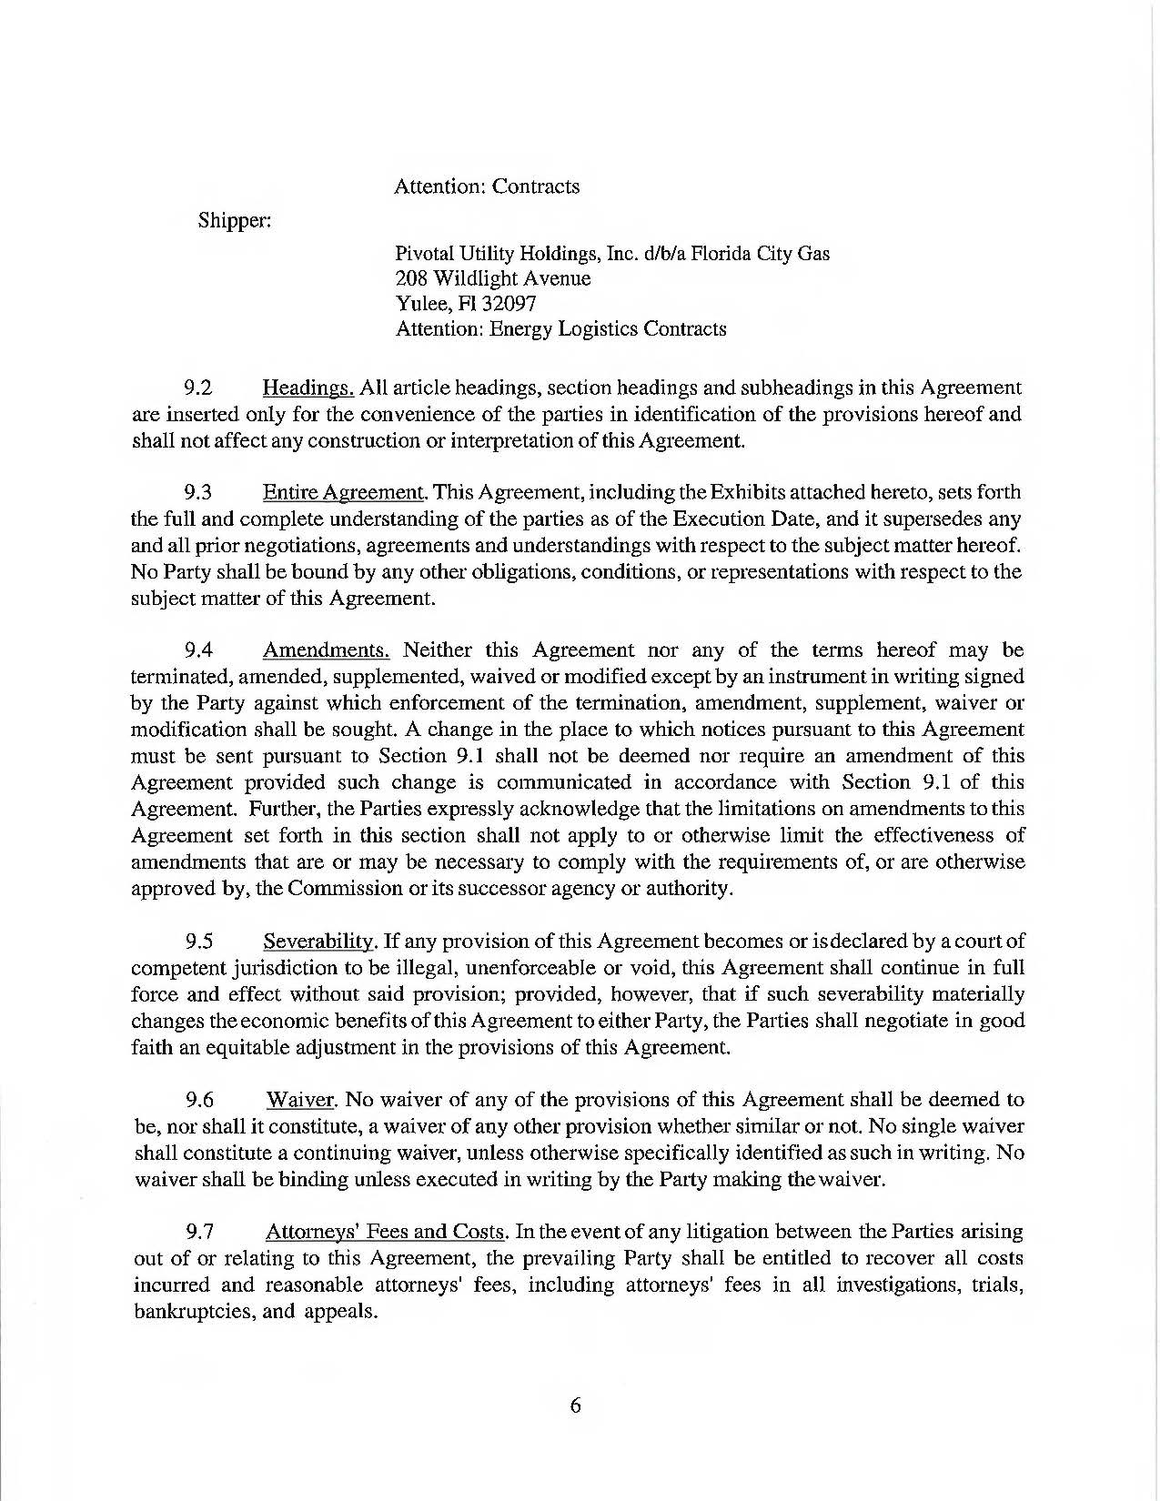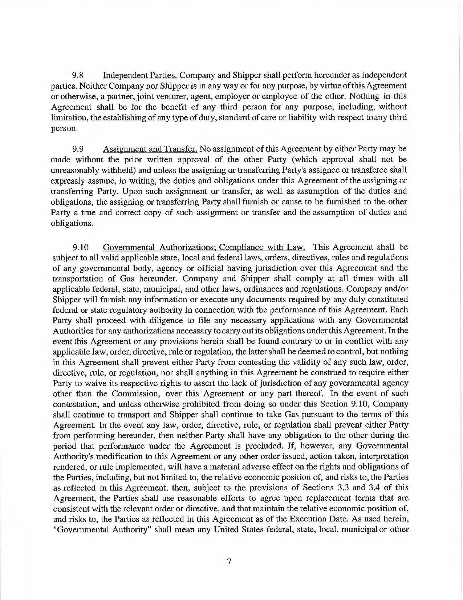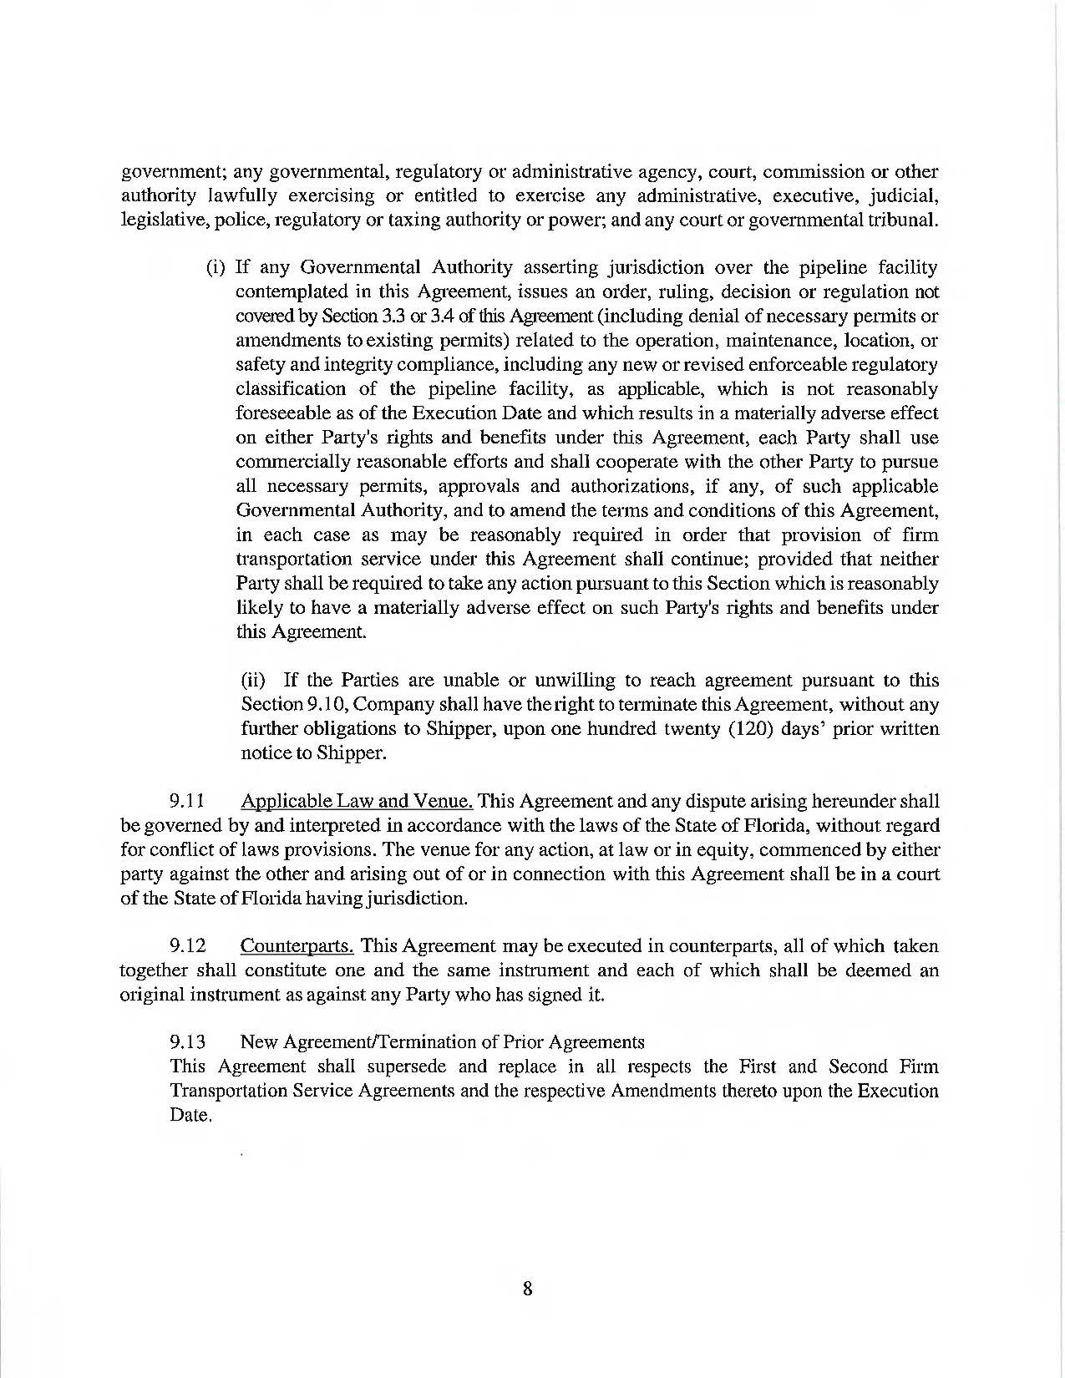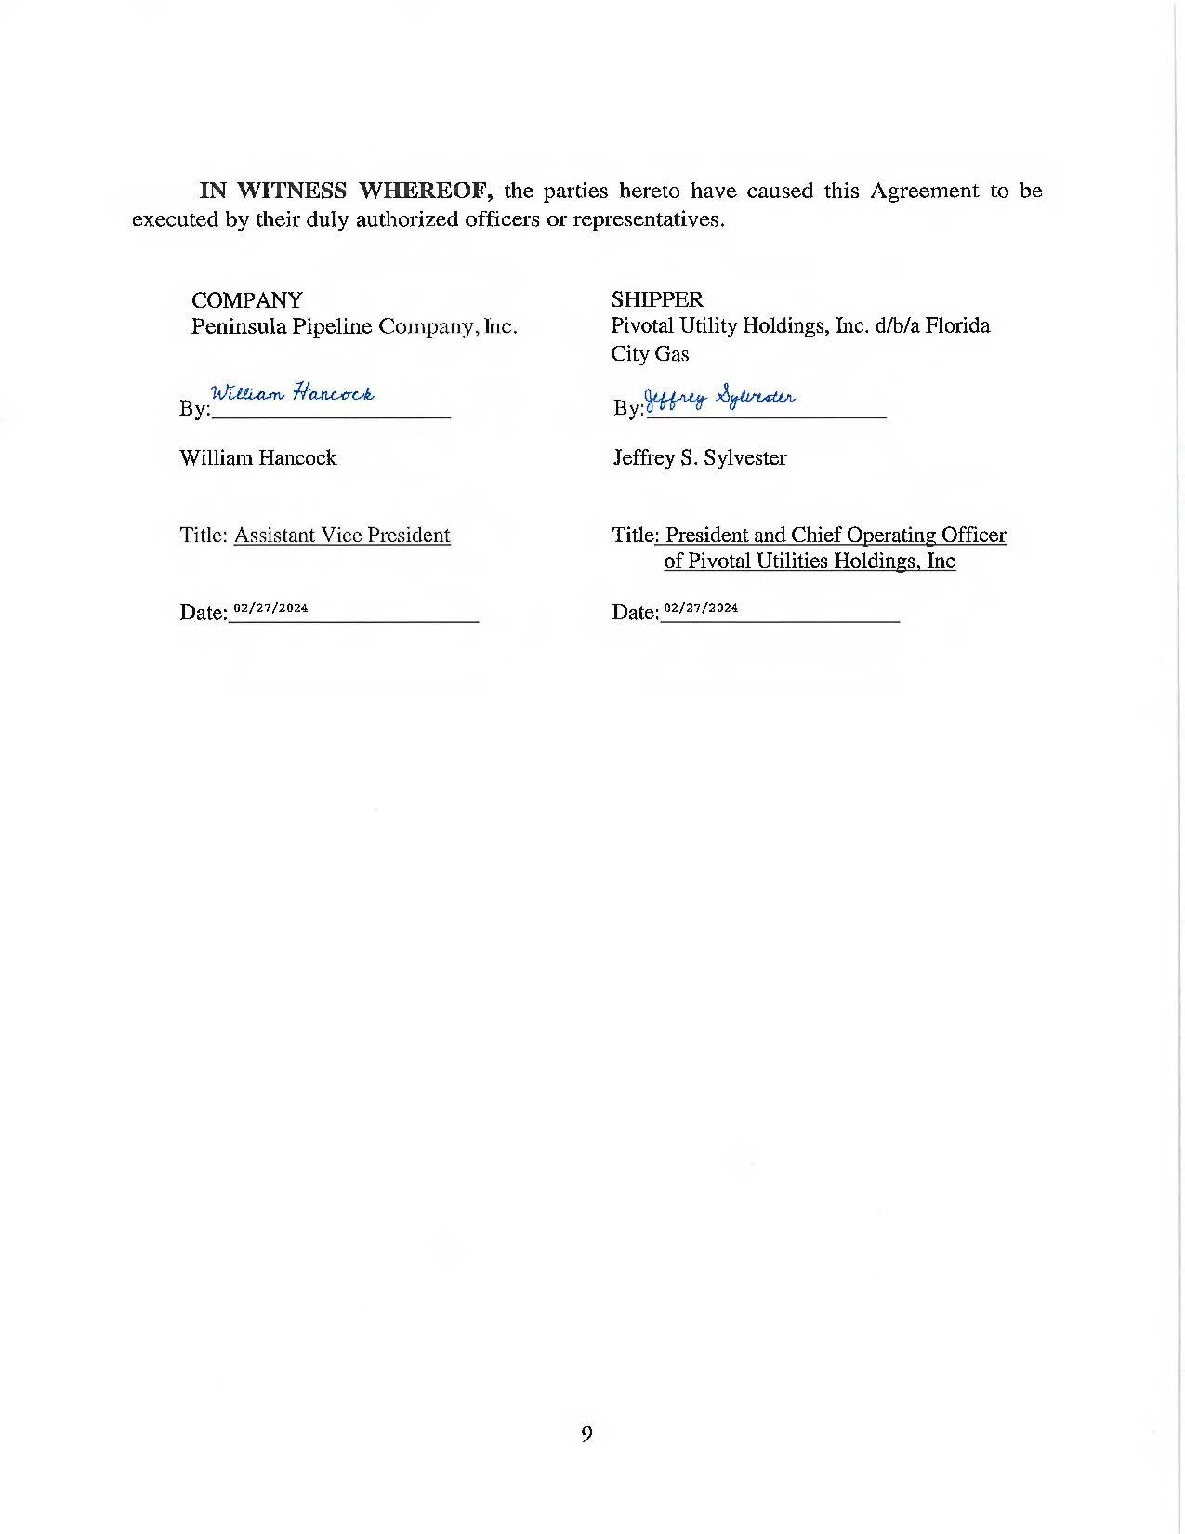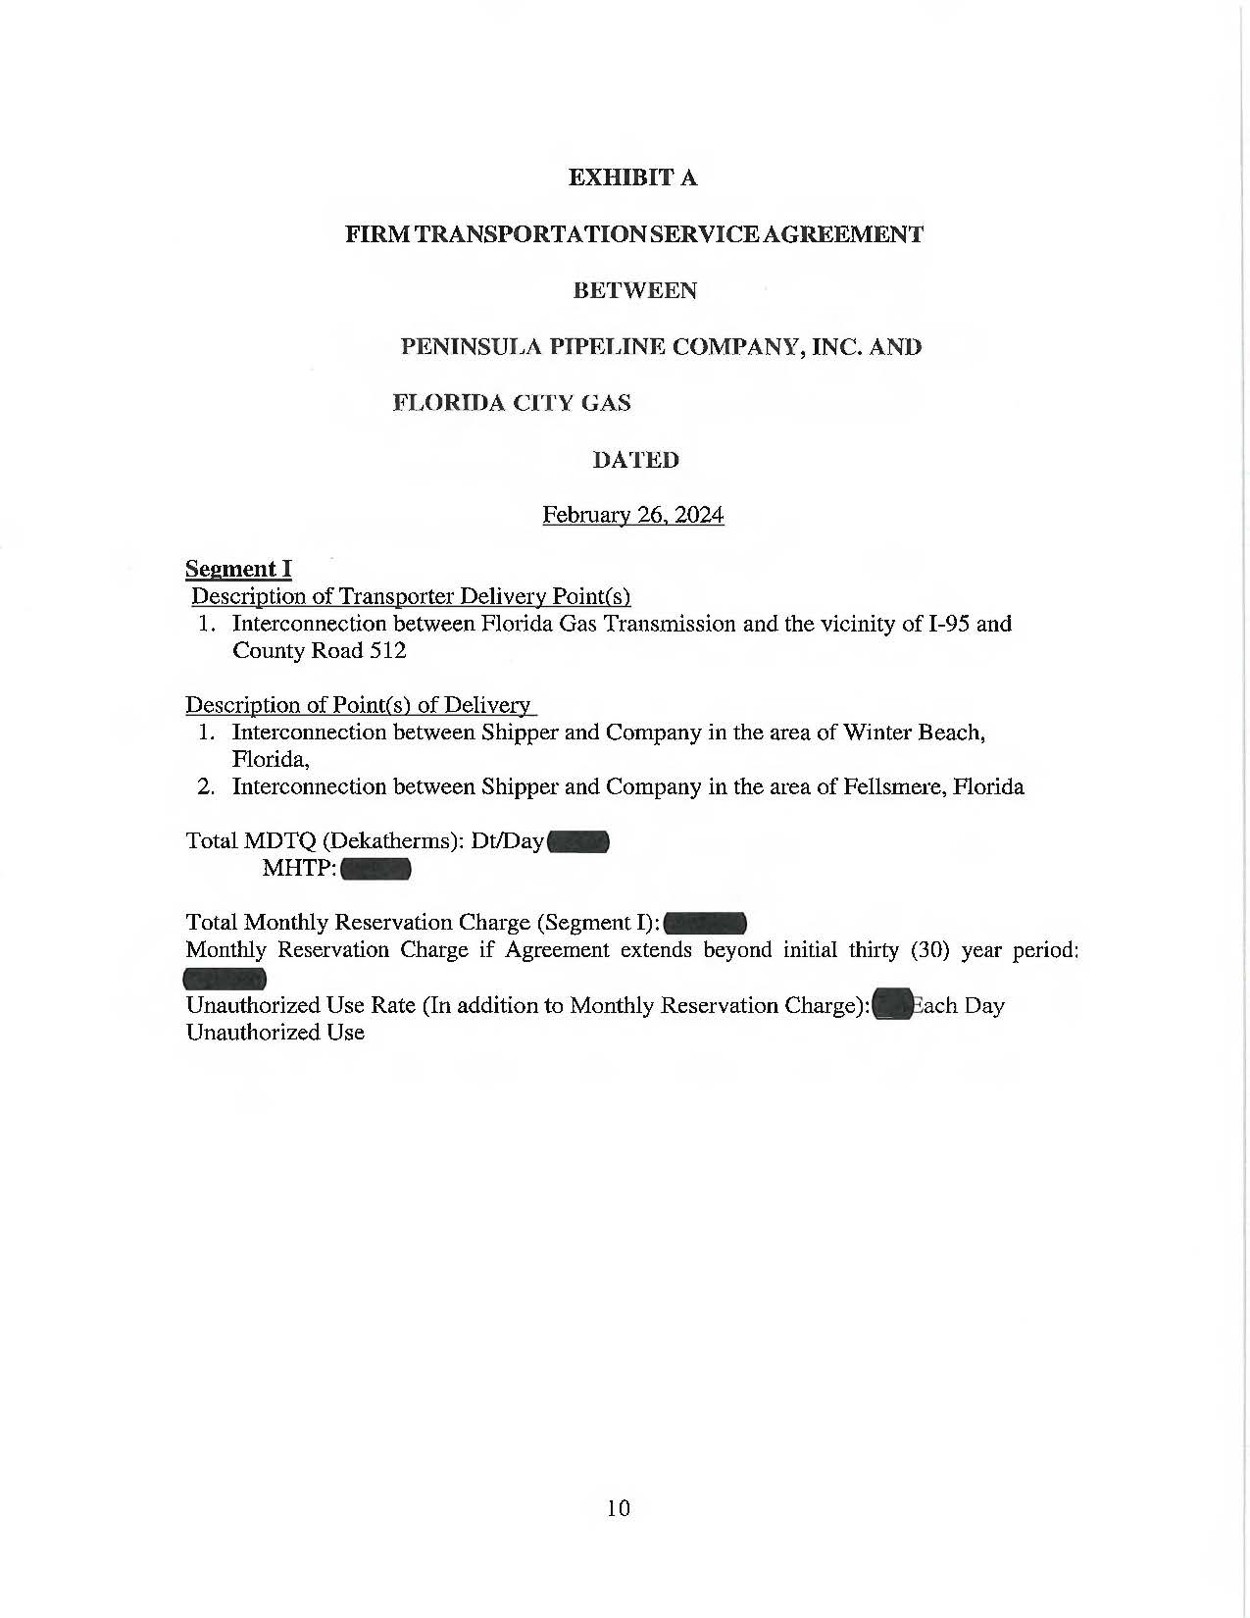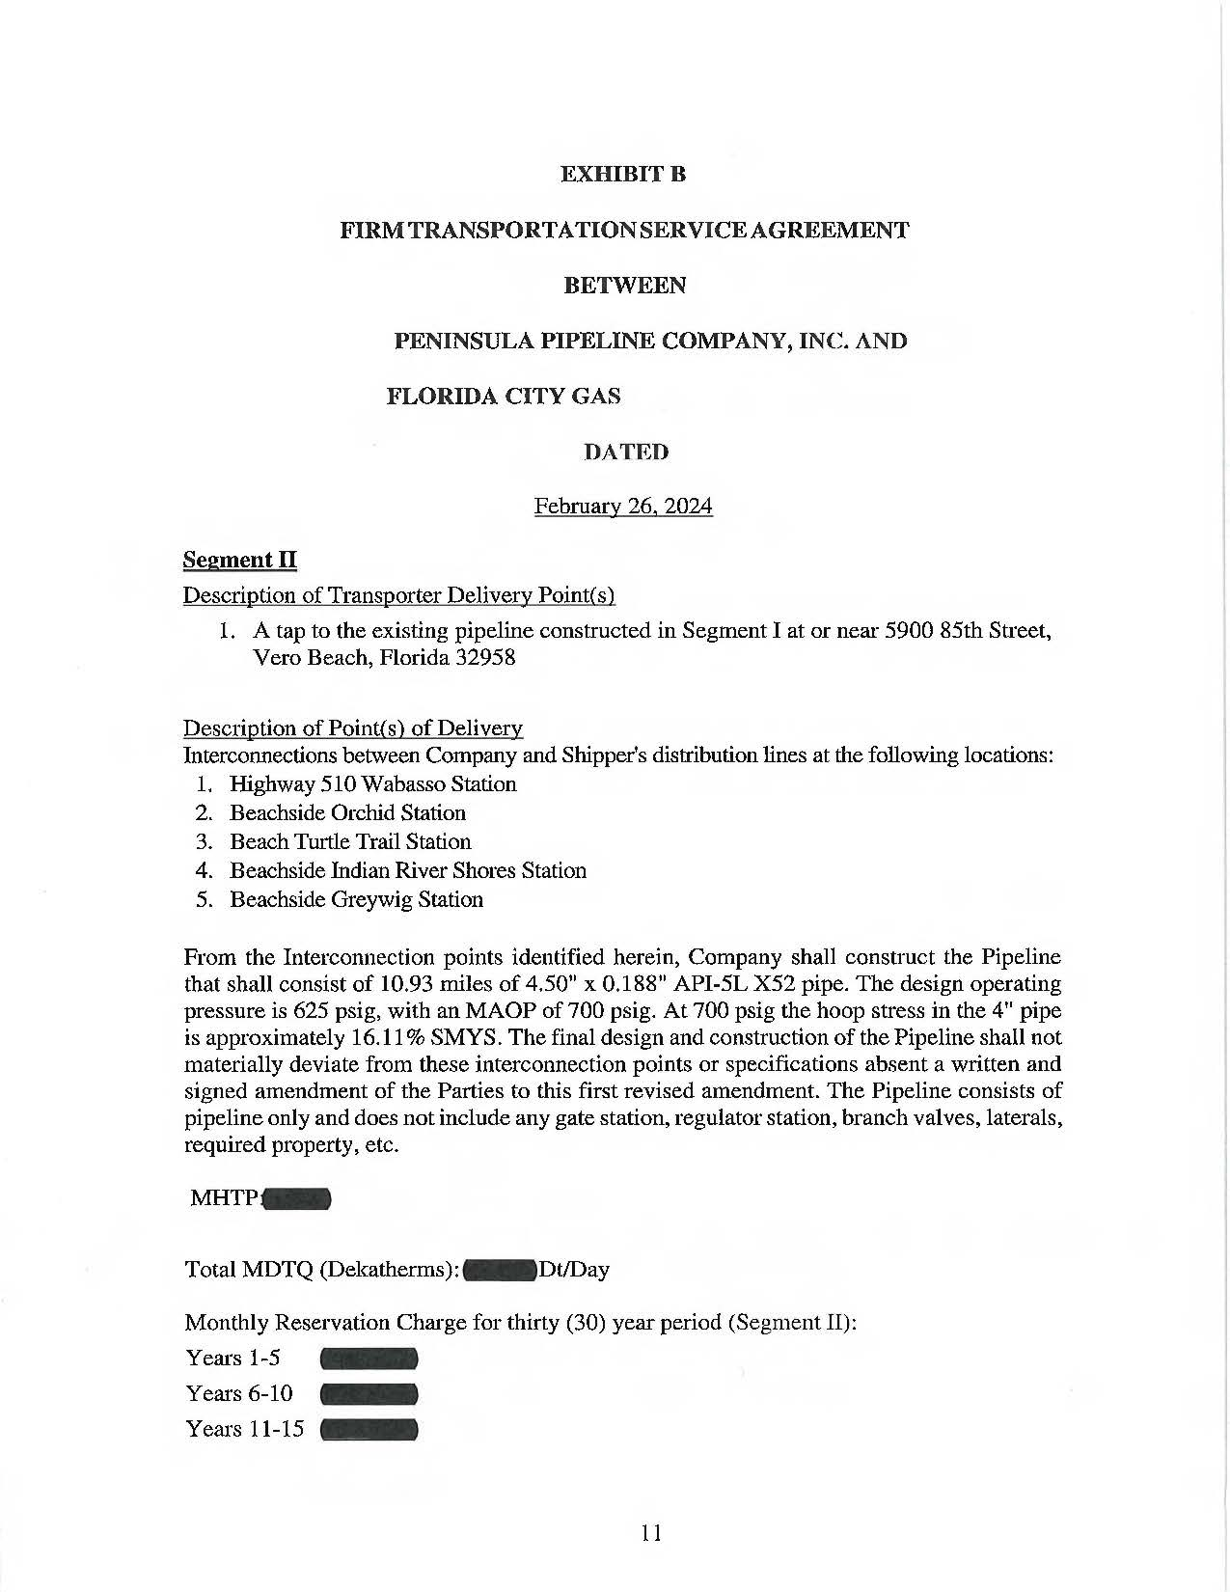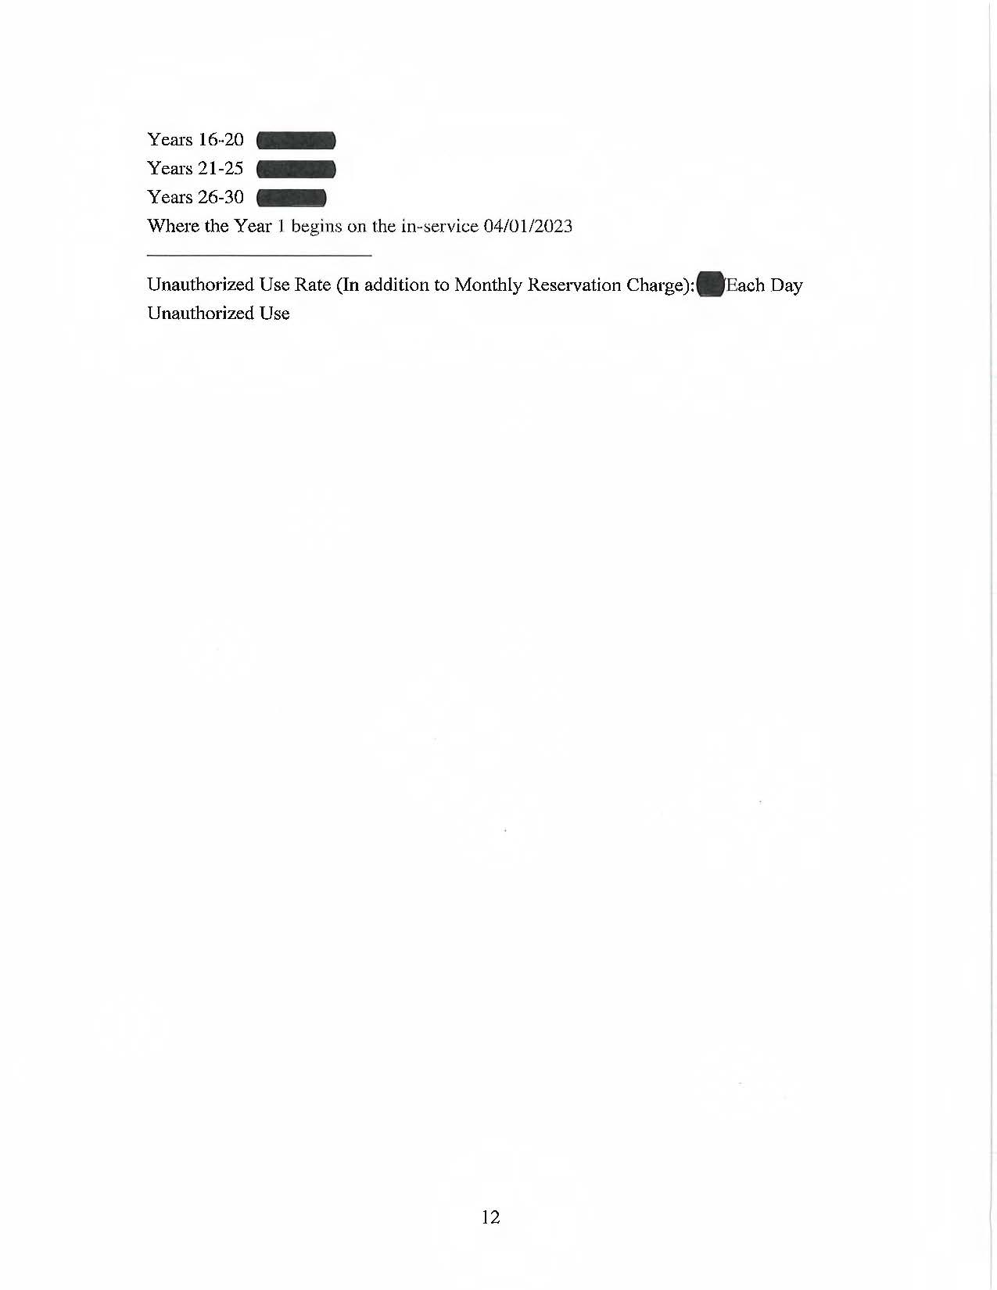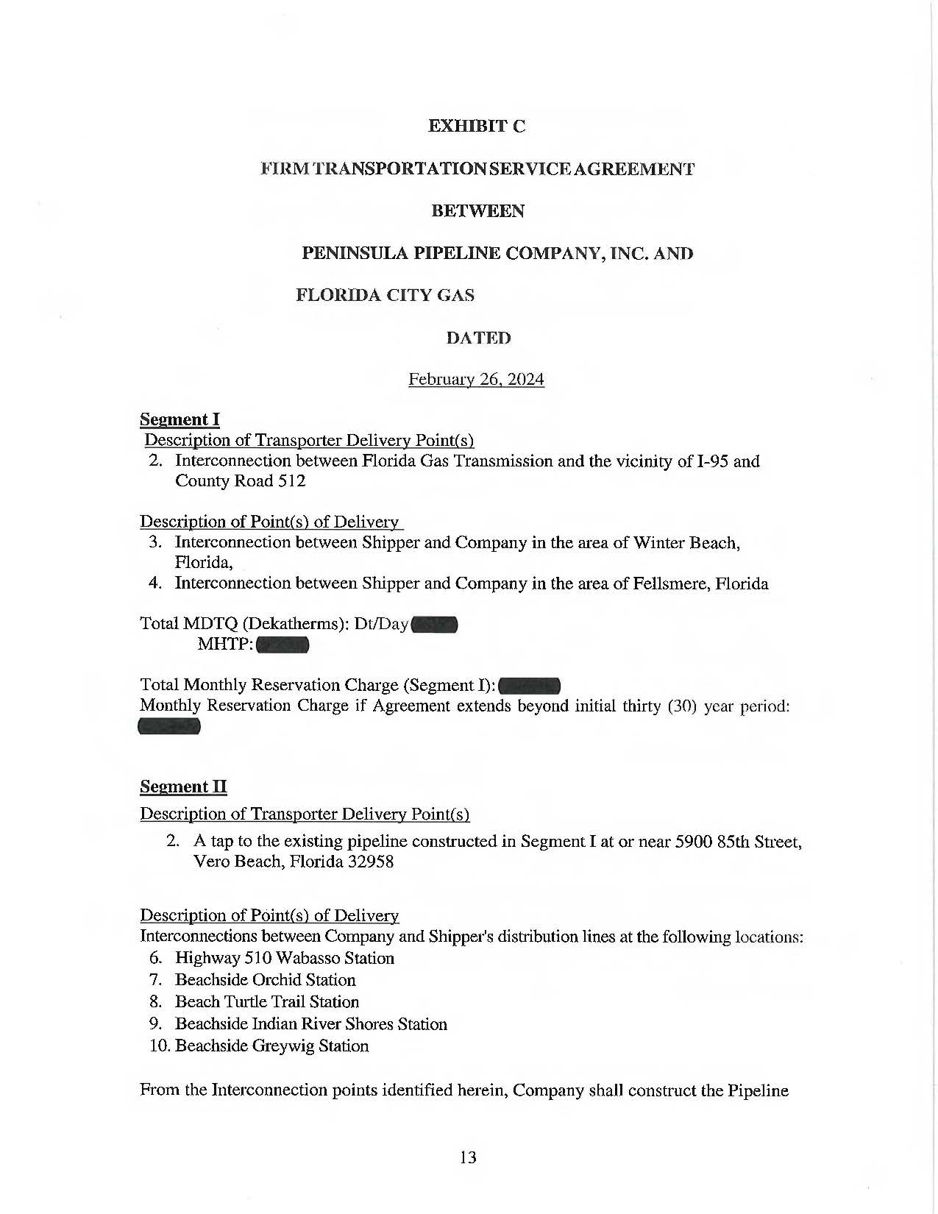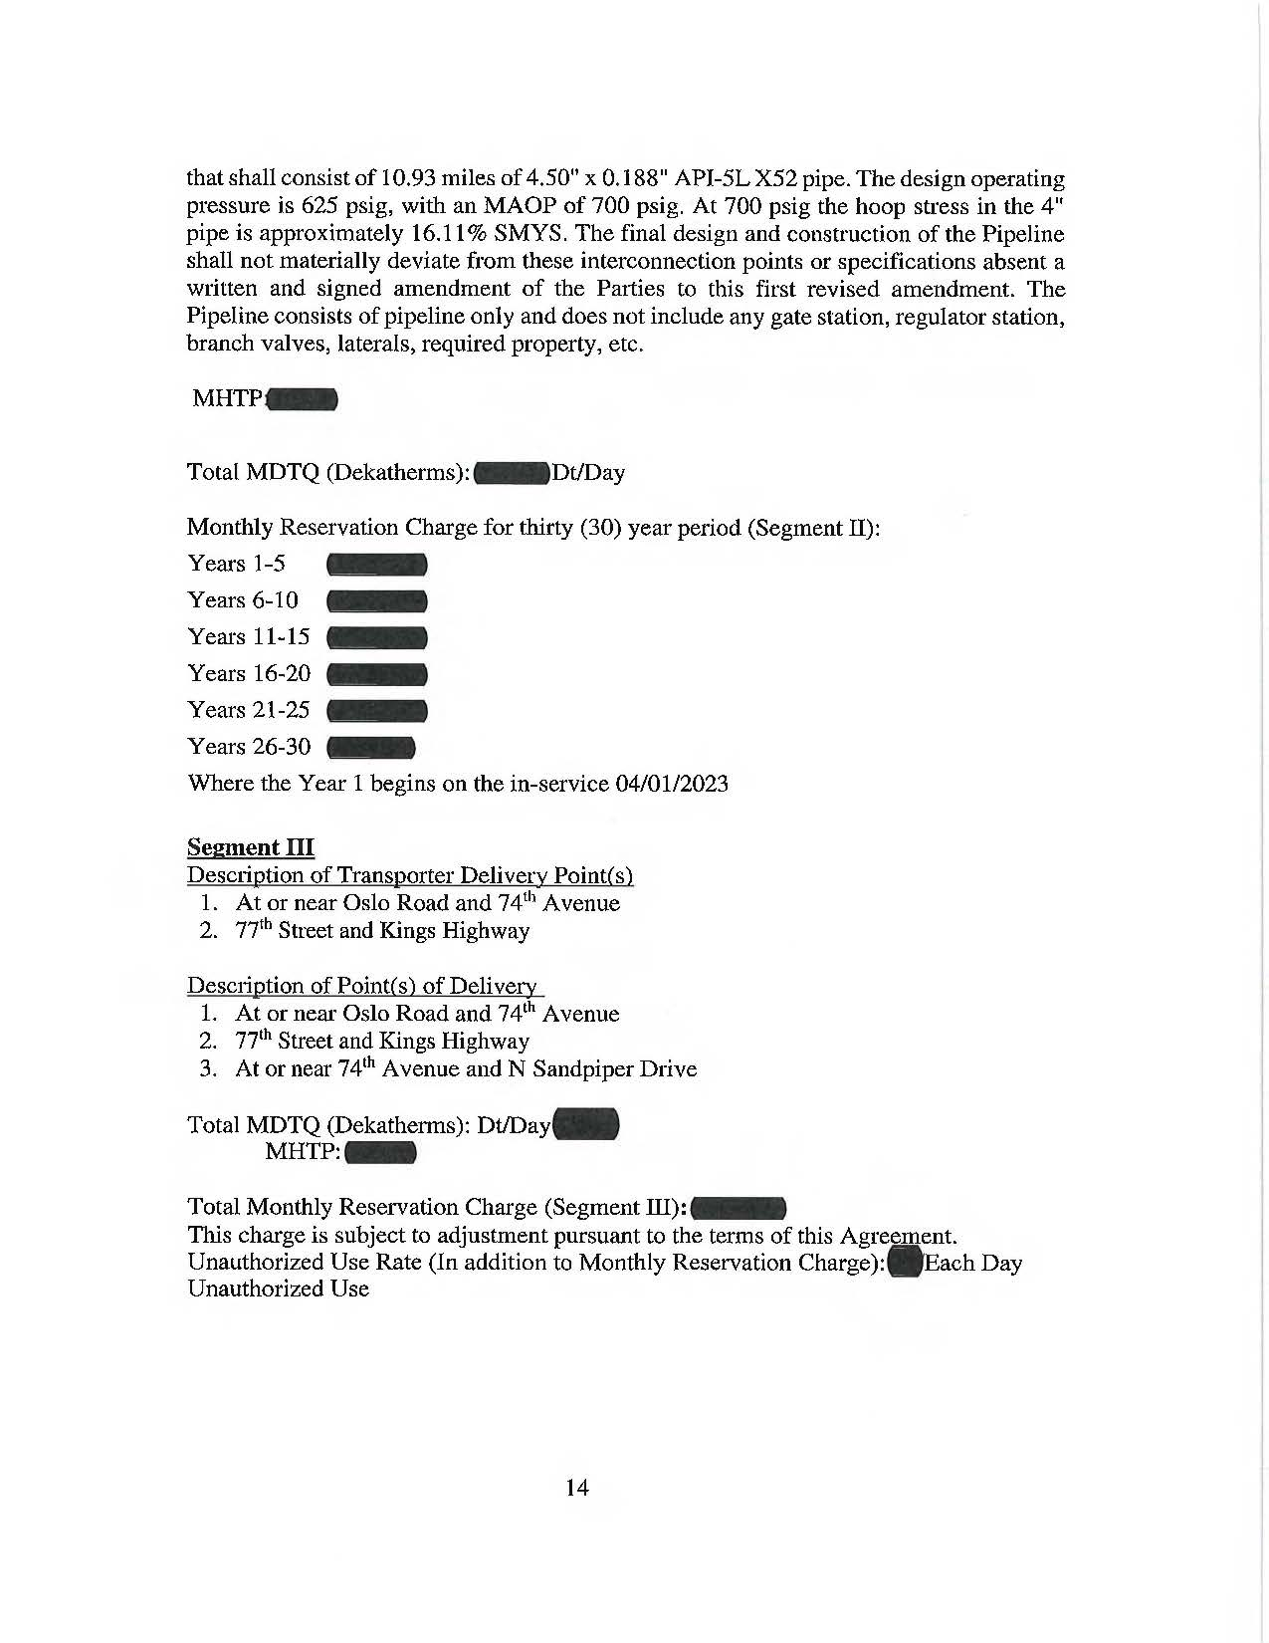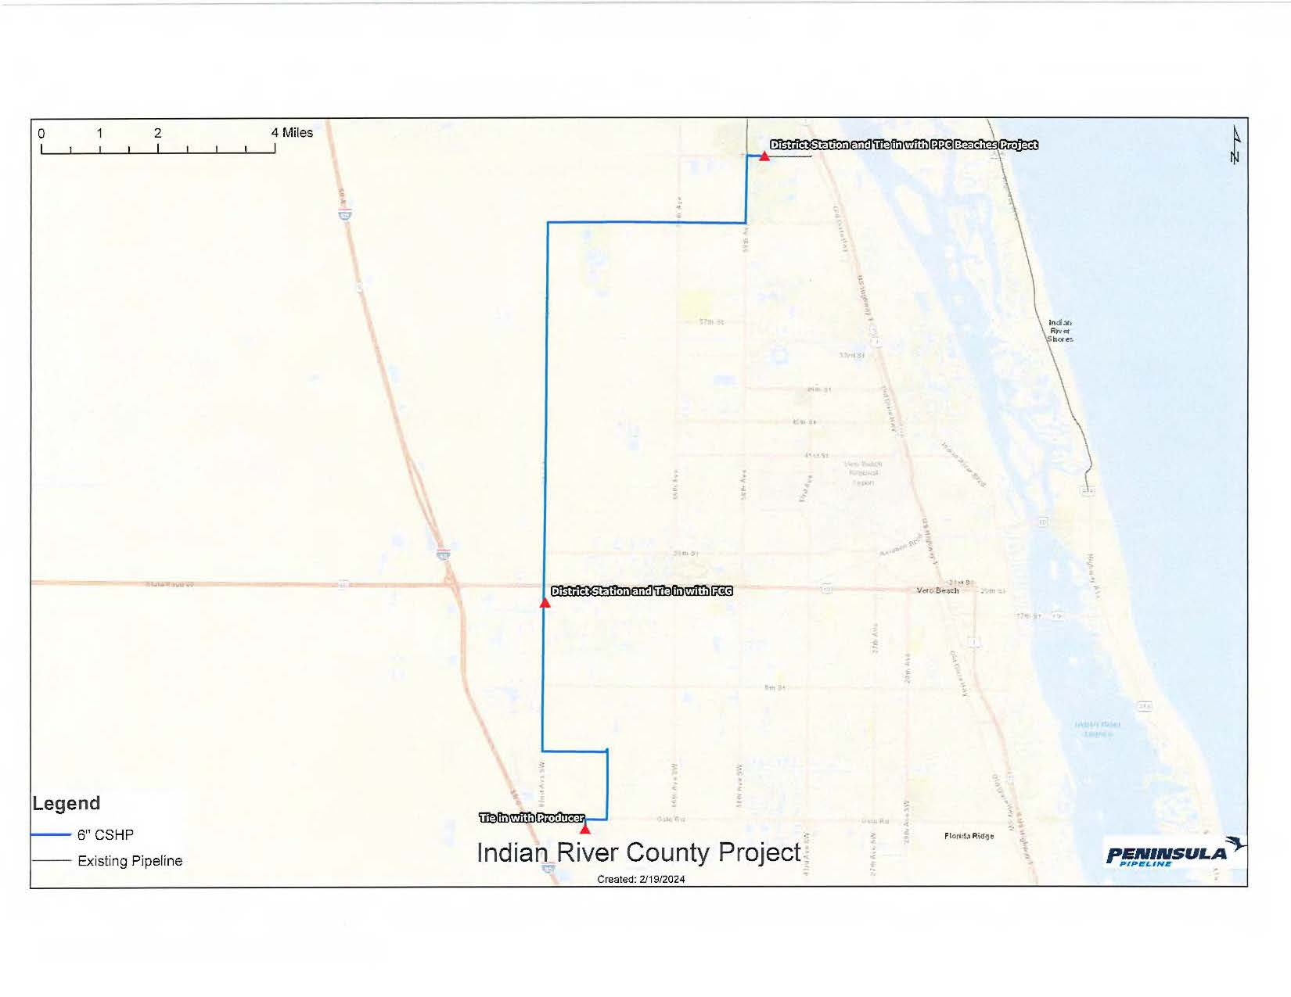

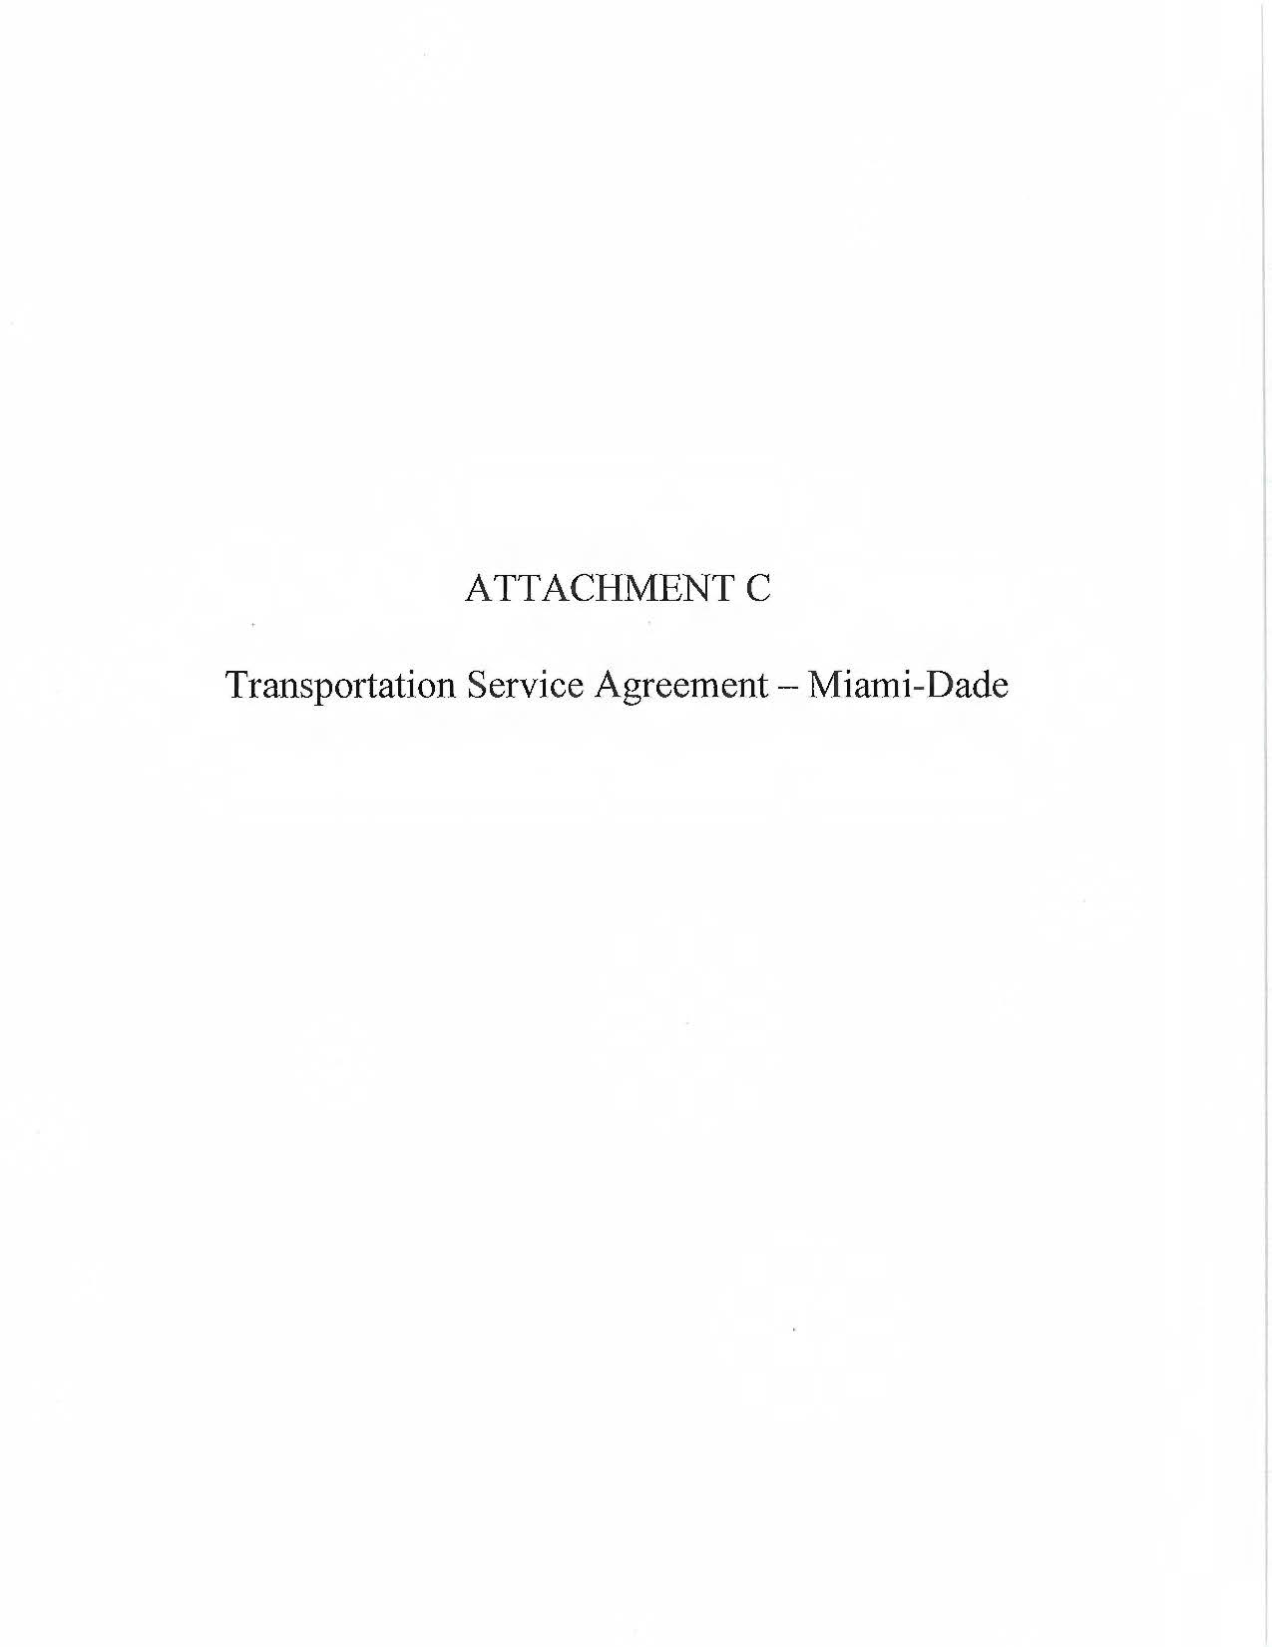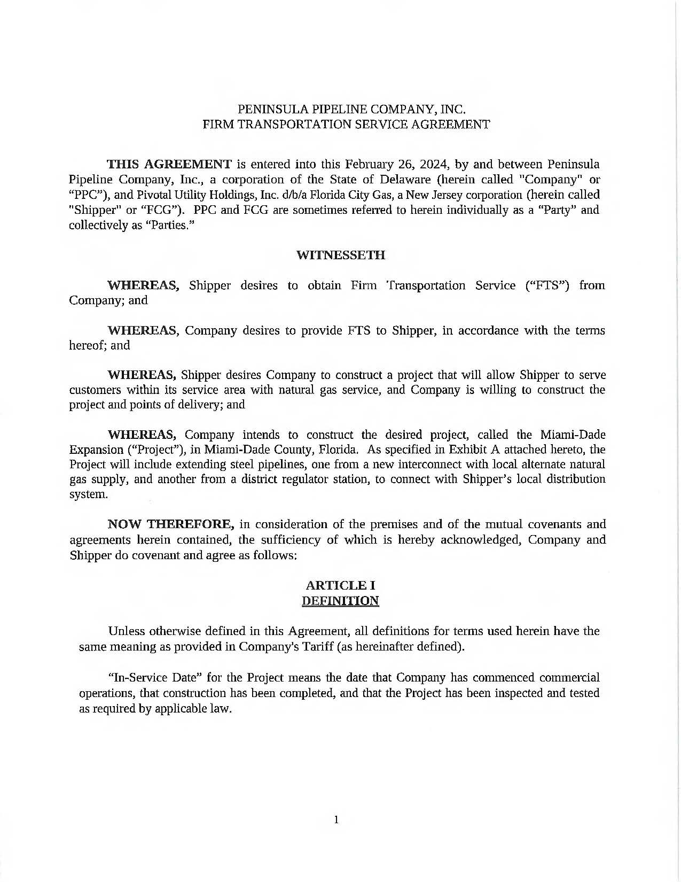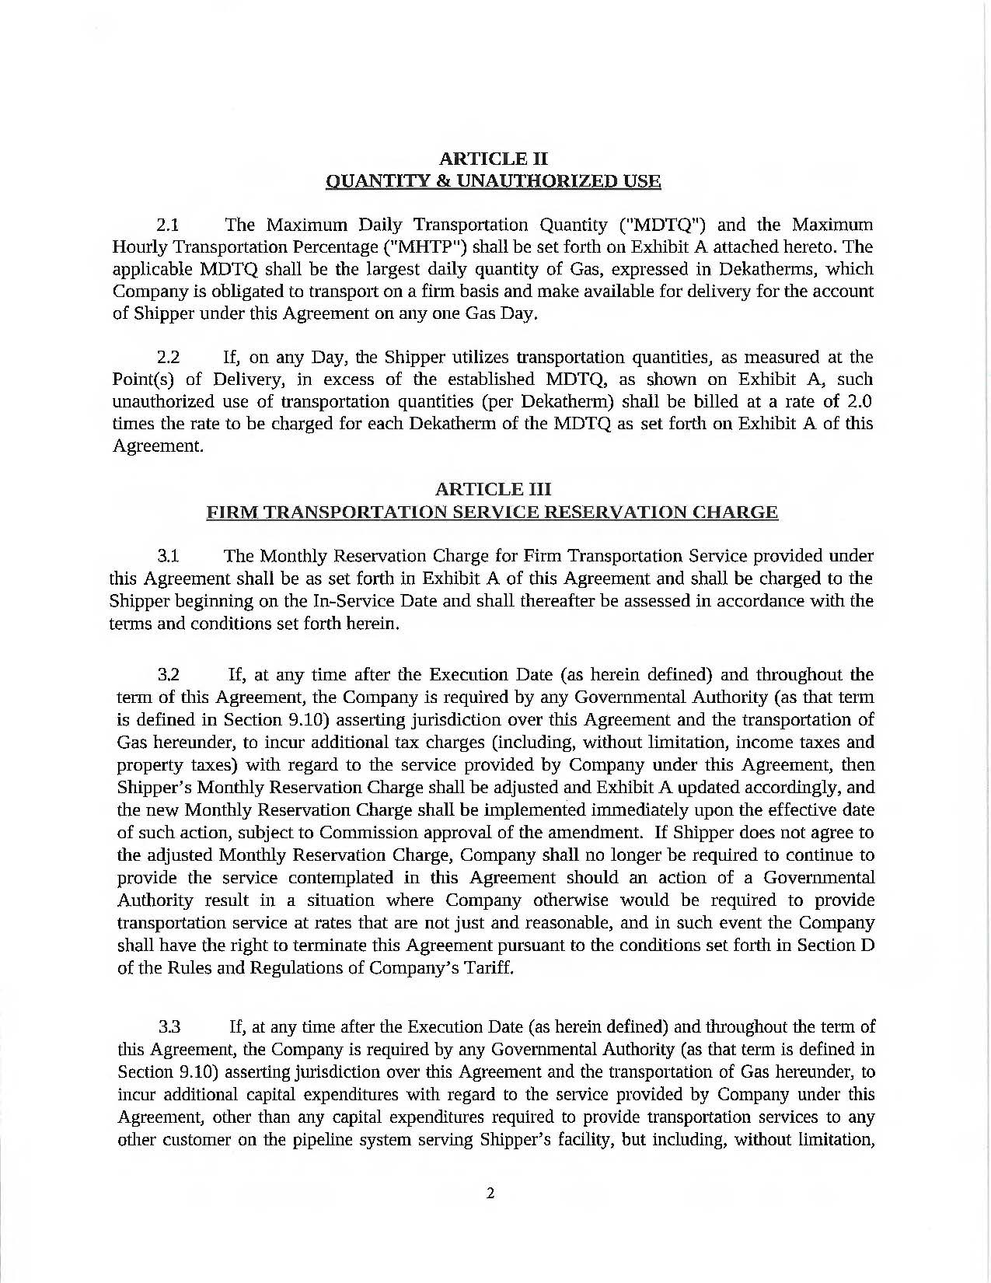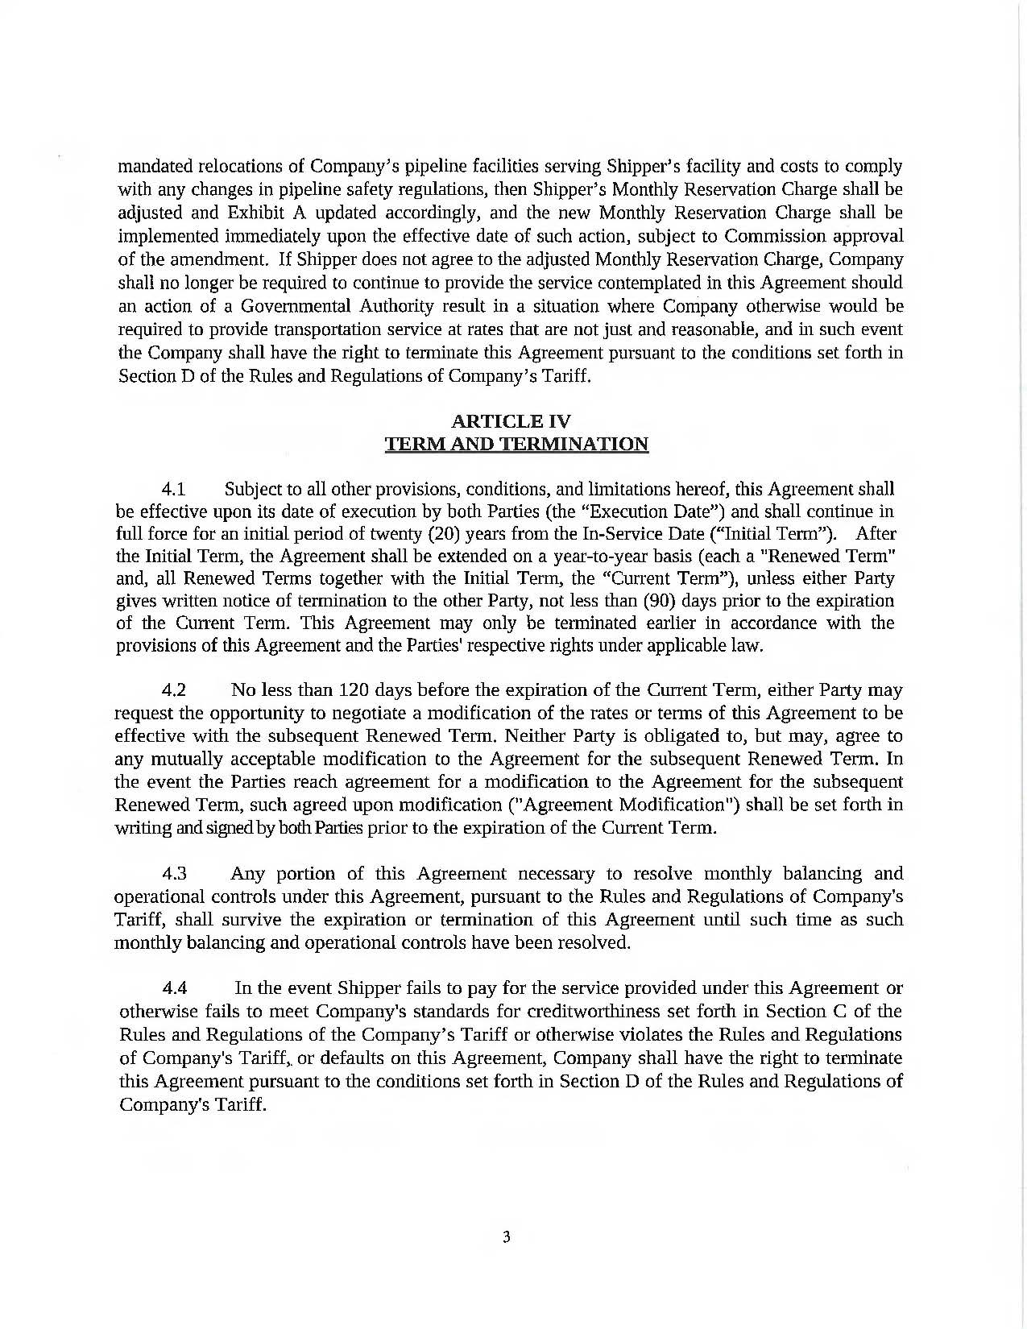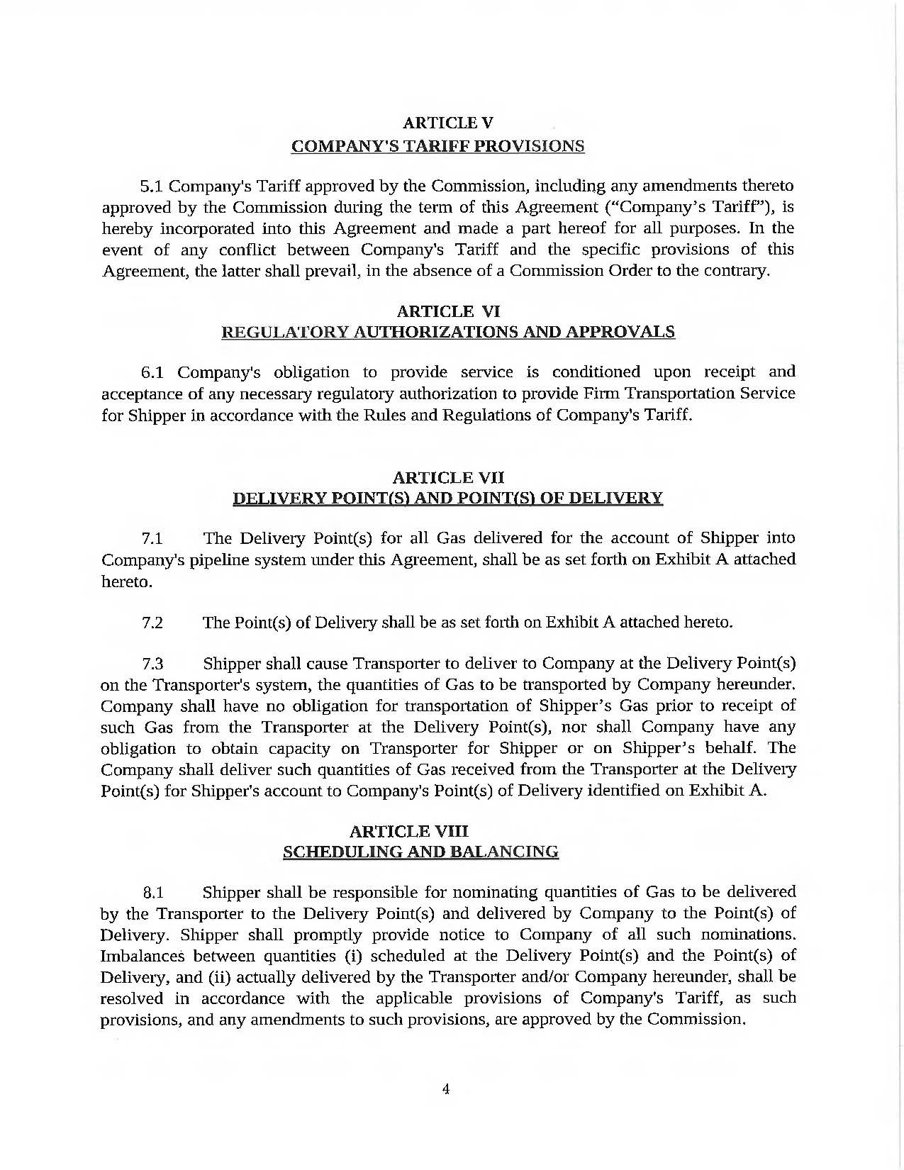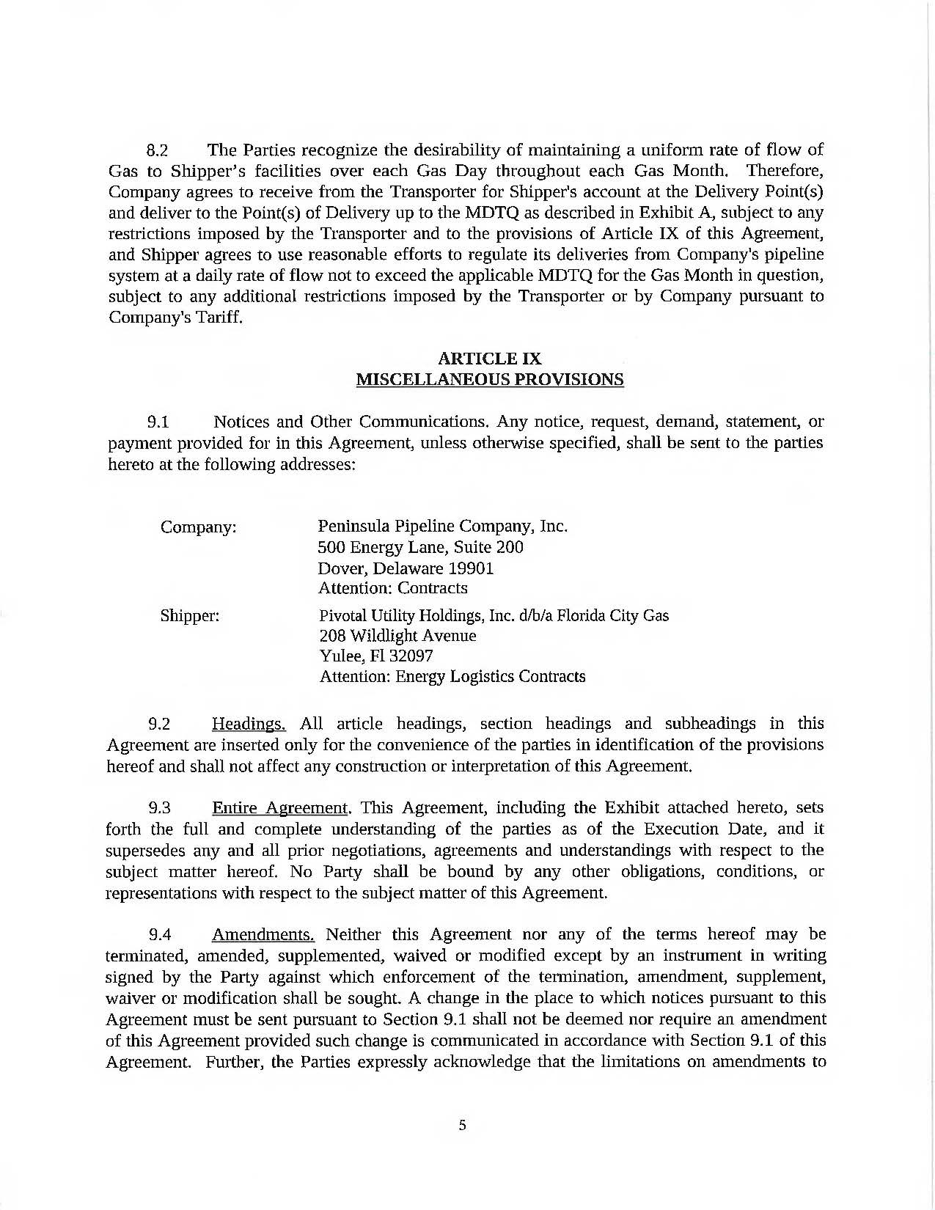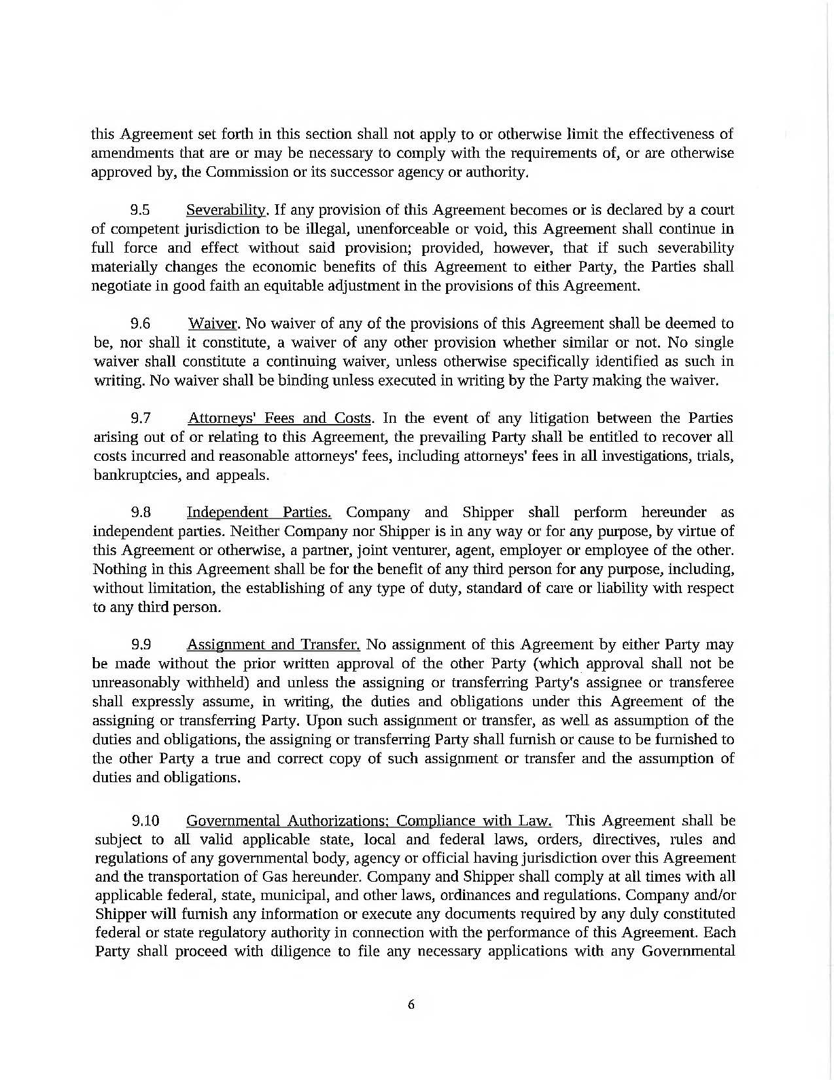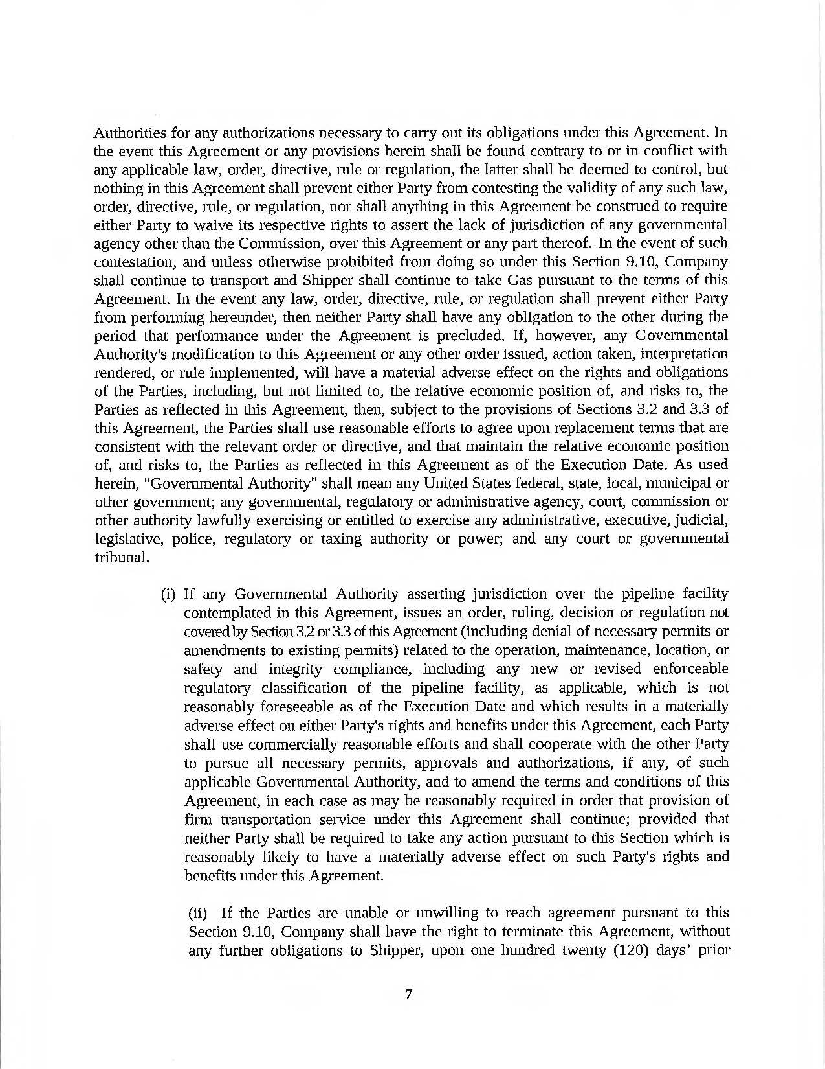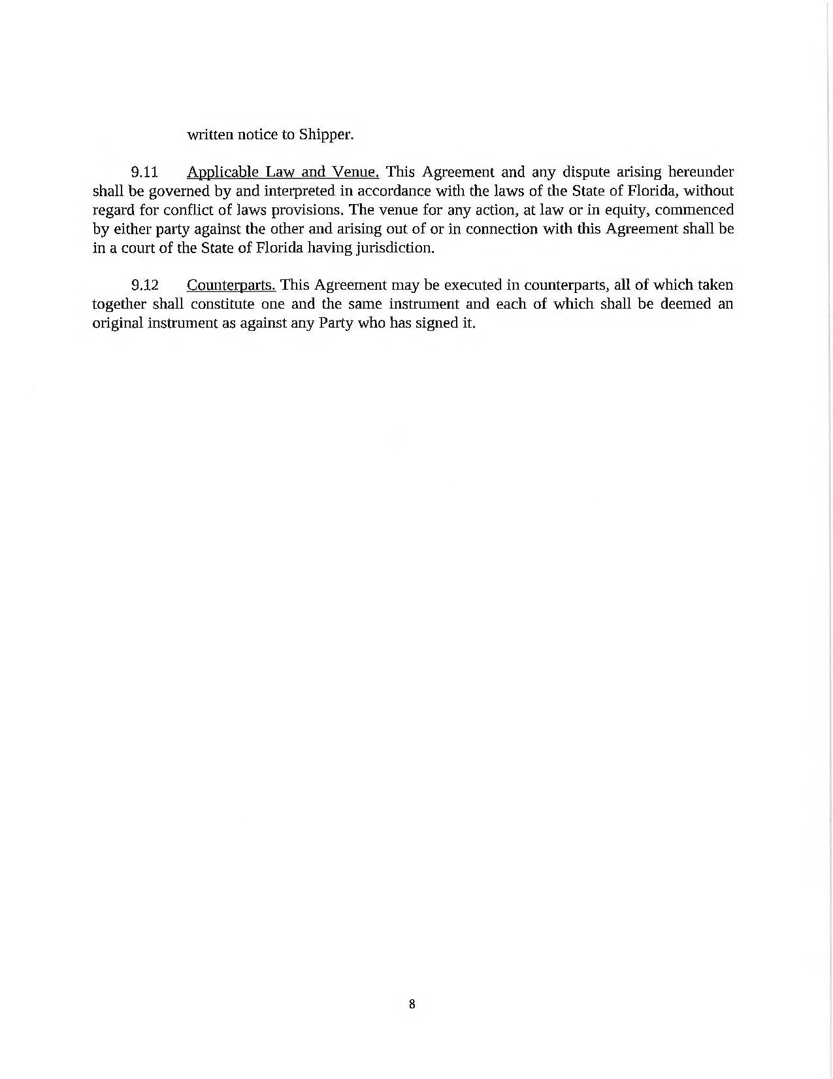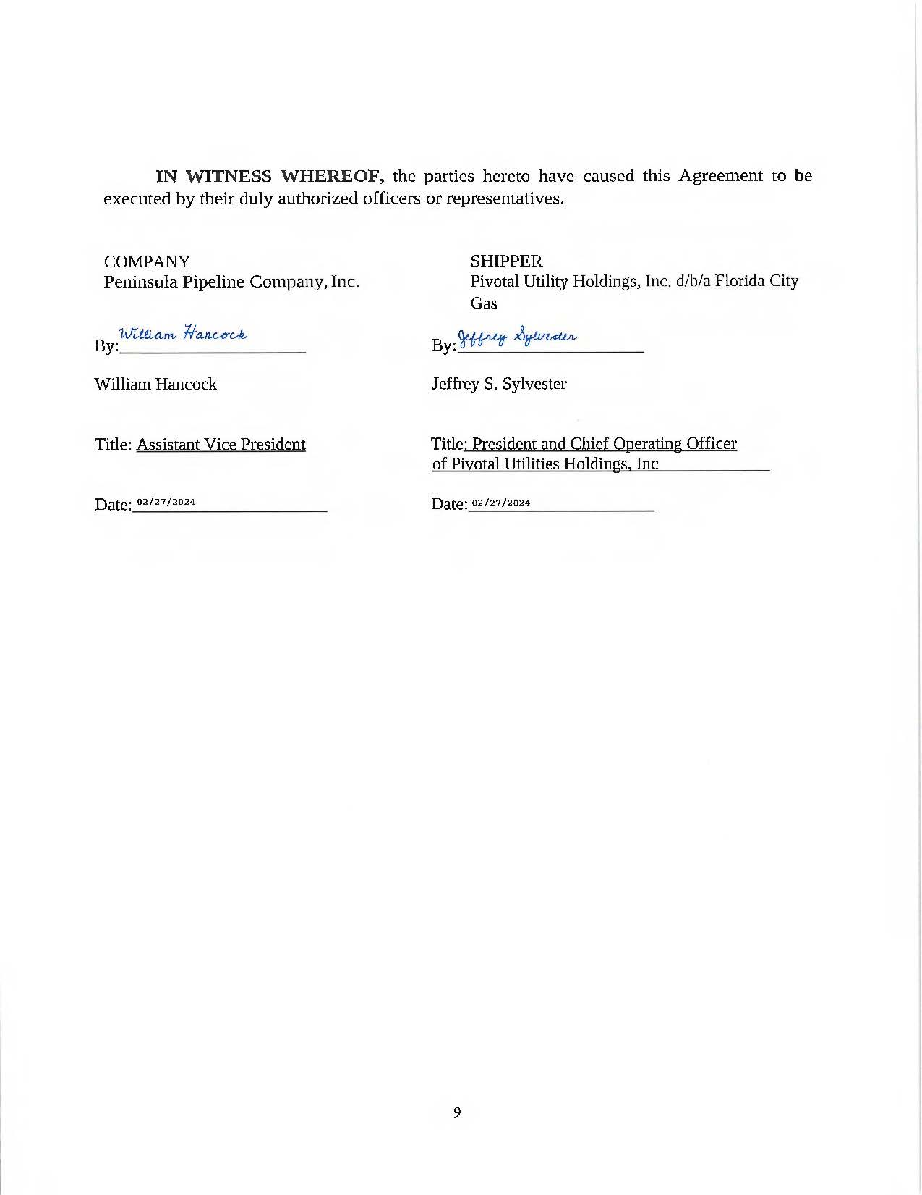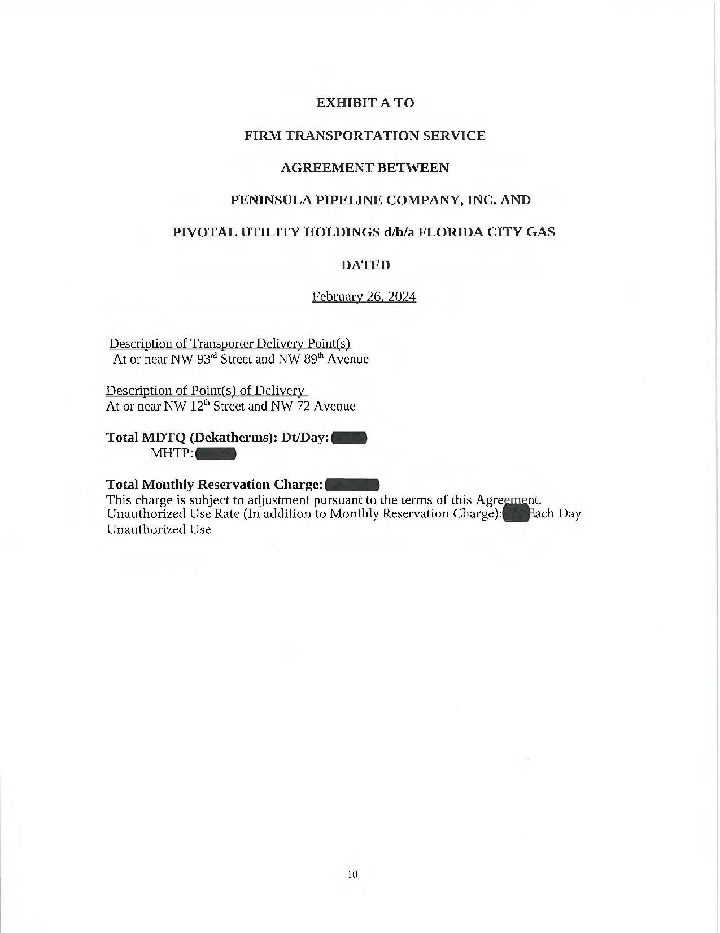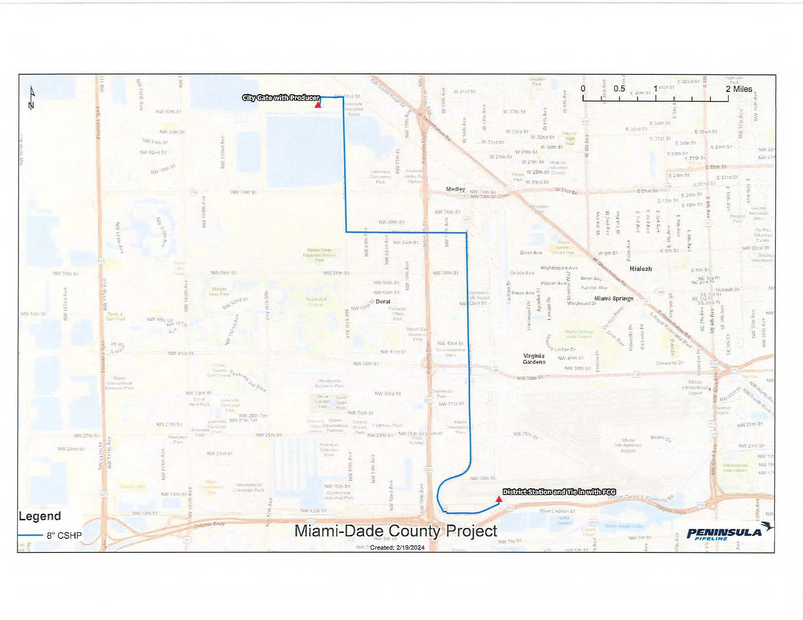

Order No. PSC-06-0023-DS-GP, issued January 9, 2006, in Docket No. 050584-GP, In re: Petition for declaratory statement by Peninsula Pipeline Company, Inc. concerning recognition as a natural gas transmission company under Section 368.101, F.S., et seq.
Order No. PSC-07-1012-TRF-GP, issued December 21, 2007, in Docket No. 070570-GP, In re: Petition for approval of natural gas transmission pipeline tariff by Peninsula Pipeline Company, Inc.
Peninsula Pipeline Company, Inc., Intrastate Pipeline Tariff, Original Sheet No. 11, Section 3.
Peninsula Pipeline Company, Inc., Intrastate Pipeline Tariff, Original Sheet No. 12, Section 4.
Response No. 1 in Staff’s Fourth Data Request, Document No. 05188-2024 and Response No. 1 in Staff’s Second Data Request, Document No. 01786-2024.
Docket No. 20240003-GU, In re: Purchased Gas Adjustment (PGA) True-Up.
Response No. 11 in Staff’s First Data Request, Document No. 01728-2024.
Response Nos. 9 and 10 in Staff’s First Data Request, Document No. 01728-2024.
Response No. 7 in Staff’s First Data Request, Document No. 01728-2024 and Response 3 in Staff’s Second Data Request, Document No. 01786-2024.
Response Nos. 1c. and 1d. in Staff’s Fourth Data Request, Document No. 05188-2024.
Response No. 1c in Staff’s Fourth Date Request, Document No. 05188-024.
Response No. 22 in Staff’s First Data Request, Document No. 01728-2024.
Response No. 5 in Staff’s Third Data Request, Document No. 02970-2024.
Response No. 23 in Staff’s First Data Request, Document No. 01728-2024.
Response No. 7 in Staff’s First Data Request, Document No. 01728-2024 and Response 3 in Staff’s Second Data Request, Document No. 01786-2024.
Response Nos. 1c. and 1d. in Staff’s Fourth Data Request, Document No. 05188-2024.
Response No. 1c in Staff’s Fourth Date Request, Document No. 05188-024.
Response No. 17 in Staff’s Third Data Request, Document No. 02970-2024.
Response No. 7 in Staff’s First Data Request, Document No. 01728-2024 and Response 3 in Staff’s Second Data Request, Document No. 01786-2024.
Response Nos. 1c. and 1d. in Staff’s Fourth Data Request, Document No. 05188-2024.
Response No. 1c in Staff’s Fourth Date Request, Document No. 05188-024.

