|  |  |  |  |
| --- | --- | --- | --- |
| State of Florida  pscSEAL | | Public Service Commission  Capital Circle Office Center ● 2540 Shumard Oak Boulevard Tallahassee, Florida 32399-0850  -M-E-M-O-R-A-N-D-U-M- | |
| DATE: | June 27, 2024 | | |
| TO: | Office of Commission Clerk (Teitzman) | | |
| FROM: | Division of Economics (McClelland, Hampson)  Office of the General Counsel (Sandy) | | |
| RE: | Docket No. 20240050-GU – Petition for approval of transportation service agreement with Florida Public Utilities Company by Peninsula Pipeline Company, Inc. | | |
| AGENDA: | 07/09/24 – Regular Agenda – Proposed Agency Action – Interested Persons May Participate | | |
| COMMISSIONERS ASSIGNED: | | | All Commissioners |
| PREHEARING OFFICER: | | | Clark |
| CRITICAL DATES: | | | None |
| SPECIAL INSTRUCTIONS: | | | None |

Case Background

On March 28, 2024, Peninsula Pipeline Company, Inc. (Peninsula) filed a petition for approval of a firm transportation service agreement between Peninsula and Florida Public Utilities Company (FPUC), (jointly, the parties). The transportation agreement will permit Peninsula to provide transportation service for FPUC along the Pioneer Supply Header Pipeline (Pioneer Header), therefore allowing FPUC to continue serving customers in Palm Beach County, provide reinforcement, and allow for future expansion. FPUC is a local distribution company (LDC) subject to the regulatory jurisdiction of the Commission pursuant to Chapter 366, Florida Statutes (F.S.). Peninsula operates as an intrastate natural gas transmission company as defined by Section 368.103(4), F.S.[1]

Peninsula provides gas transportation service only; it does not engage in the sale of natural gas to customers. By Order No. PSC-07-1012-TRF-GP (2007 Order), Peninsula received approval of an intrastate gas pipeline tariff that allows it to construct and operate intrastate pipeline facilities and to actively pursue agreements with natural gas customers.[2] Pursuant to the 2007 Order, Peninsula is allowed to enter into gas transmission agreements that meet certain criteria without prior Commission approval.[3] However Peninsula is requesting Commission approval of this proposed agreement as it does not fit any of the enumerated criteria.[4] Additionally, Peninsula and FPUC are subsidiaries of Chesapeake Utility Corporation, and agreements between affiliated companies must be approved by the Commission pursuant to Section 368.105, F.S., and the 2007 Order.

The Pioneer Header was constructed by Florida City Gas (FCG) to provide itself and other local distribution companies (LDC) and industrial customers with natural gas supply in the area in and around Palm Beach County. Currently, pursuant to a transportation agreement between FCG and FPUC, FCG provides transportation service on the Pioneer Header pipeline to FPUC.

As addressed in Docket No. 20240051-GU, the Pioneer Header is being transferred from FCG to Peninsula. This sale of the asset does not require Commission review; however, the sale will not take place until after Commission approval of the transportation service agreement between FCG and Peninsula addressed in Docket No. 20240051-GU. Following the transfer of the Pioneer Header from FCG to Peninsula, Peninsula would own the pipeline. With this petition, Peninsula is seeking approval of a transportation agreement with FPUC to provide natural gas transportation service along the Pioneer Header to FPUC. The proposed transportation agreement and project map are shown as Attachments A and B to this recommendation.

During the evaluation of the petition, staff issued a data request to the parties for which responses were received on June 14 and on June 19, 2024. The Commission has jurisdiction over this matter pursuant to Sections 366.05(1), 366.06, and 368.105, F.S.

Discussion of Issues

Issue :

 Should the Commission approve Peninsula’s transportation service agreement with FPUC?

Recommendation:

 Yes, the Commission should approve Peninsula’s transportation service agreement with FPUC, dated March 18, 2024, included as Attachment A to the recommendation. The proposed agreement is reasonable and meets the requirements of Section 368.105, F.S. Furthermore, the proposed agreement benefits FPUC’s current and potential future customers through the activation of two additional delivery points. (McClelland)

Staff Analysis:

The parties have petitioned the proposed firm transportation agreement to maintain and enhance service to the West Palm Beach area currently provided by FCG. The parties state that proposed agreement will allow Peninsula to serve FPUC with 900 dekatherms per day of firm transportation at three delivery points. The parties further assert that this level of service is needed for FPUC to serve current customers and expand to serve potential new customers with the addition of two delivery points.

The proposed firm transportation agreement between FPUC and Peninsula is contingent on the transfer of the Pioneer Header from FCG to Peninsula. This transfer would be completed following the Commission review and approval of the transportation service agreement between FCG and Peninsula addressed in Docket No. 20240051-GU.

Paragraph 11 of the petition states that the proposed monthly reservation charge that FPUC would pay to Peninsula is similar to the rate FPUC is currently paying to FCG. In the parties’ joint responses to staff’s first data request, the parties clarified that the rates have been calculated using the same methodology. However, the proposed monthly reservation charge is higher than the current rate because Peninsula has factored in activation of two additional delivery points to provide service to FPUC.

The proposed agreement would be effective for 20 years after its date of execution, and extended on a year-to-year basis after this initial term, unless either party chooses to terminate via written notice submitted 90 days prior to the expiration of the current term. Either party may request modification of the rates or terms of the agreement, to be made effective in the next renewed term, no less than 120 days before the expiration of the current term. However, the parties acknowledge that any amendments to the proposed agreements would require further Commission approval.

FPUC would recover its monthly reservation charge payments to Peninsula through the purchased gas adjustment[5] (PGA) and swing service rider. The PGA allows FPUC to periodically adjust the price of natural gas supplied to its customers to reflect the actual cost of gas purchased and delivered on behalf of the customers. The swing service rider allows FPUC to recover intrastate capacity costs from their transportation customers and is a cents per therm charge that is included in the monthly customer gas bill of transportation customers. In a bill calculation provided by FPUC, a residential RES-3 customer using 21 therms would see an increase of $0.07.

Conclusion

Based on the petition and the parties’ responses to staff’s data request, staff recommends that the Commission should approve Peninsula’s transportation service agreement with FPUC, dated March 18, 2024, included as Attachment A to the recommendation. The proposed agreement is reasonable and meets the requirements of Section 368.105, F.S. Furthermore, the proposed agreement benefits FPUC’s current and potential future customers through the activation of two additional delivery points.

Issue :

 Should this docket be closed?

Recommendation:

 If no protest is filed by a person whose substantial interest is affected within 21 days of the issuance of the Order, this docket should be closed upon the issuance of a Consummating Order. (Sandy)

Staff Analysis:

 If no protest is filed by a person whose substantial interest is affected within 21 days of the issuance of the Order, this docket should be closed upon the issuance of a Consummating Order.

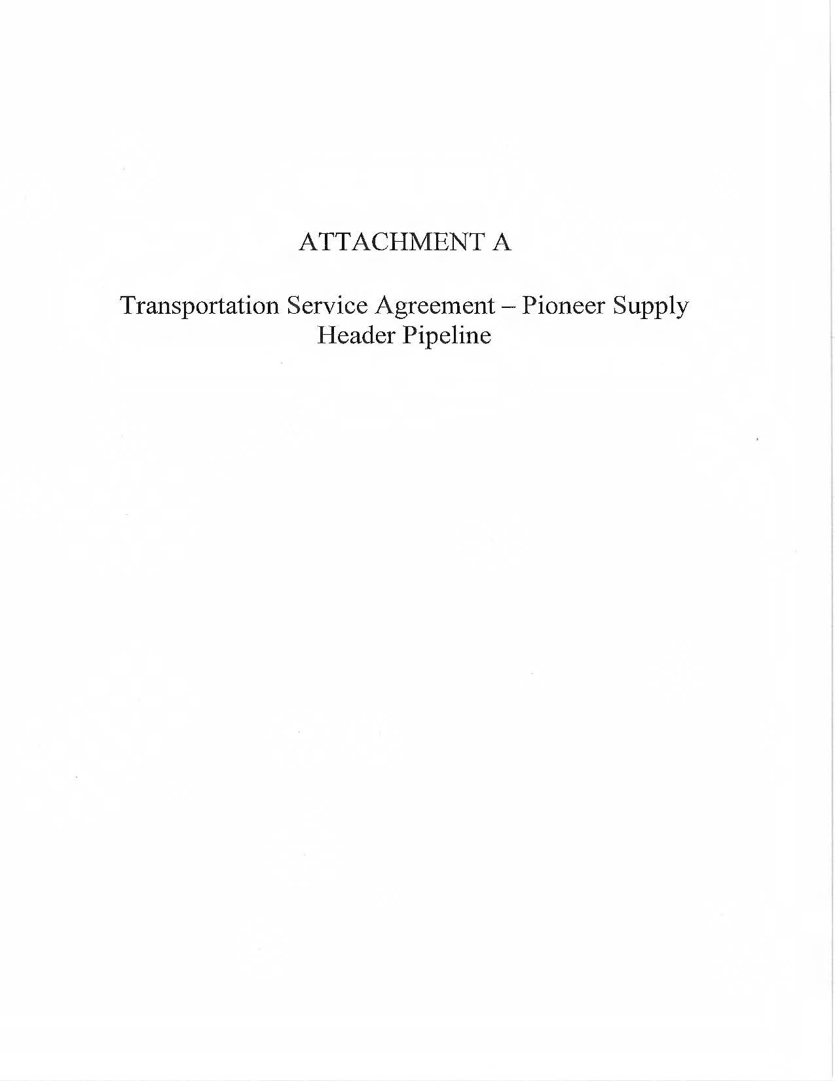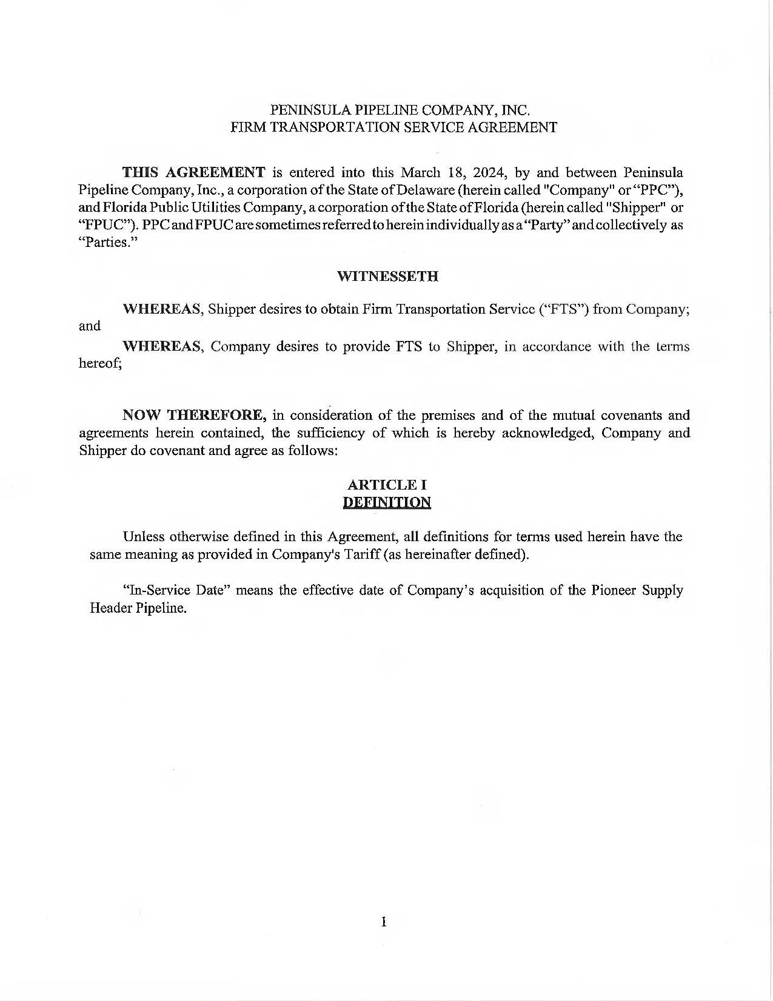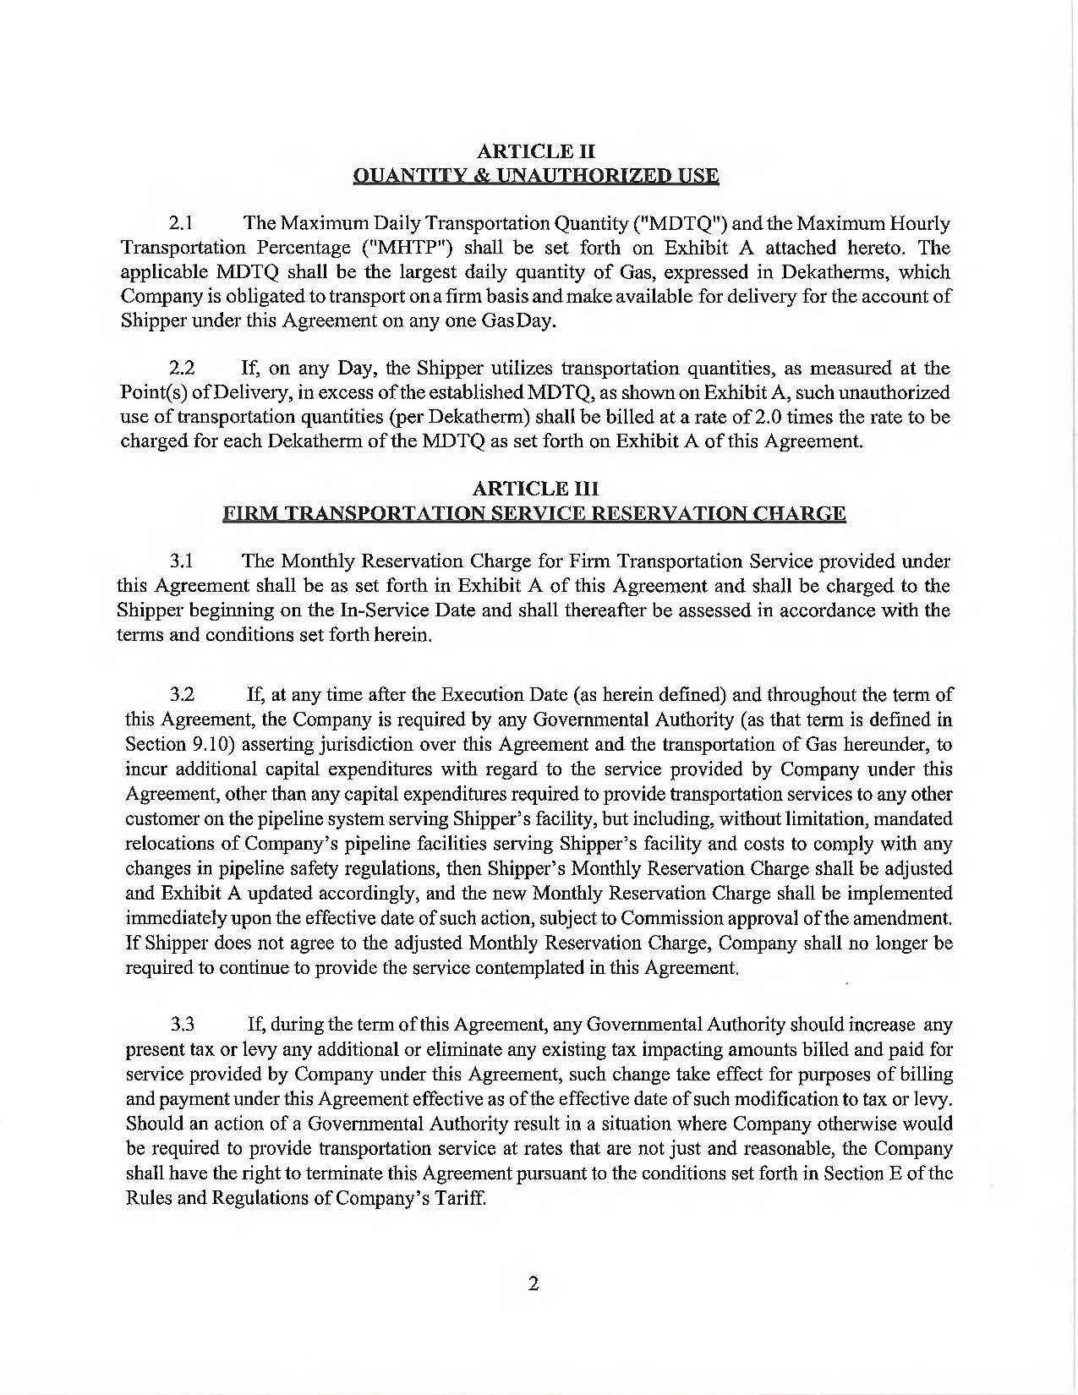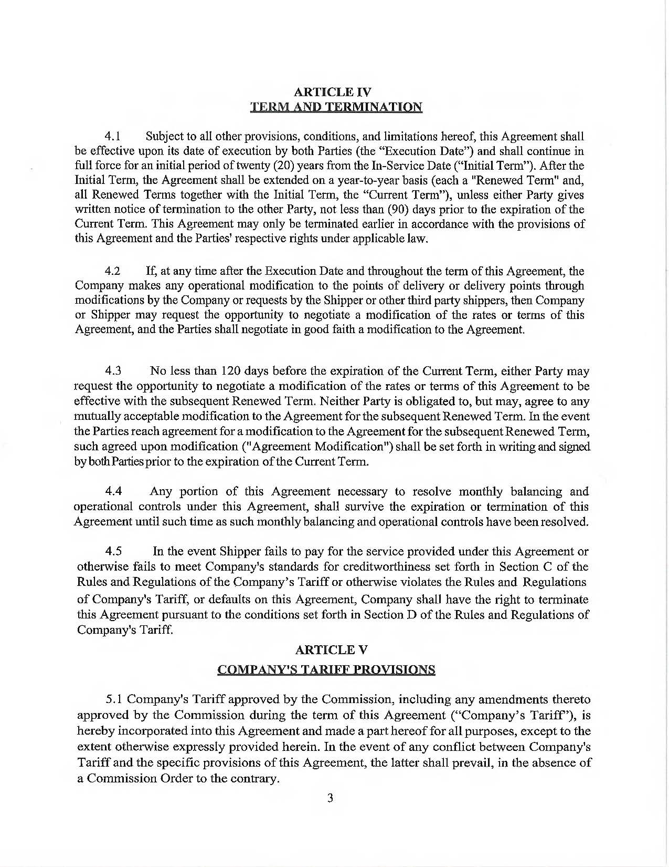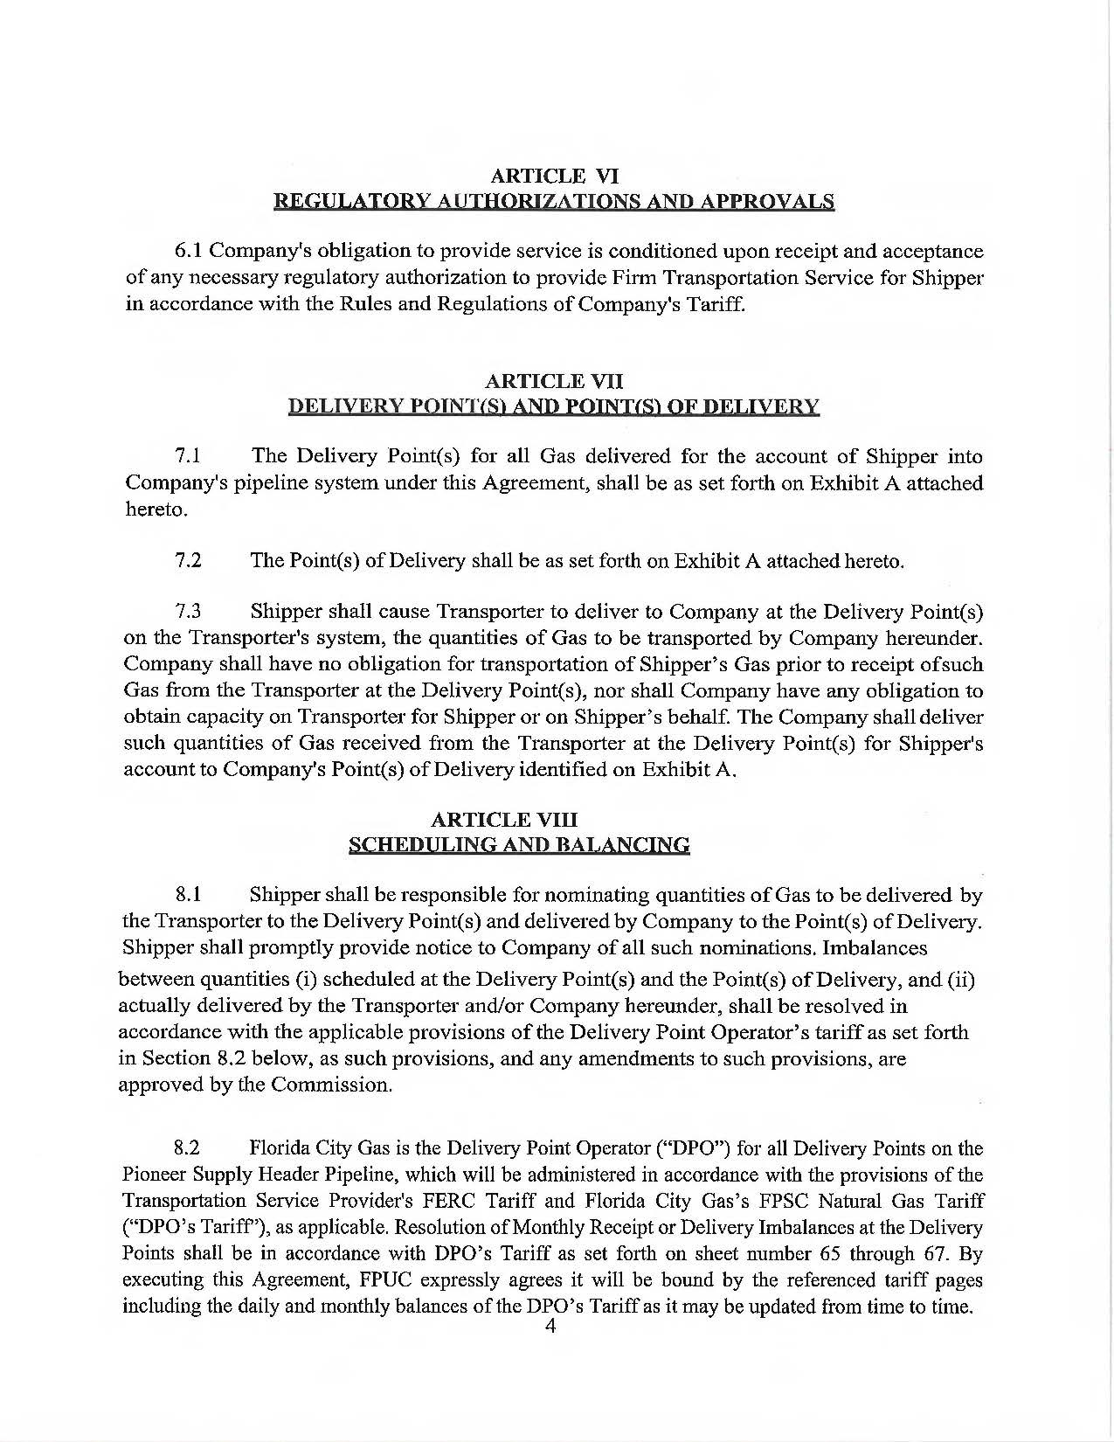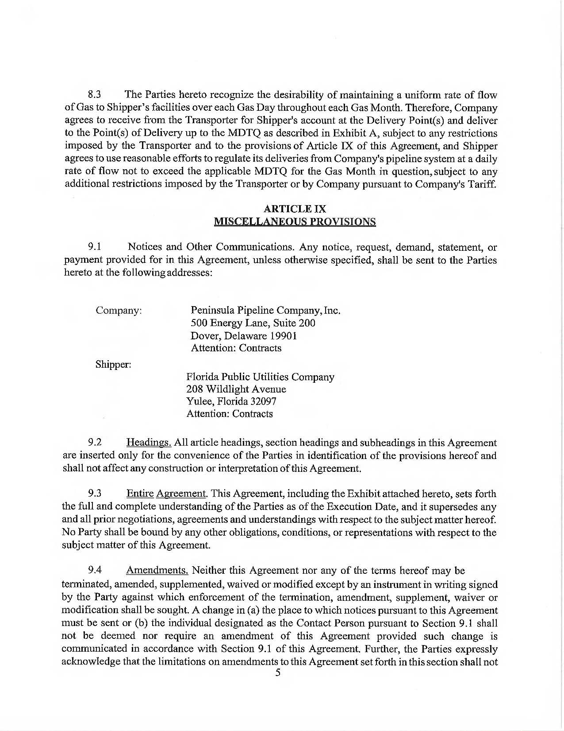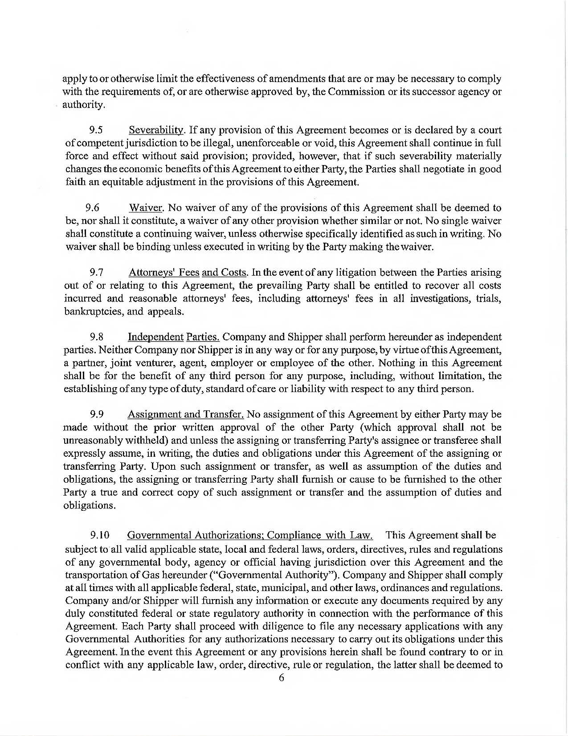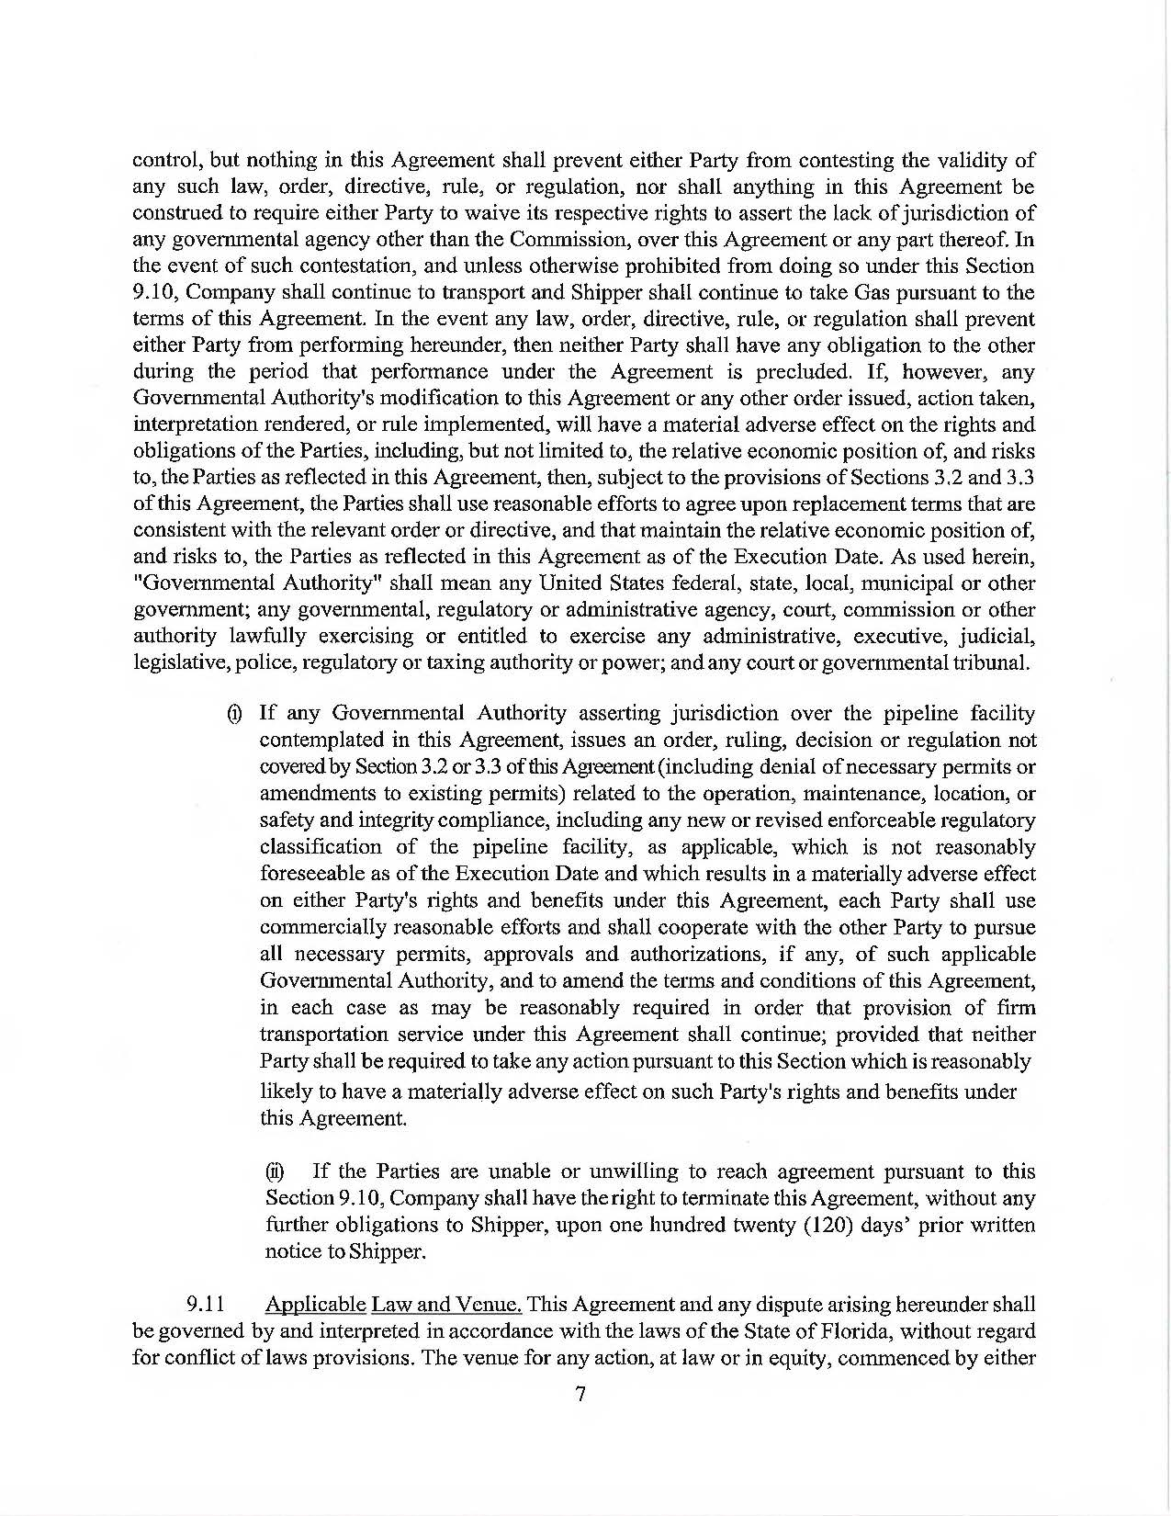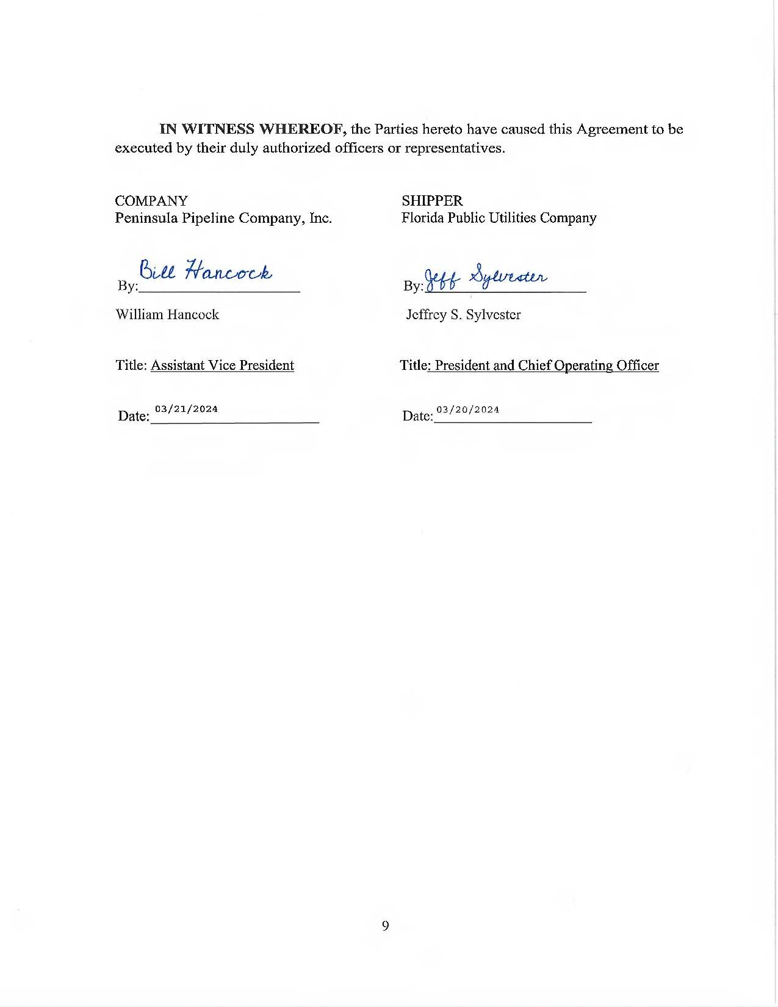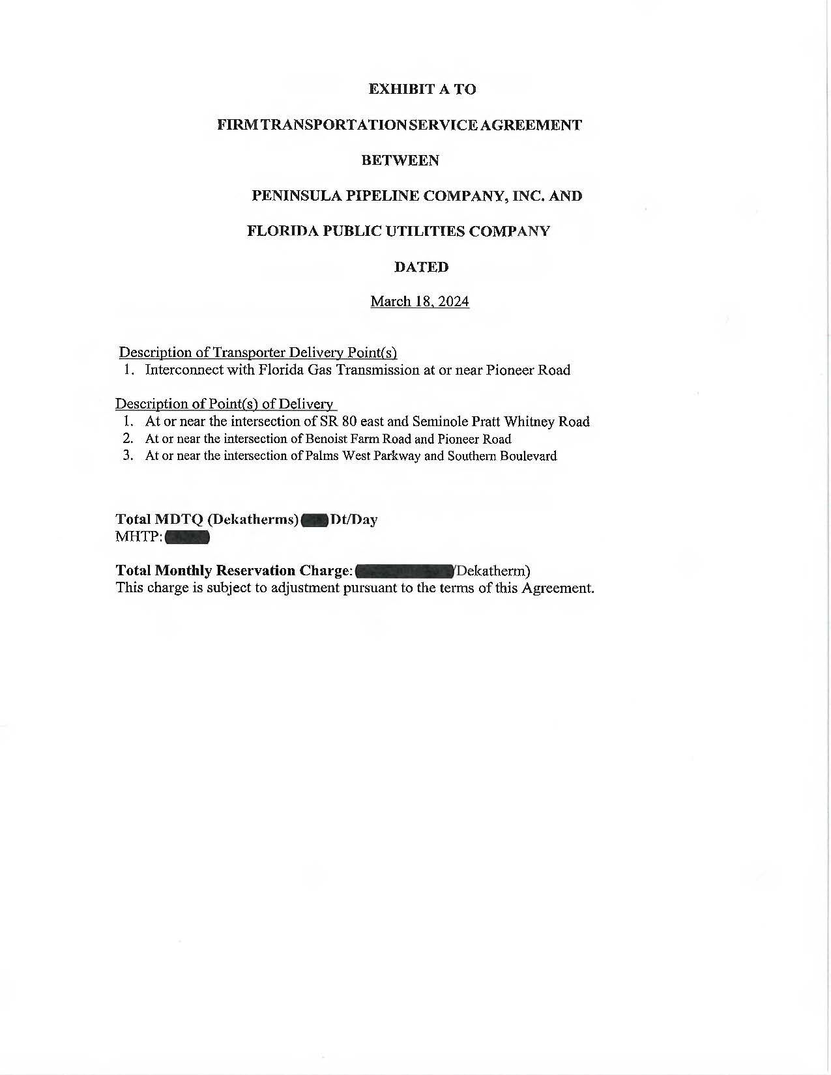

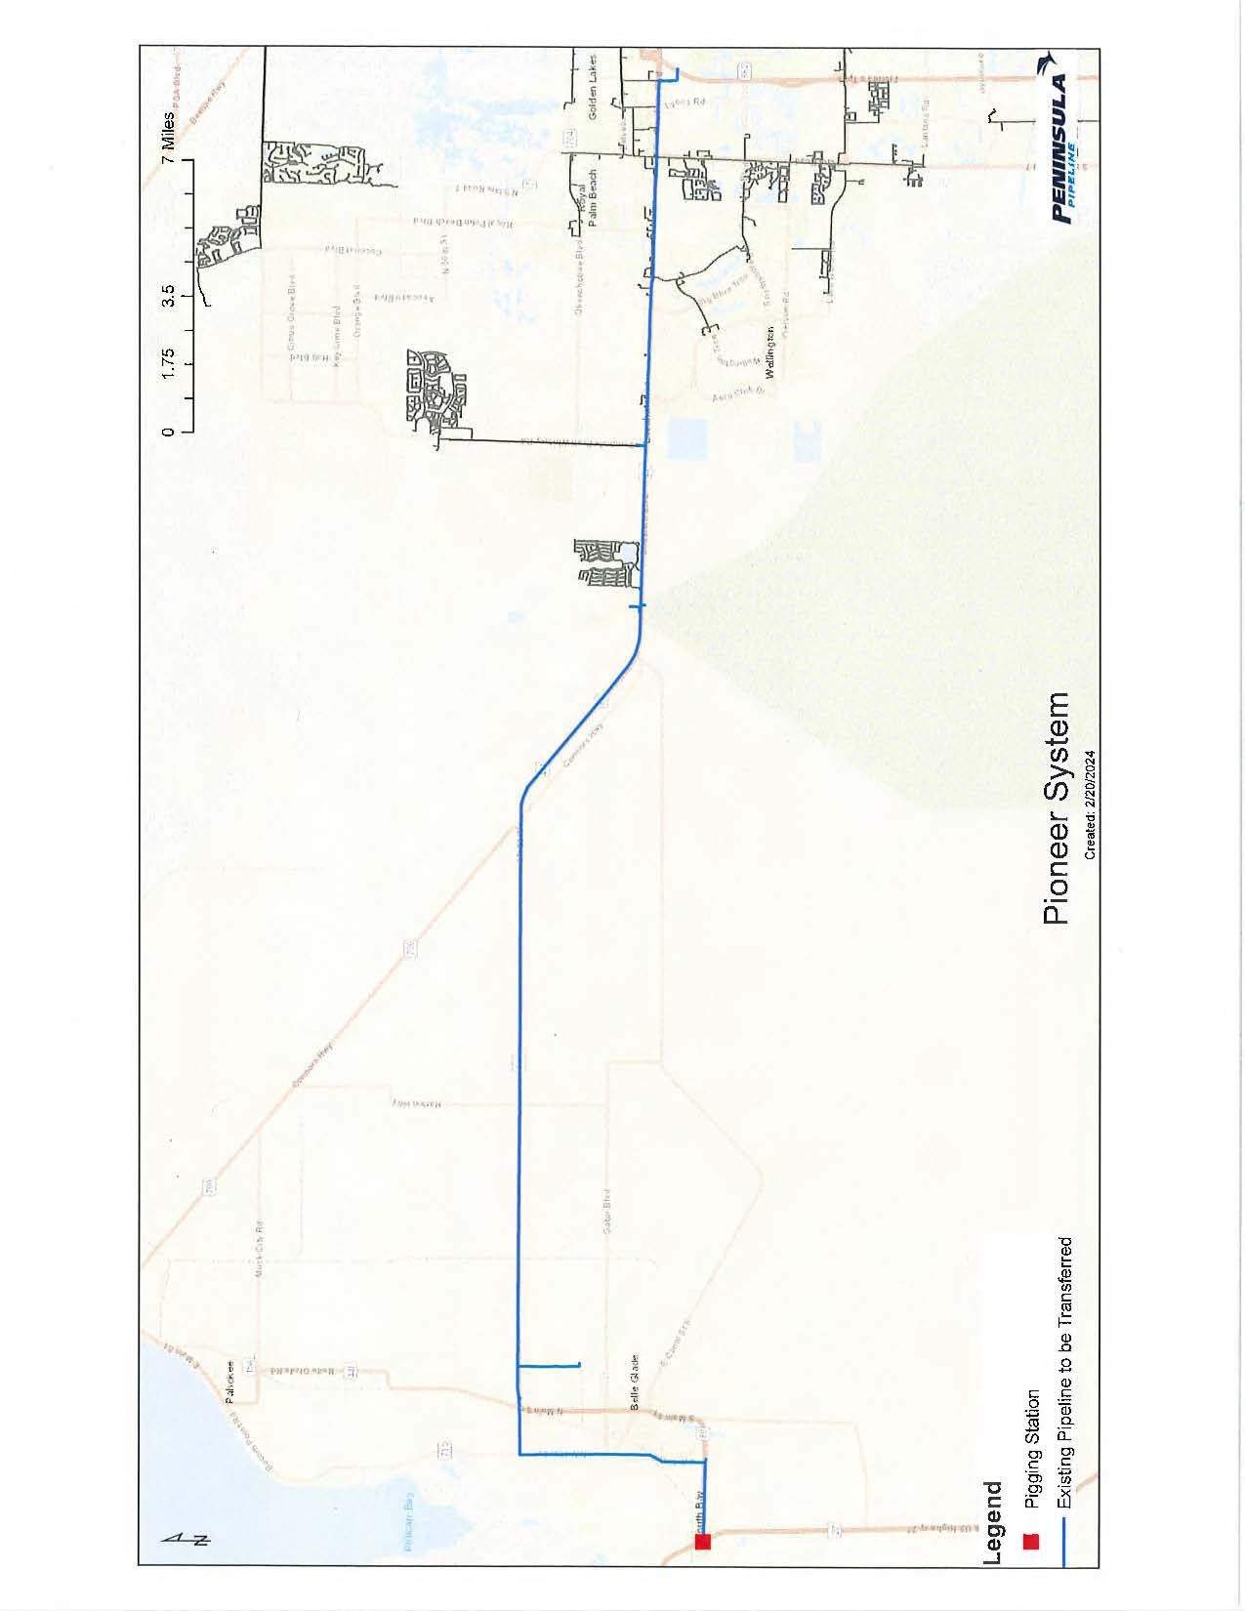

1. Order No. PSC-06-0023-DS-GP, issued January 9, 2006, in Docket No. 20050584-GP, *In re: Petition for declaratory statement by Peninsula Pipeline Company, Inc. concerning recognition as a natural gas transmission company under Section 368.101, F.S., et seq.* 
2. Order No. PSC-07-1012-TRF-GP, issued December 21, 2007, in Docket No. 070570-GP, In re: Petition for approval of natural gas transmission pipeline tariff by Peninsula Pipeline Company, Inc.
3. Peninsula Pipeline Company, Inc., Intrastate Pipeline Tariff, Original Vol. 1, Original Sheet No. 11, Section 3.
4. Peninsula Pipeline Company, Inc., Intrastate Pipeline Tariff, Original Vol. 1, Original Sheet No. 12, Section 4.
5. Docket No. 2024003-GU, *In re: Purchased gas adjustment (PGA) true-up.*