BEFORE THE FLORIDA PUBLIC SERVICE COMMISSION

In re: Petition for approval of amended standard offer contract (Schedule COG-2), by Duke Energy Florida, LLC. | DOCKET NO. 20240048-EQ  ORDER NO. PSC-2024-0229-PAA-EQ  ISSUED: July 8, 2024

The following Commissioners participated in the disposition of this matter:

MIKE LA ROSA, Chairman
ART GRAHAM
GARY F. CLARK
ANDREW GILES FAY
GABRIELLA PASSIDOMO

NOTICE OF PROPOSED AGENCY ACTION
ORDER APPROVING DUKE ENERGY FLORIDA, LLC’S REVISED RENEWABLE ENERGY TARIFF AND STANDARD OFFER CONTRACT

BY THE COMMISSION:

NOTICE is hereby given by the Florida Public Service Commission (Commission) that the action discussed herein is preliminary in nature and will become final unless a person whose interests are substantially affected files a petition for a formal proceeding, pursuant to Rule 25-22.029, Florida Administrative Code (F.A.C.).

Background

Section 366.91(3), Florida Statutes (F.S.), requires each investor-owned utility (IOU) to continuously offer to purchase capacity and energy from renewable generating facilities (RF) and small qualifying facilities (QF). Commission Rules 25-17.200 through 25-17.310, F.A.C., implement the statute and require each IOU to file with us, by April 1 of each year, a revised standard offer contract based on the next avoidable fossil-fueled generating unit of each technology type identified in the utility’s current Ten-Year Site Plan (TYSP). On March 28, 2024, Duke Energy Florida, LLC (DEF) filed a petition for approval of its amended standard offer contract and rate schedule COG-2. On May 6, 2024, DEF filed revisions to its proposed tariff sheets to correct a forecast error that impacted the avoided unit’s operating and financial assumptions. We have jurisdiction over this standard offer contract, pursuant to Sections 366.04 through 366.055, and 366.91, F.S.

Analysis

Section 366.91(3), F.S., and Rule 25-17.250, F.A.C., require that an IOU continuously make available a standard offer contract for the purchase of firm capacity and energy from RFs and QFs with design capacities of 100 kilowatts (kW) or less. Pursuant to Rules 25-17.250(1) and (3), F.A.C., the standard offer contract must provide a term of at least 10 years, and the payment terms must be based on the utility’s next avoidable fossil-fueled generating unit identified in its most recent TYSP or, if no avoided unit is identified, its next avoidable planned purchase. In its 2024 Ten-Year Site Plan, DEF has identified a 215 megawatt (MW) natural gas-fueled combustion turbine as the next avoidable planned generating unit. This unit has a projected in-service date of June 1, 2032, with planned construction beginning in July 2029.

Under DEF’s standard offer contract, the RF/QF operator commits to certain minimum performance requirements, based on the identified avoided unit, such as being operational and delivering an agreed upon amount of capacity by the in-service date of the avoided unit. In this way, the RF/QF thereby becomes eligible for capacity payments in addition to payments received for energy. The standard offer contract may also serve as a starting point for negotiation of contract terms by providing payment information to an RF/QF operator in a situation where one or both parties desire particular contract terms other than those established in the standard offer.

In order to promote renewable generation, the Commission requires each IOU to offer multiple options for capacity payments, including the options to receive early or levelized payments. If the RF/QF operator elects to receive capacity payments under the normal or levelized contract options, it will receive as-available energy payments only until the in-service date of the avoided unit (in this case June 1, 2032). Thereafter, they begin receiving capacity payments in addition to firm energy payments. If either the early or early levelized option is selected, then the operator will begin receiving capacity payments earlier than the in-service date of the avoided unit. However, payments made under the early capacity payment options tend to be lower in the later years of the contract term, because the net present value (NPV) of the total payments must remain equal for all contract payment options.

Table 1 contains DEF’s estimates of the annual payments for the normal and levelized capacity payment options available under the revised standard offer contract to an operator with a 50 MW facility operating at a capacity factor of 95 percent, which is the minimum capacity factor required under the contract to qualify for full capacity payments. Normal and levelized capacity payments begin with the projected in-service date of the avoided unit (June 1, 2032), and continue for 10 years, while early and early levelized capacity payments begin two (2) years prior to the in-service date, or 2030 in this case.

(remainder of this page intentionally left blank)
Table 0- Estimated Annual Payments to a 50 MW Renewable Facility
(95% Capacity Factor)
Year | Energy Payment | Capacity Payment
 |  | Normal | Levelized | Early | Early Levelized
 | $(000) | $(000) | $(000) | $(000) | $(000)
2025 | 14,256 | - | - | - | -
2026 | 13,941 | - | - | - | -
2027 | 13,342 | - | - | - | -
2028 | 12,710 | - | - | - | -
2029 | 12,567 | - | - | - | -
2030 | 12,243 | - | - | 5,354 | 5,359
2031 | 12,297 | - | - | 5,358 | 5,362
2032 | 12,057 | 4,120 | 4,123 | 5,362 | 5,365
2033 | 12,351 | 7,068 | 7,073 | 5,366 | 5,369
2034 | 12,159 | 7,074 | 7,077 | 5,371 | 5,372
2035 | 14,750 | 7,080 | 7,082 | 5,375 | 5,376
2036 | 15,729 | 7,085 | 7,087 | 5,380 | 5,379
2037 | 16,487 | 7,091 | 7,092 | 5,384 | 5,383
2038 | 16,827 | 7,097 | 7,096 | 5,389 | 5,387
2039 | 17,572 | 7,103 | 7,102 | 5,394 | 5,391
2040 | 18,299 | 7,110 | 7,107 | 5,399 | 5,395
2041 | 19,724 | 7,116 | 7,112 | 5,404 | 5,399
2042 | 20,039 | 7,123 | 7,117 | 5,409 | 5,403
2043 | 21,483 | 7,129 | 7,123 | 5,414 | 5,408
2044 | 21,970 | 7,136 | 7,129 | 5,419 | 5,412
Total | 310,801 | 89,333 | 89,320 | 80,776 | 80,759
Total (NPV) | 154,468 | 34,569 | 34,569 | 34,569 | 34,569
Source: DEF’s Response to Staff’s First Data Request

DEF’s standard offer contract, as revised on May 6, 2024 in type-and-strike format, is included as Attachment A to this Order. The changes made to DEF’s tariff sheets are consistent with the updated avoided unit. Revisions include updates to calendar dates and payment information, which reflect the current economic and financial assumptions for the avoided unit.

Decision

We find that the provisions of DEF’s renewable energy tariff and amended standard offer contract conform to the requirements of Rules 25-17.200 through 25-17.310, F.A.C. The amended standard offer contract offers multiple payment options so that a developer of renewable generation may select the payment stream best suited to its financial needs. Therefore, we will approve the renewable energy tariff and amended standard offer contract.

Based on the foregoing, it is

ORDERED by the Florida Public Service Commission that Duke Energy Florida, LLC’s Petition for Approval of a Renewable Energy Tariff and Standard Offer Contract is GRANTED. The revised renewable energy tariff and amended standard offer contract are approved as set forth herein. It is further

ORDERED that the provisions of this Order, issued as proposed agency action, shall become final and effective upon the issuance of a Consummating Order unless an appropriate petition, in the form provided by Rule 28-106.201, F.A.C., is received by the Commission Clerk, 2540 Shumard Oak Boulevard, Tallahassee, Florida 32399-0850, by the close of business on the date set forth in the “Notice of Further Proceedings or Judicial Review” attached hereto. It is further

ORDERED that in the event this Order becomes final, this docket shall be closed.

By ORDER of the Florida Public Service Commission this 8th day of July, 2024.

/s/ Adam J. Teitzman
ADAM J. TEITZMAN
Commission Clerk
Florida Public Service Commission
2540 Shumard Oak Boulevard
Tallahassee, Florida 32399
(850) 413-6770
www.floridapsc.com

Copies furnished: A copy of this document is provided to the parties of record at the time of issuance and, if applicable, interested persons.

SF

NOTICE OF FURTHER PROCEEDINGS OR JUDICIAL REVIEW

The Florida Public Service Commission is required by Section 120.569(1), Florida Statutes, to notify parties of any administrative hearing that is available under Section 120.57, Florida Statutes, as well as the procedures and time limits that apply. This notice should not be construed to mean all requests for an administrative hearing will be granted or result in the relief sought.

Mediation may be available on a case-by-case basis. If mediation is conducted, it does not affect a substantially interested person's right to a hearing.

The action proposed herein is preliminary in nature. Any person whose substantial interests are affected by the action proposed by this order may file a petition for a formal proceeding, in the form provided by Rule 28-106.201, Florida Administrative Code. This petition must be received by the Office of Commission Clerk, 2540 Shumard Oak Boulevard, Tallahassee, Florida 32399-0850, by the close of business on July 29, 2024.

In the absence of such a petition, this order shall become final and effective upon the issuance of a Consummating Order.

Any objection or protest filed in this/these docket(s) before the issuance date of this order is considered abandoned unless it satisfies the foregoing conditions and is renewed within the specified protest period.

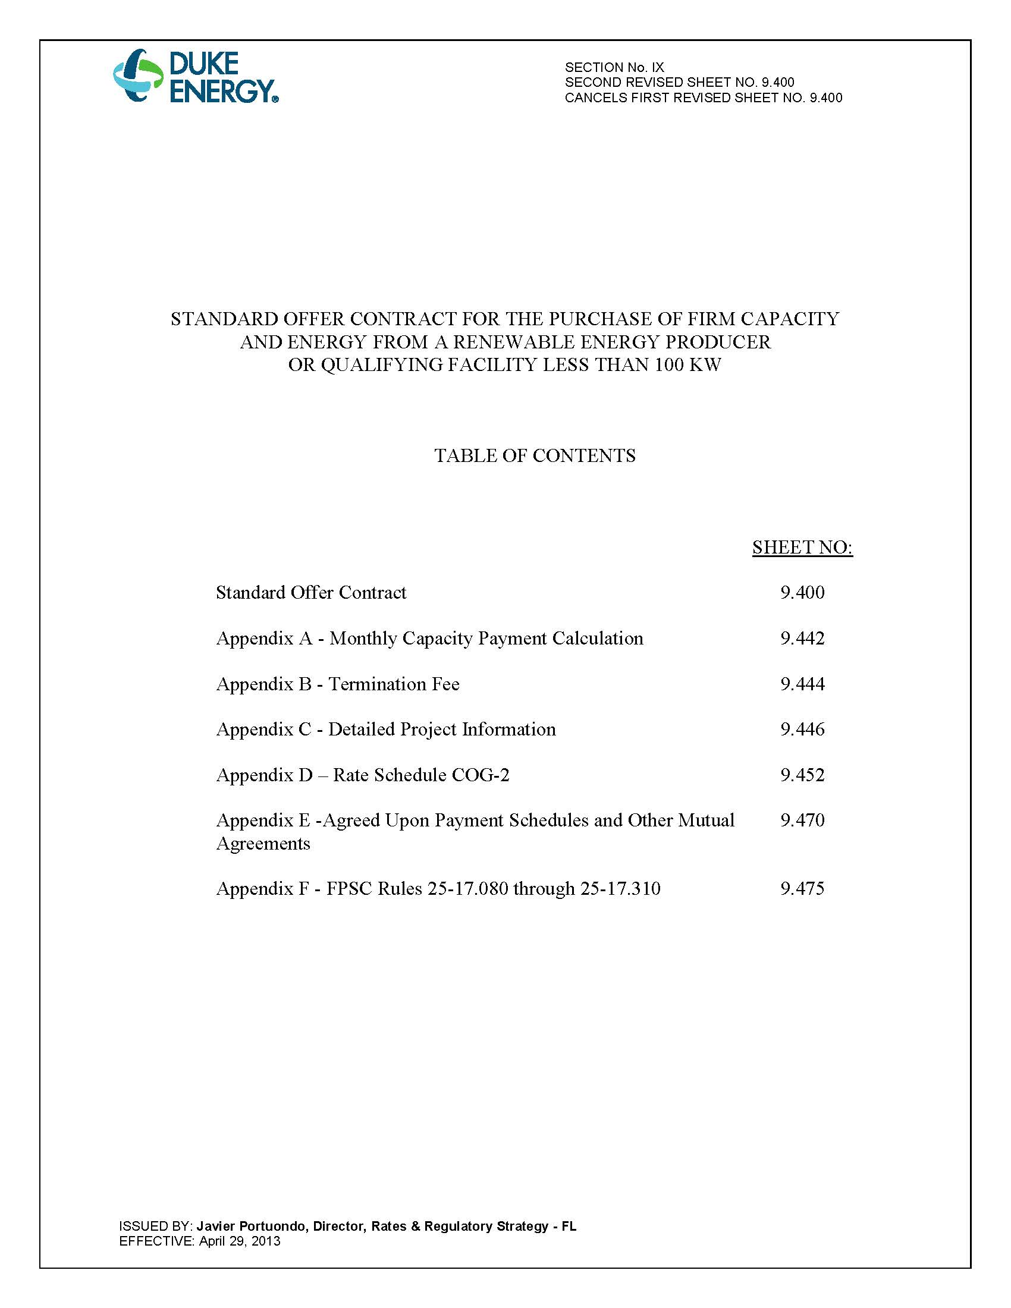

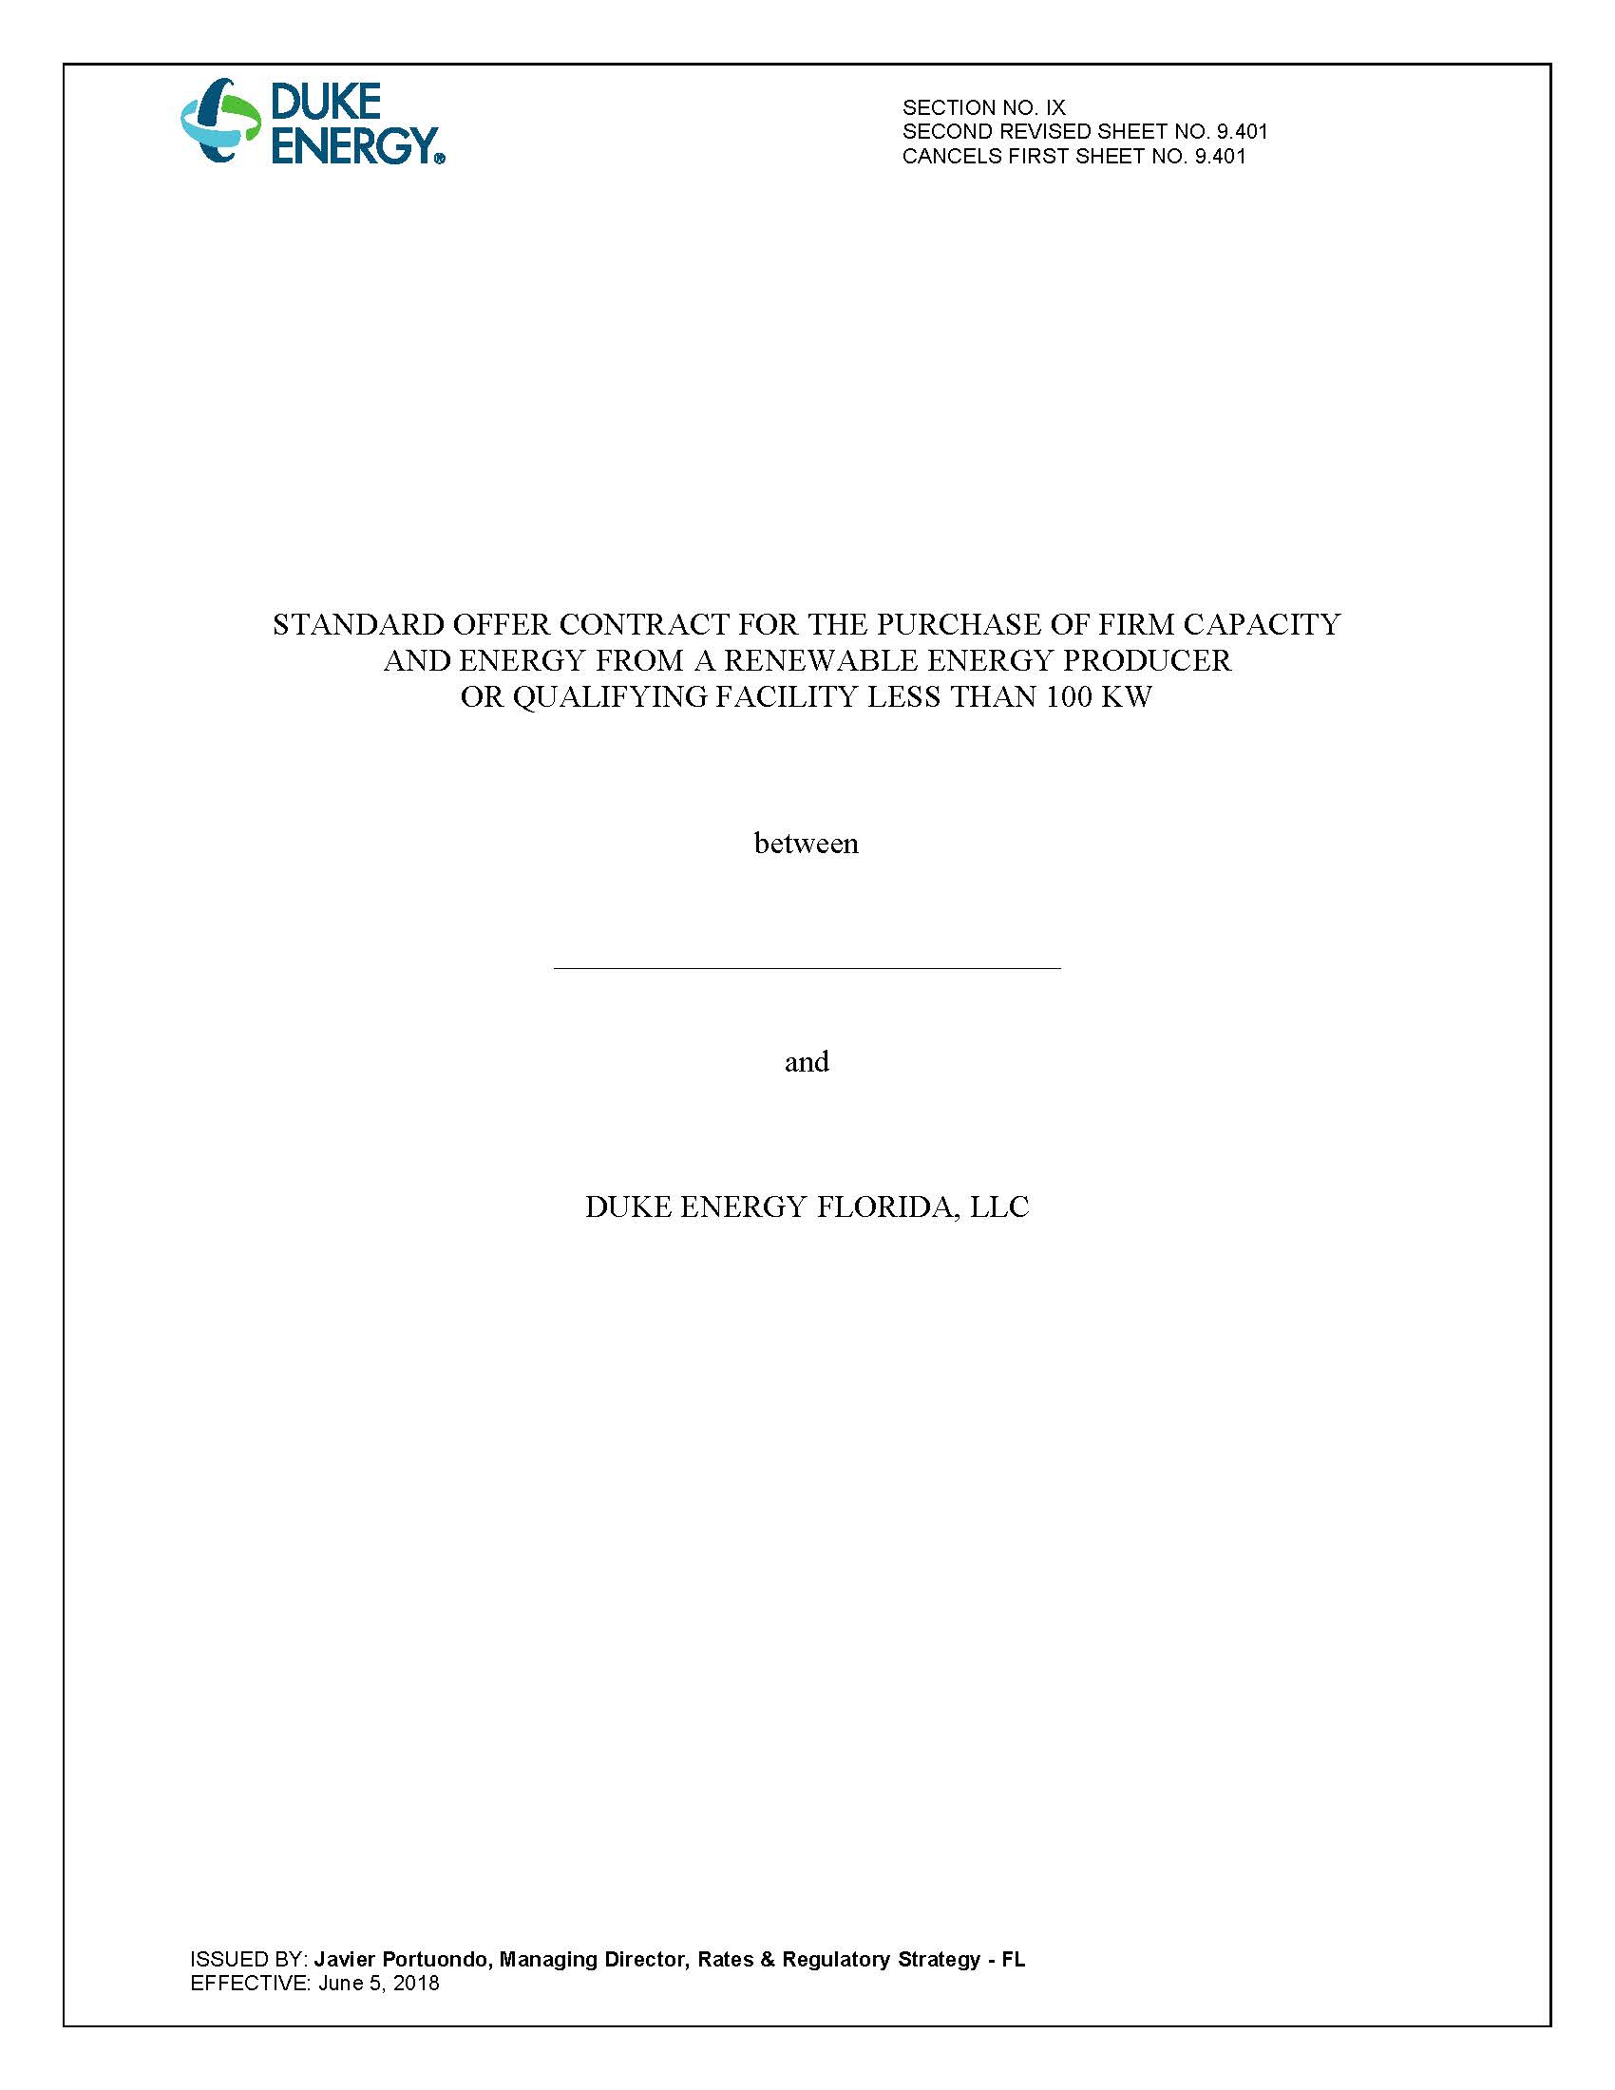
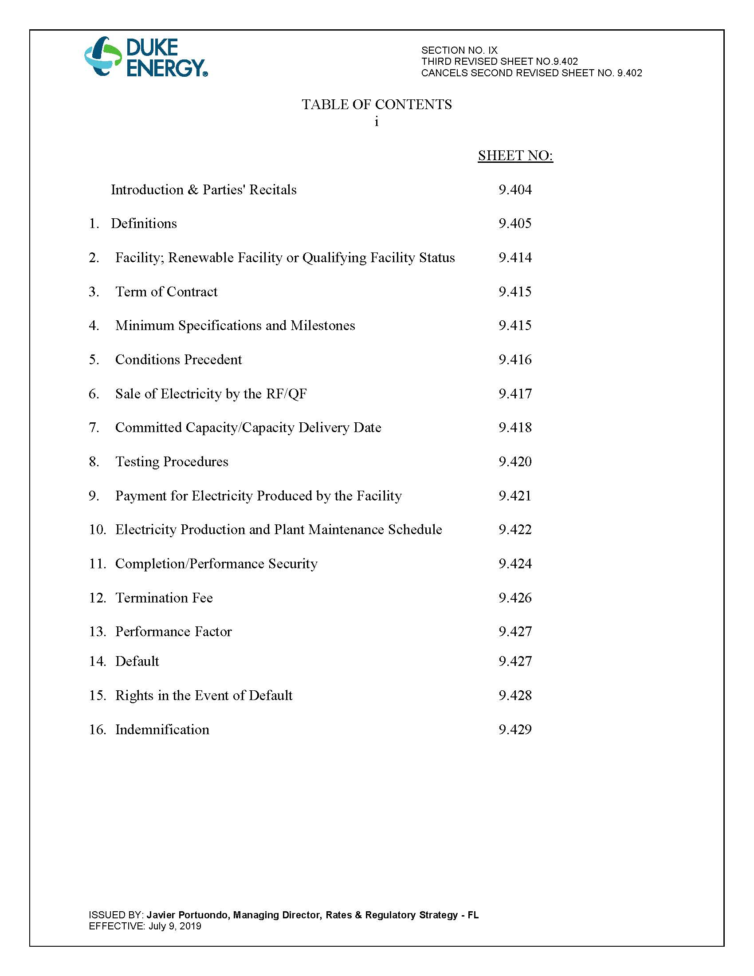
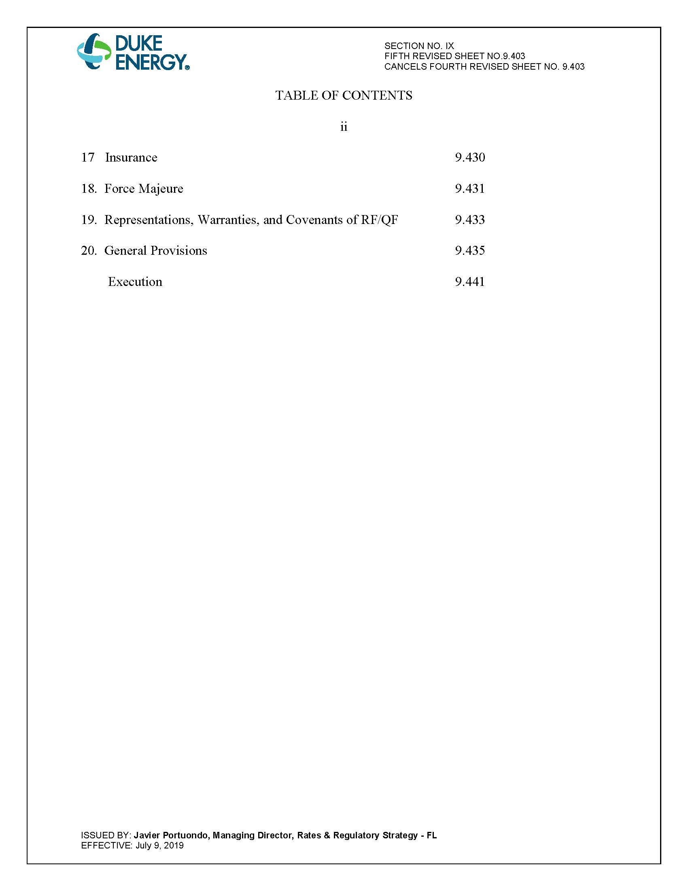
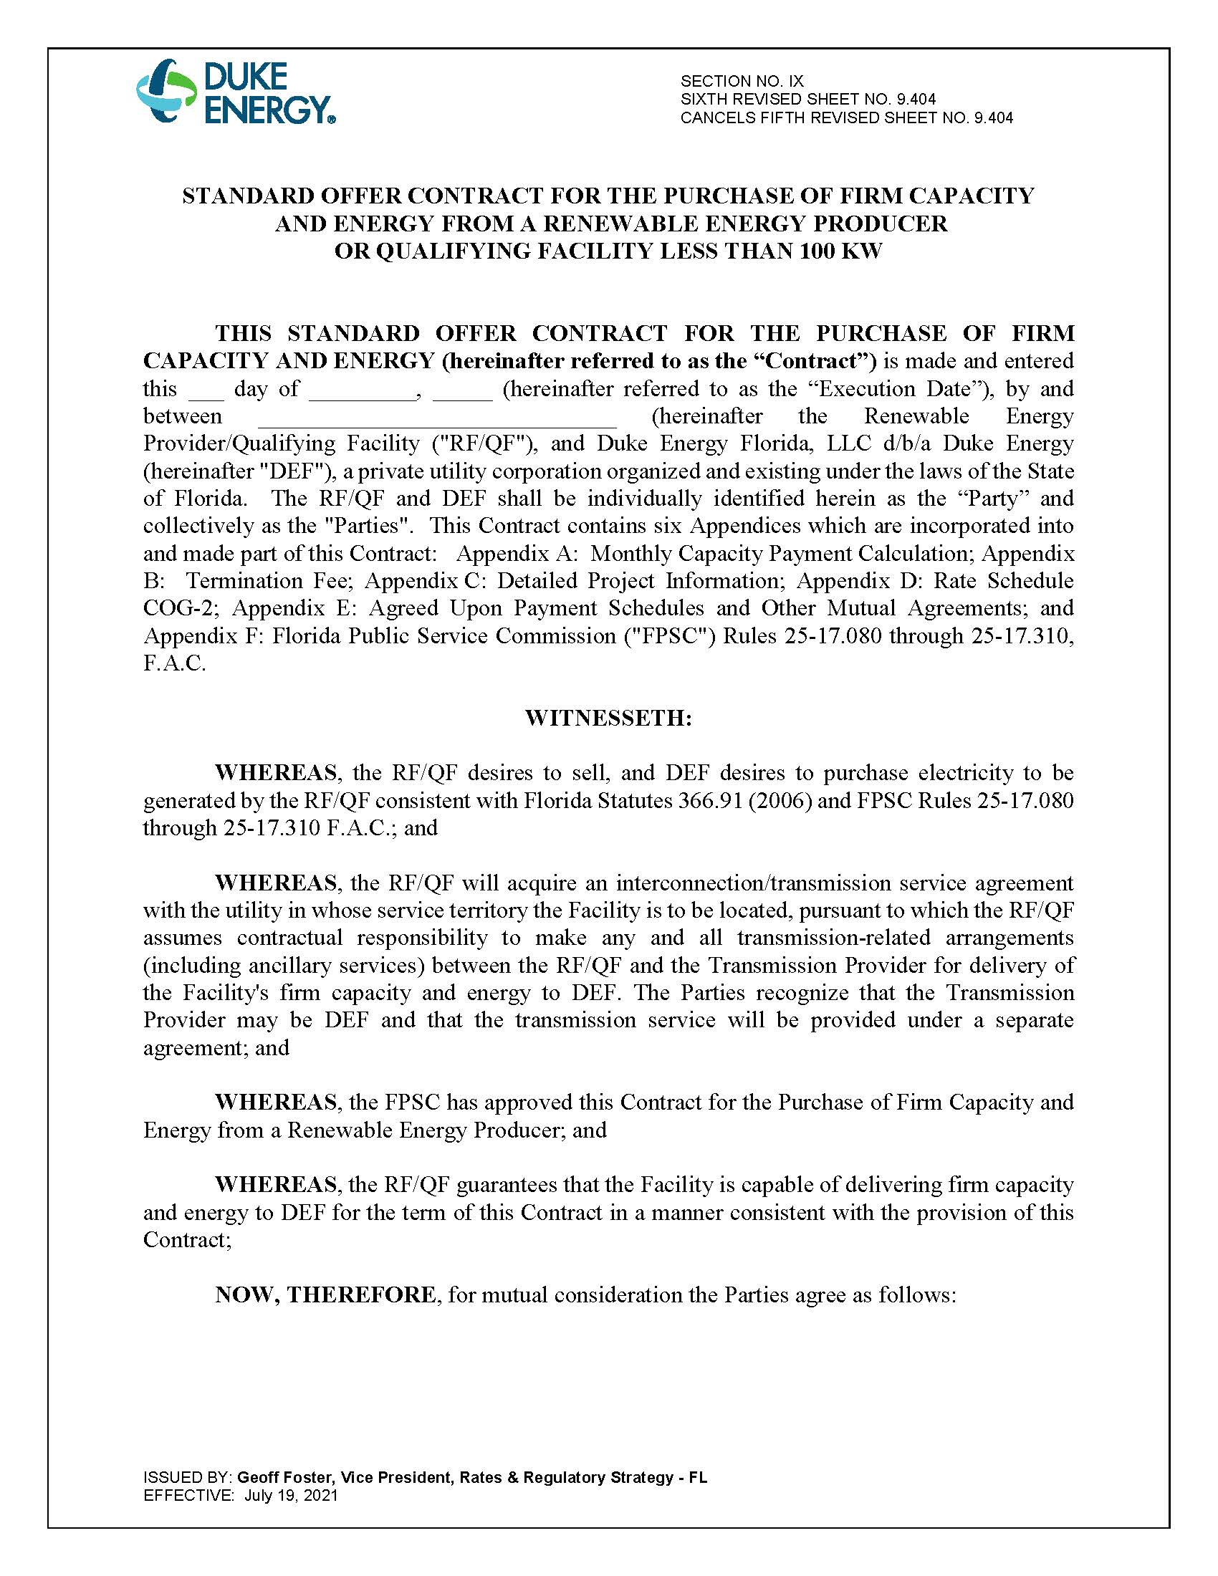
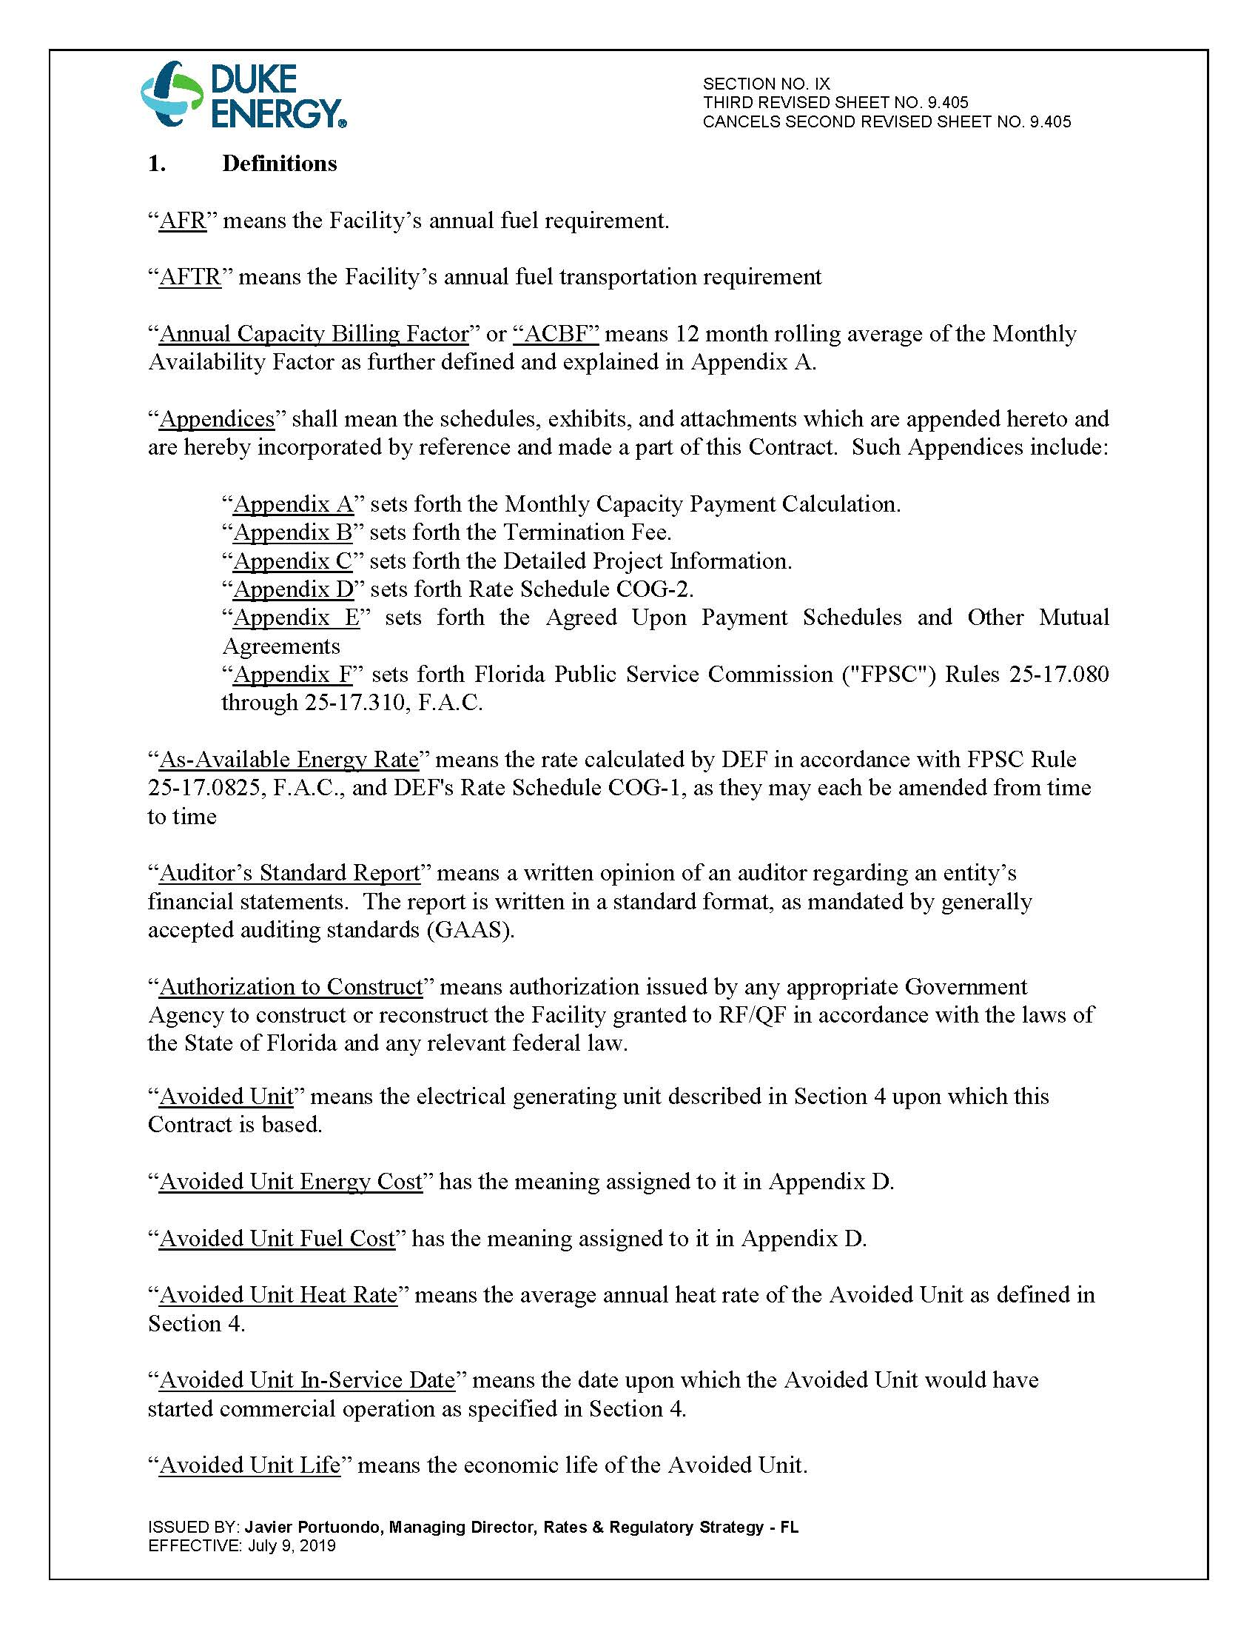
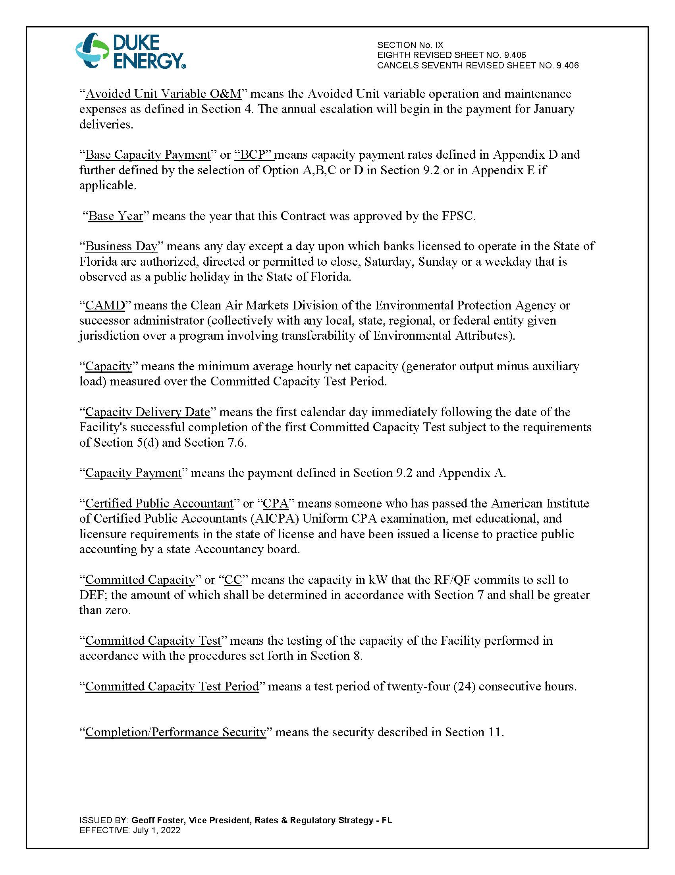
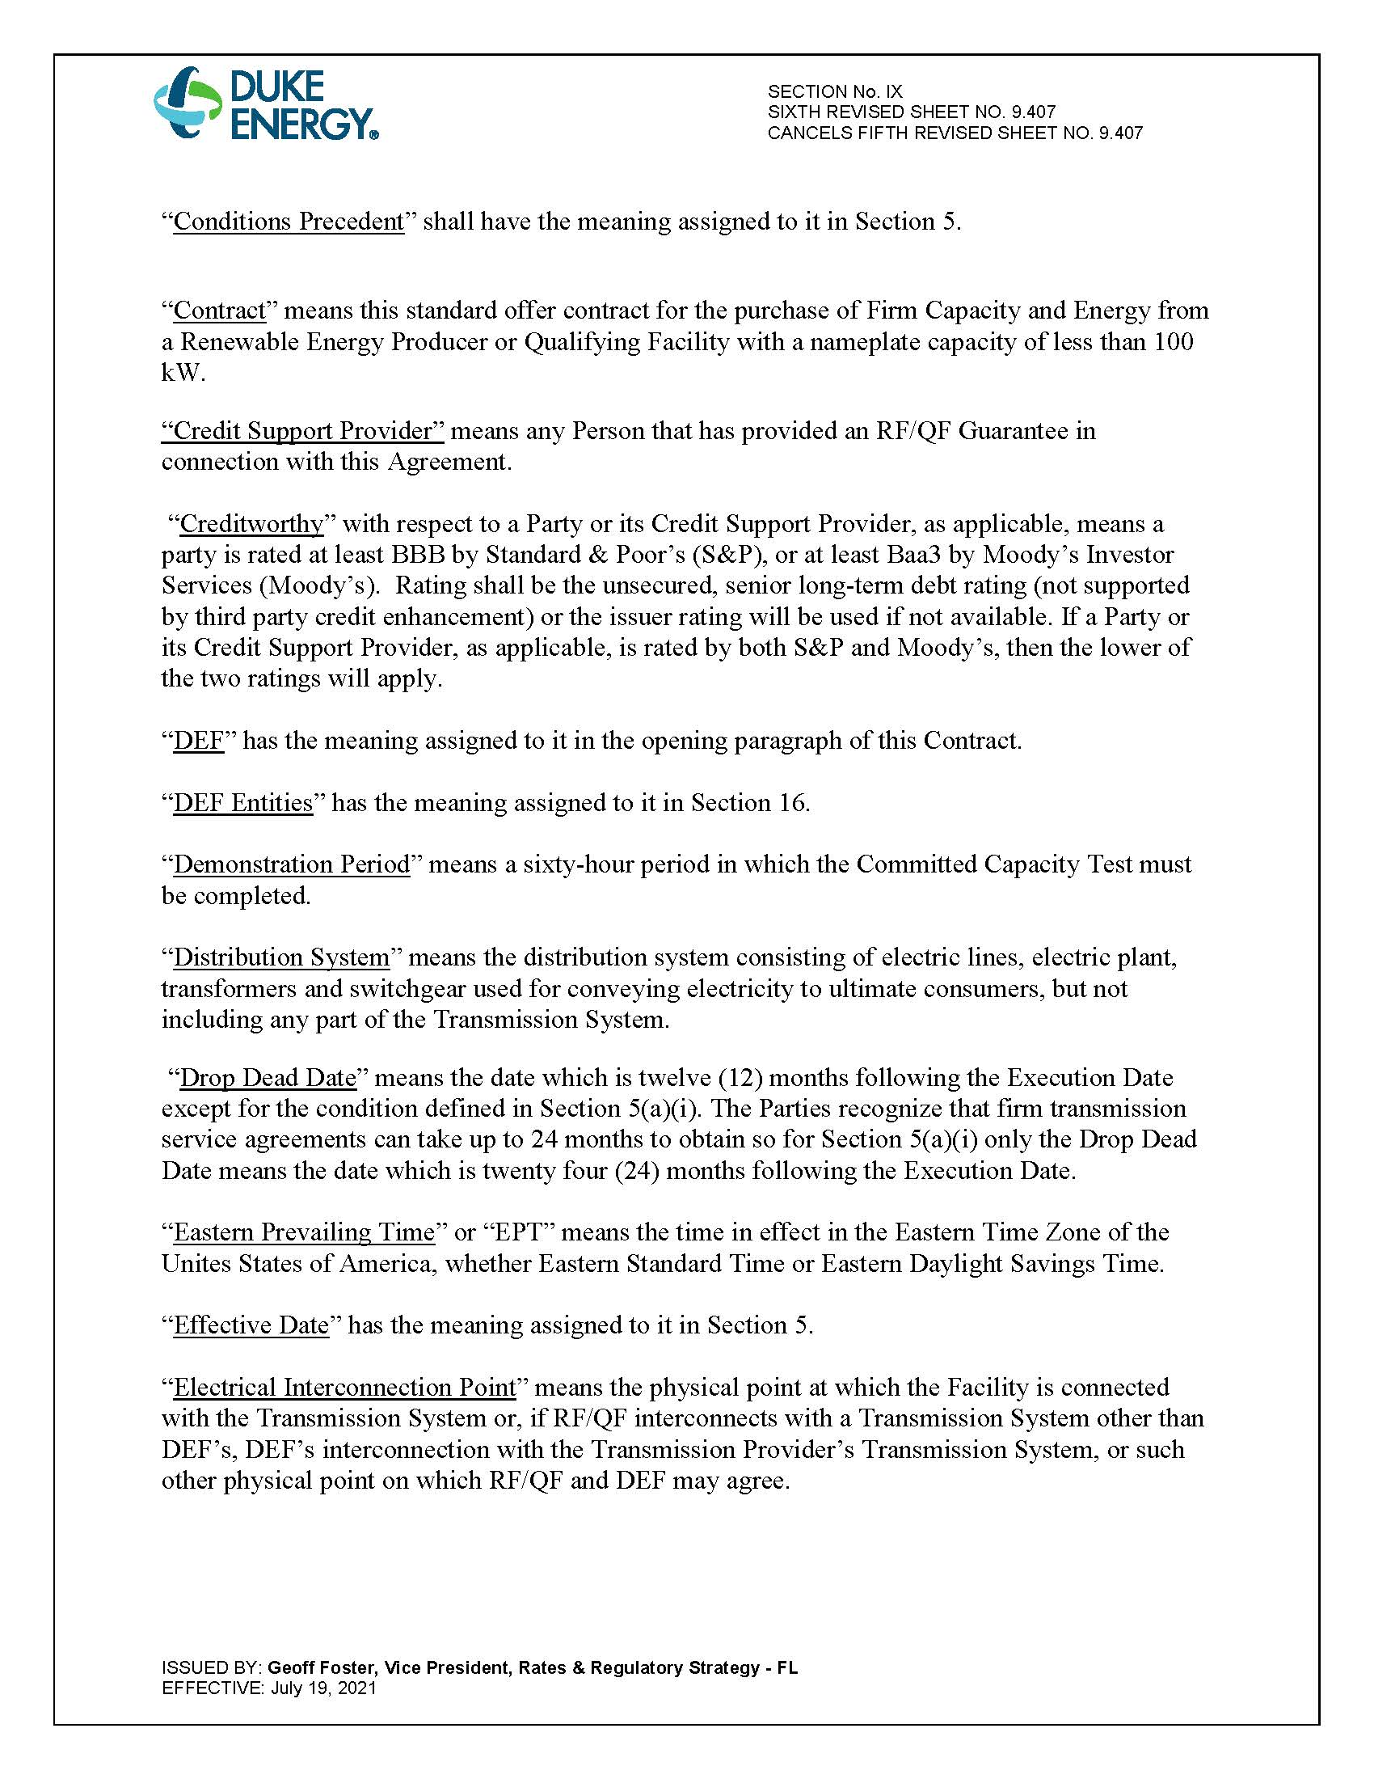
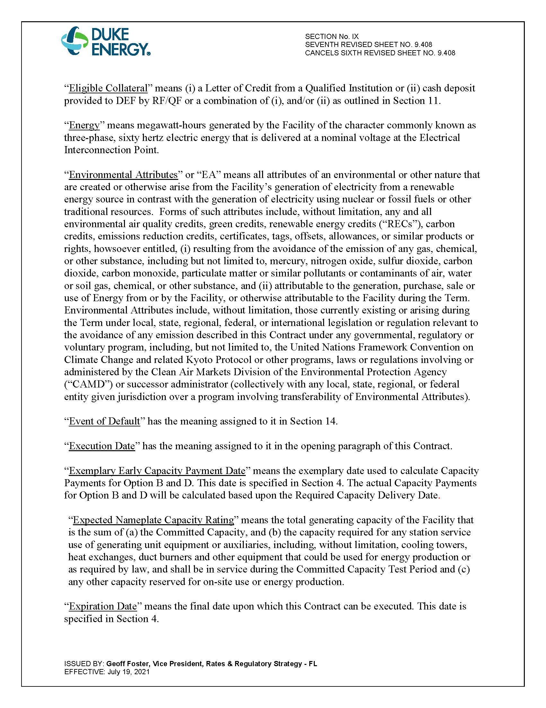
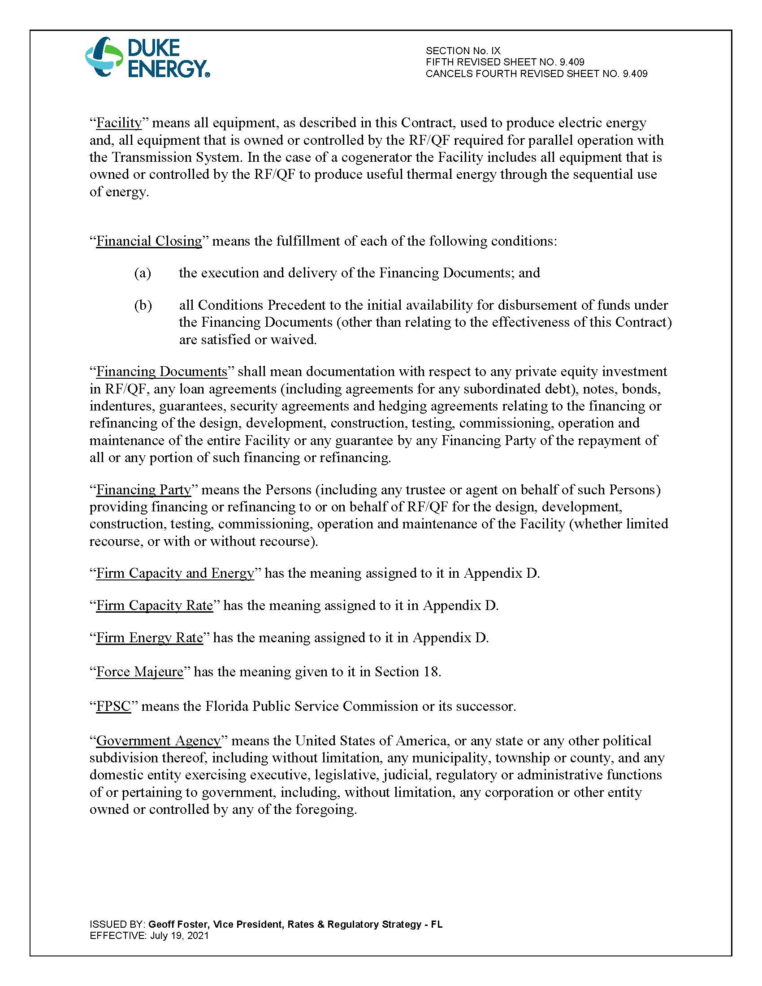
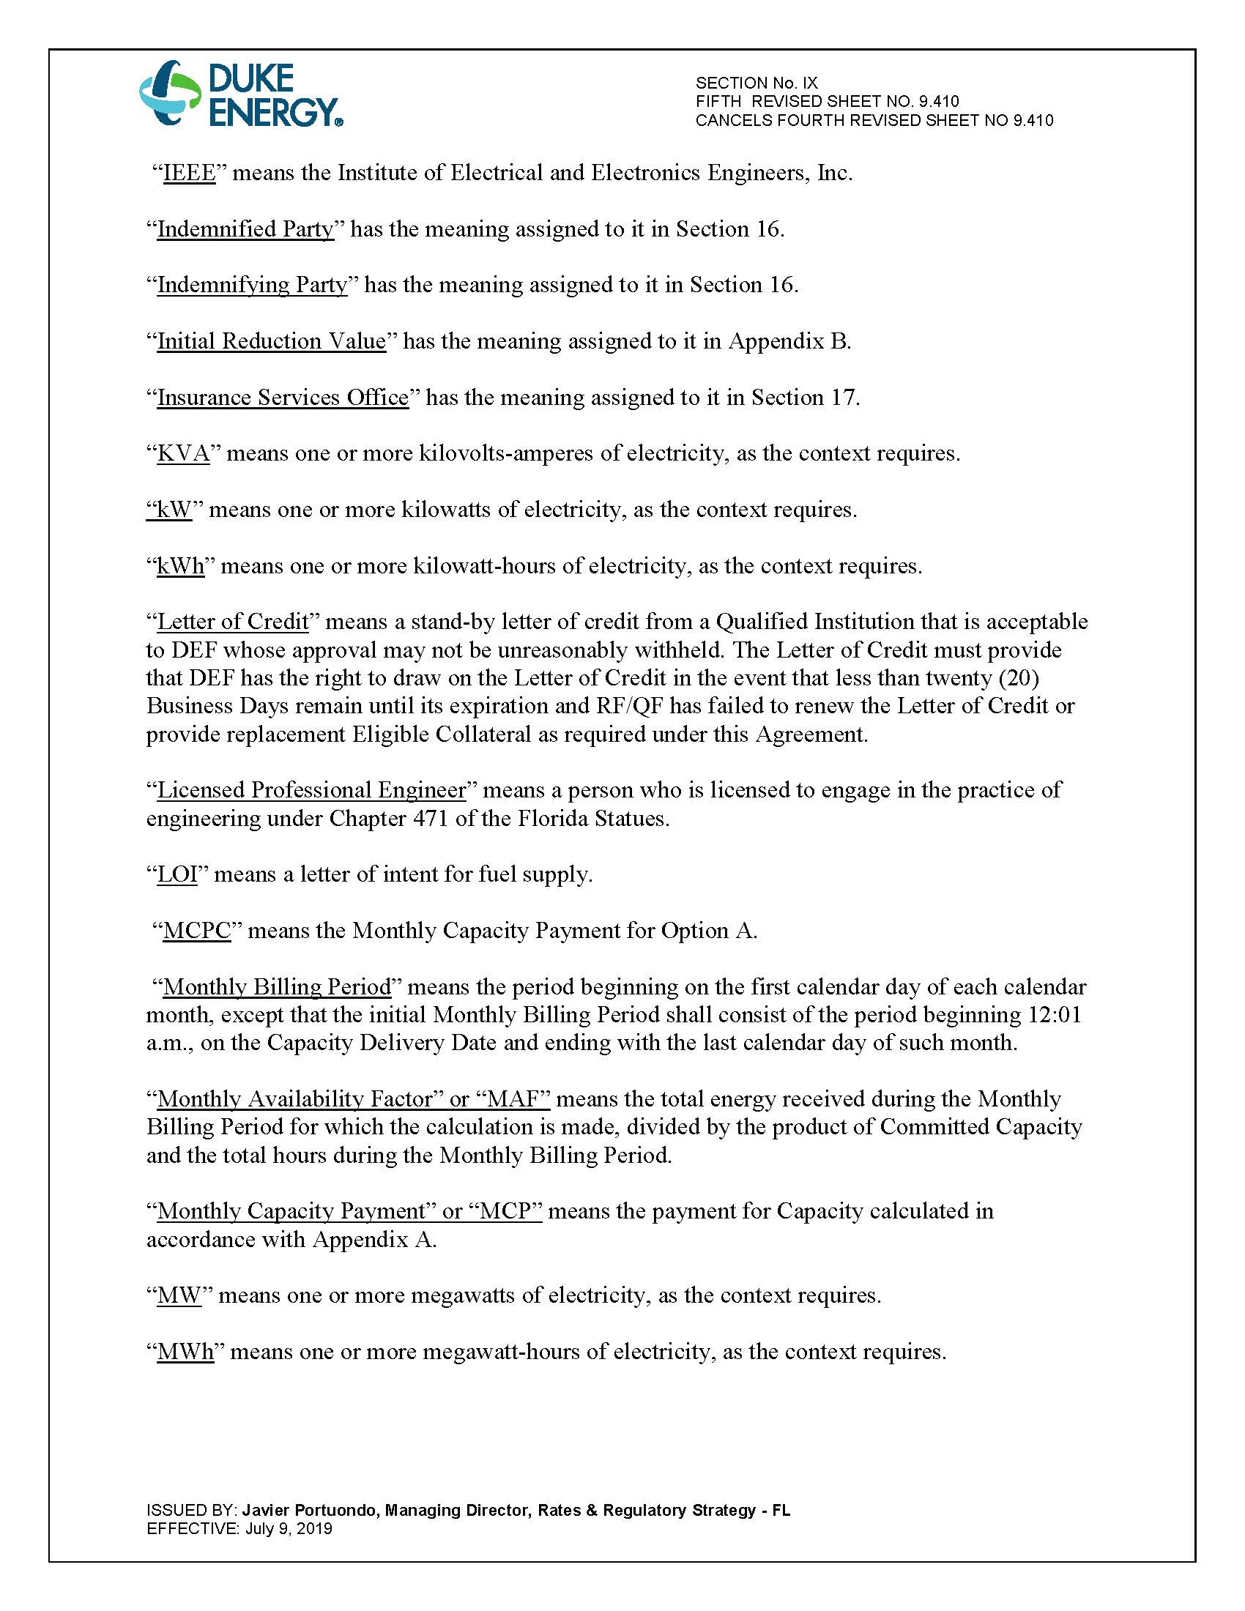
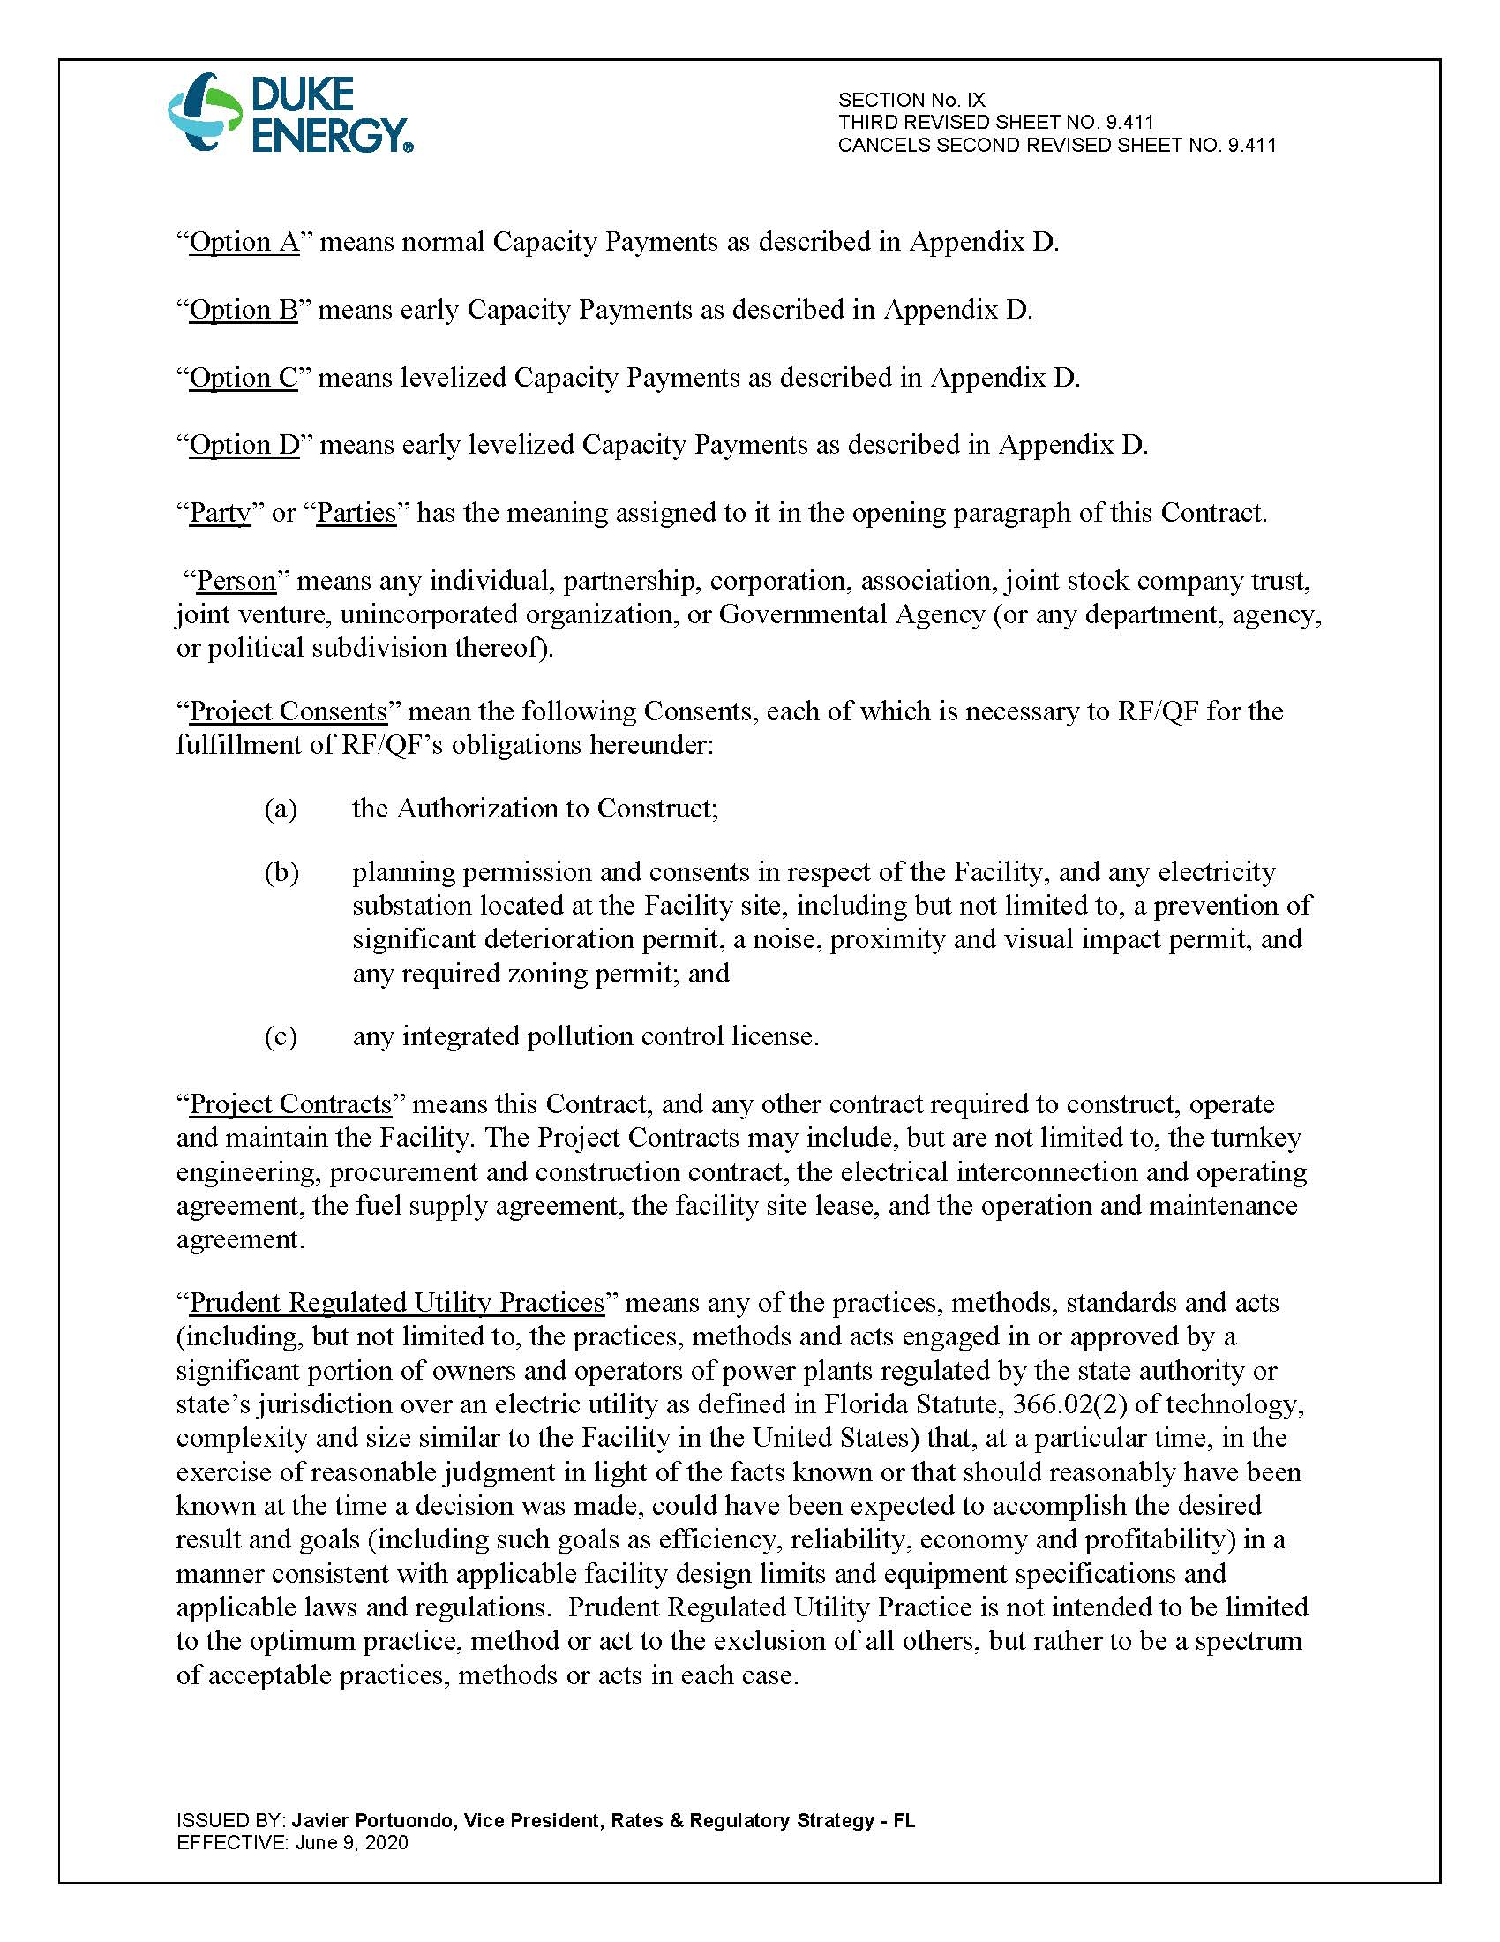
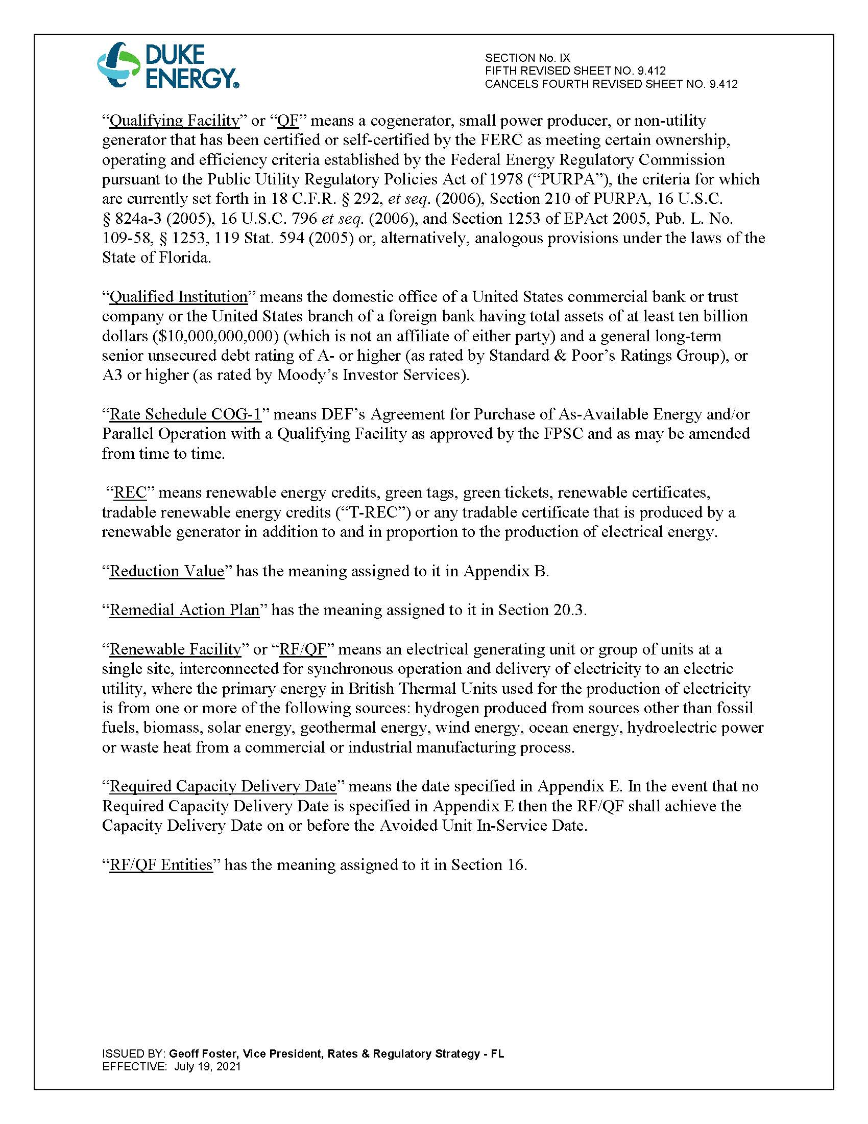
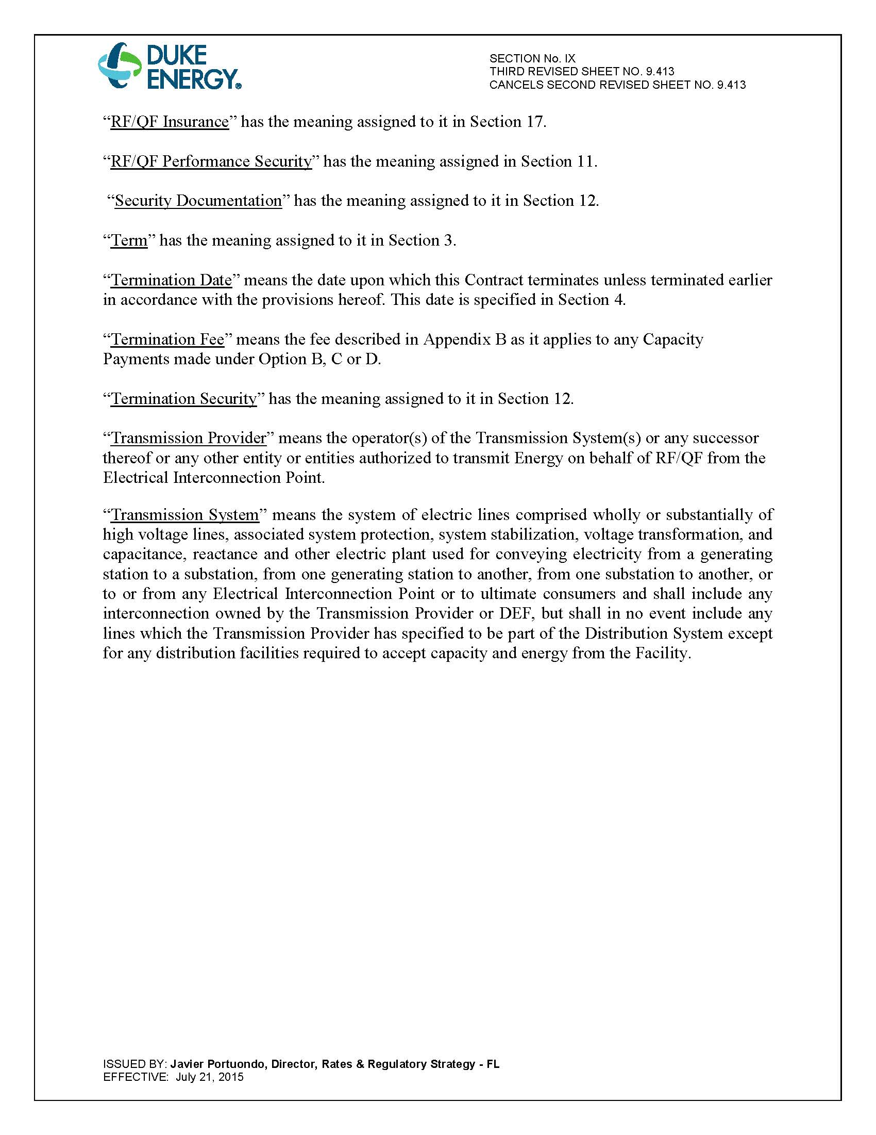
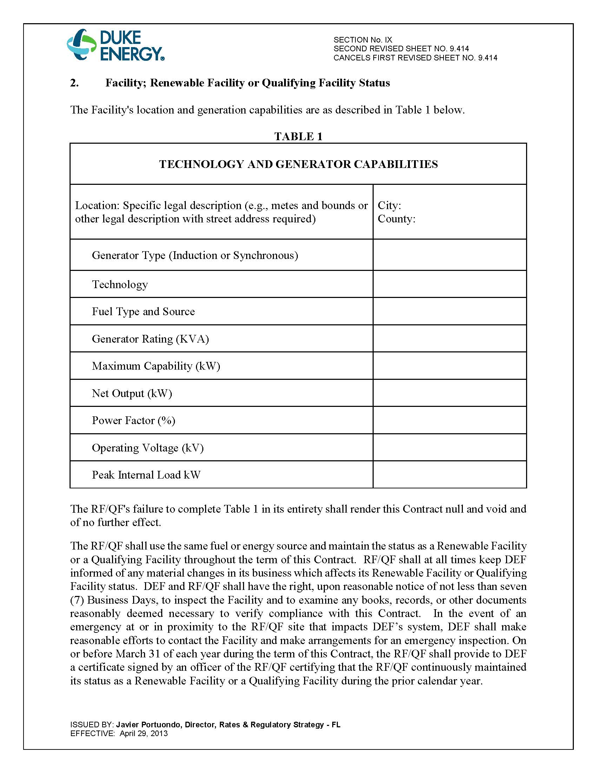
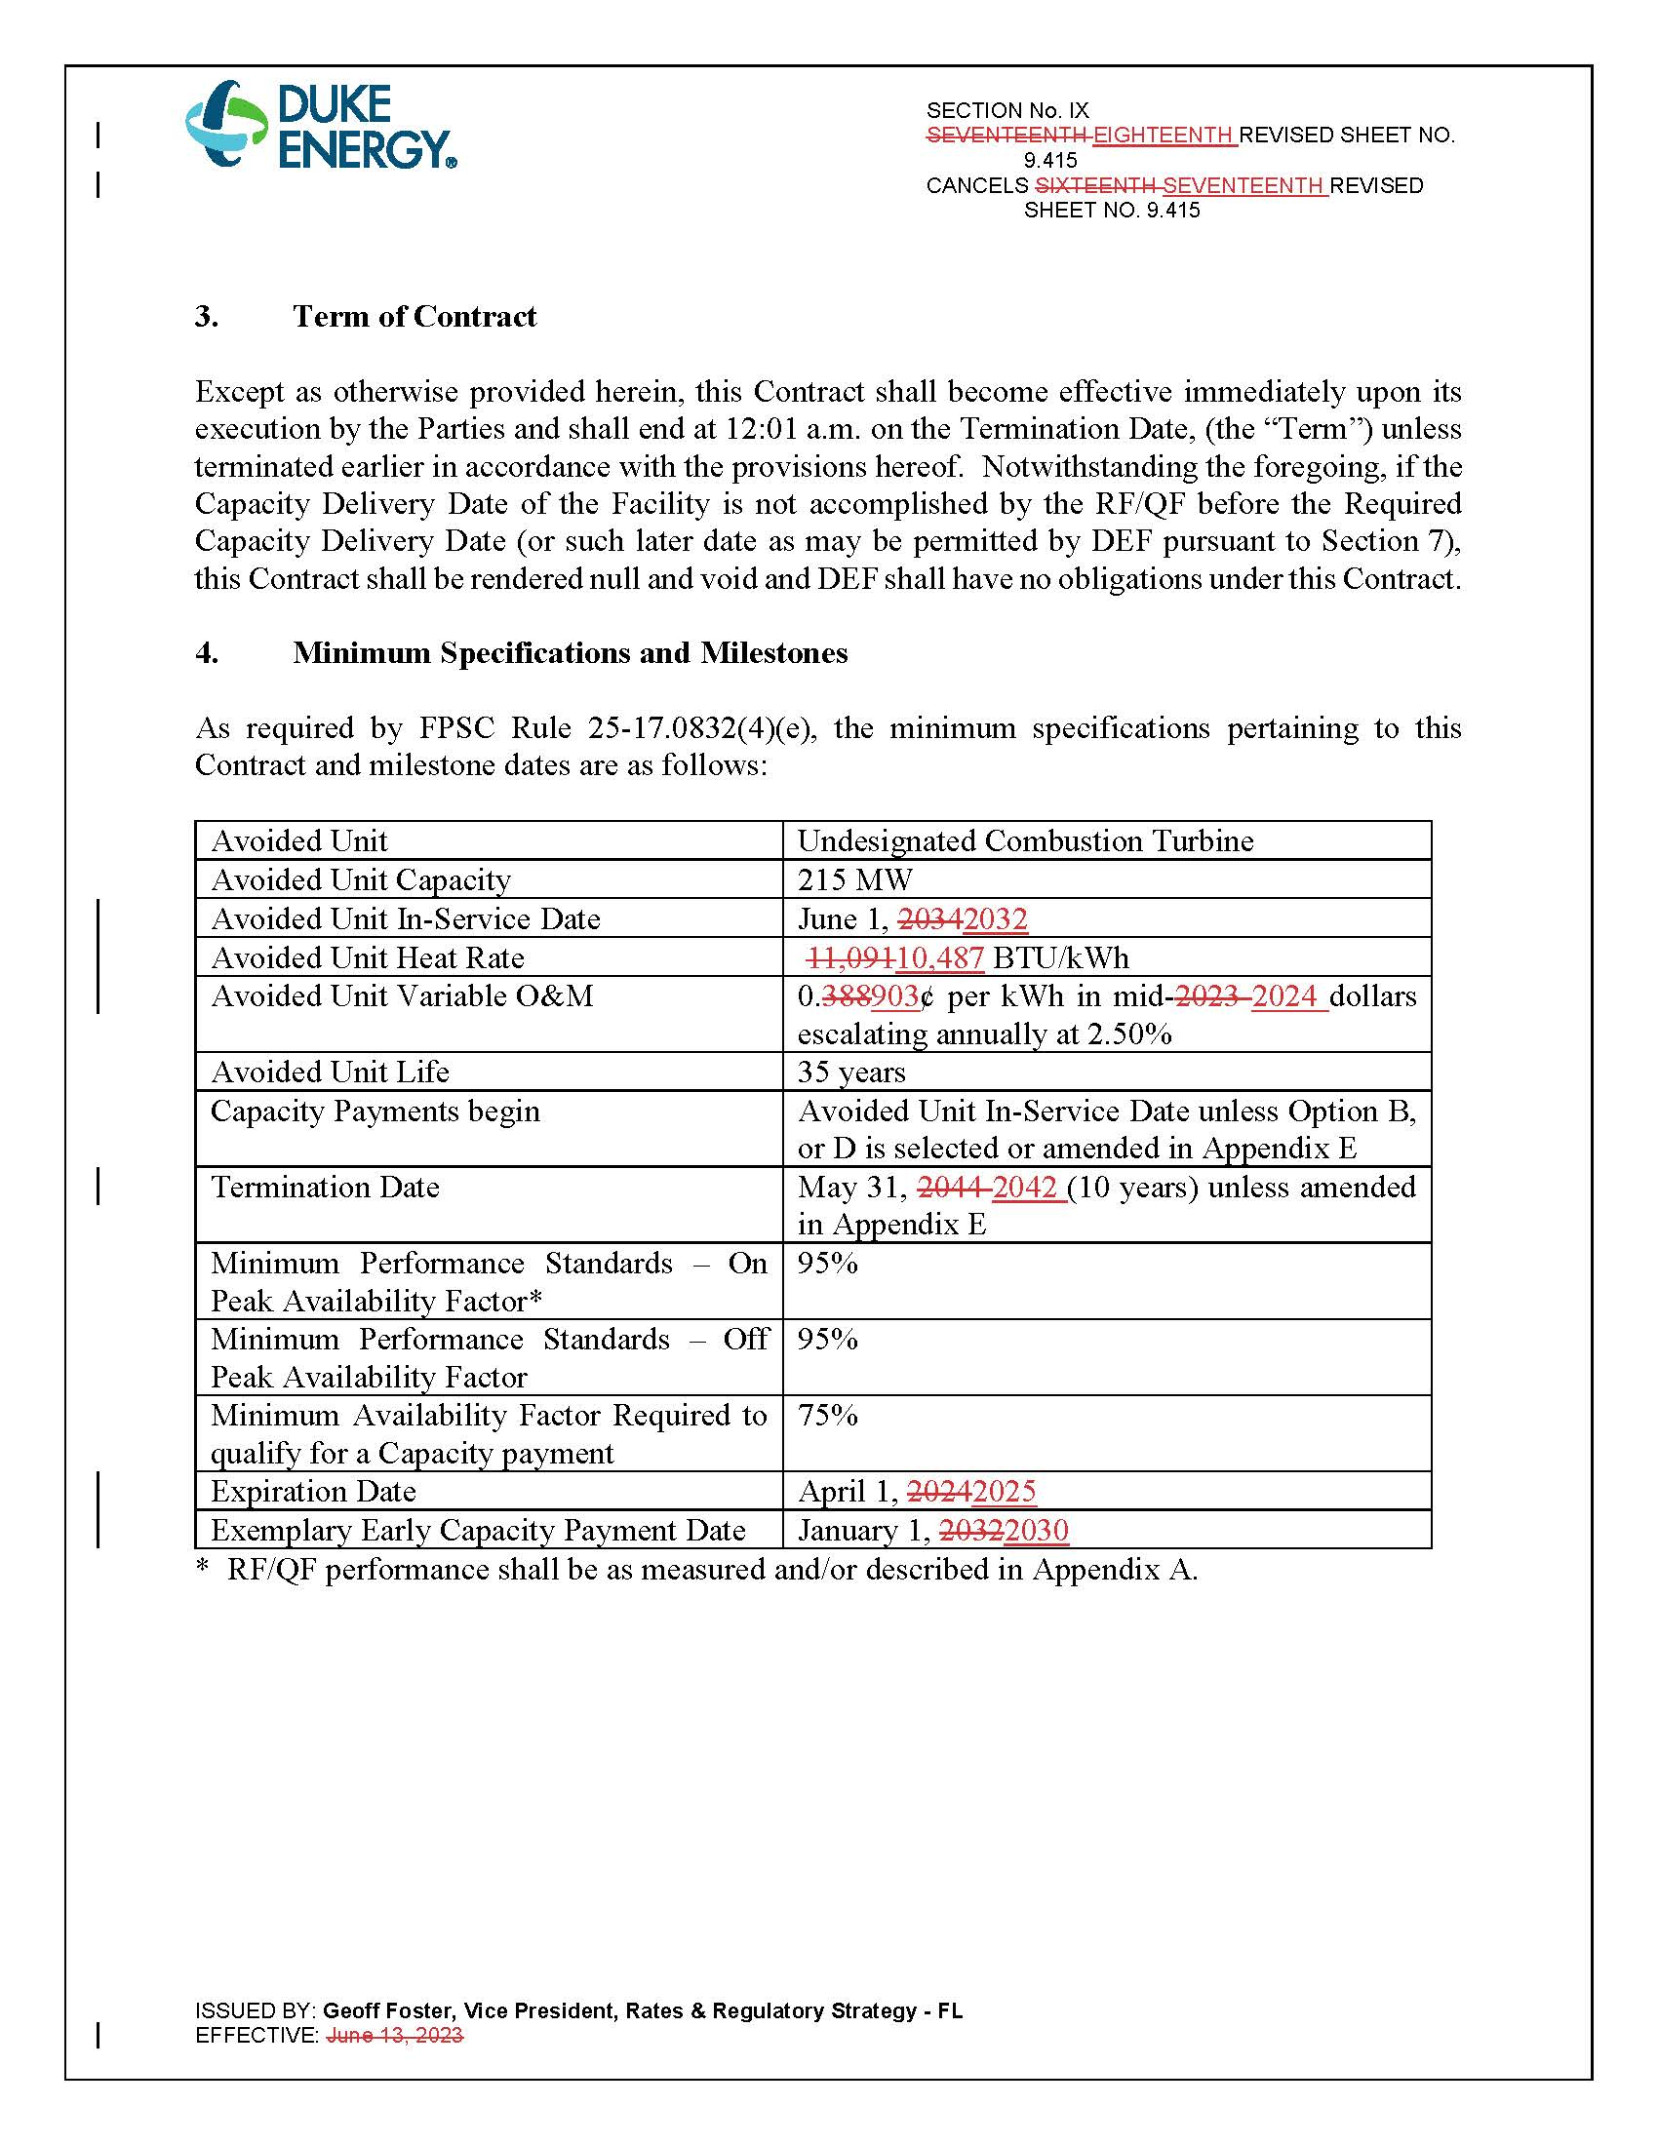
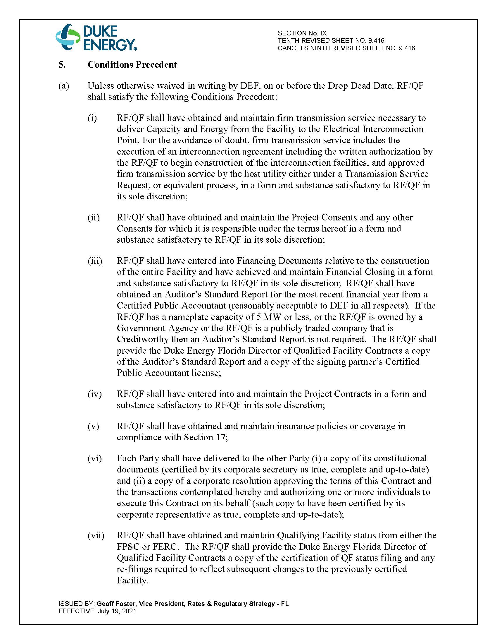
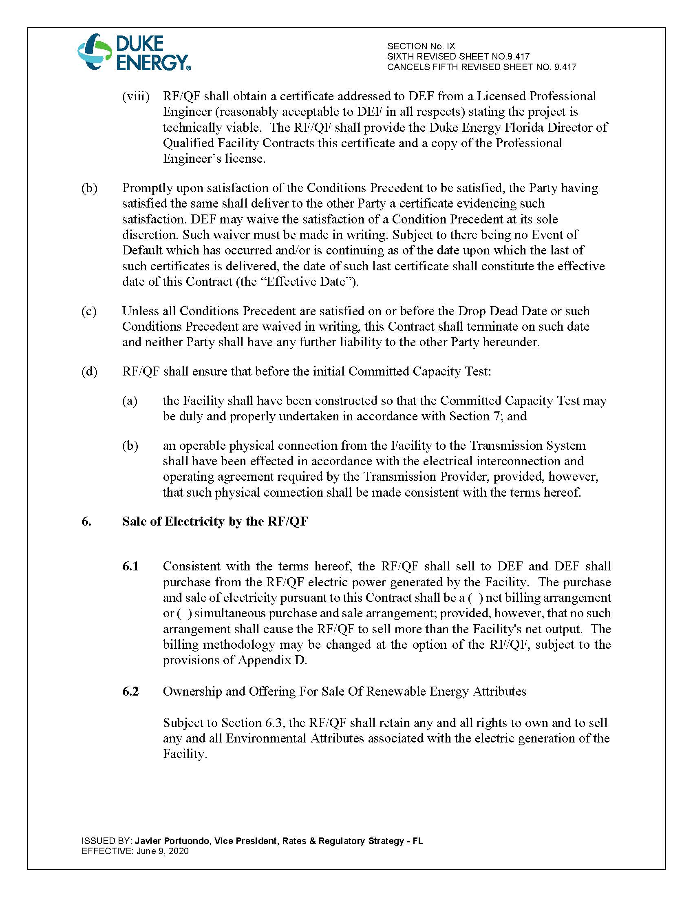
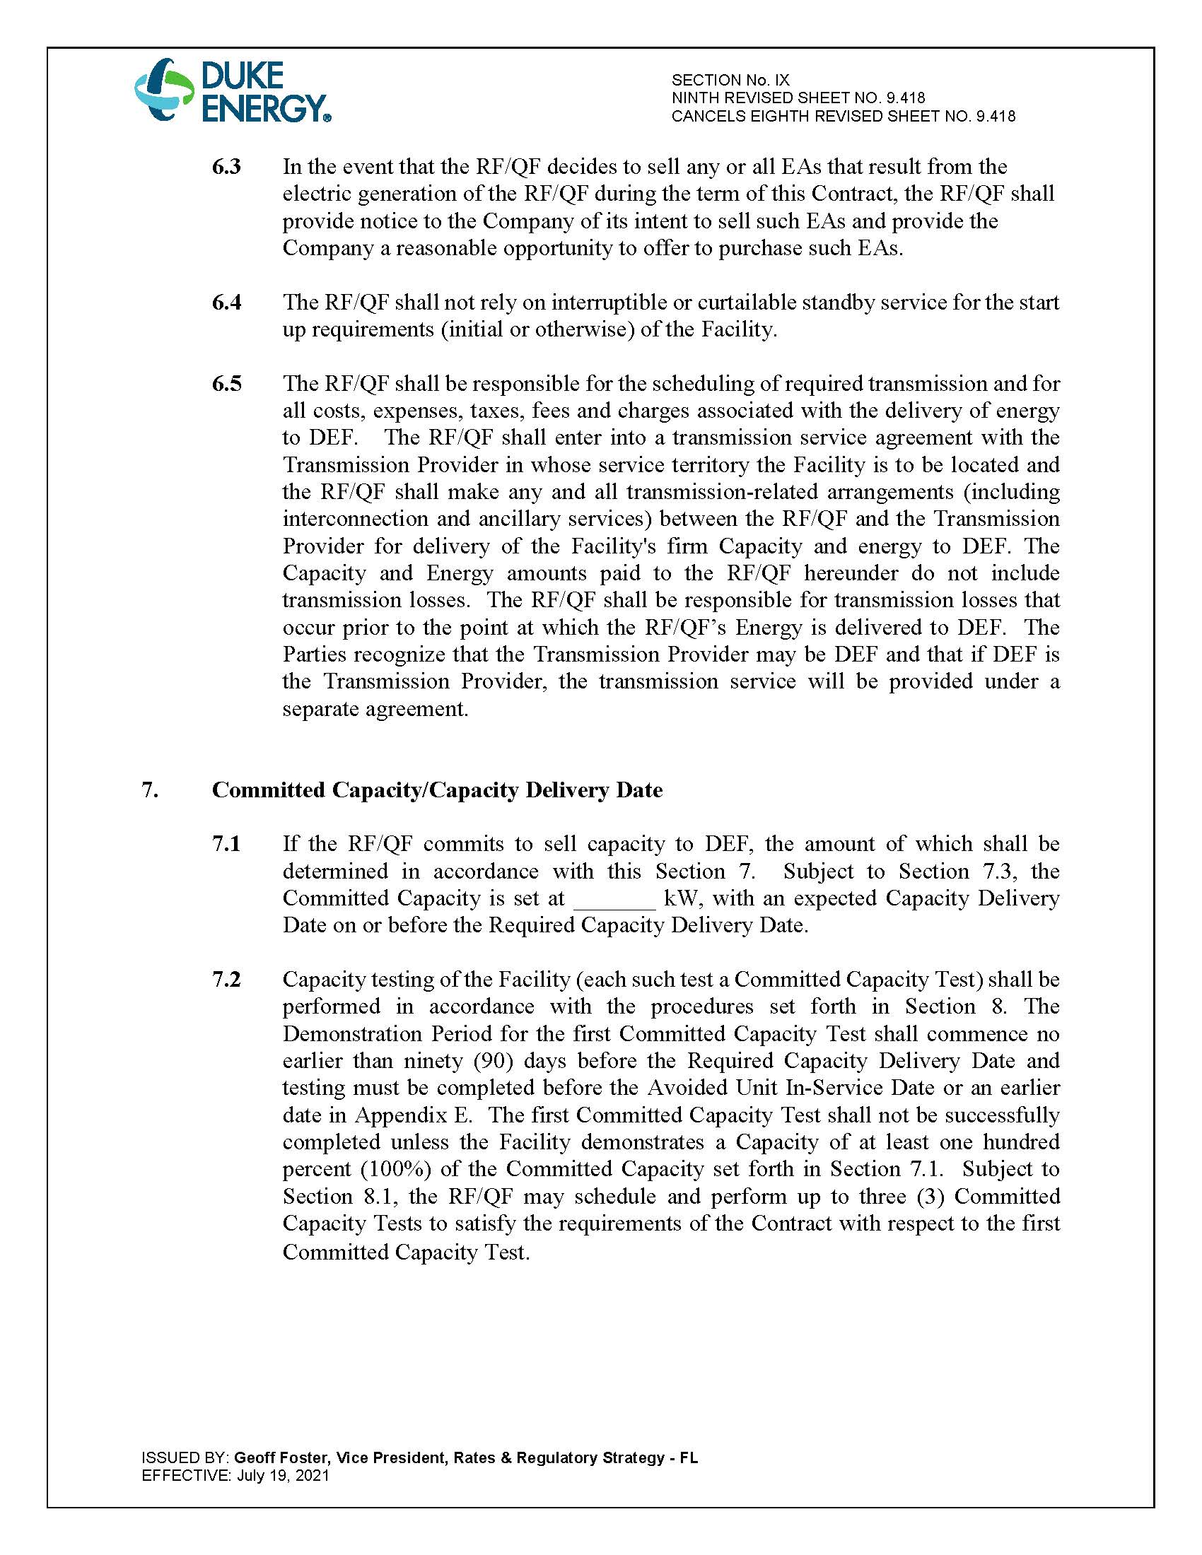

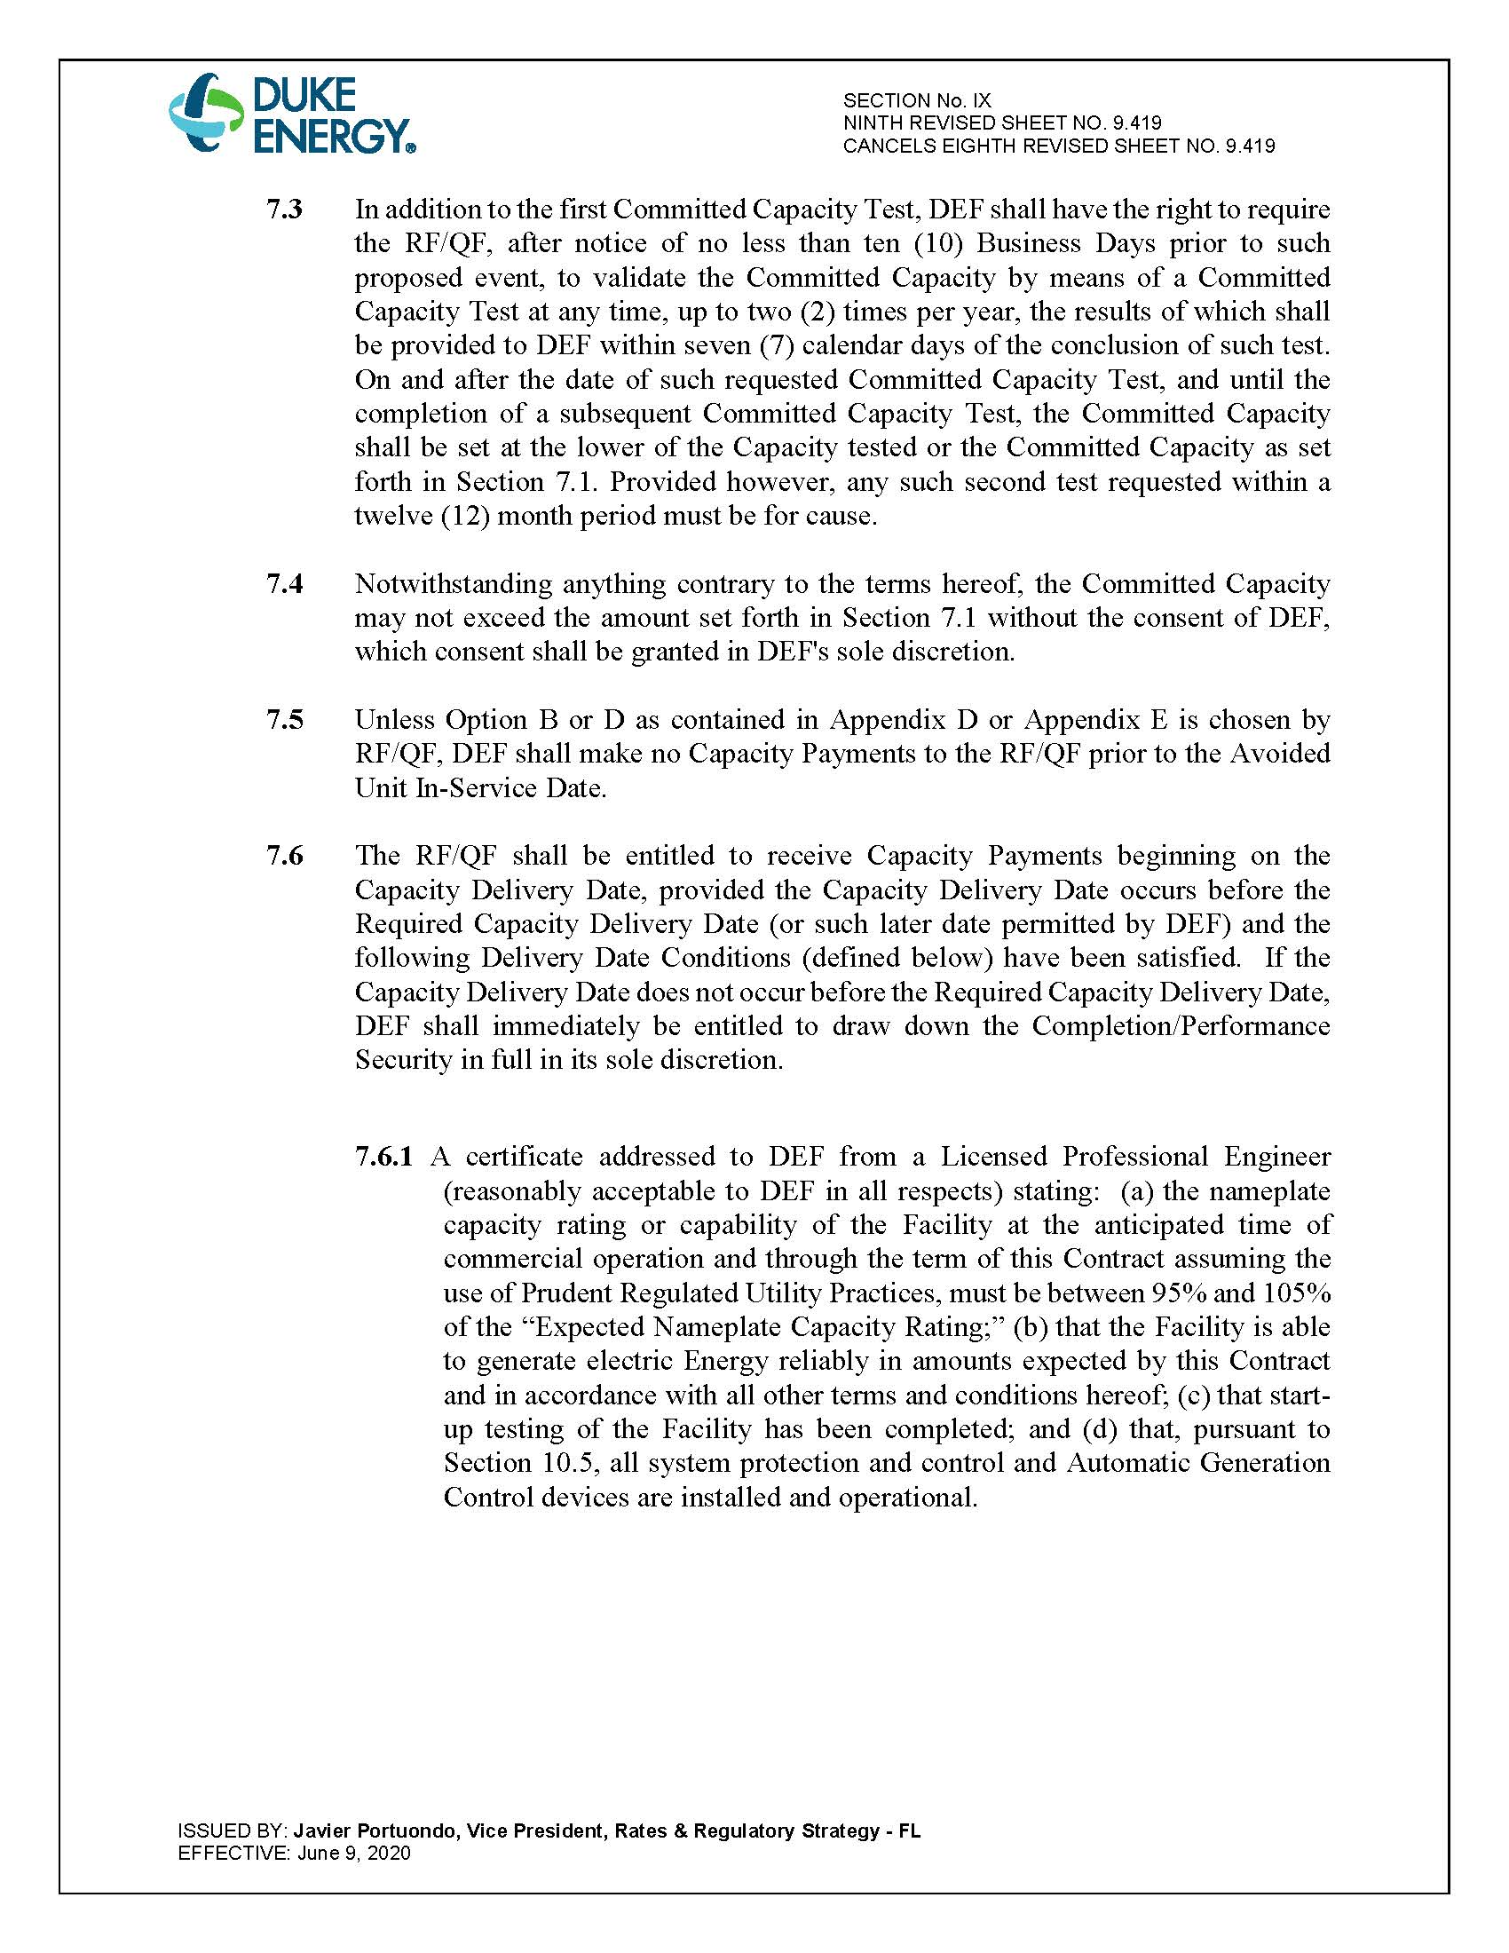
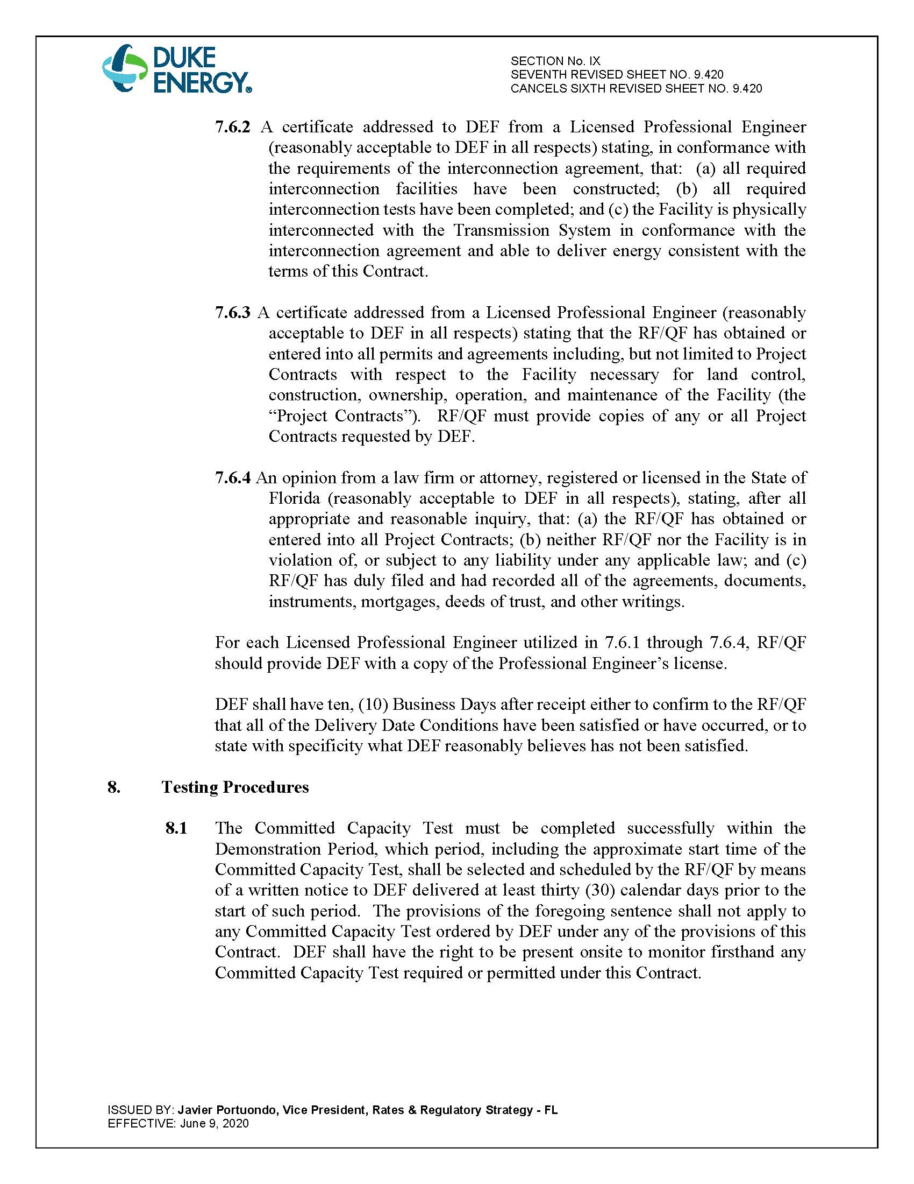

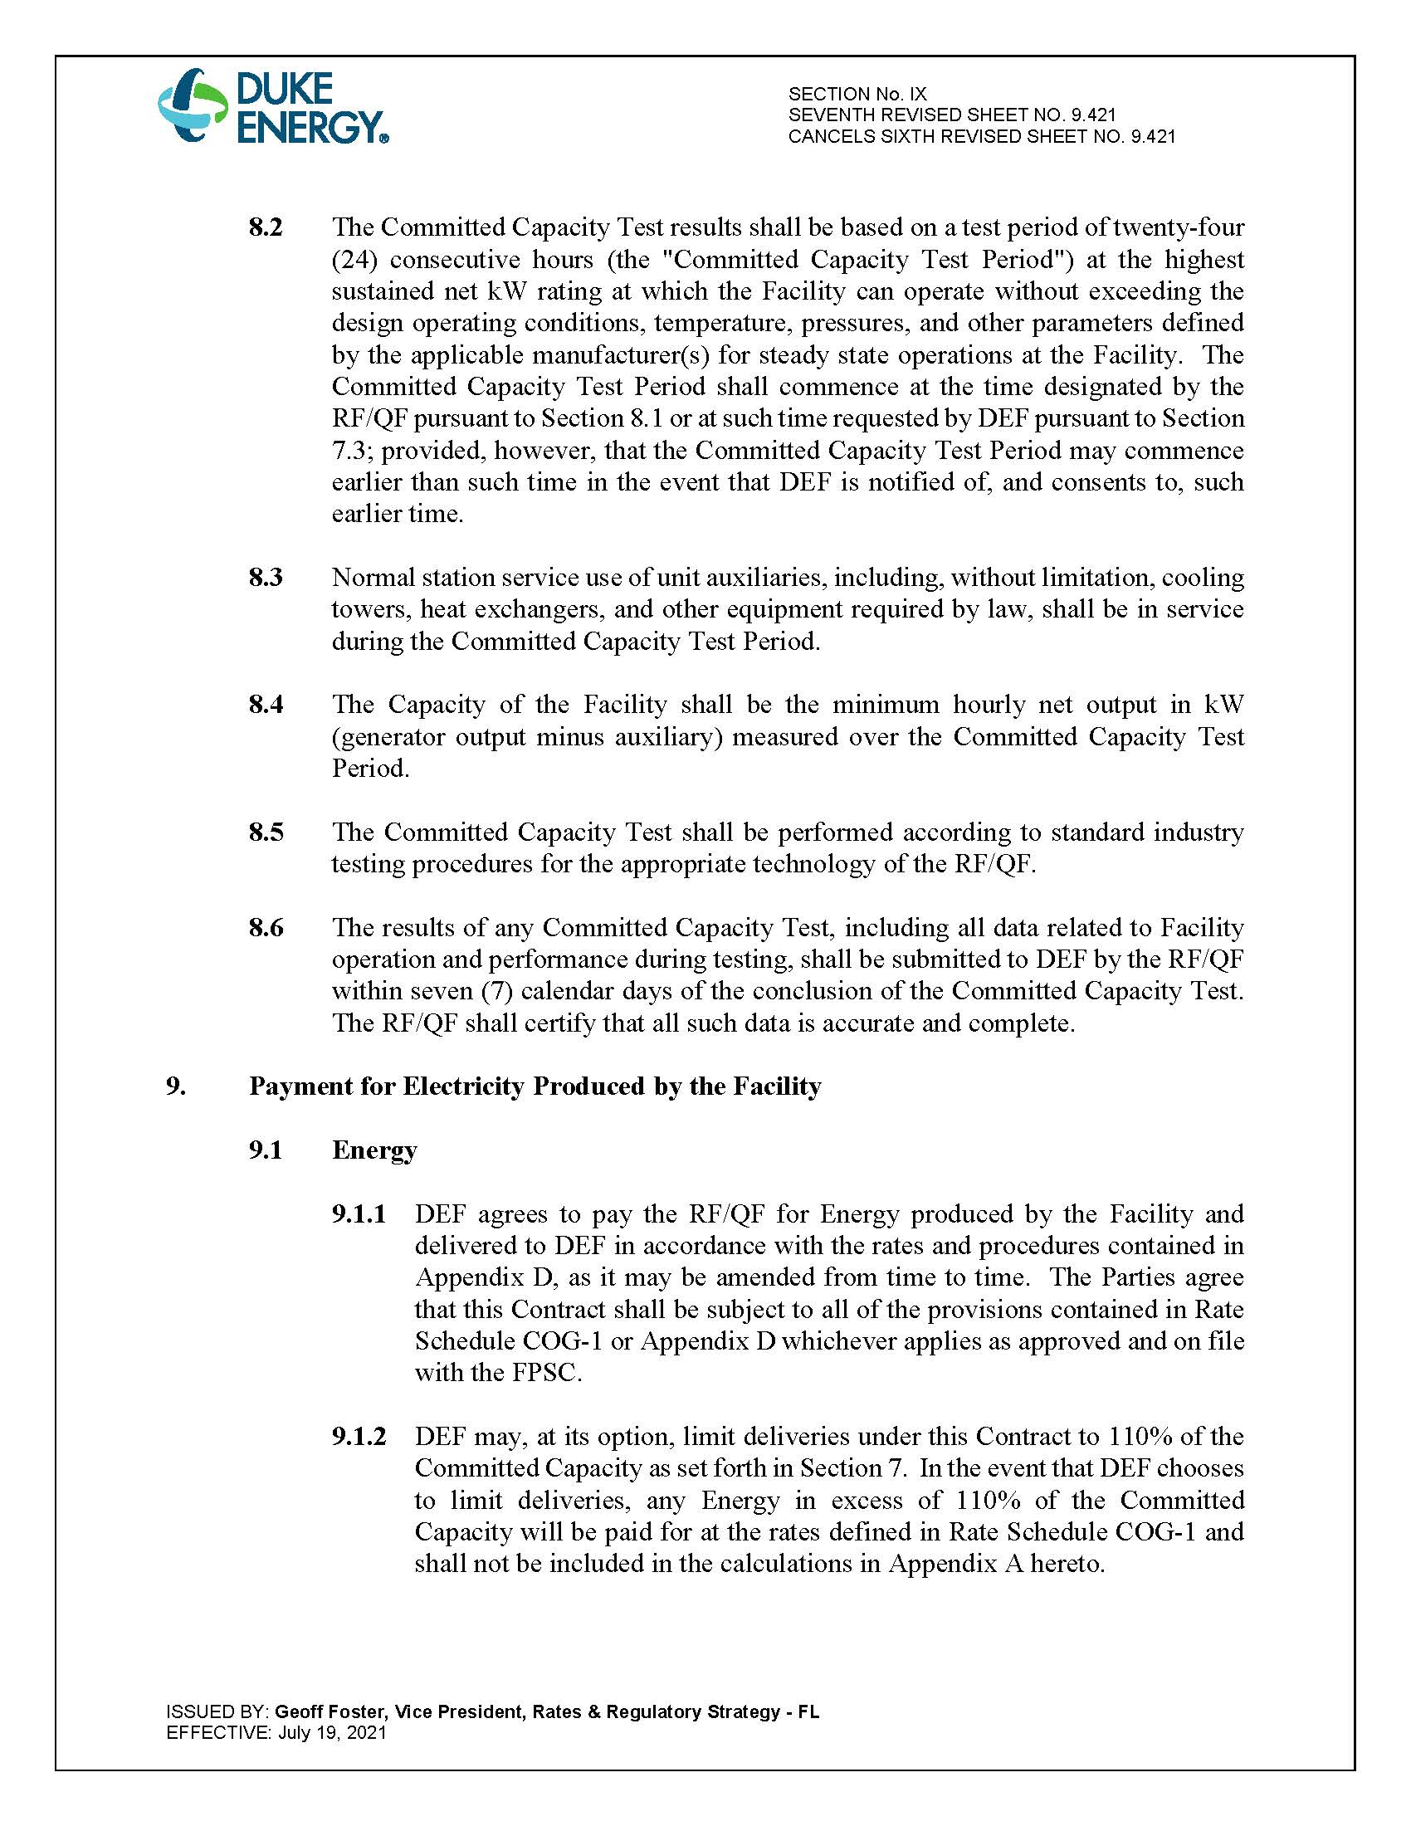

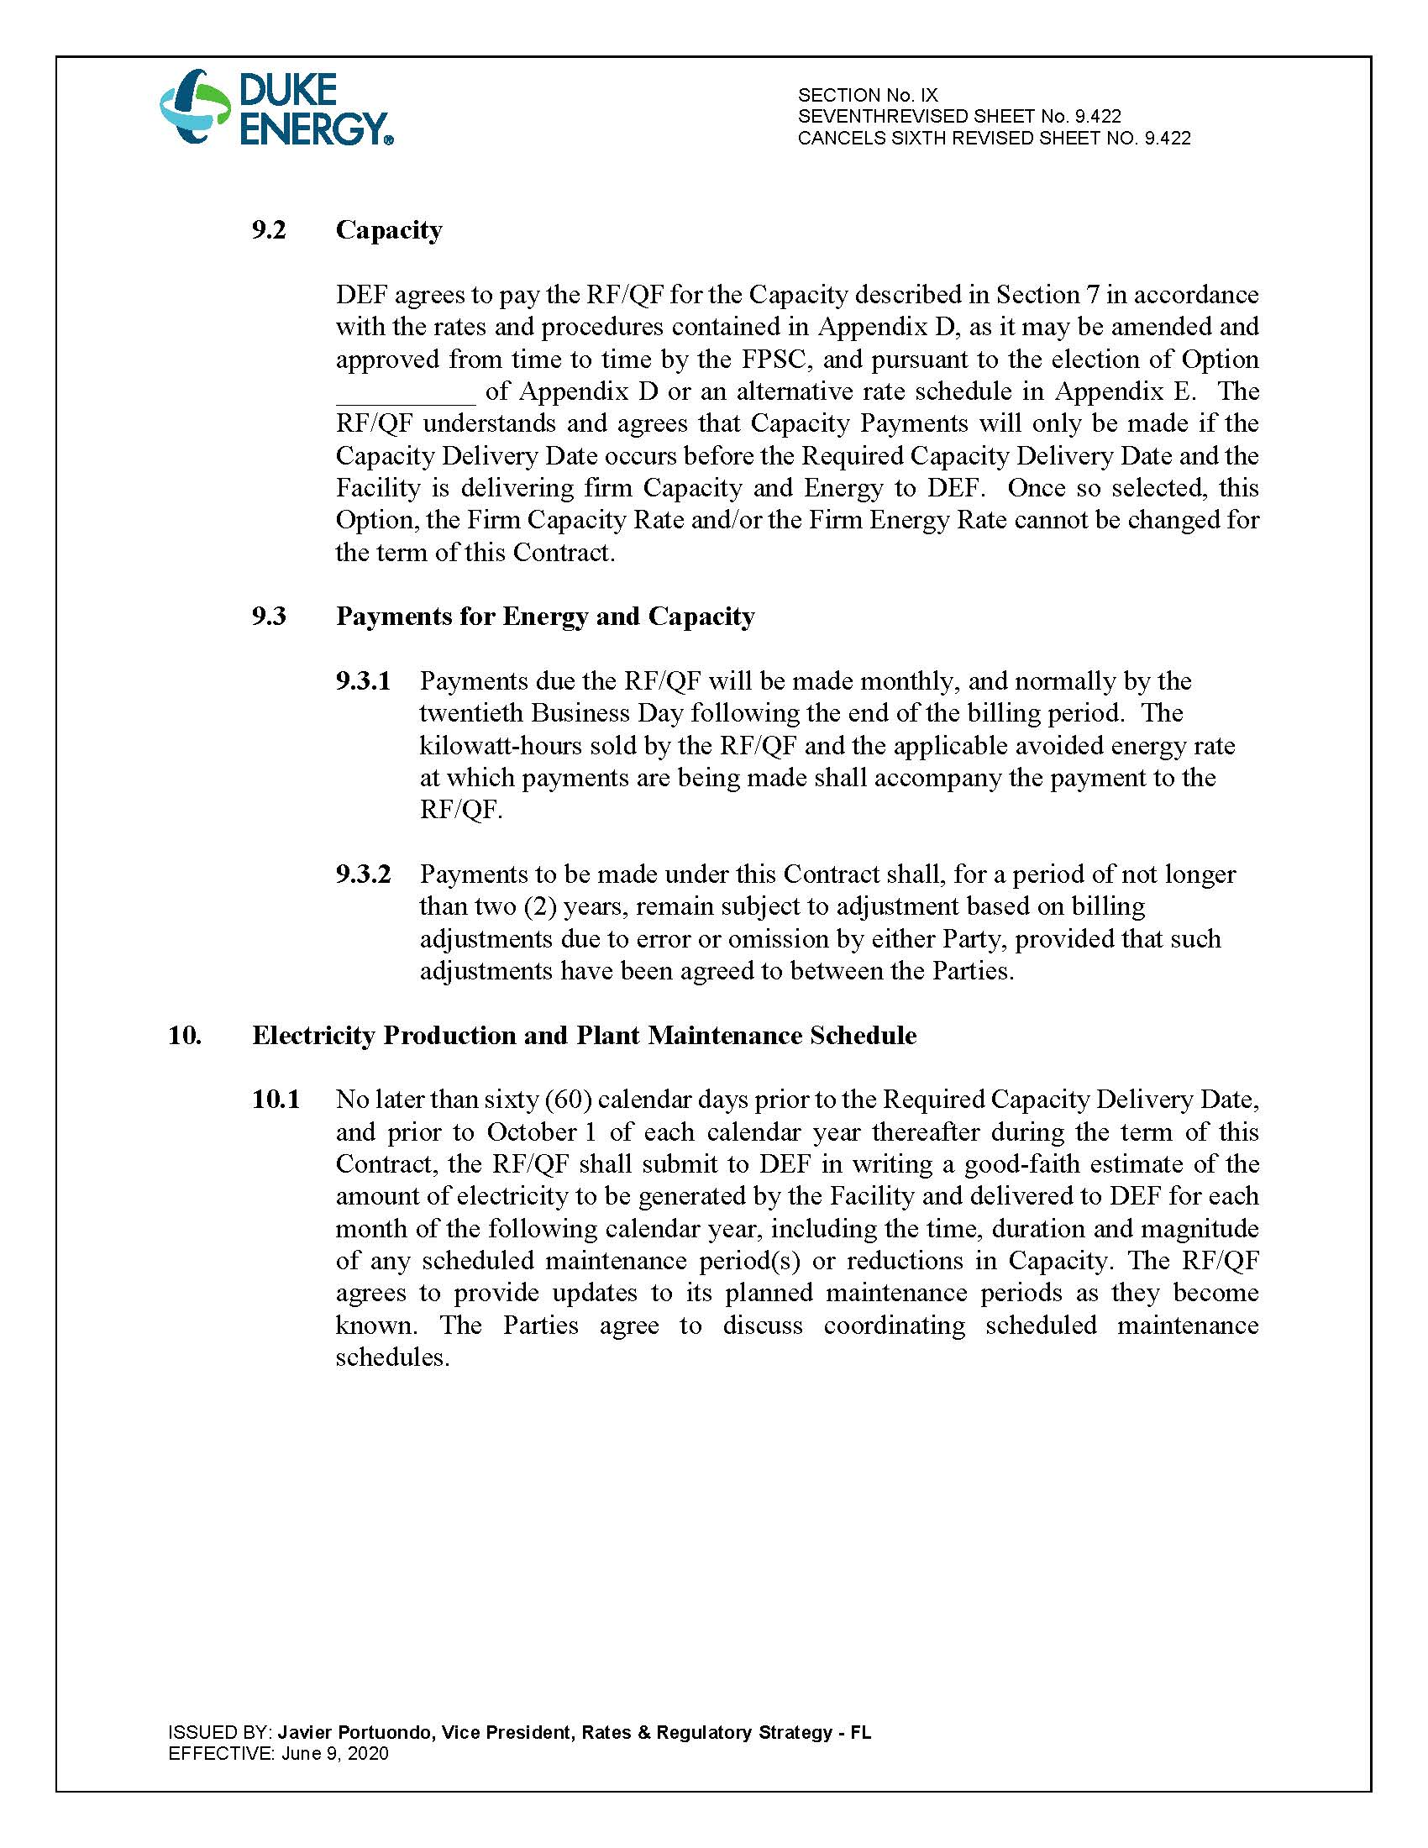

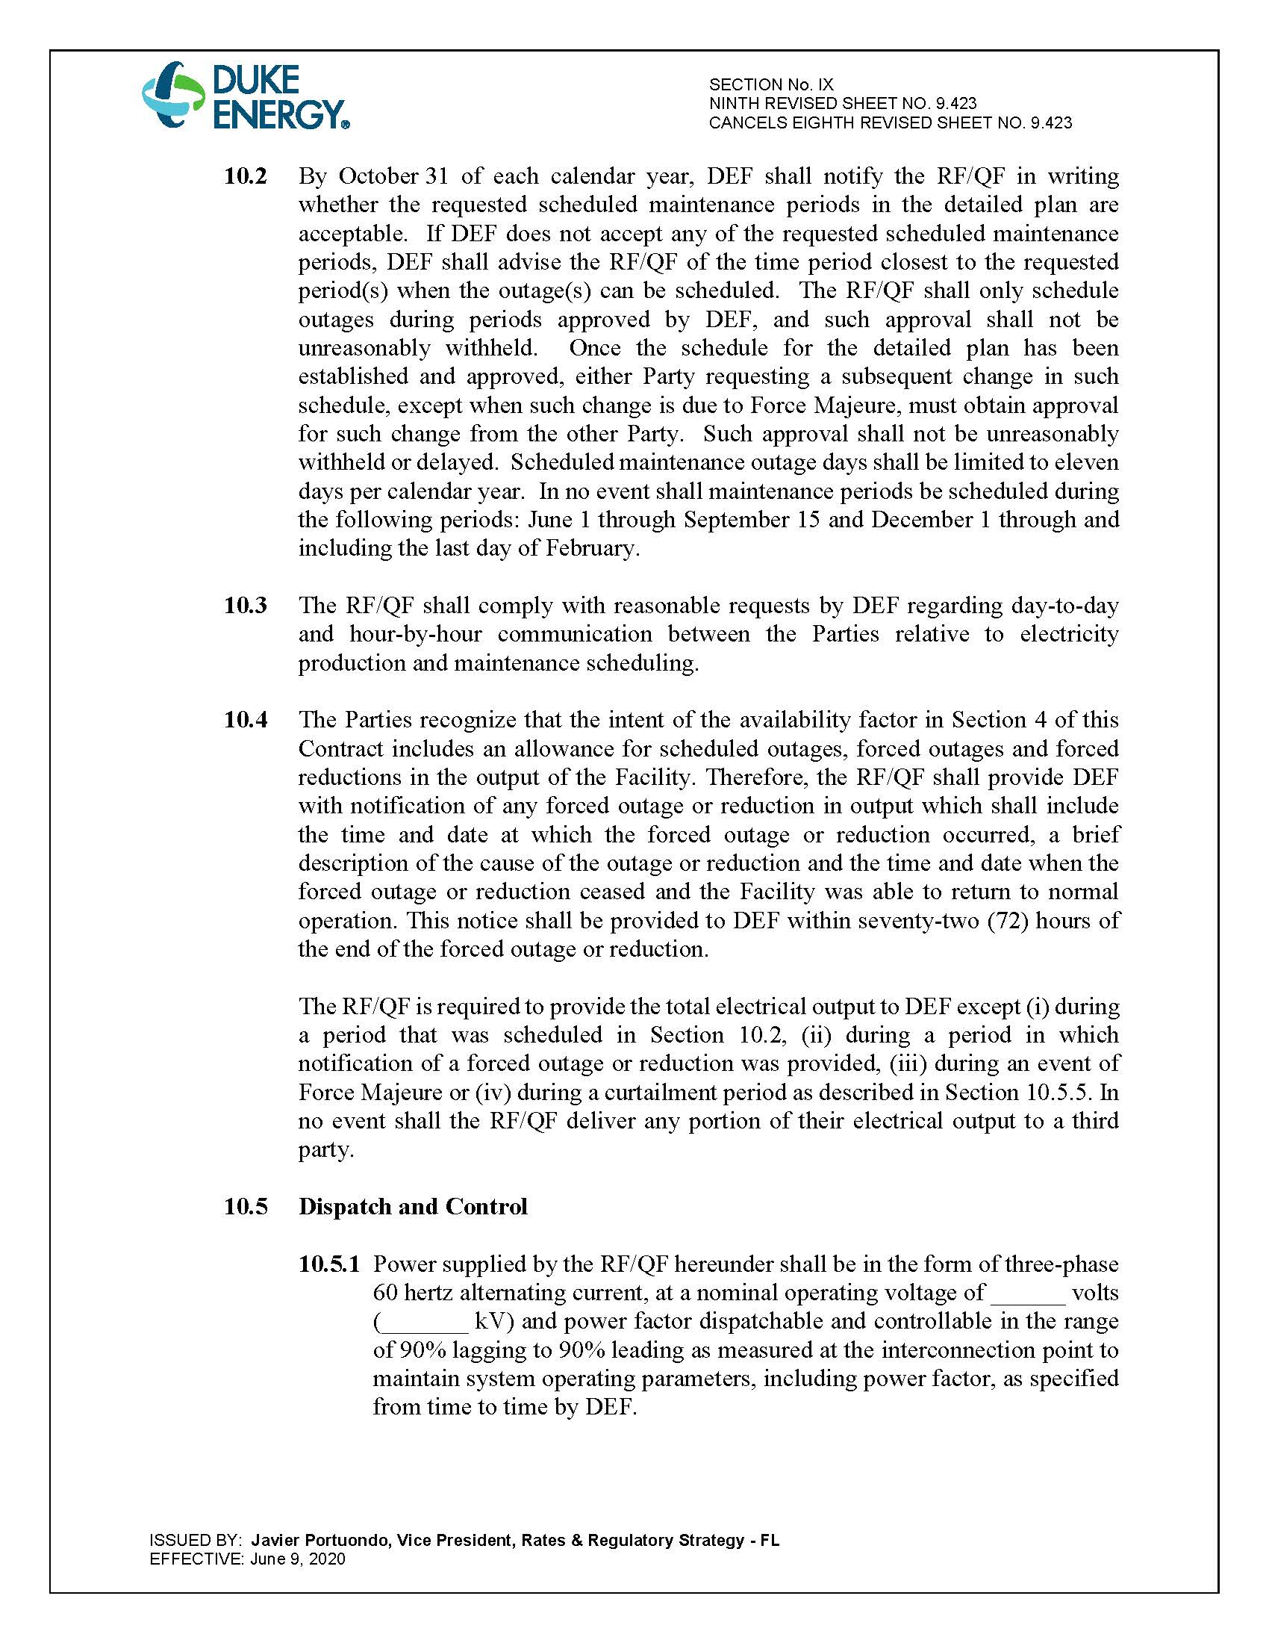

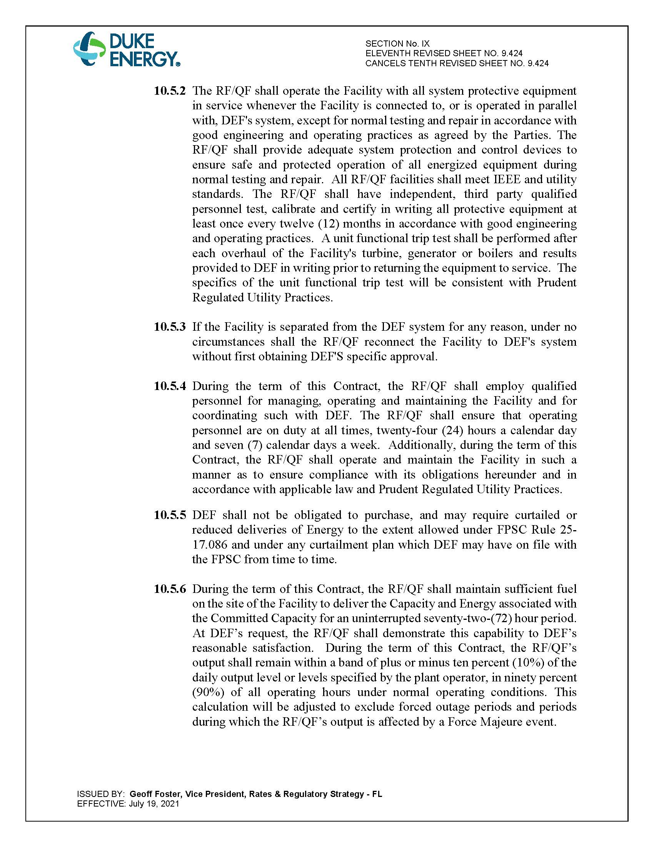

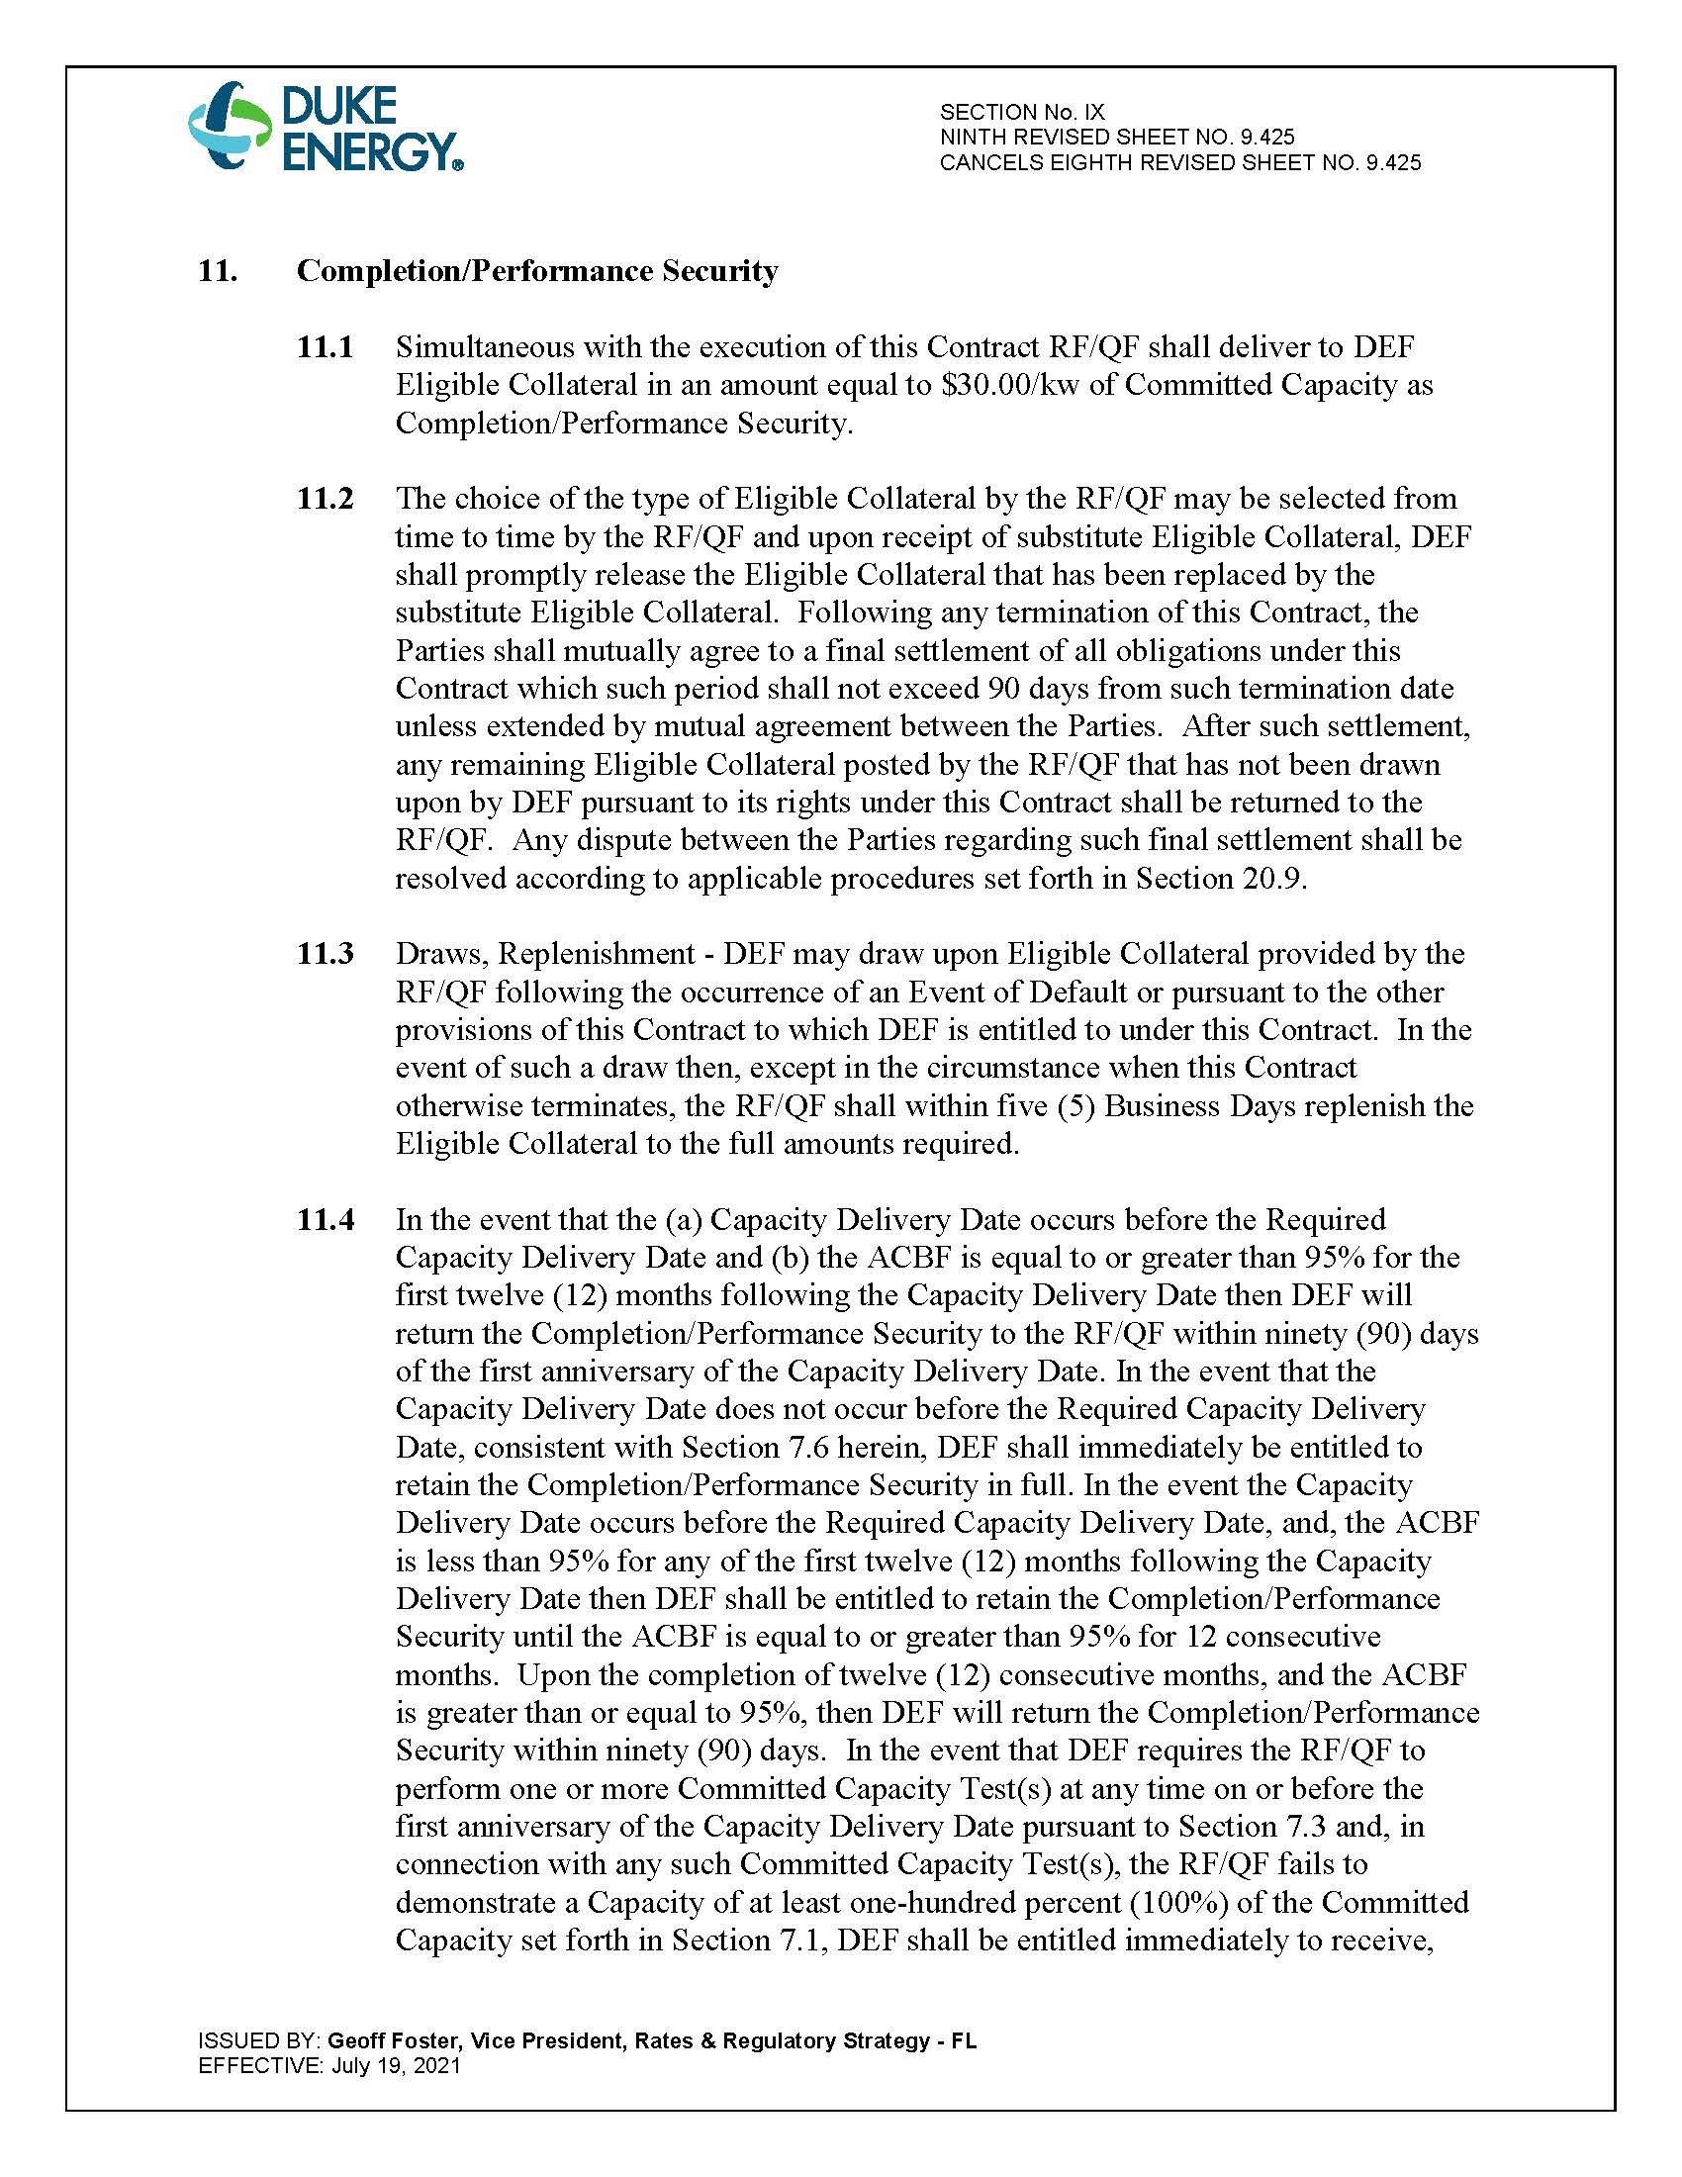

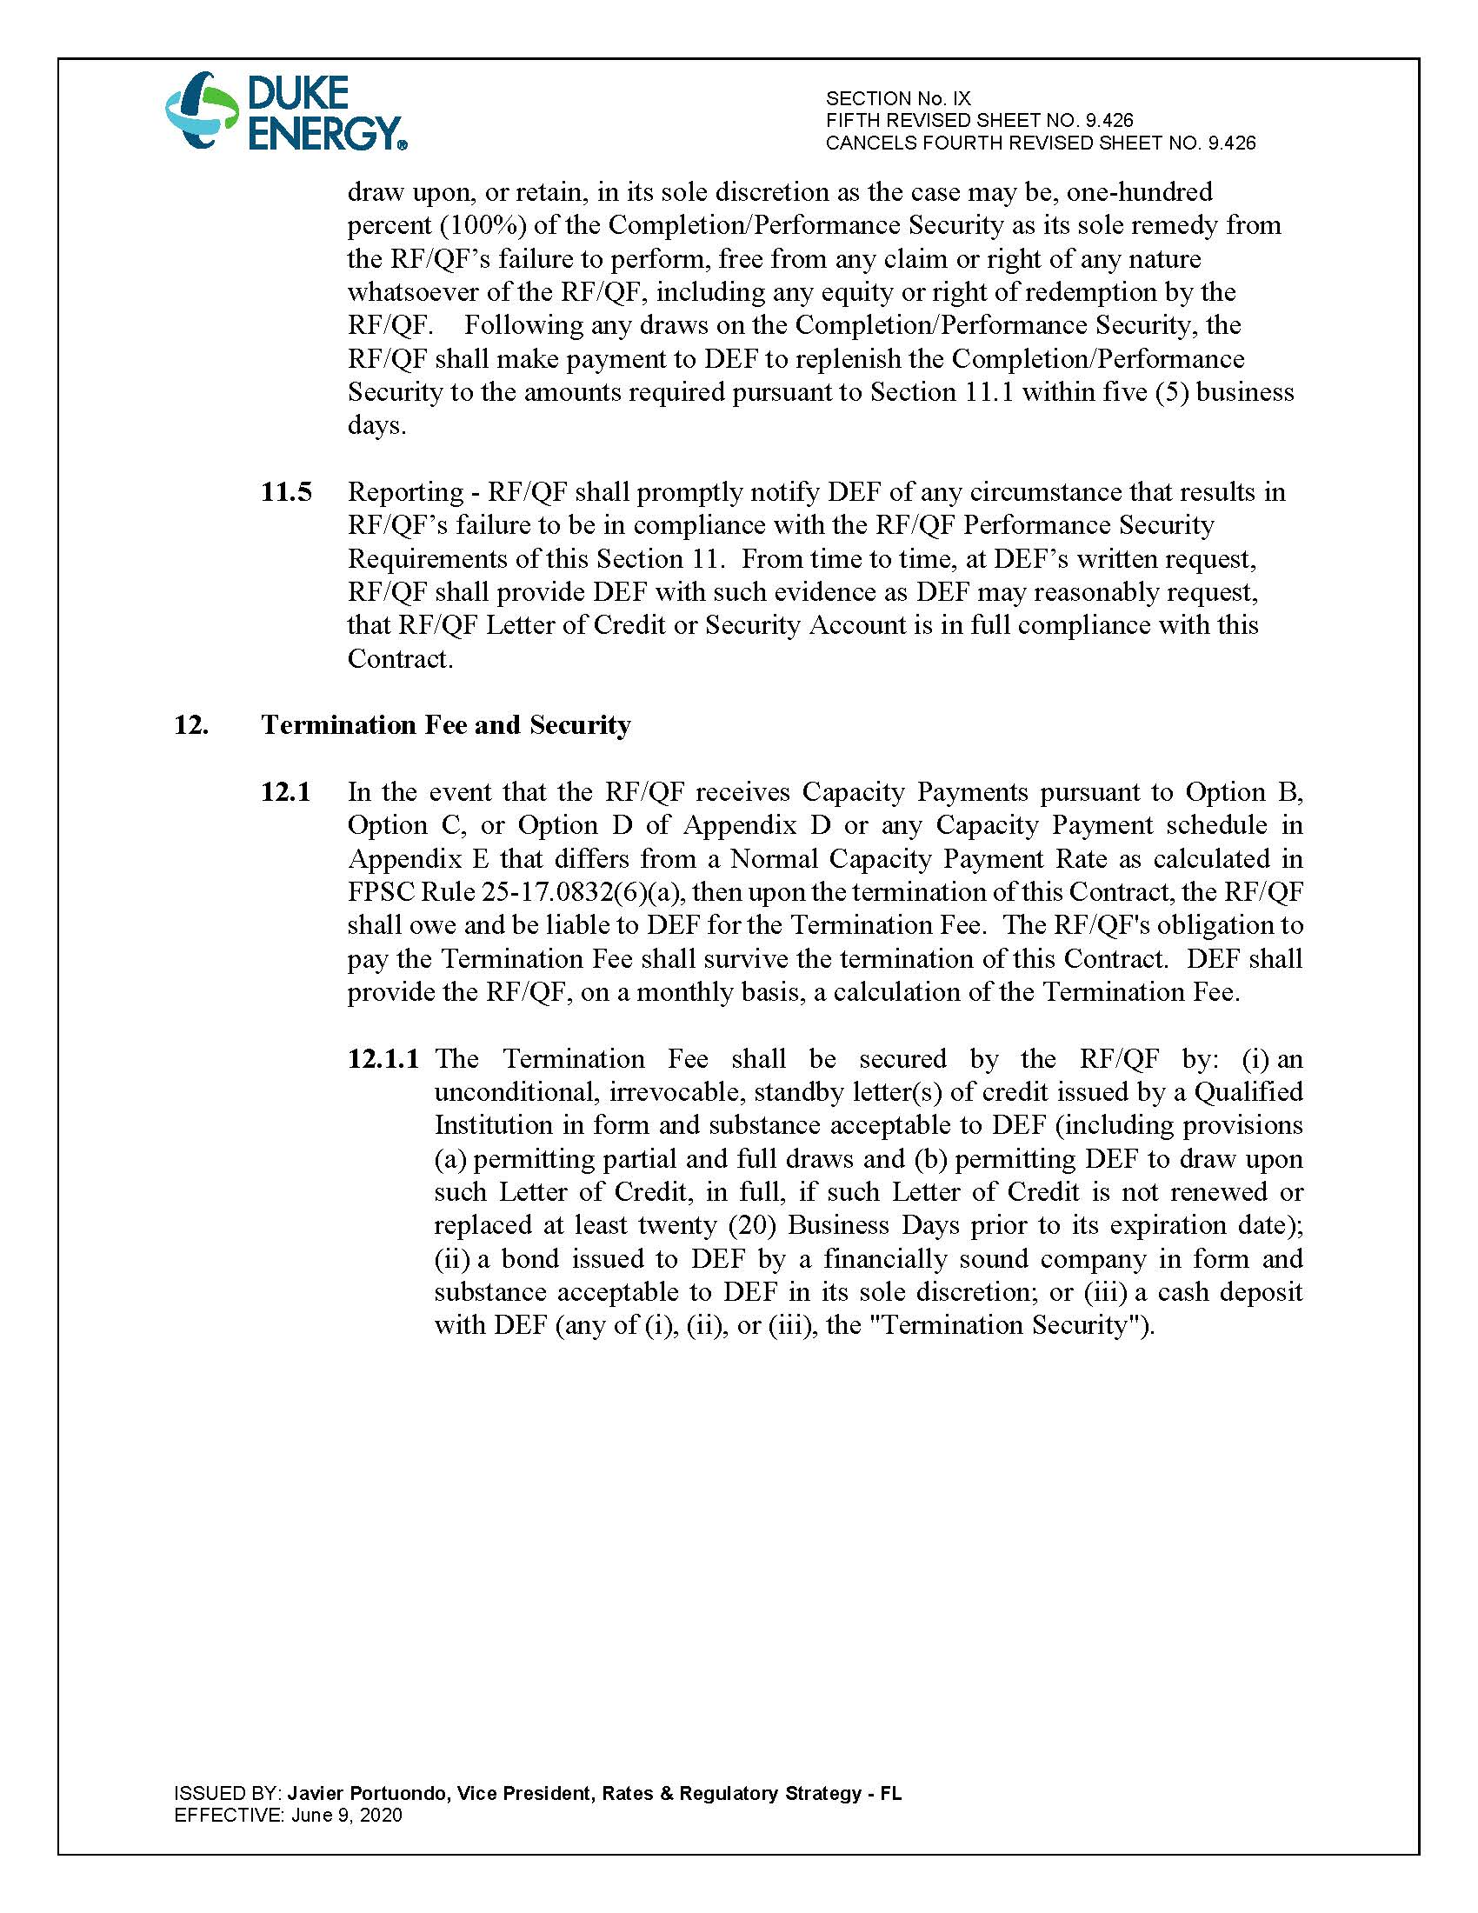

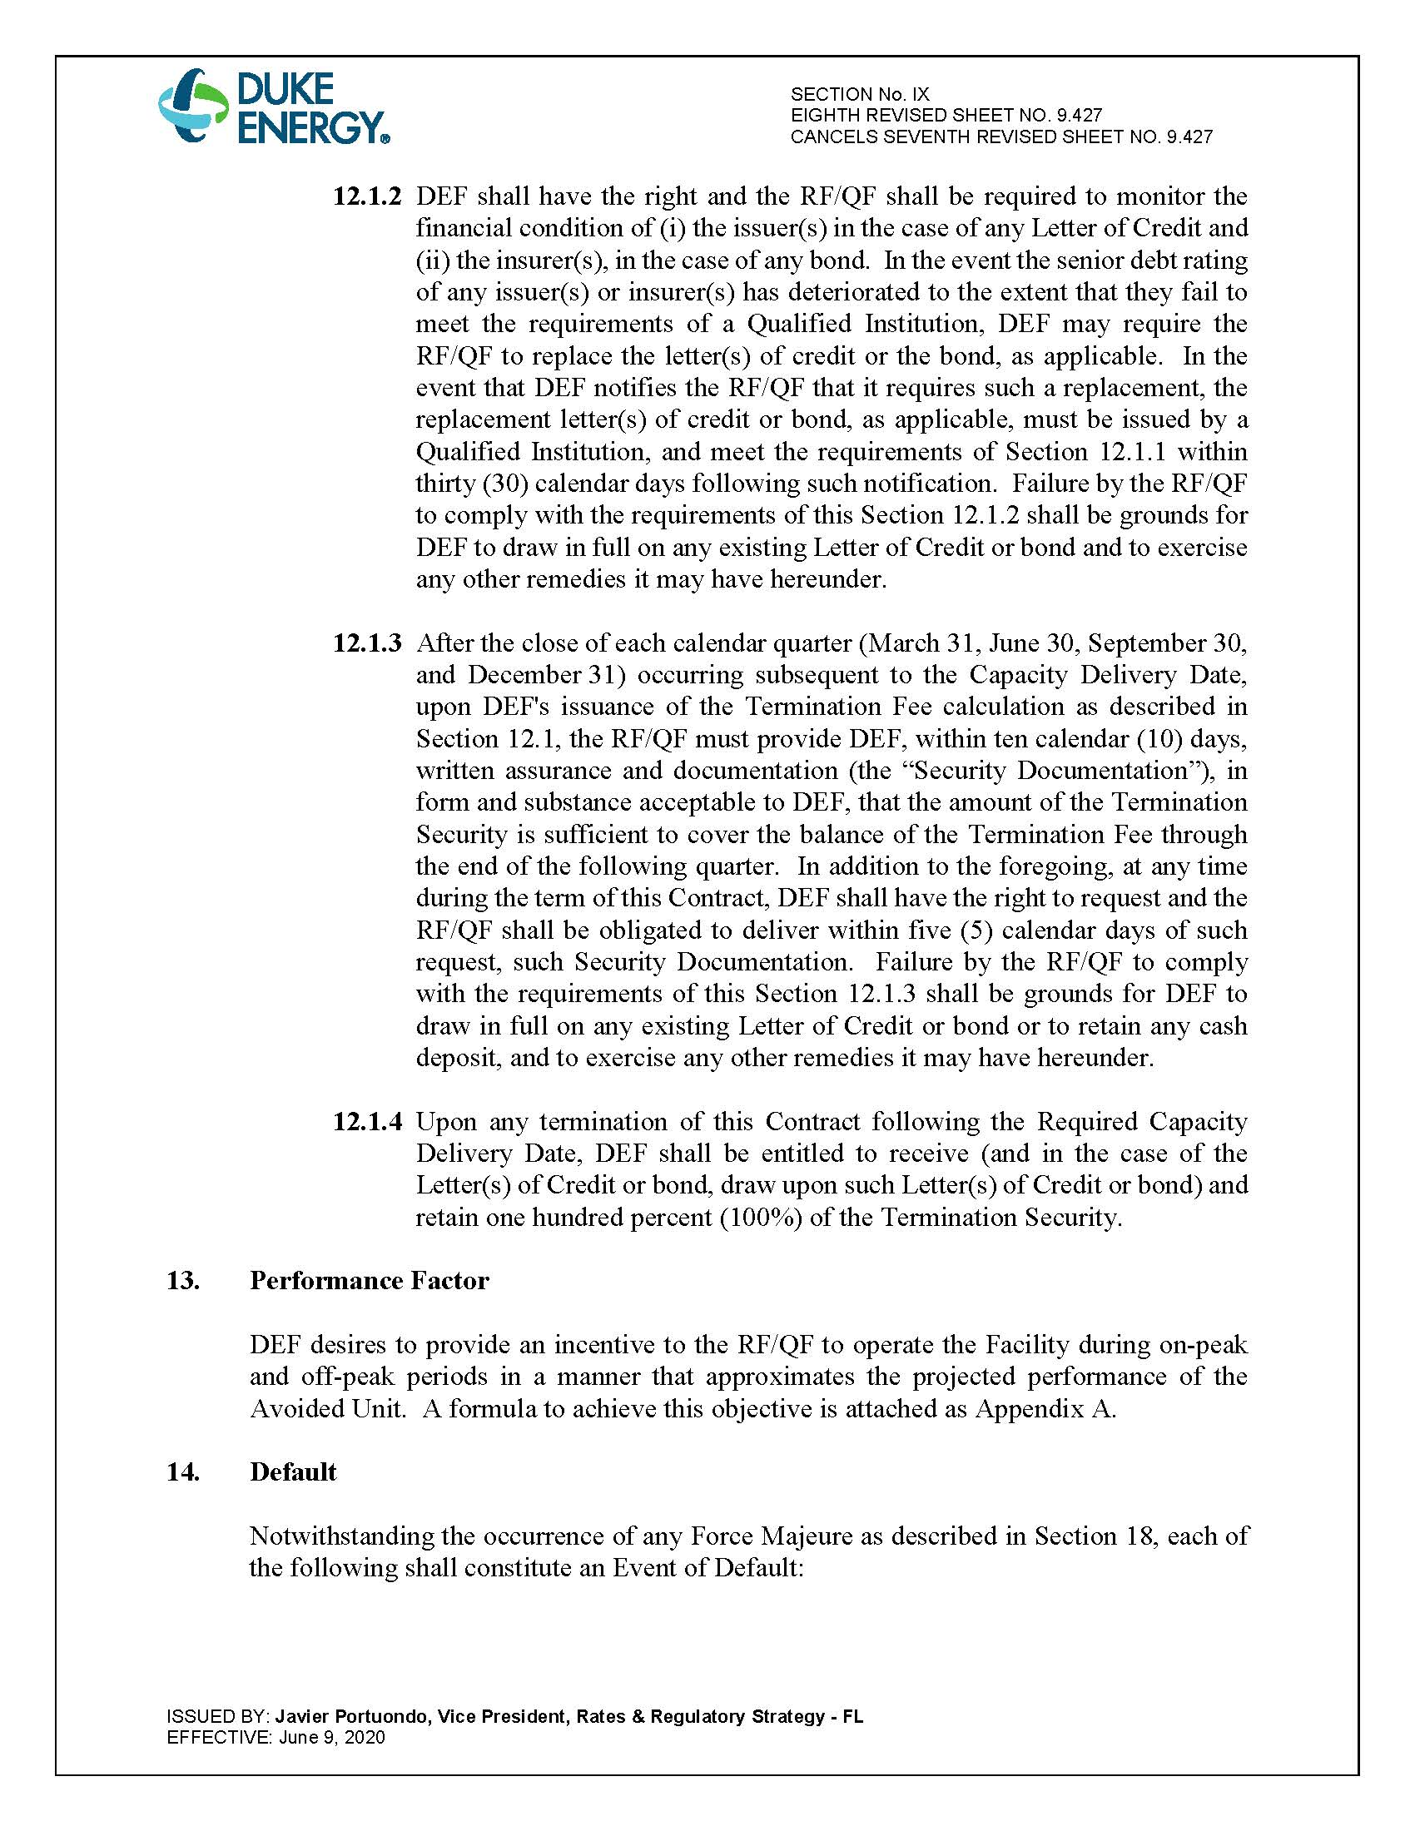

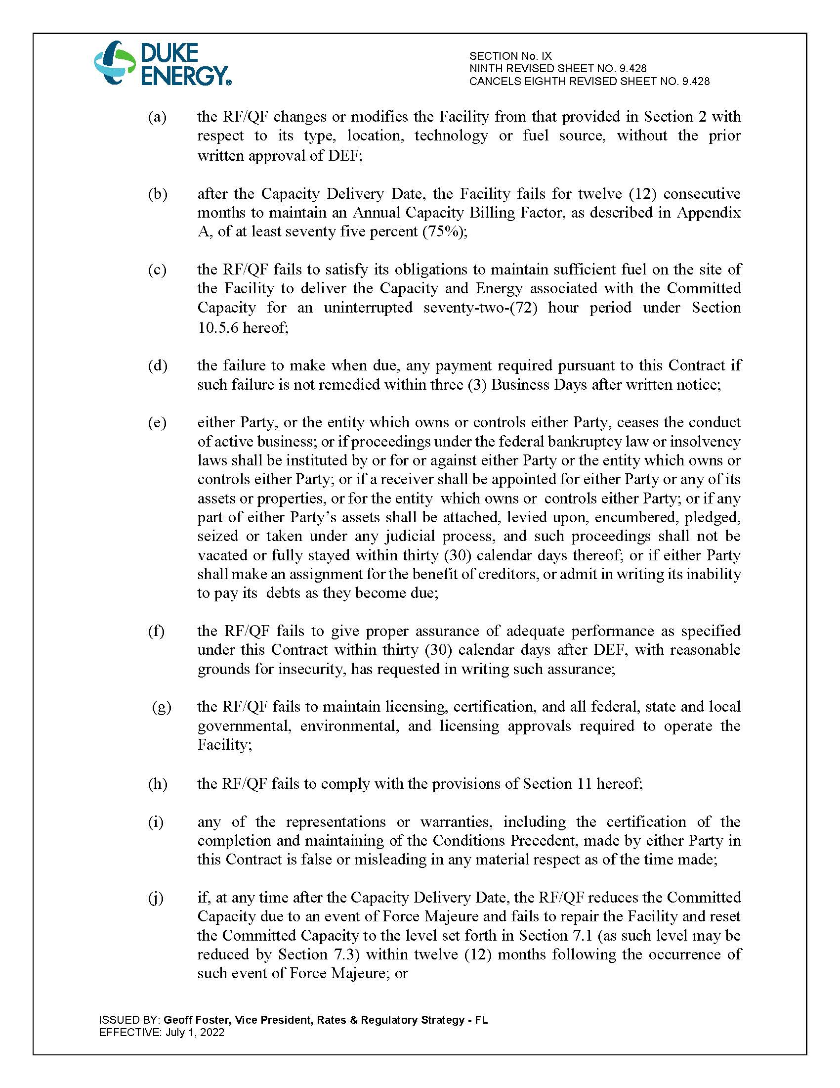

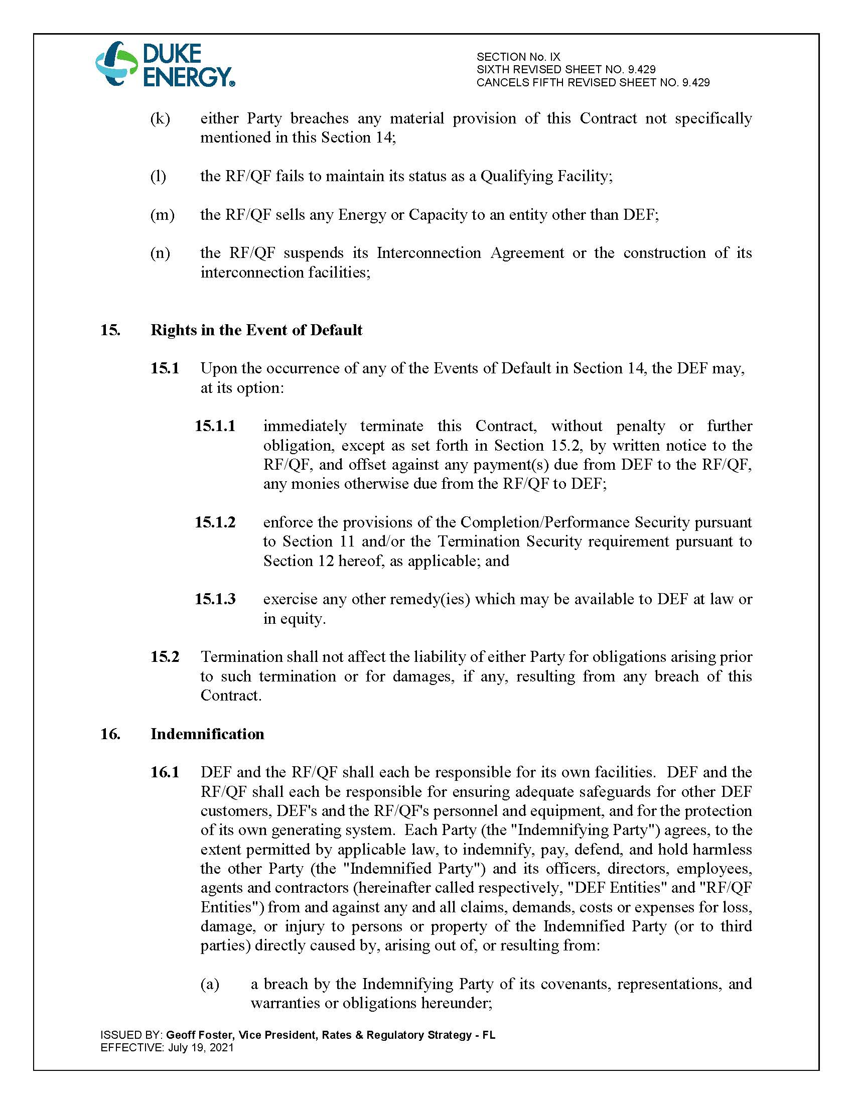

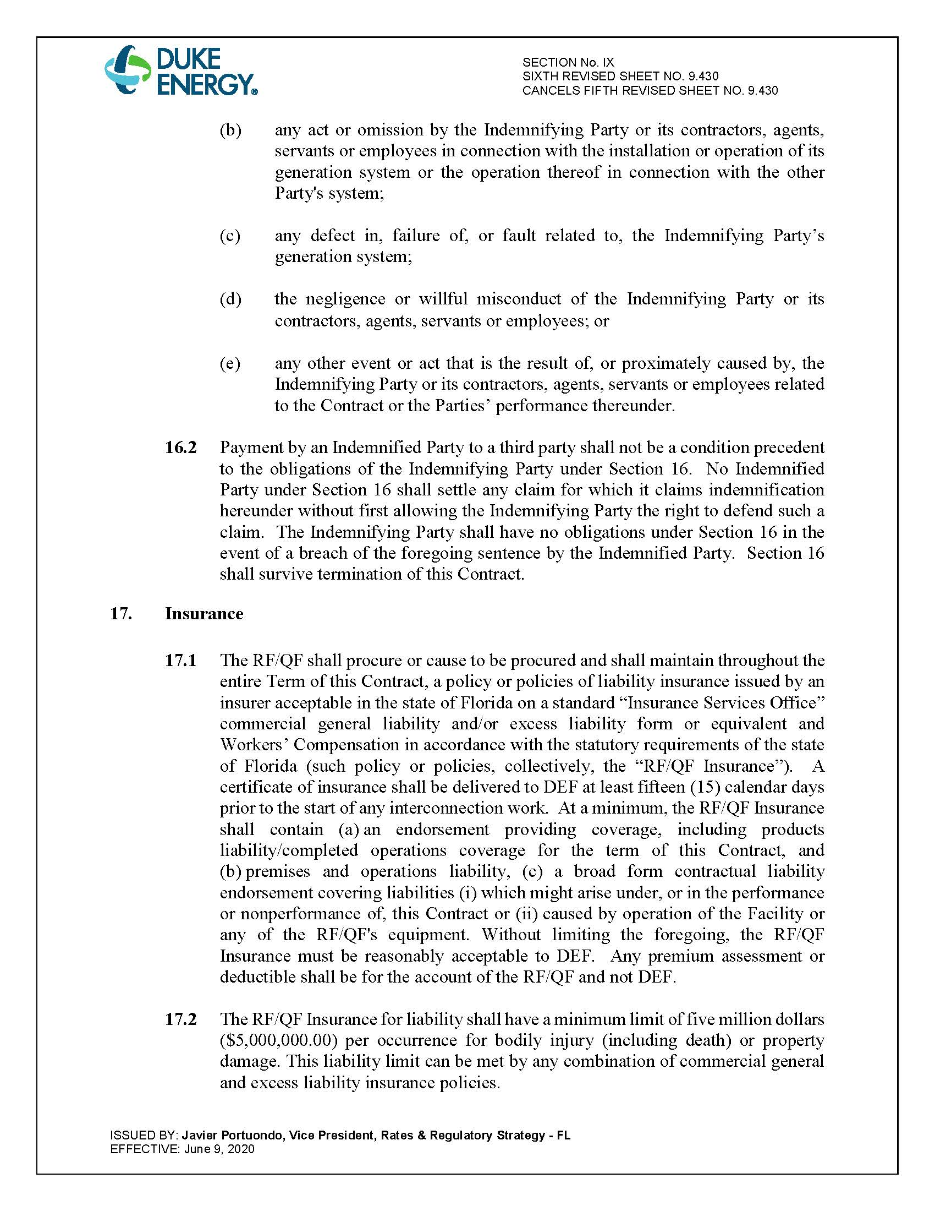

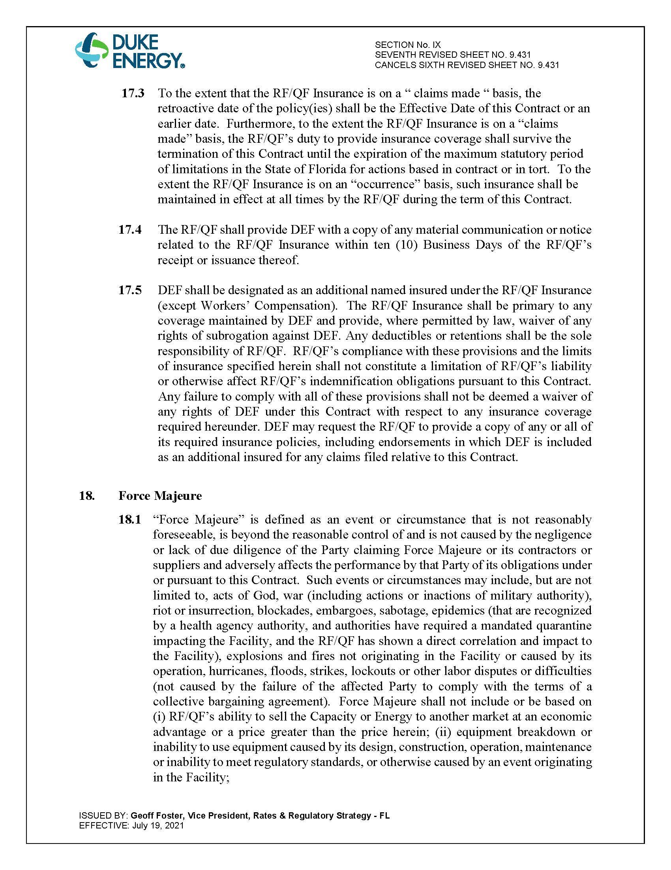

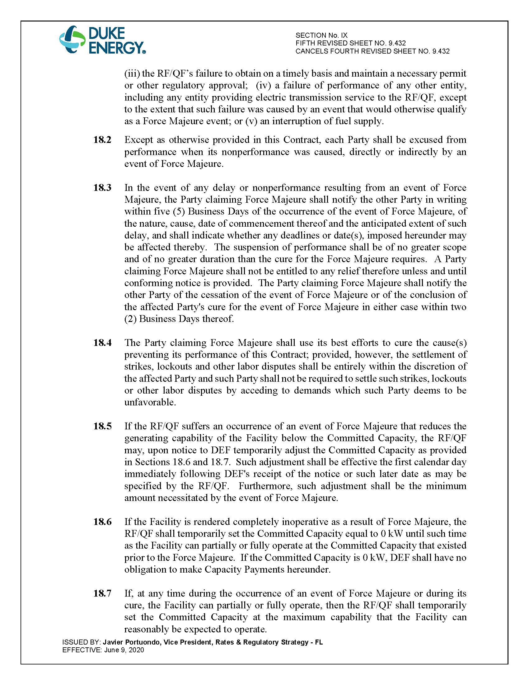

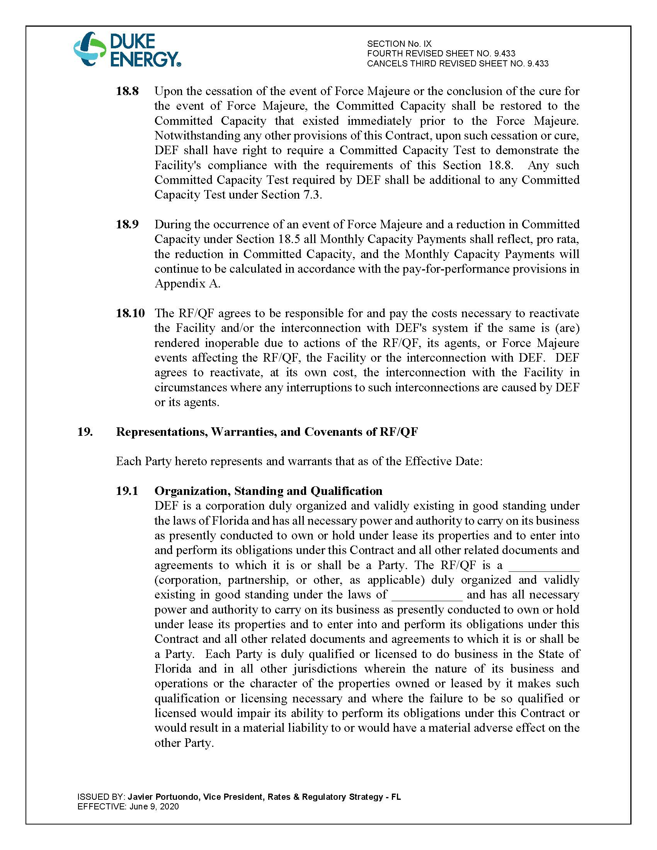

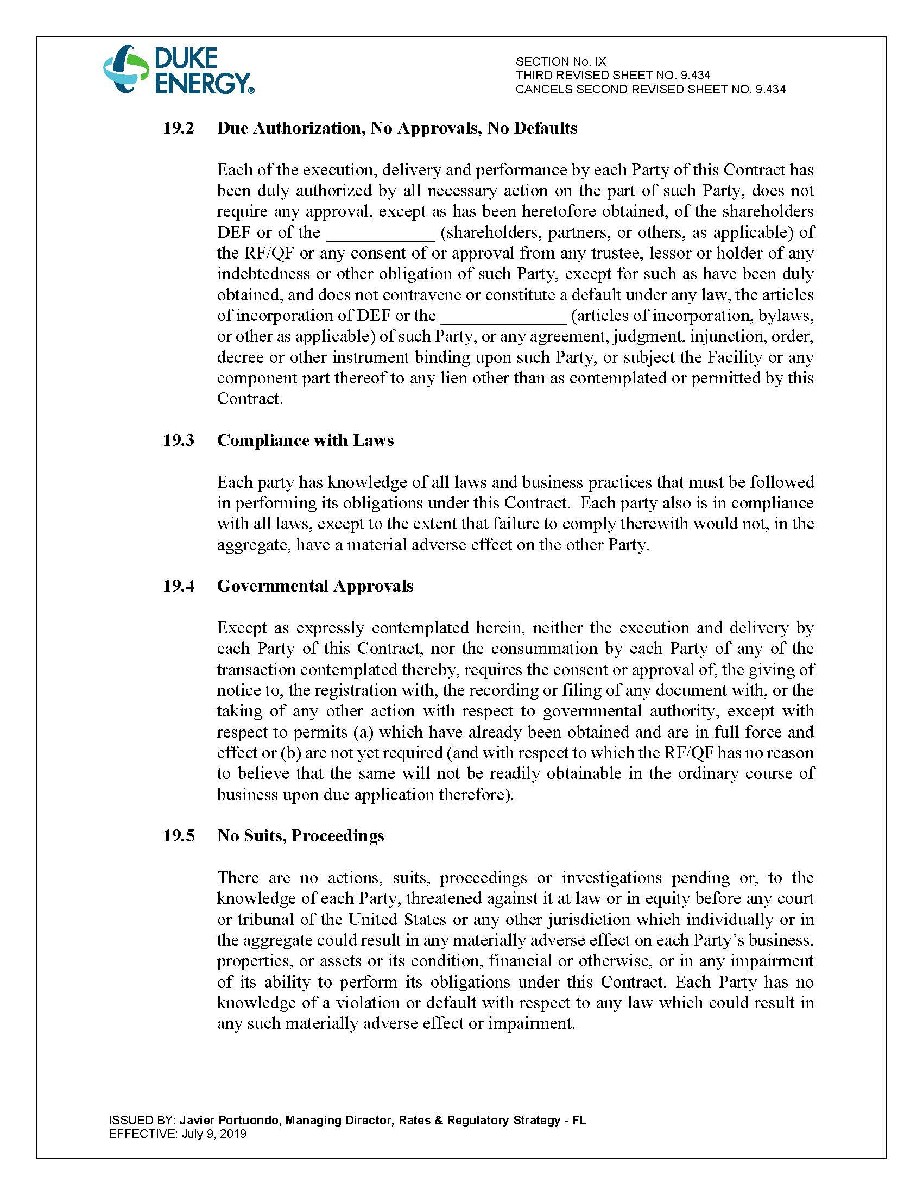

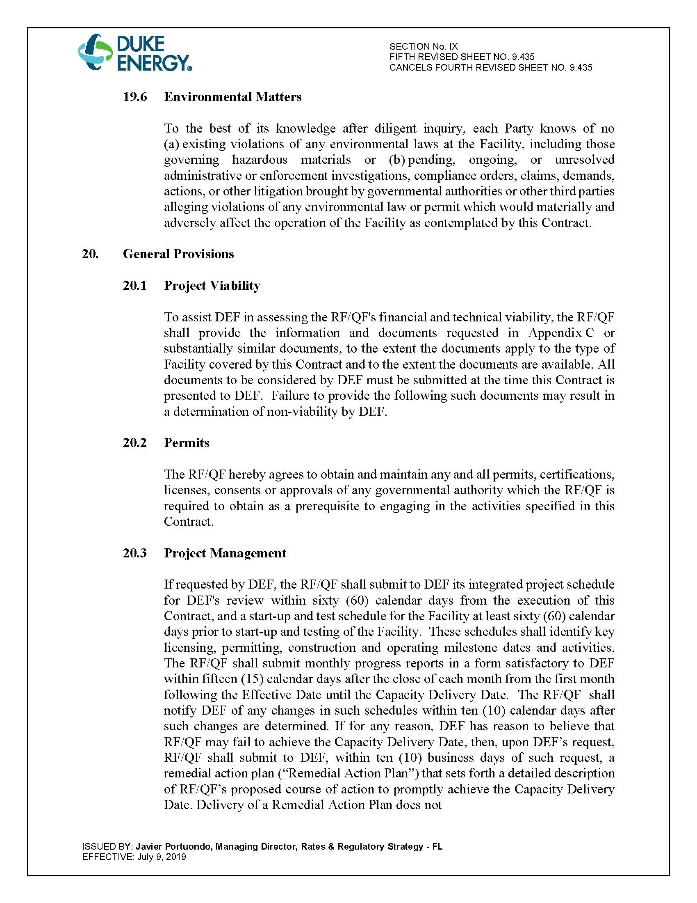

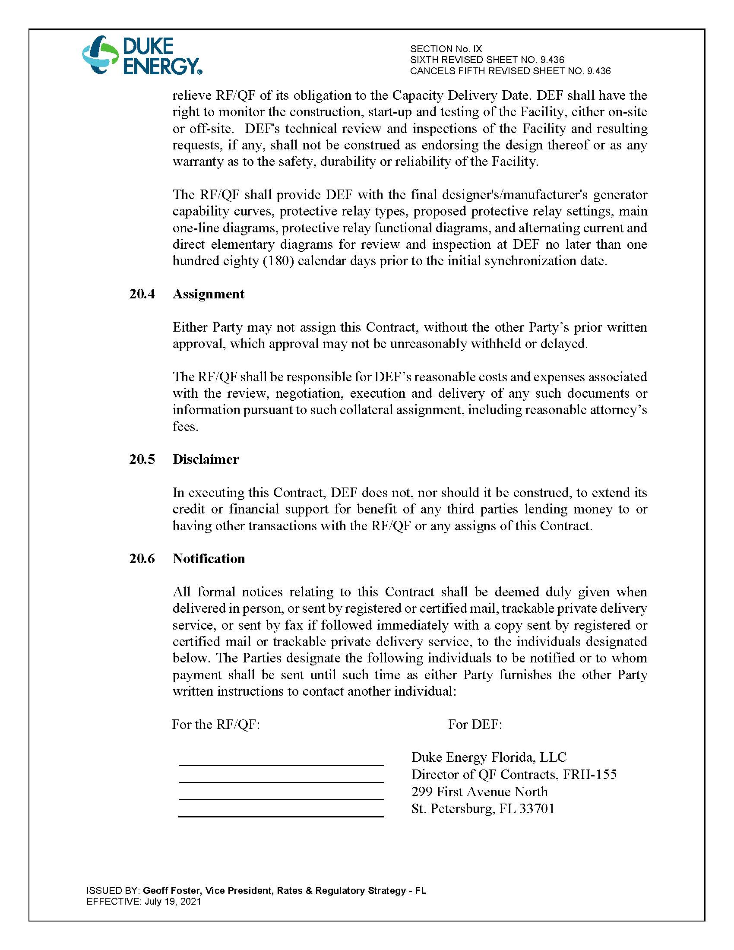

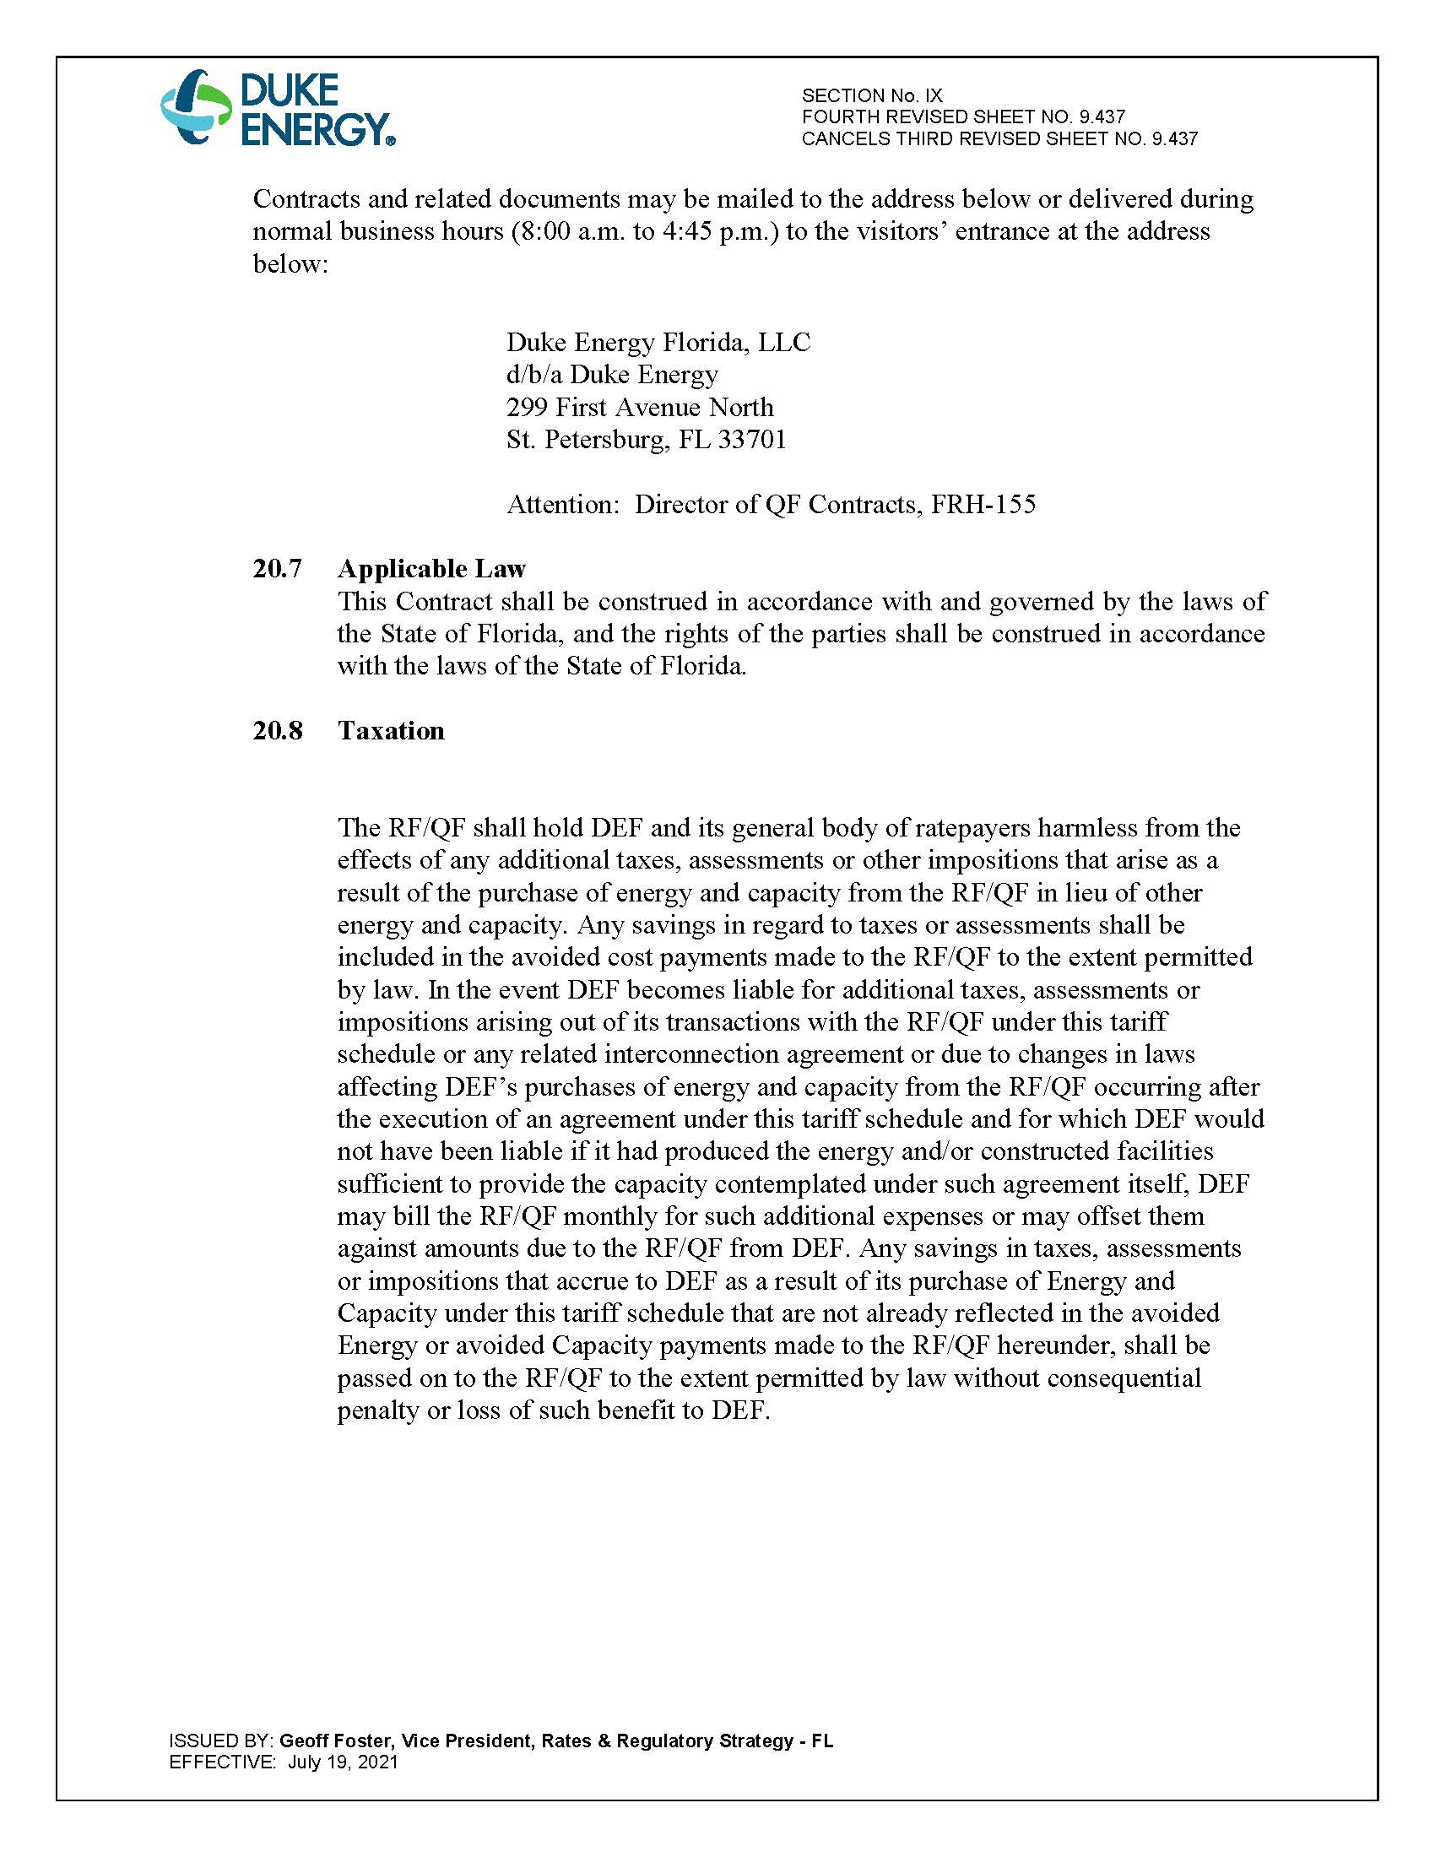

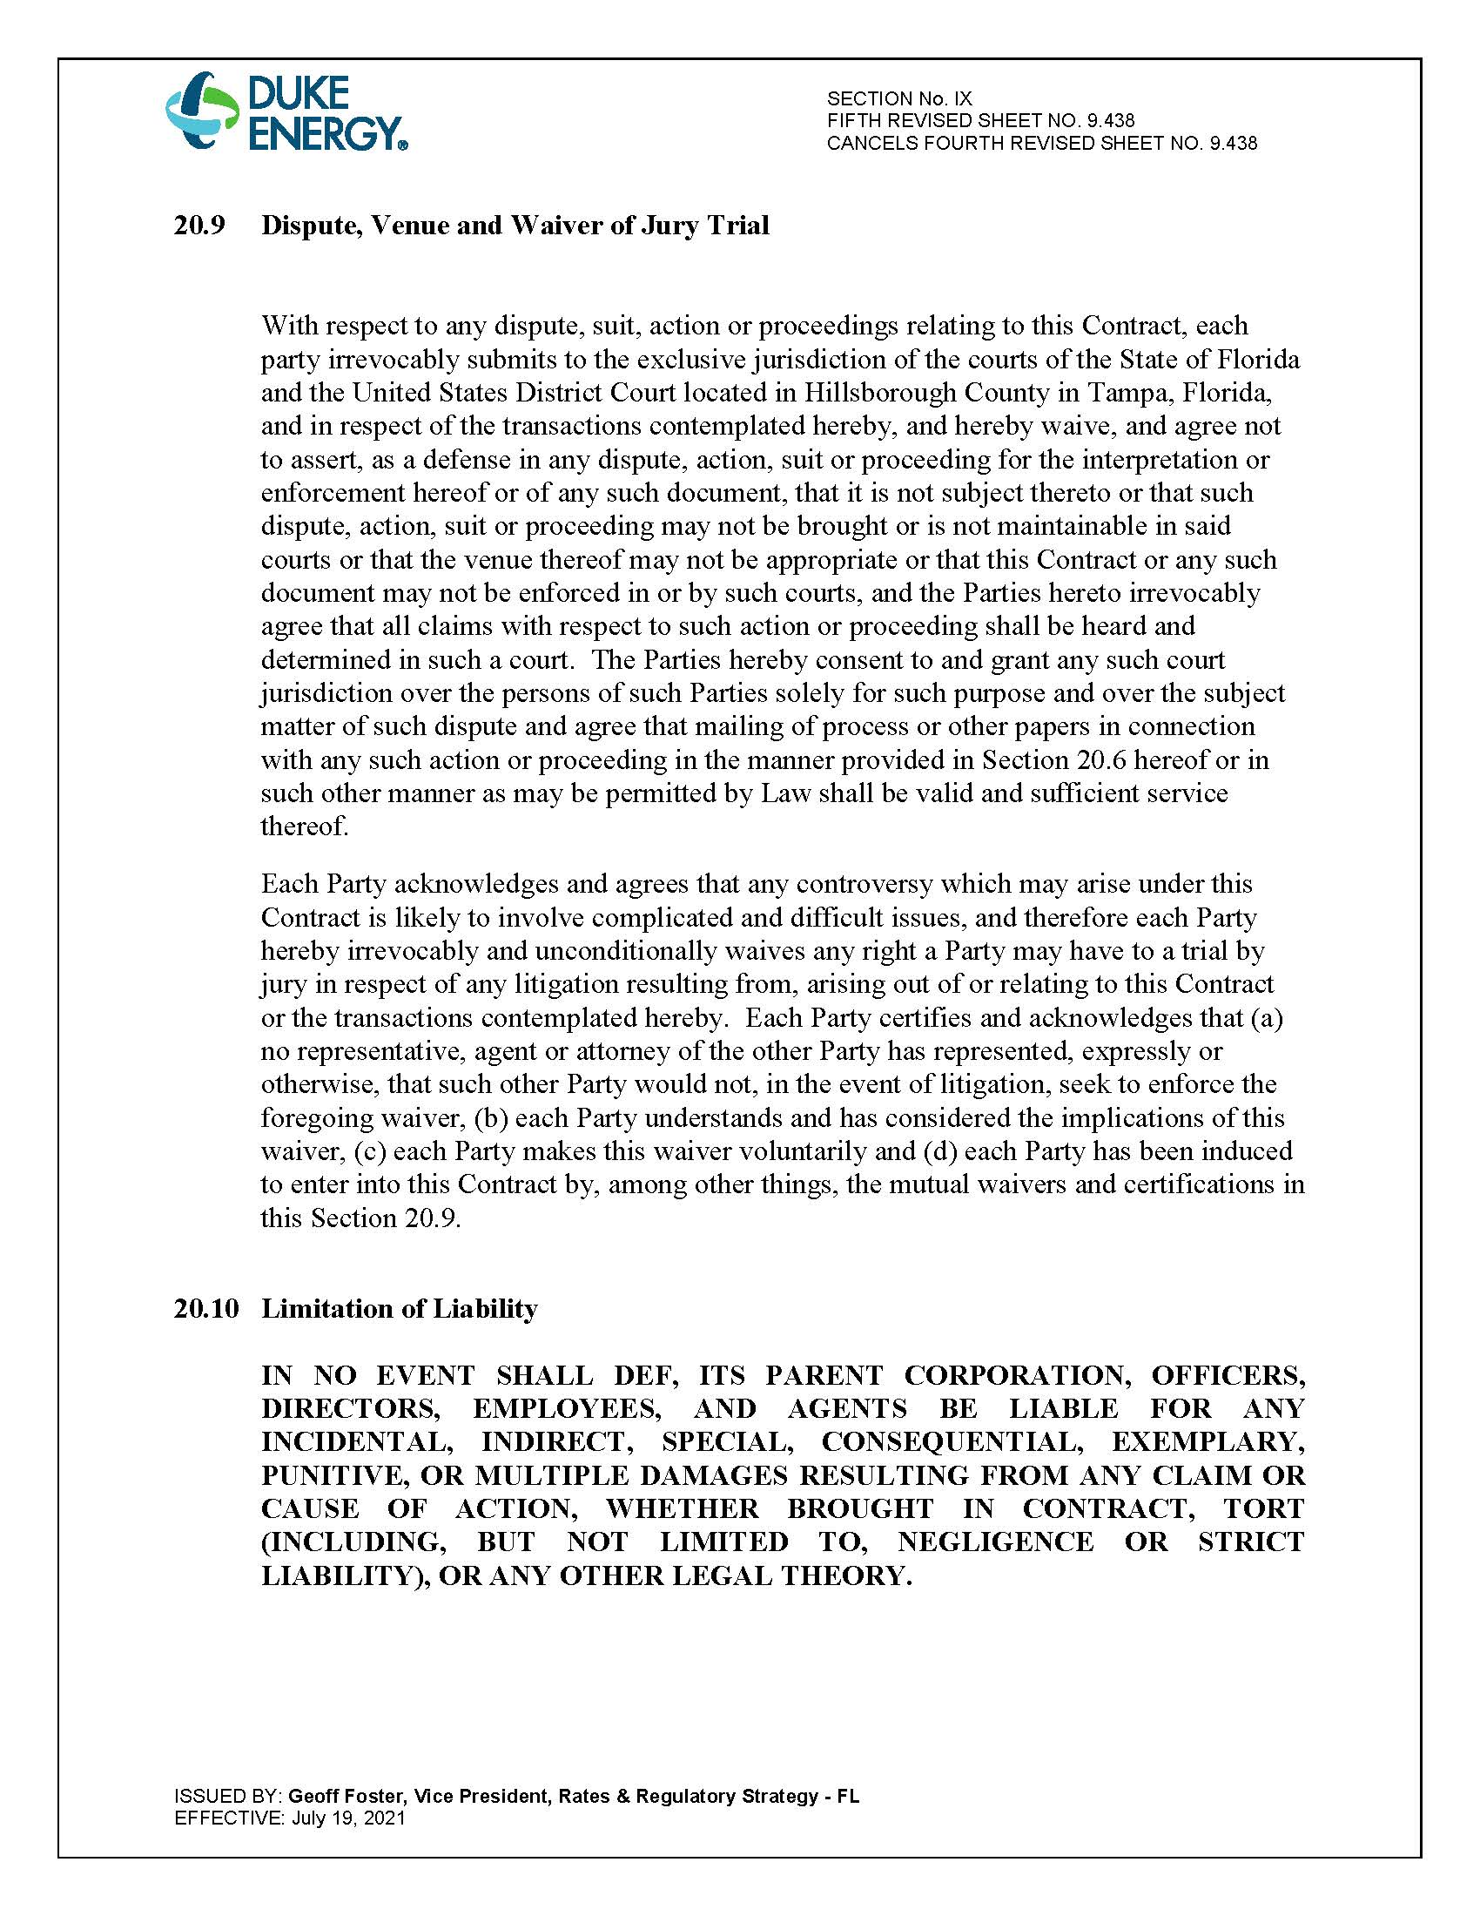

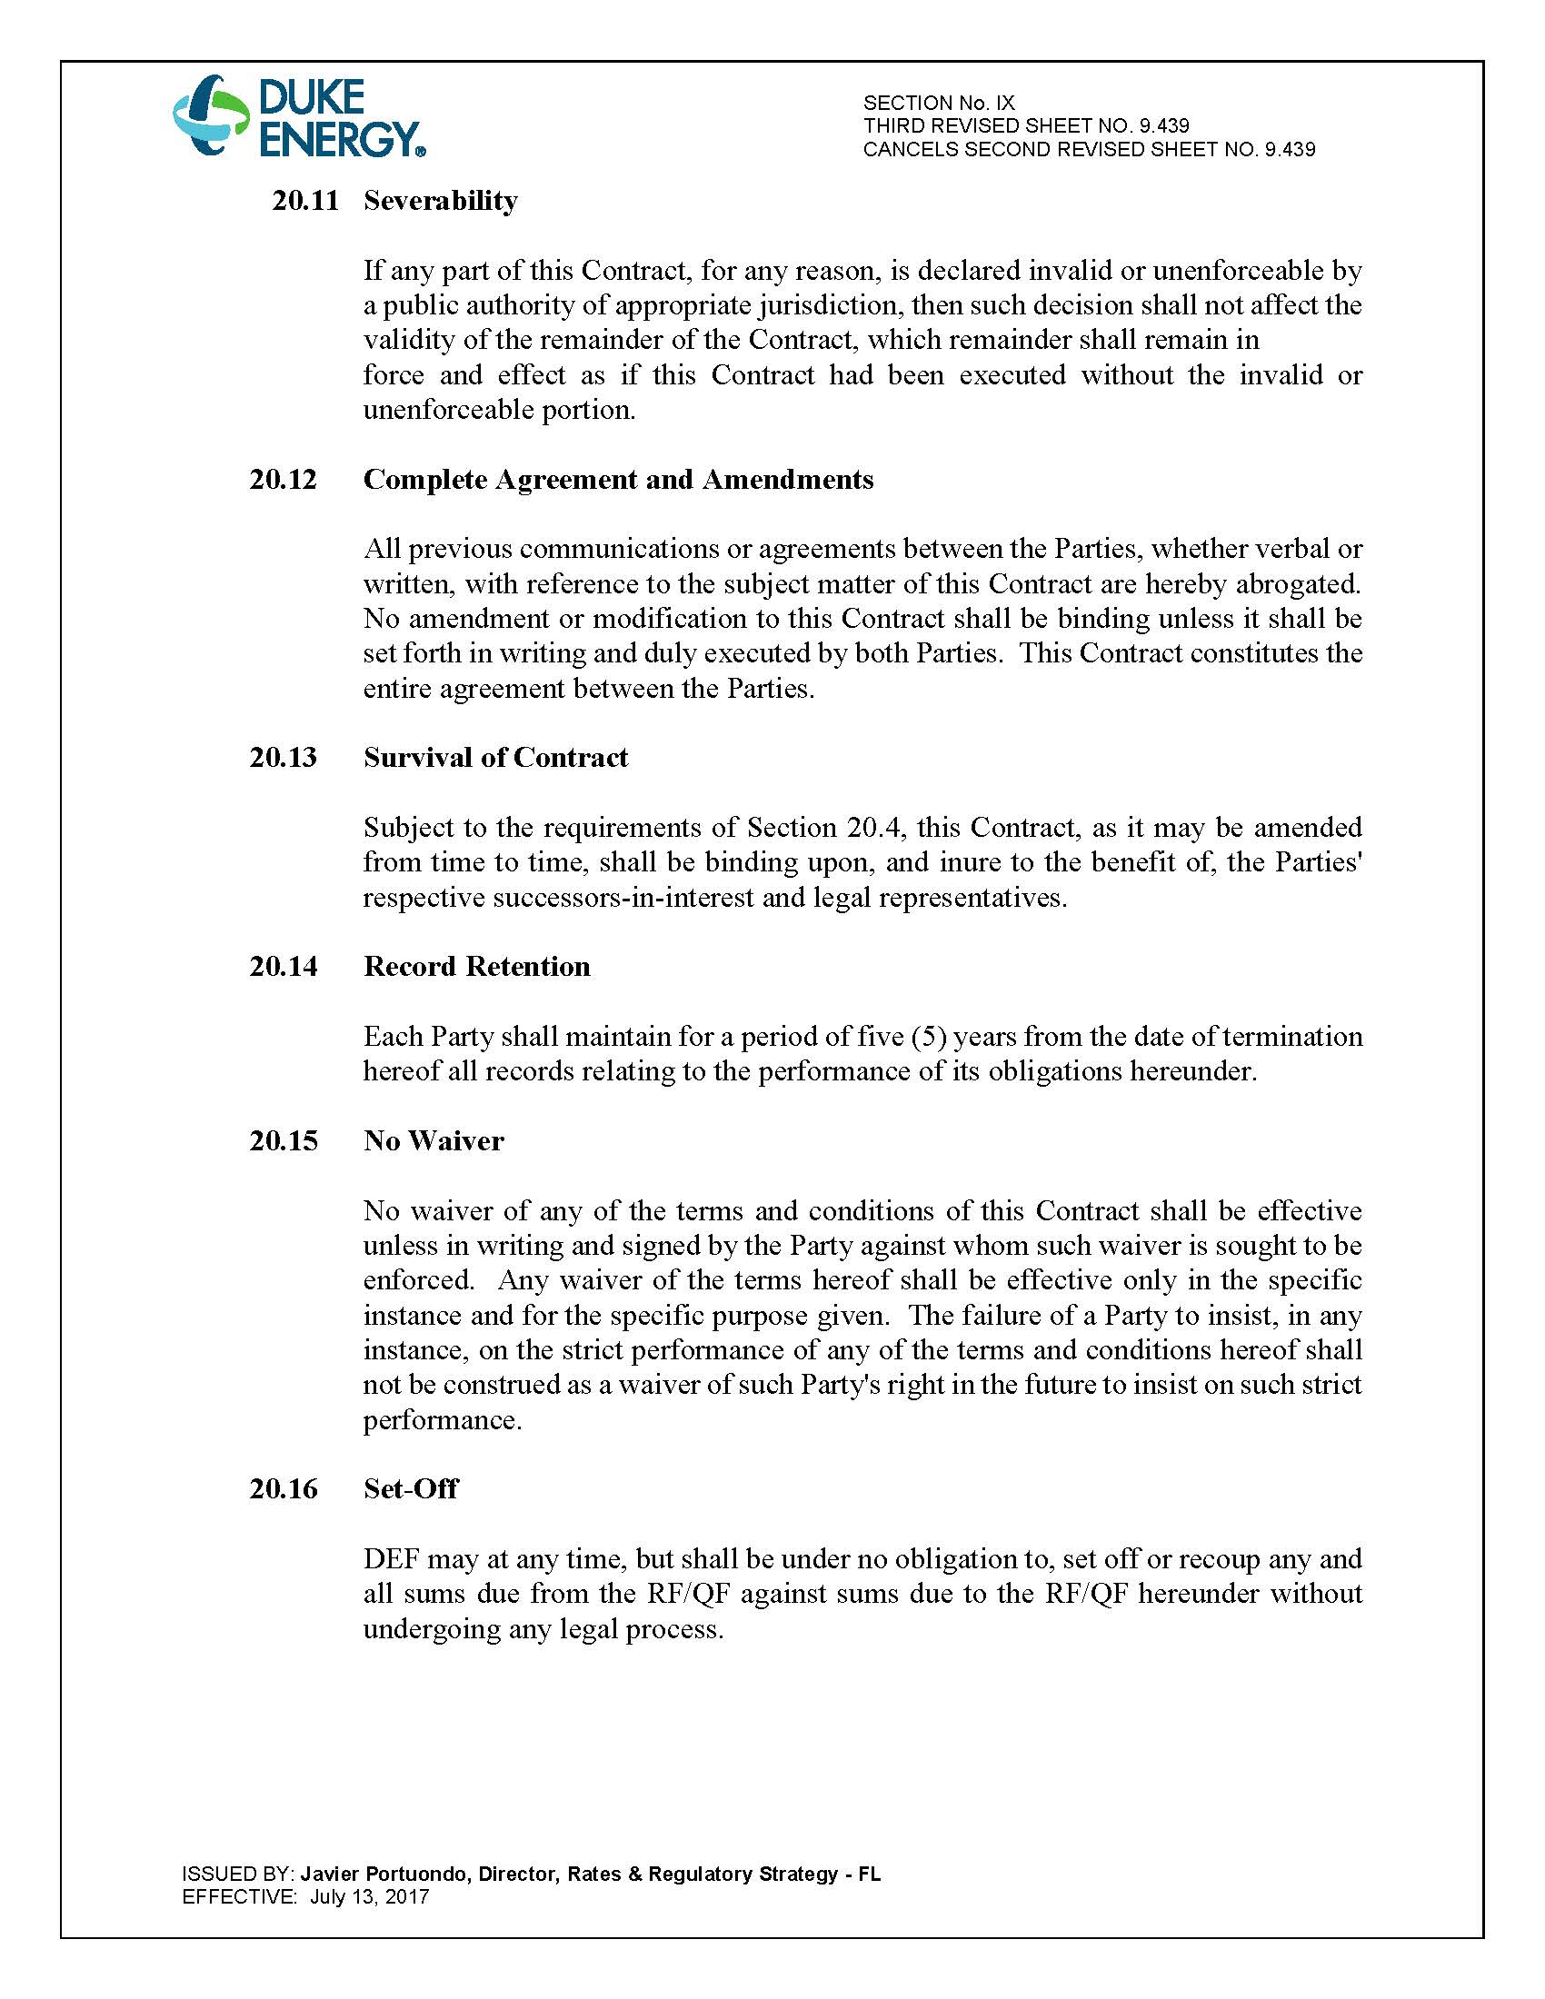

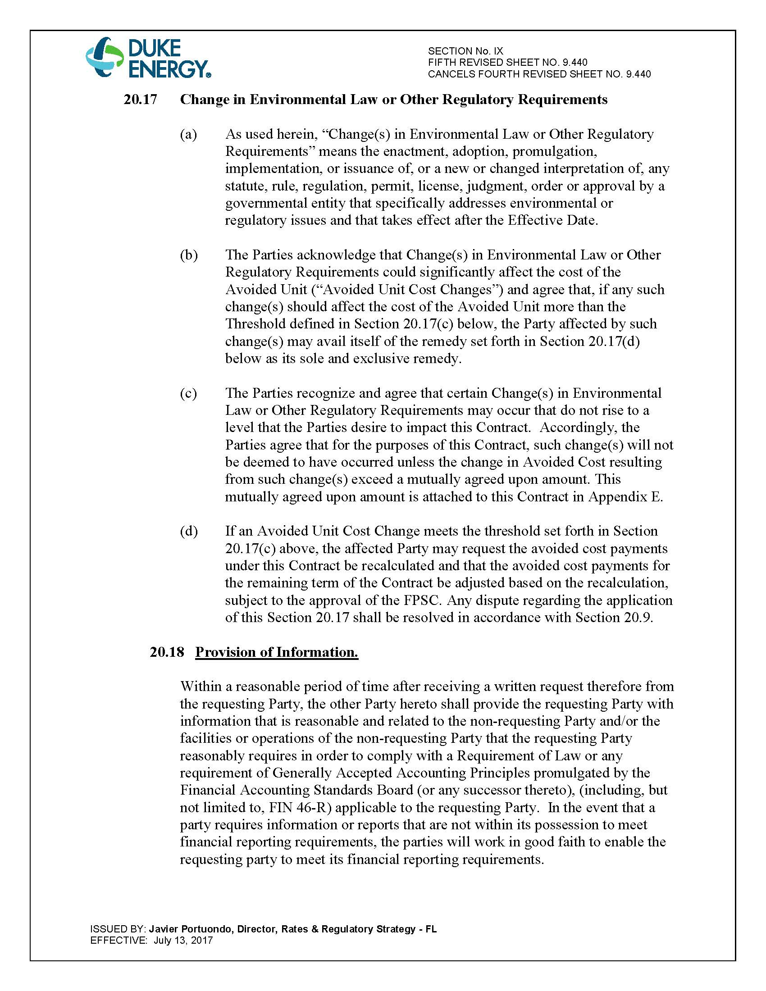

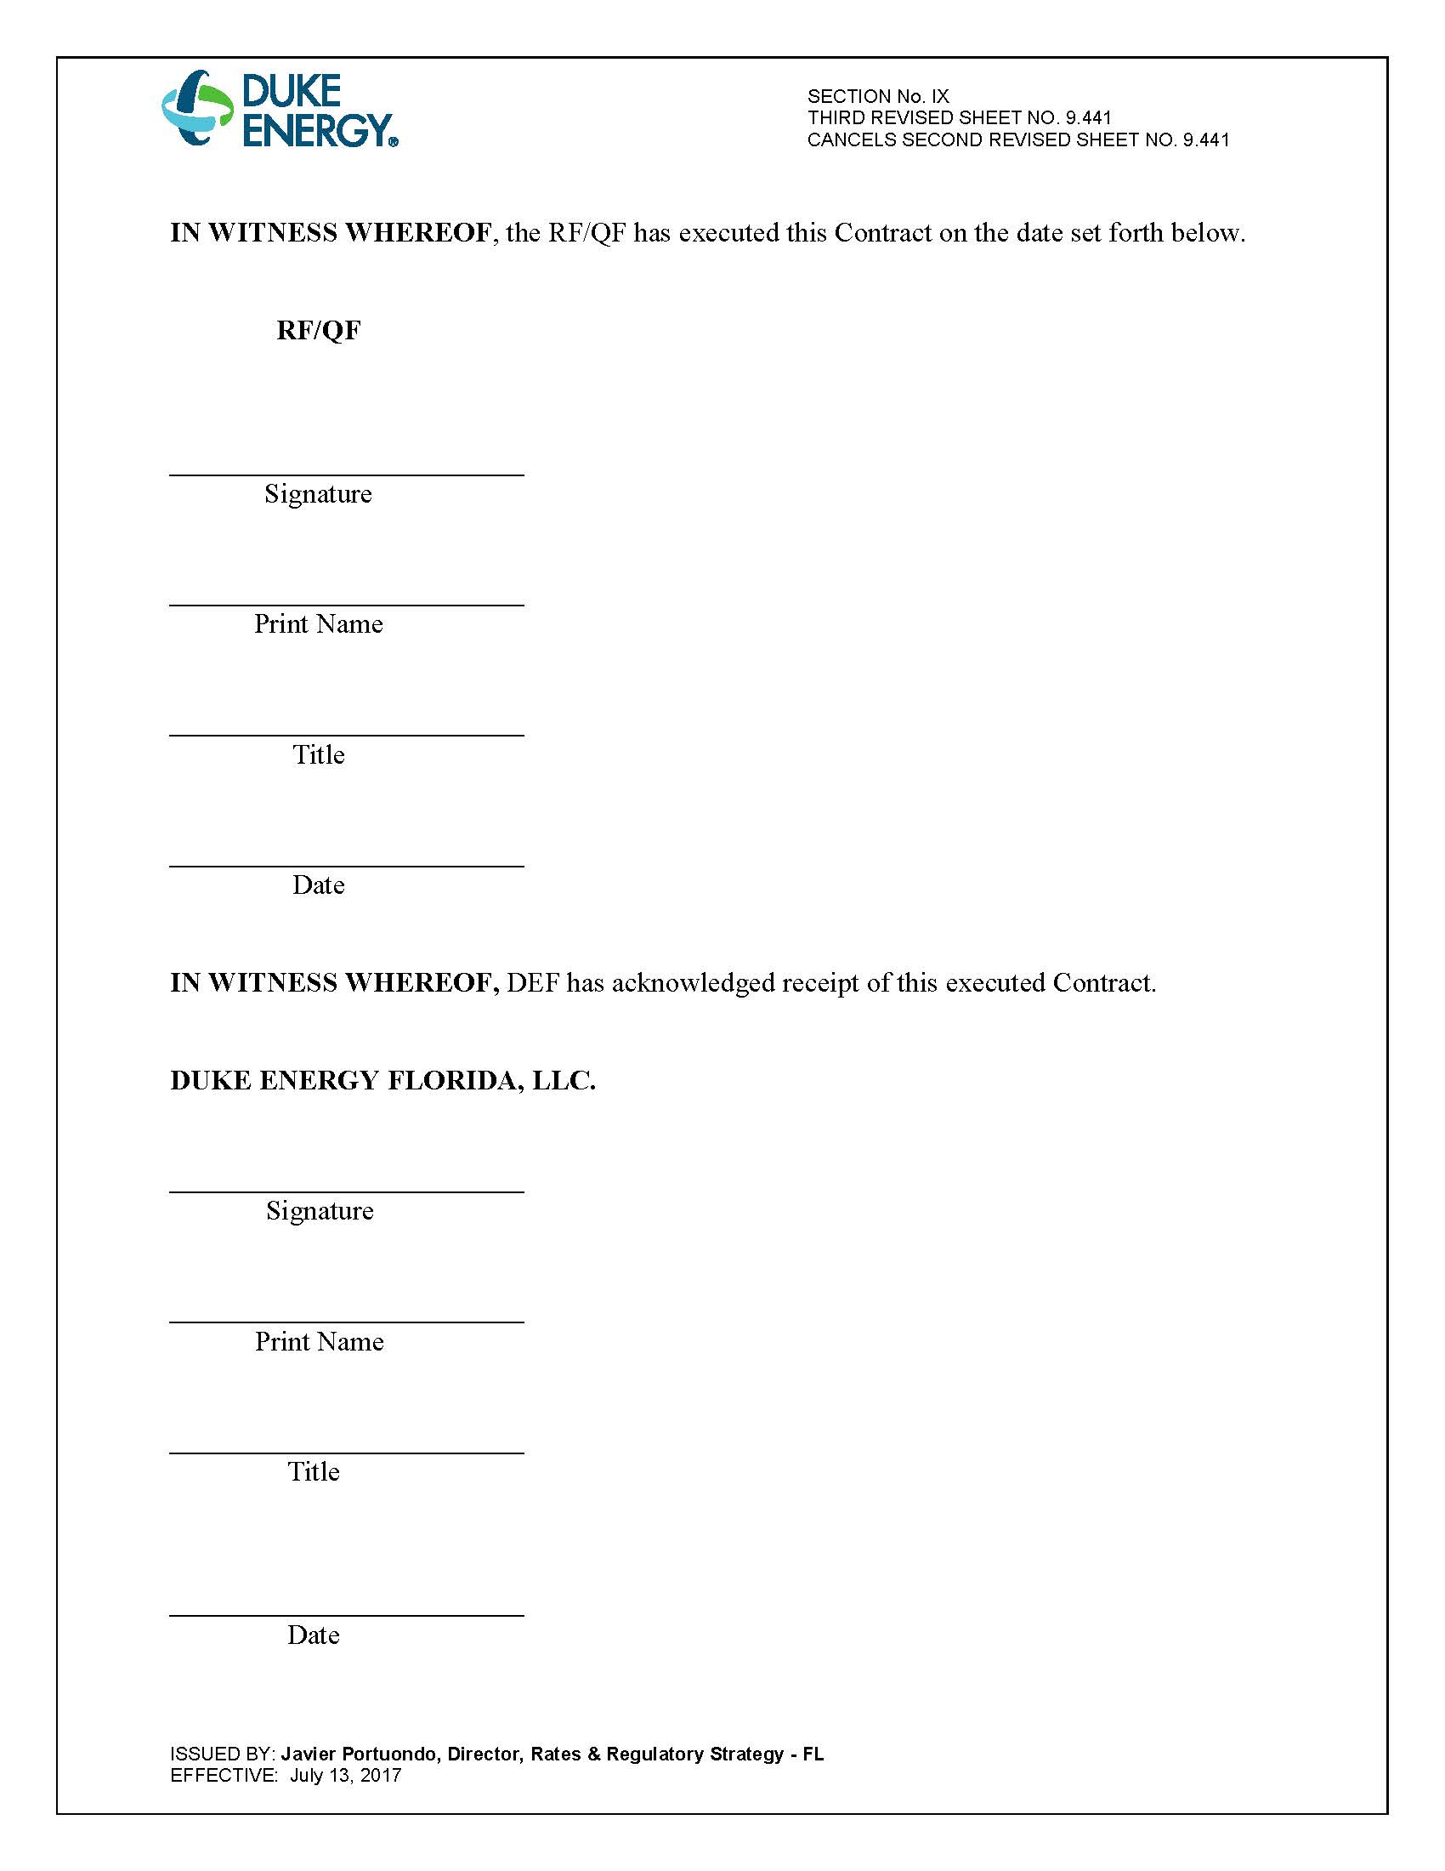

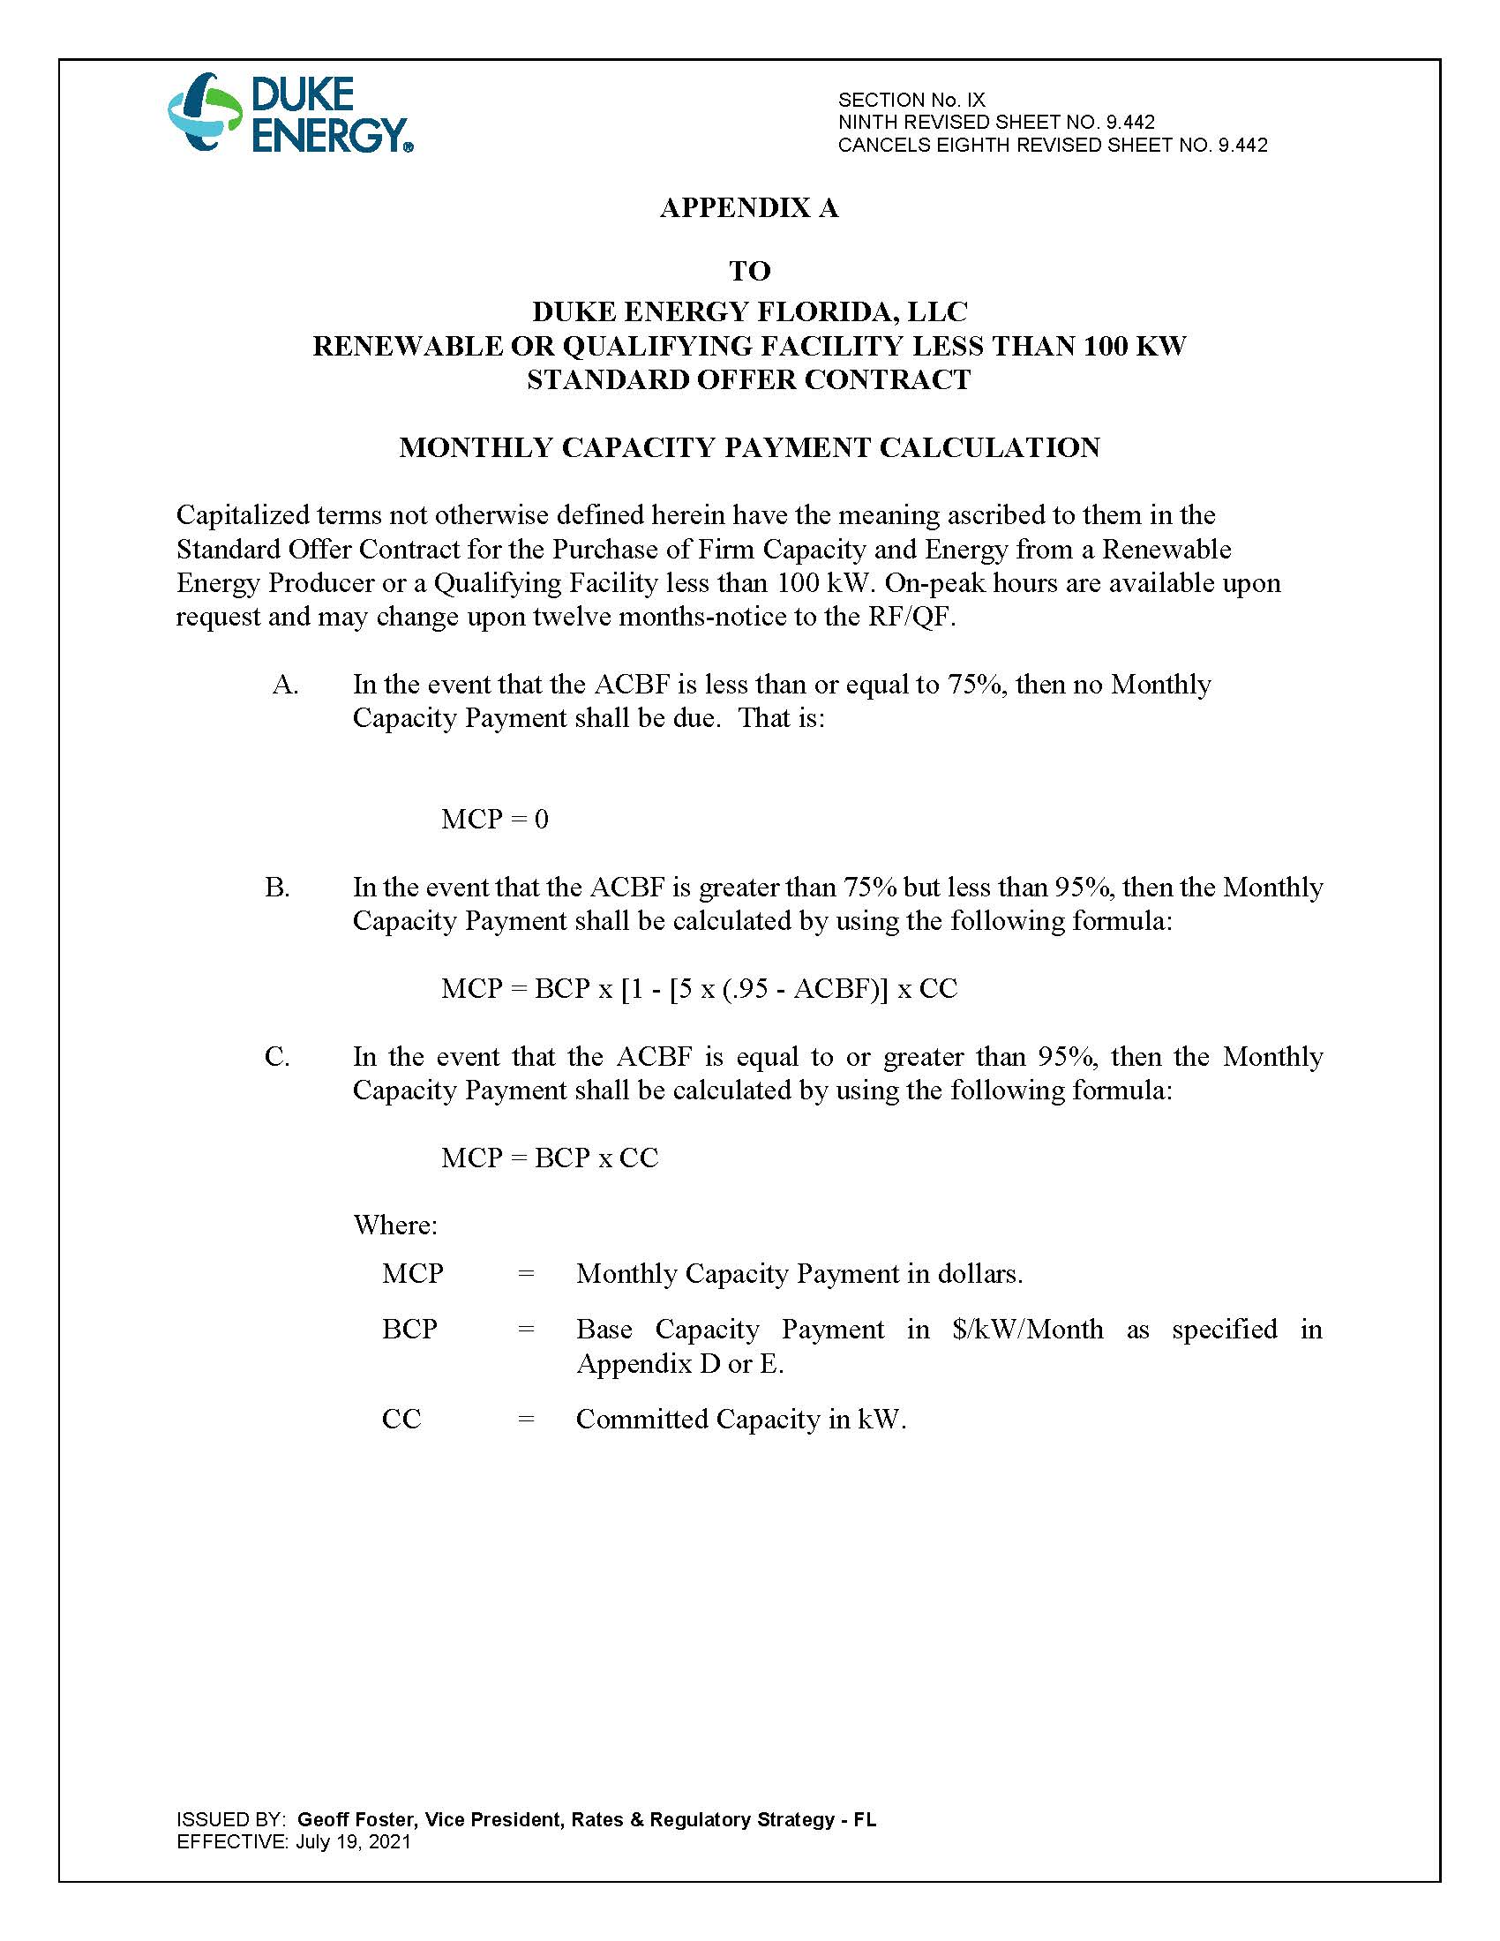

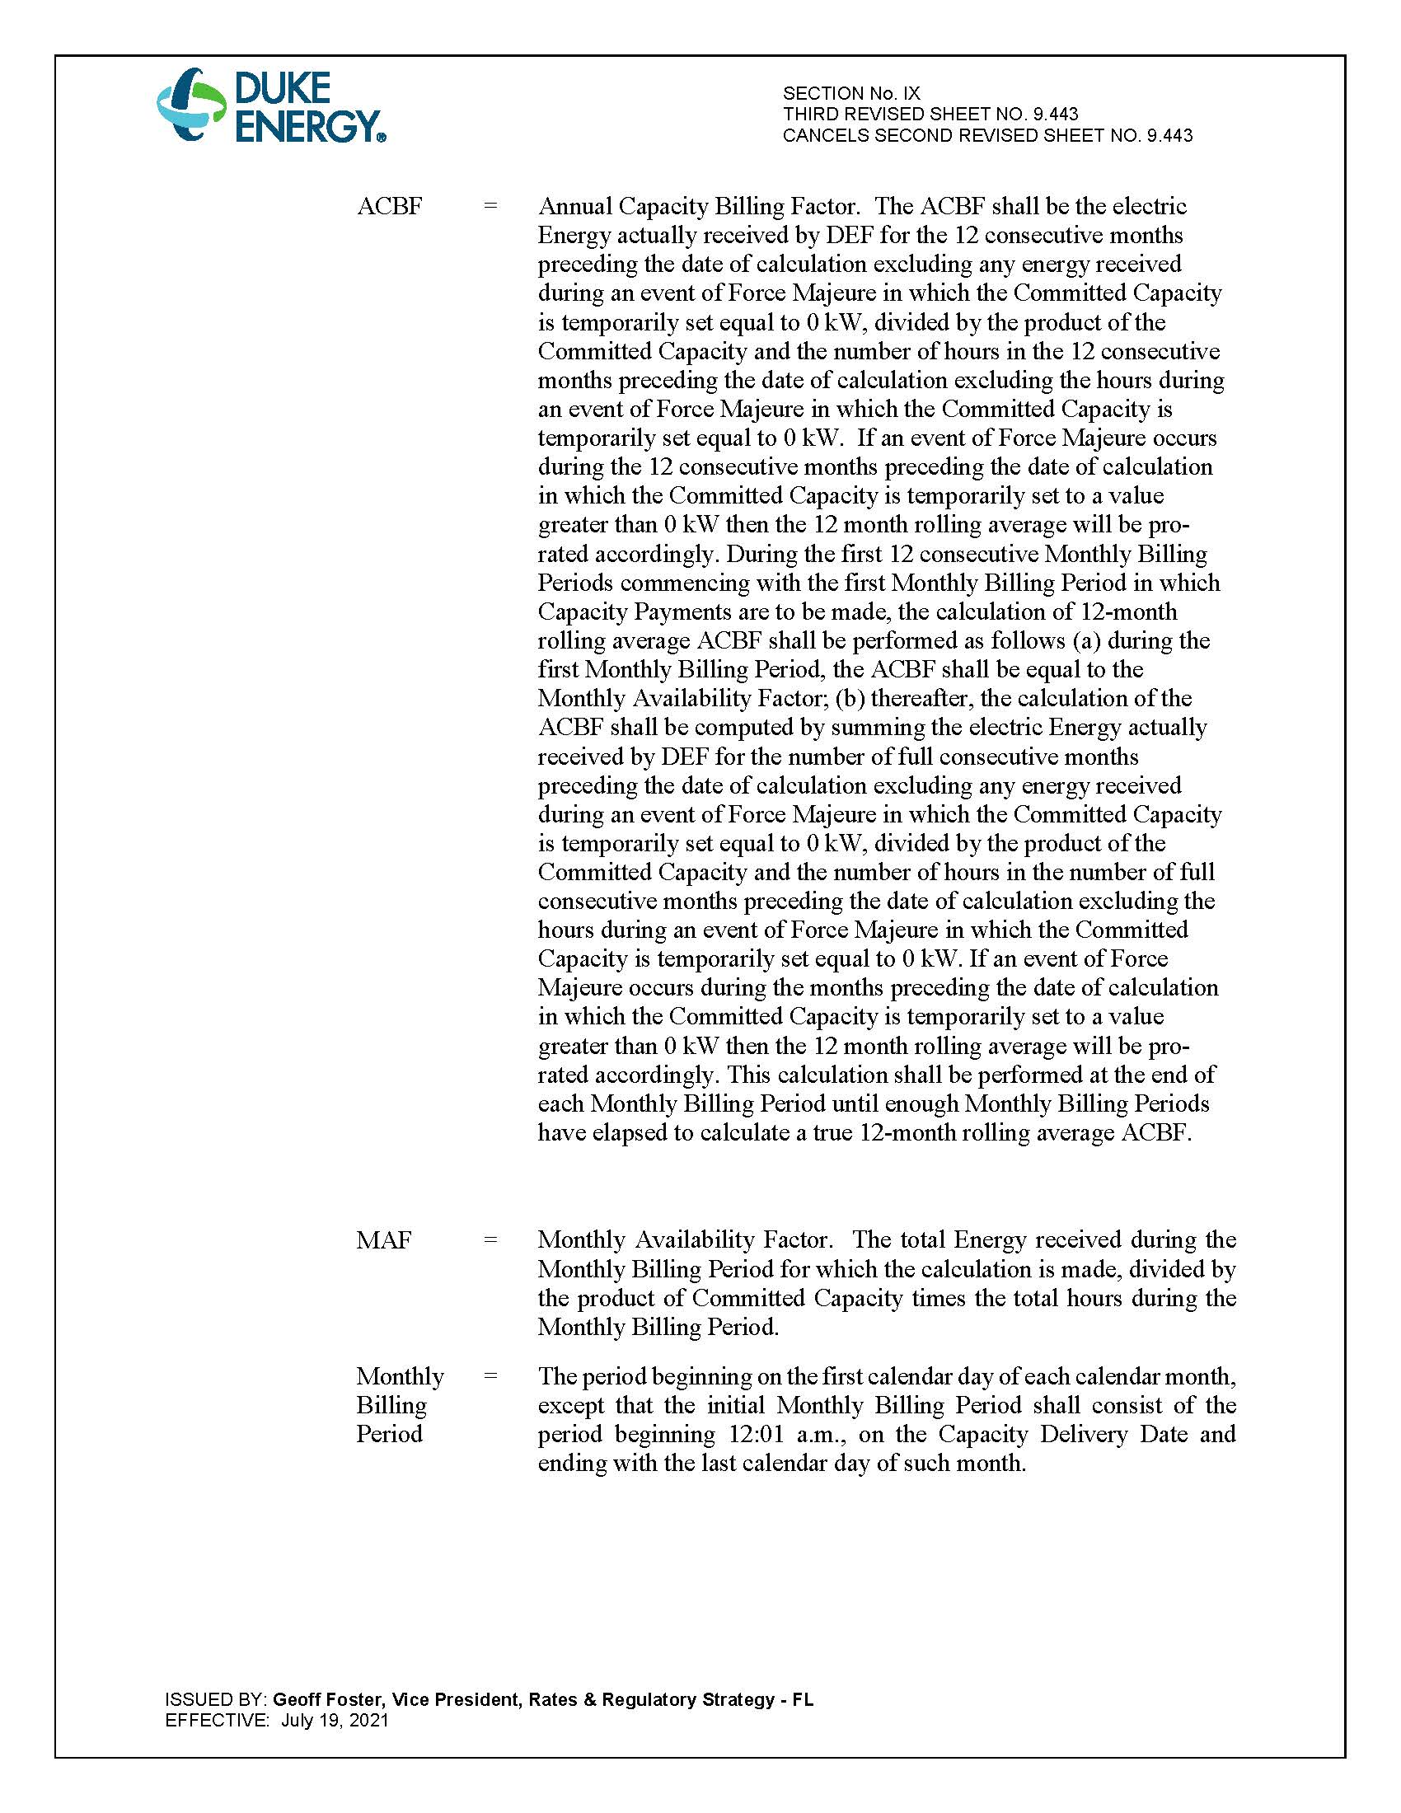

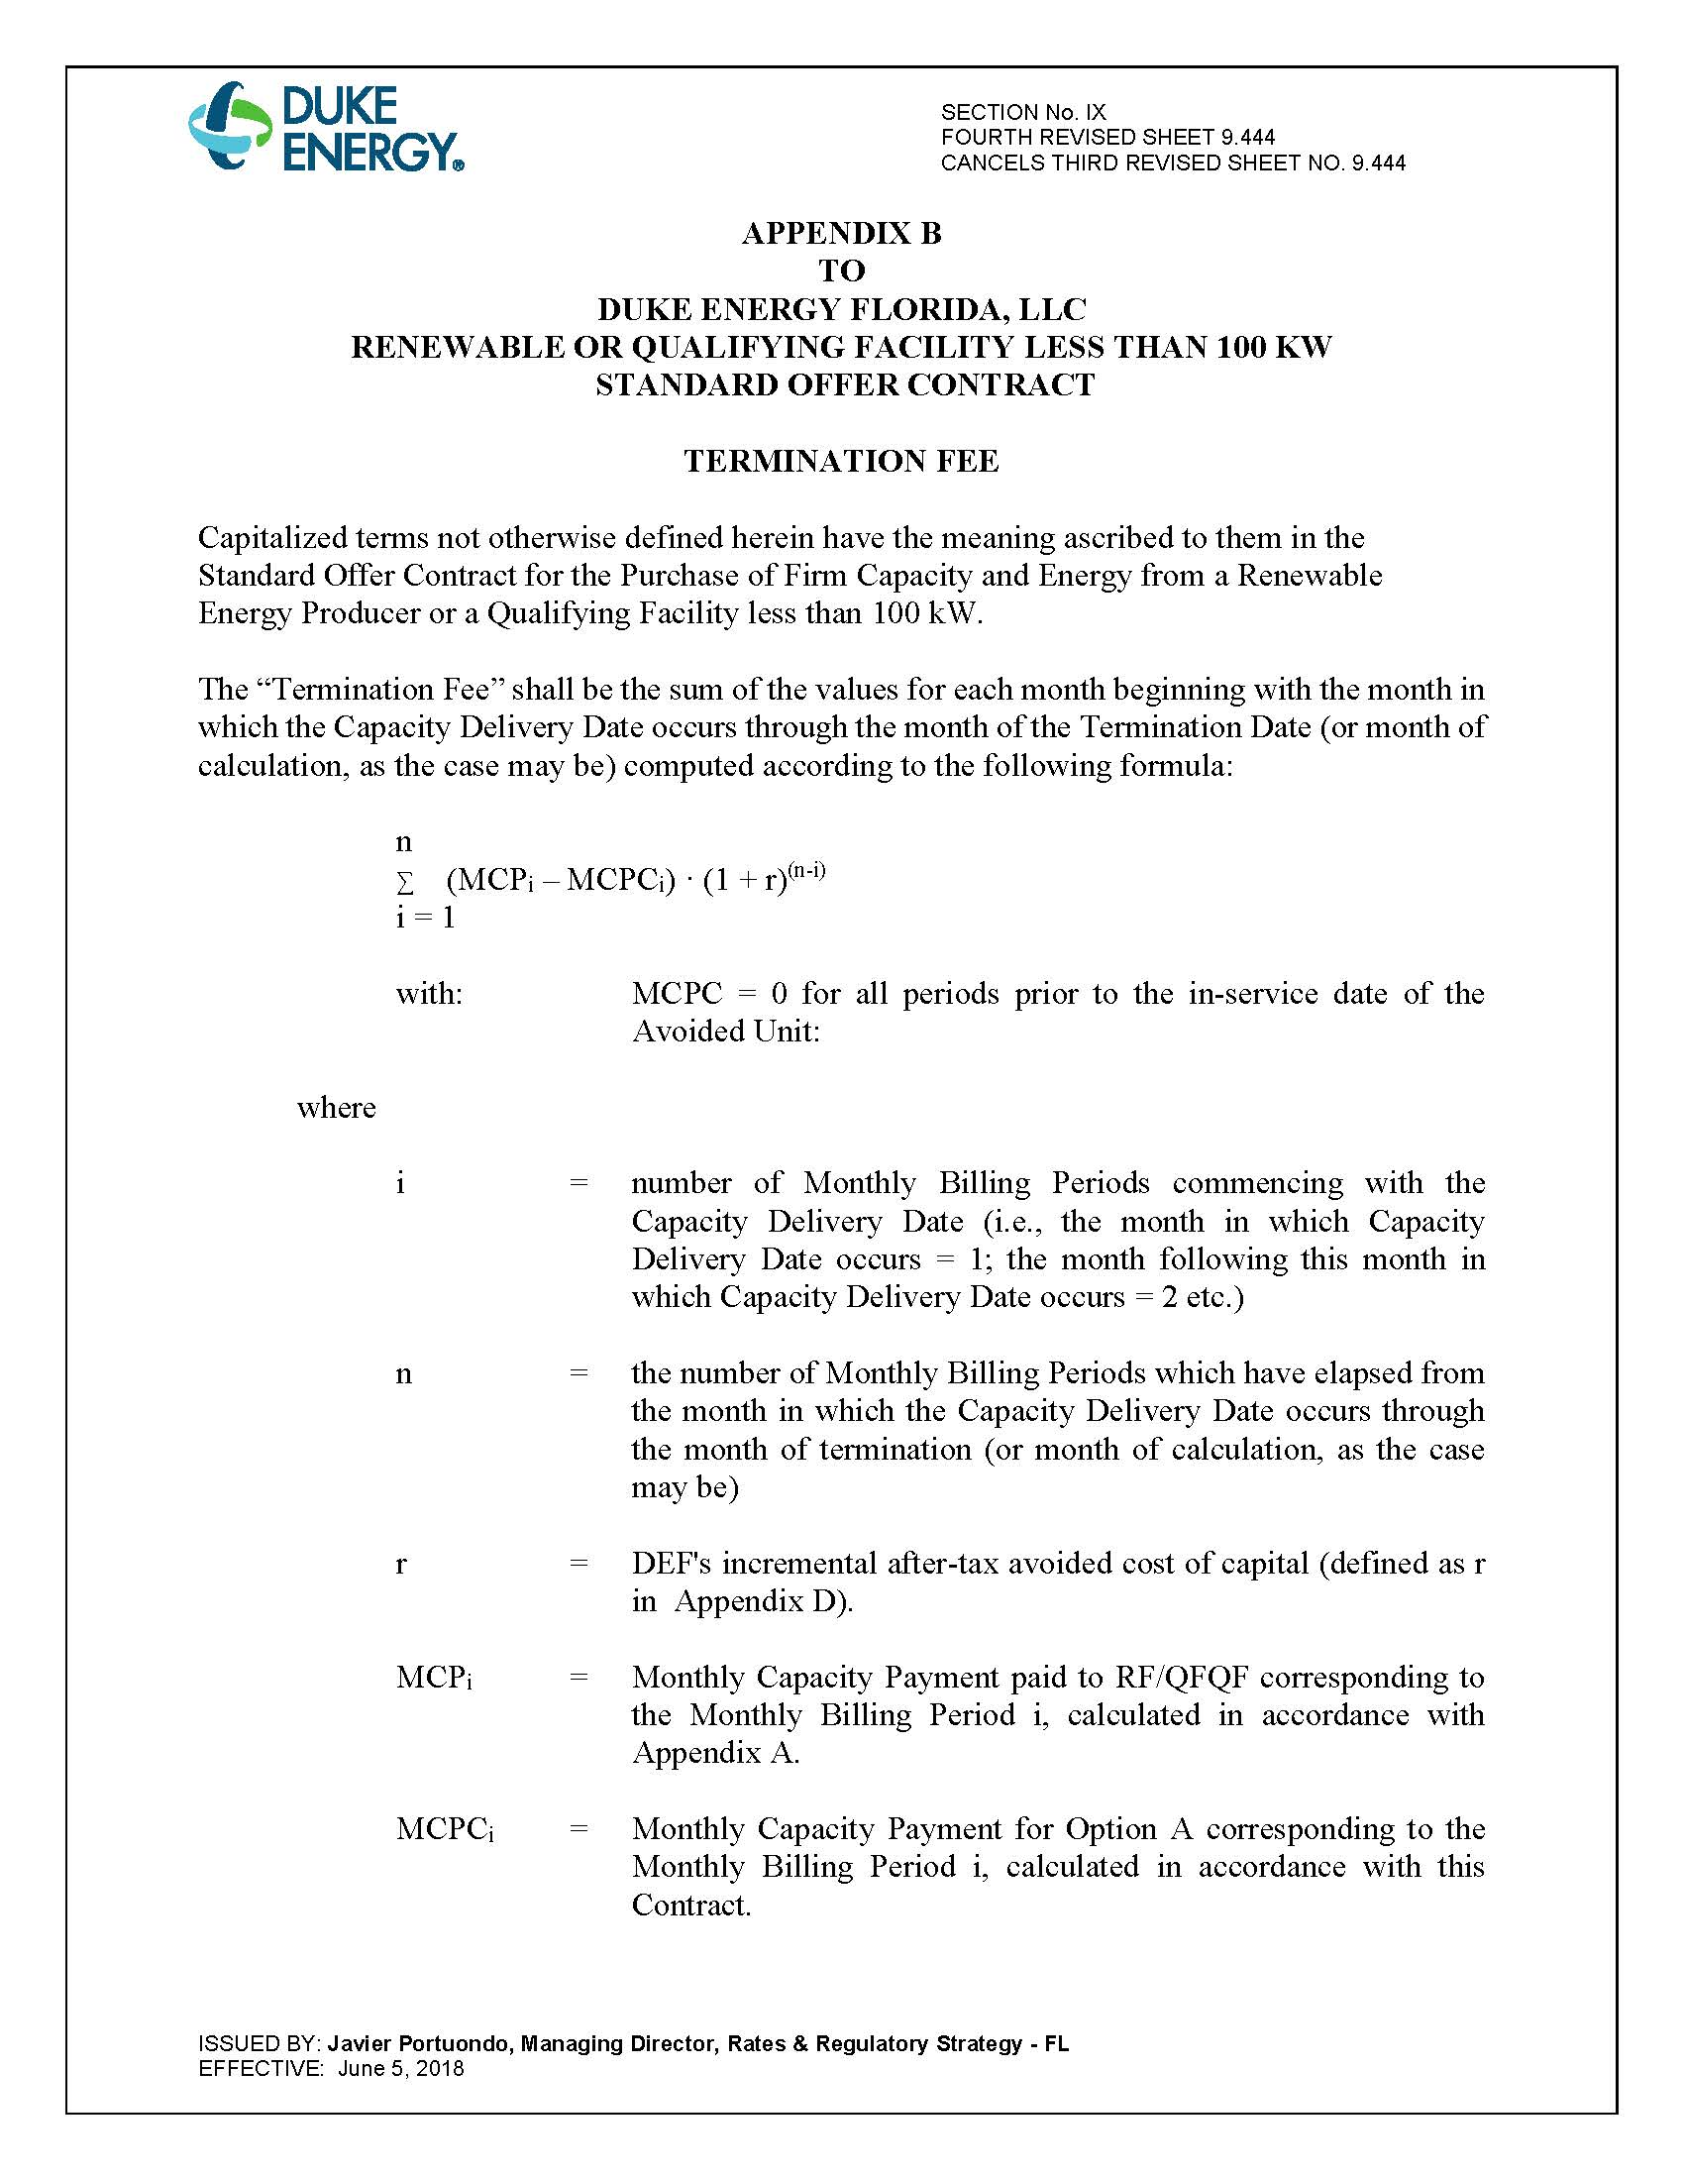

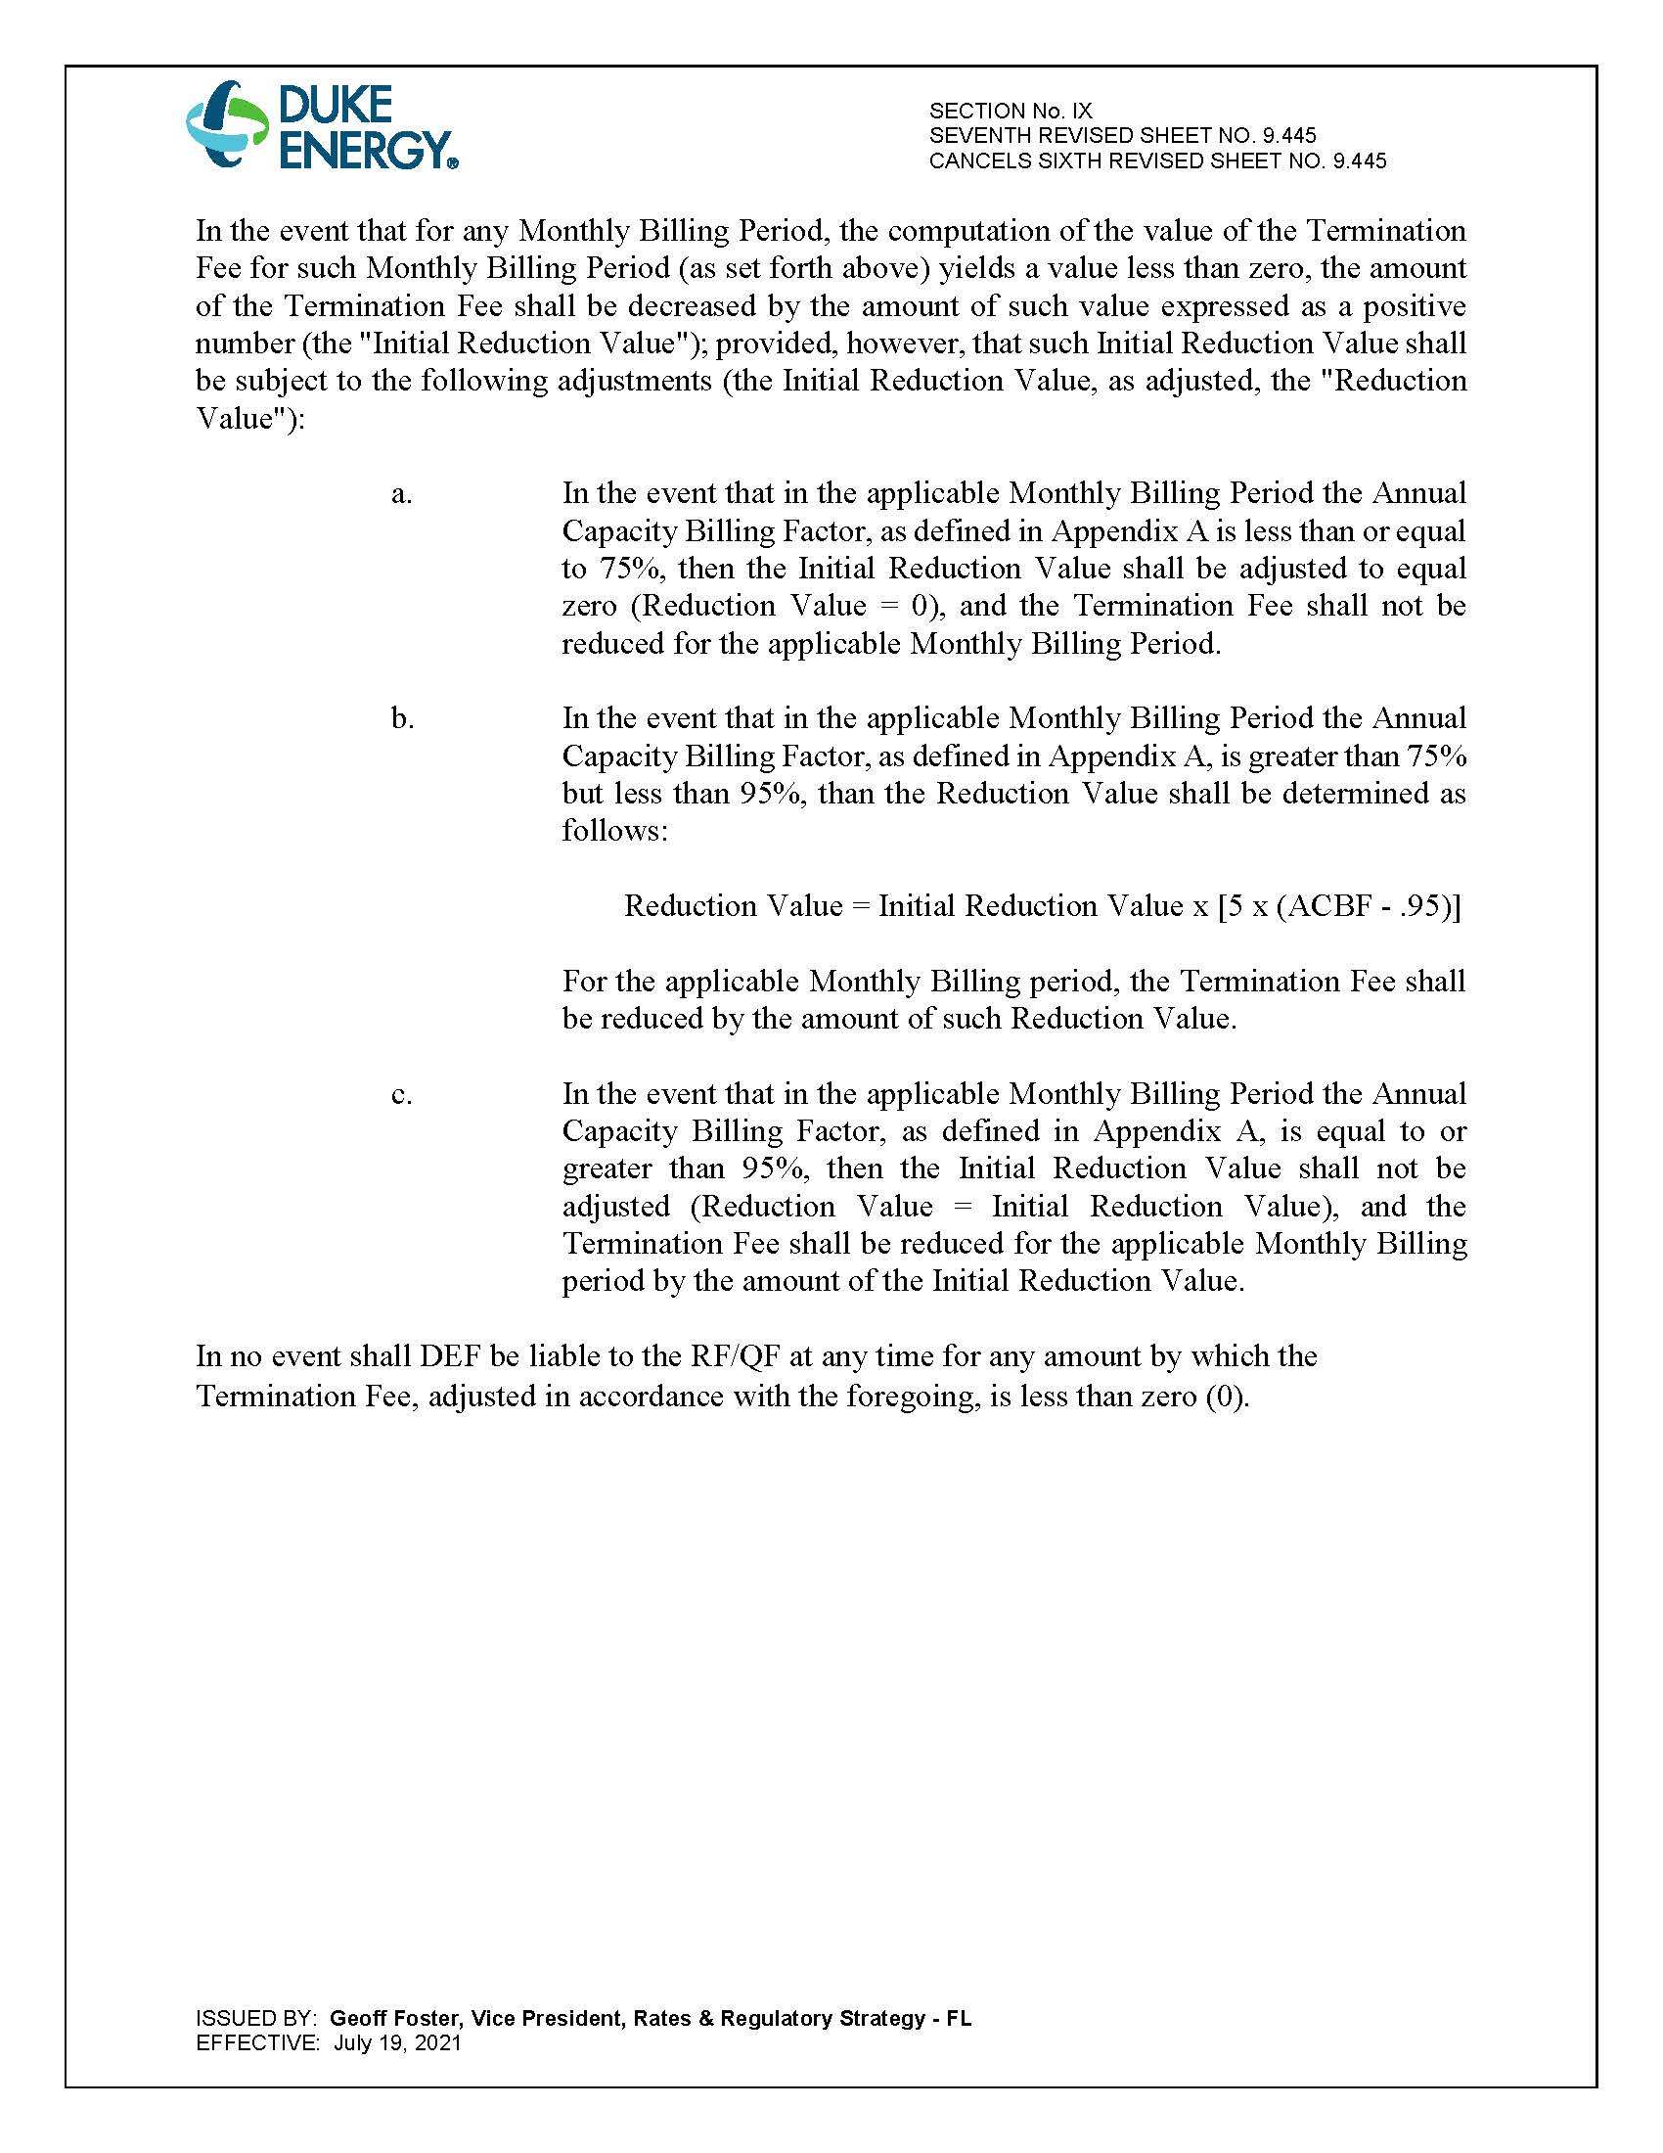

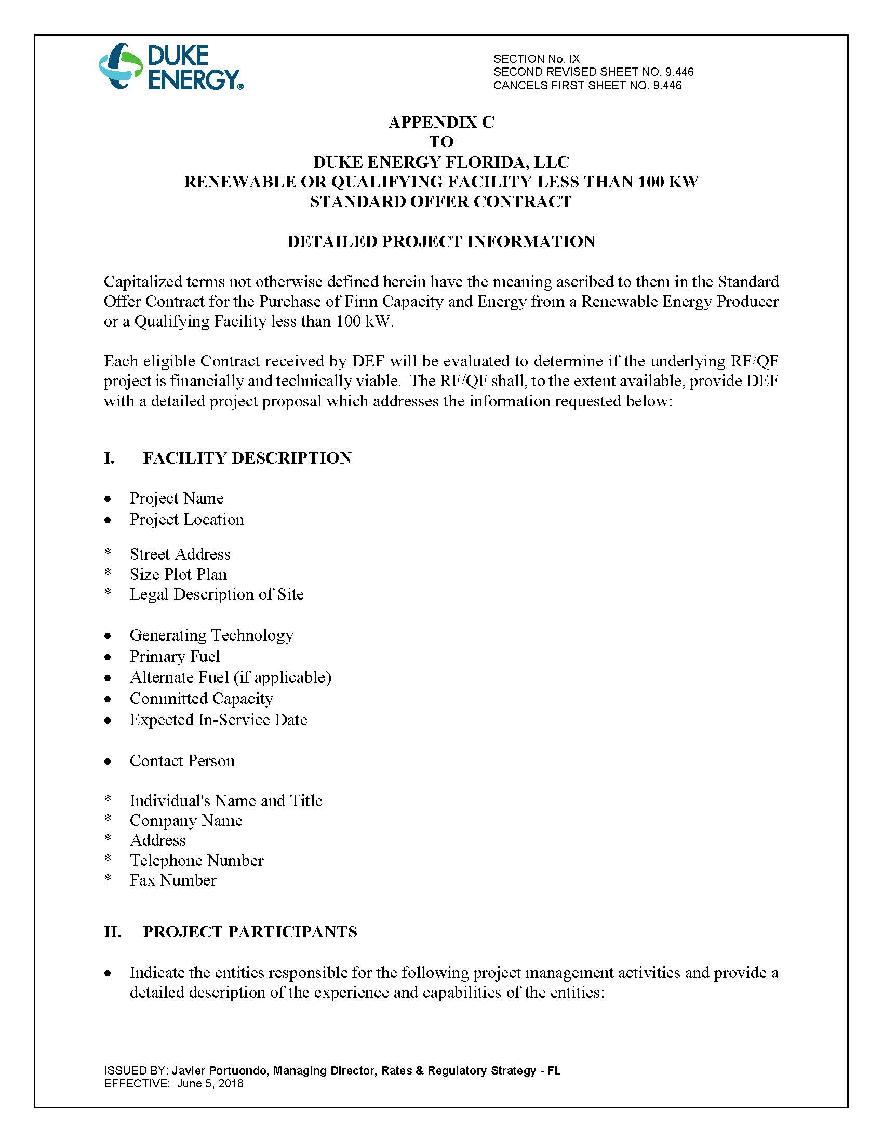

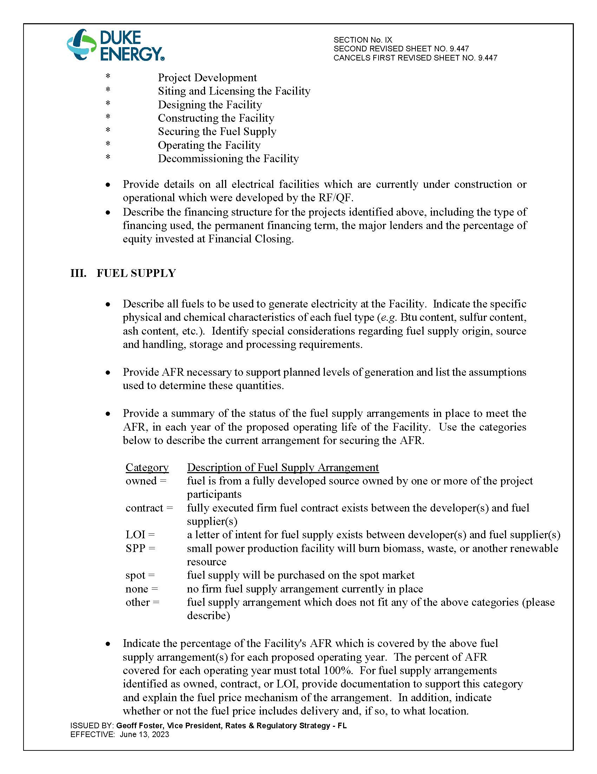

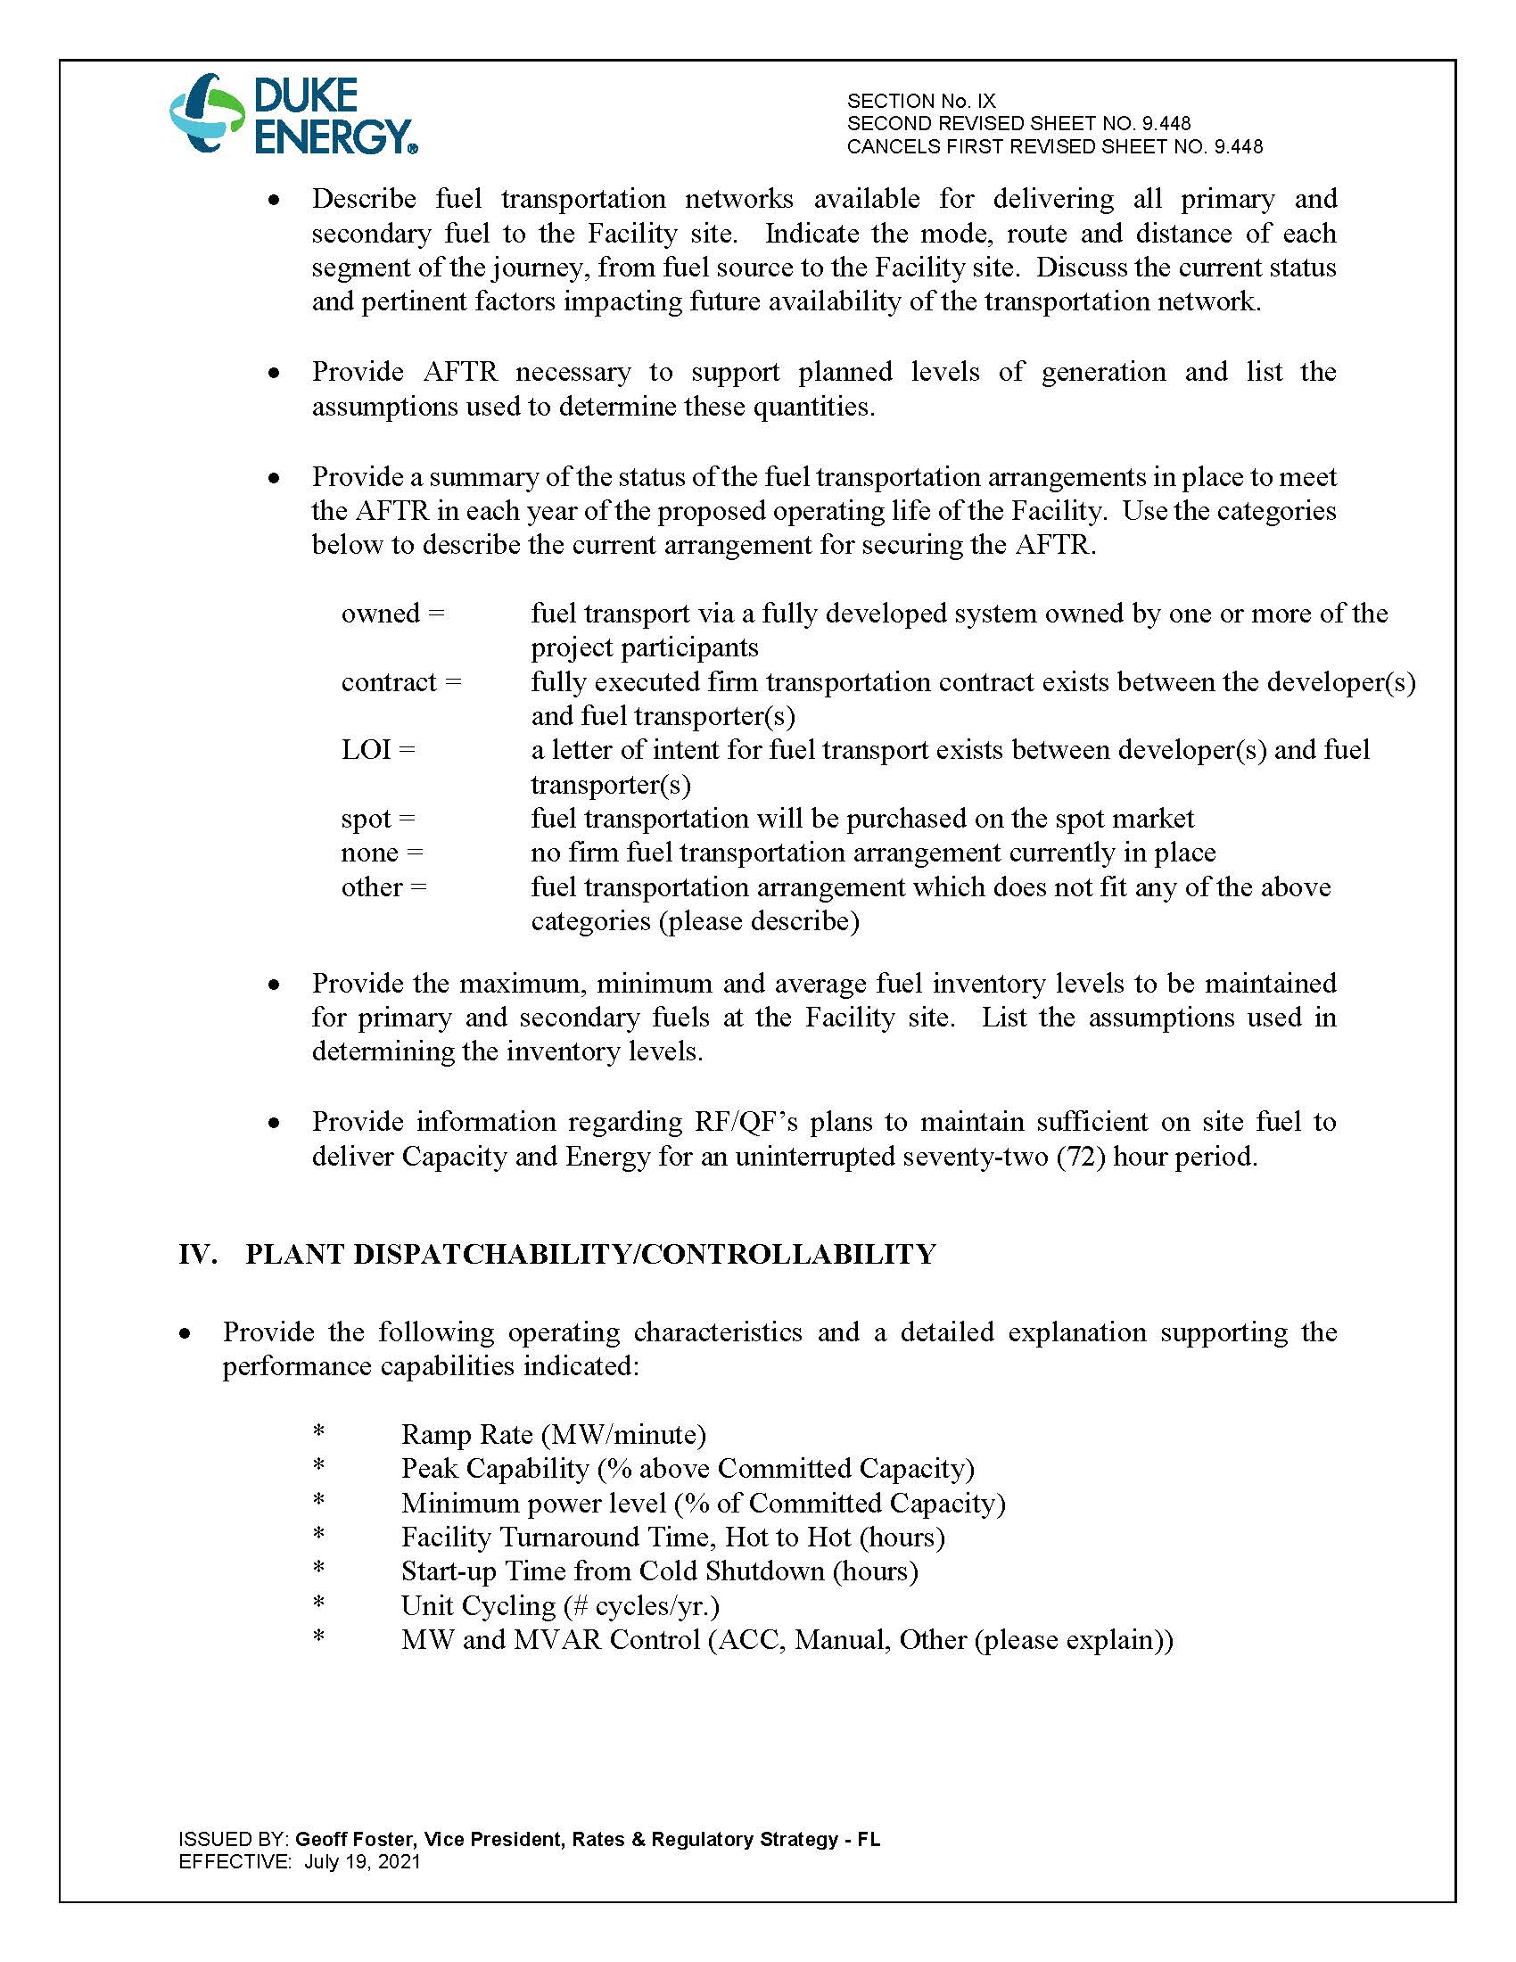

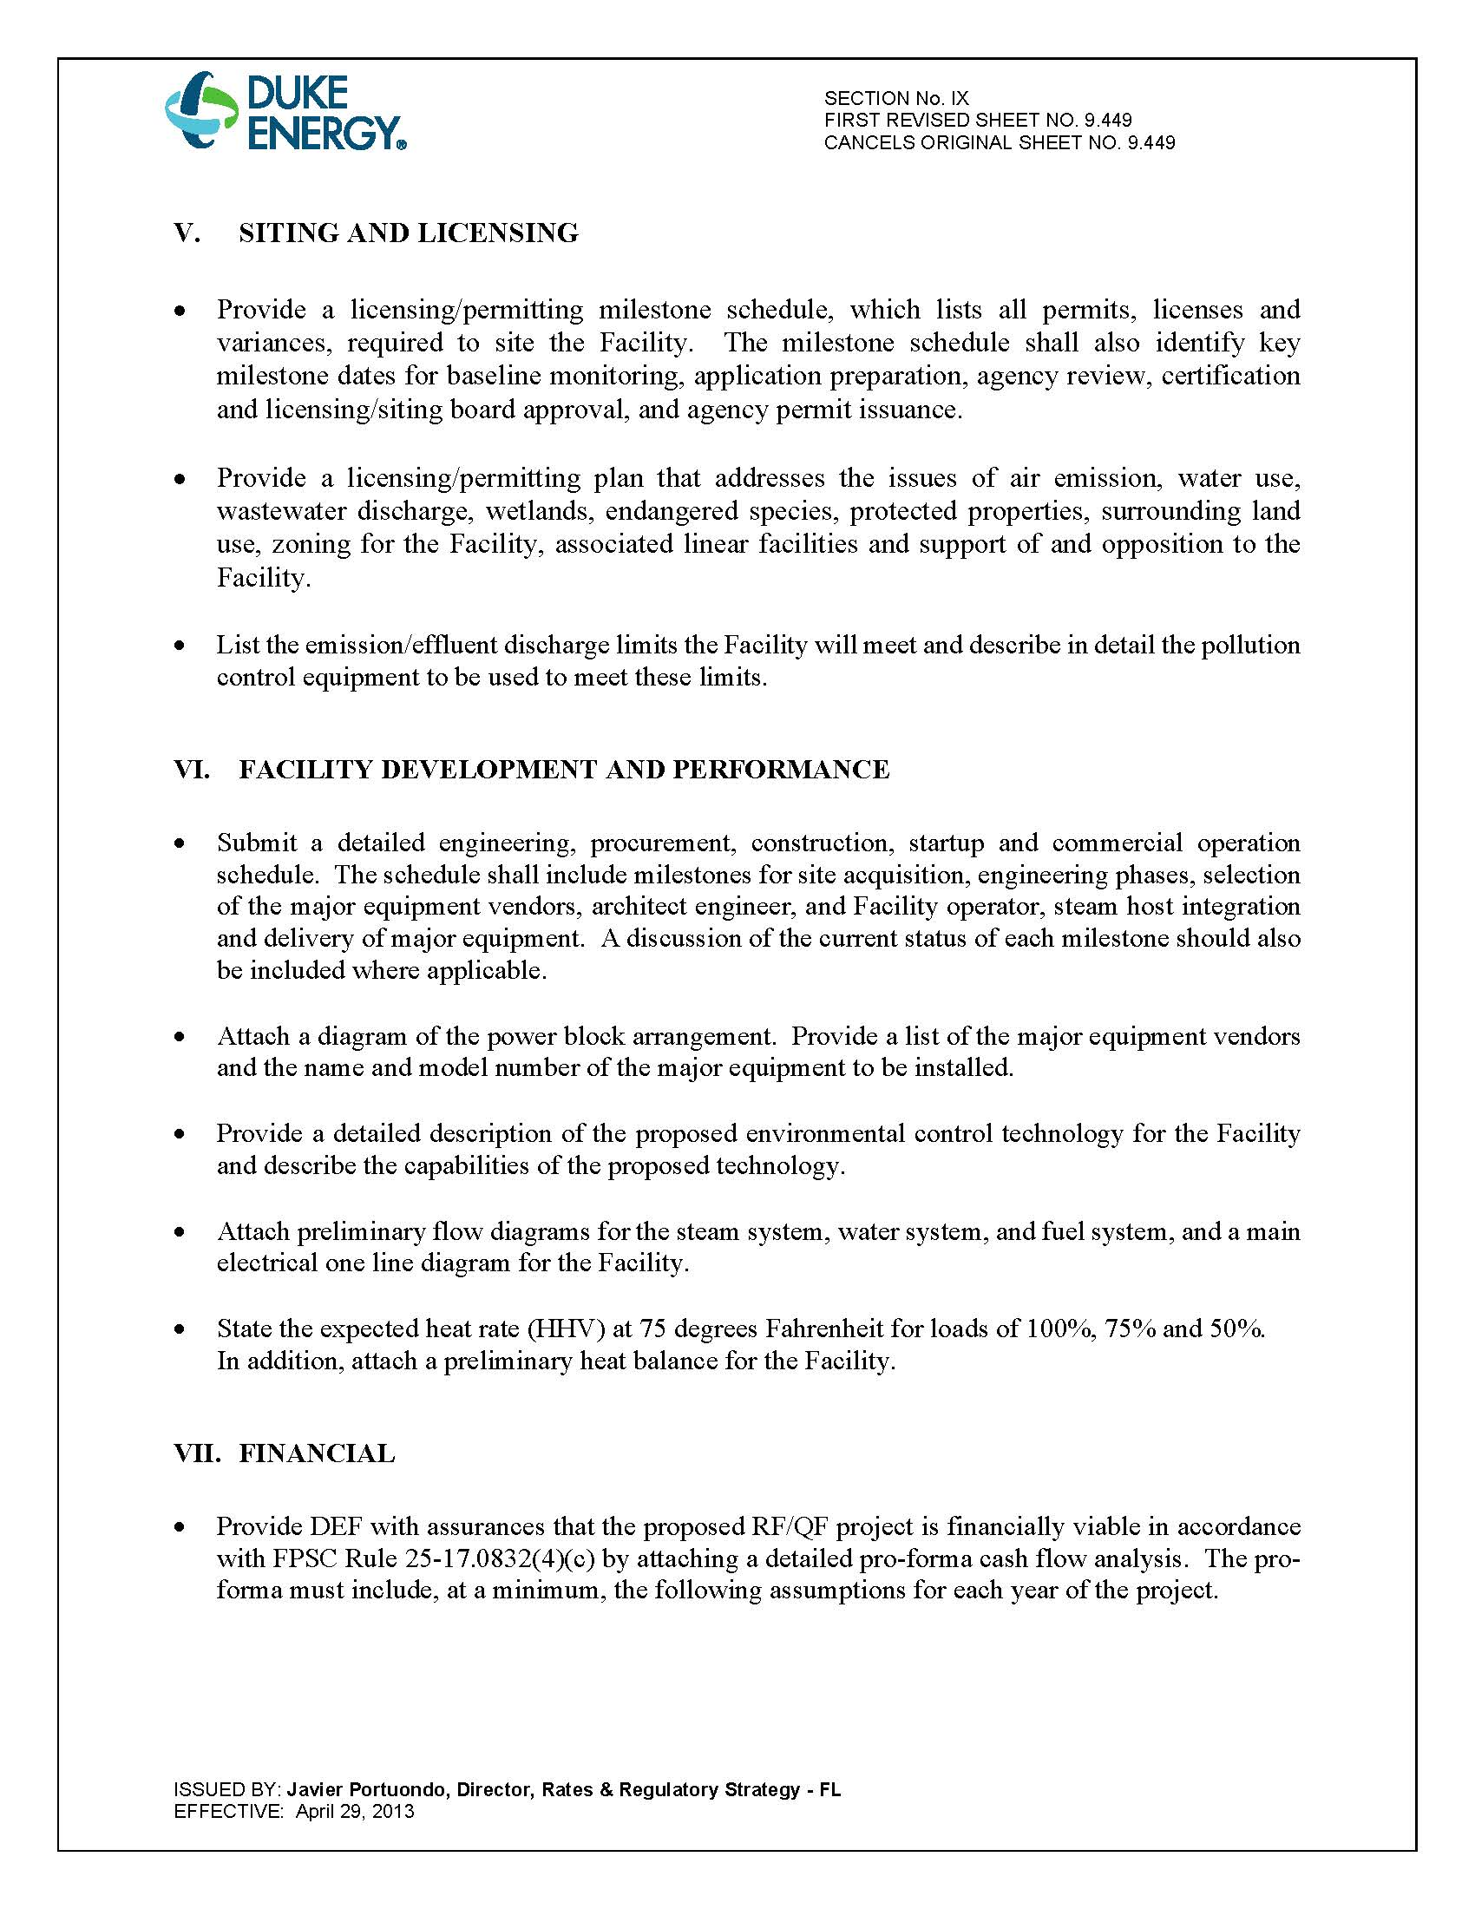

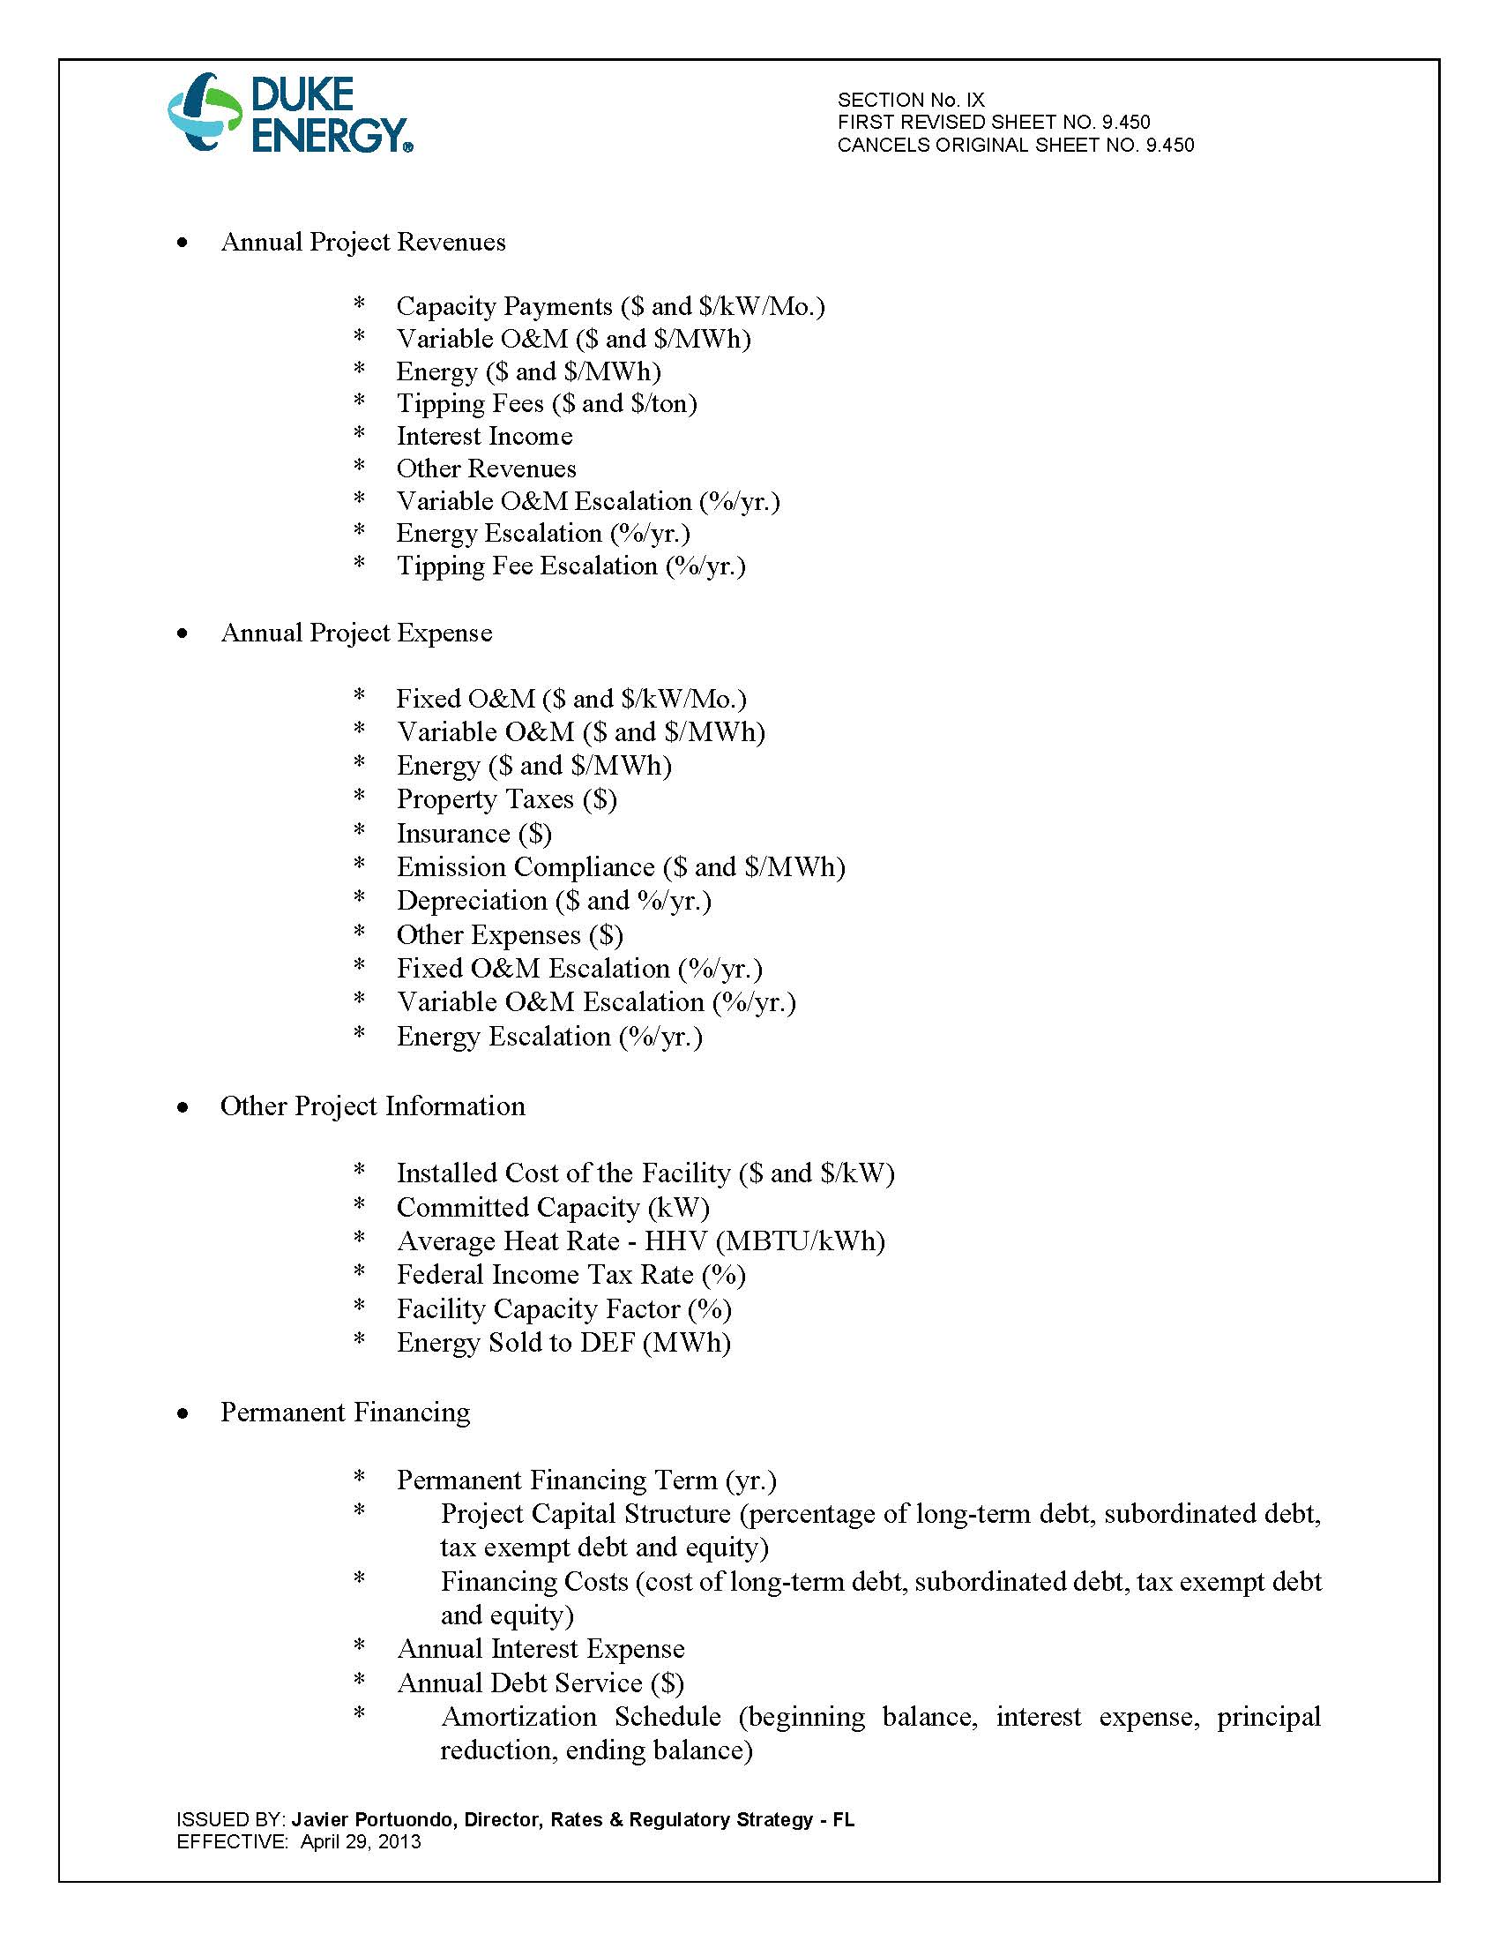

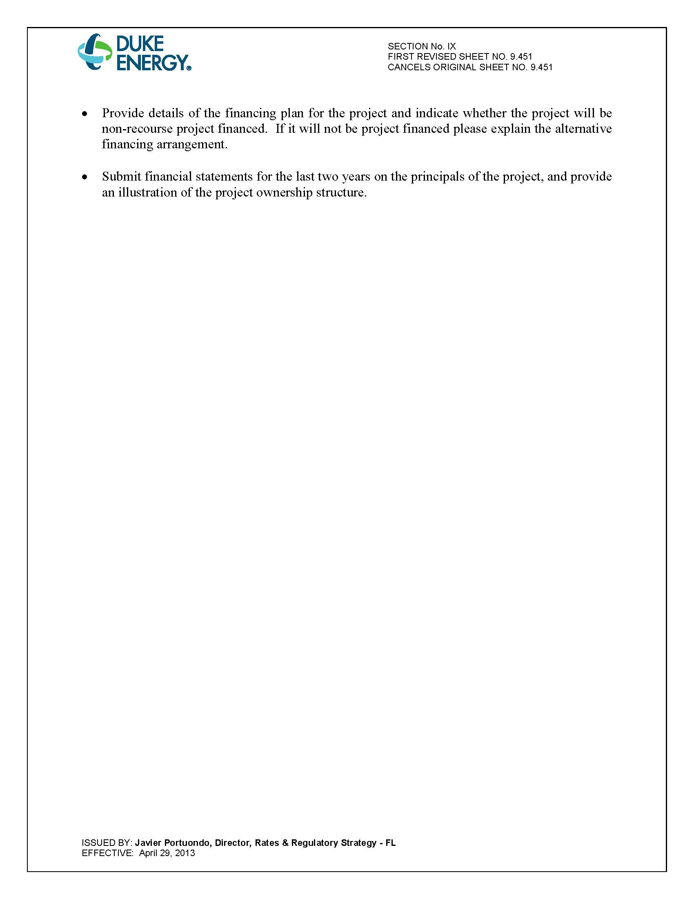

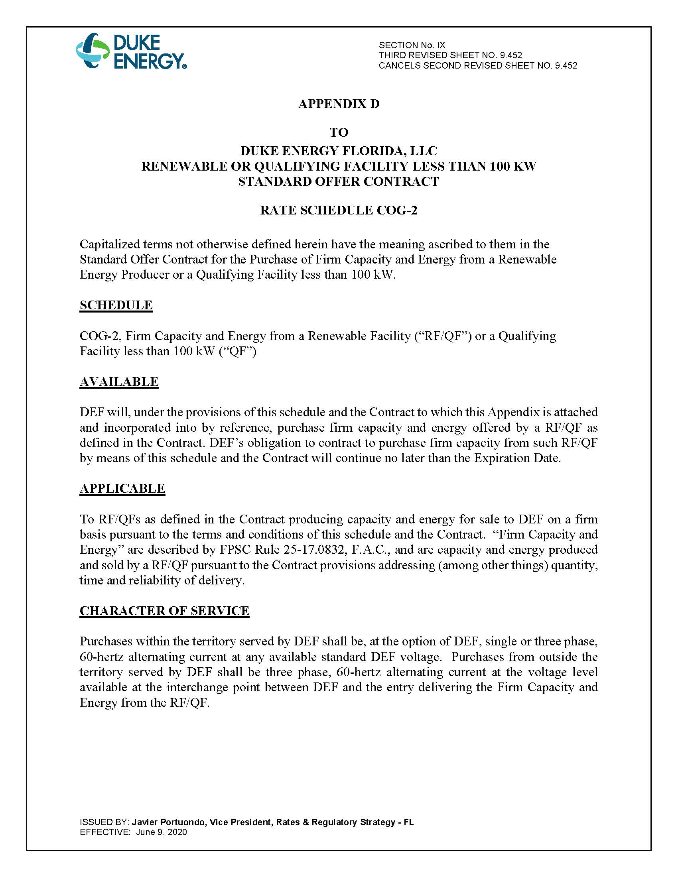

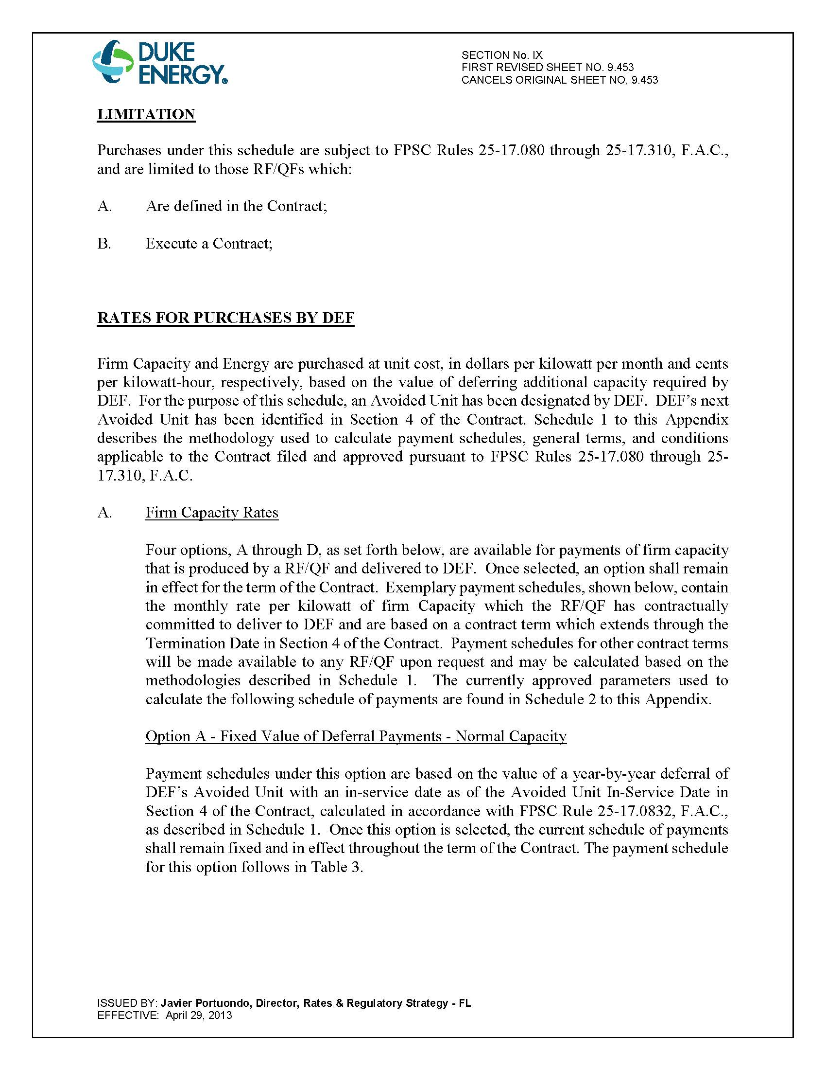

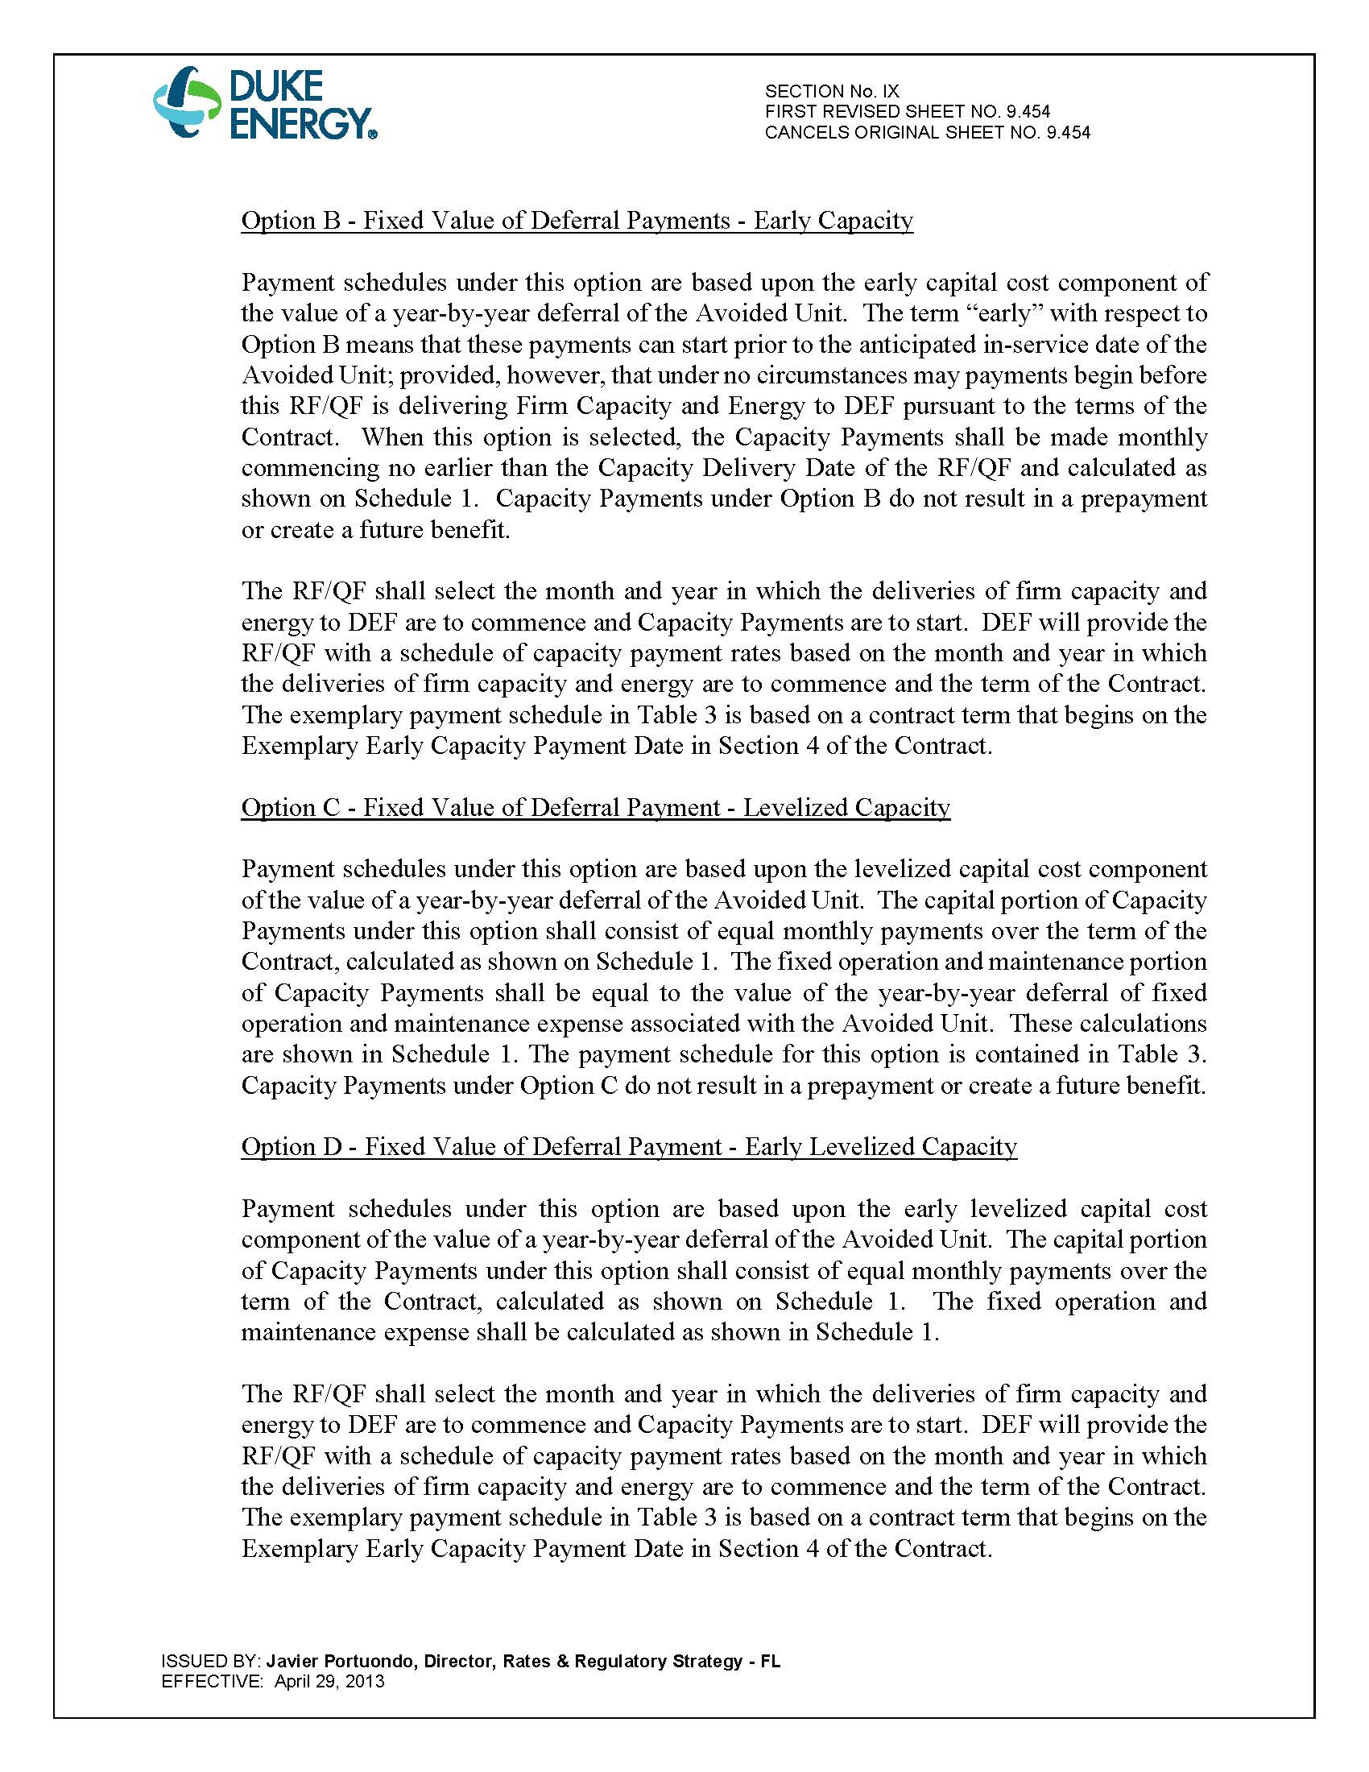

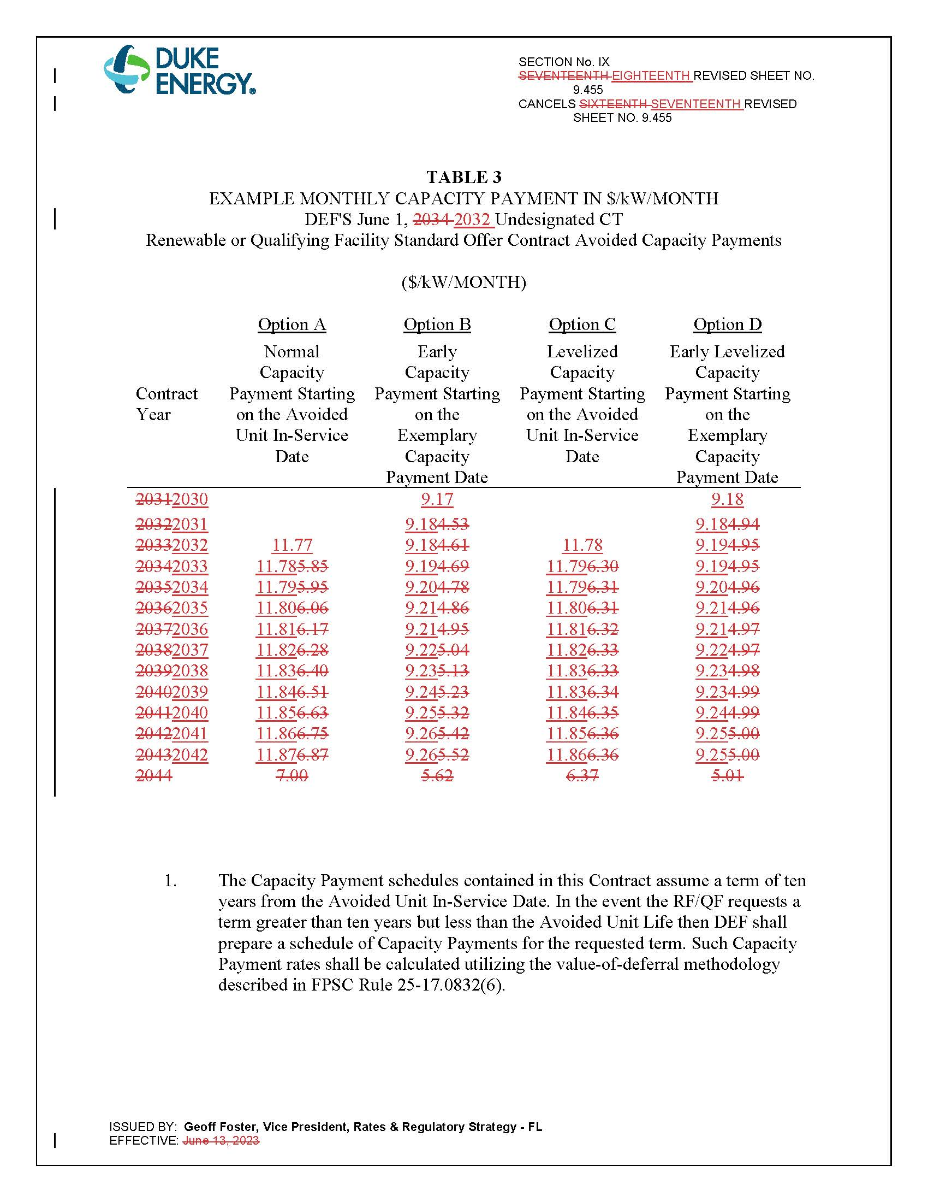

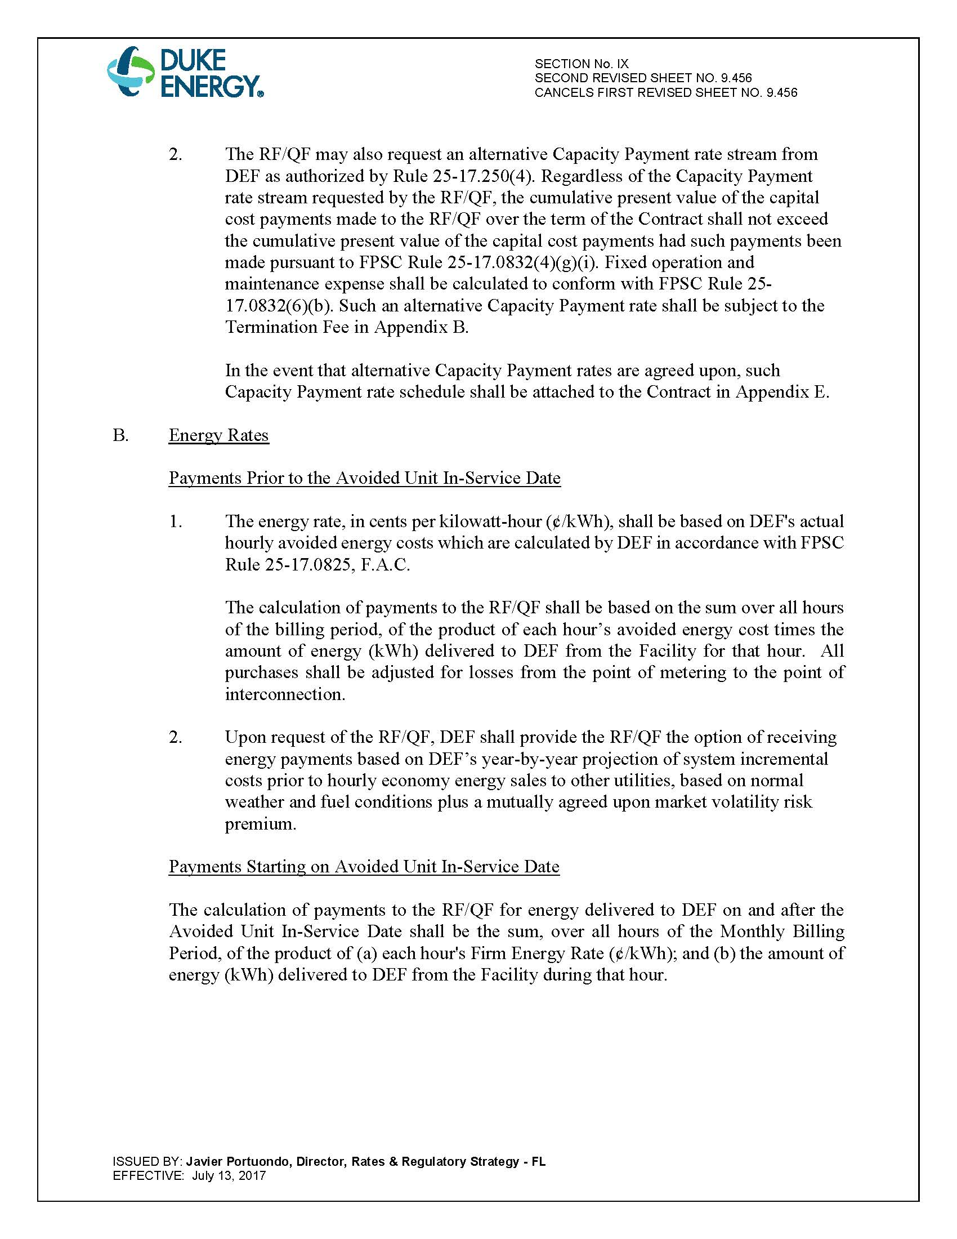

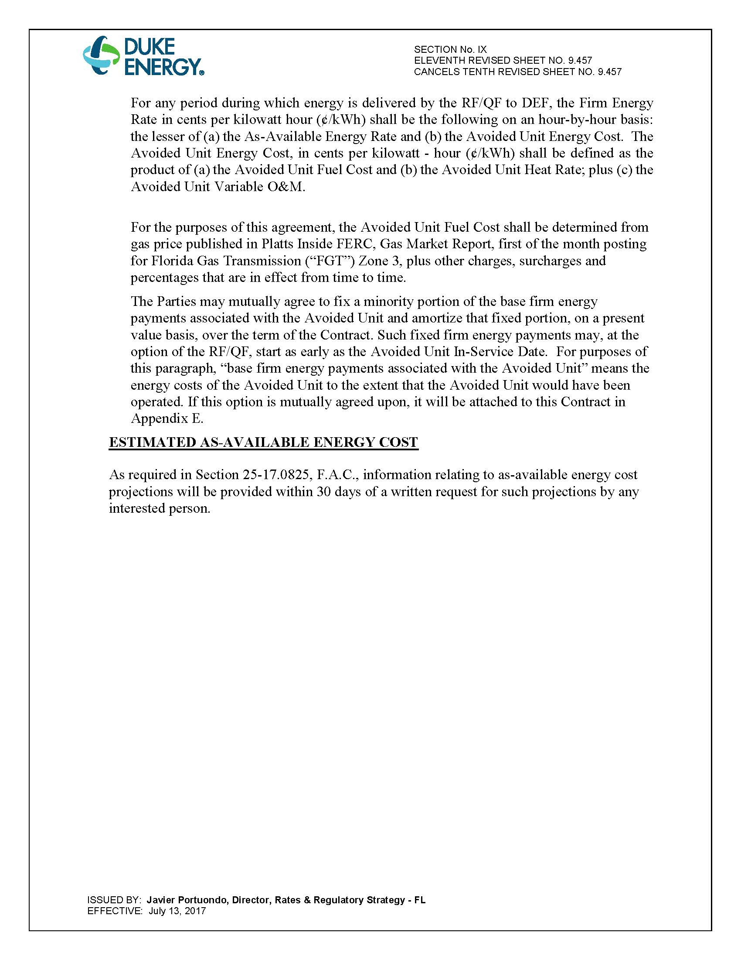

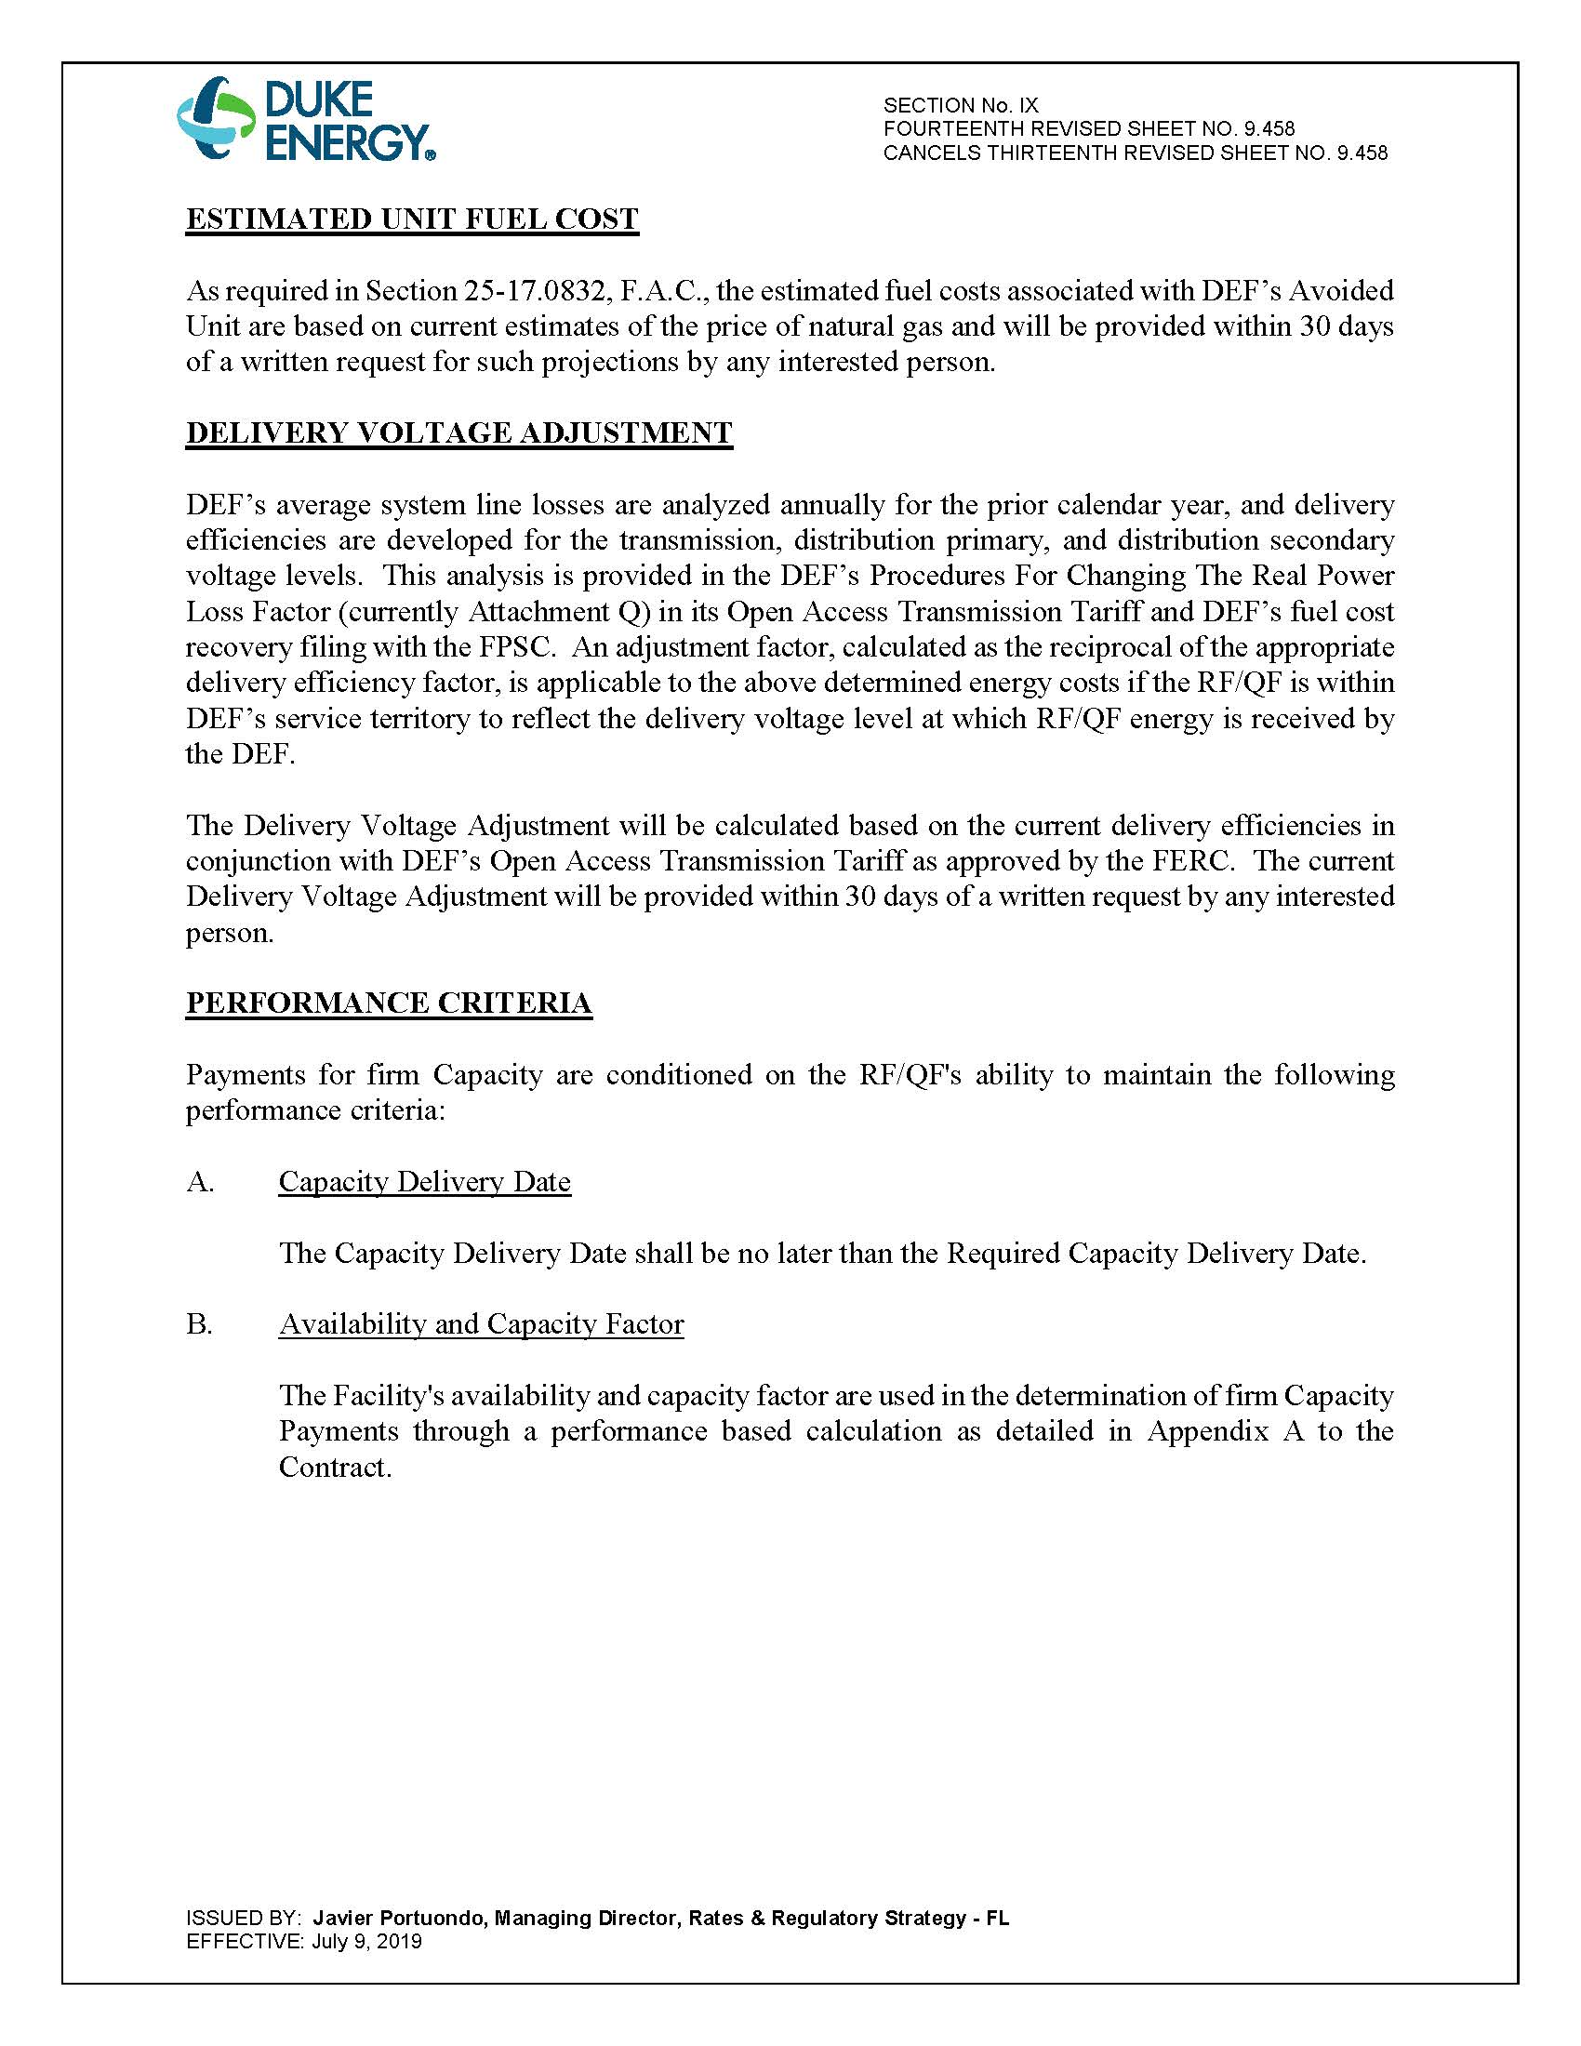

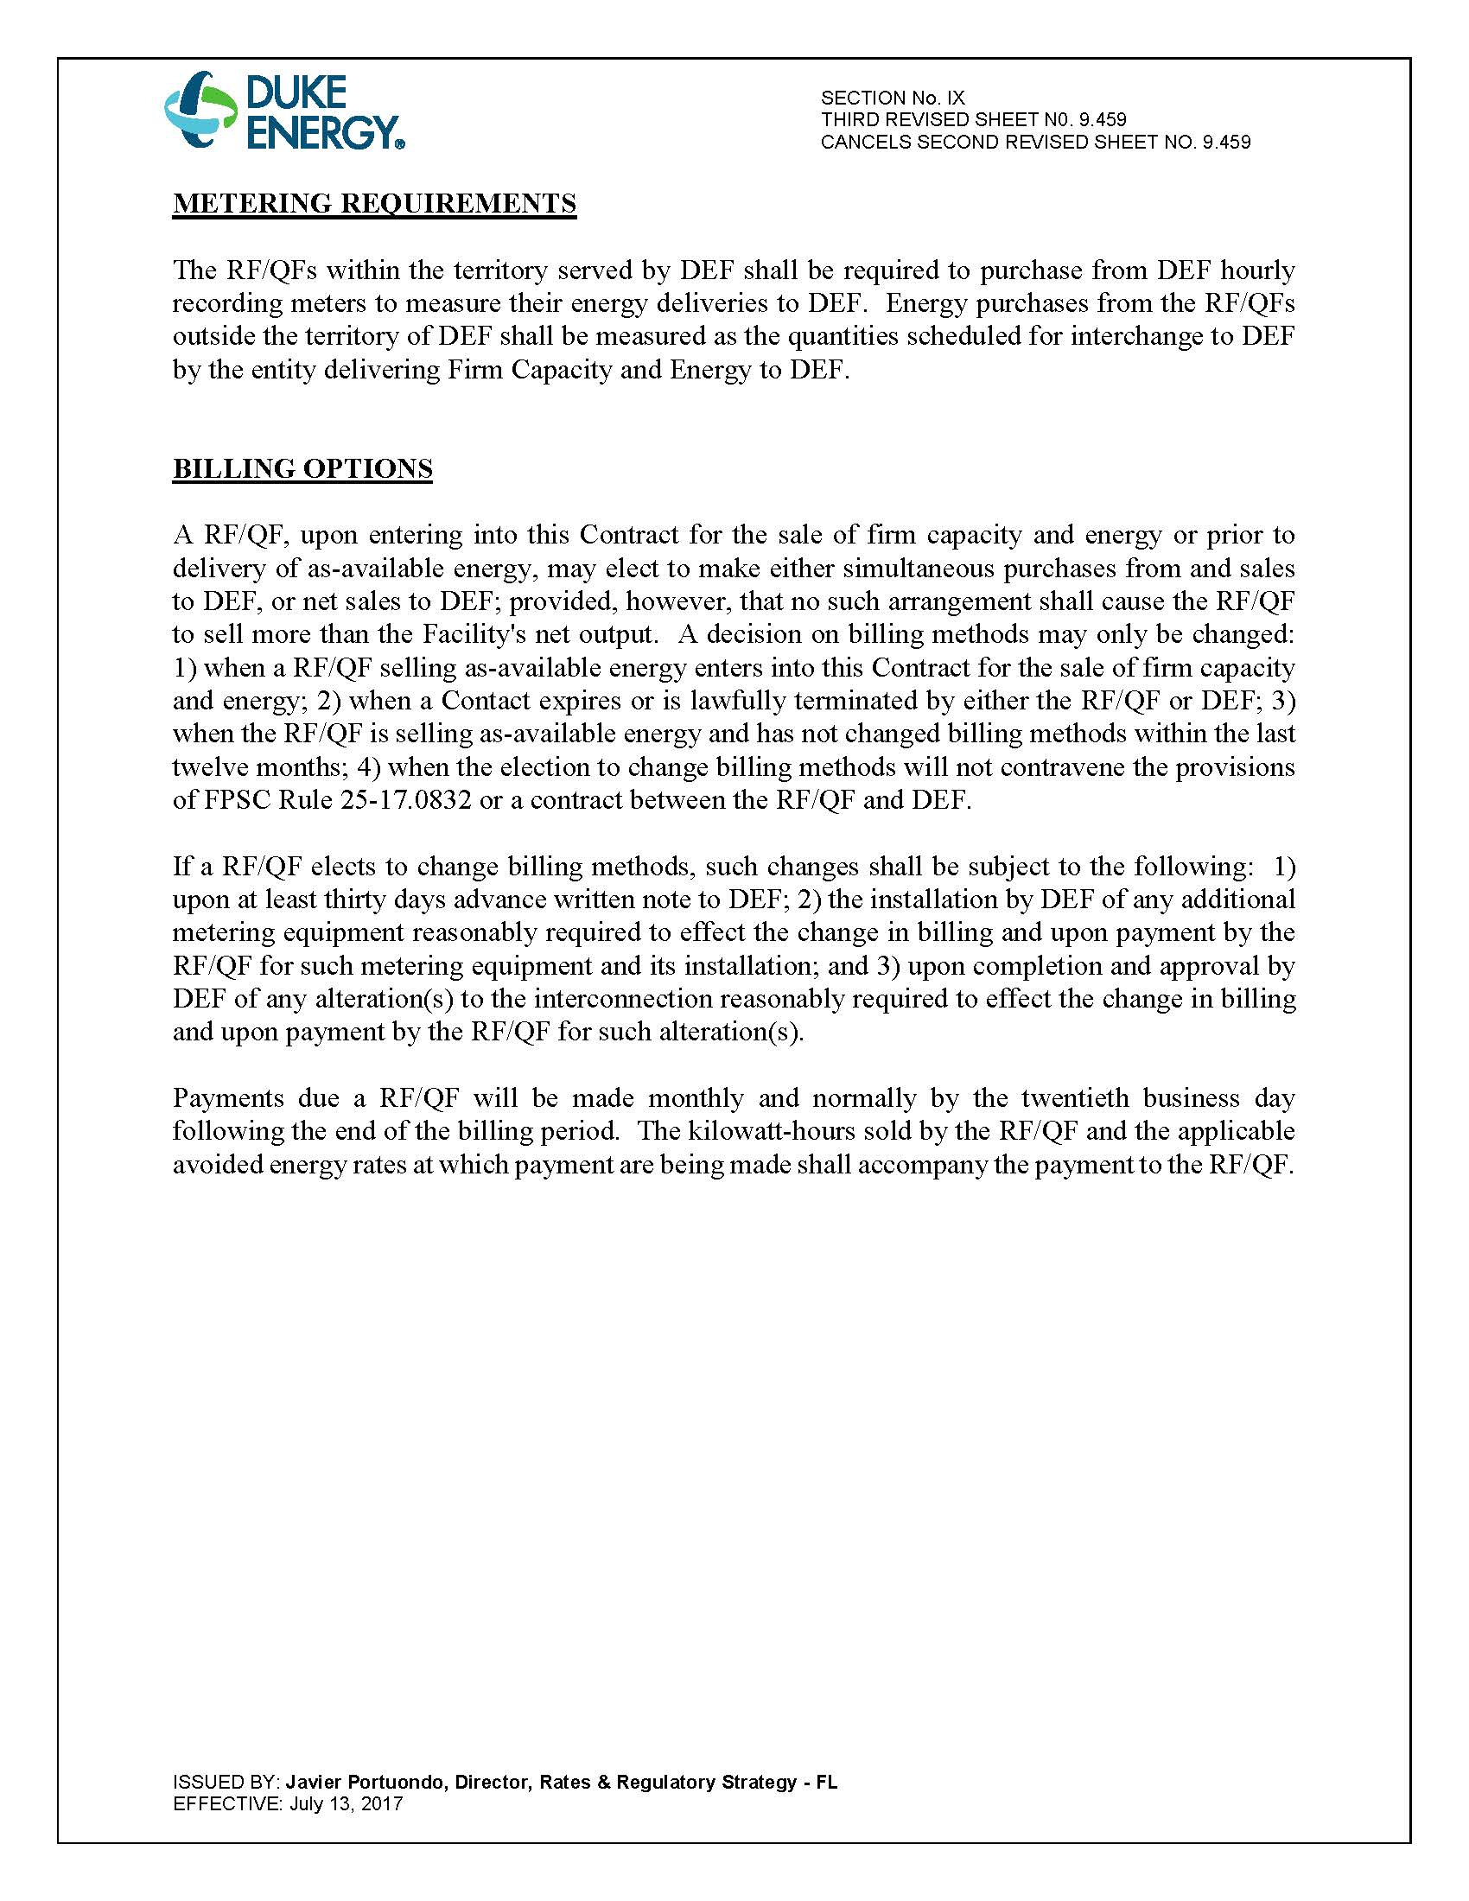

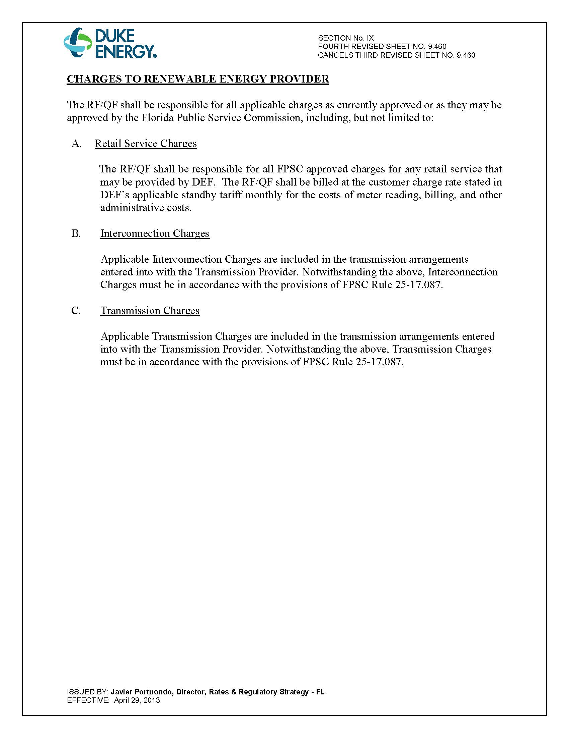

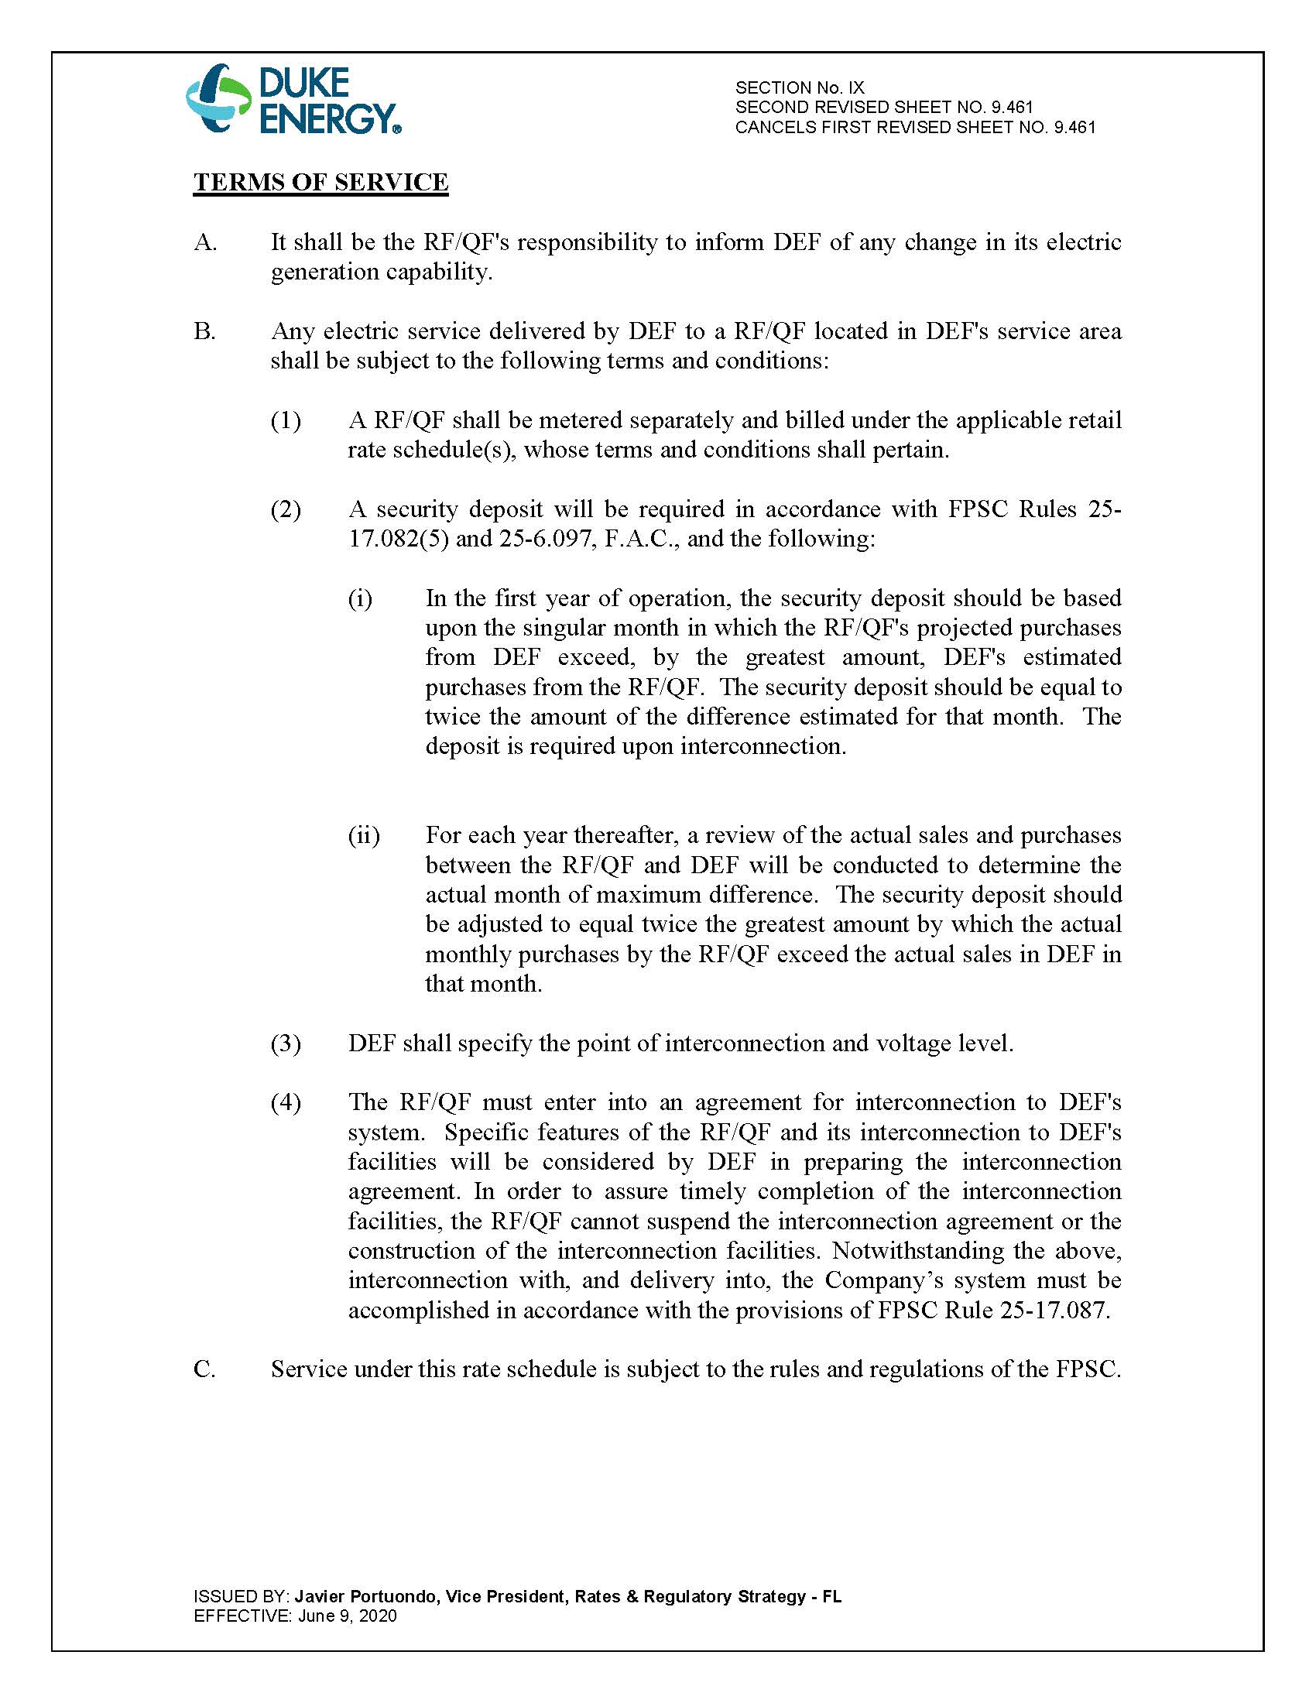

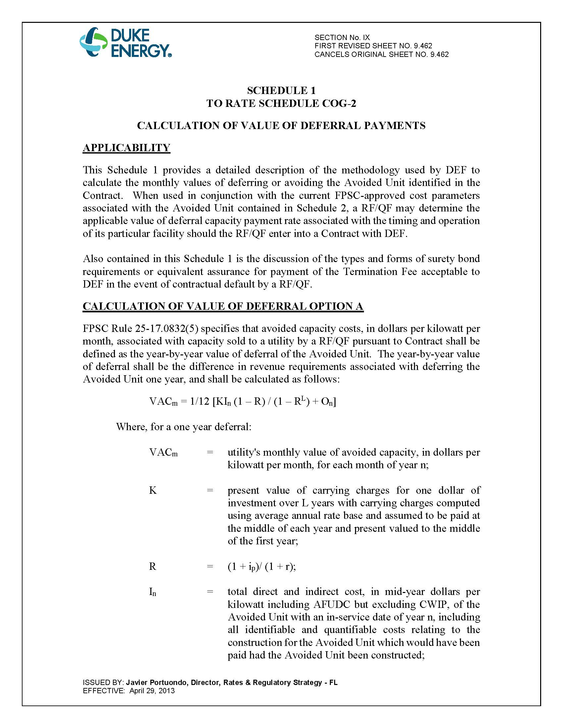

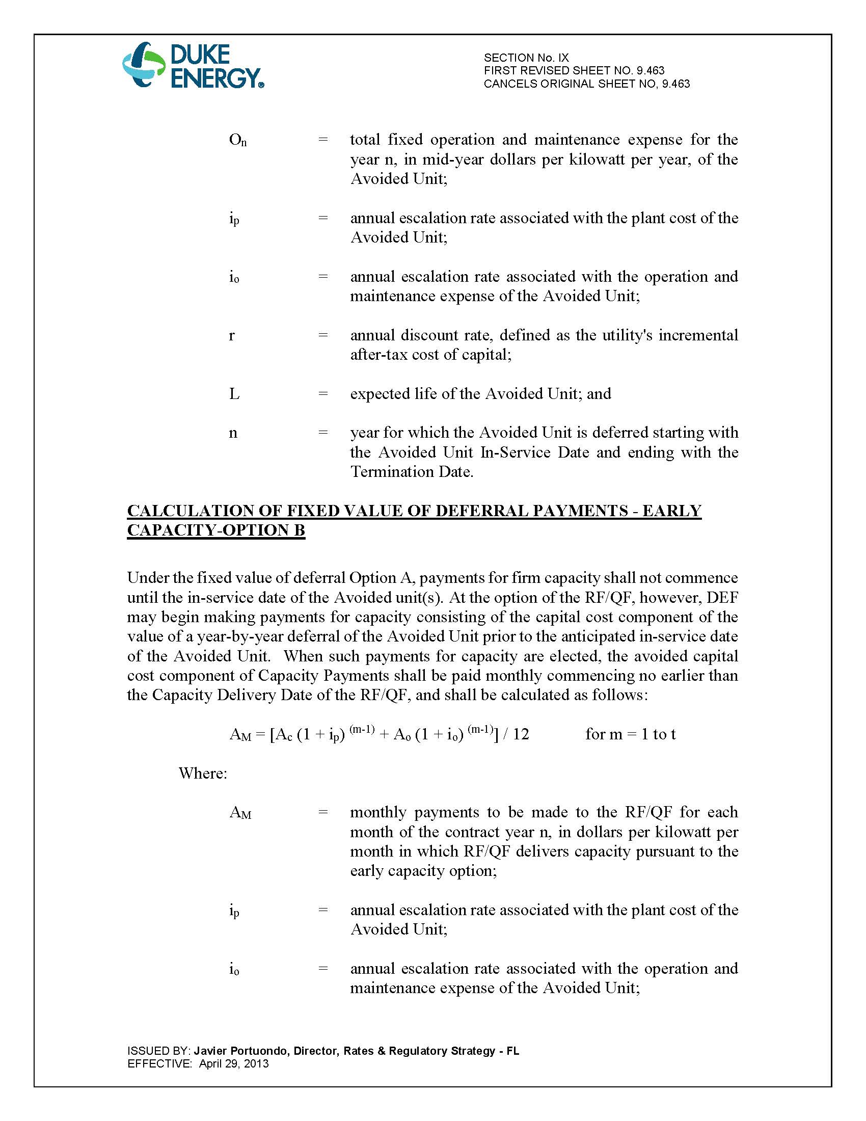

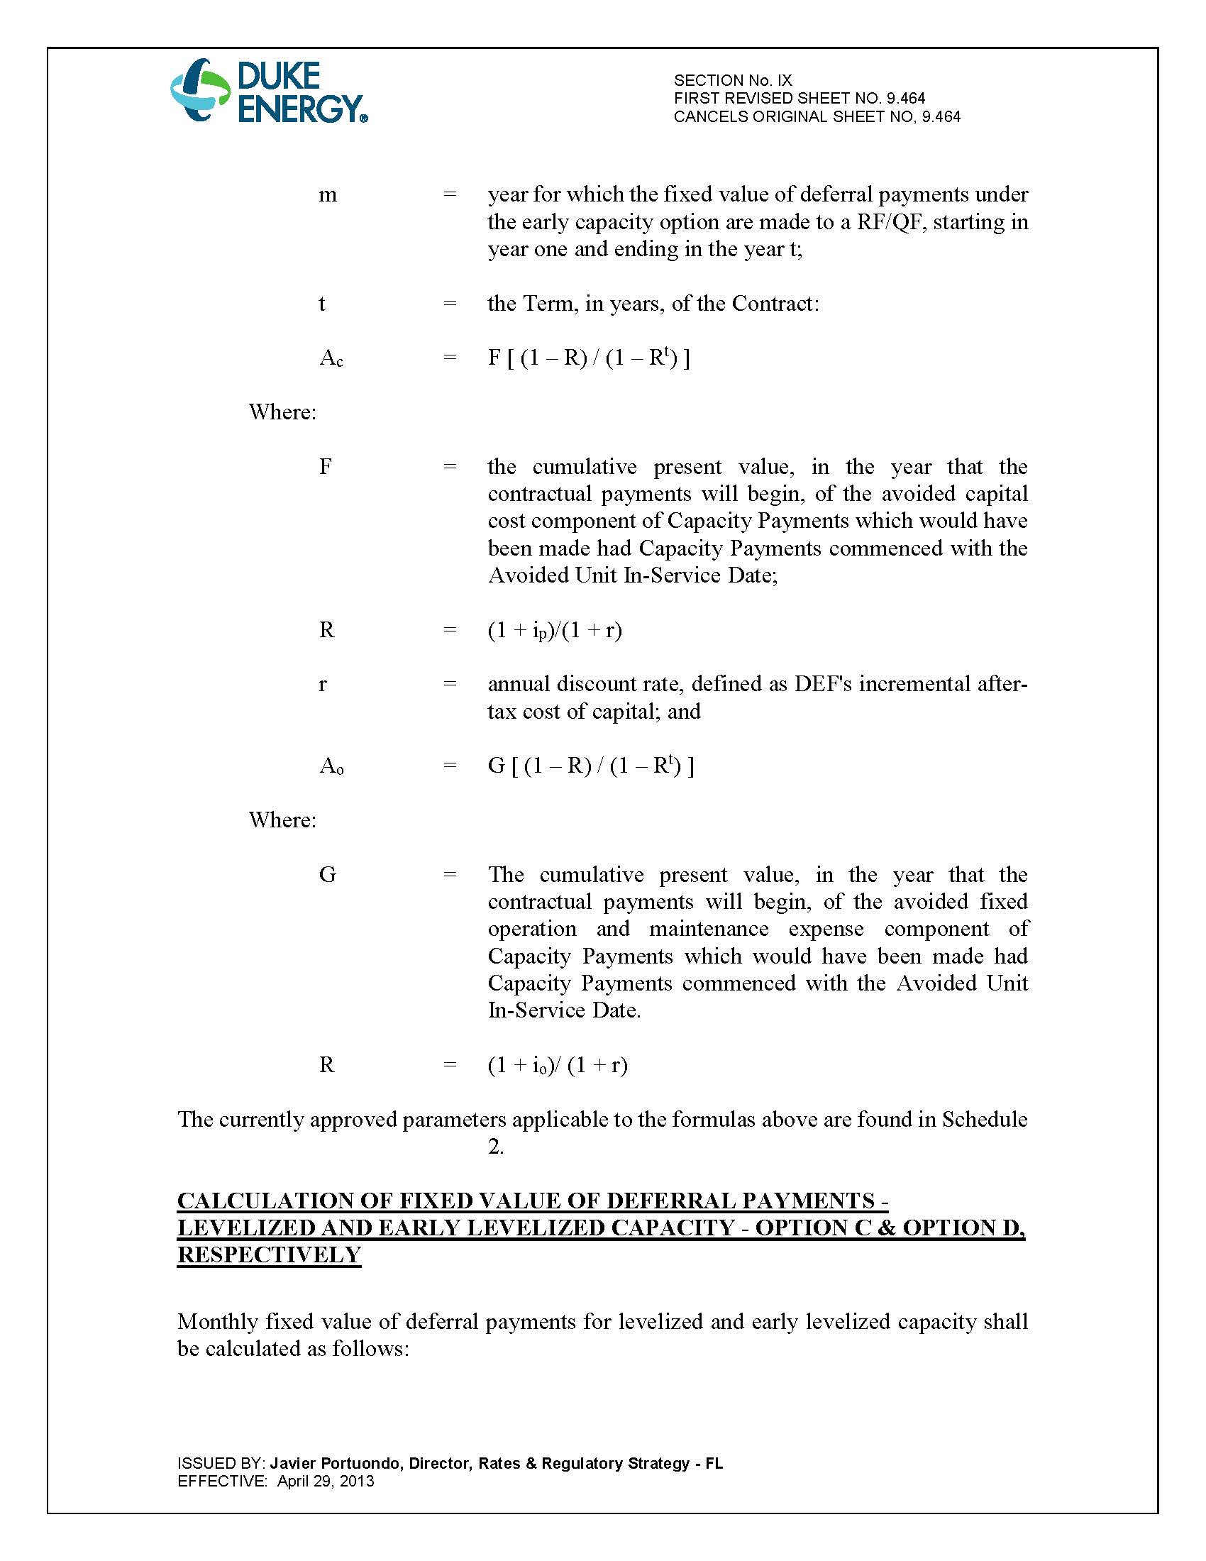

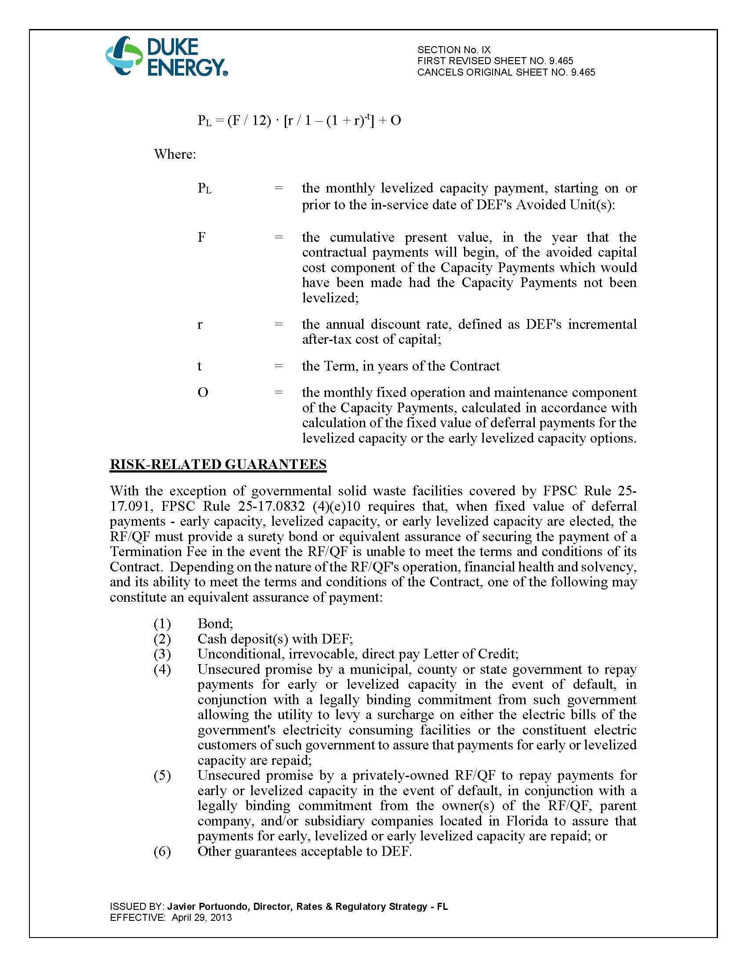

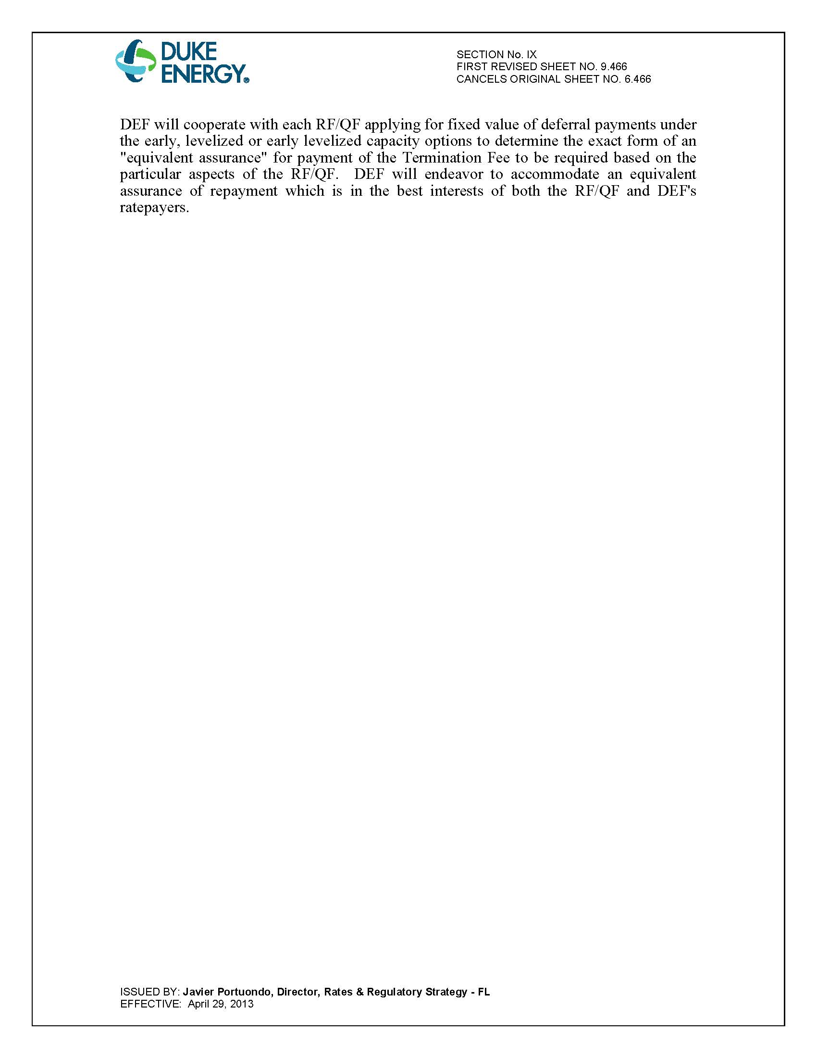

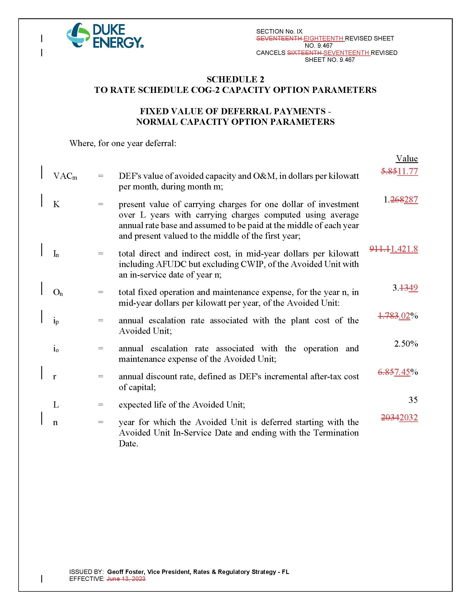

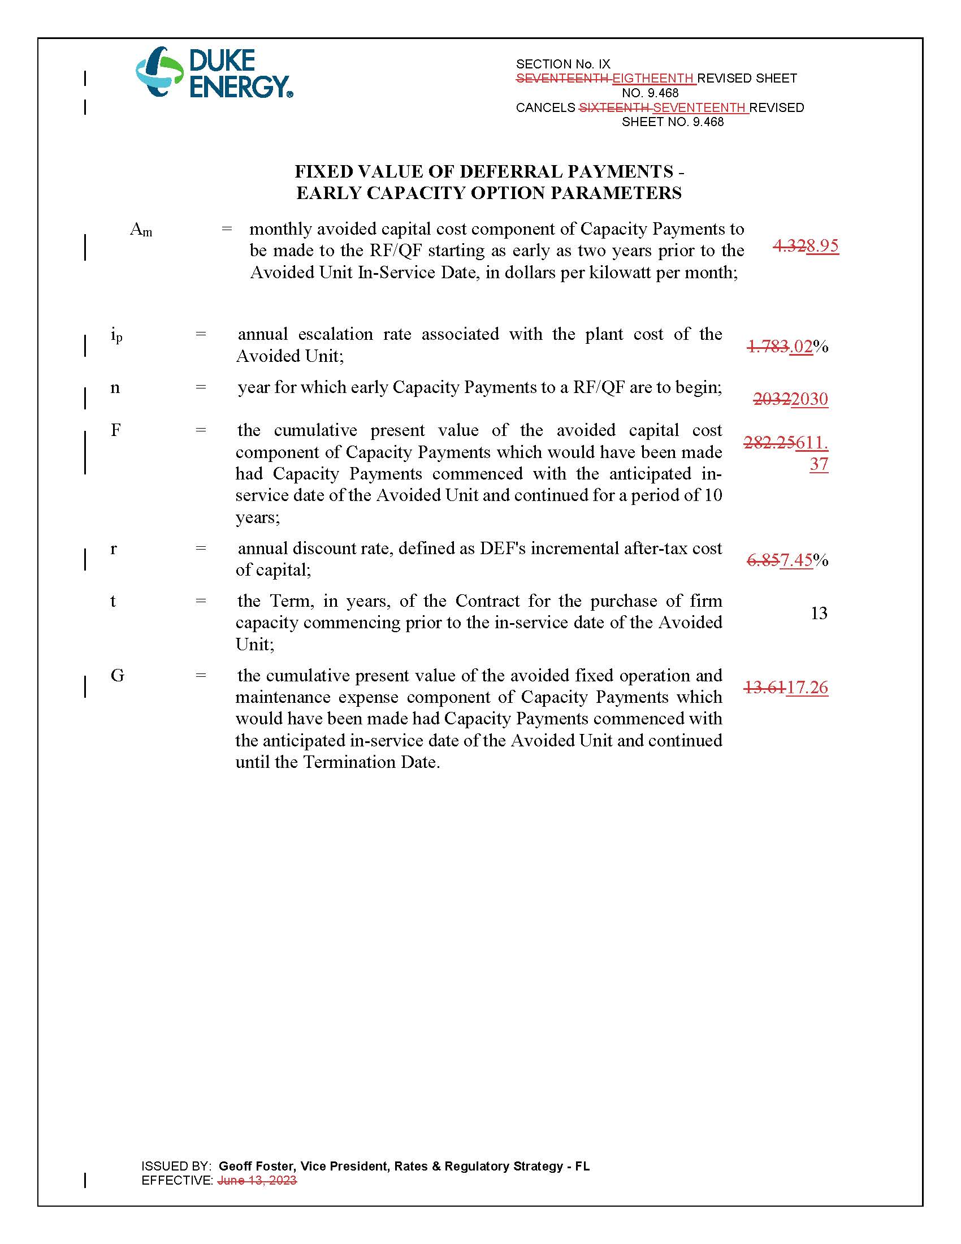

In re: Petition for approval of amended standard offer contract (Schedule COG-2), by Duke Energy Florida, LLC, Docket No. 20240048-EQ, Document No. 02782-2024 (filed May 6, 2024).

