|  |  |  |  |
| --- | --- | --- | --- |
| State of Florida  pscSEAL | | Public Service Commission  Capital Circle Office Center ● 2540 Shumard Oak Boulevard Tallahassee, Florida 32399-0850  -M-E-M-O-R-A-N-D-U-M- | |
| DATE: | July 25, 2024 | | |
| TO: | Office of Commission Clerk (Teitzman) | | |
| FROM: | Division of Accounting and Finance (Gatlin, Norris, Vogel)  Division of Economics (Draper)  Office of the General Counsel (Brownless) | | |
| RE: | Docket No. 20230020-EI – Petition for limited proceeding for recovery of incremental storm restoration costs related to Hurricanes Elsa, Eta, Isaias, Ian, Nicole, and Tropical Storm Fred, by Duke Energy Florida, LLC.  Docket No. 20230116-EI – Petition for limited proceeding for recovery of incremental storm restoration costs related to Hurricane Idalia, by Duke Energy Florida, LLC. | | |
| AGENDA: | 08/06/24 – Regular Agenda – Post-hearing Decision – Participation is Limited to Commissioners and Staff | | |
| COMMISSIONERS ASSIGNED: | | | All Commissioners |
| PREHEARING OFFICER: | | | Graham (20230020-EI)  Passidomo (20230116-EI) |
| CRITICAL DATES: | | | None |
| SPECIAL INSTRUCTIONS: | | | Vote required on Issues 16 and 17 only; all other issues were approved at the May 21, 2024 hearing. |

Case Background

On January 23,2023, Duke Energy Florida, LLC (DEF or Company) filed a petition for a limited proceeding seeking authority to recover $442.1 million for the incremental storm restoration costs related to Hurricanes Elsa, Eta, Ian, Isaias, and Nicole and Tropical Storm Fred (Storms), as well as replenish its storm reserve.[1] This amount includes approximately $4.5 million in interest. DEF filed its petition pursuant to the provisions of the 2021 Settlement Agreement (2021 Settlement) approved by Order No. PSC-2021-0202A-AS-EI. By Order No. PSC-2023-0111-PCO-EI, issued March 23, 2023, in Docket No. 20230020-EI, the Commission granted DEF’s request to recover these costs through an interim storm restoration recovery surcharge. The interim surcharges, made subject to true-up, was made effective with the first billing cycle of April 2023, ending the earlier of full recovery or with the last billing cycle of March 2024, whichever occurs first. The intervention of the Office of Public Counsel (OPC) was recognized by Order No. PSC-2023-0085-PCO-EI, issued February 15, 2023. Walmart, Inc. (Walmart) filed a petition to intervene on March 6, 2023, which was granted by Order No. PSC-2023-0377-PCO-EI, issued December 20, 2023. White Springs Agricultural Chemicals, Inc. d/b/a PCS Phosphate –White Springs (PCS Phosphate) also requested permission to intervene in this proceeding, which was granted by Order No. PSC-2024-0098-PCO-EI, which was issued April 17, 2024.

On September 29, 2023, DEF filed its petition for approval of actual costs related to the Storms, in the amount of $431.4 million, an approximate reduction of $10.7 million. DEF also requested to continue the storm restoration charge through the end of March 2024, as initially approved in Order No. PSC-2023-0111-PCO-EI. DEF requested that the disposition of any over- or under- recovery be handled through the capacity cost recovery clause. Docket No. 20230020-EI was set for hearing on May 21-22, 2024.[2]

On October 16, 2023, the Company filed a petition for a limited proceeding in Docket No. 20230116-EI seeking authority to implement an interim storm restoration recovery surcharge to recover approximately $166.1 million in incremental storm restoration costs, replenishment of the storm reserve, and interest related to Hurricane Idalia, to begin with the first billing cycle of January 2024 through December 31, 2024, subject to final true-up. The Company requested approval to include and spread the recovery of the remaining interim incremental storm restoration costs for the Storms in the surcharge for Hurricane Idalia, thereby amending the currently-approved surcharge. The $166.1 million includes $73.9 million related to the uncollected restoration costs from the Storms and $91.9 million related to Hurricane Idalia. Order No. PSC-2023-0375-PCO-EI, issued on December 19, 2023, approved the consolidated storm restoration recovery surcharge subject to final true-up.

Docket Nos. 20230020-EI and 20230116-EI were consolidated by Order No. PSC-2024-0151-PHO-EI, issued May 14, 2024, placing the costs for the Storms and for Hurricane Idalia at issue in the final hearing held on May 21-22, 2024. At the final hearing, the testimonies of Shelly Ross, William T. Fountain, Carl Vinson, Tomer Kopelovich, Christopher Menendez and Lisa Perry were admitted into the record. Exhibits 1-21 were also admitted into the record.

All parties have either agreed with, or taken no position, on Issues 1-15 and 18-19 in this docket; those issues deal with the actual dollar amounts for costs recoverable under DEF’s 2017 and 2021 Settlement Agreements.[3] These issues were approved by the Commission at the May 21 final hearing, resulting in prudent and reasonable retail Total Recoverable Storm Costs of $431,380,637 plus estimated interest.[4] These issues are included in staff’s recommendation for purposes of completeness; because they have already been approved, no vote is necessary for Issues 1-15 and 18-19. The only two remaining issues are Issue 16: Should any cost recovery approved in this docket be recovered from demand-metered customers through the demand charge? and Issue 17: If applicable, how should any under-recovery or over-recovery be handled? Post-hearing briefs addressing these remaining issues were filed by DEF, PCS Phosphate, and Walmart on June 14, 2024.

The Commission has jurisdiction over this matter pursuant to Sections 366.04, 366.05, 366.06, and 366.076, Florida Statutes (F.S.).

Discussion of Issues

Issue :

 Should the incremental cost and capitalization approach (ICAA) found in Rule 25-6.0143, F.A.C., be used to determine the reasonable and prudent amounts to be included in the restoration costs?

Approved Type 2 Stipulation:

 The ICCA approach in Rule 25-6.0143, F.A.C. and the terms of the 2019 Irma Settlement Agreement approved by Order No. PSC-2019-0232-AS-EI should be used to determine the reasonable and prudent amounts included in the restoration costs.

Issue :

 Have the terms of DEF's 2019 Settlement Agreement, approved by Order No. PSC-2019-0232-AS-EI, issued June 13, 2019, been complied with? If not, why not?

Approved Type 2 Stipulation:

 Yes.

Issue :

 What is the reasonable and prudent amount of regular payroll expense to be included in Total Storm Related Restoration Costs?

*Approved Type 2 Stipulation:*

Below is the reasonable and prudent regular payroll expense for each storm.

Table 3-1

Regular Payroll Expense

|  |  |
| --- | --- |
| **Storm** | **Amount** |
| Nicole | $1,370,120 |
| Ian | $4,674,377 |
| Fred | $167,704 |
| Elsa | $492,800 |
| Isaias | $66,191 |
| Eta | $347,959 |

The reasonable and prudent amount of regular payroll expense to be included in Total Storm Related Restoration Costs is $7,119,151.Issue 4:  What is the reasonable and prudent amount of overtime payroll expense to be included in Total Storm Related Restoration Costs?

*Approved Type 2 Stipulation*:

 Below is the reasonable and prudent overtime payroll expense for each storm.

Table 4-1

Overtime Payroll Expense

|  |  |
| --- | --- |
| **Storm** | **Amount** |
| Nicole | $3,377,663 |
| Ian | $9,965,271 |
| Fred | $258,537 |
| Elsa | $807,888 |
| Isaias | $366,526 |
| Eta | $962,313 |

The reasonable and prudent amount of overtime payroll expense to be included in Total Storm Related Restoration Costs is $15,738,198.Issue 5:  What is the reasonable and prudent amount of contractor costs, including vegetation and line clearing, to be included in Total Storm Related Restoration Costs?

*Approved Type 2 Stipulation*:

 Below are the reasonable and prudent contractor costs for each storm.

Table 5-1

Contractor Costs

|  |  |
| --- | --- |
| **Storm** | **Amount** |
| Nicole | $29,149,136 |
| Ian | $267,394,755 |
| Fred | $108,304 |
| Elsa | $8,257,533 |
| Isaias | $279,861 |
| Eta | $13,084,650 |

The reasonable and prudent amount of contractor costs, including vegetation and line clearing, to be included in Total Storm Related Restoration Costs is $318,274,239.

Issue :

 What is the reasonable and prudent amount of vehicle and fuel expense to be included in Total Storm Related Restoration Costs?

*Approved Type 2 Stipulation*:

 Below is the reasonable and prudent vehicle and fuel expense for each storm.

Table 6-1

Vehicle and Fuel Expense

|  |  |
| --- | --- |
| **Storm** | **Amount** |
| Nicole | $1,526,358 |
| Ian | $9,397,616 |
| Fred | $40,969 |
| Elsa | $426,169 |
| Isaias | $37,817 |
| Eta | $747,426 |

The reasonable and prudent amount of vehicle and fuel expense to be included in Total Storm Related Restoration Costs is $12,176,355.

Issue :

 What is the reasonable and prudent amount of employee expenses to be included in Total Storm Related Restoration Costs?

*Approved type 2 Stipulation*:

 Below are the reasonable and prudent employee expenses for each storm.

Table 7-1

Employee Expenses

|  |  |
| --- | --- |
| **Storm** | **Amount** |
| Nicole | $3,453,759 |
| Ian | $16,510,677 |
| Fred | $24,606 |
| Elsa | $836,059 |
| Isaias | $16,232 |
| Eta | $800,782 |

The reasonable and prudent amount of employee expenses to be included in Total Storm Related Restoration Costs is $21,642,115.

Issue :

 What is the reasonable and prudent amount of materials and supplies expense to be included in Total Storm Related Restoration Costs?

*Approved Type 2 Stipulation:*

 Below is the reasonable and prudent materials and supplies expense for each storm.

Table 8-1

Materials and Supplies Expense

|  |  |
| --- | --- |
| **Storm** | **Amount** |
| Nicole | $3,245,543 |
| Ian | $18,603,008 |
| Fred | $34,668 |
| Elsa | $1,002,905 |
| Isaias | $37,432 |
| Eta | $1,003,640 |

The reasonable and prudent amount of materials and supplies expense to be included in Total Storm Related Restoration Costs is $23,927,196.

Issue :

 What is the reasonable and prudent amount of logistics costs to be included in Total Storm Related Restoration Costs?

Approved Type 2 Stipulation:

 Below are the reasonable and prudent logistics costs for each storm.

Table -1

Logistics Costs

|  |  |
| --- | --- |
| **Storm** | **Amount** |
| Nicole | $4,917,493 |
| Ian | $44,649,681 |
| Fred | $59,127 |
| Elsa | $3,403,957 |
| Isaias | $12,301 |
| Eta | $2,768,223 |

The reasonable and prudent amount of logistics costs to be included in Total Storm Related Restoration Costs is $55,810,782.Issue 10:  What is the reasonable and prudent amount of other costs to be included in Total Storm Related Restoration Costs?

Approved Type 2 Stipulation:

 Below are the reasonable and prudent other costs for each storm. These amounts include labor burdens/incentives, overhead allocations, external audit, insurance deductible and Irma settlement implementation costs.

Table -1

Other Costs

|  |  |
| --- | --- |
| **Storm** | **Amount** |
| Nicole | $1,470,546 |
| Ian | $10,083,533 |
| Fred | $192,958 |
| Elsa | $914,981 |
| Isaias | $225,532 |
| Eta | $1,357,418 |

The reasonable and prudent amount of other costs to be included in Total Storm Related Restoration Costs is $14,244,968.

Issue 11:  What is the reasonable and prudent total amount of costs to be included in Total Storm Related Restoration Costs?

Approved Type 2 Stipulation:

 Below are the reasonable and prudent Total Storm Related Restoration Costs for each storm.

Table -1

Total Storm Related Restoration Costs

|  |  |
| --- | --- |
| **Storm** | **Amount** |
| Nicole | $48,510,617 |
| Ian | $381,278,918 |
| Fred | $886,874 |
| Elsa | $16,142,291 |
| Isaias | $1,041,892 |
| Eta | $21,072,410 |

The reasonable and prudent total amount of costs to be included in Total Storm Related Restoration Costs is $468,933,002.Issue 12:  What is the reasonable and prudent amount of storm-related costs that should be capitalized?

Approved Type 2 Stipulation:

 Below are the reasonable and prudent storm-related costs that should be capitalized.

Table -1

Capitalized Costs

|  |  |
| --- | --- |
| **Storm** | **Amount** |
| Nicole | $3,992,784 |
| Ian | $13,714,654 |
| Fred | $31,017 |
| Elsa | $171,265 |
| Isaias | $0 |
| Eta | $395,117 |

The reasonable and prudent amount of storm-related costs that should be capitalized is $18,304,837.

Issue 13:  What is the reasonable and prudent amount of storm-related costs that should be ICCA non-incremental O&M adjustment?

Approved Type 2 Stipulation:

 Below are the reasonable and prudent storm-related costs that should be ICCA non-incremental O&M adjustment.

Table -1

ICCA Non-Incremental O&M Adjustment

|  |  |
| --- | --- |
| **Storm** | **Amount** |
| Nicole | $1,274,876 |
| Ian | $4,096,655 |
| Fred | $690,427 |
| Elsa | $688,770 |
| Isaias | $760,300 |
| Eta | $376,694 |

The reasonable and prudent amount of storm-related costs that should be ICCA non-incremental O&M adjustments is $7,887,722.Issue 14:  What is the reasonable and prudent total amount of retail Recoverable Storm Costs?

Approved Type 2 Stipulation:

 Below are the reasonable and prudent Recoverable Storm Costs including any true-up to prior storm recovery and estimated interest on the unamortized reserve deficiency balance, subject to true-up as stated in Issue 16.

Table -1

Retail Recoverable Storm Costs

|  |  |
| --- | --- |
| **Storm** | **Amount** |
| Nicole | $42,928,330 retail |
| Ian | $359,576,056 retail |
| Fred | $155,094 retail |
| Elsa | $14,608,576 retail |
| Isaias | $258,952 retail |
| Eta | $20,160,165 retail |
| Previous Partial Recovery of Storm Costs | $10,976,144 |

The prudent and reasonable retail Total Recoverable Storm Costs plus estimated interest of $4,669,608 is $431,380,637. Issue :

 What is the appropriate accounting treatment associated with any storm costs found to have been imprudently incurred?

Approved Type 2 Stipulation:

 Imprudently incurred storm costs should not be charged to the storm reserve or recovered through a storm restoration charge on customer bills. No storm restoration costs were imprudently incurred; therefore, no such adjustment is necessary.Issue :

 Should any cost recovery in this docket be recovered from demand-metered customers through the demand charge?

Recommendation:

  No. Staff recommends that the recovery of storm restoration costs from demand-metered customers through an energy charge is more appropriate than through a demand charge because the costs recovered through a storm restoration surcharge are highly variable and are largely associated with non-recurring contractor costs. Therefore, staff recommends that no change be made to the collection of DEF’s storm restoration surcharge and that it continue to be collected from demand-metered customers on an energy ($/kWh) basis. (Draper, Brownless)

Position of the Parties

DEF:

 No. The cost recovery approved in this docket should be recovered on an energy basis from all customers, as approved by the Commission in Order Nos. PSC-2023-0111-PCO-EI and PSC-2023-0375-PCO-EI. Because Walmart has provided no new information to justify diverging from the previously approved treatment, the Commission should maintain the storm surcharge recovery as twice previously approved.

Walmart:

Walmart recommends that any cost recovery approved in this Docket going forward should be recovered from demand-metered customers through the demand charge, i.e., on a $/kW basis, and not through the energy charge, or on a $/kWh basis, as proposed by the Company.

PCS Phosphate:

 No. PCS supports continuation of the cost recovery method that DEF proposed and the Commission approved in its two interim orders issued in March and December 2023 as appropriate and in the public interest.

Staff Analysis:

PARTIES’ ARGUMENTS

DEF

DEF argues that the storm restoration costs should be recovered from all classes of customers via a non-fuel energy charge, i.e., $/kWh basis. In support of this position, DEF makes four arguments. First, the collection of the surcharges on an energy basis was approved by two separate orders, Order No. PSC-2023-0111-PCO-EI, issued March 23, 2023, and Order No. PSC-2023-0375-PCO-EI, issued December 19, 2023. (DEF BR 3) Order No. PSC-2023-0111-PCO-EI approved a storm restoration surcharge recovery tariff for demand customers based on an energy charge.[5] Order No. PSC-2023-0375-PCO-EI approved a consolidated storm restoration recovery surcharge for all customer classes to be included in the “non-fuel energy charge on customer bills.”[6] Order No. PSC-2023-0375-PCO-EI further stated that “(t)he proposed interim storm restoration recovery factors shall remain in effect until a final true-up is approved by this Commission.”[7]

DEF states that Walmart filed its request for intervention on March 6, 2023, but did not appear at the March 7, 2023 Commission Conference to voice its opposition to billing of the first storm restoration surcharge via an energy charge. And although Walmart did e-mail comments to the parties and Commission staff on March 7th objecting to the energy billing for demand customers, it did not file for reconsideration of Order No. PSC-2023-0111-PCO-EI approving energy billing. Further, when DEF later petitioned for a consolidation of the first surcharge with a surcharge for Hurricane Idalia storm restoration recovery costs, Walmart did not appear at all at the December 5, 2023 Commission Conference at which the consolidated energy charge was approved and did not file for reconsideration of Order No. PSC-2023-0375-PCO-EI.

Second, DEF argues that if Walmart’s request to stop recovering storm restoration costs through an energy charge for demand side customers is granted, the time needed to develop, test and implement a new charge could not take place before DEF’s October billing cycle at the earliest. (DEF BR 4) That being the case, the charge would only be in effect for three months of the twenty-one month recovery period. Changing the billing process this late in the process, DEF witness Menendez testified, would lead to customer confusion and frustration. (TR 110-111)

Third, DEF states that changing the method of collection would be the wrong policy. (DEF BR 4) The types of costs recovered through a storm restoration surcharge are directly related to restoring electric service – energy - to all customers. (TR 141) Restoration of the electric grid benefits all customers equally regardless of how they are billed. (TR 144-145) DEF further argues that Walmart’s attempt to compare storm restoration costs to storm hardening costs is incorrect. (DEF BR 5)

Fourth, DEF argues that the Commission staff and Walmart have interpreted the term “interim” in the phrase “interim storm restoration recovery charge” incorrectly. DEF states that Walmart and Commission staff interpret “interim” to mean that the surcharges approved by Order Nos. PSC-2023-0111-PCO-EI and PSC-2023-0375-CFO-EI are not final but are subject to modification. DEF contends that “interim” simply means the limited period between implementation of the surcharge and determination of final storm restoration costs and calculation of refund or true-up charges.

Walmart

Walmart contends that the Commission should require DEF to recover storm restoration costs on a going forward basis from demand-metered customers through the demand charge and not the energy charge. (Walmart BR 4) Walmart argues that the recovery of storm restoration costs through an energy charge for demand customers is not cost-based because “it fails to properly reflect the demand-related nature of the underlying costs, thus creating intra-class subsidies within the demand-metered customer classes.” (Walmart BR 1) Walmart is not requesting recalculation and rebilling of storm restoration costs recovered before the May 21, 2024 final hearing. However, Walmart is requesting that the billing be changed from an energy charge ($/kWh) to a demand charge ($/kw) for costs which will be recovered during the rest of 2024. Further, Walmart is requesting that any over-recovery be refunded to Walmart through an energy charge ($/kWh), the same method by which it was collected, and any under-recovery be collected using a demand charge ($/kW) for demand-metered classes. (TR 129)

In support of this position, Walmart argues that the transmission and distribution costs associated with storm hardening recovered through the Storm Protection Plan Cost Recovery Clause (SPPCRC) are identical to the transmission and distribution costs, as well as the line clearing and vegetation removal costs, recovered through the storm restoration surcharge at issue here. (EXH 13) For DEF, Florida Power & Light Company (FPL) and Tampa Electric Company (TECO) the Commission has approved the use of a demand charge to recover identified Storm Protection Plan costs from demand-metered customers.[8] In order to be consistent, Walmart argues, a demand charge should be used for demand-metered customers here. (TR 125, 128)

Walmart further argues that distribution costs associated with storm restoration are fixed in nature and do not vary with the amount of energy consumed by a particular customer. (Walmart BR 5) When these costs are recovered through an energy charge, Walmart contends that the result is a misallocation of cost responsibility leading to intra-class subsidies, i.e., higher load factor customers within the same rate class will overpay while lower load factor customers within the same class will underpay. (TR 124) Walmart states that even accepting the fact that a change to using a demand charge rather than an energy charge would take several months, that is not a reason to abandon the principle that customers should pay the costs associated with providing them service. (Walmart BR 5-6)

PCS Phosphate

For costs collected prior to the May 21, 2024 final hearing and costs to be collected from the May 21, 2024 hearing until the end of the year, PCS Phosphate agrees with DEF’s collection using an energy charge ($/kWh). (PCS Phosphate BR 3-4) PCS Phosphate gives several reasons for its position. First, use of an energy charge for the collection of storm restoration costs has been a long standing practice for DEF, TECO and FPL. (PCS Phosphate BR 2) Second, Walmart has not provided any analysis or quantification of the intraclass subsidies it alleges exist when an energy charge is used. (PCS Phosphate BR 4) Third, Walmart did not ask for reconsideration of either order approving the original storm restoration surcharge or the amended storm restoration surcharge. That being the case, a request to change the approved surcharge methodology is untimely. (PCS Phosphate BR 5) Fourth, due to the time needed to implement a change in the recovery method for the surcharge, it is unlikely that the change could be made much before the expiration of the interim cost recovery period, i.e., December 31, 2024. (*Id.*) That being the case, change to a demand charge for demand-metered customers for the remainder of this year is impractical. (PCS Phosphate BR 5-6)

ANALYSIS

The parties in this docket have agreed to stipulations for Issues 1-15 and 18-19 which were approved by the Commission at the May 21, 2024 final hearing. These issues concern the prudent and reasonable costs for the storm restoration cost activities identified in DEF’s 2017 and 2021 Settlement Agreements,[9] i.e., regular payroll expense, overtime payroll expense, contractor costs, vegetation and line clearing, vehicle and fuel expense, employee expenses, materials and supplies, logistics, and other storm related costs.[10] What remains to be decided is how the cost of these storm restoration activities will be recovered from the different classes of customers. There are three separate types of costs at issue here: costs that have already been recovered as of the May 21, 2024 final hearing; costs that will be recovered between the May 21, 2024 final hearing and December 31 of this year; and costs that will be either the subject of a refund or true-up charge. This issue addresses the appropriate recovery from demand customers for previously recovered storm restoration costs and storm restoration costs to be recovered until the end of 2024. As stated at the final hearing, Walmart is not requesting adjustments to any storm restoration costs that already have been collected but is requesting to collect the remaining storm restoration costs from demand-metered customers through a demand charge. (TR 129)

Staff agrees with Walmart that this issue is properly before the Commission based on the Prehearing Officer’s previous ruling.[11] Neither DEF nor PCS Phosphate have raised any new issues of fact or law but have simply reiterated the same arguments. Staff also agrees with Walmart that the fact that a change from an energy to demand charge can’t take place until October of this year should not affect whether the change is made, if warranted. However, Walmart’s arguments to change the recovery method for the previously approved storm recovery surcharges from an energy charge to a demand charge for demand-metered customers for costs to be recovered until the end of the year are not persuasive. Walmart did not provide any analysis or quantification of the amount of its alleged overpayment due to the use of an energy rather than demand charge. (TR 139-140) While witness Perry testified that Walmart is a high load factor customer (TR 138), Walmart also did not provide any evidence that a shift in demand-related costs from per kW demand to per kWh energy results in a shift in demand cost responsibility from lower load factor to higher load factor customers.(TR 140) Further, staff agrees with PCS Phosphate that all customers within a rate class are not similarly affected by any charge, but that does not necessarily mean that there are unacceptable intra-class subsidies in effect.

Walmart’s argument that storm restoration costs are identical to those recovered through the Storm Protection Plan Cost Recovery Clause (SPPCRC)[12] and should be treated similarly also falls short. Storm hardening costs are intended to protect and strengthen transmission and distribution infrastructure from extreme weather conditions to reduce restoration costs. (DEF BR 5) At issue here are storm restoration costs.

Costs recovered through the storm recovery cost surcharge for Hurricane Ian are listed on Exhibit 3. (TR 105) The type of costs shown are payroll, employee expenses, contractor costs, and material and supplies. Witness Menendez testified that these types of costs are the same for all of the storms at issue here, but vary greatly in amount due to how long the storm remains in the utility’s service area, the size and strength of the storm, the location of the storm, and the type of service territory affected. (TR 105-6) Staff agrees with DEF that restoration costs are heavily dependent on the amount of damage. (DEF BR 5) For instance, the total recovery restoration costs for Hurricane Ian are $359,576,056 (EXH 6), while for Hurricane Elsa the total recoverable costs are $14,609,576 (EXH 8).

The evidence shows that the storm restoration costs are not fixed and predictable as are the costs considered in the SPPCRC, but are highly variable. Contractor costs represent the time and equipment costs incurred by third party contractors hired for storm restoration activities. (EXH 3) Of the $367,587,217 in requested costs associated with Hurricane Ian, the largest expense, $317,562,371 or 86 percent of the total, is associated with contractor costs that are unique to each tropical storm or hurricane. (EXH 3)

Witness Perry testified that replacing a pole under the storm protection plan is the same asset as replacing a pole after a hurricane and represent fixed costs. (TR 146) As shown on Exhibit 3, material and supplies included in Hurricane Ian incremental storm restoration costs are $19,036,828 or 5 percent of the total. While poles would be included in materials and supplies they represent a small percentage of the total incremental storm restoration costs. The majority of the expenses requested for Hurricane Ian, and the other storms for which costs are being requested, are associated with the labor needed to restore the energy grid, i.e., employee expenses, which include the cost of lodging and meals ($16,457,252); regular payroll ($4,312,733); labor burdens/incentives ($5,075,949) and overtime payroll ($9,874,448).

CONCLUSION

The evidence presented shows that the costs recovered through a storm restoration surcharge are highly variable and are largely associated with non-recurring contractor costs and payroll. That being the case, the use of an energy charge is more appropriate than a demand charge for demand-metered customers. Therefore, staff recommends that no change be made to the collection of DEF’s storm restoration surcharge and that it continue to be collected from demand-metered customers on an energy ($/kWh) basis.

Issue :

 If applicable, how should any under-recovery or over-recovery be handled?

Recommendation:

 In order to avoid mismatching the method used to collect storm restoration costs with that used to refund those costs, and consistent with our recommendation on Issue 16, staff recommends that DEF be required to use the fuel energy charge to either refund or collect true-up storm restoration costs. (Draper, Brownless)

Position of the Parties

DEF:

  DEF will compare the final storm recovery amount approved by the Commission to actual revenues from the storm restoration charge to determine any excess or shortfall. Interest will be applied to this amount at the 30-day commercial paper rate. Thereafter, DEF will collect or refund the excess or shortfall through the capacity cost recovery clause in the normal true-up process.

Walmart:

  DEF proposes to handle any under-recovery or over-recovery through the Capacity Charge. Walmart supports that methodology for collection of any under-recovery via demand charges for demand-metered customers, but opposes any refunds of amounts collected by energy charges via demand-charge rates for demand-metered customers.

PCS Phosphate:

  PCS supports the cost recovery methods that DEF proposed in this proceeding, but PCS does not oppose Walmart’s suggestion that any demonstrated over-recovery be refunded in the same manner as those costs were collected (i.e., on an $/kWh basis).

Staff Analysis:

PARTIES’ ARGUMENTS

DEF

DEF has proposed to collect or refund any under- or over-recovery through the capacity cost recovery clause for two reasons. First, that is the way it has been done in the past. Second, it is administratively the most convenient method to handle the inevitable true-up. (DEF BR 7, TR 108-9) Finally, regardless of whether there is an over- or under-recovery, DEF would like to use one type of cost recovery. (*Id.*)

Walmart

Walmart is fine using the capacity cost recovery clause to recover any additional costs as it is a demand charge ($/kW). However, Walmart wants any refund to be given back on the same basis as it was collected, i.e., using an energy charge ($/kW). Walmart contends that using the capacity cost recovery clause for refunds will refund it less than it originally paid.

PCS Phosphate

PCS Phosphate argues that over- or under-recoveries should be recovered through additional months of surcharges or a sur-credit if one is to be fully consistent. (PCS Phosphate BR 6) PCS Phosphate also notes that in September 2023 when DEF filed its request to combine Hurricane Idalia storm restoration costs with those of the Storms, DEF had already recovered approximately $10 million more than its total projected storm restoration costs. That being the case, PCS Phosphate does not anticipate that there will be either a significant over- or under-recovery when the final true-up takes place next year. (*Id.*) PCS Phosphate does not oppose Walmart’s request that any over-recovery be refunded on an energy basis while any under-recovery be collected on a demand basis. However, it points out that Walmart has agreed to a stipulation in FPL’s storm restoration docket[13] that states true-up rates will be recovered “through the non-fuel energy charge on customers’ bills” regardless of whether the true-up results in an excess or shortfall.[14] (PCS Phosphate BR 7) Like DEF, PCS Phosphate prefers that only one type of recovery be used for both under- or over-recoveries.

ANALYSIS

DEF would like to use one type of cost recovery clause to implement the final true-up of storm restoration costs next year whether it results in a refund or the collection of additional funds. DEF has proposed using the capacity cost recovery charge to implement the storm restoration cost true-up which is a demand charge. Walmart argues that a mismatch is created when you collect money on an energy basis, as was done here, but refund any over-collection on a demand basis. Consistent with its position in Issue 16, Walmart is fine collecting any additional funds using the capacity cost recovery charge, since it is a demand charge.

DEF witness Menendez agrees with Walmart that a mismatch is created when costs are collected on an energy basis and refunded on a demand basis. (TR 108) DEF has the ability to use either its environmental cost recovery (ECRC) or fuel clause, both of which use energy charges, to implement the storm restoration cost true-up. (TR 110) Witness Menendez stated that DEF wasn’t sure whether the ECRC clause could be used for storm cost recovery and comply with the provisions of Section 366.8255, F.S. (TR 108)

Staff agrees with DEF and Walmart that a mismatch is created when funds are collected using an energy charge but refunded using a demand charge. Collection from demand customers using an energy charge results in a greater amount of money being collected than if those customers had been billed using a demand charge for the same amount of power. Since Walmart was billed using an energy charge, an energy charge should be used to make any refunds required.

The ECRC and fuel clause are both billed using an energy charge. Section 366.8255, F.S., authorizes the collection of costs for compliance with environmental laws or regulations. Section 366.8255(d), F.S., defines “environmental compliance costs” recoverable through the ECRC as including the following: inservice capital investments; operation and maintenance expenses; fuel procurement costs; purchased power costs; emission allowance costs; and direct taxes on environmental equipment. Storm restoration costs are not costs directly associated with “environmental compliance” although materials and supplies necessary to implement compliance with environmental requirements maybe damaged during a storm and need to be replaced.

Staff agrees with DEF that only one cost recovery method should be used for both collection and refund of storm restoration costs. Given the language of Section 366.8255(d), F.S., staff concludes that it is more appropriate to use the fuel energy charge rather than the ECRC for both collection and any refund of storm restoration costs.

CONCLUSION

Given these facts, and consistent with our recommendation on Issue 16, staff recommends that DEF be required to use the fuel energy charge to either refund or collect true-up storm restoration costs.

Issue :

 What additional storm restoration process improvements, if any, should DEF follow in future storms?

Approved Type 2 Stipulation:

DEF has fully implemented the Process Improvements approved in Order No. PSC-2019-0232-AS-EI. As part of DEF’s process of continuous improvements, to the extent practicable without hindering safe and efficient storm restoration, DEF has agreed to work to implement the additional process refinements included in Attachment A.Issue :

 Should this docket be closed?

Approved Type 2 Stipulation:

 No. This docket should remain open so that DEF can file supplemental schedules that compare the final storm recovery amount approved by the Commission to actual revenues from the storm restoration charge and calculate the resulting excess or shortfall for recovery.

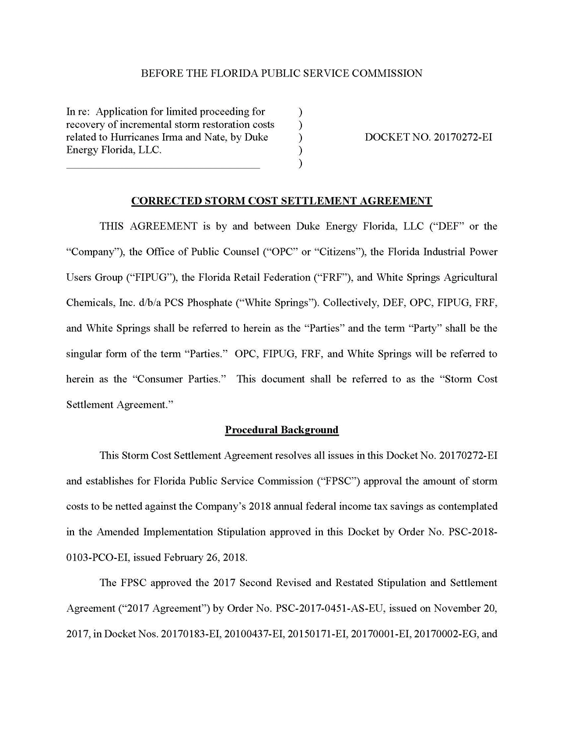

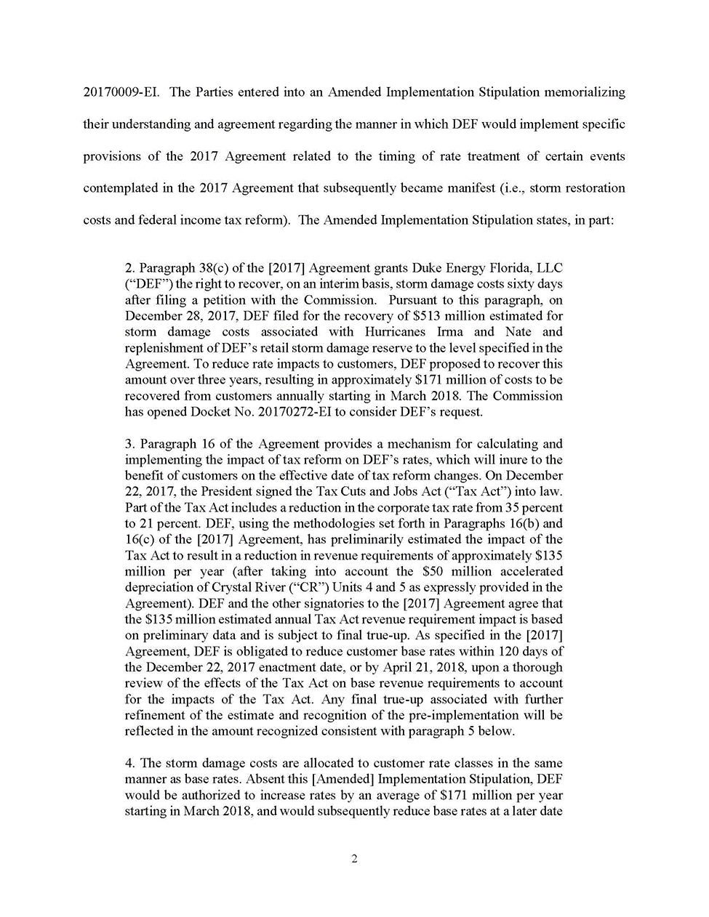

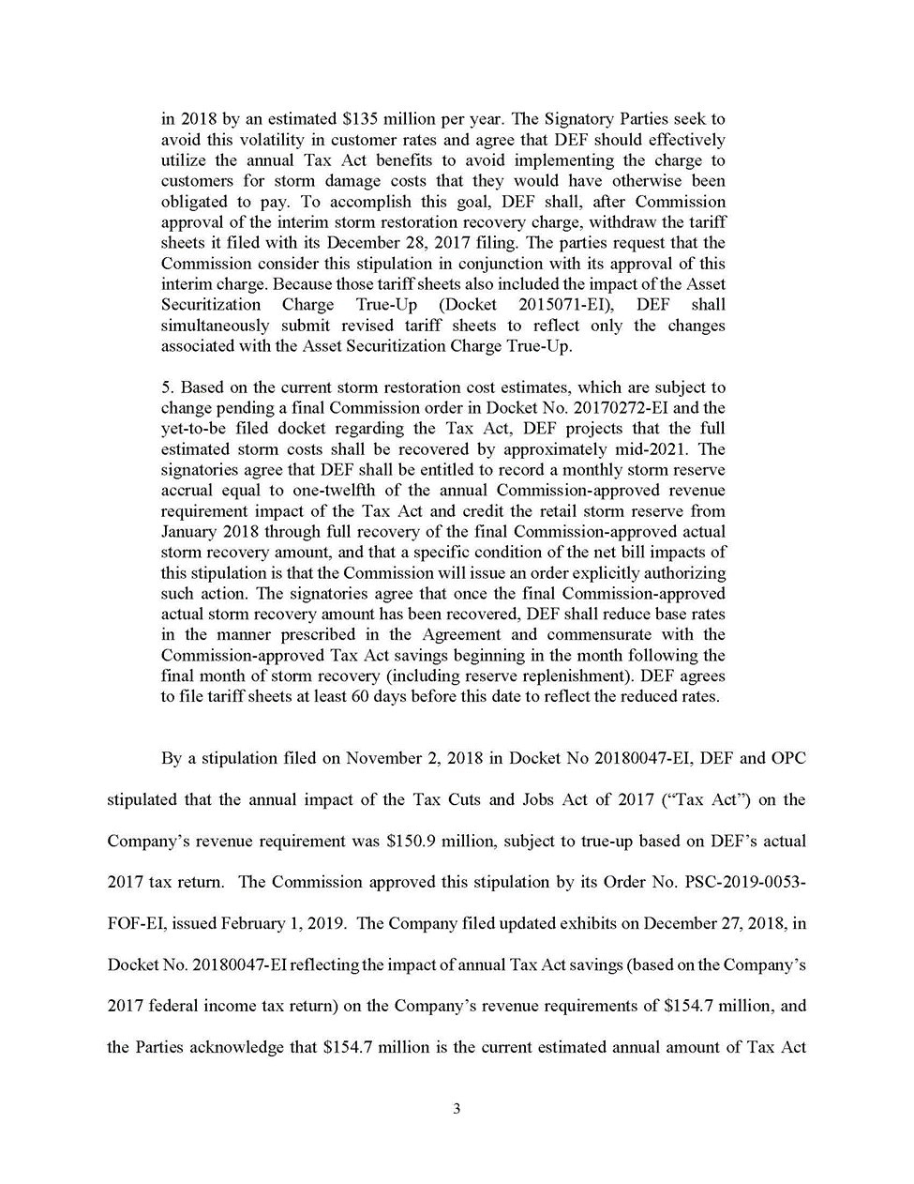

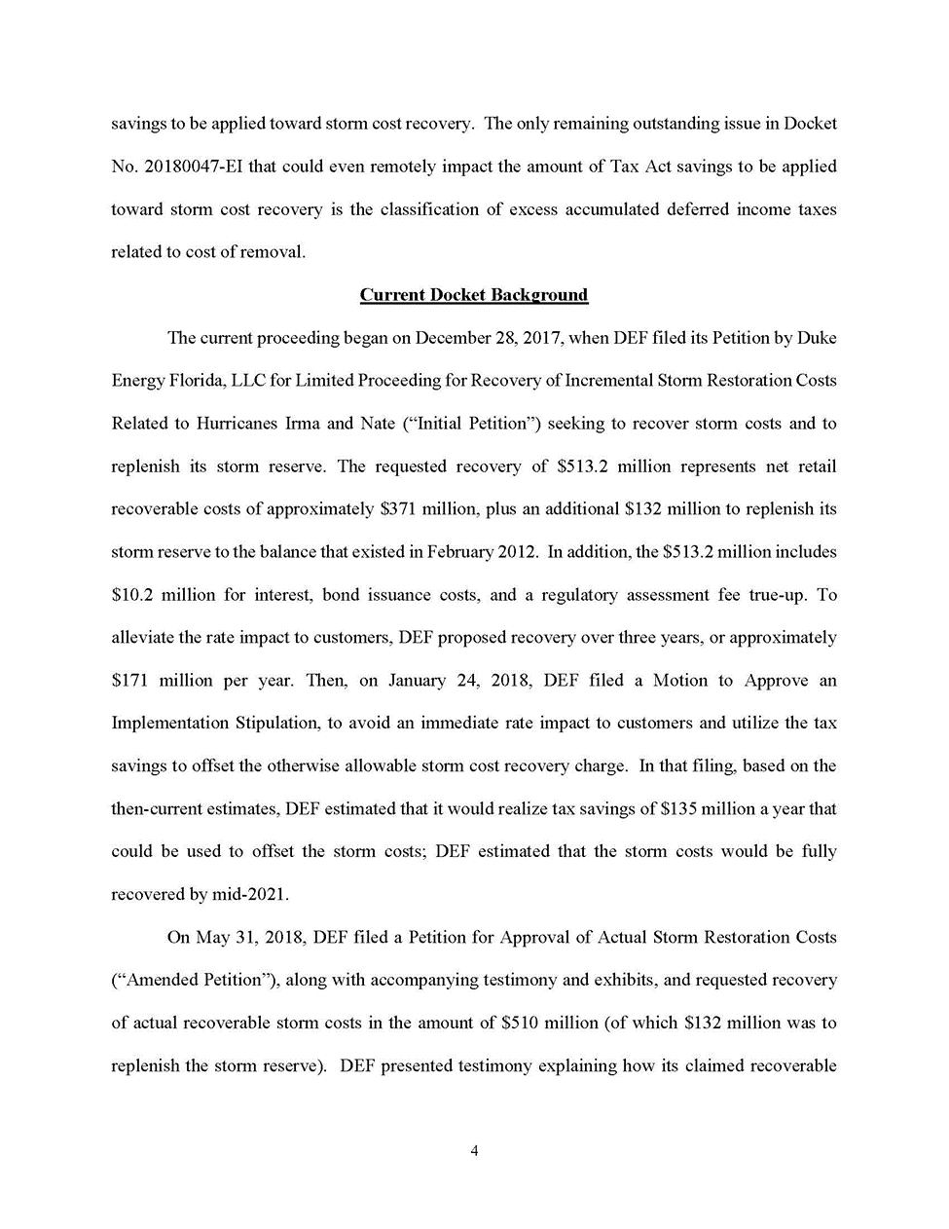

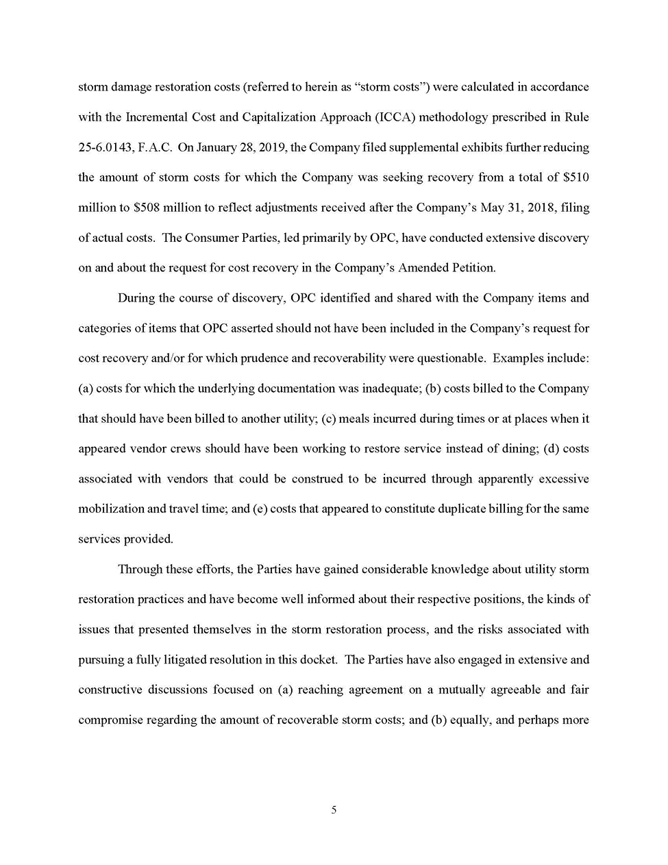

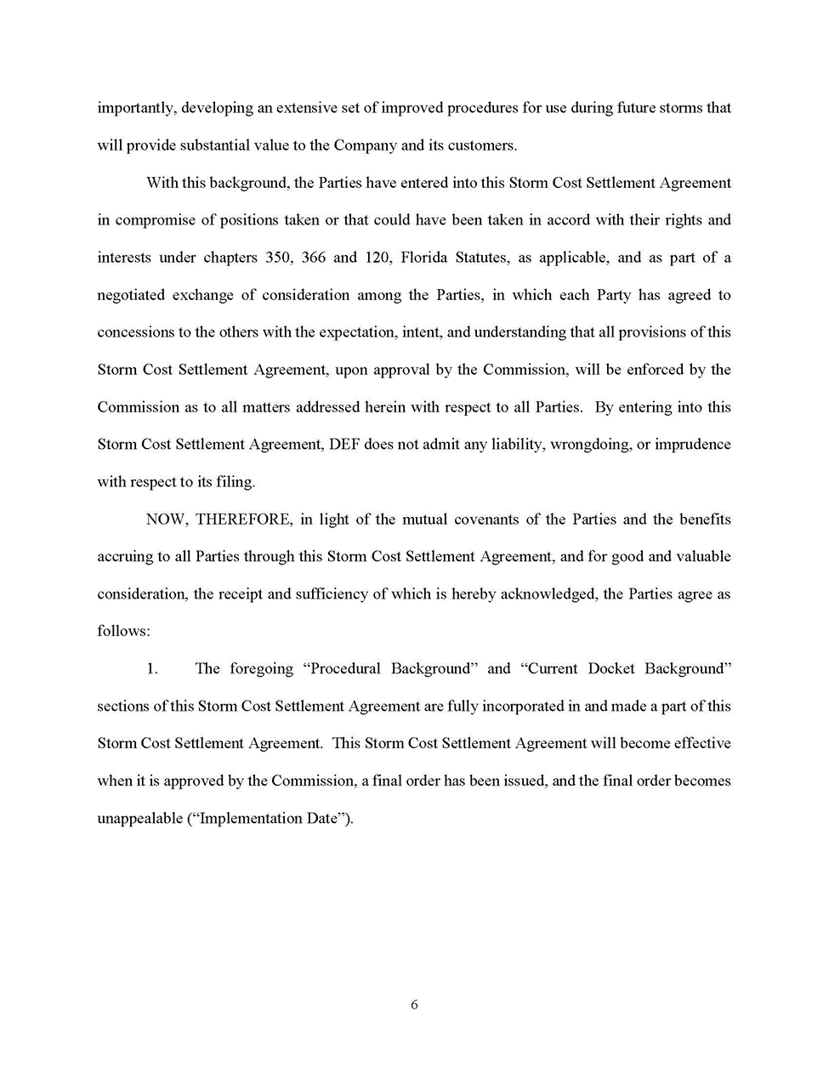

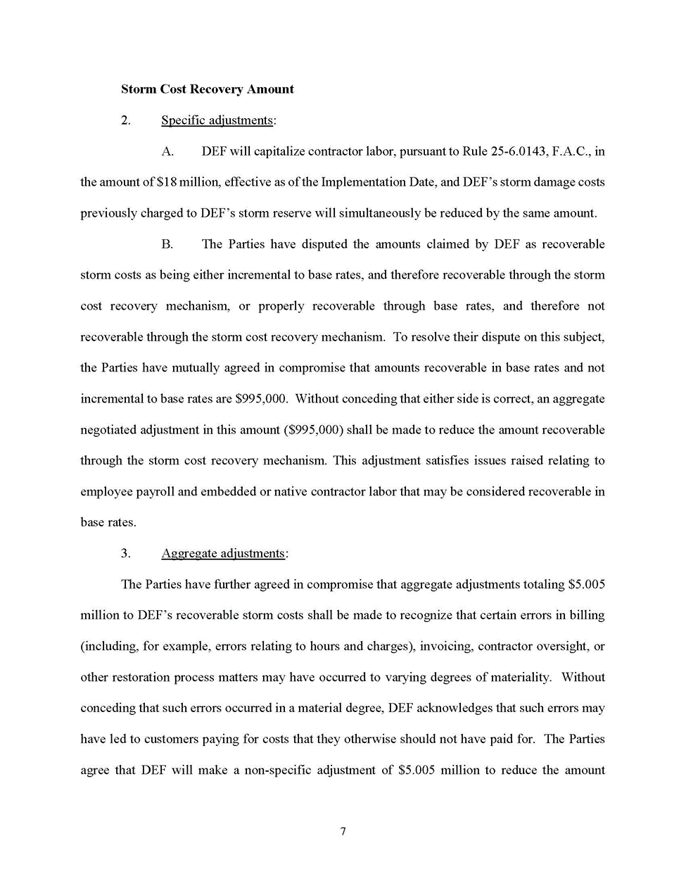

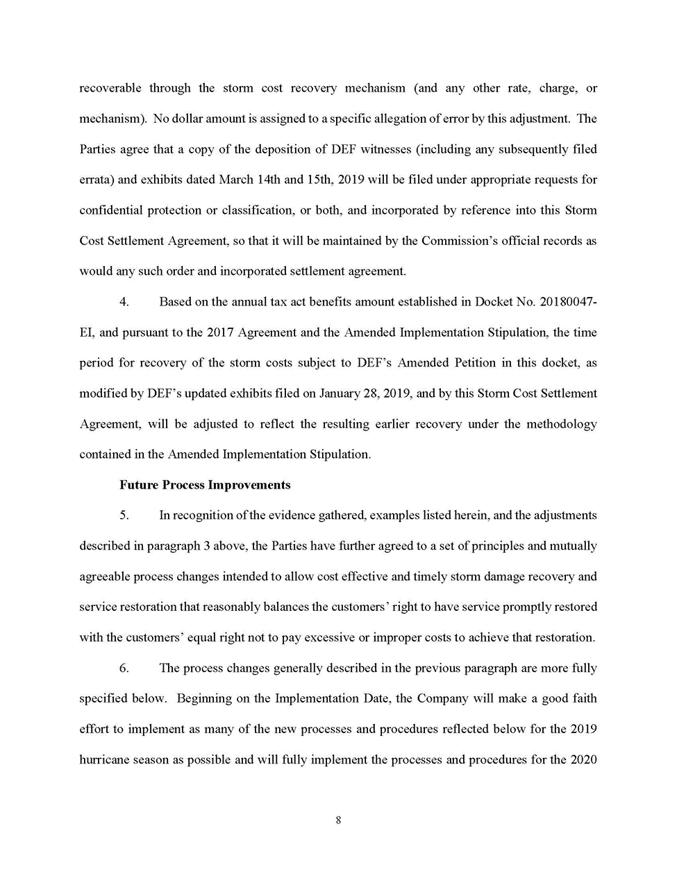

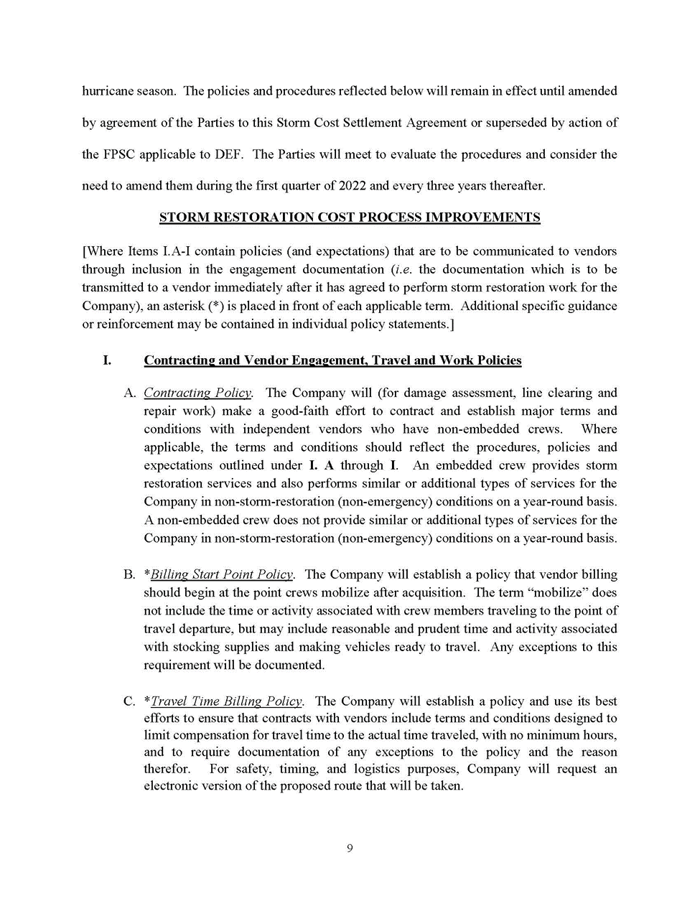

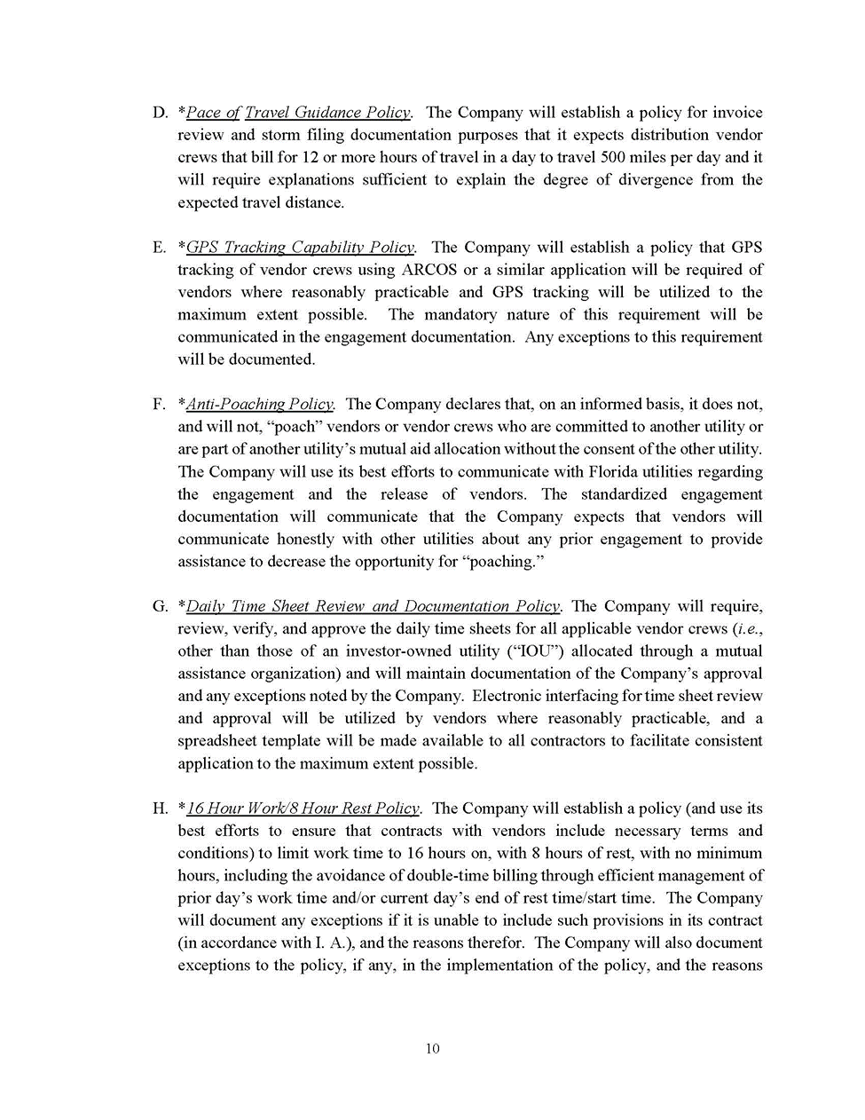

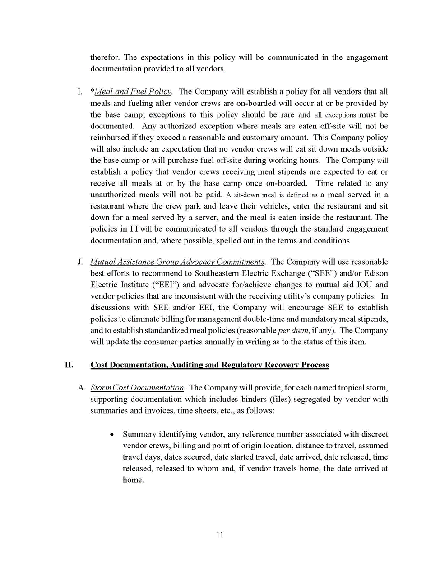

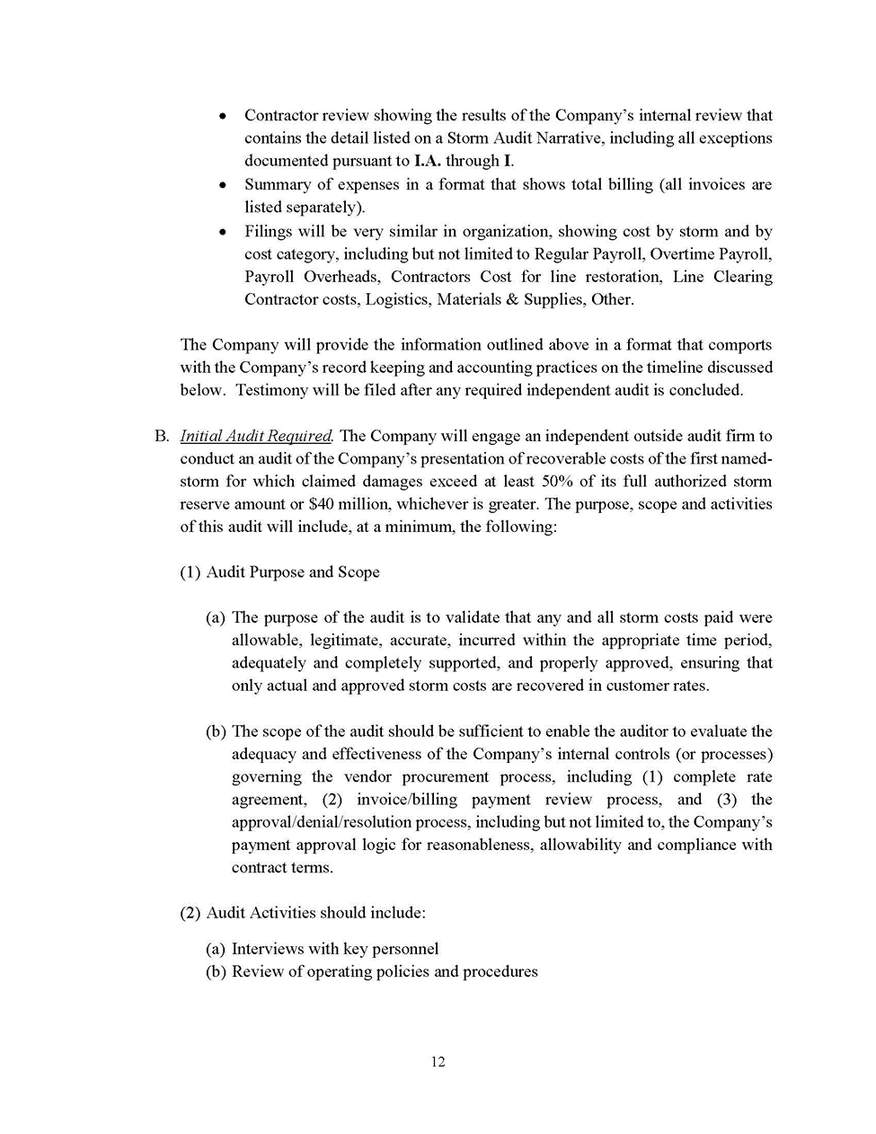

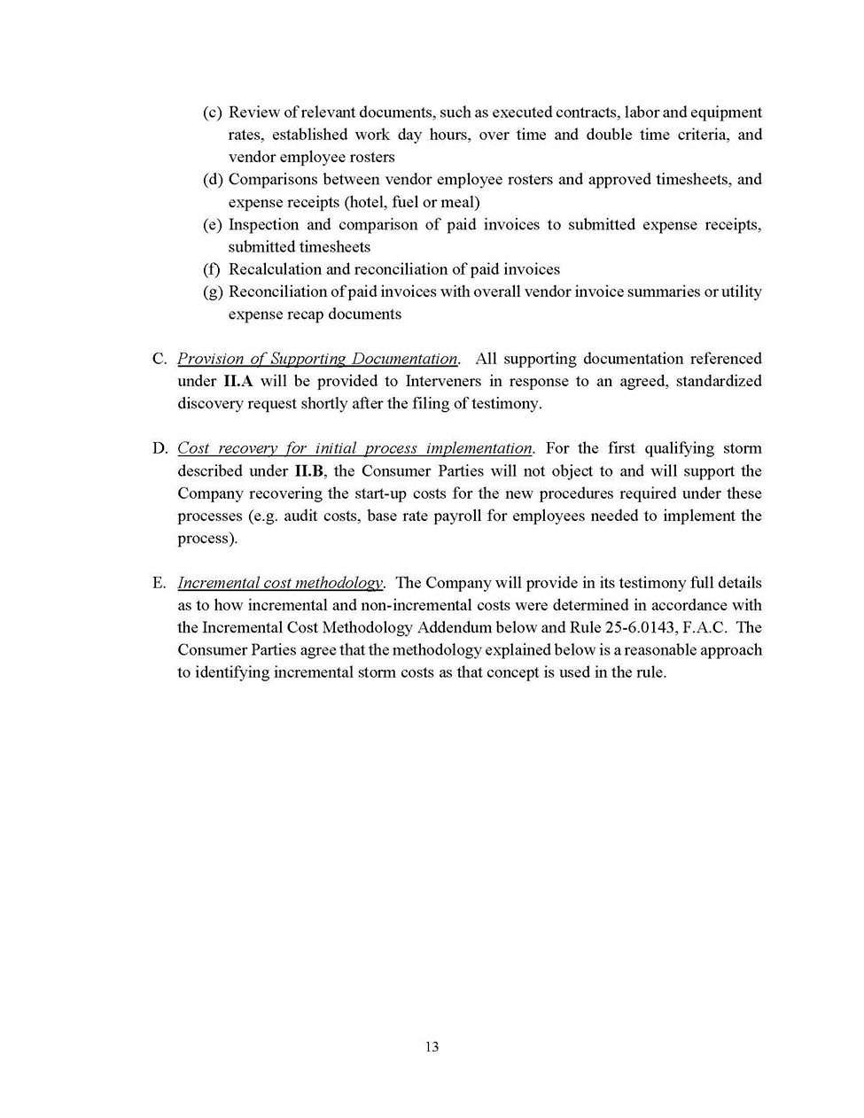

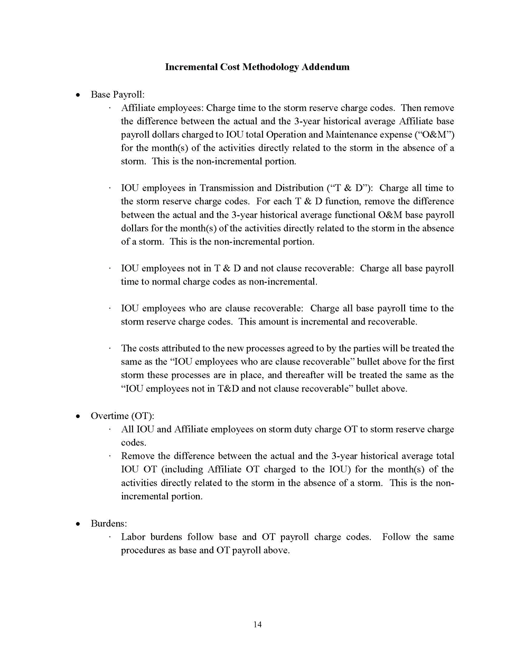

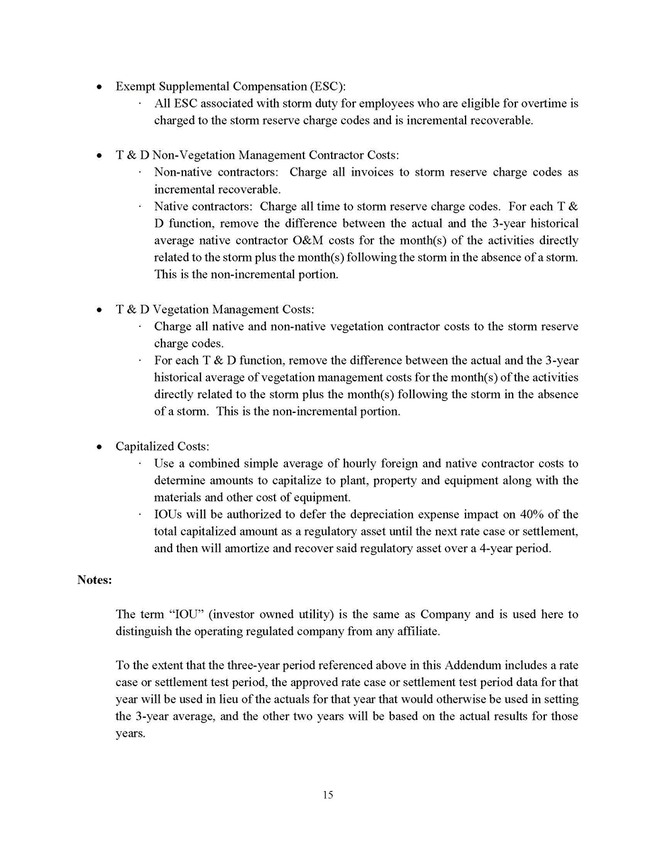

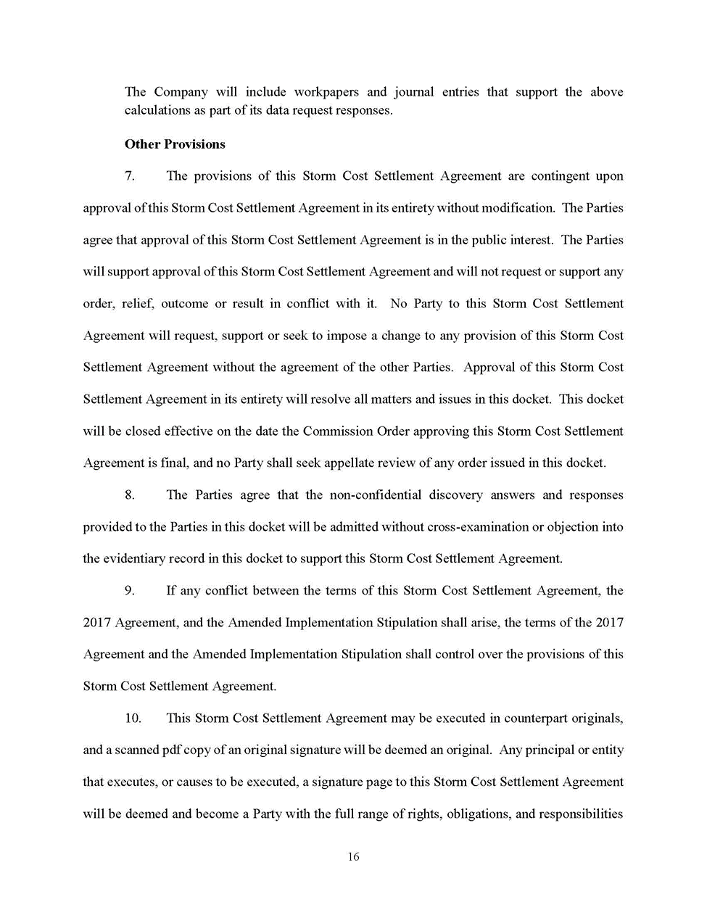

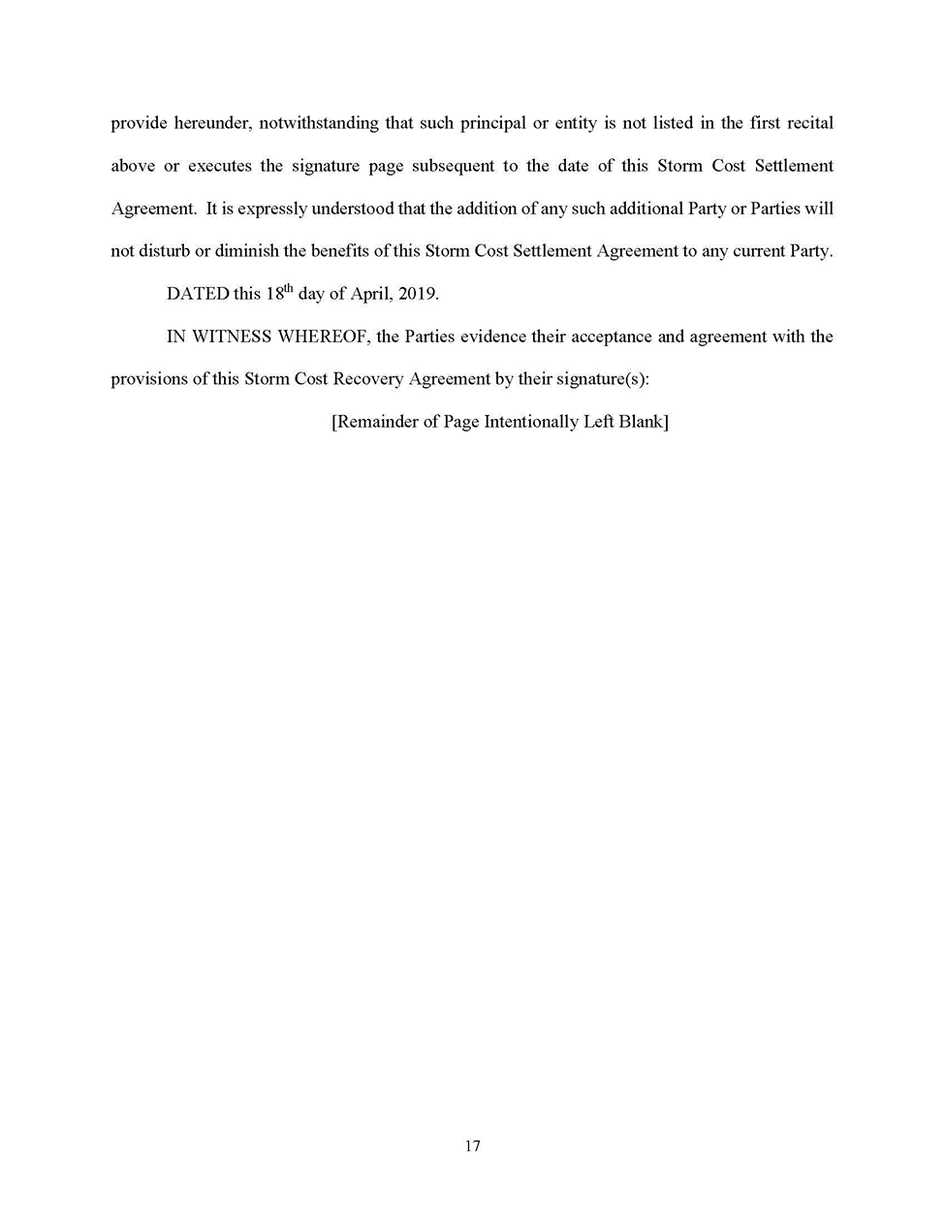

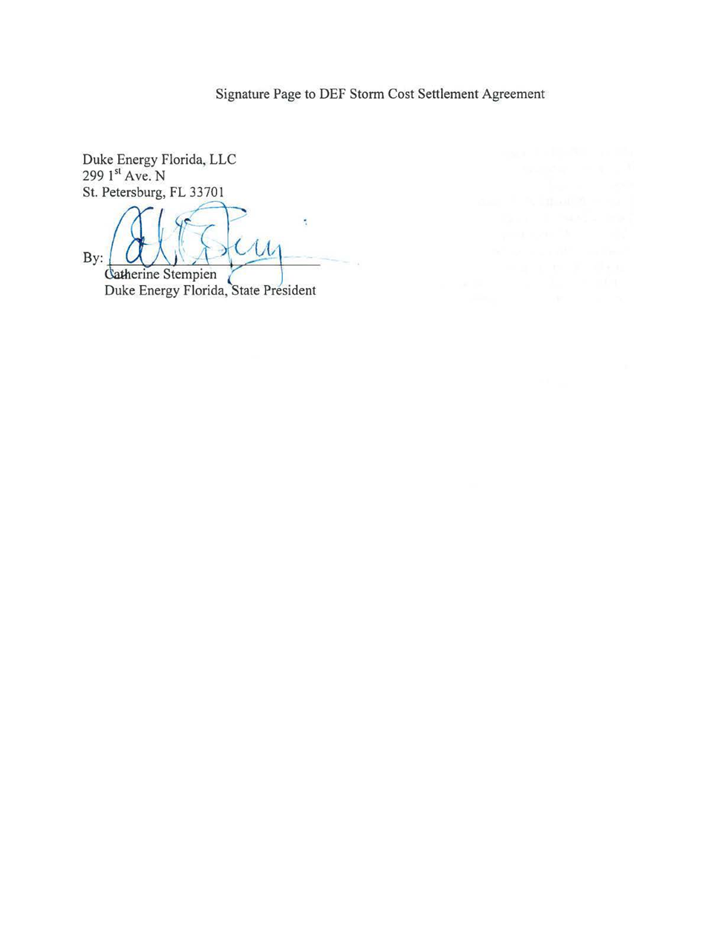

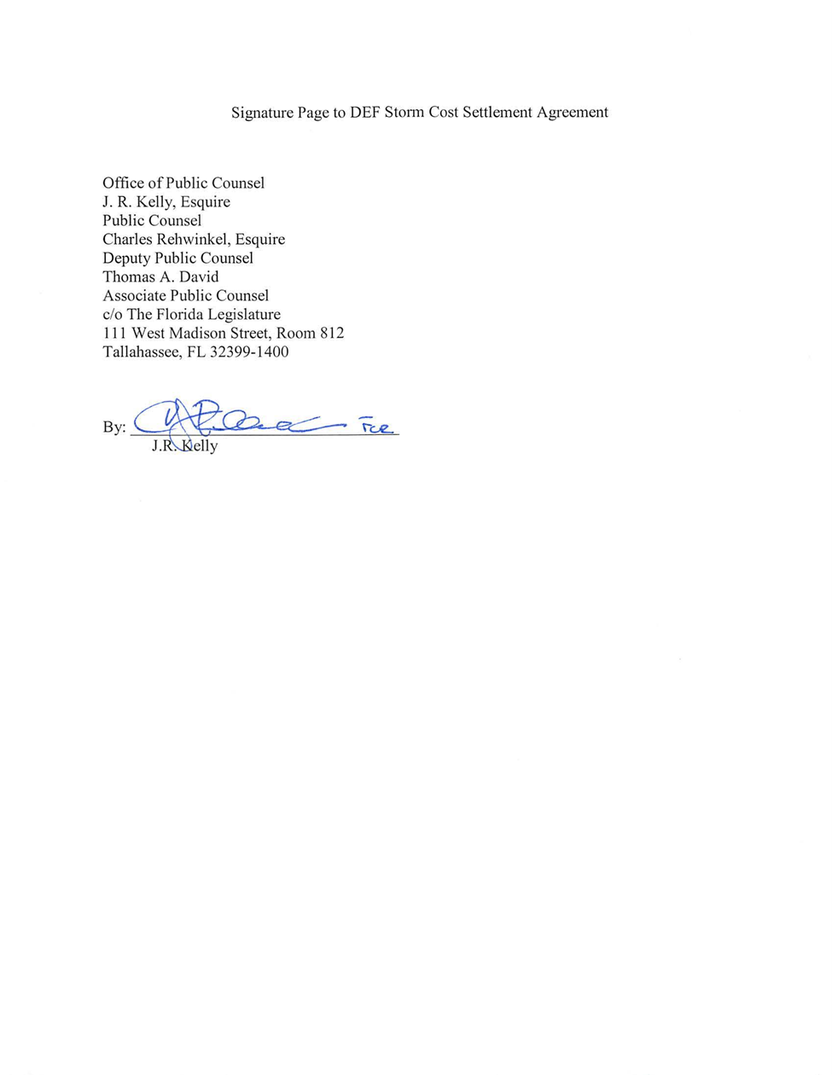

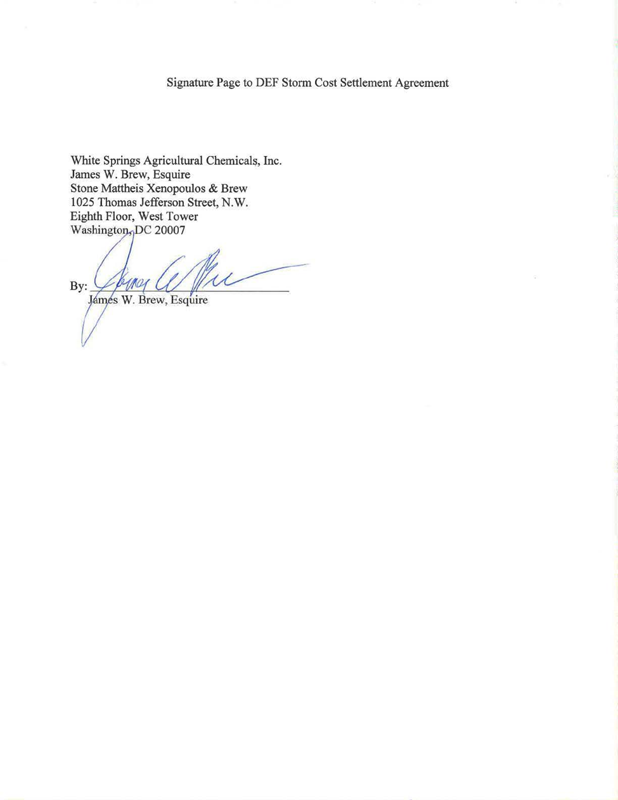

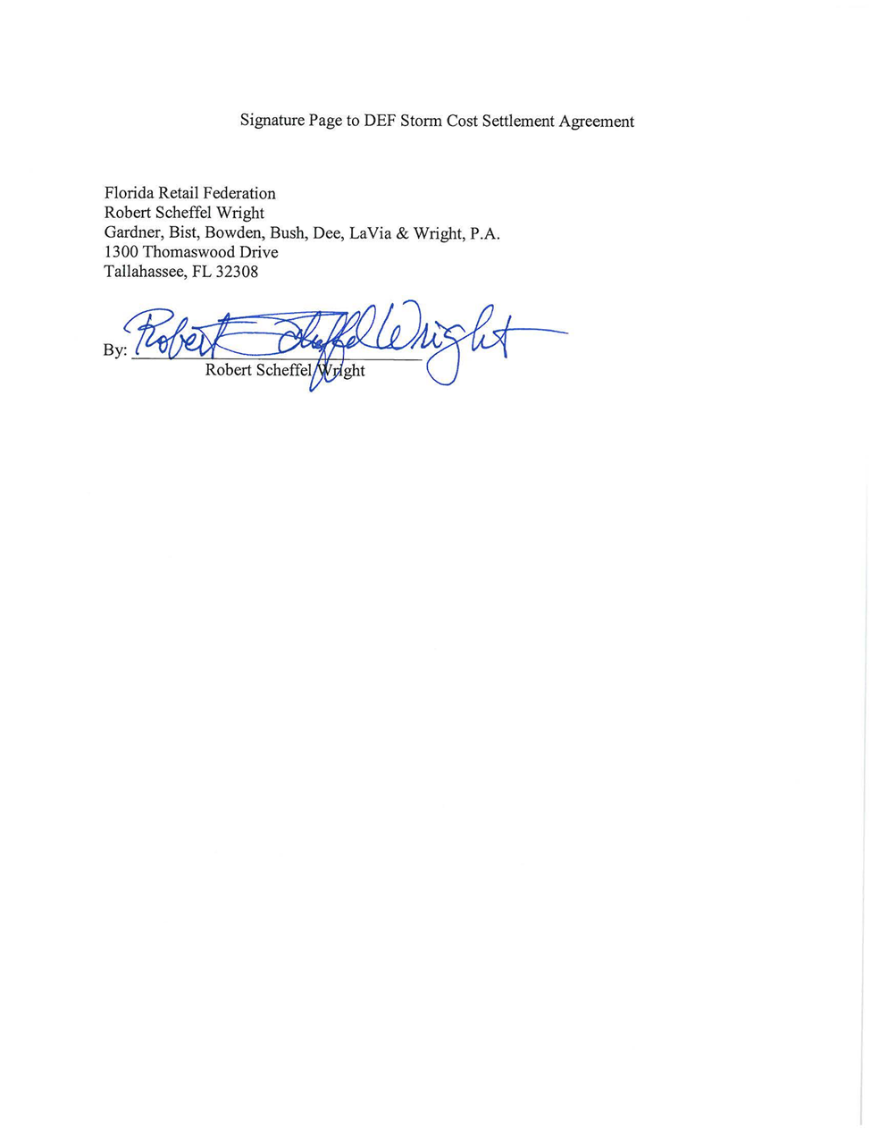

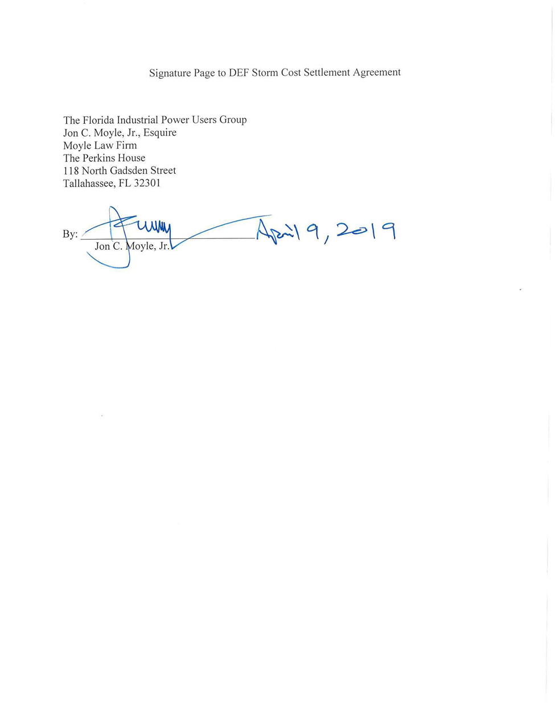

1. Docket No. 20230020-EI, *In re: Petition for limited proceeding for recovery of incremental storm restoration costs related to Hurricanes Elsa, Eta, Isaias, Ian, Nicole, and Tropical Storm Fred, by Duke Energy Florida, LLC.*
2. Order No. PSC-2023-0333-PCO-EI, issued November 2, 2023, in Docket No. 20230020-EI, *In re: Petition for limited proceeding for recovery of incremental storm restoration costs related to Hurricanes Elsa, Eta, Isaias, Ian, Nicole, and Tropical Storm Fred, by Duke Energy Florida, LLC.*
3. Order No. PSC-2017-0451-AS-EI, issued November 20, 2017, in Docket No. 20170183-EI, *In re: Application for limited proceeding to approve 2017 second revised and restated settlement agreement, including certain rate adjustments, by Duke Energy Florida, LLC;* Order No. PSC-2021-0202A, issued June 28, 2021, in Docket No. 20210016-EI, *In re: Petition for limited proceeding to approve 2021 settlement agreement, by Duke Energy Florida, LLC.* 
4. EXH 21.
5. Order No. PSC-2023-0111-PCO-EI at 6-7.
6. Order No. PSC-2023-0375-PCO-EI at 4.
7. Order No. PSC-2023-0375-PCO-EI at 3.
8. Order No. PSC-2021-0202A-AS-EI, issued June 28, 2021, in Docket No. 20210016-EI, *In re: Petition for limited proceeding to approve 2021 settlement agreement, including general base rate increases, by Duke Energy Florida, LLC*; Order No. PSC-2022-0418-FOF-EI, issued December 12, 2022, in Docket No. 20220010-EI, *In re: Storm Protection Plan Cost Recovery Clause*.
9. Order No. PSC-2017-0451-AS-EU, issued November 20, 2017, in Docket No. 20170183-EI, *In re: Application for limited proceeding to approve 2017 second revised and restated settlement agreement, including certain rate adjustments, by Duke Energy Florida, LLC*; Order No. PSC-2021-0202A-AS-EI, issued June 28, 2021, in Docket No. 20210016-EI, *In re: Petition for limited proceeding to approve 2021 settlement agreement, by Duke Energy Florida, LLC.*
10. EXH 21.
11. Order No. PSC-2024-0151-PHO-EI, issued May 14, 2024, in Docket No. 20230020-EI, *In re: Petition for limited proceeding for recovery of incremental storm restoration costs related to Hurricane Idalia, by Duke Energy Florida, LLC.,* p. 18 (In allowing Walmart’s proposed Issue 16 to be included in this proceeding, the Prehearing Officer stated that “This is the point of entry for parties to raise all issues dealing with the replacement storm costs collected through the surcharge.”)
12. *See* Docket No. 20240010-EI, *In re: Storm protection plan cost recovery clause.*
13. *See* Docket No. 20230017-EI, *In re: Petition for limited proceeding for recovery of incremental storm restoration costs related to Hurricanes Ian and Nicole, by Florida Power & Light Company.*
14. Docket No. 20230017-EI, *In re: Petition for limited proceeding for recovery of incremental storm restoration costs related to Hurricane Ian and Nicole, by Florida Power & Light Company*.