State of Florida   |  | Public Service Commission  Capital Circle Office Center ● 2540 Shumard Oak Boulevard  Tallahassee, Florida 32399-0850  -M-E-M-O-R-A-N-D-U-M-
DATE: | July 25, 2024
TO: | Office of Commission Clerk (Teitzman)
FROM: | Division of Economics (Hampson)  Office of the General Counsel (Brownless)
RE: | Docket No. 20240084-EI – Petition for approval of special contract with Agency for Persons with Disabilities for upgrading the electric distribution facilities at the Sunland Center in Marianna, Florida, by Florida Public Utilities Company.
AGENDA: | 08/06/24 – Regular Agenda – Proposed Agency Action – Interested Persons May Participate
COMMISSIONERS ASSIGNED: |  |  | All Commissioners
PREHEARING OFFICER: |  |  | Passidomo
CRITICAL DATES: |  |  | None
SPECIAL INSTRUCTIONS: |  |  | None

Case Background
On May 10, 2024, Florida Public Utilities Company (FPUC) filed a petition for approval of a Special Contract with the Agency for Persons with Disabilities (Agency). The petition was filed pursuant to Rule 25-9.034, Florida Administrative Code. The Agency for Persons with Disability is an agency of the State of Florida that is tasked with serving the needs of Floridians with developmental disabilities. FPUC provides service to the Agency as a General Service Large Demand at the Sunland Center in Marianna, Florida. The Sunland Center is a developmental disability center operated by the Agency for people who need structured care 24 hours a day.
In early 2023, the Agency notified FPUC that it had received a grant from the federal government of approximately $2 million for the upgrade and storm hardening of Sunland Center’s existing 12.47 kV distribution system. As a primary metered customer, the 12.47 kV distribution infrastructure behind the meter is the responsibility of the Agency to operate, maintain, and upgrade. FPUC worked with a third-party engineering firm, Enercon Services Inc. (Enercon), to develop cost estimates to storm harden the Agency’s distribution system. The Enercon report was included as Attachment B to the petition.
After reviewing the report, FPUC and the Agency negotiated a Special Contact that would utilize the grant funds to compensate FPUC’s work on the Sunland Center’s distribution facilities, including completion of the necessary engineering designs and the purchase of materials. The Special Contract contemplates that FPUC, with the assistance of third-party contractors, would remove as much of the overhead distribution system as possible without impacting the existing overhead telephone and communications equipment and would replace it with new overhead facilities that meet National Electric Safety Code Storm Hardening Standards. FPUC would also construct an underground electric distribution system in certain areas consisting of primary conductors/conduit, pad mounted transformers and switches, secondary conductors/conduit, as well as service conductors/conduit. The system would utilize primary overhead metering equipment, which would be designated as the point of delivery and meter all energy used at Sunland Center. The Special Contract contemplates that work would be completed by mid-year 2026.

On June 6, 2024, Commission staff held a phone conference with FPUC to discuss the petition. On June 10, 2024, staff issued a data request, to which responses were received on June 24, 2024. The proposed, unexecuted Special Contract is included in this recommendation as Attachment A. The Commission has jurisdiction over this matter pursuant to Section 366.05 Florida Statutes (F.S.).

Discussion of Issues

Issue 1:
Should the Commission approve the proposed Special Contract between FPUC and the Agency for Persons with Disabilities?

Recommendation:
Yes, the Commission should approve the proposed Special Contract between FPUC and the Agency for Persons with Disabilities. If approved, FPUC should record all costs and revenues associated with improvements behind the meter of Sunland Center as below-the-line. Furthermore, FPUC should file the executed Special Contract with the Commission, if approved. (Hampson)

Staff Analysis:
Based on the analysis and cost estimates completed by Enercon, FPUC and the Agency negotiated a Special Contract to utilize the grant funds to complete the storm hardening of Sunland Center’s distribution facilities. In Paragraph 10 of the Petition, FPUC argues that the Enercon report demonstrated that Sunland Center’s facilities need a large-scale rebuild to prevent reliability issues and improve the safety and efficiency of the facilities, due to natural degradation and the impacts of Hurricane Michael in 2018. FPUC further states that a failure in the Sunland Center’s facilities could potentially adversely impact service to other FPUC customers in the surrounding area, due to the interconnected nature of the facilities and FPUC’s distribution system.
Beginning on Page 13, Attachment I to the proposed Special Contract defines the services to be provided by FPUC. Subsection B.2 of Attachment I states that FPUC would “construct, own, and operate an underground electric distribution system within the boundaries of Sunland Center.” In response to staff’s first data request, FPUC clarified it would own certain facilities behind-the-meter and further explained that behind-the-meter facilities would not be included in rate base in the next rate case. FPUC also stated that the costs and revenues associated with the project (including FPUC’s labor, third-party contracts, and capital assets) would not be recorded on the regulated books of FPUC and, therefore, the project would have no effect on FPUC’s ratepayers.

Conclusion
Based on the petition and the information provided, staff believes that the Commission should approve the proposed Special Contract between FPUC and the Agency for Persons with Disabilities. If approved, FPUC should record all costs and revenues associated with improvements behind the meter of Sunland Center as below-the-line. Furthermore, FPUC should file the executed Special Contract with the Commission, if approved.

Issue 2:
Should this docket be closed?

Recommendation:
Yes. If no protest is filed by a person whose substantial interests are affected within 21 days of the issuance of the Order, this docket should be closed upon the issuance of a Consummating Order. (Brownless)

Staff Analysis:
If no protest is filed by a person whose substantial interests are affected within 21 days of the issuance of the Order, this docket should be closed upon the issuance of a Consummating Order.

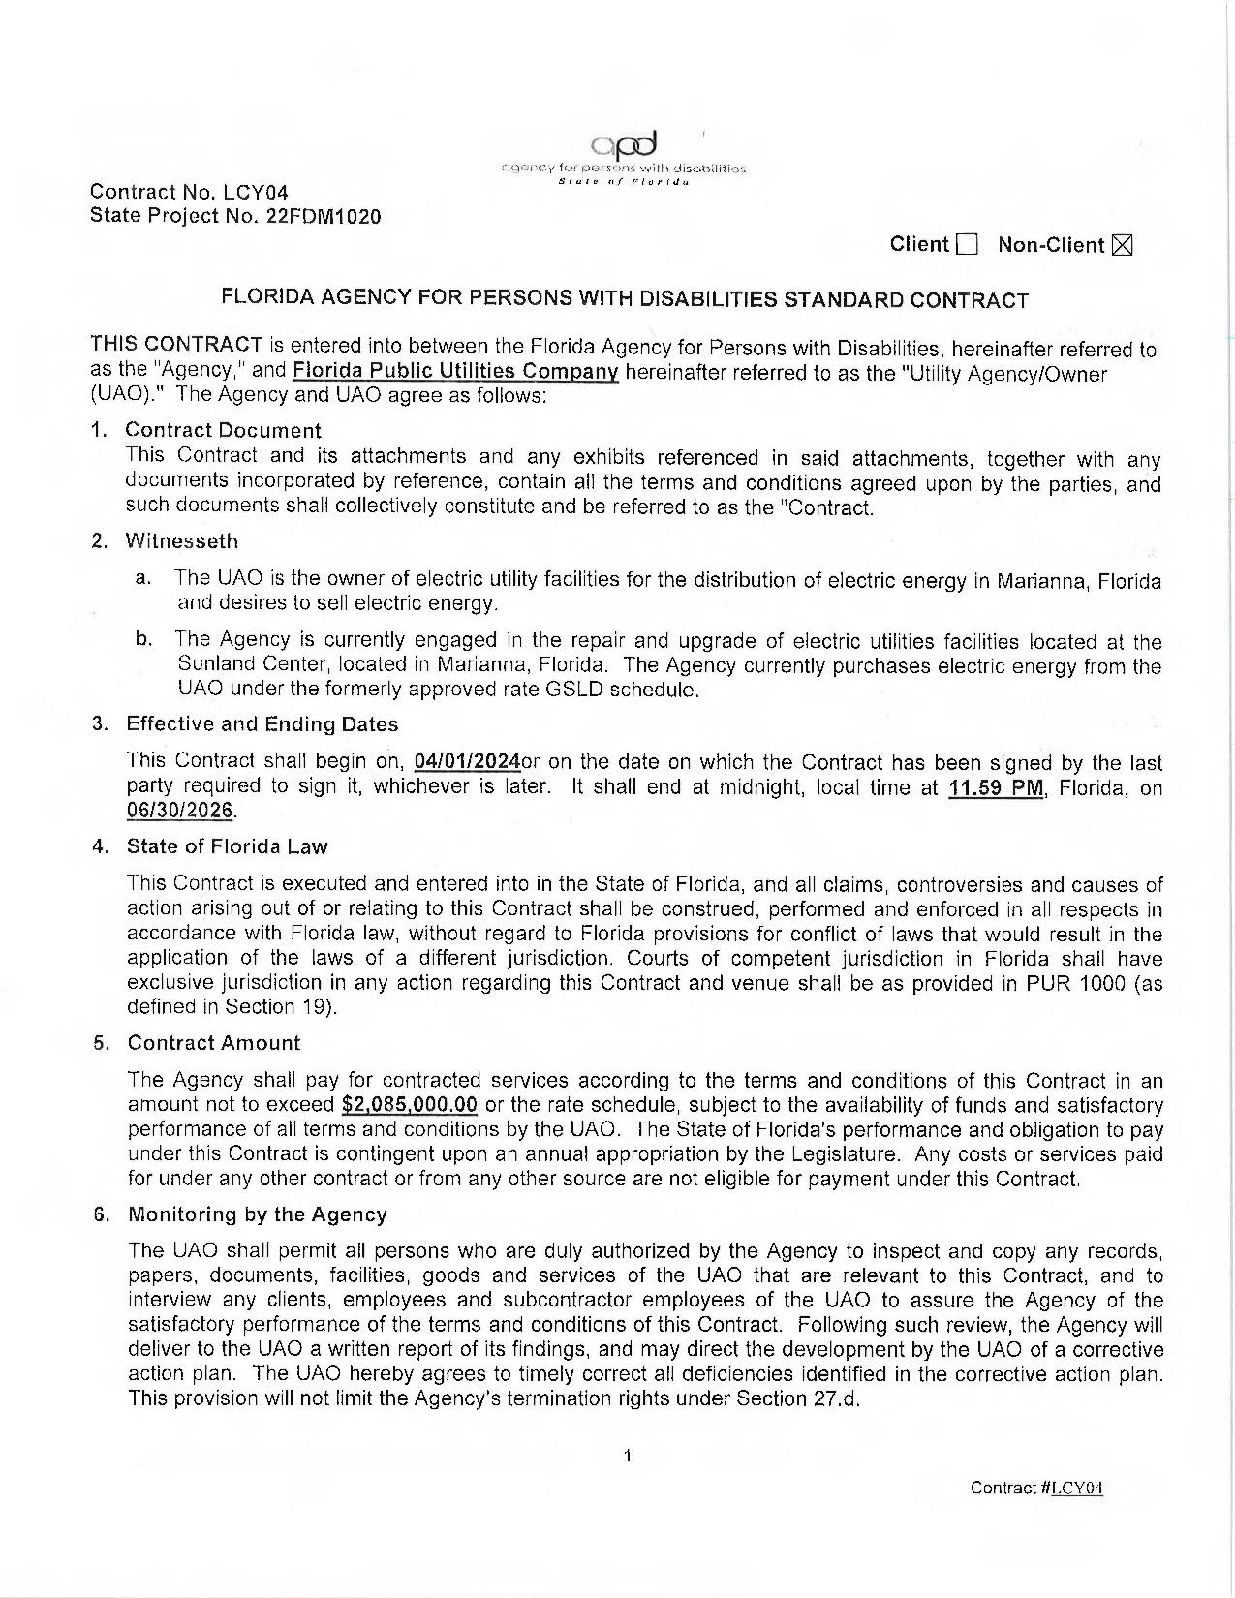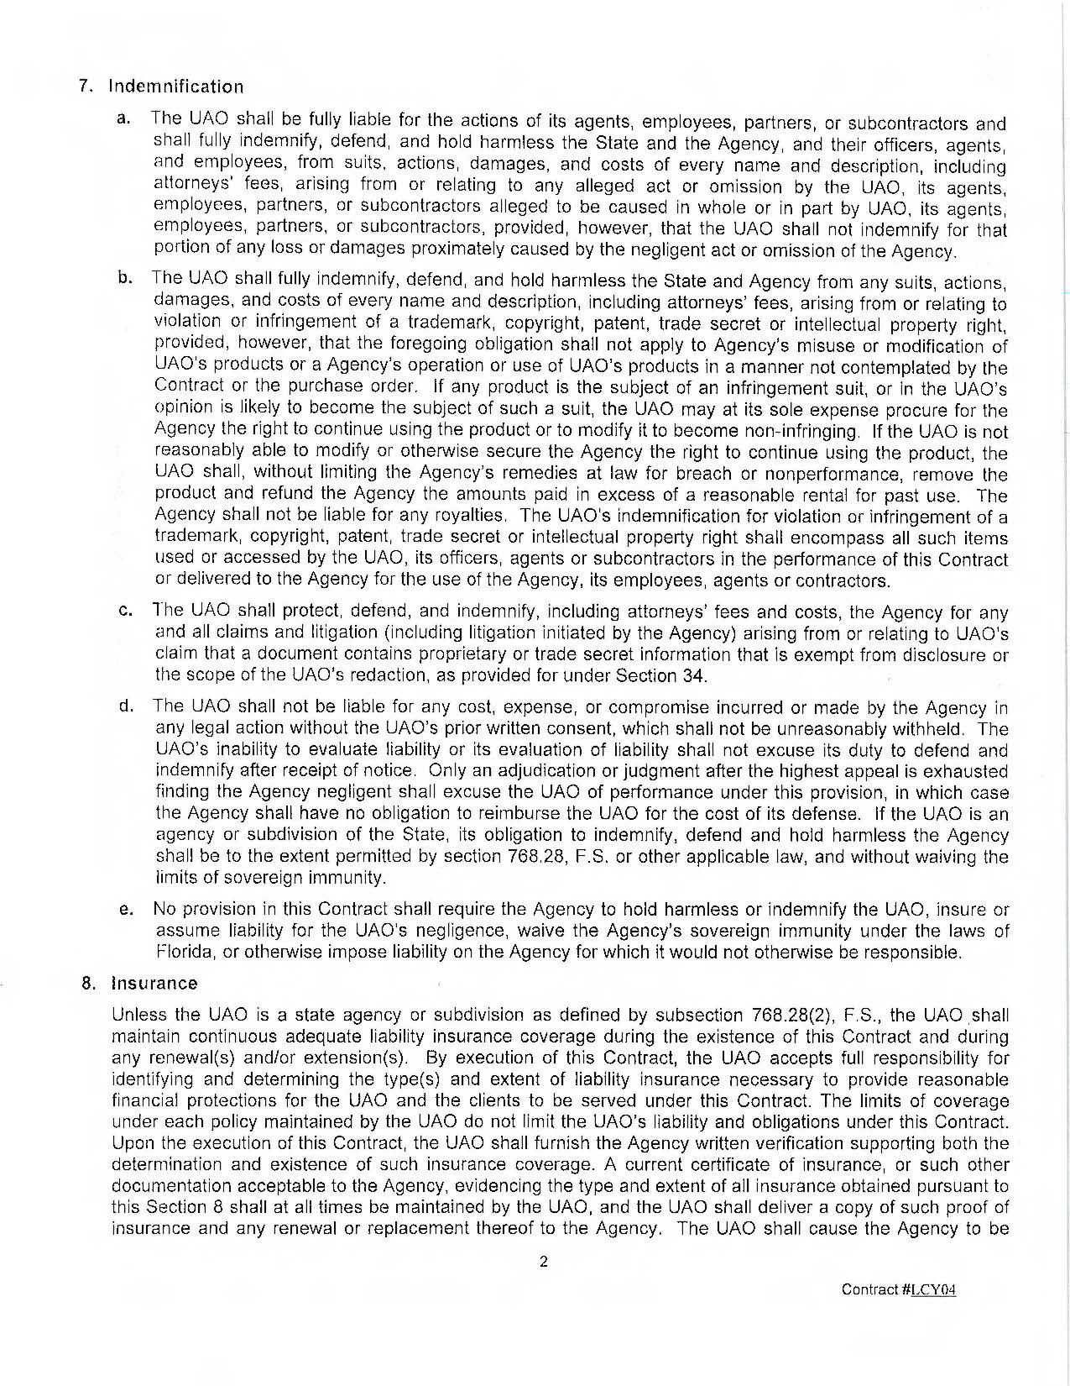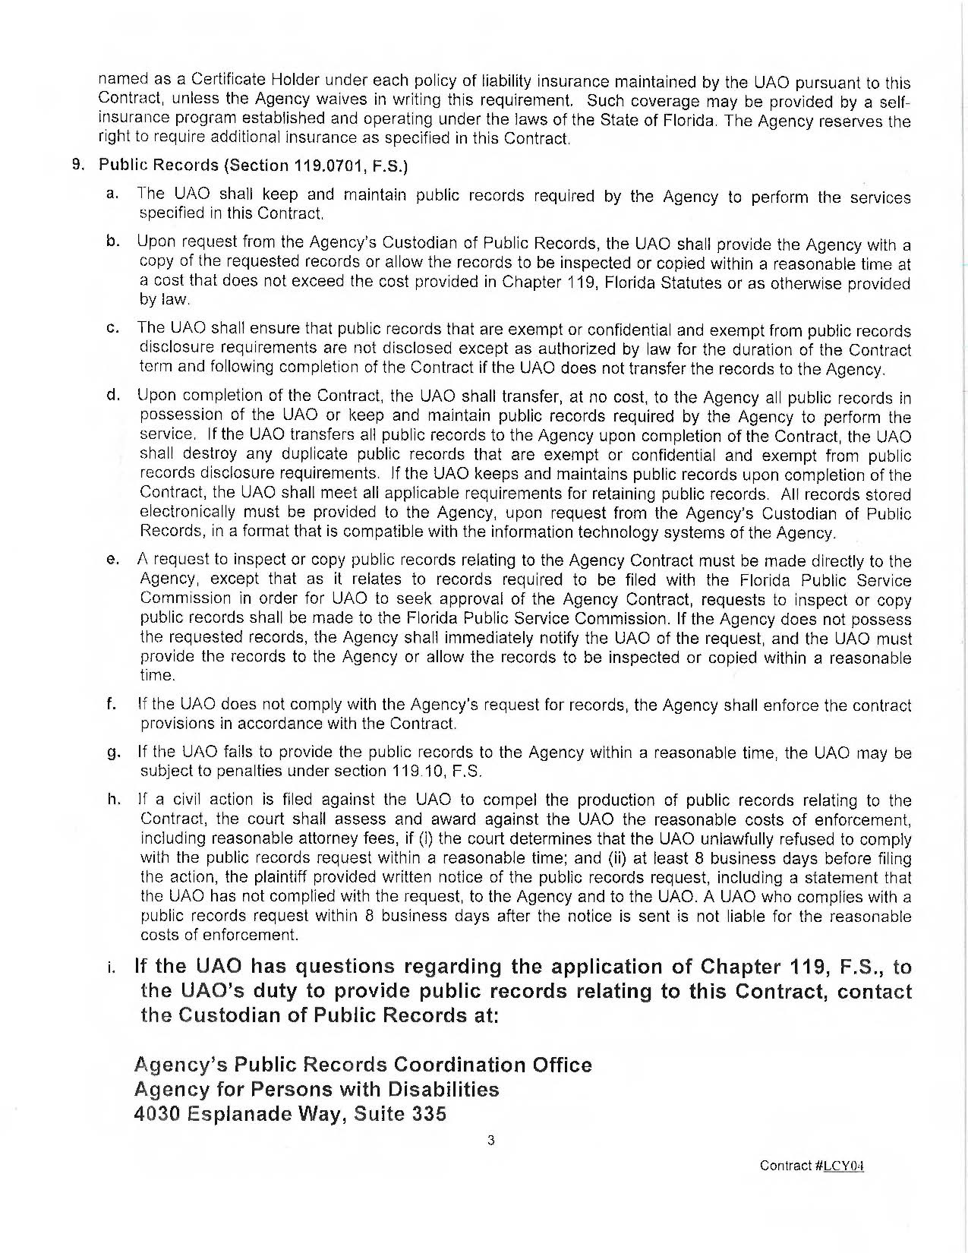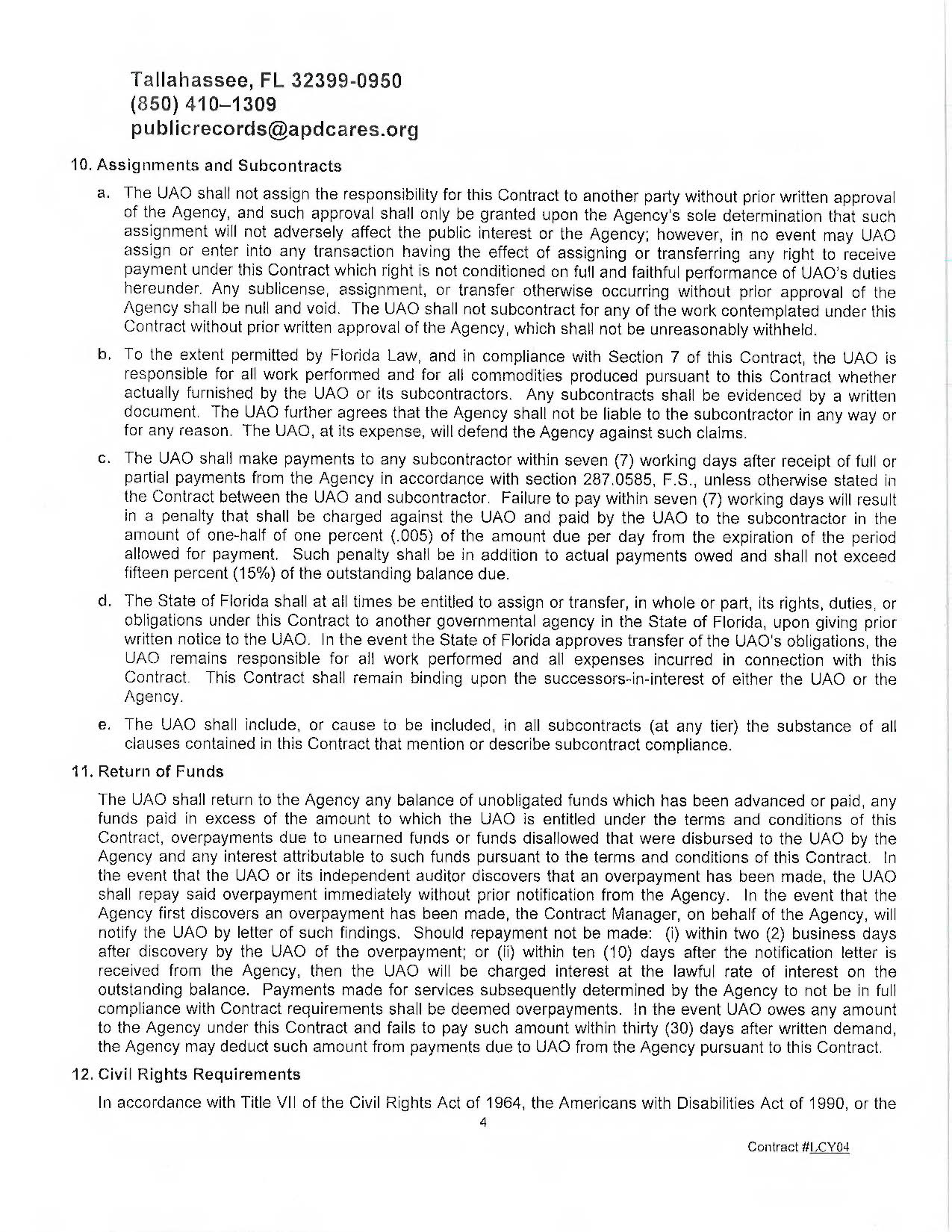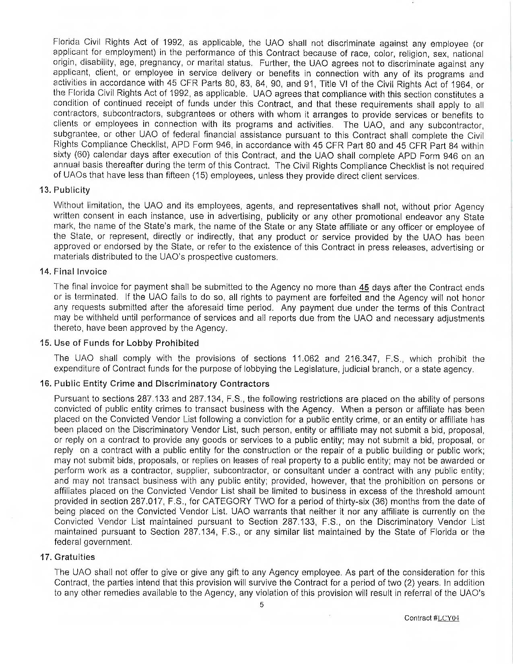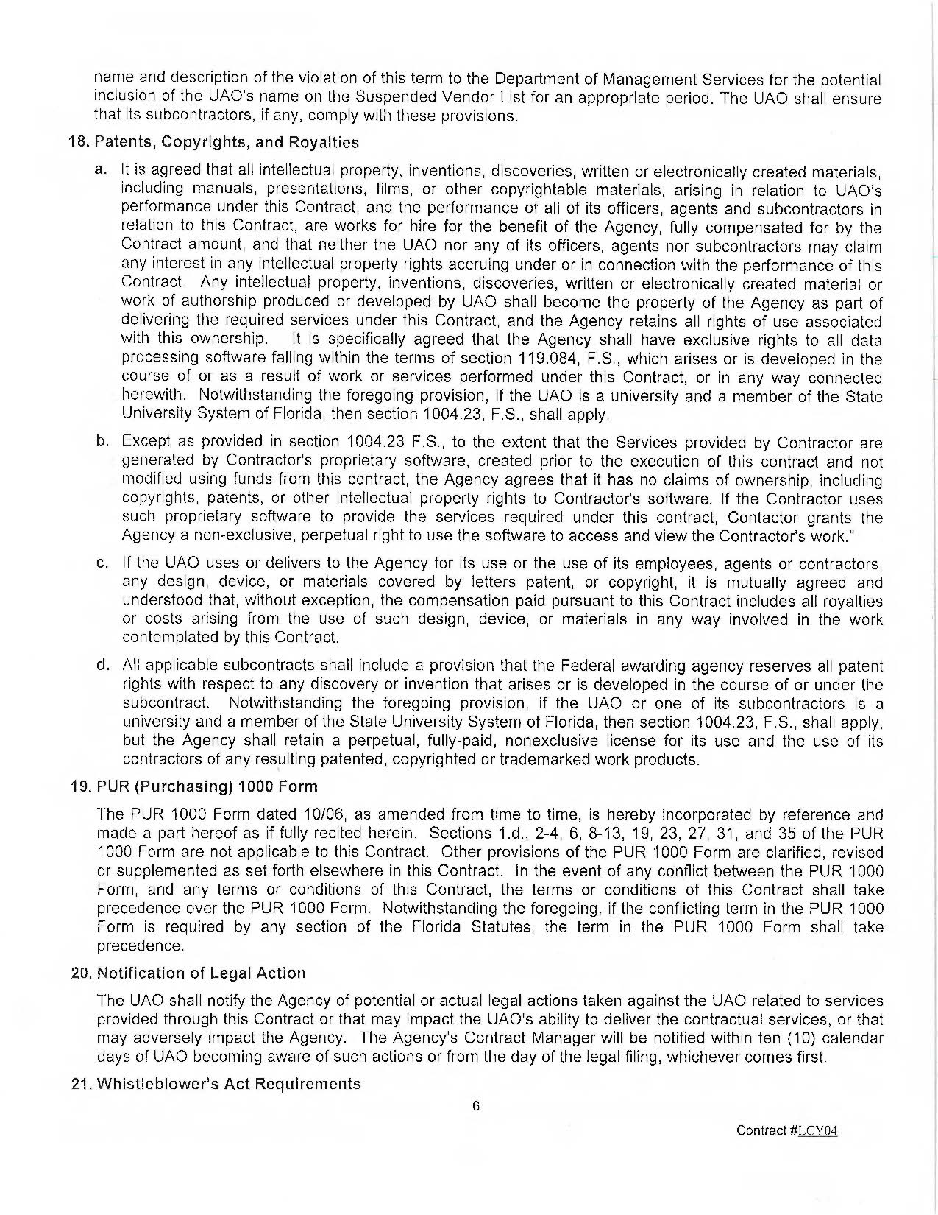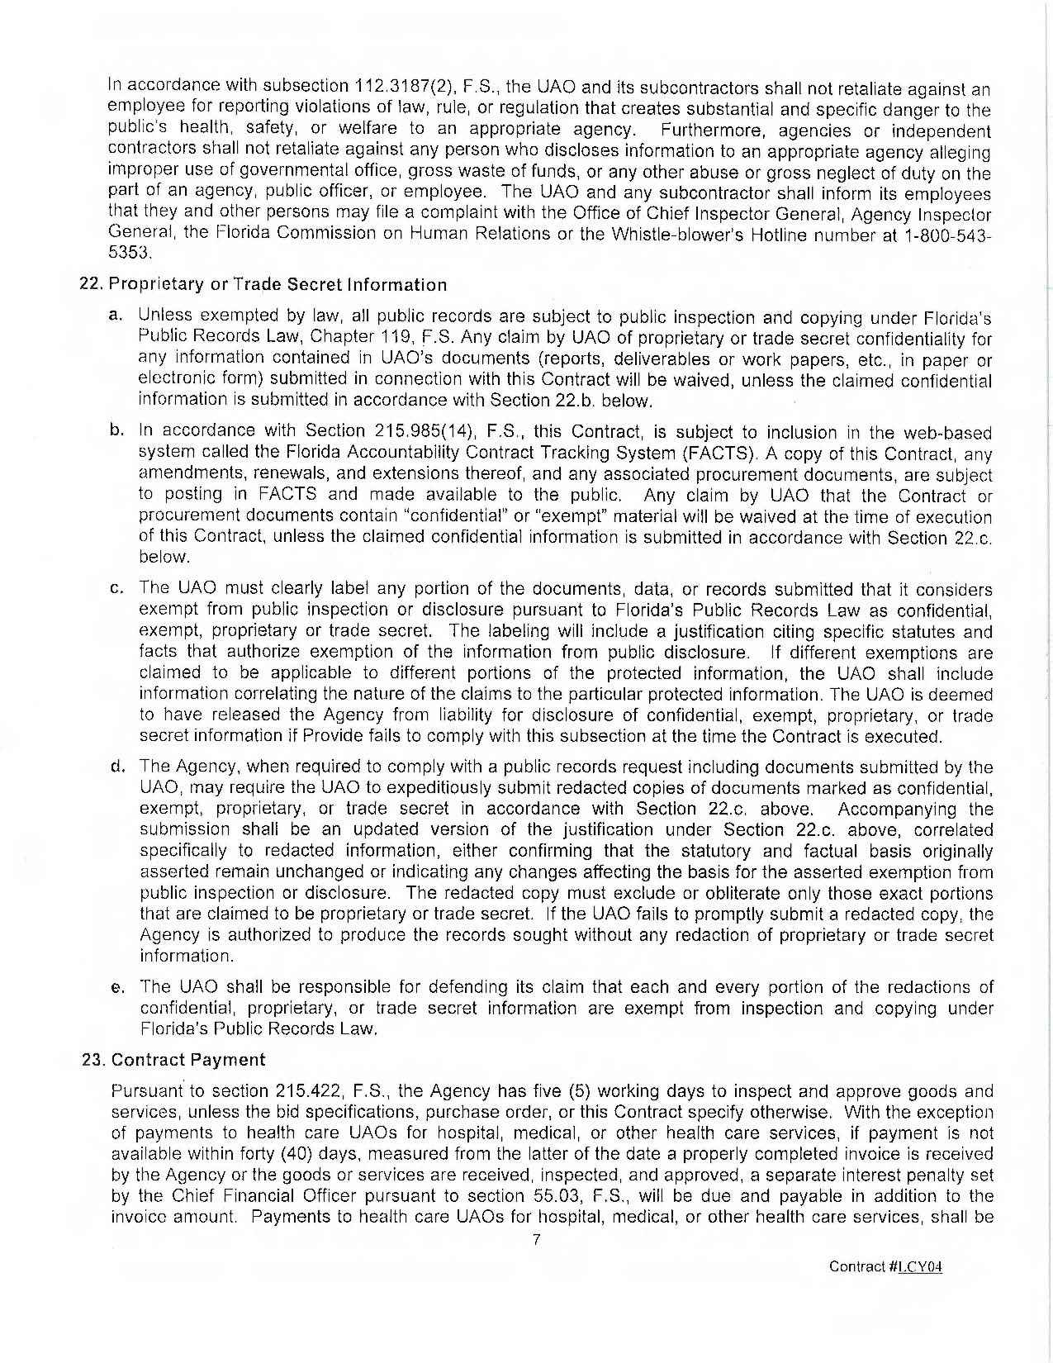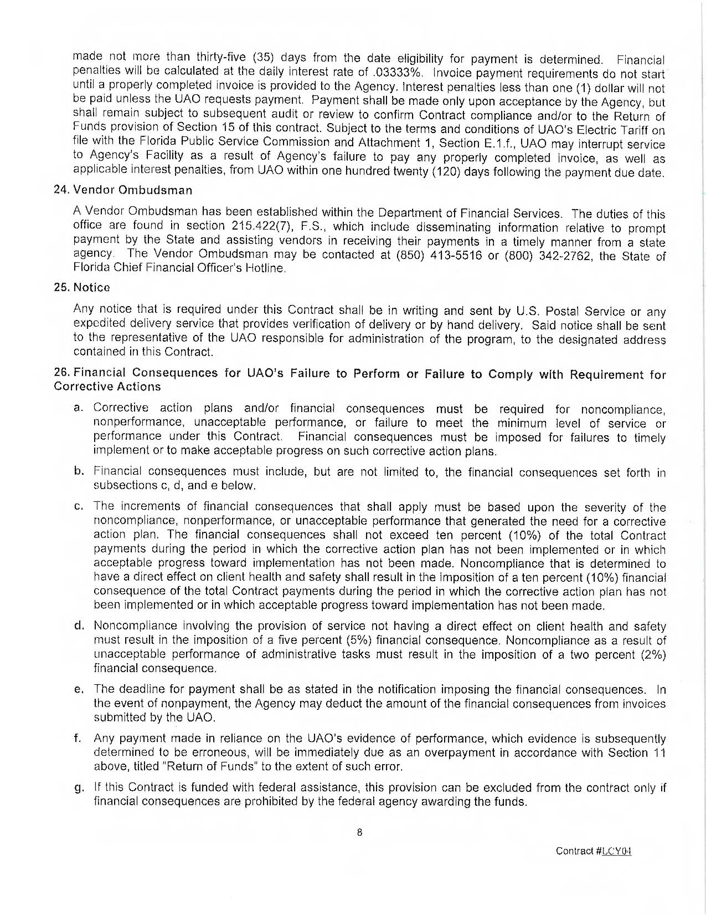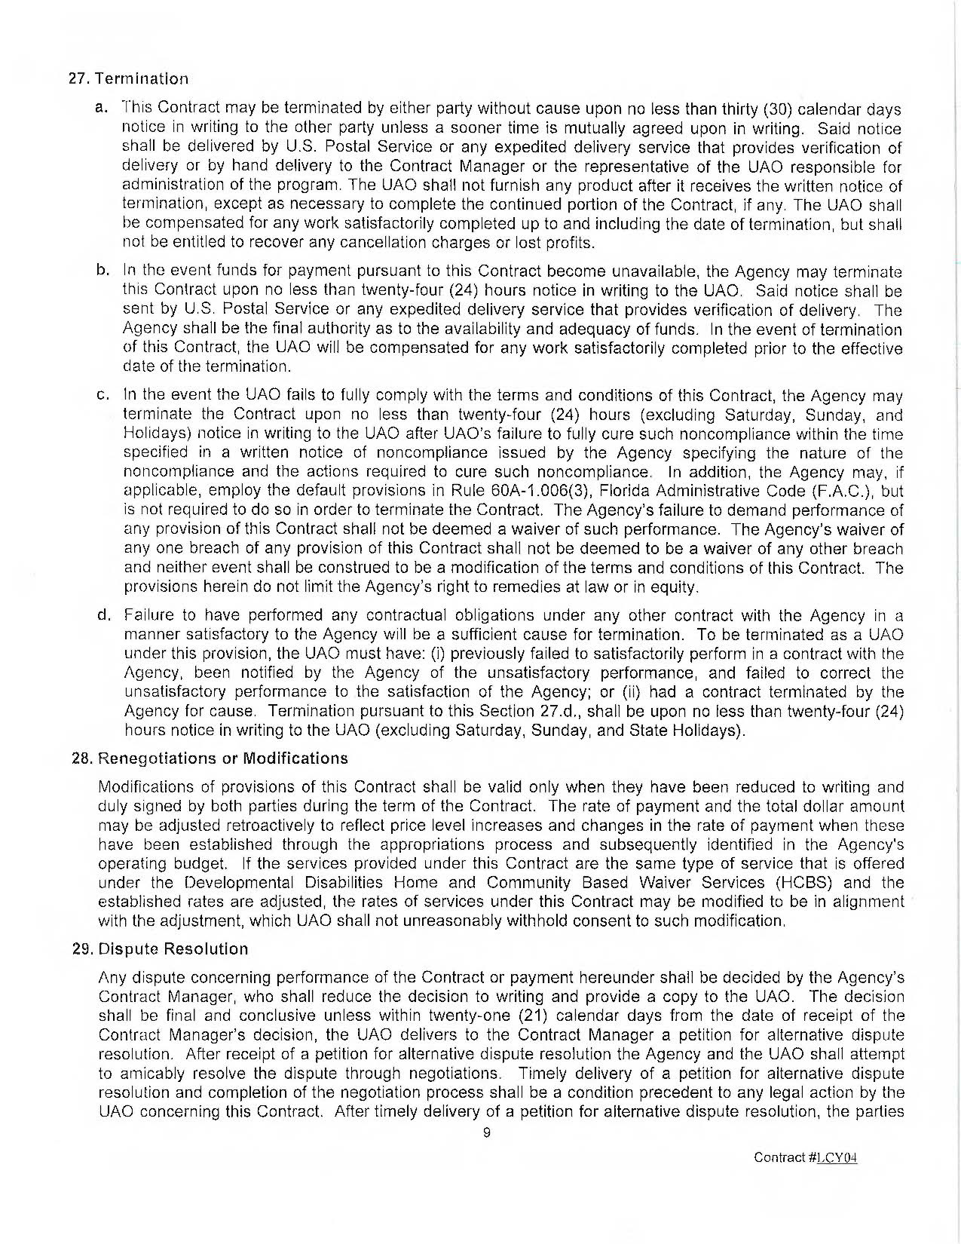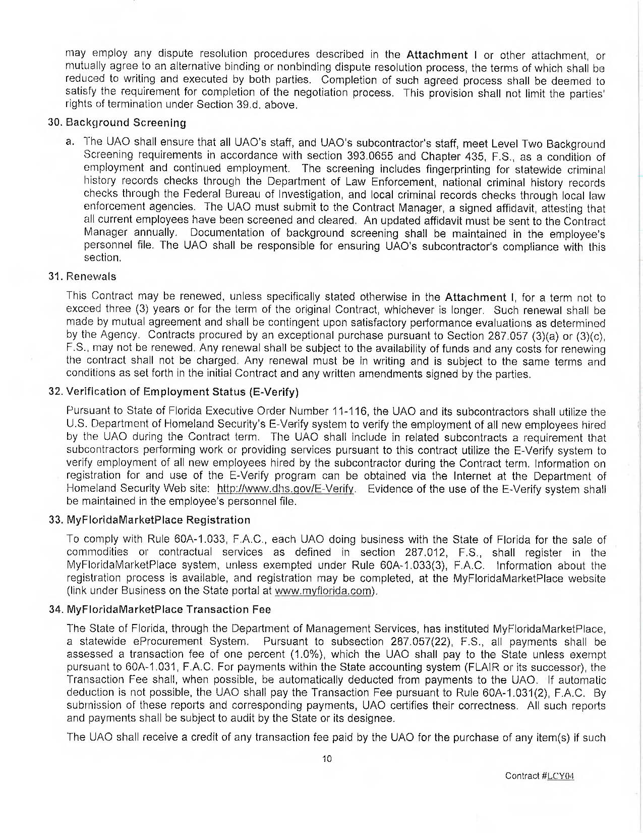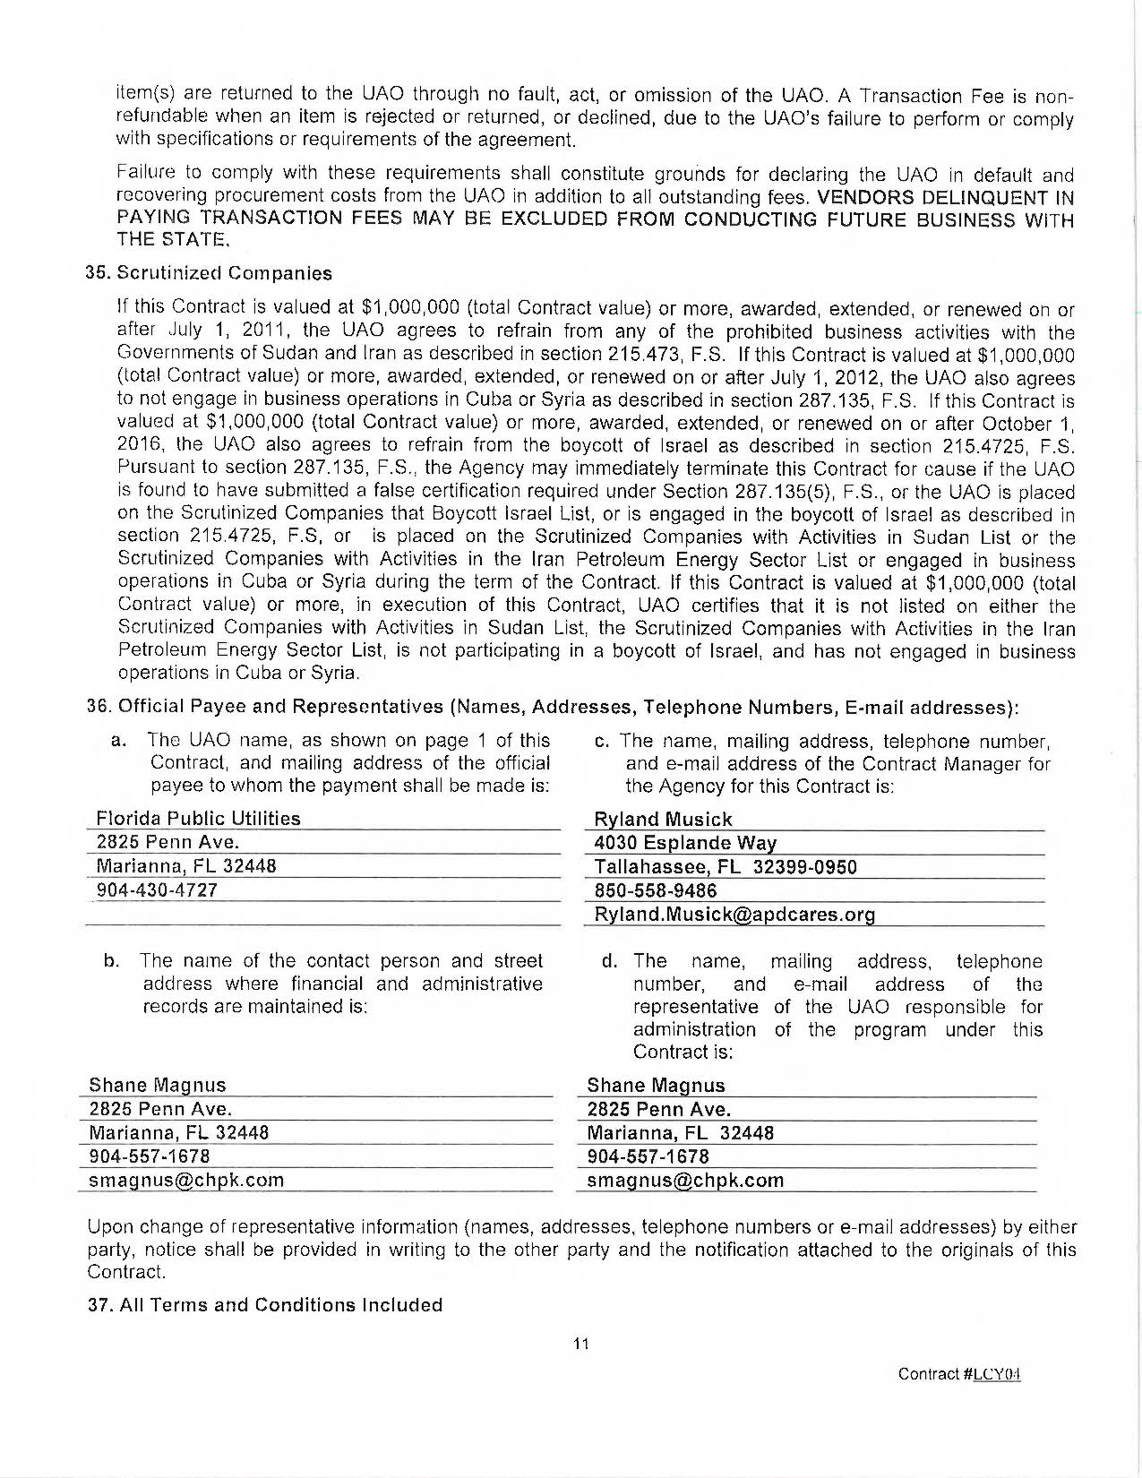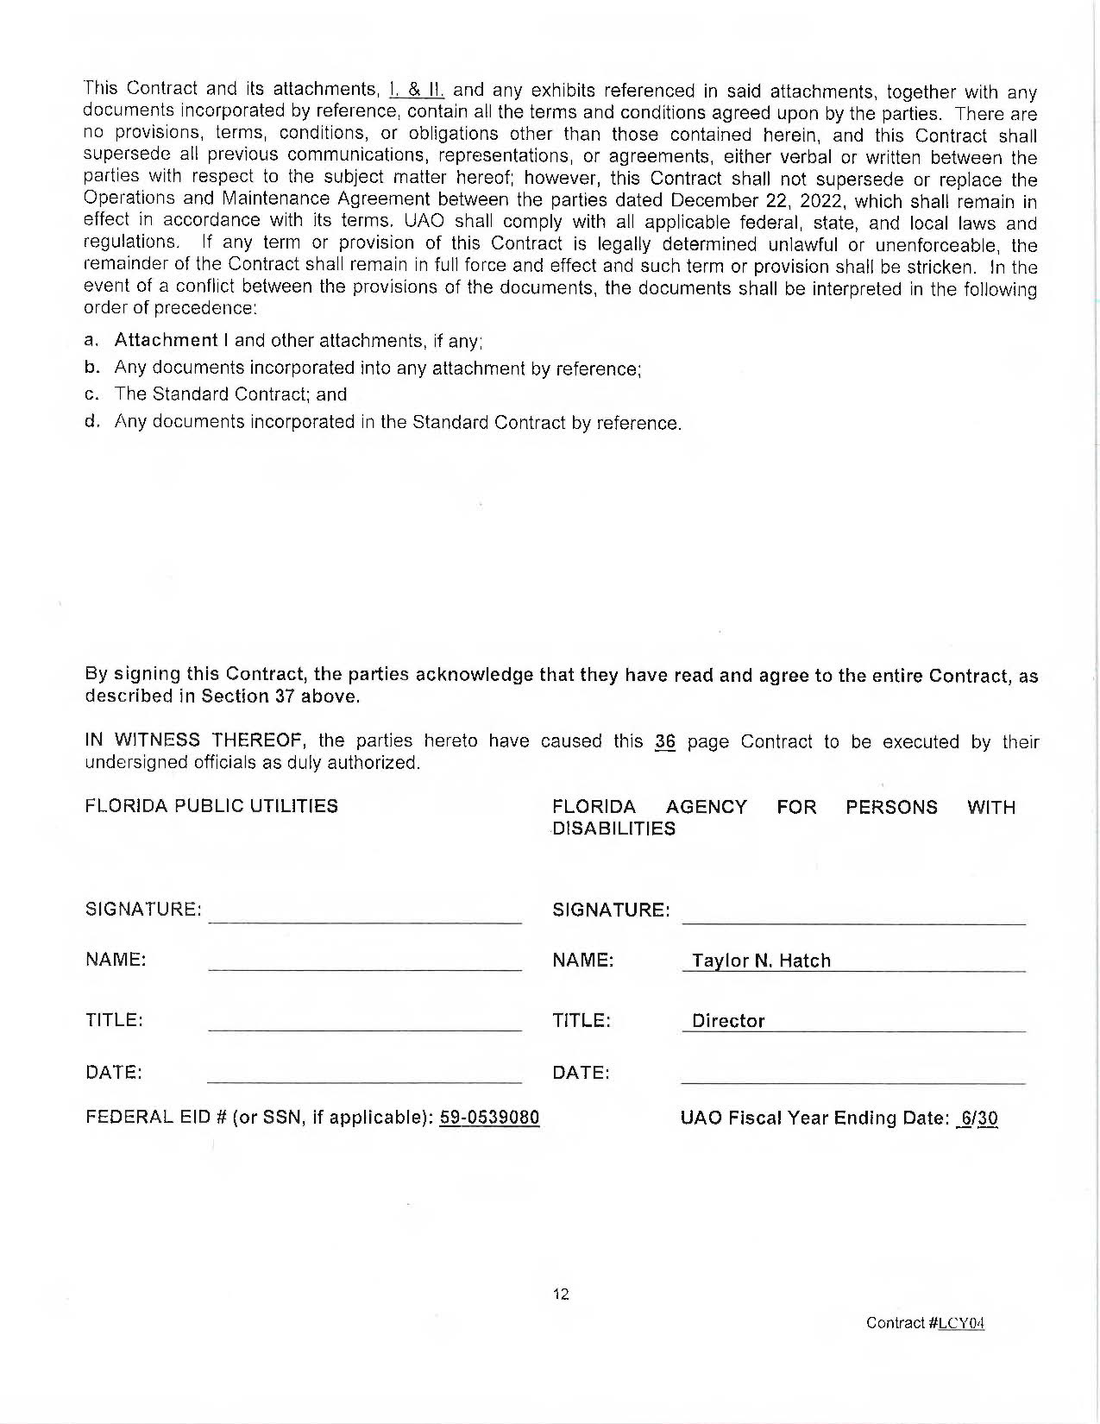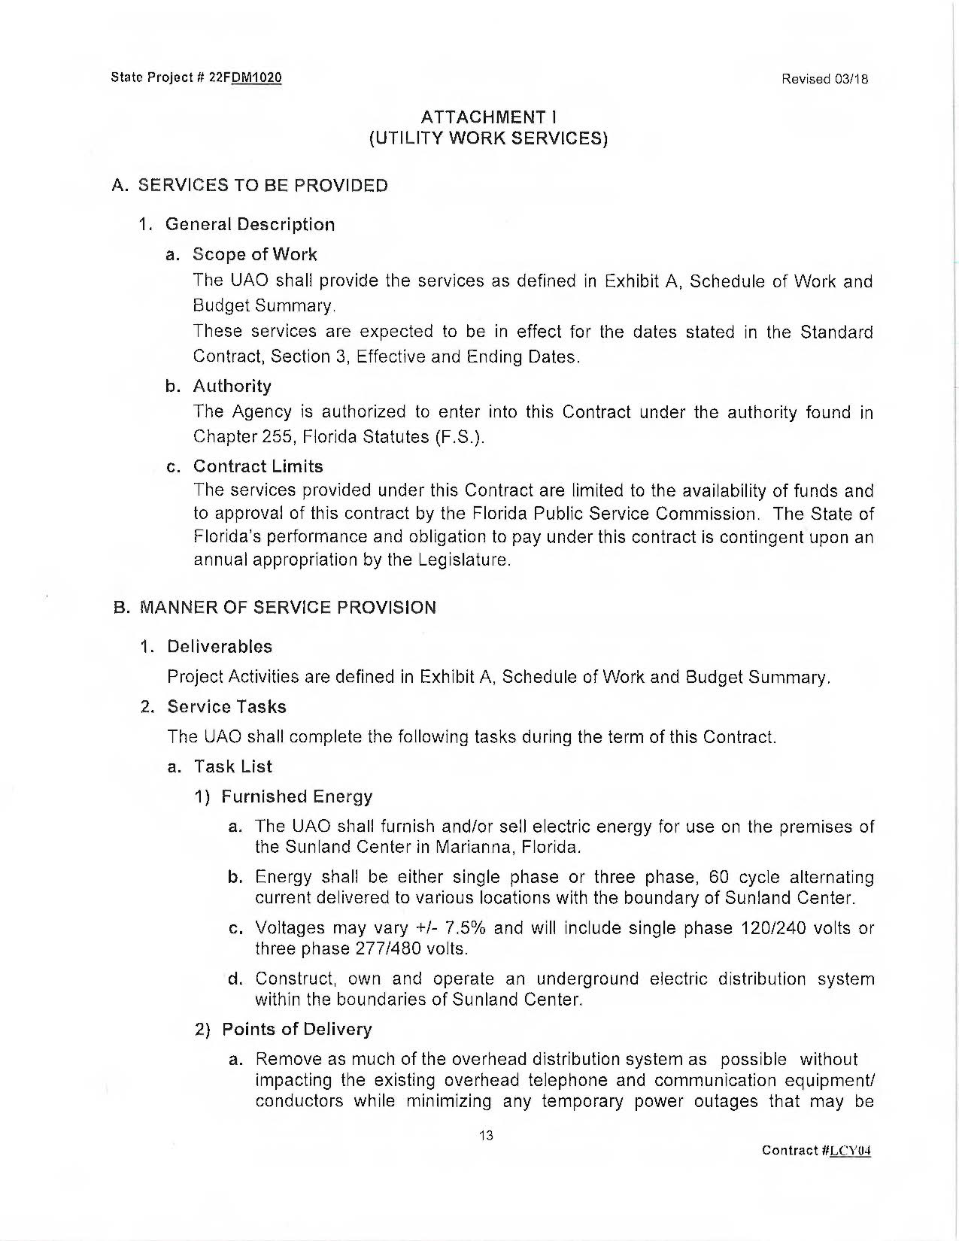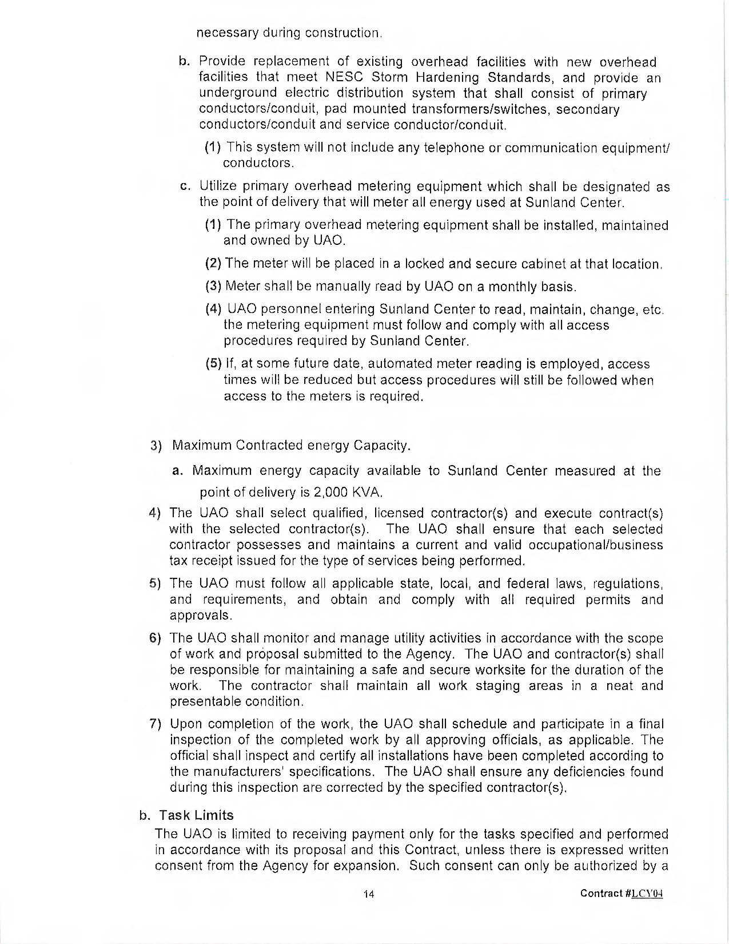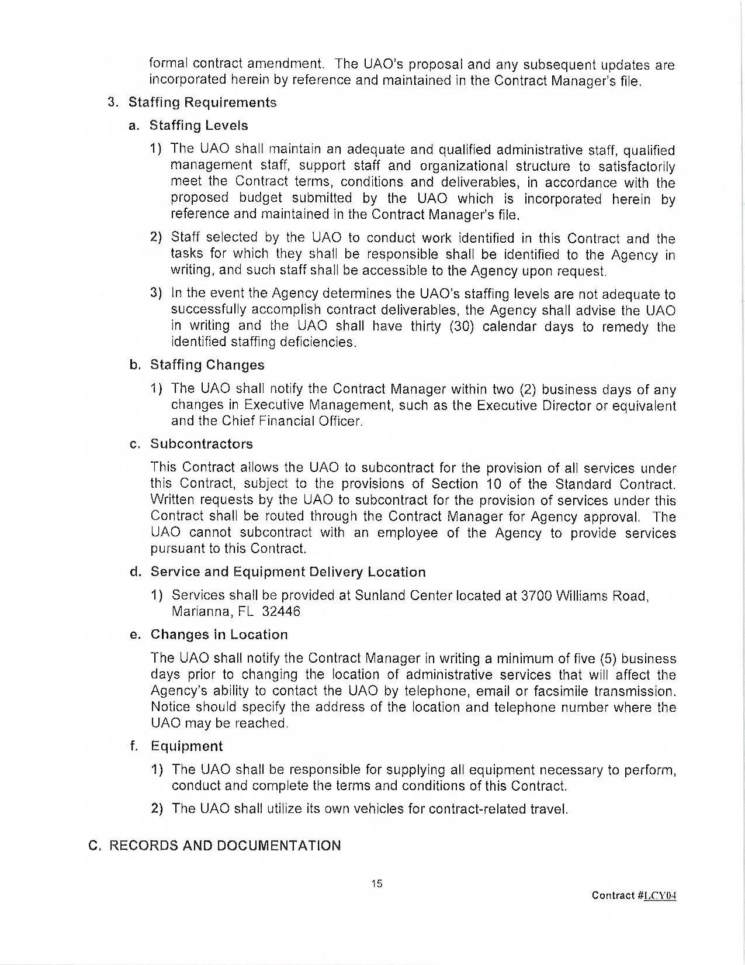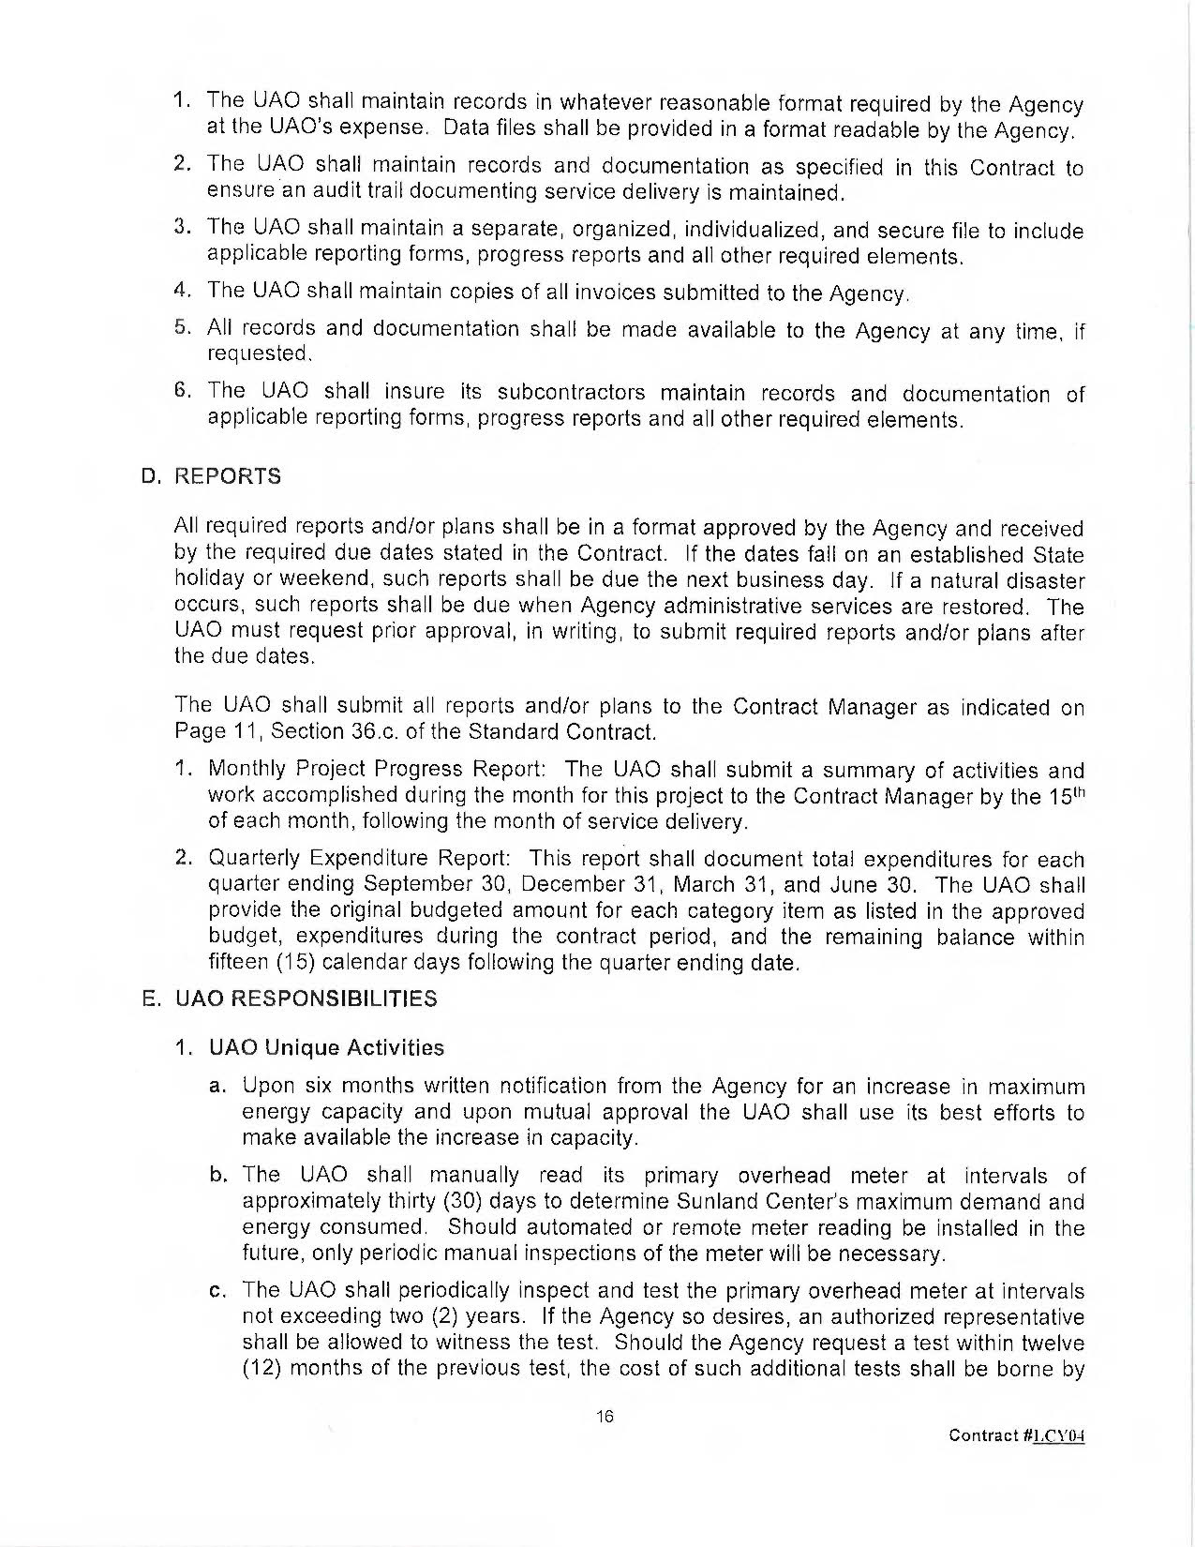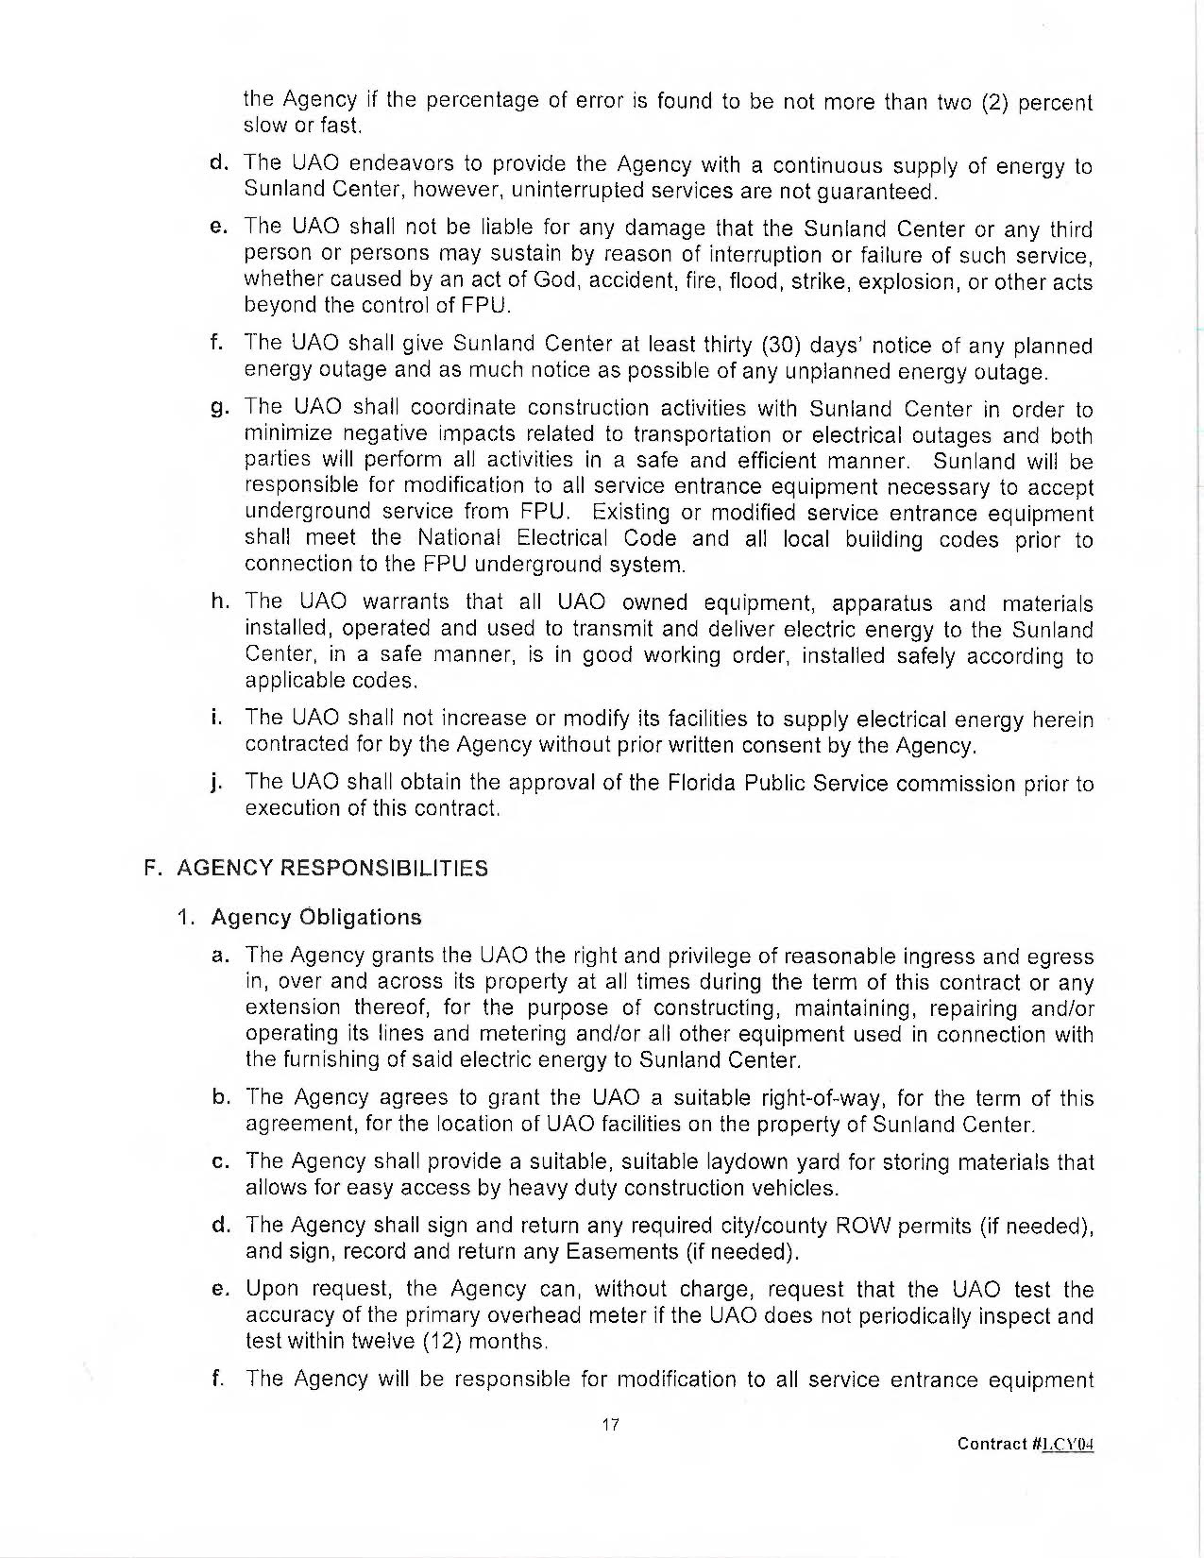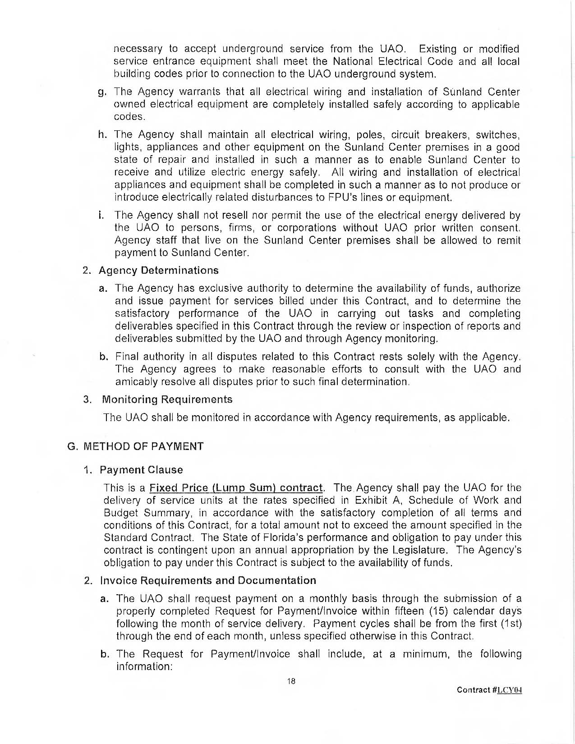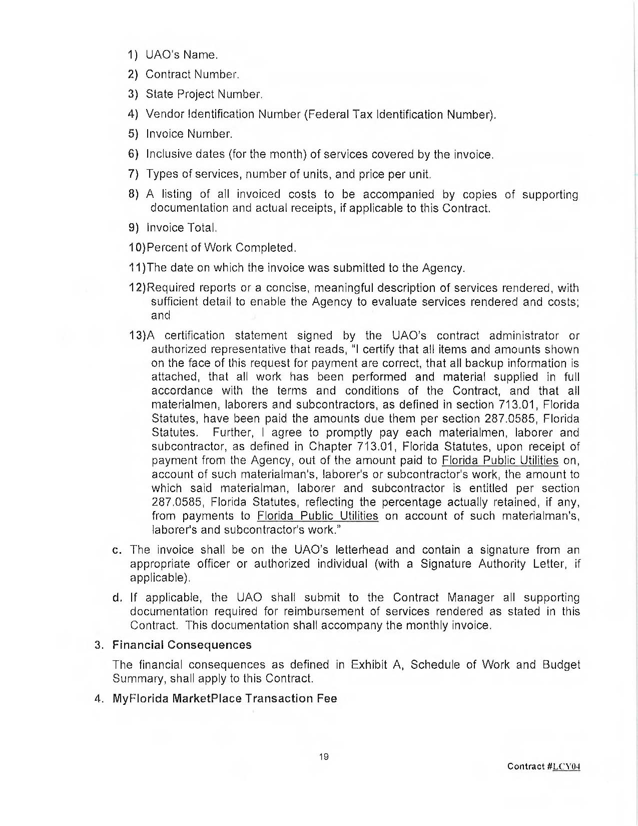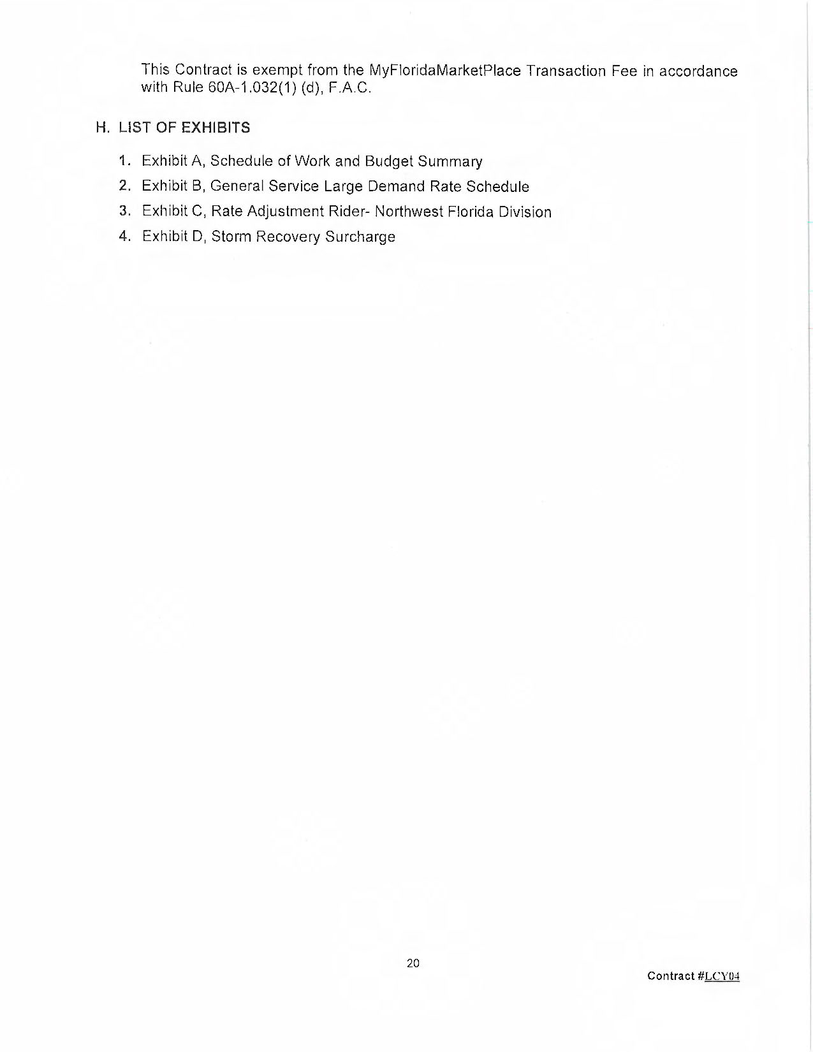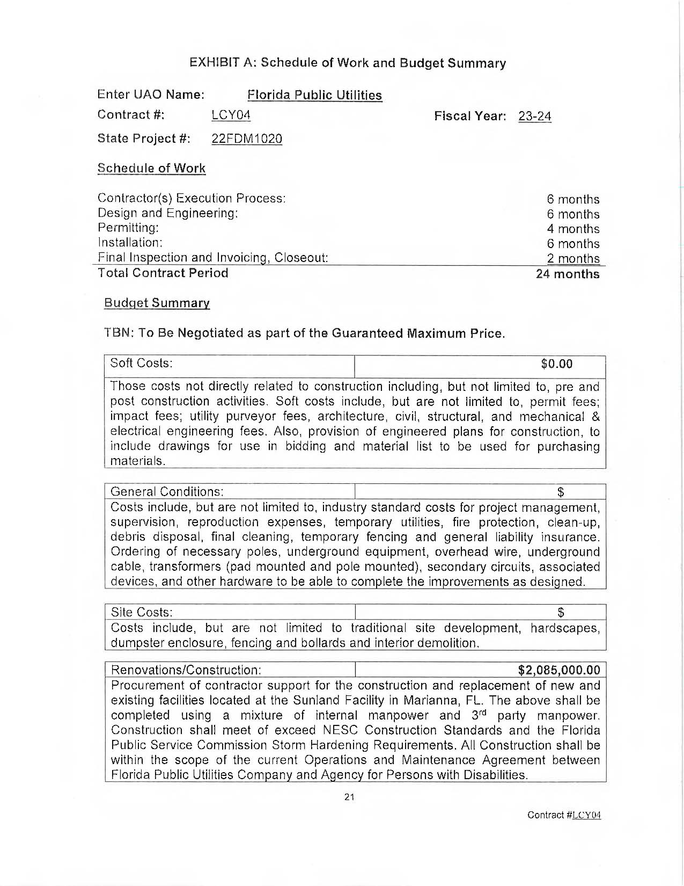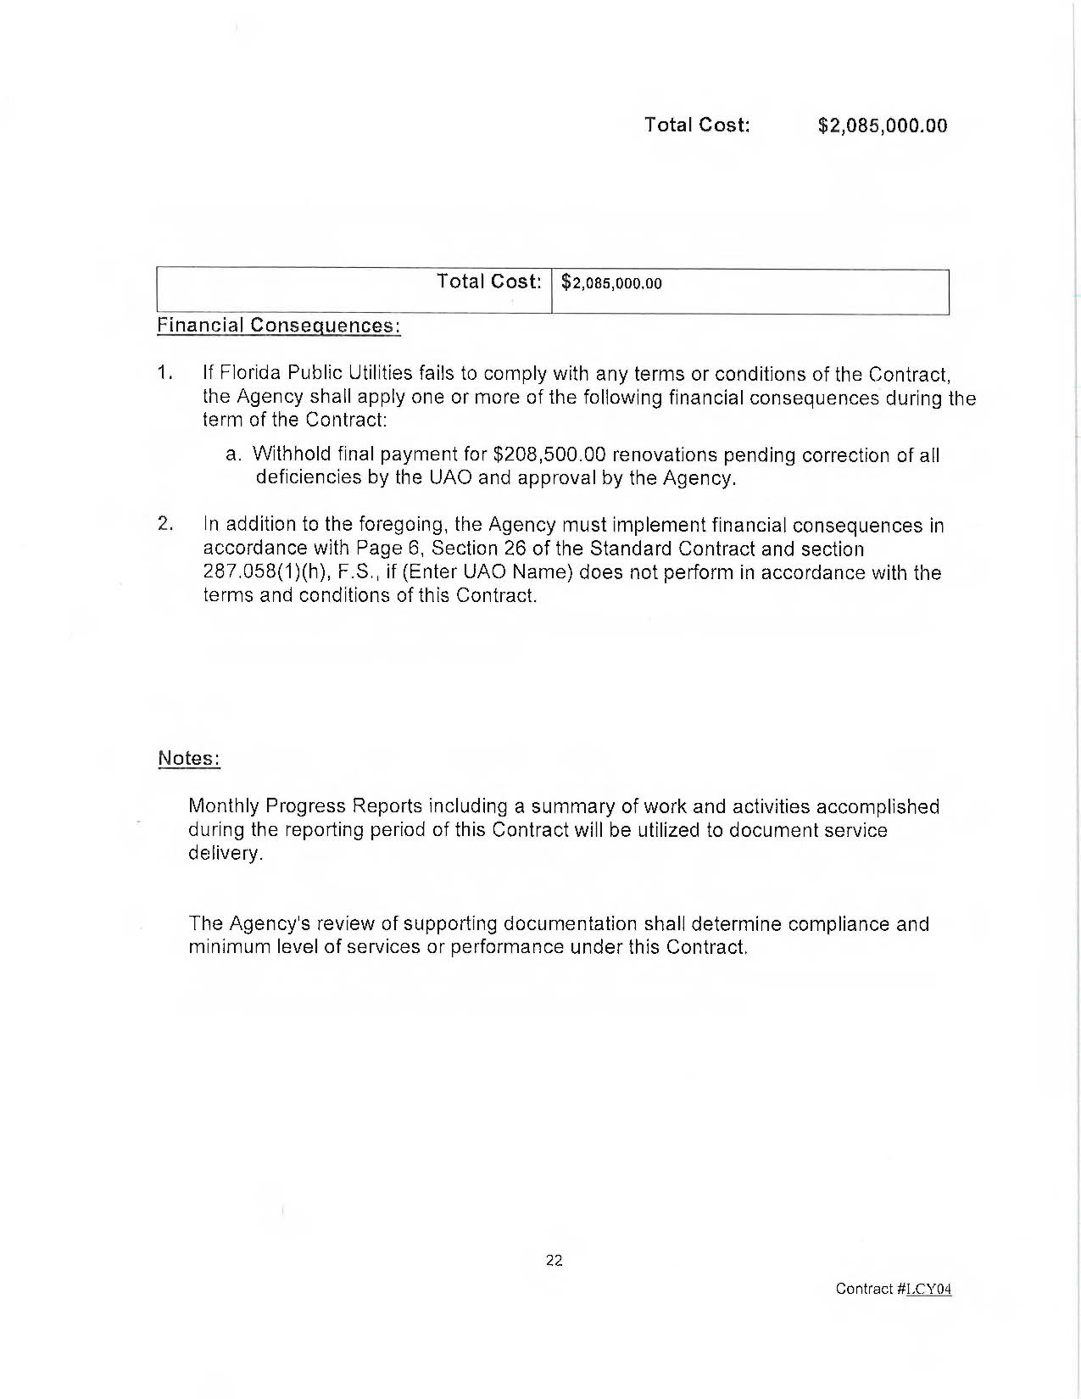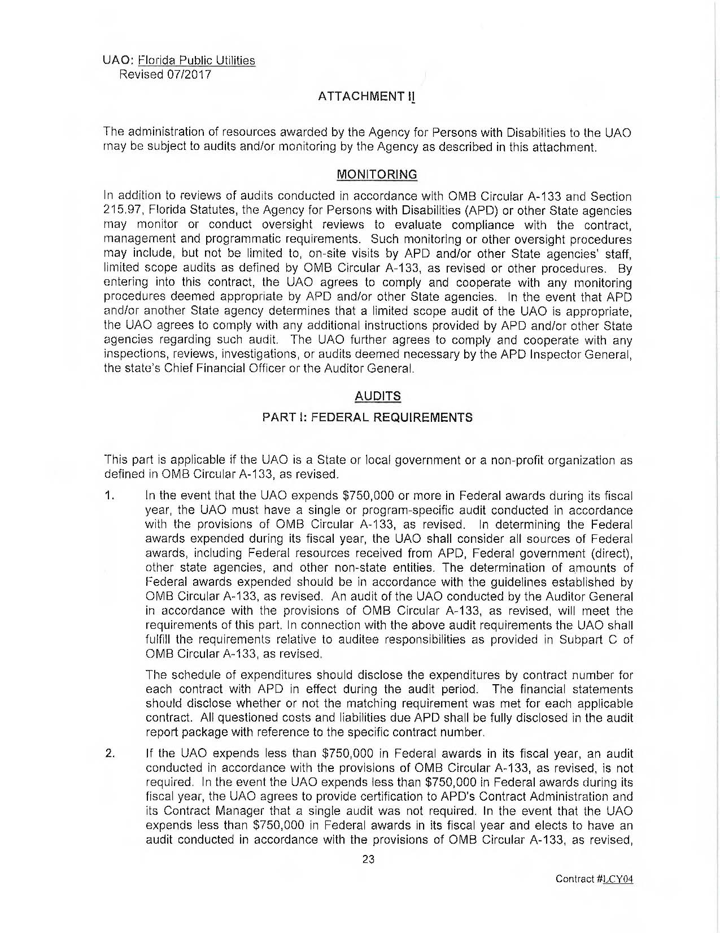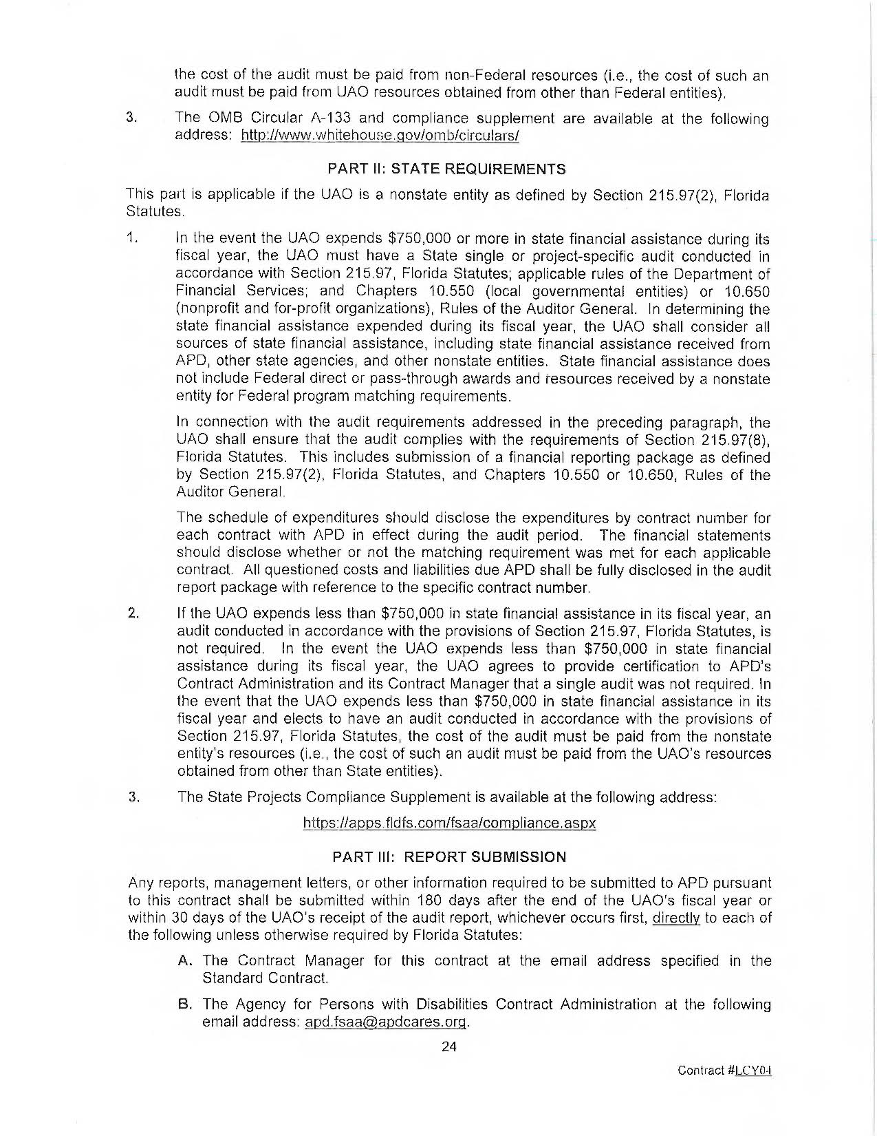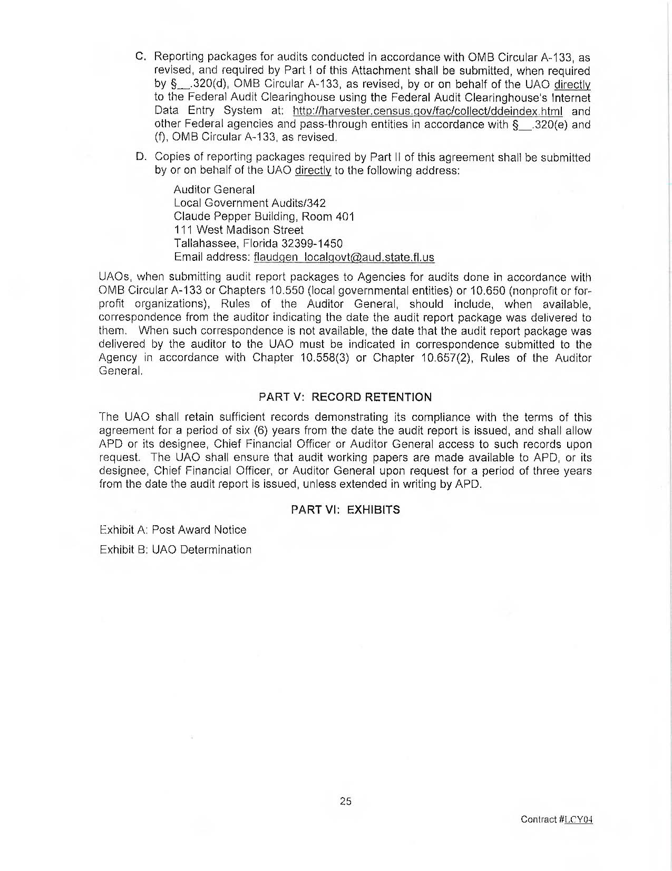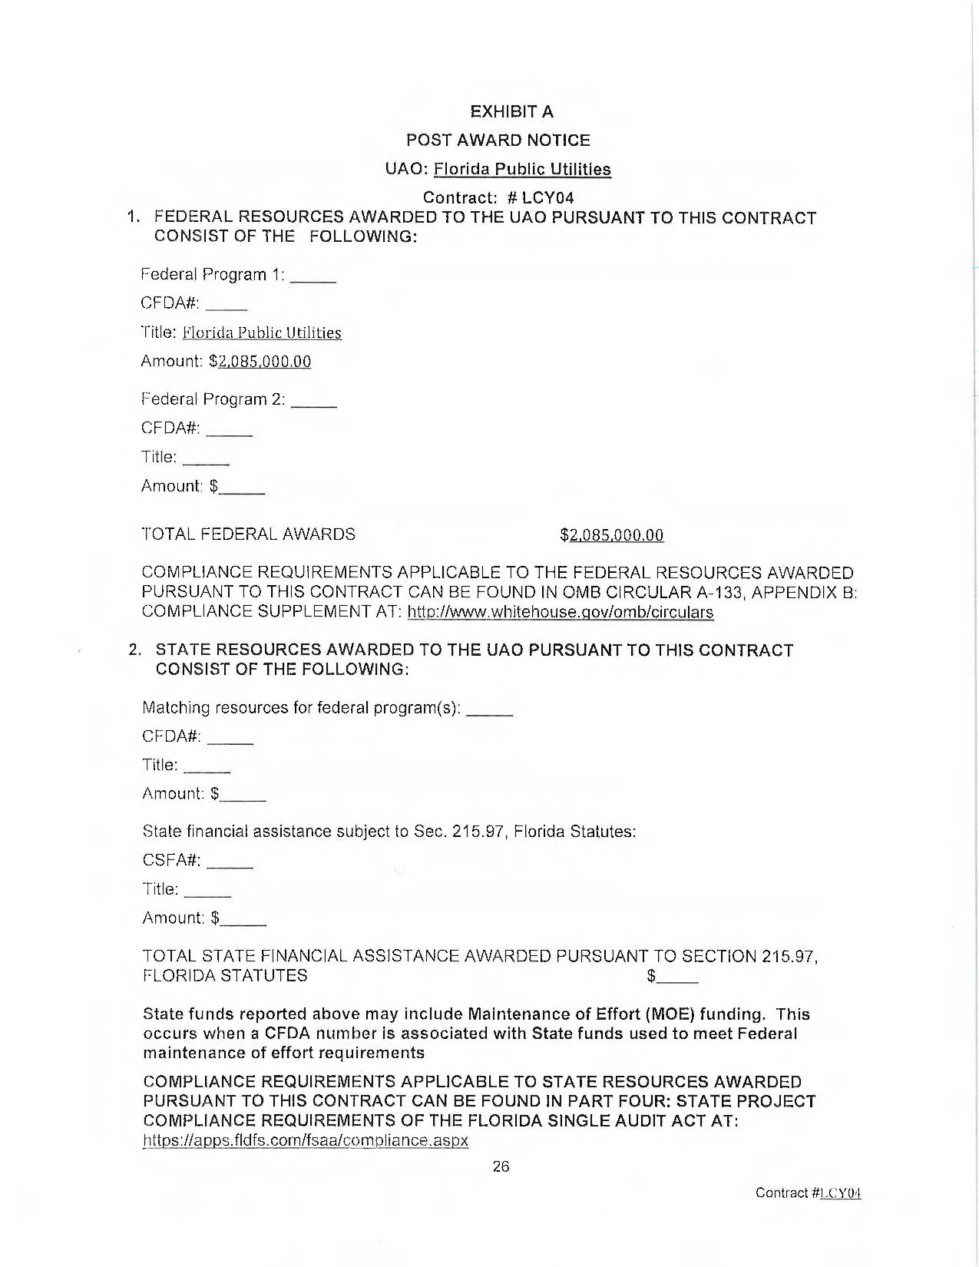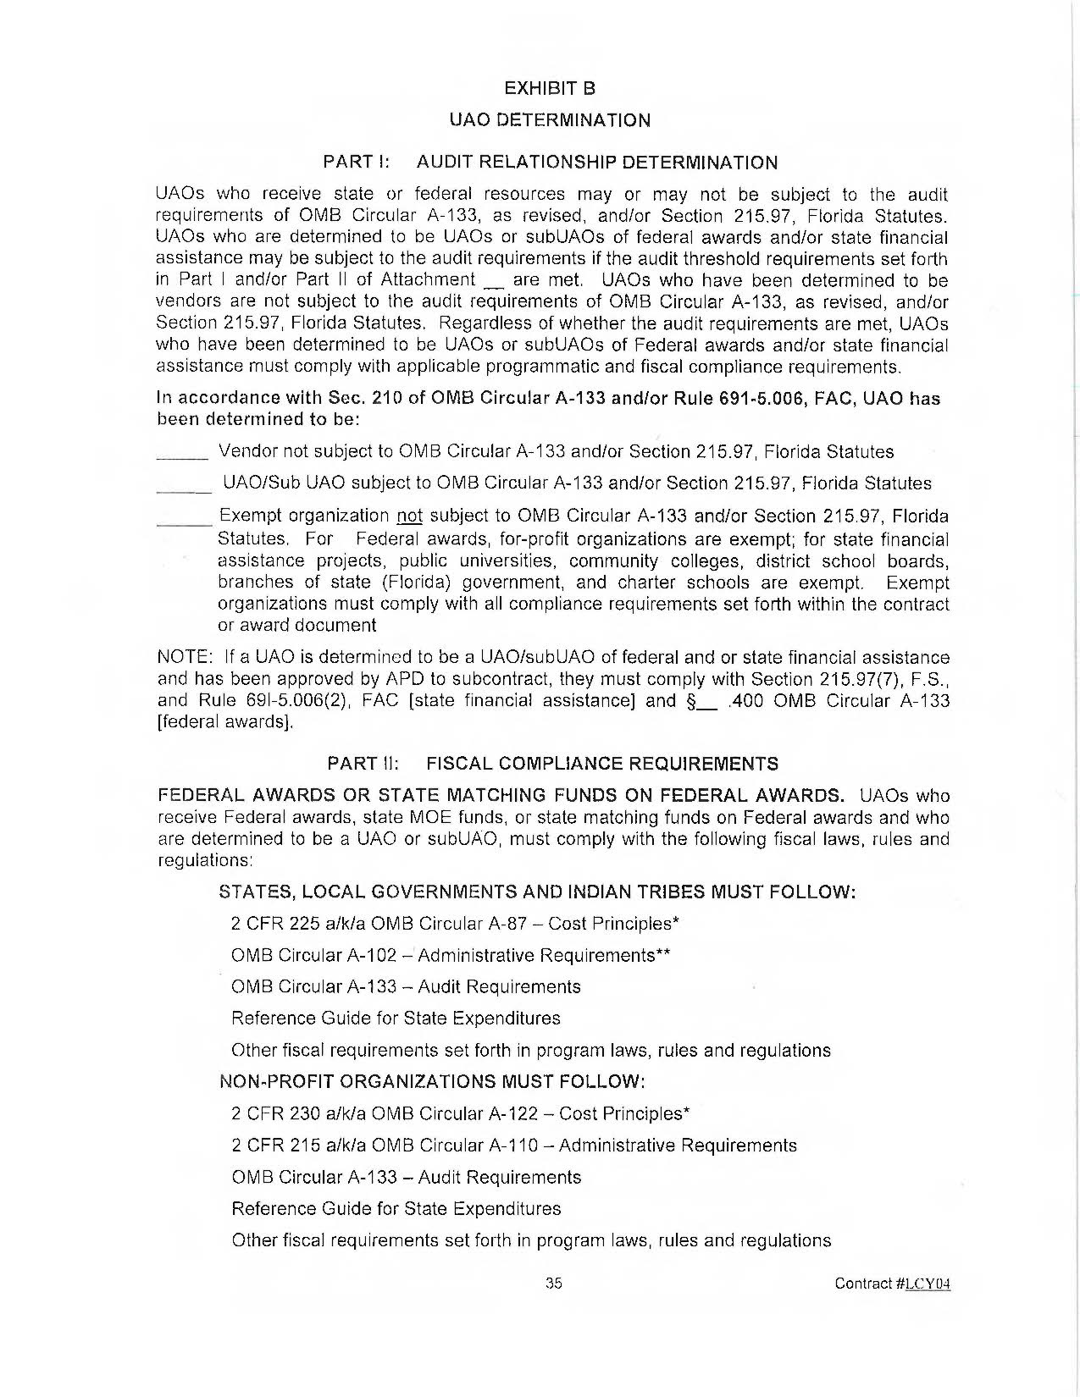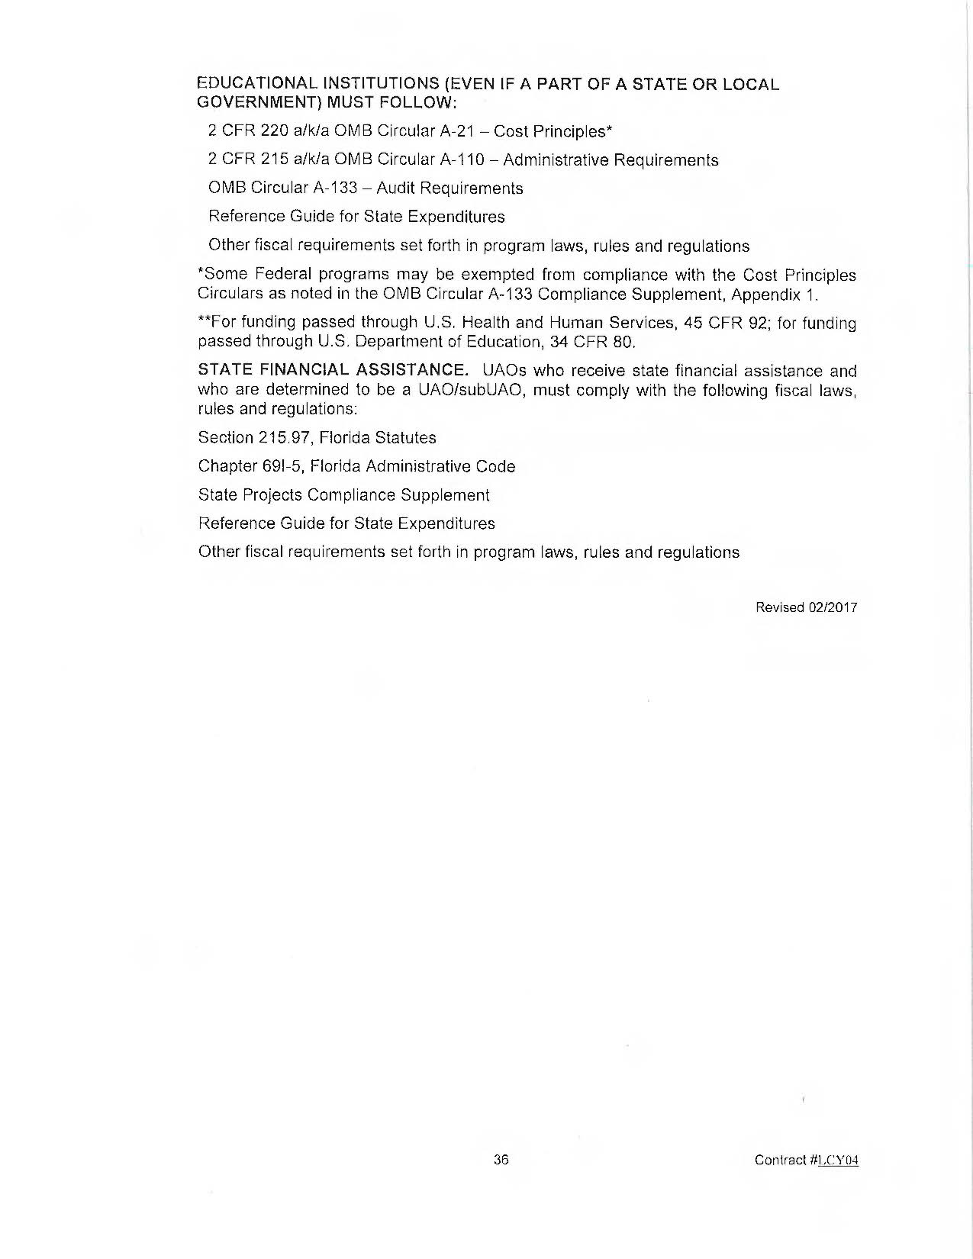

FPUC’s Responses to Staff’s First Data Request, DN 06861-2024.
FPUC’s Responses to Staff’s First Data Request, Response No. 4

