|  |  |  |  |
| --- | --- | --- | --- |
| State of Florida  pscSEAL | | Public Service Commission  Capital Circle Office Center ● 2540 Shumard Oak Boulevard Tallahassee, Florida 32399-0850  -M-E-M-O-R-A-N-D-U-M- | |
| DATE: | July 25, 2024 | | |
| TO: | Office of Commission Clerk (Teitzman) | | |
| FROM: | Division of Economics (P. Kelley)  Office of the General Counsel (Brownless) | | |
| RE: | Docket No. 20240094-GU – Joint petition by Peoples Gas System, Inc. and Florida Public Utilities Company for approval of Special Contract | | |
| AGENDA: | 08/06/24 – Regular Agenda – Proposed Agency Action – Interested Persons May Participate | | |
| COMMISSIONERS ASSIGNED: | | | All Commissioners |
| PREHEARING OFFICER: | | | Passidomo |
| CRITICAL DATES: | | | None |
| SPECIAL INSTRUCTIONS: | | | None |

Case Background

On, May 5, 2024, Peoples Gas System (Peoples) and Florida Public Utilities Company (FPUC) (jointly, Petitioners) filed a joint petition for approval of a special contract (2024 Special Contract). Under the terms of the Special Contract, Peoples would provide FPUC with firm gas transportation service for a seven-month term commencing on September 1, 2024, and terminating on April 1, 2025. Peoples and FPUC own and operate natural gas facilities in Florida and are subject to the regulatory jurisdiction of the Commission pursuant to Section 366.06, Florida Statutes (F.S.).

In 2021, Peoples and FPUC had a transportation agreement (2021 Agreement) that did not require Commission approval because the terms and conditions did not deviate from Peoples’ Commission-approved tariff. Under the 2021 Agreement, FPUC received service under Peoples’ Interruptible Service (IS) rate schedule. Pursuant to the 2021 Agreement, Peoples transported natural gas from the Florida Gas Transmission’s (FGT) interstate pipeline at the PGS-Jacksonville main gate to the Radio Avenue Interconnect into the Callahan Pipeline. The Callahan Pipeline is a 16-inch steel pipeline that was constructed in 2019 to allow FPUC and Peoples to expand natural gas service in Nassau and Duval counties.

In September of 2022, Peoples and FPUC filed a joint petition for approval of a special contract (2022 Special Contract). Commission approval was required because the terms and conditions deviated from Peoples’ Commission-approved tariff. The receipt points, delivery points, and points of delivery remained the same as in the 2021 transportation agreement. The Special Contract had a term from November 1, 2022, until June 1, 2024. The 2022 Special Contract extended the original contract to continue to allow Peoples to provide FPUC with firm natural gas service for a limited duration and obtain a fixed monthly reservation fee for the service provided. Upon the expiration of the existing contract in June, PGS ceased engaging in any obligations it had under that contract as FPUC has no rights to that capacity since the contract terminated and FPUC did not arrange a new contract with PGS in the interim. The Commission approved the Special Contract in Order No. PSC-2022-0374-PAA-GU.[1]

During the evaluation of the petition, staff issued data requests to Peoples and FPUC. Responses from FPUC were received on June 27, 2024. Responses from Peoples were received on June 27, 2024. The Commission has jurisdiction over this matter pursuant to Sections 366.04, 366.05, and 366.06, F.S.

Discussion of Issues

Issue :

 Should the Commission approved the Special Contract between Peoples and FPUC?

Recommendation:

 Yes, the Commission should approve the Special Contract between Peoples and FPUC as shown in Attachment A to the recommendation. The contract is reasonable because it facilitates the delivery of natural gas into Nassau County and benefits FPUC’s and Peoples’ general body of ratepayers. The contract should be effective September 1, 2024. (P. Kelley)

***Staff Analysis:*** As discussed in the case background, the Commission approved a 2022 Special Contract between Peoples and FPUC. In May 2024, with the natural expiration of the 2022 Special Contract approaching, FPUC sought out Peoples for modification of the 2022 Special Contract which resulted in the proposed 2024 Special Contract. The term of the contract is for 7 months with a negotiated monthly charge for the reservation of firm capacity and transportations service on Peoples’ distribution system and a daily maximum transportation quantity. The receipt points, delivery points, and points of delivery remained the same as in the 2022 Special Contract. Similarly with the 2022 Special Contract, FPUC will recover its payment to Peoples through the Purchased Gas Adjustment and from transportation customers that utilize the alternative supply in Nassau County. This contract would continue to generate revenues for Peoples, benefitting Peoples’ general body of rate payers.

The purpose of the 2024 Special Contract remains the same as the prior Commission-approved 2022 Special Contract. Typically, FPUC obtains its gas from the Transco Zone 5 for its Nassau County operations. In response to staff’s first data request, FPUC indicated that although the market has changed since the last transportation agreement, during the winter months it remains highly volatile. The agreement with PGS allows FPUC an alternative to Transco Zone 5 with an estimated savings of more than $1 million to FPUC’s customers and transportation customers over the 7-month term proposed in the 2024 Special Contract.[2]

The proposed 2024 Special Contract for a 7-month term is a much shorter time period than the 2022 Special Contract term of 19 months. FPUC indicated that based on the commodity prices it would see savings up to March 2025. For the time period after March 2025, FPUC will reassess forward commodity prices and may seek PGS for continued service. If the contract is not renewed, FPUC indicated it would return to using firm Southern Natural Gas Company (SONAT) capacity for its supply needs. SONAT is an interstate natural gas pipeline which brings gas from the Louisiana Gulf of Mexico cost to the southeastern United States, including Florida.

Conclusion

Based on the review of the petition and responses to staff’s data requests, staff believes the proposed Special Contract is reasonable because it facilitates the delivery of natural gas into Nassau County and benefits FPUC’s and Peoples’ general body of ratepayers. Staff therefore recommends approval of the proposed Special Contract between Peoples and FPUC effective September 1, 2024.Issue :

 Should this docket be closed?

Recommendation:

If no protest is filed by a person whose substantial interests are affected within 21 days of issuance of this order, this docket should be closed upon the issuance of a consummating order. (Brownless)

Staff Analysis:

 If no protest is filed by a person whose substantial interests are affected within 21 days of issuance of this order, this docket should be closed upon the issuance of a consummating order.

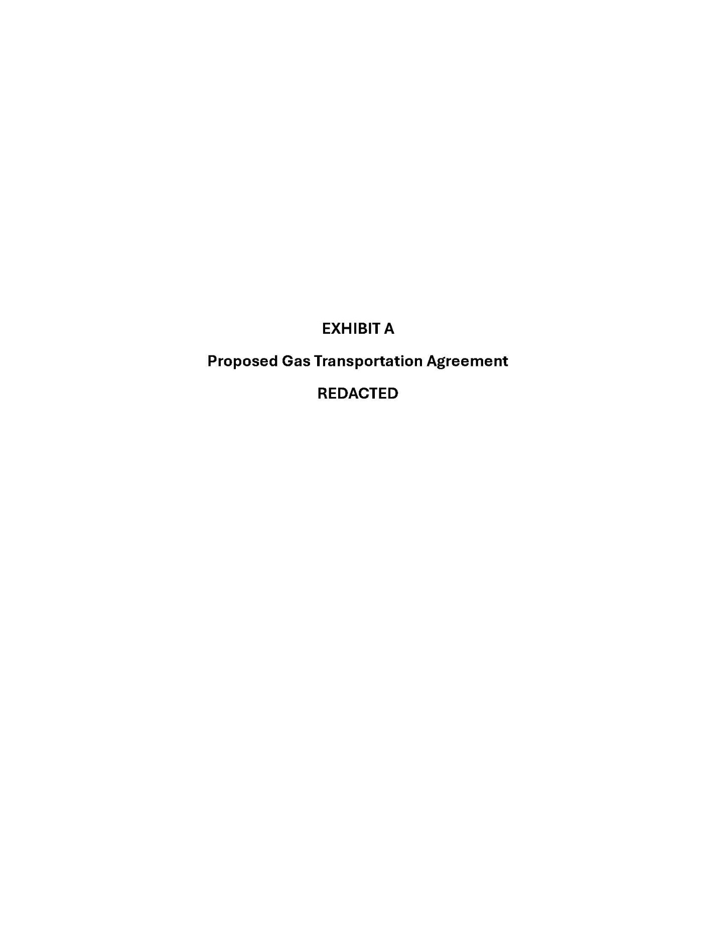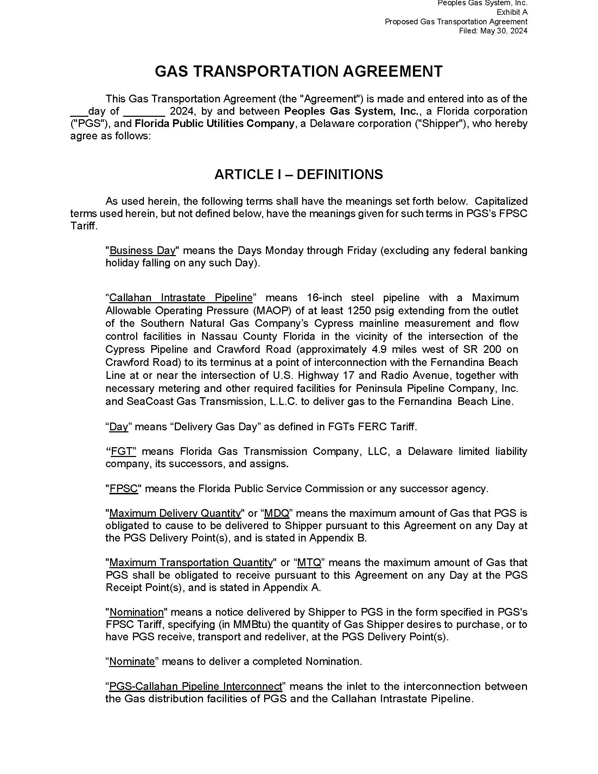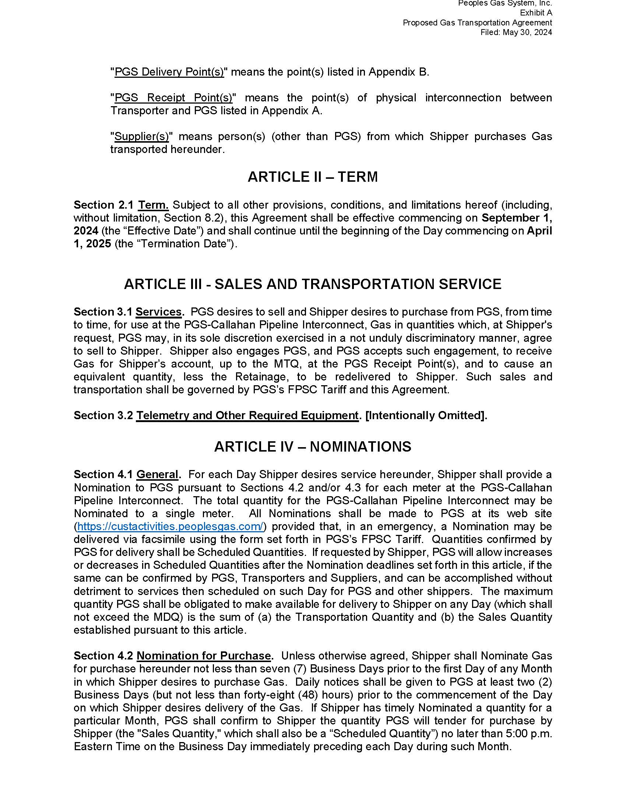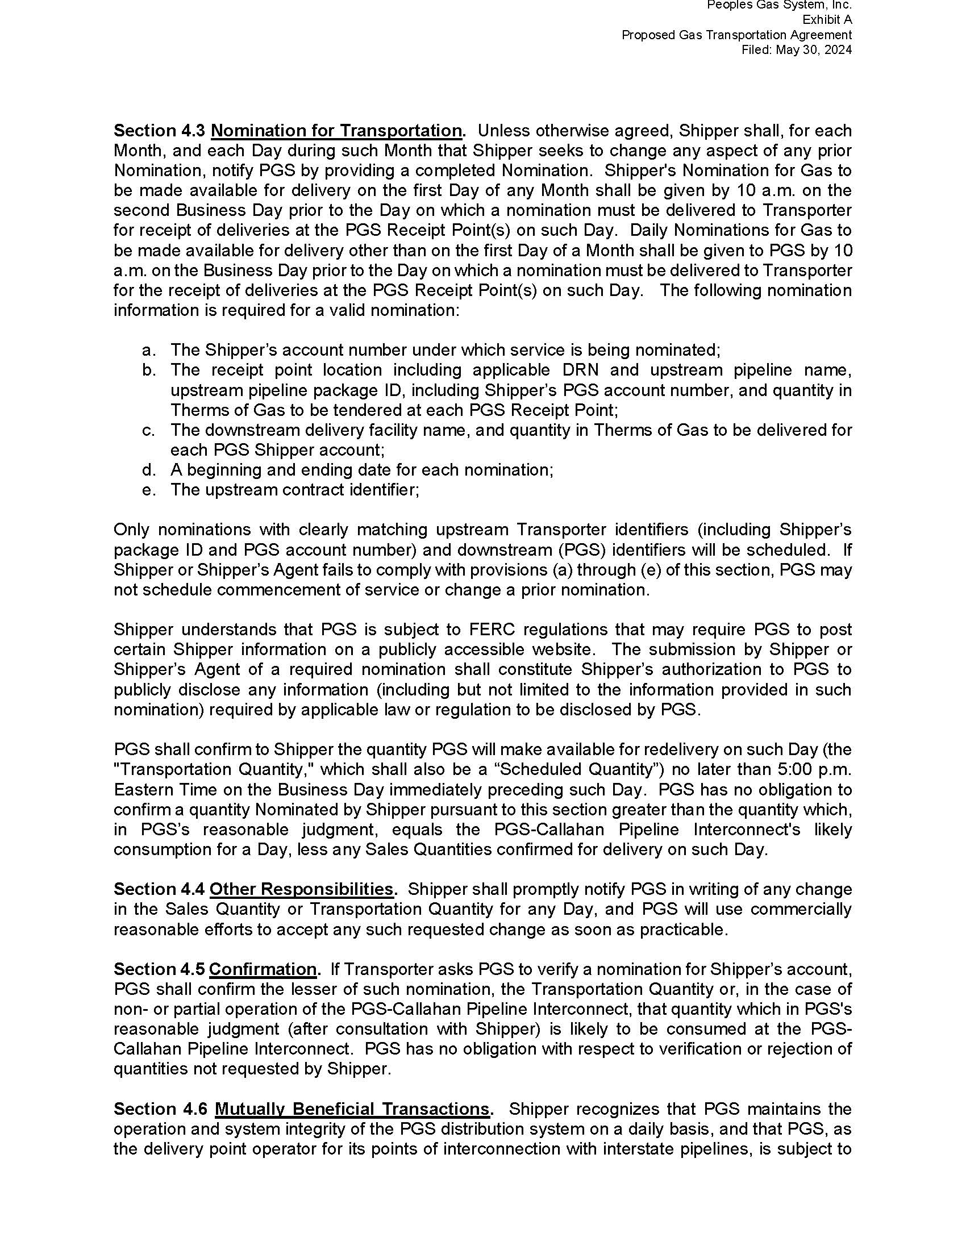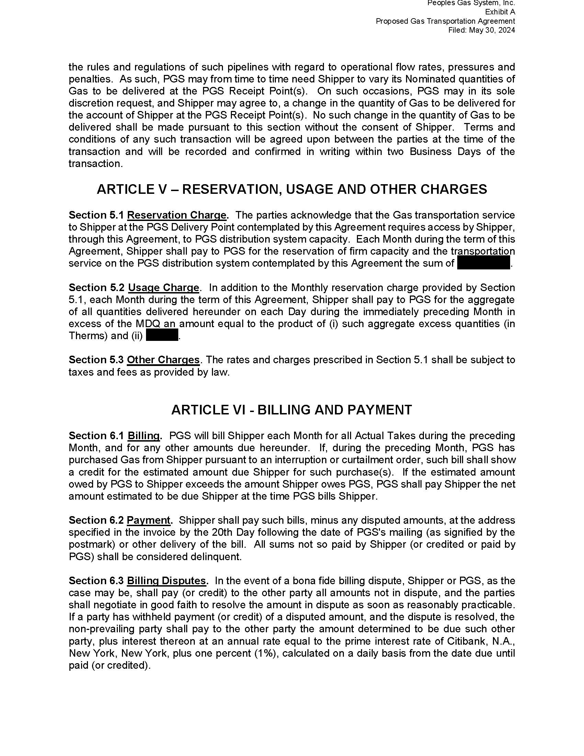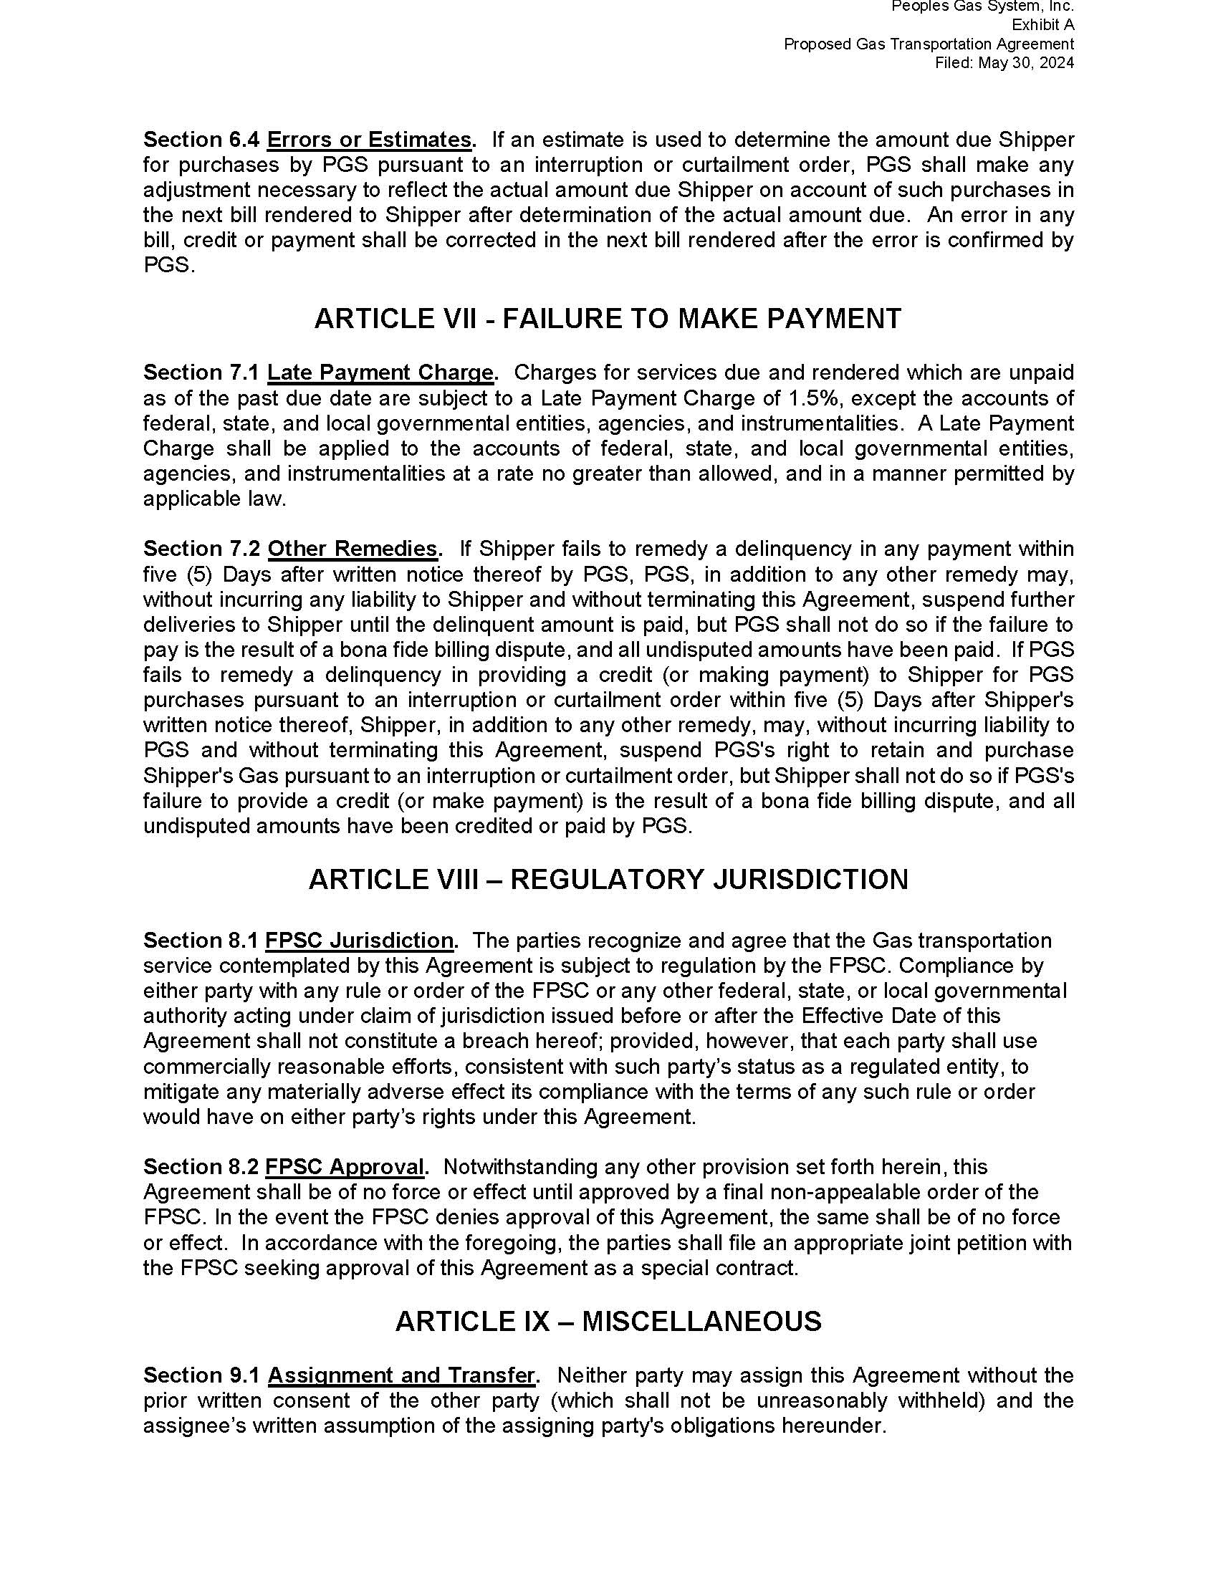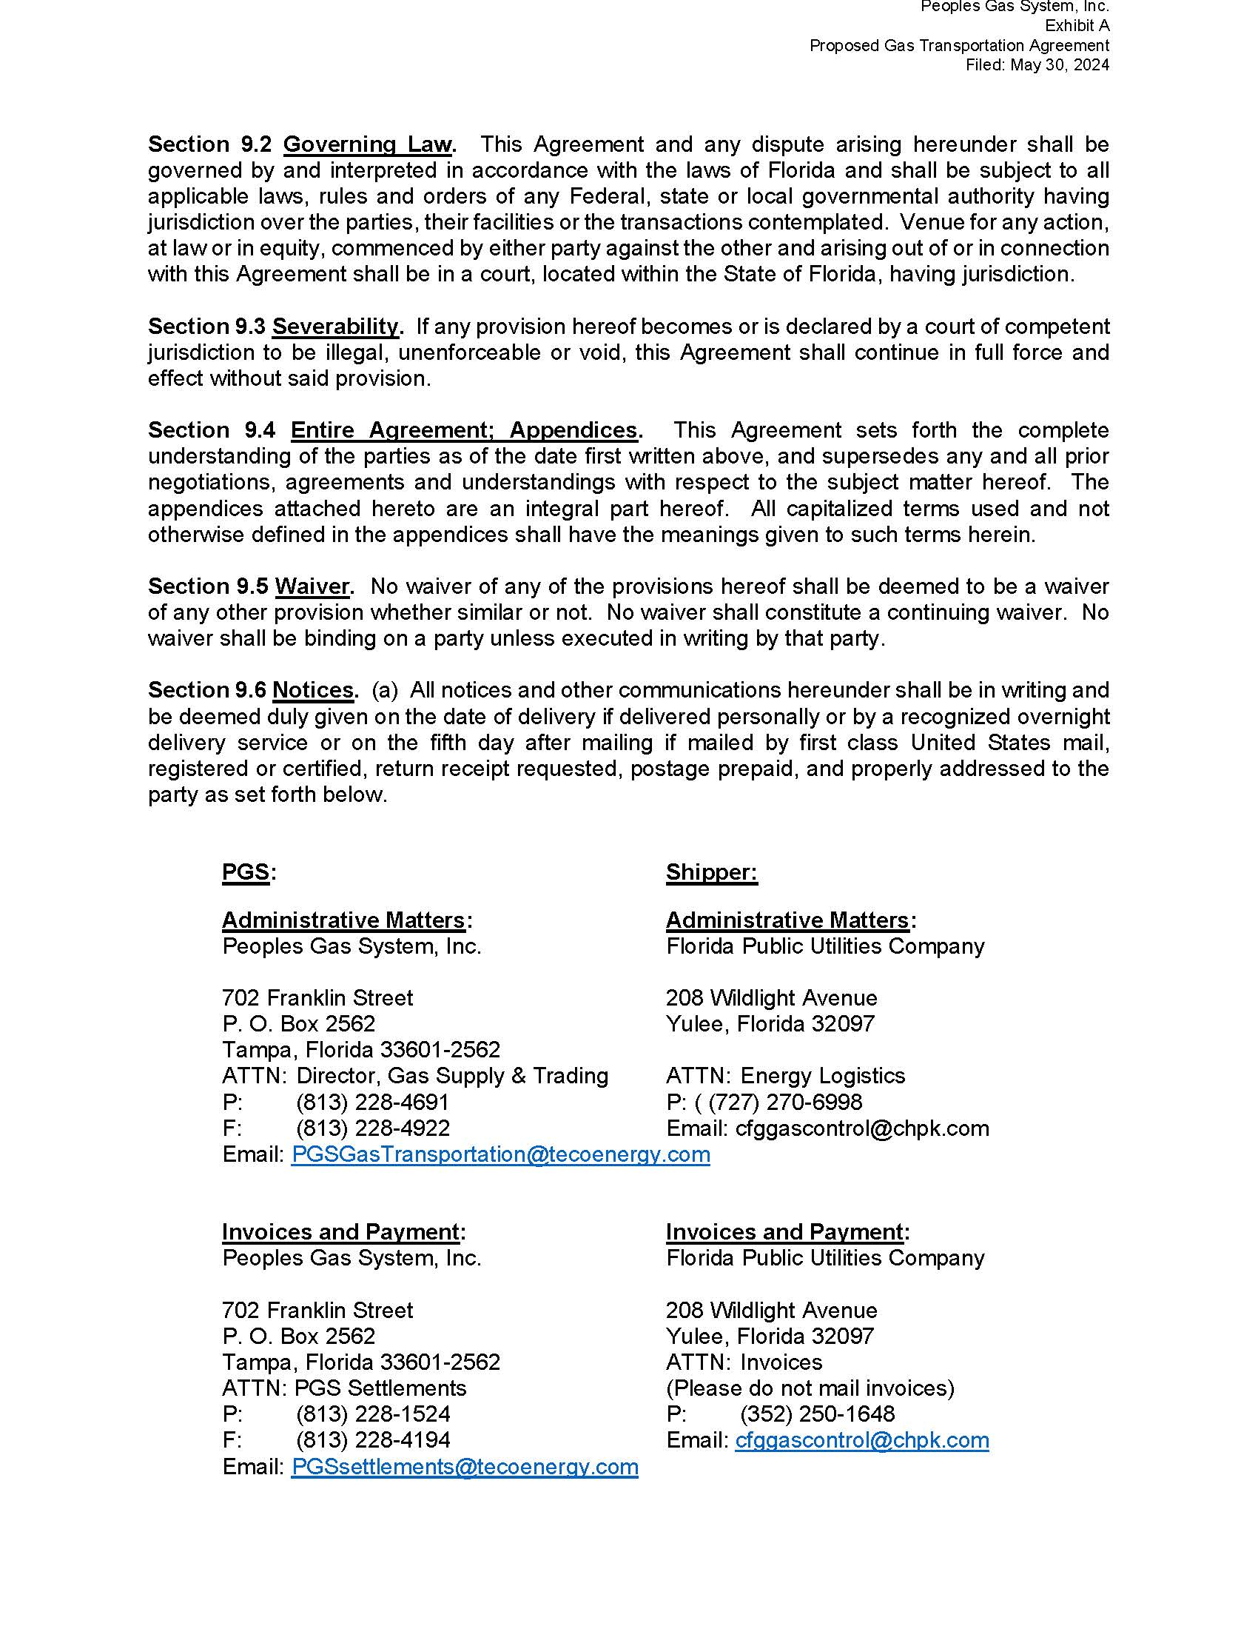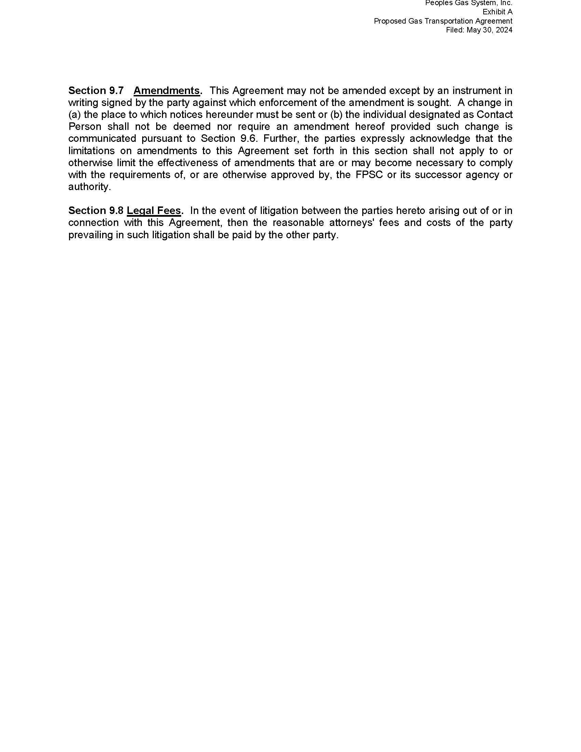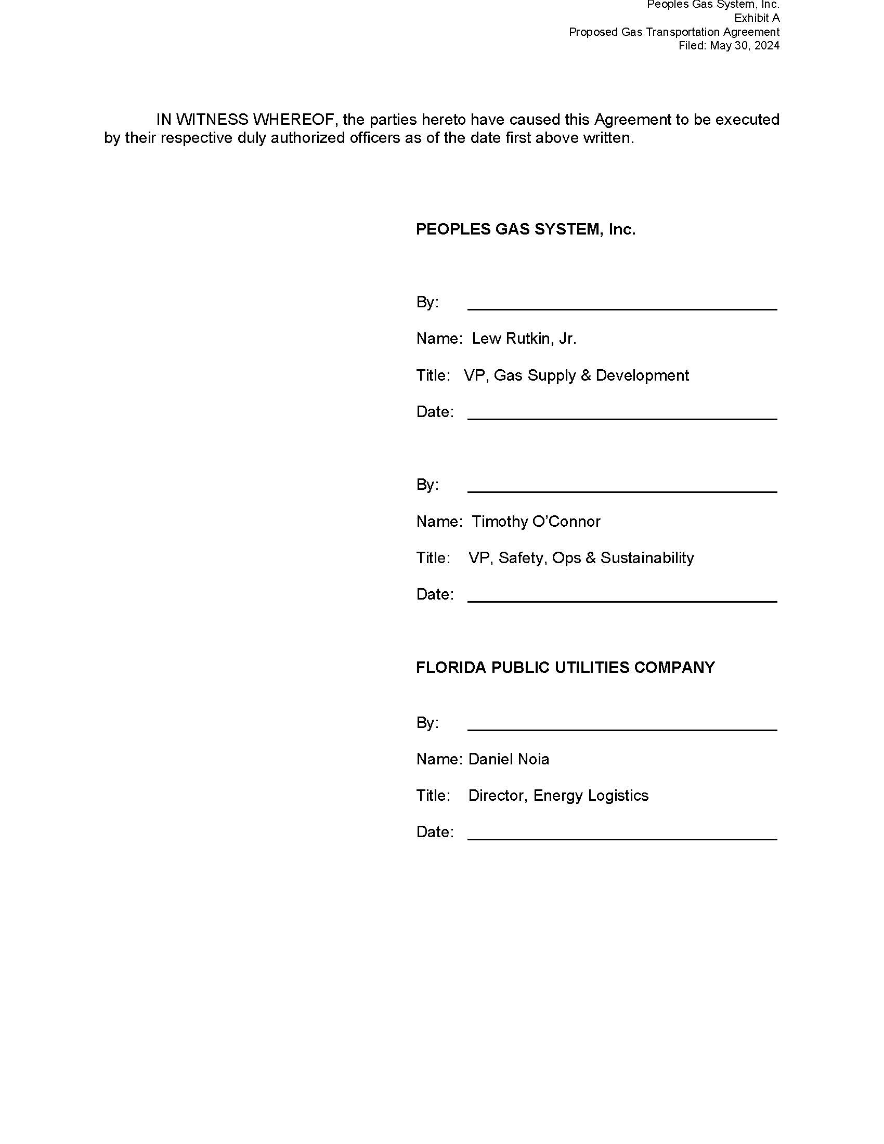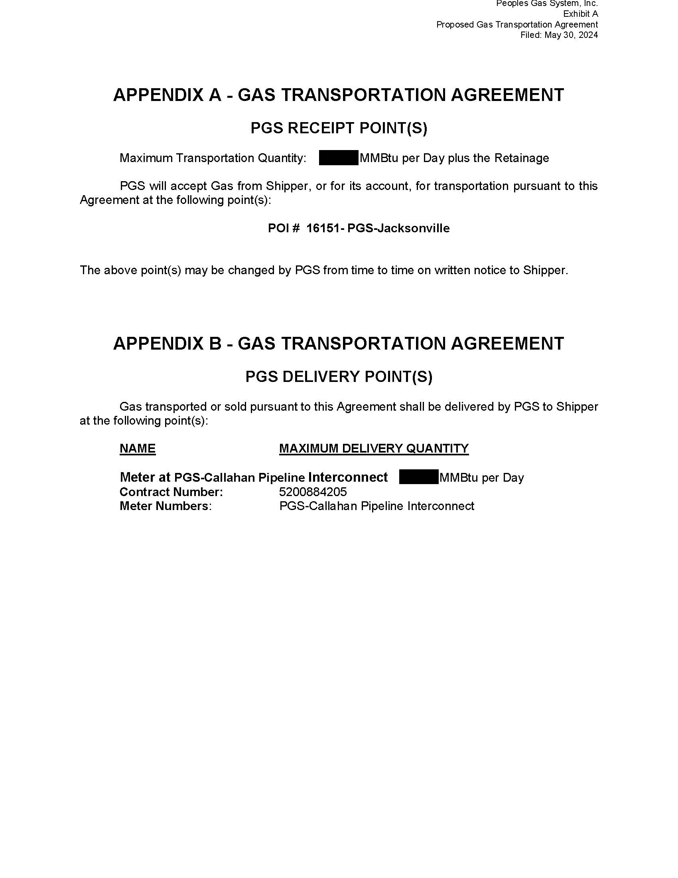

1. Order No. PSC-2022-0374-PAA-GU, issued November 4, 2022, in Docket No. 20220159-GU, *In re: Petition for approved of special contract with Florida Public Utilities Company, by Peoples Gas System, Inc.*
2. FPUC Responses to Staff’s First Data Request, Document No. 07010-2024, Response No. 3