BEFORE THE FLORIDA PUBLIC SERVICE COMMISSION

|  |  |
| --- | --- |
| In re: Petition for approval of transportation service agreement with Florida City Gas by Peninsula Pipeline Company, Inc. | DOCKET NO. 20240051-GU  ORDER NO. PSC-2024-0268-PAA-GU  ISSUED: July 25, 2024 |

The following Commissioners participated in the disposition of this matter:

MIKE LA ROSA, Chairman

ART GRAHAM

GARY F. CLARK

ANDREW GILES FAY

GABRIELLA PASSIDOMO

NOTICE OF PROPOSED AGENCY ACTION

ORDER APPROVING TRANSPORTATION SERVICE AGREEMENT

BY THE COMMISSION:

NOTICE is hereby given by the Florida Public Service Commission that the action discussed herein is preliminary in nature and will become final unless a person whose interests are substantially affected files a petition for a formal proceeding, pursuant to Rule 25-22.029, Florida Administrative Code.

Background

On March 28, 2024, Peninsula Pipeline Company, Inc. (Peninsula) filed a petition for approval of a transportation service agreement (Transportation Agreement) with Florida City Gas (FCG) (jointly, the parties). The purpose of the Transportation Agreement is to ensure continuance of gas service to FCG after the impending acquisition by Peninsula of certain pipeline facilities in the area in and around Palm Beach County. Peninsula operates as an intrastate natural gas transmission company as defined by Section 369.103(4), Florida Statutes (F.S.).[1] FCG is a local distribution company (LDC) subject to our regulatory jurisdiction pursuant to Chapter 366, F.S.

By Order No. PSC-07-1012-TRF-GP, Peninsula received approval of an intrastate gas pipeline tariff that allows it to construct and operate intrastate pipeline facilities and to actively pursue agreements with natural gas customers.[2] Peninsula provides gas transportation service only; it does not engage in the sale of natural gas. Pursuant to Order No. PSC-07-1012-TRF-GP, Peninsula is allowed to enter into certain gas transmission agreements without our prior approval.[3] However, Peninsula is requesting our approval of this proposed Transportation Agreement as it does not fit any of the criteria enumerated in the tariff for which our approval would not be required.[4] The parties are subsidiaries of Chesapeake Utility Corporation, a Delaware corporation, and agreements between affiliated companies must be approved by us pursuant to Section 368.105, F.S., and Order No. PSC-07-1012- TRF-GP.

The Pioneer Supply Header Pipeline (Pioneer Header) was constructed by FCG to provide itself and other LDCs and industrial customers with gas supply from Florida Gas Transmission Company, LLC (FGT) in the area in and around Palm Beach County. The pipeline consists of 39.5 miles of 12-inch coated steel and runs from east to west through Palm Beach County. The pipeline interconnects with FGT at its east end and a pigging station at its west end near South Bay. The proposed Transportation Agreement has been necessitated by the transfer of the Pioneer Header from FCG to Peninsula. Pursuant to the proposed Transportation Agreement, Peninsula will provide transportation service to FCG, allowing FCG to continue to receive natural gas in Palm Beach County.

The Transportation Agreement and project map are shown as Attachments A and B to this order. We have jurisdiction over this matter pursuant to Sections 366.05(1), 366.06, and 368.105, F.S.

Decision

Pioneer Header Acquisition

FCG originally constructed the Pioneer Header to provide service to itself and additional customers with gas supply from FGT. The Pioneer Header is being transferred to Peninsula at book value. Peninsula explained in its petition that it is the preferred owner-operator of this transmission asset because its core business is being a transmission grade pipeline owner and operator. Peninsula stated that the Pioneer Header is a natural fit for inclusion in its existing portfolio because it is a larger-diameter pipeline that interconnects directly with an interstate pipeline that would allow Peninsula to bring larger volumes of natural gas to LDCs or large volume industrial customers.

Peninsula further stated that the Pioneer Header will serve as the foundation for a larger-scale transmission project designed to reduce capacity constraints and improve deliverability of gas commodity to the southeastern portion of the state. Upon acquisition, Peninsula will undertake the costs associated with the ownership of the planned project protecting FCG’s general body of ratepayers. Peninsula asserts that the proposed Transportation Agreement will enable FCG to continue to obtain gas supply from FGT upon Peninsula’s acquisition of the Pioneer Header.

In response to Commission staff’s first data request, Peninsula stated that the Purchase and Sale Agreement between FCG and Peninsula for the Pioneer Header will be signed upon our approval of the Transportation Agreement (discussed below).[5] The purchase and sale agreement between FCG and Peninsula has been provided in responses to staff’s first data request; however, our approval is not required of the purchase and sale agreement. The purchase and sale agreement will be signed upon approval of the proposed Transportation Agreement.

Proposed Transportation Service Agreement

The parties have entered into the proposed Transportation Agreement to enable FCG to continue to serve natural gas customers in and around the area of Palm Beach County once Peninsula has acquired the Pioneer Header. The proposed Transportation Agreement specifies an initial term of 20 years and thereafter shall be extended on a year-to-year basis, unless either party gives no less than 90 days of written notification of termination. If either party desires to negotiate modifications to the rates or terms of this Transportation Agreement, they may do so no less than 120 days prior to the expiration of the current active term.

Pursuant to the proposed Transportation Agreement, Peninsula will provide 20,000 Dth/day of firm transportation service to FCG for a rate of $0.00 Dth/day for authorized transportation quantities. In response to staff’s first data request, Peninsula explained that the rate contained in the Transportation Agreement will prevent FCG ratepayers from additional rate impact because the cost of the Pioneer Header is currently included in base rates.[6] In its petition, Peninsula indicated that the agreement and rate are somewhat unique, recognizing the transfer of Pioneer Header.

In FCG’s next rate case, the pipeline will be removed from rate base. At that time, FCG and Peninsula will negotiate an appropriate transportation rate and petition the Commission for approval of an amended Transportation Agreement.

Conclusion

Based on the petition and the parties’ responses to staff’s data request, we find that the proposed Transportation Agreement is reasonable and meets the requirements of Section 368.105, F.S. Furthermore, the proposed Transportation Agreement benefits FCG’s current and potential future customers by ensuring that there is a continuous supply of natural gas to the area of Palm Beach County. Therefore, we approve the proposed Transportation Agreement between Peninsula and FCG dated March 18, 2024.

Based on the foregoing, it is

ORDERED by the Florida Public Service Commission that Peninsula Pipeline Company, Inc.’s transportation service agreement with Florida City Gas dated March 18, 2024, is approved. It is further

ORDERED that the provisions of this order, issued as proposed agency action, shall become final and effective upon the issuance of a Consummating Order unless an appropriate petition, in the form provided by Rule 28-106.201, Florida Administrative Code, is received by the Commission Clerk, 2540 Shumard Oak Boulevard, Tallahassee, Florida 32399-0850, by the close of business on the date set forth in the “Notice of Further Proceedings” attached hereto. It is further

ORDERED that in the event this order becomes final, this docket shall be closed.

By ORDER of the Florida Public Service Commission this 25th day of July, 2024.

|  |  |
| --- | --- |
|  | /s/ Adam J. Teitzman |
|  | ADAM J. TEITZMAN  Commission Clerk |

Florida Public Service Commission

2540 Shumard Oak Boulevard

Tallahassee, Florida 32399

(850) 413‑6770

www.floridapsc.com

Copies furnished: A copy of this document is provided to the parties of record at the time of issuance and, if applicable, interested persons.

MRT

NOTICE OF FURTHER PROCEEDINGS OR JUDICIAL REVIEW

The Florida Public Service Commission is required by Section 120.569(1), Florida Statutes, to notify parties of any administrative hearing that is available under Section 120.57, Florida Statutes, as well as the procedures and time limits that apply. This notice should not be construed to mean all requests for an administrative hearing will be granted or result in the relief sought.

Mediation may be available on a case-by-case basis. If mediation is conducted, it does not affect a substantially interested person's right to a hearing.

The action proposed herein is preliminary in nature. Any person whose substantial interests are affected by the action proposed by this order may file a petition for a formal proceeding, in the form provided by Rule 28-106.201, Florida Administrative Code. This petition must be received by the Office of Commission Clerk, 2540 Shumard Oak Boulevard, Tallahassee, Florida 32399-0850, by the close of business on August 15, 2024.

In the absence of such a petition, this order shall become final and effective upon the issuance of a Consummating Order.

Any objection or protest filed in this/these docket(s) before the issuance date of this order is considered abandoned unless it satisfies the foregoing conditions and is renewed within the specified protest period.

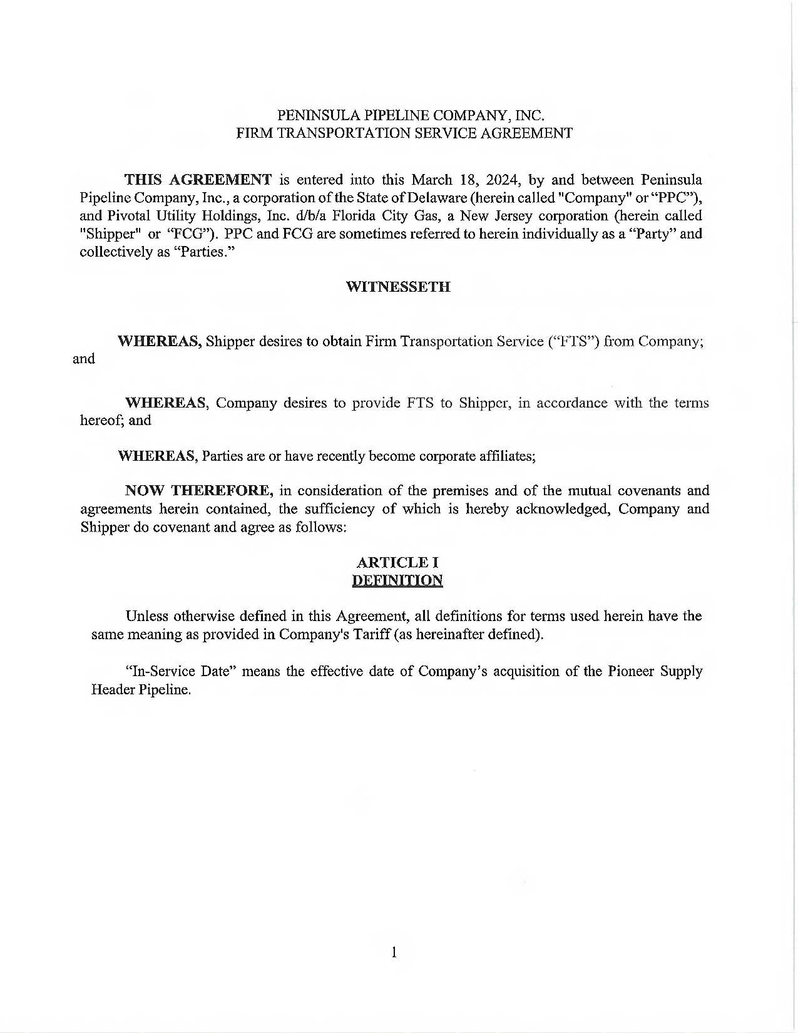

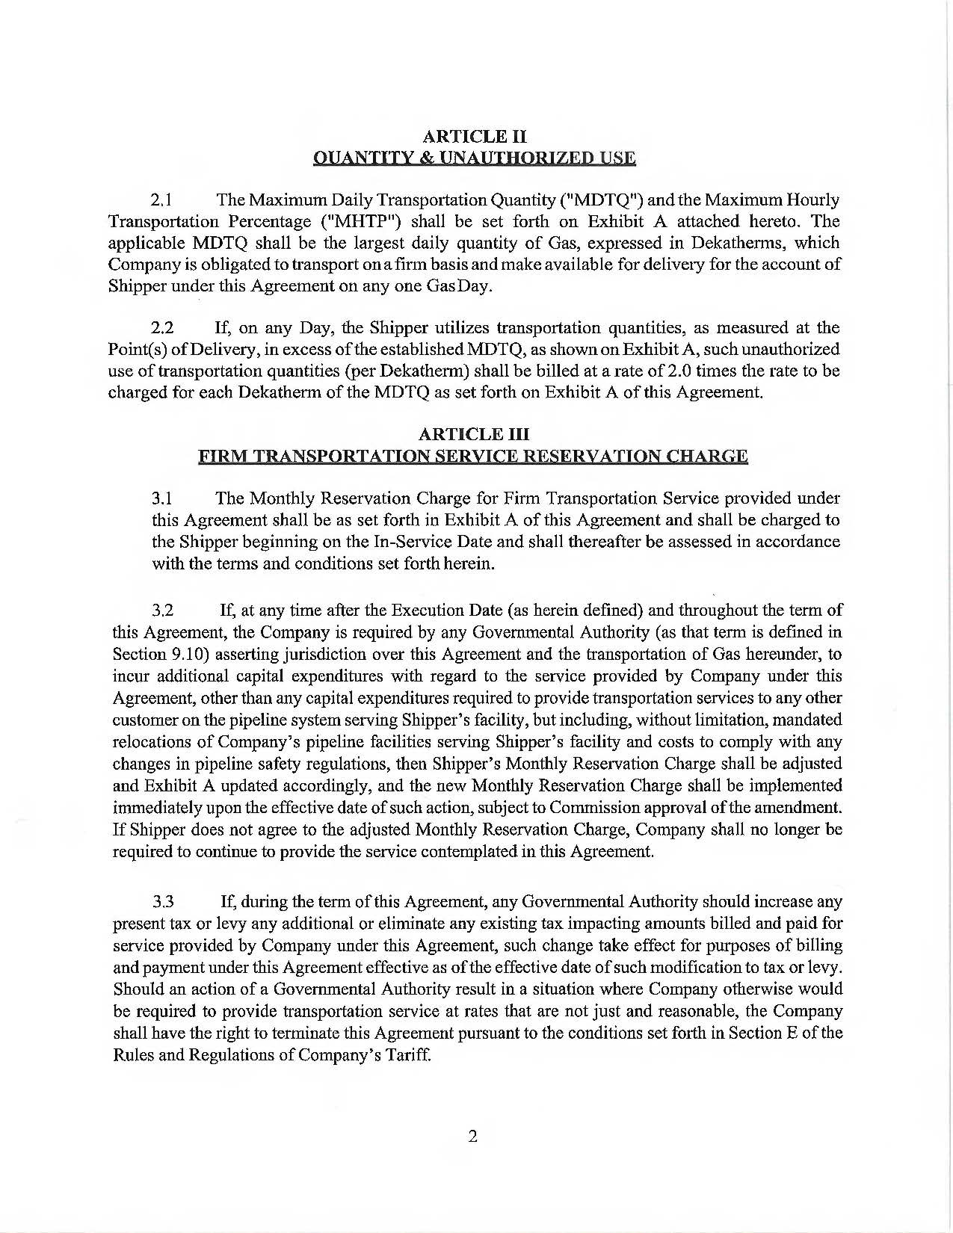

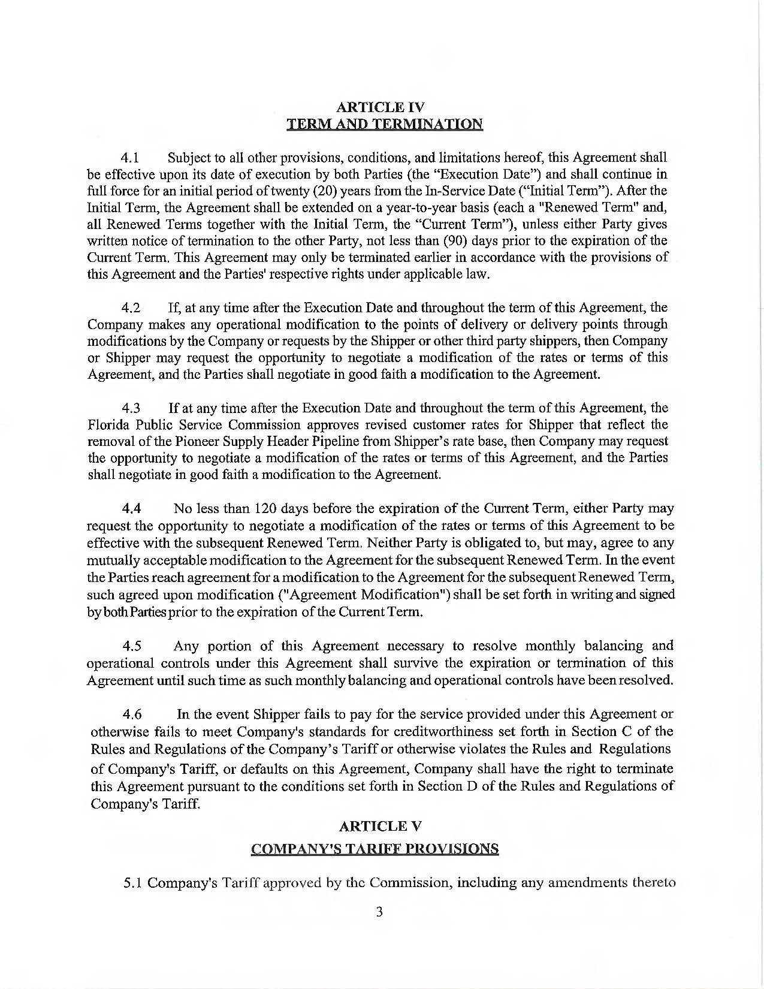

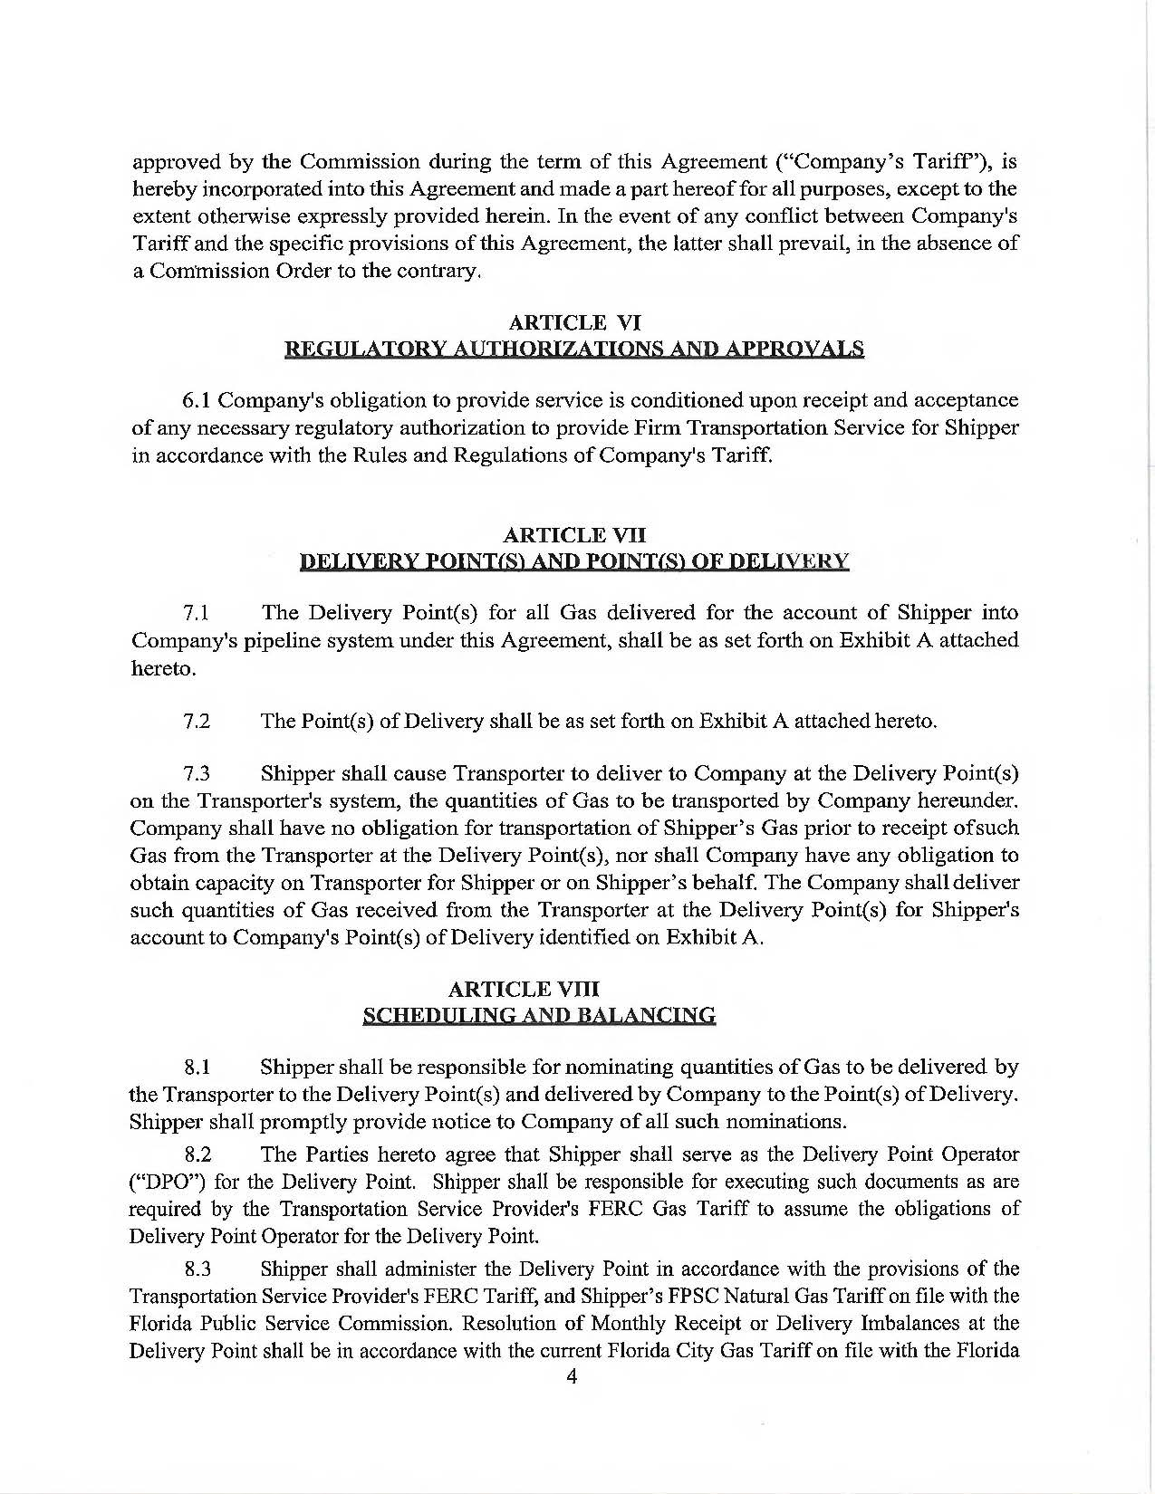

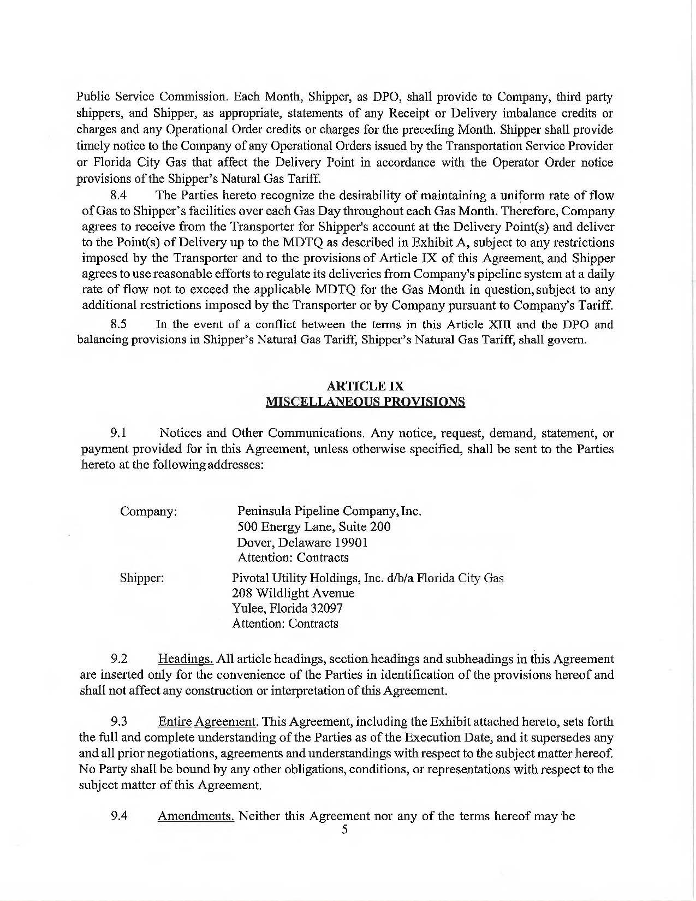

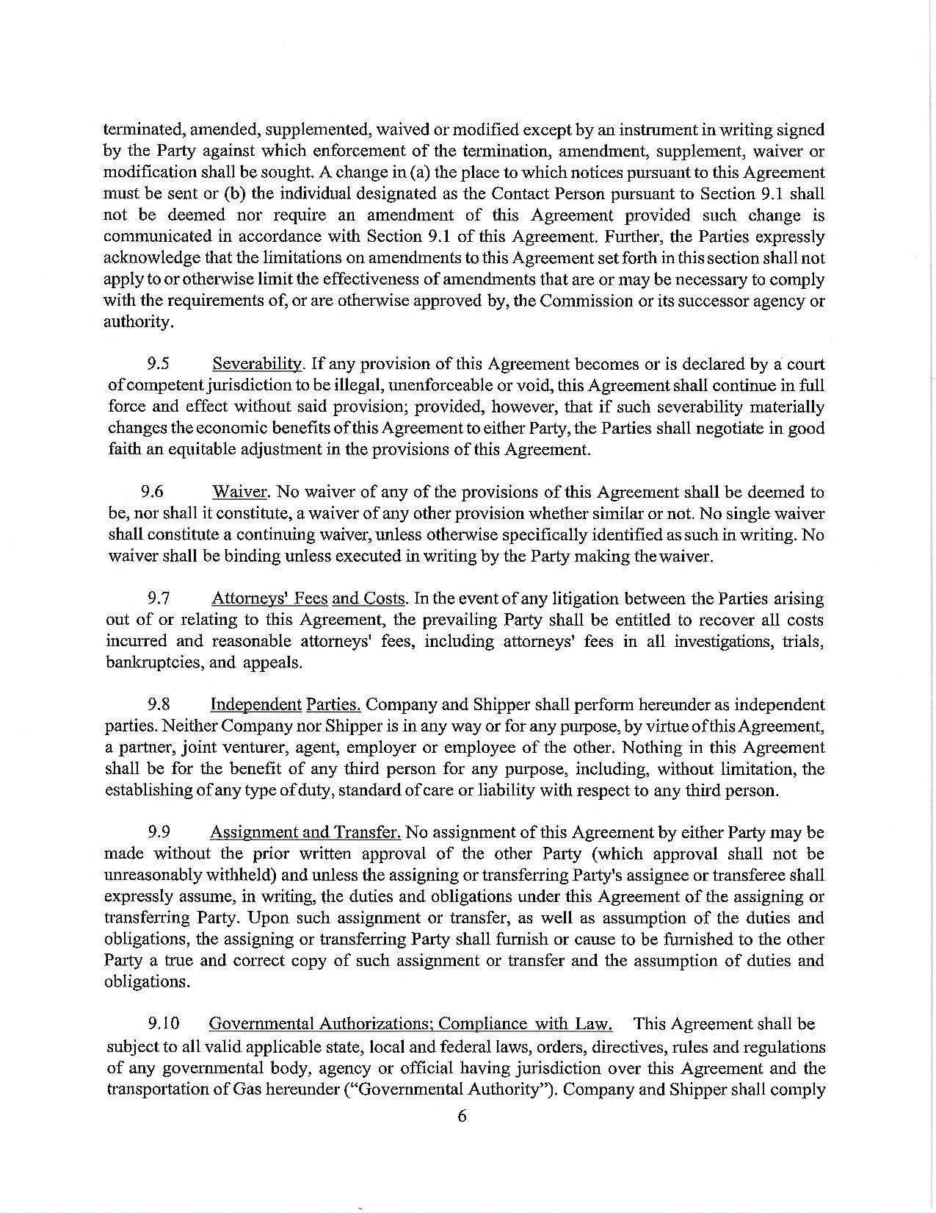

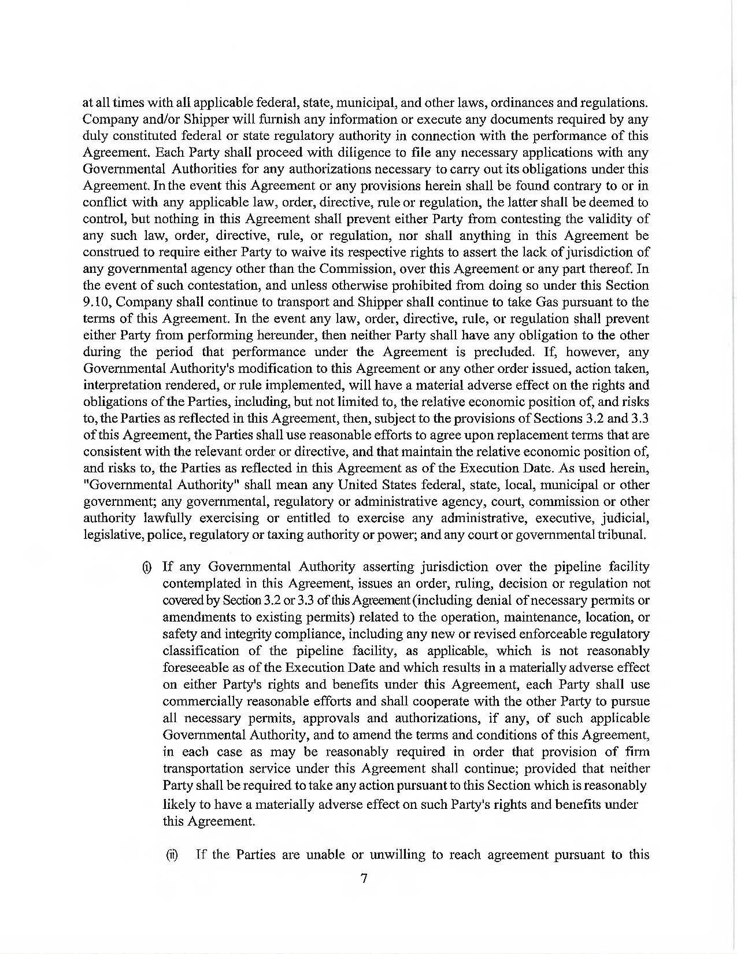

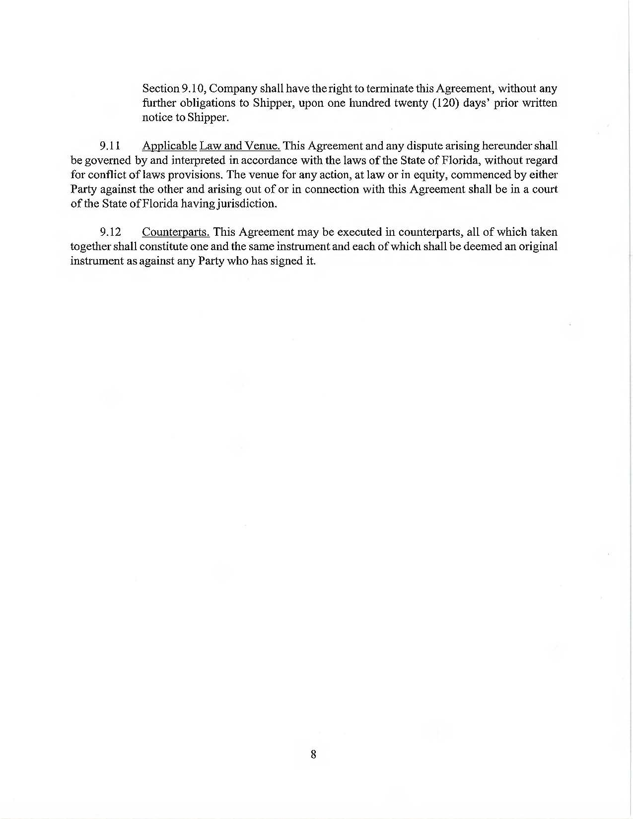

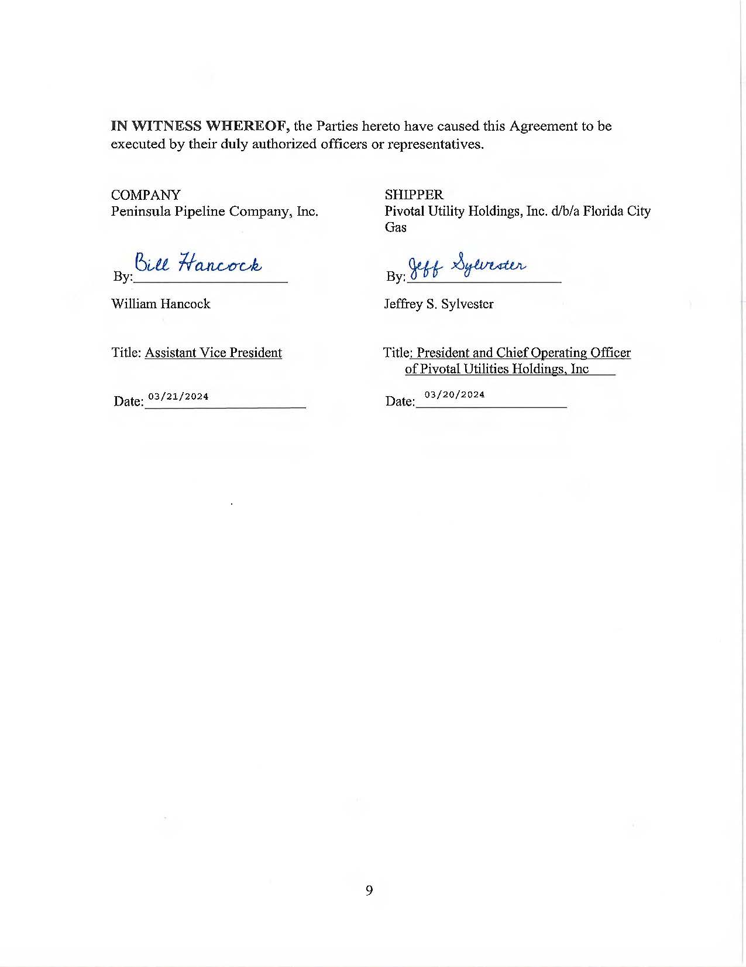

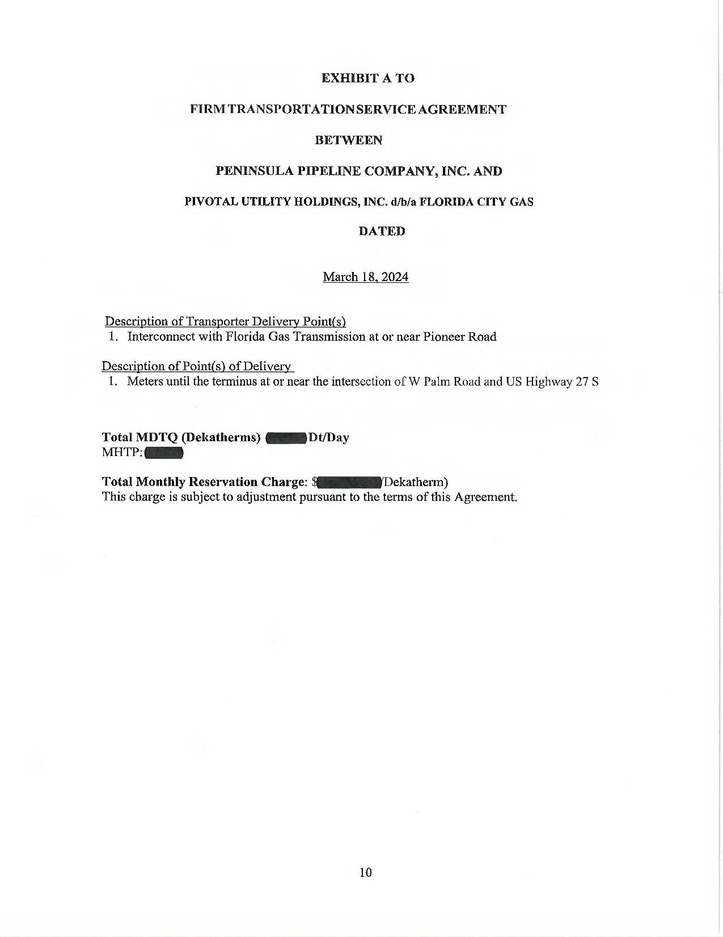

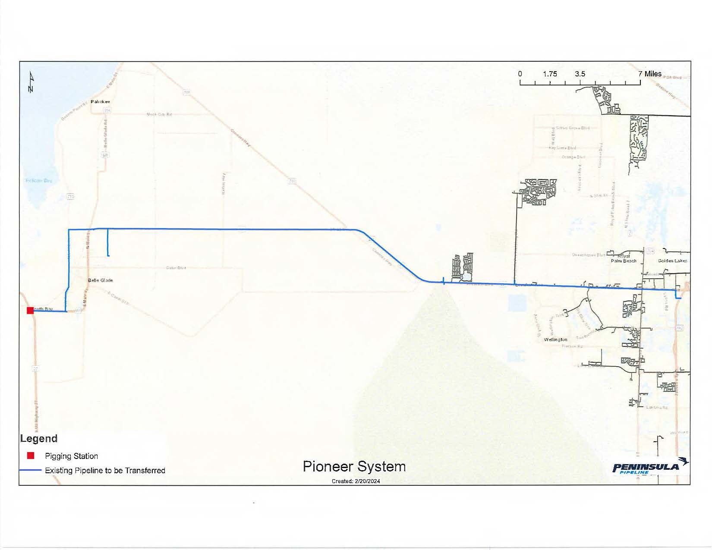

1. Order No. PSC-06-0023-DS-GP, issued January 9, 2006, in Docket No. 050584-GP, *In re: Petition for declaratory*

   *statement by Peninsula Pipeline Company, Inc. concerning recognition as a natural gas transmission company*

   *under Section 368.101, F.S., et seq.*
2. Order No. PSC-07-1012-TRF-GP, issued December 21, 2007, in Docket No. 070570-GP, *In re: Petition for*

   *approval of natural gas transmission pipeline tariff by Peninsula Pipeline Company, Inc.*
3. Peninsula Pipeline Company, Inc., Intrastate Pipeline Tariff, Original Sheet No. 11, Section 3.
4. Peninsula Pipeline Company, Inc., Intrastate Pipeline Tariff, Original Sheet No. 12, Section 4.
5. Responses to Staff’s First Data Request, Response No. 8.
6. Responses to Staff’s First Data Request, Response No. 9.