BEFORE THE FLORIDA PUBLIC SERVICE COMMISSION

|  |  |
| --- | --- |
| In re: Joint petition by Peoples Gas System, Inc. and Florida Public Utilities Company for approval of special contract. | DOCKET NO. 20240094-GU  ORDER NO. PSC-2024-0367-PAA-GU  ISSUED: August 19, 2024 |

The following Commissioners participated in the disposition of this matter:

MIKE LA ROSA, Chairman

ART GRAHAM

GARY F. CLARK

ANDREW GILES FAY

GABRIELLA PASSIDOMO

NOTICE OF PROPOSED AGENCY ACTION

ORDER APPROVING SPECIAL CONTRACT

BY THE COMMISSION:

NOTICE is hereby given by the Florida Public Service Commission that the action discussed herein is preliminary in nature and will become final unless a person whose interests are substantially affected files a petition for a formal proceeding, pursuant to Rule 25-22.029, Florida Administrative Code (F.A.C.).

BACKGROUND

On, May 5, 2024, Peoples Gas System (Peoples) and Florida Public Utilities Company (FPUC) (jointly, Petitioners) filed a joint petition for approval of a special contract (2024 Special Contract). Under the terms of the Special Contract, Peoples would provide FPUC with firm gas transportation service for a seven-month term commencing on September 1, 2024, and terminating on April 1, 2025. Peoples and FPUC own and operate natural gas facilities in Florida and are subject to our regulatory jurisdiction pursuant to Section 366.06, Florida Statutes (F.S.).

In 2021, Peoples and FPUC had a transportation agreement (2021 Agreement) that did not require our approval because the terms and conditions did not deviate from Peoples’ approved tariff. Under the 2021 Agreement, FPUC received service under Peoples’ Interruptible Service (IS) rate schedule. Pursuant to the 2021 Agreement, Peoples transported natural gas from the Florida Gas Transmission’s (FGT) interstate pipeline at the PGS-Jacksonville main gate to the Radio Avenue Interconnect into the Callahan Pipeline. The Callahan Pipeline is a 16-inch steel pipeline that was constructed in 2019 to allow FPUC and Peoples to expand natural gas service in Nassau and Duval counties.

In September of 2022, Peoples and FPUC filed a joint petition for approval of a special contract (2022 Special Contract). Our approval was required because the terms and conditions deviated from Peoples’ approved tariff. The receipt points, delivery points, and points of delivery remained the same as in the 2021 transportation agreement. The Special Contract had a term from November 1, 2022, until June 1, 2024. The 2022 Special Contract extended the original contract to continue to allow Peoples to provide FPUC with firm natural gas service for a limited duration and obtain a fixed monthly reservation fee for the service provided. Upon the expiration of the existing contract in June, PGS ceased engaging in any obligations it had under that contract as FPUC has no rights to that capacity since the contract terminated and FPUC did not arrange a new contract with PGS in the interim. We approved the Special Contract by Order No. PSC-2022-0374-PAA-GU.[1]

During the evaluation of the petition, data requests to Peoples and FPUC were issued. Responses from FPUC were received on June 27, 2024. Responses from Peoples were received on June 27, 2024. We have jurisdiction over this matter pursuant to Sections 366.04, 366.05, and 366.06, F.S.

DECISION

We approved a 2022 Special Contract between Peoples and FPUC. In May 2024, with the natural expiration of the 2022 Special Contract approaching, FPUC sought out Peoples for modification of the 2022 Special Contract which resulted in the proposed 2024 Special Contract. The term of the contract is for 7 months with a negotiated monthly charge for the reservation of firm capacity and transportations service on Peoples’ distribution system and a daily maximum transportation quantity. The receipt points, delivery points, and points of delivery remained the same as in the 2022 Special Contract. Similarly with the 2022 Special Contract, FPUC will recover its payment to Peoples through the Purchased Gas Adjustment and from transportation customers that utilize the alternative supply in Nassau County. This contract would continue to generate revenues for Peoples, benefitting Peoples’ general body of rate payers.

The purpose of the 2024 Special Contract remains the same as the prior 2022 Special Contract. Typically, FPUC obtains its gas from the Transco Zone 5 for its Nassau County operations. FPUC has stated that although the market has changed since the last transportation agreement, during the winter months natural gas prices remain highly volatile. The agreement with PGS allows FPUC an alternative to Transco Zone 5 with an estimated savings of more than $1 million to FPUC’s customers and transportation customers over the 7-month term proposed in the 2024 Special Contract.[2]

The proposed 2024 Special Contract for a 7-month term is a much shorter time period than the 2022 Special Contract term of 19 months. FPUC indicated that based on the commodity prices it would see savings up to March 2025. For the time period after March 2025, FPUC will reassess forward commodity prices and may seek PGS for continued service. If the contract is not renewed, FPUC indicated it would return to using firm Southern Natural Gas Company (SONAT) capacity for its supply needs. SONAT is an interstate natural gas pipeline which brings gas from the Louisiana Gulf of Mexico cost to the southeastern United States, including Florida.

Based on our review or the petition and responses to data requests, we find that the proposed Special Contract is reasonable, facilitates the delivery of natural gas into Nassau County, and benefits FPUC’s and Peoples’ general body of ratepayers. Therefore, we approve the proposed Special Contract between Peoples and FPUC effective September 1, 2024.

Based on the foregoing, it is

ORDERED by the Florida Public Service Commission that the joint petition by Peoples Gas System, Inc. and Florida Public Utilities Company for approval of a Special Contract is hereby granted. It is further

ORDERED that the effective date of the Special Contract is September 1, 2024. It is further

ORDERED that the provisions of this Order, issued as proposed agency action, shall become final and effective upon the issuance of a Consummating Order unless an appropriate petition, in the form provided by Rule 28-106.201, F.A.C., is received by the Commission Clerk, 2540 Shumard Oak Boulevard, Tallahassee, Florida 32399-0850, by the close of business on the date set forth in the “Notice of Further Proceedings” attached hereto. It is further

ORDERED that if no protest is filed by a person whose substantial interests are affected witin 21 days of issuance of this Order, this docket shall be closed upon the issuance of a Consummating Order.

By ORDER of the Florida Public Service Commission this 19th day of August, 2024.

|  |  |
| --- | --- |
|  | /s/ Adam J. Teitzman |
|  | ADAM J. TEITZMAN  Commission Clerk |

Florida Public Service Commission

2540 Shumard Oak Boulevard

Tallahassee, Florida 32399

(850) 413‑6770

www.floridapsc.com

Copies furnished: A copy of this document is provided to the parties of record at the time of issuance and, if applicable, interested persons.

SBr

NOTICE OF FURTHER PROCEEDINGS OR JUDICIAL REVIEW

The Florida Public Service Commission is required by Section 120.569(1), Florida Statutes, to notify parties of any administrative hearing that is available under Section 120.57, Florida Statutes, as well as the procedures and time limits that apply. This notice should not be construed to mean all requests for an administrative hearing will be granted or result in the relief sought.

Mediation may be available on a case-by-case basis. If mediation is conducted, it does not affect a substantially interested person's right to a hearing.

The action proposed herein is preliminary in nature. Any person whose substantial interests are affected by the action proposed by this order may file a petition for a formal proceeding, in the form provided by Rule 28-106.201, Florida Administrative Code. This petition must be received by the Office of Commission Clerk, 2540 Shumard Oak Boulevard, Tallahassee, Florida 32399-0850, by the close of business on September 9, 2024.

In the absence of such a petition, this order shall become final and effective upon the issuance of a Consummating Order.

Any objection or protest filed in this/these docket(s) before the issuance date of this order is considered abandoned unless it satisfies the foregoing conditions and is renewed within the specified protest period.

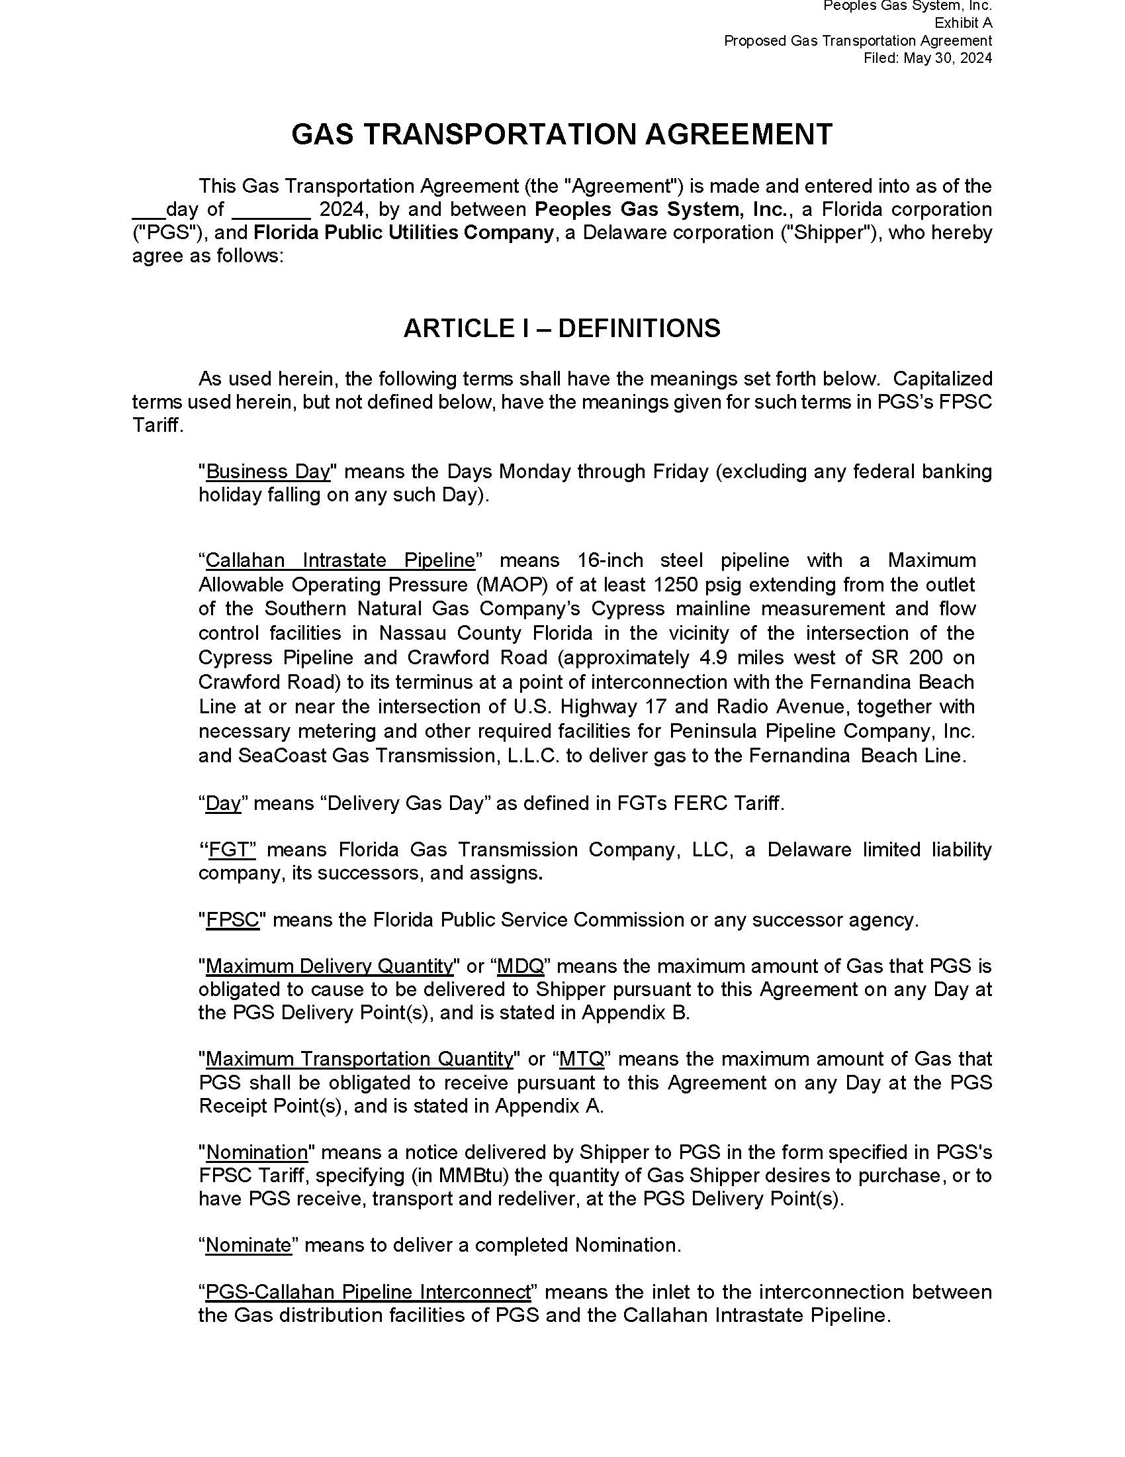

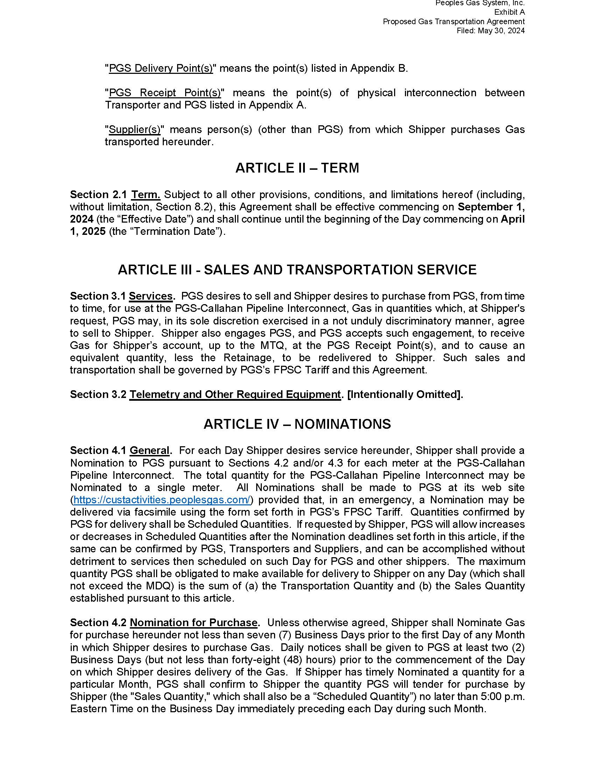

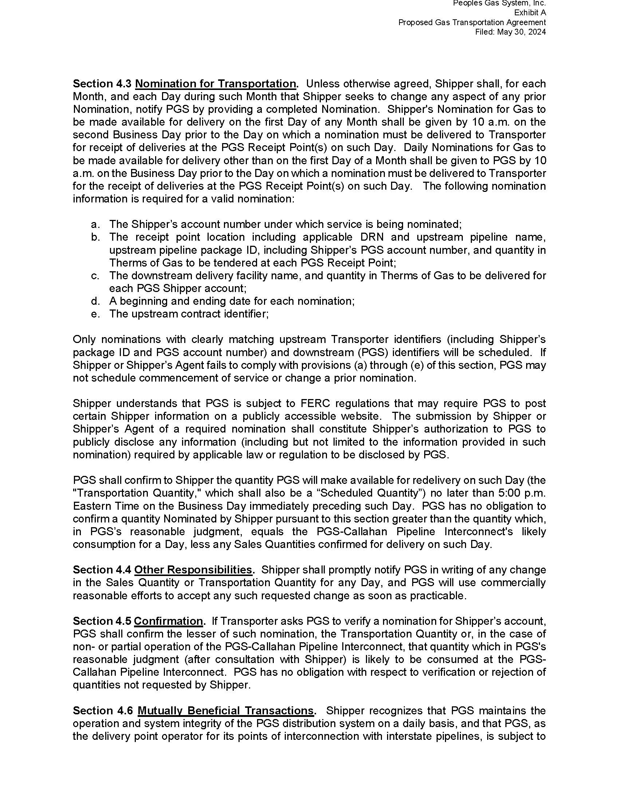

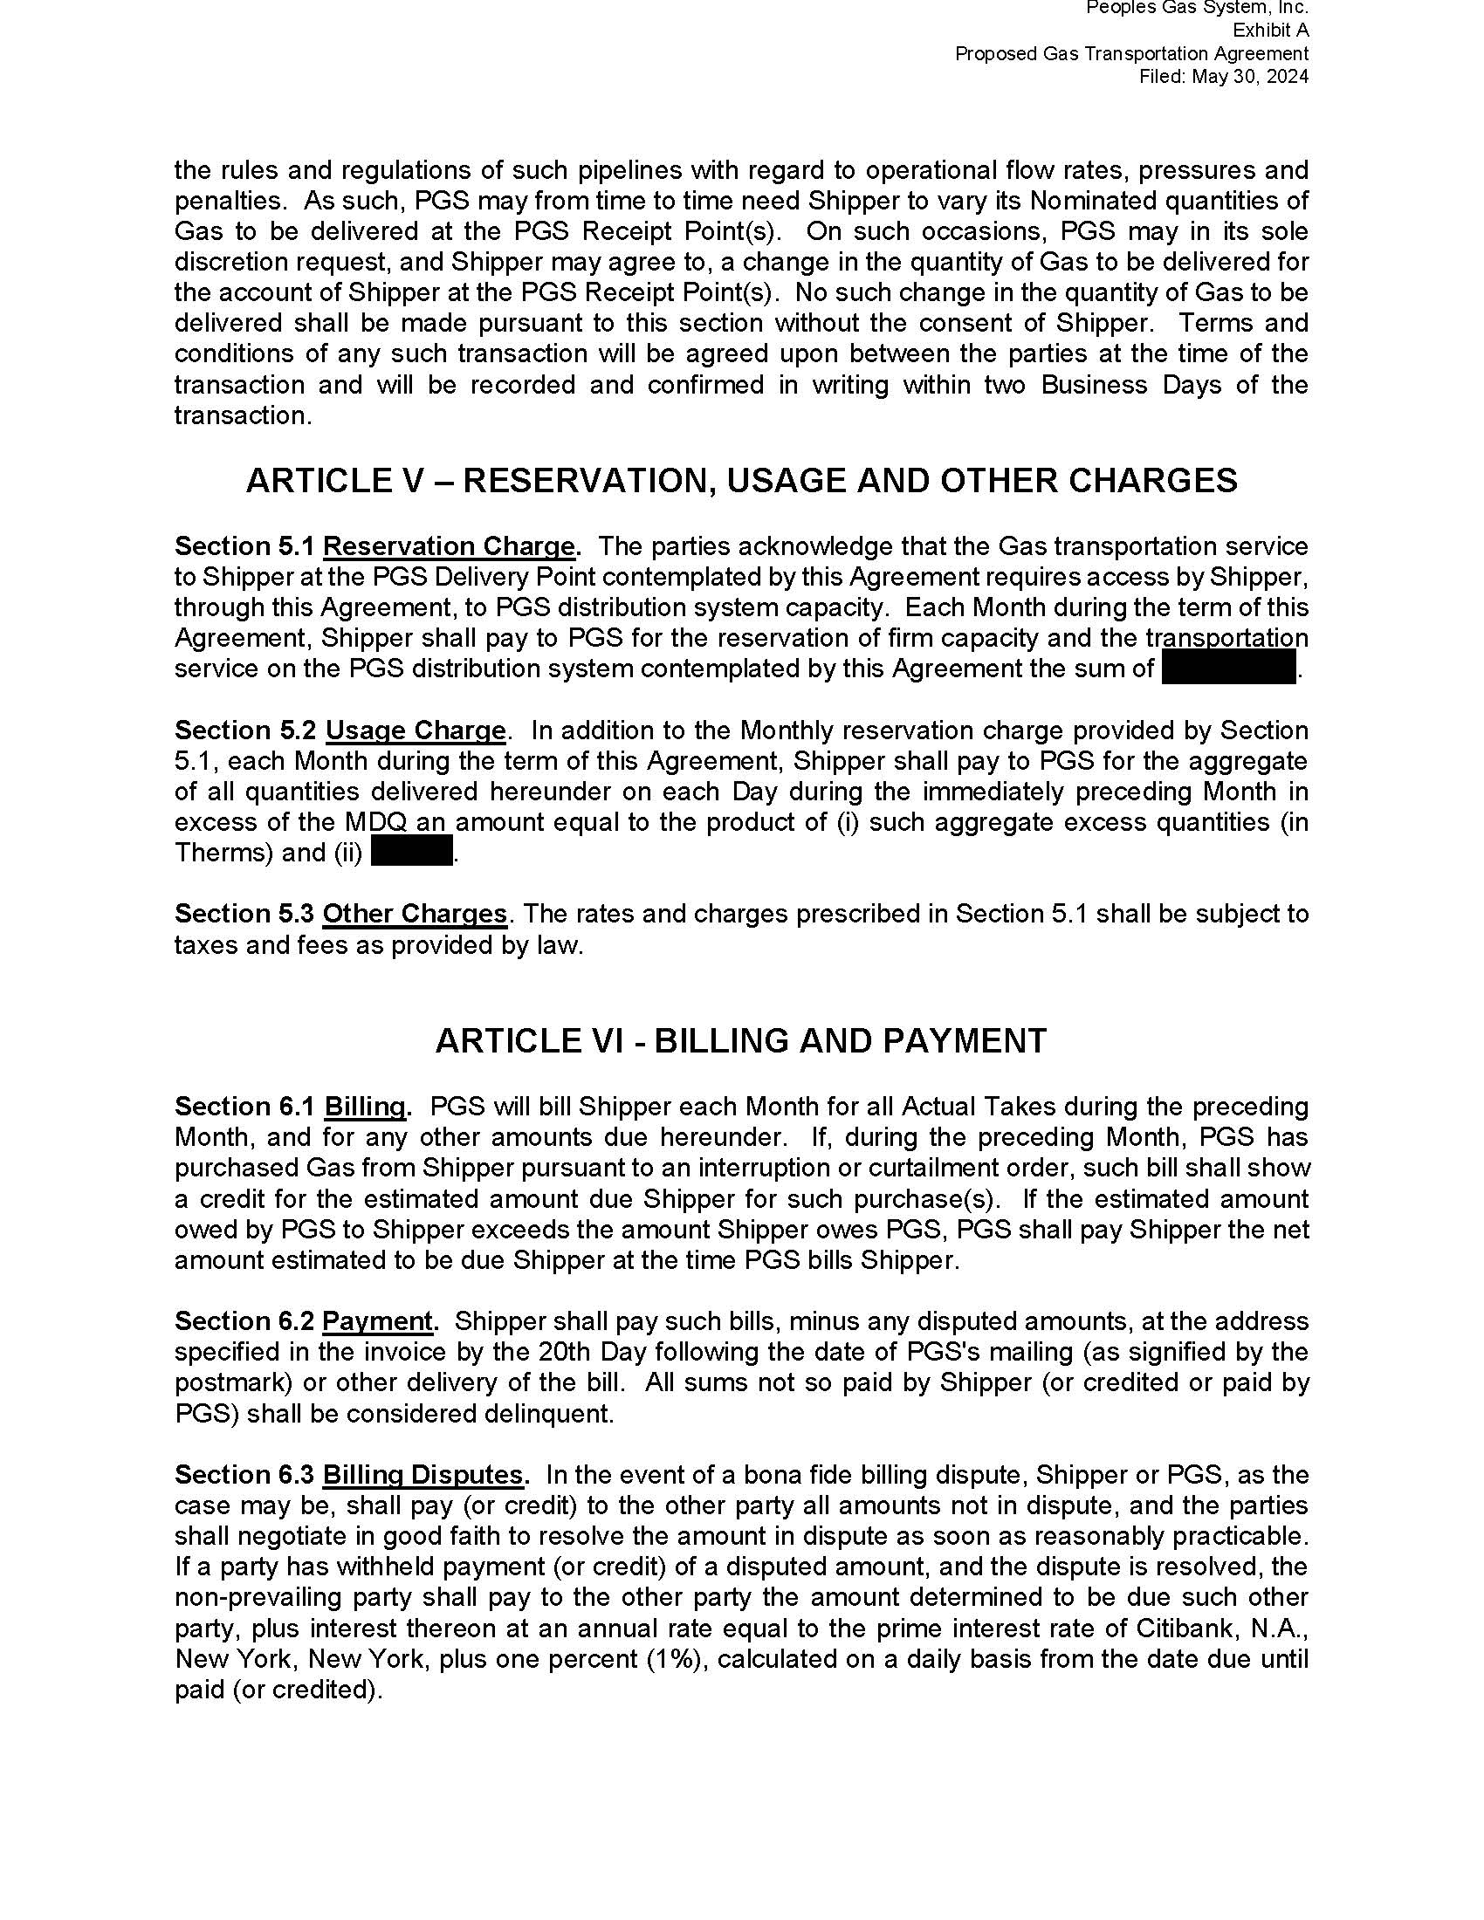

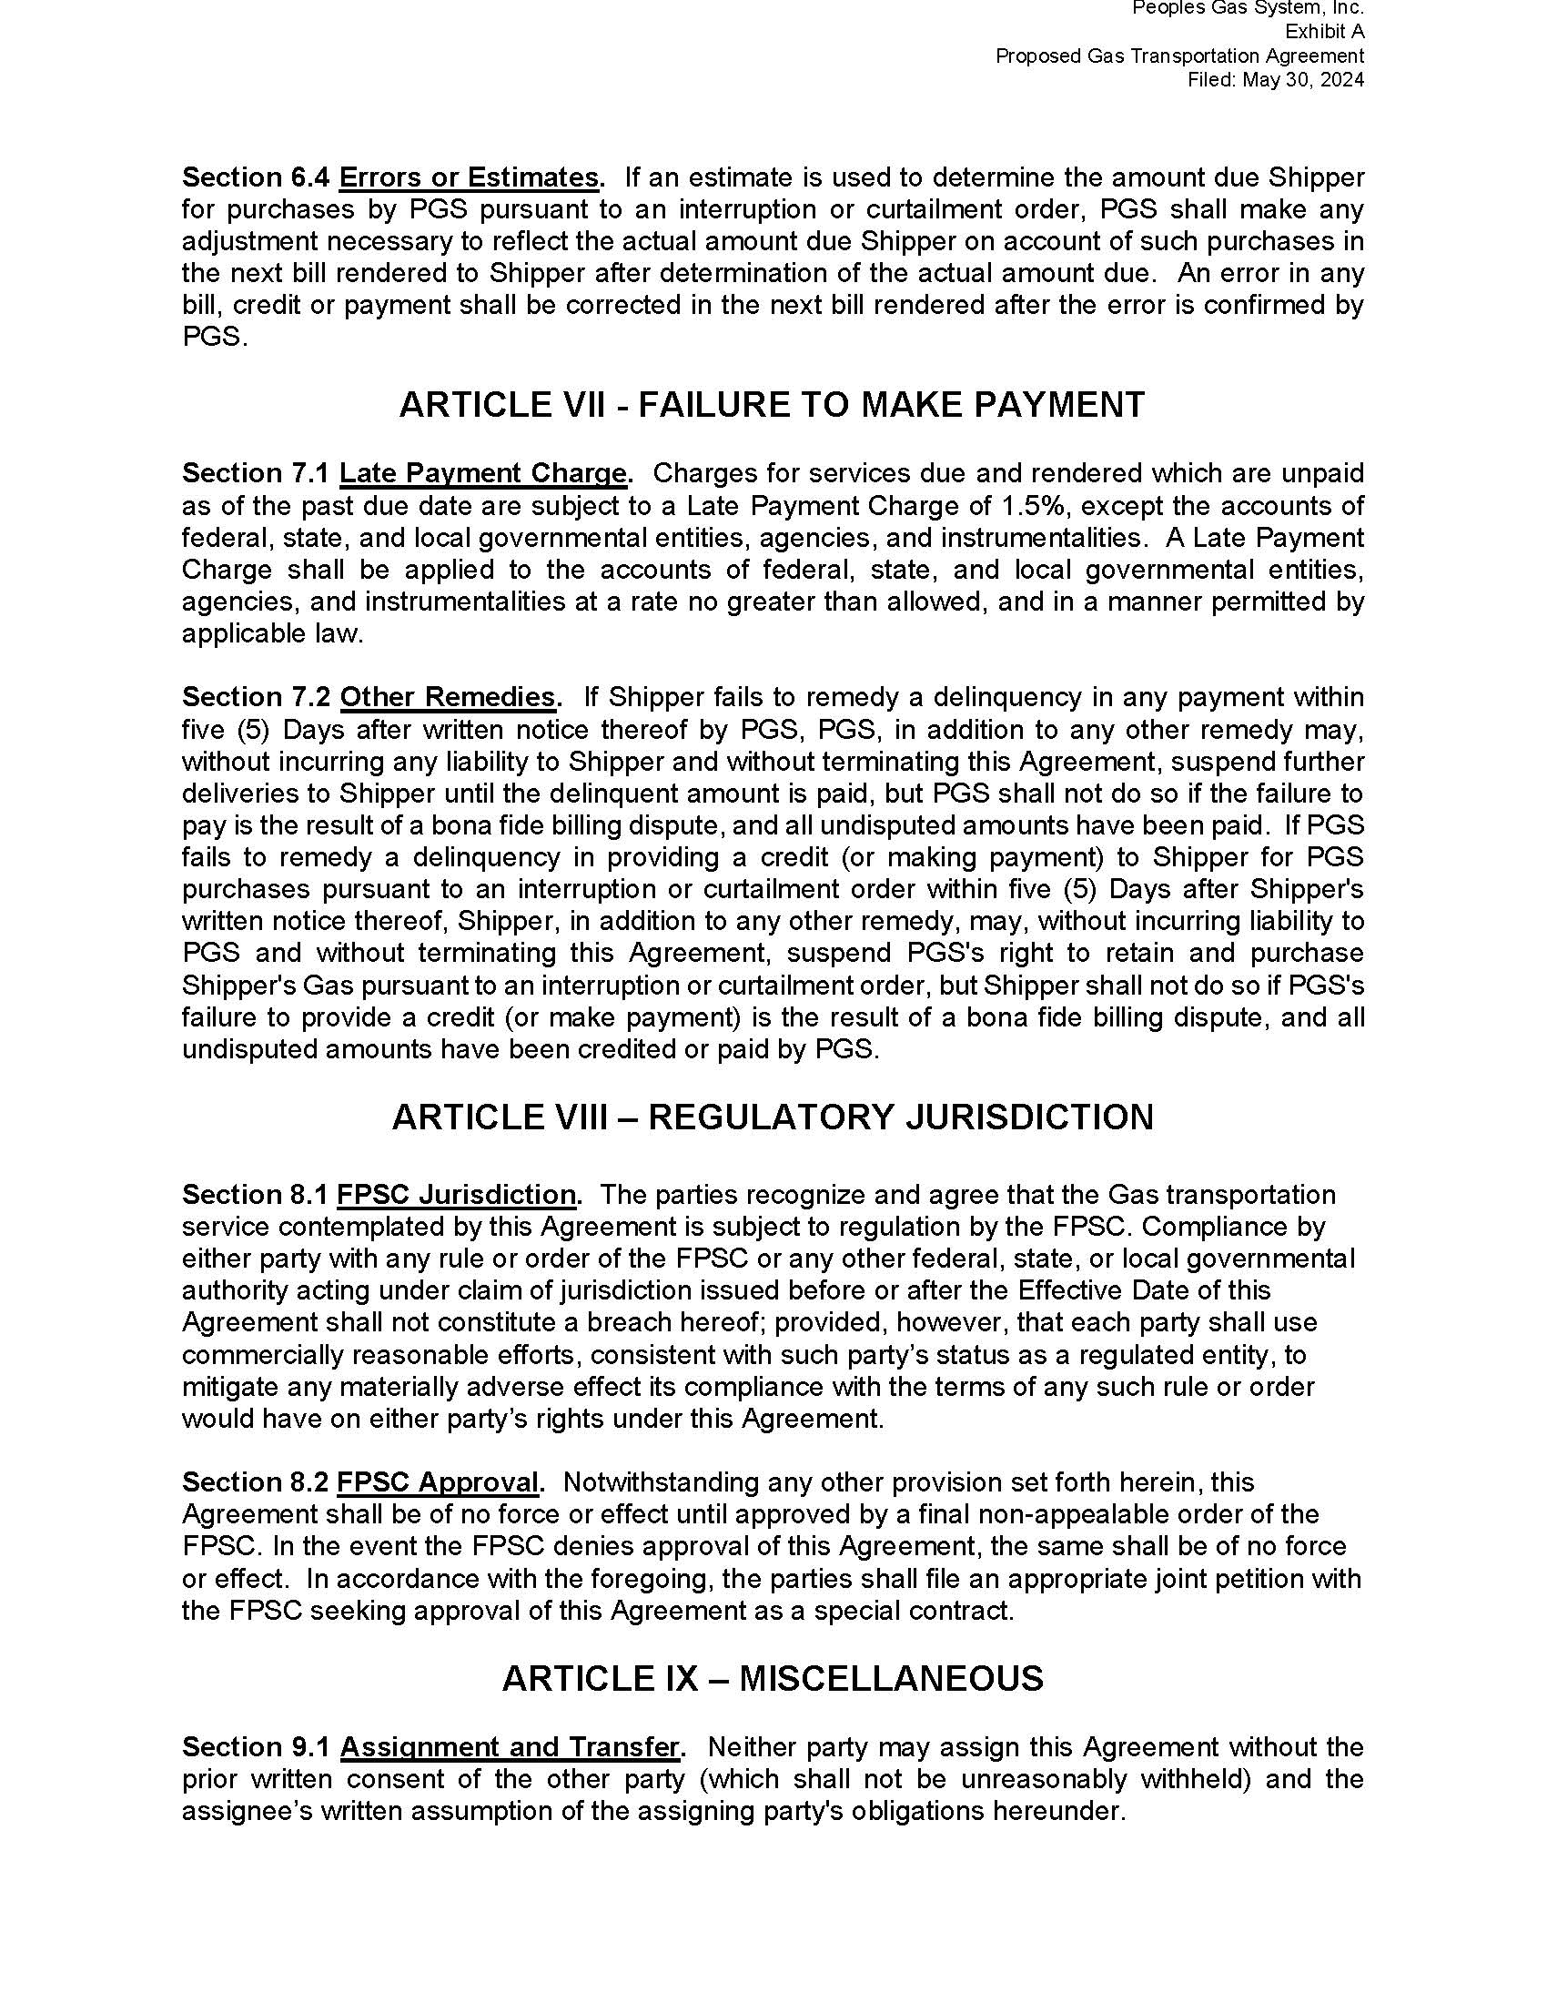

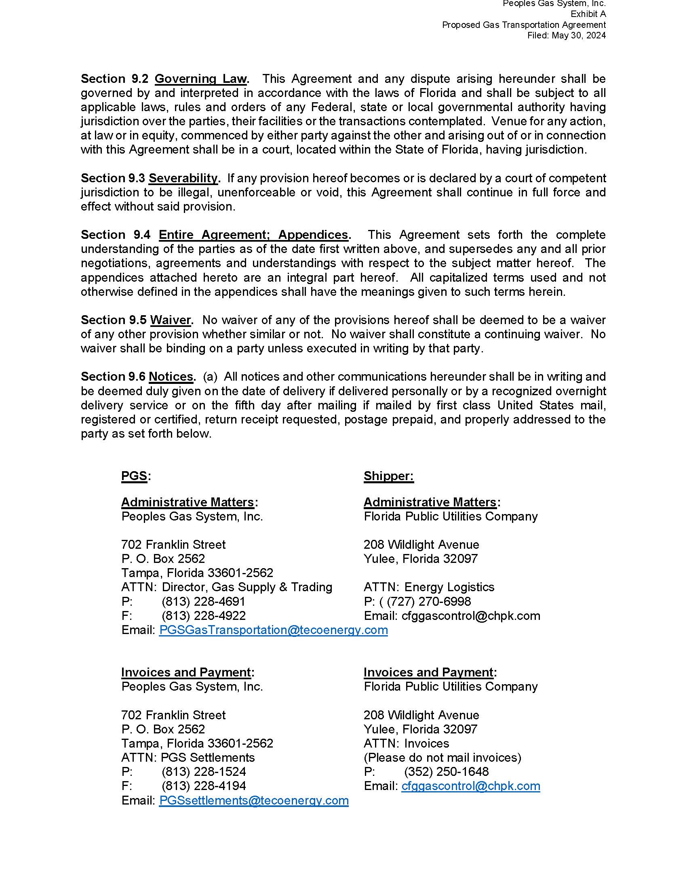

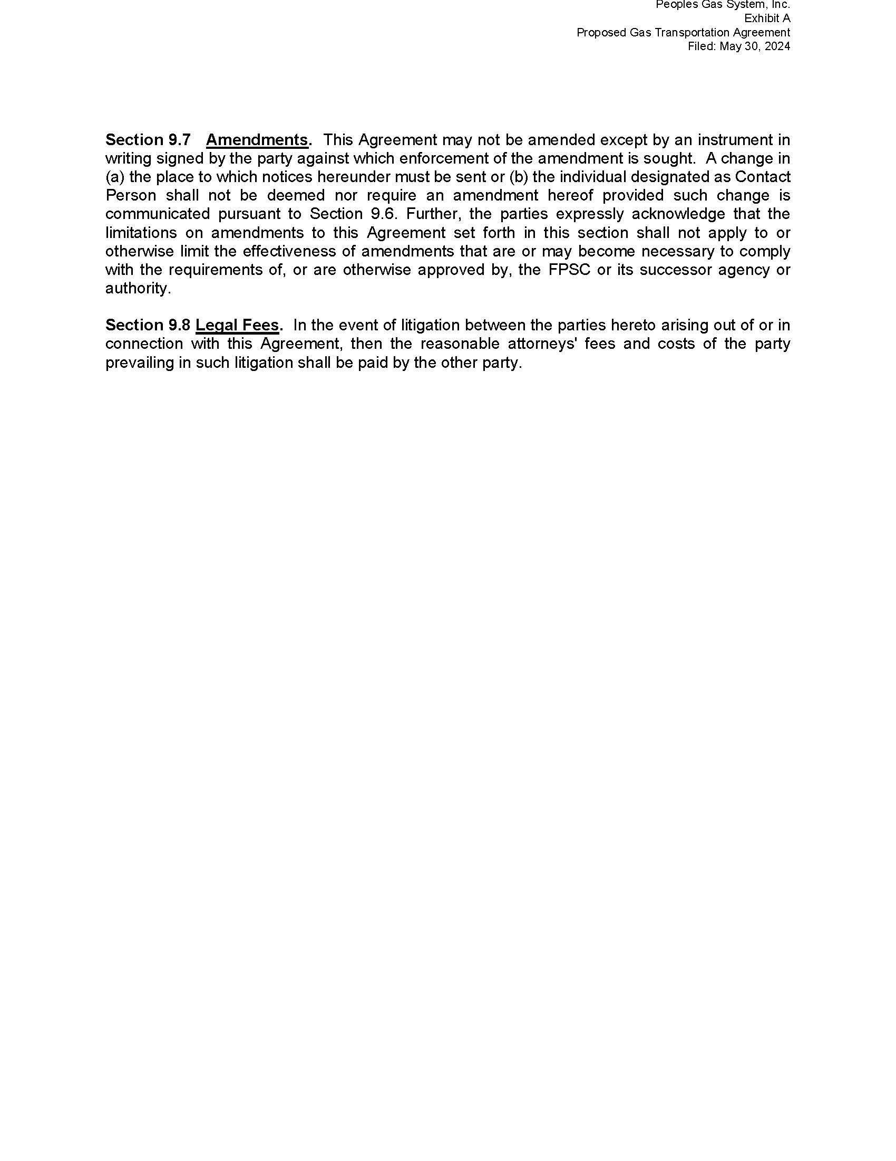

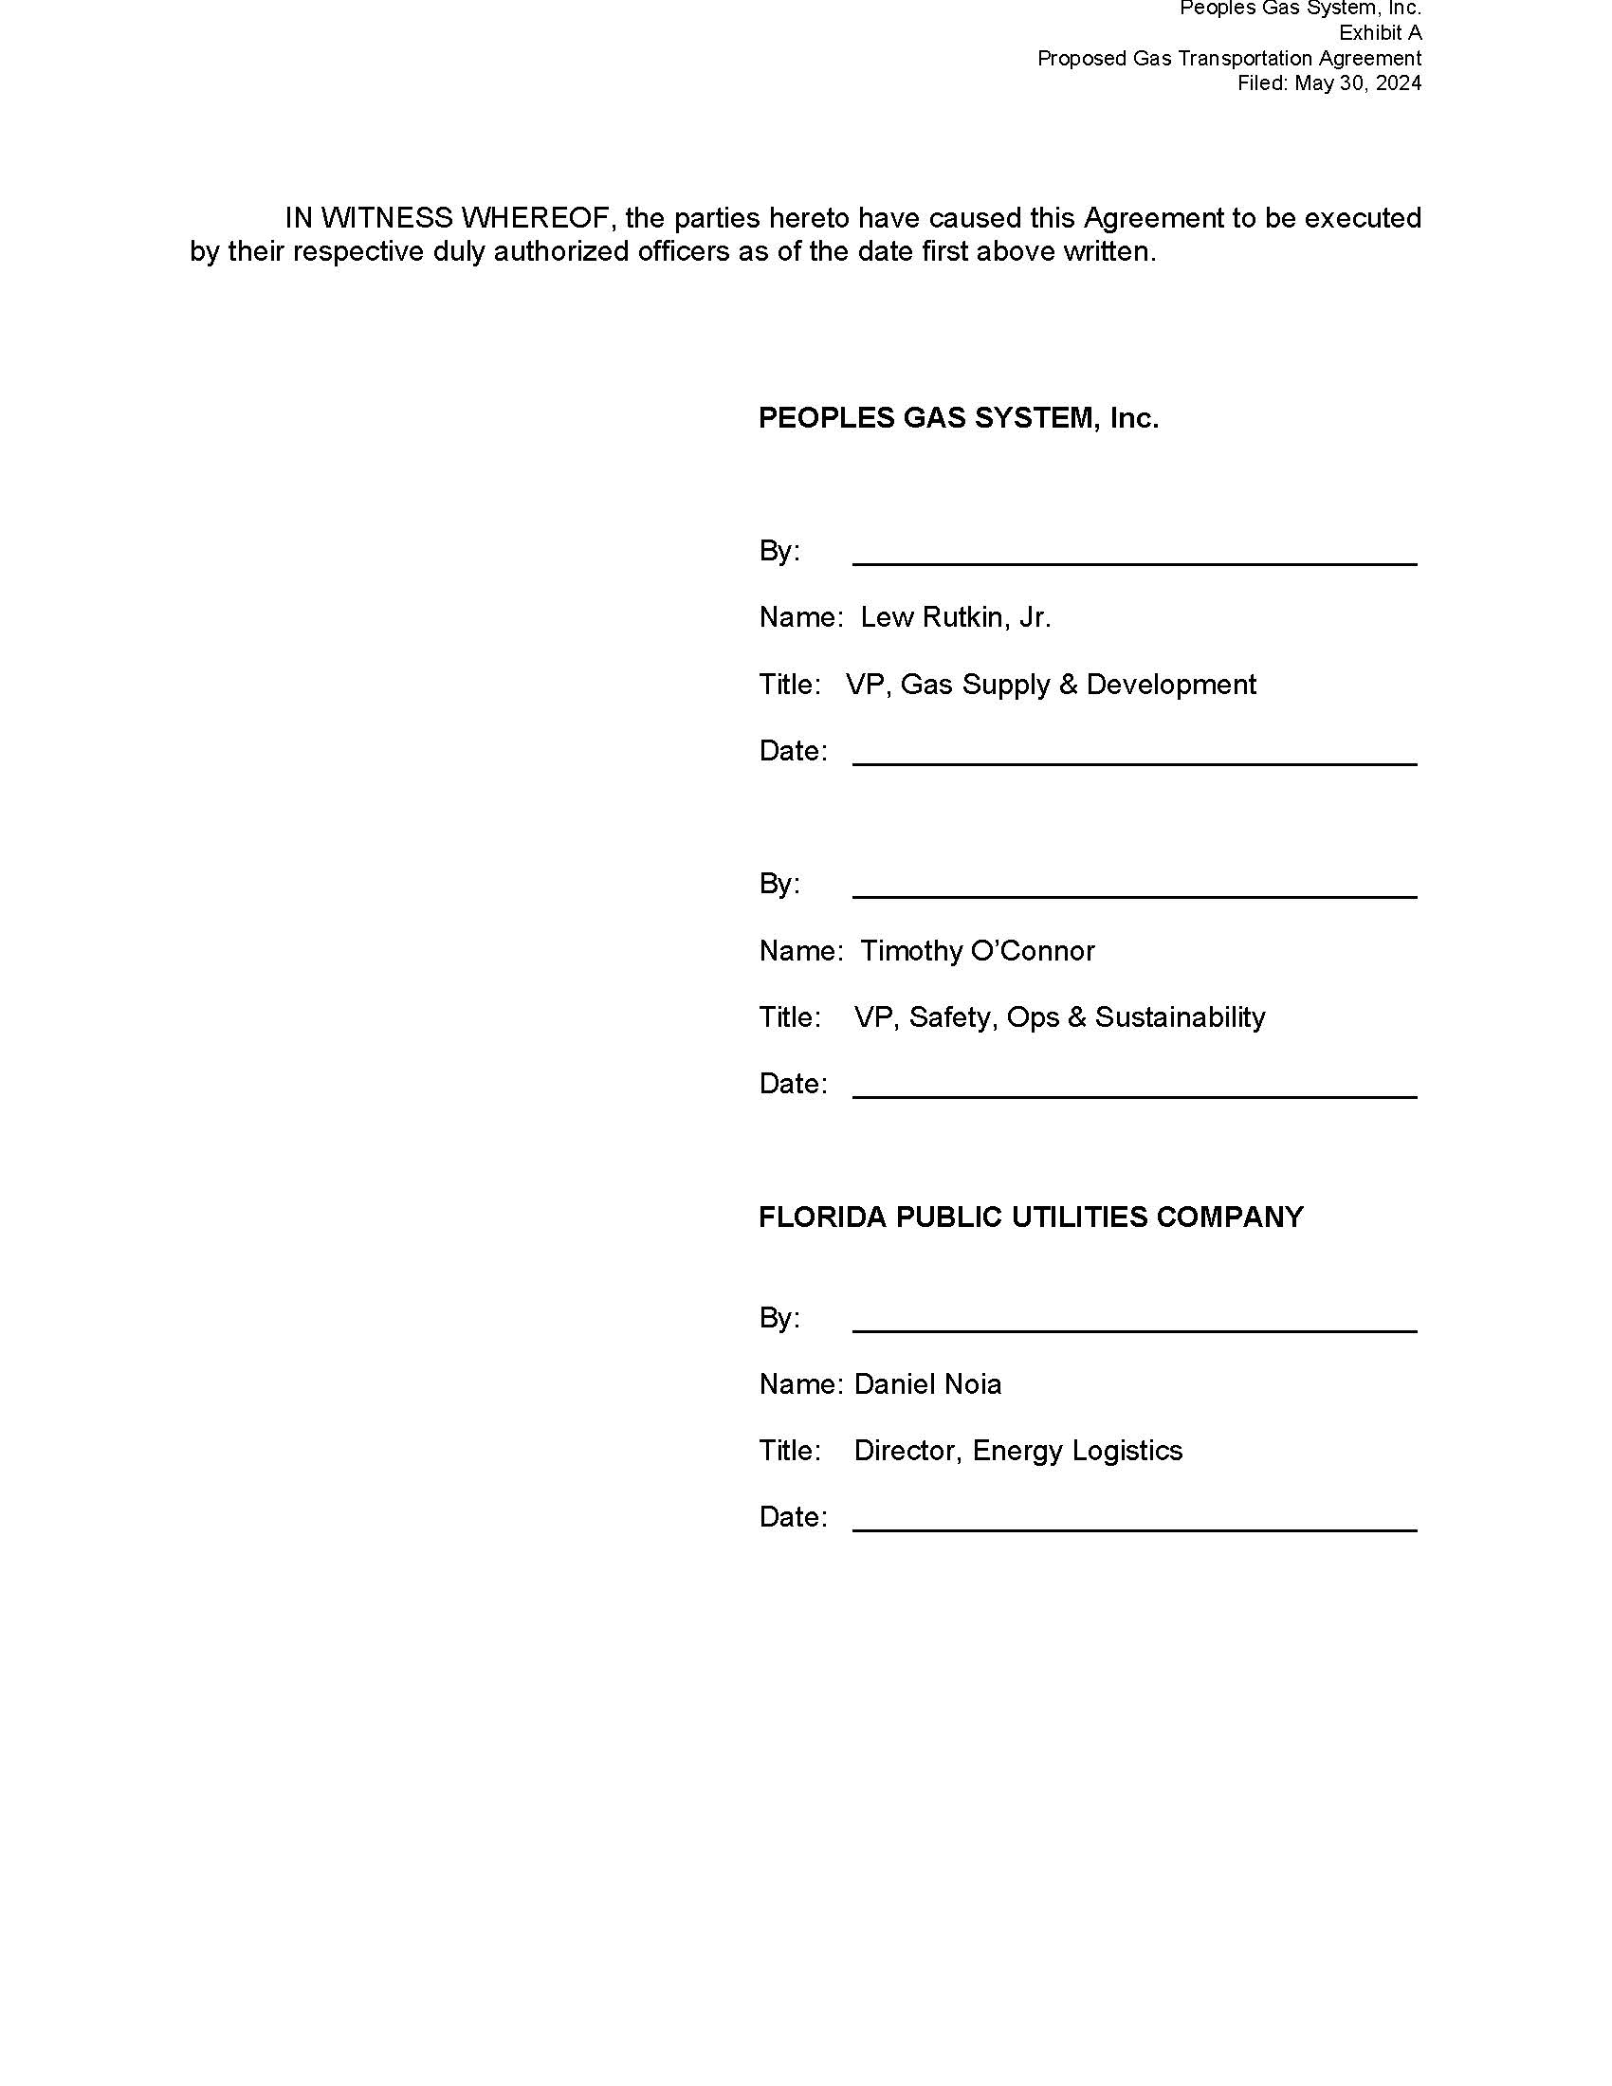

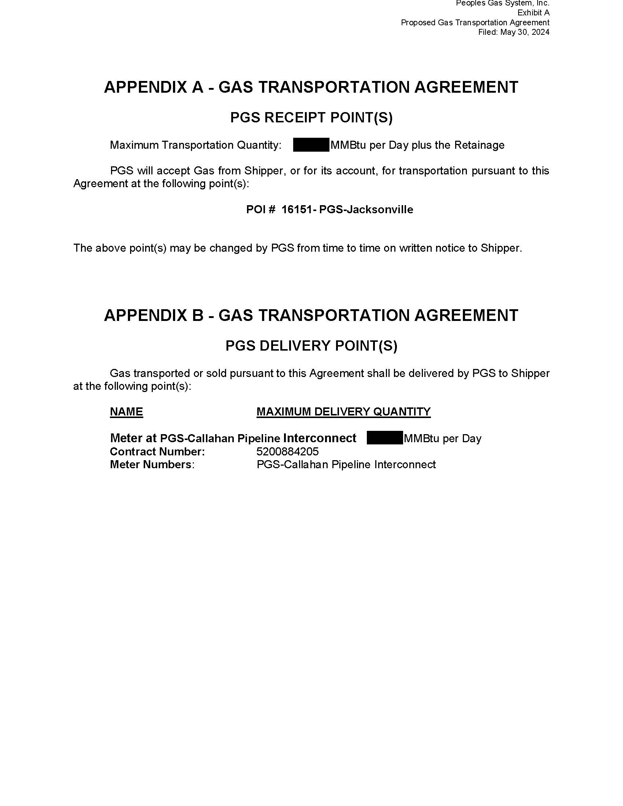

1. Order No. PSC-2022-0374-PAA-GU, issued November 4, 2022, in Docket No. 20220159-GU, *In re: Petition for approved of special contract with Florida Public Utilities Company, by Peoples Gas System, Inc.*
2. FPUC Responses to Staff’s First Data Request, Document No. 07010-2024, Response No. 3