BEFORE THE FLORIDA PUBLIC SERVICE COMMISSION

In re: Petition for approval of special contract with Agency for Persons with Disabilities for upgrading the electric distribution facilities at the Sunland Center in Marianna, Florida, by Florida Public Utilities Company. | DOCKET NO. 20240084-EI  ORDER NO. PSC-2024-0372-PAA-EI  ISSUED: August 22, 2024

The following Commissioners participated in the disposition of this matter:

MIKE LA ROSA, Chairman
ART GRAHAM
GARY F. CLARK
ANDREW GILES FAY
GABRIELLA PASSIDOMO

NOTICE OF PROPOSED AGENCY ACTION
ORDER APPROVING SUNLAND CENTER SPECIAL CONTRACT

BY THE COMMISSION:

NOTICE is hereby given by the Florida Public Service Commission that the action discussed herein is preliminary in nature and will become final unless a person whose interests are substantially affected files a petition for a formal proceeding, pursuant to Rule 25-22.029, Florida Administrative Code (F.A.C.).

BACKGROUND

On May 10, 2024, Florida Public Utilities Company (FPUC) filed a petition for approval of a Special Contract with the Agency for Persons with Disabilities (Agency). The petition was filed pursuant to Rule 25-9.034, F.A.C. The Agency for Persons with Disability is an agency of the State of Florida that is tasked with serving the needs of Floridians with developmental disabilities. FPUC provides service to the Agency as a General Service Large Demand at the Sunland Center in Marianna, Florida. The Sunland Center is a developmental disability center operated by the Agency for people who need structured care 24 hours a day.
In early 2023, the Agency notified FPUC that it had received a grant from the federal government of approximately $2 million for the upgrade and storm hardening of Sunland Center’s existing 12.47 kV distribution system. As a primary metered customer, the 12.47 kV distribution infrastructure behind the meter is the responsibility of the Agency to operate, maintain, and upgrade. FPUC worked with a third-party engineering firm, Enercon Services Inc. (Enercon), to develop cost estimates to storm harden the Agency’s distribution system. The Enercon report is Attachment B to the petition.
After reviewing the report, FPUC and the Agency negotiated a Special Contact that would utilize the grant funds to compensate FPUC’s work on the Sunland Center’s distribution facilities, including completion of the necessary engineering designs and the purchase of materials. The Special Contract contemplates that FPUC, with the assistance of third-party
contractors, would remove as much of the overhead distribution system as possible without impacting the existing overhead telephone and communications equipment and would replace it with new overhead facilities that meet National Electric Safety Code Storm Hardening Standards. FPUC would also construct an underground electric distribution system in certain areas consisting of primary conductors/conduit, pad mounted transformers and switches, secondary conductors/conduit, as well as service conductors/conduit. The system would utilize primary overhead metering equipment, which would be designated as the point of delivery and meter all energy used at Sunland Center. The Special Contract contemplates that work would be completed by mid-year 2026.

On June 6, 2024, a phone conference with FPUC was held to discuss the petition. On June 10, 2024, staff issued a data request, to which responses were received on June 24, 2024. The proposed, unexecuted Special Contract is Attachment A to this oder. We have jurisdiction over this matter pursuant to Section 366.05 Florida Statutes.

DECISION

Based on the analysis and cost estimates completed by Enercon, FPUC and the Agency negotiated a Special Contract to utilize the grant funds to complete the storm hardening of Sunland Center’s distribution facilities. In Paragraph 10 of the Petition, FPUC argues that the Enercon report demonstrated that Sunland Center’s facilities need a large-scale rebuild to prevent reliability issues and improve the safety and efficiency of the facilities, due to natural degradation and the impacts of Hurricane Michael in 2018. FPUC further states that a failure in the Sunland Center’s facilities could potentially adversely impact service to other FPUC customers in the surrounding area, due to the interconnected nature of the facilities and FPUC’s distribution system.
Beginning on Page 13, Attachment I to the proposed Special Contract defines the services to be provided by FPUC. Subsection B.2 of Attachment I states that FPUC would “construct, own, and operate an underground electric distribution system within the boundaries of Sunland Center.” FPUC clarified via data request responses that it would own certain facilities behind-the-meter and further explained that the behind-the-meter facilities would not be included in rate base in the next rate case. FPUC also stated that the costs and revenues associated with the project (including FPUC’s labor, third-party contracts, and capital assets) would not be recorded on the regulated books of FPUC and, therefore, the project would have no effect on FPUC’s ratepayers.
Based on the petition and the information provided, we hereby approve the proposed Special Contract between FPUC and the Agency for Persons with Disabilities. FPUC shall record all costs and revenues associated with improvements behind the meter of Sunland Center as below-the-line. Furthermore, FPUC shall file the fully executed Special Contract with this Commission.

Based on the foregoing, it is

ORDERED by the Florida Public Service Commission that the Special Contact between Florida Public Utilities Company and the Agency for Persons with Disabilities, Attachment A to this Order, is approved. It is further

ORDERED that the Florida Public Utilities Company shall file a copy of the fully executed Special Contract with this Commission. It is further

ORDERED that the provisions of this Order, issued as proposed agency action, shall become final and effective upon the issuance of a Consummating Order unless an appropriate petition, in the form provided by Rule 28-106.201, F.A.C., is received by the Office of Commission Clerk, 2540 Shumard Oak Boulevard, Tallahassee, Florida 32399-0850, by the close of business on the date set forth in the “Notice of Further Proceedings” attached hereto. It is further

ORDERED that if no protest is filed by a person whose substantial interests are affected within 21 days of the issuance of the Order, this docket shall be closed upon the issuance of a Consummating Order.

By ORDER of the Florida Public Service Commission this 22nd day of August, 2024.

/s/ Adam J. Teitzman
ADAM J. TEITZMAN
Commission Clerk
Florida Public Service Commission
2540 Shumard Oak Boulevard
Tallahassee, Florida 32399
(850) 413-6770
www.floridapsc.com

Copies furnished: A copy of this document is provided to the parties of record at the time of issuance and, if applicable, interested persons.

SBr

NOTICE OF FURTHER PROCEEDINGS OR JUDICIAL REVIEW

The Florida Public Service Commission is required by Section 120.569(1), Florida Statutes, to notify parties of any administrative hearing that is available under Section 120.57, Florida Statutes, as well as the procedures and time limits that apply. This notice should not be construed to mean all requests for an administrative hearing will be granted or result in the relief sought.

Mediation may be available on a case-by-case basis. If mediation is conducted, it does not affect a substantially interested person's right to a hearing.

The action proposed herein is preliminary in nature. Any person whose substantial interests are affected by the action proposed by this order may file a petition for a formal proceeding, in the form provided by Rule 28-106.201, Florida Administrative Code. This petition must be received by the Office of Commission Clerk, 2540 Shumard Oak Boulevard, Tallahassee, Florida 32399-0850, by the close of business on September 12, 2024.

In the absence of such a petition, this order shall become final and effective upon the issuance of a Consummating Order.

Any objection or protest filed in this/these docket(s) before the issuance date of this order is considered abandoned unless it satisfies the foregoing conditions and is renewed within the specified protest period.

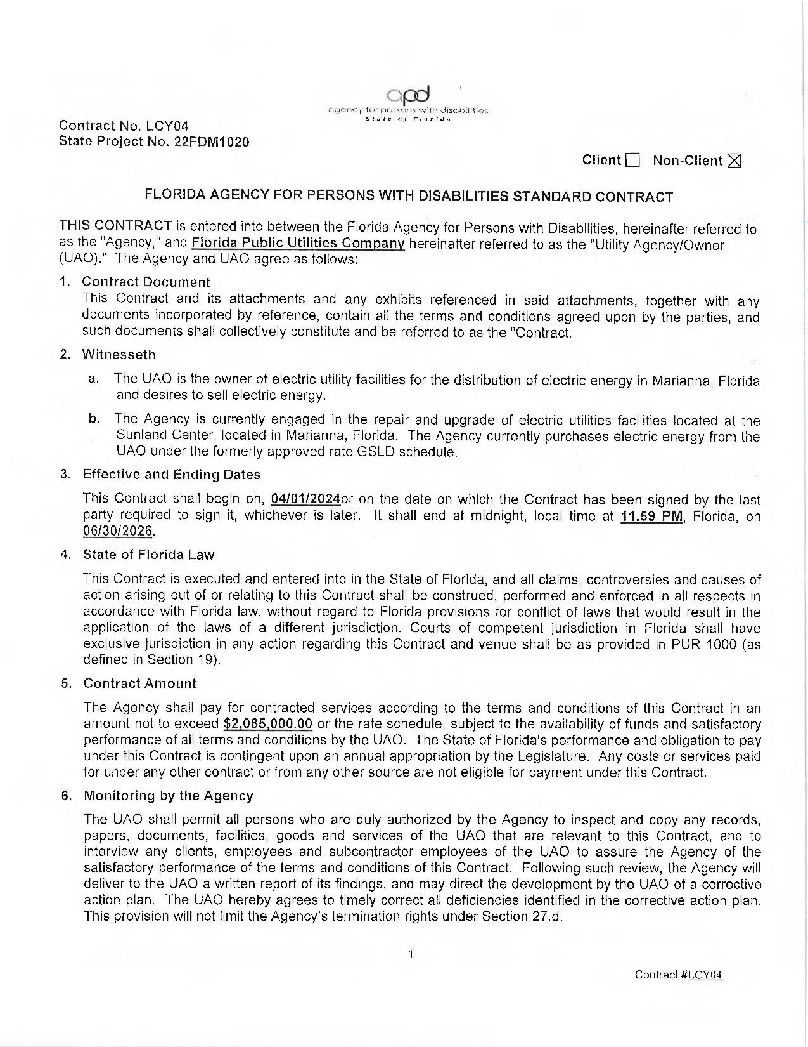
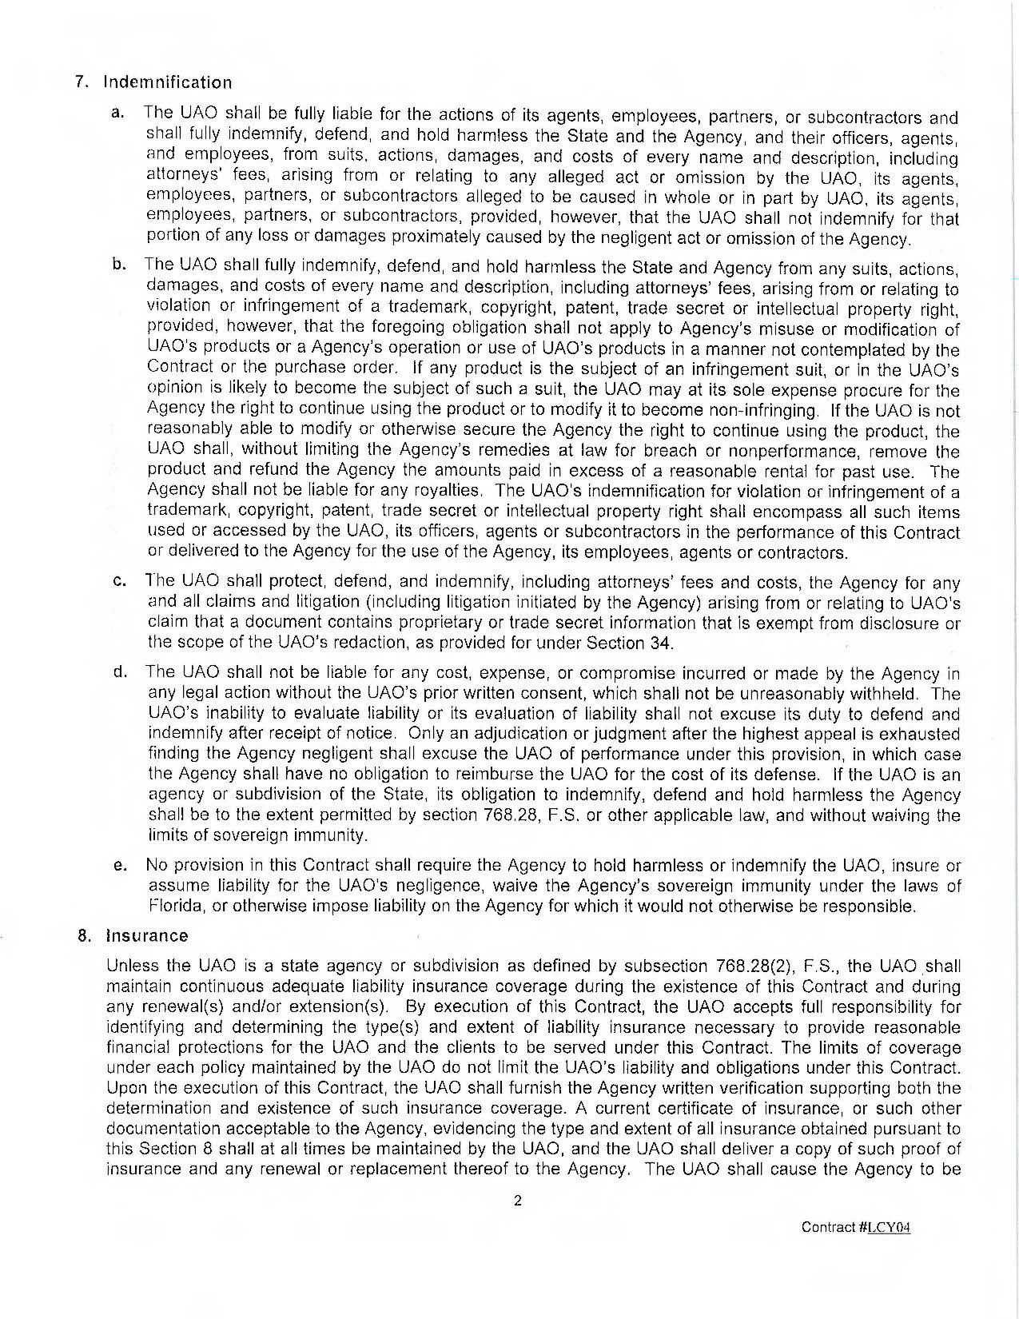
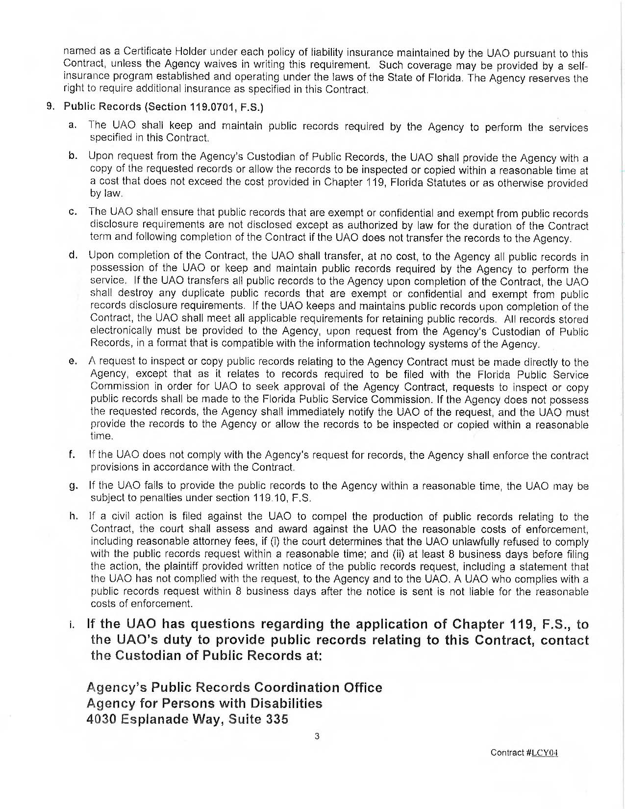
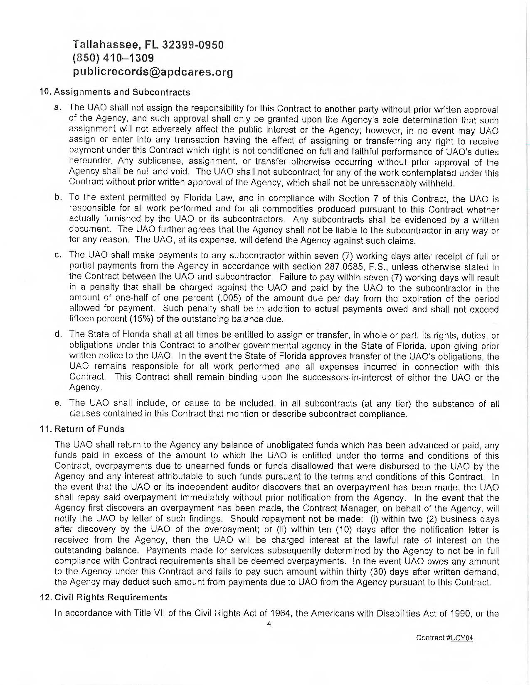
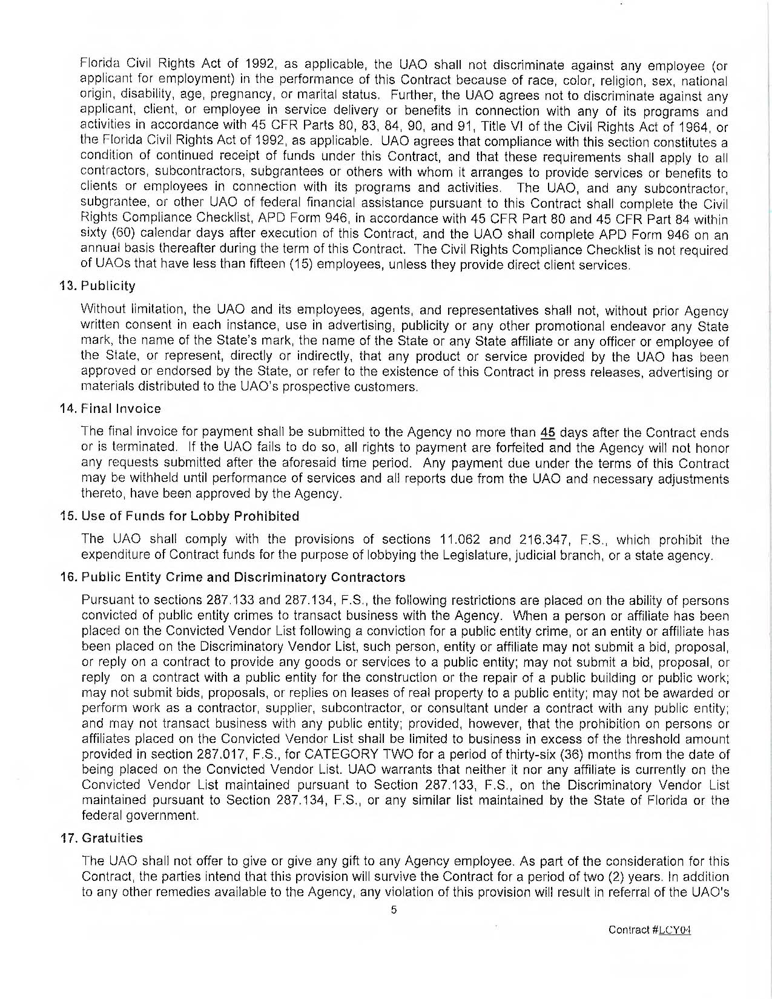
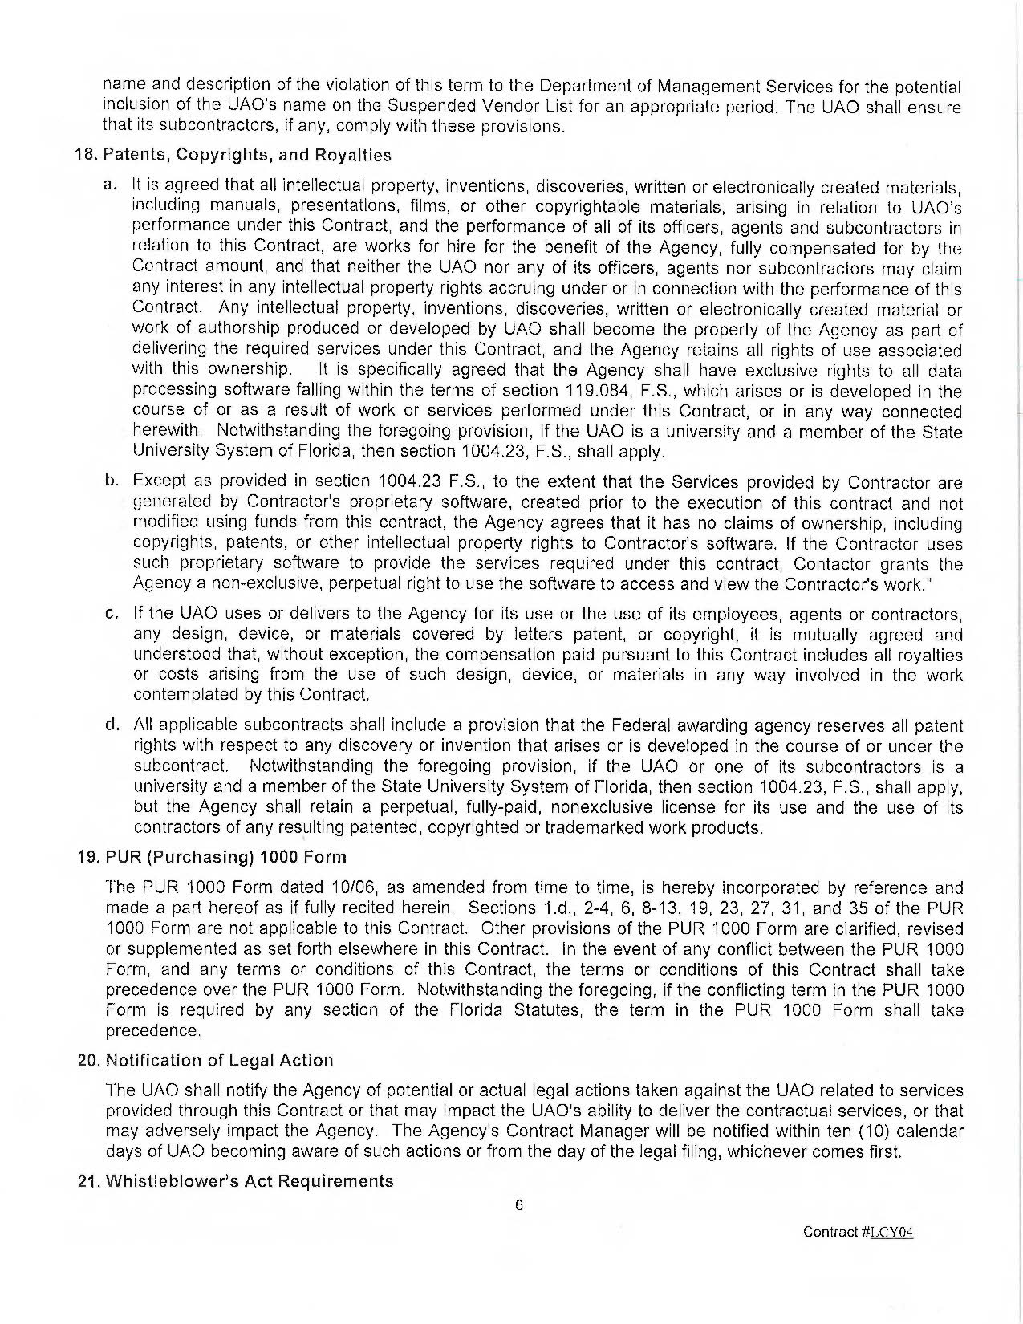
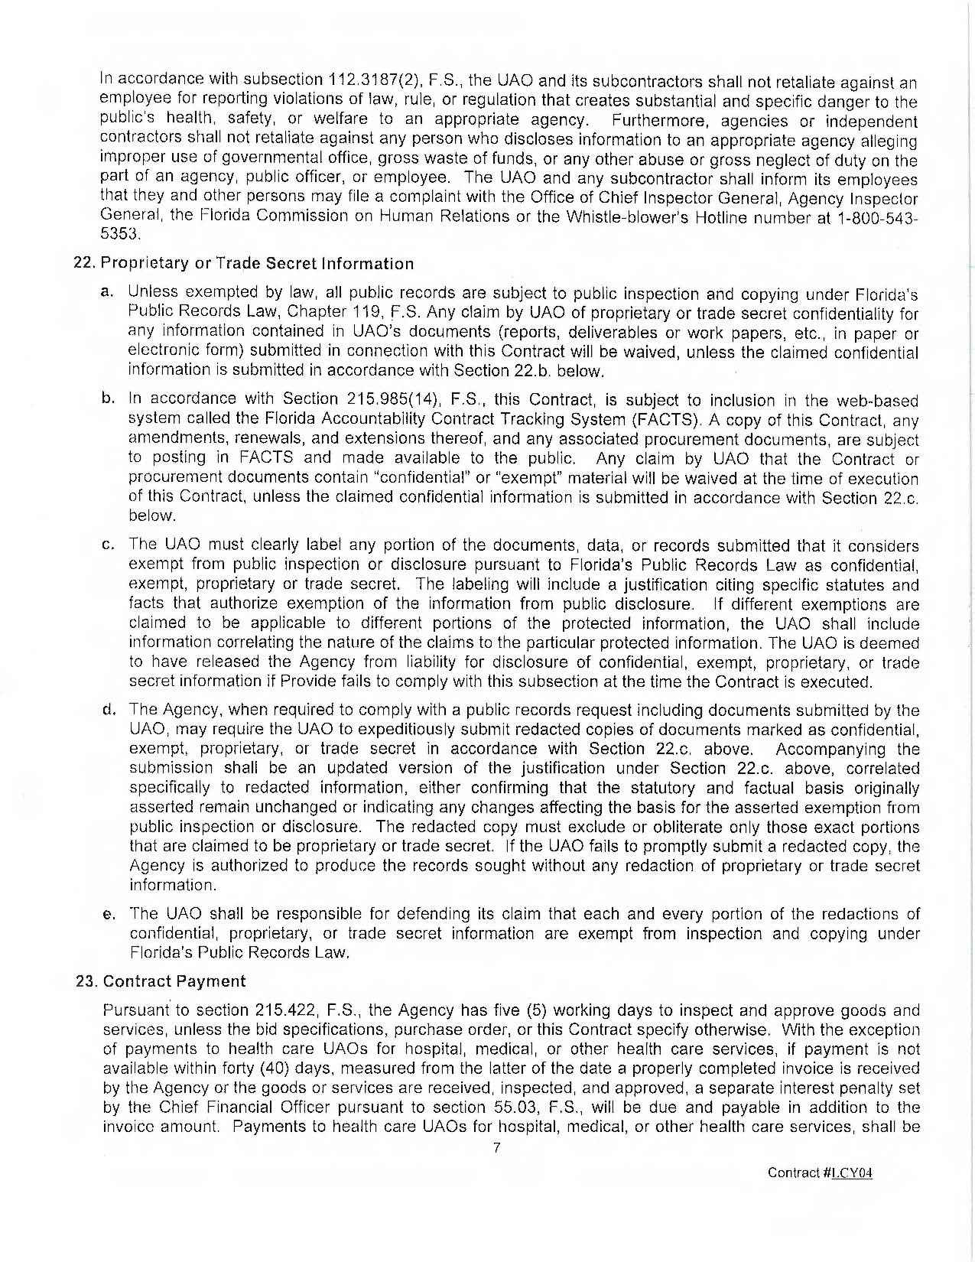
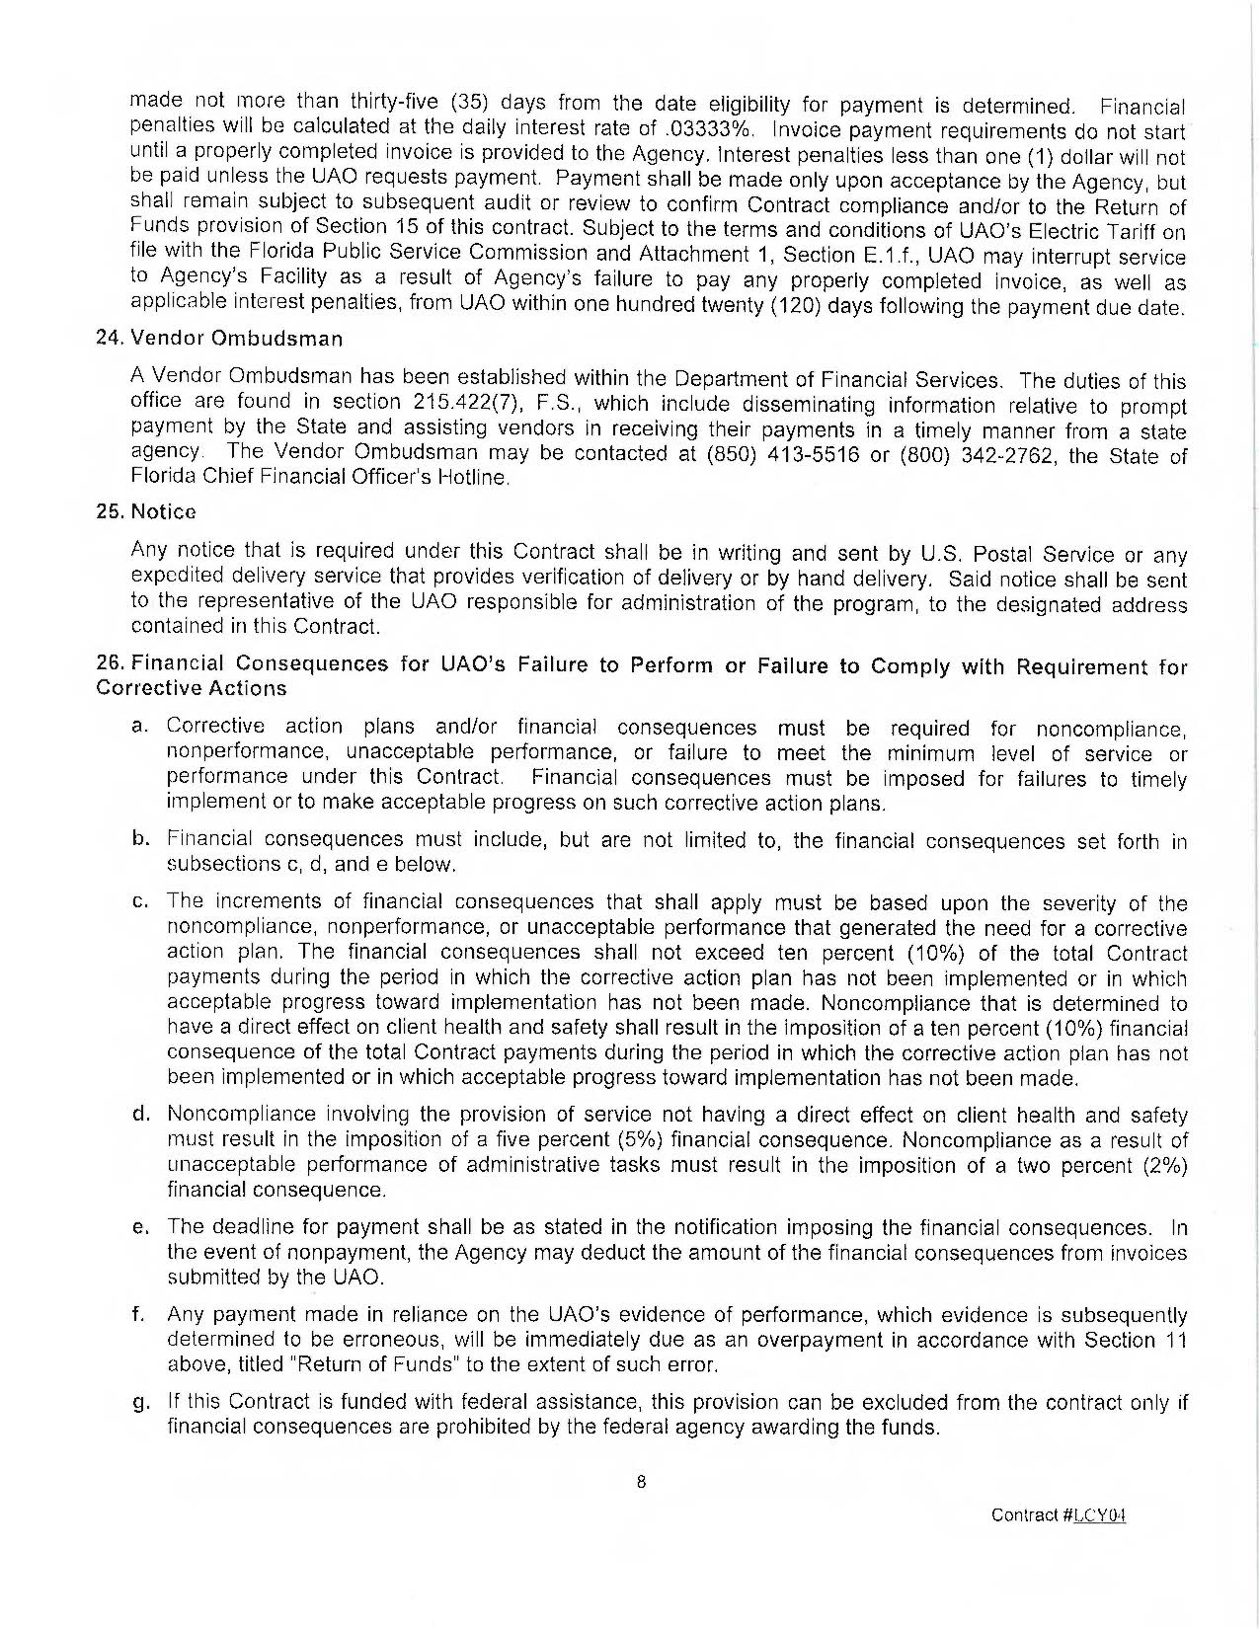
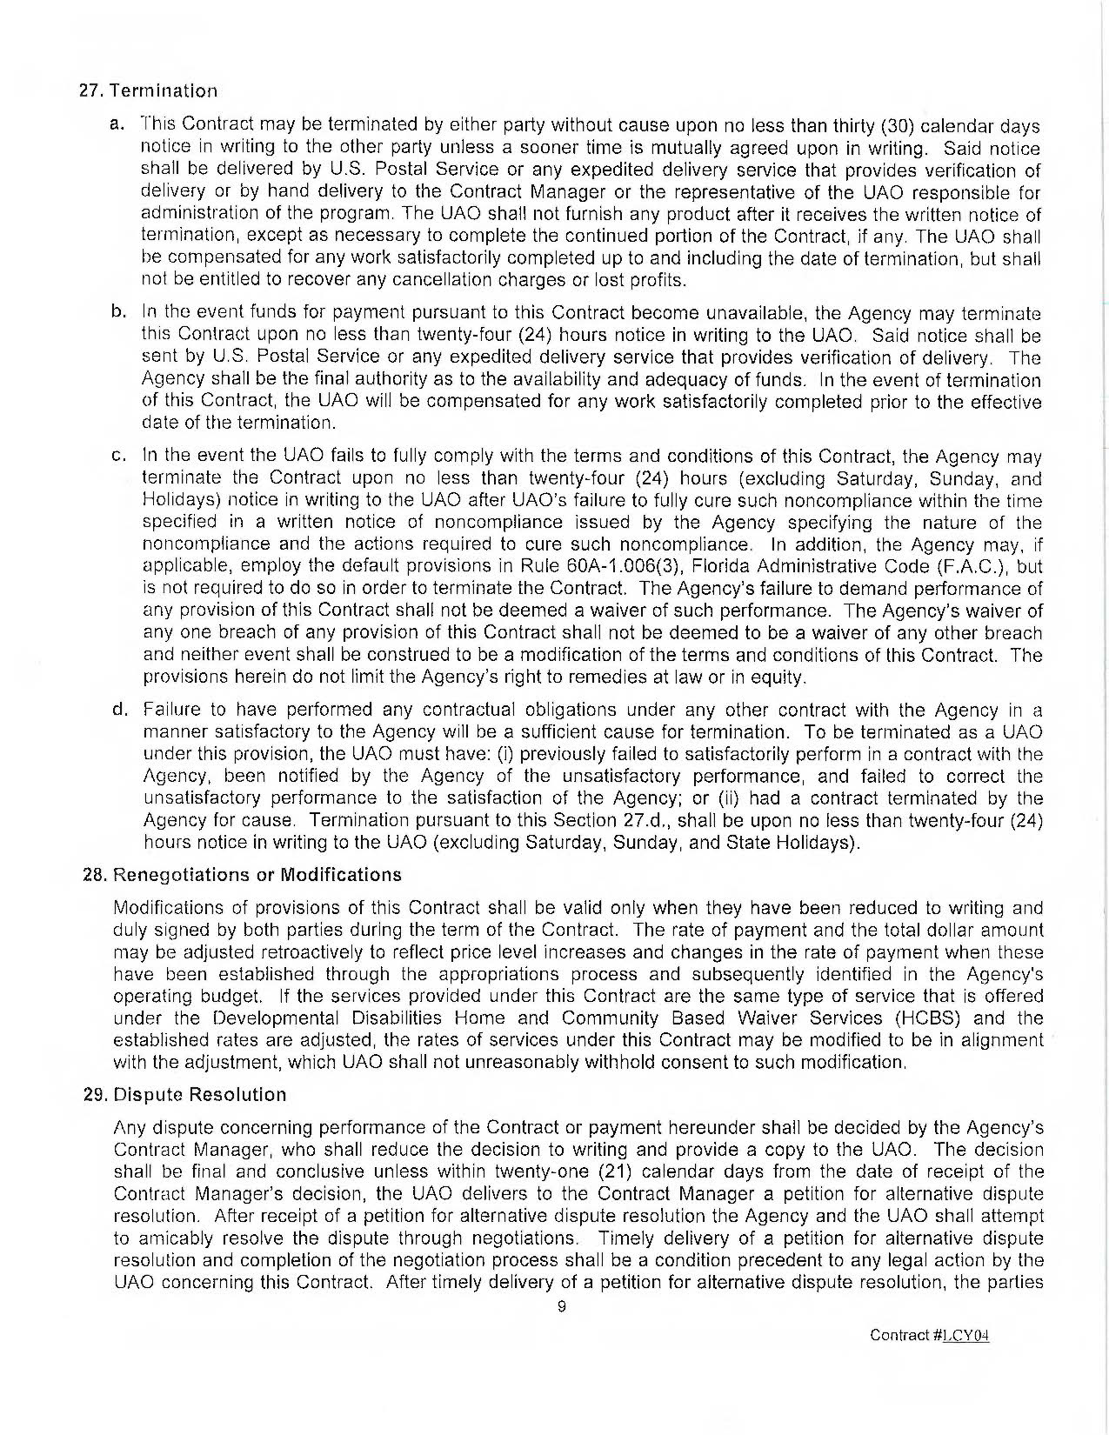
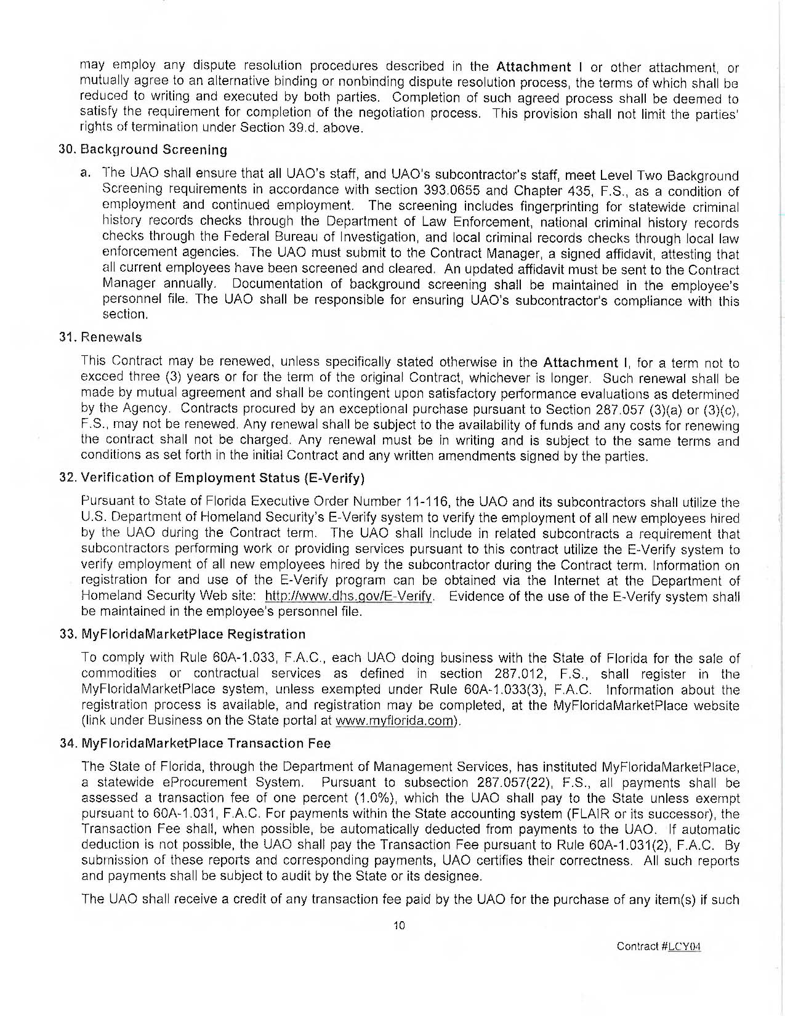
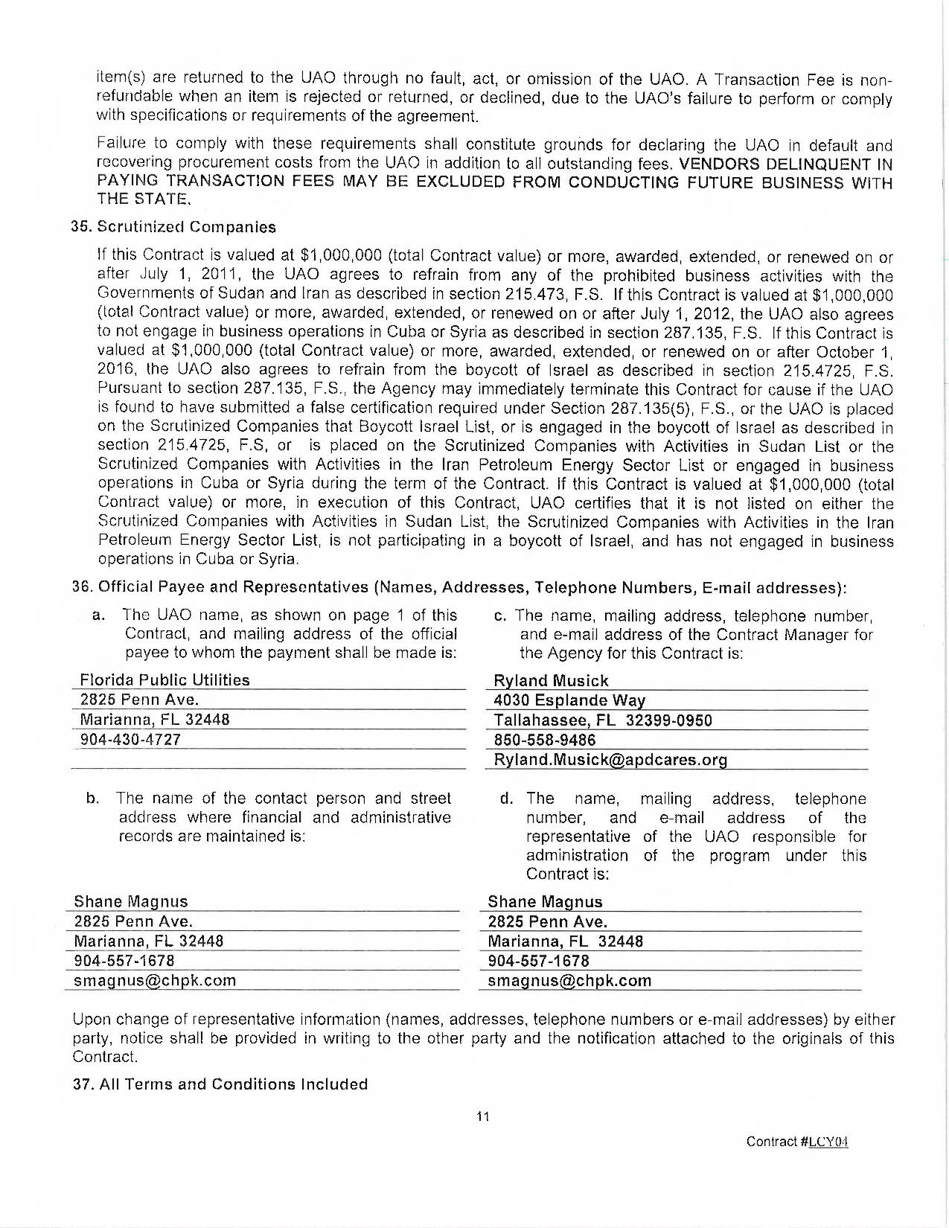
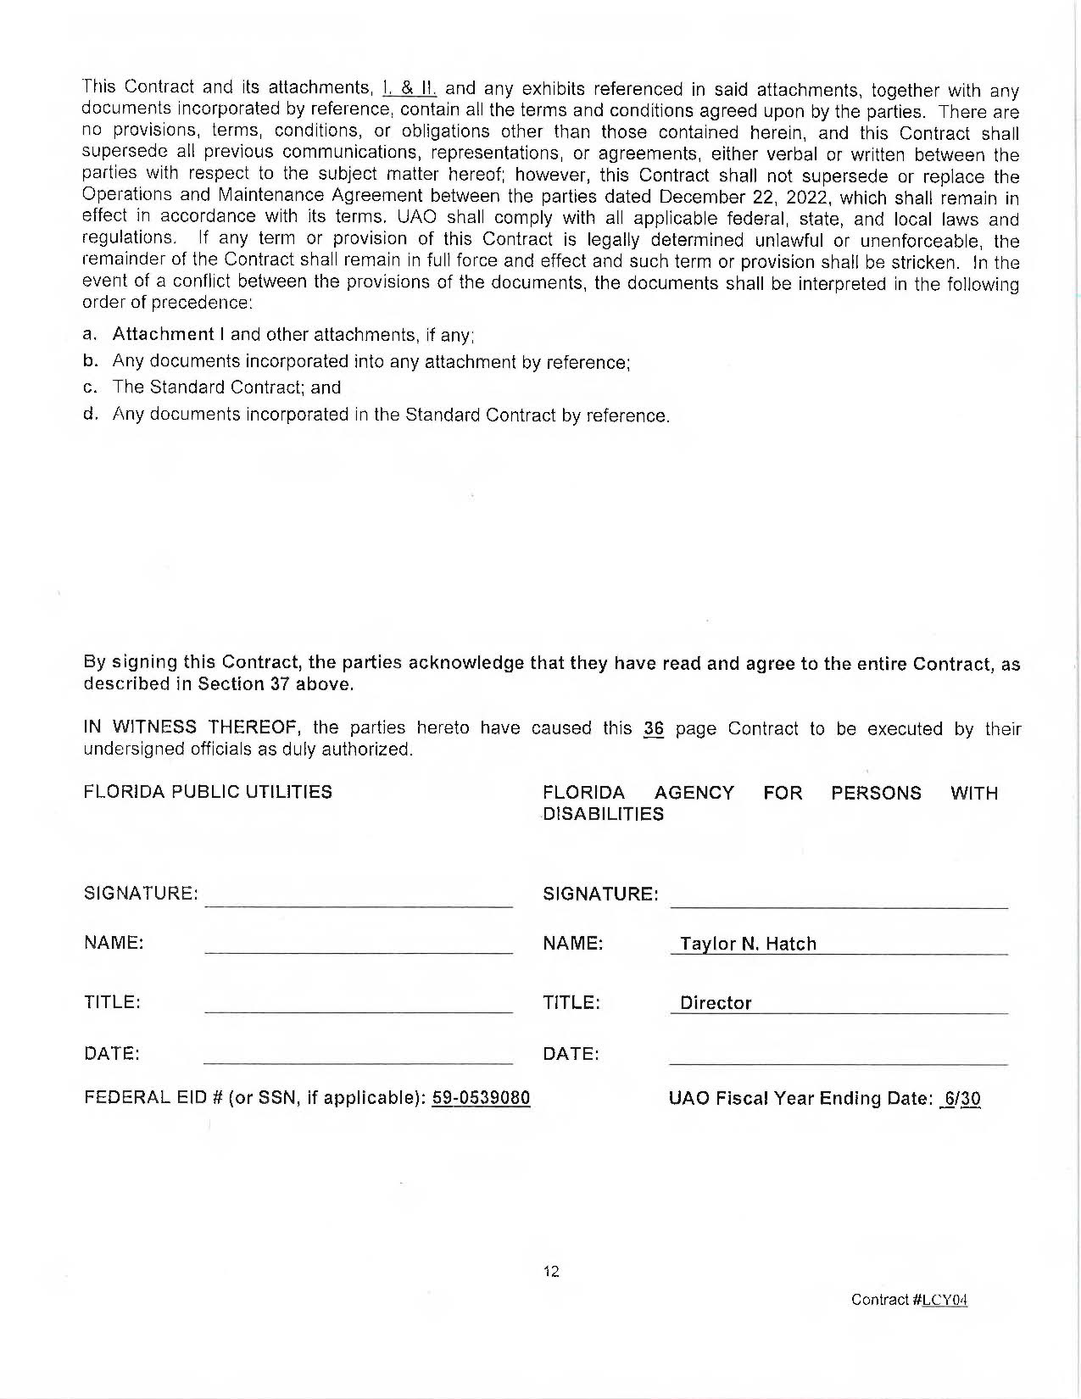
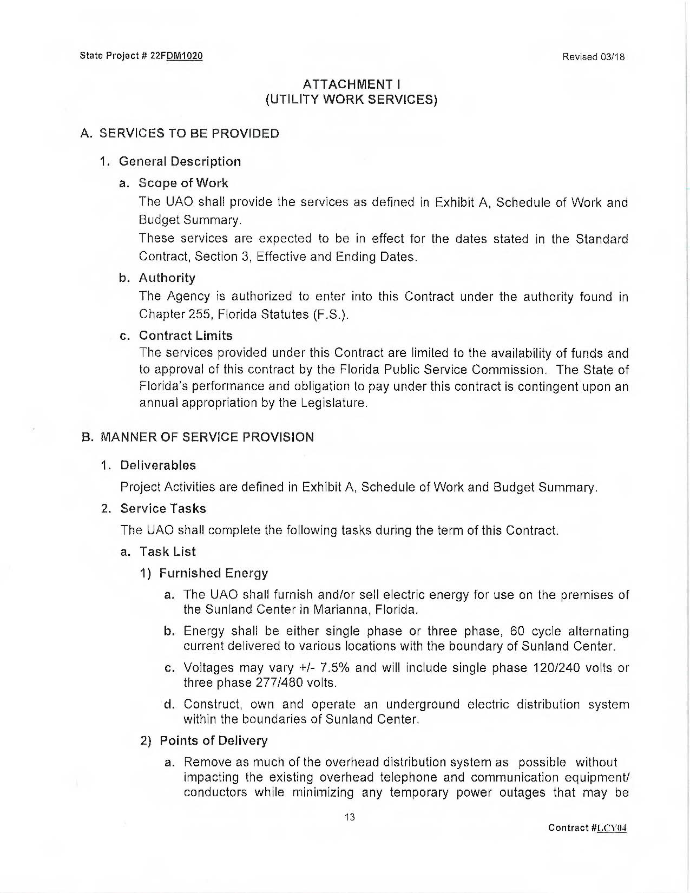
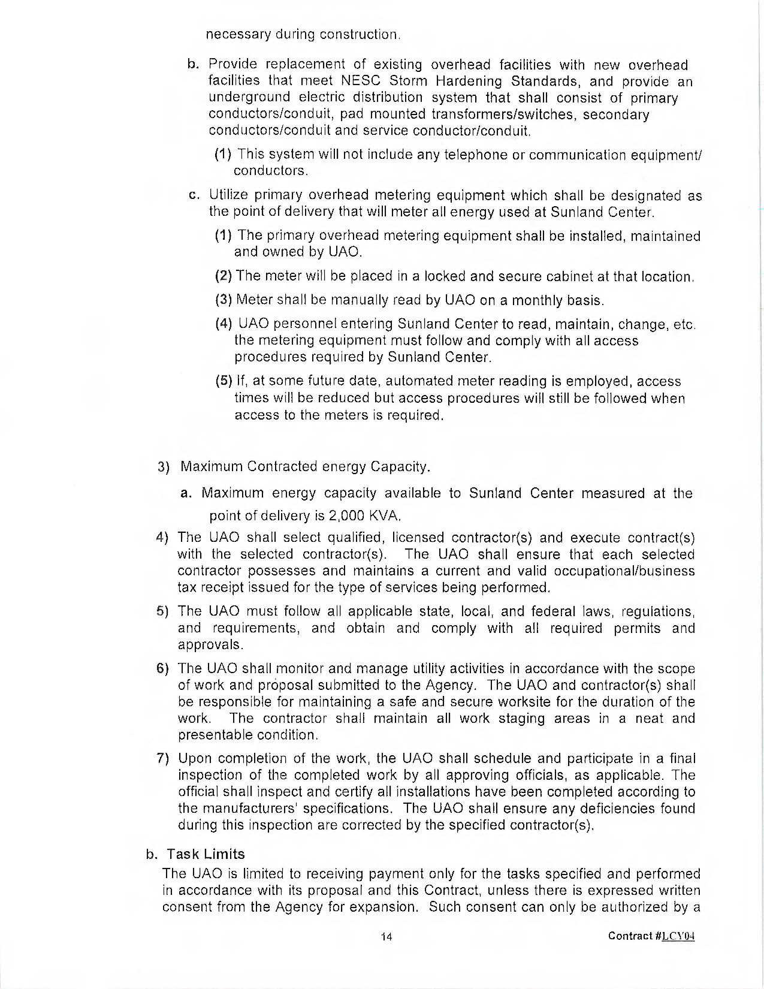
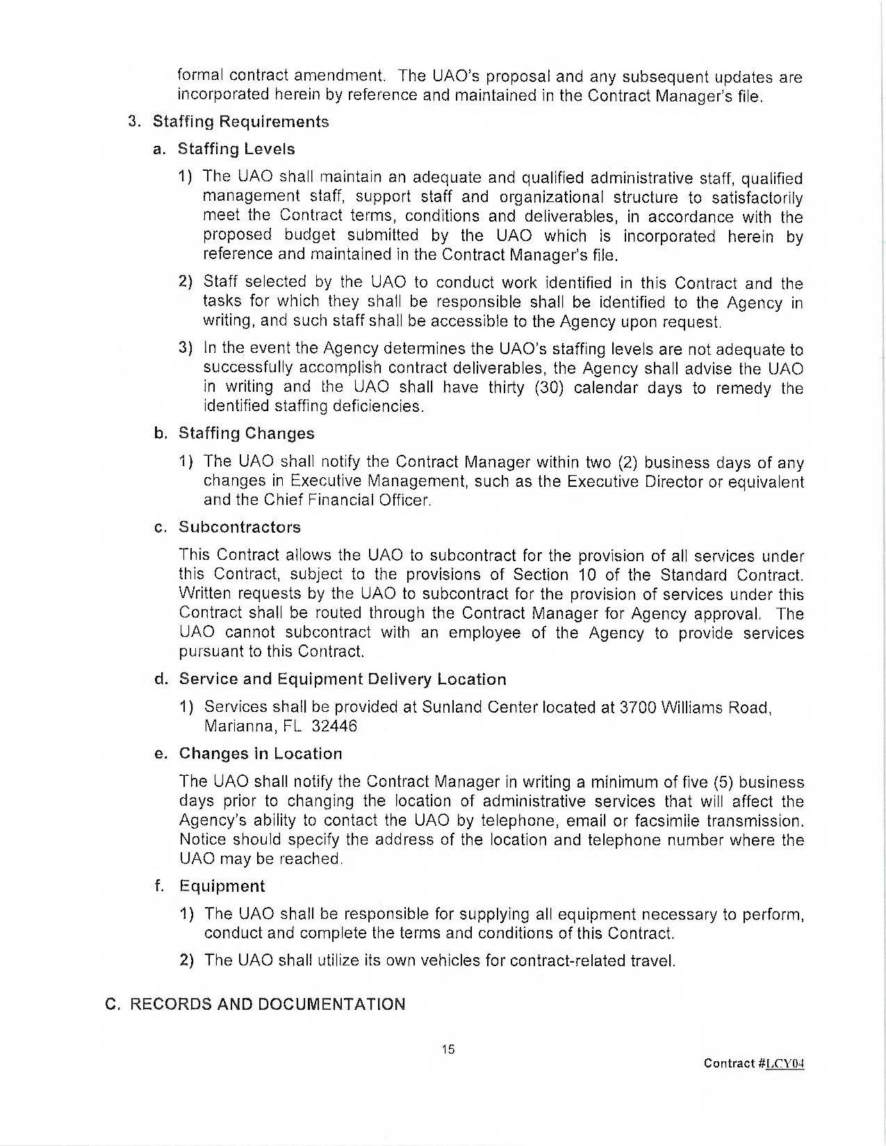
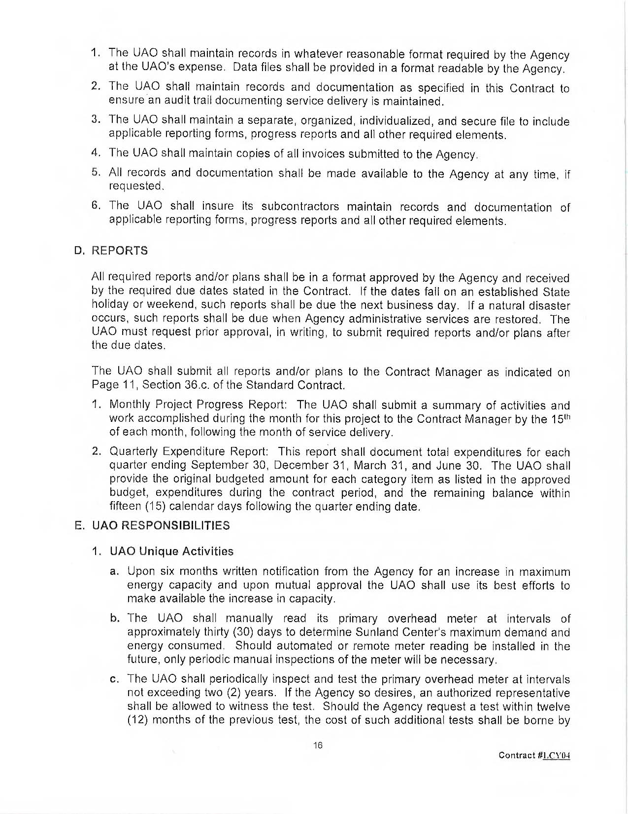
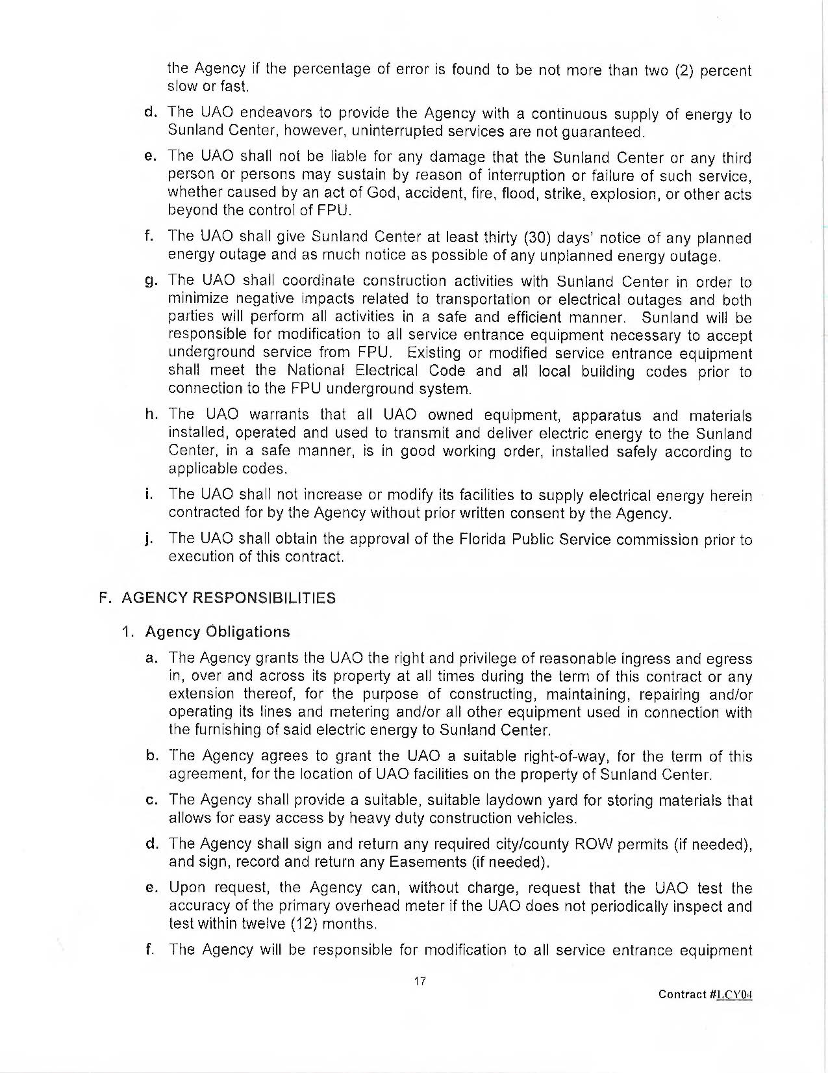
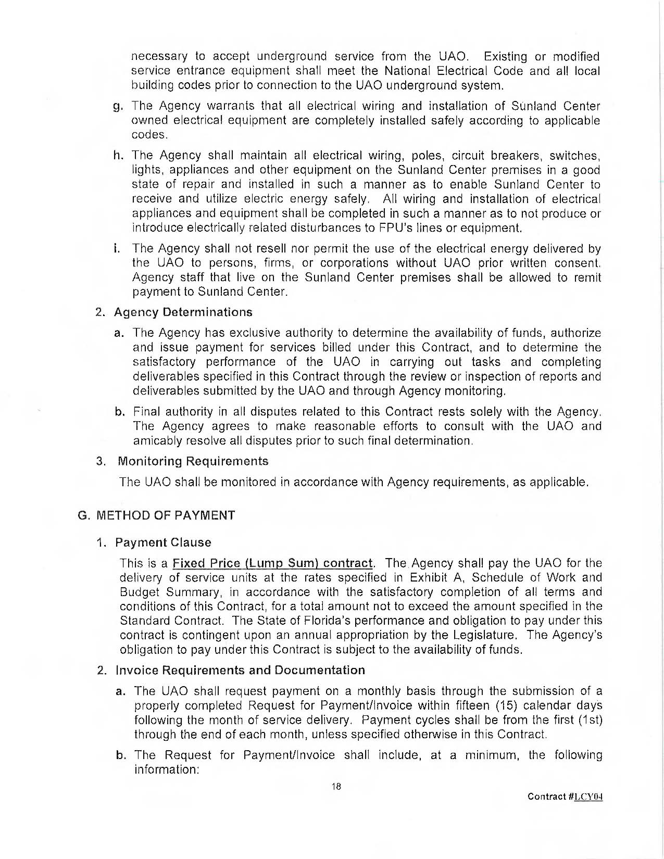
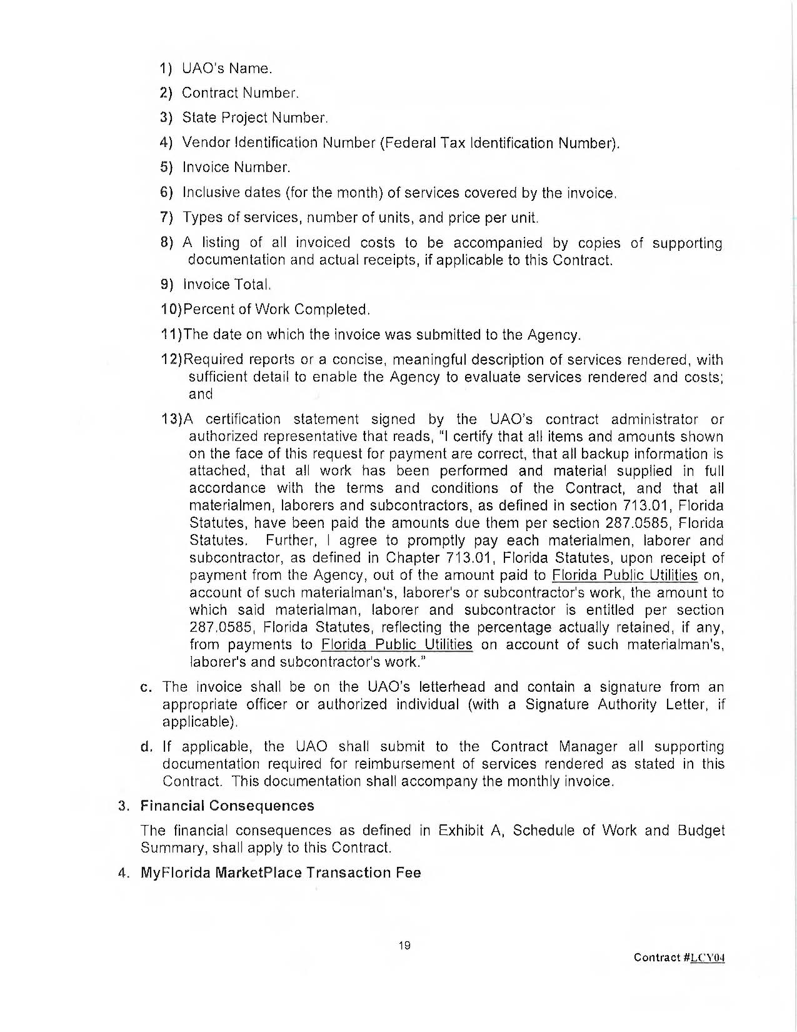
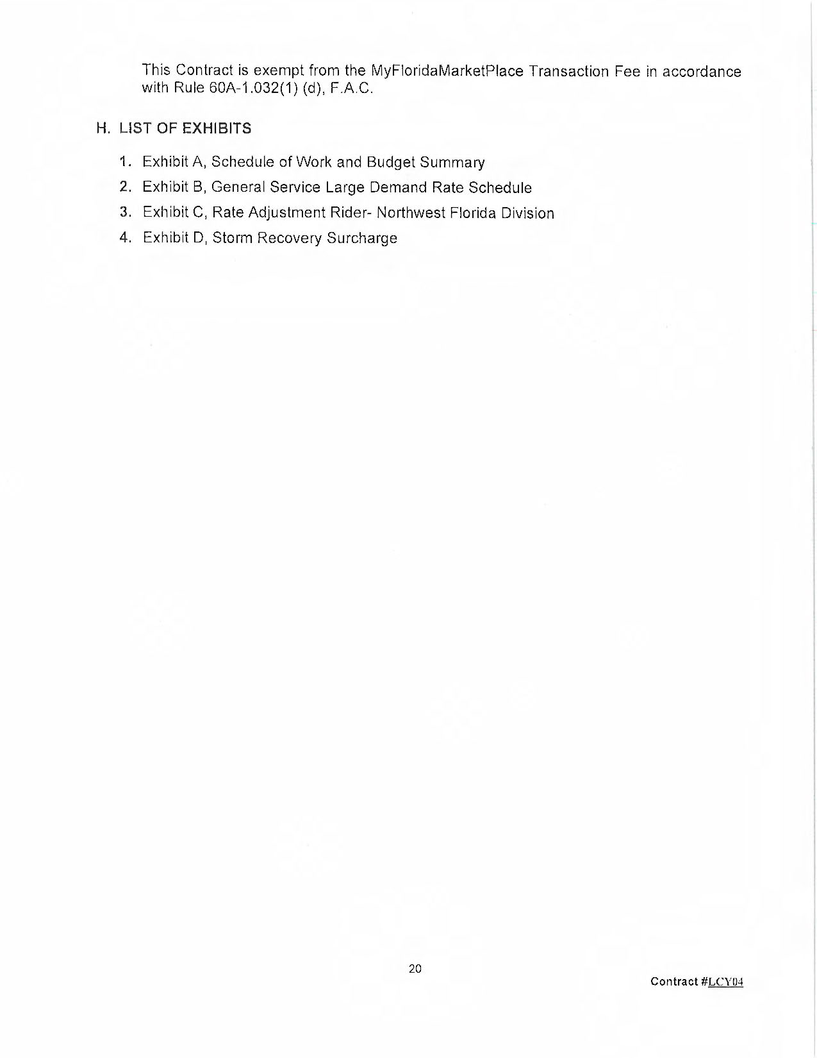
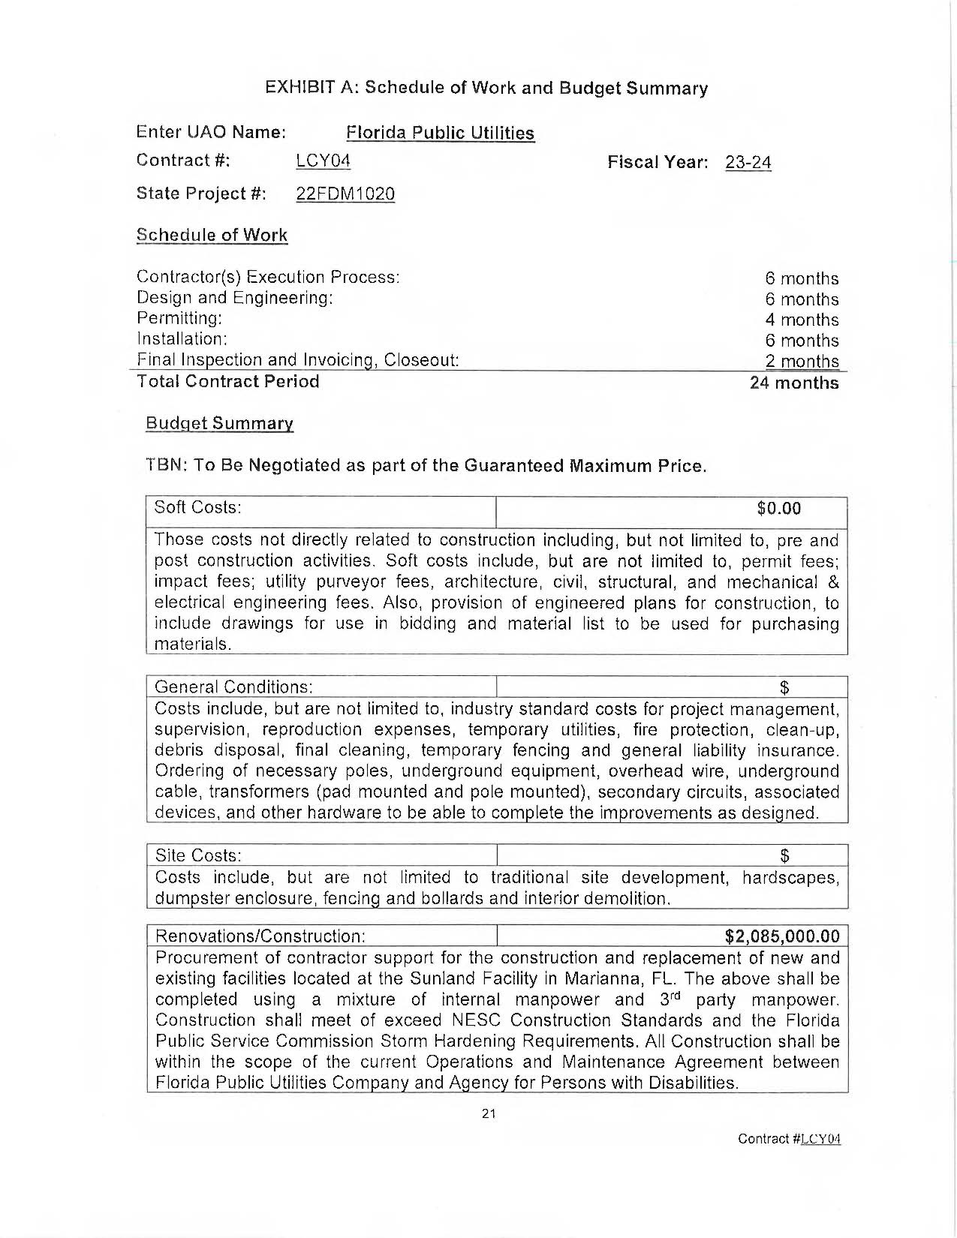
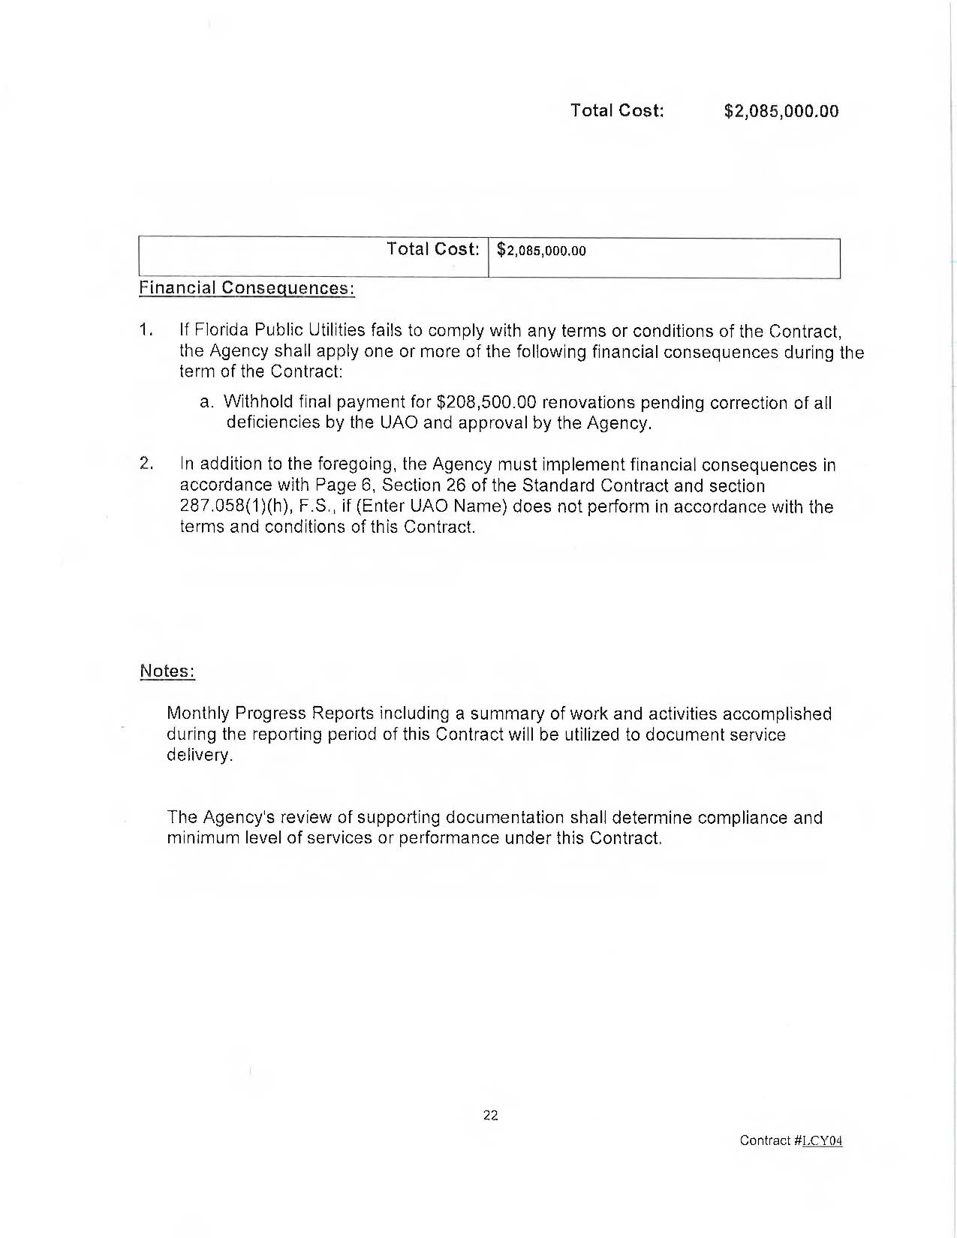
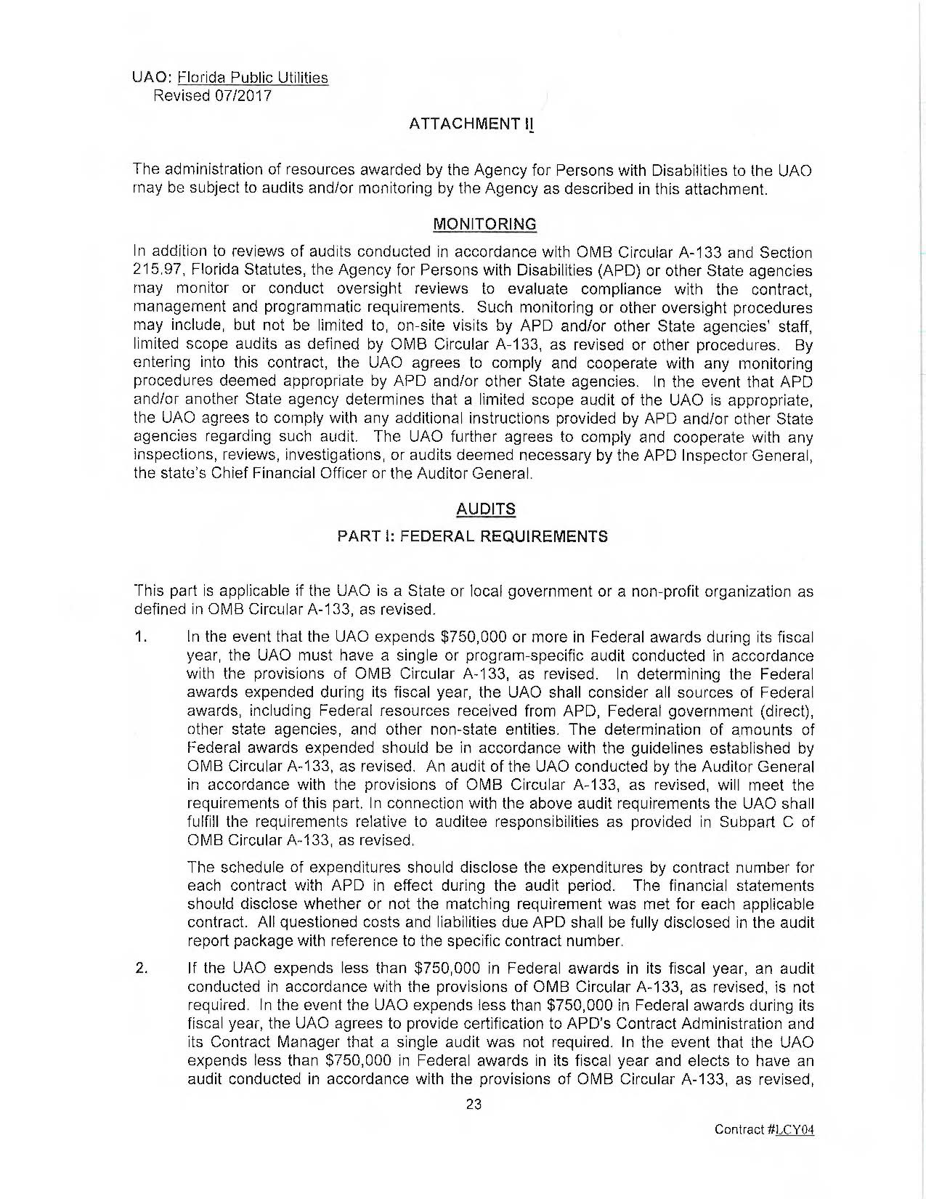
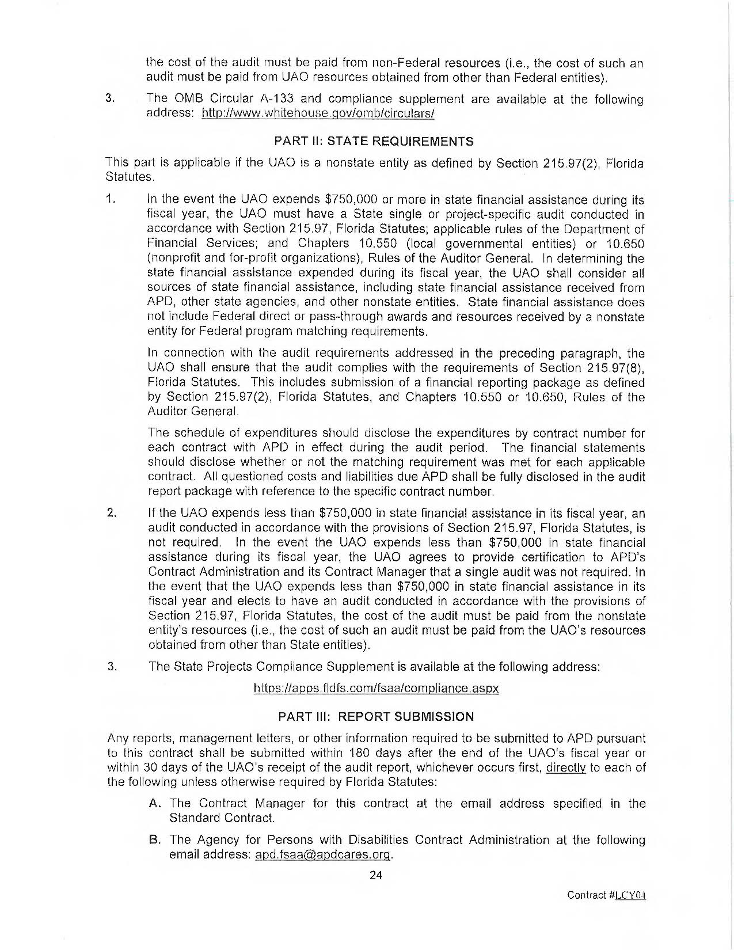
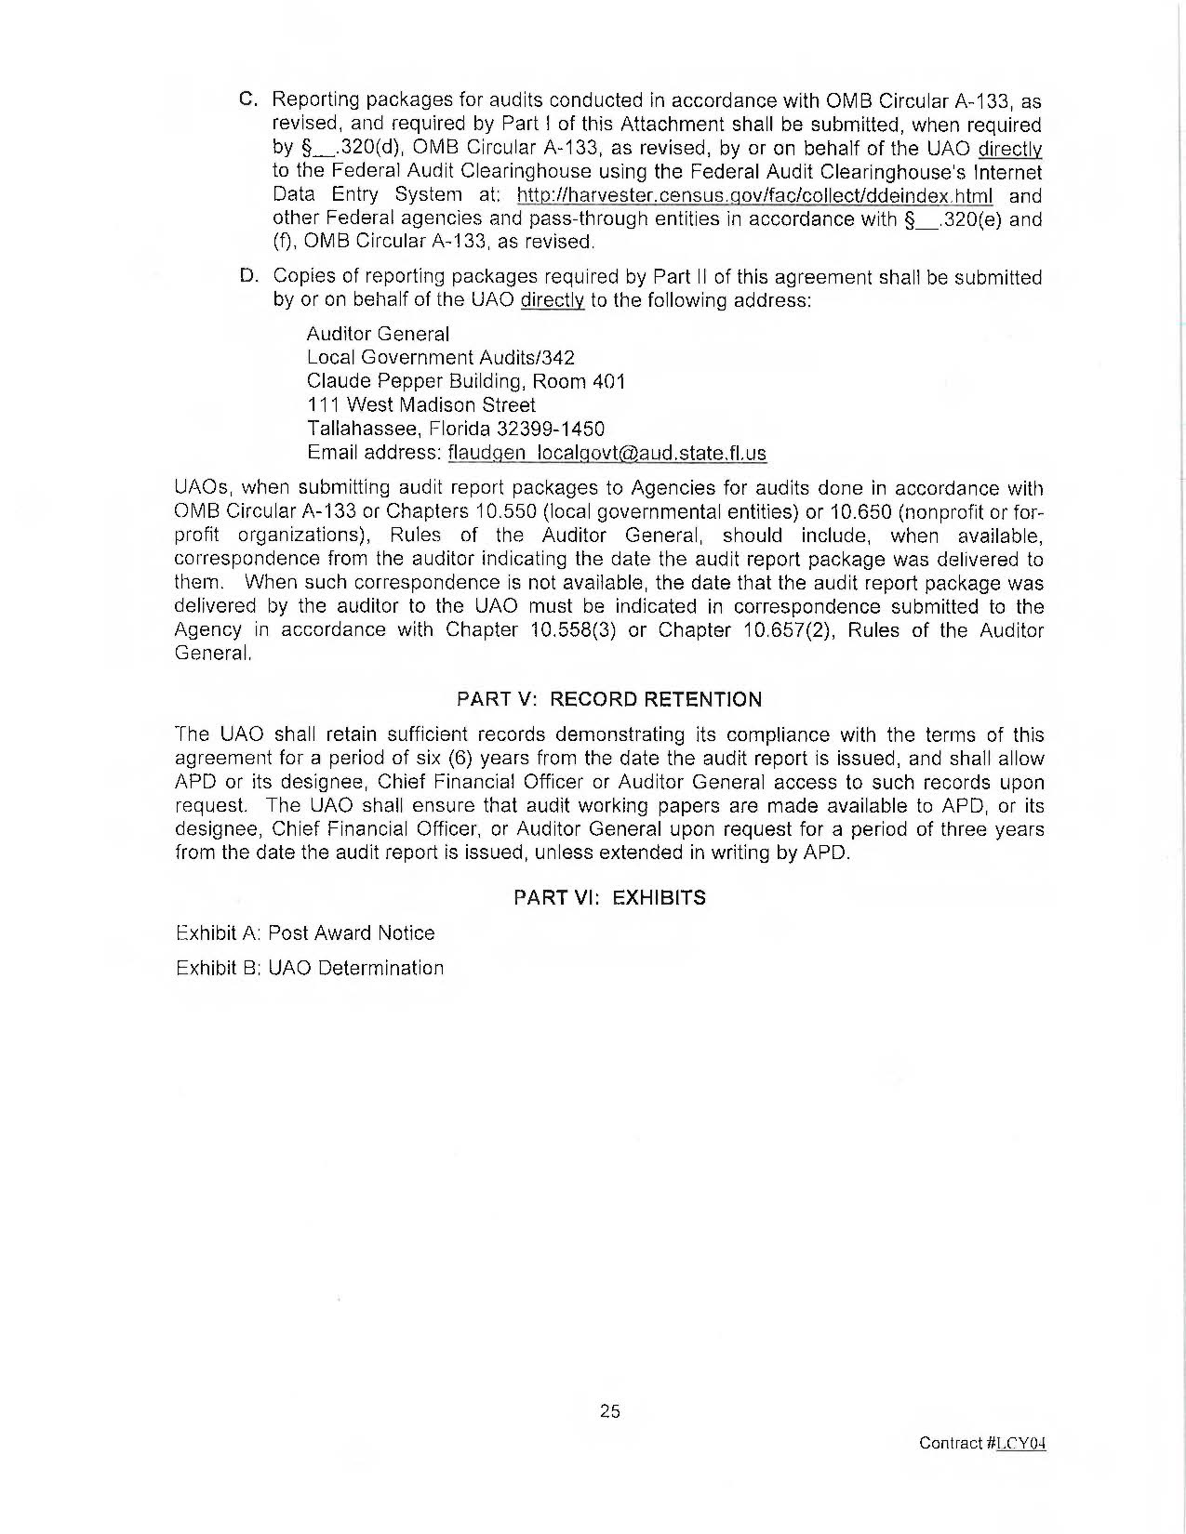
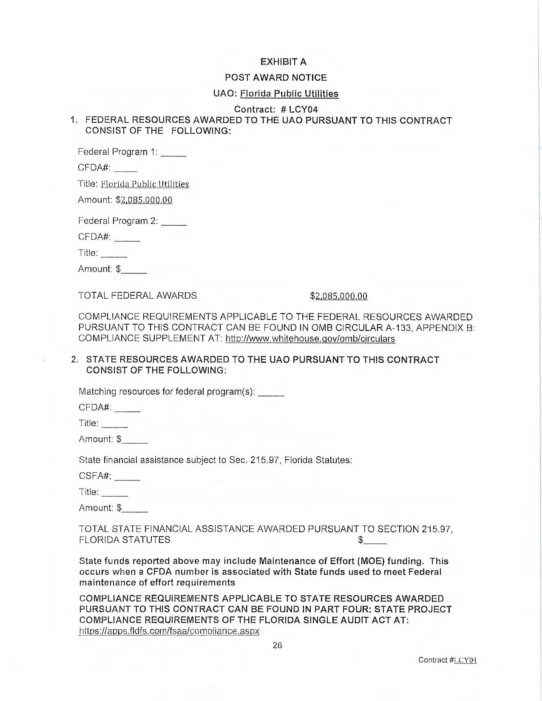
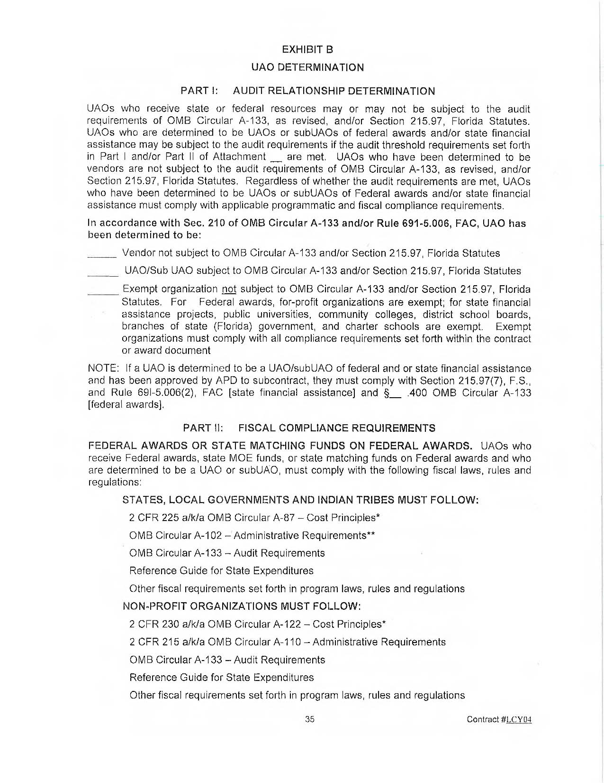
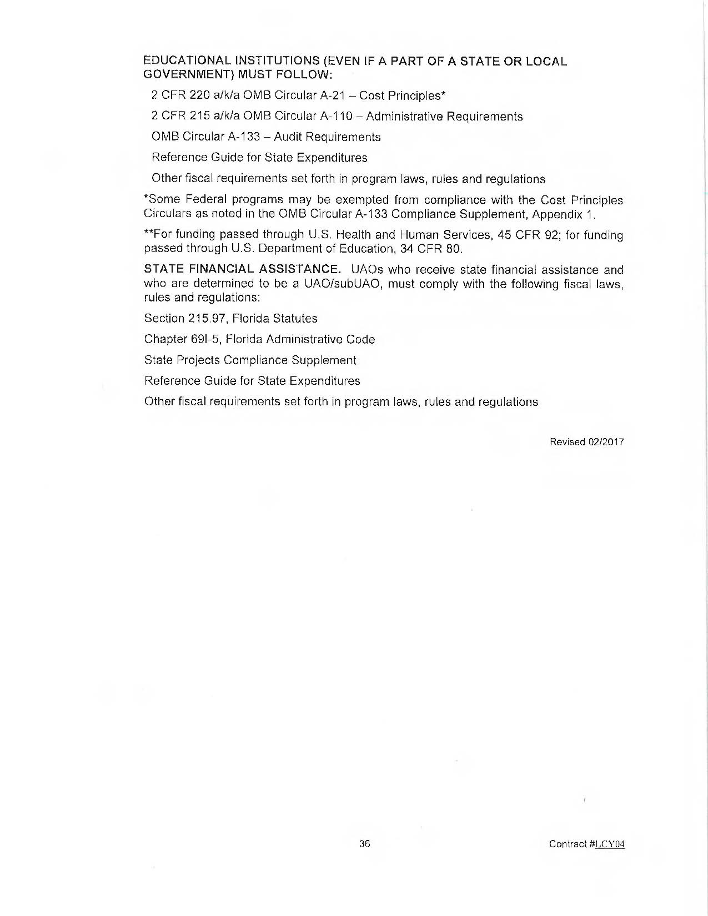

FPUC’s Responses to Staff’s First Data Request, DN 06861-2024.
FPUC’s Responses to Staff’s First Data Request, Response No. 4

