|  |  |  |  |
| --- | --- | --- | --- |
| State of Florida  pscSEAL | | Public Service Commission  Capital Circle Office Center ● 2540 Shumard Oak Boulevard Tallahassee, Florida 32399-0850  -M-E-M-O-R-A-N-D-U-M- | |
| DATE: | September 19, 2024 | | |
| TO: | Office of Commission Clerk (Teitzman) | | |
| FROM: | Office of Industry Development and Market Analysis (Deas, Fogleman)  Office of the General Counsel (Farooqi, Marquez) | | |
| RE: | Docket No. 20240112-TP – Petition for designation as an eligible telecommunications carrier in the State of Florida, by Air Voice Wireless, LLC d/b/a AirTalk Wireless. | | |
| AGENDA: | 10/01/24 – Regular Agenda – Proposed Agency Action – Interested Persons May Participate | | |
| COMMISSIONERS ASSIGNED: | | | All Commissioners |
| PREHEARING OFFICER: | | | Clark |
| CRITICAL DATES: | | | None |
| SPECIAL INSTRUCTIONS: | | | None |

Case Background

On August 2, 2024, Air Voice Wireless, LLC d/b/a AirTalk Wireless (Air Voice or Company) filed a petition with the Florida Public Service Commission (FPSC or Commission) seeking designation as an eligible telecommunications carrier (ETC) in the State of Florida. Air Voice’s request for ETC designation is for the sole purpose of providing Lifeline services to qualifying consumers throughout Florida. Air Voice is a provider of commercial mobile radio service (CMRS) and offers prepaid wireless telecommunications services to consumers as a reseller. Specifically, Air Voice uses the network infrastructure and wireless transmission facilities of AT&T to operate as a Mobile Virtual Network Operator. Air Voice is currently designated as an ETC providing Lifeline service in 40 other states.

As a CMRS provider, Air Voice is regulated as a common carrier pursuant to 47 U.S.C. § 153(11).[1] Air Voice is a Texas Limited Liability Company (LLC) authorized to do business as a foreign LLC in the State of Florida. Air Voice is a wholly owned subsidiary of VTel Holdings, LLC which is wholly owned by Henry Hung Do.

Air Voice asserts that it meets all applicable federal requirements for designation as a Lifeline only ETC in Florida pursuant to 47 U.S.C. § 214(e) and 47 C.F.R. § 54.201. Air Voice acknowledges and asserts that, if approved it will comply with Sections 364.10 and 364.105, Florida Statutes (F.S.), and Rule 25-4.0665, Florida Administrative Code (F.A.C.), which govern Lifeline service and provide transitional discount for customers who no longer qualify for Lifeline.

Section 214(e)(2) of the Telecommunications Act of 1996 (the Act) provides state public utility commissions with “primary responsibility” for the designation of ETCs. In addition, Section 364.10(3) F.S. specifically grants the Commission jurisdiction to address wireless ETC petitions for Lifeline purposes only.

Discussion of Issues

Issue :

 Should Air Voice be granted ETC designation to provide Lifeline service throughout the State of Florida?

Recommendation:

 Yes. Air Voice should be granted an ETC designation to provide Lifeline service throughout the State of Florida. Staff also recommends that if there is a future change of Company ownership, the new owners should be required to file a petition with the Commission to demonstrate that it is in the public interest to maintain the Company’s ETC designation. (Deas, Fogleman, Farooqi, Marquez)

Staff Analysis:

 ETC designation is necessary for telecommunications companies to participate in the federal Lifeline program.[2] Section 364.10(3), F.S. allows the Commission to approve wireless Lifeline ETC petitions by requesting carriers. Federal rules outline the requirements for ETC designation.[3] To obtain ETC designation to provide Lifeline services, federal rules require that carriers:

1. Be a common carrier;
2. Offer the services that are supported by the federal universal support mechanisms either using its own facilities or a combination of its own facilities and resale of another carrier’s services;
3. Advertise the availability of its Lifeline service through a media of general distribution;
4. Provide voice grade access to the public switch network or its functional equivalent;
5. Offer minutes of use for local service at no additional charge to end users;
6. Provide access to the emergency services available by local government or other public safety organizations;
7. Provide Broadband Internet Access Service;[4]
8. Demonstrate financial and technical capability to provide Lifeline service; and
9. Not charge Lifeline customers a monthly number-portability charge.

In addition, Florida law requires the following for ETC designation:

1. Offer discounted transitional basic telecommunications service.[5]
2. Participate in the Lifeline Promotion Process.[6]

**Forbearance of Facilities Requirements**

Air Voice plans to offer all of the supported services enumerated under Section 254(c) of the Act through its wireless resale agreement with AT&T. Therefore, it sought forbearance of the facilities requirement from the Federal Communications Commission (FCC). On December 26, 2012, the FCC approved Air Voice’s compliance plan that is a condition for obtaining forbearance from the facilities requirement for the provision of Lifeline service.[7] As part of its compliance plan Air Voice committed to do the following:[8]

1. Provide the supported services throughout the carrier’s designated area;
2. Remain functional in emergency situations;
3. Comply with the Cellular Telecommunications and Internet Association's Consumer Code for Wireless Service;
4. Demonstrate that it is financially and technically capable of providing the Lifeline service in compliance with federal rules; and
5. Describe the terms and conditions of the broadband Internet access service plans offered to Lifeline subscribers.

Because Air Voice will offer the supported services and is compliant with the FCC requirements pursuant to 47 U.S.C. § 214(e) and 47 C.F.R. § 54.201, as well as the Florida specific requirements, Air Voice is eligible for designation as a Lifeline only ETC in Florida.

**Financial, Managerial, and Technical Capabilities**

Air Voice states it has been a wireless provider for 24 years and a Lifeline provider for 11 years. The Company has operated as an ETC in 40 states and has not been subject to any ETC revocation proceedings. While Air Voice has had ownership changes and enforcement actions by the FCC, which were resolved promptly, the Company has not had any bankruptcies under the current ownership.[9] At present, the Company is in good standing with the FCC. The Company has over 25 years of technical and managerial experience, and it does not rely exclusively on Lifeline reimbursements for its operating revenues. As Air Voice will be providing resold wireless service, it will also rely upon the managerial and technical expertise of its underlying carrier.

**Public Interest**

State commissions are required to find that ETC designation is in the public interest.[10] Air Voice asserts granting its ETC designation will increase options for Lifeline eligible consumers by providing an additional choice of providers. Moreover, Air Voice contends that wireless service offers a more reliable mode of communication. After a thorough evaluation, staff determined that in addition to broadening consumer choice and improving service stability, Air Voice’s offerings are competitive and comparable to existing services. Therefore, staff believes that granting Air Voice ETC designation would serve the public interest.

**Conclusion**

Staff has reviewed Air Voice’s petition for ETC designation in Florida. Air Voice meets the requirements for designation as an ETC. Additionally, the Company has demonstrated sufficient financial, managerial, and technical capabilities. Therefore, staff recommends Air Voice should be granted ETC designation in the service areas identified in Attachment A of this recommendation. Staff further recommends that if there is a future change of Company ownership, the new owners should be required to file a petition with the Commission to demonstrate that it is in the public interest to maintain the Company’s ETC designation.

Issue :

 Should this docket be closed?

Recommendation:

Yes. If no person whose substantial interests are affected by the proposed agency action files a protest within 21 days of the issuance of the Proposed Agency Action Order, this docket should be closed upon the issuance of a consummating order. (Farooqi, Marquez)

Staff Analysis:

 At the conclusion of the protest period, if no protest is filed, this docket should be closed upon the issuance of a consummating order.

**EXHIBIT A**

DESIGNATED SERVICE AREA

AirVoice is proposing to offer Lifeline supported service throughout the State of Florida, as illustrated in the following coverage map for AirVoice’s underlying carrier, AT&T:

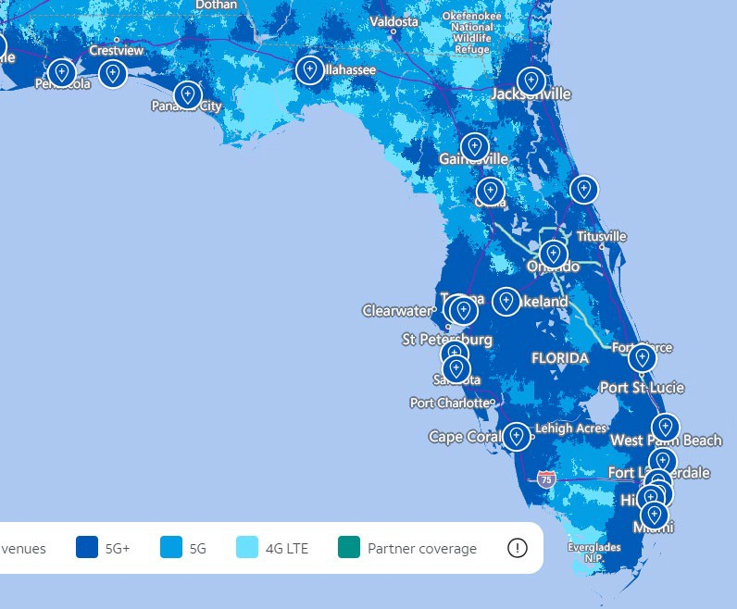

1. 47 U.S.C. § 153(11) (defining a common carrier as “any person engaged as a common carrier for hire, in interstate or foreign communications by wire or radio . . . .”); 47 U.S.C. § 332(c)(1)(A) (treating commercial mobile service providers as common carriers).
2. 47 U.S.C. § 254(e)
3. 47 U.S.C. § 214(e)(1); 47 C.F.R. § 54.101, 54.201, 54.401. While Section 54.101(a) also includes requirements addressing toll limitation services to qualifying low-income consumers, the Federal Communications Commission in its 2012 Lifeline and Link Up Reform Order (FCC 12-11) stated that: “ETCs are not required to offer toll limitation service to low-income consumers if the Lifeline offering provides a set amount of minutes that do not distinguish between toll and non-toll calls.”
4. Broadband Internet Access Service (BIAS) is defined as a mass-market retail service that provides the capability to transmit and receive data, but excluding dial-up service.
5. Section 364.105, F.S., states that each ETC shall offer a residential basic local telecommunications service at 70 percent of the residential local telecommunications service rate for any Lifeline subscriber who no longer qualifies for Lifeline for a period of 1 year after the date the subscriber ceases to qualify for Lifeline.
6. Rule25-4.0665(3), F.A.C. The Lifeline Promotion Process is an electronic system developed in collaboration with the Florida Department of Children and Families, ETCs and the FPSC. This system helps assist ETCs and the FPSC in providing information on how to apply for Lifeline assistance to eligible customers.
7. FCC, Public Notices, DA 12-2063, released December 26, 2012; DA 21-1641, released December 23, 2021; DA 24-209, released March 6, 2024.
8. 47 C.F.R. § 54.202(a).
9. Under previous ownership, Air Voice received a notice of apparent liability in 2014 (DA -14-175) for a late report filing. In 2024, it entered into a consent decree to resolve a failure to provide Lifeline service to all qualifying consumers (DA 24-175). Air Voice agreed to pay a $150,000.00 fine, of which $133,333.33 was attributable to Air Voice conduct under previous ownership and $16,666.67 was due to conduct under the current ownership. This issue was resolved shortly after the company was acquired by new owners.
10. 47 U.S.C. § 214(e)(2).