|  |  |  |  |
| --- | --- | --- | --- |
| State of Florida  pscSEAL | | Public Service Commission  Capital Circle Office Center ● 2540 Shumard Oak Boulevard Tallahassee, Florida 32399-0850  -M-E-M-O-R-A-N-D-U-M- | |
| DATE: | September 19, 2024 | | |
| TO: | Office of Commission Clerk (Teitzman) | | |
| FROM: | Division of Economics (Guffey, Hampson, Hudson)  Division of Accounting and Finance (G. Kelley, Higgins, D. Buys, Ferrer)  Office of the General Counsel (Brownless) | | |
| RE: | Docket No. 20240099-EI – Petition for rate increase by Florida Public Utilities Company. | | |
| AGENDA: | 10/01/24 – Regular Agenda – Decision on Interim Rates and Tariff Suspension – Participation is at the Commission’s Discretion | | |
| COMMISSIONERS ASSIGNED: | | | All Commissioners |
| PREHEARING OFFICER: | | | Passidomo |
| CRITICAL DATES: | | | 10/21/24 (60-Day Suspension Date, 60-Day Interim Date) |
| SPECIAL INSTRUCTIONS: | | | None |

Case Background

Florida Public Utilities Company (FPUC or Company) filed a test year notification letter with the Commission on June 18, 2024, in which the Company indicated its intent to seek a permanent increase in its rates and charges based on a test year ending December 31, 2025, and a request for an interim rate increase. On August 22, 2024, FPUC filed its petition for an increase in base rates, as well as minimum filing requirements schedules (MFRs) and the direct testimony of 10 witnesses. The Company is engaged in business as a public utility providing electric service as defined in Section 366.02, Florida Statutes (F.S.), and is subject to the jurisdiction of the Florida Public Service Commission (Commission). FPUC serves approximately 18,100 retail customers in Calhoun, Liberty, and Jackson counties in the Company’s Northwest Division and approximately 15,000 retail customers in Nassau County in its Northeast Division.

FPUC requested an increase in base rates to generate an additional $12,593,450 in annual revenues. The requested increase, according to FPUC, will provide the Company with an opportunity to earn a rate of return of 6.89 percent on the Company's plant and property used to serve its customers and a return on equity of 11.30 percent. The Company based its request on a 13-month average rate base of $150,053,096 for the projected test year ending December 2025.

FPUC stated in its petition that the requested test year period ending December 31, 2025, is the most relevant period upon which the Company’s operations should be analyzed for purposes of establishing rates for the period in which the new rates will be in effect. The Company further stated that this period will be indicative of its actual revenues, expenses, and investment during the first 12 months that the new rates will be in effect. The Commission last granted FPUC an approximately $3.75 million rate increase by Order No. PSC-14-0517-S-EI.[1]

In its petition, FPUC also requested an interim rate increase in its base rates and charges to generate $1,812,869 in additional gross revenues until the permanent rates become effective. The Company has based its interim request on a historical test year ended December 31, 2023. In its petition, FPUC stated that it will hold any revenues collected, subject to refund, with interest at a rate determined pursuant to Rule 25-6.0435(3), Florida Administrative Code (F.A.C.) and that it be allowed to collect the interim increase subject to a corporate undertaking.

On September 4, 2024, the Office of Public Counsel (OPC) filed its notice of intervention in this docket and the Order acknowledging the intervention was issued on September 5, 2024.[2] On September 4, 2024, FPUC filed revisions to MFR Schedules B-2 and G-3 to correct a reference to the prior rate case order. No numeric values were changed.

This recommendation addresses FPUC’s interim rate increase request and the suspension of the requested permanent rate increase. The Commission has jurisdiction over this request for a rate increase and interim rate increase under Sections 366.06 and 366.071, F.S.

Discussion of Issues

Issue 1:

 Should the request for a permanent increase in rates and charges be suspended for FPUC?

Recommendation:

 Yes. Staff recommends that the requested permanent increase in rates and charges be suspended for FPUC. (Guffey)

Staff Analysis:

 Staff recommends that the requested permanent increase in rates and charges be suspended for FPUC to allow staff time to analyze the case. During the analysis to date, staff issued its first data request to FPUC on September 12, 2024 for which the responses are due on September 26, 2024. Staff will be issuing additional data requests to the Company during the review process. On August 27, 2024, the Company was advised that the Commission will conduct an audit for which the formal review report is expected to be issued on November 13, 2024. Additionally, staff is finalizing the review of the Company’s Minimum Filing Requirements and the review letter to the Company will be issued on or by September 20, 2024. In light of the ongoing activities in this rate case and pursuant to Section 366.06(3), F.S., the Commission may withhold consent to the operation of all or any portion of a new rate schedule, delivering to the utility requesting such a change, a reason, or written statement of good cause for doing so within 60 days. Staff believes that the reasons stated above are good cause consistent with the requirements of Section 366.06(3), F.S.

Issue 2:

 Is FPUC’s proposed interim rate base appropriate?

Recommendation:

 Yes. FPUC’s proposed rate base of $116,666,956 for the interim historical test year ended December 31, 2023, is appropriate. (G. Kelley, Higgins)

Staff Analysis:

 In its filing, the Company proposed an interim 13-month average rate base of $116,666,956 for the period ended December 31, 2023. Pursuant to Section 366.071(5)(a), F.S., the Company is permitted to elect either an average or year-end rate base to calculate its interim revenue request. Staff has reviewed the rate base adjustments made in the current interim filing for consistency with the rulings made in the Company’s last rate case order.[3] Based on staff’s preliminary review, FPUC made the applicable and appropriate adjustments consistent with the previous rate case. Therefore, staff recommends that $116,666,956 is the appropriate amount of rate base for the 2023 interim historical test year ended December 31, 2023. The associated calculations are shown on Attachment A.

Issue 3:

 Is FPUC’s proposed interim return on equity and overall rate of return appropriate?

Recommendation:

 Yes. The appropriate interim return on equity for FPUC should be 9.25 percent and overall rate of return should be 4.95 percent. (Ferrer)

Staff Analysis:

 Pursuant to Section 366.07(2)(a), F.S., the appropriate return on equity (ROE) for purposes of determining an interim rate increase is the minimum of the Company’s currently authorized ROE range. FPUC’s authorized ROE and range is 10.25 percent plus or minus 100 basis points. The Commission set the return and range by Order No. PSC-14-0517-S-EI.[4] For its interim request, the Company appropriately used an ROE of 9.25 percent.

Staff recommends the capital structure of FPUC for the historical 13-month average test year reflect an ROE of 9.25 percent, resulting in an overall cost of capital of 4.95 percent. Attachment B details the calculations of the overall cost of capital.

Issue 4:

 Is FPUC’s proposed interim test year net operating income appropriate?

Recommendation:

 Yes. The appropriate interim test year ended December 31, 2023, net operating income for FPUC should be $4,429,839. (G. Kelley, Higgins)

Staff Analysis:

 The proposed interim test year net operating income (NOI) for FPUC of $4,429,839 is the 12-month amount for the historical test year ended December 31, 2023. Staff has reviewed the NOI adjustments made in the current interim filing for consistency with the rulings made in the Company’s last rate case.[5] Based on staff’s preliminary review, FPUC made the applicable and appropriate adjustments consistent with the previous rate case. The associated calculation is shown on Attachment A.

Issue 5:

 Is FPUC’s proposed interim net operating income multiplier appropriate?

Recommendation:

 No. The appropriate interim net operating income multiplier should be 1.3496. (G. Kelley, Higgins)

Staff Analysis:

 On MFR Schedule G-18, the Company calculated a NOI multiplier of 1.3477. This multiplier is based on a revenue expansion factor of 74.2015 percent, formulated using a 21 percent Federal Income Tax rate, a 5.50 percent state income tax rate, a 0.5227 percent bad debt rate, and a 0.0848 percent factor for regulatory assessment fees. However, the Company’s proposed interim bad debt rate includes projected data. The proposed interim bad debt rate reflects the average of the 2023 historical test year, the 2024 prior year, and the 2025 projected test year. Staff believes only historical data should be considered for determining an interim bad debt rate. Thus, staff re-calculated an interim bad debt rate based on a three-year historical average of calendar years 2021, 2022, and 2023. This resulted in an average bad debt rate of 0.6628 percent. Therefore, staff recommends that 1.3496 is the appropriate NOI multiplier. The NOI multiplier calculation is shown in Table 5-1.

**Table 5-1**

**Interim NOI Multiplier**

|  |  |
| --- | --- |
| **Description** |  |
| Revenue Requirement | 100.000% |
| Less Regulatory Assessment Fee | 0.0848% |
| Less Staff Calc. Bad Debt Rate | 0.6628% |
| Net Before Income Taxes | 99.252% |
| Less State Income Tax @ 5.5% | 5.459% |
| Net Before Federal Income Tax | 93.794% |
| Less Federal Income Tax @ 21% | 19.697% |
| Revenue Expansion Factor | 74.097% |
| NOI Multiplier (100/74.097) | 1.3496 |

Issue 6:

 Should FPUC’s requested interim revenue increase be granted?

Recommendation:

 Yes. The appropriate interim revenue increase for FPUC should be $1,812,869. (G. Kelley, Higgins)

Staff Analysis:

 FPUC requested interim rate relief in the amount of $1,812,869. As discussed in Issue 5, staff is recommending an adjustment to the NOI multiplier. The application of the revised NOI multiplier results in a new interim revenue increase of $1,815,448, for a difference of $2,579. However, staff recommends that the increase be limited to only the Company’s requested interim amount of $1,812,869.

Staff believes the Company’s requested revenue increase would allow FPUC an opportunity to earn an overall rate of return of 4.95 percent. The overall rate of return of 4.95 percent is calculated using a return on equity of 9.25 percent which is the bottom of FPUC’s currently authorized range.[6]

After a determination on the permanent rate increase has been made, the interim revenue will be reviewed to determine if any portion should be refunded to customers. The calculation of the interim revenue increase is shown in Table 6-1.

Table 6-1

Interim Revenue Increase

|  |  |
| --- | --- |
| **Description** |  |
| Jurisdictional Adjusted Rate Base | $116,666,956 |
| Overall Rate of Return | 4.95% |
| Jurisdictional Net Operating Income Requested | $5,775,014 |
| Jurisdictional Adjusted Net Operating Income | $4,429,839 |
| Revenue Deficiency | $1,345,175 |
| As-Filed Net Operating Income Multiplier | 1.3477 |
| Interim Revenue Increase | $1,812,869 |
| Base Rate Revenues | $24,525,209 |
| Recommended Percentage Increase | 7.39% |

Issue 7:

 Should FPUC’s proposed interim rates and associated tariffs be approved?

Recommendation:

  Yes, FPUC’s proposed interim rates and associated tariffs as shown in Attachment C should be approved. The interim rates should be made effective for all meter readings occurring on or after 30 days from the date of the Commission vote. In addition, pursuant to Rule 25-22.0406(8), F.A.C., the Company should provide notice to customers of the revised rates. The notice must be approved in advance by staff and provided to the customers with the first bill containing the new rates. (Guffey)

Staff Analysis:

 As discussed in Issue 6, staff recommends that the appropriate interim revenue increase is $1,812,869. The interim rates should be made effective for all meter readings occurring on or after 30 days from the date of the Commission vote. MFR Schedule G-20 demonstrates that the proposed interim revenue increase was applied uniformly to all existing rate classes, as required by Rule 25-6.0435, F.A.C. Attachment C to the recommendation provides the proposed interim tariff sheet Nos. 40, 43, 45, 47, 50, 52, 56, 57, and 61. Pursuant to Rule 25-22.0406(8), F.A.C., the Company should provide notice to customers of the revised rates. The notice must be approved in advance by staff and provided to the customers with the first bill containing the new rates.

***Issue 8:***

What is the appropriate security to guarantee the amount subject to refund?

Recommendation:

 The appropriate security to guarantee the funds collected subject to refund is a corporate undertaking. (Ferrer)

Staff Analysis:

 Staff recommends that all funds collected subject to refund be secured by a corporate undertaking. The criteria for a corporate undertaking include sufficient liquidity, ownership equity, profitability, and interest coverage to guarantee any potential refund. FPUC requested an interim revenue increase of $1,812,869. Based on an estimated eight-month collection period of interim rates, staff calculated the estimated amount of revenues that would be collected to be $1,208,579. Pursuant to Rule 25-6.0435, F.A.C., Interim Rate Relief, interim rate relief collected is subject to refund pending final order in the permanent rate relief request. Such increase shall be subject to a corporate undertaking or under bond as authorized by the Commission and any refund shall be made with an interest factor determined by using the 30-day commercial paper rate. Staff estimated the interest on the estimated amount collected is $21,580. The estimated amount that should be protected and guaranteed is $1,230,159. Staff reviewed FPUC’s three most recent annual reports filed with the Commission (2023, 2022, and 2021) to determine if the Company can support a corporate undertaking to guarantee the funds collected during the interim collection period. FPUC’s financial information demonstrates the Company has acceptable levels of liquidity, ownership equity, and interest coverage to support a potential refund of $1,230,159.

Staff believes FPUC has adequate resources to support a corporate undertaking in the amount recommended of $1,230,159. Based on this analysis, staff recommends that a corporate undertaking of $1,230,159 is acceptable. This brief financial analysis is only appropriate for deciding if the Company can support a corporate undertaking in the amount requested and should not be considered a finding regarding staff’s position on other issues in this proceeding.

Issue 9:

 Should this docket be closed?

Recommendation:

 No. This docket should remain open to process the revenue increase request of the Company. (Brownless)

Staff Analysis:

 This docket should remain open pending the Commission’s final resolution of the Company’s requested rate increase.

**FLORIDA PUBLIC UTILITIES COMPANY**

**Docket No. 20240099-EI**

**Interim Historical Test Year**

**December 31, 2023**

|  |  |  |  |  |  |
| --- | --- | --- | --- | --- | --- |
|  |  | **Historical Test** | **Staff** | **Adjusted Historical Test** |  |
|  |  | **Year Per Company** | **Adjustments** | **Year Per Staff** |  |
|  | Rate Base |  |  |  |  |
|  | Plant in Service | $171,501,015 | - | $171,501,015 |  |
|  | Accumulated Depreciation | (78,861,742) | - -- | (78,861,742) |  |
|  | Net Plant in Service | $92,639,273 | - -- | $92,639,273 |  |
|  | Construction Work In Progress | 4,190,317 | - -- | 4,190,317 |  |
|  | Net Utility Plant | $96,829,590 | - -- | $96,829,590 |  |
|  | Working Capital Allowance | 19,837,366 | - - | 19,837,366 |  |
|  | Total Rate Base | $116,666,956 | - | $116,666,956 |  |
|  |  |  |  |  |  |
|  |  |  |  |  |  |
|  | Income Statement |  |  |  |  |
|  | Total Operating Revenues | $26,190,489 | - | $26,190,489 |  |
|  | Operating Expenses: |  |  |  |  |
|  | Operation & Maintenance – Fuel | - | - | - |  |
|  | Operation & Maintenance - Other | 13,822,103 |  | 13,822,103 |  |
|  | Depreciation & Amortization | 5,304,884 | - | 5,304,884 |  |
|  | Taxes Other Than Income | 1,705,369 | - | 1,705,369 |  |
|  | Income Taxes | 5,868,734 | - | 5,868,734 |  |
|  | Deferred Income Taxes - Net | (4,940,440) | - | (4,940,440) |  |
|  | (Gain)/Loss on Disposition | - | - | - |  |
|  | Total Operating Expenses | $21,760,649 | - | $21,760,649 |  |
|  | Net Operating Income | $4,429,839 | - | $4,429,839 |  |
|  | Overall Rate of Return | 3.80% |  | 3.80% |  |
|  |  |  |  |  |  |

**FLORIDA PUBLIC UTILITIES COMPANY**

**Docket No. 20240099-EI**

**Interim Historical Test Year**

**December 31, 2023**

|  |  |  |  |  |  |
| --- | --- | --- | --- | --- | --- |
|  |  | **Jurisdictional** |  |  |  |
|  |  | **Capital** |  |  | **Weighted** |
|  | **Capital Component** | **Structure** | **Ratio** | **Rate** | **Cost Rate** |
|  | Long-Term Debt | $34,811,456 | 0.2984 | 3.64% | 1.09% |
|  | Short-Term Debt | $6,376,054 | 0.0547 | 5.35% | 0.29% |
|  | Customer Deposits | $3,930,084 | 0.0337 | 2.22% | 0.07% |
|  | Common Equity | $44,148,564 | 0.3784 | 9.25% | 3.50% |
|  | Deferred Income Taxes | $22,517,273 | 0.1930 | 0.00% | 0.00% |
|  | Regulatory Tax Liability | $4,883,526 | 0.0419 | 0.00% | 0.00% |
|  | Total | $116,666,956 | 1.0000 |  | 4.95% |
|  |  |  |  |  |  |

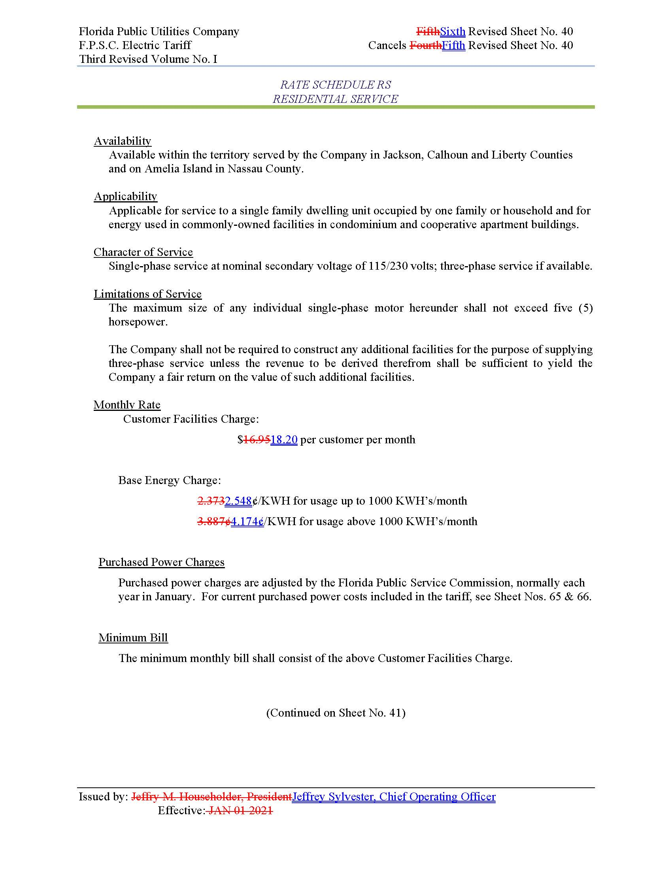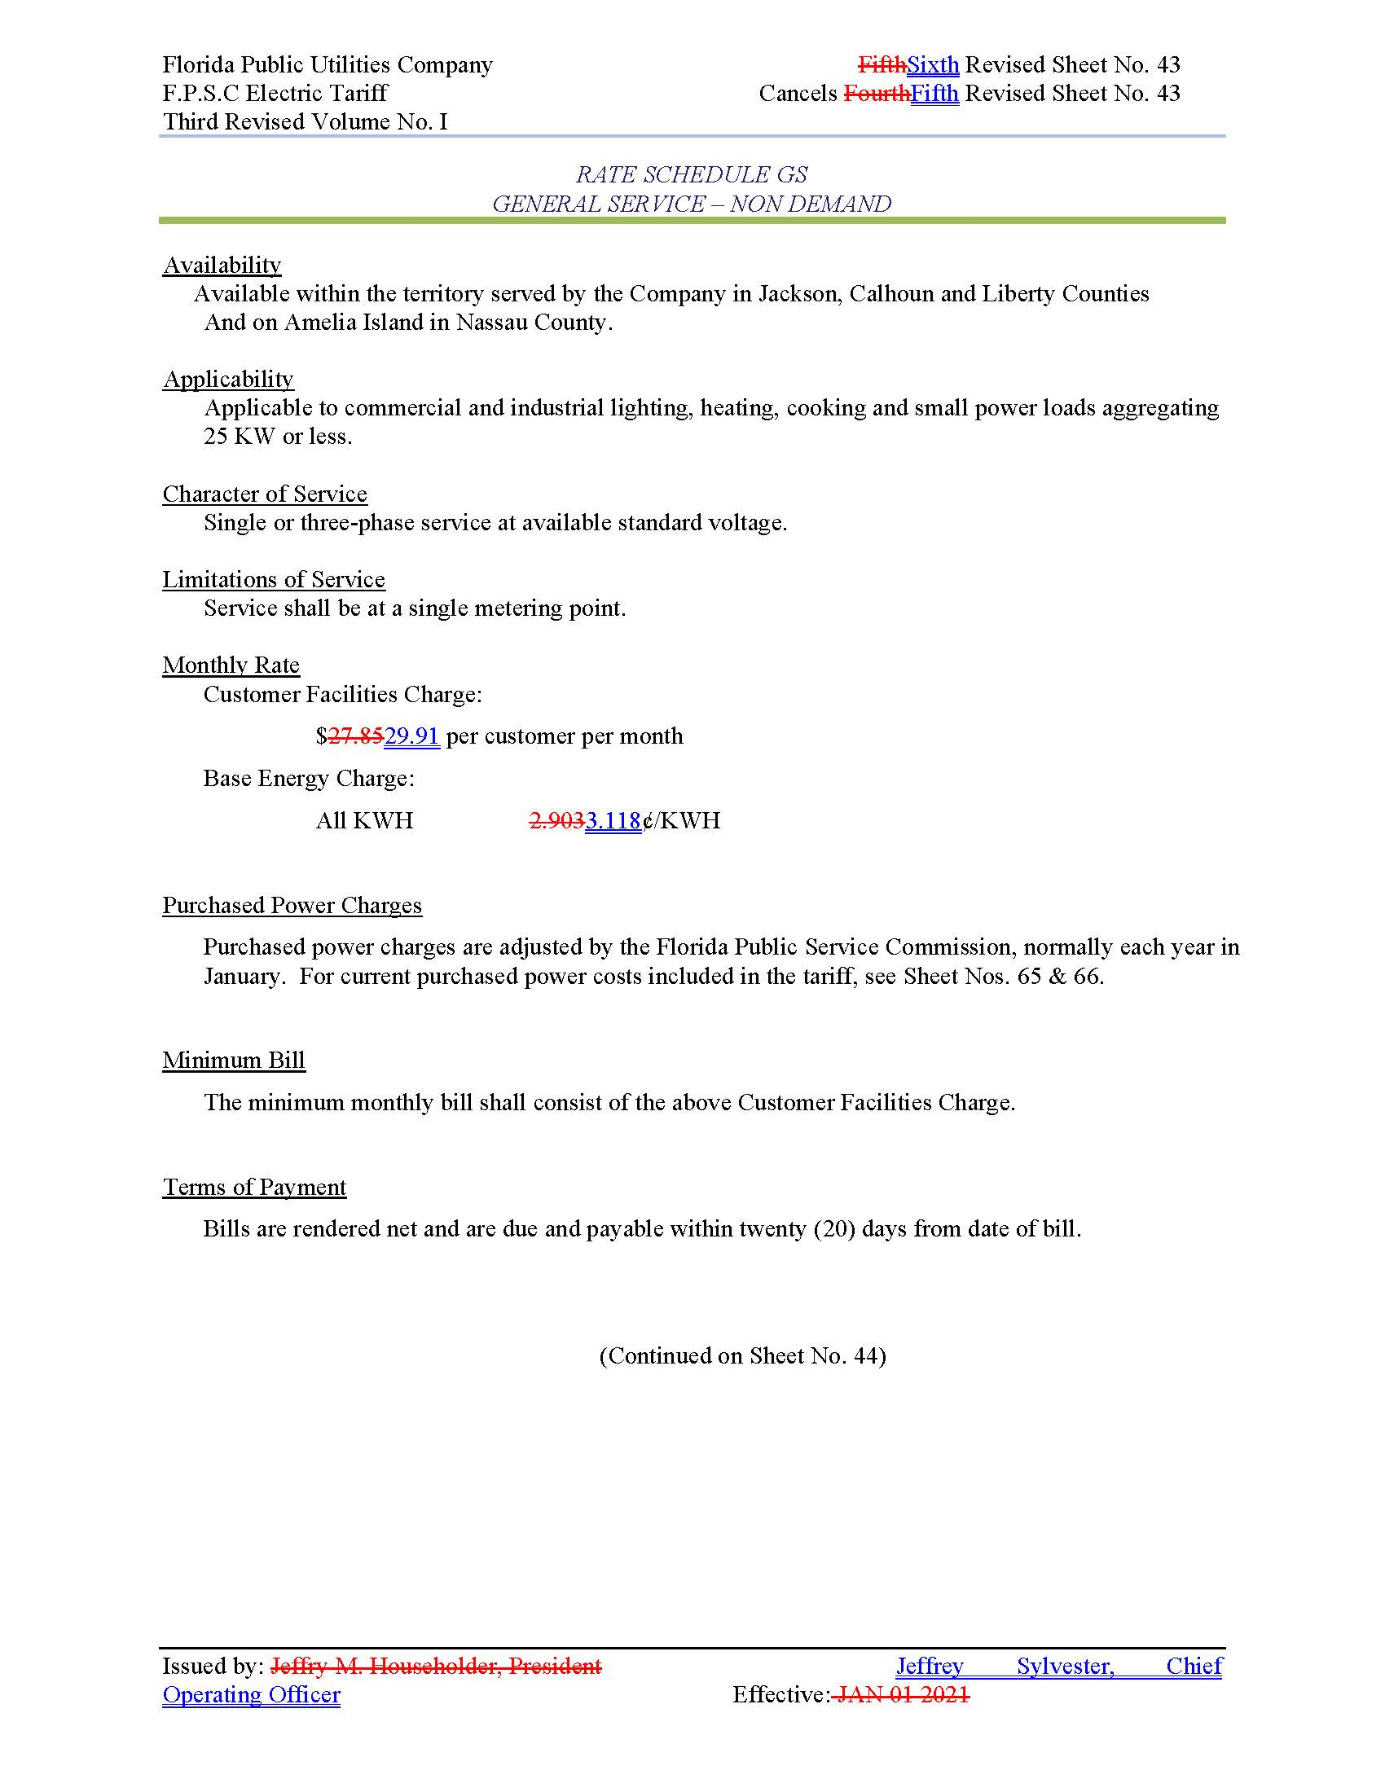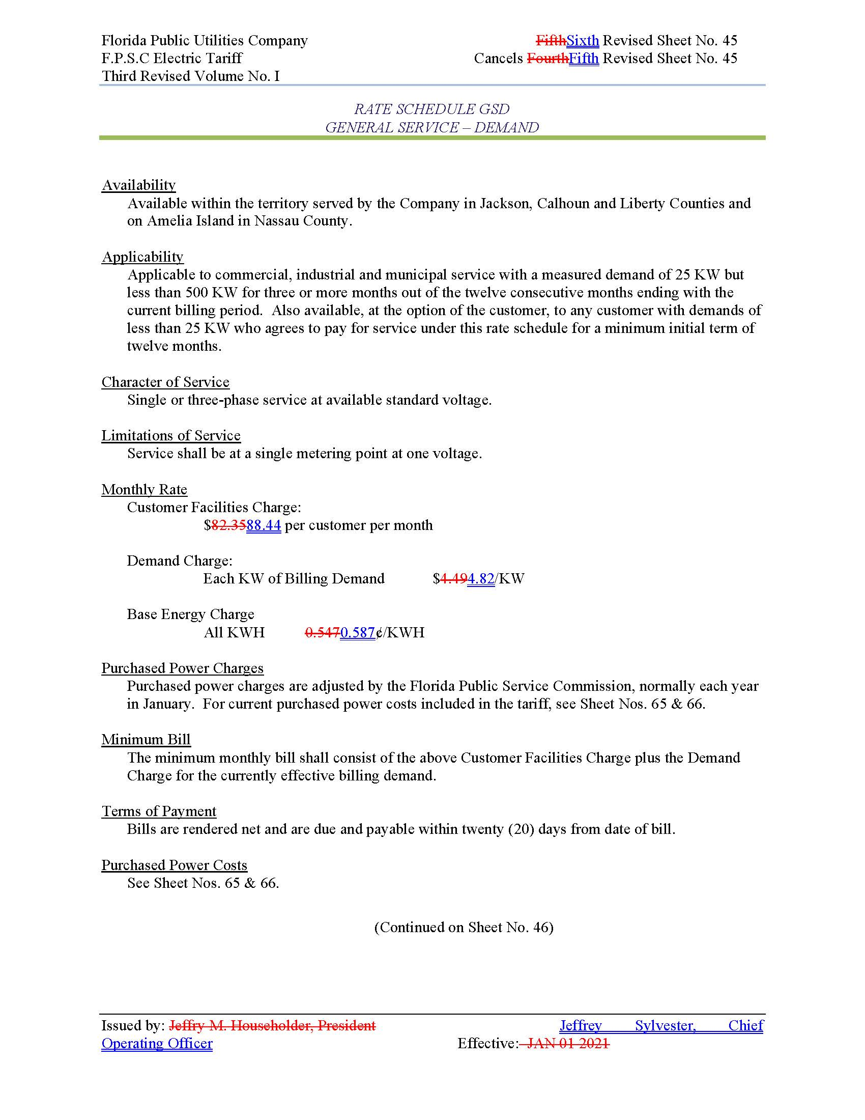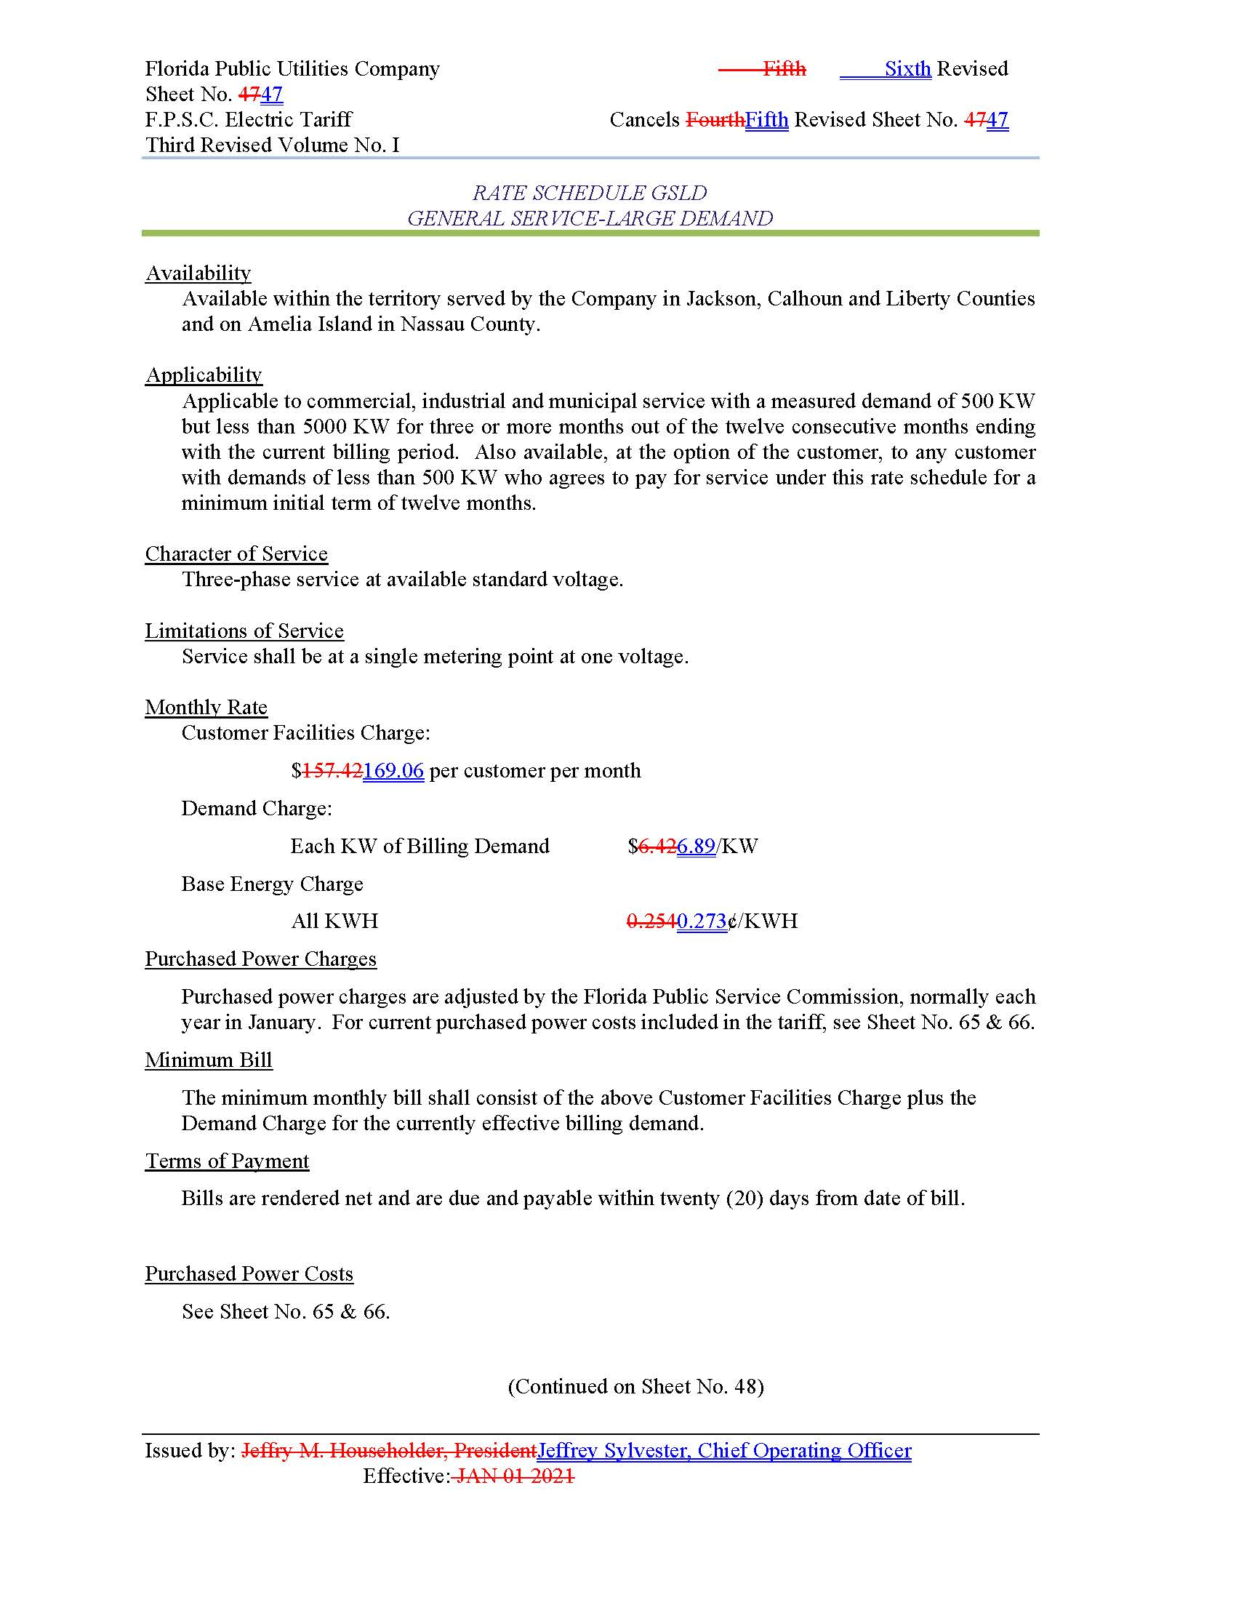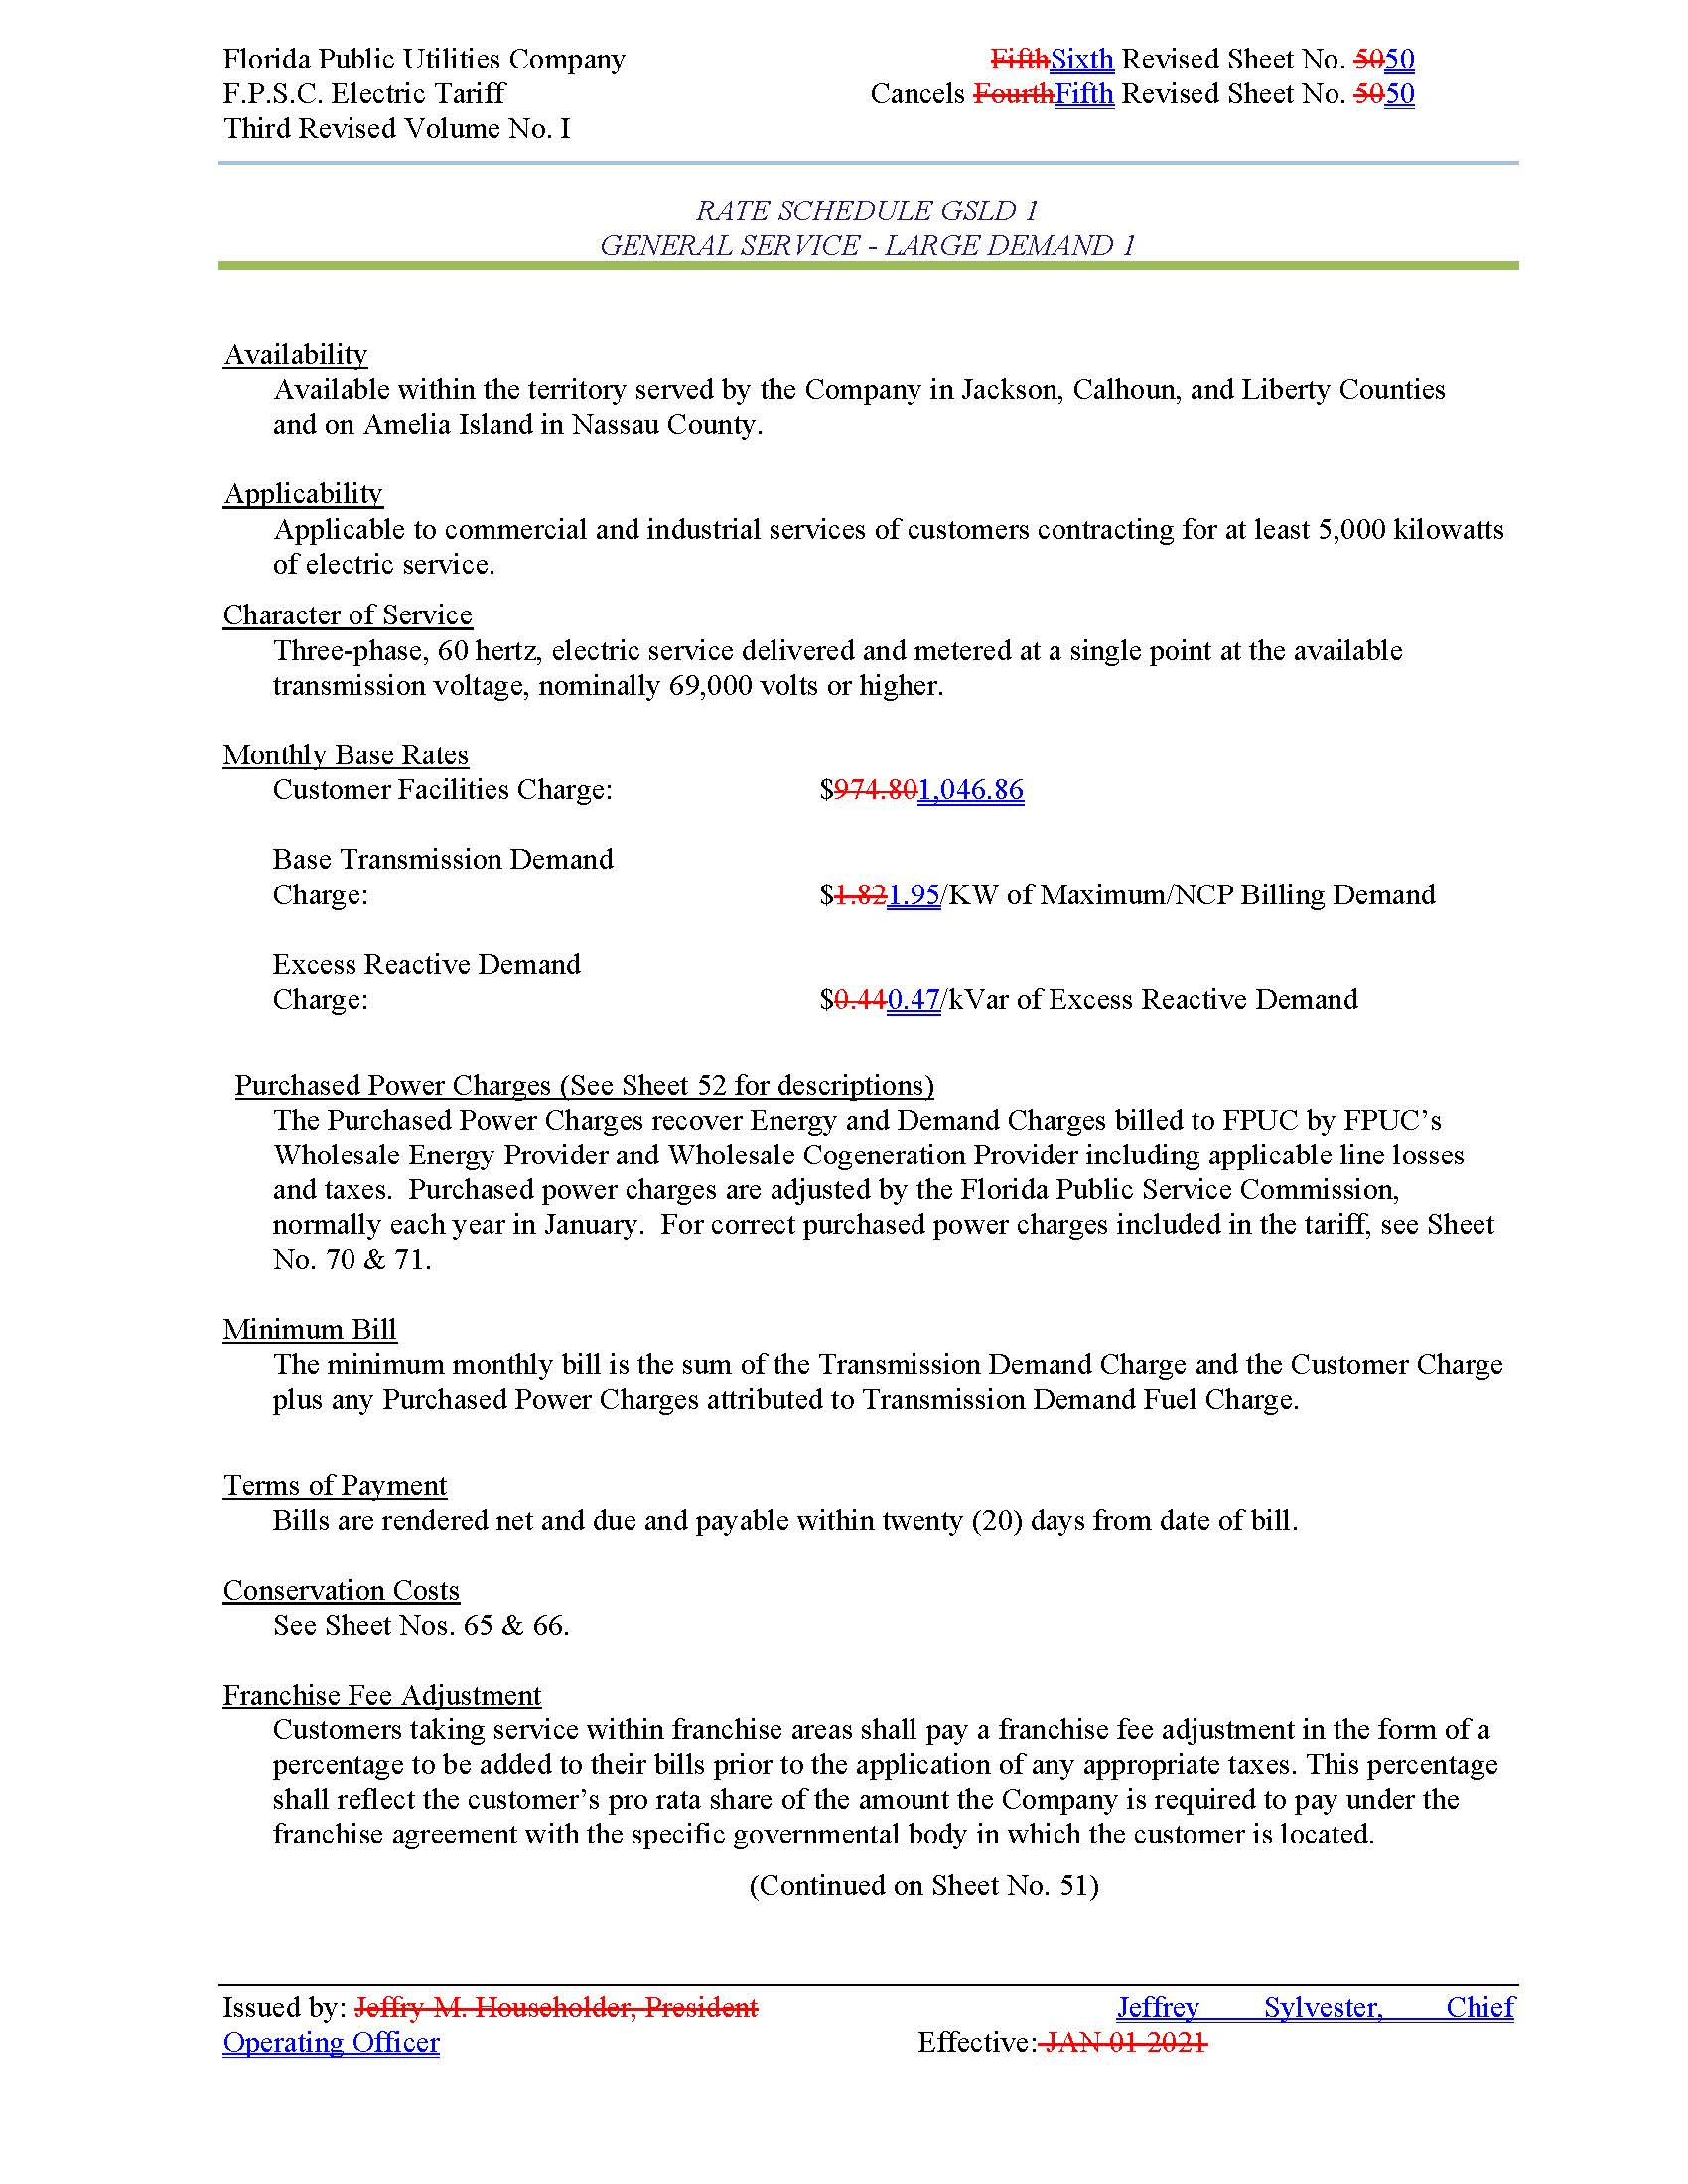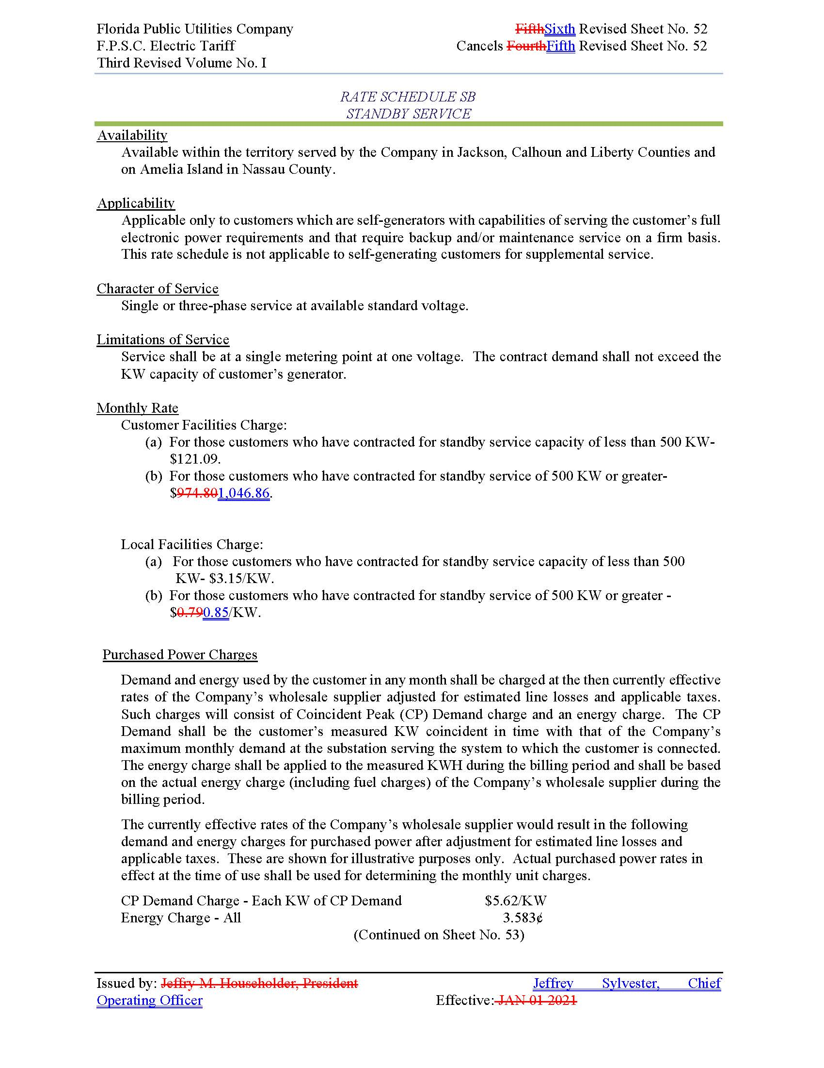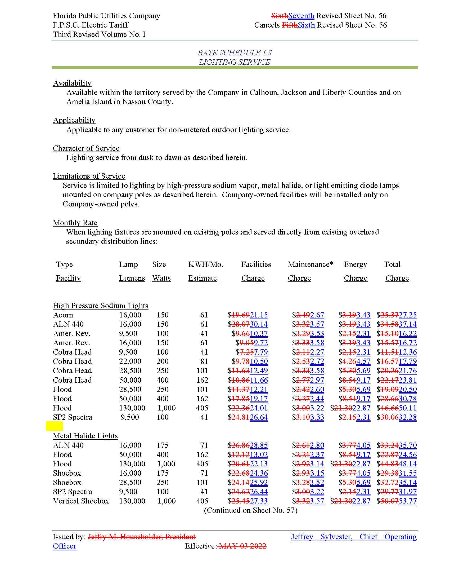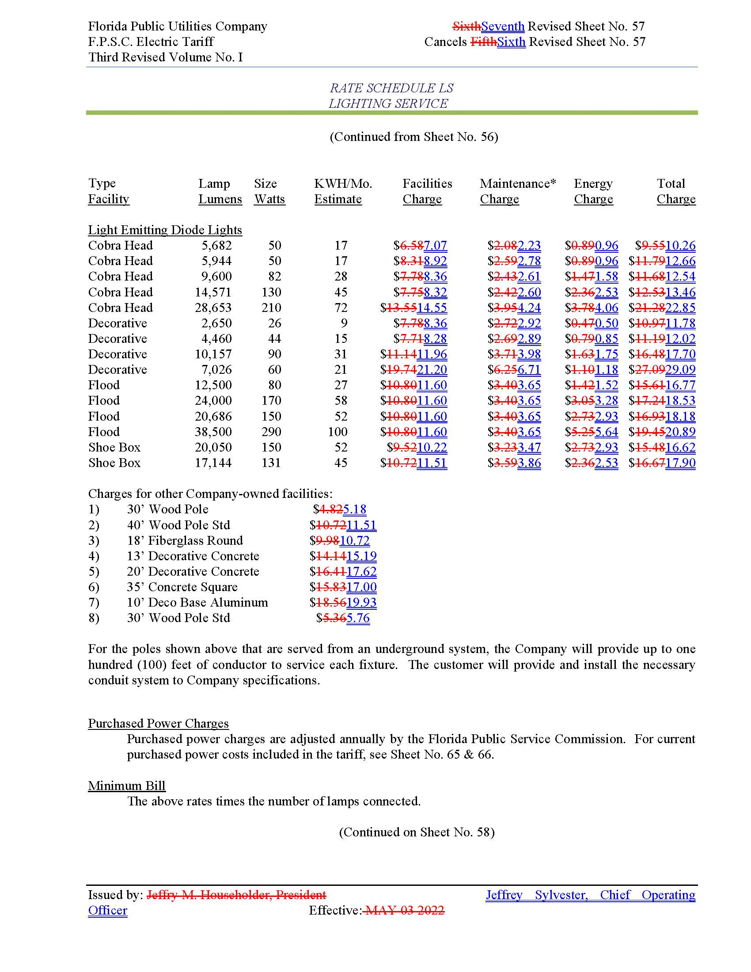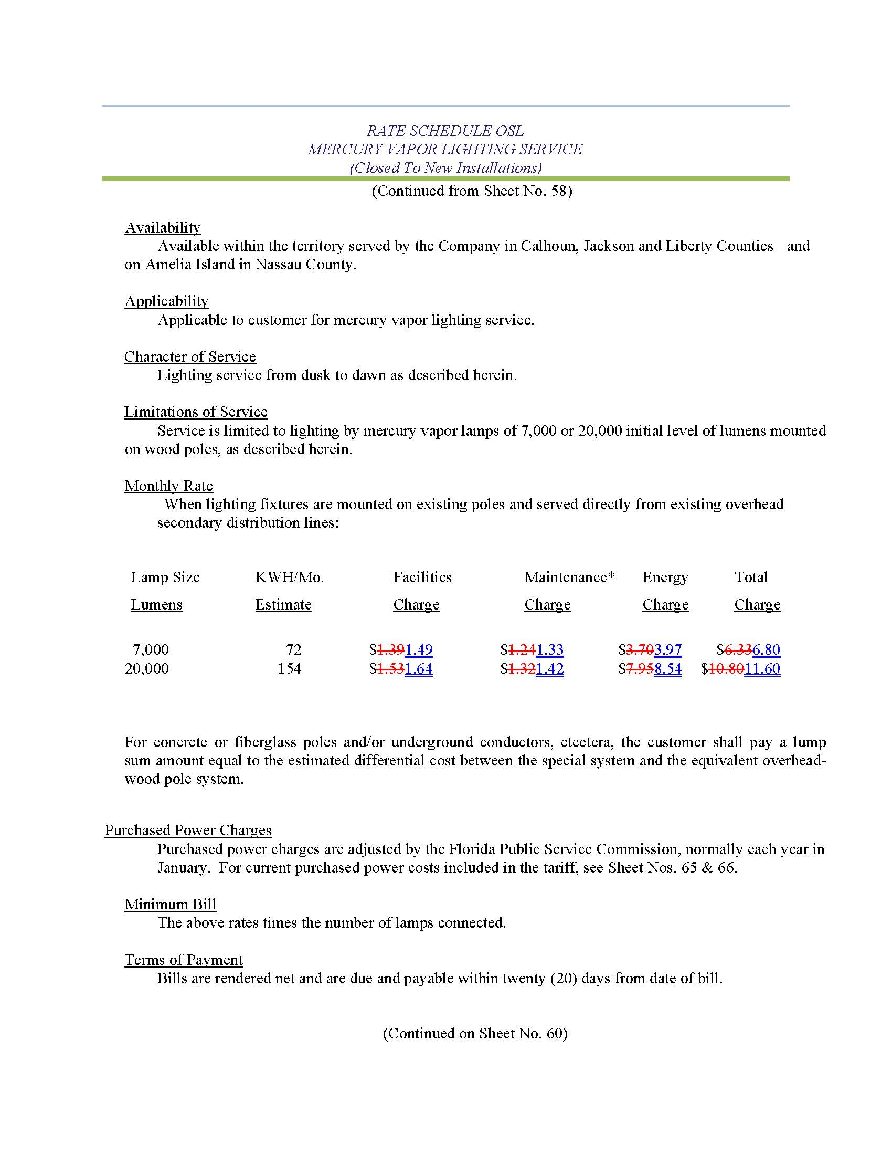

1. Order No. PSC-14-0517-S-EI, issued September 29, 2014, in Docket No. 20140025-EI, *In re: Application for rate increase by Florida Public Utilities Company*.
2. Order No. PSC-2024-0408-PCO-EI, issued September 5, 2024, in Docket No. 20240099-EI, *In re: Petition for rate increase by Florida Public Utilities Company*.
3. Order No. PSC-14-0517-S-EI, issued September 29, 2014, in Docket No. 140025-EI, *In re: Application for rate increase by Florida Public Utilities Company.*
4. *Id* at Page 2*.*
5. Order No. PSC-14-0517-S-EI, issued September 29, 2014, in Docket No. 140025-EI, *In re: Application for rate increase by Florida Public Utilities Company.*
6. *Id* at Page 2*.*