|  |  |  |  |
| --- | --- | --- | --- |
| State of Florida  pscSEAL | | Public Service Commission  Capital Circle Office Center ● 2540 Shumard Oak Boulevard Tallahassee, Florida 32399-0850  -M-E-M-O-R-A-N-D-U-M- | |
| DATE: | October 24, 2024 | | |
| TO: | Office of Commission Clerk (Teitzman) | | |
| FROM: | Division of Economics (McClelland, Hampson)  Office of the General Counsel (Sandy) | | |
| RE: | Docket No. 20240135-GU – Petition for approval of swing service rider, by Florida Public Utilities Company, Florida Public Utilities Company-Indiantown Division, Florida Public Utilities Company-Fort Meade, and Florida Division of Chesapeake Utilities Corporation. | | |
| AGENDA: | 11/05/24 – Regular Agenda – Tariff Filing – Interested Persons May Participate | | |
| COMMISSIONERS ASSIGNED: | | | All Commissioners |
| PREHEARING OFFICER: | | | Administrative |
| CRITICAL DATES: | | | 05/02/25 (8-Month Effective Date) |
| SPECIAL INSTRUCTIONS: | | | None |

Case Background

On September 3, 2024, Florida Public Utilities Company (FPUC or utility) filed a petition for approval of revised swing service rider rates and associated tariffs for the period January through December 2025. The swing service rider is a cents per therm charge that is included in the monthly gas bill of transportation customers, who purchase gas from third party marketers, and therefore do not pay the Purchased Gas Adjustment (PGA) charge.[1] FPUC is a local natural gas distribution company (LDC) subject to the regulatory jurisdiction of the Commission pursuant to Chapter 366, Florida Statutes (F.S.).

The Commission first approved FPUC’s swing service rider tariff by Order No. PSC-16-0422-TRF-GU (2016 Order) and the initial swing service rider rates were in effect for the period March through December 2017.[2] The swing service rider requires FPUC to file an annual petition to recalculate the swing service rider rates based on the utility’s actual interstate capacity costs and the most recent 12 months of usage data. Furthermore, the swing service order requires FPUC to incorporate the calculated revenues from the swing service rider as a credit to the PGA proceeding for the concurrent year. The January through December 2024 swing service rider rates were approved in Order No. PSC-2023-0358-TRF-GU.[3] The proposed modifications to the swing service rider rate schedule are indicated on Attachment A, with the proposed 2025 swing service rider tariffs on Attachment B.

By Order No. PSC-2024-0454-PCO-GU, issued October 17, 2024, the Commission suspended the proposed swing service rider tariffs for further review by staff. During evaluation of the petition, staff issued a data request to the utility for which responses were received October 3, 2024. This is staff’s recommendation to approve the proposed 2025 swing service rider rates and associated tariffs. The Commission has jurisdiction over this matter pursuant to Sections 366.04, 366.041, 366.05, and 366.06, F.S.

Discussion of Issues

Issue :

 Should the Commission approve the utility’s proposed swing service rider rates and associated tariffs for the period January through December 2025?

Recommendation:

 Yes, the Commission should approve the proposed swing service rider rates in Attachment B for the period January through December 2025. FPUC’s proposed swing service rider reflects the updated cost of swing service for transportation customers. Staff reviewed the total projected intrastate capacity costs and verified that the costs included are appropriate. Furthermore, the methodology for calculating the swing service rider rates is consistent with the 2016 Order. (McClelland)

Staff Analysis:

 The utility incurs intrastate capacity costs when it transports natural gas on intrastate pipelines (i.e., pipelines operating within Florida only). The utility has two types of natural gas customers: sales and transportation. Sales customers are primarily residential and small commercial customers that purchase natural gas from an LDC and receive allocations of intrastate capacity costs through the PGA charge. Transportation customers receive natural gas from third party marketers, known as shippers and, therefore, do not pay the PGA charge to the LDC.[4] The swing service rider allows FPUC to recover allocations of intrastate capacity costs from transportation customers.

Updated 2025 Swing Service Rider Rates

The updated 2025 swing service rider rates were calculated based on the same methodology approved in the 2016 Order. As stated in paragraph 7 of FPUC’s petition, the total intrastate capacity costs for the period July 2023 through June 2024 are $30,003,382, compared to $31,941,095 for the period July 2022 through June 2023. The total intrastate capacity costs reflect payments by FPUC to intrastate pipelines for the transportation of natural gas, pursuant to Commission-approved transportation agreements.

In response to staff’s first data request, FPUC clarified some costs included in the intrastate pipeline cost total, in Schedule D of the petition. Upon staff’s review, there appeared to be significant changes to some costs, which FPUC clarified were due to a change in the methods of organizing and classifying costs, and not a material change in costs themselves.[5] In previous years, the company had listed individual pipeline contracts on Schedule D. However, the 2025 filing combined all contracts under one line item, labeled “Peninsula Pipeline.” FPUC stated this was done for confidentiality purposes.[6] FPUC further stated there was a year-over-year increase of $1,518,270 to overall Peninsula Pipeline costs due to new projects becoming operational. [7] FPUC’s other intrastate capacity costs include payments associated with legal and consulting fees, software to manage forecasting, usage tracking, and market tracking.

In 2016, the initial order approving the swing service rider excluded Interruptible (COM-INTT) and Natural Gas Vehicle (COM-NGVT) transportation service because of the nature of their services. The utility explained, in its responses to staff’s first data request, that COM-INTT and COM-NGVT transportation customers were wrongly included in the 2024 swing service rider due to a change of personnel.[8] FPUC states they collected $150,891 from COM-INTT customers and $15,076 from COM-NGVT customers via the swing service rider. FPUC has refunded the affected customers and has corrected the 2025 swing service rider to remove the COM-INTT and COM-NGVT customer classes.[9]

Of the intrastate pipeline costs, $7,367,169 will be billed directly to certain large special contract customers. The remaining costs of $22,636,213 will be recovered during the period January 1, 2025 through December 31, 2025.

The utility used actual therm usage data for the period July 2023 through June 2024 to allocate the intrastate capacity costs. Based on the usage data, staff agrees that the appropriate split for allocating the cost is 69.96 percent or $15,837,062 to transportation customers and 30.04 percent or $6,799,151 to sales customers, as demonstrated on page 4 of FPUC’s petition. The transportation customers’ share of $15,837,062 is further allocated to the various transportation rate schedules in proportion with each rate schedule’s share of the utility’s total throughput. The sales customers’ share of the cost of $6,799,151 is embedded in the PGA.

To calculate the swing service rider rates, the transportation customers’ share of the cost is allocated to each transportation customer class and then divided by the customer class’ number of therms. The swing service revenues the utility has projected to receive in 2025 totals to $15,837,062.

Credit to the PGA

The total intrastate capacity costs are embedded in the PGA with the projected 2025 swing service rider revenues incorporated as a credit in the calculation of the 2025 PGA. The amount credited to the 2025 PGA is $15,837,062 plus $7,367,169 received from special contract customers, for a total of $23,204,231.[10]

Conclusion

After reviewing the information provided in the petition and in response to staff’s data request, staff recommends that the Commission should approve the proposed swing service rider rates in Attachment B for the period January through December 2025. FPUC’s proposed swing service rider reflects the updated cost of swing service for transportation customers. Staff reviewed the total projected intrastate capacity costs and verified that the costs included are appropriate. Furthermore, the methodology for calculating the swing service rider rates is consistent with the 2016 Order.

Issue 2:

 Should this docket be closed?

Recommendation:

 Yes. If Issue 1 is approved and a protest is filed within 21 days of the issuance of the order, the tariff should remain in effect, with any revenues held subject to refund, pending resolution of the protest. If no timely protest is filed, this docket should be closed upon the issuance of a consummating order. (Sandy)

Staff Analysis:

 Yes. If Issue 1 is approved and a protest is filed within 21 days of the issuance of the order, the tariff should remain in effect, with any revenues held subject to refund, pending resolution of the protest. If no timely protest is filed, this docket should be closed upon the issuance of a consummating order.

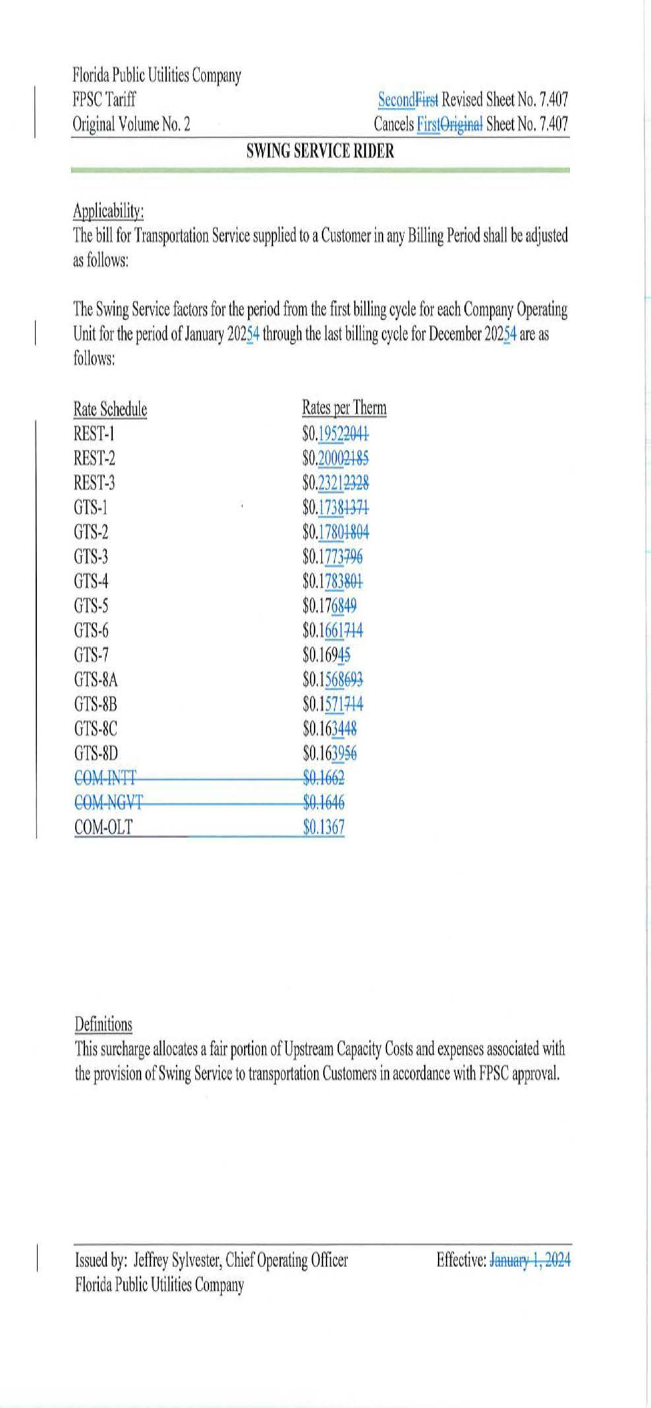

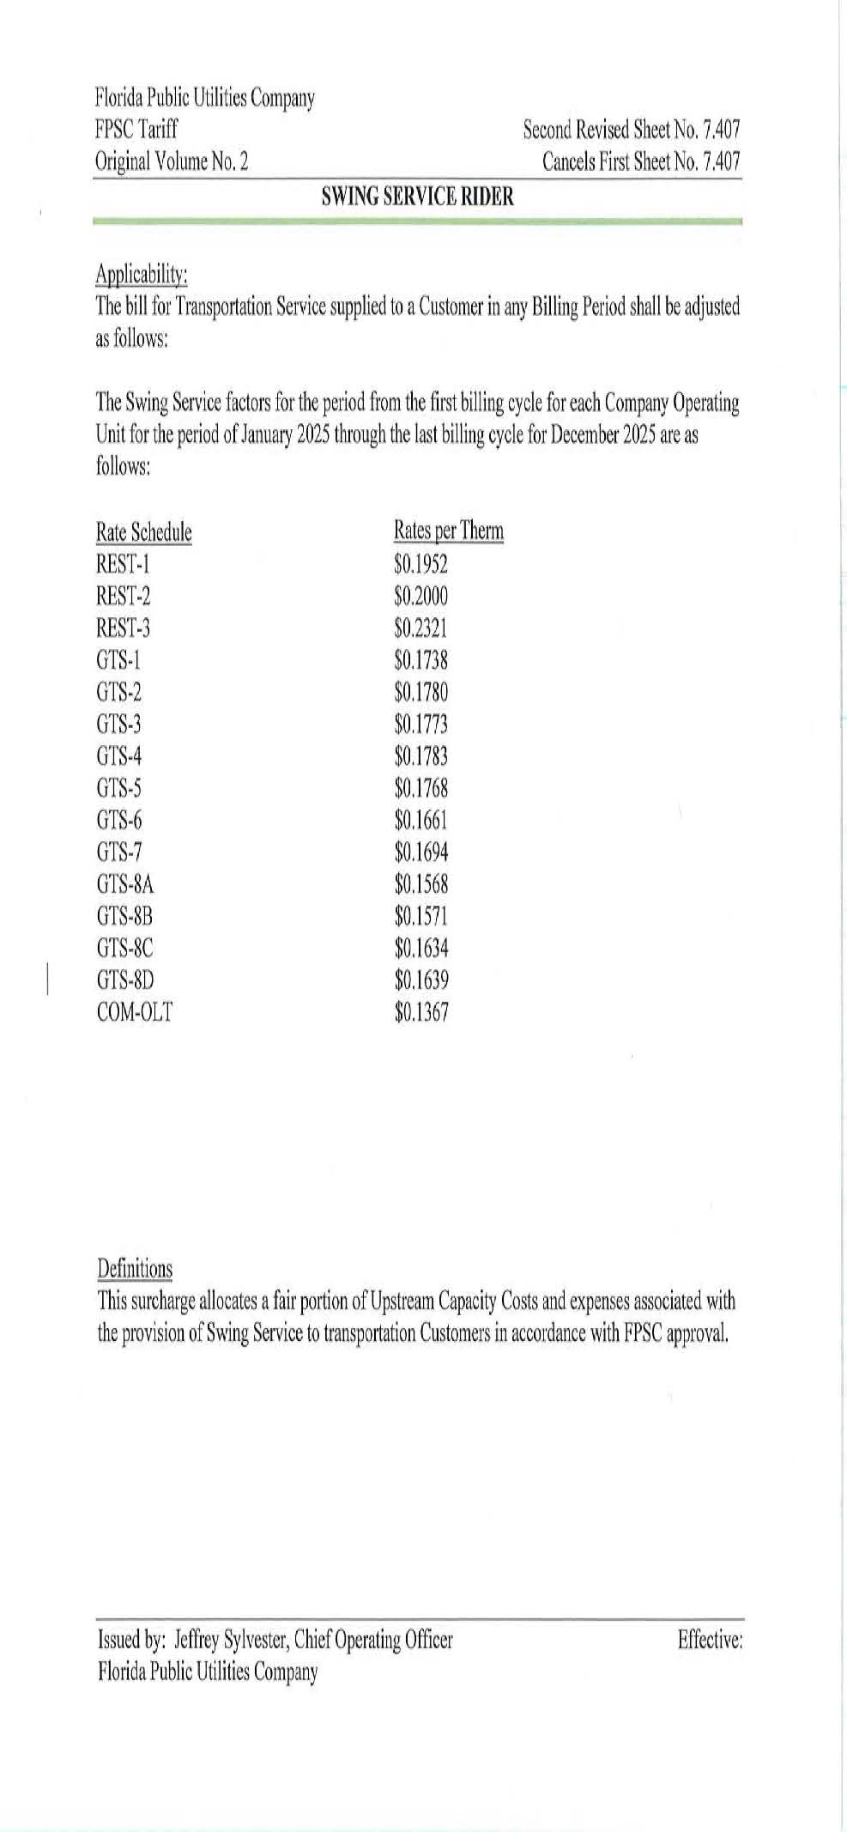

1. The PGA charge is set by the Commission in the annual PGA cost recovery clause proceeding.
2. Order No. PSC-16-0422-TRF-GU, issued October 3, 2016, in Docket No. 160085-GU, *In re: Joint petition for approval of swing service rider, by Florida Public Utilities Company, Florida Public Utilities Company-Indiantown Division, Florida Public Utilities Company-Fort Meade, and Florida Division of Chesapeake Utilities Corporation.*
3. Order No. PSC-2023-0358-TRF-GU, issued November 28, 2023, Docket No. 20230096-GU, *In re: Petition for approval of swing service rider rates for January through December 2024, by Florida Public Utilities Company.*
4. The Commission does not regulate the shippers or their charges for the gas commodity.
5. FPUC’s Responses to Staff’s First Data Requests, No. 6a.
6. FPUC’s Responses to Staff’s First Data Requests, No. 6a.
7. FPUC’s Responses to Staff’s First Data Requests, No. 6b.
8. FPUC’s Responses to Staff’s First Data Requests, No. 4a.
9. FPUC’s Responses to Staff’s First Data Requests, No. 4d.
10. See direct testimony of witness Stacey K. Laster on behalf of FPUC, filed on August 6, 2024, Document No. 08262-2024, in Docket No. 20240003-GU, Exhibit SKL-1, Schedule E-1, line 8 on page 1, and the direct testimony of Stacey K. Laster, page 3, line 21, through page 4, line 7, included in the petition.