|  |  |  |  |
| --- | --- | --- | --- |
| State of Florida  pscSEAL | | Public Service Commission  Capital Circle Office Center ● 2540 Shumard Oak Boulevard Tallahassee, Florida 32399-0850  -M-E-M-O-R-A-N-D-U-M- | |
| DATE: | November 21, 2024 | | |
| TO: | Office of Commission Clerk (Teitzman) | | |
| FROM: | Division of Economics (P. Kelley)  Office of the General Counsel (Dose) | | |
| RE: | Docket No. 20240134-GU – Petition for approval of safety, access, and facility enhancement program true-up and 2025 cost recovery factors, by Florida City Gas. | | |
| AGENDA: | 12/03/24 – Regular Agenda – Tariff Filing – Interested Persons May Participate | | |
| COMMISSIONERS ASSIGNED: | | | All Commissioners |
| PREHEARING OFFICER: | | | Administrative |
| CRITICAL DATES: | | | 04/30/25 (8-Month Effective Date) |
| SPECIAL INSTRUCTIONS: | | | None |

Case Background

On August 30, 2024, Florida City Gas (FCG or utility) filed a petition for approval of its safety, access, and facility enhancement (SAFE) program true-up and 2025 cost recovery factors. The SAFE program was originally approved by the Commission in Order No. PSC-15-0390-TRF-GU (2015 Order) to recover the cost of relocating on an expedited basis certain existing gas mains and associated facilities from rear lot easements to the street front.[1] In the 2015 Order, the Commission found that the relocation of mains and services to the street front provides for more direct access to the facilities and will enhance the level of service provided to all customers through improved safety and reliability. The Commission ordered FCG to relocate or replace 254.3 miles of mains and 11,443 associated service lines from rear property easements to the street over a 10-year period.

In the 2015 Order, the Commission also required the utility to file an annual petition to review and reset the SAFE factors to true-up any prior over-or under-recovery and to set the surcharge for the coming year. The SAFE program was originally approved as a 10-year program and was planned to finish in 2025.

During the utility’s 2022 rate case, the Commission approved a stipulation for the expansion of the SAFE program.[2] The parties agreed that the continuation of the SAFE program beyond its original 2025 expiration date and the relocation of an additional approximately 150 miles of mains and 13,874 services was reasonable.[3] The Commission further approved a stipulation for the replacement of approximately 160 miles and 8,059 associated services of “orange pipe,” through the SAFE program.[4]

In October 2024, the Commission approved FCG’s petition to modify the SAFE program to include replacing span pipes, burying shallow and exposed pipeline, and replacing obsolete pipe and related facilities.[5] The total estimated cost for the program modifications is $49.8 million over a 10-year period.[6] As described in paragraphs 10 and 11 of the instant petition, FCG prepared two versions of its annual SAFE true-up, one including the SAFE modifications and one without any modifications. As a result of the Commission’s approval of the SAFE program modifications in Docket No. 20240071-GU, staff has relied upon Attachments A-2, B-2, C-2, and D-2 to the instant petition for its analysis of the proposed SAFE program rates.

By Order No. PSC-2024-0451-PCO-GU, issued October 16, 2024, the Commission suspended the proposed tariffs to allow staff sufficient time to analyze the utility’s filing, pursuant to Section 366.06(3), Florida Statutes (F.S.). Commission staff issued its first data request to FCG on September 17, 2024, for which FCG provided a response on October 1, 2023.

FCG’s annual progress in the SAFE program is shown in Attachment A to the recommendation. The proposed 2025 SAFE factors are shown in Attachment B to the recommendation on Seventh Revised Sheet No. 79. The Commission has jurisdiction over the matter pursuant to Sections 366.04, 366.041, 366.05, and 366.06, F.S.

Discussion of Issues

Issue :

 Should the Commission approve FCG's proposed SAFE tariffs for the period January through December 2025?

Recommendation:

 Yes. The Commission should approve FCG’s proposed SAFE tariff for the period January through December 2025. After reviewing FCG’s filings and supporting documentation, the calculations of the 2025 SAFE factors appear consistent with the methodology approved in the 2015 Order and are reasonable and accurate. (P. Kelley)

Staff Analysis:

As required by the 2015 Order, the utility’s calculations for the 2025 revenue requirement and SAFE factors include a final true-up for 2023, an estimated/actual true-up for 2024, and projected costs for 2025. During 2024, the utility replaced 28.5 miles of mains and 1,283 services.[7]

Final True-ups for 2023

FCG stated that the revenues collected for 2023 were $694,998, compared to a revenue requirement of $2,436,443 resulting in an under-recovery $1,741,445. Adding the 2022 final under-recovery of $37,236 and the $1,741,445 under-recovery of 2023, including interest, results in a final 2023 under-recovery of $1,842,805.[8]

Actual/Estimated 2024 True-up

FCG provided actual revenues for January through June and forecasted revenues for July through

December 2024, totaling $4,695,456 as compared to a projected revenue requirement of $3,733,272, resulting in an over-recovery of $962,183. Adding the 2023 under-recovery of $1,852,753 to the 2024 over-recovery of $962,183, the resulting total 2024 true-up, including interest, is an under-recovery of $973,939.

Projected 2025 Costs

The utility’s projected investment for 2025 is $61,149,679 for its projects located in Miami-Dade and Brevard counties. The revenue requirement, which includes a return on investment, depreciation, and taxes is $6,538,096. The return on investment calculation includes federal income taxes, regulatory assessment fees, and bad debt. After adding the 2024 over-recovery of $973,939, the total 2025 revenue requirement is $7,512,034. Table 1-1 displays the projected 2025 SAFE program revenue requirement calculation.

Table -1

2025 SAFE Program Revenue Requirements Calculation

|  |  |
| --- | --- |
| 2025 Projected Investment | $61,149,679 |
| Return on Investment | $4,611,042 |
| Depreciation Expense | $1,043,316 |
| Property Tax Expense | $883,738 |
| 2025 Revenue Requirement | $6,538,096 |
| Plus 2024 Under-recovery | $973,939 |
| Total 2025 Revenue Requirement | $7,512,034 |

Source: Page 5 of Attachment C of the petition.

Proposed 2025 SAFE Factors

The SAFE factors are fixed monthly charges. FCG’s cost allocation methodology was approved in the 2015 Order and was used in the instant filing. The approved methodology allocates the current cost of a 2-inch pipe to all customers on a per customer basis and allocates the incremental cost of replacing a 4-inch pipe to customers who use over 6,000 therms per year. For customers who require 4-inch pipes, the cost takes into account that the minimum pipe is insufficient to serve their demand, and therefore, allocates an incremental per foot cost in addition to the all-customer cost. The resulting allocation factors are applied to the 2025 total revenue requirement to develop the monthly SAFE factors.

The proposed fixed monthly SAFE factor is $4.66 for customers using less than 6,000 therms per year (current factor is $3.17). The proposed fixed monthly SAFE factor for customers using more than 6,000 therms per year is $7.77 (current factor is $5.44).

Conclusion

The Commission should approve FCG’s proposed SAFE tariff for the period January through December 2025. After reviewing FCG’s filings and supporting documentation, the calculations of the 2025 SAFE factors appear consistent with the methodology approved in the 2015 order and are reasonable and accurate.Issue :

 Should this docket be closed?

Recommendation:

 Yes. If Issue 1 is approved and a protest is filed within 21 days of the issuance of the order, the tariffs should remain in effect, with any revenues held subject to refund, pending resolution of the protest. If no timely protest is filed, this docket should be closed upon the issuance of a consummating order. (Dose)

Staff Analysis:

 Yes. If Issue 1 is approved and a protest is filed within 21 days of the issuance of the order, the tariffs should remain in effect, with any revenues held subject to refund, pending resolution of the protest. If no timely protest is filed, this docket should be closed upon the issuance of a consummating order.

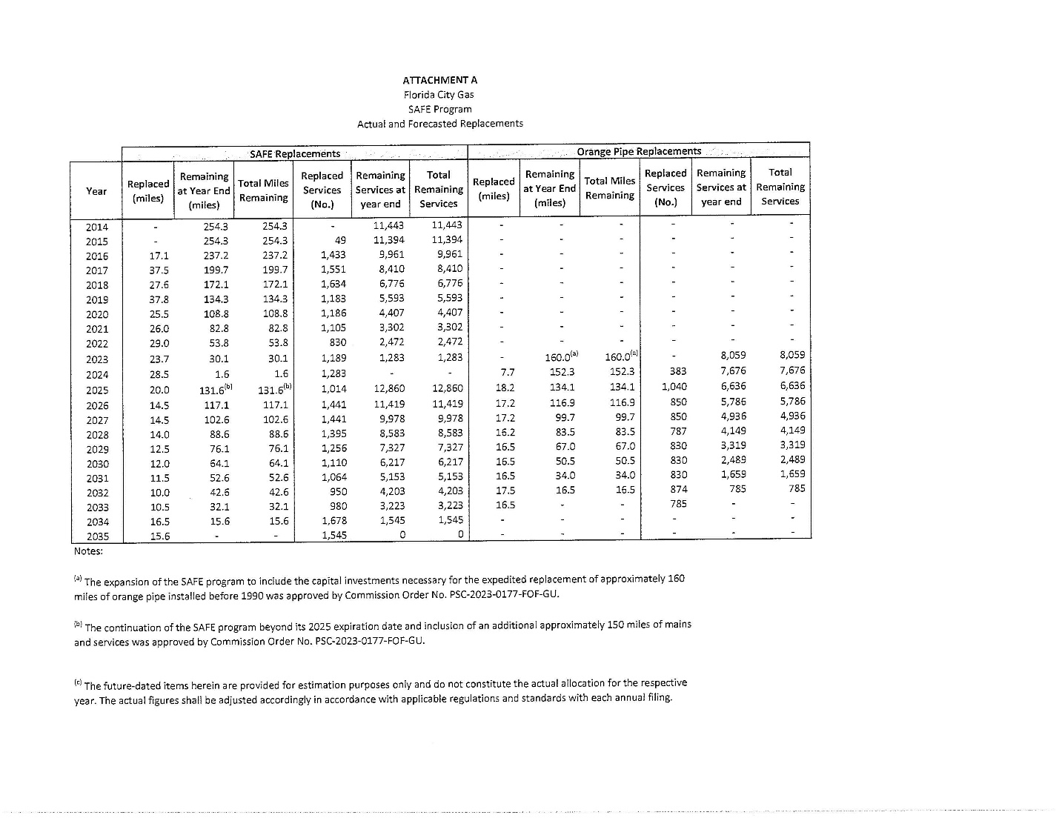

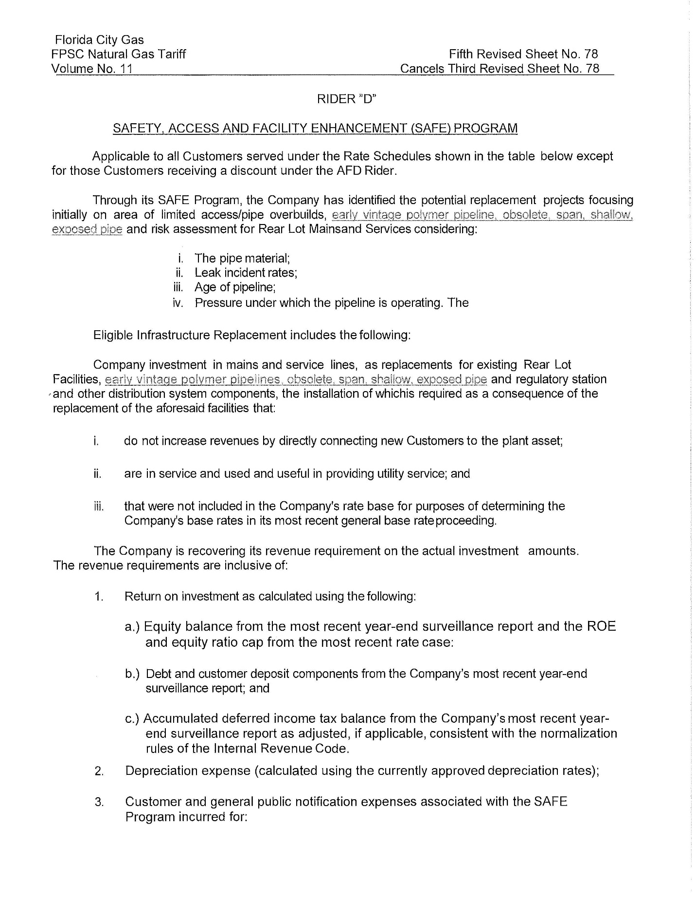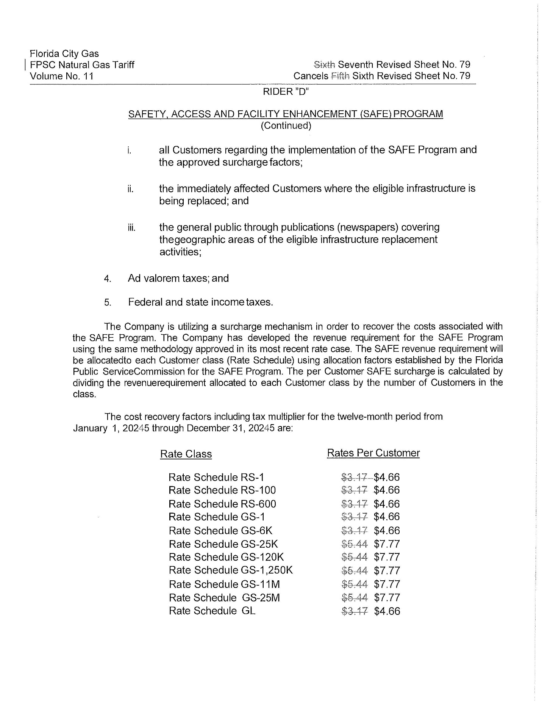

1. Order No. PSC-15-0390-TRF-GU, issued September 15, 2015, in Docket No. 20150116-GU, *In re: Petition for approval of safety, access, and facility enhancement program and associated cost recovery methodology, by Florida City Gas.*
2. Order No. PSC-2023-0177-FOF-GU, issued June 9, 2023, in Docket No. 20220069-GU, *In re: Petition for rate increase by Florida City Gas.*
3. See page 72, Section X, B. of Order No. PSC-2023-0177-FOF-GU.
4. See page 72, Section X, C. of Order No. PSC-2023-0177-FOF-GU.
5. Order No. PSC-2024-0438-PAA-GU, issued October 2, 2024, in Docket No. 20240071-GU, *In re: Petition for approval of safety, access, and facility enhancement program modifications, by Florida City Gas.*
6. See Attachment B to Document No. 04172-2024.
7. See page 1 of Attachment A to Document No. 08785-2024.
8. The calculation also includes a December 2022 true-up of $26,525 booked in January 2023.