|  |  |  |  |
| --- | --- | --- | --- |
| State of Florida  pscSEAL | | Public Service Commission  Capital Circle Office Center ● 2540 Shumard Oak Boulevard Tallahassee, Florida 32399-0850  -M-E-M-O-R-A-N-D-U-M- | |
| DATE: | November 21, 2024 | | |
| TO: | Office of Commission Clerk (Teitzman) | | |
| FROM: | Division of Economics (Guffey)  Office of the General Counsel (Brownless) | | |
| RE: | Docket No. 20240137-GU – Petition for approval of GUARD cost recovery factors, by Florida Public Utilities Company. | | |
| AGENDA: | 12/03/24 – Regular Agenda – Tariff Filing – Interested Persons May Participate | | |
| COMMISSIONERS ASSIGNED: | | | All Commissioners |
| PREHEARING OFFICER: | | | Administrative |
| CRITICAL DATES: | | | 05/03/25 (8-Month Effective Date) |
| SPECIAL INSTRUCTIONS: | | | None |

Case Background

On September 3, 2024, Florida Public Utilities Company (FPUC or Company) filed a petition for approval of its Gas Utility Access and Replacement Directive (GUARD program) cost recovery factors for January through December 2025. The petition includes the direct testimony and Exhibits SKL-1 and SKL-2 of Stacey K. Laster providing the calculations of the proposed factors and Second Revised Sheet No. 7.403.

In Order No. PSC-2023-0235-PAA-GU (GUARD Order), the Commission approved FPUC’s 10-year GUARD program consisting of two components: (1) replacement of problematic pipes and facilities and (2) relocation of mains and service lines located in rear easement and other difficult to access areas to the front lot easements.[1] As established in the GUARD Order, FPUC is able to recover the revenue requirements of expedited programs to replace problematic pipes and facilities and to relocate certain facilities in rear easements and other difficult to access areas in order to enhance the safety of portions of FPUC’s natural gas distribution system through a monthly surcharge on customers’ bills. The GUARD Order further established the methodology for annually setting the GUARD surcharge to recover the costs of the program.

The methodology to calculate the GUARD program surcharges is the same that was approved for FPUC’s concluded Gas Replacement and Infrastructure Program (GRIP).[2] The GUARD cost recovery procedure requires an annual filing with three components, similar as those approved in the 2012 GRIP Order:

1. A final true-up showing the actual replacement costs, actual surcharge revenues, and over- or under-recovery amount for the 12-month historical period from January 1 through December 31 of the year prior to FPUC’s annual GUARD petition.

2. An actual/estimated true-up showing seven months of actual and five months of projected replacement costs, surcharge revenues, and over- or under-recovery amount.

3. A revenue requirement projection showing 12 months of projected GUARD revenue requirement for the period beginning January 1 following FPUC’s annual GUARD petition filing.

In the GUARD Order, the Commission directed FPUC to file its annual GUARD program petition to revise the surcharge on or before September 1 of each year, to implement the revised surcharge effective January 1 through December 31 of the following year.

The Commission further ordered FPUC to: (1) include all calculations to show a final true-up, actual-estimated true-up, projected year investments, and associated revenue requirements, and the calculations of the GUARD factors by rate class; (2) provide a report including the location, date, description, and associated costs of all replacement projects completed and all projects scheduled for the following year; and (3) include any remaining GRIP over- or under-recovery in the 2024 GUARD cost recovery. FPUC has complied with the GUARD Order directives stated above.

Included in this recommendation are Attachment A - a list of GUARD projects for 2023-2025 Actual/Forecast; Attachment B - Second Revised Sheet No. 7.403 legislative version; and Attachment C - Second Revised Sheet No. 7.403 clean version.

During the review process, staff issued a data request to FPUC on September 23, 2024, for which the responses were received on October 8, 2024. In Order No. PSC-2024-0440-PCO-GU, the Commission suspended the proposed tariffs. The Commission has jurisdiction over this matter pursuant to Sections 366.04, 366.05, and 366.06, Florida Statutes (F.S.).

Discussion of Issues

Issue :

 Should the Commission approve FPUC's 2025 Gas Utility Access and Replacement Directive (GUARD) cost recovery factors and associated Second Revised Sheet No. 7.403 for the period January to December 2025?

Recommendation:

 Yes. The Commission should approve FPUC's 2025 GUARD cost recovery factors and associated Second Revised Sheet No. 7.403, included in Attachment B to this recommendation, to be effective for the first billing cycle of January through the last billing cycle of December 2025. The GUARD surcharge would allow FPUC to replace problematic pipes and facilities and relocate certain facilities located in rear easements to the front easements, and recover the project costs on an expedited basis. (Guffey)

Staff Analysis:

 The GUARD program is driven by risks identified under FPUC’s Distribution Integrity Management Program (DIMP) and risk assessments performed by an independent contractor.[3] As stated by witness Laster, the GUARD projects are based upon the assessment of an independent contractor. Projects in high consequence areas and those of high risk continue to be a priority. The prioritized projects for 2024 and 2025 are included in Attachment A to this recommendation. Attachment A indicates that FPUC currently has six projects in-progress which will relocate 30.7 miles of pipes from rear lots to the street front in Palm Beach and Seminole counties for an estimated investment cost of $18.7M during the third and fourth quarters of 2024. Additional five projects are scheduled for the fourth quarter of 2024, for an estimated investment cost of $3.9M which includes replacing 10.77 miles of obsolete/Aldyl-A, rear-to-front, shallow, span, and under building pipes, and replacing 176 services. For 2025, 18 projects which include replacing obsolete/Aldyl-A pipes, span pipes, and relocation of pipes from rear lot easements to the front lot easements for 36.19 miles and 2,203 services in Palm Beach, Seminole, and Volusia counties are listed for an estimated investment cost of $25M.

FPUC’s True-Ups by Year

FPUC’s calculation for the 2025 GUARD revenue requirement and surcharges includes a final true-up for 2023, an actual/estimated true-up for 2024, and projected costs for 2025. In its 2022 rate case, FPUC was authorized to recover $19.8M of annual bare steel replacement expenses in base rates.[4] Therefore, the $19.8M recovered from base rates is excluded from the GUARD true-up calculations for 2022 and 2023.

Final 2023 GUARD True-Up

Company witness Laster states that the January through December 2023 true-up resulted in an over-recovery of $571,835, inclusive of interest and remaining true-up of the concluded GRIP. As shown in Schedule C-1 of the petition, the 2022 ending balance was an over-recovery of $315,465. Combined with the 2023 over-recovery of $248,063, and monthly interest of $8,307 associated with any over- and under-recoveries results in a final 2023 over-recovery of $571,835.

Actual/Estimated 2024 GUARD True-Up

The January through December 2023 GUARD investment and associated revenue requirement amounts are shown on Exhibit SKL-1, page 2 of 6. In 2023, the actual beginning balance was an over-recovery of $571,835. The 2024 actual (January through July) and forecasted (August through December) GUARD true-up is an under-recovery of $1,257,430 (inclusive of interest), resulting in an under-recovery of $685,595. As shown in Table 1-1 below, the under-recovery is being applied to the 2025 GUARD revenue requirement, resulting in a higher revenue requirement to be recovered from customers in 2025.

Projected 2025 GUARD Revenue Requirement

For 2025, FPUC plans to invest $25,000,205 ($16,167,834 for mains and $8,832,371 for services), resulting in a total projected 2025 investment of $75,739,119 (including the year-end 2024 investment). The GUARD program revenue requirement includes a return on investment, depreciation expense, extending customer-owned fuel lines (to connect to meters which require to be relocated due to safety issues), customer notification expense, and property taxes. All expenses are dependent upon the level of investment costs. After adding the 2024 under-recovery true-up amount of $685,595, the 2025 GUARD revenue requirement to be recovered through the proposed surcharges is $7,013,251.

Table 1-1

2025 GUARD Revenue Requirement Calculation

|  |  |
| --- | --- |
| **2025 Projected Investment $75,739,119** | |
| 2025 Return on Investment | $4,325,414 |
| Depreciation Expense | $1,023,258 |
| Fuel Line Expense | 8,400 |
| Property/Ad Valorem Tax Expense | $928,584 |
| Customer Notification Expense | $42,000 |
| 2025 GUARD Revenue Requirement | $6,327,656 |
| Plus 2024 Under-Recovery | $685,595 |
| 2025 Total Revenue Requirement | $7,013,251 |

Source: Witness Laster’s Testimony Exhibit SKL-1, Schedule C-2, Page 4 of 7.

Proposed GUARD Surcharges

As approved in the GUARD Order, the total 2025 revenue requirement is allocated to the rate classes using the same methodology used for the allocation of mains and services in the cost of service study used in the Company’s most recent rate case. The respective percentages were multiplied by the 2025 revenue requirements and divided by each rate class’s projected therm sales to provide the GUARD surcharge for each rate class. This methodology was originally established by the 2012 Order approving FPUC’s GRIP program.

In 2024, the monthly bill impact was $0.65 for a residential customer using 20 therms per month or $7.80 per year. The proposed 2025 GUARD surcharge for FPUC’s residential customers who use 20 therms a month (240 therms annually) on the Residential Service tariff (RES-2) would pay $0.11116 per therm compared to the 2024 GUARD surcharge of $0.03263 per therm. The monthly bill impact for 2025 would be $2.22 for a residential customer using 20 therms per month or $26.64 per year. The proposed GUARD surcharges are shown in Attachment B, in Second Revised Sheet No. 7.403.

Conclusion

The Commission should approve FPUC's 2025 GUARD cost recovery factors and associated Second Revised Sheet No. 7.403, included in Attachment B to this recommendation, to be effective for the first billing cycle of January through the last billing cycle of December 2025. The GUARD surcharge would allow FPUC to replace problematic pipes and facilities and relocate certain facilities located in rear easements to the front easements, and recover the project costs on an expedited basis.

Issue :

 Should this docket be closed?

Recommendation:

 Yes. If a protest is filed within 21 days of the issuance of the order, the tariffs should remain in effect, with any revenues held subject to refund, pending resolution of the protest. If no timely protest is filed, this docket should be closed upon the issuance of a consummating order. (Brownless)

Staff Analysis:

 If a protest is filed within 21 days of the issuance of the order, the tariffs should remain in effect, with any revenues held subject to refund, pending resolution of the protest. If no timely protest is filed, this docket should be closed upon the issuance of a consummating order.



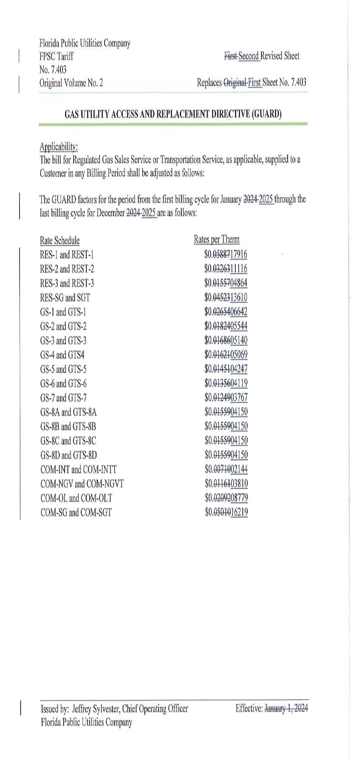

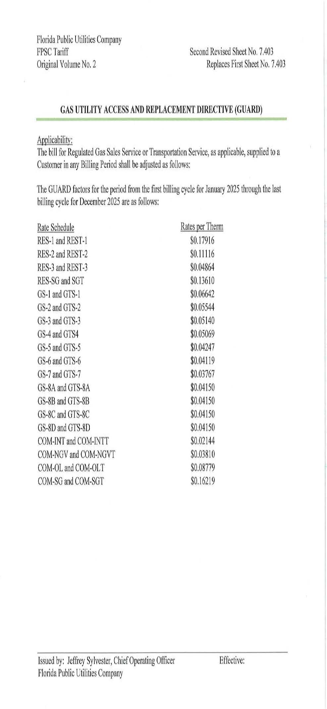

1. Order No. PSC-2023-0235-PAA-GU, issued August 15, 2023, amended by Order No. PSC-2023-0235A-PAA-GU, issued August 18, 2023, in Docket No. 20230029-GU, *In re: Petition for approval of gas utility access and replacement directive, by Florida Public Utilities Company.*
2. Order No. PSC-2012-0490-TRF, issued September 24, 2021, in Docket No. 20120036-GU, *In re: Joint petition for approval of Gas Reliability Infrastructure Program (GRIP) by Florida Public Utilities Company and the Florida Division of Chesapeake Utilities Corporation.*
3. Pursuant to Chapter 49, Section 192.1005 Code of Federal Regulations (2023), a gas distribution operator must develop and implement an integrity management program that includes a written integrity management plan.
4. Order No. PSC-2023-0103-FOF-GU, issued March 15, 2023, in Docket No. 20220067-GU, *In re: Petition for rate increase by Florida Public Utilities Company, Florida Division of Chesapeake Utilities Corporation, Florida Public Utilities Company - Fort Meade, and Florida Public Utilities Company - Indiantown Division.*