|  |  |  |  |
| --- | --- | --- | --- |
| State of Florida  pscSEAL | | Public Service Commission  Capital Circle Office Center ● 2540 Shumard Oak Boulevard Tallahassee, Florida 32399-0850  -M-E-M-O-R-A-N-D-U-M- | |
| DATE: | December 20, 2024 | | |
| TO: | Office of Commission Clerk (Teitzman) | | |
| FROM: | Division of Economics (Ward, McClelland, Barrett)  Division of Accounting and Finance (Vogel, Norris)  Office of the General Counsel (Dose, Crawford, Farooqi) | | |
| RE: | Docket No. 20240046-GU – Petition for rate increase by St. Joe Natural Gas Company, Inc.  Docket No. 20240004-GU – Natural gas conservation cost recovery. | | |
| AGENDA: | 01/07/25 – Regular Agenda – Proposed Agency Action – Interested Persons May Participate | | |
| COMMISSIONERS ASSIGNED: | | | All Commissioners |
| PREHEARING OFFICER: | | | Fay |
| CRITICAL DATES: | | | 12/03/24 (5-Month Effective Date – PAA Rate Case waived through 12/03/24) |
| SPECIAL INSTRUCTIONS: | | | None |

Case Background

On May 29, 2024, St. Joe Natural Gas Company, Inc. (SJNG or Company) filed a petition seeking the Commission’s approval to increase rates and charges. SJNG provides sales and transportation of natural gas and is a public utility subject to the Commission’s regulatory jurisdiction under Chapter 366, Florida Statutes (F.S.). SJNG currently serves approximately 3,186 residential and commercial customers in Gulf and Bay Counties.

At the December 3, 2024 Agenda Conference, the Commission approved an increase in annual operating revenues of $936,224. The total Company target revenues, including other operating revenues, is $2,506,009. The staff-calculated final revenue requirement calculation that reflect the Commission-approved increase to operating revenues is contained in Attachment A to the recommendation.

At the December 3, 2024 Agenda Conference, the Commission approved Issue 34, which combined the RS-1 and RS-2 rate classes. As part of this Issue, SJNG was required to file revised Energy Conservation Cost Recovery (ECCR) factors and associated ECCR tariffs reflecting the combination of the two rate classes for approval at the January 7, 2025 Agenda. On December 13, 2024, SJNG filed revised ECCR factors and associated ECCR tariffs. The ECCR factors and associated tariffs are contained in Attachment C.

This recommendation addresses the issues that were not addressed at the December 3, 2024 Agenda Conference: Issue 30 (customer charges), Issue 31 (distribution charges), Issue 35 (approval of tariffs), Issue 36 (effective date), and Issue 40 (close docket).

The Commission approved an interim revenue increase of $543,665 and interim rates effective September 8, 2024.[1] The base rate portion for a residential bill for a RS-2 customer who uses 20 therms per month was $33.41 prior to interim rates. Currently, under interim rates the base rate portion is $51.85. Under the proposed rates, the base rate portion would increase to $57.32. The total bill, which includes the Purchased Gas Adjustment Factor and ECCR factors, would increase from $77.68 to $82.51 for an RS-2 customer who uses 20 therms per month. Prior to interim rates the total bill for an RS-2 customer using 20 therms per month was $59.24.

On December 17, 2024, the Company filed a revised cost of service study and associated tariffs reflecting the final Commission-approved revenue requirement. The proposed customer and per therm distribution charges are calculated in the revised cost of service study shown in the attached tariffs. Even though the Commission-approved revenue increase is lower than the Company’s request in its petition, the proposed therm distribution charges are higher than the charges that were contained in the Company’s petition. The Company’s cost of service included in its petition contained errors and, therefore, reflected charges that produced revenues that were less than the Company’s request. The tariffs included in Attachment B to the recommendation reflect charges that are consistent with the Commission-approved revenue increase. The Commission has jurisdiction over this matter pursuant to Chapter 366 F.S., including Sections 366.06 and 366.071, F.S.

Discussion of Issues

Issue 30:

 What are the appropriate customer charges?

Recommendation:

 The proposed customer charges should be approved as provided in the tariffs in Attachment B to the recommendation. (McClelland)

Staff Analysis:

 The customer charges, in combination with the per therm Gas Delivery Service Rates shown in Issue 31, are designed to allow the Company to recover the total Commission-approved revenue requirement. Furthermore, the Commission approved the Company’s proposed cost of service methodology in Issue 41 at the December 3, 2024 Agenda Conference. The proposed customer charges reflect the approved revenue requirements and cost of service methodology; therefore, the proposed charges provided in the tariffs in Attachment B to the recommendation should be approved.

Issue 31:

 What are the appropriate per therm Gas Delivery Service Rates?

Recommendation:

 The proposed per therm Gas Delivery Service Rates should be approved as provided in the tariffs in Attachment B to the recommendation. (McClelland)

Staff Analysis:

 Staff has reviewed the revised cost of service study and associated tariffs, which were revised to reflect the final Commission-approved revenue requirement. Reviewing the documentation provided by SJNG, staff believes that the revised cost of service study and associated tariffs are in accordance with the Commission vote from the December 3, 2024 Agenda Conference. The Commission should approve the proposed tariffs as provided in Attachment B to the recommendation.

Issue 35:

 Should the Commission give staff administrative authority to approve tariffs reflecting Commission-approved rates and charges?

Recommendation:

 Yes. The Commission should approve the tariffs as shown in Attachments B and C to the recommendation. (McClelland, Barrett)

Staff Analysis:

 Staff has reviewed the revised cost of service study and associated tariffs for revised base rates, which were revised to reflect the final Commission-approved revenue requirement. The documentation provided by SJNG is in accordance with the Commission vote from the December 3, 2024 Agenda Conference. Staff also reviewed the revised ECCR factors and they have been calculated correctly to reflect the combination of the RS-1 and RS-2 rate classes. The Commission should approve the proposed tariffs as provided in Attachments B and C to the recommendation.

Issue 36:

 What is the effective date for SJNG's revised rates and charges?

***Recommendation:***Pursuant to Section 366.06(4), F.S., SJNG is entitled to place no more than its requested rates into effect subject to refund, upon notice to the Commission and upon filing the appropriate tariffs. Should no protest be timely filed, SJNG should be authorized to release the security holding rates subject to refund upon the expiration of the protest period and issuance of the consummating order. In the alternative, SJNG may implement the PAA rates approved herein upon the expiration of the protest period and issuance of the consummating order. (Dose, Farooqi)

Staff Analysis:

 SJNG will provide a direct notice to customers during January 2025, which will identify the final Commission-approved rates and charges. This notice will also be posted to SJNG’s website.

Pursuant to Section 366.06(4), F.S., SJNG is entitled to place no more than its requested rates into effect subject to refund, upon notice to the Commission and upon filing the appropriate tariffs. Should no protest be timely filed, SJNG should be authorized to release the security holding rates subject to refund upon the expiration of the protest period and issuance of the consummating order. In the alternative, SJNG may implement the PAA rates approved herein upon the expiration of the protest period and issuance of the consummating order.Issue 40:

 Should these dockets be closed?

Recommendation:

 After the final order is issued, Docket No. 20240046-GU should be closed. Docket No. 20240004-GU is a continuing docket and should remain open. (Dose, Farooqi)

Staff Analysis:

 After the final order is issued, Docket No. 20240046-GU should be closed. Docket No. 20240004-GU is a continuing docket and should remain open.

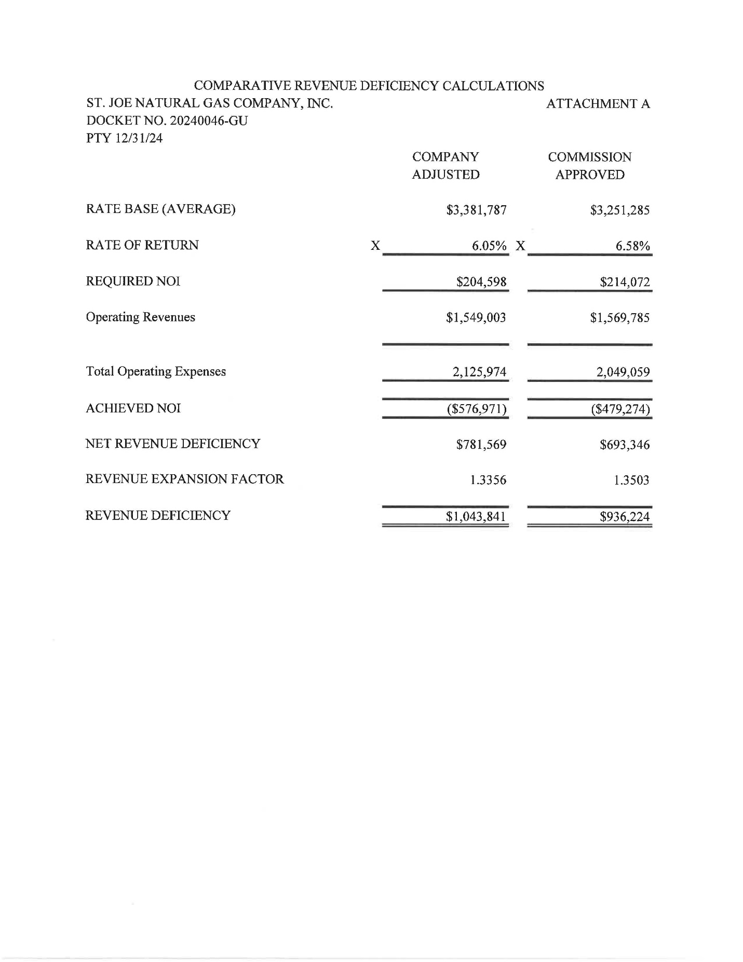

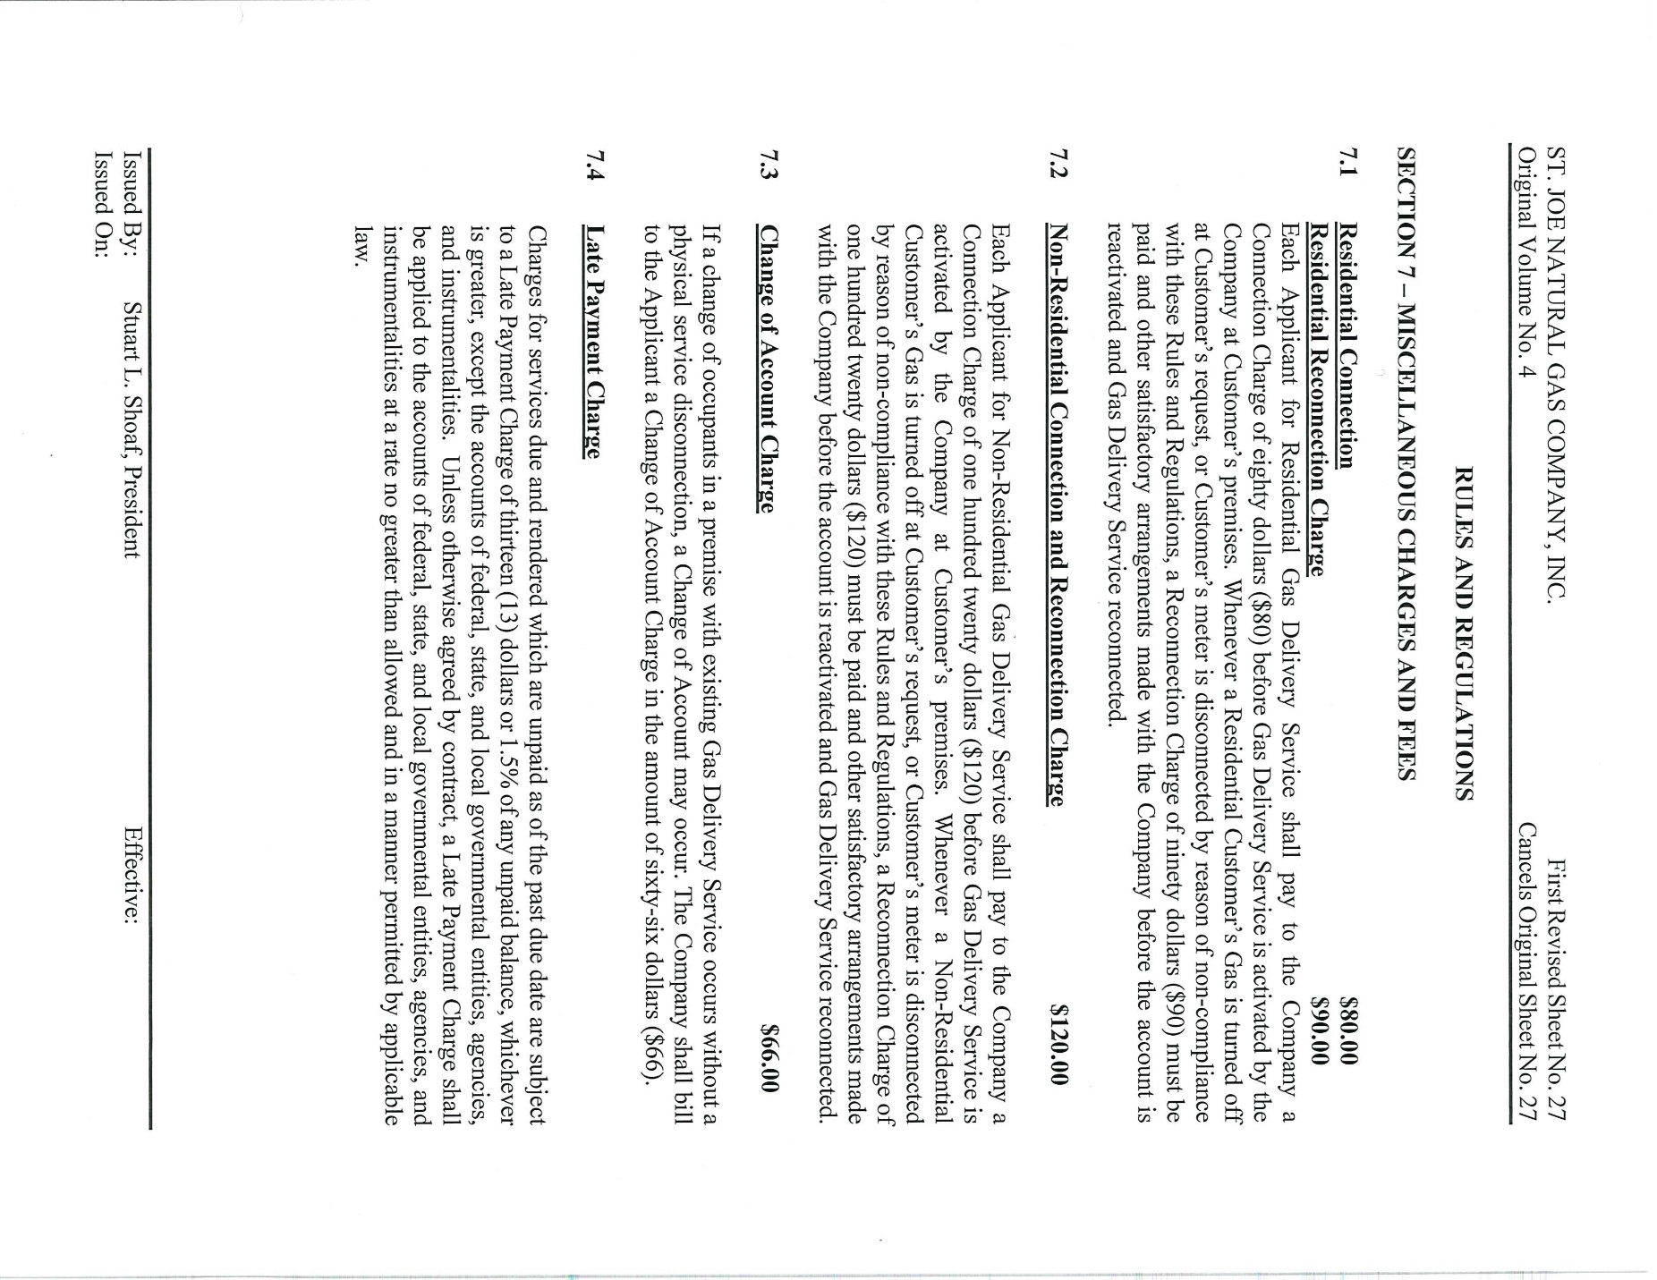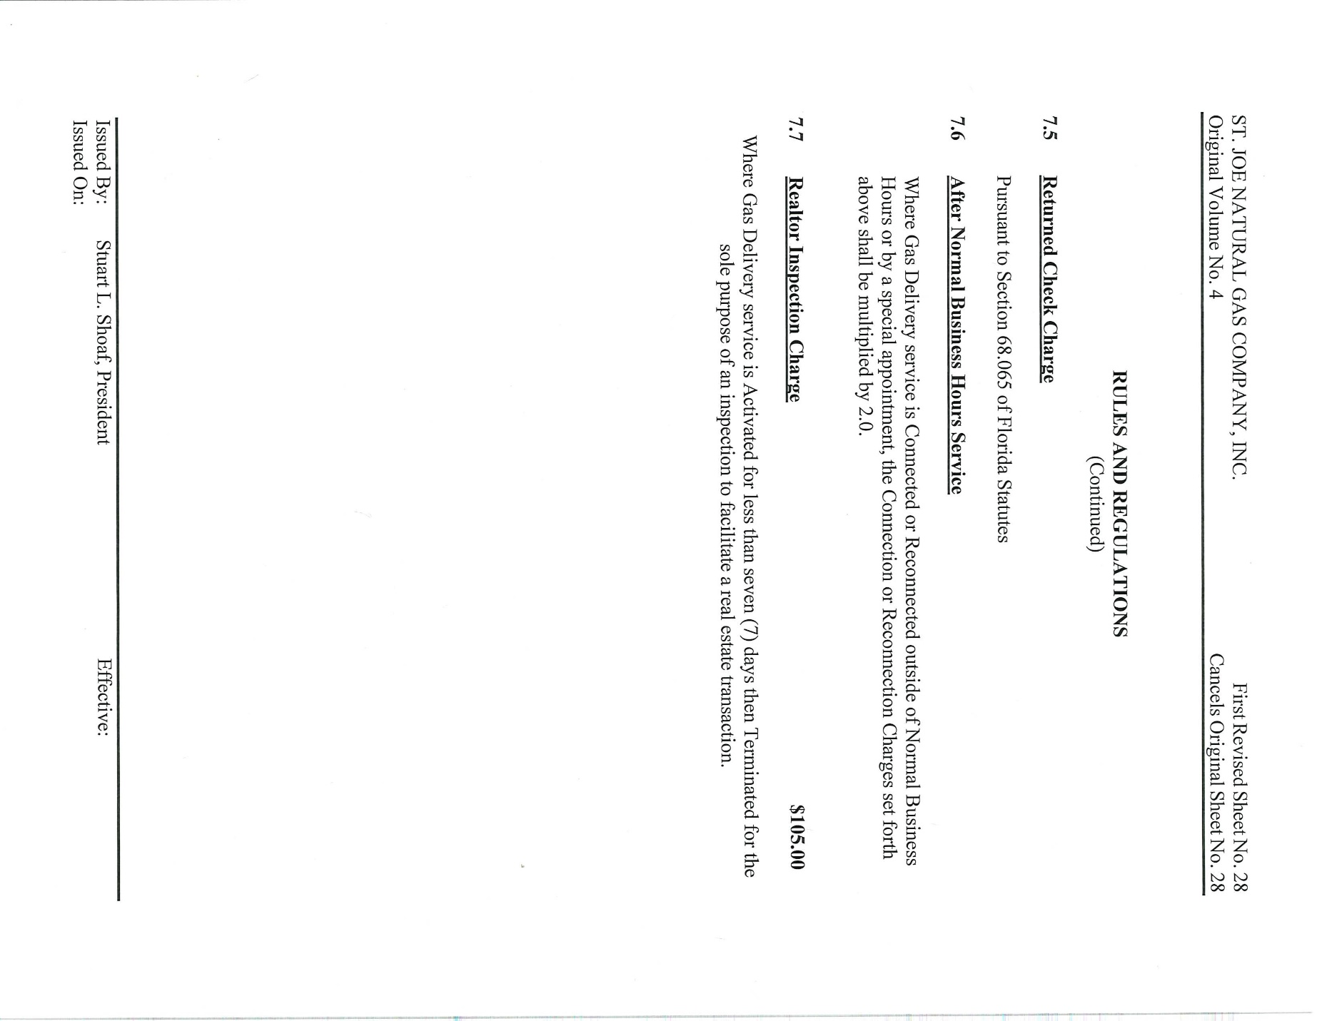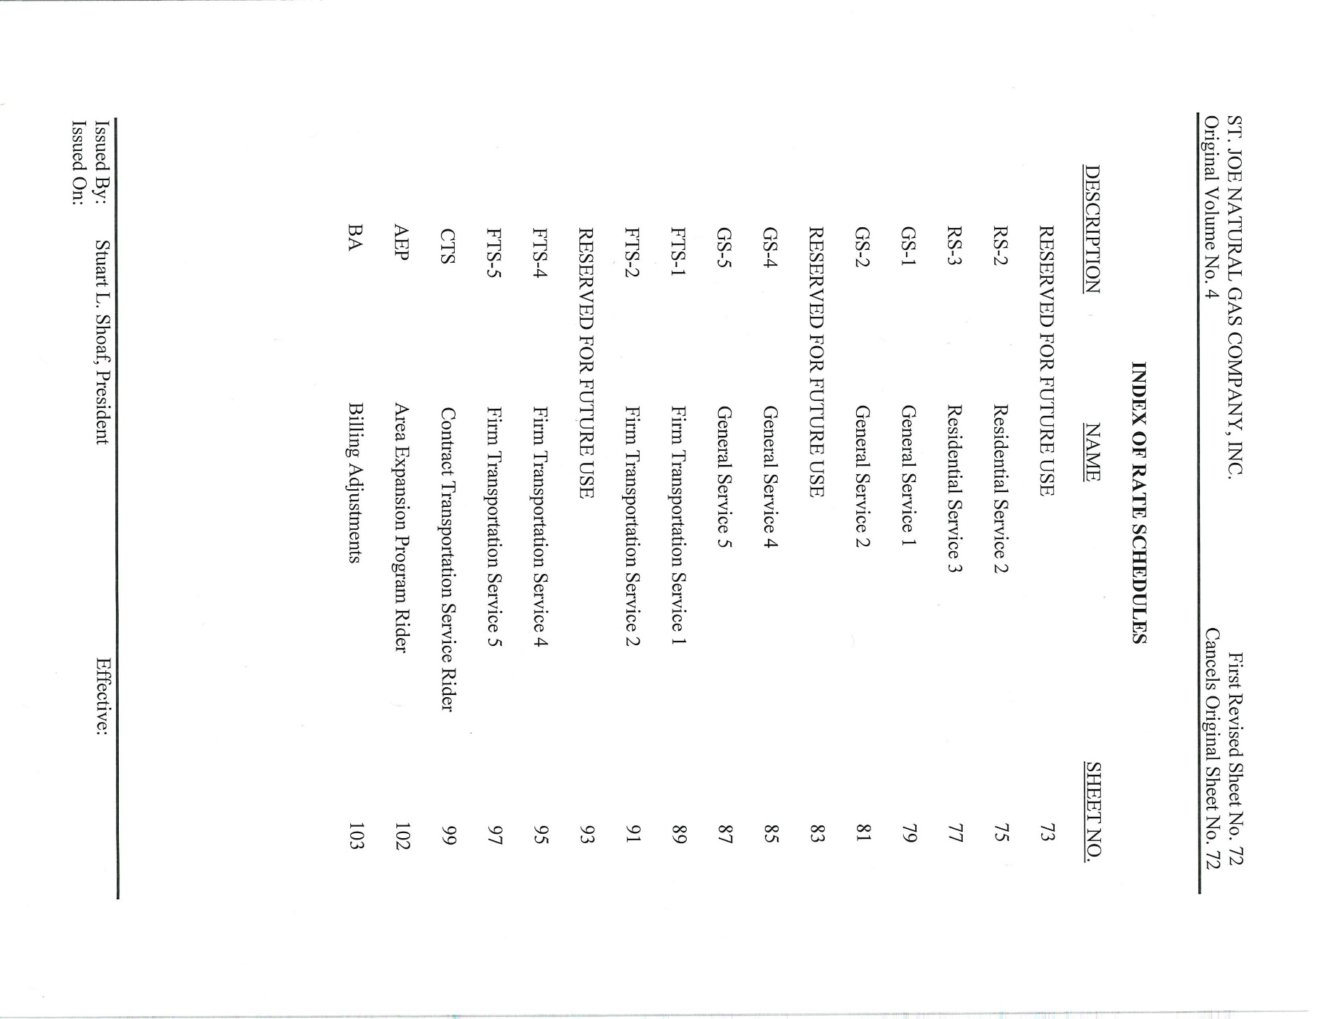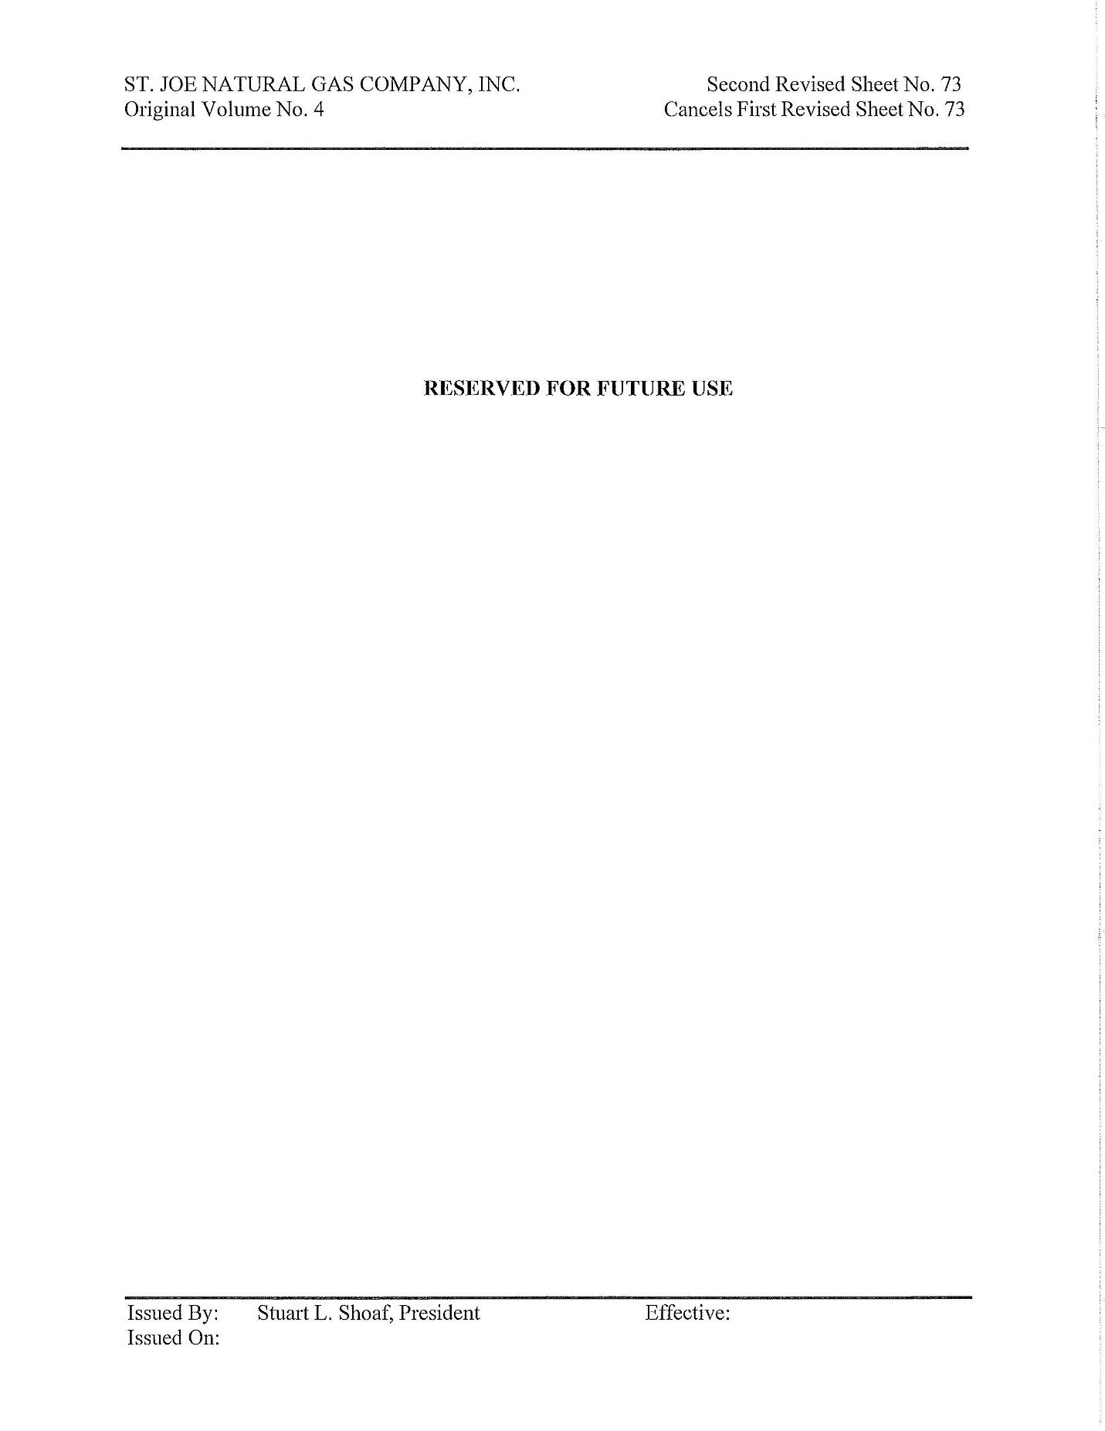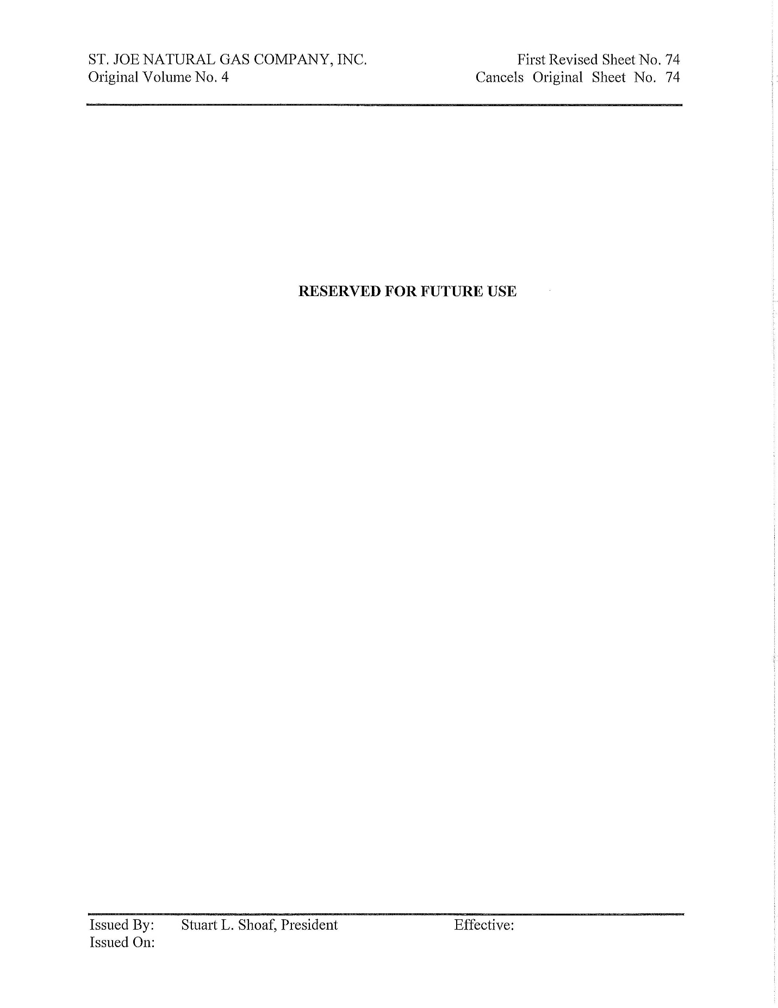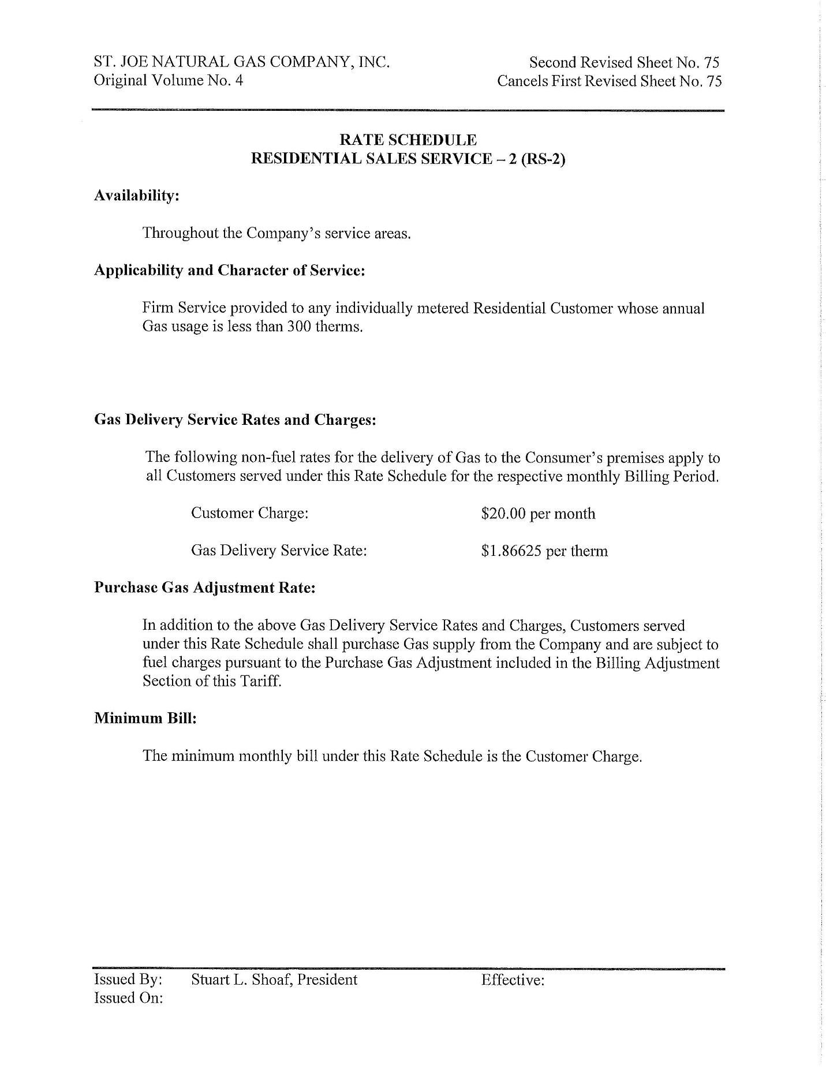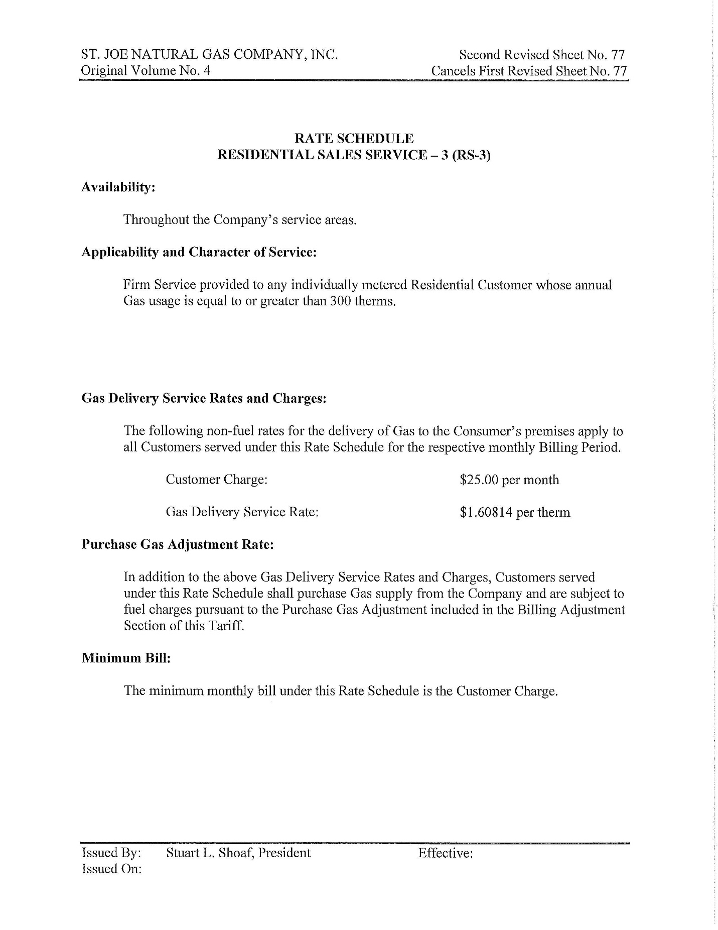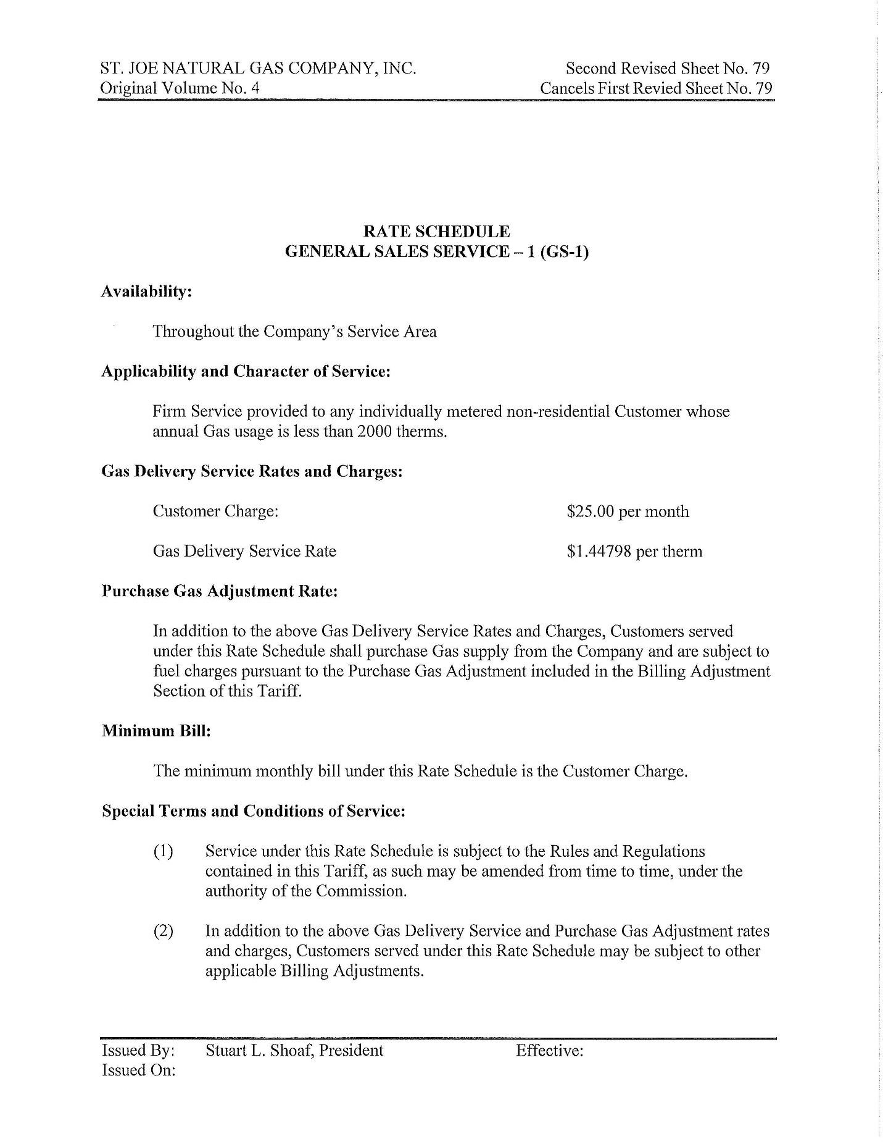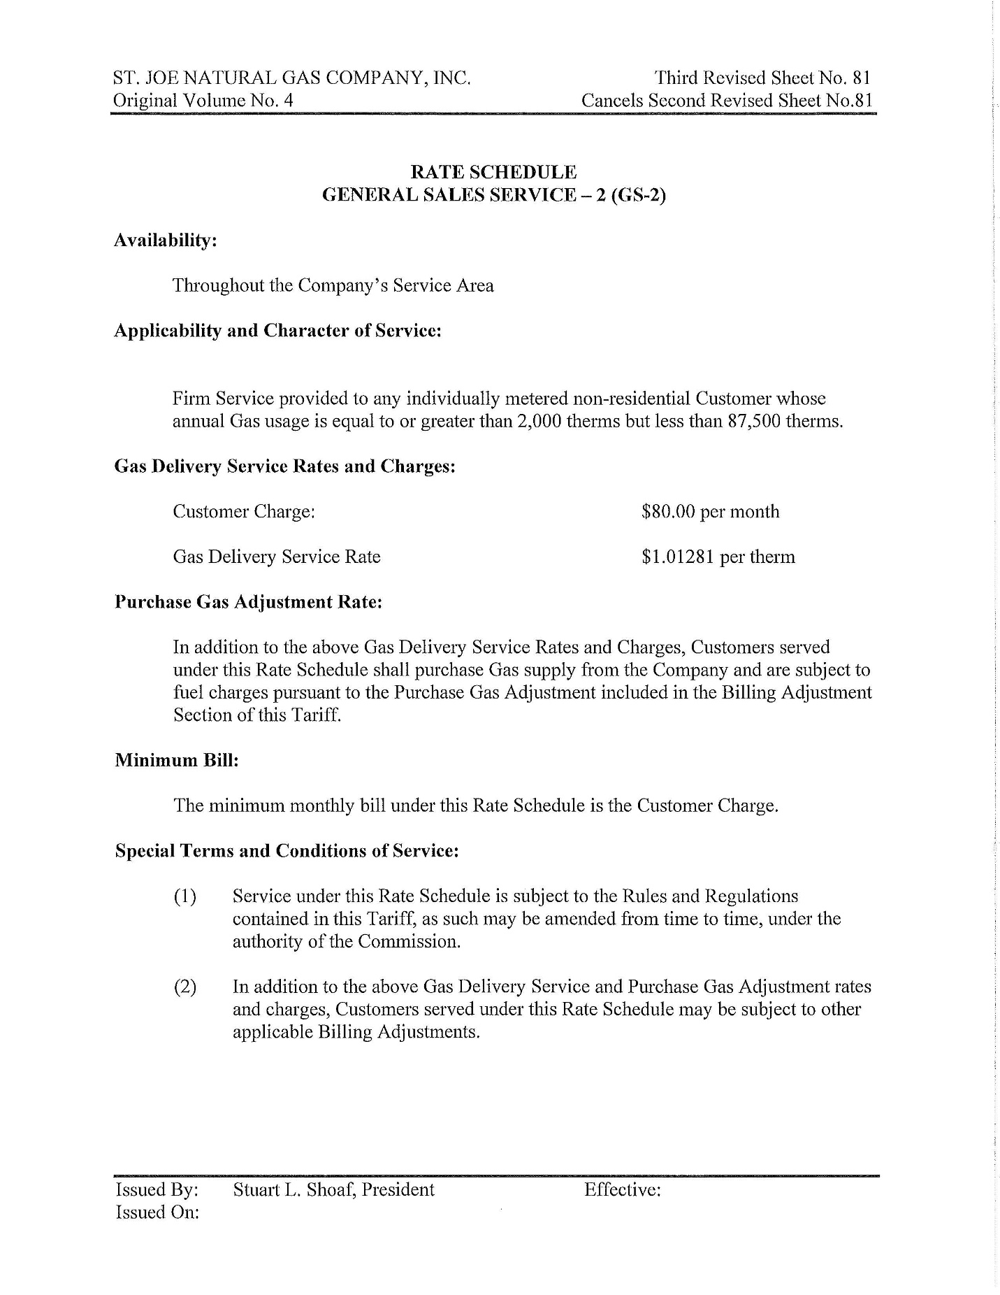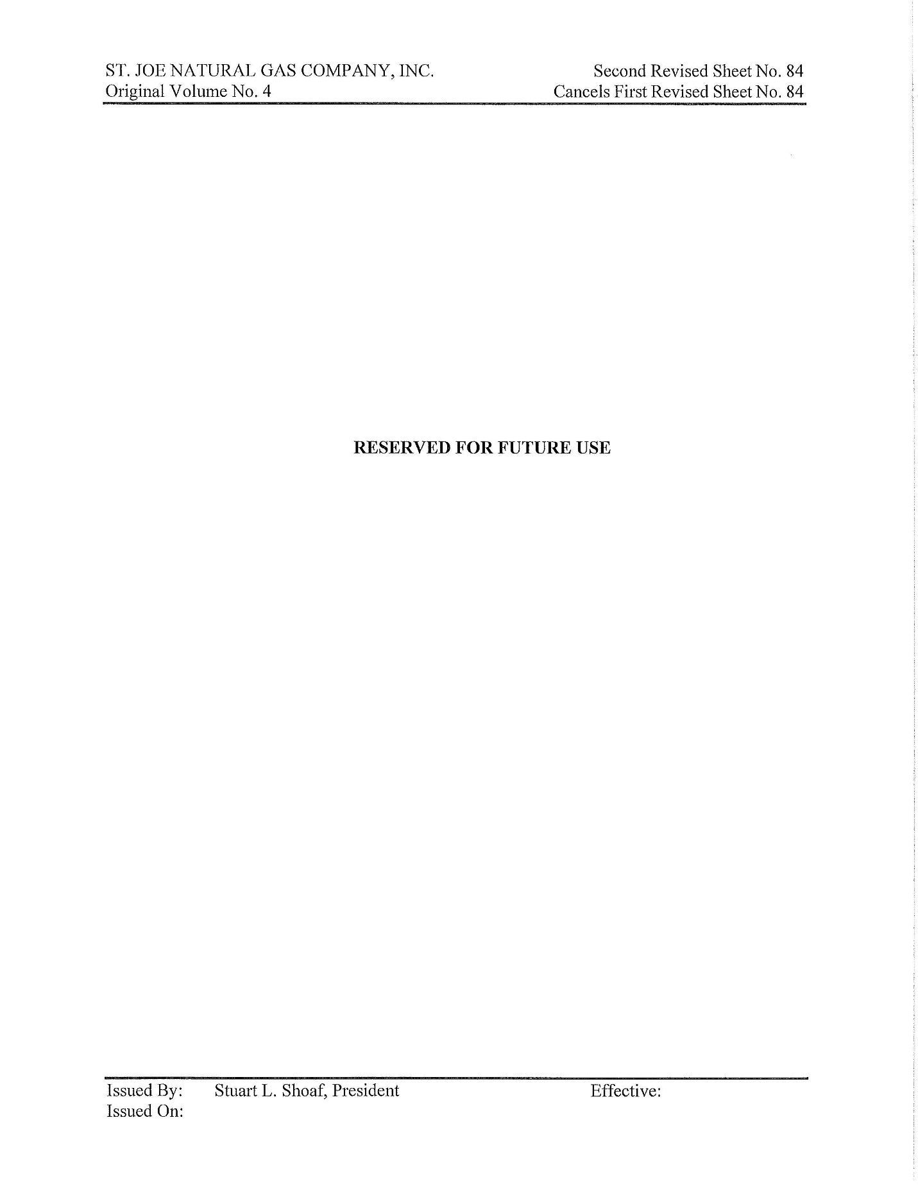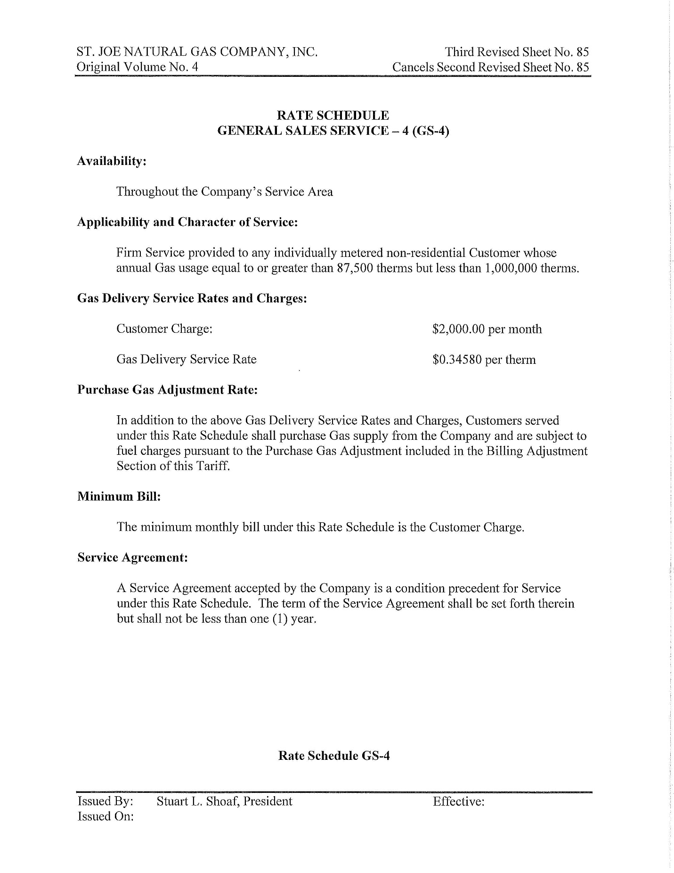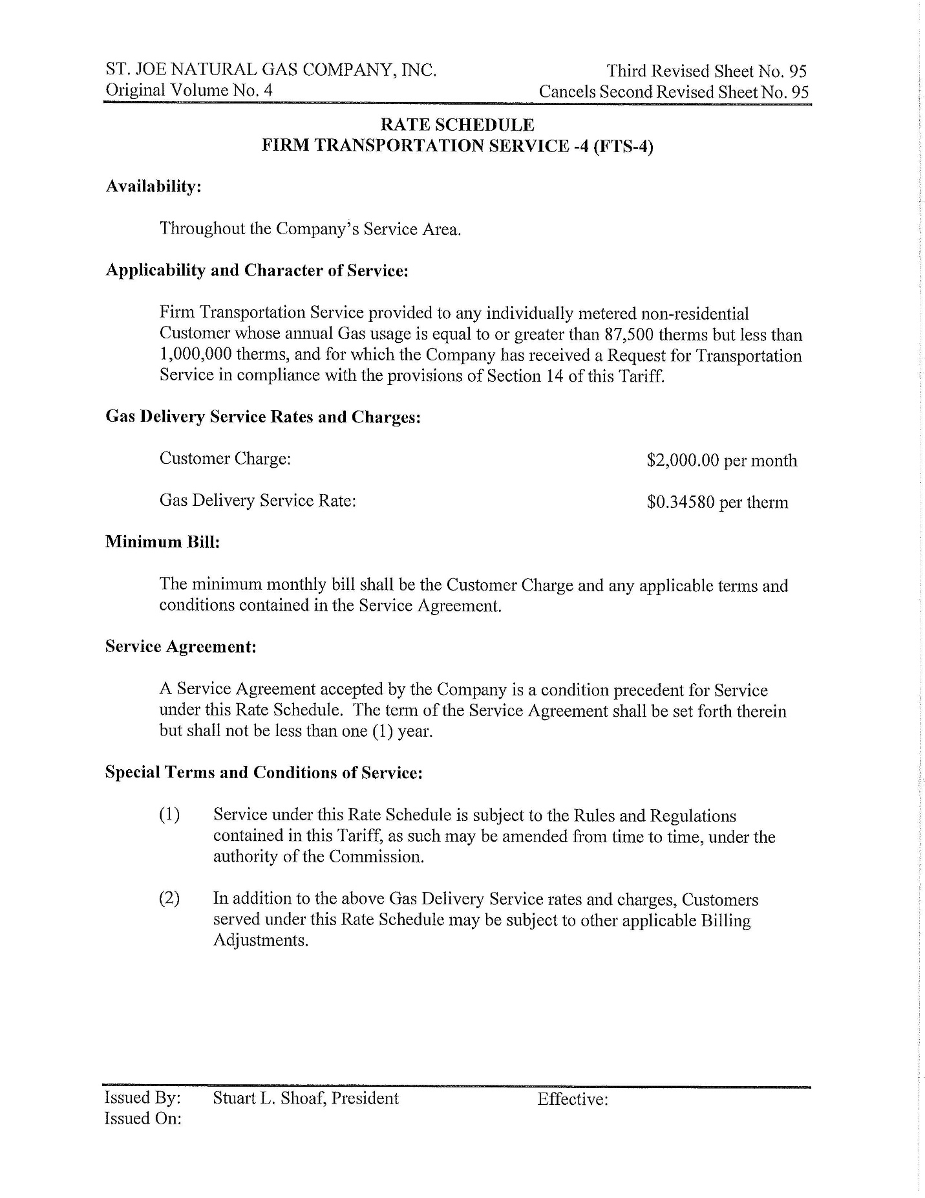

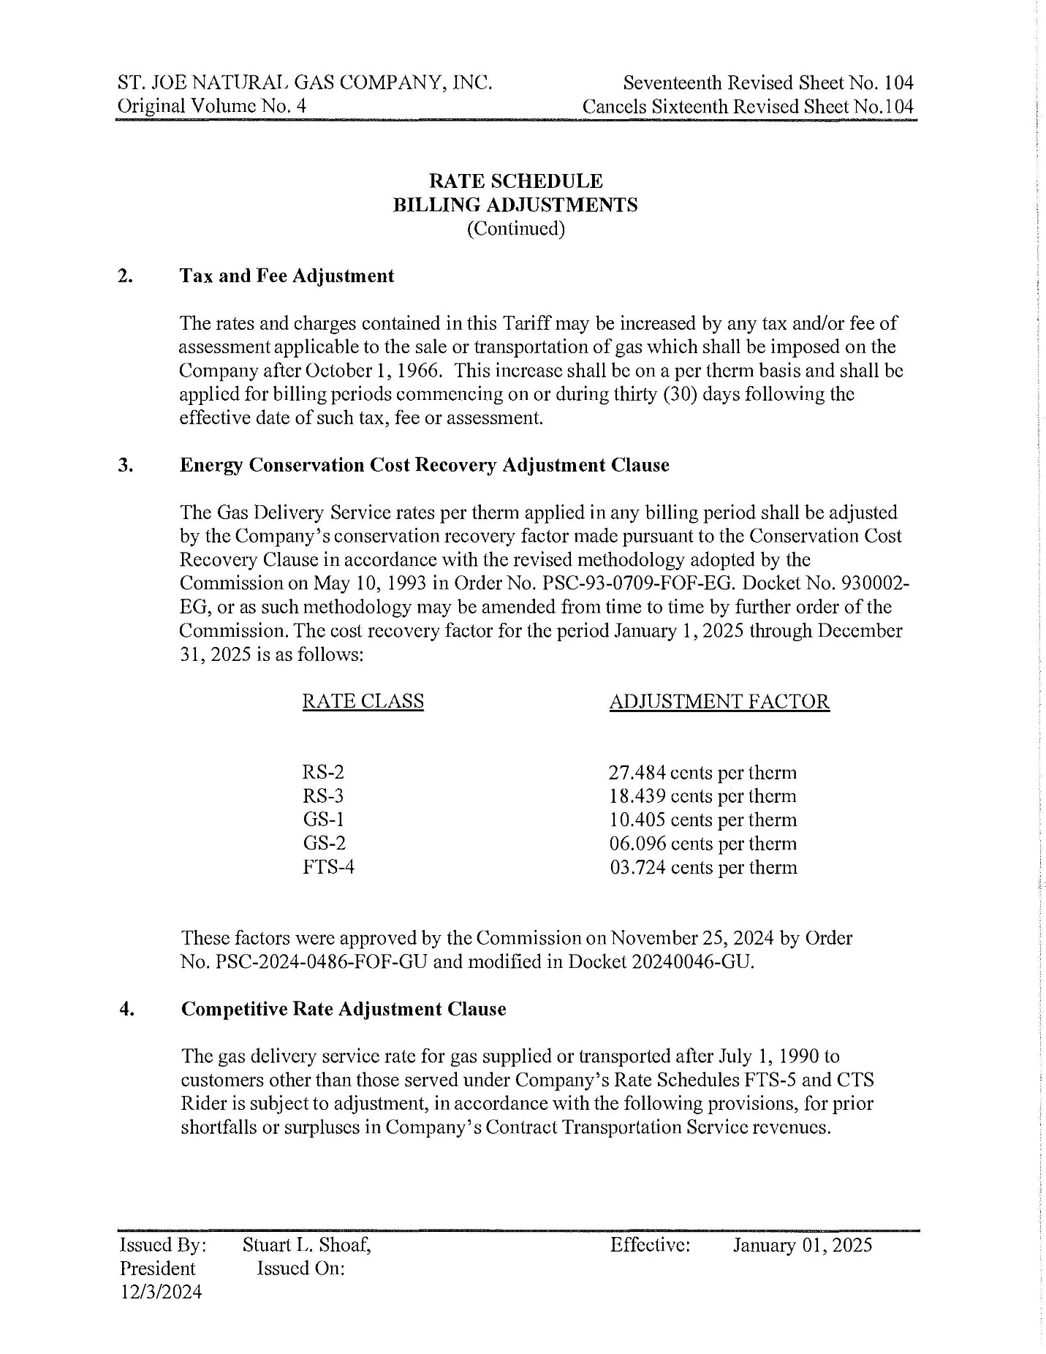

1. Order No. PSC-2024-0379-PCO-GU, issued August 28, 2024, in Docket No. 20240046-GU, *In re: Petition for rate increase by St. Joe Natural Gas Company, Inc.*