|  |  |  |  |
| --- | --- | --- | --- |
| State of Florida  pscSEAL | | Public Service Commission  Capital Circle Office Center ● 2540 Shumard Oak Boulevard Tallahassee, Florida 32399-0850  -M-E-M-O-R-A-N-D-U-M- | |
| DATE: | January 24, 2025 | | |
| TO: | Office of Commission Clerk (Teitzman) | | |
| FROM: | Division of Engineering (Wooten, Ellis, King)  Office of the General Counsel (Imig, Marquez) | | |
| RE: | Docket No. 20240148-EG – Petition for approval of proposed demand-side management plan, by Peoples Gas System, Inc. | | |
| AGENDA: | 02/04/25 – Regular Agenda – Proposed Agency Action – Interested Persons May Participate | | |
| COMMISSIONERS ASSIGNED: | | | All Commissioners |
| PREHEARING OFFICER: | | | Fay |
| CRITICAL DATES: | | | None |
| SPECIAL INSTRUCTIONS: | | | None |

Case Background

Sections 366.80 through 366.83, and 403.519, Florida Statutes (F.S.), known collectively as the Florida Energy Efficiency and Conservation Act (FEECA), require the Florida Public Service Commission (Commission) to adopt conservation goals to increase the efficiency of energy consumption. Additionally, FEECA emphasizes reducing the growth rates of weather-sensitive peak demand, reducing and controlling the growth rates of electricity consumption, reducing the consumption of expensive resources such as petroleum fuels, and encouraging demand-side renewable energy resources. The Commission most recently established conservation goals for Peoples Gas System (PGS or Utility) by Order No. PSC-2024-0280-PAA-EG, issued July 30, 2024 (2024 Goalsetting Order).[1]

Pursuant to Section 366.82(7), F.S., after goals are established, the Commission shall require each utility subject to FEECA to develop a demand-side management (DSM) plan to meet the conservation goals. On October 28, 2024, PGS filed a petition requesting approval of its DSM Plan and provided a cost-effectiveness analysis of the proposed programs pursuant to Rule 25-17.009, Florida Administrative Code (F.A.C.). The cost-effectiveness analysis includes the Gas Rate Impact Measure (G-RIM) Test and the Participants Test.

The Commission has jurisdiction over this matter pursuant to Sections 366.80 through 366.83 and 403.519, F.S.

Discussion of Issues

Issue :

 Should the Commission approve Peoples Gas System’s proposed DSM Plan and program standards?

Recommendation:

 Yes. The DSM Plan proposed by PGS is projected to exceed the annual numeric conservation goals approved by the Commission in the 2024 Goalsetting Order. PGS’s proposed DSM Plan is primarily a continuation, with some minor modifications, of its DSM portfolio used to establish the goals approved by the Commission in the 2024 Goalsetting Order. The programs within PGS’s proposed DSM Plan are projected to be cost-effective based upon both the G-RIM and Participants Tests.

Therefore, staff recommends that the Commission should allow PGS to file for cost recovery of the programs included in its proposed DSM Plan in the Natural Gas Conservation Cost Recovery (NGCCR) proceeding. However, PGS must demonstrate that the expenditures to implement its DSM programs are reasonable and prudent in order to recover those expenditures in the NGCCR.

PGS also submitted its administrative program standards with its proposed DSM Plan. Staff has reviewed PGS’s administrative program standards and recommends that the Commission find they are consistent with the Utility’s proposed DSM Plan submitted for approval. Staff requests that PGS be required to notify the Commission prior to any changes being made to the program standards as filed. (Wooten)

Staff Analysis:

 The criteria used to review the appropriateness of the conservation programs are as follows: (1) whether the program advances the policy objectives of FEECA and its implementing rules; (2) whether the program is directly monitorable and yields measurable results; and (3) whether the program is cost-effective.[2] Staff has reviewed PGS’s proposed DSM Plan, including its energy savings, cost-effectiveness, and rate impact. PGS’s proposed DSM Plan exceeds the goals set in the 2024 Goalsetting Order, and should be approved.

**Description of DSM Plan**

PGS’s proposed DSM Plan consists of 11 programs in total, 4 residential and 7 commercial/industrial. The programs within the proposed DSM Plan are similar to PGS’s existing programs, with modifications to 9 of the 11 programs. These program modifications are consistent with the potential programs identified in the DSM Goals docket, excluding a change in incentives for residential style clothes dryers. Table 1-1 provides a complete list of the programs and the program status. A description of each program can be found in Attachment A.

**Table 1-1**

**PGS DSM Plan Program Listing**

|  |  |  |
| --- | --- | --- |
| **Program Name** | **Program Status** | |
| **Modified** | **No Changes** |
| **Residential Programs** | | |
| Residential Online Energy Audit | X |  |
| Residential New Construction | X |  |
| Residential Retrofit | X |  |
| Residential Retention | X |  |
| **Commercial/Industrial Programs** | | |
| Commercial Walk-Through Energy Audit |  | X |
| Commercial New Construction | X |  |
| Commercial Retrofit | X |  |
| Commercial Retrofit Combined Heat and Power (CHP) | X |  |
| Commercial Retrofit Electric Replacement |  | X |
| Commercial Retention | X |  |
| Conservation Research and Development (R&D) | X |  |

Source: Document No. 09697-2024

The primary modifications to the Residential Programs were to program rebates and program measures. Notably, the rebate for a clothes dryer in the Residential New Construction program was changed from $200 to $300. The rebate for the dryer stub was changed from $200 to $100. Similarly, the Residential Retrofit had the dryer rebate increased from $200 to $300 to match the increase in the Residential New Construction program.

The primary modifications to the Commercial/Industrial Programs were also to program rebates and program measures. Notably, the Commercial New Construction program increased the Energy Star certification qualifications of tank water heaters. Similarly, the Commercial Retention program was changed by restructuring the rebates for fryers to be based on cooking efficiency rather than equipment cost, which the Utility believes will incentivize the installation of higher efficiency models. This restructuring is accompanied with a limitation on the number of fryers eligible for replacement with the rebate, in order to prevent excessive installation of applicable units.

The other modifications made to the programs are as follows: (1) Gas Space Conditioning was added as a measure to the respective residential and commercial new construction programs; (2) the natural gas space heater measure was eliminated from the Residential program due to low historical participation totals; (3) the Commercial New Construction program included a $400 rebate for commercial customers who installed residential-style clothes dryers that matched the Residential New Construction rebate amount; (4) the Commercial Retrofit program included a $300 rebate for commercial customers who installed residential-style clothes dryers that matched the Residential Retrofit rebate amount; (5) due to historical nonexistent customer participation in the Commercial Retrofit CHP program, the rebate amount was increased in an effort to incentivize more customer participation; (6) the Commercial Retention program reduced and removed various equipment cost bands due to lack of utilization; (7) renaming the Residential Customer Assisted Energy Audit program to the Residential Online Energy Audit program; and (8) the Commercial Retention program included a $150 rebate for commercial customers who installed residential-style clothes dryers that matched the Residential Retention rebate amount.

PGS also submitted its administrative program standards along with its proposed DSM Plan, which can be found in Attachment B. Staff has reviewed the administrative program standards and they appear consistent with the Utility’s proposed DSM Plan.

***Program Participation***

PGS projects program participation using historical program participation trends. PGS’s DSM Goal projections were calculated in January 2024, based upon these historical trends. When PGS calculated its proposed DSM plan projections in October 2024, additional actual participation data was available that indicated an increase in participation for certain programs, leading to an increase in the DSM Goal projected program participation amounts. Specifically, PGS saw increases in the following programs: Residential New Construction, Residential Retrofit, Residential Retention, Commercial New Construction, Commercial Retrofit, and Commercial Retention. These projections also show that the Commercial Retrofit CHP and Commercial Retrofit Electric Replacement programs are projected to have zero participation. PGS forecasted zero participation for these DSM programs based upon the programs’ historical participation rates.

***Comparison of DSM Plan to Goals***

As in the 2024 Goalsetting Order, PGS estimated program savings through a combination of state and national industry sources, current building code and appliance standards, and a review of historical DSM program activity. Based on staff’s review, PGS’s proposed DSM Plan will exceed the Commission’s established annual goals.

This increase from the Commission’s established goals is based upon the aforementioned increased projected participation rates and an increase in the therm savings associated with the water tank heater under PGS’s Commercial programs. The water tank heater therm savings were increased from 317.91 in the DSM Goals proceeding to 426.13 in the Utility’s proposed DSM Plan. This increase is based upon changes to the Utility’s program standards that increased the minimum thermal efficiency from 90 to 94 percent, thus leading to an increase in therm savings. PGS will be responsible for monitoring actual participation rates and seeking Commission action, if necessary, to modify, add, or remove programs. If PGS is unable to meet the Commission’s goals, the Utility may be subject to appropriate action by the Commission, up to and including financial penalties.

Section 366.82(10), F.S., requires the Commission to provide an annual report to the Governor and Legislature on the progress of each utility toward meeting the established goals. PGS will continue to submit to the Commission an annual report no later than March 1 of each year, summarizing the achievements of its DSM Plan. Staff will continue to monitor and report the actual amount of DSM savings each year, on an annual and cumulative basis, as part of the FEECA Report.

**Cost-Effectiveness Review**

As required by Rule 25-17.009, F.A.C., PGS provided a cost-effectiveness analysis of the proposed programs using the G-RIM and the Participants Tests. These tests consist of the program benefits divided by the program costs, so that programs are determined to be cost-effective if the result of the test is a ratio greater than 1.00. The data PGS used to develop the costs associated with the cost-effectiveness tests was obtained from PGS’s current costs in facilitating existing programs, and from costs currently incurred by the Utility and customers for energy efficient natural gas equipment and infrastructure. All programs maintained the cost-effectiveness in the Utility’s proposed DSM plan that were established in the DSM Goals proceeding.

**Rate Impact**

Staff reviewed the projected program costs for PGS’s proposed DSM Plan. Table 1-2 shows the total projected program costs for each program in PGS’s proposed DSM Plan. PGS projects that the total cost for its proposed DSM Plan will be approximately $194 million over the period 2025 through 2034.

**Table 1-2**

**Total Program Costs of PGS’s DSM Plan**

|  |  |
| --- | --- |
| **Program Name** | **Program Costs** |
| **Residential Programs** | |
| Residential Online Energy Audit | $1,432,985 |
| Residential New Construction | $117,854,725 |
| Residential Retrofit | $3,887,788 |
| Residential Retention | $36,871,433 |
| **Commercial/Industrial Programs** | |
| Commercial Walk-Through Energy Audit | $1,247,373 |
| Commercial New Construction | $13,029,171 |
| Commercial Retrofit | $6,467,210 |
| Commercial Retrofit CHP | $0 |
| Commercial Retrofit Electric Replacement | $0 |
| Commercial Retention | $13,216,963 |
| Conservation R&D | $0 |

Source: Document No. 09697-2024

As shown in Table 1-2, the Commercial Retrofit CHP and Commercial Retrofit Electric Replacement programs have a projected zero program cost due to the zero projected program participations previously mentioned. The Conservation R&D program has a projected zero program cost as PGS has not commenced any projects since 2021 and currently has no planned projects under the Conservation R&D program. Staff notes that the proposed DSM plan includes language that total program cost for the Conservation R&D program shall not exceed $500,000 for the five-year period. Staff recommends that PGS be required to update the Commission on program costs and all other relevant program information should either program participation be achieved or if R&D projects be undertaken.

If approved, the cost to implement PGS’s proposed DSM Plan would flow through to the ratepayers through the NGCCR proceeding. In the NGCCR proceeding, PGS would file annually for recovery of incentives, and equipment and administrative costs. The NGCCR amounts represent a monthly bill impact to customers as part of the non-fuel cost of energy charges on their bills. Much like investments in generation, transmission, and distribution, investments in energy efficiency have an immediate rate impact, but may produce savings over time.

Table 1-3 is an estimate of the monthly bill impact on a typical residential and commercial customer for PGS’s proposed DSM Plan. The estimated NGCCR factors are based upon the participation rates and administrative costs used in the cost-effectiveness analysis discussed above and are not final.

**Table 1-3**

**PGS’s Estimated Monthly Bill Impact of Proposed DSM Plan**

|  |  |  |
| --- | --- | --- |
| **Year** | **Residential Customer**  **13 Therms/mo** | **Commercial Customer**  **415 Therms/mo** |
| **Monthly Bill Impact ($)** | |
| **2025** | 1.19 | 12.49 |
| **2026** | 1.02 | 12.18 |
| **2027** | 0.99 | 11.86 |
| **2028** | 0.97 | 11.56 |
| **2029** | 0.95 | 11.28 |
| **2030** | 0.93 | 11.03 |
| **2031** | 0.91 | 10.79 |
| **2032** | 0.89 | 10.61 |
| **2033** | 0.88 | 10.40 |
| **2034** | 0.86 | 10.20 |

Source: Document No. 09697-2024

Conclusion

The DSM Plan proposed by PGS is projected to exceed the annual numeric conservation goals approved by the Commission in the 2024 Goalsetting Order. PGS’s proposed DSM Plan is primarily a continuation, with some minor modifications, of its DSM portfolio used to establish the goals approved by the Commission in 2024 Goalsetting Order. The programs within PGS’s proposed DSM Plan are projected to be cost-effective based upon both the G-RIM and Participants Tests.

Therefore, staff recommends that the Commission should allow PGS to file for cost recovery of the programs included in its proposed DSM Plan in the NGCCR proceeding. However, PGS must demonstrate that the expenditures to implement its DSM programs are reasonable and prudent in order to recover those expenditures in the NGCCR proceeding.

PGS also submitted its administrative program standards with its proposed DSM Plan. Staff has reviewed PGS’s administrative program standards and recommends that the Commission find they are consistent with the Utility’s proposed DSM Plan submitted for approval. Staff requests that PGS be required to notify the Commission prior to any changes being made to the program standards as filed.

Issue :

 Should this docket be closed?

Recommendation:

 Yes. If no person whose substantial interests are affected by the proposed agency action files a protest within 21 days of the issuance of the order, this docket should be closed upon the issuance of a consummating order. (Imig)

Staff Analysis:

 If no person whose substantial interests are affected by the proposed agency action files a protest within 21 days of the issuance of the order, this docket should be closed upon the issuance of a consummating order.

**Peoples Gas System**

**Residential Programs**

**Residential Online Energy Audit**

The Residential Customer-Assisted Energy Audit Program allows for residential customers to engage in an online energy audit.

**Residential New Construction**

The Residential New Construction Program offers rebates to builders and developers who construct new single family and multi-family homes with the installation of energy efficient natural gas appliances.

|  |  |
| --- | --- |
| **Natural Gas Appliance/System** | **Incentive/Appliance Installation** |
| Dryer Stub | $100 |
| Dryer | $300 |
| Range/Cooktop | $300 |
| Tank Water Heater | $550 |
| ENERGY STAR Tank Water Heater | $650 |
| Tankless Water Heater | $700 |
| Central Heating | $725 |
| Gas Space Conditioner | $500/ton |

**Residential Retrofit**

The Residential Retrofit Program offers rebates to existing and new natural gas customers who replace electric equipment with new, energy efficient natural gas equipment.

|  |  |
| --- | --- |
| **Natural Gas Appliance/System** | **Incentive/Appliance Installation** |
| Dryer | $300 |
| Range/Cooktop | $300 |
| Tank Water Heater | $550 |
| ENERGY STAR Tank Water Heater | $650 |
| Tankless Water Heater | $700 |
| Central Heating | $725 |
| Gas Space Conditioner | $500/ton |

**Residential Retention**

The Residential Retention Program offers rebates to existing natural gas customers who replace less efficient natural gas equipment with new, energy efficient natural gas equipment.

|  |  |
| --- | --- |
| **Natural Gas Appliance/System** | **Incentive/Appliance Installation** |
| Range/Cooktop | $100 |
| Dryer | $150 |
| Tank Water Heater | $350 |
| ENERGY STAR Tank Water Heater | $400 |
| Central Heating | $500 |
| Tankless Water Heater | $550 |
| Gas Space Conditioner | $150/ton |

**Commercial Programs**

**Commercial Walk-Through Energy Audit**

In the Commercial Walk-Through Energy Audit Program, an audit is conducted by a trained commercial energy analyst who will provide tailored recommendations to encourage the customer to implement cost-effective measures.

**Commercial New Construction**

The Commercial New Construction Program offers rebates to builders and developers who construct commercial and industrial facilities with the installation of energy efficient natural gas appliances.

|  |  |
| --- | --- |
| **Natural Gas Appliance/System** | **Incentive/Appliance Installation** |
| Range/Cooktop | $2,000 |
| Dryer | $2,500 |
| Residential Dryer | $400 |
| ENERGY STAR Tank Water Heater | $2,500 |
| Fryer | $3,500 |
| Tankless Water Heater | $3,500 |
| Gas Space Conditioner | $500/ton |

**Commercial Retrofit**

The Commercial Retrofit Program offers rebates to existing and new natural gas customers who replace electric equipment with new, energy efficient natural gas equipment.

|  |  |
| --- | --- |
| **Natural Gas Appliance/System** | **Incentive/Appliance Installation** |
| Range/Cooktop | $2,000 |
| Dryer | $2,500 |
| Residential Dryer | $300 |
| Tank Water Heater | $2,500 |
| Fryer | $3,500 |
| Tankless Water Heater | $3,500 |
| Gas Space Conditioner | $500/ton |

**Commercial Retrofit Combined Heat and Power**

The Commercial Retrofit Combined Heat and Power Program offers customer rebates for installing new, energy-efficient natural gas combined heat and power equipment to utilize waste heat to displace portions of natural gas usage for on-site heating, cooling, and water heating.

* Maximum Incentive: $450/kW of actual electric demand reduced of installed combined heat and power equipment

**Commercial Retrofit Electric Replacement**

The Commercial Retrofit Electric Replacement Program offers rebates to existing and new natural gas customers who install new, energy efficient natural gas equipment.

* Maximum Incentive: $100/kW reduction for qualifying natural gas equipment

**Commercial Retention**

The Commercial Retention Program offers rebates to existing natural gas customers who replace less efficient natural gas equipment with new, energy efficient natural gas equipment.

|  |  |
| --- | --- |
| **Natural Gas Appliance/System** | **Incentive/Appliance Installation** |
| Range/Cooktop | $1,500 |
| Tank Water Heater | $1,500 |
| Dryer | $2,000 |
| Residential Dryer | $150 |
| Tankless Water Heater | $2,000 |
| Fryer | $3,000 |
| Gas Space Conditioner | $150/ton |

**Research and Development**

**Conservation Research and Development (R&D)**

The Conservation R&D Program allows PGS to explore DSM measures that have insufficient data on cost-effectiveness, and the impact on PGS and its ratepayers. Though no projects are currently planned, the total program cost shall not exceed $500,000 for the five-year period.

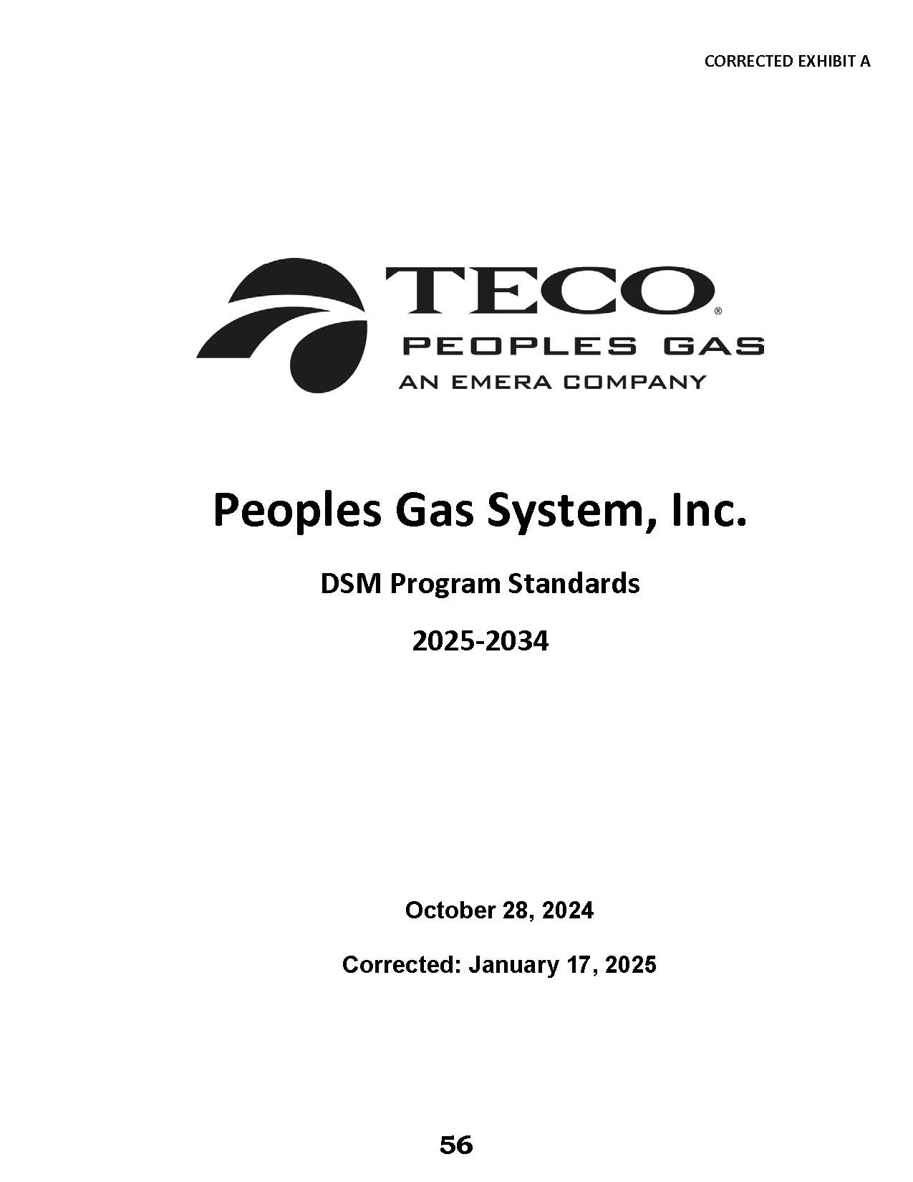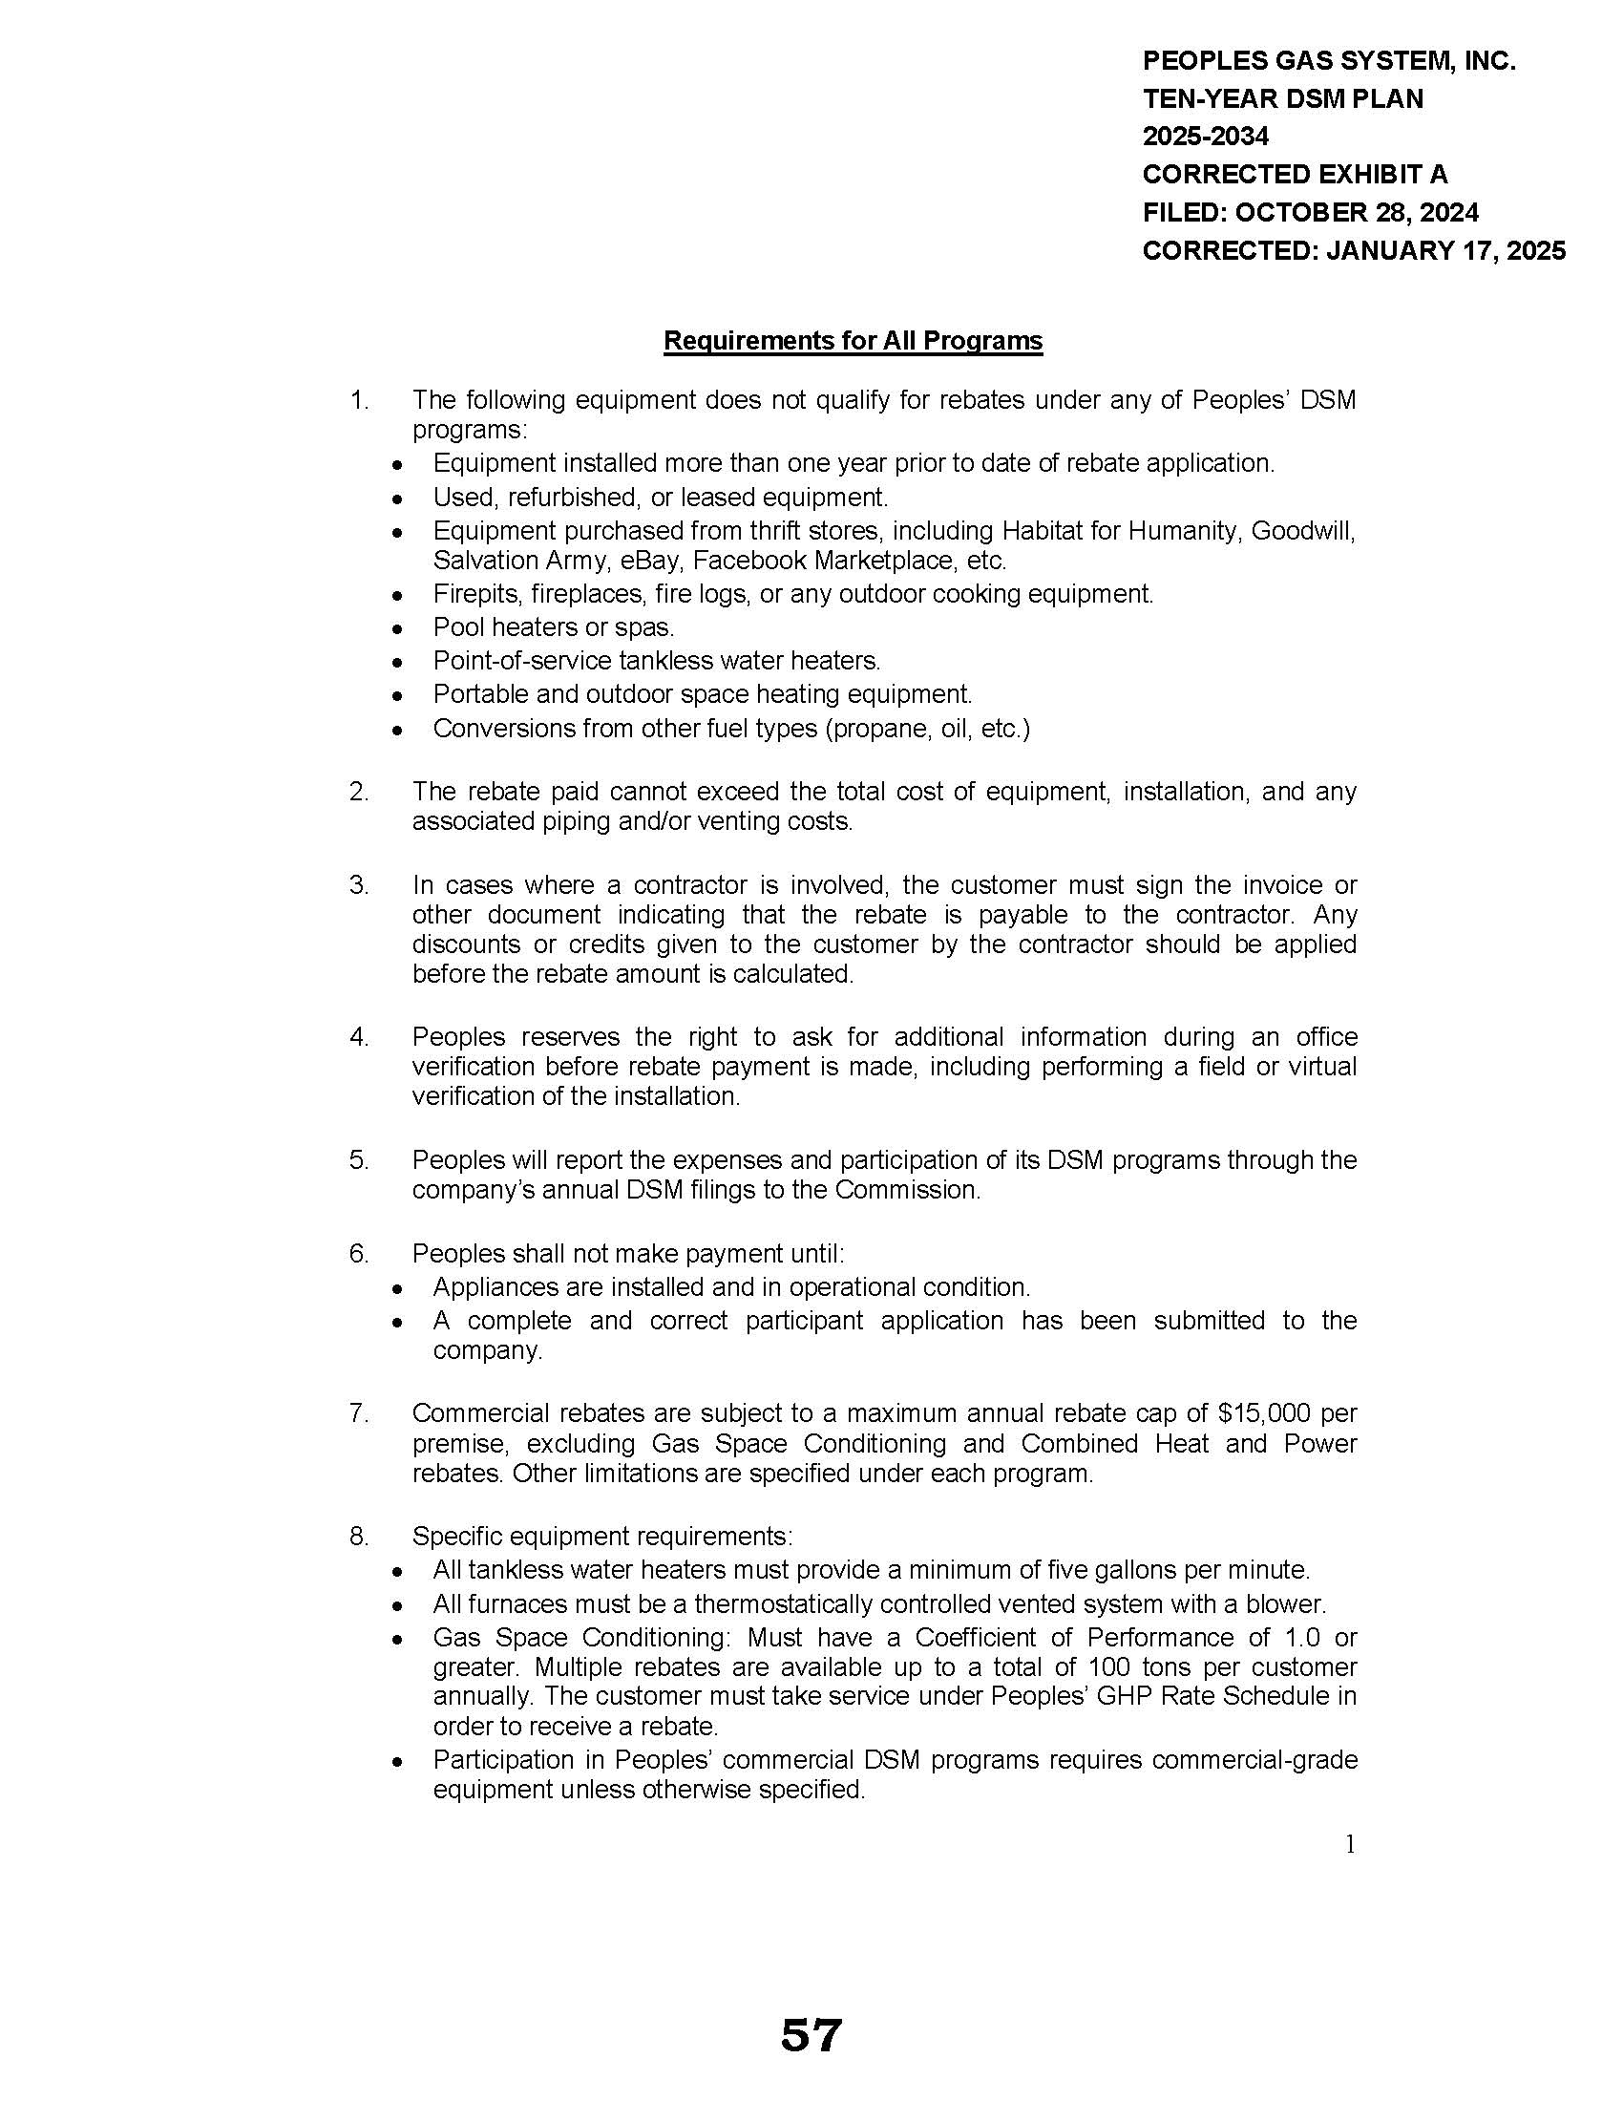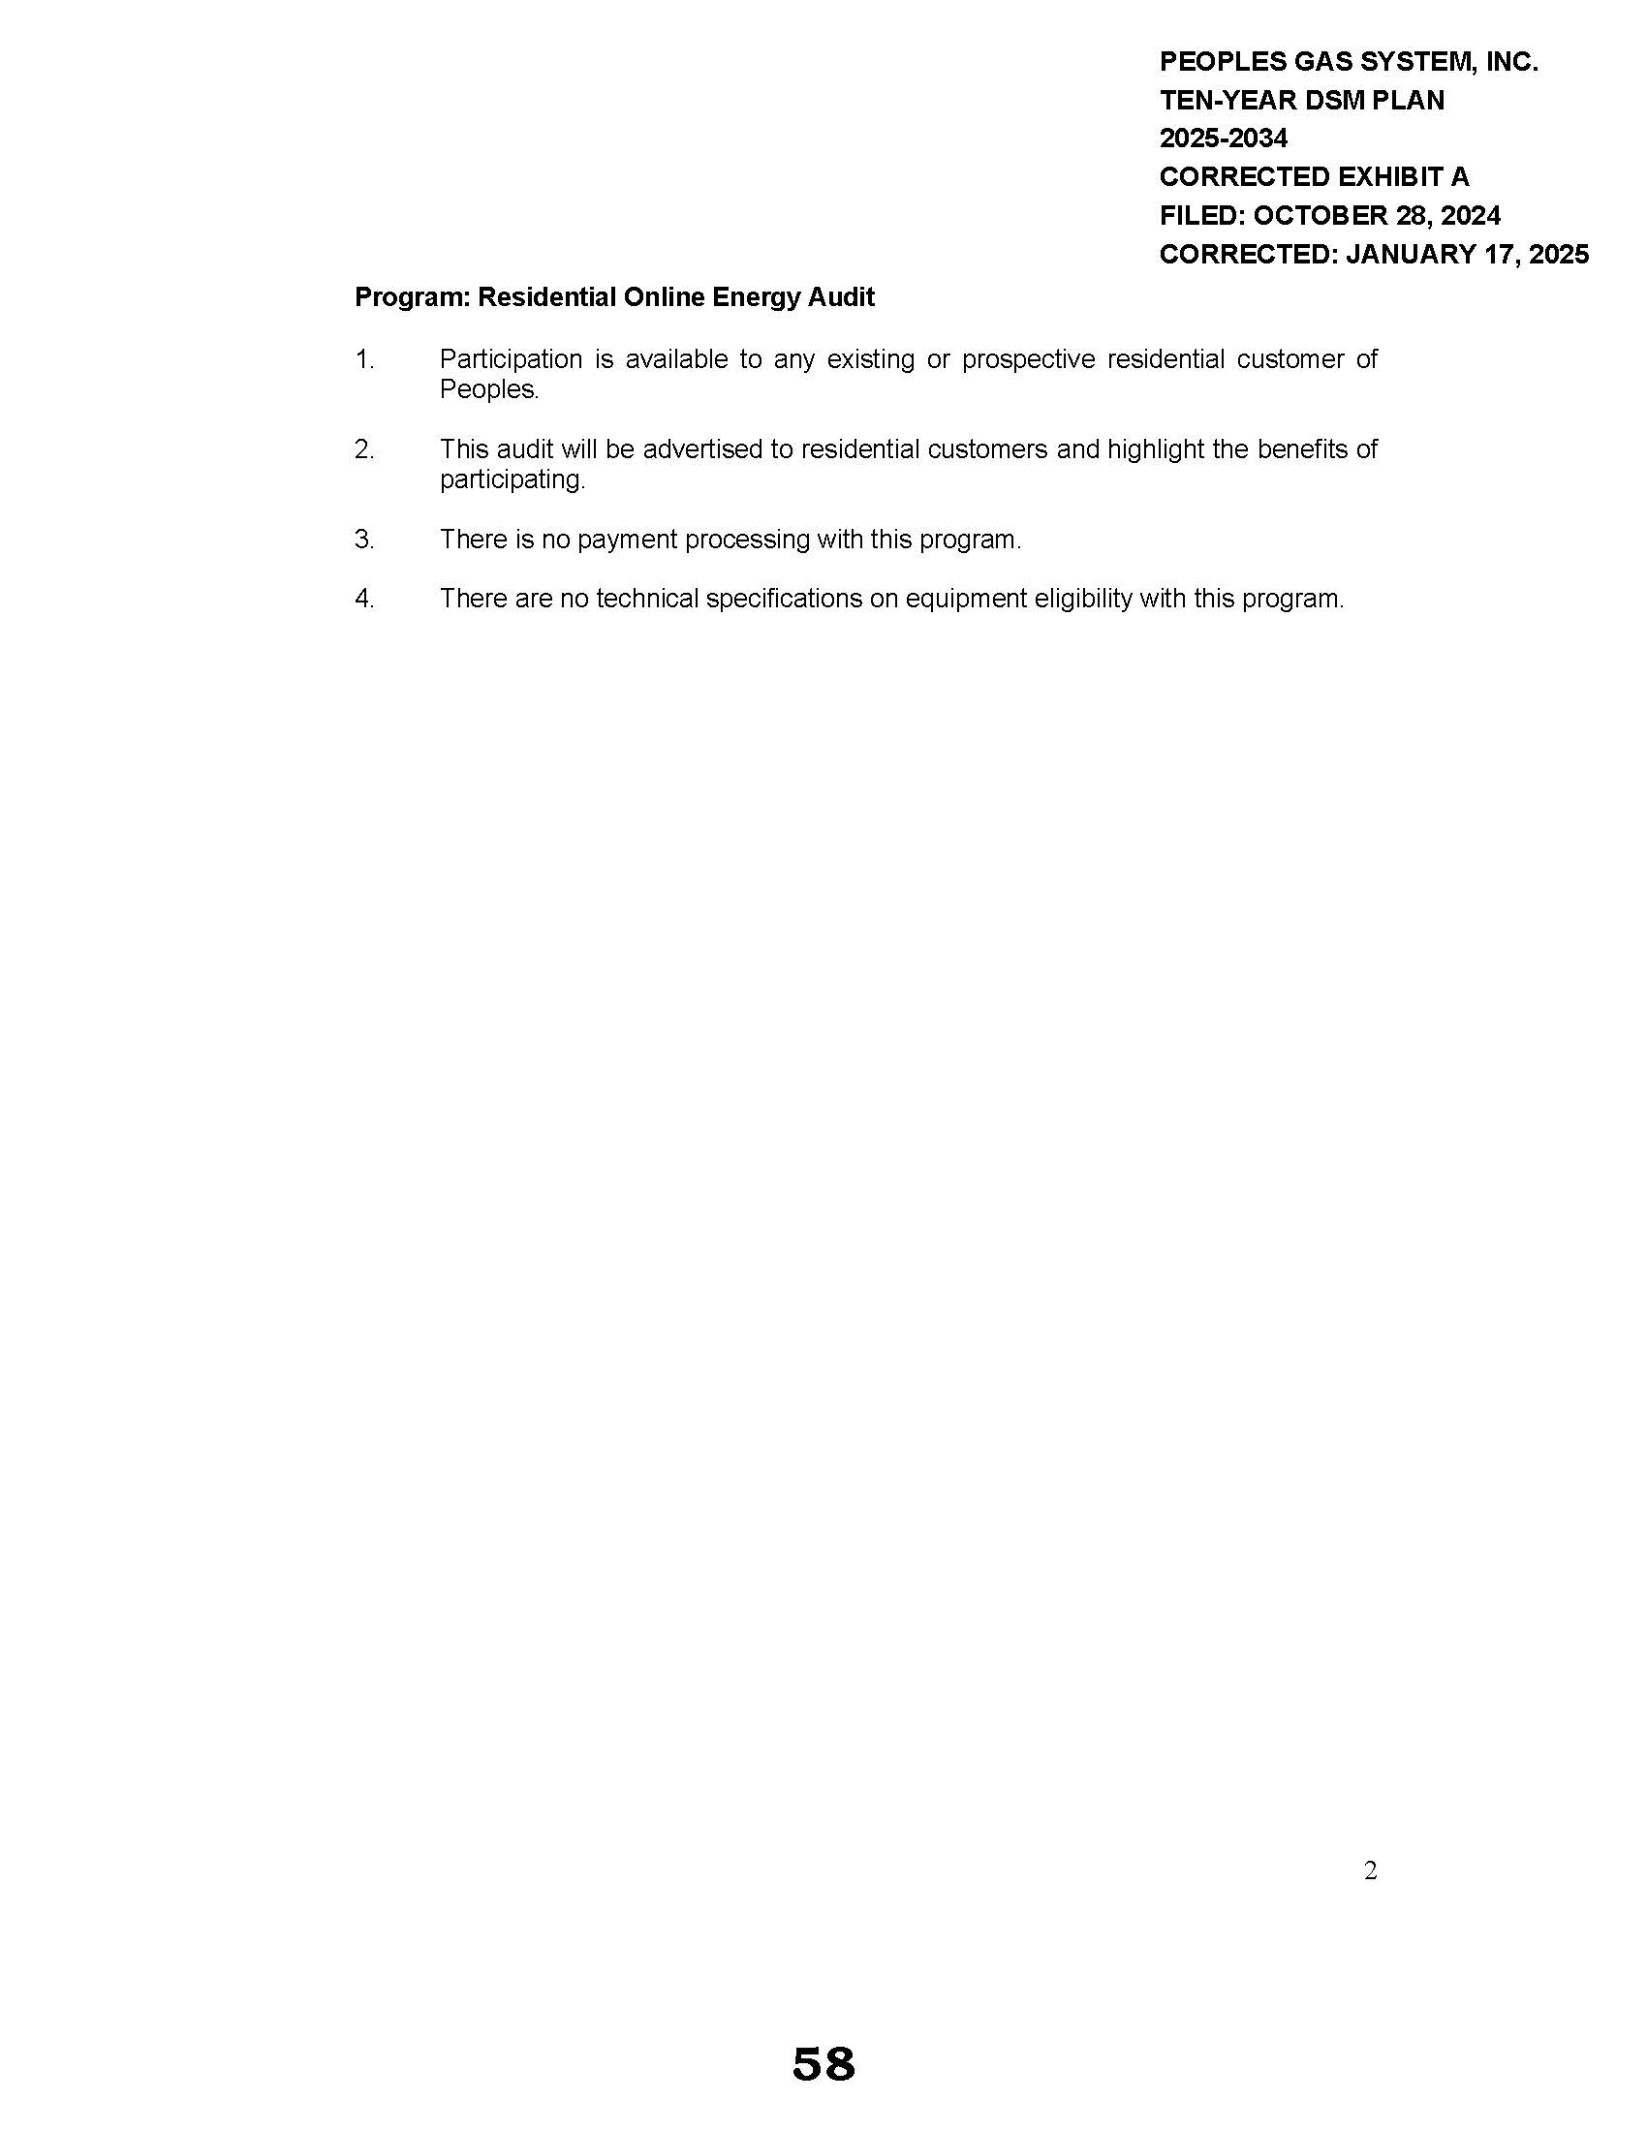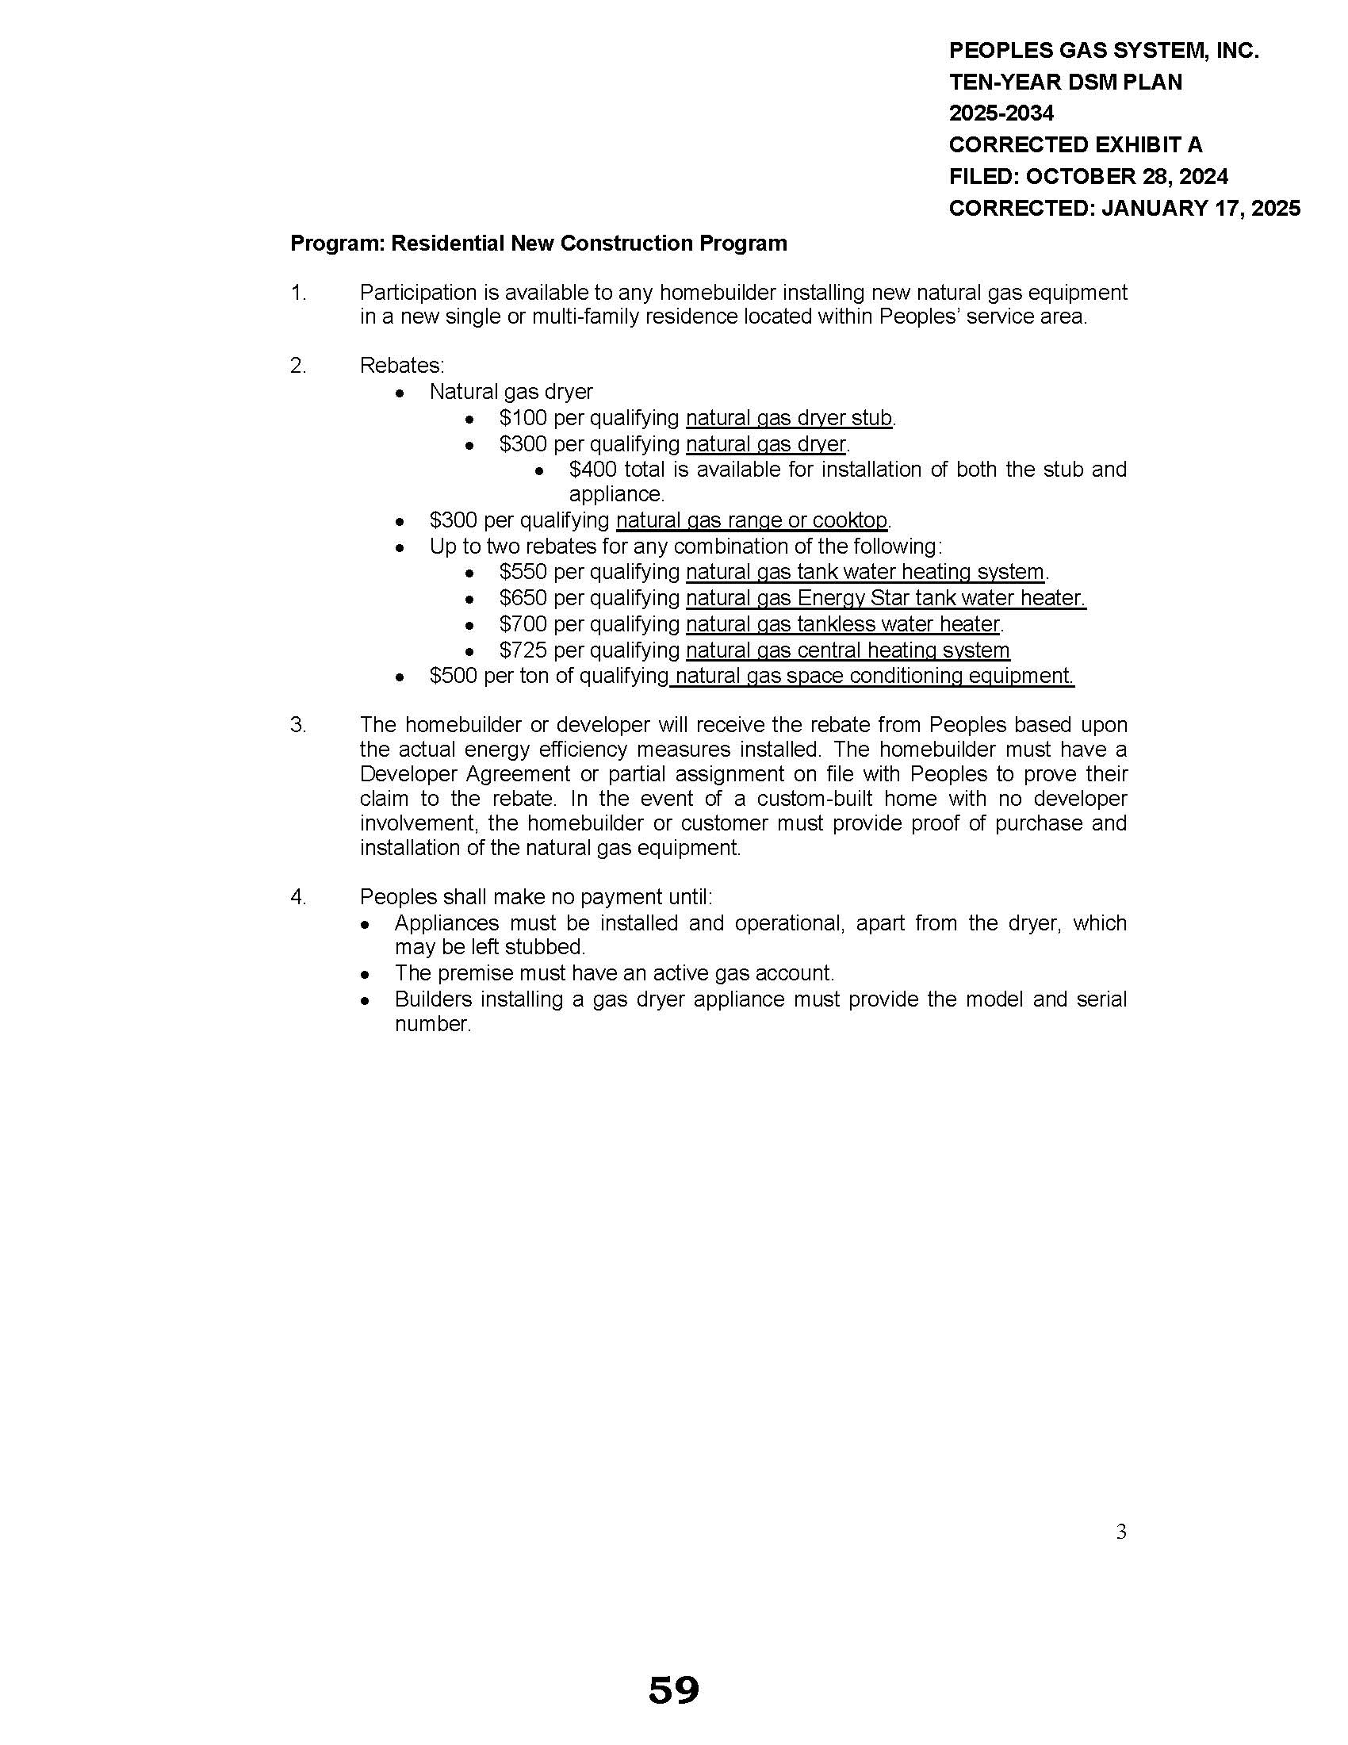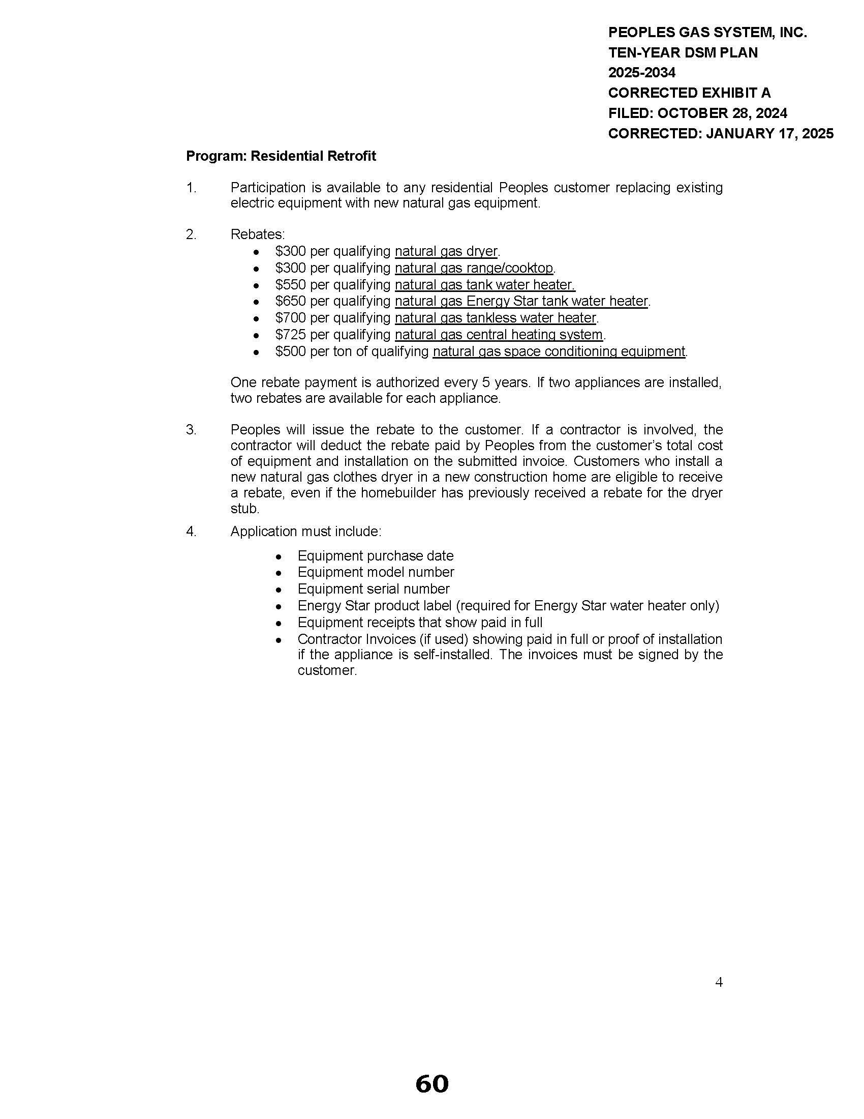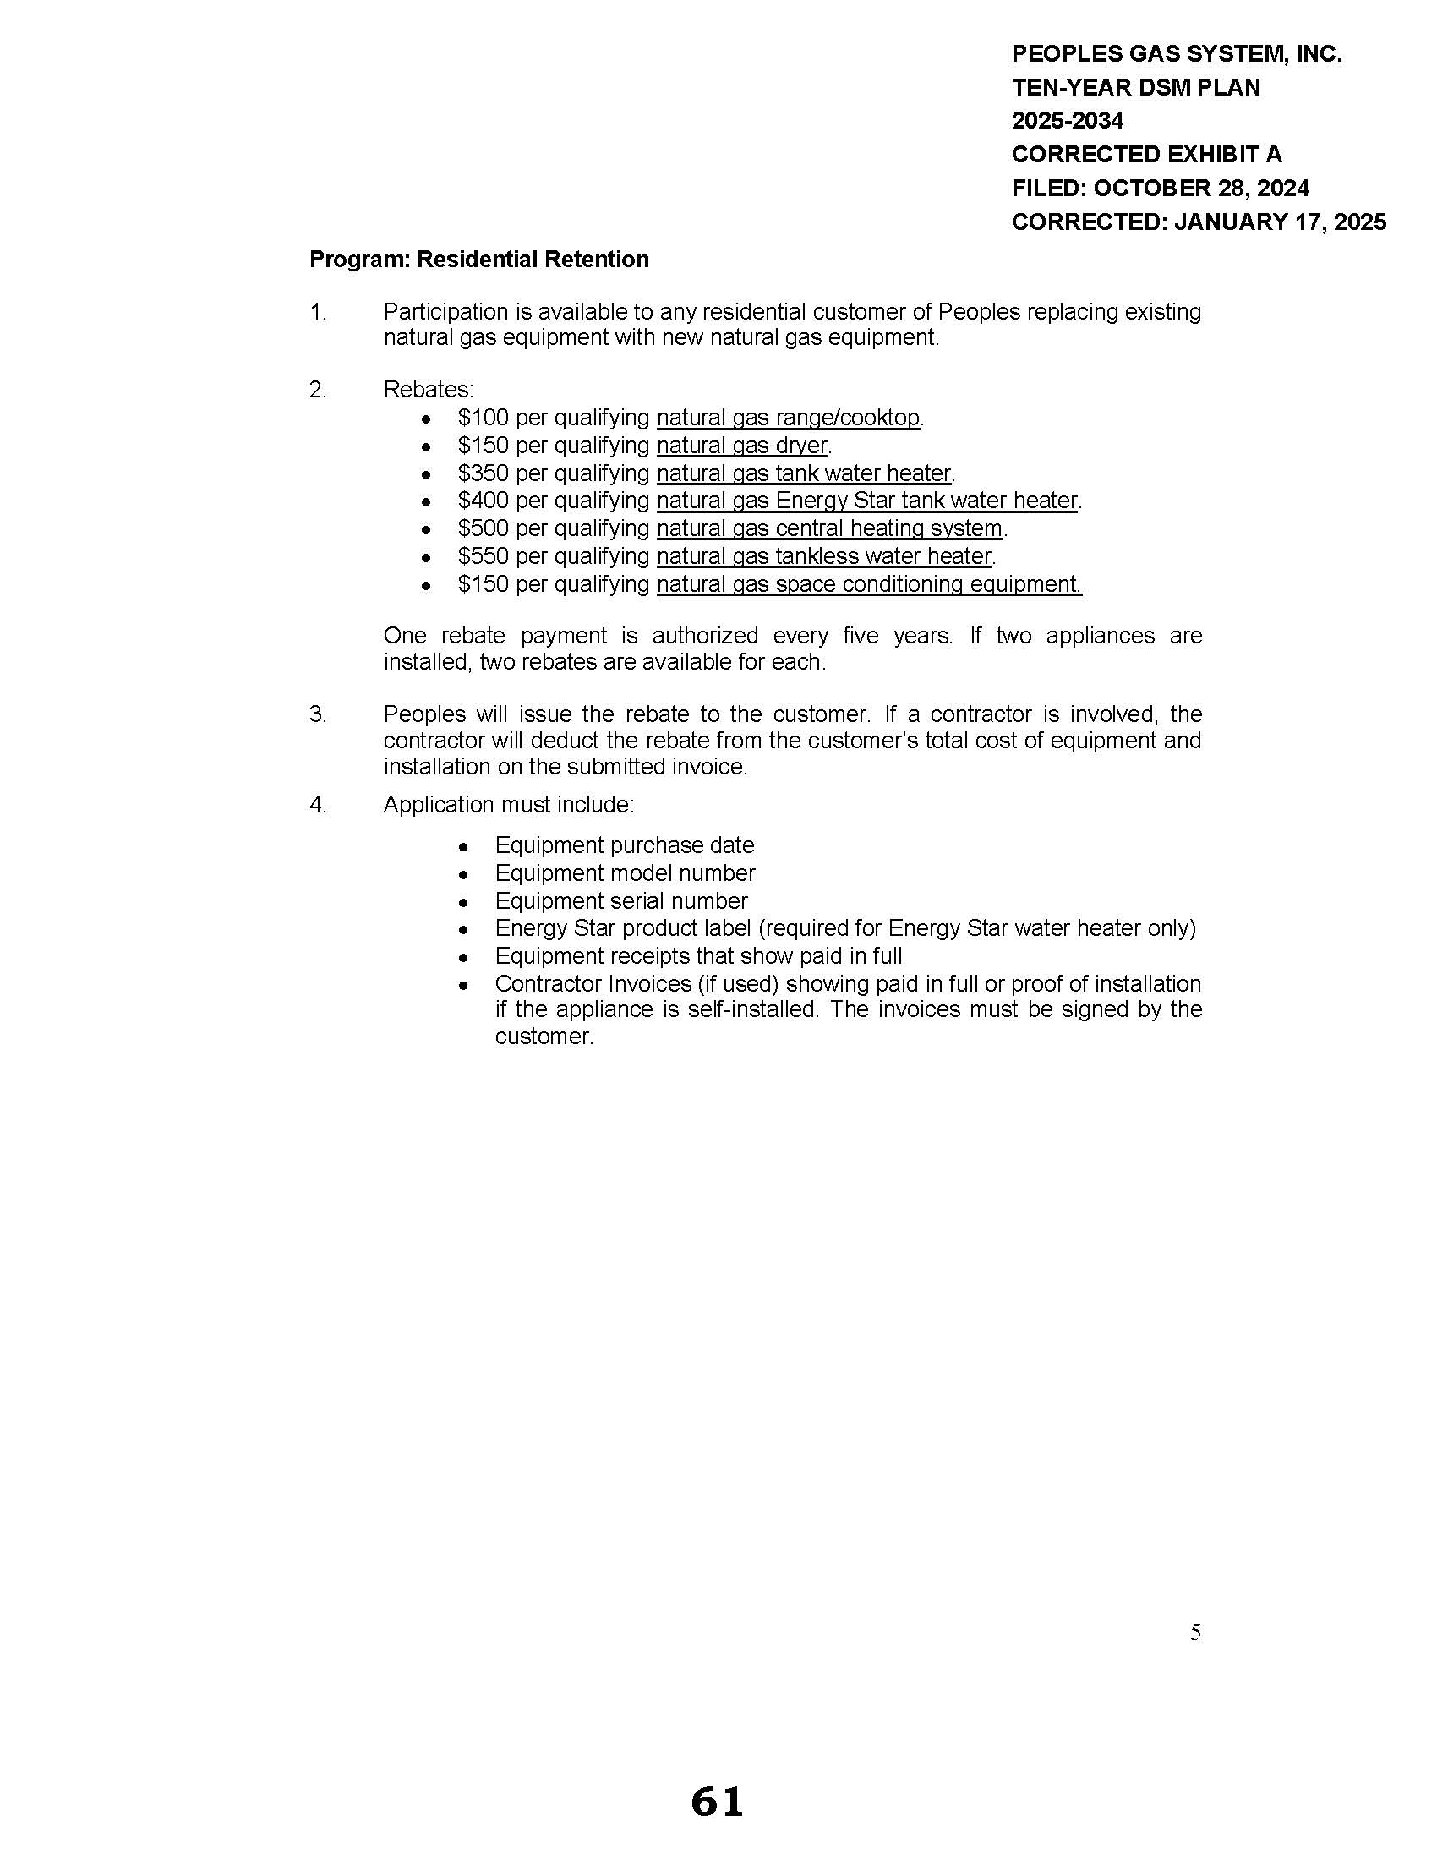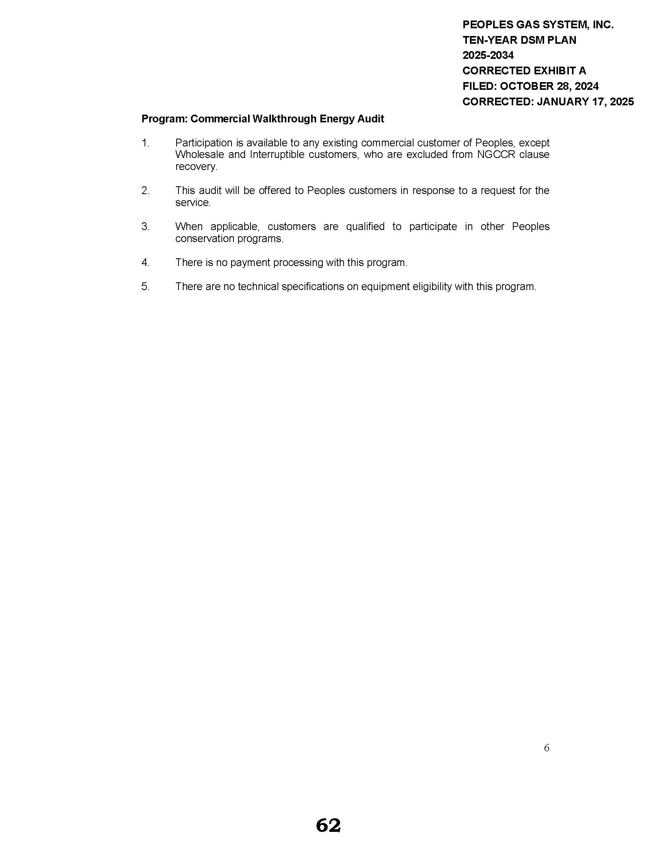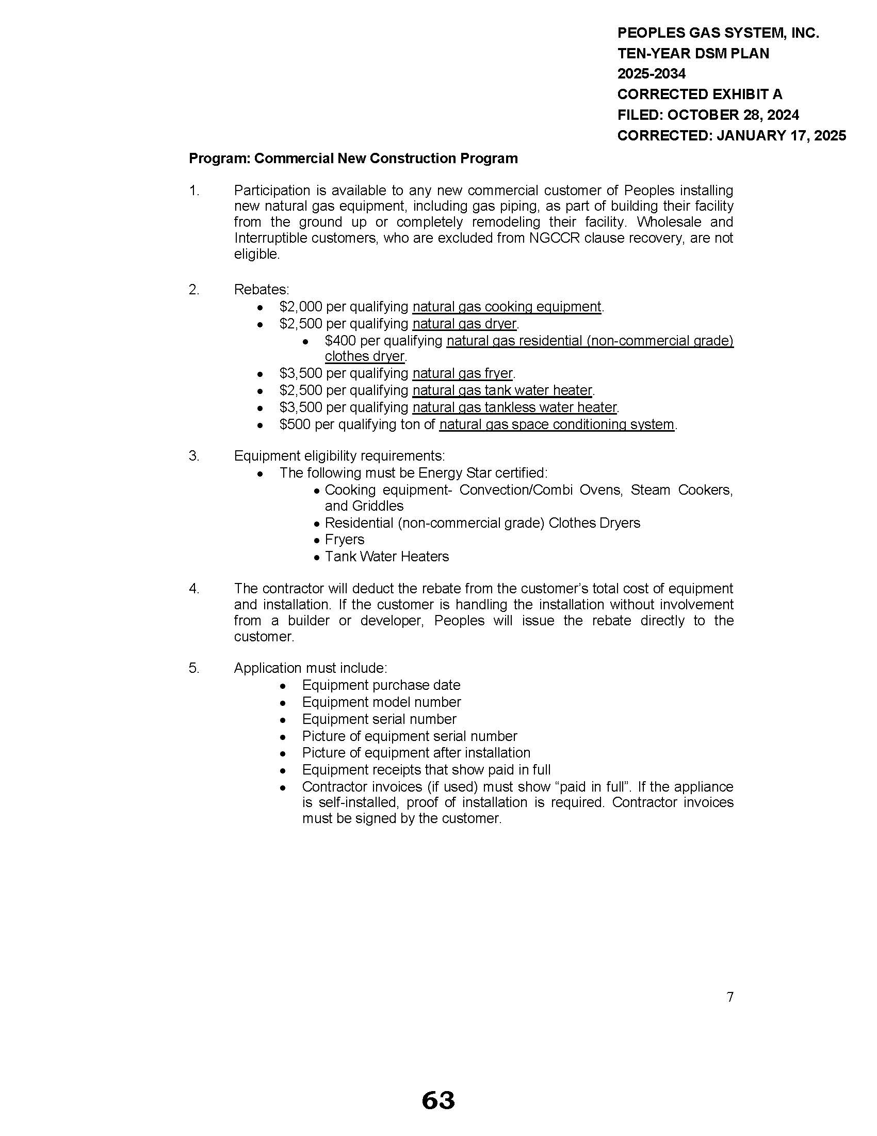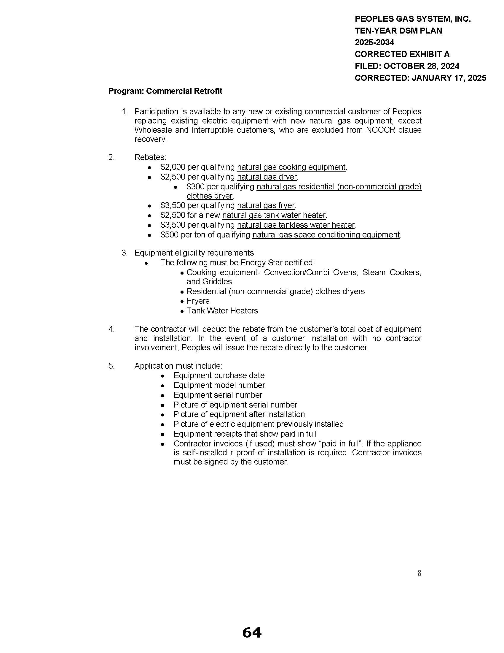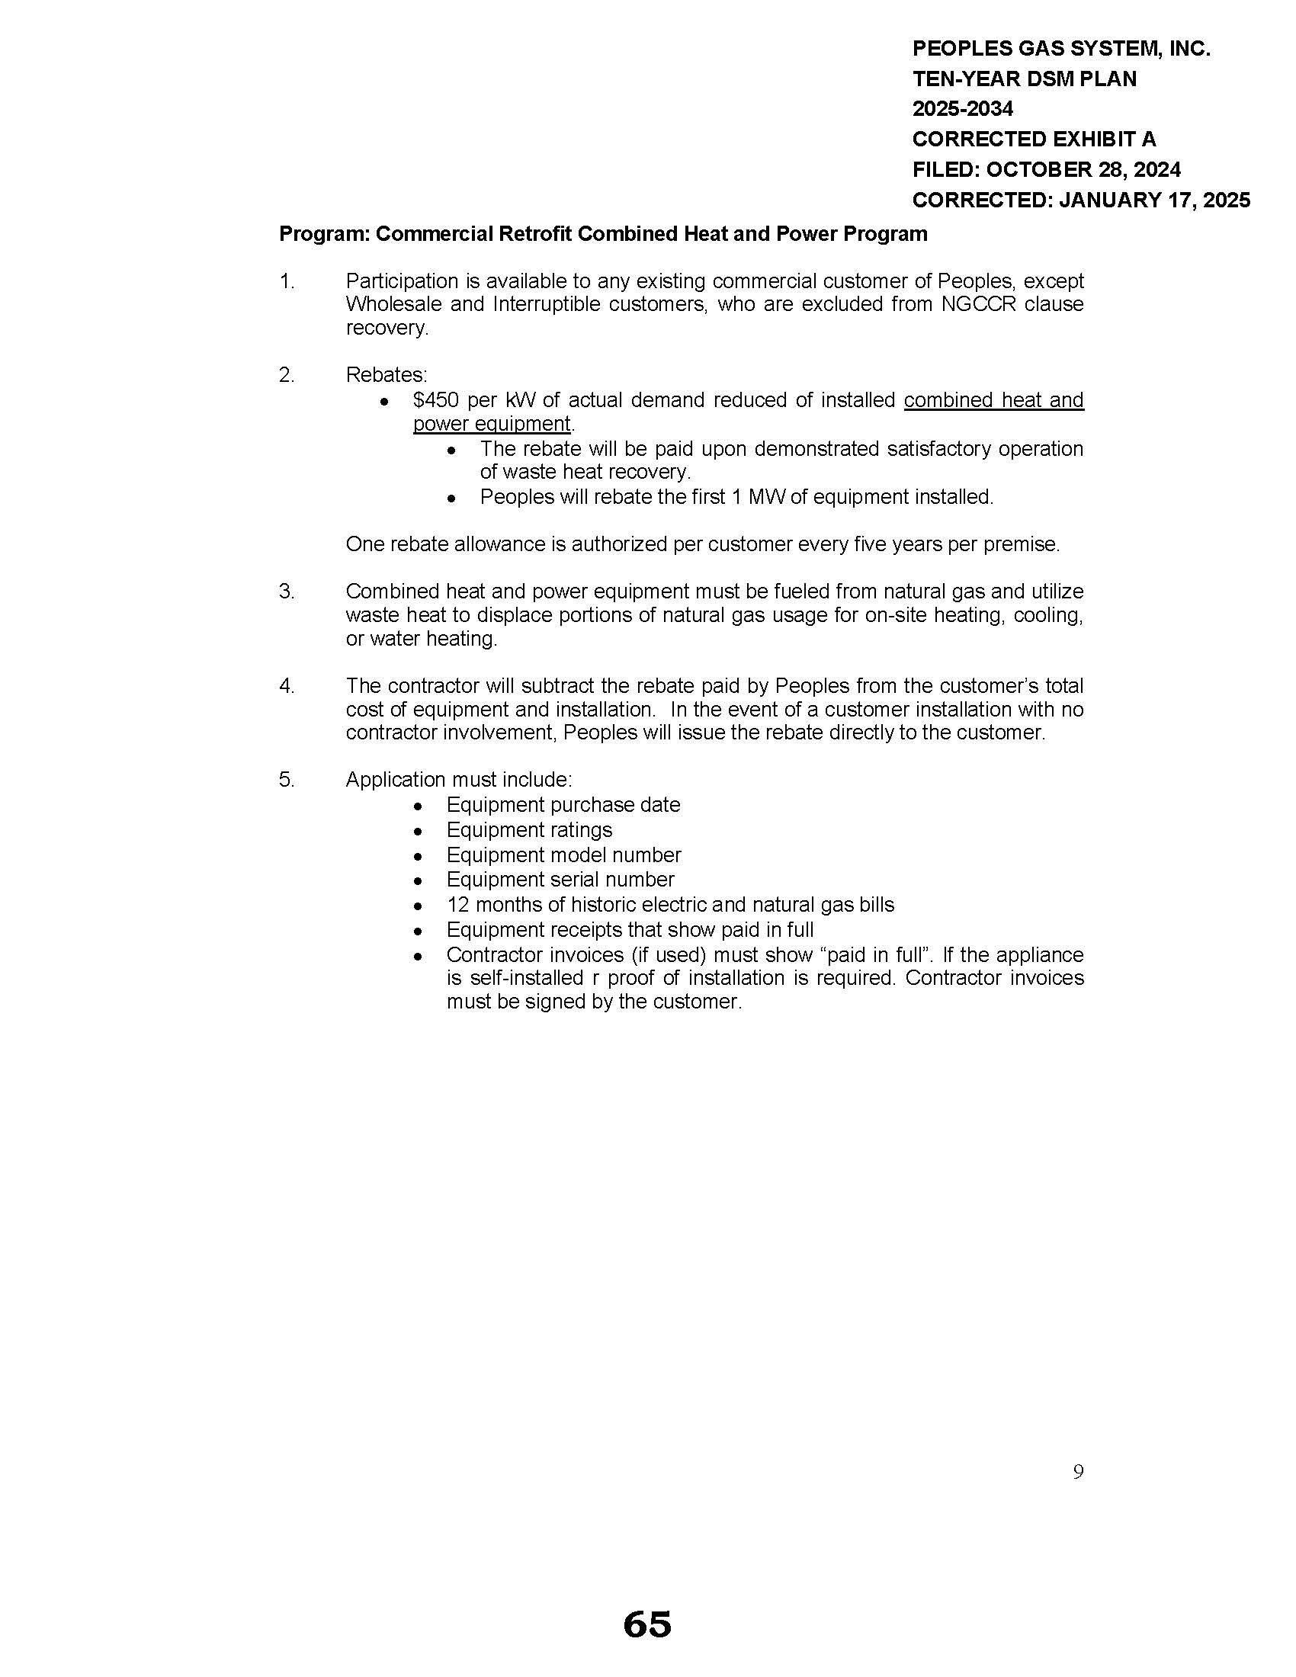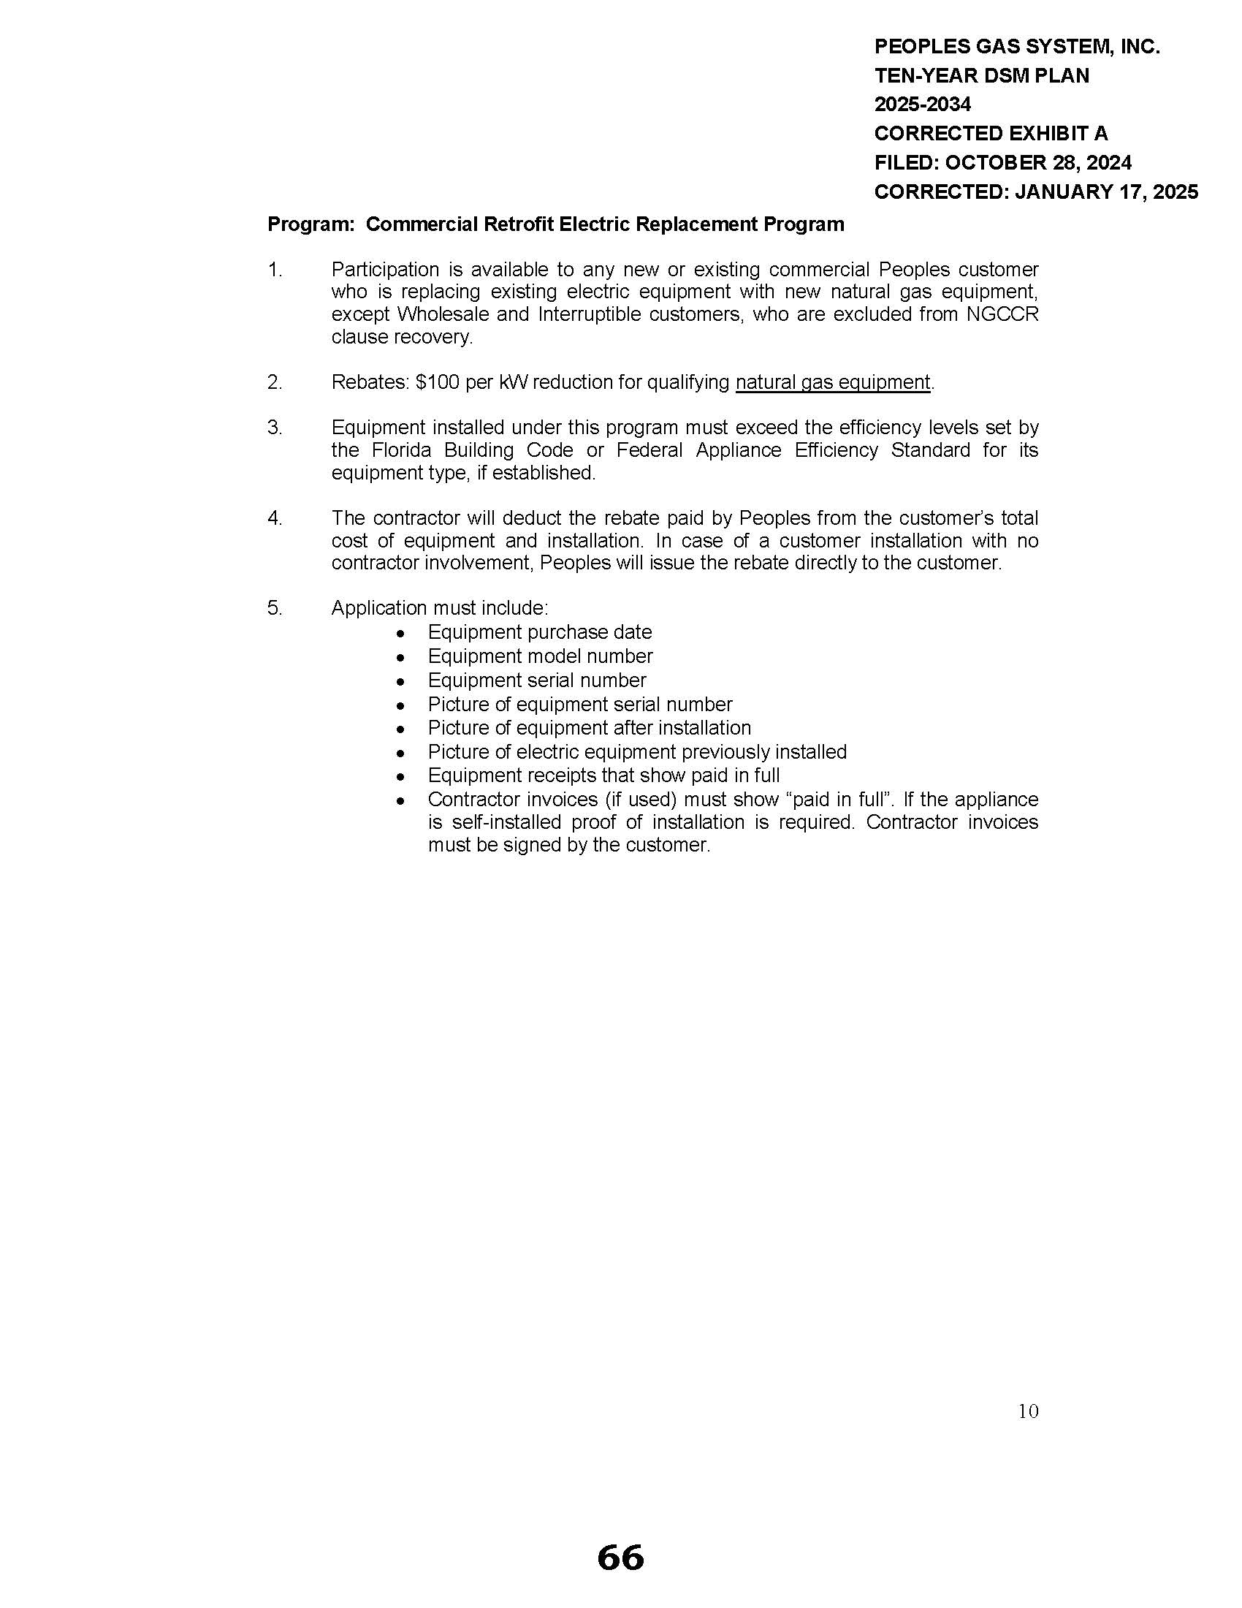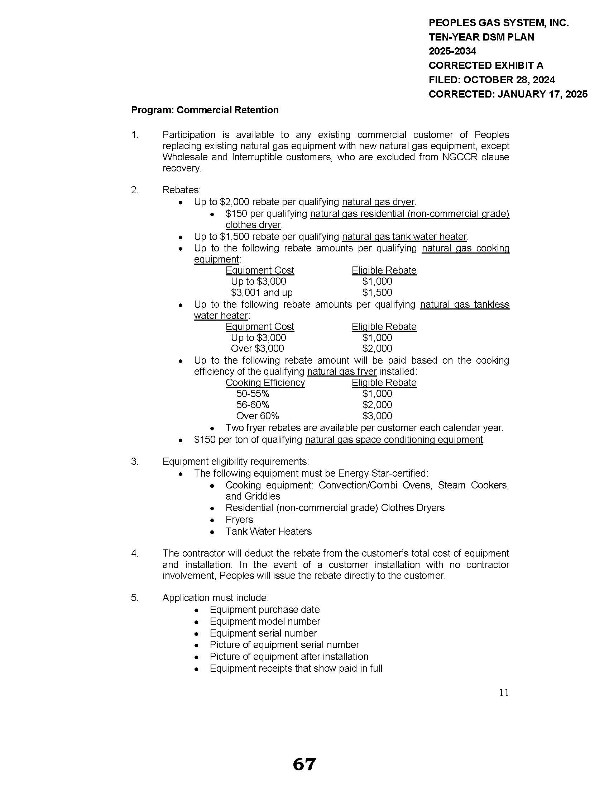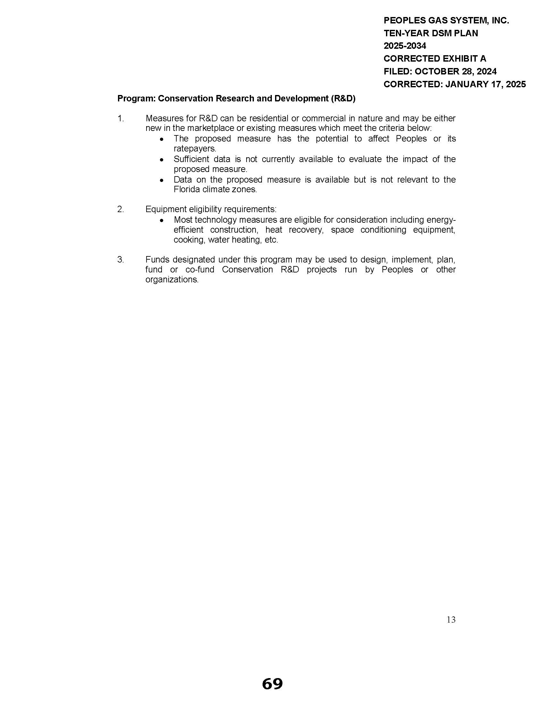

1. Order No. PSC-2024-0280-PAA-EG, issued July 30, 2024, in Docket No. 20240018-EG, *In re: Commission review of numeric conservation goals (Peoples Gas System, Inc.)*.
2. PSC Order No. 22176, issued November 14, 1989, in Docket No. 19890737-PU, *In re:* *Implementation of Section 366.80-.85, F.S., Conservation Activities of Electric and Natural Gas Utilities*.