|  |  |  |  |
| --- | --- | --- | --- |
| State of Florida  pscSEAL | | Public Service Commission  Capital Circle Office Center ● 2540 Shumard Oak Boulevard Tallahassee, Florida 32399-0850  -M-E-M-O-R-A-N-D-U-M- | |
| DATE: | January 24, 2025 | | |
| TO: | Office of Commission Clerk (Teitzman) | | |
| FROM: | Division of Accounting and Finance (Vogel, Norris, D. Buys, Quigley, Gatlin)  Division of Economics (Hampson, McClelland)  Division of Engineering (Ellis, Ramos)  Office of the General Counsel (Thompson) | | |
| RE: | Docket No. 20240172-EI – Petition for recovery of costs associated with named tropical systems during the 2023 and 2024 hurricane seasons and replenishment of storm reserve, by Tampa Electric Company. | | |
| AGENDA: | 02/04/25 – Regular Agenda – Interested Persons May Participate | | |
| COMMISSIONERS ASSIGNED: | | | All Commissioners |
| PREHEARING OFFICER: | | | Clark |
| CRITICAL DATES: | | | None |
| SPECIAL INSTRUCTIONS: | | | None |

Case Background

On December 27, 2024, Tampa Electric Company (TECO or Company) filed a petition for a limited proceeding seeking authority to implement an interim storm restoration recovery charge to recover $463.6 million for the incremental restoration costs related to Hurricanes Idalia, Debby, Helene, and Milton (collectively, the Storms), as well as the replenishment of its storm reserve. Included in the $463.6 million is accrued interest and projected interest in the amount of $14.4 million. Pursuant to the 2021 Stipulation and Settlement Agreement (2021 Settlement) approved by the Commission by Order No. PSC-2021-0423-S-EI, the recovery of storm costs from customers will begin, on an interim basis, 60 days after the filing of a cost recovery petition and tariff with the Commission.[1] In TECO’s 2024 rate case, the Commission voted on December 3, 2024 to continue the existing storm cost recovery mechanism established in the 2021 Settlement. TECO requested a 12-month recovery period, applied to all customer bills starting with the first billing cycle of March 2025.

The Commission has jurisdiction over this matter pursuant to Sections 366.04, 366.05, 366.06, and 366.076, Florida Statutes.

Discussion of Issues

Issue 1:

 Should the Commission authorize TECO to implement an interim storm restoration recovery charge?

Recommendation:

 Yes. The Commission should authorize TECO to implement an interim storm restoration recovery charge, subject to refund. Once the total actual storm costs are known, TECO should be required to file documentation of the total actual storm costs for Commission review and true-up of any excess or shortfall. (Gatlin)

Staff Analysis:

 As stated in the Case Background, TECO filed a petition to seek recovery of $463.6 million in incremental storm restoration costs and interest related to Hurricanes Idalia, Debby, Helene, and Milton, as well as the replenishment of its storm reserve. In its petition, TECO requested to replenish the storm reserve to $55.8 million.

The petition was filed pursuant to the provisions of the 2021 Settlement. Pursuant to paragraph 8(a) of the 2021 Settlement, TECO is authorized to begin recovery of storm costs, on an interim basis, 60 days following the filing of a petition for recovery.

In its petition, TECO asserted that it incurred approximate recoverable costs in the amounts of $34.3 million for Hurricane Idalia; $4.0 million for Hurricane Debby; $52.0 million for Hurricane Helene; $358.9 million for Hurricane Milton. The remaining $14.4 million is for the interest accrued and projected interest on the unrecovered balance related to the Storms. The Company further asserted that all amounts were calculated in accordance with the Incremental Cost and Capitalization Approach methodology prescribed in Rule 25-6.0143, Florida Administrative Code.

The approval of an interim storm restoration recovery charge is preliminary in nature and is subject to refund pending further review once the total actual storm restoration costs are known. After the actual costs are reviewed for prudence and reasonableness, and are compared to the actual amount recovered through the interim storm restoration recovery charge, a determination will be made whether any over/under recovery has occurred. The disposition of any over or under recovery, and associated interest, will be considered by the Commission at a later date.

Based on a review of the information provided by TECO in its petition, staff recommends that the Commission authorize the Company to implement an interim storm restoration recovery charge subject to refund. Once the total actual storm costs are known, TECO should be required to file documentation of the storm costs for Commission review and true-up of any excess or shortfall.

Issue 2:

 What is the appropriate security to guarantee the amount collected subject to refund through the interim storm restoration recovery charge?

Recommendation:

 The appropriate security to guarantee the funds collected subject to refund is a corporate undertaking. (Quigley, D. Buys)

Staff Analysis:

 Staff recommends that all funds collected subject to refund be secured by a corporate undertaking. The criteria for a corporate undertaking include sufficient liquidity, equity ownership, profitability, and interest coverage to guarantee any potential refund. TECO requested a 12-month collection period beginning with the first billing cycle in March 2025 through February 2026 for Interim Storm Recovery Charges of $464 million related to the Storms. Staff reviewed DEF’s three most recent annual reports filed with the Commission (2021, 2022, and 2023) to determine if the Company can support a corporate undertaking to guarantee the funds collected for incremental storm restoration costs related to the subject weather events. TECO’s financial information indicates the Company’s financial position to support a corporate undertaking of $464 million is marginal, but satisfactory. TECO’s average net income over the last three years is $431 million, which is less than the requested interim amount. The Company’s net income in 2023 was $466 million which is slightly more than the requested storm cost recovery interim amount. TECO’s profitability, equity ownership, current ratio, and interest coverage for 2023 is sufficient to support a potential refund up to $233 million. Staff’s corporate undertaking guidelines indicate that the maximum that should be allowed for a corporate undertaking is one-half of TECO’s 2023 net income, or $233 million. However, it is improbable TECO will be required to refund the entire requested amount of approximately $464 million. Historically, TECO has supported its requested interim storm cost recovery amounts through a hearing process and the Commission has approved those cost amounts with only minor adjustments. Further, the storm cost recovery mechanism is a surcharge for the sole purpose of recovering the costs incurred for storm restoration and any potential refund would be applied to the funds already collected and effectuated by reduced charges on future customer bills.

Accordingly, staff believes TECO has adequate resources to support a corporate undertaking in the amount requested. Based on this analysis, staff recommends that a corporate undertaking of $464 million is acceptable. This brief financial analysis is only appropriate for deciding if TECO can support a corporate undertaking in the amount requested and should not be considered a finding regarding staff’s position on other issues in this proceeding.

Issue 3:

 Should the Commission approve TECO's proposed interim storm restoration recovery charge tariff as shown in Attachment A to the recommendation?

Recommendation:

 Yes, the Commission should approve TECO’s proposal to revise the interim storm restoration recovery tariff and associated surcharges, as shown in Attachment A to this recommendation. The tariff should become effective the first billing cycle of March 2025. The interim storm restoration surcharges should be subject to final true-up once the total actual storm costs are known. (McClelland)

Staff Analysis:

 TECO calculated the interim storm surcharge for the 12-month period of March 1, 2025, through February 28, 2026, subject to true-up once the final total recoverable storm amount is known and determined. In paragraph 12 of the petition, TECO states that the proposed surcharges are developed using the cost-of-service methodology approved in TECO’s 2024 rate case at the December 3, 2024 Commission Conference.[2] Staff has reviewed the allocation to rate classes and believes that the allocations provided in Exhibit 5, page 2 to the petition are consistent with those approved in TECO’s most recent rate case. Furthermore, staff has reviewed the derivation of the surcharges provided in Exhibit 5 to the petition. Staff agrees that the surcharges have been calculated correctly, using projected kilowatt hour (kWh) sales for March 2025 through February 2026.

The proposed interim storm restoration surcharges are shown on Third Revised Tariff Sheet No. 6.024, provided in Exhibit 6 to the petition. For residential customers, the proposed surcharge would be 3.004 cents per kWh, which equates to a total surcharge of $30.04 for a 1,000 kWh monthly bill. The storm cost recovery surcharge would be included in the non-fuel energy charge on customer bills.

In response to staff’s first data request, TECO stated that it had considered alternative recovery periods and its corresponding expected bill impacts. The Company decided that the 12-month recovery period reasonably balanced the length of the recovery period, customer bill impacts, and timeliness of recovery. A longer period would incur greater total cost due to additional interest charges. If a 22-month billing period were adopted, the recovery period would extend through December 2026 and would result in a bill impact of $16.33 per 1,000 kWh on a monthly residential bill.

Paragraph 12(b) of the 2021 Settlement states that TECO may petition to the Commission for recovery of storm costs at a rate beyond $4.00 on a 1,000 kWh residential bill if TECO incurs in excess of $100 million of storm recovery costs, and it does not specify a recovery period.

Staff recommends that the Commission approve TECO’s proposed interim storm restoration recovery tariff and associated surcharges, as shown in Attachment A to this recommendation. The tariff should become effective the first billing cycle of March 2025. The interim storm restoration surcharges should be subject to final true-up once the total actual storm costs are known.

Issue 4:

 Should this docket be closed?

Recommendation:

 No. This docket should remain open pending final reconciliation of actual recoverable storm costs with the amount collected pursuant to the interim storm restoration recovery charge and the calculation of a refund or additional charge if warranted. (Thompson)

Staff Analysis:

 No, this docket should remain open pending final reconciliation of actual recoverable storm costs with the amount collected pursuant to the interim storm restoration recovery charge and the calculation of a refund or additional charge if warranted.

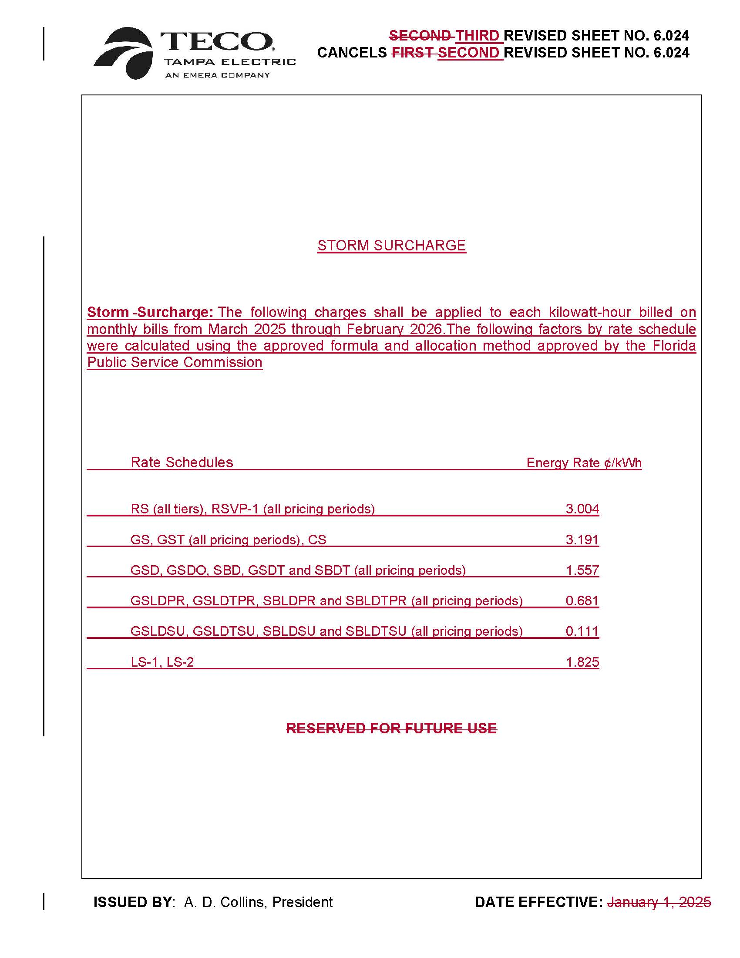

1. Order No. PSC-2021-0423-S-EI, issued November 10, 2021, in Docket No. 20210034-EI, *In re: Petition for rate increase by Tampa Electric Company.*
2. Docket No. 20240026-EI