|  |  |  |  |
| --- | --- | --- | --- |
| State of Florida  pscSEAL | | Public Service Commission  Capital Circle Office Center ● 2540 Shumard Oak Boulevard Tallahassee, Florida 32399-0850  -M-E-M-O-R-A-N-D-U-M- | |
| DATE: | January 24, 2025 | | |
| TO: | Office of Commission Clerk (Teitzman) | | |
| FROM: | Office of Industry Development and Market Analysis (Mallow, Day, Deas, Fogleman)  Office of the General Counsel (Imig, Augspurger) | | |
| RE: | Docket No. 20240162-TP – Petition for designation as an eligible telecommunications carrier, by TAG Mobility, LLC d/b/a TAG Mobile. | | |
| AGENDA: | 02/04/25 – Regular Agenda – Proposed Agency Action – Interested Persons May Participate | | |
| COMMISSIONERS ASSIGNED: | | | All Commissioners |
| PREHEARING OFFICER: | | | Clark |
| CRITICAL DATES: | | | None |
| SPECIAL INSTRUCTIONS: | | | None |

Case Background

On December 12, 2024, TAG Mobility, LLC d/b/a TAG Mobile (TAG Mobility or Company) filed a petition with the Florida Public Service Commission (Commission) seeking designation as an eligible telecommunications carrier (ETC) for the sole purpose of providing Lifeline service to qualifying consumers throughout Florida. TAG Mobility is a Mobile Virtual Network Operator (MVNO) and offers prepaid wireless telecommunications services to consumers as a wireless reseller. Specifically, TAG Mobility uses the network infrastructure and wireless transmission facilities of AT&T to operate as a MVNO. TAG Mobility is currently designated as an ETC providing Lifeline service in 19 other states.

As a MVNO, TAG Mobility is regulated as a common carrier pursuant to 47 U.S.C. § 153(11).[1] TAG Mobility is a Limited Liability Company that was organized in the State of Texas in January of 2024, in connection with the bankruptcy reorganization of its predecessor entity, TAG Mobile, LLC. As part of that reorganization, TAG Mobile, LLC’s assets were divided between two newly created entities, both of which were acquired indirectly by Mr. Henry Hung Do.

TAG Mobility asserts that it meets all applicable federal requirements for designation as a Lifeline only ETC in Florida pursuant to 47 U.S.C. 214(e) and 47 C.F.R. 54.201. TAG Mobility acknowledges and asserts that, if approved, it will comply with Section 364.10 and 364.105, Florida Statutes (F.S.) and Rule 25-4.0665, Florida Administrative Code (F.A.C.), which govern Lifeline service and provide for a transitional discount for customers who no longer qualify for Lifeline.

The Commission is vested with jurisdiction in this matter pursuant to Section 214(e)(2) of the Telecommunications Act of 1996 (the Act) and Section 364.10, Florida Statutes.

Discussion of Issues

Issue 1:

 Should TAG Mobility be granted ETC designation to provide Lifeline service throughout the State of Florida?

Recommendation:

Yes. TAG Mobility should be granted ETC designation to provide Lifeline service throughout the State of Florida. Staff also recommends that if there is a future change of Company ownership, the new owners should be required to file a petition with the Commission to demonstrate that it is in the public interest to maintain the Company’s ETC designation. (Mallow, Day, Deas, Fogleman)

Staff Analysis:

 ETC designation is necessary for telecommunications companies to participate in the federal Lifeline program.[2] Section 364.10, F.S., allows the Commission to approve wireless Lifeline ETC petitions by requesting carriers. Specifically, Section 364.10(1)(a) and (3)(a) F.S., provide that the Commission has the authority to designate a commercial mobile radio service provider as an ETC for the limited purpose of providing Lifeline service.

Federal rules outline the requirements for ETC designation.[3] To obtain ETC designation to provide Lifeline services, federal rules require that carriers:

1. Be a common carrier;
2. Offer the services that are supported by the federal universal support mechanisms either using its own facilities or a combination of its own facilities and resale of another carrier’s services;
3. Advertise the availability of its Lifeline service through a media of general distribution;
4. Provide voice grade access to the public switch network or its functional equivalent;
5. Offer minutes of use for local service at no additional charge to end users;
6. Provide access to the emergency services available by local government or other public safety organizations;
7. Provide Broadband Internet Access Service;[4]
8. Demonstrate financial and technical capability to of provide Lifeline service; and
9. Not charge Lifeline customers a monthly number-portability charge.

In addition, Florida law requires ETCs to:

1. Offer a discounted transitional basic telecommunications service;[5] and
2. Participate in the Lifeline Promotion Process.[6]

**Forbearance of Facilities Requirements**

TAG Mobility plans to offer all of the supported services enumerated under Section 254(c) of the Act through its wireless resale agreements with AT&T. Therefore, it sought forbearance of the facilities requirement from the FCC. On September 21, 2022, the FCC approved TAG Mobility’s amended compliance plan as a condition of obtaining forbearance from the facilities requirement for the provision of Lifeline service. As part of its compliance plan TAG Mobility committed to the following: [7]

1. Provide the supported services throughout the carriers designated areas;
2. Remain functional in emergency situations;
3. Comply with the Cellular Telecommunications and Internet Association's Consumer Code for Wireless Service;
4. Demonstrate that it is financially and technically capable of providing the Lifeline service in compliance with federal rules; and
5. Describe the terms and conditions of the broadband Internet access service plans offered to Lifeline subscribers.

Because TAG Mobility will offer the supported services and is compliant with the FCC requirements pursuant to 47 U.S.C. 214(e) and 47 C.F.R. 54.201, as well as the Florida specific requirements, TAG Mobility is eligible for designation as a Lifeline only ETC in Florida.

**Financial, Managerial, and Technical Capabilities**

As noted in its petition, TAG Mobility has offered service since 2024 and has not filed for any form of bankruptcy relief. The company has operated as an ETC in 19 states and has not been subject to any ETC revocation proceedings in any state. The company has many years of technical and managerial experience, and it does not rely exclusively on Lifeline reimbursements for its operating revenues. As TAG Mobility will be providing resold wireless service, it will also rely upon the managerial and technical expertise of its underlying carriers.

**Public Interest**

State commissions are required to find that ETC designation is in the public interest.[8] TAG Mobility asserts granting its ETC designation will bring Lifeline eligible consumers more choice in providers without creating additional burden on the federal high-cost programs. The Commission’s most recent Lifeline report notes that three wireless companies represent 98 percent of the Lifeline market in Florida.[9] However, the FPSC’s estimated Lifeline participation rate for last year was 12.8 percent.[10] While the Commission has designated additional Lifeline ETCs, the increase in carriers servicing this market may increase participation through additional marketing and would serve the public interest.

**Conclusion**

Staff has reviewed TAG Mobility’s petition for ETC designation in Florida. TAG Mobility meets all the requirements for designation as an ETC. Additionally, the company has demonstrated sufficient financial, managerial and technical capabilities. Therefore, staff recommends TAG Mobility should be granted ETC designation throughout the State of Florida as identified in Attachment A of this recommendation. Staff further recommends that if there is a future change of Company ownership, the new owners should be required to file a petition with the Commission to demonstrate that it is in the public interest to maintain the Company’s ETC designation.

Issue 2:

 Should this docket be closed?

Recommendation:

 Yes. If no person whose substantial interests are affected by the proposed agency action files a protest within 21 days of the issuance of the Proposed Agency Action Order, this docket should be closed upon the issuance of a consummating order. (Imig)

Staff Analysis:

 At the conclusion of the protest period, if no protest is filed, this docket should be closed upon the issuance of a consummating order.

DESIGNATED SERVICE AREA

TAG Mobile is proposing to offer Lifeline supported service throughout the State of Florida, as

illustrated in the following coverage map for TAG Mobile’s underlying carrier, AT&T:

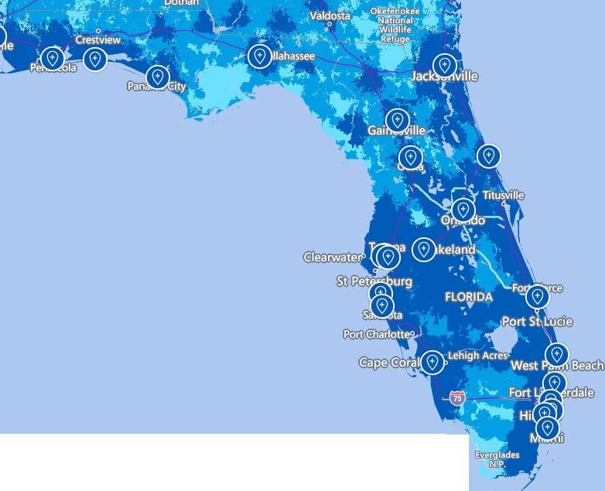

venues ■SG+ ■SG

4G LTE ■Partner coverage 0

1. 47 U.S.C. § 153(11) (defining a common carrier as “any person engaged as a common carrier for hire, in interstate or foreign communications by wire or radio . . . .”; 47 U.S.C. §332(c)(1)(A) (treating commercial mobile service providers as common carriers).
2. 47 C.F.R. § 54.201(a).
3. 47 C.F.R. § 214(e)(1), 47 U.S.C. 54.101, 47 U.S.C. 54.201, and 47 U.S.C. 54.401; While Section 54.101(a) also includes requirements addressing toll limitation services to qualifying low-income consumers, the FCC in its 2012 Lifeline and Link Up Reform Order (FCC 12-11) stated that: “ETCs are not required to offer toll limitation service to low-income consumers if the Lifeline offering provides a set amount of minutes that do not distinguish between toll and non-toll calls.”
4. Broadband Internet Access Service (BIAS) is defined as a mass-market retail service that provides the capability to transmit and receive data, but excluding dial-up service.
5. Section 364.105, F.S states that each ETC shall offer a residential basic local telecommunications service at 70 percent of the residential local telecommunications service rate for any Lifeline subscriber who no longer qualifies for Lifeline for a period of 1 year after the date the subscriber ceases to qualify for Lifeline .
6. Rule25-4.0665(3), Florida Administrative Code (F.A.C.); The Lifeline Promotion Process is an electronic system developed in collaboration with the Florida Department of Children and Families, ETCs and the FPSC. This system helps assist ETCs and the FPSC in providing information on how to apply for Lifeline assistance to eligible customers.
7. 47 C.F.R. § 54.202(a)
8. 47 U.S.C. 214(e)(2)
9. 2024 Florida Lifeline Assistance Report, December 2024, Appendix C, p 24.
10. Ibid, p 18.