|  |  |  |  |
| --- | --- | --- | --- |
| State of Florida  pscSEAL | | Public Service Commission  Capital Circle Office Center ● 2540 Shumard Oak Boulevard Tallahassee, Florida 32399-0850  -M-E-M-O-R-A-N-D-U-M- | |
| DATE: | January 24, 2025 | | |
| TO: | Office of Commission Clerk (Teitzman) | | |
| FROM: | Division of Accounting and Finance (Vogel, D. Buys, Mason, Norris)  Division of Economics (Hampson, Hudson, McClelland)  Division of Engineering (P. Buys, Ramos, Smith II)  Office of the General Counsel (Dose) | | |
| RE: | Docket No. 20240173-EI – Petition for limited proceeding for recovery of incremental storm restoration costs related to Hurricanes Debby, Helene and Milton, by Duke Energy Florida, LLC. | | |
| AGENDA: | 02/04/25 – Regular Agenda – Interested Persons May Participate | | |
| COMMISSIONERS ASSIGNED: | | | All Commissioners |
| PREHEARING OFFICER: | | | Clark |
| CRITICAL DATES: | | | None |
| SPECIAL INSTRUCTIONS: | | | None |

Case Background

On December 27, 2024, Duke Energy Florida, LLC (DEF or Company) filed a petition for a limited preceding seeking authority to implement an interim storm restoration recovery charge to recover $1.09 billion for the incremental restoration costs related to Hurricanes Debby, Helene, and Milton (collectively, the Storms), as well as the replenishment of its retail storm reserve. Included in the $1.09 billion is interest charged on unrecovered costs for Hurricanes Debby, Helene, and Milton. Pursuant to the 2024 Settlement Agreement (2024 Settlement) approved by the Commission in Order No. PSC-2024-0472-AS-EI, the recovery of storm costs from customers will begin, on an interim basis, 60 days after the filing of a cost recovery petition and tariff with the Commission.[1] DEF requested a 12-month recovery period, applied to all bills from March 2025 through February 2026.

The Commission has jurisdiction over this matter pursuant to Sections 366.04, 366.05, 366.06, and 366.076, Florida Statutes.

Discussion of Issues

Issue :

Should the Commission authorize DEF to implement an interim storm restoration recovery charge?

Recommendation:

 Yes. The Commission should authorize DEF to implement an interim storm restoration recovery charge, subject to refund. Once the total actual storm costs are known, DEF should be required to file documentation of the total actual storm costs for Commission review and true-up of any excess or shortfall. (Mason)

Staff Analysis:

 As stated in the Case Background, DEF filed a petition for a limited proceeding seeking authority to implement an interim storm restoration charge to recover an estimated total of $1.09 billion for incremental storm restoration costs for the Storms and to replenish its storm reserve. In its petition, DEF requested to replenish the storm reserve to $131.9 million.

The petition was filed pursuant to the provisions of the 2024 Settlement approved by the Commission in Order No. PSC-2024-0472-AS-EI. Pursuant to the 2024 Settlement, DEF can begin recovery of storm costs 60 days following the filing of a petition for recovery.

In its petition, DEF asserted that it incurred approximate recoverable costs in the amounts of $61.0 million for Hurricane Debby, $372.5 million for Hurricane Helene, and $769.7 million for Hurricane Milton. The Company further asserted that all amounts were calculated in accordance with the Incremental Cost and Capitalization Approach methodology prescribed in Rule 25-6.0143, Florida Administrative Code.

The approval of an interim storm restoration recovery charge is preliminary in nature and is subject to refund pending further review once the total actual storm restoration costs are known. After the actual costs are reviewed for prudence and reasonableness, and are compared to the actual amount recovered through the interim storm restoration recovery charge, a determination will be made whether any over/under recovery has occurred. The disposition of any over or under recovery, and associated interest, will be considered by the Commission at a later date.

Based on a review of the information provided by DEF in its petition, staff recommends that the Commission authorize the Company to implement an interim storm restoration recovery charge subject to refund. Once the total actual storm costs are known, DEF should be required to file documentation of the storm costs for Commission review and true-up of any excess or shortfall.

Issue :

What is the appropriate security to guarantee the amount collected subject to refund through the interim storm restoration recovery charge?

Recommendation:

 The appropriate security to guarantee the funds collected subject to refund is a corporate undertaking. (Ferrer, D. Buys)

Staff Analysis:

 Staff recommends that all funds collected subject to refund be secured by a corporate undertaking. The criteria for a corporate undertaking include sufficient liquidity, equity ownership, profitability, and interest coverage to guarantee any potential refund. DEF requested a 12-month collection period beginning with the first billing cycle in March 2025 through February 2026 for Interim Storm Recovery Charges of $1.09 billion related to Hurricanes Debby, Helene, and Milton. Staff reviewed DEF’s three most recent annual reports filed with the Commission (2021, 2022, and 2023) to determine if the Company can support a corporate undertaking to guarantee the funds collected for incremental storm restoration costs related to the subject weather events. DEF’s financial information indicates the Company’s financial position to support a corporate undertaking of $1.09 billion is marginal, but satisfactory. DEF’s average net income over the last three years is $889 million, which is less than the requested interim amount. The Company’s net income in 2023 was $1.019 billion, slightly less than the requested storm cost recovery interim amount. DEF’s profitability, equity ownership, current ratio, and interest coverage for 2022, and 2023 are sufficient to support a potential refund up to $510 million. Staff’s corporate undertaking guidelines indicate that the maximum that should be allowed for a corporate undertaking is one-half DEF’s 2023 net income, or $510 million. However, DEF participates in Duke Energy Corporation’s (DEF’s parent company) money pool and has access to additional funds if needed. In addition, it is improbable DEF will be required to refund the entire requested amount of $1.09 billion. Historically, DEF has supported its requested interim storm cost recovery amounts through a hearing process and the Commission has approved those cost amounts with only minor adjustments. Further, the storm cost recovery mechanism is a surcharge for the sole purpose of recovering the costs incurred for storm restoration and any potential refund would be applied to the funds already collected and effectuated by reduced charges on future customer bills.

Accordingly, staff believes DEF has adequate resources to support a corporate undertaking in the amount requested. Based on this analysis, staff recommends that a corporate undertaking of $1.09 billion is acceptable. This brief financial analysis is only appropriate for deciding if DEF can support a corporate undertaking in the amount requested and should not be considered a finding regarding staff’s position on other issues in this proceeding.

Issue :

Should the Commission approve DEF’s proposed interim storm restoration recovery charge tariff as shown in Attachment A to the recommendation?

Recommendation:

 Yes, the Commission should approve DEF’s proposal to revise the interim storm restoration recovery tariff and associated surcharges, as shown in Attachment A to this recommendation. The tariff should become effective the first billing cycle of March 2025. The interim storm restoration surcharges should be subject to final true-up once the total actual storm costs are known. (McClelland)

Staff Analysis:

 DEF calculated the interim storm surcharge for the 12-month period of March 1, 2025, through February 28, 2026, subject to true-up once the final total recoverable storm amount is known and determined. In paragraph 21 of the petition, DEF states that the proposed surcharges are allocated to the rate classes consistent with the rate design approved in the 2021 and 2024 Settlements. Staff has reviewed the allocation to rate classes provided in Appendix A to the petition and the derivation of the surcharges provided in Appendix B to the petition. Staff believes that the surcharges have been calculated correctly, using projected kilowatt hour (kWh) sales for March 2025 through February 2026.

The proposed interim storm restoration surcharges are shown on One Hundred and Eighth Revised Tariff Sheet No. 6.105, provided in Appendix B to the petition.[2] For residential customers, the proposed surcharge would be 3.118 cents per kWh, which equates to a total surcharge of $31.18 for a 1,000 kWh monthly bill. The storm cost recovery surcharge would be included in the non-fuel energy charge on customer bills.

In response to staff’s first data request, DEF stated that its decision to use a 12-month recovery period (March 2025 – February 2026) is based upon DEF’s 2021 Settlement approved in Order No. PSC-2021-0202-AS-EI. Interim recovery of storm costs is governed by Paragraph 30c of the 2021 Settlement, which provides that “recovery from customers for storm damage costs will begin, subject to Commission approval on an interim basis, sixty (60) days following the filing of a cost recovery petition with the Commission, and subject to true-up pursuant to further proceedings before the Commission, and will be based on a 12-month recovery period.” Similar language is included in the 2024 Settlement approved in Order No. PSC-2024-047-AS-EI. Staff concurs with DEF’s intepretation of the settlement with respect to its petition. DEF further states that even if the 12-month recovery period was not required by the 2021 and 2024 settlements, extending recovery beyond 12 months has several negative impacts and risks. In response to staff’s first data request, DEF stated if a 22-month billing period were adopted, the recovery period would extend through December 2026 and would result in a bill impact of $17.06 per 1,000 kWh on a monthly residential bill.

Staff recommends that the Commission approve DEF’s proposed interim storm restoration recovery tariff and associated surcharges, as shown in Attachment A to this recommendation. The tariff should become effective the first billing cycle of March 2025. The interim storm restoration surcharges should be subject to final true-up once the total actual storm costs are known.

Issue :

 Should this docket be closed?

Recommendation:

 No. This docket should remain open pending final reconciliation of actual recoverable storm costs with the amount collected pursuant to the interim storm restoration recovery charge and the calculation of a refund or additional charge if warranted. (Dose)

Staff Analysis:

 No, this docket should remain open pending final reconciliation of actual recoverable storm costs with the amount collected pursuant to the interim storm restoration recovery charge and the calculation of a refund or additional charge if warranted.

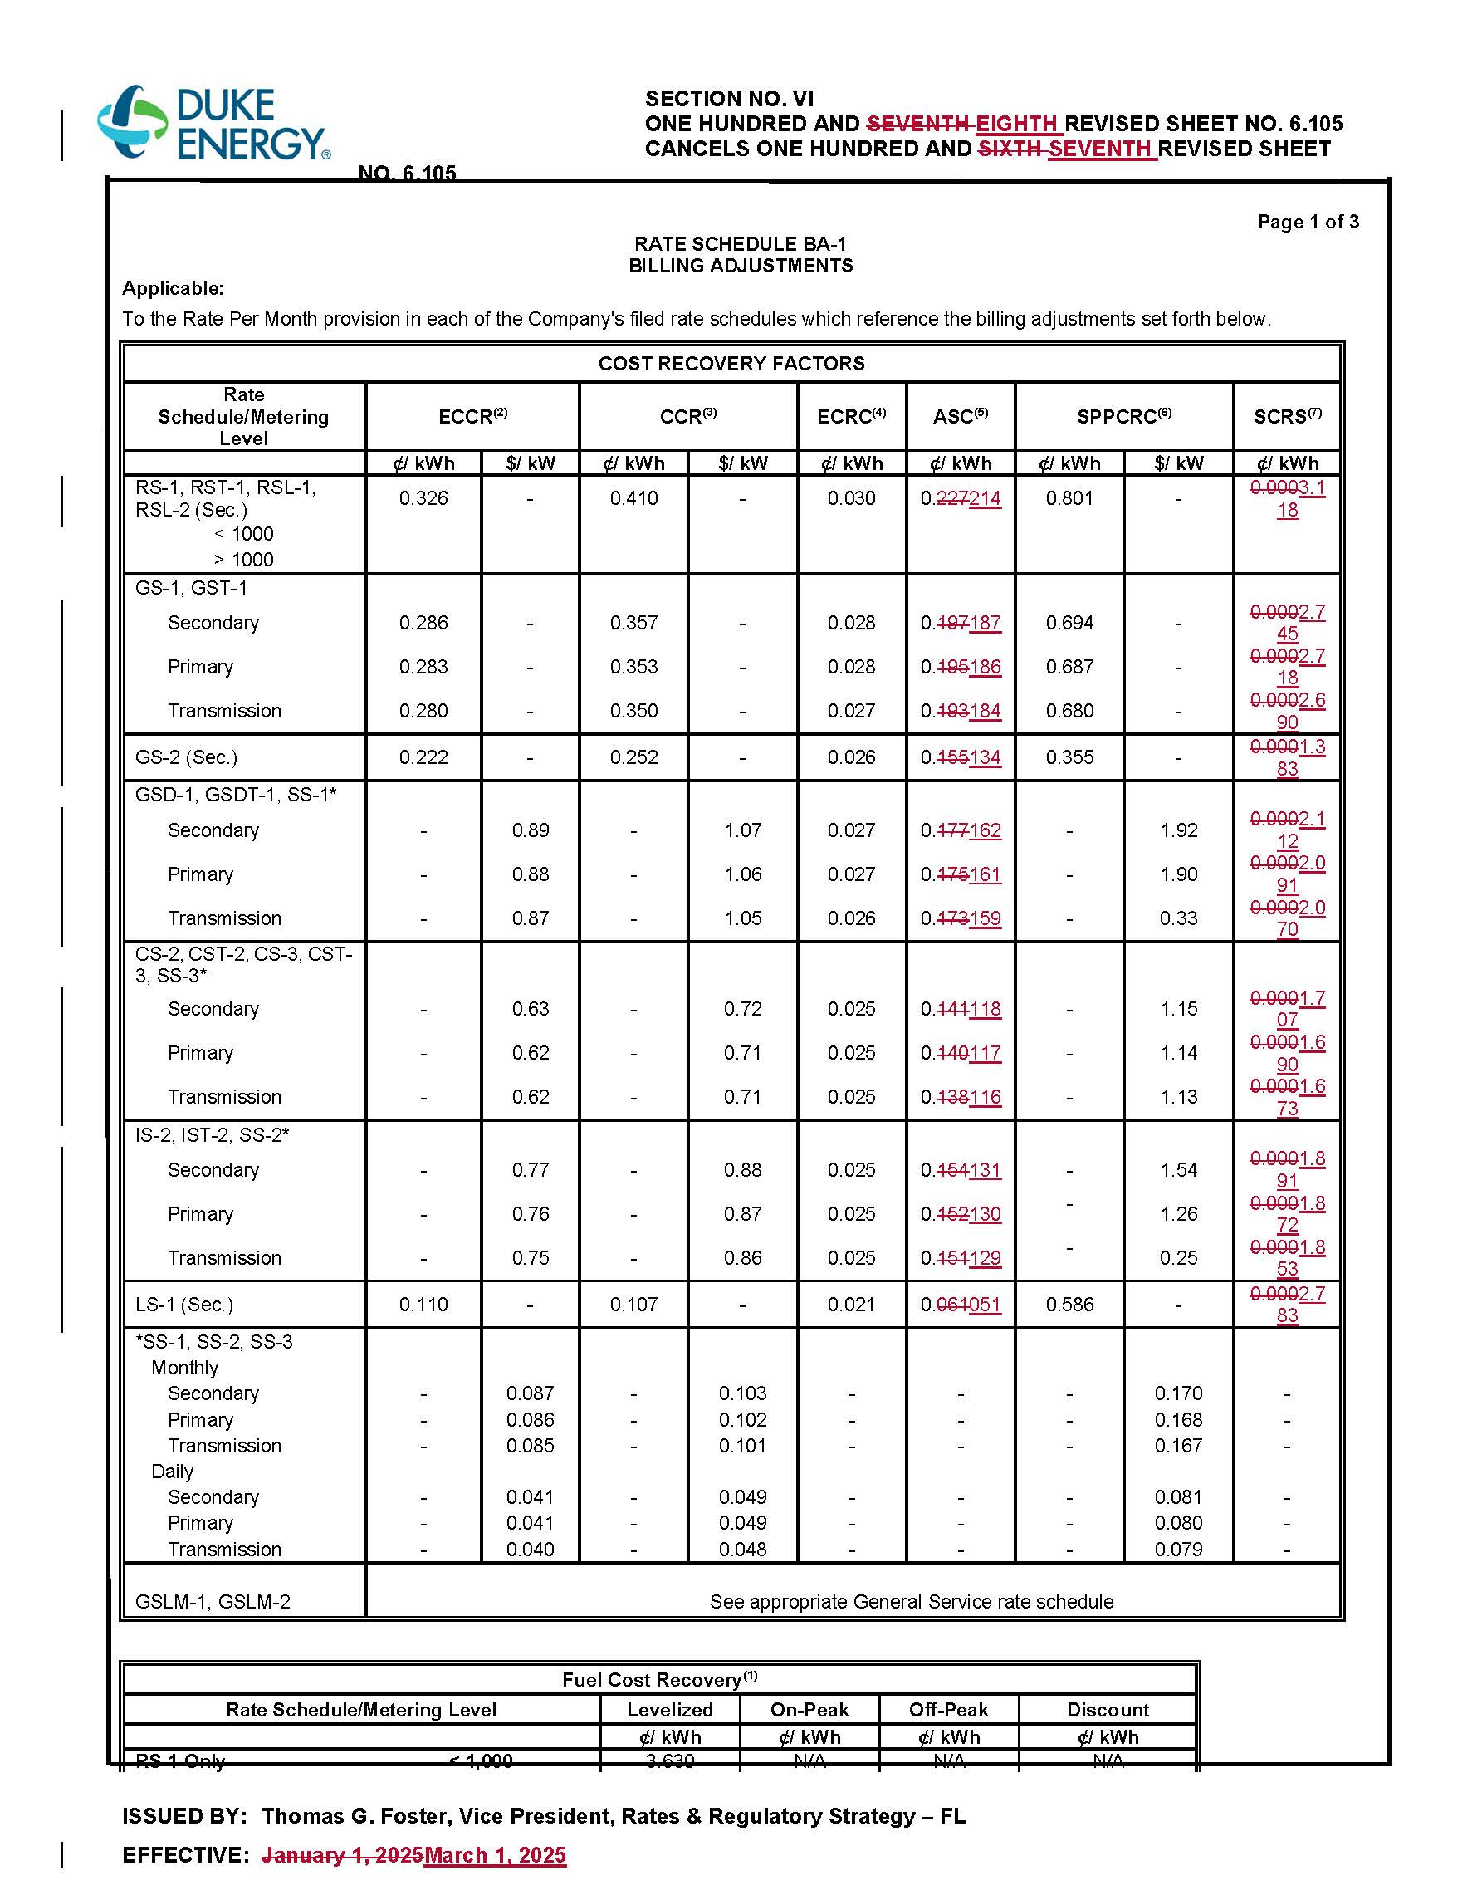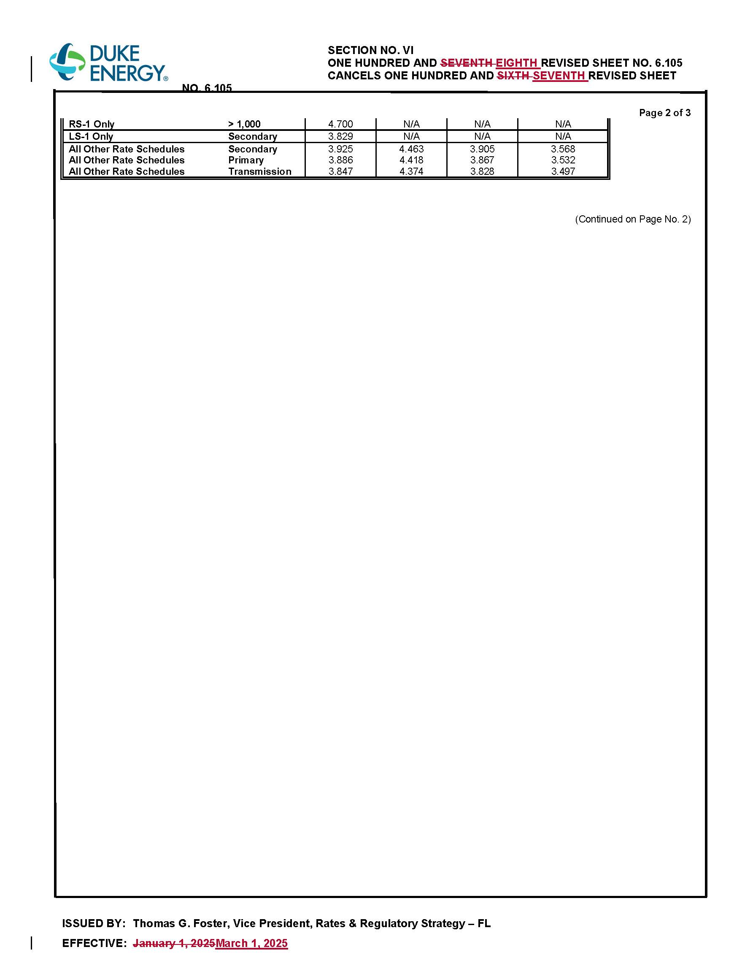

1. Order No. PSC-2024-0472-AS-EI, issued November 12, 2024, in Docket No. 20240025-EI, *In re: Petition for rate increase by Duke Energy Florida, LLC.*
2. Staff notes that the attached tariff sheet No. 6.105 also includes revisions to the Asset Securitization Charge (ASC), effective March 1, 2025. Approval of the revised ACS charges is not at issue in this docket.