|  |  |  |  |
| --- | --- | --- | --- |
| State of Florida  pscSEAL | | Public Service Commission  Capital Circle Office Center ● 2540 Shumard Oak Boulevard Tallahassee, Florida 32399-0850  -M-E-M-O-R-A-N-D-U-M- | |
| DATE: | January 24, 2025 | | |
| TO: | Office of Commission Clerk (Teitzman) | | |
| FROM: | Division of Economics (Hampson)  Office of the General Counsel (Sandy) | | |
| RE: | Docket No. 20240141-GU – Petition for approval of transportation service agreement between Peninsula Pipeline Company, Inc. and Florida City Gas. | | |
| AGENDA: | 02/04/25 – Regular Agenda – Proposed Agency Action – Interested Persons May Participate | | |
| COMMISSIONERS ASSIGNED: | | | All Commissioners |
| PREHEARING OFFICER: | | | Passidomo |
| CRITICAL DATES: | | | None |
| SPECIAL INSTRUCTIONS: | | | None |

Case Background

On September 20, 2024, Peninsula Pipeline Company, Inc. (Peninsula) filed a petition seeking approval of a firm transportation service agreement between Peninsula and Pivotal Utility Holdings, Inc. d/b/a Florida City Gas (FCG). Concurrent with the approval of the transportation service agreement, FCG would sell three pipeline assets and associated facilities to Peninsula. Peninsula states that once completed, the project will provide better options for transporting gas supplies to the subject area of FCG’s distribution system and more alternatives for delivering gas point to point on FCG’s system. The project would take place in Miami-Dade County, in the area referred to as the “Miami Loop.”

Peninsula, a wholly owned subsidiary of Chesapeake Utilities Corporation (CUC), operates as an intrastate natural gas transmission company as defined by Section 368.103(4), Florida Statutes (F.S.).[1] FCG, which recently became a subsidiary of CUC, is a local distribution company subject to the regulatory jurisdiction of the Commission pursuant to Chapter 366, F.S. FCG provides natural gas service to residential, commercial, and industrial customers in Brevard, Indian River, and Miami-Dade Counties, and receives deliveries of natural gas to serve these customers over the interstate transmission pipelines owned by Florida Gas Transmission Company, LLC.

By Order No. PSC-07-1012-TRF-GP, Peninsula received approval of an intrastate gas pipeline tariff that allows it to construct and operate intrastate pipeline facilities and to actively pursue agreements with natural gas customers.[2] Peninsula provides gas transportation service only; it does not engage in the sale of natural gas to customers. Pursuant to the Order, Peninsula is allowed to enter into certain gas transmission agreements without prior Commission approval.[3] However, Peninsula is requesting Commission approval of the proposed firm transportation agreement as it does not fit any of the criteria enumerated in the tariff for which Commission approval would not be required.[4] The Parties are subsidiaries of CUC, and agreements between affiliated companies must be approved by the Commission pursuant to Section 368.105, F.S.

In July 2024, the Commission approved a firm transportation service agreement between Peninsula and FCG, located in the Miami Loop area.[5] As described on pages 7 and 8 of Order No. PSC-2024-0271-PAA-GU, the firm transportation service agreement enabled a producer of Renewable Natural Gas to connect with FCG’s local distribution system. This previously approved transportation service agreement is referred to as the Miami-Dade Project, which will connect with the Miami Loop North and South segments. Furthermore, the Miami-Dade Project is depicted in Attachment B to the petition as the pink line.[6]

Staff held an informal conference phone call with Peninsula and FCG on January 21, 2025. Attachment A to the recommendation is the proposed firm transportation agreement. Attachment B to the recommendation is the Miami Loop Project map. The Commission has jurisdiction over this matter pursuant to Sections 366.05(1), 366.06, and 368.105, F.S.

Discussion of Issues

Issue :

 Should the Commission approve the proposed firm transportation service agreement between Peninsula and FCG, dated September 18, 2024?

Recommendation:

 Yes, the Commission should approve the proposed firm transportation agreement between Peninsula and FCG, dated September 18, 2024. The proposed agreement is reasonable and meets the requirements of Section 368.105, F.S. Furthermore, the proposed agreement benefits FGC’s current and future customers by increasing system resiliency and reliability. (Hampson)

Staff Analysis:

  There are three pipeline segments which are contemplated in the petition: Miami Loop West, Miami Loop South, and Miami Loop North. Each pipeline segment and its associated facilities would be acquired by Peninsula from FCG. In paragraph 13 of the petition, Peninsula explains that completing the transfer and acquisitions of the pipeline segments will allow it to enhance these systems with new construction and expansion to provide service to FCG’s system. Staff notes that these pipeline acquisitions are not subject to approval by the Commission; however, Peninsula must seek the Commission’s approval for the resulting firm transportation service agreement which allows Peninsula to serve FCG through the pipelines.

Article 4.1 of the proposed agreement specifies a term of 20 years and shall be extended year-to-year, unless either party gives written termination not less than 90 days prior to the expiration of the current term. Peninsula states that each of the projects associated with the pipeline segments are estimated to be completed in the third quarter of 2025.

FCG would recover its payments to Peninsula from its sales customers through the Purchased Gas Adjustment Clause and from its transportation customers through the Transportation Balancing Charge tariffs. FCG states that the impact of the proposed agreement would be minimal on the PGA factor.

Miami Loop West

As described in paragraph 14 of the petition, the first pipeline segment and associated facilities to be acquired by Peninsula from FCG is known as Miami Loop West. Peninsula explains that FCG had purchased the pipeline segment recently and, as a result, the pipeline segment is not in service nor included in FCG’s base rates. Due to the pipeline’s inactivity, Peninsula expects to conduct testing on the facilities of the Miami Loop West segment. In addition, Peninsula plans additional construction of facilities to tie-in the pipeline segment to FCG’s distribution system as well as interconnect the pipeline segment with the Miami Loop South segment. Furthermore, Peninsula plans to extend the Miami Loop West segment further west, enabling FCG to serve new commercial customers.

As described above, the Miami Loop West segment is not currently included for recovery in FCG’s base rates. However, during discussions with staff, FCG explained that the net book value of the gate station and meter for the pipeline segment are currently in the utility’s rate base. As a result, the majority of the net book value associated with the Miami Loop West segment and associated facilitates would be included in the proposed, confidential monthly reservation charge. FCG explained to staff that the marginal change in the monthly reservation charge from before and after FCG’s next applicable rate case is a result of the gate station and meter currently in rate base.

Miami Loop South

The Miami Loop South segment would also be acquired by Peninsula from FCG, as discussed in the beginning of paragraph 17 of the petition. Peninsula intends to complete work to increase the operating system pressure, including updating a regulator station and construction of an additional 2.3 miles of pipeline. Peninsula states that increasing the operating system pressure will improve service to FCG and its customers served via the Miami Loop South segment as well as enhance the resiliency of FCG’s system.

Peninsula explains that, unlike the previously discussed segment, Miami Loop South is currently included in FCG’s rate base. As shown in Exhibit A to the proposed firm transportation agreement, Peninsula proposes two sets of monthly reservation charges to avoid the double recovery of assets. One set of monthly reservation charges would apply prior to the pipeline segments being removed from FCG’s rate base. The second set of monthly reservation charges would apply after FCG’s next rate case, once these assets are removed from FCG’s rate base. Article 4.3 of the proposed firm transportation agreement states that if at any time during the term of the agreement the Commission approves revised customer rates for FCG that reflect the removal of the assets from FCG’s rate base, then Peninsula would replace the monthly reservation charge in accordance with Exhibit A to the agreement. During a phone call with staff, Peninsula confirmed that Article 4.3 of the agreement would be based upon the issuance of a Consummating Order in FCG’s next rate case.

Miami Loop North

As described in paragraph 20 of the petition, Peninsula would acquire the Miami Loop North pipeline segment from FCG. Peninsula further stated that in order to increase system reliability, a new interconnect would be built to connect the Miami Loop North to the previously approved Miami-Dade Project. Furthermore, Peninsula explained that connecting the Miami Loop South and Miami-Dade project will allow for the bi-directional flow of gas to both the Miami Loop North and South segments, creating increased system resiliency.

Similar to the Miami Loop South segment, the Miami Loop North segment is also currently included in FCG’s base rates. As such, the monthly reservation charge in the first set does not include the cost to acquire the Miami Loop North segment from FCG. Once the assets are removed from FCG’s rate base in its next rate case, the second monthly reservation charge would take effect.

Conclusion

Based on the petition and the discussions with staff, the Commission should approve the proposed firm transportation agreement between Peninsula and FCG, dated September 18, 2024. The proposed agreement is reasonable and meets the requirements of Section 368.105, F.S. Furthermore, the proposed agreement benefits FGC’s current and future customers by increasing system resiliency and reliability.

Issue :

 Should this docket be closed?

Recommendation:

 If no person whose substantial interests are affected by the proposed agency action files a protest within 21 days of the issuance of the order, this docket should be closed upon the issuance of a consummating order. (Sandy)

Staff Analysis:

 At the conclusion of the protest period, if no protest is filed this docket should be closed upon the issuance of a consummating order.

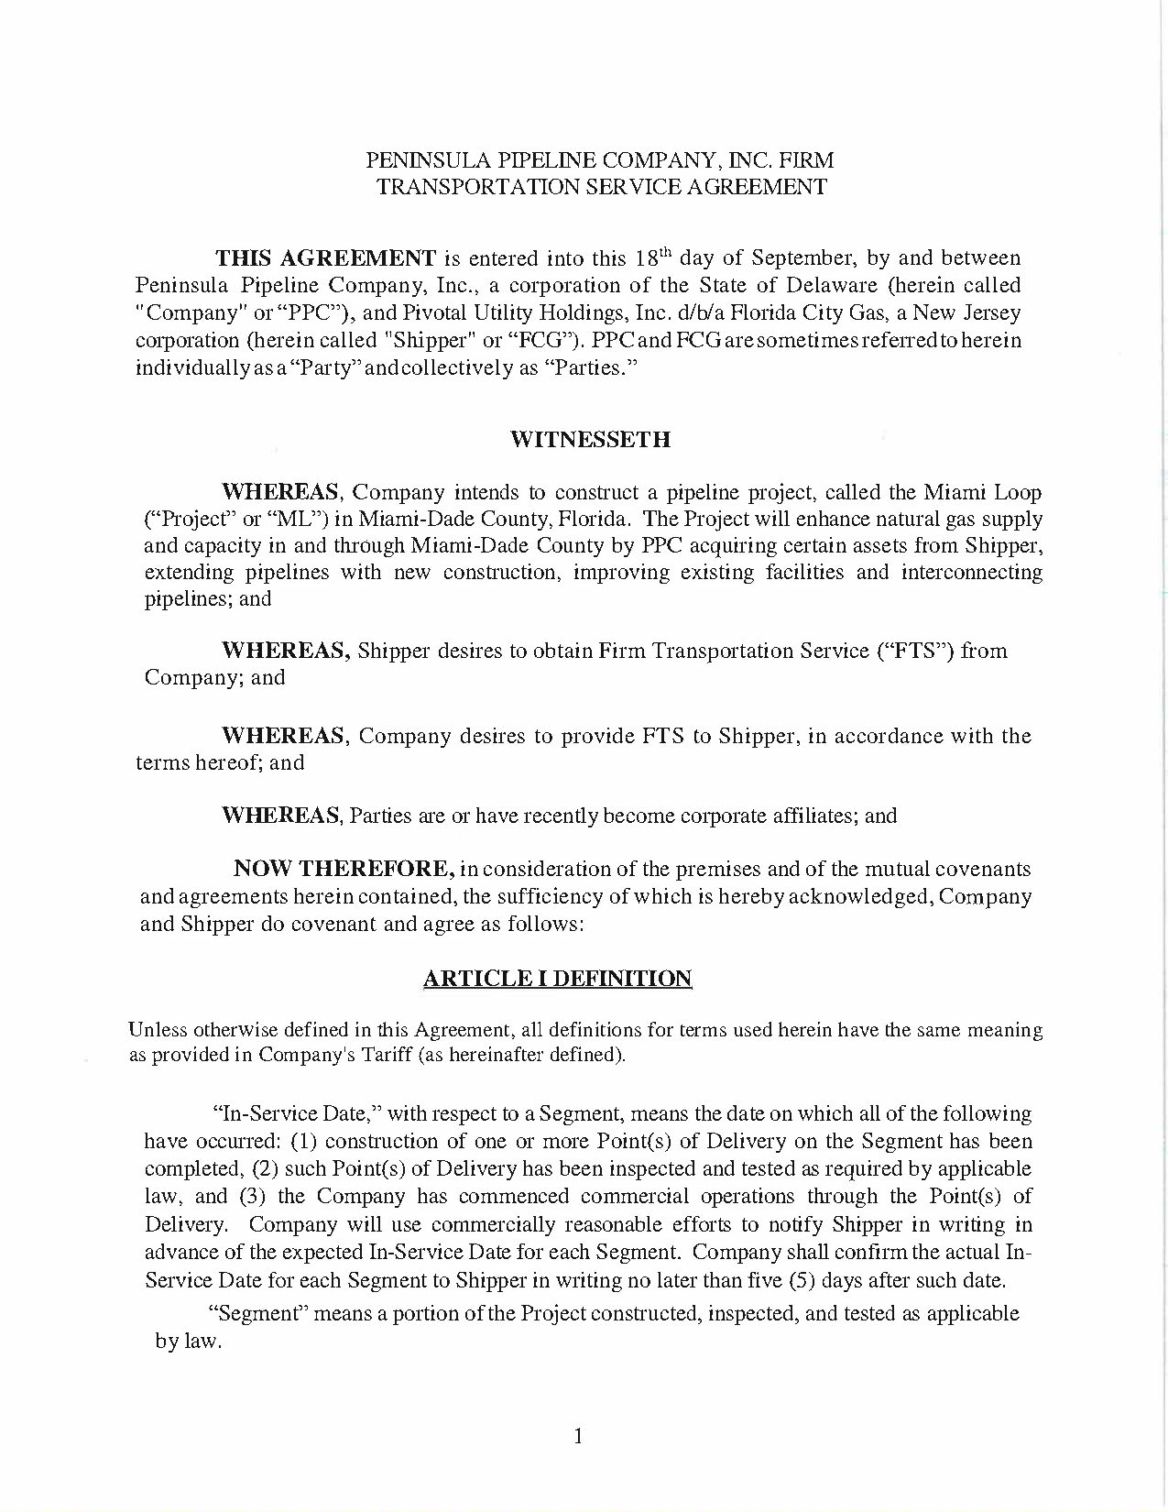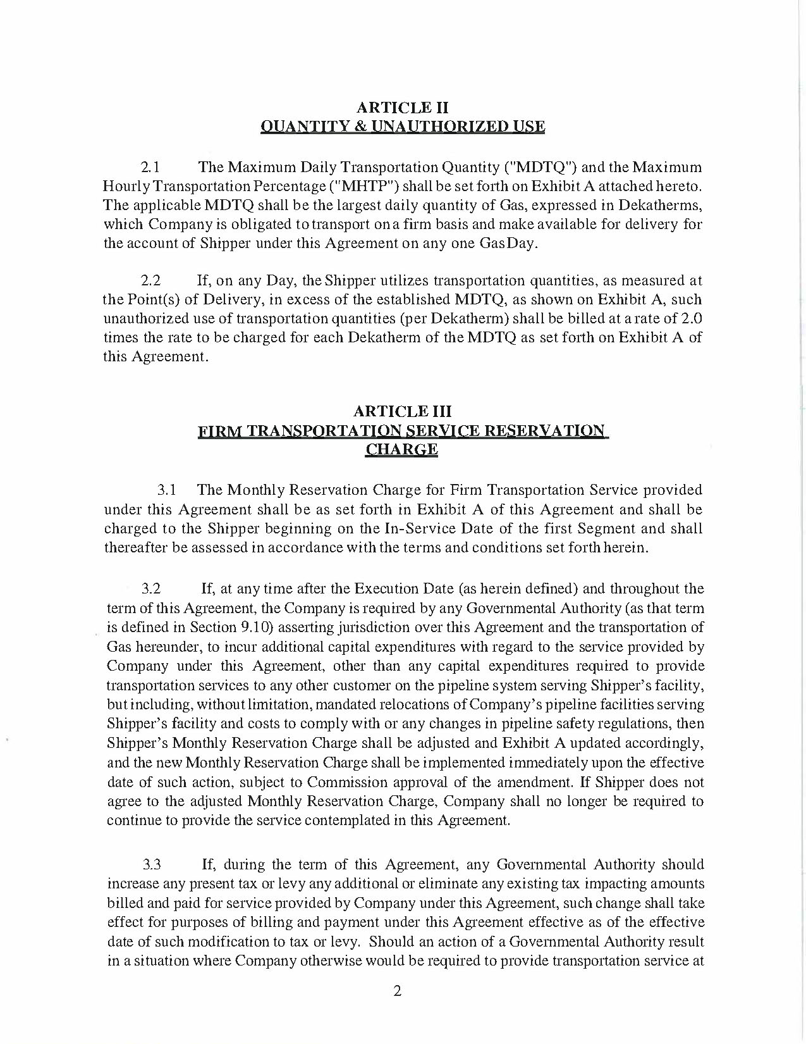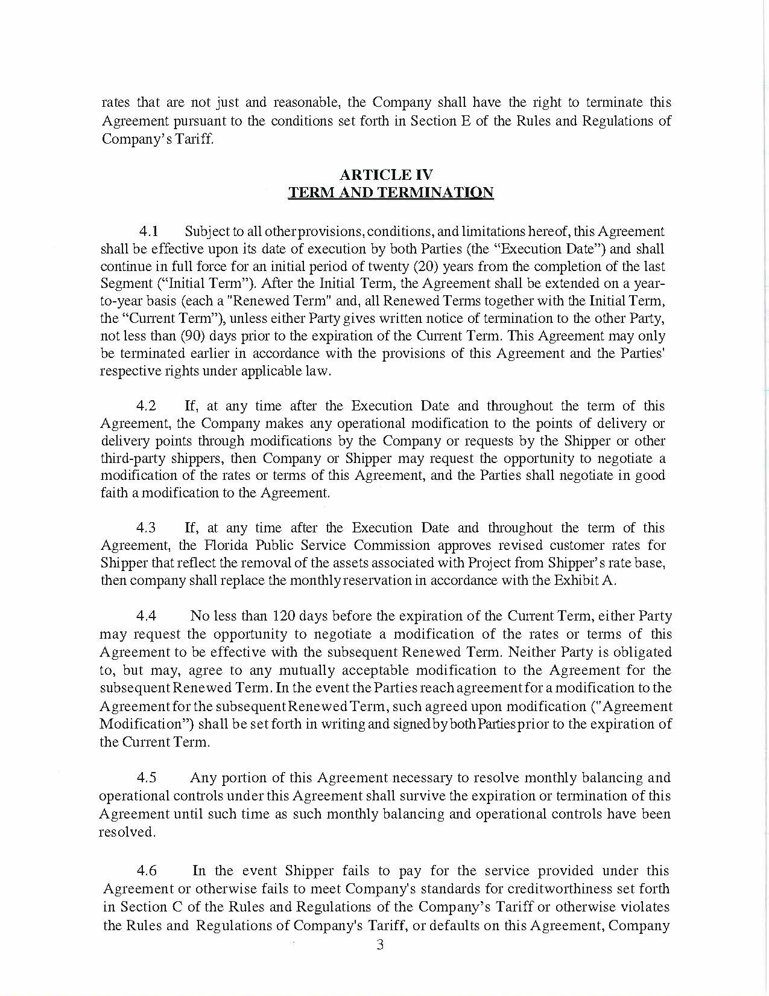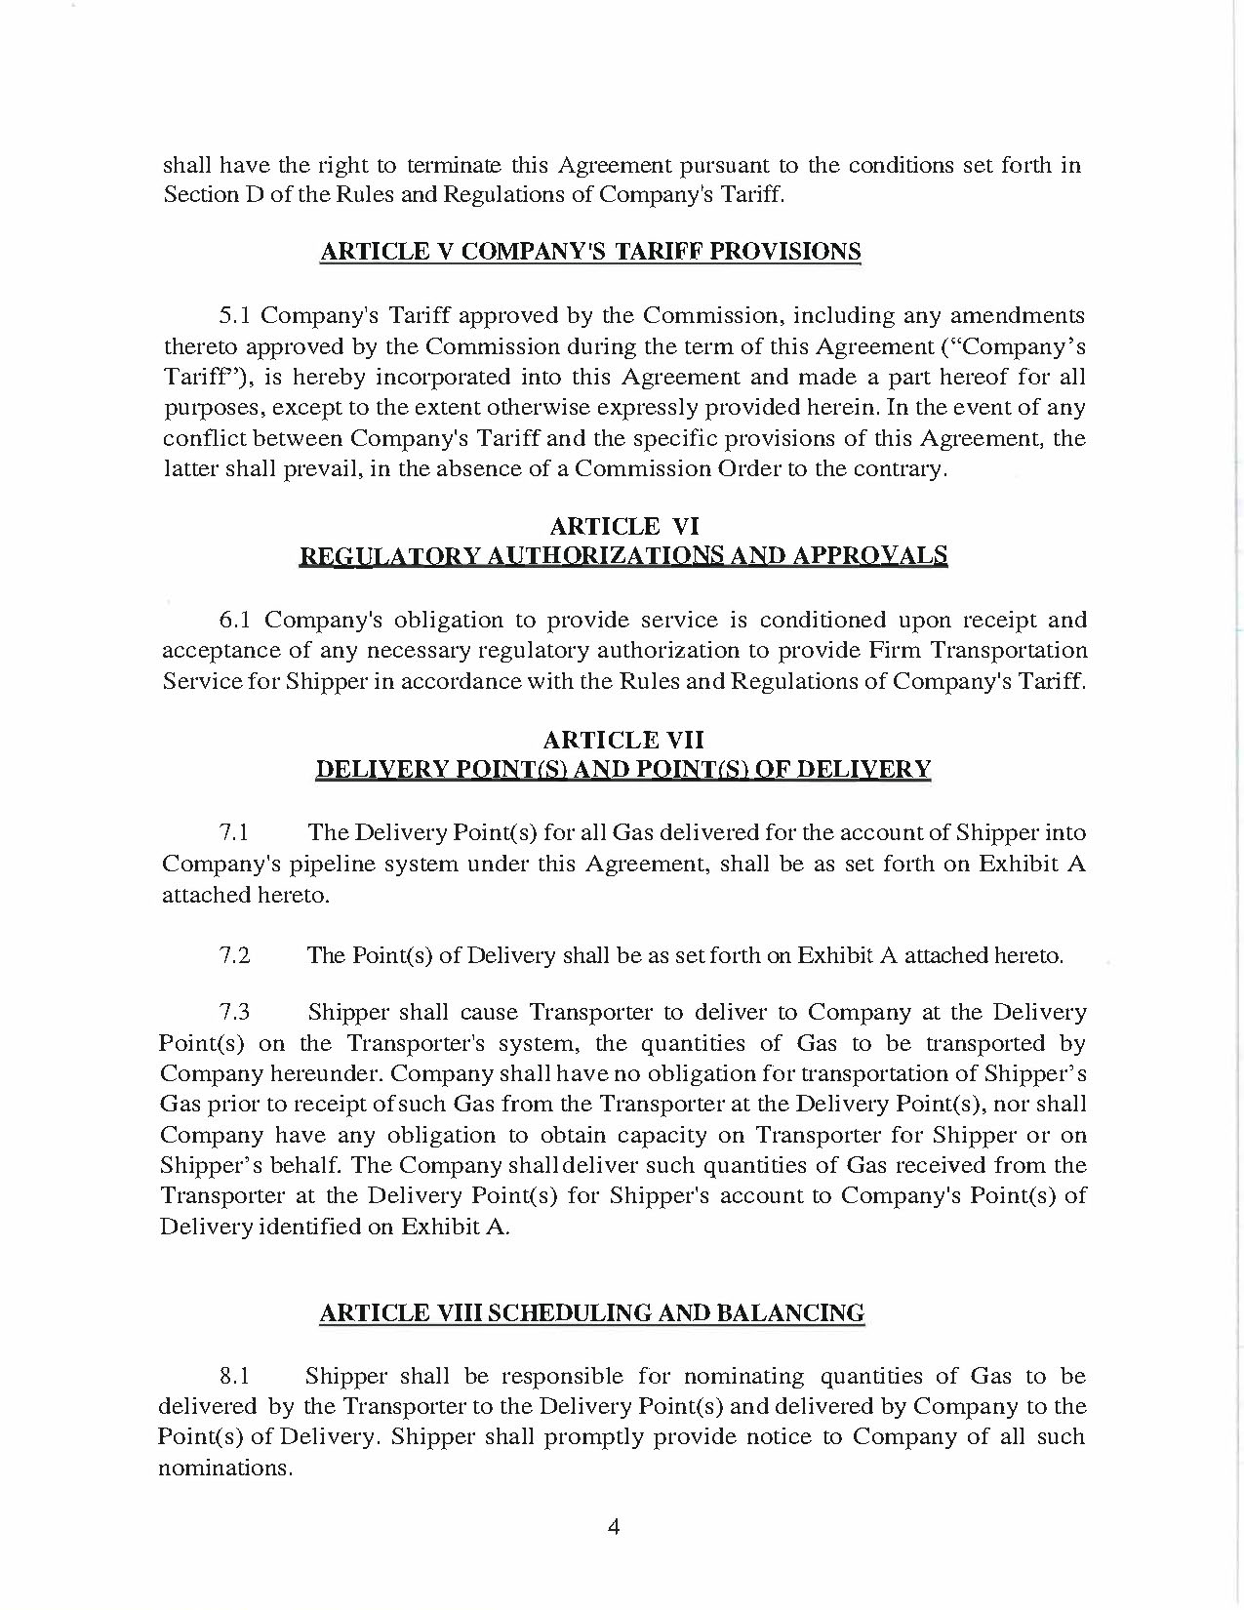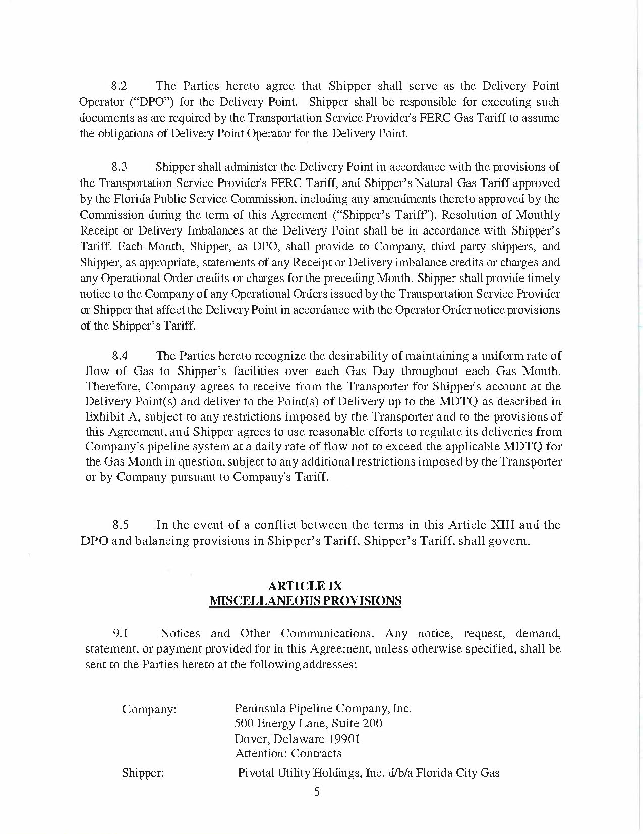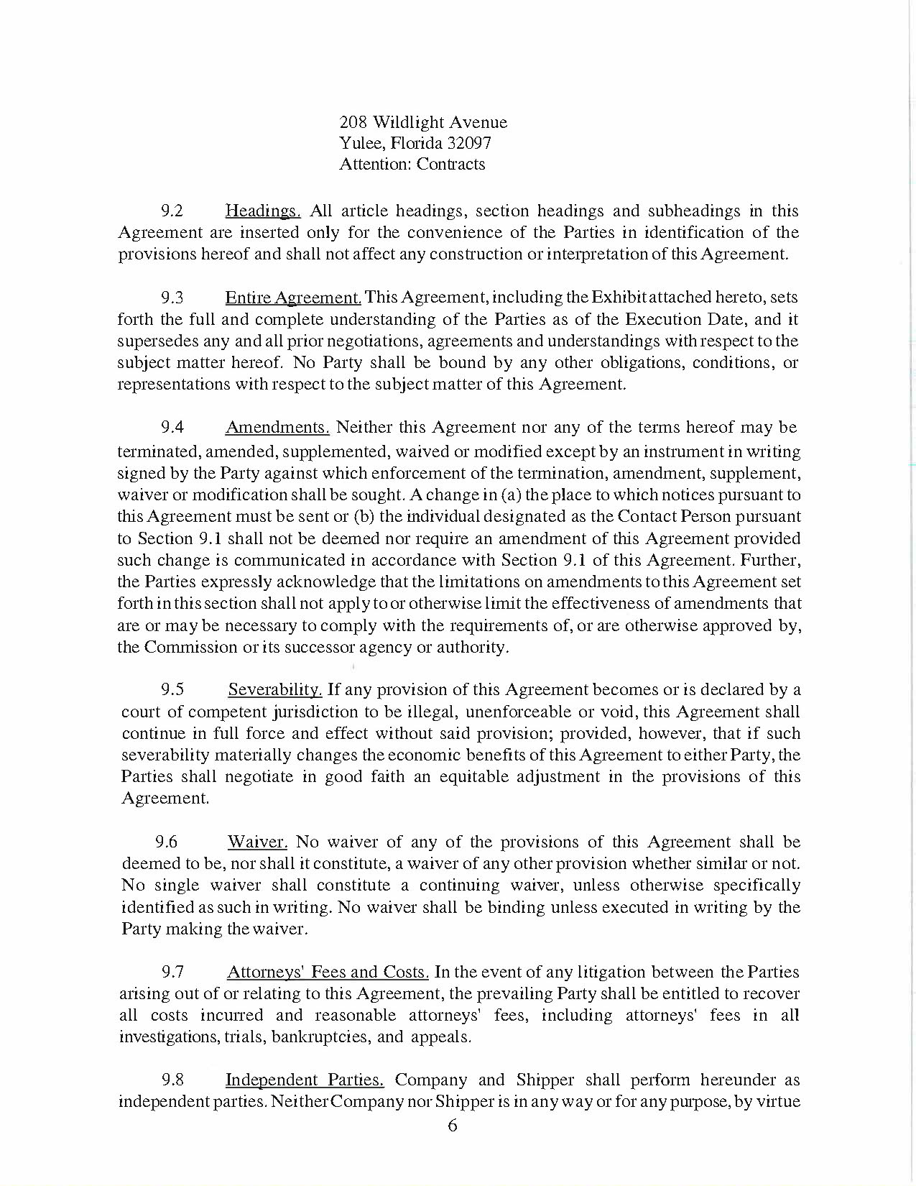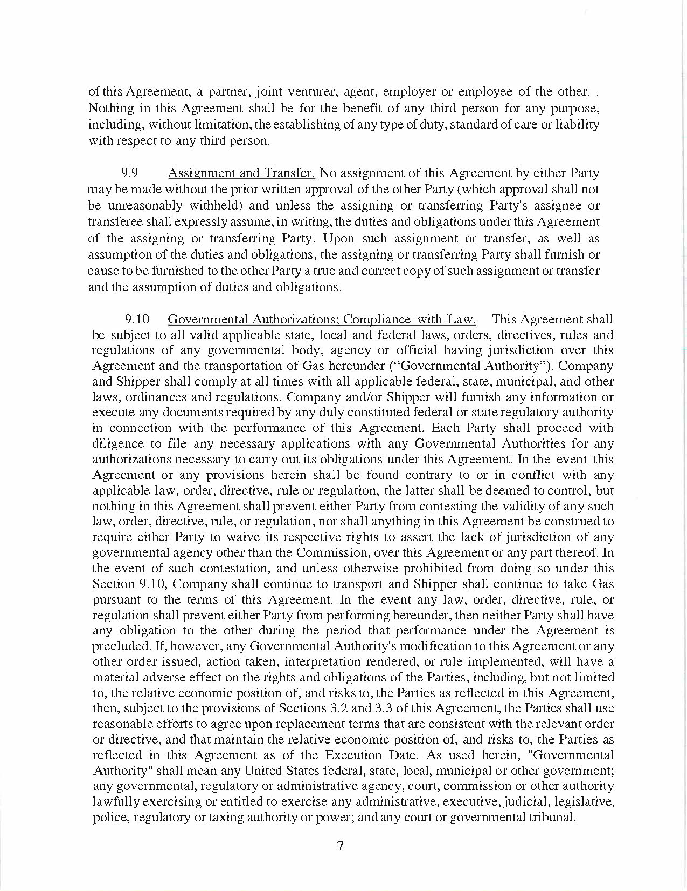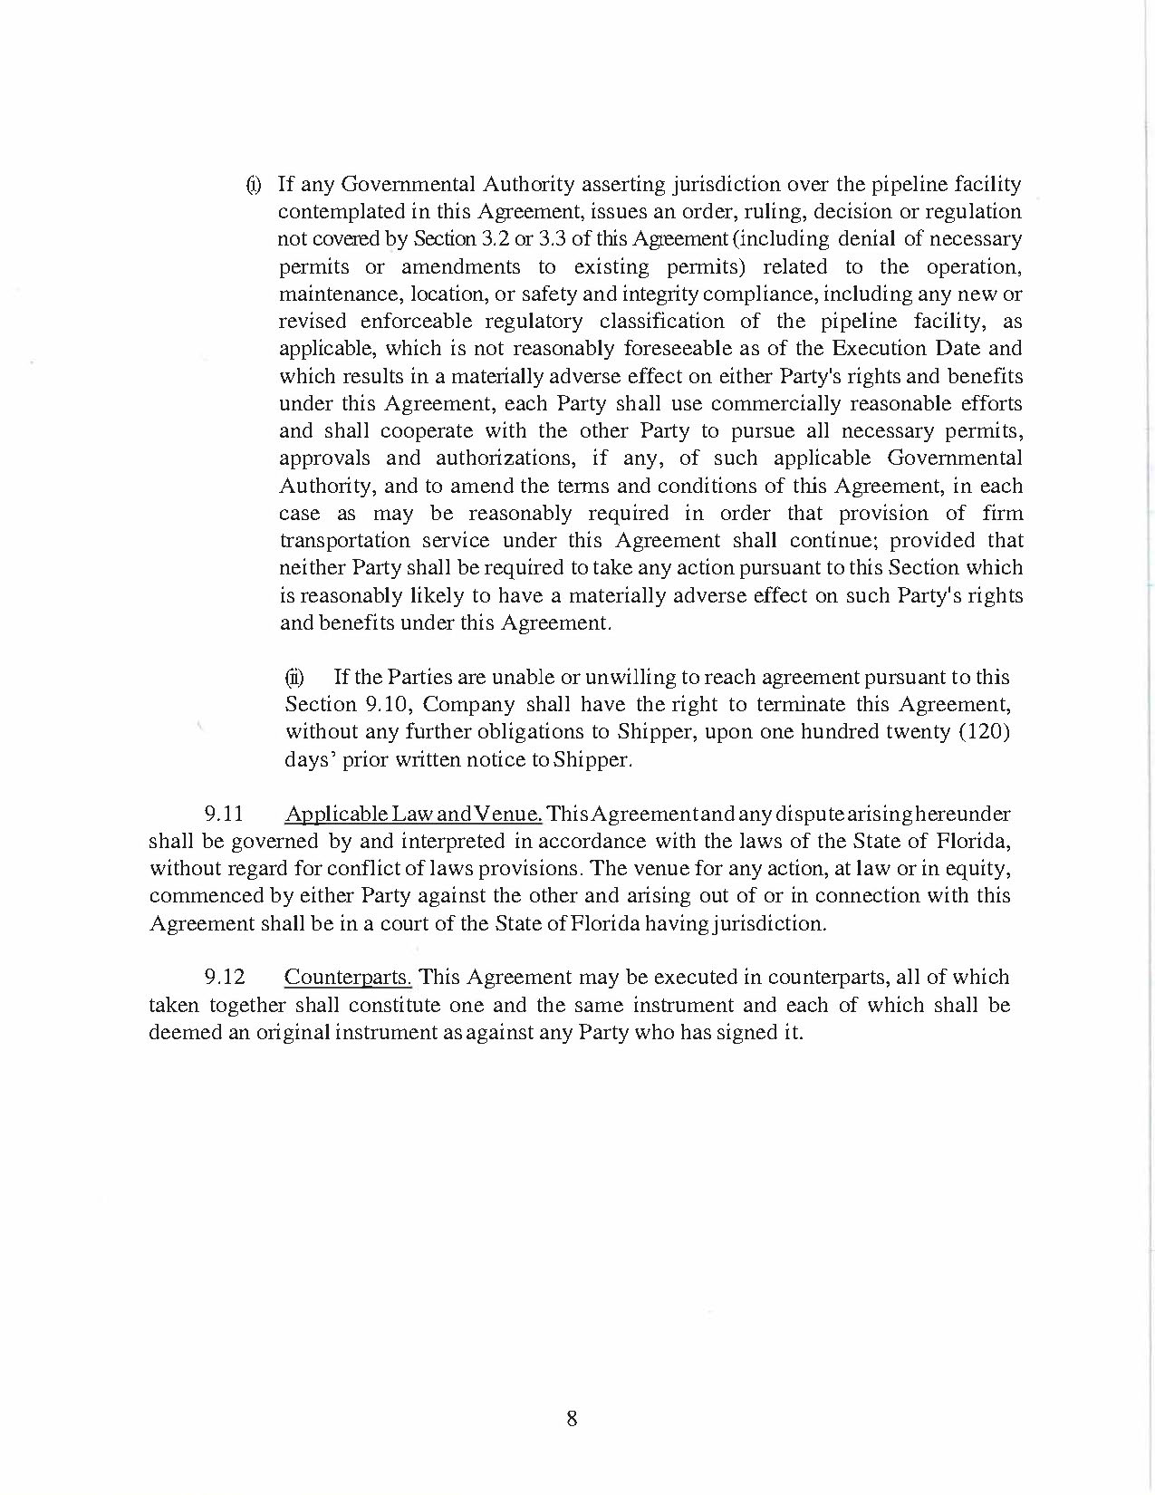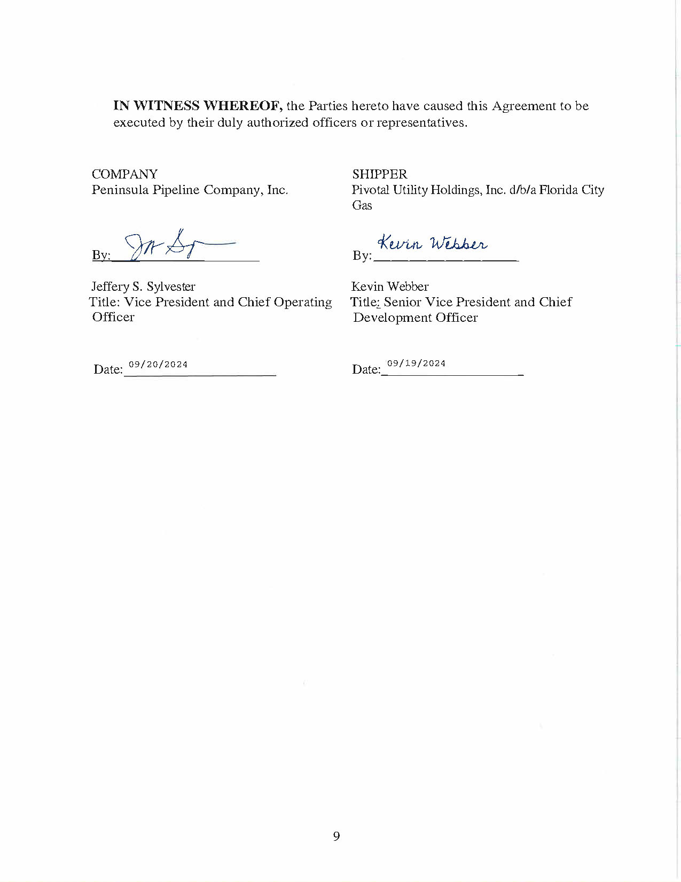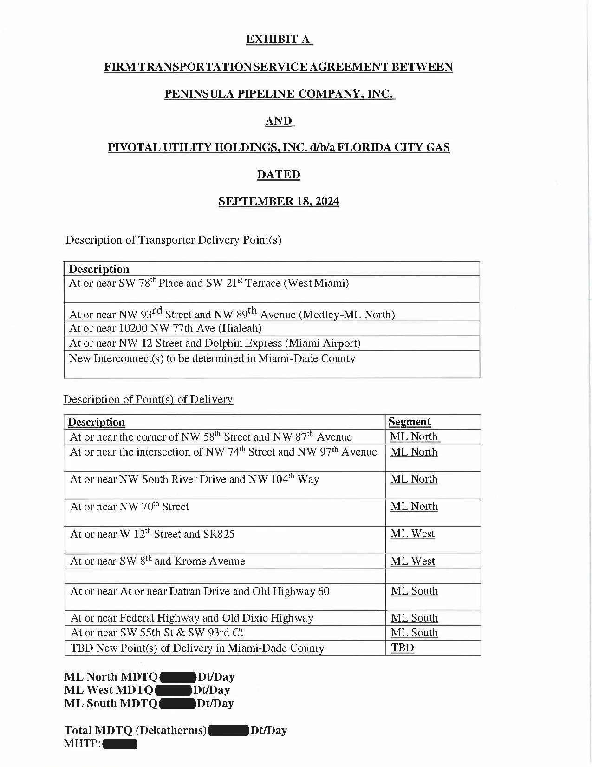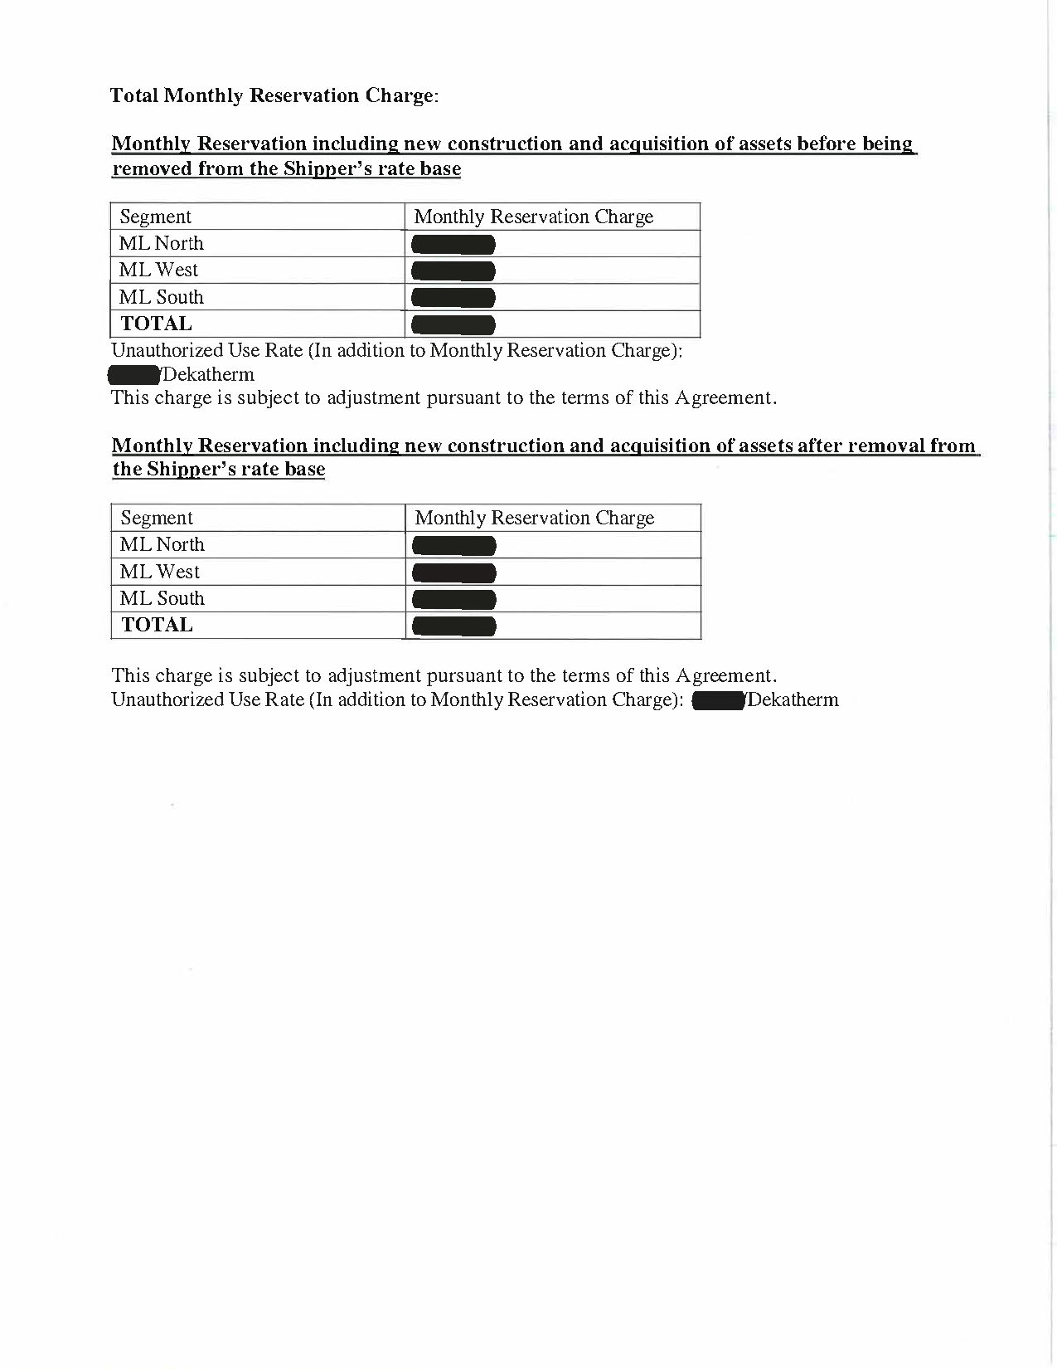

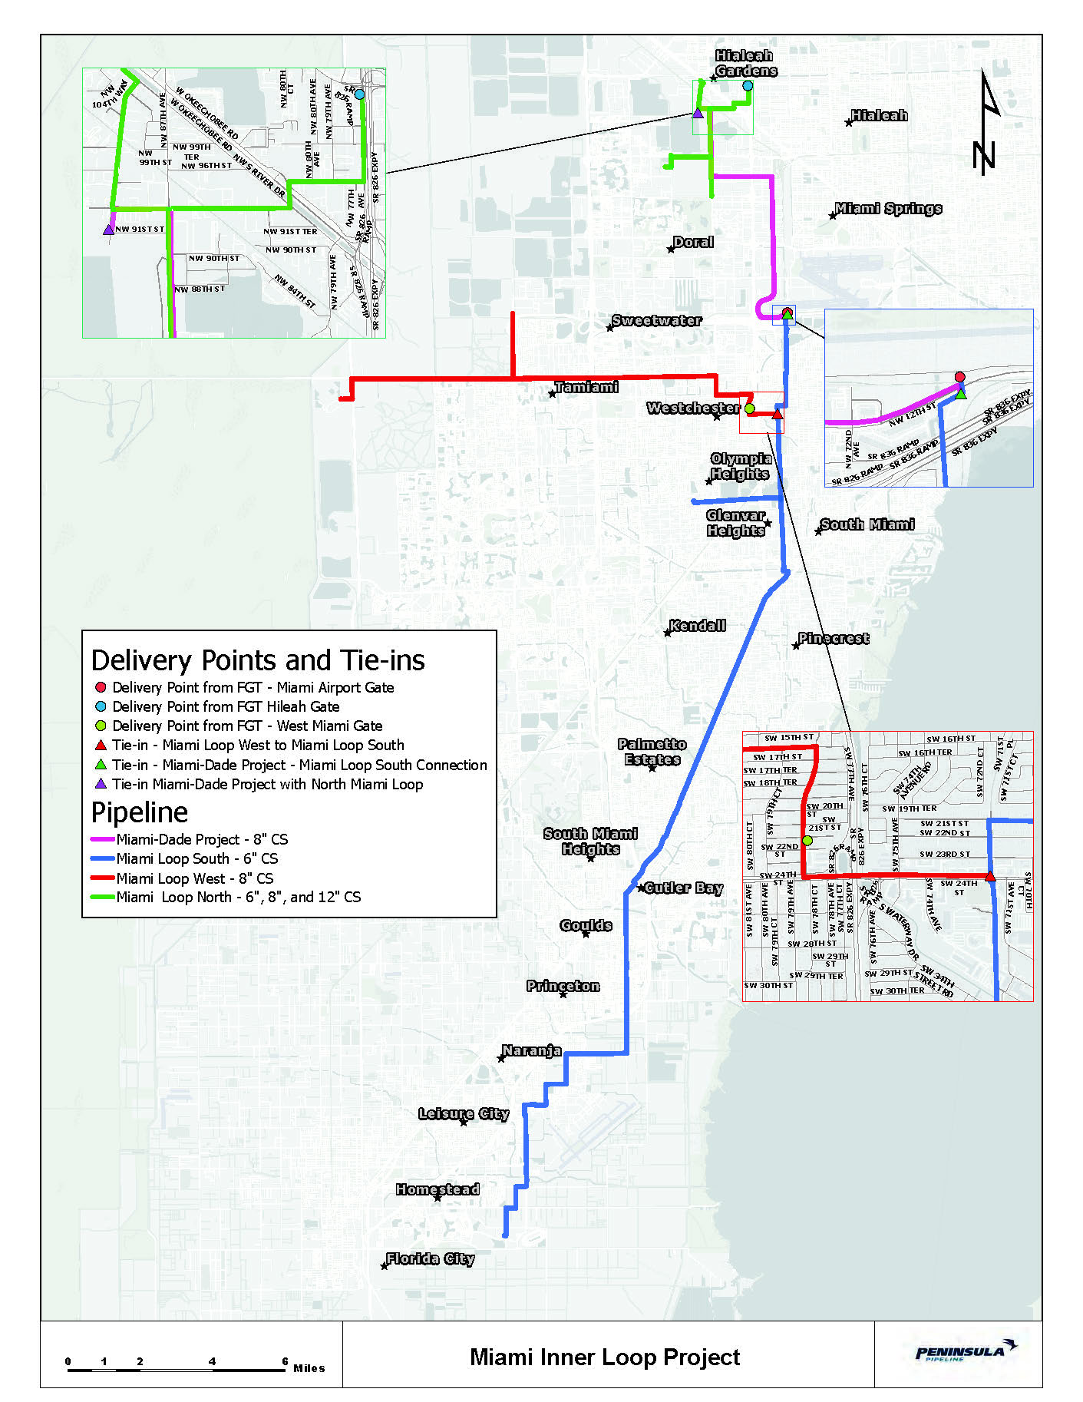

1. Order No. PSC-06-0023-DS-GP, issued January 9, 2006, in Docket No. 050584-GP, *In re: Petition for declaratory statement by Peninsula Pipeline Company, Inc. concerning recognition as a natural gas transmission company under Section 368.101, F.S., et seq.*
2. Order No. PSC-07-1012-TRF-GP, issued December 21, 2007, in Docket No. 070570-GP, *In re: Petition for approval of natural gas transmission pipeline tariff by Peninsula Pipeline Company, Inc.*
3. Peninsula Pipeline Company, Inc., Intrastate Pipeline Tariff, Original Sheet No. 11, Section 3.
4. Peninsula Pipeline Company, Inc., Intrastate Pipeline Tariff, Original Sheet No. 12, Section 4.
5. Order No. PSC-2024-0271-PAA-GU, issued July 26, 2024, in Docket No. 20240039-GU, *In re: Petition for approval of transportation service agreements between Peninsula Pipeline Company, Inc. and Pivotal Utility Holdings, Inc. d/b/a Florida City Gas.*
6. A similar map, which depicts solely the Miami-Dade project, is provided on page 50 of Order No. PSC-2024-0271-PAA-GU.