State of Florida   |  | Public Service Commission  Capital Circle Office Center ● 2540 Shumard Oak Boulevard  Tallahassee, Florida 32399-0850  -M-E-M-O-R-A-N-D-U-M-
DATE: | February 20, 2025
TO: | Office of Commission Clerk (Teitzman)
FROM: | Office of the General Counsel (Rubottom) SMC  Division of Economics (Guffey) EJD  Division of Engineering (Brown) TB
RE: | Docket No. 20250018-GU – Amendment of Rule 25-12.005, F.A.C., Codes and Standards Adopted; Rule 25-12.008, F.A.C., New Reconstructed or Converted Facilities, Rule 25-12.027, F.A.C., Welder Qualification, Rule 25-12.045, F.A.C., Inactive Gas Service Lines, and Rule 25-12.052, F.A.C., Corrosion Control Criteria for Cathodic Protection of Buried or Submerged Metallic Pipeline; and adoption of new Rule 25-12.100, F.A.C., Penalty.
AGENDA: | 03/04/25 – Regular Agenda – Rule Proposal – Interested Persons May Participate
COMMISSIONERS ASSIGNED: |  |  | All Commissioners
PREHEARING OFFICER: |  |  | Graham
RULE STATUS: |  |  | Proposal Should Not Be Deferred
CRITICAL DATES: |  |  | 04/01/25 – New Rule 25-12.100, F.A.C., must be proposed by this date pursuant to Section 120.74(5), F.S.
SPECIAL INSTRUCTIONS: |  |  | None

Case Background
Pursuant to sections 368.01-368.061, Florida Statutes (F.S.), known collectively as the Gas Safety Law of 1967 (Gas Safety Law), the Commission regulates the safety standards of intrastate gas transmission and distribution companies in Florida. The Commission also maintains a certification agreement with the federal Pipeline and Hazardous Materials Safety Administration (PHMSA) to enforce pipeline safety that requires adoption of certain minimum standards prescribed by PHMSA.

Statutory Background
Section 368.061, F.S., establishes civil penalties for violation of the Gas Safety Law or any regulation issued thereunder. Prior to 2024, the statute provided that a person was subject to a penalty of up to $25,000 per day for each violation up to a maximum civil penalty of $500,000 for any related series of violations. The penalties established by Florida law were significantly lower than those established by federal law, and the difference was consistently raised by PHMSA as part of its annual review of the Commission’s pipeline safety program.
In 2024, the Legislature amended Section 368.061(1)(a), F.S., to increase the maximum civil penalties to $216,015 per day up to a total of $2,660,135 for any related series of violations. The Legislature also added Section 368.061(1)(b), F.S., which requires the Commission, on or after July 1, 2025, to establish maximum penalties by rule, and to then review the penalties at least annually and revise as necessary.
When the amended statute took effect on July 1, 2024, the penalties established in Section 368.061, F.S., matched the federal penalties established by PHMSA at the time. However, on December 30, 2024, PHMSA increased the maximum federal penalties to $272,926 per day for each violation and $2,729,245 for any related series of violations.

Procedural Matters
Staff initiated rulemaking to propose new Rule 25-12.100, Florida Administrative Code, (F.A.C.), for the purpose of implementing the requirements of section 368.061, F.S., as amended by the Legislature in 2024. The statutory amendment increased penalties for violation of the Gas Safety Law and requires that after July 1, 2024, maximum penalties must be implemented by the Commission.
Staff also initiated rulemaking to amend Rules 25-12.005, 25-12.008, 25-12.027, 25-12.045, and 25-12.052, F.A.C., which also relate to gas safety, for the purpose of incorporating by reference the updated, October 1, 2023, version of certain minimum federal safety standards and reporting requirements for pipeline facilities and transportation of natural gas as prescribed by PHMSA in 49 Code of Federal Regulations (C.F.R.) Parts 191, 192, and 199.
A Notice of Development of Rulemaking for these rules appeared in the October 24, 2024, edition of the Florida Administrative Register, Vol. 50, No. 209. No requests for a rule development workshop were made, and no workshop was held. This recommendation addresses whether the Commission should propose the amendment of Rules 25-12.005, 25-12.008, 25-12.027, 25-12.045, and 25-12.052, F.A.C., and the adoption of new Rule 25-12.100, F.A.C. The Commission has jurisdiction pursuant to Sections 120.54, 368.03, 368.05, and 368.061, F.S.

Discussion of Issues

Issue 1:
Should the Commission propose the amendment of Rule 25-12.005, F.A.C., Codes and Standards Adopted; Rule 25-12.008, F.A.C., New Reconstructed or Converted Facilities, Rule 25-12.027, F.A.C., Welder Qualification; Rule 25-12.045, F.A.C., Inactive Gas Service Lines; and Rule 25-12.052, F.A.C., Corrosion Control Criteria for Cathodic Protection of Buried or Submerged Metallic Pipeline; and propose the adoption of new Rule 25-12.100, F.A.C., Penalties?

Recommendation:
Yes. The Commission should propose the amendment of Rules 25-12.005, 25-12.008, 25-12.027, 25-12.045, and 25-12.052, F.A.C., and should propose the adoption of new Rule 25-12.100, F.A.C., as set forth in Attachment A. Pursuant to Section 120.695, F.S., the Commission should also certify that the rules are not rules the violation of which would be a minor violation. The Commission should also delegate administrative authority to staff to conduct an annual review of the penalties established in Rule 25-12.100, F.A.C., to determine whether a revision of the penalties is necessary, as required by Section 368.061, F.S. (Brown, Rubottom)

Staff Analysis:
The gas safety rules at issue may be considered under two separate headings, the first addressing the adoption of a new rule to establish civil penalties for the violation of gas safety statutes and Commission regulations, and the second addressing the amendment of existing rules implementing safety standards.

New Rule to Establish Penalties
Section 368.061, F.S., requires the Commission, by July 1, 2025, to establish maximum civil penalties by rule and to review the penalties at least annually thereafter, revising as necessary. Section 368.061(1)(b), F.S., provides that in establishing and annually reviewing such penalties, the Commission shall consider:
. . . the penalties established in paragraph (a) and make revisions to such penalties based upon consideration of the Consumer Price Index, penalties established in federal law for pipeline safety violations, and the intent of the Legislature that the [C]ommission maintain its certification with the Pipeline and Hazardous Materials Safety Administration, or any of its successor agencies, to enforce pipeline safety.
Pursuant to this statutory directive, staff reviewed each of the considerations enumerated in the statute, the Consumer Price Index (CPI), federal penalties, and PHMSA certification requirements:
- Consumer Price Index – PHMSA uses a CPI calculation to perform an annual inflation adjustment to its civil penalties as required by federal law. To derive the 2025 adjustment, the penalty amounts were multiplied by the percent change between the October 2024 Consumer Price Index for All Urban Consumers (CPI–U) and the October 2023 CPI–U, the percent change in this case being 1.02598. With respect to the penalties established under Florida law, staff calculated the percent change in the CPI-U between July 2024, when the amendments to Section 368.061, F.S., took effect, and January 2025, the most recent report available at the time this recommendation was filed, to be 1.0176.
- Penalties Established in Federal Law – At the time the Legislature amended Section 368.061, F.S., the penalties established therein were identical to the penalties established by PHMSA. However, PHMSA amended the federal regulations in December of 2024, increasing the penalties to a maximum of $272,926 per penalty per day up to a total of $2,729,245 for any related series of violations.
- The Commission’s PHMSA Certification – Federal law requires that in order to maintain its certification with PHMSA to enforce pipeline safety, a state authority must enforce “satisfactory compliance with applicable safety standards” prescribed by federal law. If a state authority’s certification is rejected, federal authorities could reassert United States Government jurisdiction in order to achieve adequate enforcement. Any difference between the penalties established under Florida law and the federal penalties may be raised by PHMSA as part of its annual review of the Commission’s pipeline safety program.
In light of these considerations, staff recommends that revision of the maximum civil penalties for violating the Gas Safety Law is necessary at the present time in order to make adjustments that reflect upward movement in the CPI since Florida’s penalties were last revised, keep Florida’s penalties in line with federal penalties, and to ensure that the Commission maintains its certification agreement with PHMSA. Staff therefore recommends the Commission propose the adoption of Rule 25-12.100, F.A.C., as set forth in Attachment A, establishing maximum civil penalties of $272,926 per penalty per day up to a total of $2,729,245 for any related series of violations.
As discussed above, the Commission is required to review the penalties at least annually and revise as necessary, pursuant to Section 368.061, F.S. To fulfill this requirement, staff recommends that the Commission delegate to staff administrative authority to conduct an annual review of the penalties established in the Commission’s rule and, when necessary in light of its review, to initiate rulemaking to revise the penalties. Staff notes that, as with all rulemaking proceedings, staff would bring a recommendation for the Commissioner’s vote on whether to propose any future amendment of the rule to revise the penalty amounts.

Existing Rules Implementing Safety Standards
Rule 25-12.005, F.A.C., implements federal reporting requirements and safety standards, including safety and incident reporting requirements, gas transportation safety standards, and drug and alcohol testing protocols for employees of natural gas pipeline operators and emergency response persons under the direct authority or control of a gas utility or gas pipeline operator. The rule incorporates by reference federal regulations found in 49 C.F.R. Parts 191, 192, and 199 that apply to natural gas pipeline operators within the Commission’s jurisdiction. Staff recommends that the Commission propose the amendment of Rule 25-12.005, F.A.C., as set forth in Attachment A to incorporate by reference the updated version of the federal regulations as published in the October 1, 2023, version of the C.F.R.
The updated C.F.R. provisions further clarify standards pertaining to pipeline safety regulations. For example, the updates clarify certain integrity management provisions, bolster gas transmission pipeline corrosion control requirements, and require operators to inspect pipelines following extreme weather events. Other revision include numerous editorial and technical corrections that are captured within the updated C.F.R.
Rules 25-12.008, 25-12.027, 25-12.045, and 25-12.052, F.A.C., relate to various safety standards and practices for the installation, operation, and maintenance of gas transmission and distribution facilities. Each rule makes reference to the federal regulations incorporated by reference into Rule 25-12.005, F.A.C. The amendments are designed to update and clarify such references in order to reflect the updated C.F.R provisions. Staff recommends that the Commission propose the amendment of Rules 25-12.008, 25-12.027, 25-12.045, and 25-12.052, F.A.C., as set forth in Attachment A.

Minor Violation Rules Certification
Pursuant to Section 120.695, F.S., for each rule filed for adoption, the agency head shall certify whether any part of the rule is designated as a rule the violation of which would be a minor violation. Existing Rules 25-12.005, 25-12.008, 25-12.027, 25-12.045, and 25-12.052, F.A.C., are not on the Commission’s minor violation rule list because violation of the rules would result in physical harm to a person; adverse effects on the public health, safety, or welfare; or would create a significant threat of such harm. Similarly, violation of new Rule 25-12.100, F.A.C., would have an adverse effect on the public health, safety, or welfare, or would create a significant threat of such harm. Thus, if the Commission proposes the amendment of these rules, staff recommends that the Commission certify that each rule is not a rule the violation of which would be a minor violation pursuant to Section 120.695, F.S.

Statements of Estimated Regulatory Cost
Pursuant to Section 120.54, F.S., agencies are encouraged to prepare a statement of estimated regulatory costs (SERC) before the adoption, amendment, or repeal of any rule. Agencies are required to prepare a SERC for any rule that will have an adverse impact on small business or that is likely to directly or indirectly increase regulatory costs in excess of $200,000 in the aggregate within one year after implementation. The SERC analysis includes whether the rule will, within five years of implementation, have an adverse impact in excess of $1 million in the aggregate on economic factors such as economic growth, private sector job creation or employment, private sector investments, or business competitiveness, productivity, or innovation. If expected adverse impacts or regulatory costs exceed any of the above criteria, a proposed rule may not take effect until it is ratified by the Legislature.
SERCs were prepared for each rule and are appended hereto as Attachment B. Each SERC concludes that the rule will not have an adverse impact on small business and that the rule is not likely to directly or indirectly increase regulatory costs in excess of $200,000 in the aggregate within one year after implementation. Further, the SERCs conclude that the rules will not likely have an adverse impact on economic growth, private sector job creation or employment, private sector investment, or business competitiveness, productivity, or innovation in excess of $1 million in the aggregate within five years of implementation. None of the adverse impact or regulatory cost criteria set forth in Section 120.541(2)(a), F.S., will be exceeded as a result of the recommended amendments to the existing rules or the creation of the new rule. Thus, the rules do not require legislative ratification pursuant to Section 120.541(3), F.S. In addition, the SERCs states that the rules will have no impact on small cities or counties and will not increase the cost to the Commission to implement and enforce the rule. No regulatory alternatives have been submitted pursuant to Section 120.541(1)(a), F.S.

Conclusion
Based on the foregoing, staff recommends the Commission should propose the amendment of Rules 25-12.005, 25-12.008, 25-12.027, 25-12.045, and 25-12.052, F.A.C., and should propose the adoption of new Rule 25-12.100, F.A.C., as set forth in Attachment A. The Commission should also certify that each rule is not a rule the violation of which would be a minor violation pursuant to Section 120.695, F.S. The Commission should also delegate administrative authority to staff to conduct an annual review of the penalties established in Rule 25-12.100, F.A.C., to determine whether a revision of the penalties is necessary, as required by Section 368.061(1)(b), F.S.

Issue 2:
Should this docket be closed?

Recommendation:
Yes. If no requests for hearing or comments from the Joint Administrative Procedures Committee (JAPC) are filed, and no proposal for a lower cost regulatory alternative is submitted, the rules may be filed with the Department of State for adoption, and the docket should be closed. (Rubottom)

Staff Analysis:
If no requests for hearing or JAPC comments are filed, and no proposal for a lower cost regulatory alternative is submitted pursuant to Section 120.541(1)(a), F.S., the rules may be filed with the Department of State for adoption, and the docket should be closed.

25-12.005 Codes and Standards Adopted.
The reporting requirements for operators of natural gas pipeline facilities prescribed by the Pipeline and Hazardous Materials Safety Administration in 49 C.F.R. Part 191 (October 1, 2023 2021), are adopted and incorporated by reference as part of these rules and may be accessed at [insert new hyperlink] https://www.flrules.org/Gateway/reference.asp?No=Ref-15209. The minimum federal safety standards for natural gas pipeline facilities and the transportation of natural gas prescribed by the Pipeline and Hazardous Materials Safety Administration in 49 C.F.R. Part 192 (October 1, 2023 2021), are adopted and incorporated by reference as part of these rules and may be accessed at [insert new hyperlink] https://www.flrules.org/Gateway/reference.asp?No=Ref-15210. The drug and alcohol testing requirements prescribed by the Pipeline and Hazardous Materials Safety Administration in 49 C.F.R. Part 199 (October 1, 2023 2021), are adopted and incorporated by reference as part of these rules and may be accessed at [insert new hyperlink] https://www.flrules.org/Gateway/reference.asp?No=Ref-15211.
Rulemaking Authority 368.03, 368.05(2), 350.127(2) FS. Law Implemented 368.03, 368.05 FS. History–New 11-14-70, Amended 9-24-71, 9-21-74, 10-7-75, 11-30-82, 10-2-84, Formerly 25-12.05, Amended 8-8-89, 1-7-92, 5-13-99, 4-26-01, 12-15-09, 10-11-12, 3-2-17, 7-10-19, 3-20-23, .

25-12.008 New, Reconstructed or Converted Facilities.
(1) No new or reconstructed system or portion thereof may be:
(a) Constructed, until written construction specifications complying with these rules are developed.
(b) Placed in service until the pipeline facilities have been inspected and found to comply with the construction specifications and Operating and Maintenance Plans.
(2) Before a piping system can be converted to a regulated gas, the operator must:
(a) Have a general conversion procedure as a part of its operation and maintenance plan.
(b) File a conversion plan with the Commission for the specific system at least 15 days prior to start of conversion. This plan need not be filed for minor conversions which are scheduled to be completed in one day and where sectionalizing of the system to be converted is not planned.
(c) Have inspections performed of the pipeline to assure that it was constructed in accordance with standards applicable at the time of installation. Visual inspection of the underground facilities will not be required if construction and testing records have been maintained.
(d) Review the operating and maintenance history of the system to be converted. Any areas showing abnormal maintenance requirements shall be replaced, reconditioned or otherwise made safe prior to conversion.
(e) Establish the maximum allowable operating pressure no greater than the highest sustained operating pressure during the 5 years prior to conversion unless it was tested or uprated after July 1, 1970 in accordance with the Subparts J or K of 49 C.F.R. 192 (2017), as incorporated adoped in Rule 25-12.005, F.A.C.
(f) Make a leak survey over the entire converted system concurrent with the conversion.
(g) Determine areas of active corrosion in accordance with as required by Subpart I of 49 C.F.R. 192 (2017), as incorporated in Rule 25-12.005, F.A.C., and these rules. Required cathodic protection must be accomplished within 1 year after the date of conversion except that buried steel tubing must be protected prior to placing the system into operation.
Rulemaking Authority 350.127(2), 368.03, 368.05(2) FS. Law Implemented 368.03, 368.05(2) FS. History–New 11-14-70, Amended 9-21-74, 10-7-75, 10-2-84, Formerly 25-12.08, Amended 12-15-09, 10-11-12, 3-2-17, .

25-12.027 Welder Qualification.
(1) No welder shall make any pipeline weld unless the welder has qualified in accordance with Section 6, or Section 12 for automatic welding, of American Petroleum Institute Standard 1104 (API 1104), Welding of Pipelines and Related Facilities, 21st edition, September 2013, incorporated by reference herein, or Appendix C of 49 C.F.R. 192 (2017), as incorporated adopted in Rule 25-12.005, F.A.C., within the preceding 15 months, but at least once each calendar year. API 1104 is copyrighted and A copy of API 1104 may be inspected and examined obtained at no cost at the Florida Public Service Commission Office of the Commission Clerk, 2540 Shumard Oak Blvd., Suite 152, Tallahassee, FL 32399-0850. A copy of the American Petroleum Institute Standard 1104 may also be obtained from the American Petroleum Institute (API), 200 Massachusetts Avenue NW, Suite 1100, Washington, DC 20001-5571 or from http://www.api.org/Standards/.
(2) No welder shall weld with a particular welding process unless the welder has engaged in welding with that process within the preceding six calendar months. A welder who has not engaged in welding with that process within the preceding six calendar months must requalify for that process as set forth in subsection (1) of this rule.
Rulemaking Authority 350.127(2), 368.03, 368.05(2) FS. Law Implemented 368.03, 368.05 FS. History–New 1-7-92, Amended 12-15-09, 10-11-12, 3-2-17.

25-12.045 Inactive Gas Service Lines.
(1) An operator shall take the following actions for inactive gas service lines that have been used, but have become inactive without reuse:
(a) An operator shall take immediate action to protect persons and property if it determines that an inactive service line is an existing or probable hazard to persons or property, and shall retire and physically abandon said line within three months of that determination.
(b) If the operator determines that there is no prospect for reuse, the service line shall be retired and physically abandoned within three months of that determination.
(c) Annual risk assessments shall be made for all service lines that have been inactive for more than one year.
1. The annual risk assessments shall identify potential threats and shall rank risks using the operator’s Distribution Integrity Management Plan developed pursuant to Subpart P of 49 C.F.R. 192, Subpart P (2011) which is incorporated by reference in Rule 25-12.005, F.A.C. The annual risk assessments shall include the following required elements of the operator’s Distribution Integrity Management Plan in identifying threats: Presence of excess flow valves, incident and leak history, corrosion control records, continuing surveillance records, patrolling records, maintenance history, excavation damage experience, and any other data deemed relevant by the operator.
2. The annual risk assessments records shall be maintained by the operator for at least 10 years.
3. Inactive service lines that are identified in the annual risk assessments as potential threats with a high-risk ranking shall be retired and physically abandoned within six months after completion of the annual risk assessment.
(d) After a service line has been inactive for a period of two years, if there is a prospect for reuse of the service line, the operator shall verify that the service line is permanently marked to identify the operator’s name and phone number and shall take one of the following actions within six months:
1. Disconnect the service line from all sources of gas and physically abandon or remove;
2. A valve on the service line shall be locked in the closed position and the service line plugged to prevent the flow of gas; or
3. Remove the meter and plug the end of the service line to prevent the flow of gas.
(e) After a service line has been inactive for a period of five years, if the inactive service line is constructed of bare steel or cast iron or does not comply with current materials standards in 49 C.F.R. 192 (2011), as incorporated by reference in Rule 25-12.005, F.A.C., the inactive service line shall be retired and physically abandoned within six months.
(f) After ten years of inactivity, service lines shall be retired and physically abandoned within six months.
(2) To physically abandon a service line, the operator must disconnect the service line from all sources of gas at the nearest point to the gas main. Where the appropriate governmental authority prohibits cutting pavement, the service line shall be disconnected at the nearest point not under a paved surface. The stub of the service line, the short section of the remaining service line to the main, shall be disconnected closer to the main or at the main, if at some later date it becomes accessible during normal operations.
(3) Records must be kept of the size, material, and location of all remaining service line stubs. These records must be readily available to personnel assigned to pipeline locating activities.
Rulemaking Authority 350.127(2), 368.03, 368.05(2) FS. Law Implemented 368.03, 368.05(2) FS. History–New 9-21-74, Repromulgated 10-7-75, Amended 10-2-84, Formerly 25-12.45, Amended 1-7-92, 3-18-13, .

25-12.052 Corrosion Control Criteria for Cathodic Protection of Buried or Submerged Metallic Pipeline.
(1) The only acceptable criteria for the determination of cathodic protection shall be I-A(1), I-A(3) and I-A(5) of Appendix D, of 49 C.F.R. 192 (2011), incorporated by reference in Rule 25-12.005, F.A.C.
(a)(2) I-A(1) shall be the only criterion acceptable for determination of the degree of cathodic protection of externally coated buried or coated submerged pipelines installed after June 1, 1975. When requirements cannot be met due to ineffective insulating capabilities of the external coating, that portion of the pipeline may be isolated and protected using other criteria listed in subsection (1) above.
(b)(3) Application of Criterion I-A(5) is restricted to bare and essentially bare ineffectively coated metallic gas pipelines installed prior to July 31, 1971.
1.(a) Prior to utilization of Criterion I-A(5), a proposed, comprehensive, written procedure for application and monitoring shall be submitted to the Commission’s Bureau of Safety.
2.(b) The effectiveness of the procedure shall be supported by test data obtained in actual field application of the procedure. An acceptable procedure shall demonstrate that the procedure can attain a protective net current flow from the surrounding electrolyte into the pipeline surface at all current discharge (anodic) points.
3.(c) All procedure qualification records shall be retained as long as the qualified procedure is used.
4.(d) If application of the qualified procedure fails to provide the required protective net current flow from the surrounding electrolyte into the pipeline surface for a segment of the pipeline, the procedure shall be modified accordingly and requalified for use in similar conditions.
5.(e) The placement of the electrodes for resurvey monitoring of the application of I-A(5) shall utilize the same electrode locations as the initial survey when practical.
6.(f) Each pipeline that is under cathodic protection utilizing Criterion I-A(5) shall be tested at least once each calendar year, but with intervals not exceeding 15 months, to determine whether the cathodic protection meets the requirements of these rules.
(2)(4) If gas leakage results from active corrosion of a pipeline, remedial action shall include application of cathodic protection to meet one of the criteria of this rule, as described in subsection (1), unless the pipeline is replaced with non-metallic pipe. Cathodic protection for these remedial applications must be tested at least once every calendar year, but with intervals not exceeding 15 months, to determine whether the cathodic protection meets the requirements of this rule.
(3)(5) Each operator must take remedial action within three (3) months to correct or make substantial progress toward correction of any deficiencies indicated by monitoring.
Rulemaking Authority 350.127(2), 368.03, 368.05(2) FS. Law Implemented 368.03, 368.05 FS. History–New 10-7-75, Amended 10-2-84, Formerly 25-12.52, Amended 1-7-92, 10-11-12, .

25-12.100 Penalties.
If a utility violates part I of Chapter 368, F.S., or any rule issued in Chapter 25-12, F.A.C., the utility is subject to a civil penalty of not more than $272,926 for each violation for each day that the violation persists, except that the maximum civil penalty will not exceed $2,729,245 for any related series of violations.
Rulemaking Authority 368.03, 368.05(2), 368.061(4), 350.127(2) FS. Law Implemented 368.061 FS. History–New .

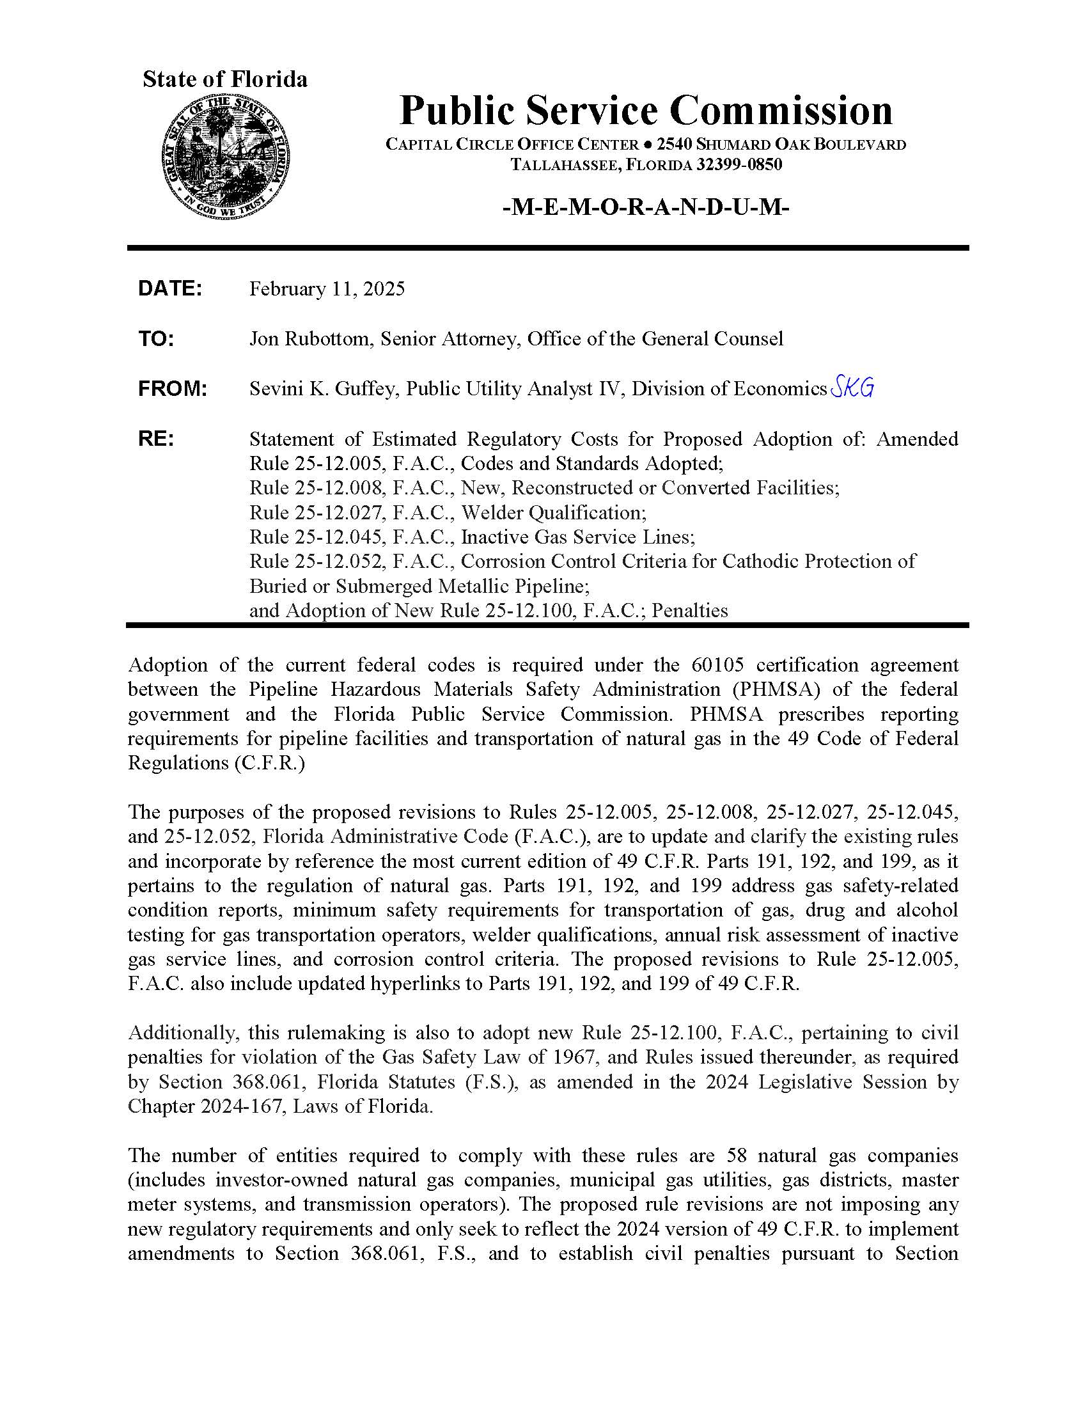
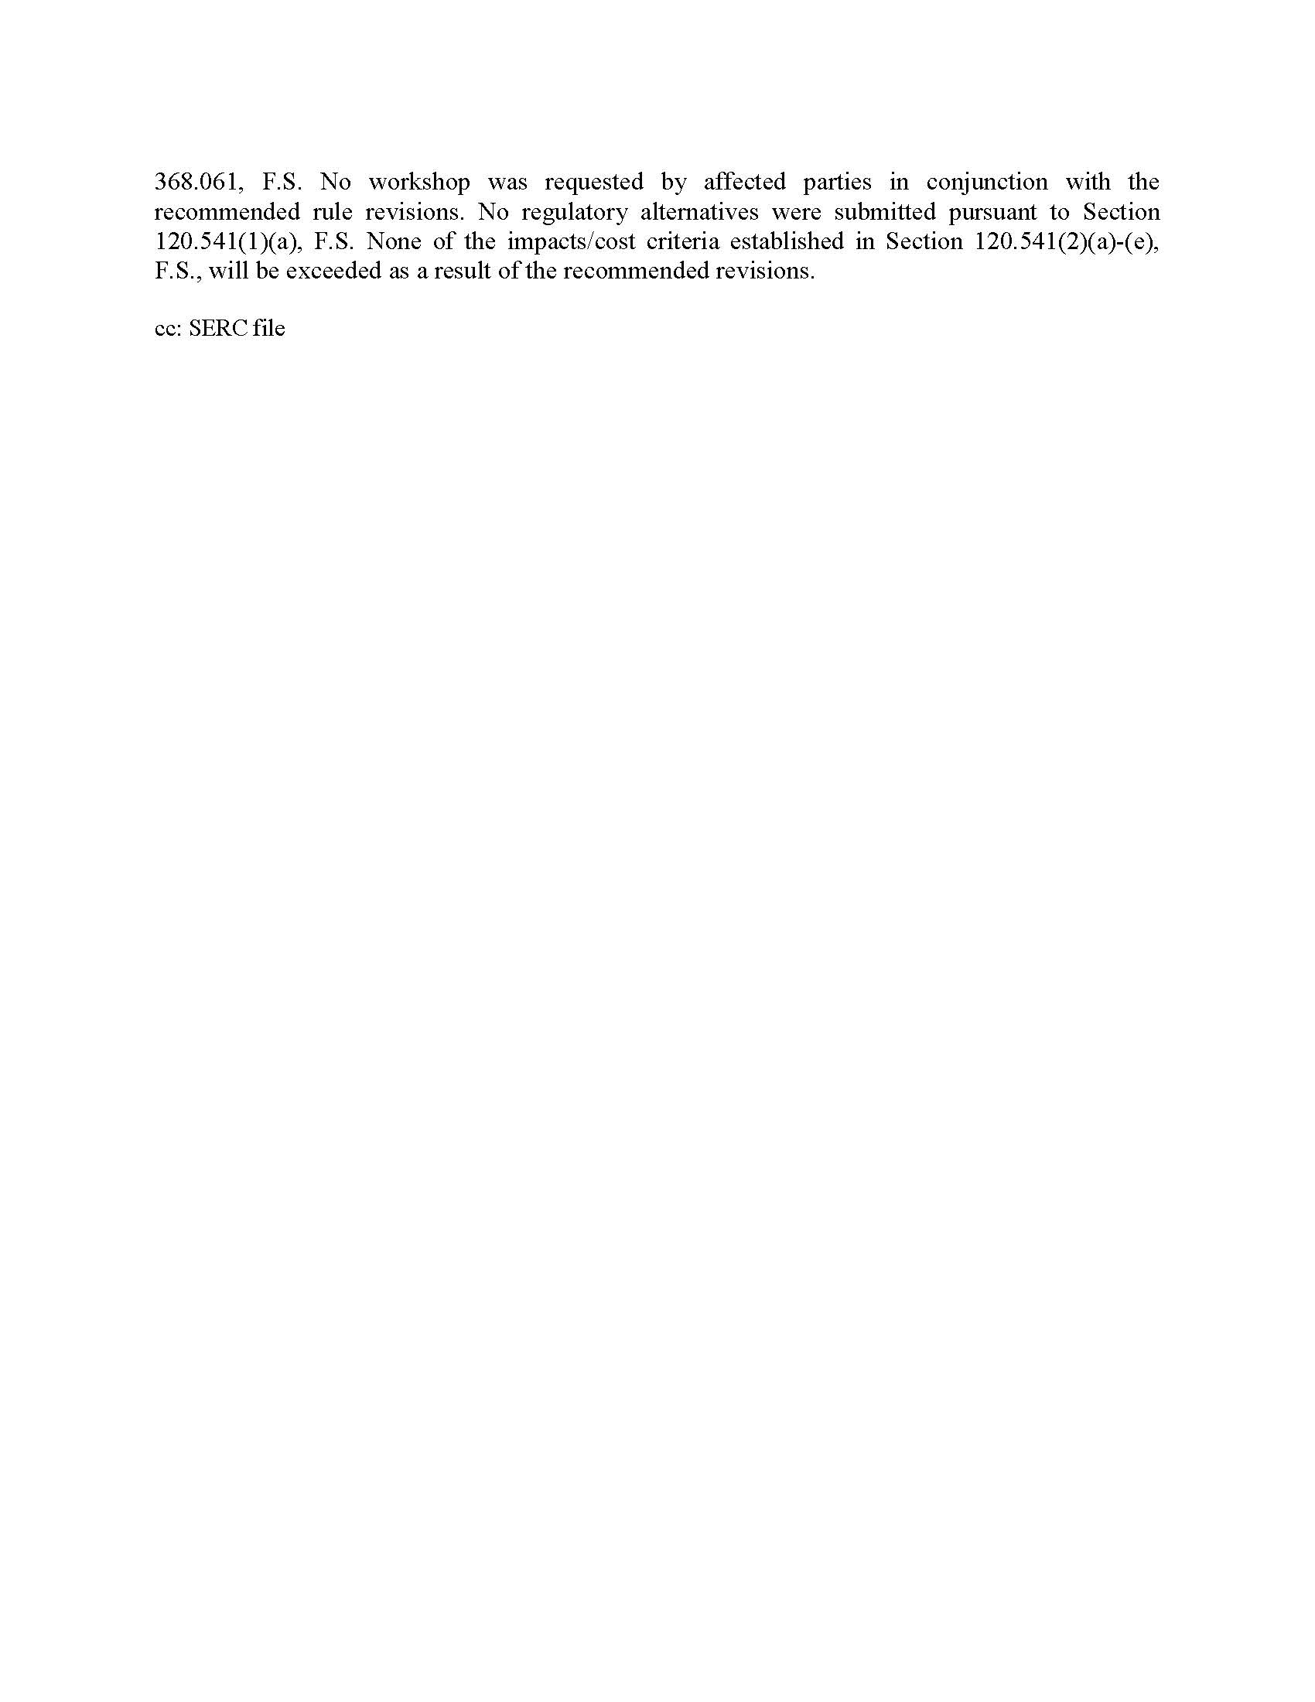
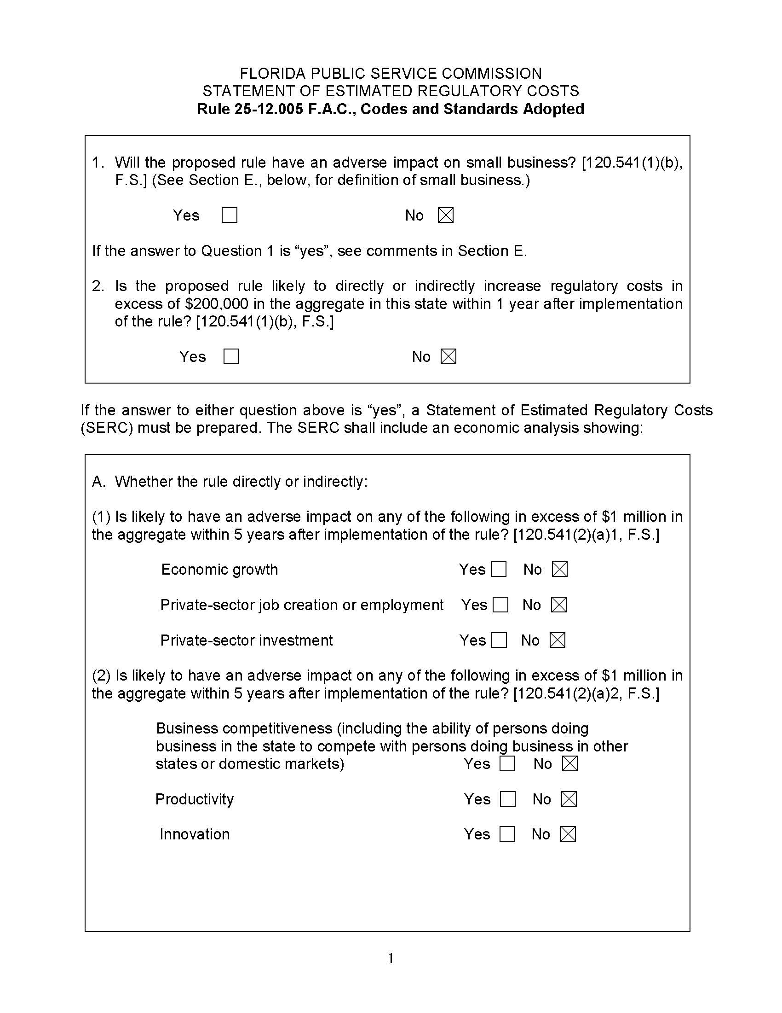
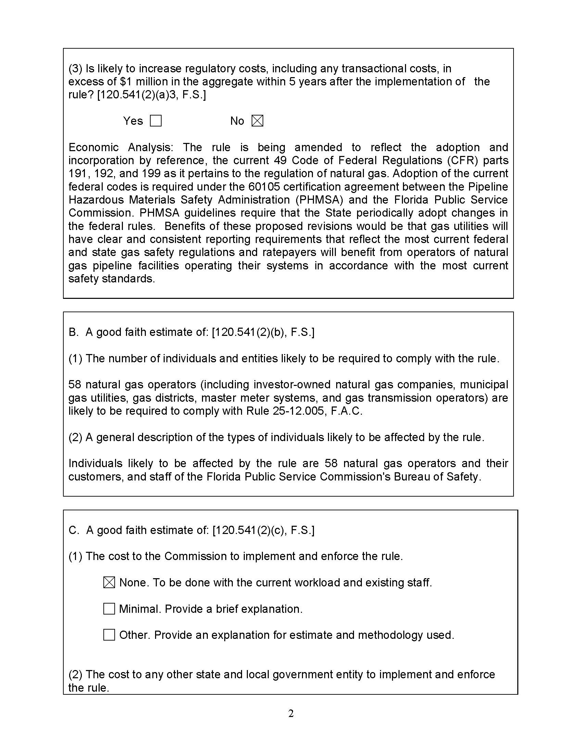
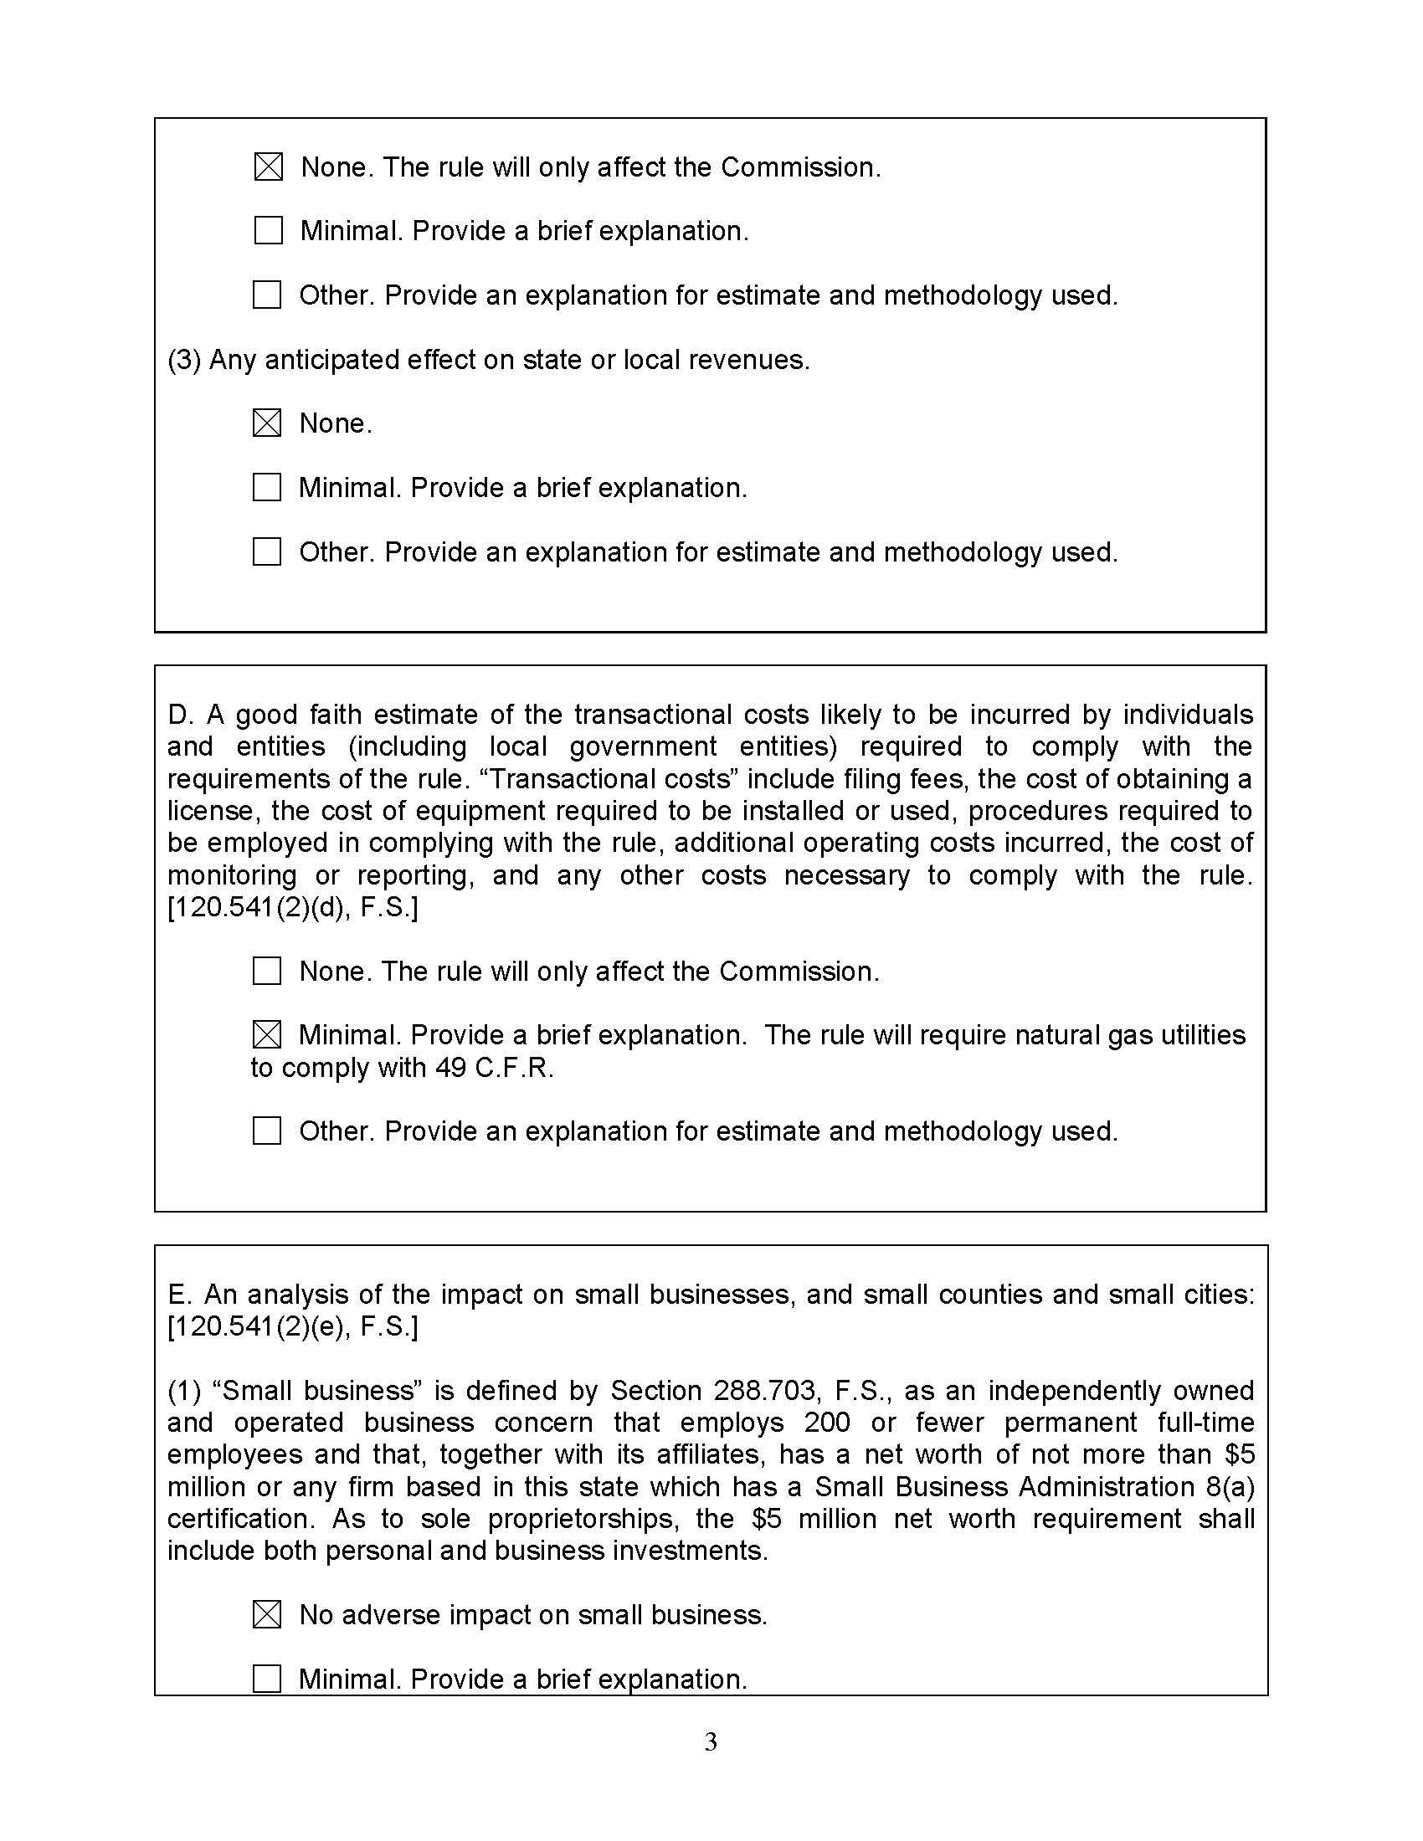
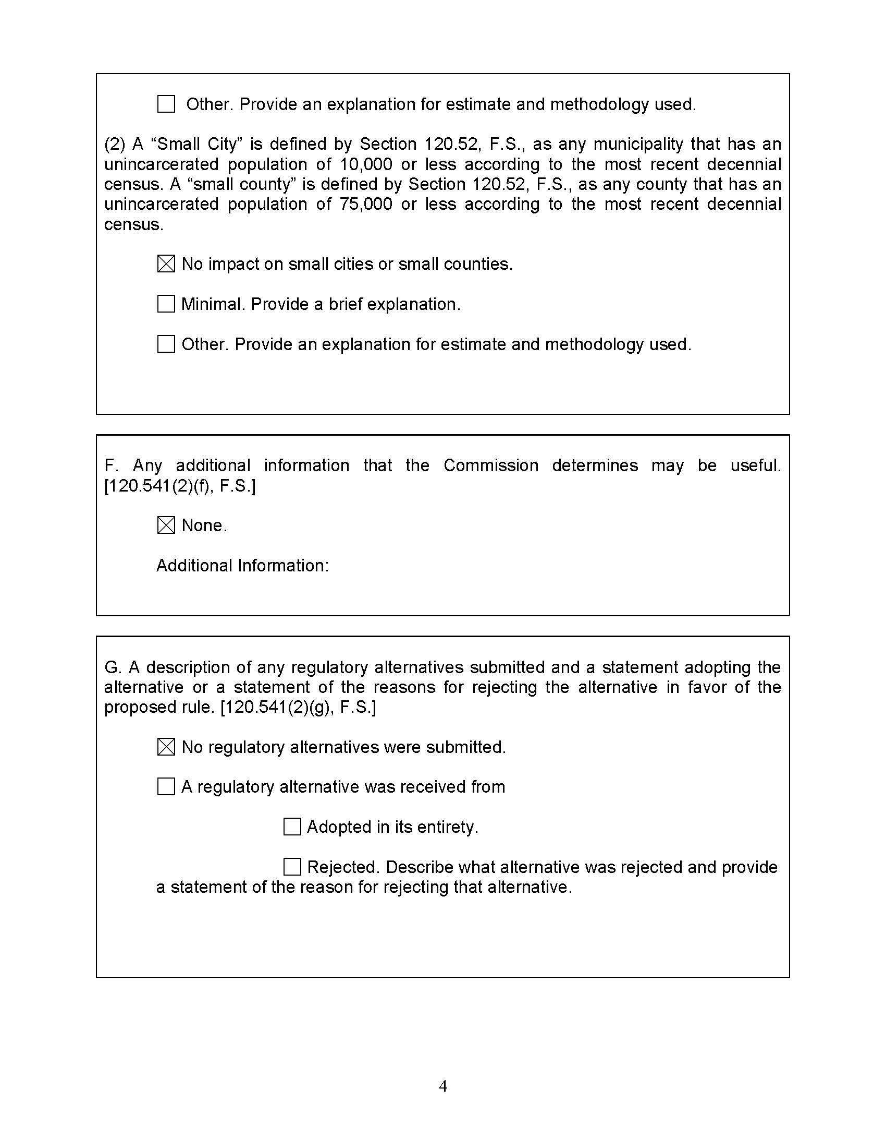
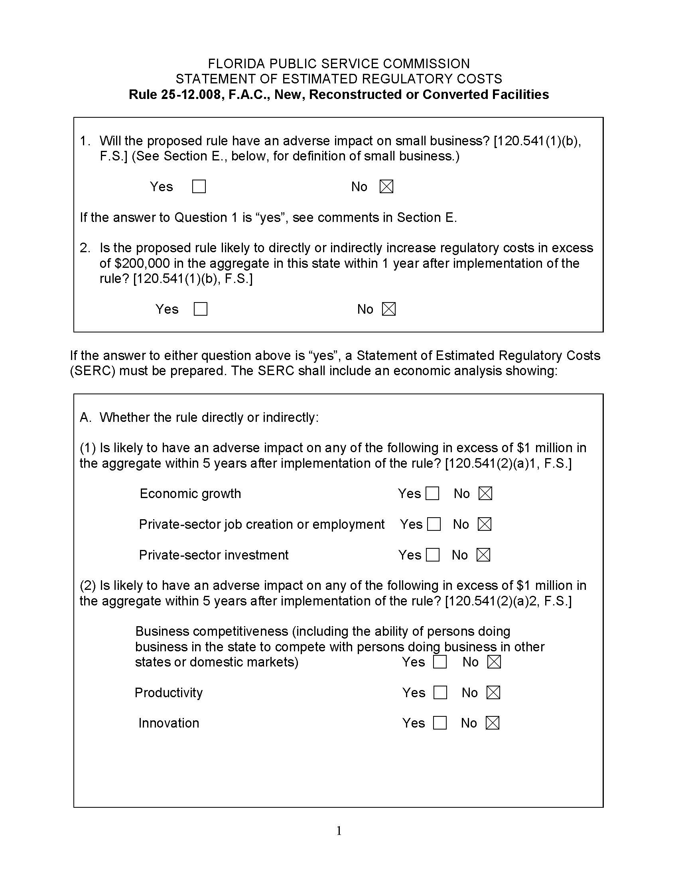
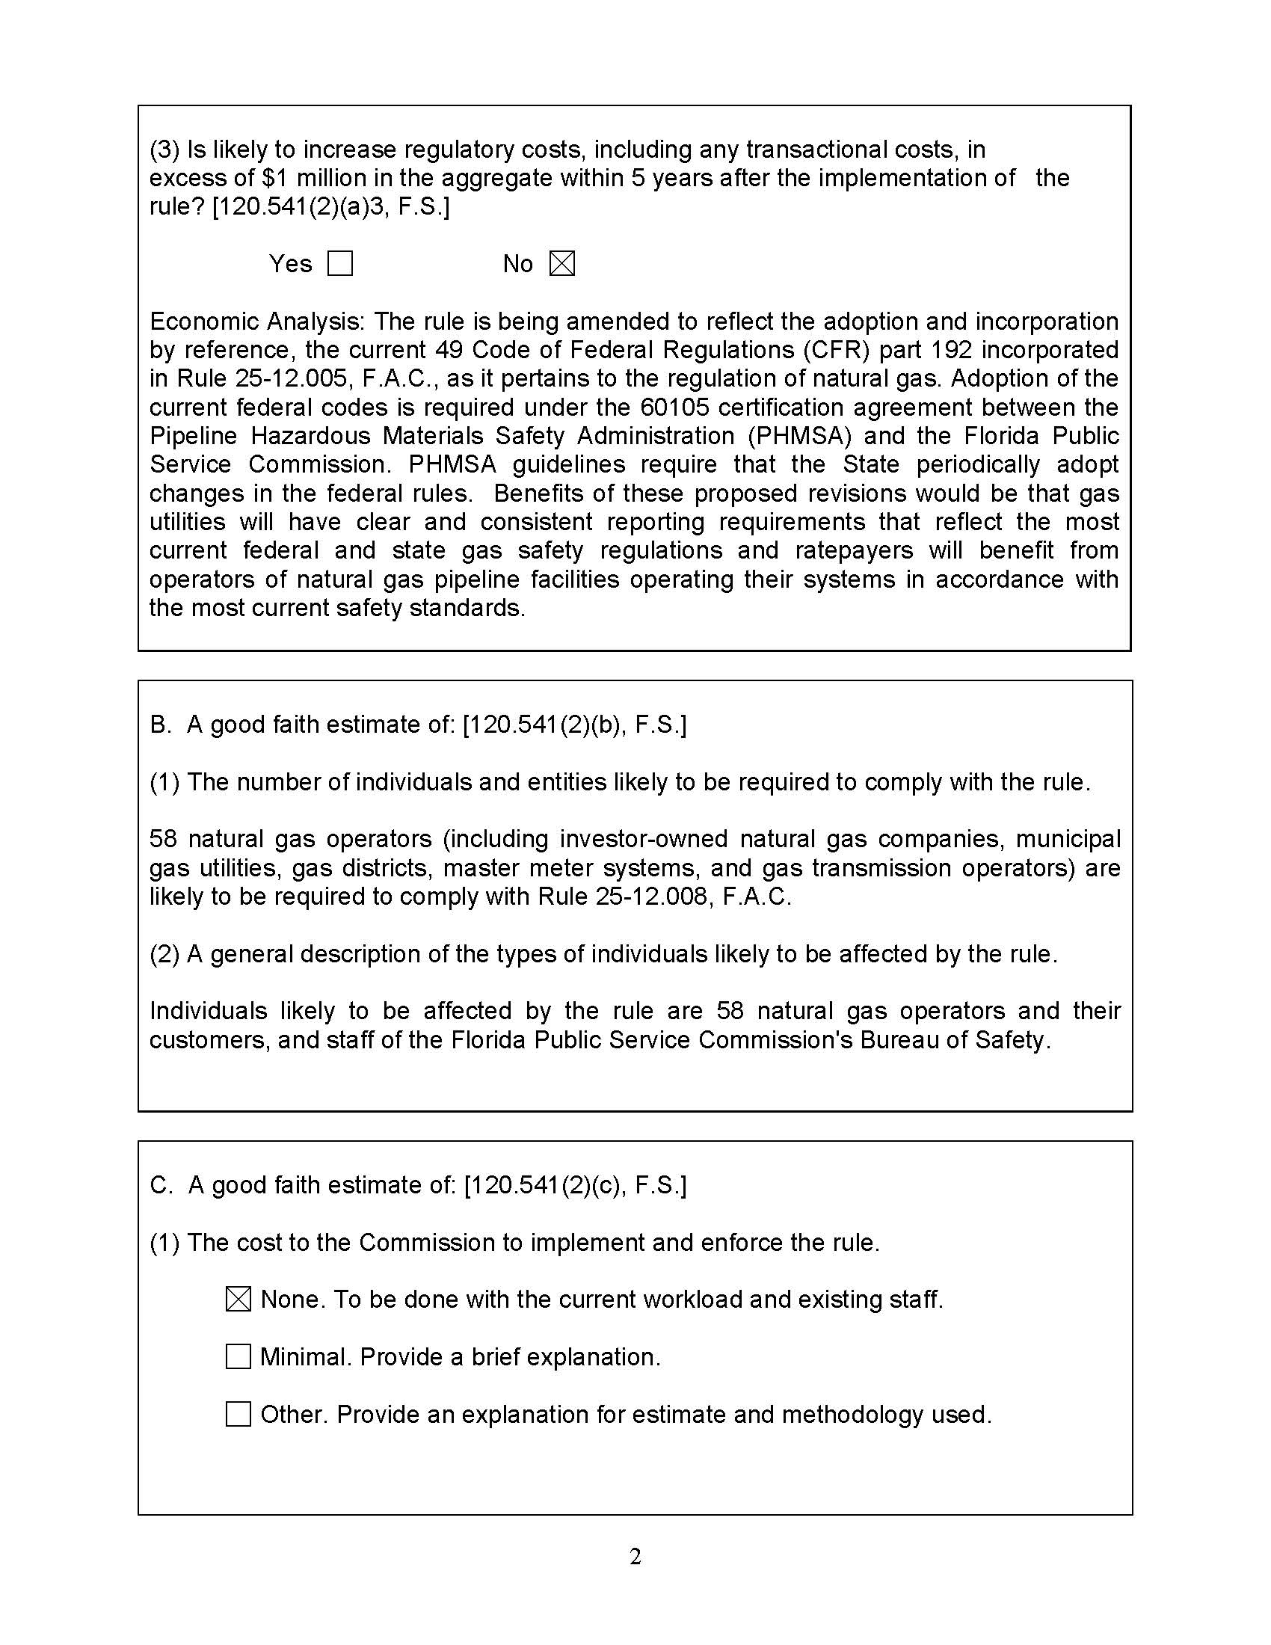
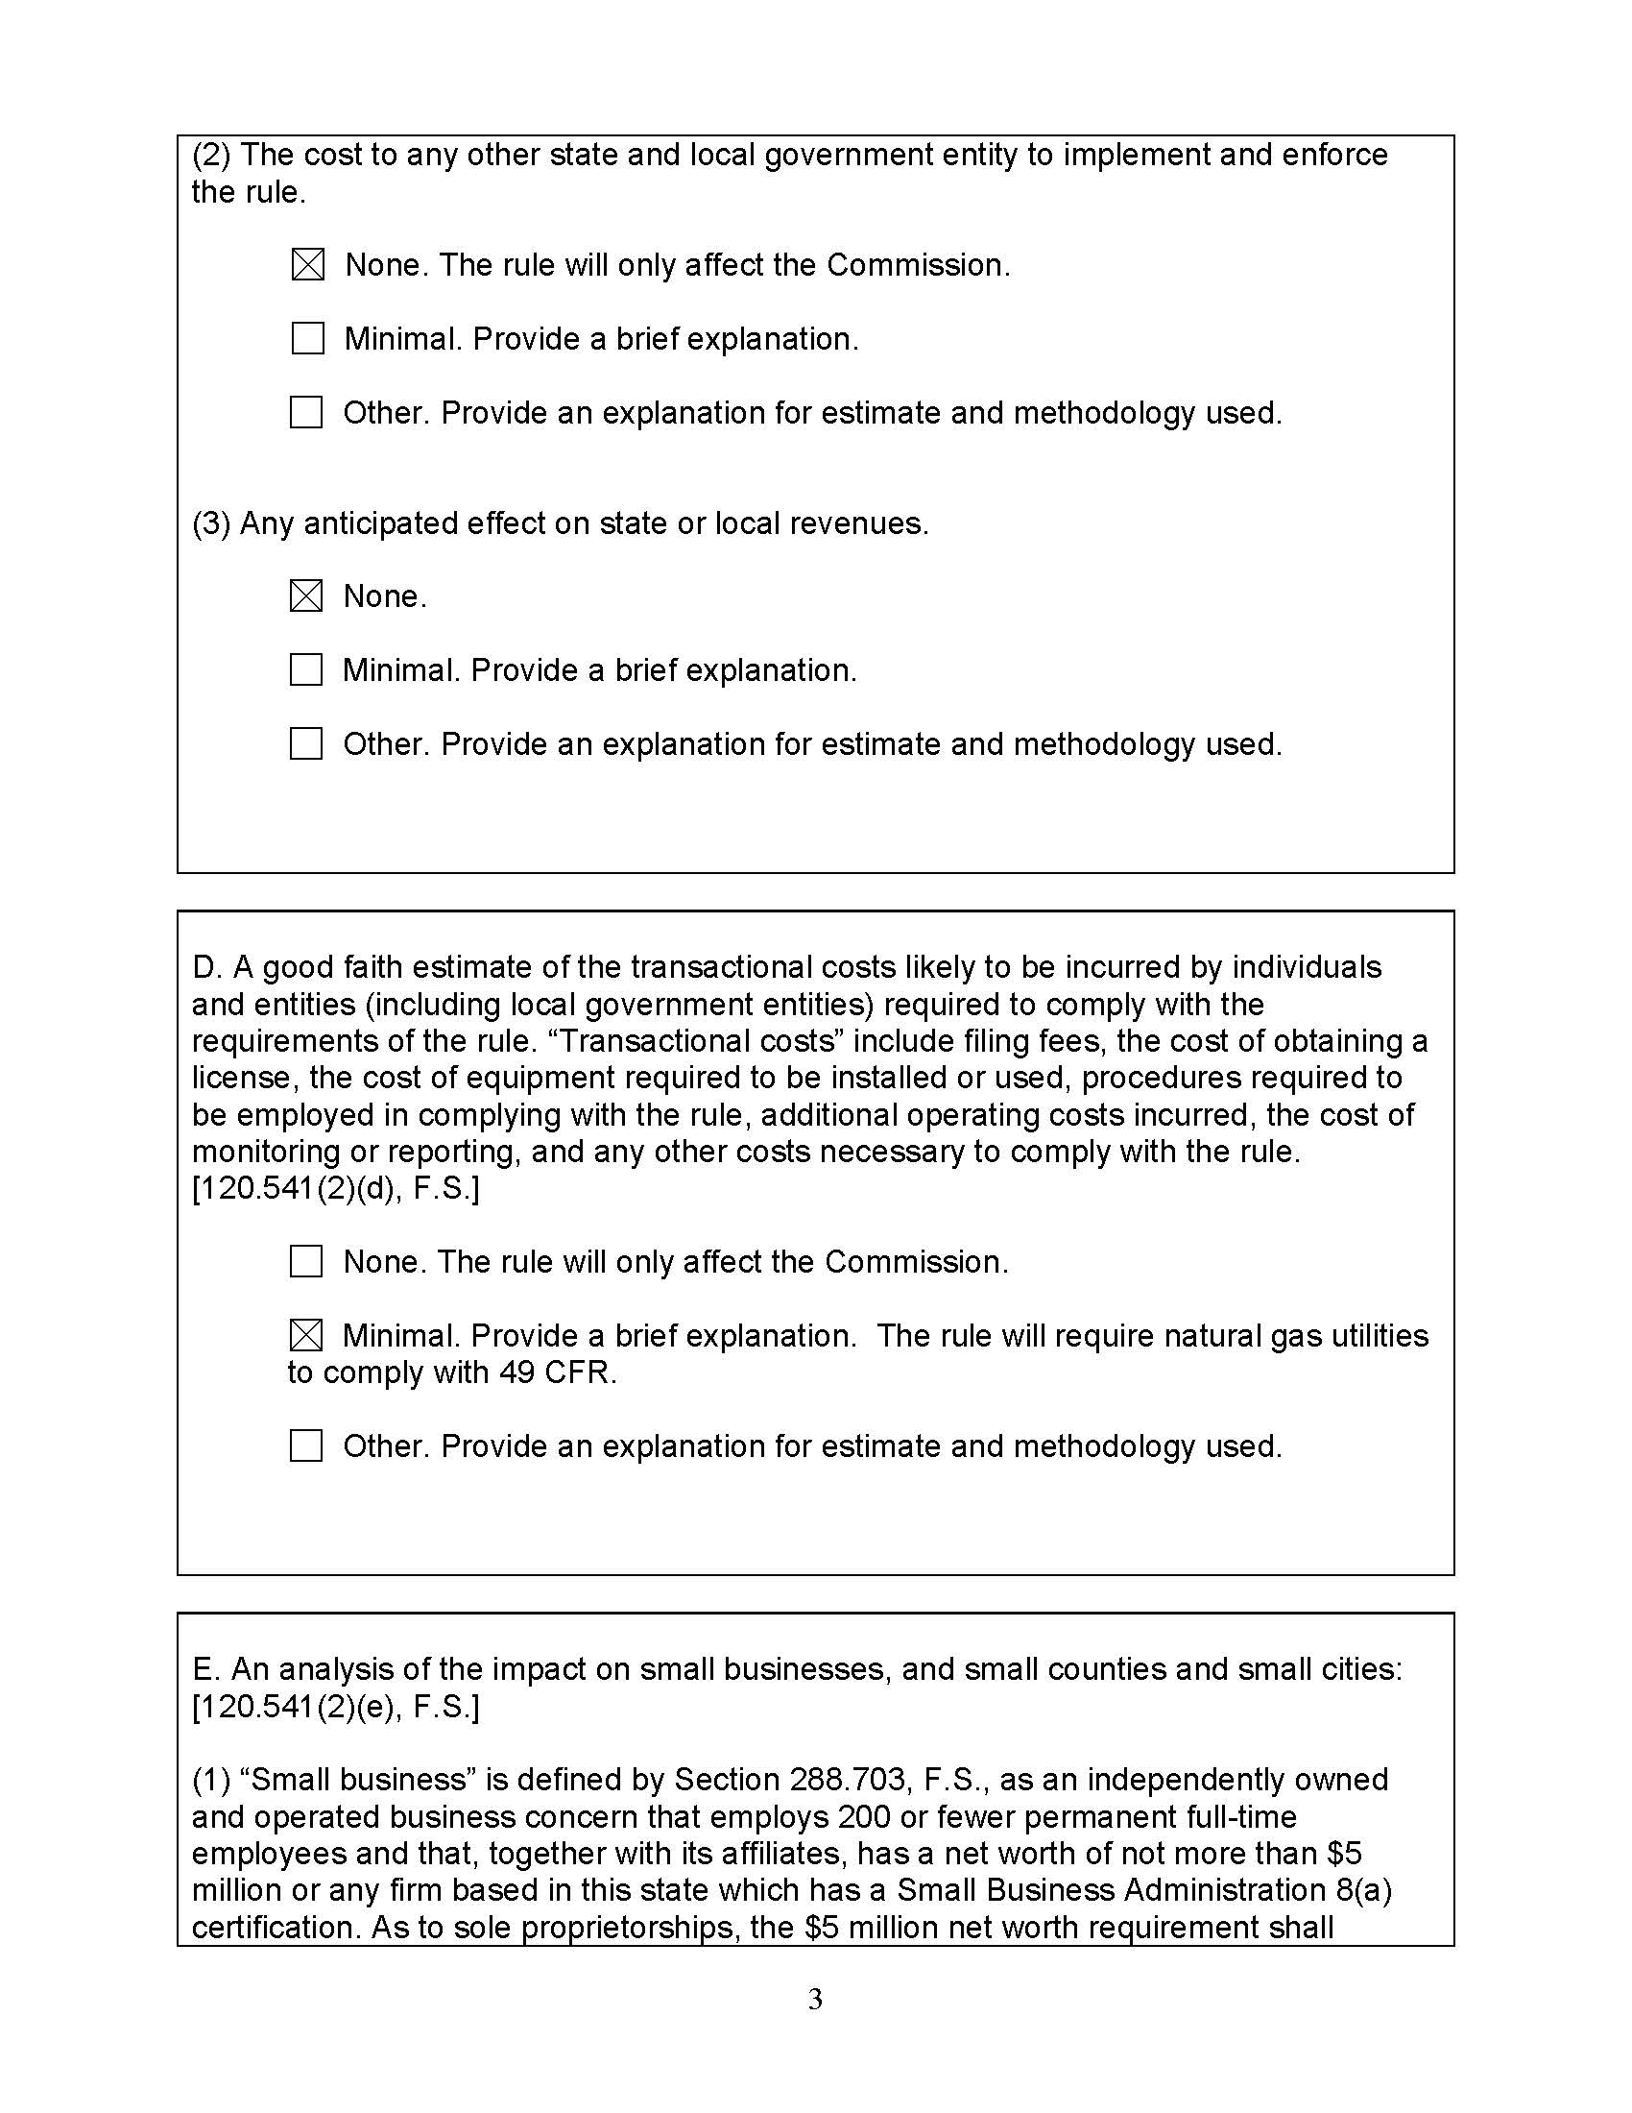
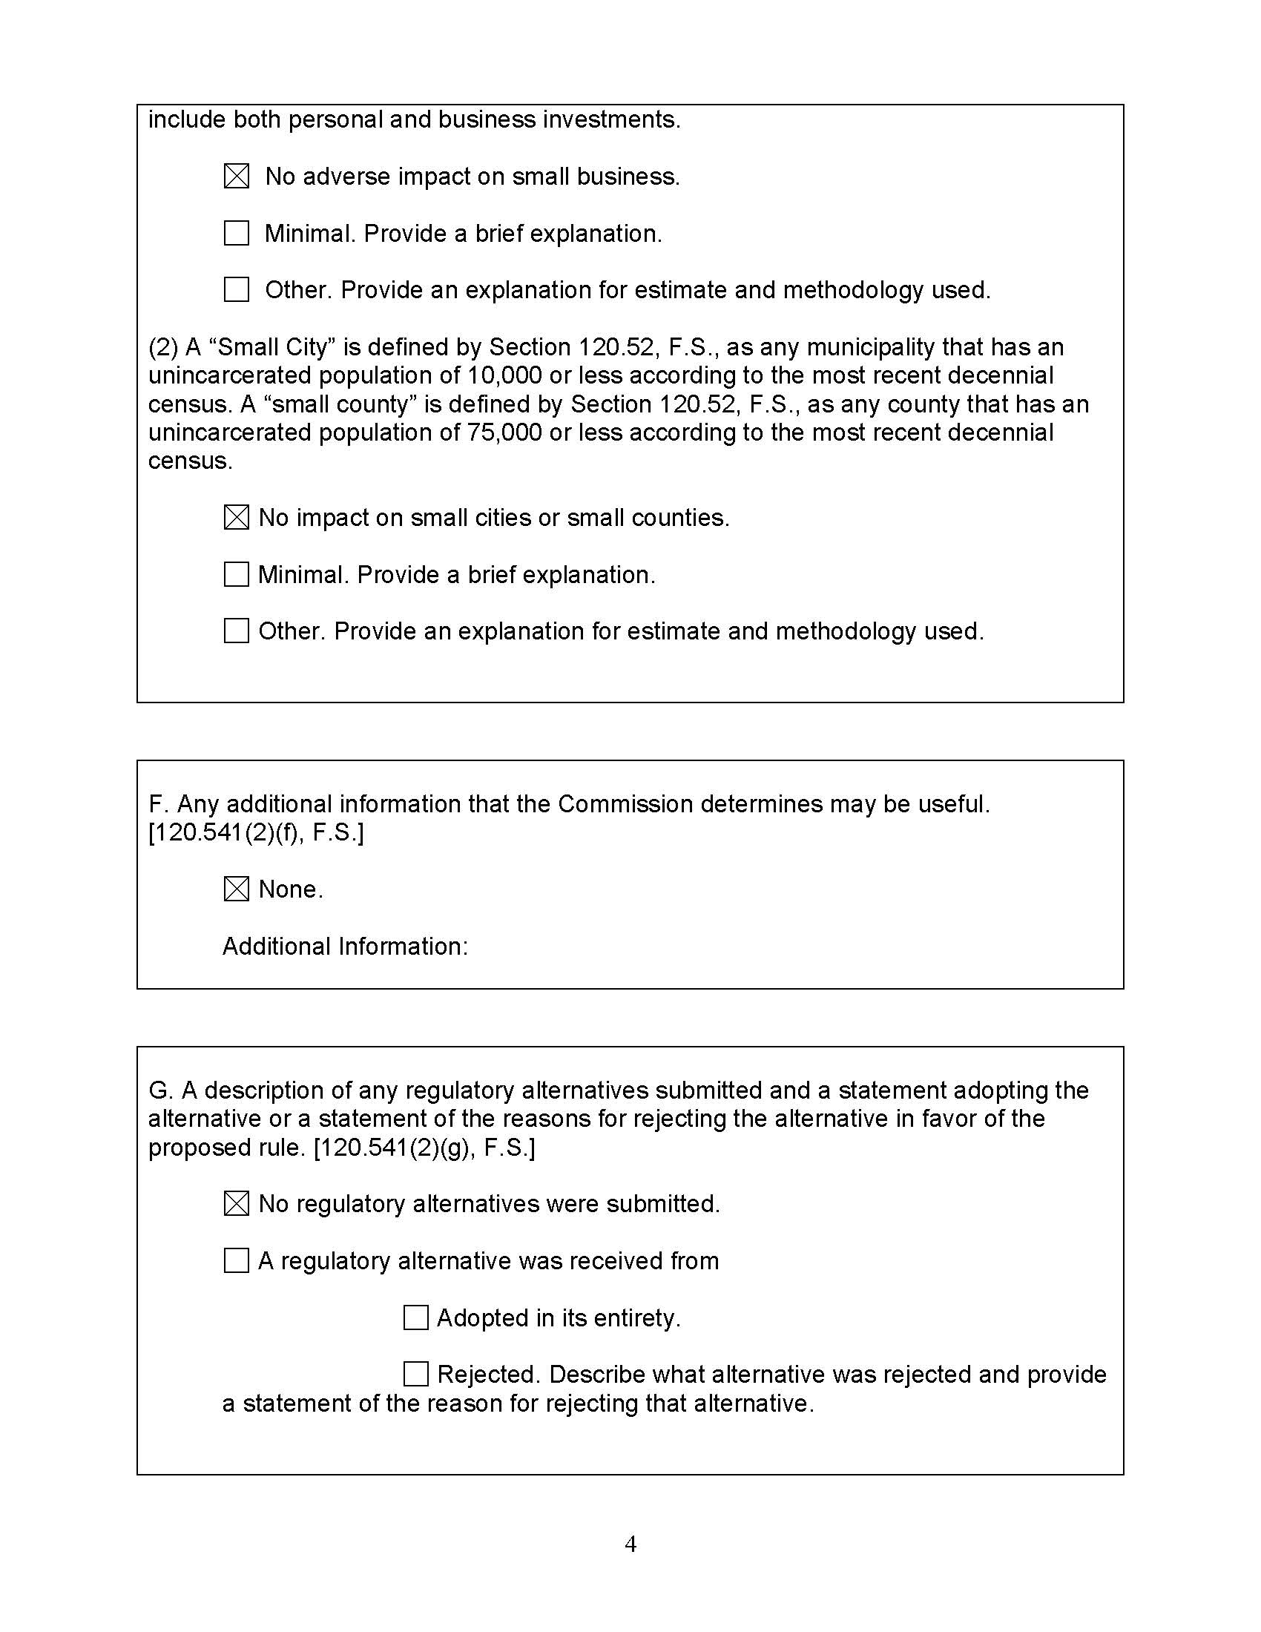
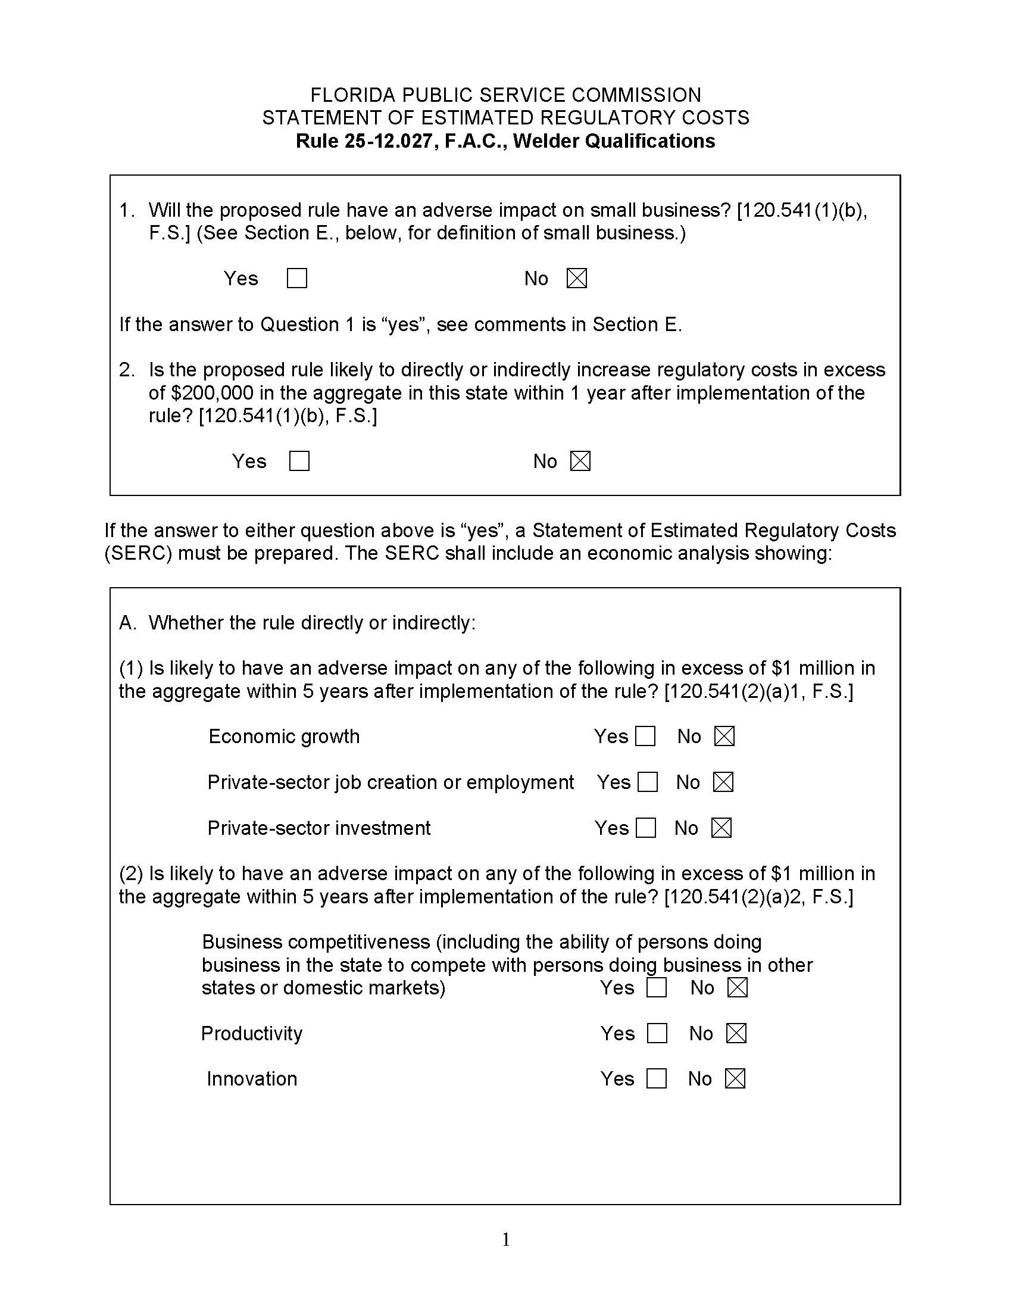
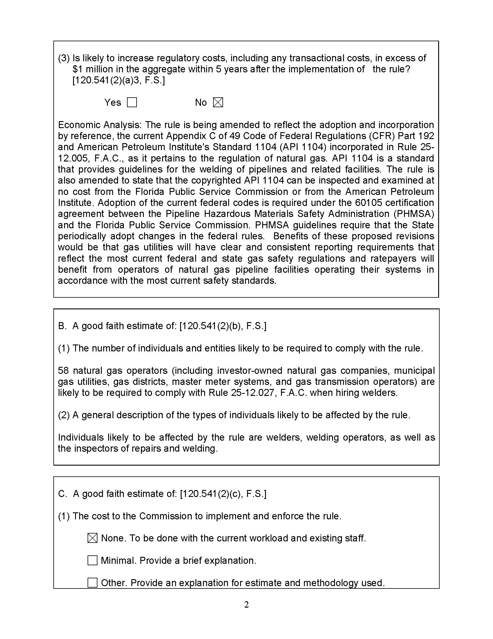
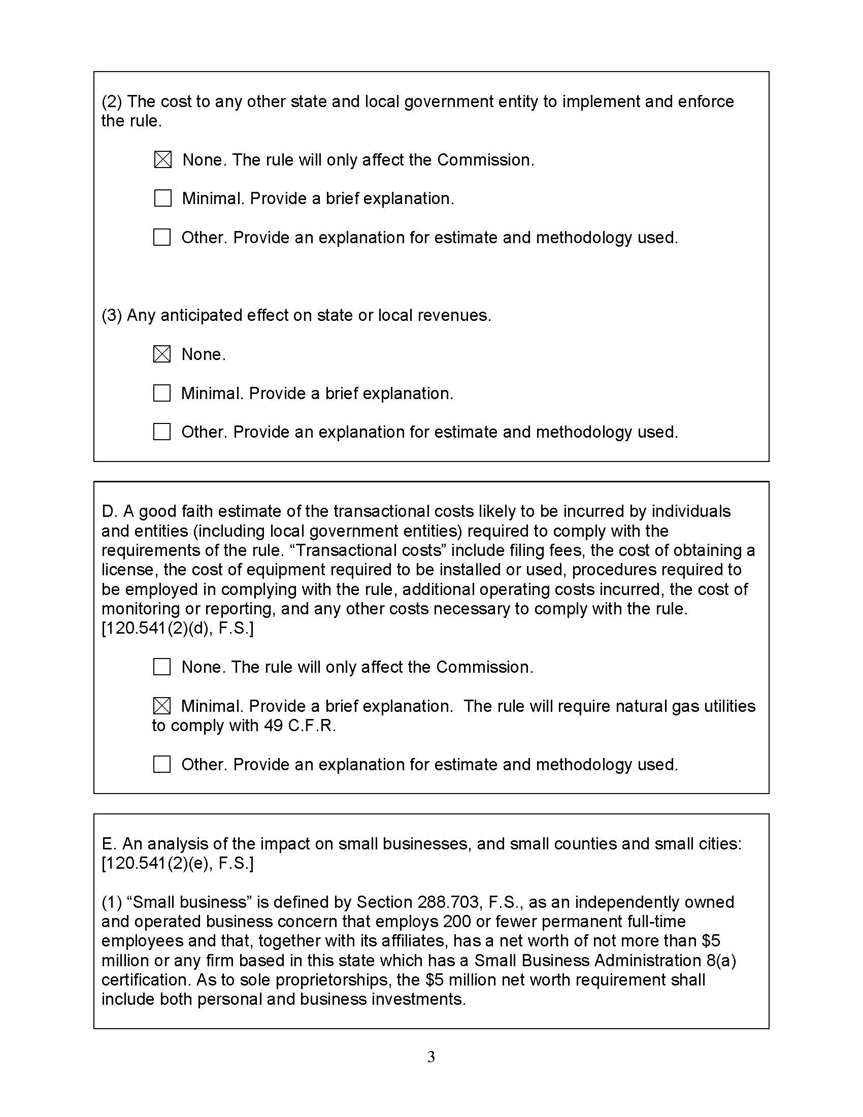
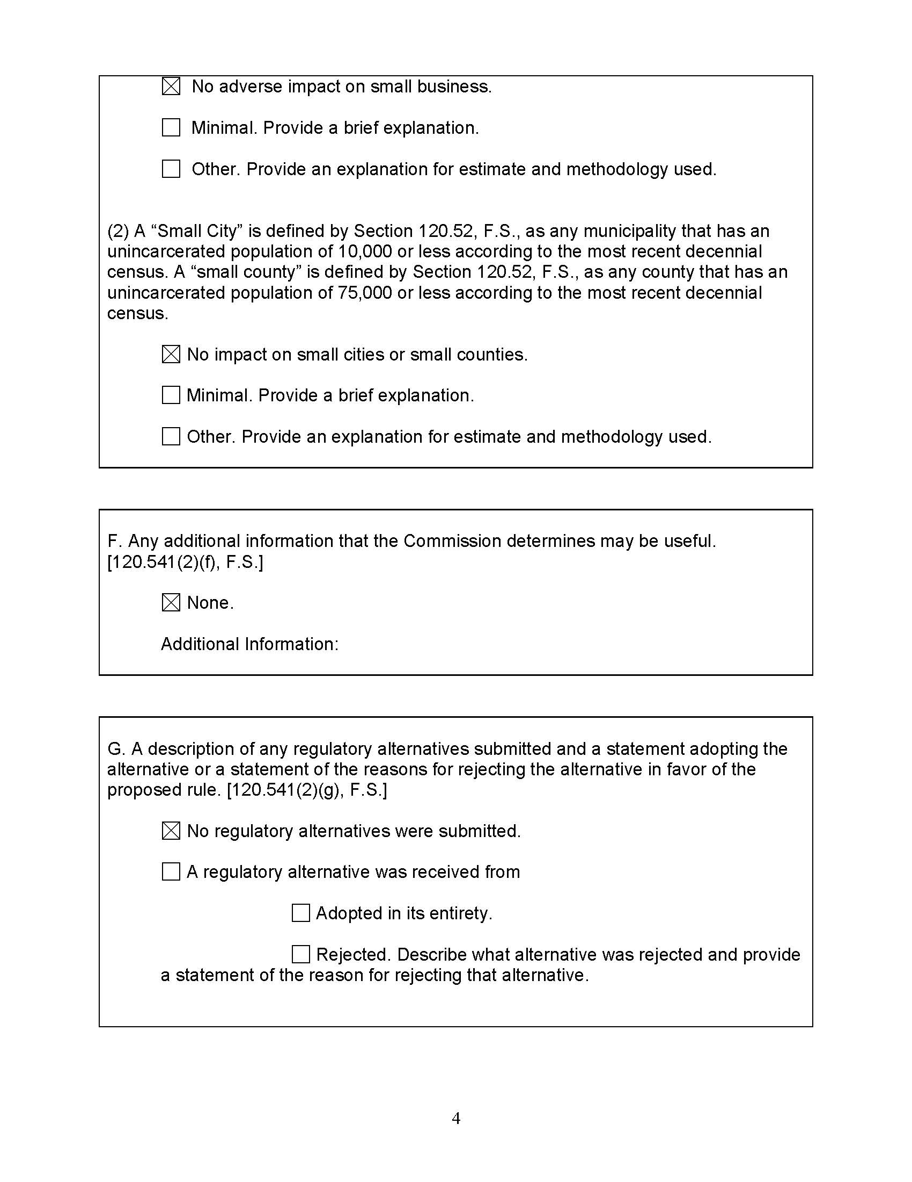
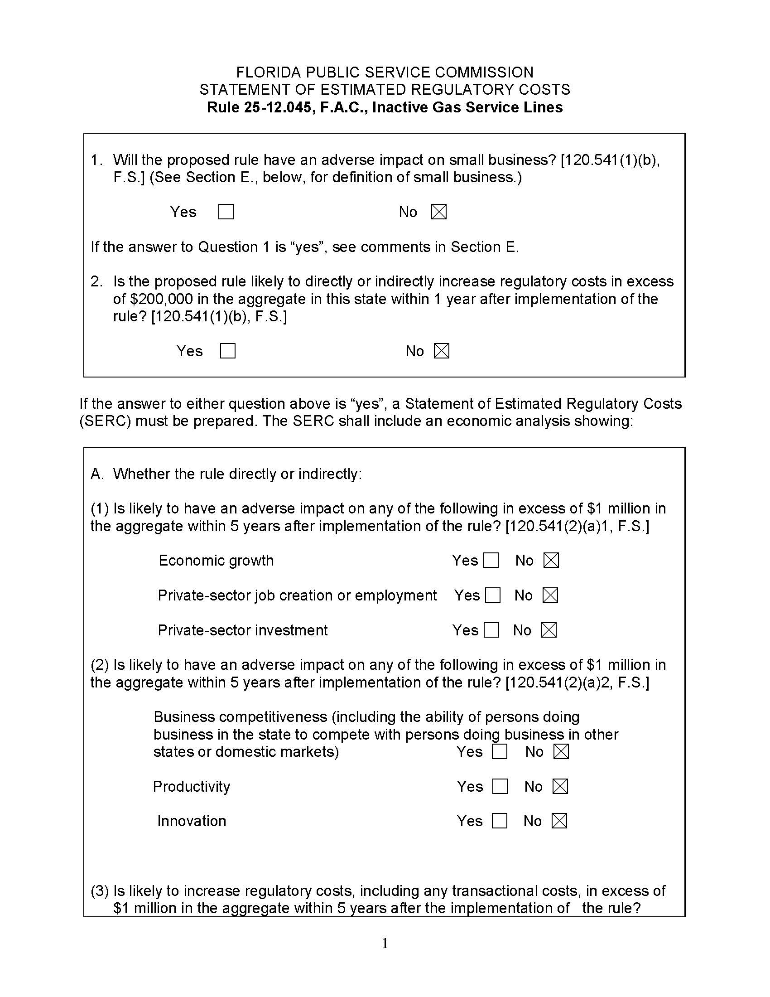
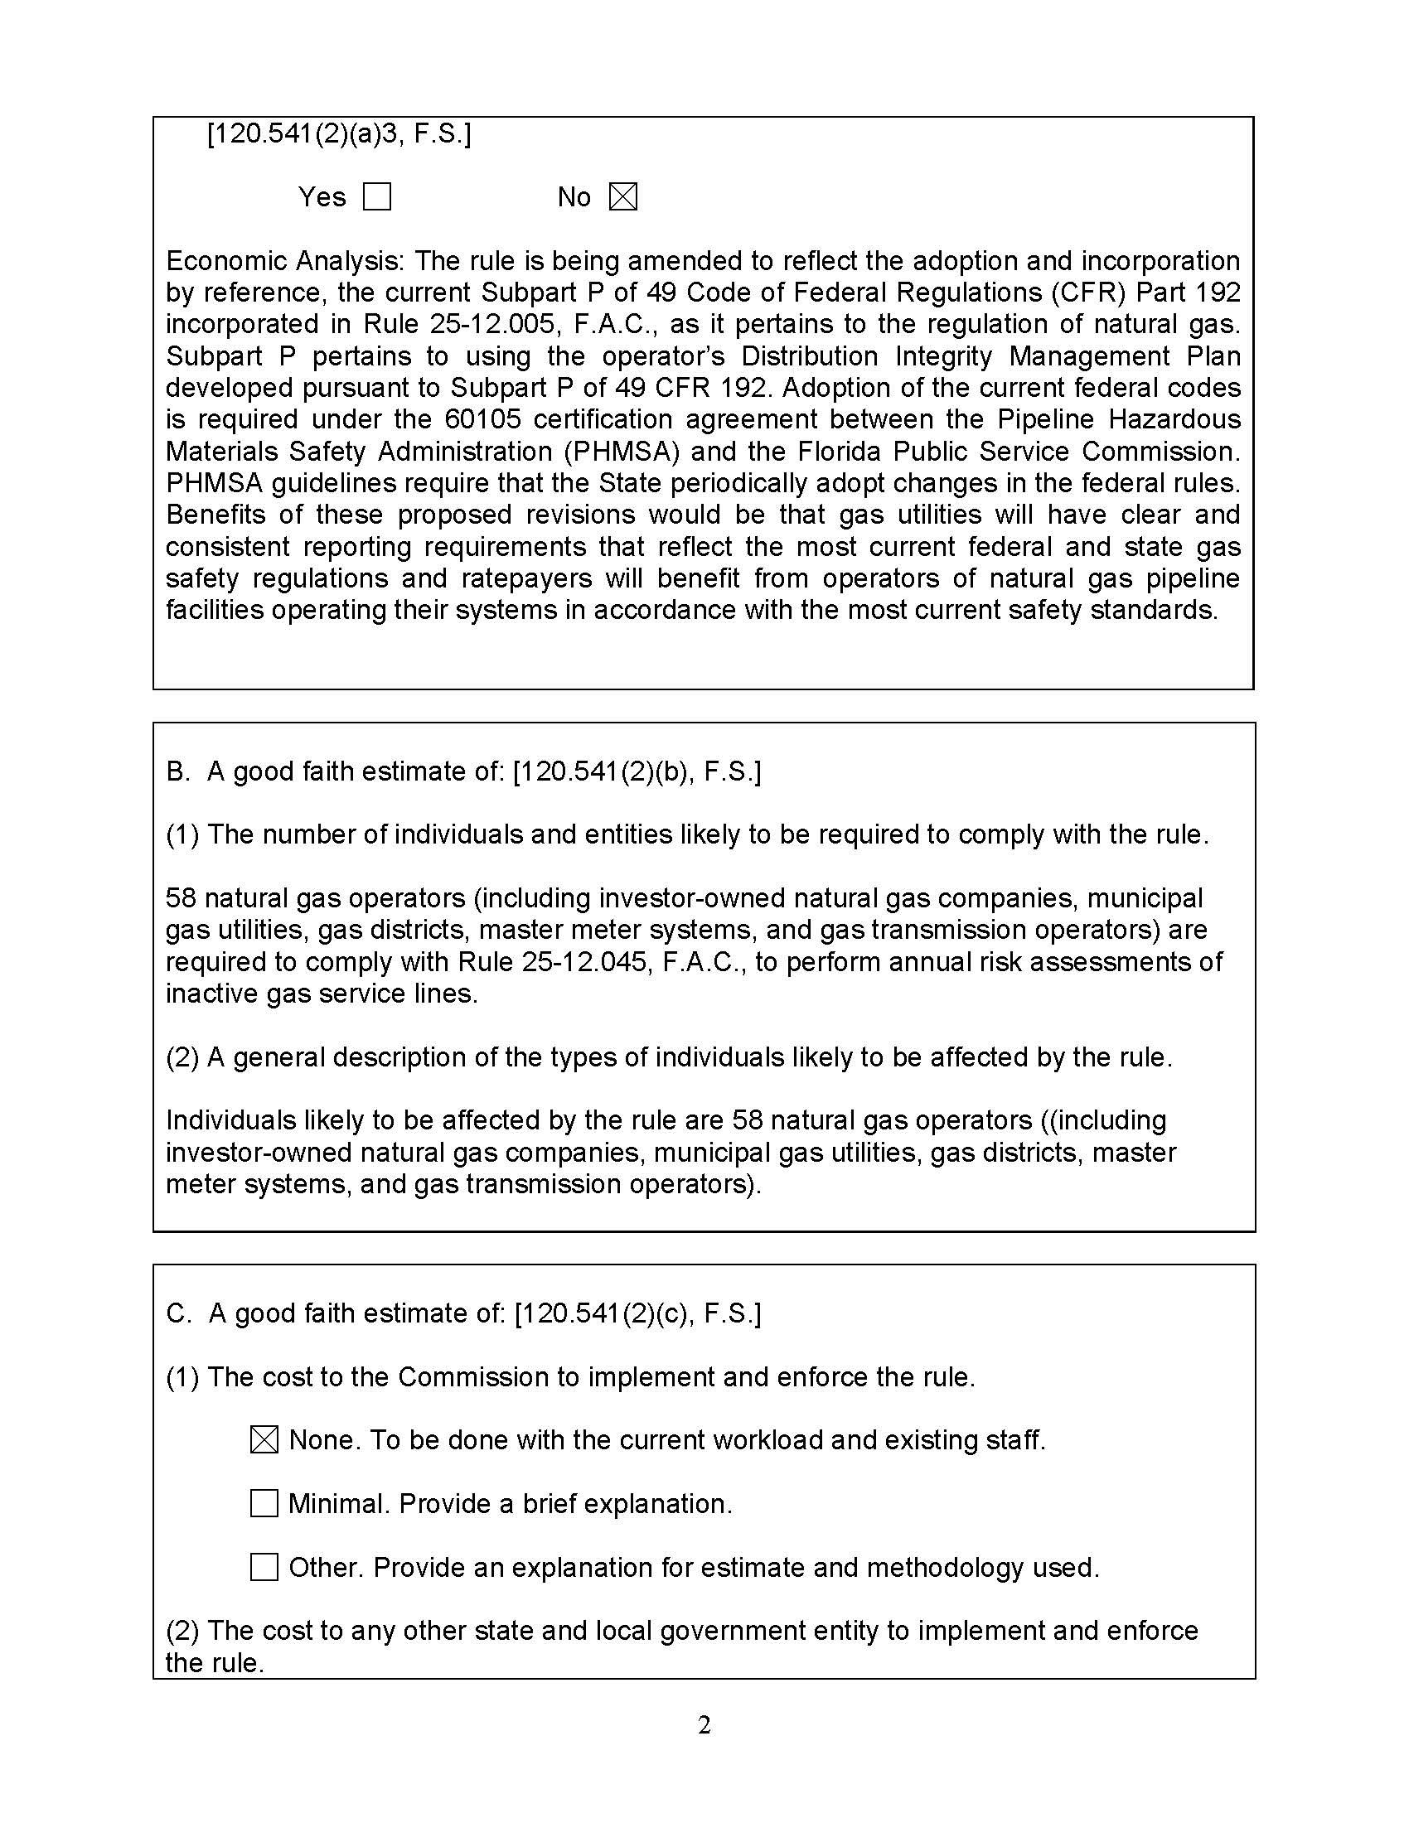
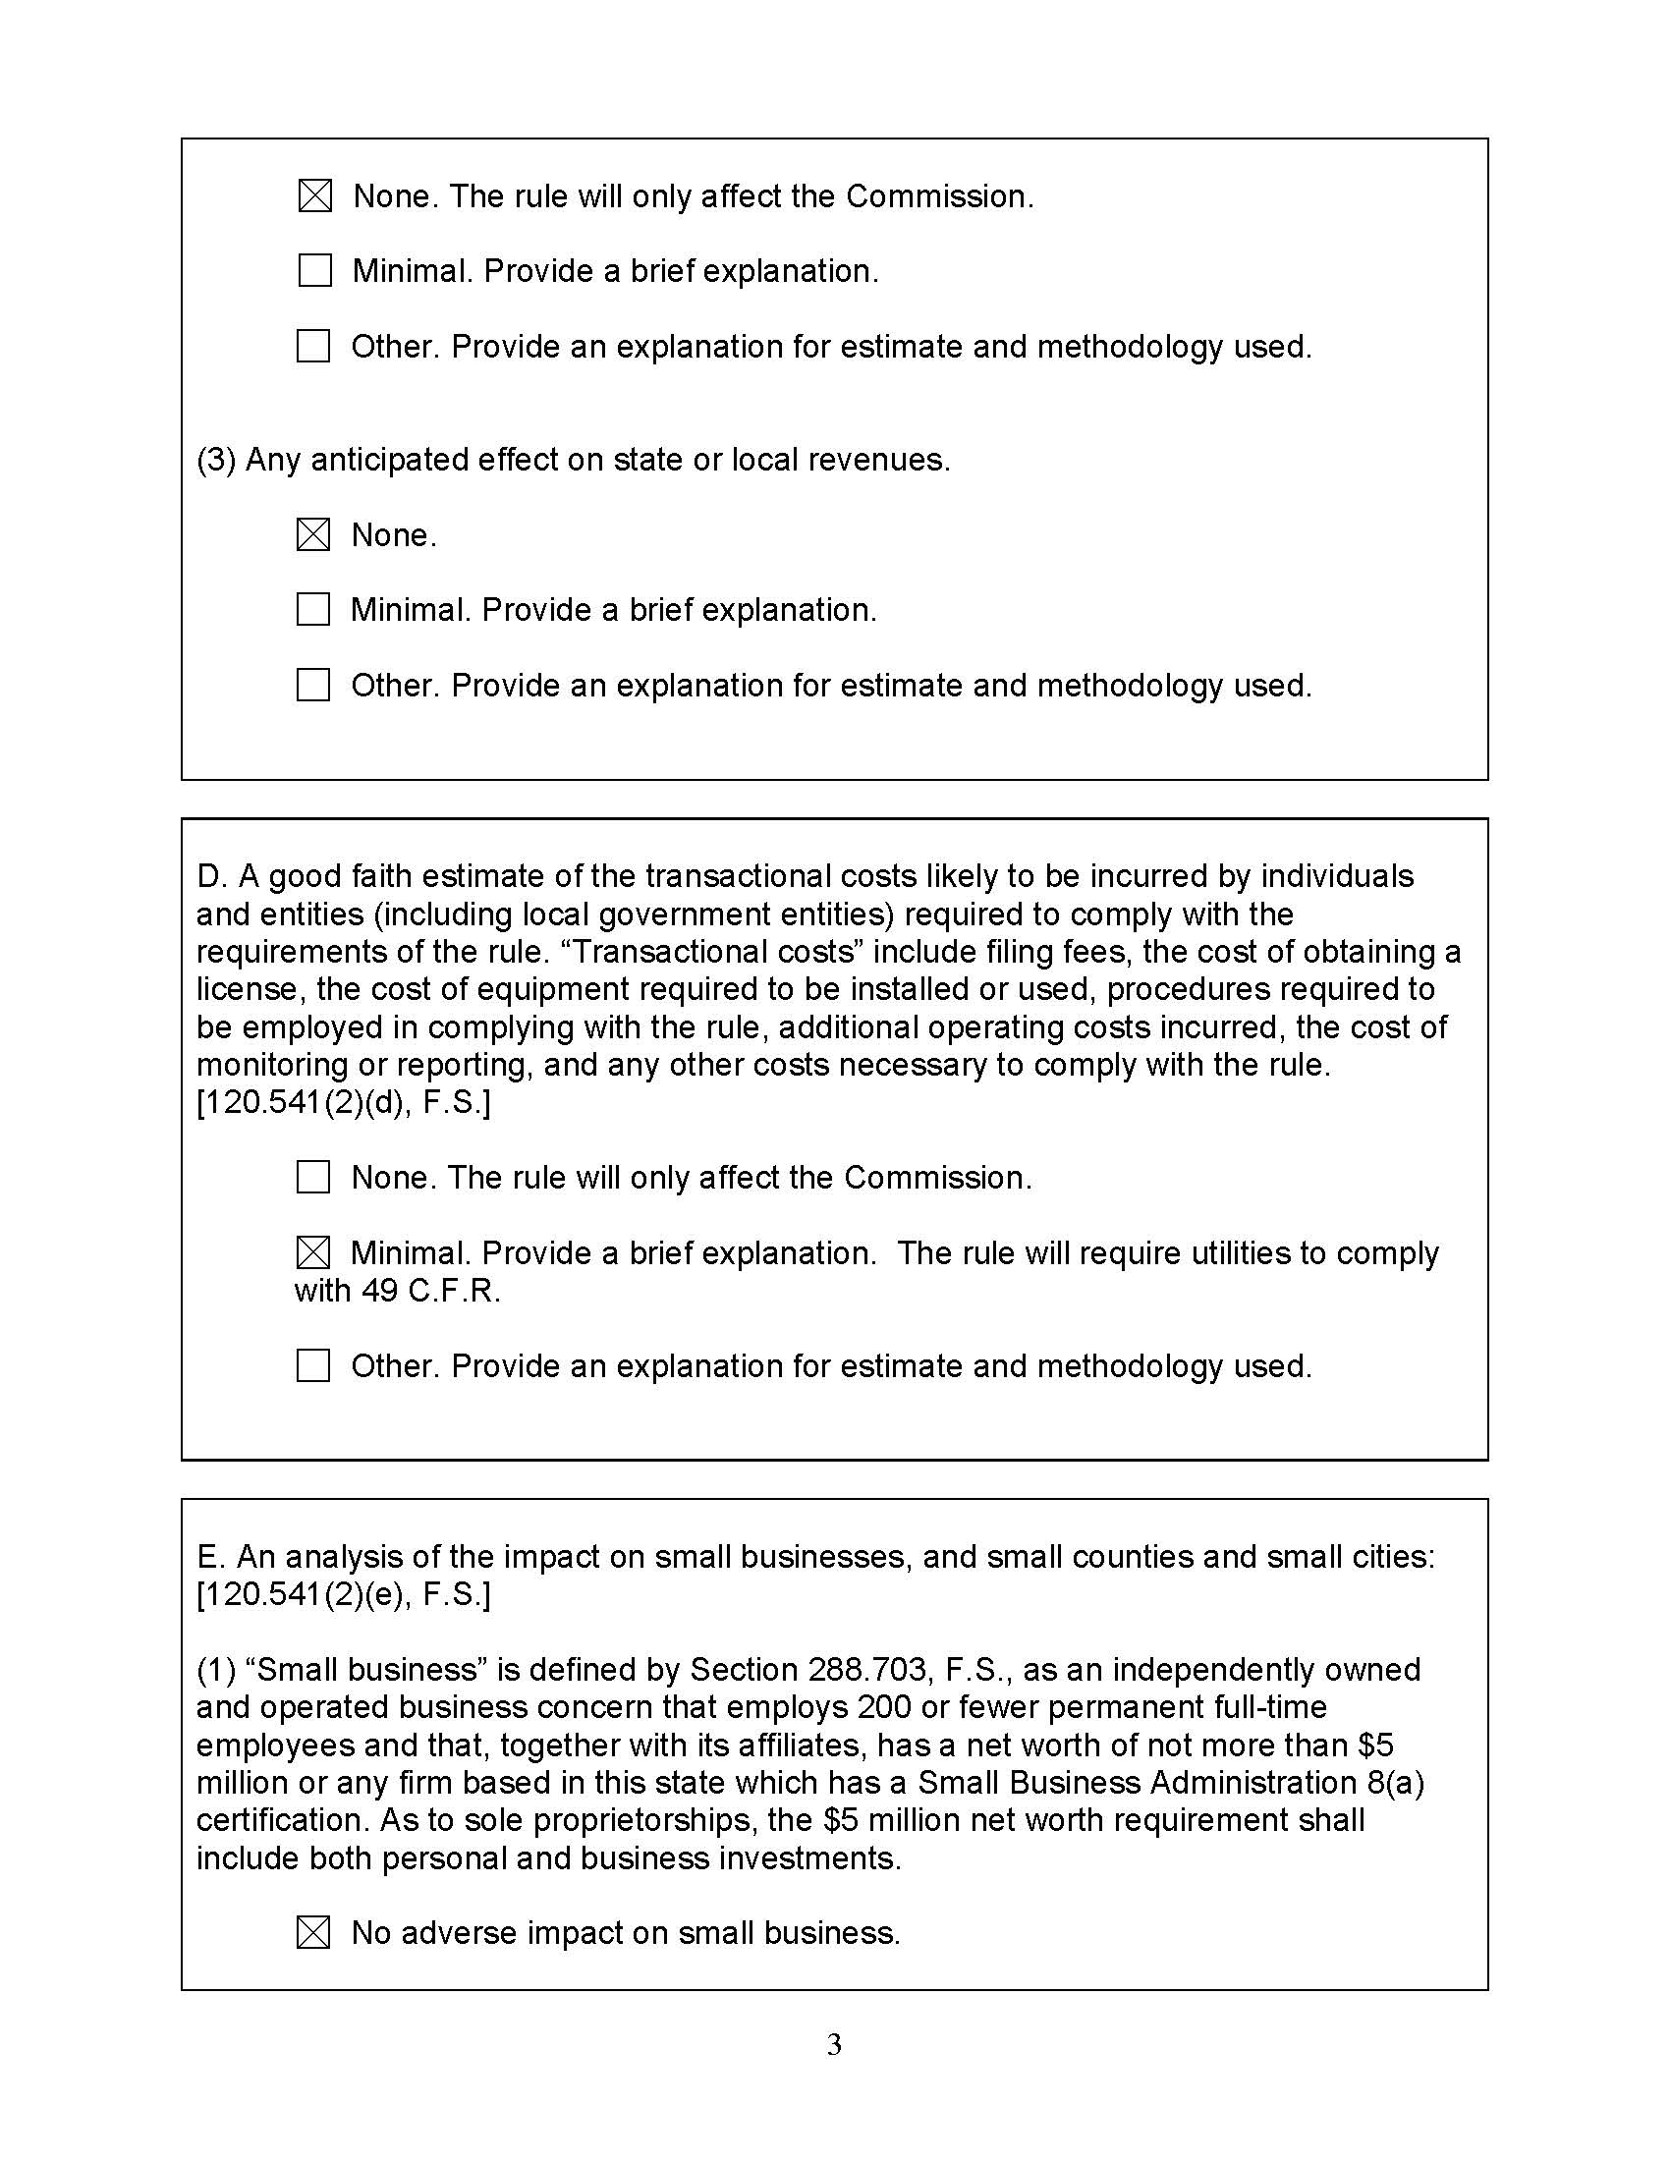
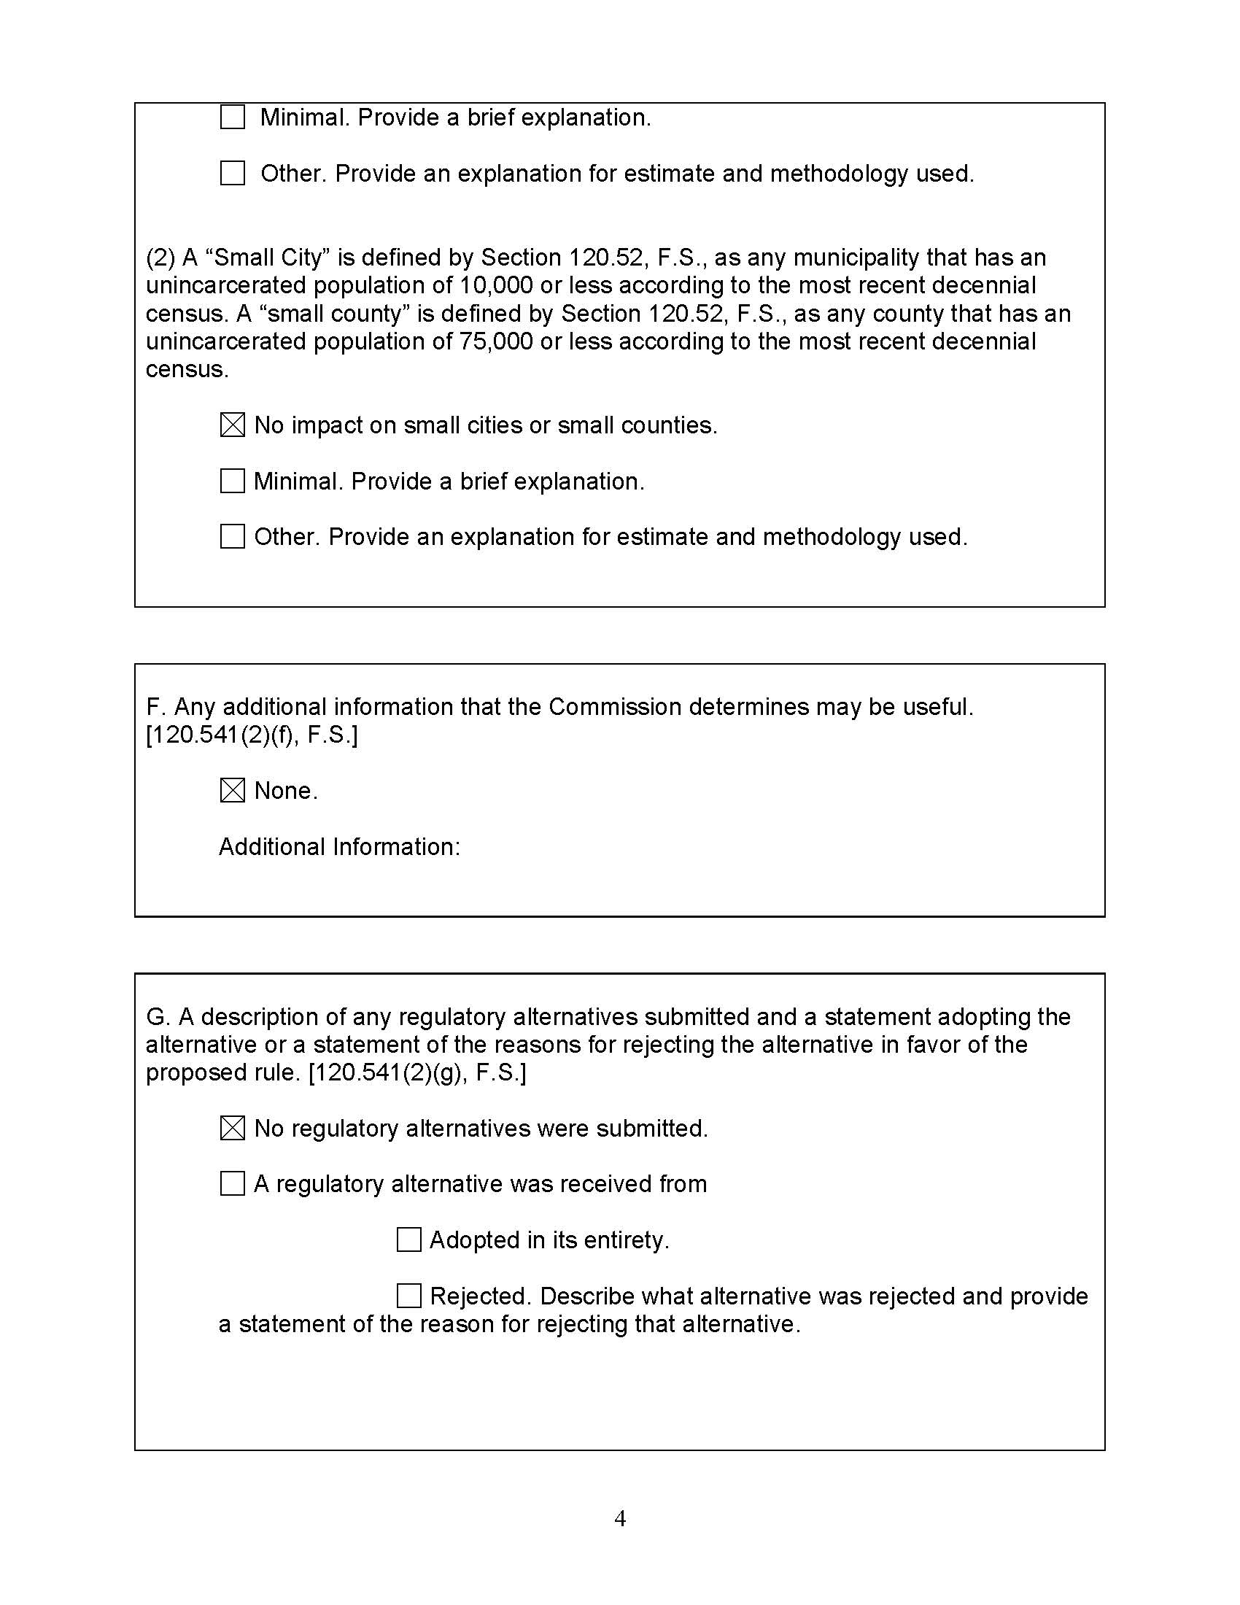
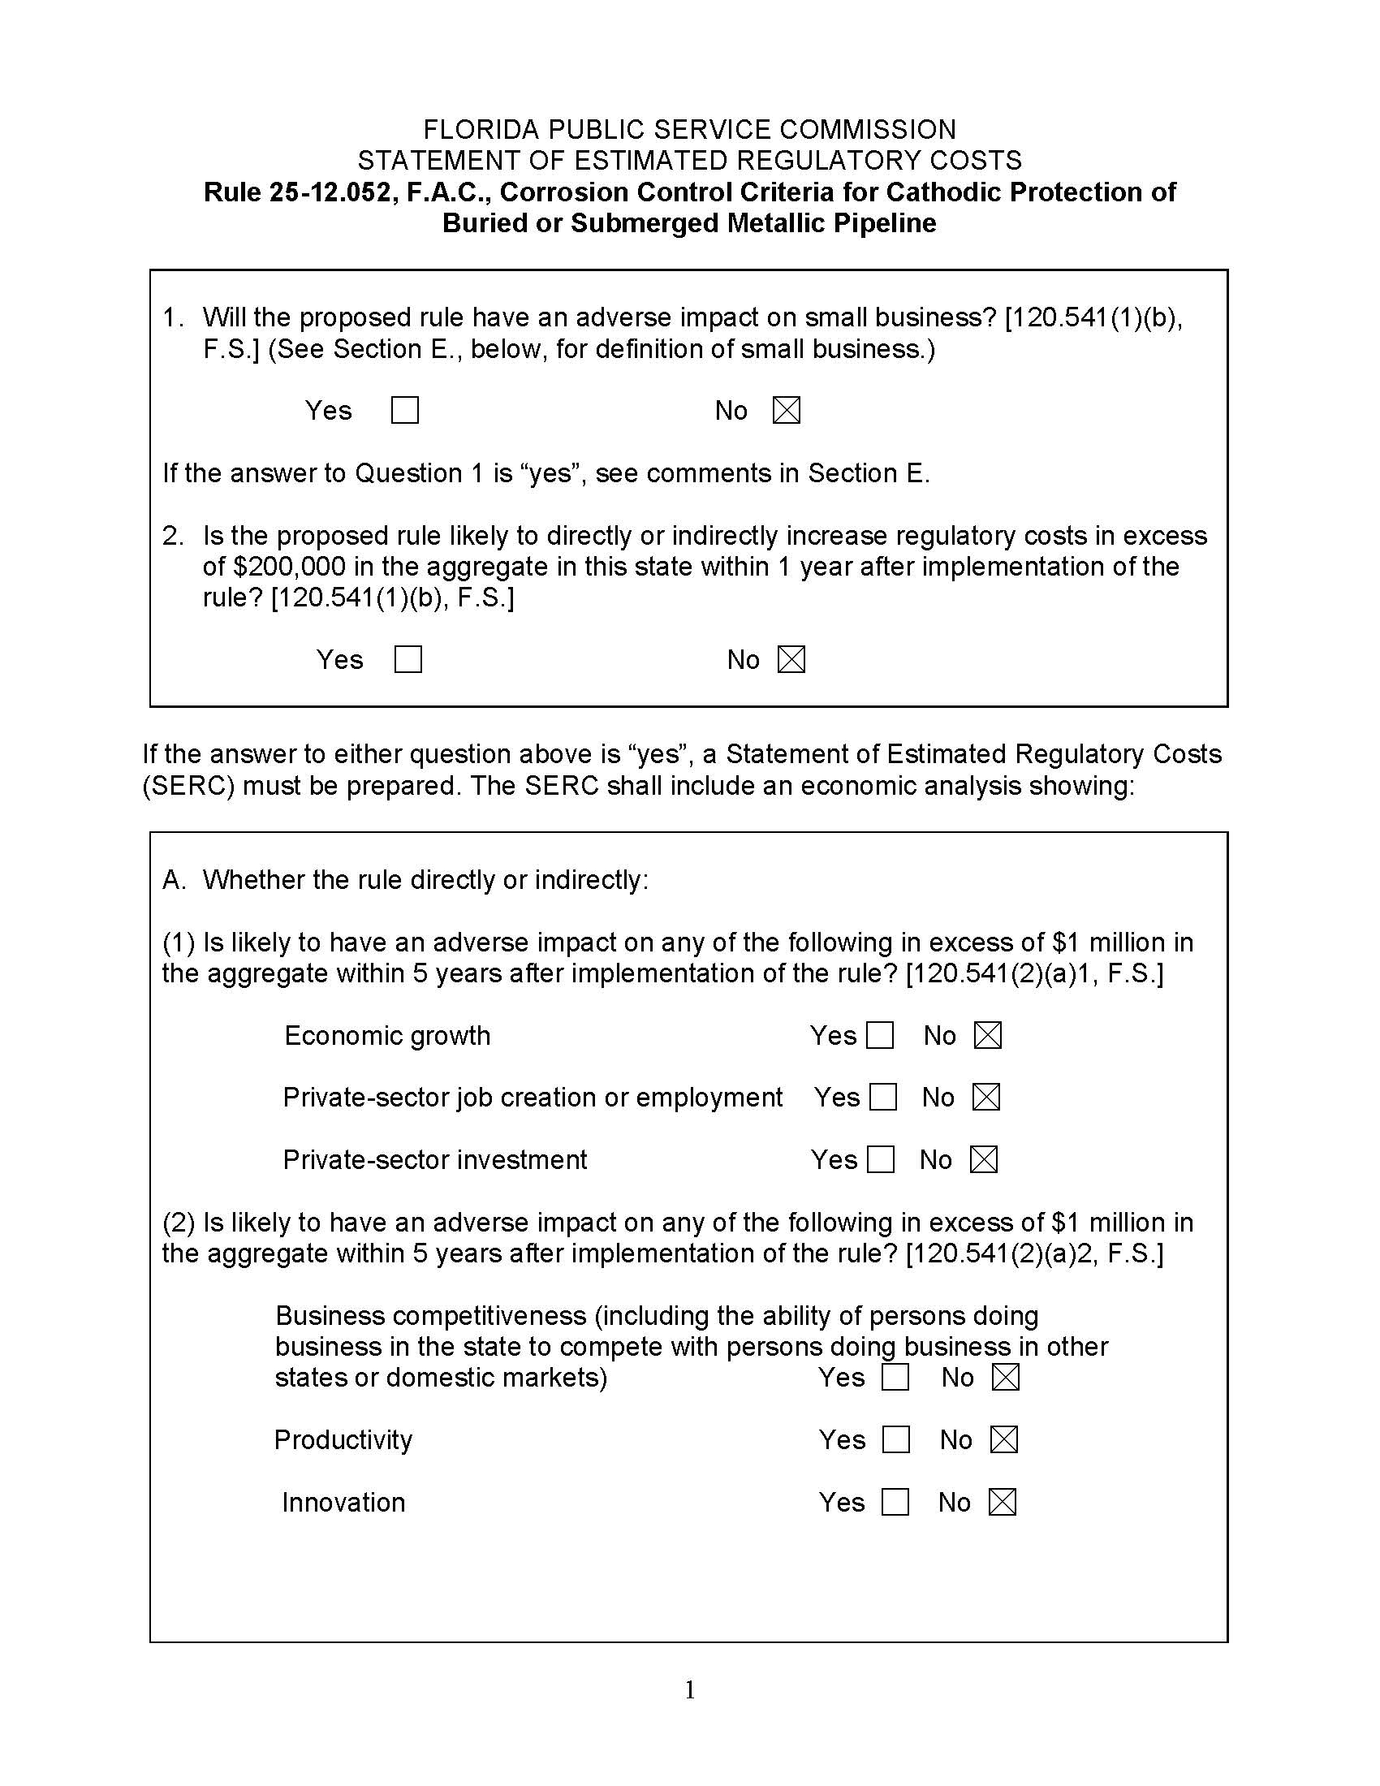
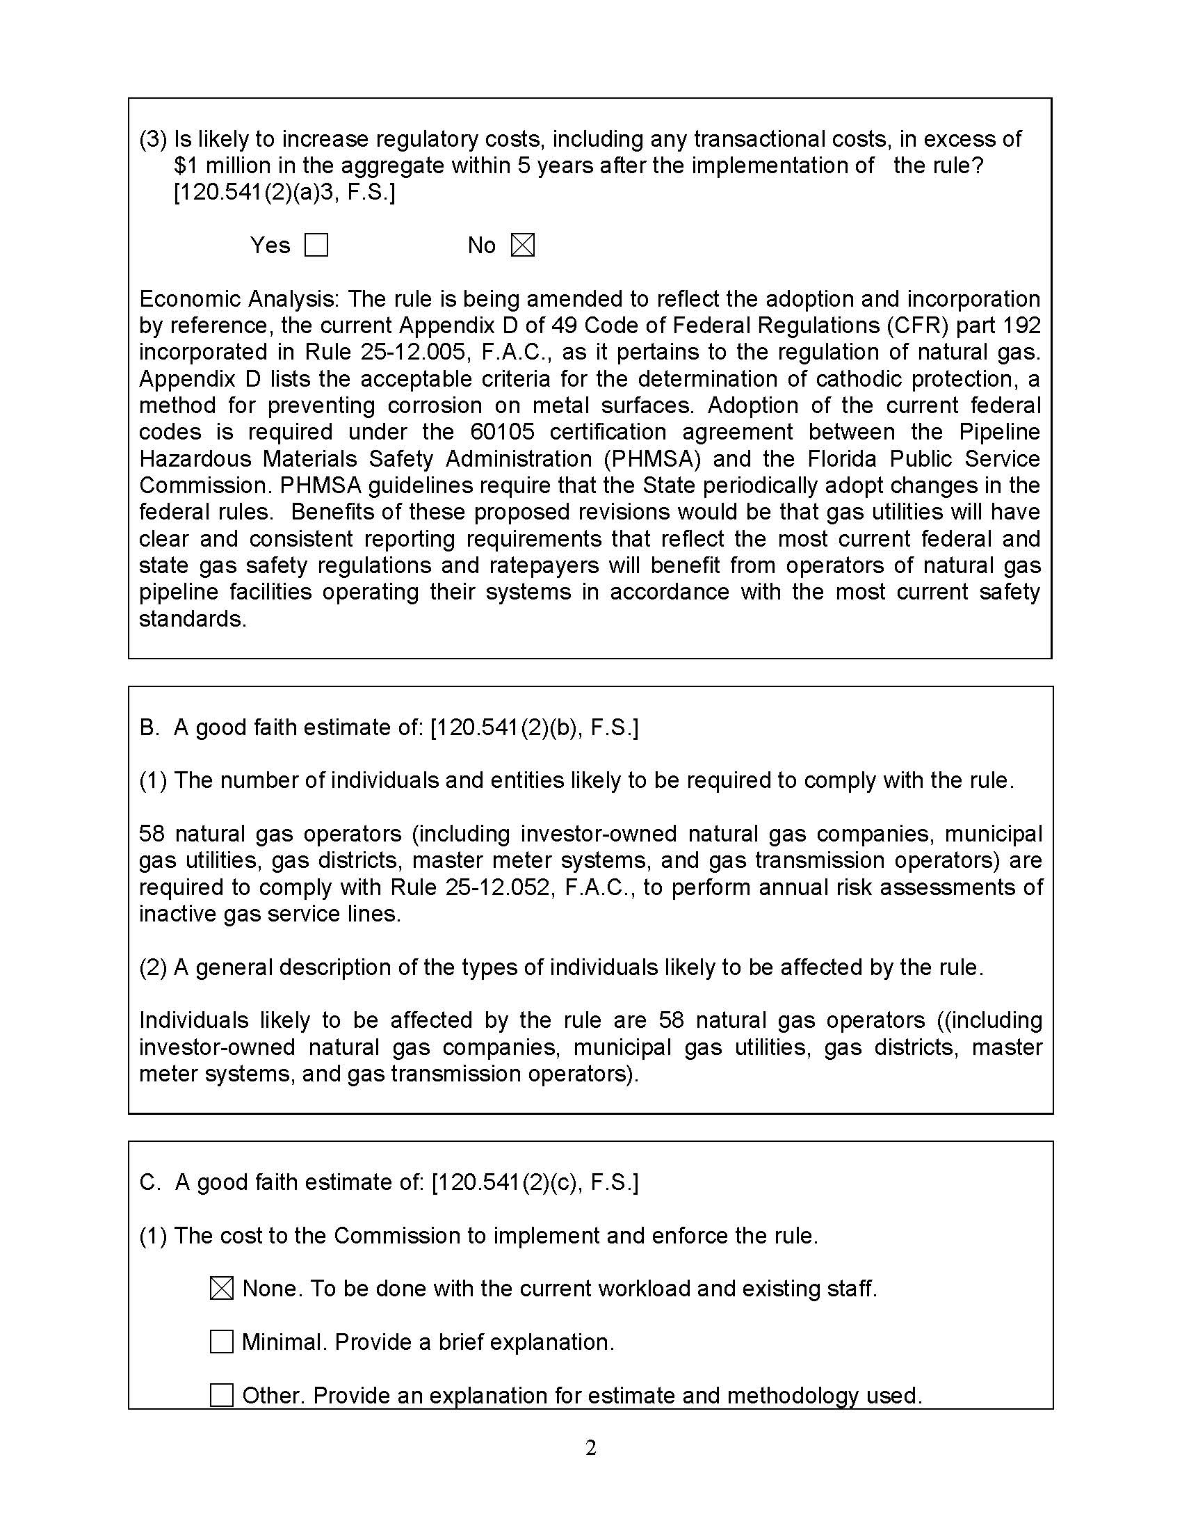
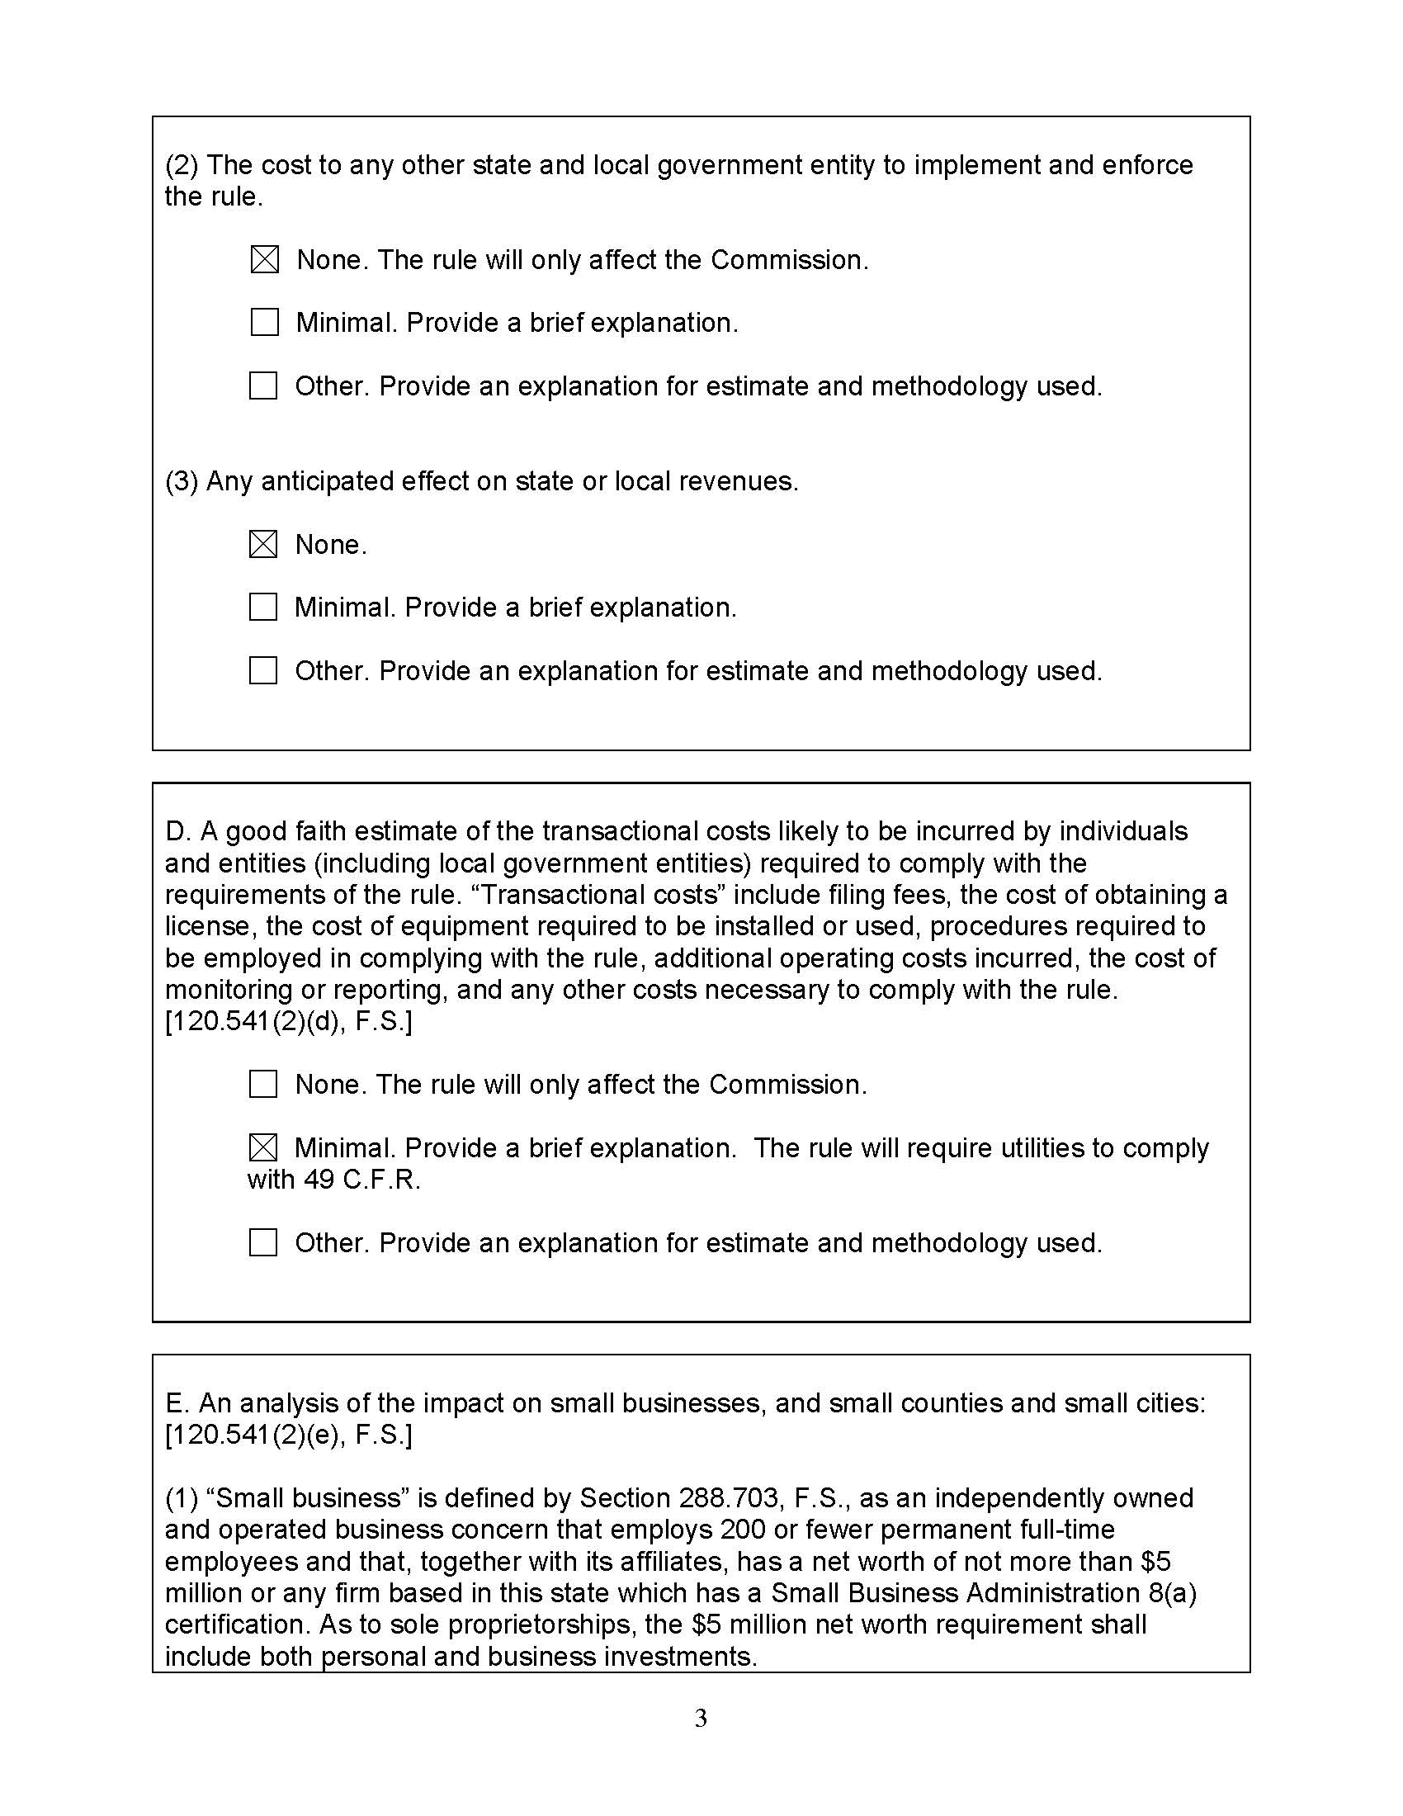
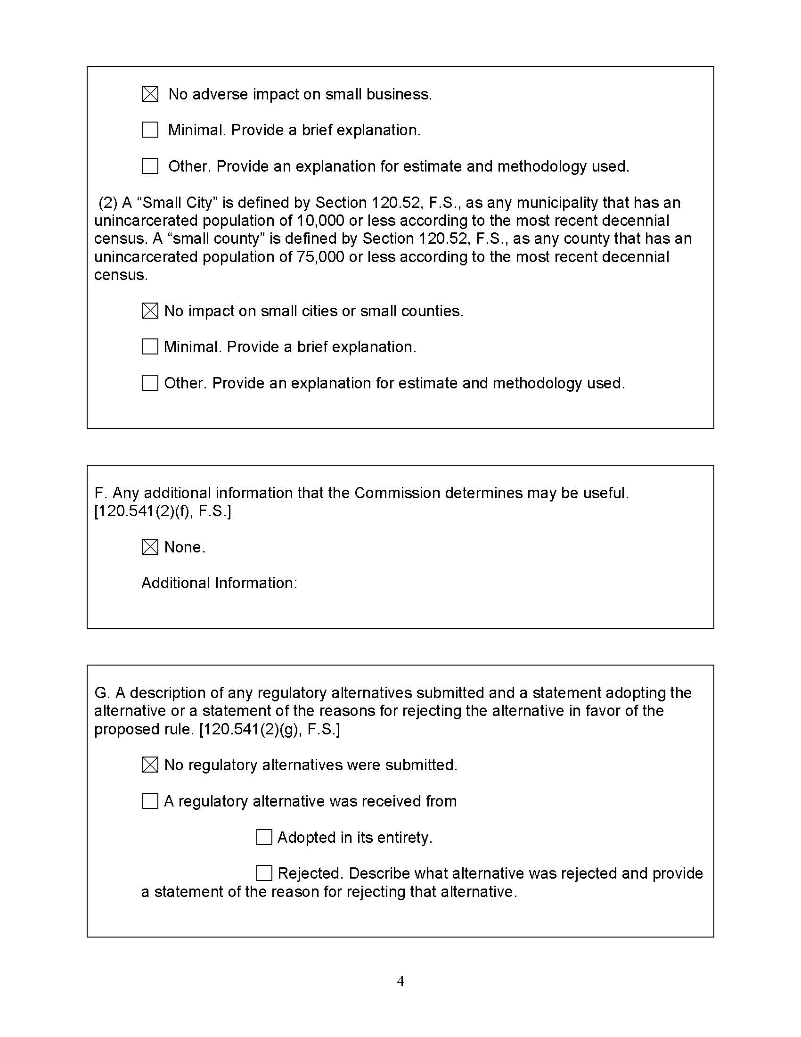
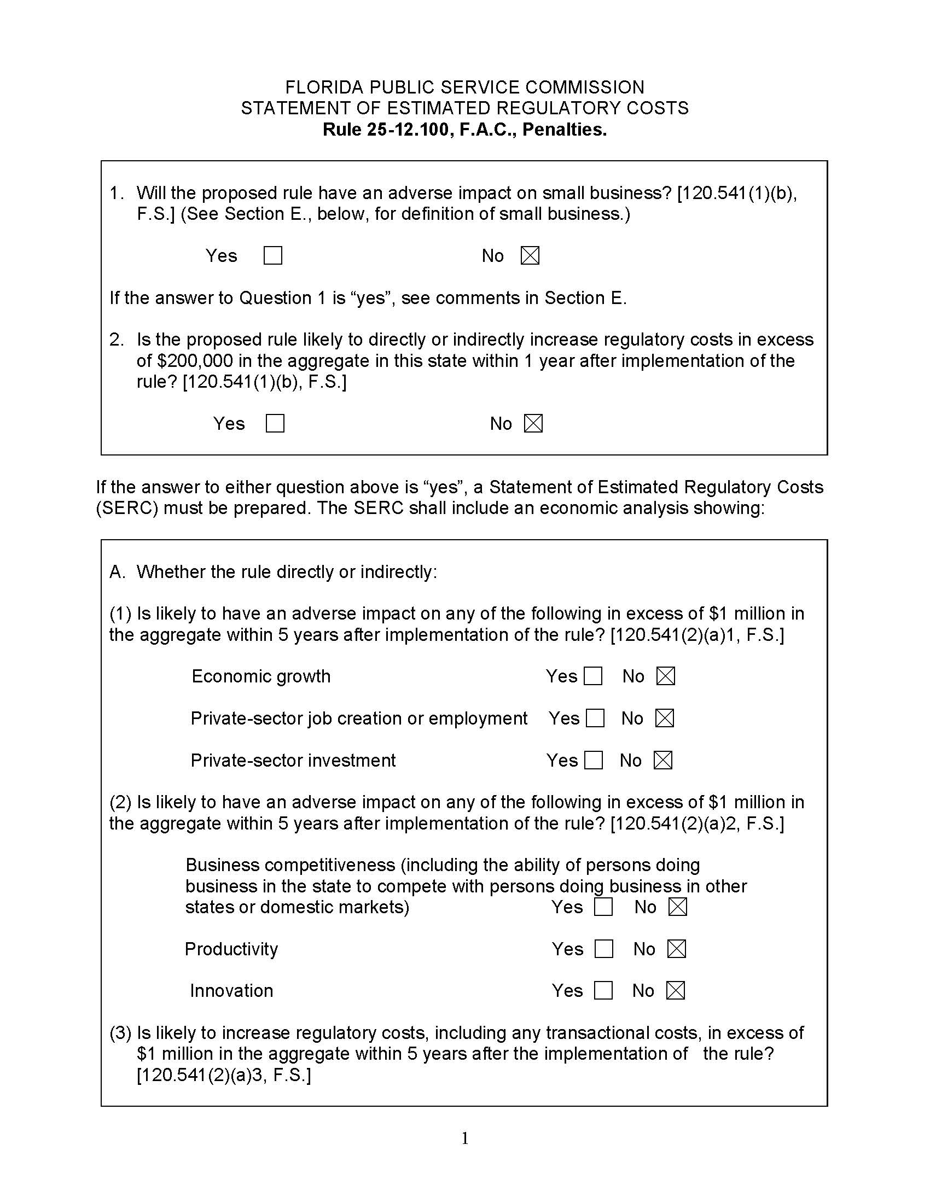
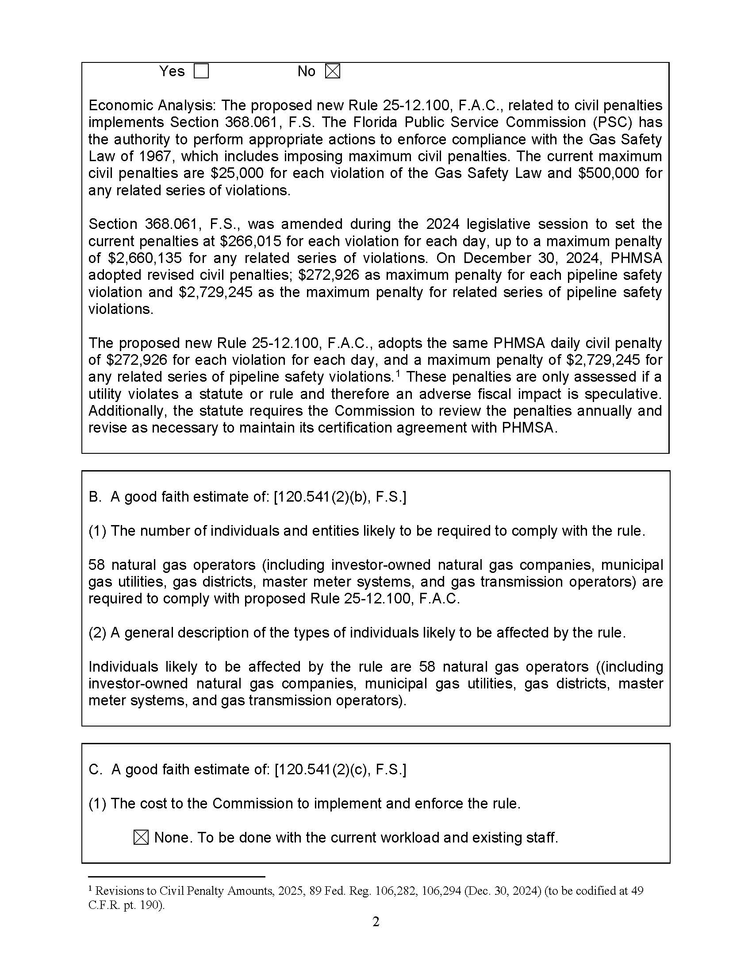
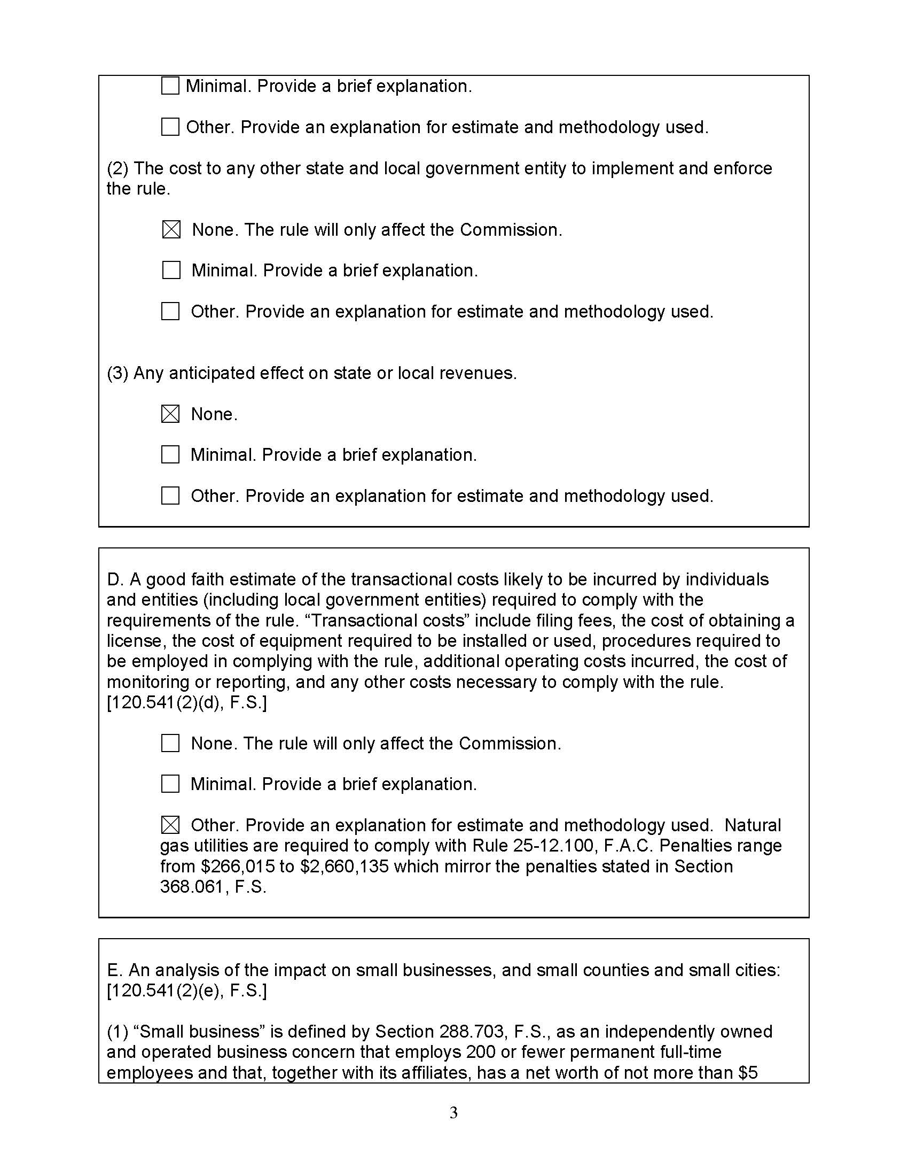
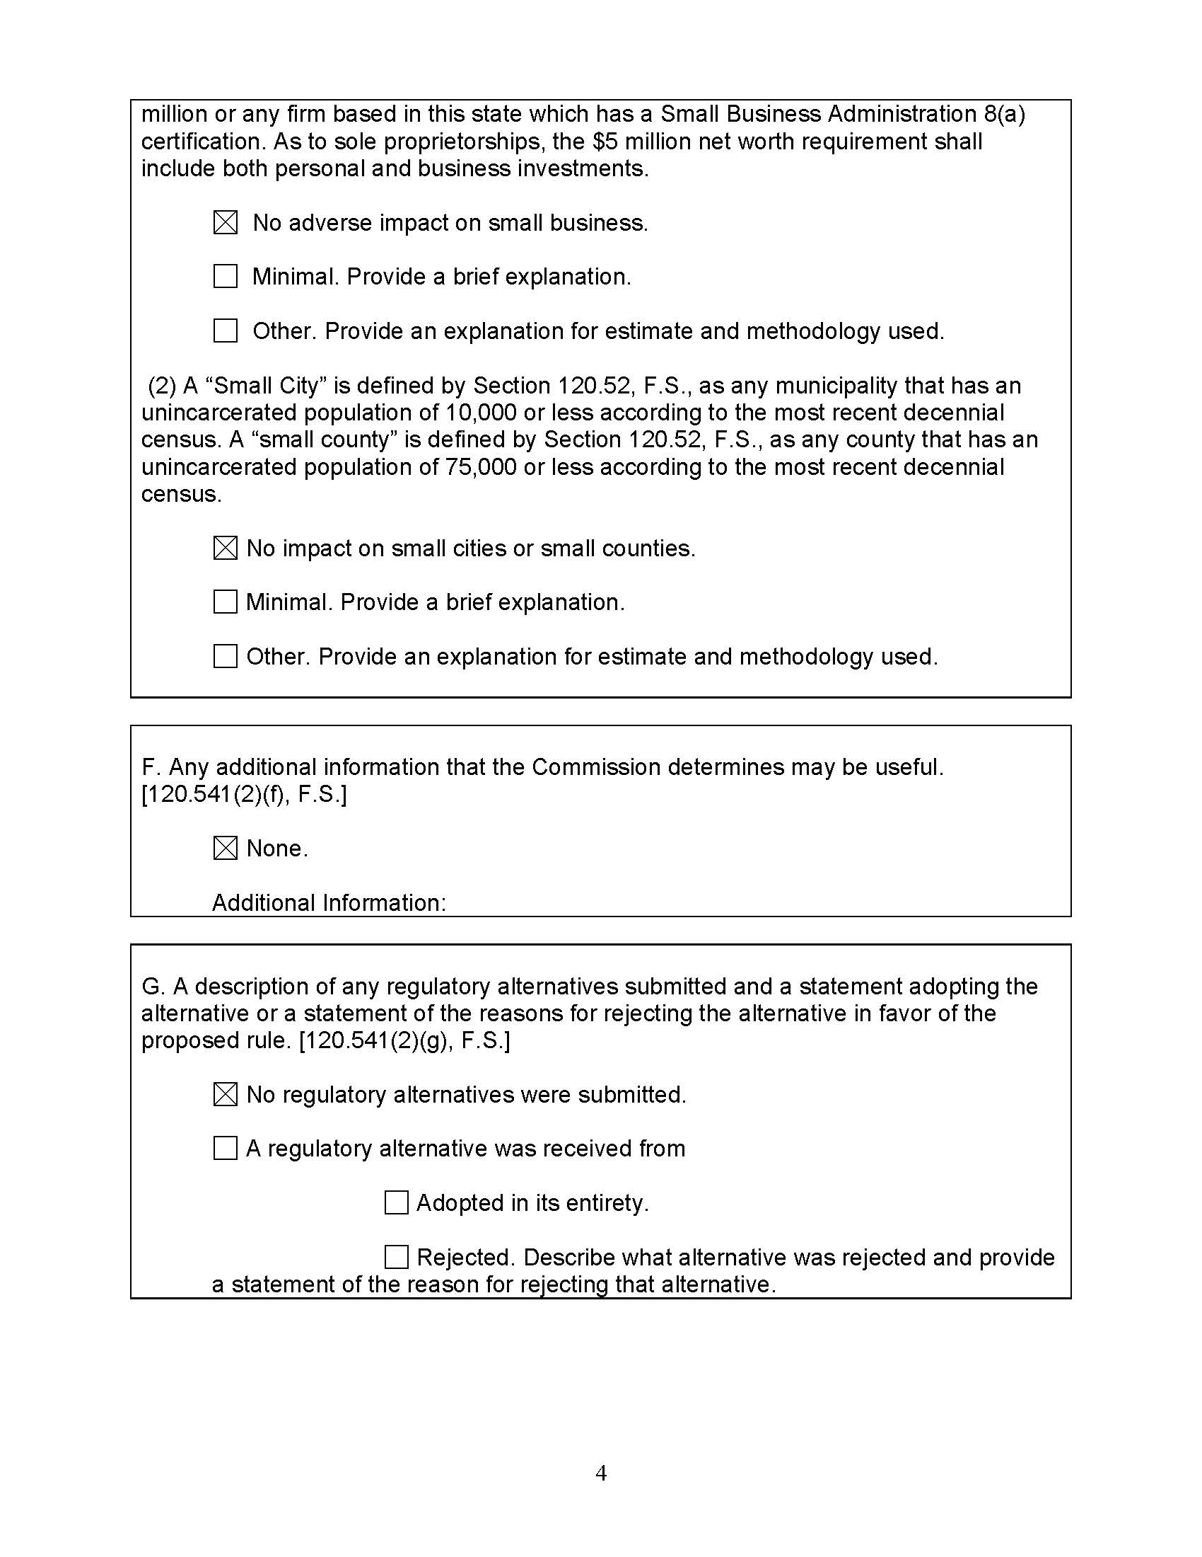

Under 49 United States Code (U.S.C.) § 60105, PHMSA has no regulatory jurisdiction over safety standards and practices of intrastate pipeline facilities and transportation to the extent that a State authority annually certifies that it implements and enforces applicable federal standards through a compliant pipeline safety program.
See, Senate Committee on Fiscal Policy, Bill Analysis and Fiscal Impact Statement for CS/SB 366, p. 5, Feb. 5, 2024, accessible at https://flsenate.gov/Session/Bill/2024/366/Analyses/2024s00366.ri.PDF, (last visited on Jan. 29, 2025).
Ch. 2024-167, section 1, Laws of Fla.
See Senate Committee on Fiscal Policy, Bill Analysis and Fiscal Impact Statement for CS/SB 366, supra note 2 at p. 5; 49 C.F.R. § 190.223.
See Revisions to Civil Penalty Amounts, 2025, 89 Fed. Reg. 106,282, 106,294 (Dec. 30, 2024) (to be codified at 49 C.F.R. pt. 190).
See ch. 2024-167, section 1, Laws of Fla.
Section 368.061(1)(b), F.S.
See the Federal Civil Penalties Inflation Act Improvement Act of 2015, Pub. L. 114-74, § 701 (requiring federal agencies to annually adjust civil monetary penalties for inflation no later than January 15 of each year, notwithstanding Section 553 of the Federal Administrative Procedures Act).
See Federal Reserve Economic Data (FRED), Consumer Price Index for All Urban Consumers: All Items in US City Average, https://fred.stlouisfed.org/series/CPIAUCSL (last accessed on Jan. 30, 2025).
See 49 C.F.R. § 190.223(a).
See Revisions to Civil Penalty Amounts, 2025, 89 Fed. Reg. 106,282, 106,294 (Dec. 30, 2024) (to be codified at 49 C.F.R. pt. 190).
See 49 U.S.C. § 60105(f).
See, Senate Committee on Fiscal Policy, Bill Analysis and Fiscal Impact Statement for CS/SB 366, supra note 2 at p. 5.
Section 120.695(2)(c)3., F.S.

