|  |  |  |  |
| --- | --- | --- | --- |
| State of Florida  pscSEAL | | Public Service Commission  Capital Circle Office Center ● 2540 Shumard Oak Boulevard Tallahassee, Florida 32399-0850  -M-E-M-O-R-A-N-D-U-M- | |
| DATE: | February 20, 2025 | | |
| TO: | Office of Commission Clerk (Teitzman) | | |
| FROM: | Office of the General Counsel (Rubottom) **SMC**  Division of Economics (Guffey) **EJD**  Division of Engineering (Brown) **TB** | | |
| RE: | Docket No. 20250019-EU – Amendment of Rule 25-6.034, F.A.C., Standard of Construction; and Rule 25-6.0345, F.A.C., Safety Standards for Construction of New Transmission and Distribution Facilities. | | |
| AGENDA: | 03/04/25 – Regular Agenda – Rule Proposal - Interested Persons May Participate | | |
| COMMISSIONERS ASSIGNED: | | | All Commissioners |
| PREHEARING OFFICER: | | | Graham |
| RULE STATUS: | | | Proposal May Be Deferred |
| SPECIAL INSTRUCTIONS: | | | None |

Case Background

Rule 25-6.034, Florida Administrative Code (F.A.C.), Standard of Construction, and Rule 25-6.0345, F.A.C., Safety Standards for Construction of New Transmission and Distribution Facilities, pertain to safety standards for the construction, maintenance, and operation of electric transmission and distribution facilities. In particular, the rules require electric utilities to comply with the requirements of the National Electrical Safety Code (NESC) when constructing transmission and distribution systems. The rules implement Sections 366.04(2), (5), and (6), Florida Statutes (F.S.), and Section 366.05(1), F.S.

Section 366.04(2)(c), F.S., sets forth the Commission’s jurisdiction over electric utilities to require electric power conservation and reliability through a coordinated grid. Section 366.04(6), F.S., grants the Commission exclusive jurisdiction to prescribe and enforce safety standards for transmission and distribution facilities of all public electric utilities, cooperatives organized under the Rural Electric Cooperative Law, and electric utilities owned and operated by municipalities. Sections 366.04(6)(b), and 366.05(1)(a), F.S., provide that the Commission shall, at a minimum, review and adopt any new edition of the NESC as the applicable safety standard, and that the Commission may adopt construction standards that exceed the NESC.

Staff initiated rulemaking to amend Rule 25-6.0345, F.A.C., for the purpose of incorporating by reference the updated, 2023 edition of the NESC, which is the most recent version. Staff initiated rulemaking to amend Rule 25-6.034, F.A.C., to clarify that the reference to the applicable NESC is the same version incorporated by reference in Rule 25-6.0345, F.A.C.

A Notice of Development of Rulemaking for these rules was published in the September 16, 2024 edition of the Florida Administrative Register, Volume 50, No. 181. There were no requests for a rule development workshop, and no workshops were held. This recommendation addresses whether the Commission should propose the amendment of Rules 25-6.034 and 25-6.0345, F.A.C. The Commission has jurisdiction pursuant to Sections 120.54, 366.04, 366.05, and 366.06, F.S.

Discussion of Issues

Issue 1:

 Should the Commission propose the amendment of Rule 25-6.034, F.A.C., Standard of Construction, and Rule 25-6.0345, F.A.C., Safety Standards for Construction of New Transmission and Distribution Facilities?

Recommendation:

 Yes. The Commission should propose the amendment of Rules 25-6.034 and 25-6.0345, F.A.C., as set forth in Attachment A. The Commission should also certify that the rules are not rules the violation of which would be a minor violation, pursuant to Section 120.695, F.S. (Brown, Rubottom)

Staff Analysis:

 The Legislature granted the Commission power over electric utilities to prescribe and enforce safety standards for transmission and distribution facilities of all electric utilities, including investor-owned utilities, rural electric cooperatives, and municipally owned utilities.[1] Pursuant to these provisions, the Legislature requires the Commission to, at a minimum, review and adopt new editions of the NESC “for the protection of the public” and “for purposes of ensuring the reliable provision of service, and service rules and regulations to be observed by each utility.”[2]

The NESC is published by the Institute of Electrical and Electronic Engineers, Inc. (IEEE), and “sets the ground rules and guidelines for practical safeguarding of utility workers and the public during the installation, operation, and maintenance of electric supply, communication lines and associated equipment.”[3] The NESC is updated every five years to reflect changes in the industry and technology.[4]

Pursuant to Florida law, the Commission adopts the NESC as the governing safety standard for regulated electric utilities in Rule 25-6.0345, F.A.C., Safety Standards for Construction of New Transmission and Distribution Facilities. The Commission last amended the rule in 2017, adopting the then-current edition of the NESC. A new edition was published by the IEEE in 2023. Staff has reviewed the updated NESC and believes it constitutes “acceptable and adequate requirements for the protection of the safety of the public.”[5] Updates for the 2023 Edition include new rules for photovoltaic (PV) generating stations as well as revisions to better present vertical and horizontal wind clearances and to provide correction factors for clearances on higher elevations. Staff therefore recommends that the Commission propose the amendment of Rule 25-6.0345, F.A.C., as set forth in Attachment A to incorporate by reference into the rule the updated, 2023 edition of the NESC.

Rule 25-6.034, F.A.C., Standard of Construction, requires electric utilities to comply with the NESC in order to promote “continuity of service and uniformity in the quality of service furnished.” That rule refers to the NESC incorporated by reference in Rule 25-6.0345, F.A.C. The purpose of staff’s recommended amendments is to clarify the reference to Rule 25-6.0345, F.A.C., to ensure that the same edition of the NESC governs in both rules and for all utility facilities. Paragraphs (2)(a) and (b) were eliminated since “new” construction is already addressed in the revised rule, and the question of which NESC edition applies to existing facilities is discussed in subsection 013.B of the NESC. Staff therefore recommends that the Commission propose the amendment of Rule 25-6.034, F.A.C., as set forth in Attachment A.

Minor Violation Rules Certification

Pursuant to Section 120.695, F.S., for each rule filed for adoption, the agency head shall certify whether any part of the rule is designated as a rule the violation of which would be a minor violation.[6] Rules 25-6.034 and 25-6.0345, F.A.C., are not on the Commission’s minor violation rule list because violation of the rules would result in physical harm to a person; adverse effects on the public health, safety, or welfare; or would create a significant threat of such harm. Thus, if the Commission proposes the amendment of the rules, staff recommends that the Commission certify that each rule is not a rule the violation of which would be a minor violation pursuant to Section 120.695, F.S.

Statements of Estimated Regulatory Cost

Pursuant to Section 120.54, F.S., agencies are encouraged to prepare a statement of estimated regulatory costs (SERC) before the adoption, amendment, or repeal of any rule. Agencies are required to prepare a SERC for any rule that will have an adverse impact on small business or that is likely to directly or indirectly increase regulatory costs in excess of $200,000 in the aggregate within one year after implementation. The SERC analysis includes whether the rule will, within five years of implementation, have an adverse impact in excess of $1 million in the aggregate on economic factors such as economic growth, private sector job creation or employment, private sector investments, or business competitiveness, productivity, or innovation. If expected adverse impacts or regulatory costs exceed any of the above criteria, a proposed rule may not take effect until it is ratified by the Legislature.

SERCs were prepared for each rule and are appended hereto as Attachment B. Each SERC concludes that the rule will not have an adverse impact on small business and that the rules are not likely to directly or indirectly increase regulatory costs in excess of $200,000 in the aggregate within one year after implementation. Further, the SERCs conclude that the rules will not likely have an adverse impact on economic growth, private sector job creation or employment, private sector investment, or business competitiveness, productivity, or innovation in excess of $1 million in the aggregate within five years of implementation. None of the adverse impact or regulatory cost criteria set forth in Section 120.541(2)(a), F.S., will be exceeded as a result of the recommended amendments to the rules. Thus, the rules do not require legislative ratification pursuant to Section 120.541(3), F.S. In addition, the SERCs state that the rules will have no impact on small cities or counties and will not increase the cost to the Commission to implement and enforce the rule. No regulatory alternatives have been submitted pursuant to Section 120.541(1)(a), F.S.

Conclusion

Based on the foregoing, staff recommends the Commission should propose the amendment of Rules 25-6.034 and 25-6.0345, F.A.C., as set forth in Attachment A. The Commission should also certify that each rule is not a rule the violation of which would be a minor violation pursuant to Section 120.695, F.S.

Issue 2:

 Should this docket be closed?

Recommendation:

 Yes. If no requests for hearing or JAPC comments are filed, and no proposal for a lower cost regulatory alternative is submitted, the rules may be filed with the Department of State for adoption, and the docket should be closed. (Rubottom)

Staff Analysis:

 If no requests for hearing or JAPC comments are filed, and no proposal for a lower cost regulatory alternative is submitted pursuant to Section 120.541(1)(a), F.S., the rules may be filed with the Department of State for adoption, and the docket should be closed.

**25-6.034 Standard of Construction.**

(1) The facilities of each utility shall be constructed, installed, maintained and operated in accordance with generally accepted engineering practices to assure, as far as is reasonably possible, continuity of service and uniformity in the quality of service furnished.

(2) For new construction, e~~E~~ach utility shall, at a minimum, comply with the National Electrical Safety Code (NESC) ~~[ANSI C-2] [NESC]~~, incorporated by reference in Rule 25-6.0345, F.A.C.

~~(a) For facilities constructed on or after February 1, 2007, the 2007 NESC shall apply. A copy of the 2007 NESC, ISBN number 0-7381-4893-8, may be obtained from the Institute of Electric and Electronic Engineers, Inc. (IEEE), 3 Park Avenue, New York, NY, 10016-5997.~~

~~(b) Facilities constructed prior to February 1, 2007, shall be governed by the edition of the NESC specified by subsections 013.B.1, 013.B.2, and 013.B.3 of the 2007 NESC, incorporated by reference in Rule 25-6.0345, F.A.C.~~

*Rulemaking Authority 350.127(2), 366.05(1) FS. Law Implemented 366.04(2)(c), (f), (5), 366.05(1) FS. History–New 7-29-69, Amended 12-20-82, Formerly 25-6.34, Amended 2-1-07, .*

**25-6.0345 Safety Standards for Construction of New Transmission and Distribution Facilities.**

The safety standards prescribed by the ~~Commission adopts and incorporates by reference the~~ 2023 ~~2017~~ National Electrical Safety Code (NESC) C2-2023 ~~C2-2017~~, is adopted and incorporated by reference into this rule as the applicable safety standards for transmission and distribution facilities subject to the Commission’s ~~safety~~ jurisdiction. Each investor-owned electric utility, rural electric cooperative, and municipal electric system shall, at a minimum, comply with the standards in these provisions. The 2023 ~~2017~~ National Electrical Safety Code (NESC) C2-2023 ~~C2-2017~~ is copyrighted and may be inspected and examined at no cost at the Florida Public Service Commission, 2540 Shumard Oak Boulevard, Tallahassee, Florida 32399-0850. A copy of the NESC C2-2023 ~~C2-2017~~ may also be obtained from the Institute of Electric and Electronic Engineers, Inc. (IEEE), 3 Park Avenue, New York, NY 10016-5997.

*Rulemaking Authority 350.127(2), 366.05(1) FS. Law Implemented 366.04(2), (6) FS. History–New 8-13-87, Amended 2-18-90, 11-10-93, 8-17-97, 7-16-02, 2-1-07, 12-16-12, 7-27-17, .*

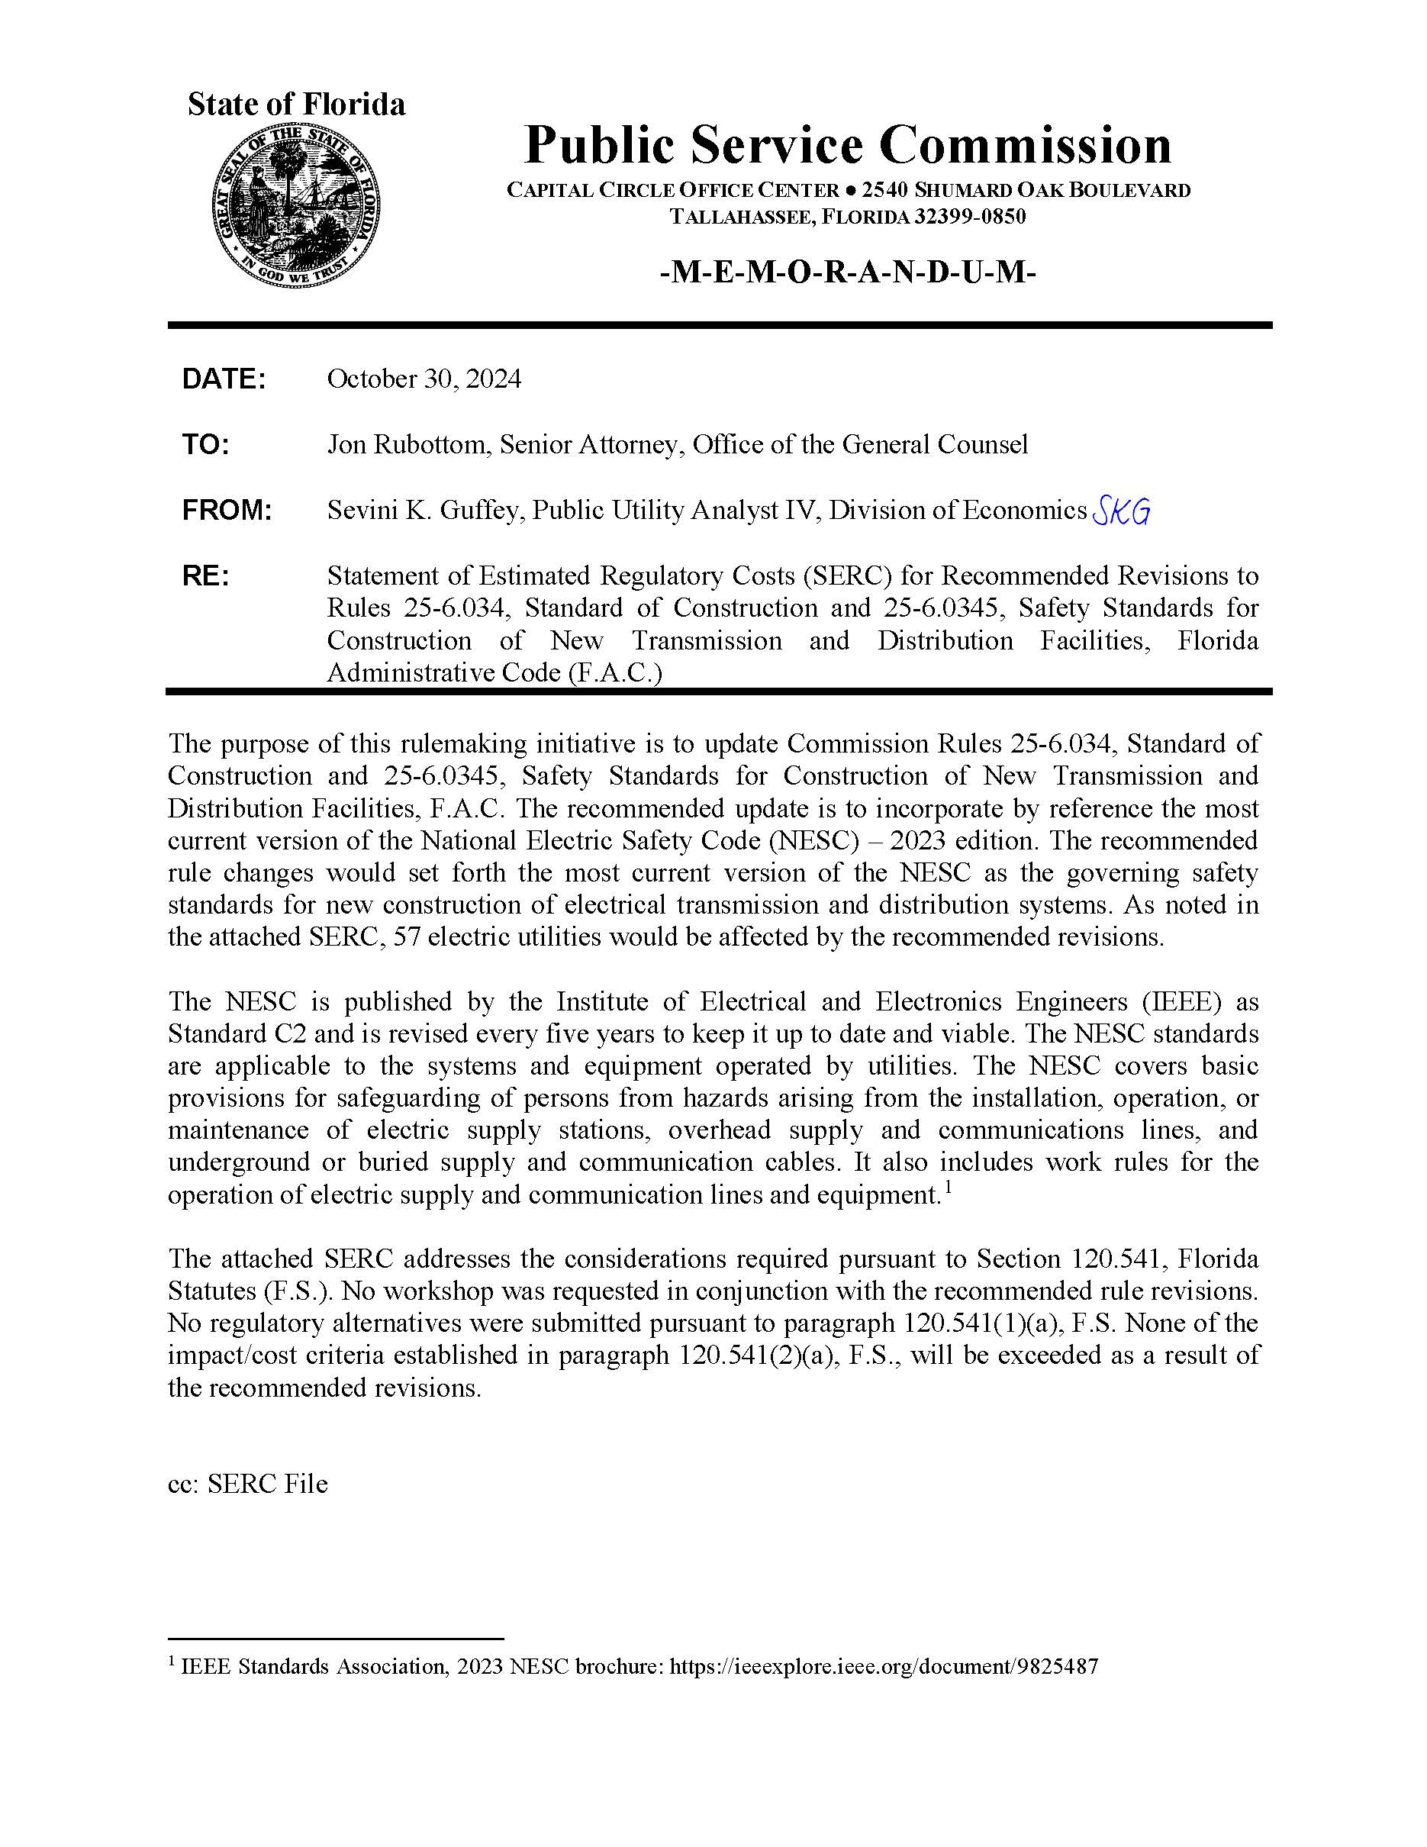

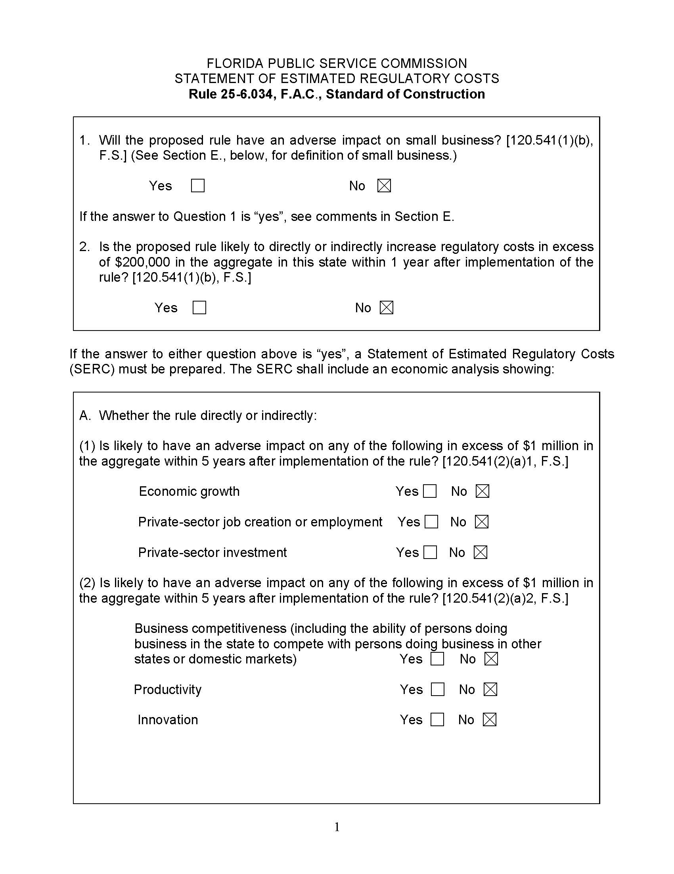

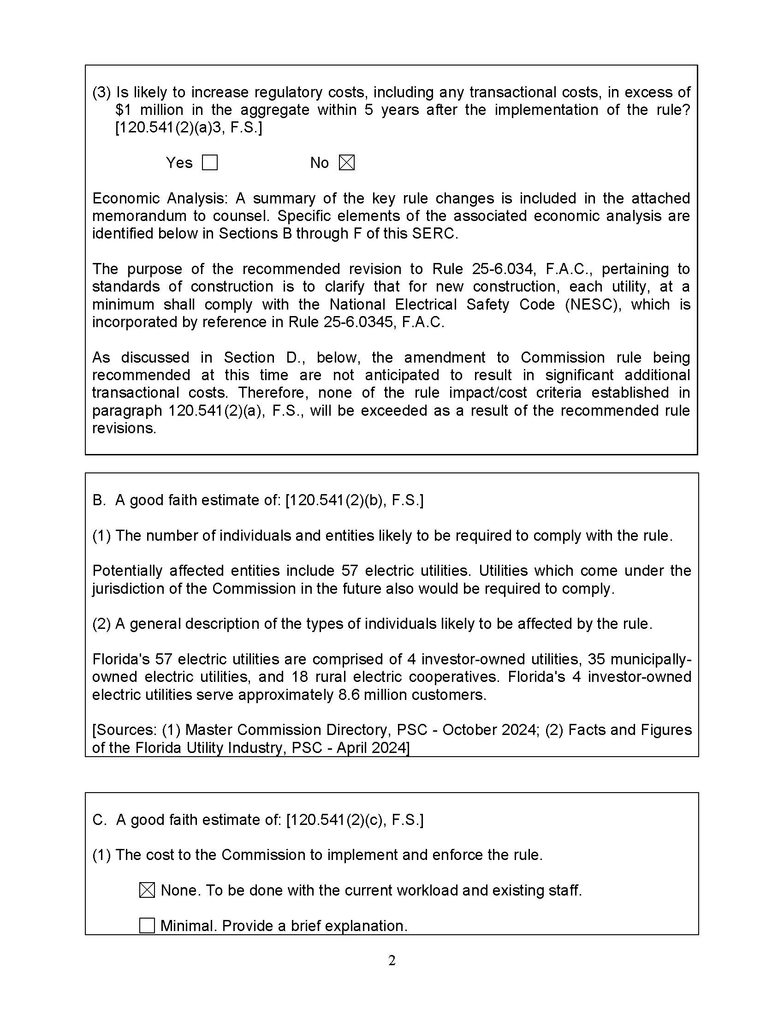

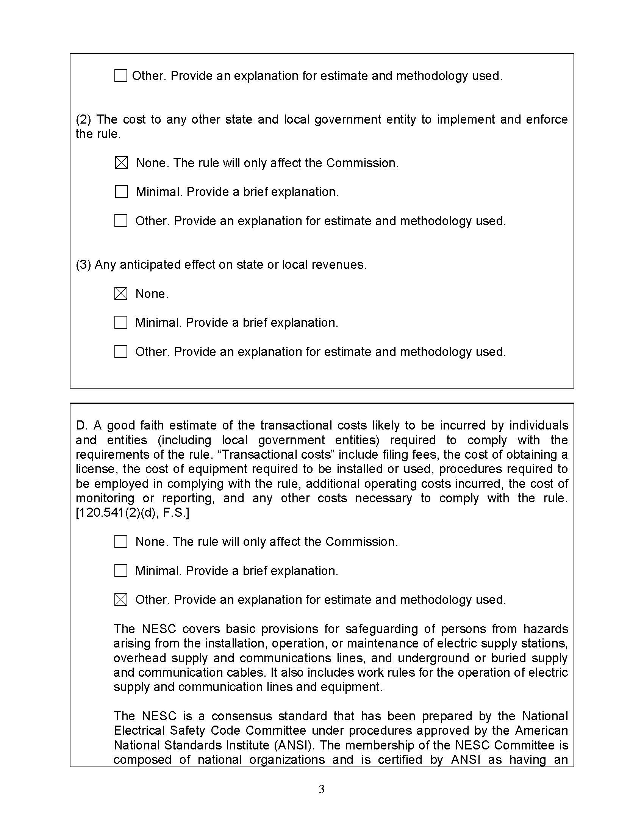

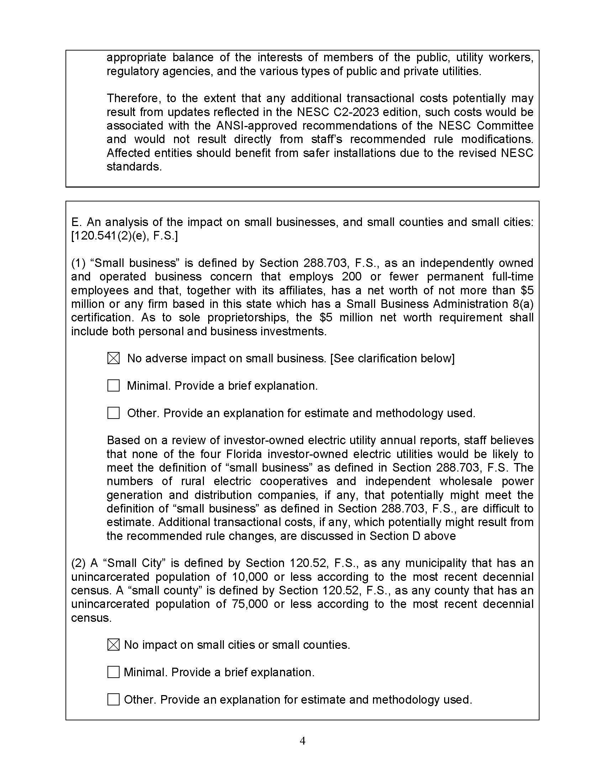

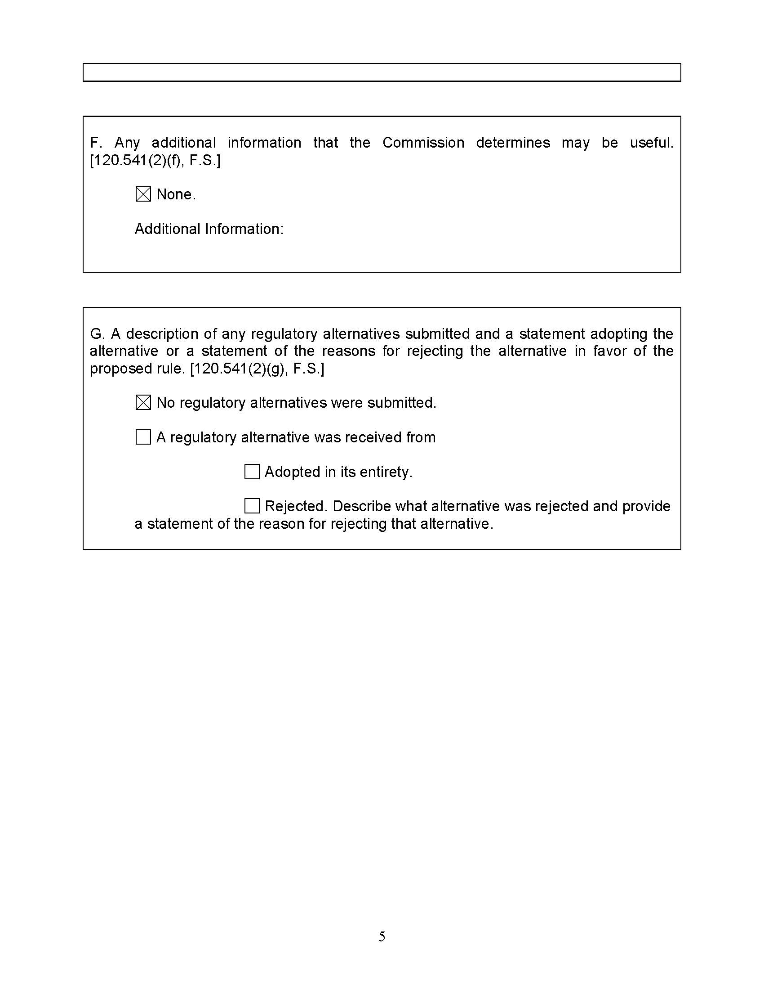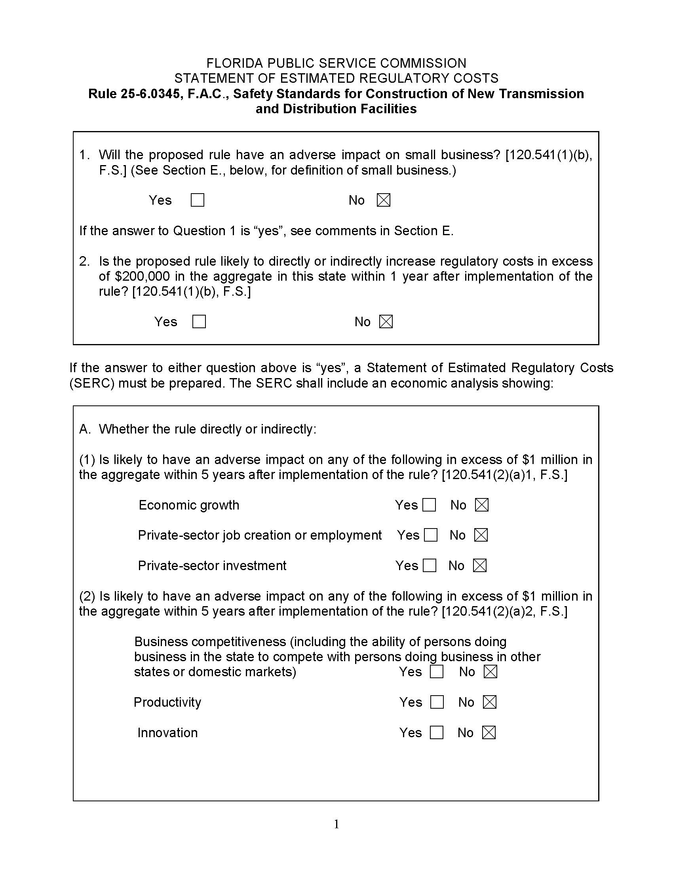

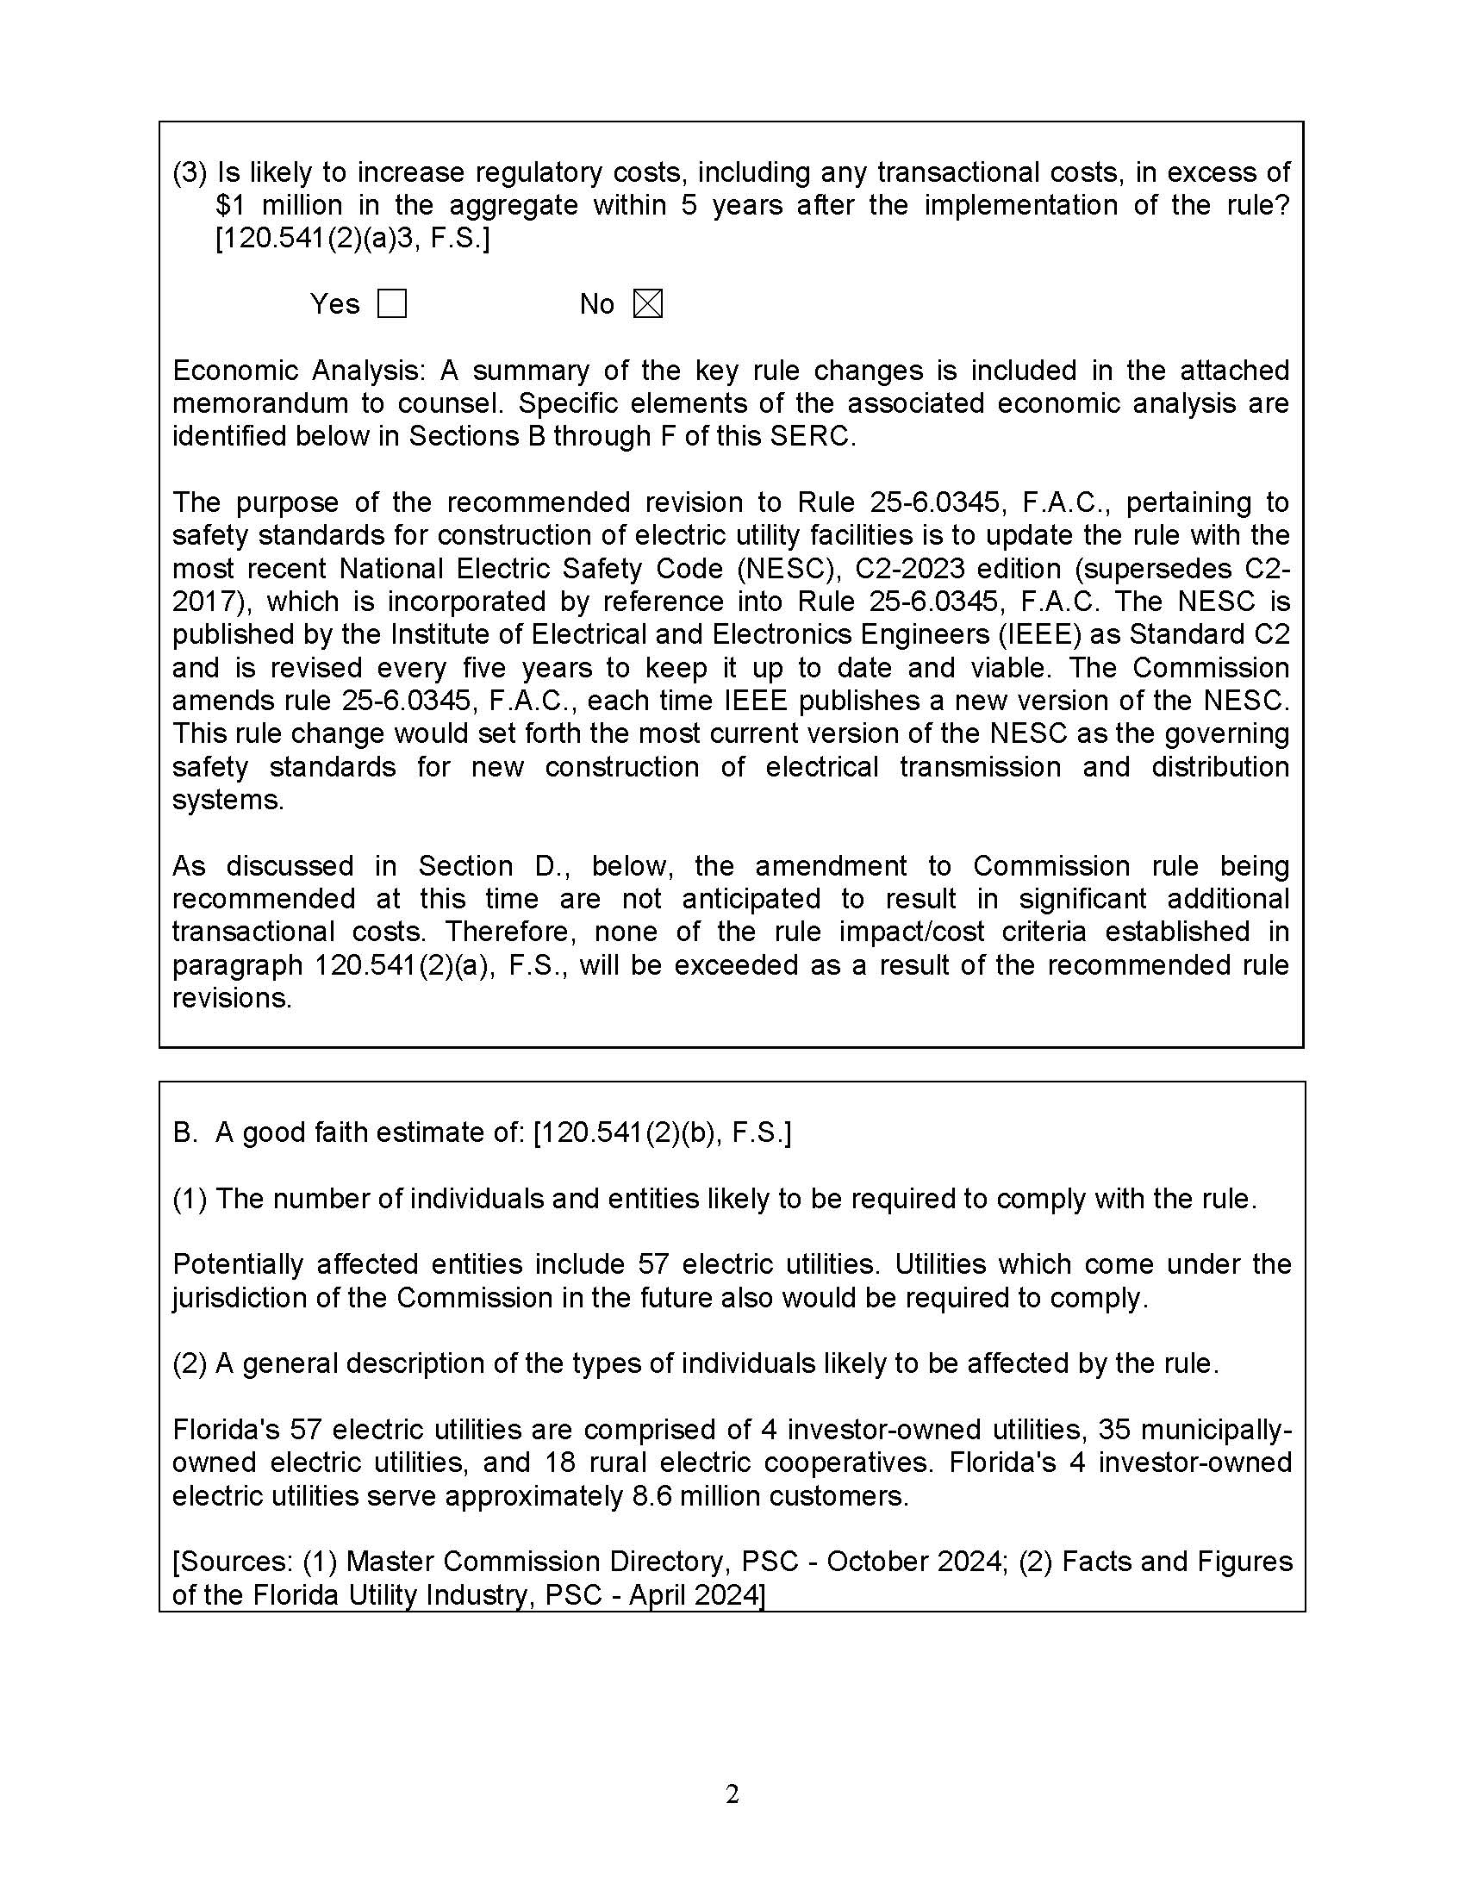

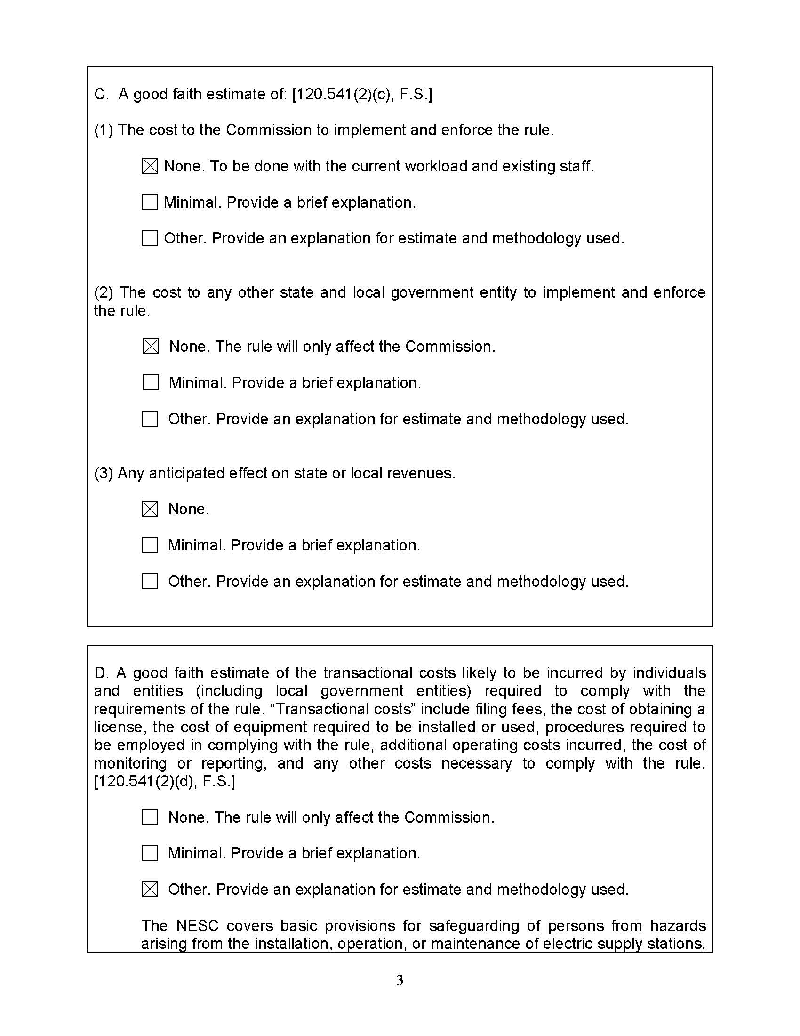

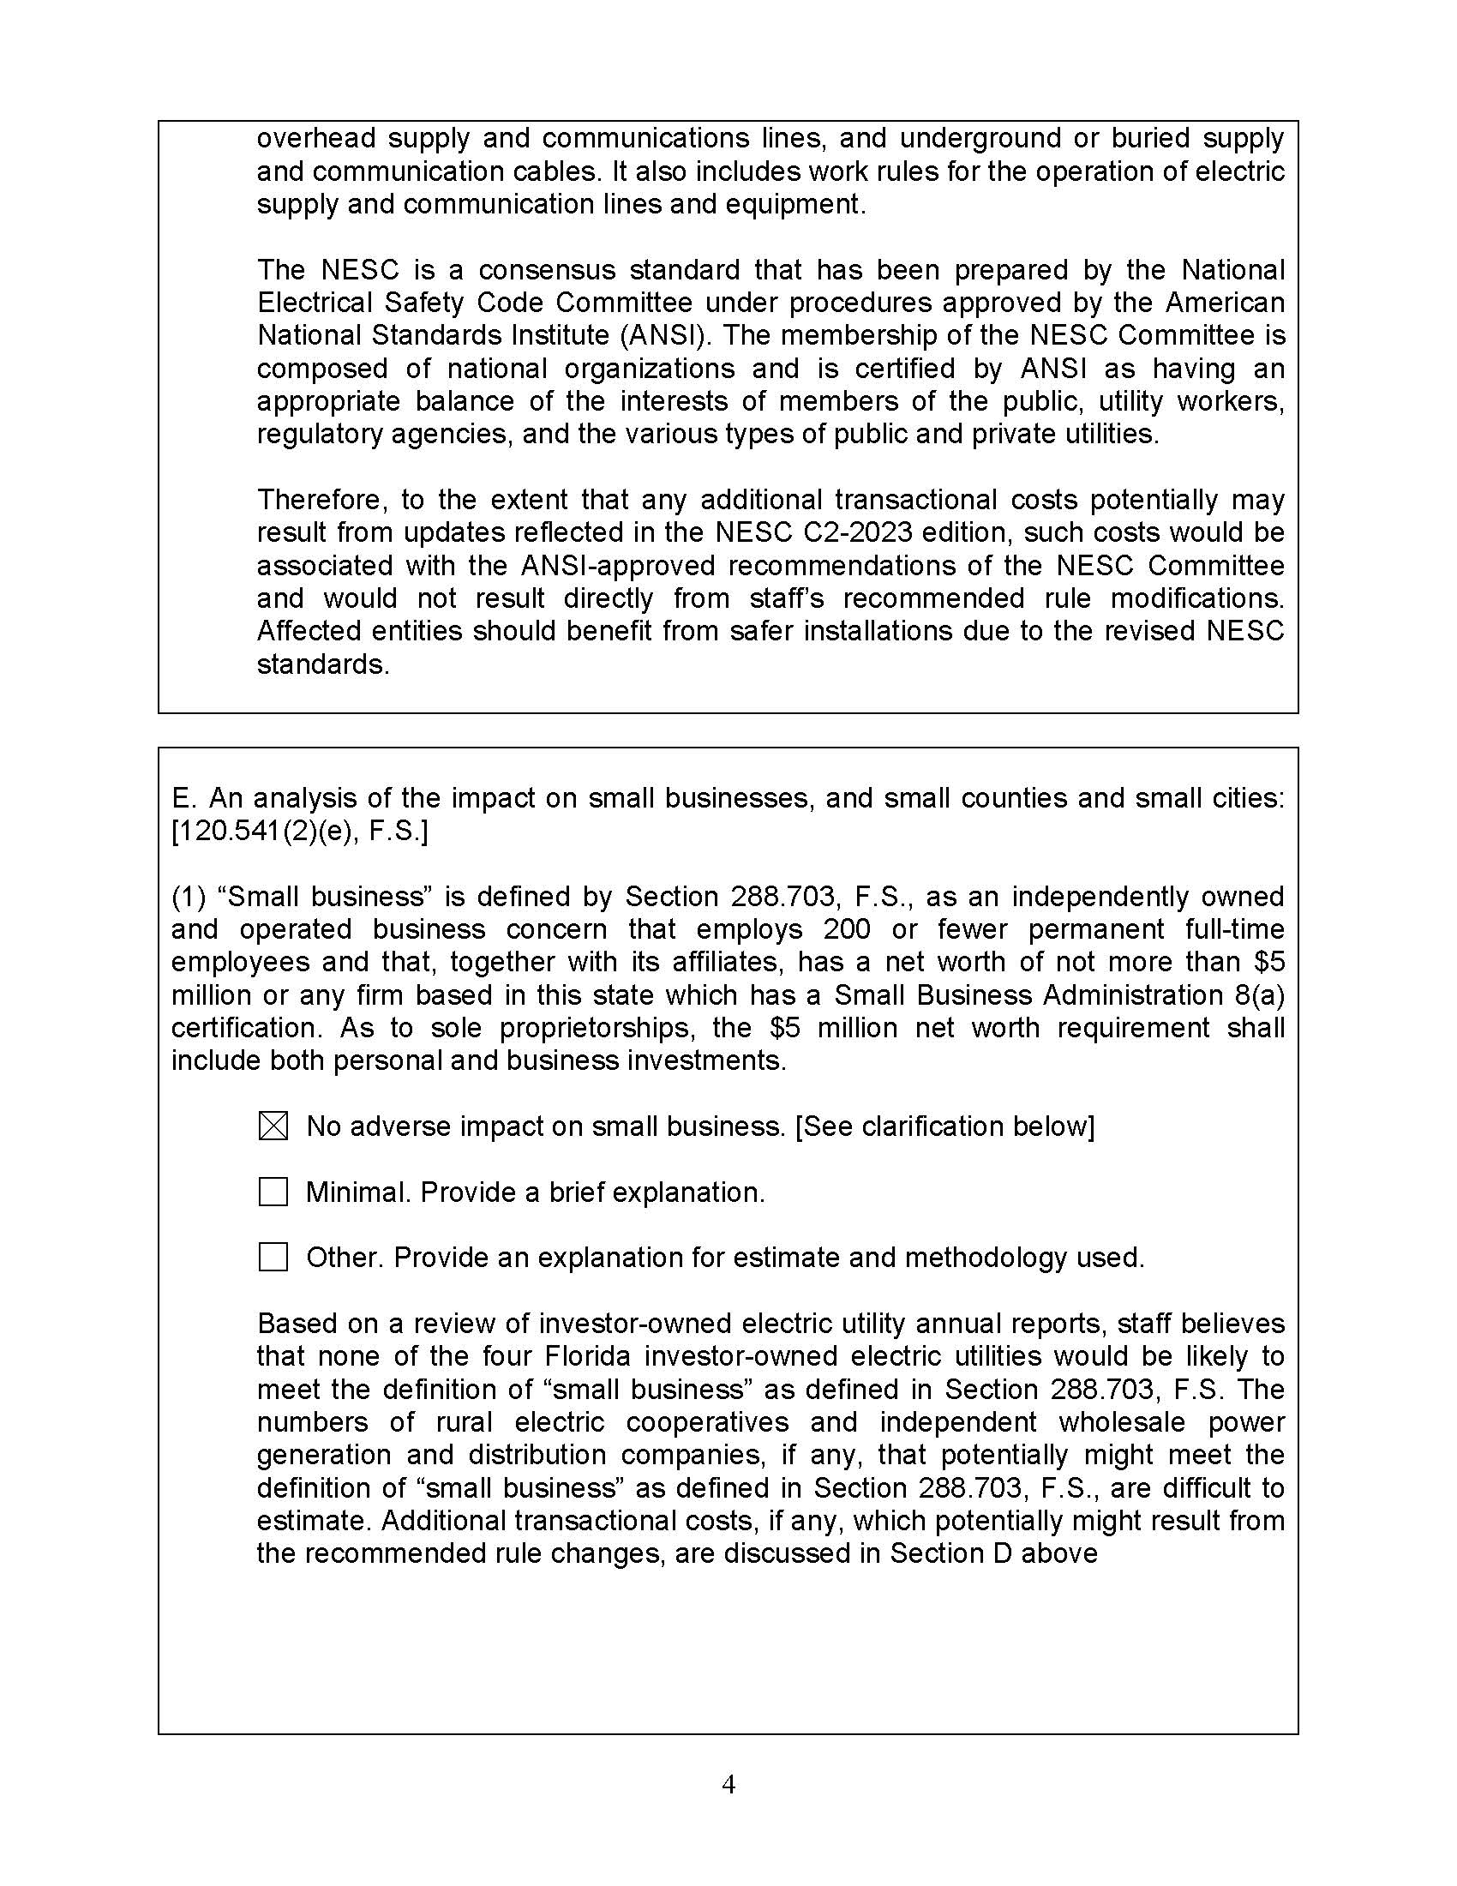

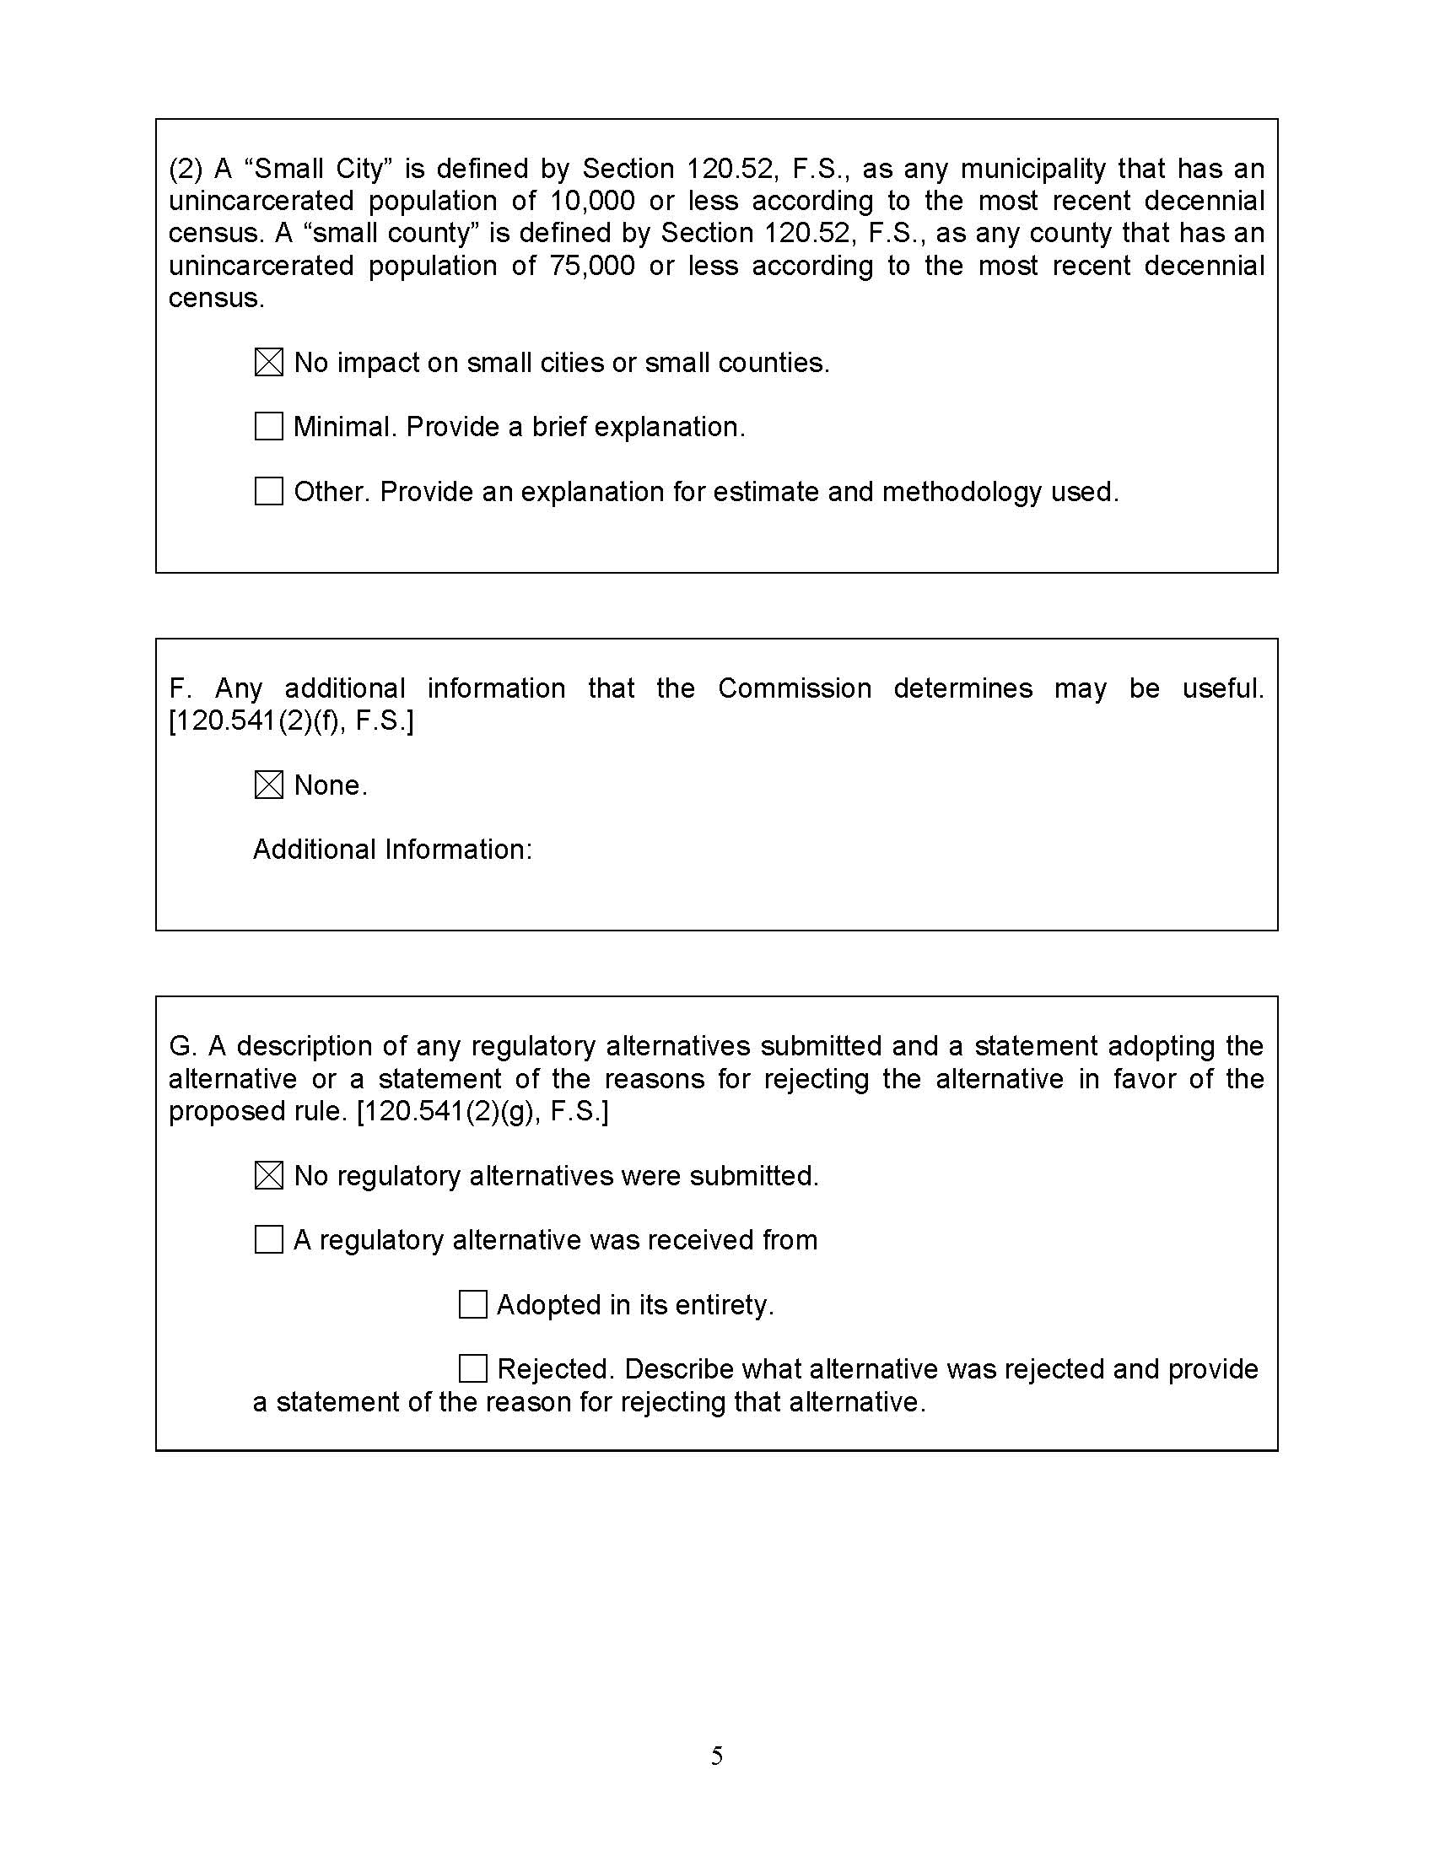

1. Section 366.06(6), F.S.
2. *Id.*; Section 366.05(1)(a), F.S.
3. IEEE, *The NESC*, https://standards.ieee.org/products-programs/nesc/ (last visited Jan. 21, 2025).
4. *Id.*
5. Section 366.06(6), F.S.
6. Section 120.695(2)(c)3., F.S.