|  |  |  |  |
| --- | --- | --- | --- |
| State of Florida  pscSEAL | | Public Service Commission  Capital Circle Office Center ● 2540 Shumard Oak Boulevard Tallahassee, Florida 32399-0850  -M-E-M-O-R-A-N-D-U-M- | |
| DATE: | February 20, 2025 | | |
| TO: | Office of Commission Clerk (Teitzman) | | |
| FROM: | Office of the General Counsel (Sapoznikoff) **SMC**  Division of Economics (Guffey) **ECO**  Office of Industry Development and Market Analysis (Hinton) **CH** | | |
| RE: | Docket No. 20250020-GU – Adoption of new Rule 25-7.150, F.A.C., Natural Gas Facilities Relocation Cost Recovery Clause. | | |
| AGENDA: | 03/04/25 – Regular Agenda – Rule Proposal – Interested Persons May Participate | | |
| COMMISSIONERS ASSIGNED: | | | All Commissioners |
| PREHEARING OFFICER: | | | Graham |
| RULE STATUS: | | | Proposal May Not Be Deferred. |
| CRITICAL DATES: | | | 04/01/25 – Rule must be proposed by this date pursuant to Section 120.74(5), F.S. |
| SPECIAL INSTRUCTIONS: | | | None |

Case Background

In 2024, the Florida Legislature passed HB 1645 that enacted, in part, Section 366.99, Florida Statutes (F.S.), entitled “Natural gas facilities relocation costs.” The statute permits a public utility[1] that supplies gas to seek approval from the Commission to recover natural gas facilities relocation costs. Section 366.99(3), F.S., requires the Commission to conduct an annual proceeding to determine allowable costs (reasonable projected costs and prudently incurred actual costs), which may be recovered through a charge separate and apart from base rates. Section 366.99(6), F.S., requires the Commission to adopt rules to implement the statute. For ease of reference, a copy of Section 366.99, F.S., is appended to this recommendation as Attachment C.

Section 366.99(1)(d), F.S., defines “natural gas facilities relocation costs” as:

the costs to relocate or reconstruct facilities as required by a mandate, a statute, a law, an ordinance, or an agreement between the utility and an authority, including, but not limited to, costs associated with reviewing plans provided by an authority. The term does not include any costs recovered through the public utility’s base rates.

Section 366.99(1)(a), F.S., defines “authority” by reference to Section 337.401(1)(a), F.S., which definition includes the Florida Department of Transportation (FDOT) and other governmental entities that have jurisdiction over and control of public roads.

Section 366.99(3), F.S., limits the Commission’s review to the prudence of costs already incurred and the reasonableness of projected costs, and does not provide for review of the prudence or reasonableness of the relocation projects.

Procedural Matters

In furtherance of the Legislature’s directive in Section 366.99, F.S., staff initiated rulemaking to adopt new Rule 25-7.150, Florida Administrative Code (F.A.C.), “Natural Gas Facilities Relocation Cost Recovery Clause” (NGFRCRC). The Commission’s Notice of Development of Rulemaking was published in Volume 50, Number 212, of the Florida Administrative Register on October 29, 2024.

Staff held a rule development workshop on December 16, 2024, to obtain stakeholder comments on the draft rule. Representatives of Peoples Gas System, Inc. (PGS), Florida City Gas (FCG), Florida Public Utilities Company (FPUC), and the Office of Public Counsel (OPC) attended the workshop. OPC, FPUC/FCG, and PGS submitted post-workshop comments.

This recommendation addresses whether the Commission should propose new Rule 25-7.150, F.A.C. The Commission has jurisdiction pursuant to Sections 120.54, 350.127(2), and 366.99, F.S.

Discussion of Issues

Issue :

 Should the Commission propose the adoption of Rule 25-7.150, F.A.C., Natural Gas Facilities Relocation Cost Recovery Clause?

Recommendation:

 Yes. The Commission should propose the adoption of Rule 25-7.150, F.A.C., as set forth in Attachment A. The Commission should also certify the rule as a minor violation rule. (Sapoznikoff, Hinton, Guffey)

Staff Analysis:

 The purpose of this rulemaking is to adopt new Rule 25-7.150, F.A.C., to implement the requirements of Section 366.99, F.S. Staff recommends that the Commission propose the adoption of Rule 25-7.150, F.A.C., as set forth in Attachment A. The rule establishes a cost recovery clause, the NGFRCRC, as required by the statute. Each section of the rule as recommended by staff is explained in detail below.

Subsection (1) – Requiring petitions to be supported by certain testimony

This provision establishes that recovery under the NGFRCRC must be supported by testimony that provides details of the facilities relocation activities and associated costs.

OPC submitted comments requesting that the rule should explicitly state that cost recovery is limited to relocation or reconstruction of existing facilities, not new construction. Staff believes that is not necessary. Section 366.99(1)(b), F.S., already defines “facilities relocation” as “the physical moving, modification, or reconstruction of public utility facilities to accommodate the requirements imposed by an authority.”

OPC also submitted comments requesting that utilities should have to affirm that the petition does not seek any double recovery and explain how the costs are not also included in base rates. A rule cannot require an affirmation if an affirmation is not required by statute, and Section 366.99, F.S., contains no such requirement. Moreover, Section 366.99(1)(d), F.S., already prohibits double recovery by excluding recovery through the NGFRCRC of “any costs recovered through the public utility’s base rates,” so this provision cannot be duplicated in the rule. Restating statutory language in a rule is inappropriate pursuant to Section 120.545(1)(c), F.S.

OPC also wanted rule language indicating that neither it nor the Commission should have to conduct discovery to ensure that there is no double recovery. Staff does not believe this rule language should be included because discovery is standard in litigation and staff does not believe this rule should circumvent standard procedure. The statute imposes the requirement that there be no double recovery and the burden is already on a utility seeking cost recovery under the NGFRCRC to abide by that directive.

Subsection (2) – Setting forth what must be attached to the petition

This section sets forth what information is required to be submitted to the Commission in support of cost recovery via the NGFRCRC.

Paragraph (2)(a) – Requiring the notification from the authority

The statute allows for cost recovery via the NGFRCRC when a specified authority requires the relocation of gas facilities. This paragraph requires the utility provide the actual notification from the authority regarding a particular facilities relocation required by an underlying relationship with the authority.

OPC suggested that the rule should define “authority” as FDOT and local governmental entities. As Section 366.99(1)(a), F.S., already defines authority, via reference to Section 337.401(1)(a), F.S., restating the definition is not required and is inappropriate pursuant to Section 120.545(1)(c), F.S. The definition of authority in Section 337.401(1)(a), F.S., includes the Florida DOT and other governmental entities that have jurisdiction over and control of public roads.

OPC also submitted comments requesting that the rule explicitly state that cost recovery is limited to facilities relocation required by FDOT or local governmental entities. Staff believes the Commission should decline to incorporate this suggestion as Section 366.99(1)(a), F.S., already defines “facilities relocation” as being in response to “requirements imposed by an authority” and Section 366.99(1)(d), F.S., already limits cost recovery to costs “required by a mandate, a statute, a law, and ordinance, or any agreement between the utility and an authority.” Accordingly, staff believes the rule language is clear that cost recovery is only for relocation projects required by FDOT or other governmental entities.

A comment from PGS requested that the rule address both “identified” relocation projects and “anticipated” relocation projects, with “identified” projects being those for which an authority has notified a utility that “facilities relocation” is required and “anticipated” projects being those projects that are not currently required, but are likely to be required, based on FDOT’s five-year plan, long-term forecasts, and the company’s business knowledge. While staff is cognizant that timing of relocation projects is often unpredictable, staff believes including “anticipated” projects in cost recovery is inappropriate. Section 366.99, F.S., explicitly limits cost recovery to facilities relocation *required* by an authority. Thus, staff believes the plain language of the statute excludes cost recovery for “anticipated” projects that will not occur until some future time and are not yet mandated.

Paragraph (2)(b) – Requiring a description of the scope of the facilities relocation

This paragraph requires the utility to disclose the scope of the facilities relocation to be undertaken per the requirements imposed by the authority.

OPC submitted comments requiring a description not only of the scope of facilities relocation, but also identification of the particular projects and work to be performed. Section 366.99(3), F.S., limits the Commission’s review to the prudence of costs already incurred and the reasonableness of projected costs. Unlike other statutes requiring the Commission to review and approves plans or determine need before costs may be incurred,[2] Section 366.99, F.S., contains no such grant of authority, and it is not the Commission’s practice to micromanage how utilities perform their statutory obligations.

PGS requested including the term “identified” to limit for which projects the information was required. As the rule already only allows for cost recovery for facilities relocation projects that would be considered “identified” (declining to also allow PGS’s request to include “anticipated” projects, as discussed above), there is no need to specify that only “identified” projects are addressed in this paragraph.

Paragraph (2)(c) – Requiring an estimate of associated costs

This paragraph requires the utility seeking cost recovery through the NGFRCRC provide an estimate of the costs associated with the relocation of the natural gas facilities. Comments from FPUC and FCG suggested adding additional language to define costs to include “annual depreciation on the cost, calculated at the public utility’s current approved depreciation rates, and a return on the undepreciated balance of the costs at the public utility’s weighted average cost of capital using the last approved return on equity.”

Staff does not believe that costs need to be defined in the rule as Section 366.99(5), F.S., already states that costs include “annual depreciation on the cost, calculated at the public utility’s current approved depreciation rates, and a return on the undepreciated balance of the costs at the public utility’s weighted average cost of capital using the last approved return on equity, along with costs associated with reviewing plans provided by the authority.” Restating the definition in the rule is not required and is inappropriate pursuant to Section 120.545(1)(c), F.S.

Subsection (3) – Establishing procedure for review of costs

This subsection directs how the statutorily mandated review of incurred and proposed costs will occur and follows the Commission’s established procedure for its other cost recovery clauses. The rule provides that an annual hearing to address petitions for recovery of natural gas facilities relocation costs will be held and will be limited to determining the reasonableness of projected costs, the prudence of actual costs incurred by the utility, and to cost recovery factors consistent with the requirements of this rule. The process set forth in paragraphs (3)(a)-(e) is consistent with that of other rules pertaining to cost recovery clauses.

Paragraph (3)(a) – Final True-Up for Previous Year

FPUC and FCG submitted comments to include language clarifying that the initial filing for cost recovery would include eligible projects undertaken since July 1, 2024, the effective date of Section 366.99, F.S. Staff believes such language is unnecessary. First, the Commission’s practice, per rule making statutes, is for the rule to apply as of the effective date of the authorizing statute. In addition, this clarification would only be pertinent to petitions for cost recovery filed in 2025. As utilities are not mandated to seek recovery under the NGFRCRC, an “initial filing” may not occur in 2025.

Paragraph (3)(b) – Estimated True-Up for Current Year

PGS submitted comments seeking to clarify that the current year true-up would be for costs that “have been, will be, and are projected to be incurred.” The draft language addresses costs that “have been or will be incurred” and is identical to language the Commission used in the rule pertaining to the Storm Protection Plan cost recovery clause.[3] Staff believes the draft rule language is appropriate and the recommended additions are unnecessary.

Paragraph (3)(c) – Projected Costs for Subsequent Year

PGS submitted comments that would add language to include both “identified” and “anticipated” costs, and to add language specifying what would constitute the basis for costs of “anticipated” projects. As discussed above (regarding paragraphs (2)(a) and (b)), staff believes the statute only allows for cost recovery for what PGS calls “identified” projects—facilities relocation which a utility is required to do per notification from an authority. Accordingly, as expressed in the discussion of paragraphs (2)(a) and (b), staff believes including “anticipated” projects in cost recovery is inappropriate. Section 366.99, F.S., explicitly limits cost recovery to facilities relocation *required* by an authority. Thus, staff believes the plain language of the statute excludes cost recovery for “anticipated” projects that will not occur until some future time and are not yet mandated.

Paragraph (3)(d) – True-Up Variances

Consistent with other cost recovery clauses, under the recommended rule language, the utility must report observed true-up variances, including sales forecasting variances, changes in the utility’s prices of services and/or equipment, and changes in the scope of work relative to the estimates provided in the petition. The utility must also provide explanations for variances regarding the facilities relocation. None of the workshop participants had any objection to or comment on this provision.

Paragraph (3)(e) – Proposed Natural Gas Facilities Relocation Cost Recovery Factors

Consistent with other cost recovery clauses, the utility must provide the calculations of its proposed factors and effective 12-month billing period. None of the workshop participants had any objection to or comment on this provision.

Subsection (4) – Setting forth accounting treatment

Under the recommended rule language, natural gas facilities relocation cost recovery clause true-up amounts will be afforded deferred accounting treatment at the 30-day commercial paper rate. This provision is in accord with the Commission’s other cost recovery clauses. None of the workshop participants had any objection to or comment on this provision.

Subsection (5) – Subaccounts.

To ensure separation of costs subject to recovery through the clause, staff recommends that the new rule require the utility filing for cost recovery must maintain subaccounts for all items consistent with the Uniform System of Accounts prescribed by this Commission pursuant to Rule 25-7.014, F.A.C. None of the workshop participants had any objection to or comment on this provision.

Subsection (6) – Option to include unrecovered costs in a subsequent rate proceeding

Under staff’s recommended rule language, the NGFRCRC allows utilities to initiate recovery of required costs with minimal regulatory lag. However, as the relocation projects covered by this rule are likely large, capital expenditures, subsection (6) provides the option for utilities to move costs into base rates at a subsequent rate proceeding, and remove them from on-going clause proceedings. None of the workshop participants had any objection to or comment on this provision.

Comments Requesting to Add Language to Allow for Filing of Mid-Course Corrections.

Due to the unpredictability of when an authority may require natural gas facilities to be relocated and the variation in cycle times, both PGS and FPUC/FCG submitted comments to add rule language allowing a utility to seek a mid-course correction for costs that may vary significantly over a 12-month period. Comments from PGS included language akin to the language of Rule 25-6.0424, F.A.C., pertaining to a petition for mid-course correction to the fuel cost recovery or capacity cost recovery factors. Under the language suggested by PGS, a utility could request a mid-course correction if the revised projected costs for the remainder of the period exceeded projected revenues by more than ten percent, and had filing requirements identical to that of Rule 25-6.0424, F.A.C. Comments from FPUC and FCG included language that a utility be required to file for a mid-course correction should the difference between projected expenses and projected revenues exceed 25 percent, but allowing a utility to file a petition for a mid-course correction prior to reaching the 25 percent threshold, if projected expenses exceed projected revenues by ten percent or more.

Staff believes a mid-course correction provision is not only unnecessary, but also is prohibited by Section 366.99, F.S. First, Section 366.99(3), F.S., directs the Commission to hold “*an* annual proceeding” (emphasis added), the plain meaning of which indicates one proceeding each year. Holding additional proceedings to address requested mid-course corrections would violate that language. In addition, the provisions of Section 366.99, F.S., which allow utilities to seek cost recovery at an annual proceeding, already significantly accelerate their ability to recover eligible costs. Prior to Section 366.99, F.S., utilities could only recover facilities relocation costs in base rate proceedings. Under Section 366.99, F.S., and this recommended new rule, utilities may seek to have required relocation costs assessed annually under a process that accounts for changes between projected, estimated, and actual costs.

Staff also notes that the rationale underlying the need for a mid-course correction provision in the fuel cost recovery clause does not apply to facilities relocation costs. The fuel clause has two components: fuel cost recovery and capacity cost recovery, both of which may fluctuate significantly during the year and both of which have such sufficient magnitude that those fluctuations would cause dramatic over- or under-recovery. The costs for facilities relocation projects are not of the same magnitude.

Minor Violation Rule Certification

Pursuant to Section 120.695, F.S., for each rule filed for adoption, the agency head shall certify whether any part of the rule is designated as a rule the violation of which would be a minor violation. Under Section 120.695(2)(b), F.S., a violation of a rule is minor if it does not result in economic or physical harm to a person or adversely affect the public health, safety, or welfare or create a significant threat of such harm. Rule 25-7.150, F.A.C., should be listed as a minor violation rule by the Commission. This rule is a minor violation rule because the violation of it would not result in economic or physical harm to a person, cause an adverse effect on the public health, safety, or welfare, or create a significant threat of such harm. Therefore, for the purposes of filing the rule for adoption with the Department of State, staff recommends that the Commission certify Rule 25-7.150, F.A.C., as a minor violation rule.

Statement of Estimated Regulatory Costs

Section 120.54(3)(b)1., F.S., encourages agencies to prepare a Statement of Estimated Regulatory Costs (SERC) before the adoption, amendment, or repeal of any rule. A SERC was prepared for this rulemaking and is appended as Attachment B. As required by Section 120.541(2)(a)1., F.S., the SERC analysis includes whether the rule is likely to have an adverse impact on economic growth, private sector job creation or employment, or private sector investment in excess of $1 million in the aggregate within five years after implementation.

The SERC concludes that the rule will likely not directly or indirectly increase regulatory costs in excess of $200,000 in the aggregate in Florida within one year after implementation. Further, the SERC concludes that the rule will not likely increase regulatory costs, including any transactional costs, or have an adverse impact on business competitiveness, productivity, or innovation, in excess of $1 million in the aggregate within five years of implementation. Thus, pursuant to Section 120.541(3), F.S., the rule do not require legislative ratification.

In addition, the SERC states that the rule would have no adverse impact on small businesses, would have no implementation or enforcement costs on the Commission or any other state or local government entity, and would have no impact on small cities or small counties. The SERC states that there will be no transactional costs likely to be incurred by individuals and entities required to comply with the requirements. None of the impact/cost criteria established in Section 120.541(2)(a), F.S., will be exceeded as a result of the rule.

Conclusion

Based on the foregoing, staff recommends the Commission should propose the adoption of Rule 25-7.150, F.A.C., as set forth in Attachment A. Staff also recommends the Commission certify the rule as a minor violation rule.

Issue :

 Should the docket be closed?

Recommendation:

 Yes. If no request for hearing is made or comments from the Joint Administrative Procedures Committee (JAPC) are filed, and no proposal for a lower cost regulatory alternative is submitted pursuant to Section 120.541(1)(a), F.S., the rule should be filed for adoption with the Department of State, and the docket should be closed. (Sapoznikoff)

Staff Analysis:

 If no request for hearing is made or comments from JAPC are filed, and no proposal for a lower cost regulatory alternative is submitted pursuant to Section 120.541(1)(a), F.S., the rule should be filed for adoption with the Department of State, and the docket should be closed.

**25-7.150 Natural Gas Facilities Relocation Cost Recovery Clause.**

(1) A utility may file a petition for recovery of natural gas facilities relocation costs through the annual natural gas facilities relocation cost recovery clause (NGFRCRC). The petition seeking such cost recovery must be supported by testimony that provides details of the facilities relocation activities and associated costs.

(2) As part of the NGFRCRC or by a separate filing, a utility must seek a determination that “natural gas facilities relocation costs” are eligible for recovery through the NGFRCRC by providing the following information:

(a) The notification by the authority requiring the facilities relocation per section 366.99(1), Florida Statutes,

(b) A description of the scope of the facilities relocation to be undertaken per the requirements imposed by the authority, and

(c) An estimate of the costs associated with the relocation of the natural gas facilities.

(3) Each year, pursuant to the order establishing procedure in the annual NGFRCRC, a utility must submit the following:

(a) Final True-Up for Previous Year. The final true-up of natural gas facilities relocation cost recovery for a prior year must include revenue requirements based on a comparison of actual costs for the prior year and previously filed projected costs and revenue requirements for such prior year for each project determined to be eligible by the Commission. The final true-up must also include identification of each of the utility’s eligible facilities relocation projects for which costs were incurred during the prior year, including a description of the work actually performed during such prior year.

(b) Estimated True-Up for Current Year. The actual/estimated true-up of natural gas facilities relocation cost recovery must include revenue requirements based on a comparison of current year actual/estimated costs and the previously-filed projected costs and revenue requirements for such current year for each eligible project. The actual/estimated true-up must also include identification of each of the utility’s eligible facilities relocation projects for which costs have been and will be incurred during the current year, including a description of the work projected to be performed during such current year.

(c) Projected Costs for Subsequent Year. The projected natural gas facilities relocation cost recovery must include costs and revenue requirements for the subsequent year for each eligible project. The projection filing must also include identification of each of the utility’s eligible facilities relocation projects for which costs will be incurred during the subsequent year, including a description of the work projected to be performed during such year.

(d) True-Up of Variances. The utility must report observed true-up variances, including sales forecasting variances, changes in the utility’s prices of services and/or equipment, and changes in the scope of work relative to the estimates provided pursuant to paragraphs (2)(b) and (2)(c). The utility must also provide explanations for variances regarding the facilities relocation.

(e) Proposed Natural Gas Facilities Relocation Cost Recovery Factors. The utility must provide the calculations of its proposed factors and effective 12-month billing period.

(4) Natural gas facilities relocation cost recovery clause true-up amounts will be afforded deferred accounting treatment at the 30-day commercial paper rate.

(5) Subaccounts. To ensure separation of costs subject to recovery through the clause, the utility filing for cost recovery must maintain subaccounts for all items consistent with the Uniform System of Accounts prescribed by this Commission pursuant to Rule 25-7.014, F.A.C.

(6) Recovery of costs under this rule does not preclude a utility from proposing inclusion of unrecovered natural gas facilities relocation costs in base rates in a subsequent rate proceeding. Recovery of costs under this rule does not preclude inclusion of such costs in base rates in a subsequent rate proceeding, provided that such costs are removed from the NGFRCRC.

*Rulemaking Authority 366.99, FS. Law Implemented 366.99, FS. History–New _____*.

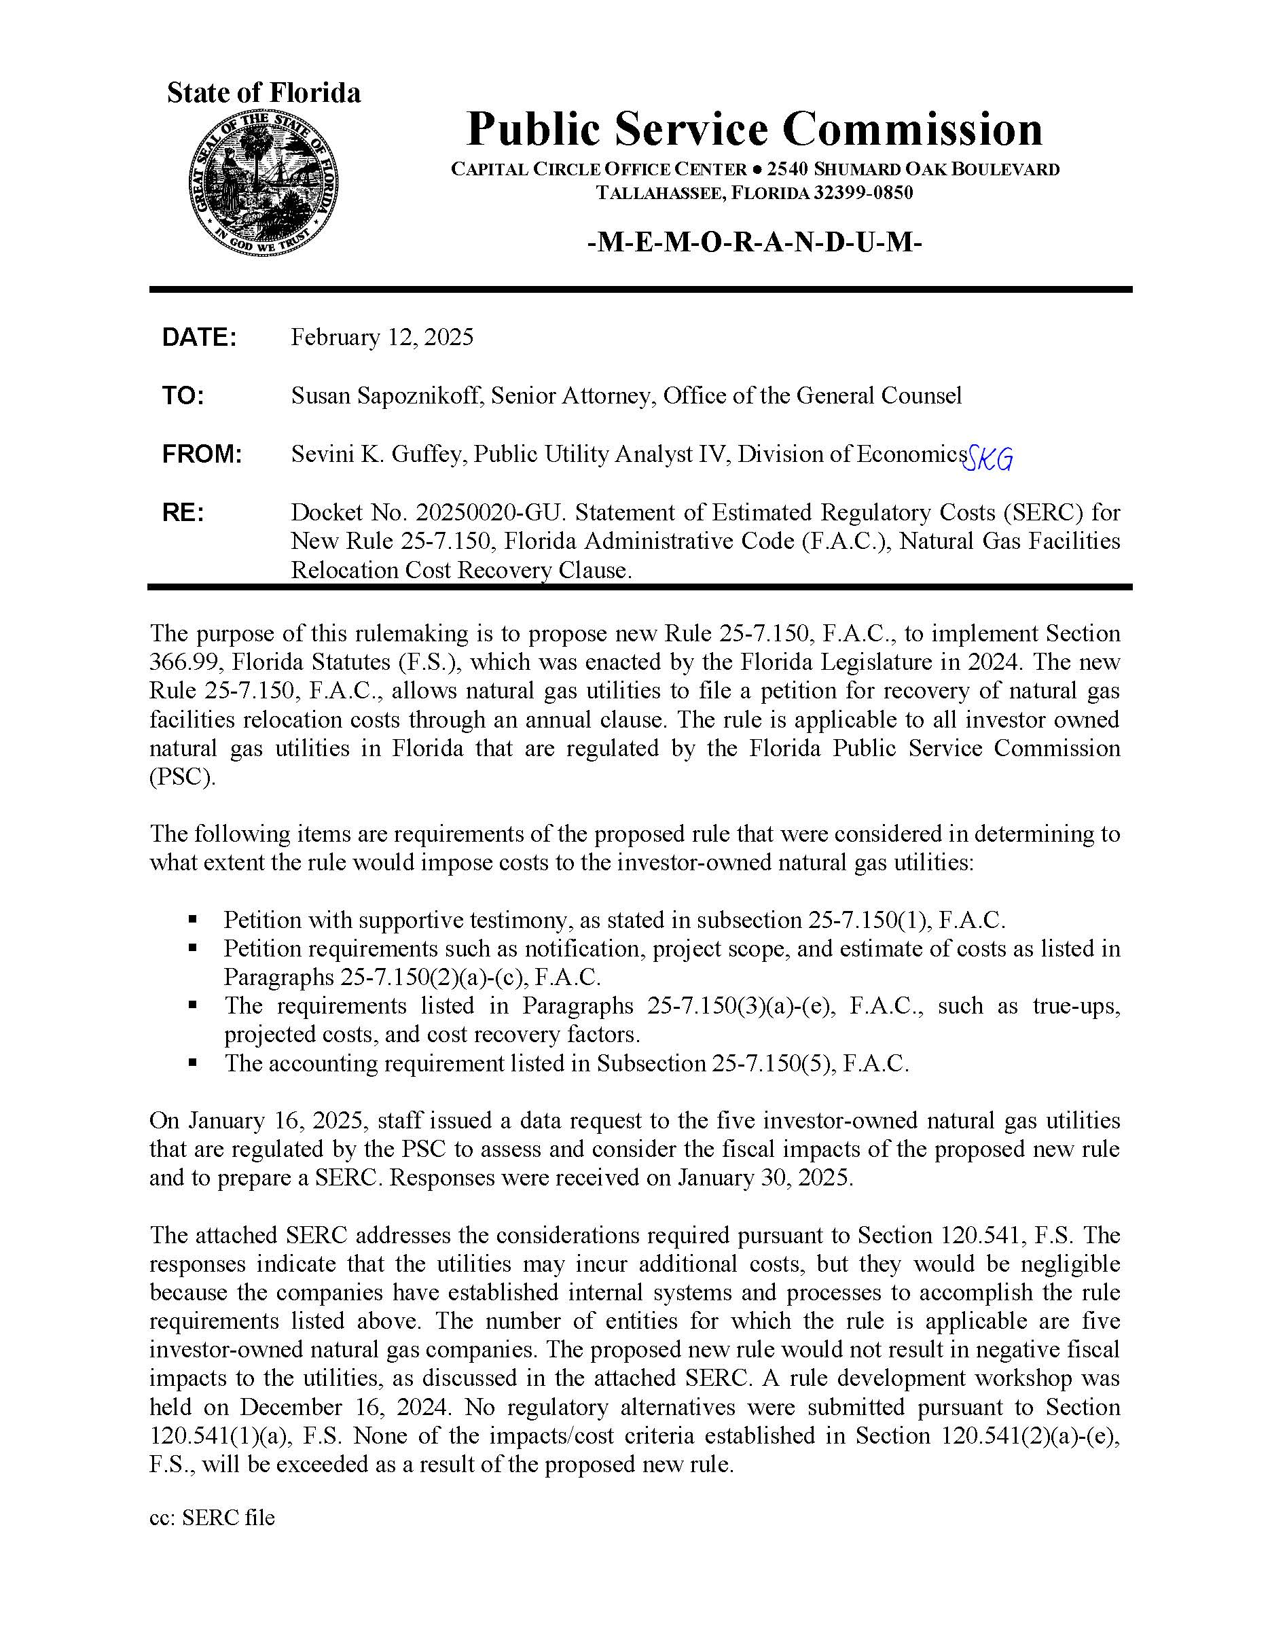

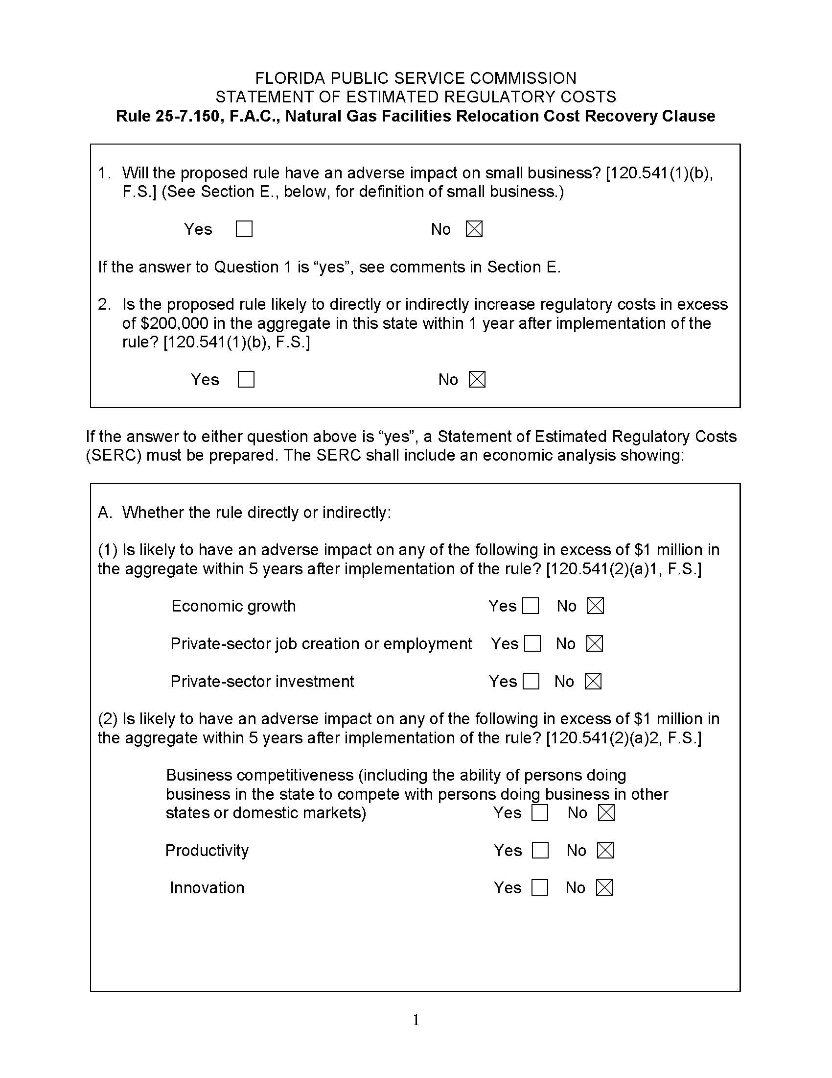

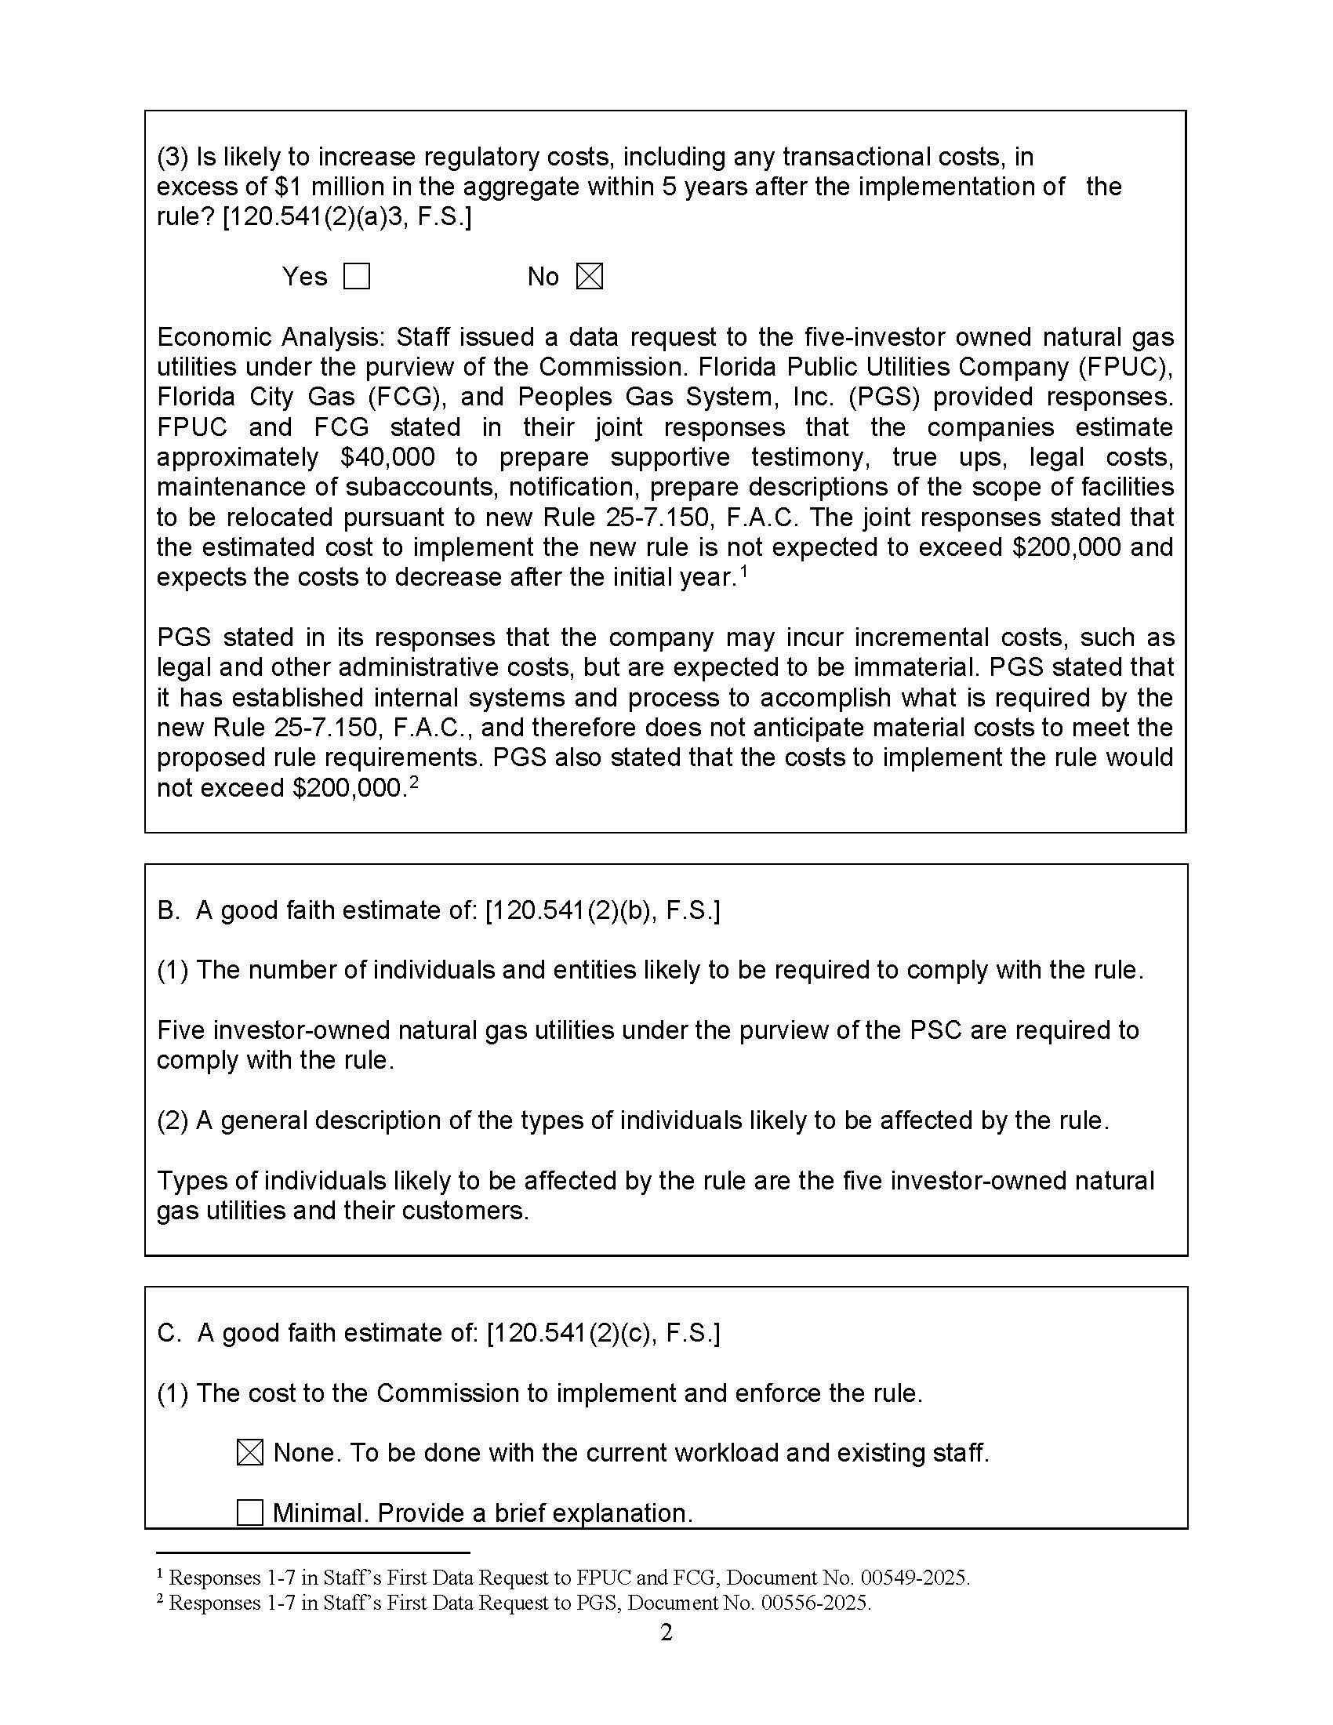

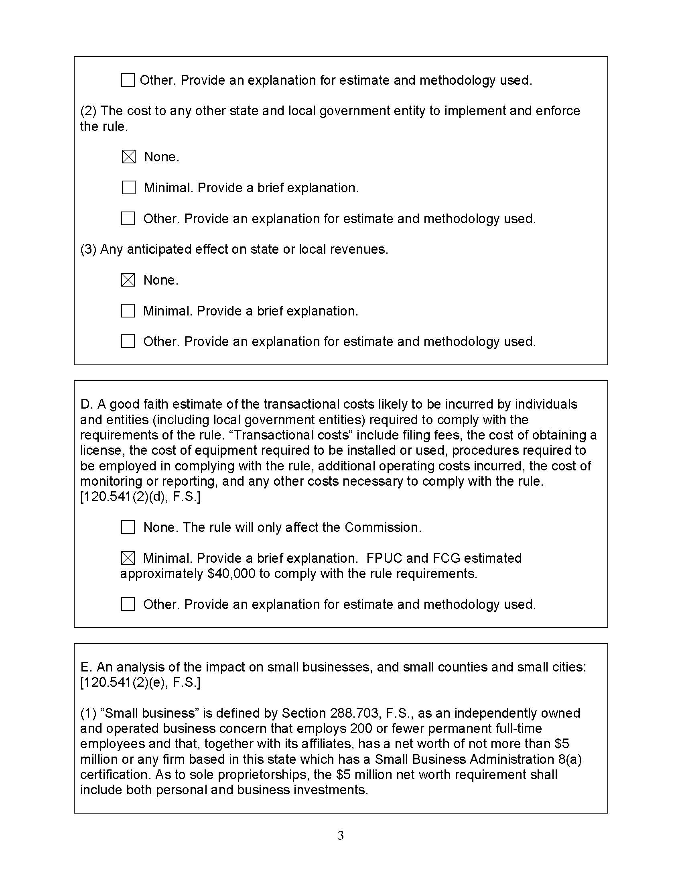

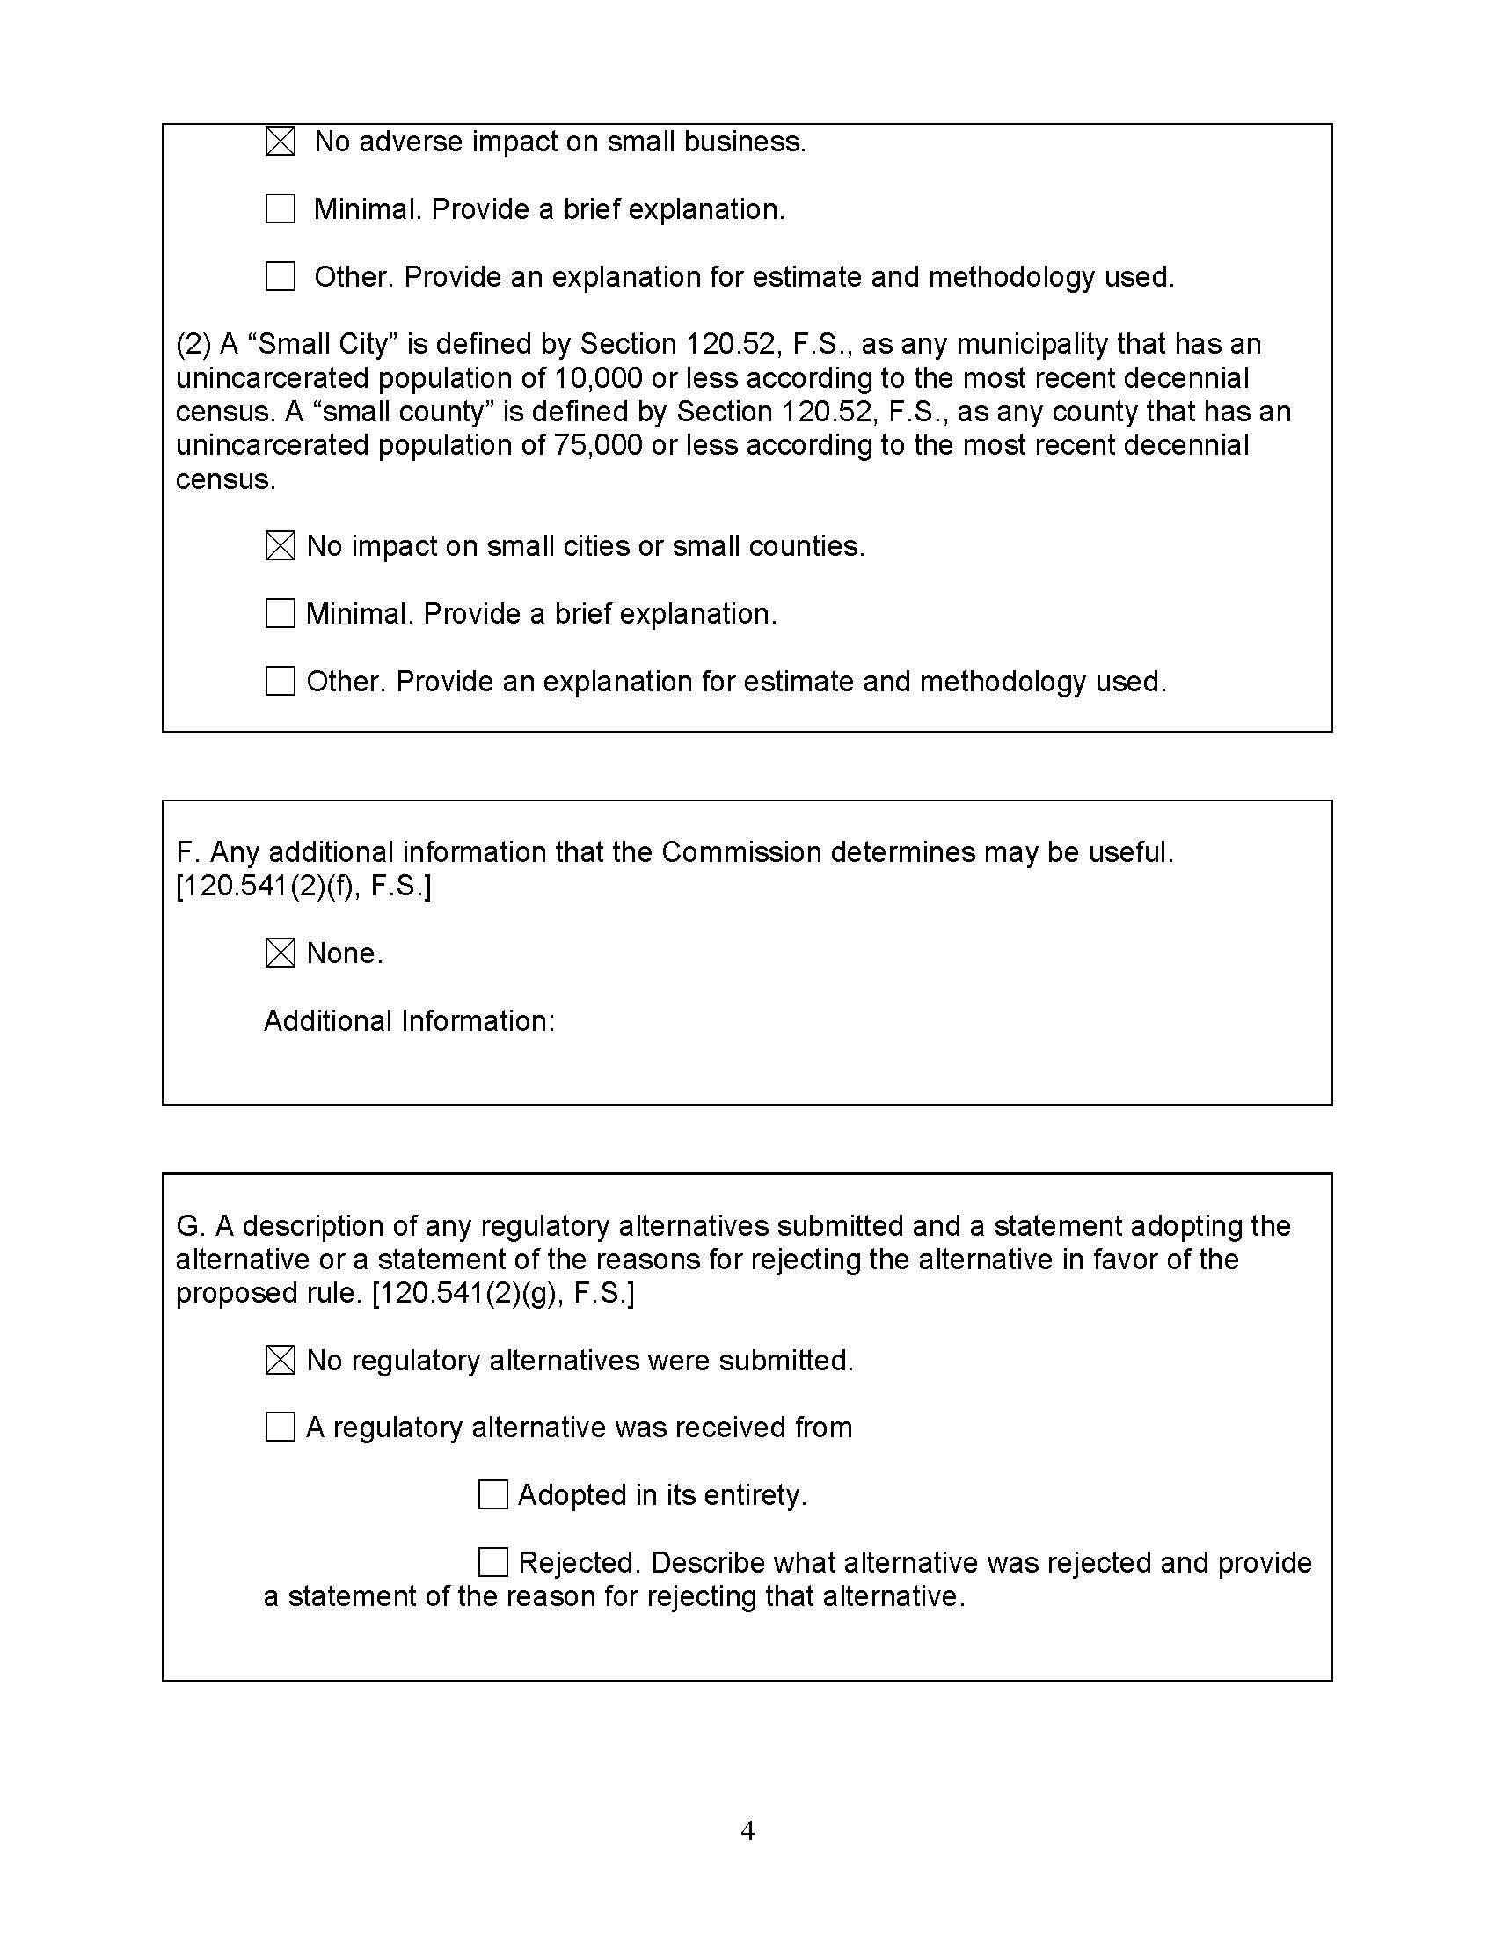

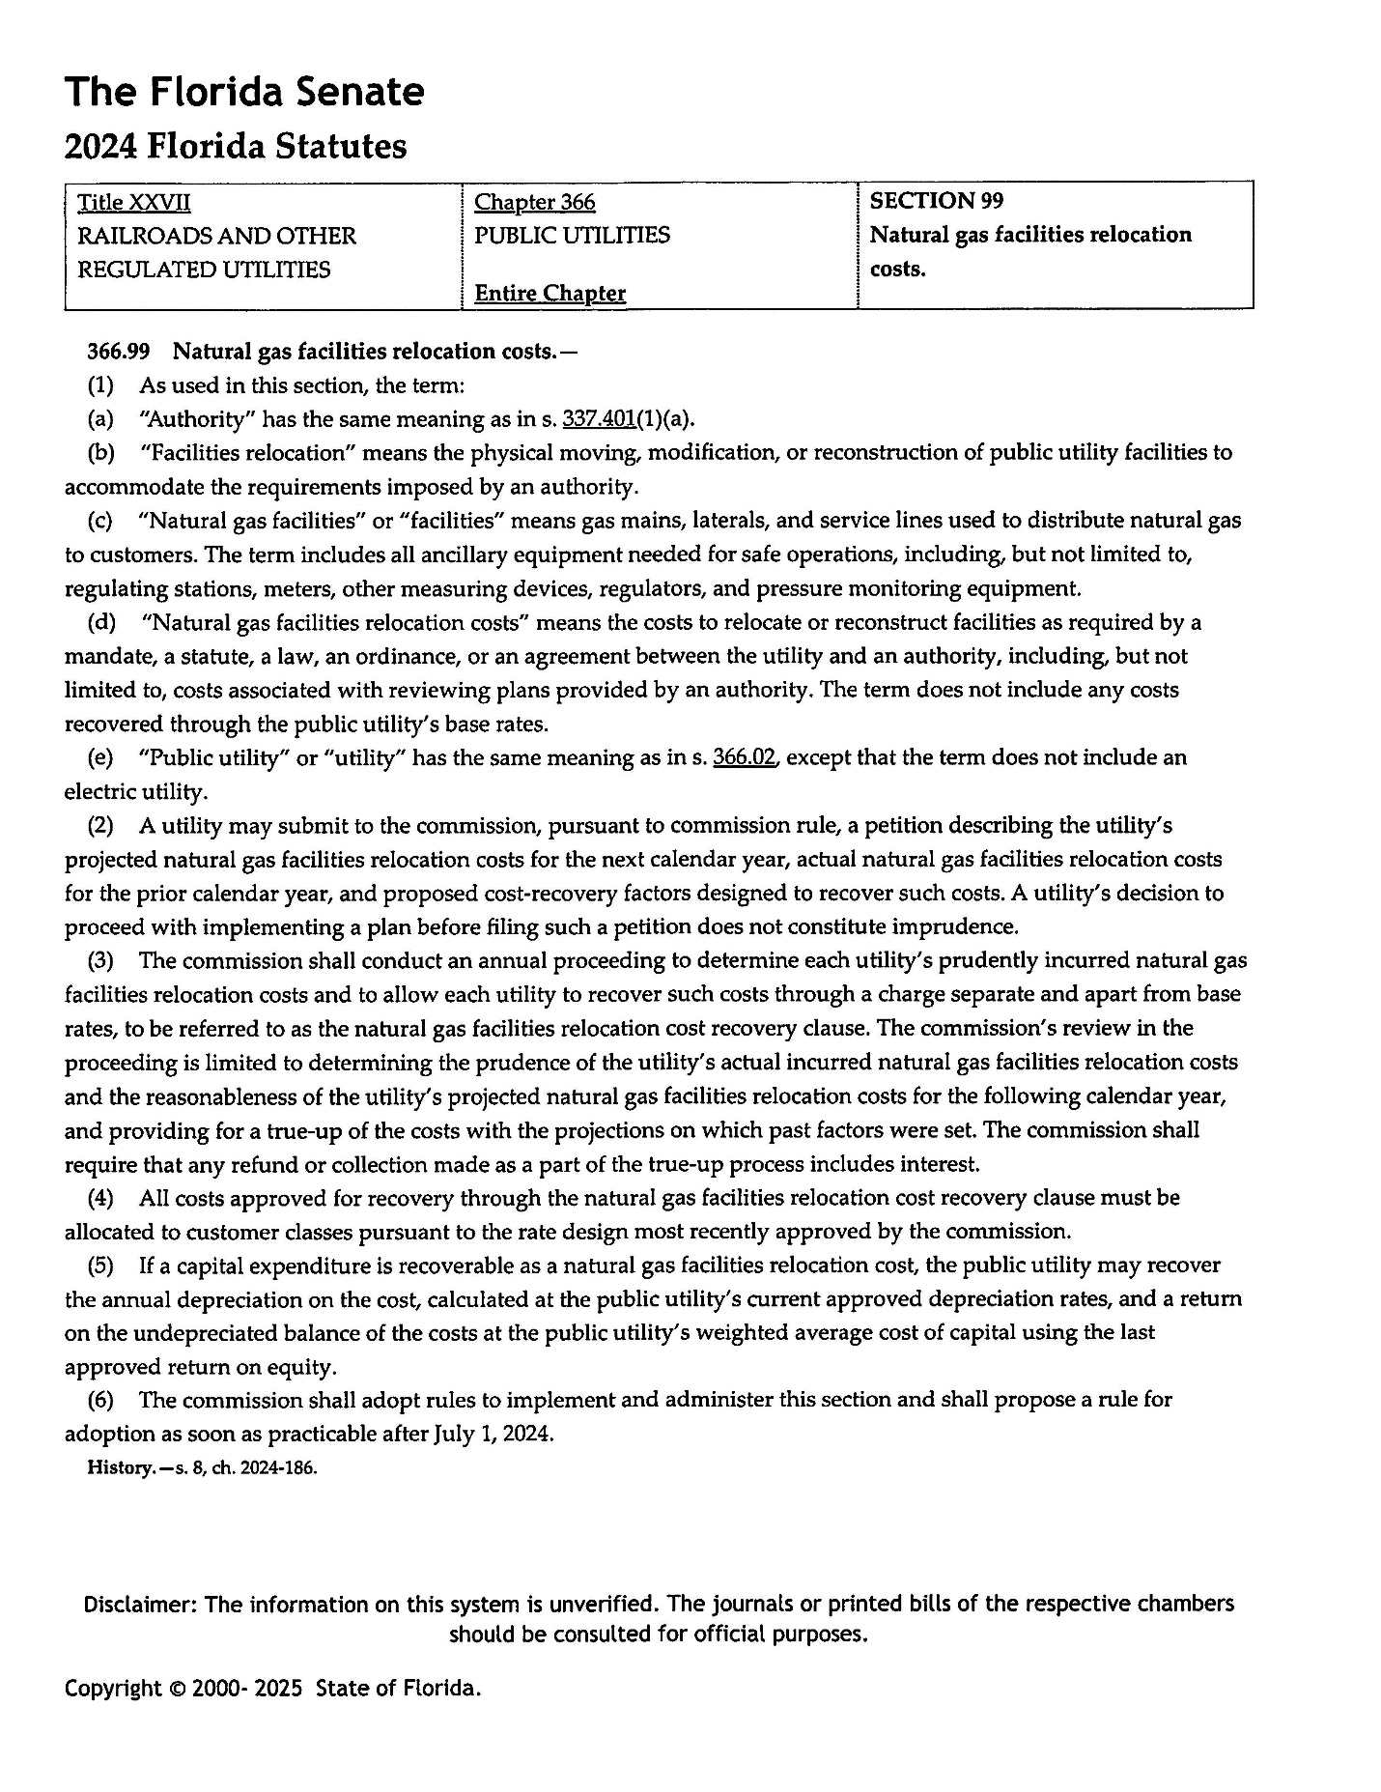

1. As defined in Section 366.02(8), F.S.
2. *See, e.g.*, Sections 366.82(2) and (7), 366.825(3), 366.8255(2), 366.93(3)(a) and (c), and 403.519(1), F.S.
3. *See* Rule 25-6.031(7)(b), F.A.C.