|  |  |  |  |
| --- | --- | --- | --- |
| State of Florida  pscSEAL | | Public Service Commission  Capital Circle Office Center ● 2540 Shumard Oak Boulevard Tallahassee, Florida 32399-0850  -M-E-M-O-R-A-N-D-U-M- | |
| DATE: | February 20, 2025 | | |
| TO: | Office of Commission Clerk (Teitzman) | | |
| FROM: | Division of Engineering (Davis, Ellis, Ramos)  Division of Accounting and Finance (Higgins)  Office of the General Counsel (Marquez, Farooqi) | | |
| RE: | Docket No. 20240170-EG – Petition for approval of proposed demand-side management plan, by Florida Public Utilities Company. | | |
| AGENDA: | 03/04/25 – Regular Agenda – Proposed Agency Action - Interested Persons May Participate | | |
| COMMISSIONERS ASSIGNED: | | | All Commissioners |
| PREHEARING OFFICER: | | | Clark |
| CRITICAL DATES: | | | None |
| SPECIAL INSTRUCTIONS: | | | Staff recommends the Commission simultaneously consider Docket Nos. 20240163-EG, 20240166-EG, 20240167-EG, 20240169-EG, and 20240170-EG. |

Case Background

Sections 366.80 through 366.83, and 403.519, Florida Statutes (F.S.), known collectively as the Florida Energy Efficiency and Conservation Act (FEECA), require the Florida Public Service Commission (Commission) to adopt conservation goals to increase the efficiency of energy consumption. FEECA emphasizes reducing the growth rates of weather-sensitive peak demand, reducing and controlling the growth rates of electricity consumption, reducing the consumption of expensive resources such as petroleum fuels, and encouraging demand-side renewable energy resources. The Commission most recently established conservation goals for Florida Public Utilities Company (FPUC or Utility) by Order No. PSC-2024-0431-FOF-EG (2024 Goalsetting Order), issued September 20, 2024, in Docket 20240015-EG.[1] On December 19, 2024, FPUC filed a petition requesting approval of its demand-side management (DSM) Plan and associated program standards. In addition, FPUC filed a request to add a supplement program to its DSM Plan with the addition of the Light Emitting Diode (LED) Lighting program, which would not count towards the DSM goals.

The Commission has jurisdiction over this matter pursuant to Sections 366.80 through 366.83 and 403.519, F.S.

Discussion of Issues

Issue :

 Should the Commission approve Florida Public Utility Company’s proposed DSM Plan and program standards?

Recommendation:

 Yes. FPUC’s DSM Plan is consistent with the proposed programs used to establish its DSM goals and is projected to meet the annual numeric conservation goals approved by the Commission in the 2024 Goalsetting Order. In addition, staff has reviewed FPUC’s program participation standards and they appear to be consistent with FPUC’s DSM Plan. Therefore, staff recommends that the Commission should allow FPUC to file for cost recovery of the programs included in its proposed DSM Plan in the Energy Conservation Cost Recovery (ECCR) proceeding. However, FPUC must demonstrate that the expenditures to implement its DSM programs are reasonable and prudent in order to recover those expenditures. (Davis)

Staff Analysis:

 Section 366.82(7), F.S., requires that following the adoption of annual conservation goals, the Commission shall also require each utility subject to FEECA to develop a DSM plan to meet its conservation goals. Rule 25-17.0021(4), Florida Administrative Code (F.A.C.), requires each electric utility subject to FEECA to file its DSM plan, which consists of one or more DSM programs, and program participation standards for Commission approval. The Commission considers the appropriateness of DSM programs by evaluating the following criteria, first outlined in Order No. 22176: (1) whether the program advances the policy objectives of FEECA and its implementing rules (such as reducing demand and energy usage); (2) whether the program is directly monitorable and yields measurable results; and (3) whether the program is cost-effective.[2] Pursuant to 366.82(7), F.S., the Commission may then elect to approve, modify, or deny the utility’s DSM plan.

FPUC’s Proposed DSM Plan

Staff reviewed FPUC’s DSM Plan, including its demand and energy savings, cost-effectiveness, and rate impact. Overall, the programs within the proposed DSM Plan are consistent with the proposed DSM programs evaluated by the Commission in the 2024 DSM Goalsetting proceeding. A complete list of the programs and a brief description of each can be found in Attachment A. Staff has also reviewed FPUC’s program participation standards, which can be found in Attachment B, and they appear to be consistent with FPUC’s DSM Plan.

FPUC’s proposed DSM Plan consists of 7 programs in total, including 4 residential and 3 commercial/industrial programs. FPUC’s DSM plan includes retaining the Residential HVAC program and rebranding the Residential Energy Survey program as “Efficiency 1st” with a stronger emphasis on do-it-yourself energy-saving installations. These programs include updated rebate amounts, and a new weatherization and home energy kit. FPUC is addressing limited participation in commercial programs by adding an interior lighting option and increased rebate amounts for the Commercial HVAC program. In addition, FPUC is launching a new low income program called “Efficiency for All.” This program will assist low income families with energy efficiencies that will benefit all customers. Also, FPUC will be introducing a new web-based platform to enhance delivery of the Efficiency 1st survey program.

The projected program demand and energy savings meet the goals established by the Commission in the 2024 Goalsetting Order, and the programs included in FPUC’s DSM Plan are directly monitorable and measurable. As required by Rule 25-17.008, F.A.C., FPUC provided a cost-effectiveness analysis for the programs included in its DSM plan using the Rate Impact Measure (RIM), Total Resource Cost (TRC), and the Participants tests. All of the DSM programs passed the Participants test, all but 2 passed the TRC test, and all failed the RIM test. Staff notes that the cost-effectiveness of the DSM programs is consistent with what was provided in the 2024 DSM Goalsetting proceeding. Overall, staff recommends that FPUC’s DSM plan and program standards be approved.

FPUC is responsible for continuing to monitor actual participation in its programs, and requesting modifications to its DSM plan and/or program standards as necessary to meet the annual conservation goals. If FPUC is unable to meet the annual conservation goals established by the Commission, the Utility may be subject to appropriate action by the Commission, up to and including financial penalties. Table 1-1 shows an estimate of the annual ECCR expenditures and monthly rate impact on a typical residential customer for FPUC’s DSM Plan.

Table -1

FPUC’s DSM Plan Annual ECCR Costs and Estimated Monthly Impact

|  |  |  |
| --- | --- | --- |
| **Year** | **Annual ECCR Costs**  **($)** | **Residential Customer**  **($/1,200 kWh-mo)** |
| **2025** | $731,191 | $1.45 |
| **2026** | $753,127 | $1.45 |
| **2027** | $775,721 | $1.45 |
| **2028** | $798,992 | $1.45 |
| **2029** | $822,962 | $1.45 |
| **2030** | $847,651 | $1.45 |
| **2031** | $873,080 | $1.45 |
| **2032** | $899,273 | $1.45 |
| **2033** | $926,251 | $1.45 |
| **2034** | $954,038 | $1.45 |
| **Total** | $8,382,285 | - |

Source: FPUC’s Response to Staff’s First Data Request.

Conclusion

FPUC’s DSM Plan is consistent with the proposed programs used to establish its DSM goals and is projected to meet the annual numeric conservation goals approved by the Commission in the 2024 Goalsetting Order. In addition, staff has reviewed FPUC’s program participation standards and they appear to be consistent with FPUC’s DSM Plan. Therefore, staff recommends that the Commission should allow FPUC to file for cost recovery of the programs included in its proposed DSM Plan in the ECCR proceeding. However, FPUC must demonstrate that the expenditures to implement its DSM programs are reasonable and prudent in order to recover those expenditures.

Issue :

 Should the Commission approve FPUC's LED Lighting program and associated program standards?

Recommendation:

 Staff recommends approval of FPUC’s proposed LED Lighting program with three proposed modifications: (1) remove communication expenses, (2) remove net base rate items for new LEDs, and (3) adjust the amount to be recovered and the credit to reflect the remaining balance and number of fixtures as of the date of the Commission’s approval. The Commission should approve FPUC’s request to create a regulatory asset related to the unrecovered amount of the non-LED lighting as adjusted. Further, the Commission should find that the approval to record the regulatory asset for accounting purposes does not limit the Commission’s ability to review the amounts and recovery period for reasonableness in a future proceeding in which the regulatory asset is included. The Commission should also grant staff administrative authority to approve the revised program standards. (Ellis, Higgins)

Staff Analysis:

 In addition to the DSM Plan described in Issue 1, FPUC is also separately proposing an additional new program. FPUC is not seeking to have the demand and energy savings associated with the additional program included in the calculation of the Utility’s annual numeric conservation goals.

Utility’s Proposed LED Lighting Program

The LED Lighting program is a program focused on the replacement of existing non-LED outside lighting, such as high pressure sodium (HPS) or metal halide (MH) lights, with LED lighting options that are more efficient. The proposed program is structured as a temporary, two-year conservation initiative (beginning the first quarter of 2025) aimed at recovering depreciation and investment-related expenses through the aforementioned targeted conservation measure. Specifically, the program focuses on offsetting costs associated with converting 7,122 streetlamps to high-efficiency LEDs. FPUC seeks to recover the unrecovered plant costs of the HPS and MH lights of the old non-LED lighting, incremental expenses for the new LED lighting, and additional marketing expenses associated with the program. Unlike traditional conservation programs, in which a participating customer receives a rebate or credit, the Utility would receive a credit for each non-LED light replaced, to be recovered through the ECCR Clause.

By Order No. PSC-2022-0132-TRF-EI, the Commission closed FPUC’s Rate Schedule LS of non-LED offerings to new customers and included LED replacement options.[3] However, the Utility has not yet replaced all the existing customers’ lighting fixtures. The proposed LED Lighting program would expedite the remaining conversion process.

FPUC is seeking recovery of a regulatory asset over two years based upon the projected cost of (1) unrecovered plant costs of the HPS and MH lights, (2) net rate base expenses associated with the new LED lights, such as return on investment, depreciation, and property taxes, and (3) communication expenses for customers. For purposes of cost recovery, FPUC requests recovery in the ECCR of the unamortized costs for HPS and MH lights removed both during the prior year and current year, or are expected to be removed through the projection year.

FPUC seeks to create a regulatory asset for the unrecovered plant associated with the HPS and MH lights, which would be expensed for each light replaced with the intention of resulting in zero balance at the end of the program. FPUC plans to file a petition to address the net unrecovered cost of the new LED lights in a future tariff proceeding.

The Utility estimates the unamortized costs for the HPS and MH lighting to be $1,224,541 for 7,122 lights, or $171.94 per light, as of the end of December 2024. This value would be adjusted at the beginning of the program to reflect actual costs as of the date of the Commission’s decision. The net rate base expenses, an estimated $206,638 over the two year period, and communication expenses of $15,000, brings the total of program cost to $1,446,179, or $203.06 per light that would be recovered in the ECCR by FPUC. This results in an annual cost of the program of $723,090, assuming approximately 300 fixtures are replaced monthly using a combination of utility staff and contractors. This results in a rate impact of $1.44/mo. for 2025 and $1.40/mo. for 2026 for a typical residential 1,200 kWh monthly bill. Table 2-1 summarizes the proposed costs to be recovered under the program.

Table -1

FPUC Proposed LED Lighting Program Expenses

|  |  |  |  |  |
| --- | --- | --- | --- | --- |
| **Expense** | **2025**  **($)** | **2026**  **($)** | **Total**  **($)** | **Unit Cost\***  **($/Fixture)** |
| Non-LED Lighting Expenses |  |  |  |  |
| Unrecovered Depreciation | $612,271 | $612,271 | $1,224,542 | $171.94 |
| New LED Lighting Expenses |  |  |  |  |
| Net Return on Investment | $3,397 | $215,876 | $219,273 | $30.79 |
| Net Depreciation Expense | ($68,454) | $5,496 | ($62,958) | ($8.84) |
| Net Property Taxes | $0 | $50,322 | $50,322 | $7.07 |
| Administrative Expenses |  |  |  |  |
| Marketing/Communications | $7,500 | $7,500 | $15,000 | $2.11 |
| Total | 554,714 | $891,465 | $1,446,179 | $203.06 |

Source: FPUC’s Petition.

Review of Proposed Program

Staff agrees that approval of the LED Lighting program would result in net energy savings that advance the intent of FEECA. The amount of savings per light fixture and number of light fixtures covered are both monitorable and measurable factors. Overall, with the Utility’s requested expenses, the program has a cost-effectiveness ratio above 1.0 for both the RIM (1.075) and TRC (1.824) tests.

The proposed program is similar in structure to Tampa Electric Company’s (TECO’s) Street and Outdoor Lighting Conversion Program, which also featured recovery of unamortized cost of non-LED lighting.[4] In the TECO Order, the Commission allowed recovery of the unrecovered plant associated with the non-LED lighting but excluded recovery of advertising/communication expenses. TECO did not request recovery of incremental rate base costs associated with the new LED lighting.

Staff recommends that the Commission approve, for cost recovery in the ECCR, the unamortized portion of the HPS and MH lighting. This is appropriate for DSM because the lighting program serves a conservation purpose, is cost-effective, and furthers FEECA objectives. As such, the program is eligible for recovery in the ECCR. Moreover, staff recommends that the Commission approve the creation of a regulatory asset for the amount associated with the unrecovered plant (i.e., the non-LED lights to be converted). The establishment of a regulatory asset is appropriate, because it will allow for FPUC to recover the associated costs over a multi-year period as contemplated in the petition.

Staff recommends, however, that the following requested expenses associated with the LED program be denied. First, communication expenses should be removed. Communication expenses would not be appropriate as participation in the DSM program is non-voluntary and done at the Utility’s discretion, not the lighting customer’s. The removal of communication expenses is also consistent with the Commission’s prior Order for TECO.

Second, net rate base expenses should be removed. Customers will be paying rates under FPUC’s Rate Schedule LS for the new LED lights, which is the appropriate place for recovery of new assets. Rate base expense recovery is more appropriate in a base rate case, not a clause. Based on the values in Table 2-1, these two adjustments reduce FPUC’s request by $221,637.

Third, the amount of the regulatory asset and the credit per light should be adjusted to reflect the remaining balance and number of fixtures as of the date of program approval. This is because pursuant to Section 366.82(7), F.S., any incremental lighting replaced before the Commission’s approval of the DSM program are not be eligible without the Commission’s prior approval.

Furthermore, Commission approval of FPUC’s regulatory asset in this case does not limit the Commission’s ability to review the amounts and recovery period for reasonableness in a future proceeding in which the regulatory asset is included. In other words, any remaining balance in the regulatory asset at the end of the LED Lighting program should be evaluated in a future proceeding for recovery.

To reflect the changes, staff recommends FPUC be required to file the updated unrecovered balance as adjusted above and number of fixtures as of the Commission’s decision, and revised program standards with a per-light credit value reflecting the updated values. Staff recommends that the Commission grant staff administrative authority to approve these revised program standards, provided they are consistent with the Commission’s decision.

Conclusion

Staff recommends approval of FPUC’s proposed LED Lighting program with three proposed modifications: (1) remove communication expenses, (2) remove net base rate items for new LEDs, and (3) adjust the amount to be recovered and the credit to reflect the remaining balance and number of fixtures as of the date of the Commission’s approval. The Commission should approve FPUC’s request to create a regulatory asset related to the unrecovered amount of the non-LED lighting as adjusted. Further, the Commission should find that the approval to record the regulatory asset for accounting purposes does not limit the Commission’s ability to review the amounts and recovery period for reasonableness in a future proceeding in which the regulatory assets are included. The Commission should also grant staff administrative authority to approve the revised program standards.

Issue :

 Should this docket be closed?

Recommendation:

 Yes. If no person whose substantial interests are affected by the proposed agency action files a protest within 21 days of the issuance of the order, this docket should be closed upon the issuance of a consummating order. (Marquez, Farooqi)

Staff Analysis:

 If no person whose substantial interests are affected by the proposed agency action files a protest within 21 days of the issuance of the order, this docket should be closed upon the issuance of a consummating order.

**Florida Public Utility Company 2025 – 2034 DSM Programs**

**Residential Programs:**

***Residential Energy Survey Program (Efficiency First)***

The Efficiency First Program provides FPUC's residential customers with energy conservation advice that encourages the implementation of efficiency measures that result in energy savings. Once implemented, these measures also lower FPUC's energy requirements and improve operating efficiencies.

***Residential Heating and Cooling Efficiency Upgrade Program***

The Residential Heating and Cooling Upgrade Program incentivize customers operating inefficient heat pumps and air conditioners to replace them with more efficient units. This program provides incentives to install a new heat pump or replace older heat pumps or air conditioners with more efficient units.

***Low-Income Energy Outreach (Efficiency for All)***

The Efficiency for All Program is aimed at enhancing energy efficiency in low-income households and communities. Participants will complete online energy surveys and monitor their monthly energy consumption. Upon reaching specific milestones, the participants will receive tiered incentives such as weatherization kits, smart power strips, and programmable thermostats.

***Residential Small Appliance Program***

This program offers a $25 rebate to residential customers who purchase an Energy-Star certified clothes washer. These washers use approximately 20% less energy and 30% less water than standard models, leading to significant utility savings over time and reduce environmental impacts.

**Commercial Programs:**

***Commercial Heating and Cooling Efficiency Upgrade Program***

The Commercial Heating and Cooling Efficiency Upgrade Program provides rebates to small commercial customers (customers with a maximum 5 ton units) if the customers install a high-efficiency central air conditioner or heat pump with a minimum 15 SEER.

***Commercial Chiller Upgrade Program***

This program aims to mitigate the growth of peak demand and energy consumption across FPUC's commercial and industrial sectors. To achieve this, the program requires customers to replace existing chillers with more efficient systems.

***Commercial Indoor Lighting Program***

The Commercial Exterior and Interior Lighting Program is a new addition to FPUC’s energy conservation offerings. This program encourages non-residential customers to replace outdated, inefficient lighting systems with modern, energy-efficient alternatives. Incentives are based on projected annual energy savings and accommodates a wide range of end-use applications.

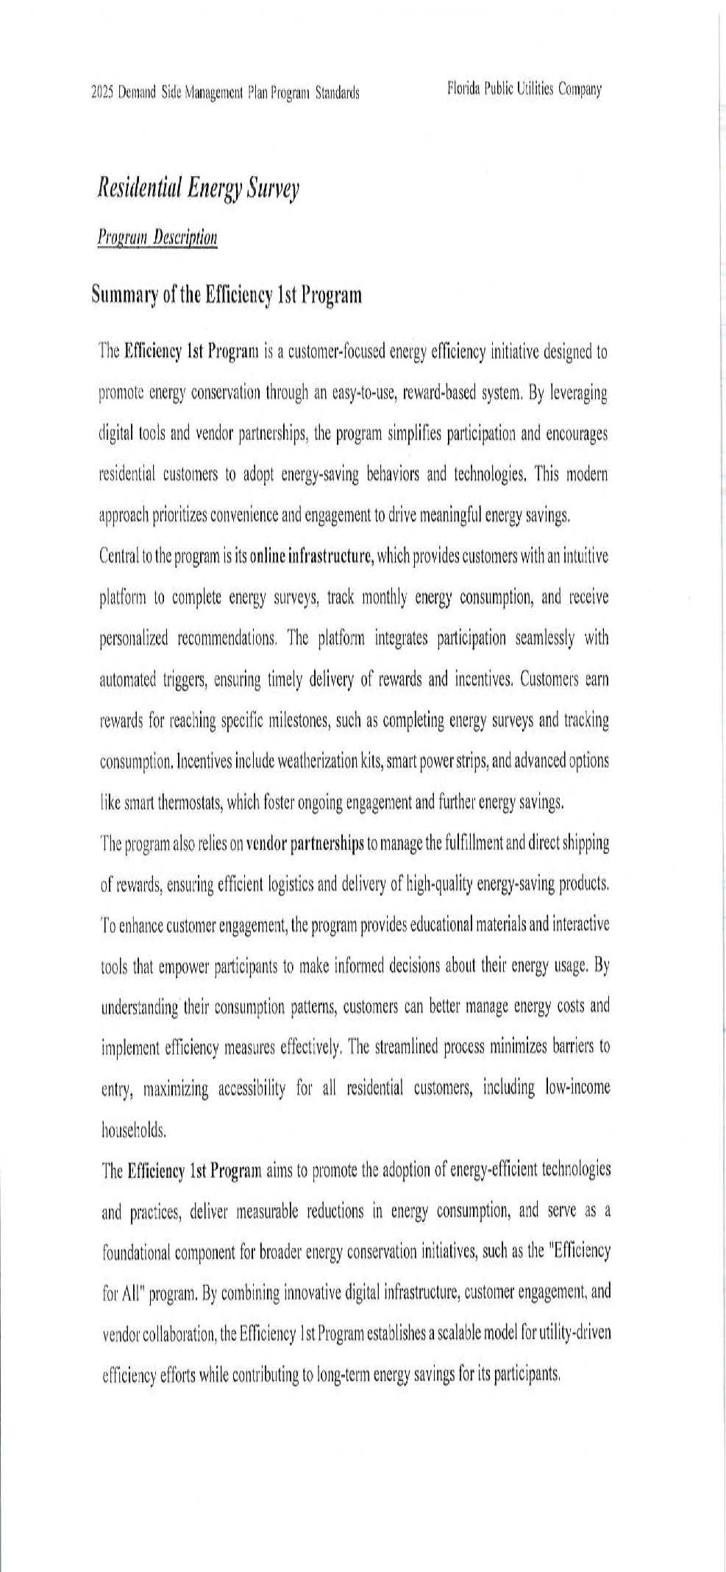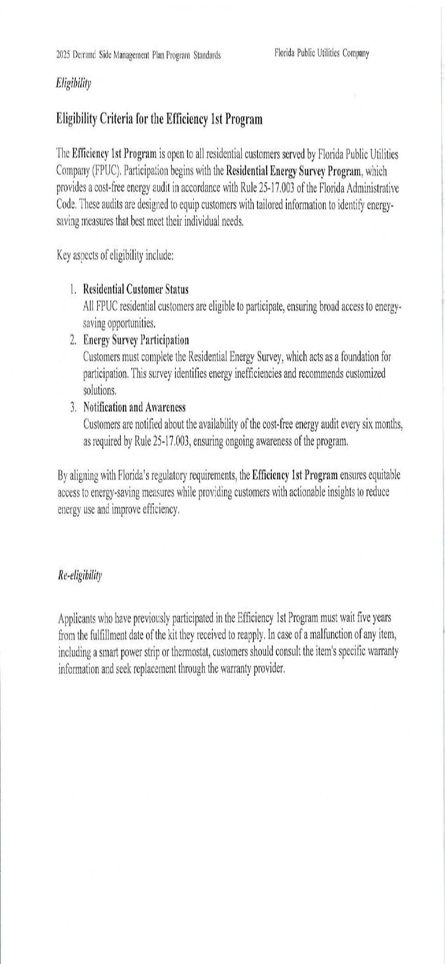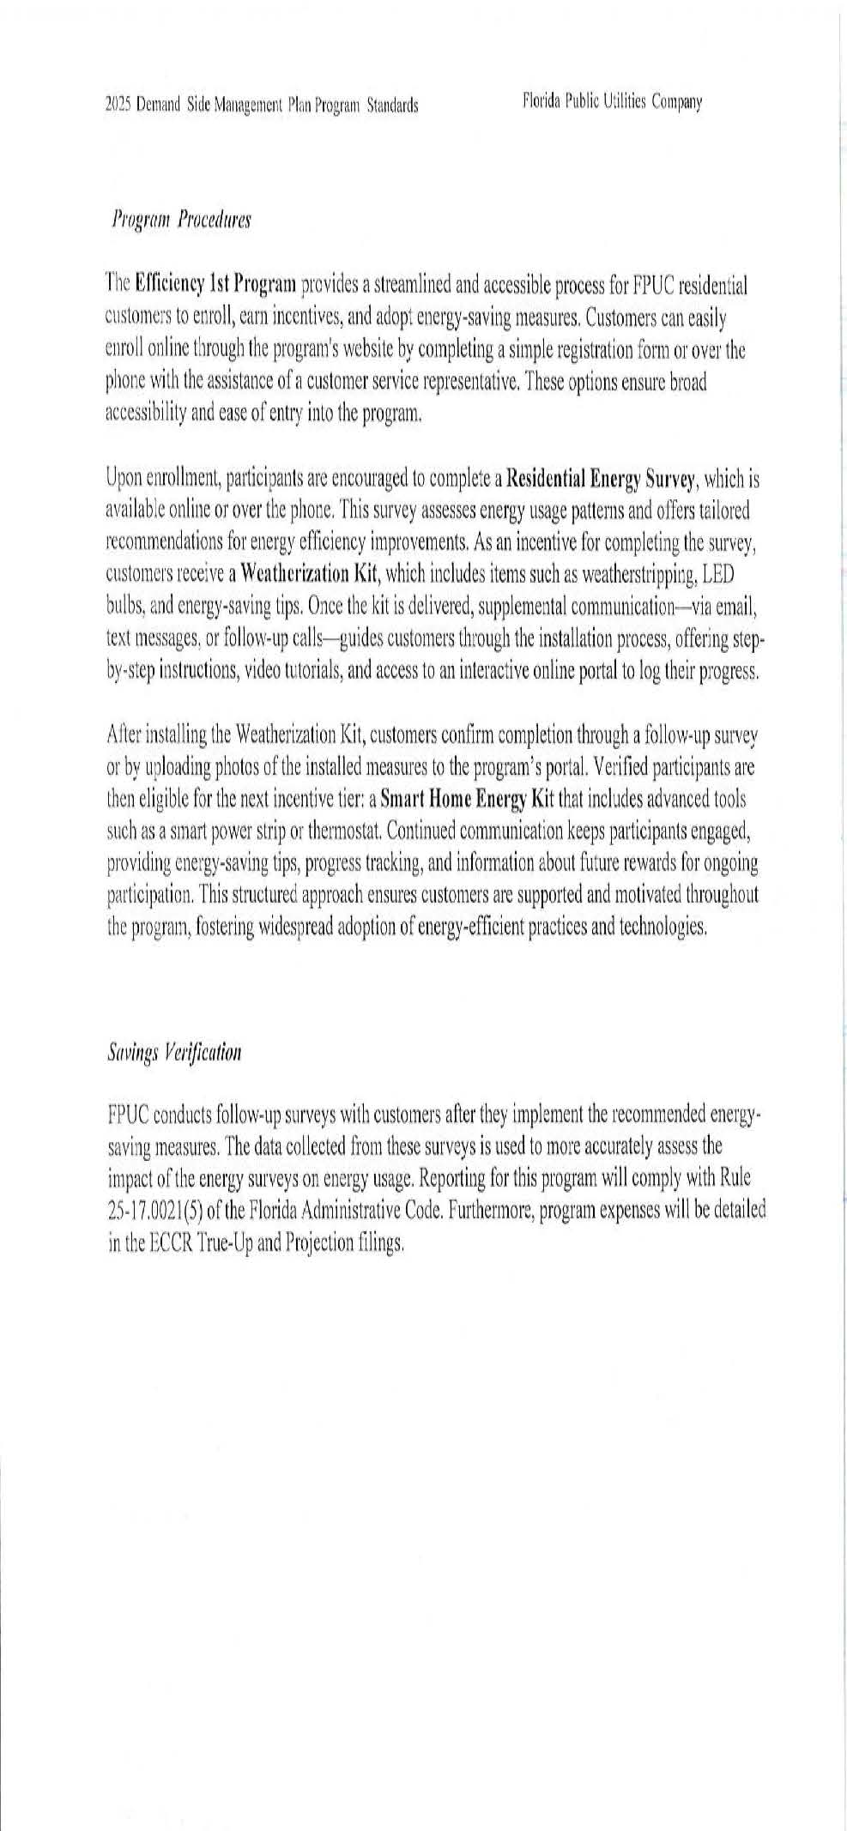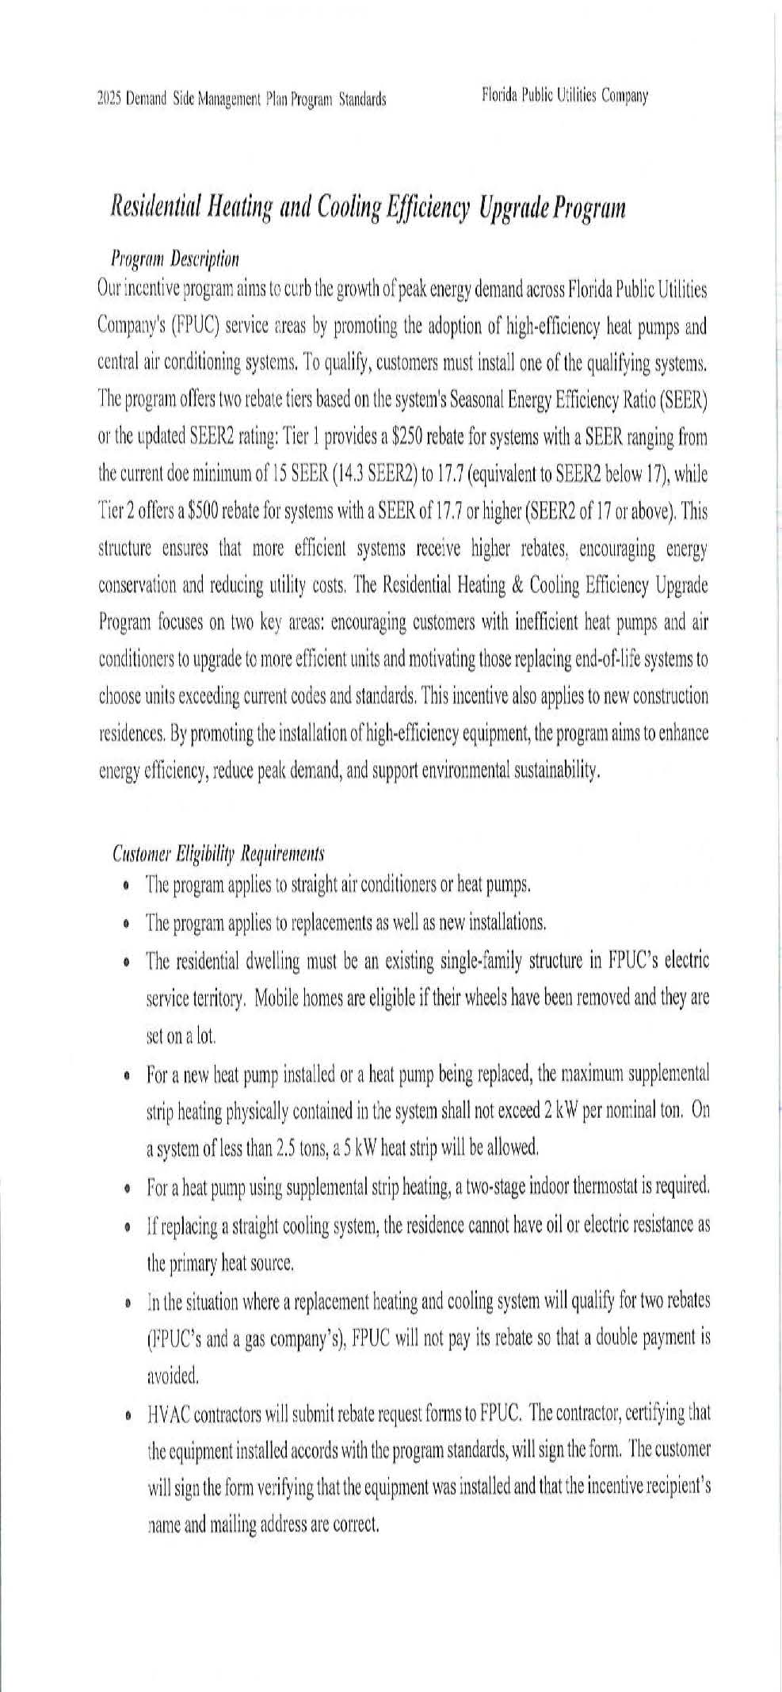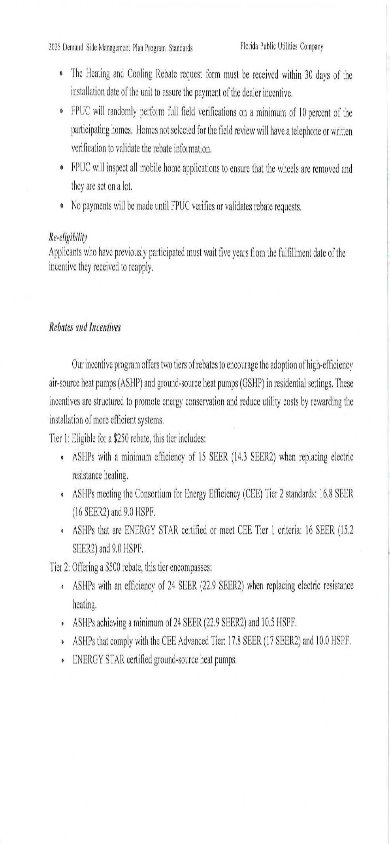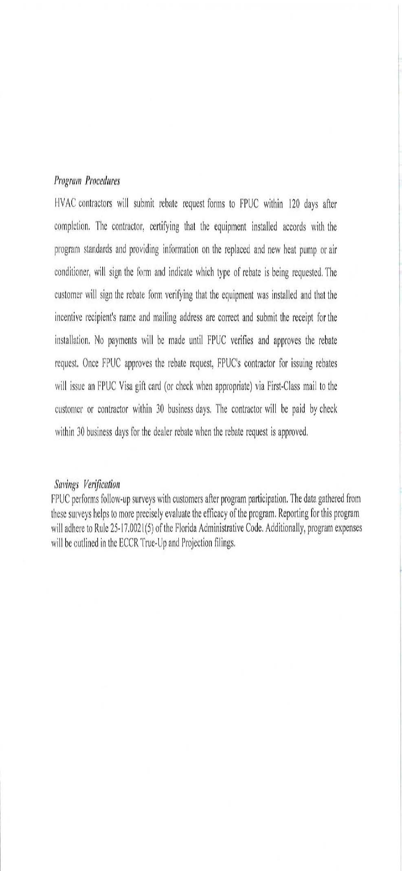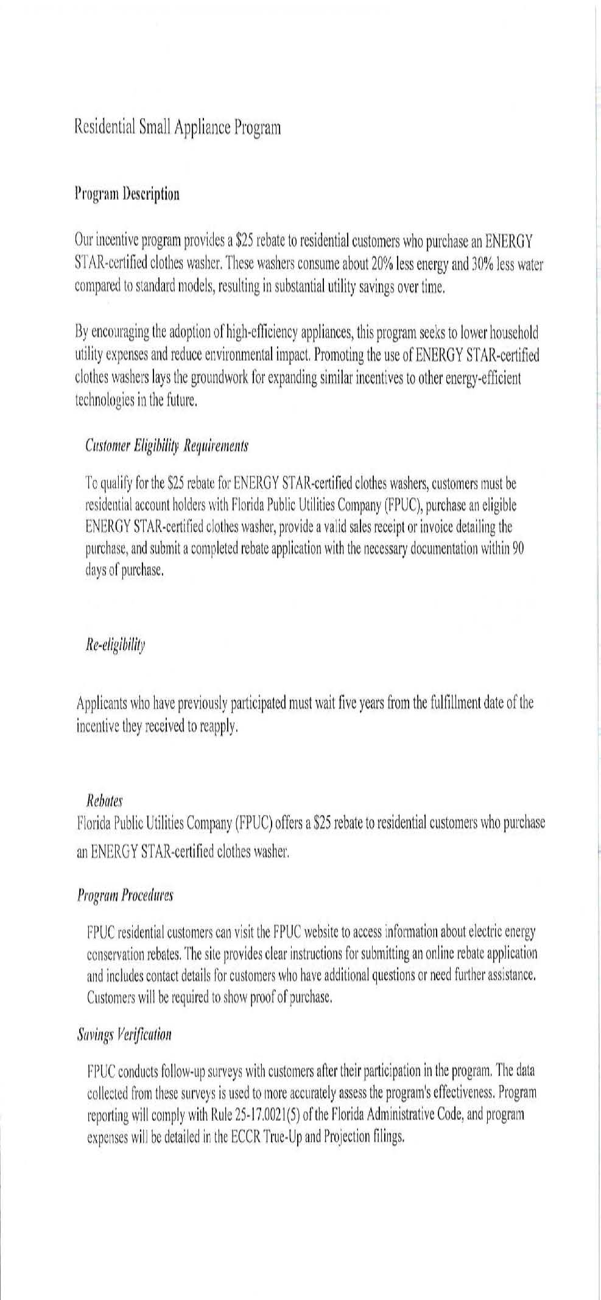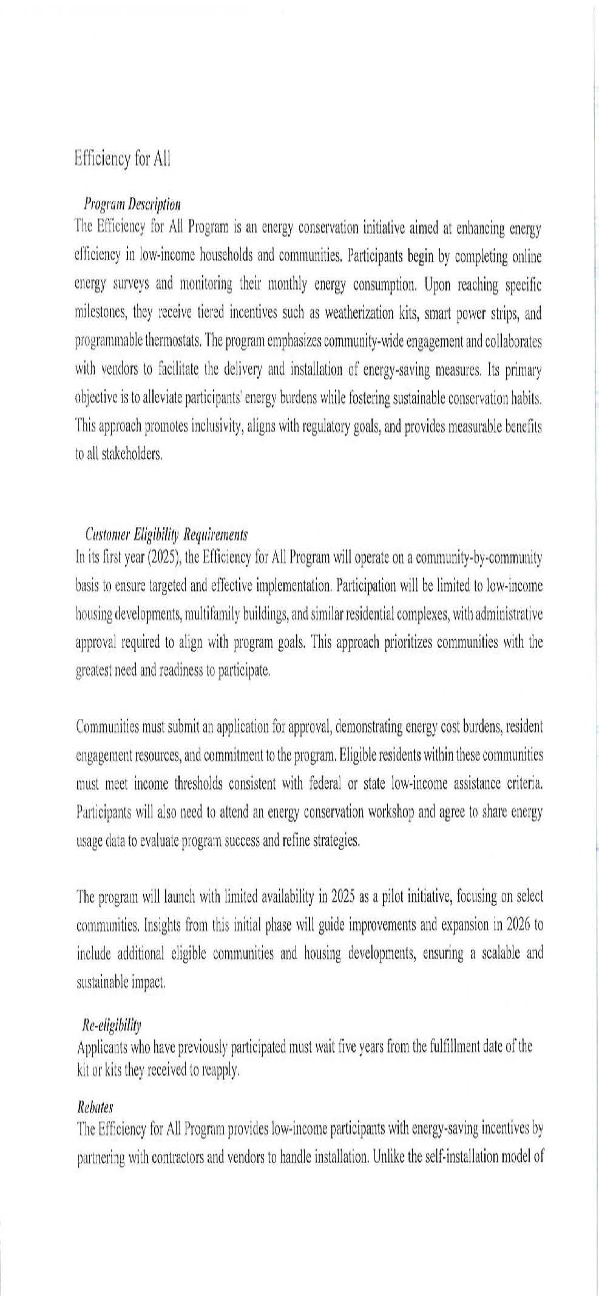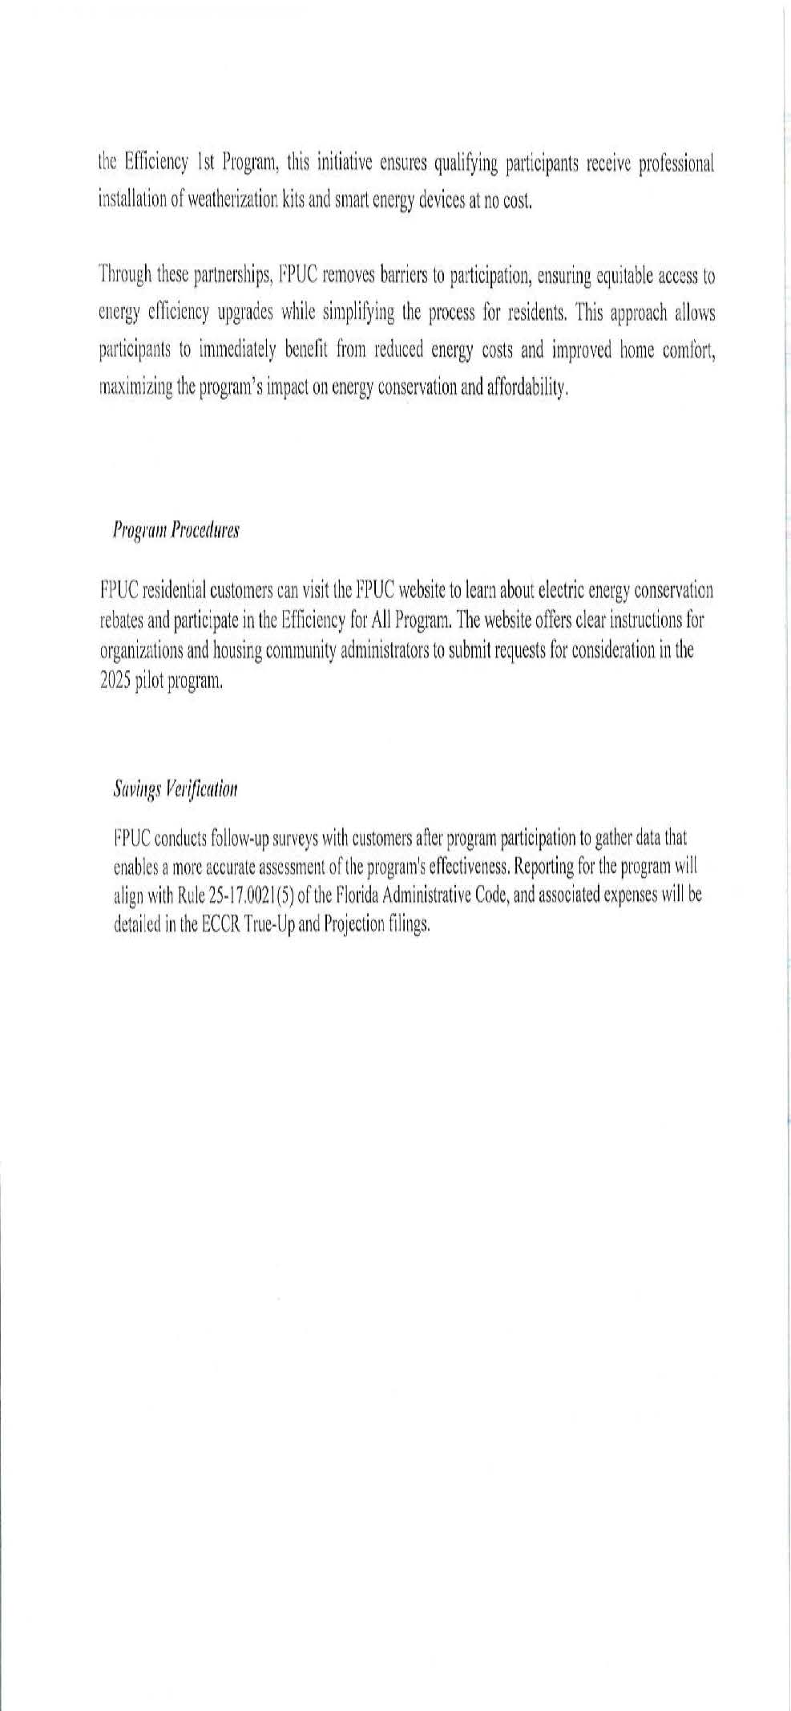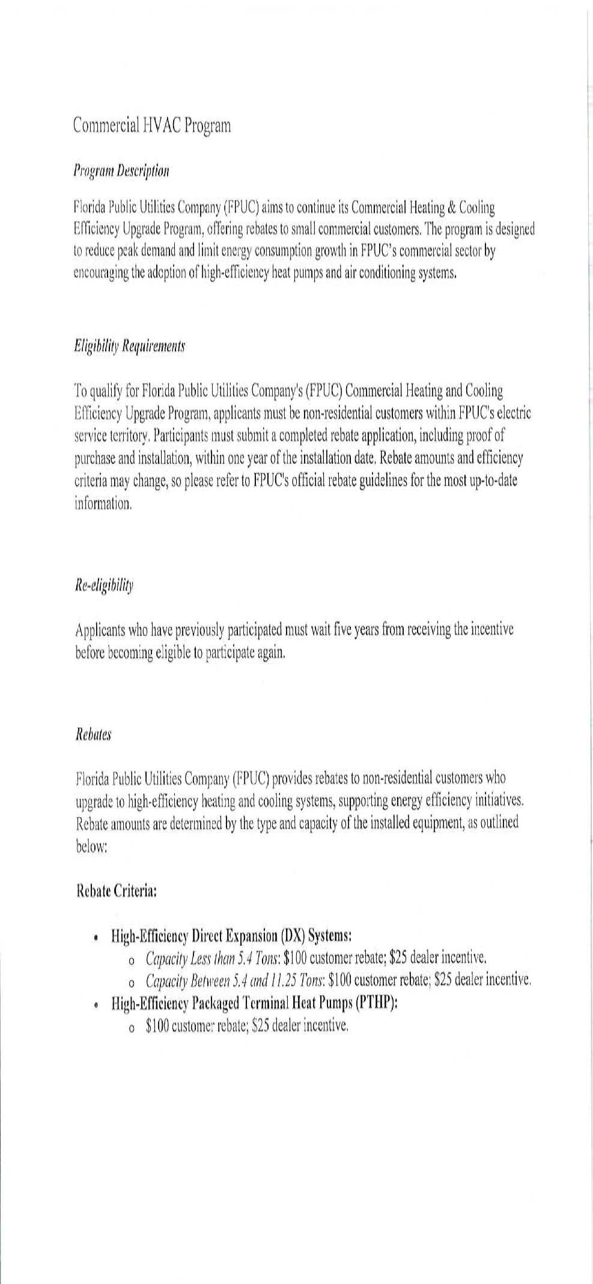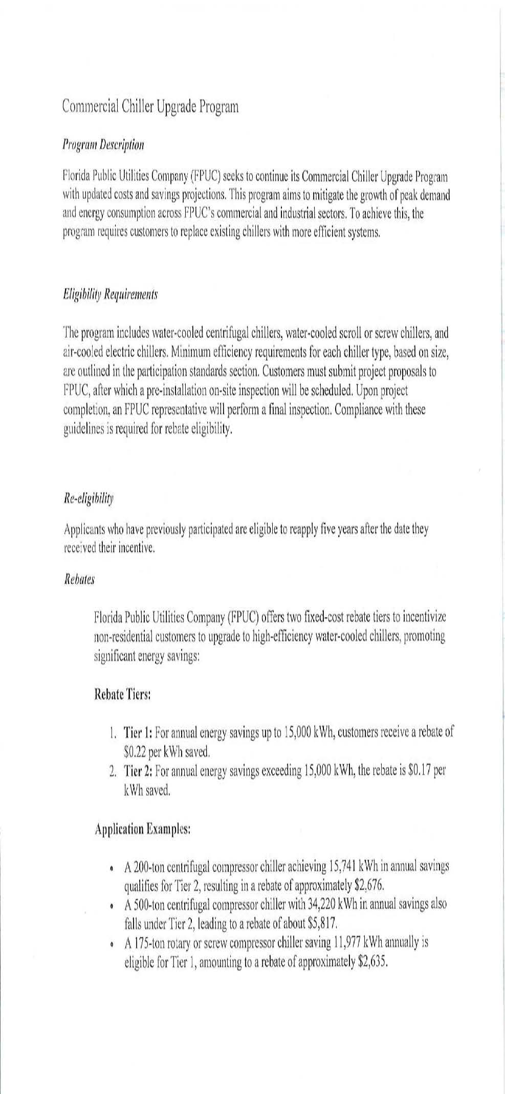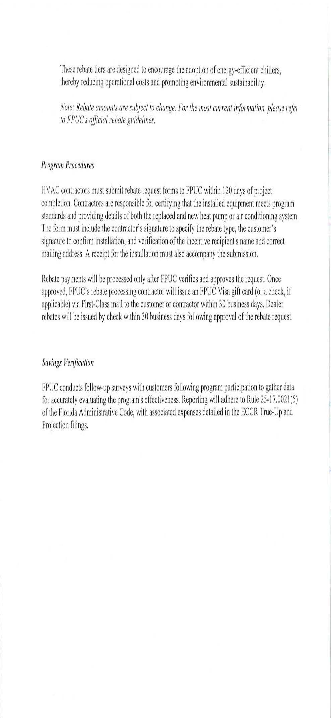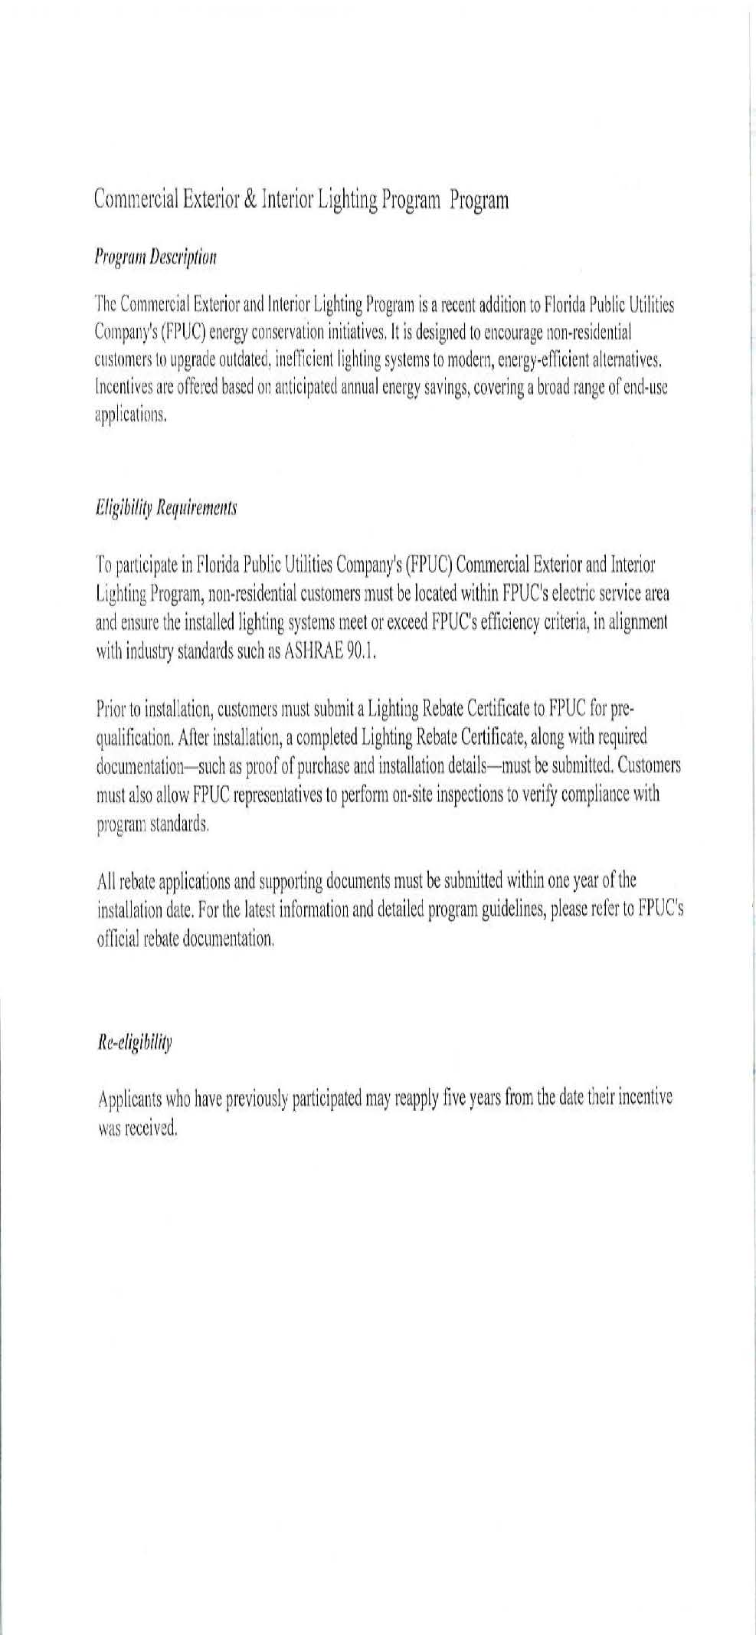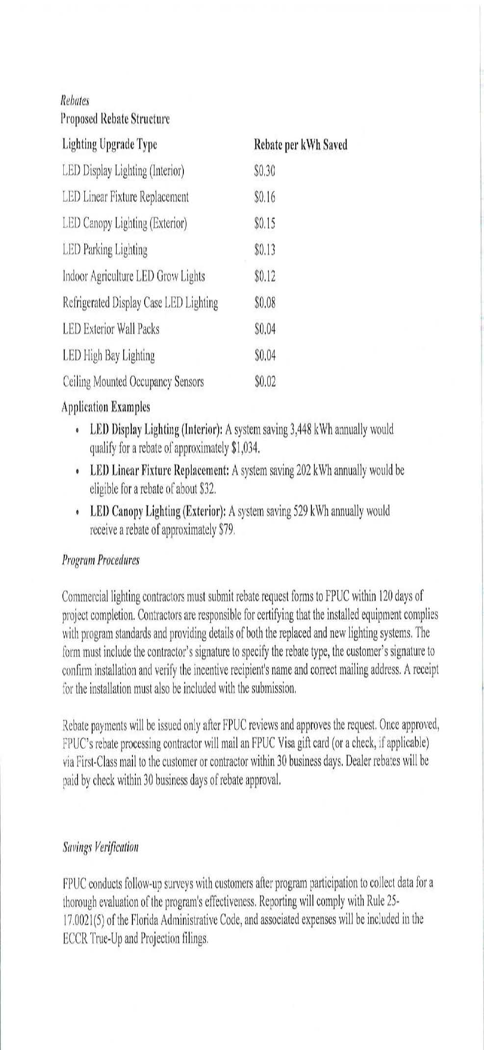

1. Order No. PSC-2024-0431-FOF-EG, issued September 20, 2024, in Docket No. 20240015-EG, *In re: Commission review of numeric conservation goals (Florida Public Utilities Company).*
2. PSC Order No. 22176, issued November 14, 1989, in Docket No. 890737-PU, *In re:* *Implementation of Section 366.80-.85, F.S., Conservation Activities of Electric and Natural Gas Utilities*.
3. *See* Order No. PSC-2022-0132-TRF-EI, issued April 8, 2022, in Docket No. 20220011-EI, *In re: Petition to modify tariff to close existing lighting tariff to new business and introduce new LED lighting tariff by Florida Public Utilities Company.*
4. See Order No. PSC-2018-0110-PAA-EI, issued February 27, 2018, in Docket No. 20170199-EI, *In re: Petition for approval of conservation street and outdoor lighting conversion program, by Tampa Electric Company.*