BEFORE THE FLORIDA PUBLIC SERVICE COMMISSION

|  |  |
| --- | --- |
| In re: Petition for limited proceeding for recovery of incremental storm restoration costs related to Hurricanes Debby, Helene and Milton, by Duke Energy Florida, LLC. | DOCKET NO. 20240173-EI  ORDER NO. PSC-2025-0061-PCO-EI  ISSUED: February 24, 2025 |

The following Commissioners participated in the disposition of this matter:

MIKE LA ROSA, Chairman

ART GRAHAM

GARY F. CLARK

ANDREW GILES FAY

GABRIELLA PASSIDOMO SMITH

ORDER APPROVING DUKE ENERGY FLORIDA, LLC’S

INTERIM STORM RESTORATION RECOVERY CHARGE

BY THE COMMISSION:

Background

On December 27, 2024, Duke Energy Florida, LLC (DEF or Company) filed a petition for a limited preceding seeking authority to implement an interim storm restoration recovery charge to recover $1.09 billion for the incremental restoration costs related to Hurricanes Debby, Helene, and Milton (collectively, the Storms), as well as the replenishment of its retail storm reserve. Included in the $1.09 billion is interest charged on unrecovered costs for Hurricanes Debby, Helene, and Milton. Pursuant to the 2024 Settlement Agreement (2024 Settlement) approved by us in Order No. PSC-2024-0472-AS-EI, the recovery of storm costs from customers will begin, on an interim basis, 60 days after the filing of a cost recovery petition and tariff with us.[1] DEF requested a 12-month recovery period, applied to all bills from March 2025 through February 2026.

On January 31, 2025, DEF submitted updated rate calculations for all rate classes (Appendix A) and revised tariffs (Appendix B), as well as an updated response to our first data request. The updated calculations reflect revised cost allocation factors, resulting in minor changes to the storm cost recovery factors for all customers. Specifically, in the petition, DEF had included a distribution allocation factor for customers taking service at transmission level, overstating the allocation of distribution storm costs to transmission-level customers. The revised rate calculation is consistent with the calculation of previous storm cost recovery charges approved in Order No. PSC-2024-0377-FOF-EI.[2] The updated rate calculations do not change the total $1.09 billion incremental storm costs proposed for recovery. The updated tariff is included as Attachment A to this order.

We have jurisdiction over this matter pursuant to Sections 366.04, 366.05, 366.06, and 366.076, Florida Statutes.

Decision

DEF filed a petition for a limited proceeding seeking authority to implement an interim storm restoration charge to recover an estimated total of $1.09 billion for incremental storm restoration costs for the Storms and to replenish its storm reserve. In its petition, DEF requested to replenish the storm reserve to $131.9 million.

The petition was filed pursuant to the provisions of the 2024 Settlement approved by us in Order No. PSC-2024-0472-AS-EI. Pursuant to the 2024 Settlement, DEF can begin recovery of storm costs 60 days following the filing of a petition for recovery.

In its petition, DEF asserted that it incurred approximate recoverable costs in the amounts of $61.0 million for Hurricane Debby, $372.5 million for Hurricane Helene, and $769.7 million for Hurricane Milton. The Company further asserted that all amounts were calculated in accordance with the Incremental Cost and Capitalization Approach methodology prescribed in Rule 25-6.0143, Florida Administrative Code.

The approval of an interim storm restoration recovery charge is preliminary in nature and is subject to refund pending further review once the total actual storm restoration costs are known. After the actual costs are reviewed for prudence and reasonableness, and are compared to the actual amount recovered through the interim storm restoration recovery charge, a determination will be made whether any over/under recovery has occurred. The disposition of any over or under recovery, and associated interest, will be considered by us at a later date.

Based on a review of the information provided by DEF in its petition, we authorize the Company to implement an interim storm restoration recovery charge subject to refund. Once the total actual storm costs are known, DEF shall be required to file documentation of the storm costs for our review and true-up of any excess or shortfall.

All funds collected subject to refund shall be secured by a corporate undertaking. The criteria for a corporate undertaking include sufficient liquidity, equity ownership, profitability, and interest coverage to guarantee any potential refund. DEF requested a 12-month collection period beginning with the first billing cycle in March 2025 through February 2026 for Interim Storm Recovery Charges of $1.09 billion related to Hurricanes Debby, Helene, and Milton. We have reviewed DEF’s three most recent annual reports filed with us (2021, 2022, and 2023) to determine if the Company can support a corporate undertaking to guarantee the funds collected for incremental storm restoration costs related to the subject weather events. DEF’s financial information indicates the Company’s financial position to support a corporate undertaking of $1.09 billion is marginal, but satisfactory. DEF’s average net income over the last three years is $889 million, which is less than the requested interim amount. The Company’s net income in 2023 was $1.019 billion, slightly less than the requested storm cost recovery interim amount. DEF’s profitability, equity ownership, current ratio, and interest coverage for 2022 and 2023 are sufficient to support a potential refund up to $510 million. Our corporate undertaking guidelines indicate that the maximum that should be allowed for a corporate undertaking is one-half DEF’s 2023 net income, or $510 million. However, DEF participates in Duke Energy Corporation’s (DEF’s parent company) money pool and has access to additional funds if needed. In addition, it is improbable DEF will be required to refund the entire requested amount of $1.09 billion. Historically, DEF has supported its requested interim storm cost recovery amounts through a hearing process and we have approved those cost amounts with only minor adjustments. Further, the storm cost recovery mechanism is a surcharge for the sole purpose of recovering the costs incurred for storm restoration and any potential refund would be applied to the funds already collected and effectuated by reduced charges on future customer bills.

Accordingly, we find that DEF has adequate resources to support a corporate undertaking in the amount requested. Based on this analysis, we find that a corporate undertaking of $1.09 billion is acceptable. This brief financial analysis is only appropriate for deciding if DEF can support a corporate undertaking in the amount requested and shall not be considered a finding on other issues in this proceeding.

DEF calculated the interim storm surcharge for the 12-month period of March 1, 2025, through February 28, 2026, subject to true-up once the final total recoverable storm amount is known and determined. In paragraph 21 of the petition, DEF states that the proposed surcharges are allocated to the rate classes consistent with the rate design approved in the 2021 and 2024 Settlements. We have reviewed the allocation to rate classes provided in Appendix A to the petition and the derivation of the surcharges provided in Appendix B to the petition. We find that the surcharges have been calculated correctly, using projected kilowatt hour (kWh) sales for March 2025 through February 2026.

The proposed interim storm restoration surcharges are shown on One Hundred and Eighth Revised Tariff Sheet No. 6.105, provided in Appendix B to the petition.[3] For residential customers, the proposed surcharge would be 3.240 cents per kWh, which equates to a total surcharge of $32.40 for a 1,000 kWh monthly bill. The storm cost recovery surcharge shall be included in the non-fuel energy charge on customer bills.

In response to our staff’s first data request, DEF stated that its decision to use a 12-month recovery period (March 2025 – February 2026) is based upon DEF’s 2021 Settlement approved in Order No. PSC-2021-0202-AS-EI. Interim recovery of storm costs is governed by Paragraph 30c of the 2021 Settlement, which provides that “recovery from customers for storm damage costs will begin, subject to Commission approval on an interim basis, sixty (60) days following the filing of a cost recovery petition with the Commission, and subject to true-up pursuant to further proceedings before the Commission, and will be based on a 12-month recovery period.” Similar language is included in the 2024 Settlement approved in Order No. PSC-2024-047-AS-EI. We concur with DEF’s interpretation of the settlement with respect to its petition. DEF further states that even if the 12-month recovery period was not required by the 2021 and 2024 settlements, extending recovery beyond 12 months has several negative impacts and risks. In the revised response to staff’s first data request, DEF stated if a 22-month billing period were adopted, the recovery period would extend through December 2026 and would result in a bill impact of $17.73 per 1,000 kWh on a monthly residential bill.

We approve DEF’s proposed interim storm restoration recovery tariff and associated surcharges, as shown in Attachment A to this order. The tariff shall become effective the first billing cycle of March 2025. The interim storm restoration surcharges shall be subject to final true-up once the total actual storm costs are known.

Based on the foregoing, it is

ORDERED by the Florida Public Service Commission that Duke Energy Florida, LLC’s petition to implement an interim storm restoration recovery charge for costs related to Hurricanes Debby, Helene, and Milton subject to refund is hereby granted. Once the total actual storm costs are known, DEF shall file documentation of the total storm costs for our review and true-up of any excess or shortfall. It is further

ORDERED that the appropriate security to guarantee the funds collected subject to refund is a corporate undertaking. It is further

ORDERED that DEF’s proposal to revise the interim storm restoration recovery tariff and associated surcharges, as shown in Attachment A to this order, shall be granted. The tariff shall become effective the first billing cycle of March 2025. The interim storm restoration surcharges shall be subject to final true-up once the total actual storm costs are known. It is further

ORDERED that this docket shall remain open pending final reconciliation of actual recoverable storm costs with the amount collected pursuant to the interim storm restoration recovery charge and the calculation of a refund or additional charge if warranted.

By ORDER of the Florida Public Service Commission this 24th day of February, 2025.

|  |  |
| --- | --- |
|  | /s/ Adam J. Teitzman |
|  | ADAM J. TEITZMAN  Commission Clerk |

Florida Public Service Commission

2540 Shumard Oak Boulevard

Tallahassee, Florida 32399

(850) 413‑6770

www.floridapsc.com

Copies furnished: A copy of this document is provided to the parties of record at the time of issuance and, if applicable, interested persons.

DD

NOTICE OF FURTHER PROCEEDINGS OR JUDICIAL REVIEW

The Florida Public Service Commission is required by Section 120.569(1), Florida Statutes, to notify parties of any administrative hearing or judicial review of Commission orders that is available under Sections 120.57 or 120.68, Florida Statutes, as well as the procedures and time limits that apply. This notice should not be construed to mean all requests for an administrative hearing or judicial review will be granted or result in the relief sought.

Mediation may be available on a case-by-case basis. If mediation is conducted, it does not affect a substantially interested person's right to a hearing.

Any party adversely affected by this order, which is preliminary, procedural or intermediate in nature, may request: (1) reconsideration within 10 days pursuant to Rule 25-22.0376, Florida Administrative Code; or (2) judicial review by the Florida Supreme Court, in the case of an electric, gas or telephone utility, or the First District Court of Appeal, in the case of a water or wastewater utility. A motion for reconsideration shall be filed with the Office of Commission Clerk, in the form prescribed by Rule 25-22.0376, Florida Administrative Code. Judicial review of a preliminary, procedural or intermediate ruling or order is available if review of the final action will not provide an adequate remedy. Such review may be requested from the appropriate court, as described above, pursuant to Rule 9.100, Florida Rules of Appellate Procedure.

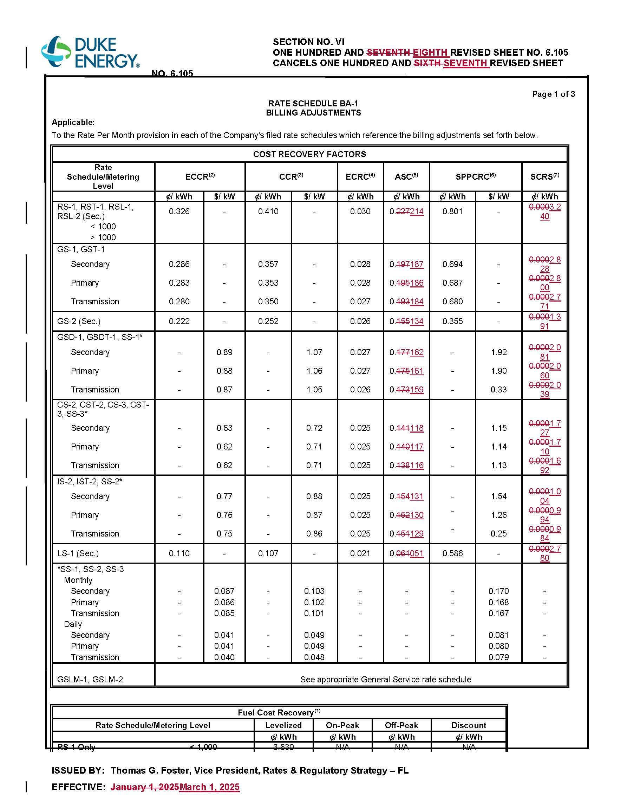

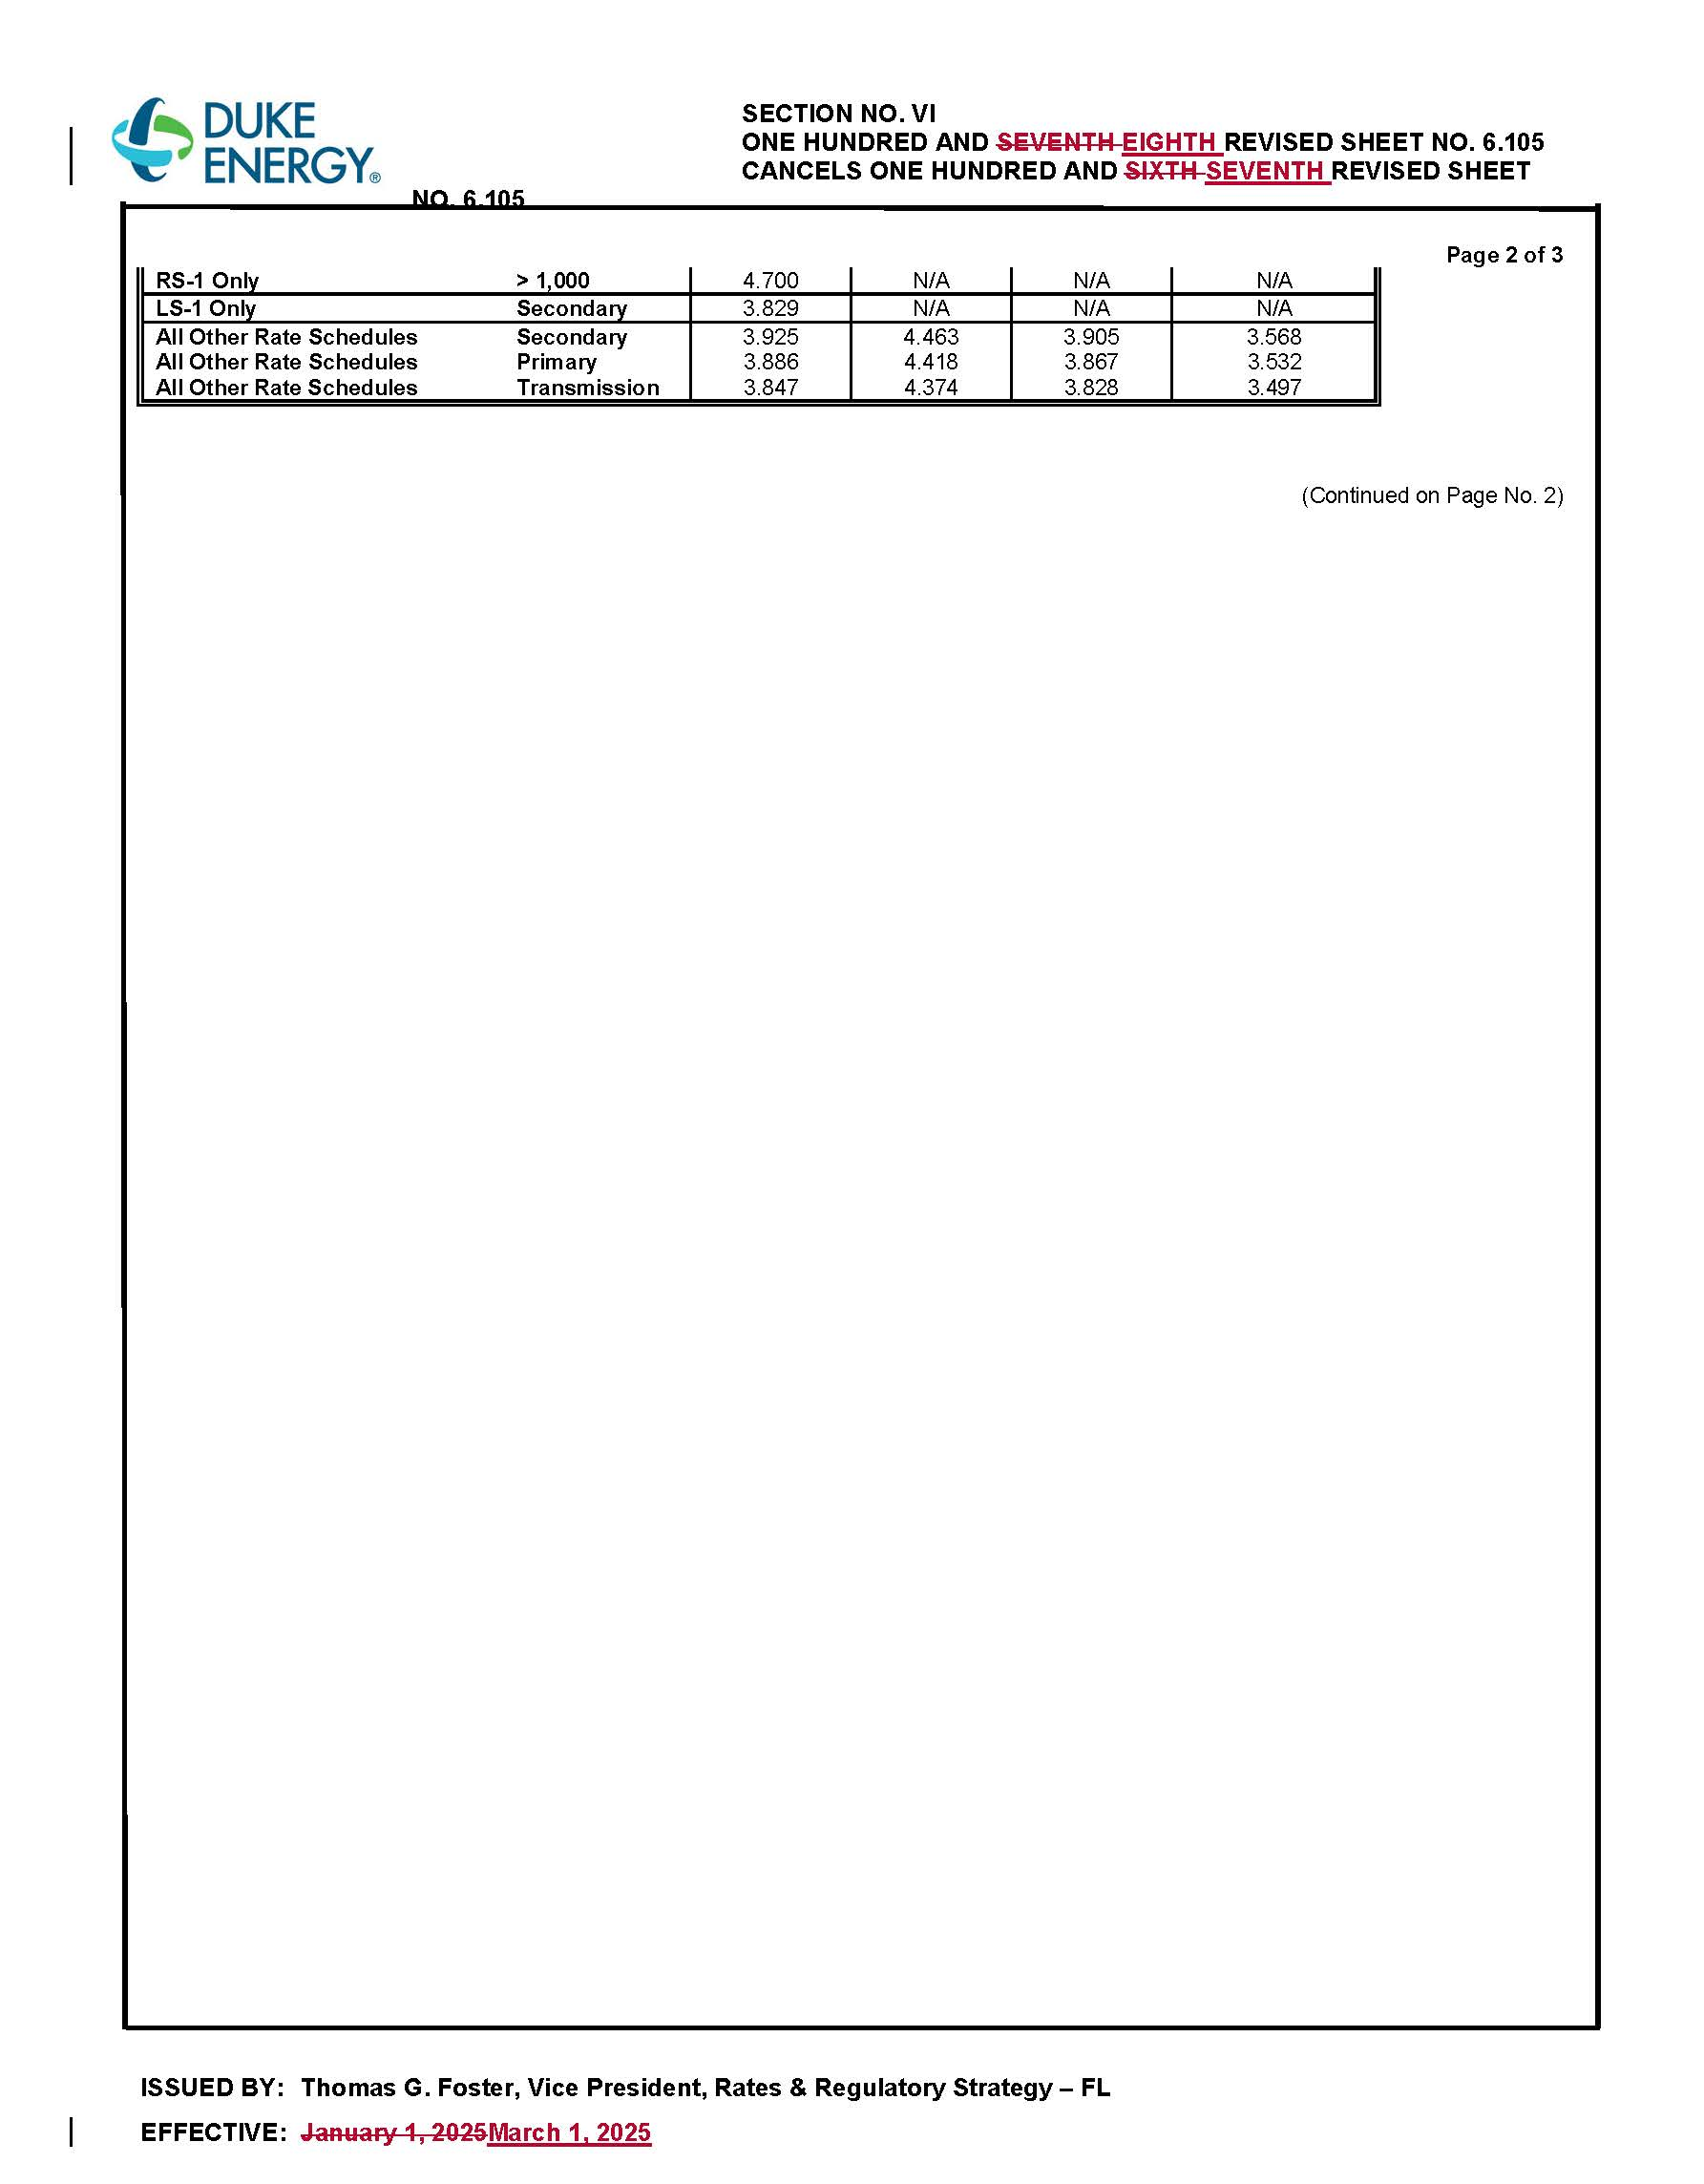

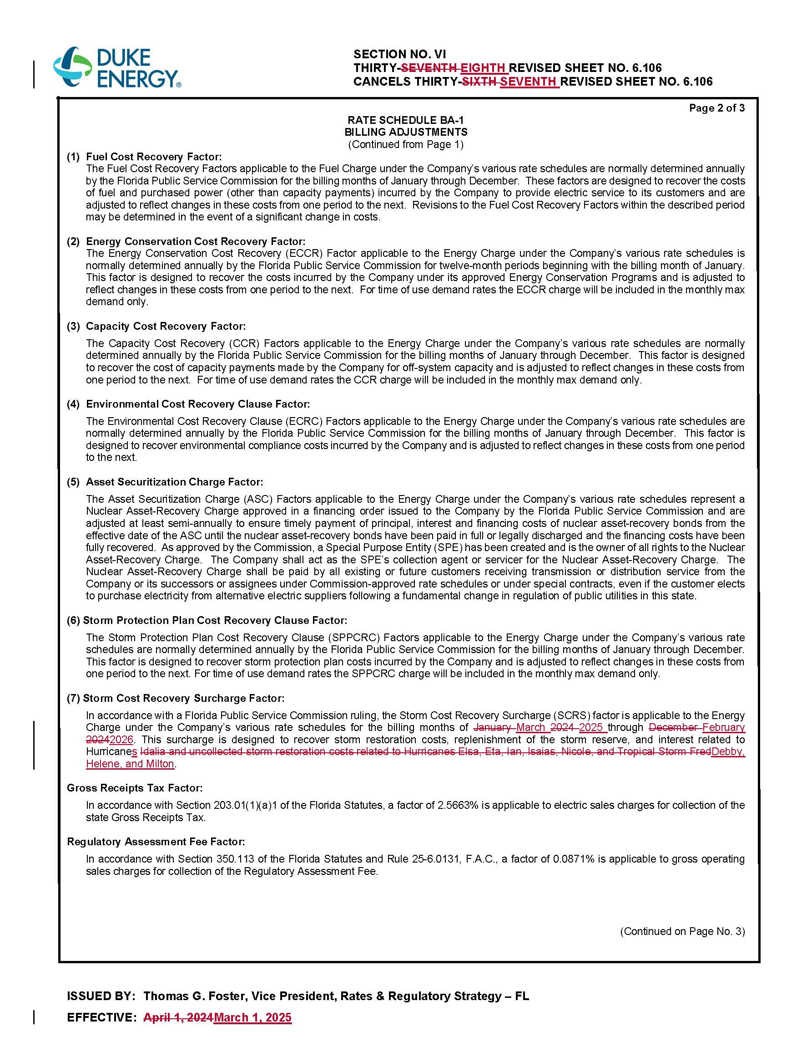

1. Order No. PSC-2024-0472-AS-EI, issued November 12, 2024, in Docket No. 20240025-EI, *In re: Petition for rate increase by Duke Energy Florida, LLC.*
2. Order No. PSC-2024-0377-FOF-EI, issued August 27, 2024, in Docket No. 20230020-EI, *In re: Petition for limited proceeding for recovery of incremental storm restoration costs related to Hurricanes Elsa, Eta, Isaias, Ian, Nicole, and Tropical Storm Fred, by Duke Energy Florida, LLC.*
3. We note that the attached tariff sheet No. 6.105 also includes revisions to the Asset Securitization Charge (ASC), effective March 1, 2025. Approval of the revised ACS charges is not at issue in this docket.