BEFORE THE FLORIDA PUBLIC SERVICE COMMISSION

|  |  |
| --- | --- |
| In re: Petition for recovery of costs associated with named tropical systems during the 2023 and 2024 hurricane seasons and replenishment of storm reserve, by Tampa Electric Company. | DOCKET NO. 20240172-EI  ORDER NO. PSC-2025-0062-PCO-EI  ISSUED: February 24, 2025 |

The following Commissioners participated in the disposition of this matter:

MIKE LA ROSA, Chairman

ART GRAHAM

GARY F. CLARK

ANDREW GILES FAY

GABRIELLA PASSIDOMO SMITH

ORDER APPROVING TAMPA ELECTRIC COMPANY’S

INTERIM STORM COST RECOVERY CHARGE

BY THE COMMISSION:

BACKGROUND

On December 27, 2024, Tampa Electric Company (TECO or Company) filed a petition for a limited proceeding seeking authority to implement an interim storm restoration recovery charge to recover $463.6 million for the incremental restoration costs related to Hurricanes Idalia, Debby, Helene, and Milton (collectively, the Storms), as well as the replenishment of its storm reserve. Included in the $463.6 million is accrued interest and projected interest in the amount of $14.4 million. Pursuant to the 2021 Stipulation and Settlement Agreement (2021 Settlement) we approved in Order No. PSC-2021-0423-S-EI, the recovery of storm costs from customers will begin, on an interim basis, 60 days after the filing of a cost recovery petition and tariff.[1] In TECO’s 2024 rate case,[2] we approved the continuation of the existing storm cost recovery mechanism established in the 2021 Settlement. TECO requested a 12-month recovery period, applied to all customer bills starting with the first billing cycle of March 2025.

We have jurisdiction over this matter pursuant to Sections 366.04, 366.05, 366.06, and 366.076, Florida Statutes.

DECISION

TECO filed a petition to seek recovery of $463.6 million in incremental storm restoration costs and interest related to Hurricanes Idalia, Debby, Helene, and Milton, as well as the replenishment of its storm reserve. In its petition, TECO requested to replenish the storm reserve to $55.8 million.

The petition was filed pursuant to the provisions of the 2021 Settlement. Pursuant to paragraph 8(a) of the 2021 Settlement, TECO is authorized to begin recovery of storm costs, on an interim basis, 60 days following the filing of a petition for recovery.

In its petition, TECO asserted that it incurred approximate recoverable costs in the amounts of $34.3 million for Hurricane Idalia; $4.0 million for Hurricane Debby; $52.0 million for Hurricane Helene; $358.9 million for Hurricane Milton. The remaining $14.4 million is for the interest accrued and projected interest on the unrecovered balance related to the Storms, based on a 12-month recovery period. For an 18-month recovery period, TECO would seek recovery of an additional $3.1 million due to the increase of projected interest for the longer recovery period, resulting in a total recoverable amount of $466.7. The Company further asserted that all amounts were calculated in accordance with the Incremental Cost and Capitalization Approach methodology prescribed in Rule 25-6.0143, Florida Administrative Code.

The approval of an interim storm restoration recovery charge is preliminary in nature and is subject to refund pending further review once the total actual storm restoration costs are known. After the actual costs are reviewed for prudence and reasonableness, and are compared to the actual amount recovered through the interim storm restoration recovery charge, a determination will be made whether any over/under recovery has occurred. The disposition of any over or under recovery, and associated interest, will be considered by this Commission at a later date.

Based on a review of the information provided by TECO in its petition, we hereby authorize the Company to implement an interim storm restoration recovery charge subject to refund. Once the total actual storm costs are known, TECO shall file documentation of the storm costs for our review and true-up of any excess or shortfall.

All funds collected subject to refund shall be secured by a corporate undertaking. The criteria for a corporate undertaking include sufficient liquidity, equity ownership, profitability, and interest coverage to guarantee any potential refund. TECO requested a 12-month collection period beginning with the first billing cycle in March 2025 through February 2026 for Interim Storm Recovery Charges of $463.6 million related to the Storms. For an 18-month collection period, the amount held subject to refund is $466.7 million due to an increase in interest charges for the longer period. On an annual basis, the amount held subject to refund is $311 million ($466.7 million × 0.667). We have reviewed TECO’s three most recent annual reports filed with us (2021, 2022, and 2023) to determine if the Company can support a corporate undertaking to guarantee the funds collected for incremental storm restoration costs related to the subject weather events. TECO’s financial information indicates the Company’s financial position to support a corporate undertaking of $463.6 million is marginal, but satisfactory. TECO is in a stronger financial position to support a corporate undertaking over an 18-month recovery period as opposed to a 12-month recovery period. TECO’s average net income over the last three years is $431 million, which is less than the requested interim amount. The Company’s net income in 2023 was $466 million which is slightly more than the requested storm cost recovery interim amount. TECO’s profitability, equity ownership, current ratio, and interest coverage for 2023 is sufficient to support a potential refund up to $233 million. Our corporate undertaking guidelines indicate that the maximum that should be allowed for a corporate undertaking is one-half of TECO’s 2023 net income, or $233 million. However, it is improbable TECO will be required to refund the entire requested amount of approximately $466.7 million ($311 million on an annual basis). Historically, TECO has supported its requested interim storm cost recovery amounts through a hearing process and we have approved those cost amounts with only minor adjustments. Further, the storm cost recovery mechanism is a surcharge for the sole purpose of recovering the costs incurred for storm restoration and any potential refund would be applied to the funds already collected and effectuated by reduced charges on future customer bills.

For these reasons, we find that TECO has adequate resources to support a corporate undertaking in the amount requested and that a corporate undertaking of $466.7 million ($311 million on an annual basis) is acceptable. This brief financial analysis is only appropriate for deciding if TECO can support a corporate undertaking in the amount requested and will not be considered in our evaluation of other issues in this proceeding.

TECO calculated the interim storm surcharge for the 12-month period of March 1, 2025, through February 28, 2026, subject to true-up once the final total recoverable storm amount is known and determined. In paragraph 12 of the petition, TECO states that the proposed surcharges are developed using the cost-of-service methodology approved in Order No. PSC-2025-0038-FOF-EI.[3] We have reviewed the allocation to rate classes and find that the allocations provided in Exhibit 5, page 2 to the petition are consistent with those approved in TECO’s most recent rate case. Furthermore, we have reviewed the derivation of the surcharges provided in amended Exhibit 5 to the petition for an 18-month recovery period. We find that the surcharges have been calculated correctly, using projected kilowatt hour (kWh) sales for March 2025 through August 2026.

The proposed interim storm restoration surcharges are shown on Third Revised Tariff Sheet No. 6.024, provided in Exhibit 6 to the petition. For residential customers, the proposed surcharge would be 3.004 cents per kWh, which equates to a total surcharge of $30.04 for a 1,000 kWh monthly bill. The storm cost recovery surcharge would be included in the non-fuel energy charge on customer bills.

In response to staff’s first data request, TECO stated that it had considered alternative recovery periods and its corresponding expected bill impacts. The Company decided that the 12-month recovery period reasonably balanced the length of the recovery period, customer bill impacts, and timeliness of recovery. A longer period would incur greater total cost due to additional interest charges but a lower monthly cost. If an 18-month period were adopted, the recovery period would extend through August 2026 and would result in a bill impact of $19.95 per 1,000 kWh on a monthly residential bill.

Paragraph 12(b) of the 2021 Settlement states that TECO may petition this Commission for recovery of storm costs at a rate above $4.00 on a 1,000 kWh residential bill if TECO incurs in excess of $100 million of storm recovery costs, and it does not specify a recovery period.

Therefore, we hereby approve TECO’s proposed interim storm restoration recovery tariff and associated surcharges, as shown in Attachment A to this order, utilizing an 18-month recovery period. The 18-month recovery period balances the need for TECO to recover its costs while keeping the monthly surcharge as affordable as possible for customers. The tariff shall become effective the first billing cycle of March 2025 and the interim storm restoration surcharges shall be subject to final true-up once the total actual storm costs are known.

Based on the foregoing, it is

ORDERED by the Florida Public Service Commission that Tampa Electric Company’s petition for recovery of incremental storm restoration costs related to Hurricanes Idalia, Debby, Helene, and Milton through the implementation of an interim storm restoration recovery charge subject to refund is hereby granted. Once the total actual storm costs are known, TECO shall file documentation of the total actual storm costs for our review and true-up of any excess or shortfall. It is further

ORDERED that the appropriate security to guarantee the funds collected subject to refund is a corporate undertaking in the amount of $466.7 million. It is further

ORDERED that TECO’s proposed interim storm restoration recovery tariff and associated surcharges, as shown in Attachment A of this order, is hereby approved effective with the first billing cycle of March 2025. The interim storm restoration surcharges shall be subject to final true-up once the total actual storm costs are known. It is further

ORDERED that this docket shall remain open pending final reconciliation of actual recoverable storm costs with the amount collected pursuant to the interim storm restoration recovery charge and the calculation of a refund or additional charge if warranted.

By ORDER of the Florida Public Service Commission this 24th day of February, 2025.

|  |  |
| --- | --- |
|  | /s/ Adam J. Teitzman |
|  | ADAM J. TEITZMAN  Commission Clerk |

Florida Public Service Commission

2540 Shumard Oak Boulevard

Tallahassee, Florida 32399

(850) 413‑6770

www.floridapsc.com

Copies furnished: A copy of this document is provided to the parties of record at the time of issuance and, if applicable, interested persons.

MRT

NOTICE OF FURTHER PROCEEDINGS OR JUDICIAL REVIEW

The Florida Public Service Commission is required by Section 120.569(1), Florida Statutes, to notify parties of any administrative hearing or judicial review of Commission orders that is available under Sections 120.57 or 120.68, Florida Statutes, as well as the procedures and time limits that apply. This notice should not be construed to mean all requests for an administrative hearing or judicial review will be granted or result in the relief sought.

Mediation may be available on a case-by-case basis. If mediation is conducted, it does not affect a substantially interested person's right to a hearing.

Any party adversely affected by this order, which is preliminary, procedural or intermediate in nature, may request: (1) reconsideration within 10 days pursuant to Rule 25-22.0376, Florida Administrative Code; or (2) judicial review by the Florida Supreme Court, in the case of an electric, gas or telephone utility, or the First District Court of Appeal, in the case of a water or wastewater utility. A motion for reconsideration shall be filed with the Office of Commission Clerk, in the form prescribed by Rule 25-22.0376, Florida Administrative Code. Judicial review of a preliminary, procedural or intermediate ruling or order is available if review of the final action will not provide an adequate remedy. Such review may be requested from the appropriate court, as described above, pursuant to Rule 9.100, Florida Rules of Appellate Procedure.

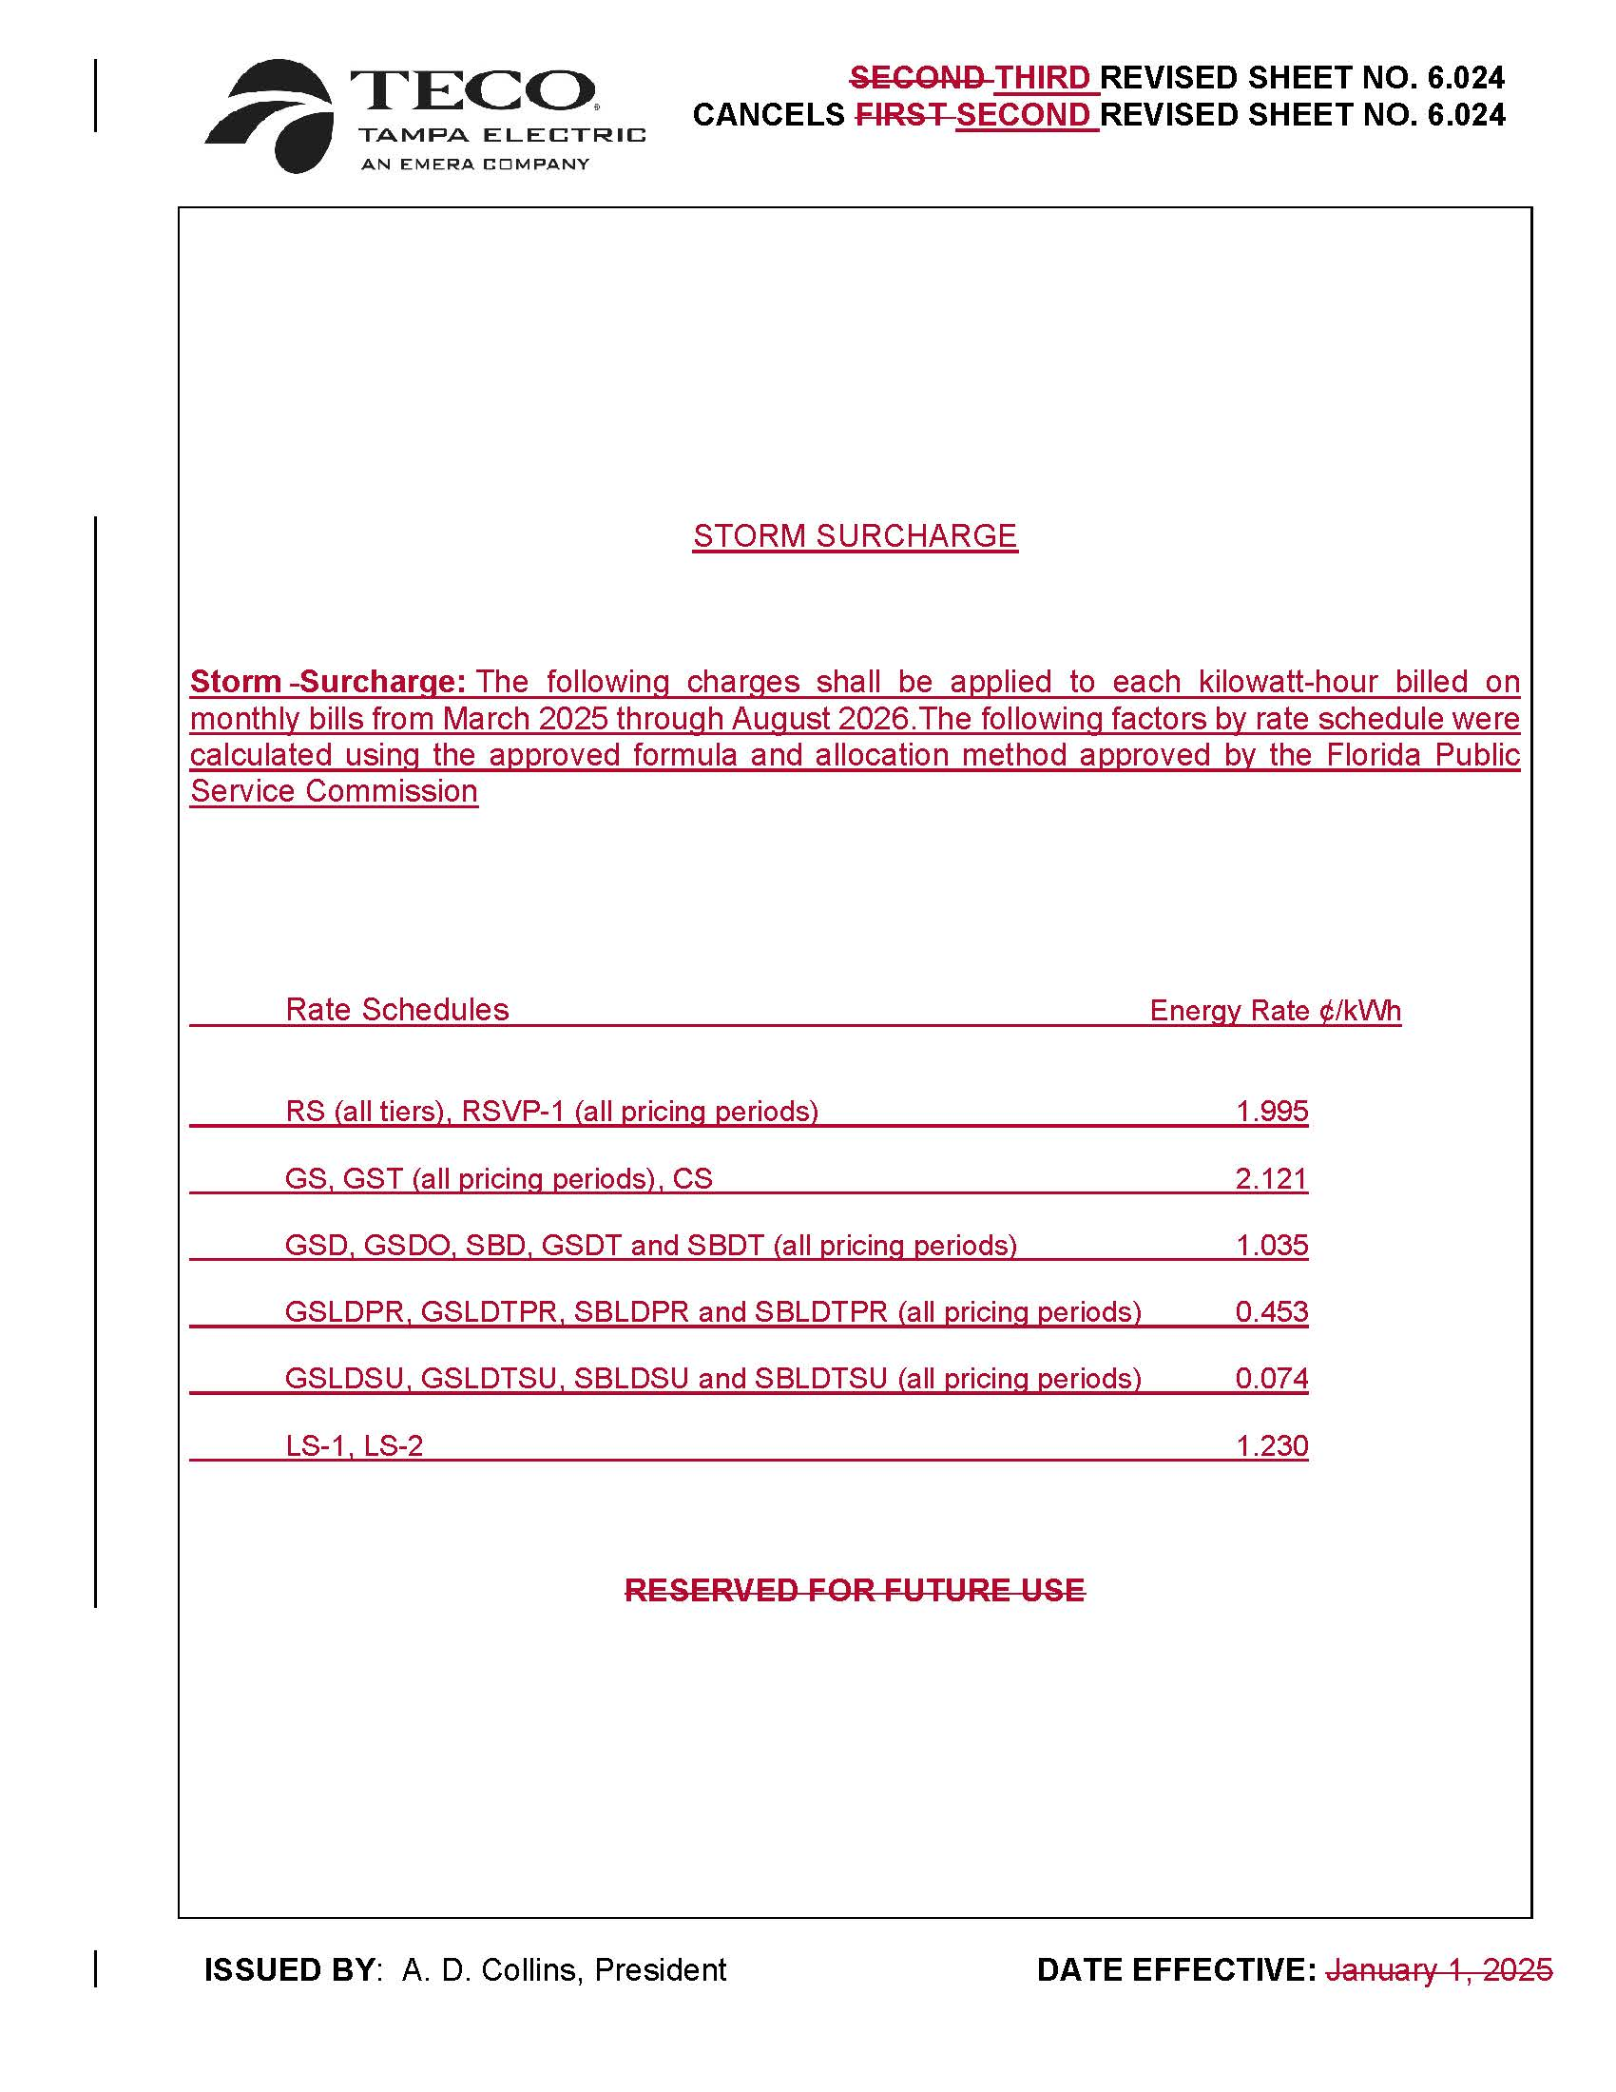

1. Order No. PSC-2021-0423-S-EI, issued November 10, 2021, in Docket No. 20210034-EI, *In re: Petition for rate increase by Tampa Electric Company.*
2. Order No. PSC-2025-0038-FOF-EI, issued February 3, 2024, in Docket No. 20240026-EI, *In re: Petition for rate increase by Tampa Electric Company*.
3. Docket No. 20240026-EI.