BEFORE THE FLORIDA PUBLIC SERVICE COMMISSION

|  |  |
| --- | --- |
| In re: Petition to expand eligible telecommunications service area to statewide, by Assurance Wireless USA, L.P. | DOCKET NO. 20240147-TP  ORDER NO. PSC-2025-0085-PAA-TP  ISSUED: March 24, 2025 |

The following Commissioners participated in the disposition of this matter:

MIKE LA ROSA, Chairman

ART GRAHAM

GARY F. CLARK

ANDREW GILES FAY

GABRIELLA PASSIDOMO SMITH

NOTICE OF PROPOSED AGENCY ACTION

ORDER GRANTING ASSURANCE WIRELESS USA, L.P.

ELIGIBLE TELECOMMUNICATIONS

SERVICE AREA TO STATEWIDE

BY THE COMMISSION:

NOTICE is hereby given by the Florida Public Service Commission that the action discussed herein is preliminary in nature and will become final unless a person whose interests are substantially affected files a petition for a formal proceeding, pursuant to Rule 25-22.029, Florida Administrative Code (F.A.C.).

Background

On October 22, 2024, Assurance Wireless USA, L.P. (Assurance or Company) filed a petition with this Commission requesting to expand its eligible telecommunications carrier (ETC) service area statewide solely to participate in the Lifeline program.

Assurance (previously known as Virgin Mobile USA, L.P.) had previously been granted a Lifeline-only ETC designation on July 12, 2010, over specific Florida wire centers that served AT&T, Frontier Florida (formerly Verizon), and CenturyLink.[1] Beyond Assurance’s current request for statewide ETC status, its petition indicates that it specifically seeks ETC status in three wire centers that are in AT&T, Frontier Florida, and CenturyLink territories, but which were not part of the list of wire centers for which ETC designation was previously granted in 2010.[2] Assurance is not seeking designation to receive high-cost support from the Universal Service Fund.

T-Mobile USA, Inc. (T-Mobile) acquired Assurance in 2020 as part of its purchase of Sprint Corporation. Assurance is a commercial mobile radio service (CMRS) provider that utilizes T-Mobile’s network to offer prepaid wireless telecommunications services. As a result, Assurance does not resell other carriers services.[3] As a CMRS provider, Assurance is regulated as a common carrier pursuant to 47 U.S.C. § 153(11). Assurance is one of the largest Lifeline providers in the United States and has been designated as a wireless ETC in 45 other states (46 including Florida) and the District of Columbia. Assurance is Florida's largest Lifeline provider, serving 116,807 active subscribers as of June 2024.[4]

On November 22, 2024, the Federal Communications Commission (FCC) ordered T-Mobile and Assurance to continue to provide Lifeline service to former Q-LINK Lifeline subscribers.[5] T-Mobile was the underlying carrier used by Q-LINK to provide Lifeline service. Q-LINK’s ETC status in Florida was revoked by this Commission as a result of fraud.[6] The FCC’s action was taken nationwide in order to ensure that customers would not lose service as a result of Q-LINK’s actions. Assurance has indicated that there are nine affected customers in the wire centers for which it now seeks ETC designation. Assurance is currently providing Lifeline services to the nine affected customers, but will be unable to receive reimbursements from Universal Service Administrative Company until its amended ETC petition is approved.[7]

Assurance asserts that it meets all applicable federal requirements for a statewide designation as a Lifeline-only ETC in Florida pursuant to 47 U.S.C. § 214(e) and 47 C.F.R. § 54.201. Additionally, Assurance acknowledges and asserts its commitment to comply with Sections 364.10 and 364.105, Florida Statutes (F.S.). Furthermore, Assurance acknowledges and asserts compliance with Rule 25-4.0665, Florida Administrative Code (F.A.C.), which governs the Lifeline service. This includes requirements such as providing a transitional discount for customers who no longer qualify for the Lifeline program and ensuring participation in the Lifeline Promotion Process.

We are vested with jurisdiction in this matter pursuant to Section 214(e)(2) of the Telecommunications Act of 1996 (the Act) and Section 364.10, F.S.

Decision

1. Requirements for ETC Designation

In Assurance’s amended petition for statewide ETC designation, it also specifically identifies three wire centers for which it requests ETC designation. Staff notes that granting the requested statewide ETC designation will satisfy all of Assurance's requests.[8] A statewide ETC designation is necessary for telecommunications companies to participate in the federal Lifeline program throughout the State of Florida.[9] Section 364.10, F.S., allows this Commission to approve the wireless Lifeline ETC petitions of requesting carriers. Specifically, Section 364.10(1)(a) and (3)(a), F.S., provide that we have the authority to grant ETC designation to a CMRS provider for the limited purpose of providing Lifeline service.

Federal rules outline the requirements for ETC designation.[10] To obtain ETC designation to provide Lifeline services, federal rules require that carriers:

1. Be a common carrier;
2. Offer the services that are supported by the federal universal support mechanisms either using its own facilities or a combination of its own facilities and resale of another carrier’s services;
3. Advertise the availability of its Lifeline service through a media of general distribution;
4. Provide voice grade access to the public switch network or its functional equivalent;
5. Offer minutes of use for local service at no additional charge to end users;
6. Provide access to the emergency services available by local government or other public safety organizations;
7. Provide Broadband Internet Access Service;[11]
8. Demonstrate financial and technical capability to provide Lifeline service; and,
9. Not charge Lifeline customers a monthly number-portability charge.

In addition, Florida law requires ETCs to:

1. Offer a discounted transitional basic telecommunications service;[12] and
2. Participate in the Lifeline Promotion Process.[13]

Assurance asserts it will comply with all federal and state requirements governing ETCs. Assurance further asserts it offers all the supported services listed under Section 254(c) of the Act through the use of its own facilities. The company notes its facilities may change over time.[14]

Financial, Managerial, and Technical Capabilities

Assurance asserts it has the financial, technical, and managerial backing of T-Mobile, the second largest wireless carrier in the United States. As shown in Attachment A, Assurance offers statewide wireless T-Mobile coverage capable of providing Lifeline services throughout the entirety of Florida. As a current ETC in Florida, Assurance is in good standing with this Commission, and consistently responds to Staff’s annual data requests. Assurance is also an ETC in 45 other states, as well as the District of Columbia, and has never been subject to any ETC revocation proceedings.[15] Based on these factors, Assurance has demonstrated the financial, managerial, and technical qualifications necessary to provide statewide Lifeline services.

1. Public Interest

State commissions are required to find that ETC designation serves the public interest.[16] Assurance offers its Lifeline subscribers 1,000 minutes and 4.5 GB of data per month at no cost to the consumer.[17] Additionally, annual data collected by the Commission indicates that Assurance is Florida’s most selected Lifeline provider. Over the past five years, Assurance has consistently accounted for more than half of Florida's Lifeline market, with June 2024 Lifeline data indicating that Assurance served 55 percent of all Lifeline subscribers in the state.[18]

Assurance asserts in its petition that if granted a statewide ETC designation, substantially more low-income consumers will have the choice of selecting Assurance as a Lifeline provider. As noted above, Assurance is providing Lifeline discounts to nine households outside of its current ETC designated area. As a result, it cannot receive reimbursements for these households from Universal Service Administrative Company.[19] Granting Assurance its requested statewide ETC designation will ensure that all affected customers will continue to receive Lifeline services. For these reasons, we believe that granting Assurance a statewide ETC designation is in the public interest.

1. Conclusion

We have reviewed Assurance’s petition and determined that the company meets all requirements to expand its service area and receive the requested statewide ETC designation. Assurance also asserts it will comply with all federal and state requirements governing ETCs. Furthermore, Assurance has demonstrated sufficient financial, managerial, and technical capabilities. We find that granting Assurance a statewide ETC designation serves the public interest. Therefore, this Commission will grant Assurance ETC designation throughout the State of Florida as identified in Attachment A of this Order. If there is a future change of Company ownership, the new owners shall be required to file a petition with the Commission to demonstrate that it is in the public interest to maintain the company’s ETC designation.

Based on the foregoing, it is

ORDERED by the Florida Public Service Commission that the petition by ASSURANCE WIRELESS USA, L.P. to expand its eligible telecommunications service area to statewide throughout Florida as identified in Attachment A is GRANTED. It is further

ORDERED that if there is a future change in ASSURANCE WIRELESS USA, L.P.’s ownership, the new owners shall file a petition with the Commission demonstrating that it is in the public interest to maintain the ETC designation. It is further

ORDERED that the provisions of this Order, issued as a proposed agency action, shall become final and effective upon the issuance of a Consummating Order unless an appropriate petition, in the form provided by Rule 28-106.201, F.A.C., is received by the Commission Clerk at 2540 Shumard Oak Blvd., Tallahassee, FL 32399-0850, by the close of business on the date set forth in the ‘Notice of Further Proceedings or Judicial Review” attached hereto. It is further

ORDERED that in the event this Order becomes final, this docket shall be closed.

By ORDER of the Florida Public Service Commission this 24th day of March, 2025.

|  |  |
| --- | --- |
|  | /s/ Adam J. Teitzman |
|  | ADAM J. TEITZMAN  Commission Clerk |

Florida Public Service Commission

2540 Shumard Oak Boulevard

Tallahassee, Florida 32399

(850) 413‑6770

www.floridapsc.com

Copies furnished: A copy of this document is provided to the parties of record at the time of issuance and, if applicable, interested persons.

JLA

NOTICE OF FURTHER PROCEEDINGS OR JUDICIAL REVIEW

The Florida Public Service Commission is required by Section 120.569(1), Florida Statutes, to notify parties of any administrative hearing that is available under Section 120.57, Florida Statutes, as well as the procedures and time limits that apply. This notice should not be construed to mean all requests for an administrative hearing will be granted or result in the relief sought.

Mediation may be available on a case-by-case basis. If mediation is conducted, it does not affect a substantially interested person's right to a hearing.

The action proposed herein is preliminary in nature. Any person whose substantial interests are affected by the action proposed by this order may file a petition for a formal proceeding, in the form provided by Rule 28-106.201, Florida Administrative Code. This petition must be received by the Office of Commission Clerk, 2540 Shumard Oak Boulevard, Tallahassee, Florida 32399-0850, by the close of business on April 14, 2025.

In the absence of such a petition, this order shall become final and effective upon the issuance of a Consummating Order.

Any objection or protest filed in this/these docket(s) before the issuance date of this order is considered abandoned unless it satisfies the foregoing conditions and is renewed within the specified protest period.

**Page 1 of 1**

**Florida**

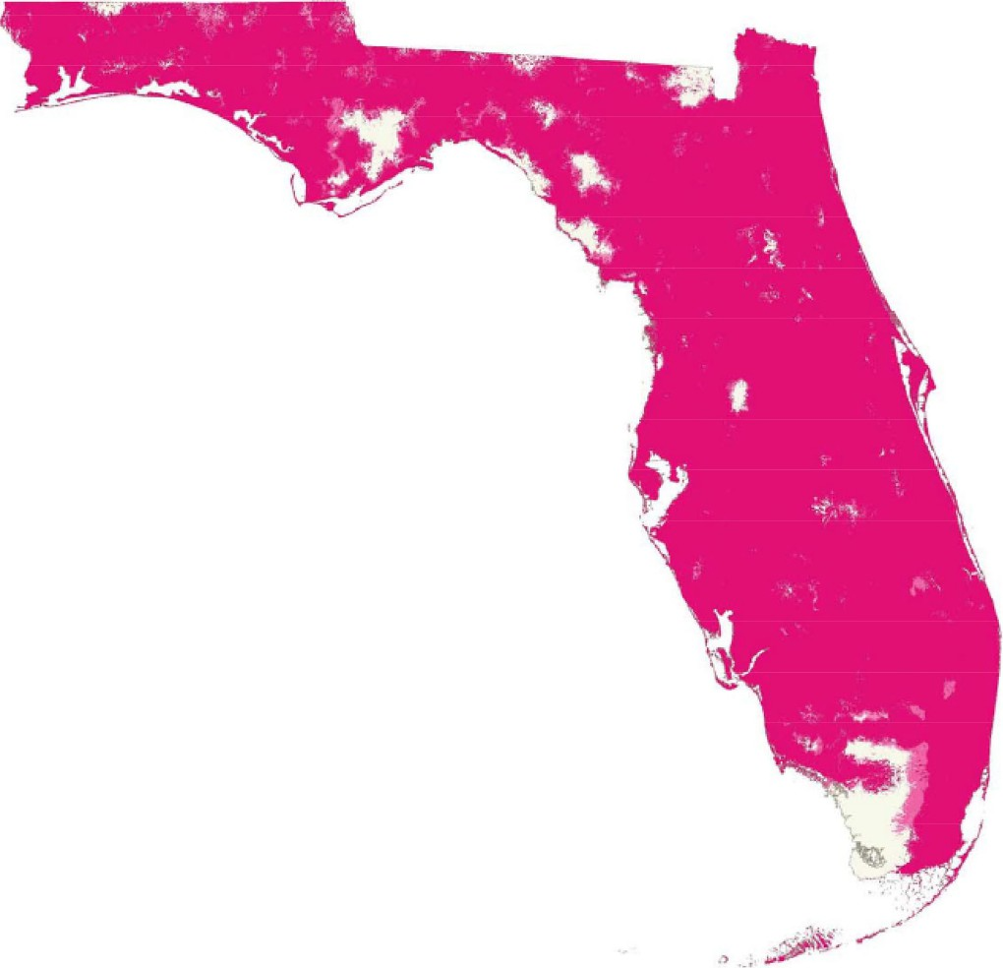

**-T-Mobile** Coverage

1. FPSC Docket No. 20090245-TP, PSC-10-0323-PAA-TP. See also, Consummating Order PSC-10-0444-CO-TP, issued July 12, 2010.
2. FPSC Docket 20240147-TP, DN 09645-2024, Exhibit A.
3. FPSC Docket 20240147-TP, DN 00660-2025.
4. FPSC 2024 Florida Lifeline Report, p. 24, Appendix C, https://www.floridapsc.com/pscfiles/website-files/PDF/Publications/Reports/Telecommunication/LifelineReport/2024.pdf, accessed February 19, 2025.
5. FCC Order, DA 24-1182, released November 22, 2024.
6. FPSC Docket No. 20240146-TP, DN 09982-2024.
7. FPSC Docket No. 20240147-TP, DN 00660-2025.
8. Assurance specifically requested ETC designation in the wire centers of WPBHFLGR, MICCFLBB, and KSSMFXC, while also concurrently requesting statewide ETC designation.
9. 47 C.F.R. § 254(e).
10. 47 U.S.C. § 214(e)(1), 47 C.F.R. § 54.101, 47 C.F.R. § 54.201, and 47 C.F.R. § 54.401. While 47 C.F.R. § 54.101(a) also includes requirements addressing toll limitation services to qualifying low-income consumers, the FCC in its 2012 Lifeline and Link Up Reform Order (FCC 12-11) stated that: “ETCs are not required to offer toll limitation service to low-income consumers if the Lifeline offering provides a set amount of minutes that do not distinguish between toll and non-toll calls.”
11. Broadband Internet Access Service (BIAS) is defined as a mass-market retail service that provides the capability to transmit and receive data, but excluding dial-up service.
12. Section 364.105, F.S., states that each ETC shall offer a residential basic local telecommunications service at 70 percent of the residential local telecommunications service rate for any Lifeline subscriber who no longer qualifies for Lifeline for a period of 1 year after the date the subscriber ceases to qualify for Lifeline .
13. *See* Rule25-4.0665(3), F.A.C. The Lifeline Promotion Process is an electronic system developed in collaboration with the Florida Department of Children and Families, ETCs and the FPSC. This system helps assist ETCs and the FPSC in providing information on how to apply for Lifeline assistance to eligible customers.
14. Assurance is not required to obtain an approved FCC compliance plan in accordance with the 2012 Lifeline Reform Order because it meets the facilities requirement.
15. FPSC Docket No. 20240147-TP, DN 00660-2025.
16. 47 U.S.C. § 214(e)(2).
17. FPSC, 2024 Florida Lifeline Report, p. 16, https://www.floridapsc.com/pscfiles/website-files/PDF/Publications/Reports/Telecommunication/LifelineReport/2024.pdf, accessed February 19, 2025.
18. FPSC 2024 Florida Lifeline Report, p. 24, Appendix C, https://www.floridapsc.com/pscfiles/website-files/PDF/Publications/Reports/Telecommunication/LifelineReport/2024.pdf, accessed February 19, 2025.
19. FPSC Docket 20240147-TP, DN 00660-2025.