BEFORE THE FLORIDA PUBLIC SERVICE COMMISSION

|  |  |
| --- | --- |
| In re: Joint petition for approval of temporary services by Tampa Electric Company and City of Lakeland. | DOCKET NO. 20240171-EU  ORDER NO. PSC-2025-0089-PAA-EU  ISSUED: March 24, 2025 |

The following Commissioners participated in the disposition of this matter:

MIKE LA ROSA, Chairman

ART GRAHAM

GARY F. CLARK

ANDREW GILES FAY

GABRIELLA PASSIDOMO SMITH

NOTICE OF PROPOSED AGENCY ACTION

ORDER APPROVING JOINT PETITION FOR TEMPORARY SERVICES

BY THE COMMISSION:

NOTICE is hereby given by the Florida Public Service Commission that the action discussed herein is preliminary in nature and will become final unless a person whose interests are substantially affected files a petition for a formal proceeding, pursuant to Rule 25-22.029, Florida Administrative Code (F.A.C.).

Background

On December 23, 2024, the City of Lakeland, Florida, d/b/a Lakeland Electric (Lakeland), and Tampa Electric Company (TECO) filed a joint petition seeking our approval to provide temporary electric service to two parcels. The existing territorial agreement between Lakeland and TECO (joint petitioners or utilities), executed in 1991 (Original Agreement)[1] and subsequently amended twice,[2] allows for temporary electric service to extra-territorial customers. While the term “temporary service” is not defined in the Original Agreement, the joint petitioners cite to Sections 2.2 and 4.1, which require them to enter into a joint agreement and then seek our approval of the requested temporary service.[3]

Lakeland and TECO make similar requests to each other in the joint petition. Specifically, TECO has requested Lakeland to extend and provide retail electric service to 39 lots within the proposed property development referred to as Schaller Preserve subdivision. The lots are currently located within TECO’s service territory. In turn, Lakeland has requested TECO to extend and provide retail electric service to the second proposed property development referred to as Phase 2 of Cadence Crossing. The lots are currently located in Lakeland’s service territory. The joint petitioners assert that in both cases, the other party has distribution facilities that are physically closer with the capacity to provide needed service.

The joint petitioners seek approval of their proposed temporary services request on an expedited basis in an effort to facilitate property developer timeframes. Pending approval of the instant petition, the facilities that would ultimately be installed by both parties would be permanent facilities. The joint petitioners view the services that would be provided as temporary insofar as we must approve the joint petitioners’ subsequent territorial agreement filing in order for such service to become permanent. Through a Letter of Intent attached to their petition, the joint petitioners state they are engaged in developing a comprehensive territorial amendment pleading to make these and other changes permanent. The petition includes exhibits that are attached to this Order as Attachment A for informational purposes.

During the review process, Commission staff held a meeting with the parties on December 16, 2024, and issued two data requests to the joint petitioners, for which responses were received January 21, 2025 and February 11, 2025.­

We have jurisdiction over this matter under Section 366.04(2)(d), F.S.

Discussion

Sections 2.2 and 4.1 of the Original Agreement require that the joint petitioners seek our approval in order to provide temporary service. With such approval, the joint petitioners state that they will then fulfill their written agreement to extend and provide temporary retail electric service to the Schaller Preserve (Lakeland Electric) and Phase 2 of Cadence Crossing (TECO). In addition, as further described below, the parties have expressed their intent to file with us a petition for a territorial amendment to make permanent the temporary service to these parcels on or before June 30, 2025.

Petition Summary

The provision of temporary service is addressed Section 2.2 of the Original Agreement, which provides in relevant part as follows:

TECO and LAKELAND recognize that in exceptional circumstances, economic constraints on either utility or good engineering practices may indicate that a Customer’s temporary end use and/or small discrete service area and/or future retail Customers should not be immediately served by the utility in whose service territory they are located. In such instances, upon written request by the utility in whose territory the end use facility is located to the other utility, the other utility may agree in writing to provide service to such Customer’s temporary end use, small discrete service areas and future retail Customers. Such agreements shall be submitted to the Florida Public Service Commission in accordance with Article IV, Section 4.1 hereof.

In order to structure their forthcoming amendment, the joint petitioners have entered into a Letter of Intent[4] to negotiate and execute an appropriate amendment to their Original Agreement, and to seek our approval of the same.

The joint petitioners have asserted that the proposed boundary line changes are minor, and cite to two main reasons for them. First, the joint petitioners contend that minor changes are needed to avoid uneconomic duplication of services. Second, the proposed temporary service arrangement, if approved, would permit the developers to make their design and acquisition decisions timely and without disruption. The joint petitioners stated that the process for filing a comprehensive territorial amendment is time consuming and labor intensive on the part of the utilities and obtaining our decision on a comprehensive territorial amendment is not consistent with the timeline for development of the Schaller Preserve and Phase 2 of Cadence Crossing subdivisions. The joint petitioners also state that the service will be temporary in that it will only last until we make a decision on a subsequent request for a permanent territorial amendment. The developers plan to proceed to develop the parcels after we approve temporary service, and the utilities plan to coordinate with the developers to install electric service as site development progresses.

Plat maps for each respective parcel were included in the original filing and are included for informational purposes as Exhibits A and B in Attachment A to this Order. Additional maps were provided in data request responses.[5]

The joint petitioners state that we have previously approved temporary service in Docket No. 970999-EU.[6] The joint petitioners contend that this order demonstrates a precedent for us to approve the instant petition, although they acknowledge that the facts and circumstances at issue herein are not factually similar to those supporting the earlier temporary service request. In the 1997 docket, we approved the placement of temporary facilities to energize a single circuit providing service to a pump station until such time as the other utility had facilities in place within its own territory. However, in the instant petition, there are no existing customers and the service is described as temporary, but the facilities are placed with the intention of being permanent in both petitioners’ territories.

Although the instant petition was filed on December 23, 2024, the joint petitioners executed their Letter of Intent in September of 2024. In a data request response, the joint petitioners stated that responding to hurricane events played a part in the difference between those dates. The joint petitioners contend that the timeline the developers are seeking to adhere to, and the timeline for the utilities to negotiate and execute an appropriate amendment to their Original Agreement, are quite different. Through this pleading, the petitioners are collectively endeavoring to bridge the gap between those timelines. Although the joint petitioners state they are seeking authority to provide temporary electric services, their intent is to install permanent facilities in the parcels that currently exist in each others’ respective service areas. A description of the two parcels and the proposals for temporary service provisions is as follows:

Schaller Preserve

The lots at issue in the Schaller Preserve subdivision are currently located in TECO’s service territory, and the current plat map for this development spans the service territory of both utilities. Pursuant to the Letter of Intent, the joint petitioners propose boundary changes that would permit Lakeland, not TECO, to serve those lots, if the instant petition is approved. The Schaller Preserve subdivision would add 39 lots to Lakeland’s service territory, as shown in the map the joint petitioners provided with their petition. An additional map was provided in response to a staff data request. Lakeland anticipates that it would provide standard residential electric and lighting services to these lots.

Lakeland has stated that the developer for the Schaller Preserve subdivision anticipates initiating development work within the February-April 2025 timeframe (60 to 120 days from the date the petition was filed, which was December 23, 2024). Additionally, Lakeland states it will work with the developer to coordinate scheduling of the electric infrastructure. The estimated cost for Lakeland to provide residential electric and lighting services to these 39 lots in Schaller Preserve is approximately $78,000. In comparison, the estimated cost for TECO to provide this service is approximately $105,000.

In their responses to data request responses, the joint petitioners assert that Lakeland would provide standard residential electric service and lighting services to the subject lots, pursuant to Lakeland’s tariffs on file with us. Although the plat map for the Schaller Preserve development spans the service territories of both utilities, the nearest Lakeland facilities to the 39 lots at issue herein is approximately five feet. For comparison, the approximate distance from the subject lots and TECO’s facilities is about 1,000 feet. Lakeland did not provide us with an estimated date that they will energize Schaller Preserve, but stated they will be ready to provide service depending on the developer’s schedule.

Phase 2 of Cadence Crossing

Cadence Crossing Phase 2 refers to a specific portion of the entire Cadence Crossing development. The map the joint petitioners provided with their petition also show Phases 1 and 3 for Cadence Crossing, but the instant pleading pertains solely to Phase 2 of Cadence Crossing, which is currently platted into 34 lots. An additional map of Phase of Cadence Crossing was provided in response to a staff data request. The entire geographic area for Phase 2 of the Cadence Crossing subdivision is currently located in Lakeland’s service territory. Pursuant to the Letter of Intent and the joint petitioner’s motion, TECO would be the utility serving these lots. TECO anticipates that it would provide services pursuant to its current RS, LS-1, or LS-2 tariffs, with the potential for a GS or GSD customer. Phase 2 of Cadence Crossing will also require two additional auxiliary services, a well pump and lighting services. The nearest TECO facilities to the subject lots are about 20 feet away. For comparative purposes, the nearest Lakeland facilities to Phase 2 of Cadence Crossing are about 50 feet away.

TECO states that it plans to finalize the engineering necessary to feed Phase 2 of Cadence Crossing by mid-February of 2025. At that time, and pending approval of this joint petition, TECO will proceed with approval of engineering and then construction. The estimated cost for TECO to provide this service to the 34 lots is $115,000. In comparison, the estimated cost for Lakeland to provide this service is $118,000. TECO anticipates energizing Phase 2 by the fourth quarter of 2025.

Circumstances Supporting the Temporary Service

The first circumstance supporting the instant petition is the indication that no uneconomic duplication of service would result from the proposed service extensions. As indicated above, the estimated costs for providing service to the Schaller Preserve lots is lower for Lakeland than TECO. Conversely, the estimated costs for providing service to the Phase 2 of Cadence Crossing is lower for TECO than Lakeland.

The second supportive circumstance of the instant petition is that the temporary service requested would not require the transfer of existing customers for either utility. In addition, the utilities have indicated no service reliability issues are expected to occur as a result of the proposed provision of temporary service.

Last, the identified parcels are components of large-scale developments, and the parties are engaged in evaluating other potential boundary line changes outside of Schaller Preserve and Cadence Crossing. These evaluations have contributed to the complexity of filing a comprehensive territorial amendment and the joint petitioners opted to file the instant petition to accommodate developer timelines.

Necessary Conditions

We find that certain conditions are warranted in order to ensure that our conclusive review of the joint petitioners’ territorial boundaries per Rule 25-6.0440, F.A.C., is not delayed. Rule 25-6.0440, F.A.C. provides specific guidance on topics such as pricing of transferred facilities, precise mapping, prospective reliability impacts, and the elimination or prevention of potential uneconomic duplication of facilities. Pursuant to the Letter of Intent, the joint petitioners intend to file a comprehensive territorial amendment on or before June 30, 2025. In the event that the joint petitioners do not meet that deadline, the joint petitioners shall provide a detailed report explaining the progress made towards filing such an amendment, the reasons why an amendment could not be timely filed, and when the joint petitioners expect to file the territorial amendment.

While the services to be provided are described as “temporary” by the utilities, the petition proposes to allow the installation of facilities designed for permanent services and to establish new service territories for each utility. This request would be more appropriately presented in a petition for a territorial amendment subject to the standards of review set forth in Rule 25-6.0440, F.A.C.

As noted previously, the joint petitioners cite to provisions in their Original Agreement in requesting approval of temporary service, yet the term is not clearly defined. In past instances, we have addressed requests for temporary service tied to a specific time period (*e.g.*, five years) when the temporary provision of electric service would be replaced by permanent service by the incumbent utility.[7] In those instances, no revision of boundary lines were contemplated because the facilities were temporary, like the service. Indeed, the Original Agreement refers to such temporary service being provided when the customer(s) “should not be immediately served” by the incumbent utility, connoting a time limiting aspect. Further complicating the definition of “temporary service” is the fact that the joint petitioners do not contemplate actually energizing the facilities (i.e., providing electric service) until as late as the fourth quarter of 2025.

Because the term “temporary service” is undefined in the Original Agreement, and because the application of that term by the joint petitioners is intuitively incongruent, we encourage the joint petitioners to consider amending Section 2.2 to either include an appropriate definition of “temporary” and criteria under which those services could be provided, or to delete all references to the provision of temporary services.

Decision

We approve the joint petitioners’ request regarding the proposed provision of temporary retail electric service between Lakeland and TECO. The circumstances supportive of our approval include: (1) a clear indication that no uneconomic duplication of service would result from the proposed service extensions; (2) no customers will be transferred and no service reliability issues are expected to occur; and (3) the timing of relatively large-scale developments of the impacted land parcels, and the complexity of the anticipated boundary changes, has contributed to the urgency of the provision of temporary electric service. Thus, we approve the joint petitioners’ request for temporary electric service between Lakeland and TECO, subject to the following conditions:

1. The joint petitioners must continue their good faith effort to meet all of the respective obligations set forth in the joint petition’s Letter of Intent including filing a comprehensive territorial amendment for the subject parcels identified in the joint petition with us on or before June 30, 2025; and
2. In the event the joint petitioners do not file a comprehensive territorial amendment on or before June 30, 2025, they must, by that date, provide a detailed report explaining the progress made towards filing such amendment, the reasons why an amendment could not be timely filed, and when the joint petitioners expect to file the territorial amendment.
3. The joint petitioners are encouraged to consider amending Section 2.2 of the Original Agreement to either include an appropriate definition of services currently described as “temporary” and identify criteria under which those services could be provided, or to delete all references to the provision of temporary services.

Based on the foregoing, it is

ORDERED by the Florida Public Service Commission that the joint petition by Tampa Electric Company and the City of Lakeland for the approval of temporary services is approved. It is further

ORDERED that Tampa Electric Company and the City of Lakeland must file with us no later than June 30, 2025, either a comprehensive territorial amendment for the subject parcels identified in the joint petition, or a detailed report explaining the progress made towards filing such amendment, the reasons why the amendment could not be timely filed, and an estimate as to when the joint petitioners expect to file the territorial amendment. It is further

ORDERED that Tampa Electric Company and the City of Lakeland are encouraged to consider amending Section 2.2 of the Original Agreement to either include an appropriate definition of services currently described as “temporary” and identify criteria under which those services could be provided, or to delete all references to the provision of temporary services. It is further

ORDERED that the provisions of this Order, issued as proposed agency action, shall become final and effective upon the issuance of a Consummating Order unless an appropriate petition, in the form provided by Rule 28-106.201, Florida Administrative Code, is received by the Commission Clerk, 2540 Shumard Oak Boulevard, Tallahassee, Florida 32399-0850, by the close of business on the date set forth in the “Notice of Further Proceedings” attached hereto. It is further

ORDERED that in the event this Order becomes final, this docket shall be closed.

By ORDER of the Florida Public Service Commission this 24th day of March, 2025.

|  |  |
| --- | --- |
|  | /s/ Adam J. Teitzman |
|  | ADAM J. TEITZMAN  Commission Clerk |

Florida Public Service Commission

2540 Shumard Oak Boulevard

Tallahassee, Florida 32399

(850) 413‑6770

www.floridapsc.com

Copies furnished: A copy of this document is provided to the parties of record at the time of issuance and, if applicable, interested persons.

SPS

NOTICE OF FURTHER PROCEEDINGS OR JUDICIAL REVIEW

The Florida Public Service Commission is required by Section 120.569(1), Florida Statutes, to notify parties of any administrative hearing that is available under Section 120.57, Florida Statutes, as well as the procedures and time limits that apply. This notice should not be construed to mean all requests for an administrative hearing will be granted or result in the relief sought.

Mediation may be available on a case-by-case basis. If mediation is conducted, it does not affect a substantially interested person's right to a hearing.

The action proposed herein is preliminary in nature. Any person whose substantial interests are affected by the action proposed by this order may file a petition for a formal proceeding, in the form provided by Rule 28-106.201, Florida Administrative Code. This petition must be received by the Office of Commission Clerk, 2540 Shumard Oak Boulevard, Tallahassee, Florida 32399-0850, by the close of business on April 14, 2025.

In the absence of such a petition, this order shall become final and effective upon the issuance of a Consummating Order.

Any objection or protest filed in this/these docket(s) before the issuance date of this order is considered abandoned unless it satisfies the foregoing conditions and is renewed within the specified protest period.

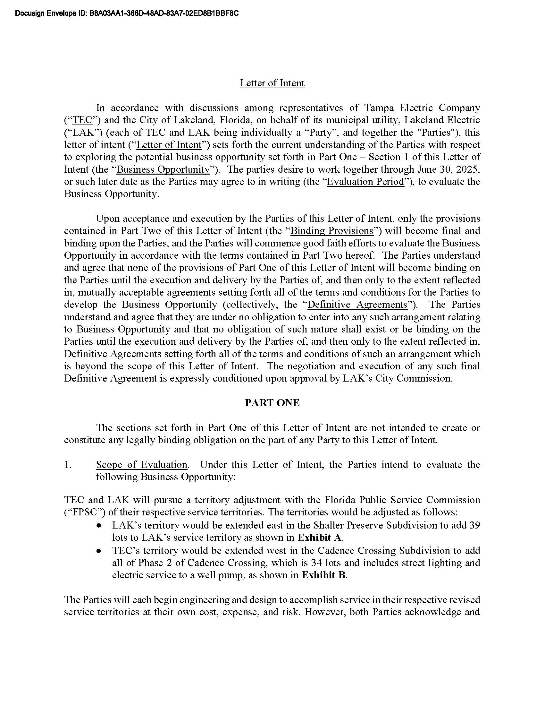

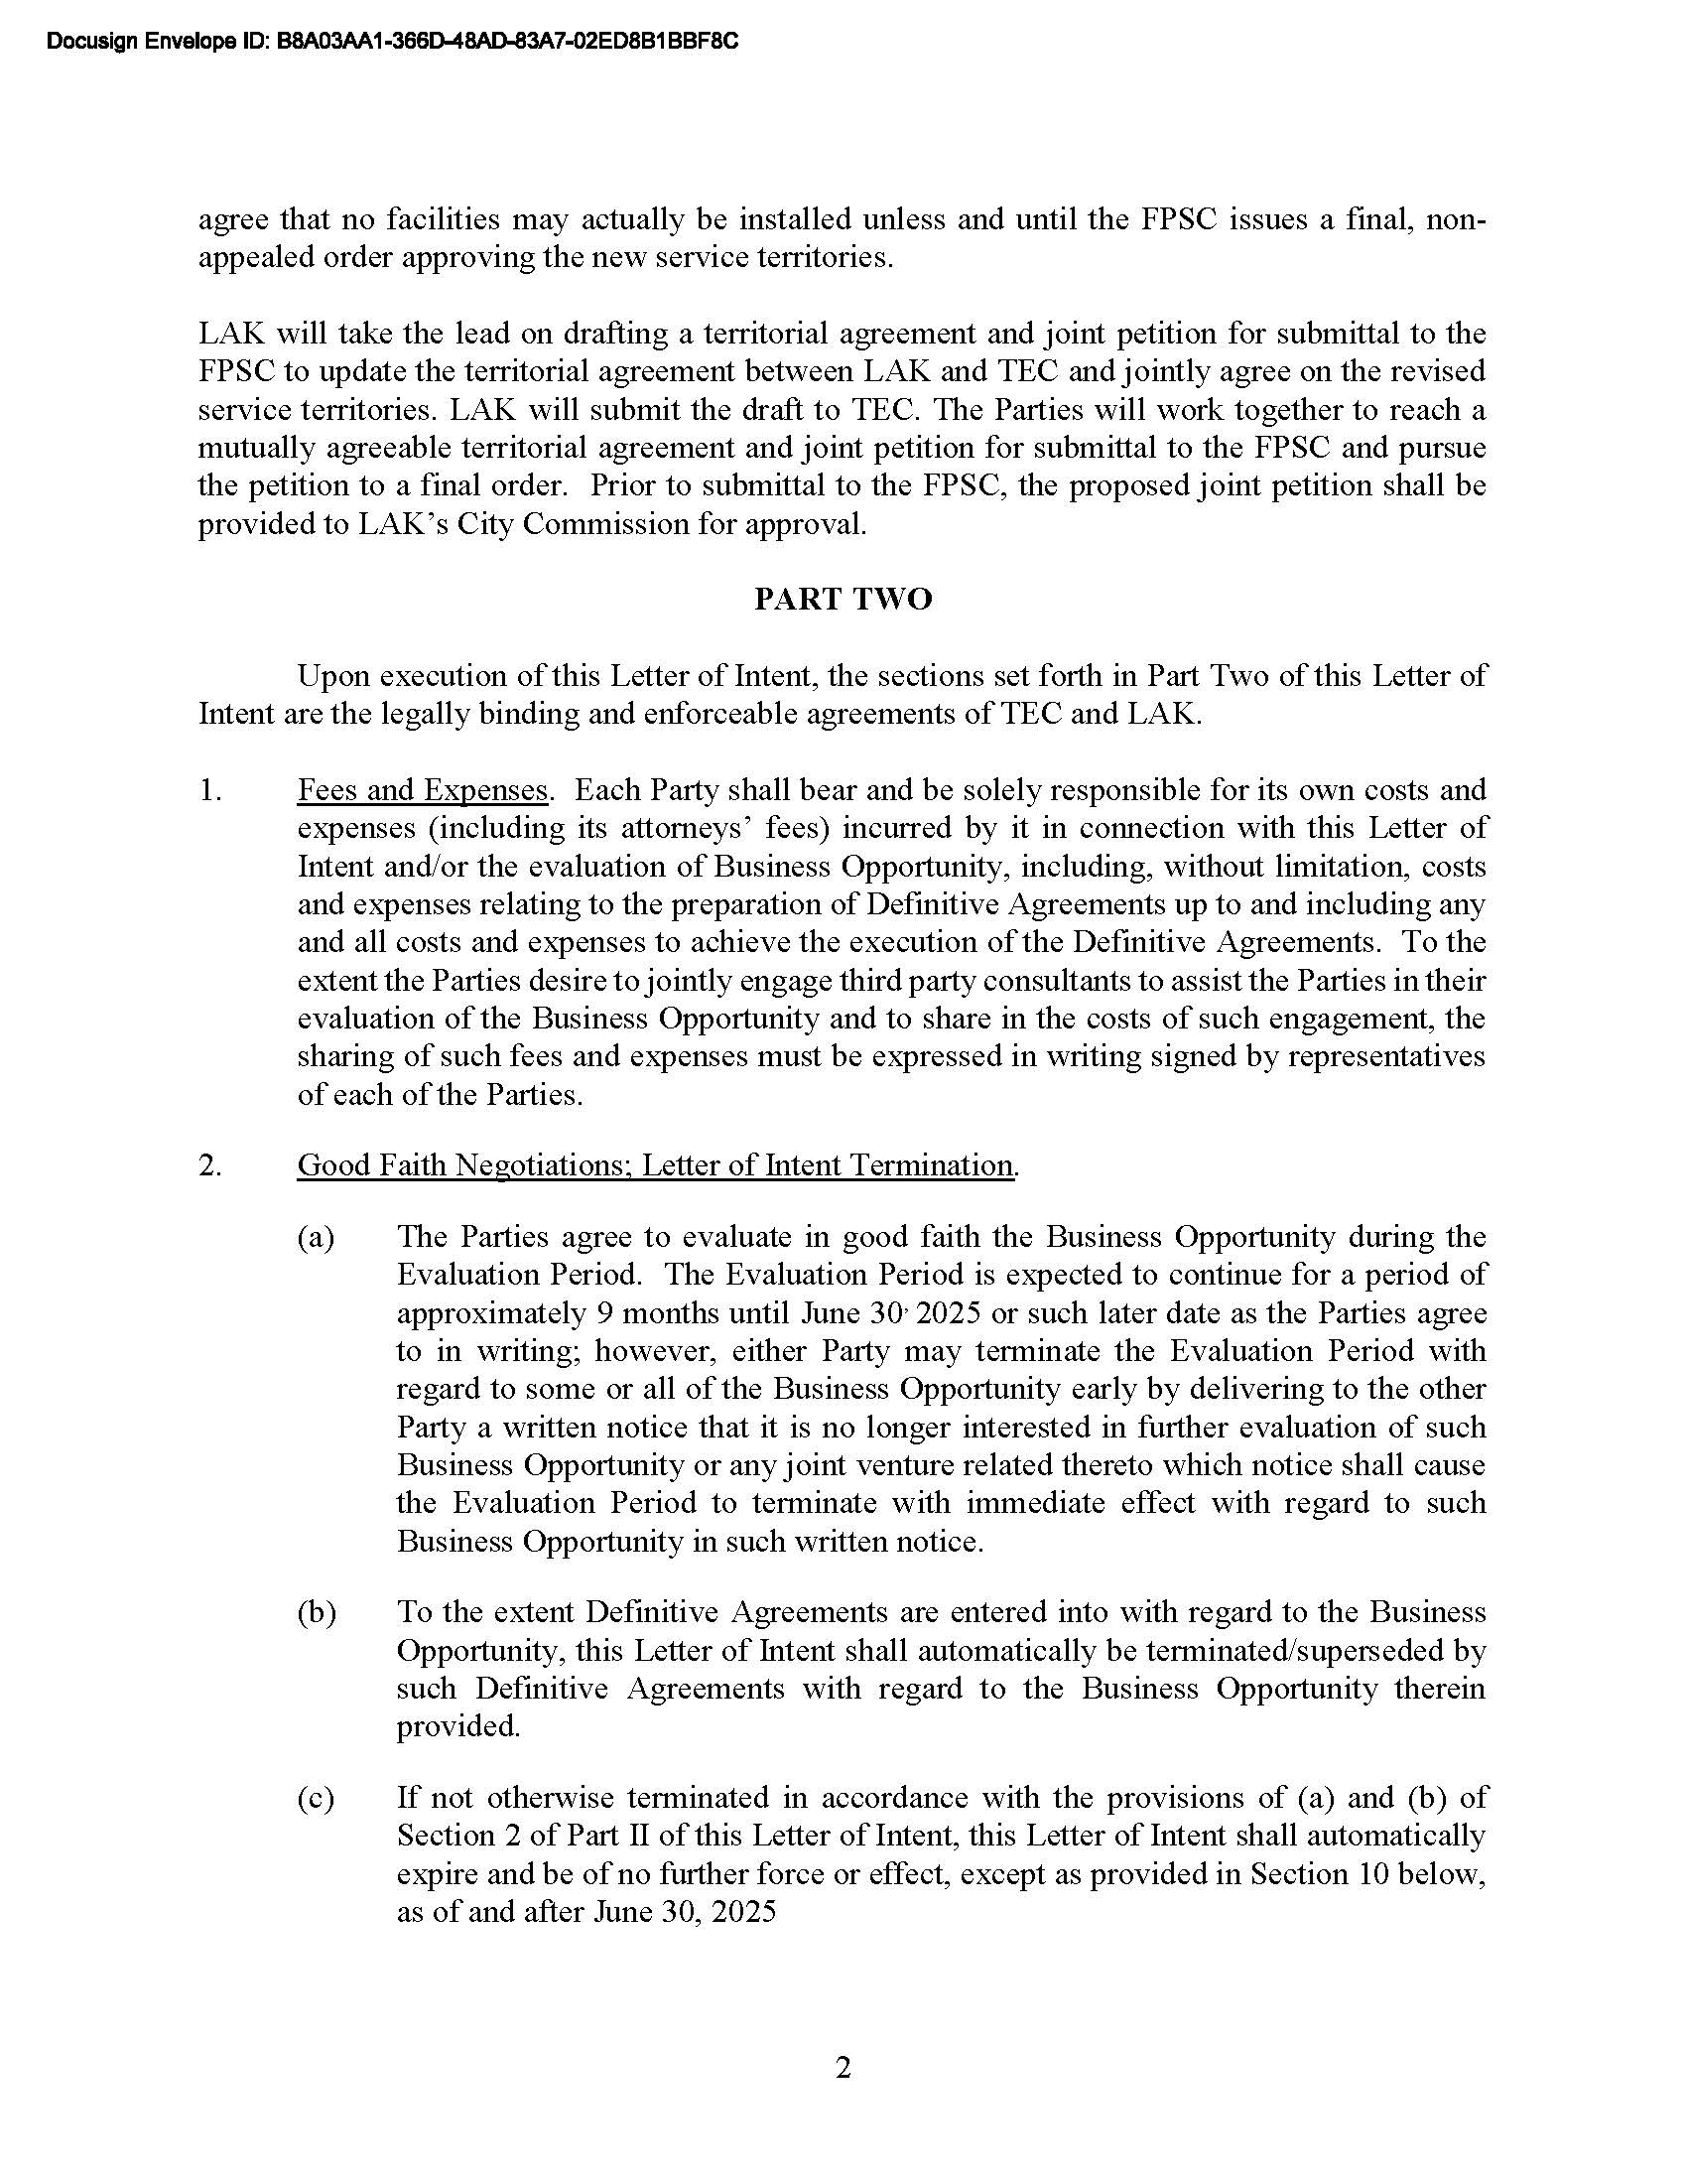

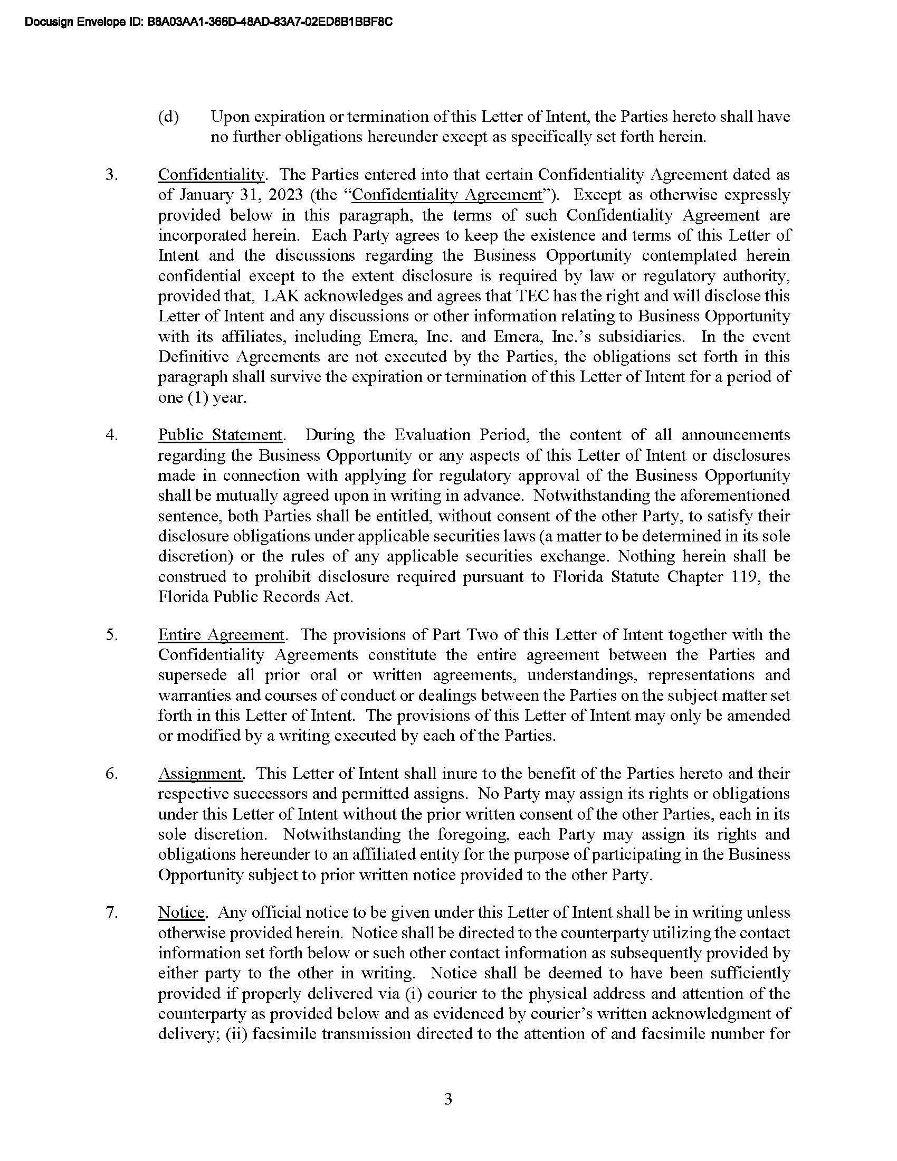

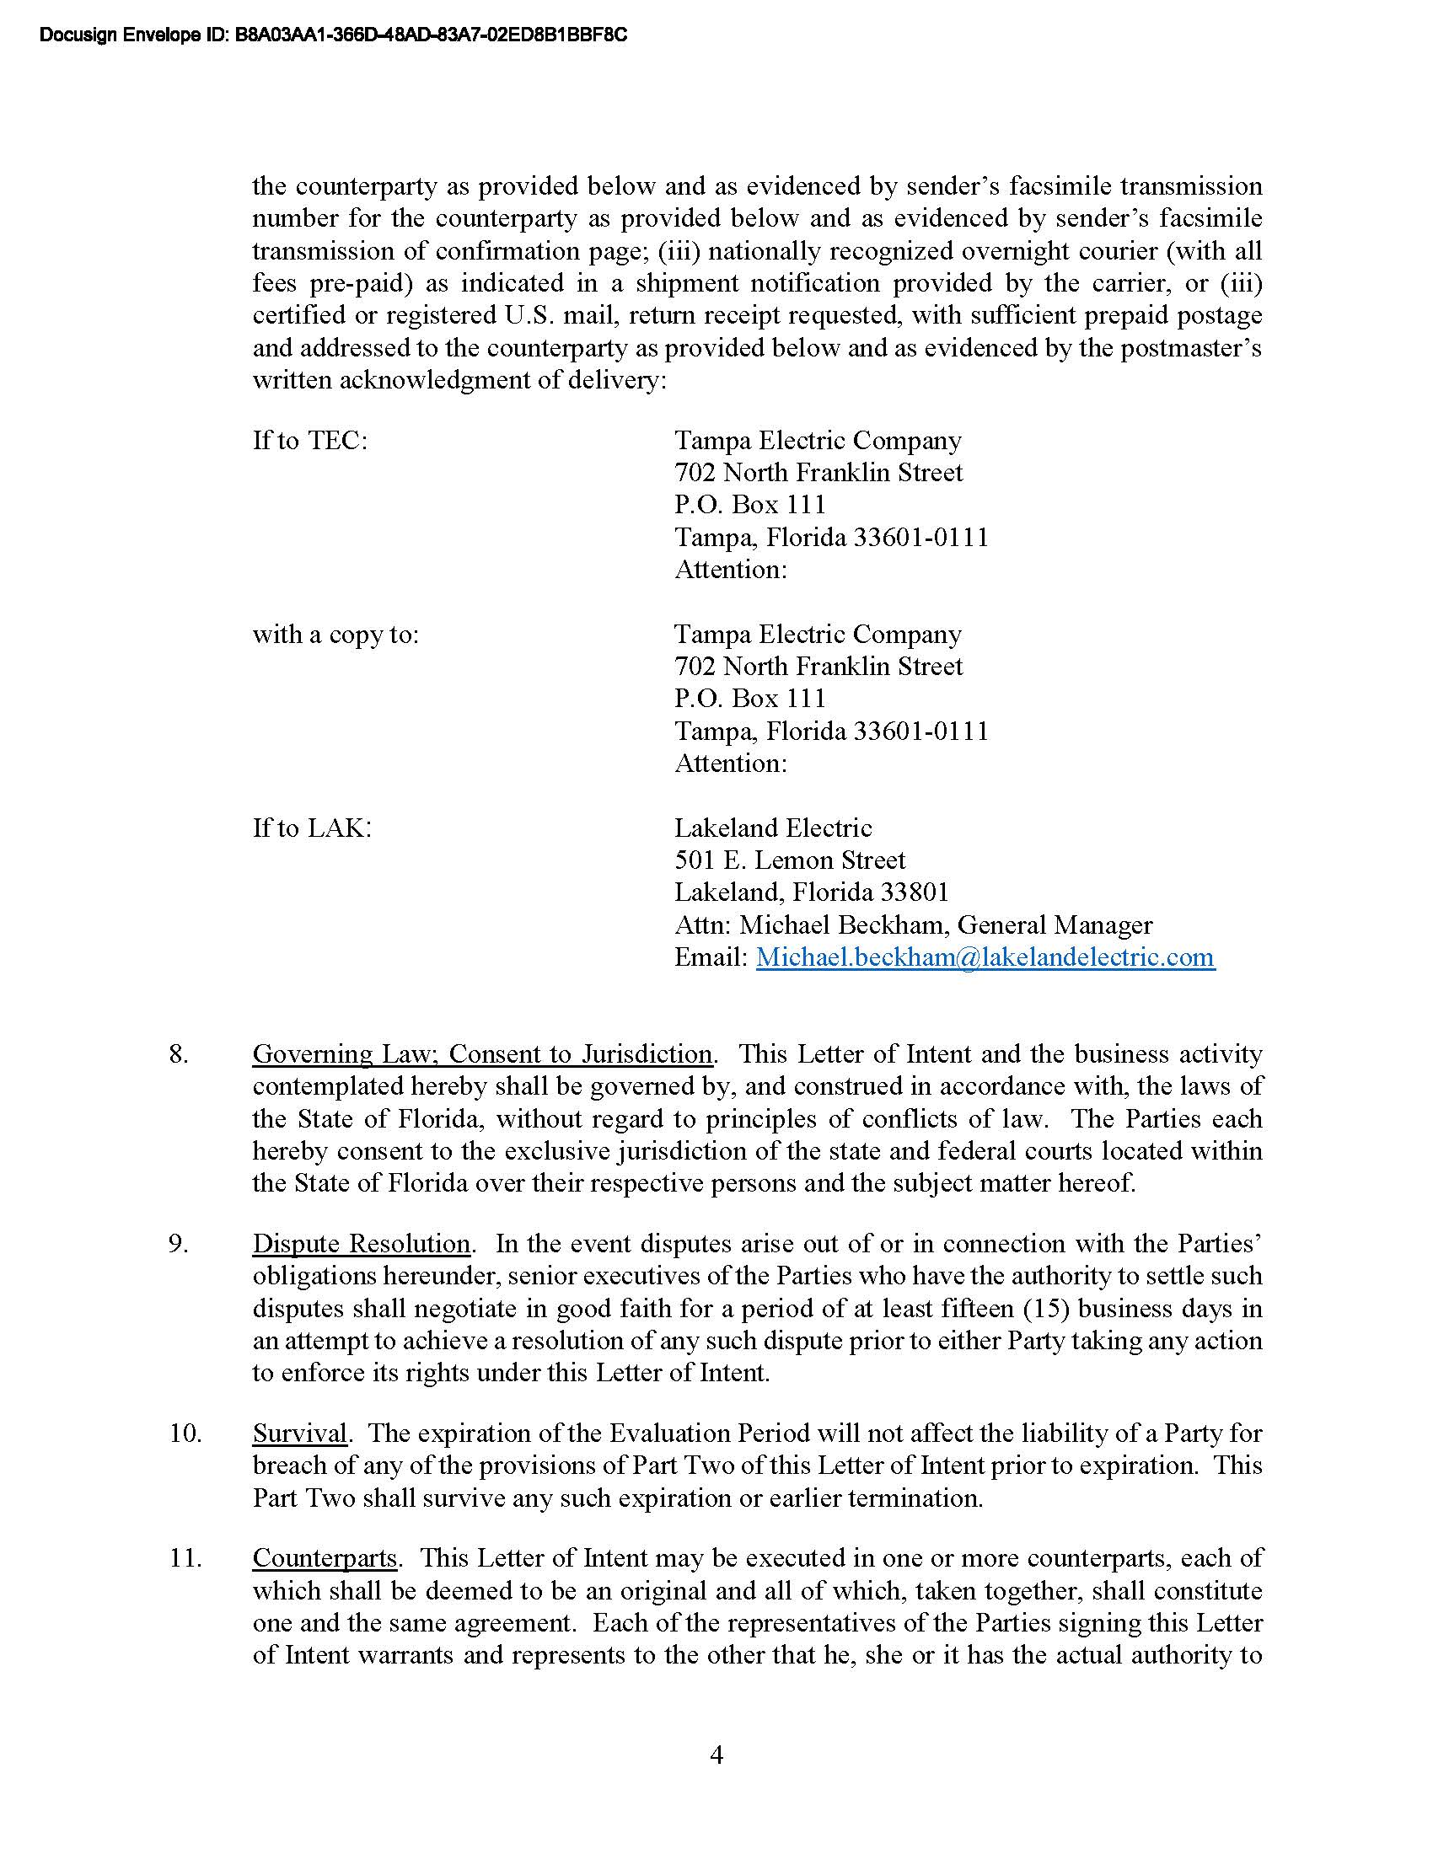

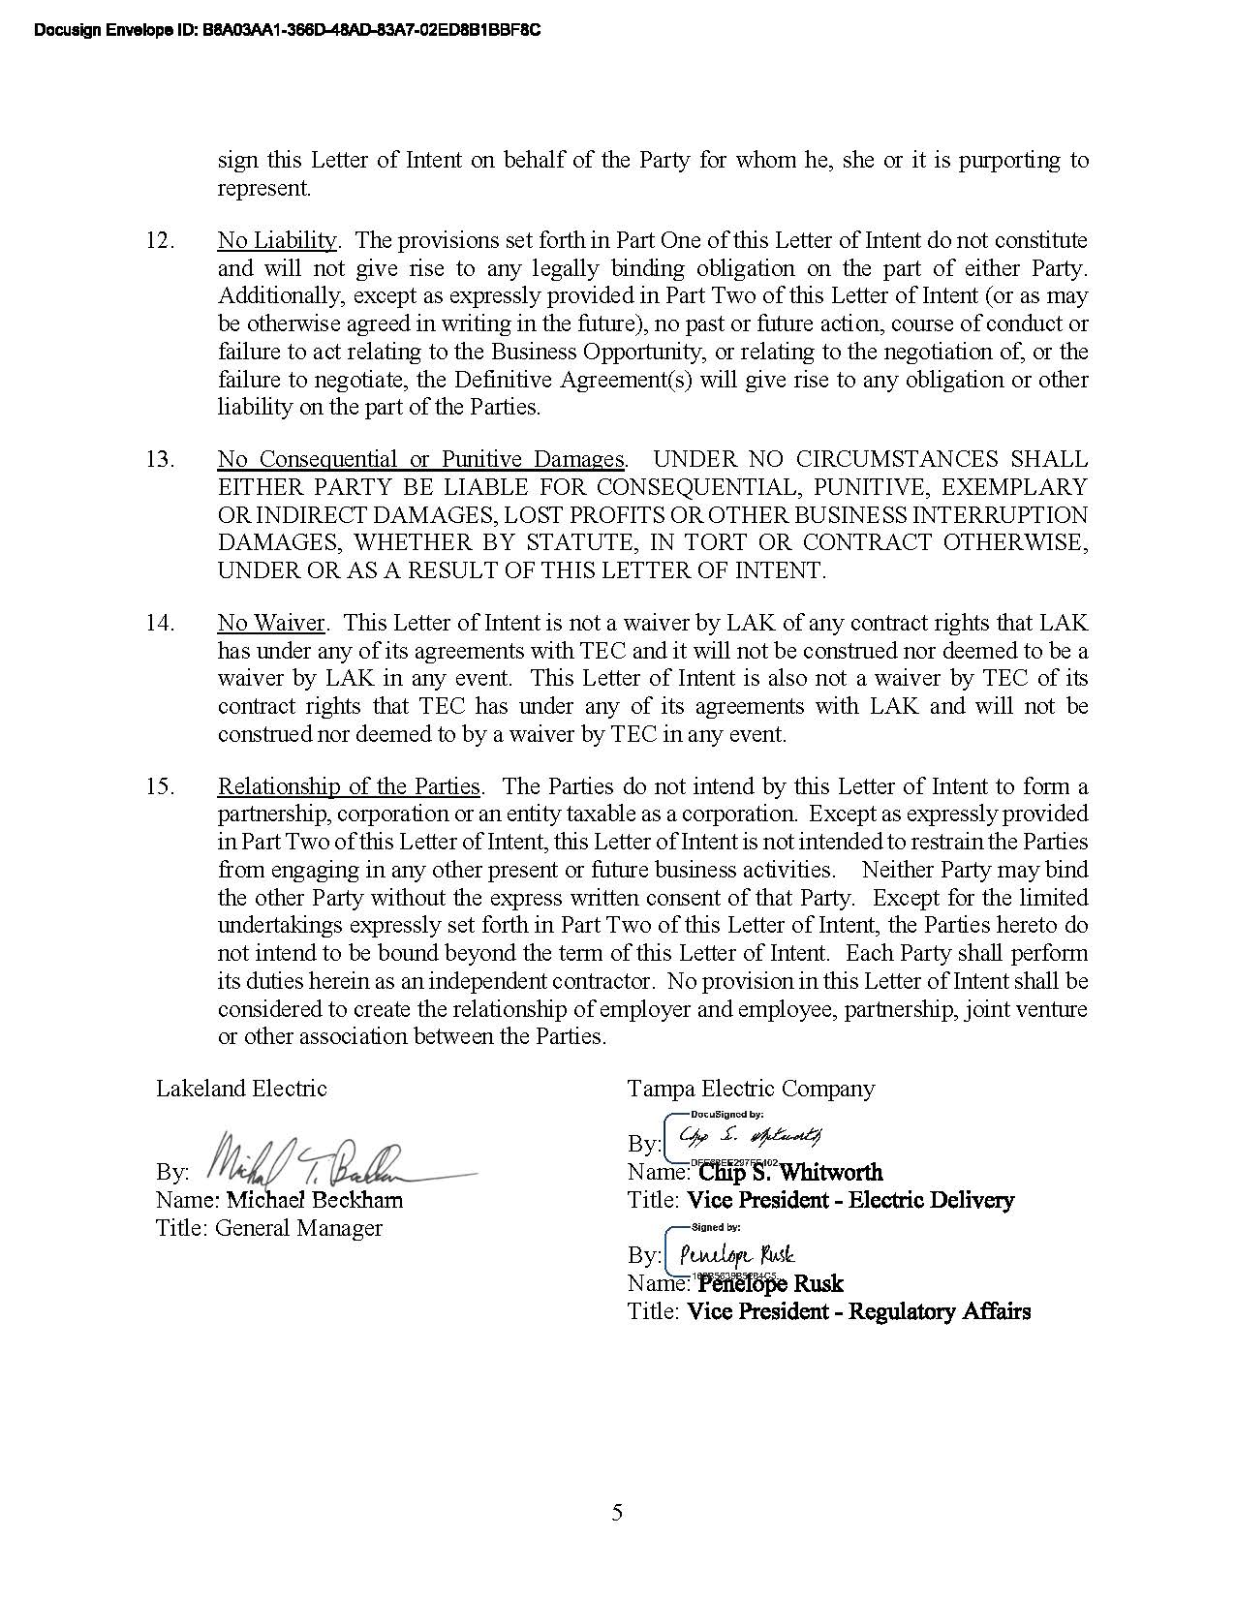

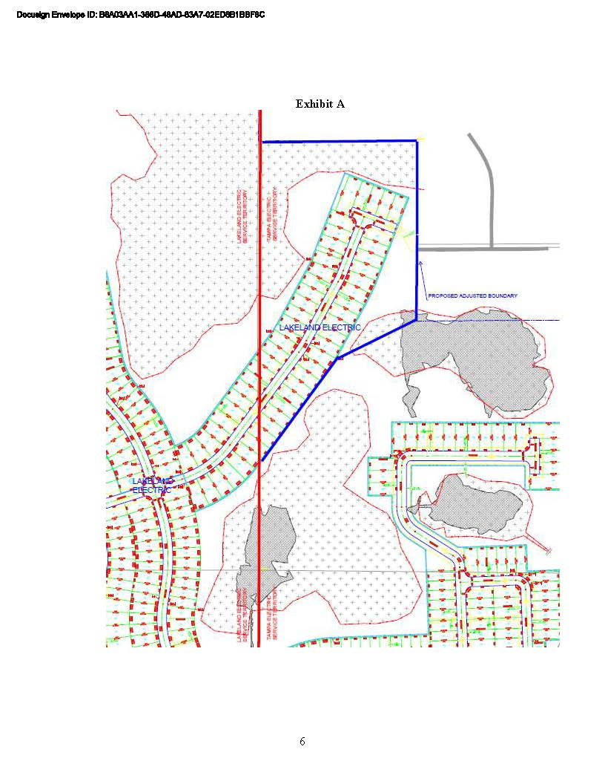

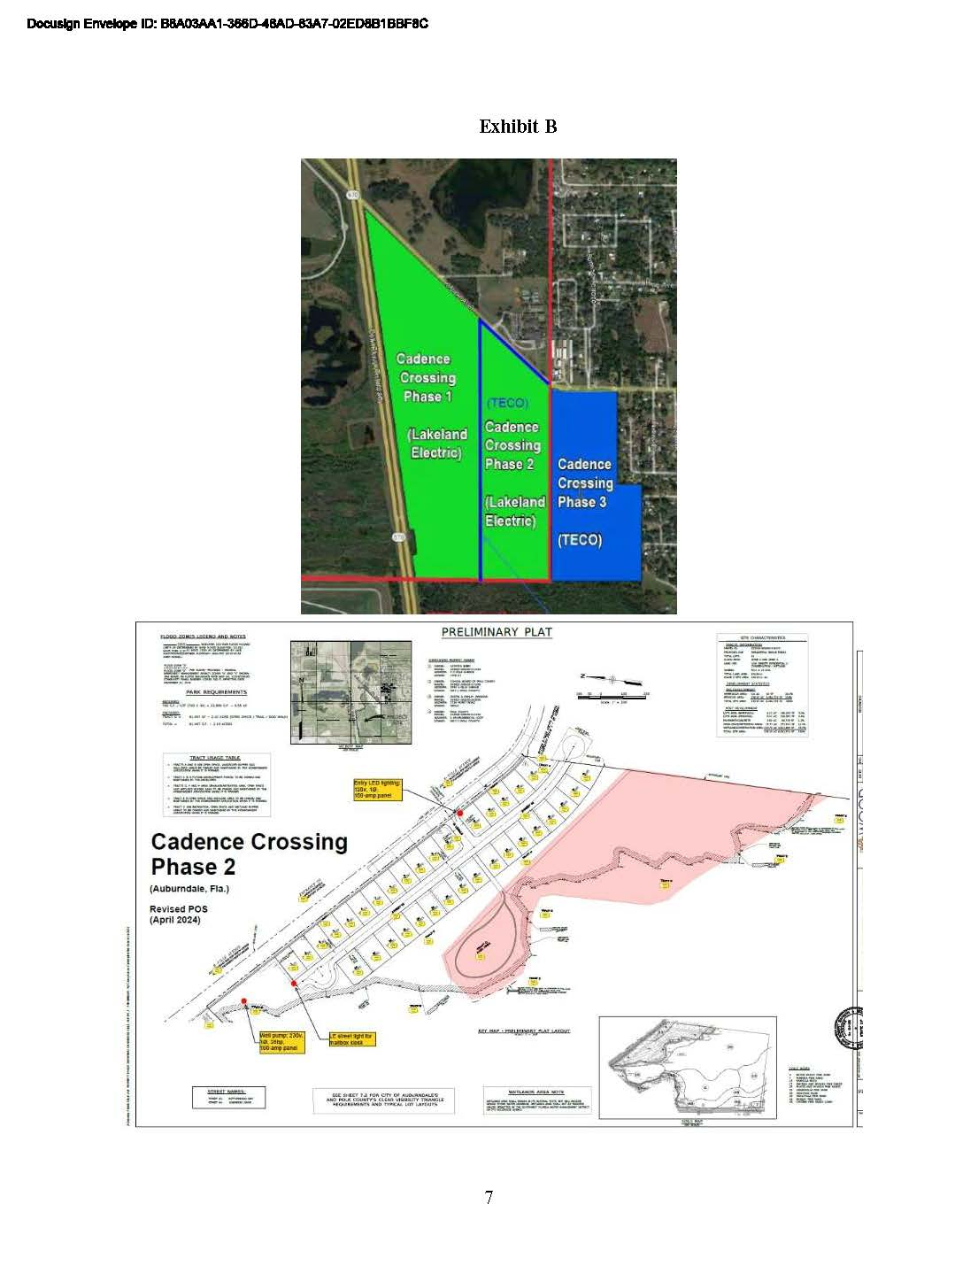

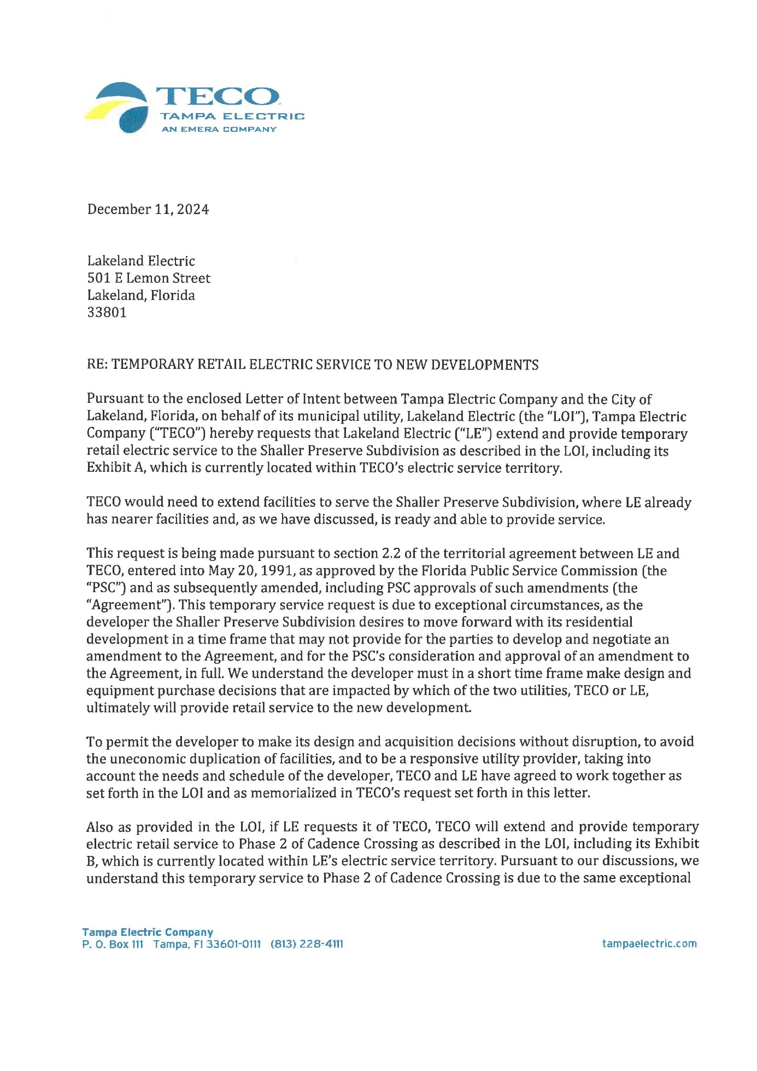

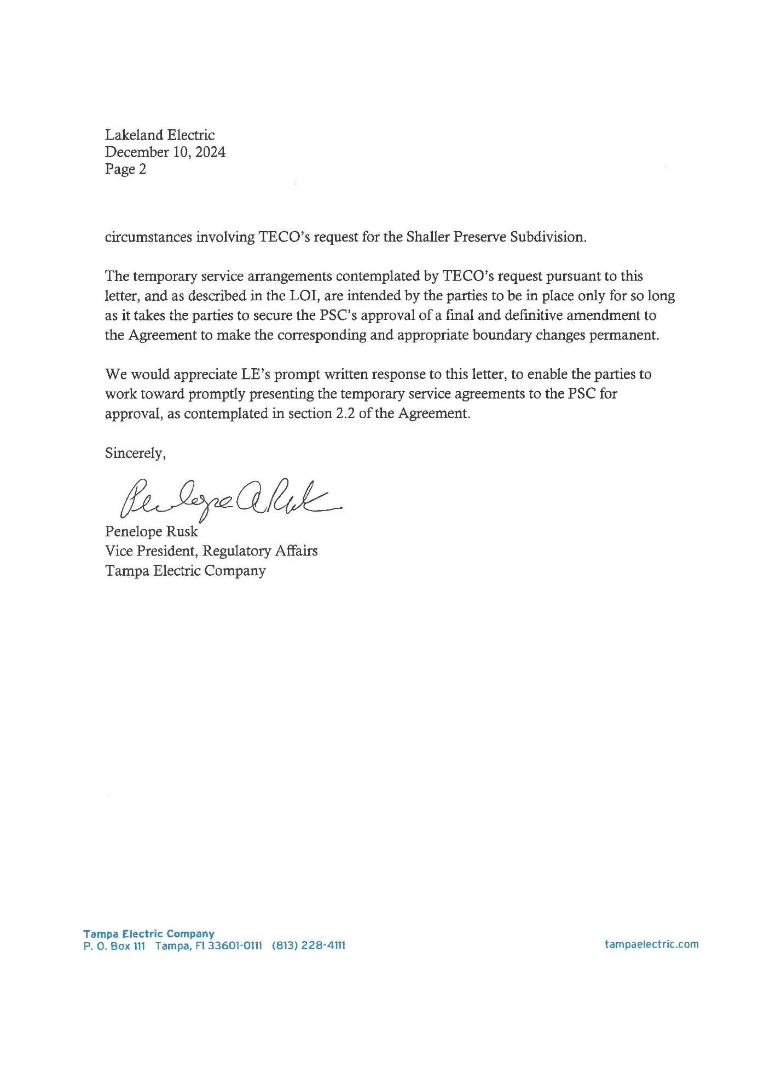

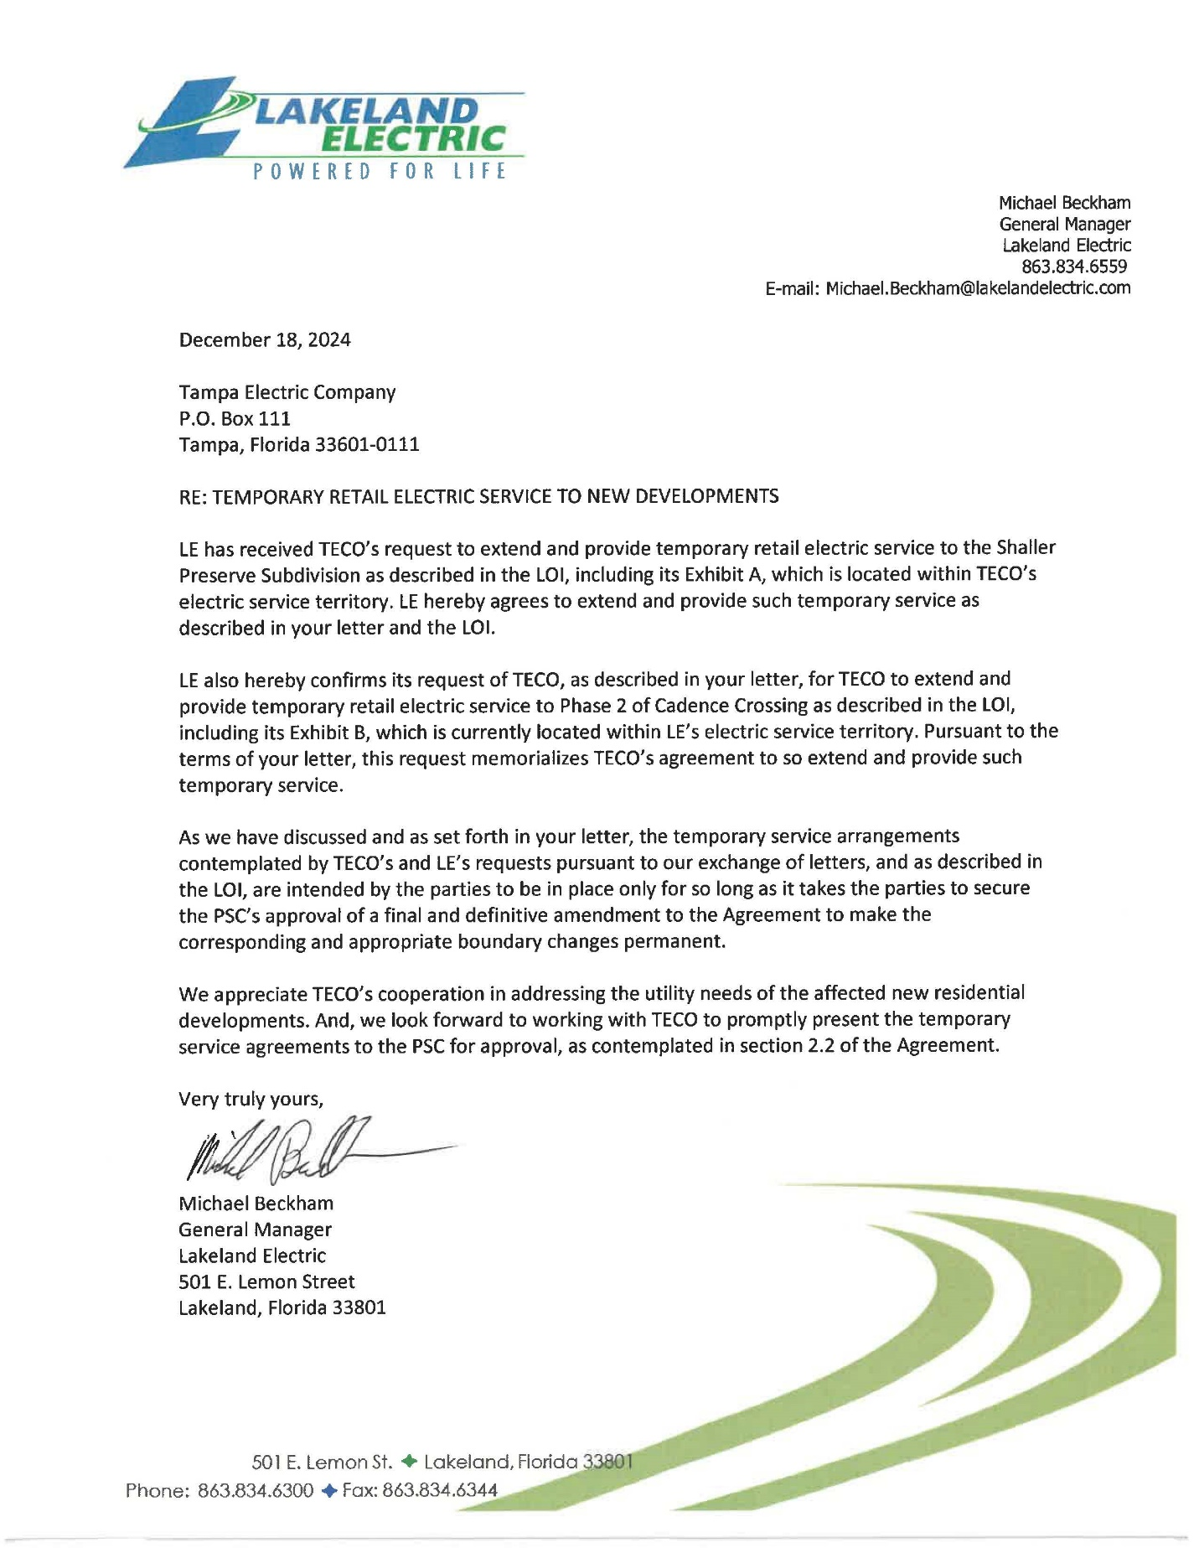

1. Order No. PSC-92-0570-FOF-EU, issued June 25, 1992, in Docket No. 920251-EU, *In re: Joint Petition of Tampa Electric Company and the City of Lakeland for Approval of Territorial Agreement.*
2. Order No. PSC-99-0024-FOF-EU, issued January 4, 1999, in Docket No. 981263-EU, *In re: Joint Petition of Tampa Electric Company and the City of Lakeland for Approval of Amendment to Territorial Agreement*; Order No. PSC-14-0268-PAA-EU, issued May 28, 2014, in Docket No. 140054-EU, *In re: Joint Petition of Tampa Electric Company and City of Lakeland for Approval of Second Amendment to Territorial Agreement.*
3. Order No. PSC-92-0570-FOF-EU., issued June 25, 1992, in Docket No. 920251-EU, *In re: Joint Petition of Tampa Electric Company and the City of Lakeland for Approval of Territorial Agreement.*
4. Exhibit A in Attachment A to this Order.
5. Document No. 00391-2025, joint petitioners’ responses to Staff’s First Data Request, No. 1.g (Schaller Preserve), and No. 2.d. (Cadence Crossing, Phase 2).
6. Order No. PSC-97-1485-FOF-EU, issued November 24, 1997, in Docket No. 970999-EU, *In re: Joint Petition of Tampa Electric Company and the City of Lakeland for approval of temporary power service by Lakeland to a customer located in Tampa Electric’s service area.*
7. *See* Order No. PSC-10-0580-PAA-EU, in Docket No. 100336-EU, pages 1 and 2, *In re: Joint Petition to Extend Territorial Settlement Agreement*; and Order No. PSC-2023-0186-PAA-EU, in Docket No. 20230035-EU, pages 1 and 2, *In re: Joint Petition of Duke Energy Florida, LLC and Peace River Electric Cooperative, Inc. for Approval of Agreement for Temporary Territorial Variance.*