BEFORE THE FLORIDA PUBLIC SERVICE COMMISSION

|  |  |
| --- | --- |
| In re: Application for increase in water and wastewater rates in Brevard, Citrus, Duval, Highlands, Marion, and Volusia Counties by CSWR-Florida Utility Operating Company. | DOCKET NO. 20250052-WS  ORDER NO. PSC-2025-0361-PCO-WS  ISSUED: September 24, 2025 |

The following Commissioners participated in the disposition of this matter:

MIKE LA ROSA, Chairman

ART GRAHAM

GARY F. CLARK

ANDREW GILES FAY

GABRIELLA PASSIDOMO SMITH

ORDER GRANTING INTERIM RATES IN PART

AND DENYING INTERIM RATES IN PART

BY THE COMMISSION:

Background

CSWR-Florida Utility Operating Company (CSWR or utility) is a Class A utility providing water and wastewater service to 11 systems in the following counties: Brevard, Citrus, Duval, Highlands, Marion, and Volusia. As the result of recent acquisitions and a grandfather certificate, CSWR is now a Florida domestic limited liability company that owns and operates the water and wastewater systems that are the subject of this rate case application. CSWR is a wholly-owned subsidiary of CSWR-Florida Utility Holding Company, LLC.

In 2024, the utility recorded consolidated company operating revenues of $3,853,102 for water and $3,332,319 for wastewater. CSWR reported a net operating loss of $1,436,909 for water and $136,494 for wastewater. The utility has approximately 144,303 water customers and 87,571 wastewater customers for its combined systems. The following table reflects the rate proceeding in which rates were last established for each of CSWR’s systems.

**Last Rate Proceedings Establishing Rates for CSWR Systems**

|  |  |  |
| --- | --- | --- |
| Former Utility Name | Order | Issuance Date |
| BFF Corp. | PSC-2002-0487-PAA-SU | April 8, 2002 |
| C.F.A.T. H2O, Inc. | PSC-2011-0366-PAA-WS | August 31, 2011 |
| Neighborhood Utilities, Inc. | PSC-2016-0537-PAA-WU | November 23, 2016 |
| North Peninsula Utilities, Corp. | PSC-2019-0461-PAA-SU | October 25, 2019 |
| Rolling Oaks Utilities, Inc. | Citrus County Approved | February 1, 2022 |
| Sebring Ridge Utilities, Inc. | PSC-1996-0869-FOF-WS | July 2, 1996 |
| Sunshine Utilities, Inc. | PSC-2012-0357-PAA-WU | July 10, 2012 |
| TKCB, Inc. | PSC-2021-0435-PAA-SU | November 22, 2021 |
| Tradewinds Utilities, Inc. | PSC-2011-0385-PAA-WS | September 13, 2011 |
| Tymber Creek Utilities, Inc. | PSC-2011-0345-PAA-WS;  Amendatory Order PSC-2011-0345A-PAA-WS | August 16, 2011 |

During the years of 2021-2024, CSWR applied to acquire ten of the systems in this rate proceeding, and all ten transfer dockets were approved by us. On August 26, 2024, CSWR applied for a grandfather certificate for Rolling Oaks Utilities, Inc. as the eleventh system. On July 21, 2025, we approved the grandfather certificate.[1]

On May 30, 2025, CSWR filed an application for approval of interim and final water and wastewater rate increases. By letter dated June 27, 2025, our staff advised the utility that its Minimum Filing Requirements (MFRs) had several deficiencies. Having reviewed the utility’s deficiency response, staff sent a second letter to CSWR on August 15, 2025, advising that the utility’s rate application remains deficient. To date, the official date of filing has not been established for noticing purposes.

The utility's application for increased final water and wastewater rates is based on the historical 12-month period ended January 31, 2025, with requested capital recovery for facility improvements since the time of acquisitions. Additionally, the utility requested a single, consolidated rate structure. In approving interim rates pursuant to Section 367.082, Florida Statutes (F.S.), it has been our practice to use the utility’s current rate structure at the time of the interim rate request. For purposes of this order, the analysis for each rate structure will be referred to by the former utility name prior to the acquisitions.

CSWR requested interim rates for all of its systems, designed to generate additional revenues of $2,279,365 for water operations and $225,973 for wastewater operations. In setting final rates, the current rate structure of each system is also used for the collection of the final revenues. CSWR requested final rates designed to generate additional revenues of $3,223,769 for water operations and $954,881 for wastewater operations.

The intervention of the Office of Public Counsel (OPC) was acknowledged by Order No. PSC-2025-0113-PCO-WS, issued April 7, 2025, in this docket. On August 15, 2025, OPC filed a letter with us offering its preliminary review of CSWR’s interim request.

Several additional interim filings were submitted for review prior to our evaluation of interim rate request due to the insufficiency of the original interim filing. The original 60-day statutory deadline for us to suspend the utility’s requested final rates and address its interim rate request was August 5, 2025. However, by letter dated June 30, 2025, the utility agreed to extend the statutory time frame to September 4, 2025, by which date we were required to address the suspension of CSWR’s final rates and its interim rate request. By Order No. PSC-2025-0318-PCO-WS, issued August 21, 2025, we suspended CSWR’s final rates request. This order addresses the utility’s interim rate request for all but one of its systems, Aquarina. CSWR’s original and interim filings contained one set of MFRs for Aquarina’s water system; however, it was determined that Aquarina consists of two separate and distinct water systems (Potable and Non-Potable) with each requiring its own set of MFRs. CSWR waived the September deadline to allow itself more time to gather the required information. A recommendation will be filed to address the requested interim rates for that system on September 25, 2025, for the October 7, 2025 Agenda Conference. By letter dated July 25, 2025, the utility agreed to extend the statutory time frame to authorize Aquarina’s interim rates through the October 7, 2025.

We have jurisdiction pursuant to Sections 367.081 and 367.082, F.S.

Decision

1. Interim Revenue Increase

Pursuant to Section 367.082(1), F.S., we may authorize the collection of interim rates during any proceeding for a change of rates upon petition from any party or on our own motion, and, in order to establish a prima facie entitlement for interim relief, the utility shall demonstrate that it is earning outside the range of reasonableness on its rate of return. Pursuant to Section 367.082(2)(a), F.S., in a proceeding for an interim increase in rates, we shall authorize, within 60 days of the filing for such relief, the collection of rates sufficient to earn the minimum of the range of rate of return. CSWR filed rate base, cost of capital, and operating statements to support its requested interim water and wastewater rate increases.

Pursuant to Section 367.082(5)(b)1., F.S., the achieved rate of return for interim purposes must be calculated by applying adjustments consistent with those used in the utility’s most recent rate proceeding and annualizing any rate changes. We reviewed CSWR’s interim request, as well as all orders that addressed the utility’s most recent rate proceedings. This is Rolling Oaks’ first rate proceeding since receiving a grandfather certificate from us. Based on our practice, most recently approved in Order No. PSC-16-0364-PCO-WU, adjustments from a prior rate case are not necessary for Rolling Oaks, as it was under another jurisdiction.[2]

We have attached accounting schedules for each applicable system to illustrate the utility’s rate base, capital structure, and test year operating income amounts. The rate base schedules are labeled as Schedule Nos. 1-A, 1-B, and 1-C. The capital structure schedule is labeled Schedule No. 2. The operating income schedules are labeled as Schedule Nos. 3-A, 3-B, and 3-C. Our adjustments are discussed below.

Tymber Creek

The interim filing for Tymber Creek included unique adjustments not present in the other systems. The ownership of this system was transferred to CSWR during the interim test year, with a closing date of the May 31, 2024.[3] The schedules for this system were filed with eight months of actual revenue and expense data from June 2024 through January 2025, which reflect the period of CSWR’s ownership. CSWR made an adjustment to impute revenues and expenses for February 2024 through May 2024 of the interim test year using an average of the existing months of data. In response to our staff’s data request, the utility stated that it did not have any information prior to the closing of the transfer and was attempting to gather the information.[4] In a follow-up conversation to gather any updates to the utility’s response, CSWR affirmed that it is unable to retrieve the data for the missing months and would not update the interim test year through June 2025.

We find that these adjustments are improper for interim purposes. Rule 25-30.437(2)(d), Florida Administrative Code (F.A.C.), states that for the utility to “demonstrate that it is earning outside the range of reasonableness” on its rate of return “the utility must submit schedules of rate base, cost of capital and net operating income on an historical basis.”[5] The adjustments to impute months of non-existent data are inconsistent with the historical nature of the interim process, and do not comport with our prior decisions regarding interim rates. Further, CSWR’s application for transfer of Tymber Creek affirmed that, consistent with the requirements of Rule 25-30.037(2)(j)7., F.A.C., it had or would obtain the books and records of the former owner.[6] We therefore shall not authorize interim rates for Tymber Creek due to the lack of historical test year data.

Interim Rate Base

Simple Average Adjustment

Consistent with Rule 25-30.433(5), F.A.C., and each system’s previous rate case, the utility’s interim test year for its Class B and C utilities shall reflect rate base calculated using the simple beginning and end-of-year average (simple average) method. CSWR’s interim filing reflects a rate base calculated using a 13-month average. We adjusted the balances for each Class B and C system to reflect the simple average method, as shown on Schedule No. 1 for each system. We find the adjustments reflected in the tables below:

Table 1

Adjustments to Reflect Simple Average – Water

|  |  |  |  |  |  |
| --- | --- | --- | --- | --- | --- |
| System | Plant | Land | Accumulated Depreciation | CIAC | Accumulated Amortization of CIAC |
| CFAT | ($16,724) | $0 | ($1,300) | $0 | $0 |
| Neighborhood | ($24,793) | $0 | ($1,292) | $0 | $380 |
| Sunshine – Unified[7] | ($287,195) | $69,937 | ($7,359) | $1,128 | $2,881 |
| Sunshine – Other[8] | ($37,654) | $0 | ($1,460) | ($635) | $6 |
| Tradewinds | ($17,947) | $0 | ($1,458) | ($4,807) | $511 |

Table 2

Adjustments to Reflect Simple Average – Wastewater

|  |  |  |  |  |
| --- | --- | --- | --- | --- |
| System | Plant | Accumulated Depreciation | CIAC | Accumulated Amortization of CIAC |
| BFF | $2,619 | ($1,000) | $0 | $49 |
| CFAT | ($37,970) | ($1,805) | $0 | $0 |
| North Peninsula | ($84,135) | ($2,727) | ($188) | $2 |
| Sebring Ridge | ($121,174) | ($2,847) | ($392) | $393 |
| TKCB | ($23,701) | ($625) | $0 | $0 |
| Tradewinds | ($6,971) | ($434) | $56 | $0 |

Under- and Over-Amortization of Contributions-In-Aid-of-Construction (CIAC)

In correcting the utility’s averaging adjustments, the water and wastewater CIAC balances for CFAT appeared to be under- and over-amortized, respectively. The CIAC balance for the water system was not fully amortized, yet the Accumulated Amortization of CIAC balance did not change in the test year and no CIAC amortization expense was reflected in the filing. Alternately, the CIAC balance for the wastewater system was over-amortized by $2,512, with the filing reflecting $2,068 of CIAC amortization expense. As such we shall increase the Accumulated Amortization of CIAC for CFAT’s water system by $1,930 and decrease the wastewater balance by $2,512. Corresponding adjustments shall be made to increase CIAC amortization expense by $3,861 for water and decrease CIAC amortization expense by $2,068 for wastewater.

Tradewinds’ wastewater CIAC balance was also over-amortized. We made an adjustment to decrease the wastewater accumulated amortization of CIAC and amortization expense by $942 and $1,522, respectively.

***Used & Useful (U&U)***

We reviewed the utility’s interim U&U calculations on a per system basis, our previous decisions, and available usage and capacity data contained in CSWR’s MFR schedules. Consistent with our prior practice, we find no adjustments for all water treatment, storage, distribution, wastewater treatment and collection systems that have been determined to be 100 percent U&U by the prior rate case orders.[9] These systems are:

* CFAT – water distribution system
* Neighborhood
* North Peninsula
* Sunshine – Unified – water treatment plant
* Sunshine – Other – water treatment plant
* TKCB
* Tradewinds

There are four water systems, and one wastewater system that were not determined to be 100 percent U&U in their last rate case. For these systems, we find adjustments for the water treatment plant (WTP), water storage, wastewater treatment plant (WWTP), distribution, and collection systems identified in Table 3, based on current system conditions and using the methodology approved in the system’s prior rate case order. Additionally, U&U values have not been previously established by us for the Rolling Oaks water system and the CFAT and Rolling Oaks wastewater systems as the transfers of these systems were approved by us in 2022 and 2025,[10] respectively.[11] However, for interim purposes, as shown in Table 3, we find that the Rolling Oaks water and wastewater systems shall be considered 100 percent and 55 percent U&U, respectively, and the CFAT WWTP shall be considered 39 percent U&U.[12]

**Table 3**

**Interim U&U Adjustments**

|  |  |  |  |
| --- | --- | --- | --- |
| System | Last Rate Case U&U | CSWR Requested U&U | Commission Approved  U&U |
| CFAT – WTP | 65% | 65% | 65% |
| CFAT -Water Storage | 86% | 86% | 86% |
| Sunshine - Unified - Distribution System | 83% | 83% | 83% |
| Sunshine - Other - Distribution System | 93% | 93% | 93% |
| Sebring Ridge – WWTP | 81% | 81% | 81% |
| Sebring Ridge – Collection System | 79% | 79% | 79% |
| BFF – Collection System | 88% | 100% | 88% |
| Rolling Oaks - WTP | N/A | 53% | 100% |
| Rolling Oaks - WWTP | N/A | 85% | 55% |
| CFAT- WWTP | N/A | 100% | 39% |

Based on the above calculations and our corrections to CSWR’s simple average rate base balances, we find the adjustments to reflect the correct non-used and useful components indicated in the tables below.

**Table 4**

**Interim – Non-Used & Useful Adjustments – Water**

| System | Rate Base | Depreciation Expense | Property Tax |
| --- | --- | --- | --- |
| CFAT | ($128) | $0 | $0 |
| Rolling Oaks | $211,649 | $19,973 | $598 |
| Sunshine – Other | $2,956 | $142 | $16 |
| Sunshine – Unified | $54,285 | $3,104 | $320 |

**Table 5**

**Interim – Non-Used & Useful Adjustments – Wastewater**

| System | Rate Base | Depreciation Expense | Property Tax |
| --- | --- | --- | --- |
| BFF | $4,842 | $23 | $8 |
| CFAT | ($13,617) | ($1,399) | ($64) |
| Rolling Oaks | $433,342 | $6,435 | $354 |
| Sebring Ridge | $105,329 | $3,302 | $2 |

Construction Work in Progress (CWIP)

In its interim filing, the utility adjusted the rate base for Sunshine – Unified to include a pro forma adjustment of $720,427 for CWIP. The utility also included $372,650 of CWIP in the rate base for Sunshine – Other. The proposed pro forma adjustment data would project costs for facilities before they are placed in service, and it is not appropriate for interim purposes. These adjustments shall be removed from rate base for the calculation of interim rates.

Acquisition Adjustment

In its filing, the utility requested an acquisition adjustment for the following utilities: North Peninsula and Sunshine.[13] The utility reflected an acquisition adjustment of $1,196,741 for North Peninsula, $5,457,165 for Sunshine – Unified, and $403,712 for Sunshine – Other in its interim request. The acquisition adjustments have been removed from rate base for the purpose of calculating interim rates, as they have not been approved by us. It is expected that CSWR’s acquisition adjustment petitions will be consolidated with the instant rate proceeding, and that the acquisition adjustment requests will be addressed together with CSWR’s rate request in a future administrative hearing.

Working Capital Allowance

Although CSWR, post-consolidation, would be classified as a Class A utility, working capital shall be calculated for each system using the same basis from its respective prior rate case. Pursuant to Rule 25-30.433(3), F.A.C., working capital allowance for Class A utilities is calculated using the balance sheet method, and Class B and C utilities are calculated using the formula method, which is one-eighth of operation and maintenance (O&M) expenses. CSWR did not follow these methodologies in its MFRs, instead calculating a working capital allowance of approximately one-eighth hundredth of O&M expenses for each system. We adjusted the working capital allowance for each utility pursuant to Rule 25-30.433(3), F.A.C.

We recalculated working capital allowance using the formula method and our approved O&M for all systems, with the exception of Rolling Oaks. This is the only system in the utility’s filing that is a Class A system. Based on the balance sheet method, Rolling Oaks reflects negative working capital balances of $782,584 and $537,050 for the water and wastewater systems, respectively. It is our practice to set negative working capital allowance balances to zero for ratemaking purposes.[14] As such, we find that the working capital allowance for Rolling Oaks shall be set to zero. The following tables show all working capital adjustments made by us.

**Table 6**

**Working Capital Adjustments – Water Systems**

| System | Increase/(Decrease) Adjustment |
| --- | --- |
| CFAT | $20,695 |
| Neighborhood | $27,947 |
| Rolling Oaks | ($2,486) |
| Sunshine – Unified | $194,659 |
| Sunshine – Other | $17,772 |
| Tradewinds | $30,962 |

**Table 7**

**Working Capital Adjustments – Wastewater Systems**

| System | Increase/(Decrease) Adjustment |
| --- | --- |
| BFF | $13,322 |
| CFAT | $15,693 |
| North Peninsula | $29,420 |
| Rolling Oaks | ($1,834) |
| Sebring Ridge | $21,346 |
| TKCB | $18,005 |
| Tradewinds | $18,572 |

Interim Cost of Capital

Capital Structure

In its initial filing, each system’s capital structure included only common equity and short-term debt. CSWR has not been authorized by us to collect customer deposits since acquiring any of the systems, thus there are none to reflect in the capital structure. Our staff asked the utility for clarification on how each system’s capital structure was calculated. The utility confirmed that the cost of capital for each system is imputed from CSWR-Florida. The capital structure for each system is calculated based on the actual financial data of each system. The debt portion consists of notes payable to the parent, which are available as the result of a debt facility sourced by the parent in 2024 and transferred in response to the capital needs of the system. The equity consists of paid-in capital contributed primarily for the acquisition and improvement of the system and the accumulated retained earnings or deficit.[15]

Return on Equity (ROE)

In its initial filing, the utility requested separate interim overall cost of capital rates for each water and wastewater system based on ROEs from each system’s previous rate case and each respective rate base. Under Section 367.082(5)(b)3., F.S., an interim decrease shall be calculated using the maximum ROE limit, and an interim increase shall be calculated using the minimum ROE limit.

CSWR’s deficient initial interim filing, dated May 30, 2025, included schedules for each system labeled “Interim Rate – Revenue Deficiency” which indicated the use of the ROEs from each system’s previous rate case, with the exception of Rolling Oaks. In CSWR’s updated interim filing, dated June 27, 2025, the MFR Schedule D-1 for each system reflected a ROE of 8.77 percent. The Excel workpapers did not provide support calculations for the ROE. The updated filing also included the “Interim Rate – Revenue Deficiency” schedules with ROEs from each previous rate case, but the actual calculation of revenue requirement reflected 8.77 percent for each system.

Section 367.082(5)(b), F.S., states the required rate of return shall be calculated using the last authorized rate of return on equity of the utility or regulated company. However, consistent with our past practice, the existing ROE does not survive when a system is transferred to a new owner.[16] We find that the interim cost of capital shall be calculated with new ROE percentages using the 2025 leverage formula, as provided under Section 367.082(5)(b)3., F.S., as shown on Schedule No. 2 for each system.[17]

Simple Average Adjustment

Consistent with Rule 25-30.433(5), F.A.C., and each system’s previous rate case, the utility’s interim test year for its Class B and C utilities shall reflect a cost of capital calculated using the simple average method. CSWR’s interim filing reflects a cost of capital calculated using a 13-month average. We adjusted the balances for each system, except for its Class A system Rolling Oaks, to reflect the simple average method, as shown on Schedule No. 2 for each system.

Pro Rata Adjustment

In its MFRs, the utility prorated the cost of capital to common equity only. Each system’s capital structure consists of common equity and short term debt. Consistent with each system’s most recent rate case and our recent decisions for Rolling Oaks, we find that capital structure shall be prorated across both sources of capital, as shown on Schedule No. 2 for each system.[18]

Sunshine

Based on its previous rate case, the utility filed two separate sets of interim MFRs for the Sunshine – Unified revenue requirement and Sunshine – Other revenue requirement.[19] Each revenue requirement reflected its own capital structure. However, consistent with its last rate case, Sunshine – Unified and Sunshine - Other shall reflect a consolidated capital structure. As such, we consolidated the components and prorated each based on the total rate base of both systems.

The utility’s proposed capital structure and our approved capital structure for each system are reflected on Schedule No. 2 for each system, with only a single Schedule No. 2 for Sunshine – Unified and Sunshine – Other.

Interim Net Operating Income

Pursuant to Section 367.082(5)(b)1., F.S., the achieved rate of return for interim purposes must be calculated by applying adjustments consistent with those made in the utility’s most recent rate proceeding and annualized for any rate changes. Based on our review, several adjustments are necessary for interim purposes as reflected on the respective adjustments to operating income schedules.

Test Year O&M Adjustments – Annualization

CSWR made several adjustments to O&M expenses for each system related to new third party contracts that began during the test year. However, we find this set of adjustments is improper for interim purposes. Rule 25-30.437(2)(d), F.A.C., states that for the utility to “demonstrate that it is earning outside the range of reasonableness” on its rate of return, “the utility must submit schedules of rate base, cost of capital and net operating income on an historical basis, with all adjustments thereto.” The adjustments provided in CSWR’s interim filings were made to annualize a change in O&M expenses that occurred during the test year. These adjustments would shift O&M expenses in their entirety from a historical basis to a pro forma basis. We find these adjustments are appropriate for consideration in the final rate increase, but violate the nature of the interim process. As such, we shall remove the annualization adjustments from each system as shown in the tables below.

Table 8

Commission Adjustments to Remove Annualization – Water Systems

|  |  |
| --- | --- |
| System | Adjustment |
| CFAT | ($2,753) |
| Neighborhood | $6,331 |
| Rolling Oaks | $193,167 |
| Sunshine – Unified | $99,840 |
| Sunshine – Other | $3,966 |
| Tradewinds | $11,033 |

Table 9

Commission Adjustments to Remove Annualization – Wastewater Systems

|  |  |
| --- | --- |
| System | Adjustment |
| BFF | ($6,216) |
| CFAT | $5,809 |
| North Peninsula | $21,634 |
| Rolling Oaks | $125,343 |
| Sebring Ridge | $6,135 |
| TKCB | ($7,927) |
| Tradewinds | ($151) |

O&M Adjustments Consistent with the Last Rate Case

Adjustments to bad debt expense are necessary for interim purposes in order to be consistent with the treatment in each system’s last rate case. Through its multiple revised interim filings, CSWR incorrectly applied a 3-year averaging adjustment to bad debt expense for all systems. However, upon review, we determined that only four systems required a 3-year averaging adjustment consistent with each system’s prior rate case.

As such, Neighborhood’s, CFAT’s, TKCB’s, and Tradewinds’ bad debt adjustments were corrected, and the adjustments for all other systems were removed.[20] Consistent with the last rate cases, we have recalculated the adjustment using 2022, 2023, and 2024 bad debt expense as provided in the each system’s annual reports. CSWR’s and our approved adjustments are detailed in the tables below:

Table 10

3-Year Averaging Adjustment to Bad Debt – Water Systems

|  |  |  |
| --- | --- | --- |
| System | Utility Adjustment | Commission Adjustment |
| CFAT | $36 | $120 |
| Neighborhood | $475 | ($76) |
| Rolling Oaks | $7,037 | ($7,037) |
| Sunshine – Unified | $6,751 | ($6,751) |
| Sunshine – Other | $524 | ($524) |
| Tradewinds | ($13) | $415 |

Table 11

3-Year Averaging Adjustment to Bad Debt – Wastewater Systems

|  |  |  |
| --- | --- | --- |
| System | Utility Adjustment | Commission Adjustment |
| CFAT | ($118) | $80 |
| North Peninsula | $799 | ($799) |
| Rolling Oaks | $2,521 | ($2,521) |
| Sebring Ridge | ($152) | $152 |
| TKCB | ($326) | $567 |
| Tradewinds | ($391) | $486 |

Excessive Unaccounted for Water (EUW)

We reviewed the utility’s interim EUW calculations on a per system basis, our previous decisions, and available usage data contained in CSWR’s MFR schedules. Table 12 identifies where we previously found EUW, CSWR’s requested interim EUW values, and our approved interim EUW adjustments to the test year water treatment expense by system.

**Table 12**

**Excessive Unaccounted for Water (EUW)**

| System | Last Rate Case EUW | CSWR Requested EUW | Commission Approved  EUW |
| --- | --- | --- | --- |
| CFAT | None | 27% | 27% |
| Neighborhood | None | 27% | 27% |
| Rolling Oaks | N/A | 28% | 28% |
| Sunshine – Unified* | 8%/10% | 33% | 33% |
| Sunshine - Other | 8% | 33% | 33% |
| Tradewinds | None | 3% | 3% |

*We found Sunshine’s Sandy Acres system to have 10% EUW in its last rate case, while all remaining systems in Sunshine – Unified were found to have 8% EUW.

Following the same methodology used in the last rate case, we applied the updated EUW percentages from the MFRs to the actual purchased power and chemicals expenses and apply the adjustments to each system as shown below.

Table 13

EUW Adjustments

|  |  |
| --- | --- |
| System | Adjustment |
| CFAT | ($2,397) |
| Neighborhood | ($3,858) |
| Rolling Oaks | ($78,135) |
| Sunshine – Unified | ($38,049) |
| Sunshine – Other | ($2,714) |
| Tradewinds | ($710) |

***Infiltration & Inflow (I&I)***

We reviewed the utility’s interim excessive I&I calculations on a per system basis, our previous decisions, and available usage data contained in CSWR’s MFR schedules.[21] Using the methodology approved in prior rate cases and current conditions, we do not find any I&I adjustments for interim purposes. However, it should be noted that we have not previously determined I&I for the CFAT and Rolling Oaks wastewater systems. While we find no adjustment for interim purposes, the I&I for these systems will be investigated by our staff during the course of this rate case.

Earnings Analysis

Tradewinds

Based on the adjustments outlined above, Tradewinds reflected overearnings in the interim test year. Pursuant to Section 367.082(2)(b), F.S., in a proceeding for an interim decrease in rates, we shall authorize the continued collection of the previously authorized rates; however, revenues collected under those rates that are sufficient to reduce the achieved rate of return to the maximum of the rate of return shall be held subject to refund with interest. Although CSWR has reflected a decrease to Tradewinds’ rates, we find that the utility shall continue to collect its current rates and hold, subject to refund, revenues collected under those rates that are sufficient to reduce the achieved rate of return to the maximum of their current rate of the returns, with interest. Over the full course of the rate case and potential rate consolidation, our staff will evaluate the potential refund. As such, we find that $162,602 and $60,390 shall be held subject to refund for Tradewinds water and wastewater systems, respectively.

Rolling Oaks – Wastewater

In its interim request, Rolling Oaks reflected a decrease to its test year revenue requirement. However, our approved adjustment to test year revenues, as discussed in Section II, reflects a lower amount of test year revenues, thus resulting in a net interim increase. As such, there are no overearnings present. Our approved increase is discussed below.

Revenue Requirement

We have approved revenue requirements consistent with the calculations required by 367.082, F.S. For those systems that appear to be underearning, the revenue requirements were determined using the minimum ROE limit. Consistent with the interim statute, for those systems that appear to be overearning, we used the maximum ROE limit. Consistent with our practice, we limited the revenue requirements of Neighborhood, Rolling Oaks, Sebring Ridge, and Tradewinds to the level requested by CSWR.[22]

Based upon recovery of actual operating expenses for the year ended January 31, 2025, we find that the appropriate combined interim revenue requirements are $4,863,706 and $2,893,926, respectively, for the utility’s water and wastewater systems. This results in an interim increase in annual revenues of $1,723,908 for the water systems and $547,612 for the wastewater systems. For the Tradewinds systems that appear to be earning above their maximum ROE, we find that revenues totaling $222,992 shall be collected subject to refund with interest, and Tradewinds shall continue collecting current rates.

According to Section 367.082(4), F.S., any refund “shall be calculated to reduce the rate of return of the utility or regulated company during the pendency of the proceeding to the same level within the range of the newly authorized rate of return which is found fair and reasonable on a prospective basis.” We will evaluate each system’s post-consolidation revenue requirement to determine if any refunds shall be made.

The following tables show the revenue requirement and interim increase in annual revenues for each respective system.

Table 14

Interim Revenue Requirement – Water Systems

|  |  |  |  |  |
| --- | --- | --- | --- | --- |
| System | Adjusted Test Year Revenues | Revenue Increase | % Increase | Revenue Requirement |
| CFAT | $122,938 | $106,420 | 86.56% | $229,358 |
| Neighborhood | $161,065 | $113,946 | 70.75% | $275,011 |
| Rolling Oaks | $1,639,803 | $542,825 | 33.10% | $2,182,628 |
| Sunshine – Unified | $1,126,715 | $856,801 | 76.04% | $1,983,516 |
| Sunshine – Other | $89,277 | $103,916 | 116.40% | $193,193 |

Table 15

Interim Revenue Requirement – Wastewater Systems

|  |  |  |  |  |
| --- | --- | --- | --- | --- |
| System | Adjusted Test Year Revenues | Revenue Increase | % Increase | Revenue Requirement |
| BFF | $100,259 | $28,361 | 28.29% | $128,620 |
| CFAT | $136,724 | $43,700 | 31.96% | $180,424 |
| North Peninsula | $283,728 | $92,164 | 32.48% | $375,892 |
| Rolling Oaks | $1,630,126 | $139,283 | 8.54% | $1,769,409 |
| Sebring | $68,620 | $176,267 | 256.87% | $244,887 |
| TKCB | $126,857 | $67,837 | 53.48% | $194,694 |

1. Interim Water and Wastewater Rates

We find that interim service rates for CSWR shall be designed to allow the utility the opportunity to generate additional annual operating revenues as shown below. The test year revenues were adjusted to annualize the rate in effect at the end of the test year. To determine the appropriate increase to apply to the service rates, miscellaneous revenues shall be removed from the adjusted test year revenues. The calculations are as follows:

**Table 16**

**Percentage Increase Less Miscellaneous Revenues**

|  |  |  |  |  |  |
| --- | --- | --- | --- | --- | --- |
| System (W/WW) | Adjusted Test Year Revenues | Miscellaneous Revenues | Revenues – Miscellaneous Revenues | Revenue Increase | % Rate Increase |
| BFF Corp. - W | **$**100,259 | $0 | **$**100,259 | $28,190 | 28.29% |
| C.F.A.T. H2O - W | **$**122,938 | $0 | **$**122,938 | $111,559 | 86.56% |
| C.F.A.T. H2O-WW | **$**136,724 | $0 | **$**136,724 | $43,700 | 31.96% |
| Neighborhood -W | $161,065 | $5,536 | **$**155,529 | $113,946 | 73.26% |
| North Peninsula -WW | $283,728 | $1,156 | **$**282,572 | $101,309 | 32.61% |
| Rolling Oaks -W | $1,639,803 | $77,726 | **$**1,562,077 | $542,825 | 34.75% |
| Rolling Oaks -WW | $1,014,857 | $67,507 | **$**1,562,619 | $139,283 | 8.91% |
| Sebring Ridge - WW | $68,620 | $2,730 | **$**65,890 | $176,267 | 267.51% |
| Sunshine (Unified.) - W | $1,126,715 | $35,451 | **$**1,091,264 | $878,186 | 78.51% |
| Sunshine (Other) - W | $89,277 | $9,424 | **$**79,853 | $108,148 | 130.13% |
| TKCB - WW | **$**126,857 | $0 | **$**126,857 | $70,337 | 53.48% |

**Table 17**

**Typical Residential 5/8" x 3/4" Meter Bill Comparison**

**At 5,000 Gallons**

|  |  |  |  |
| --- | --- | --- | --- |
| System (W/WW) | Utility  Current  Rates | Utility  Proposed  Interim Rates | Commission  Approved  Interim Rates |
| BFF Corp. - W | $76.73 | $102.08 | $98.46 |
| C.F.A.T. H2O - W | $41.70 | $86.70 | $77.80 |
| C.F.A.T. H2O-WW | $41.14 | $54.63 | $54.28 |
| Neighborhood -W | $32.14 | $54.72 | $55.68 |
| Rolling Oaks -W | $15.76 | $25.26 | $21.22 |
| Rolling Oaks -WW | $36.00 | $35.07 | $39.20 |
| Sebring Ridge - WW | $33.72 | $110.97 | $123.93 |
| Sunshine (Unified.) - W | $18.87 | $38.69 | $33.67 |
| Sunshine (Other) - W | $22.22 | $45.58 | $51.12 |
| TKCB - WW | $55.95 | $96.45 | $85.88 |

Consistent with our practice for interim rates, the above percentage increases shall be applied as an across-the-board increase to the service rates in effect as of January 31, 2025, in each respective county. Due to a decrease in percentage, we find that Tradewinds’ water and wastewater rates shall remain the same for interim purposes. While we have identified that CSWR’s Tradewinds system may have exceeded their maximum allowed ROE, we do not find a change in rates at this time. However, as discussed in Section I, we have approved amounts to be held subject to refund for that system.

The approved rates, as shown on Schedule Nos. 4-A and 4-B, shall be effective for service rendered on or after the stamped approval date on the tariff sheets pursuant to Rule 25-30.475(1)(a), F.A.C. The utility shall file revised tariff sheets and a proposed customer notice to reflect the approved rates. In addition, the approved rates shall not be implemented until the required security has been filed, our staff has approved the proposed customer notice, and the notice has been received by the customers. The utility shall provide proof of the date notice was given within 10 days of the date of the notice.

1. Security to Guarantee the Interim Increase

Pursuant to Section 367.082, F.S., revenues collected under interim rates shall be placed under bond, escrow, letter of credit, or corporate undertaking subject to refund with interest at a rate ordered by us. As found in Section I, the total interim increase is $2,271,520, with an additional $222,992 being held subject to refund due to potential overearnings. In accordance with Rule 25-30.360, F.A.C., we calculated the potential refund of revenues and interest collected under interim conditions to be $2,332,541. This amount is based on an estimated 11-month collection period of interim rates.

The criteria for a corporate undertaking includes sufficient liquidity, equity ownership, and profitability to guarantee any potential refund. We reviewed the utility’s parent company, CSWR, LLC’s 2022, 2023, and 2024 confidential financial statements filed with us to determine if CSWR, LLC can support a corporate undertaking for the requested amount.[23] Our analysis indicated that over the three-year period ending December 31, 2024, the company’s parent, CSWR, LLC, had insufficient profitability over the period, but had sufficient liquidity and equity ownership. The parent company has a substantial amount of cash available which is sufficient to support a corporate undertaking in the amount of $2,332,541. Additionally, CSWR, LLC has positive working capital and its equity capital significantly exceeds the requested amount and is supported by an equity ratio that is greater than 50 percent.

Based on the analysis of CSWR, LLC’s financial position, we find that CSWR, LLC can support a corporate undertaking in the amount of $2,332,541. Our approval is contingent upon CSWR, LLC providing a signed letter by a corporate officer that it will support CSWR in its corporate undertaking endeavor. A parent company supporting a corporate undertaking on behalf of its subsidiary for interim purposes is consistent with our practice in prior rate cases.[24] We also received confirmation from the utility that it had no other outstanding guarantees on behalf of CSWR-owned utilities in other jurisdictions.[25]

This brief financial analysis is only appropriate for determining if the utility, through its parent, can support a corporate undertaking in the amount proposed and shall not be considered a finding regarding our position on other issues in this proceeding. In no instance shall maintenance and administrative costs be associated with any refund be borne by the customers. Such costs are the responsibility of, and shall be borne by, the utility.

Pursuant to Rule 25-30.360(6), F.A.C., the utility shall provide a report by the 20th day of each month indicating the monthly and total revenue collected subject to refund. Should a refund be required, the refund shall be with interest and undertaken in accordance with Rule 25-30.360, F.A.C.

Based on the foregoing, it is

ORDERED by the Florida Public Service Commission that CSWR-Florida Utility Operating Company shall be authorized to collect annual water and wastewater revenues as indicated below. We deny interim rates for Tymber Creek water and wastewater systems due to the lack of historical test year data.

|  |  |  |  |  |
| --- | --- | --- | --- | --- |
| Water System | Adjusted Test Year Revenues | Revenue Increase | % Increase | Revenue Requirement |
| CFAT | $122,938 | $106,420 | 86.56% | $229,358 |
| Neighborhood | $161,065 | $113,946 | 70.75% | $275,011 |
| Rolling Oaks | $1,639,803 | $542,825 | 33.10% | $2,182,628 |
| Sunshine – Unified | $1,126,715 | $856,801 | 76.04% | $1,983,516 |
| Sunshine – Other | $89,277 | $103,916 | 116.40% | $193,193 |

|  |  |  |  |  |
| --- | --- | --- | --- | --- |
| Wastewater System | Adjusted Test Year Revenues | Revenue Increase | % Increase | Revenue Requirement |
| BFF | $100,259 | $28,361 | 28.29% | $128,620 |
| CFAT | $136,724 | $43,700 | 31.96% | $180,424 |
| North Peninsula | $283,728 | $92,164 | 32.48% | $375,892 |
| Rolling Oaks | $1,630,126 | $139,283 | 8.54% | $1,769,409 |
| Sebring Ridge | $68,620 | $176,267 | 256.87% | $244,887 |
| TKCB | $126,857 | $67,837 | 53.48% | $194,694 |

One system appears to be earning above its maximum return on equity. As such, revenues shall be collected subject to refund, as shown in the table below, instead of decreasing rates at this time.

|  |  |  |
| --- | --- | --- |
| System | Revenue Held Subject to Refund | Percentage |
| Tradewinds (Water) | ($162,602) | (32.08%) |
| Tradewinds (Wastewater) | ($60,390) | (24.39%) |

It is further

ORDERED that the service rates for CSWR-Florida Utility Operating Company in effect as of January 31, 2025, shall be increased as shown below to generate the approved revenue increase for the interim period.

|  |  |
| --- | --- |
| System | % Rate Increase |
| BFF Corp. - Water | 28.29% |
| C.F.A.T. H2O, Inc. - Water | 86.56% |
| C.F.A.T. H2O, Inc. -Wastewater | 31.96% |
| Neighborhood Utilities, Inc. -Water | 70.75% |
| North Peninsula Utilities, Inc. -Wastewater | 32.48% |
| Rolling Oaks Utilities, Inc. -Water | 33.10% |
| Rolling Oaks Utilities, Inc. -Wastewater | 8.54% |
| Sebring Ridge Utilities, Inc. - Wastewater | 256.87% |
| Sunshine Utilities, Inc.(Unified) - Water | 76.04% |
| Sunshine Utilities, Inc.(Other) - Water | 116.40% |
| TKCB, Inc. - Wastewater | 53.48% |

The rates, as shown on Schedule Nos. 4-A and 4-B, shall be effective for service rendered on or after the stamped approval date on the tariff sheets pursuant to Rule 25-30.475(1), F.A.C. The utility shall file revised tariff sheets and a proposed customer notice to reflect the approved rates. In addition, the approved rates shall not be implemented until the required security has been filed, our staff has approved the proposed customer notice, and the notice has been received by the customers. The utility shall provide proof of the date notice was given within 10 days of the date of the notice. It is further

ORDERED that the appropriate security to guarantee the funds collected subject to refund is a corporate undertaking by CSWR, LLC, on behalf of its subsidiary, CSWR-Florida Utility Operating Company. CSWR, LLC shall be required to provide a written guarantee that it will support a corporate undertaking on behalf of CSWR-Florida Utility Operating Company in the amount of $2,332,541. It is further

ORDERED that this docket shall remain open pending our final action on CSWR-Florida Utility Operating Company’s requested rate increase.

By ORDER of the Florida Public Service Commission this 24th day of September, 2025.

|  |  |
| --- | --- |
|  | /s/ Adam J. Teitzman |
|  | ADAM J. TEITZMAN  Commission Clerk |

Florida Public Service Commission

2540 Shumard Oak Boulevard

Tallahassee, Florida 32399

(850) 413‑6770

www.floridapsc.com

Copies furnished: A copy of this document is provided to the parties of record at the time of issuance and, if applicable, interested persons.

DD

NOTICE OF FURTHER PROCEEDINGS OR JUDICIAL REVIEW

The Florida Public Service Commission is required by Section 120.569(1), Florida Statutes, to notify parties of any administrative hearing or judicial review of Commission orders that is available under Sections 120.57 or 120.68, Florida Statutes, as well as the procedures and time limits that apply. This notice should not be construed to mean all requests for an administrative hearing or judicial review will be granted or result in the relief sought.

Any party adversely affected by this order, which is non-final in nature, may request (1) reconsideration within 10 days pursuant to Rule 25-22.0376, Florida Administrative Code, or (2) judicial review by the Florida Supreme Court, in the case of an electric, gas or telephone utility, or the First District Court of Appeal, in the case of a water or wastewater utility. A motion for reconsideration shall be filed with the Office of Commission Clerk, in the form prescribed by Rule 25-22.0376, Florida Administrative Code. Citizens of the State of Florida v. Mayo, 316 So.2d 262 (Fla. 1975), states that an order on interim rates is not final or reviewable until a final order is issued. Such review may be requested from the appropriate court, as described above, pursuant to Rule 9.100, Florida Rules of Appellate Procedure.







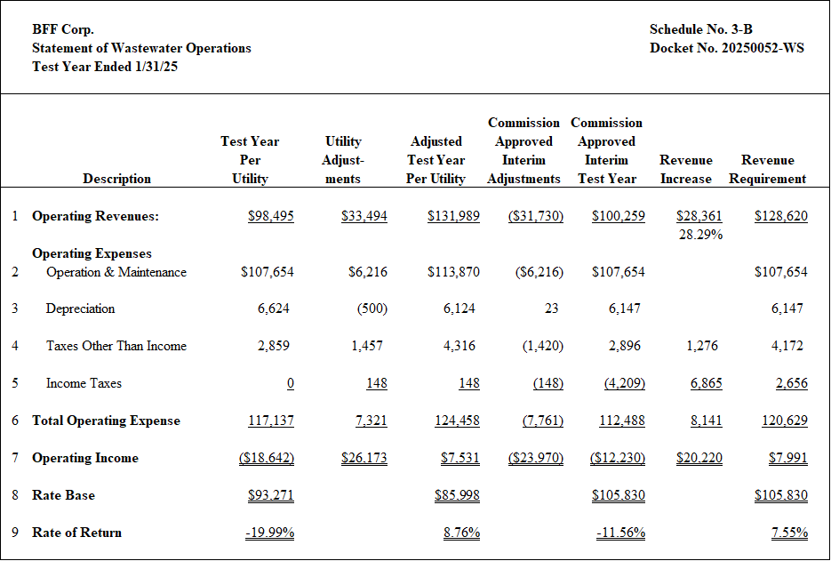









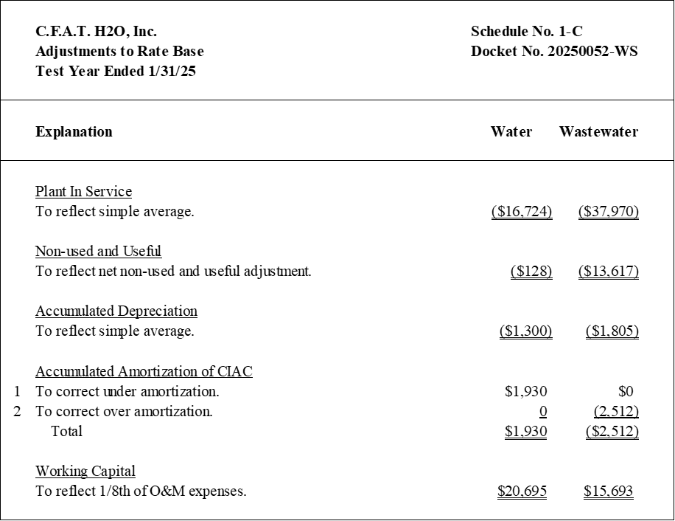







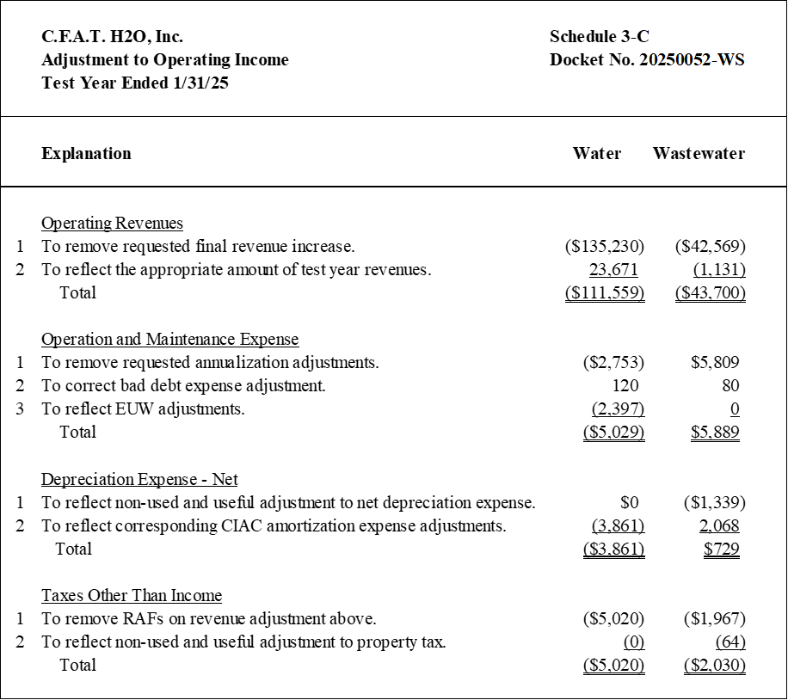







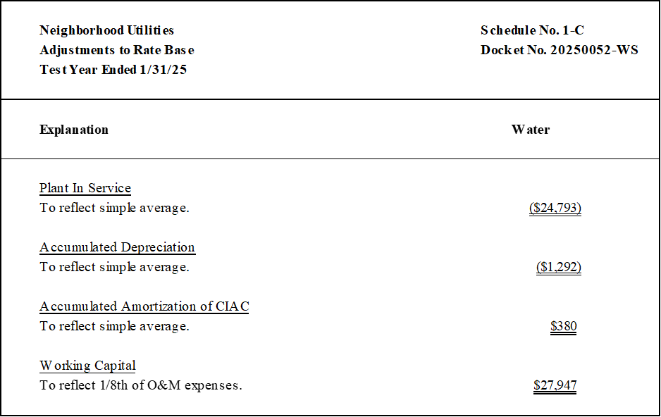

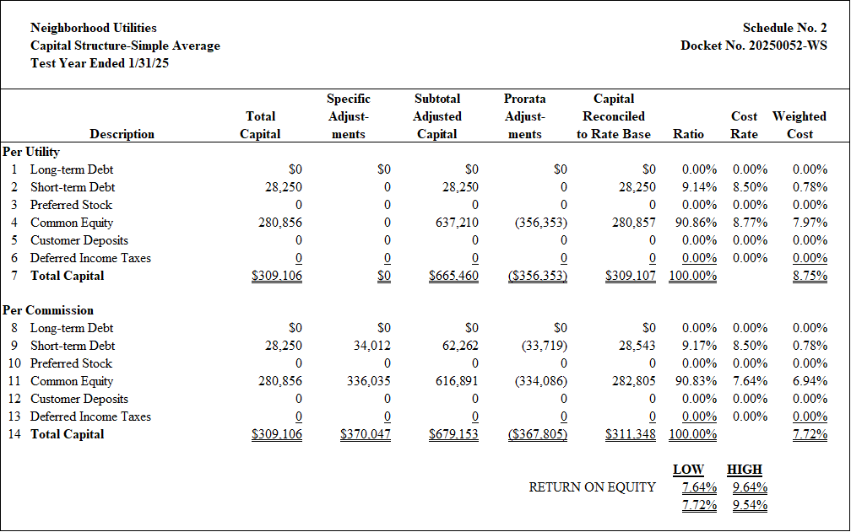



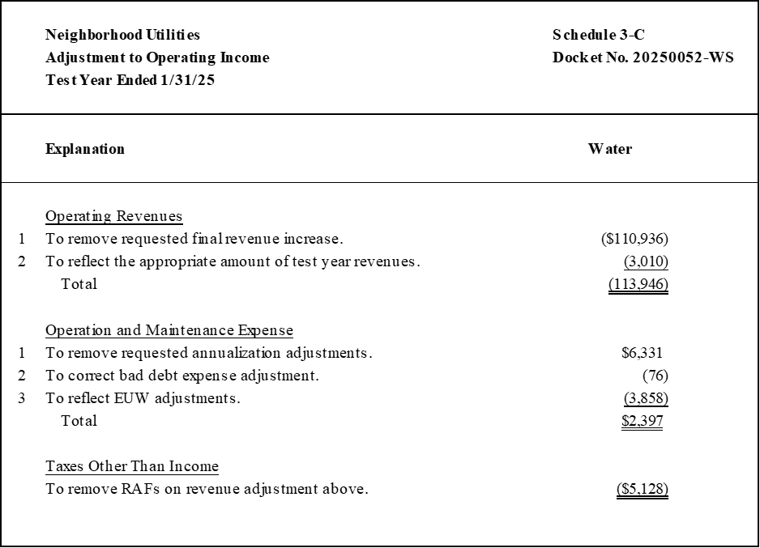





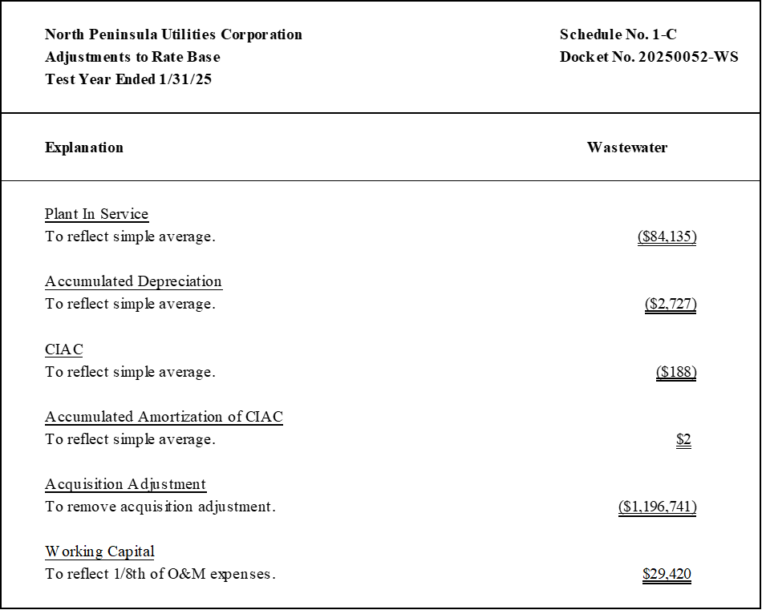





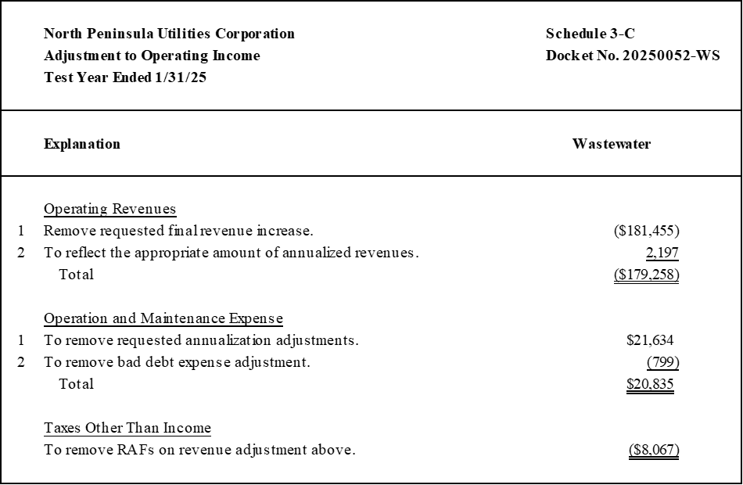







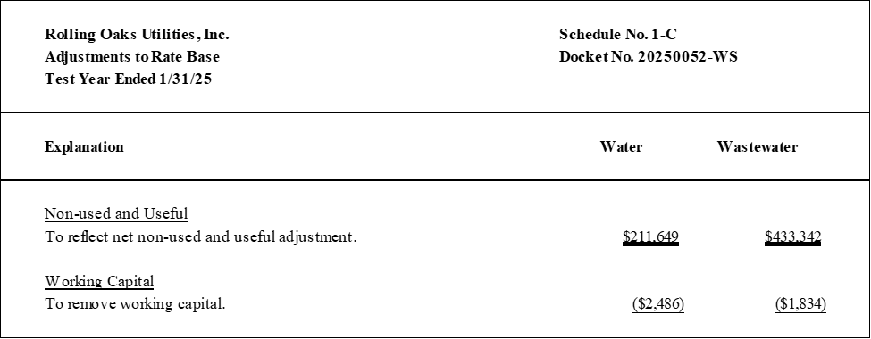





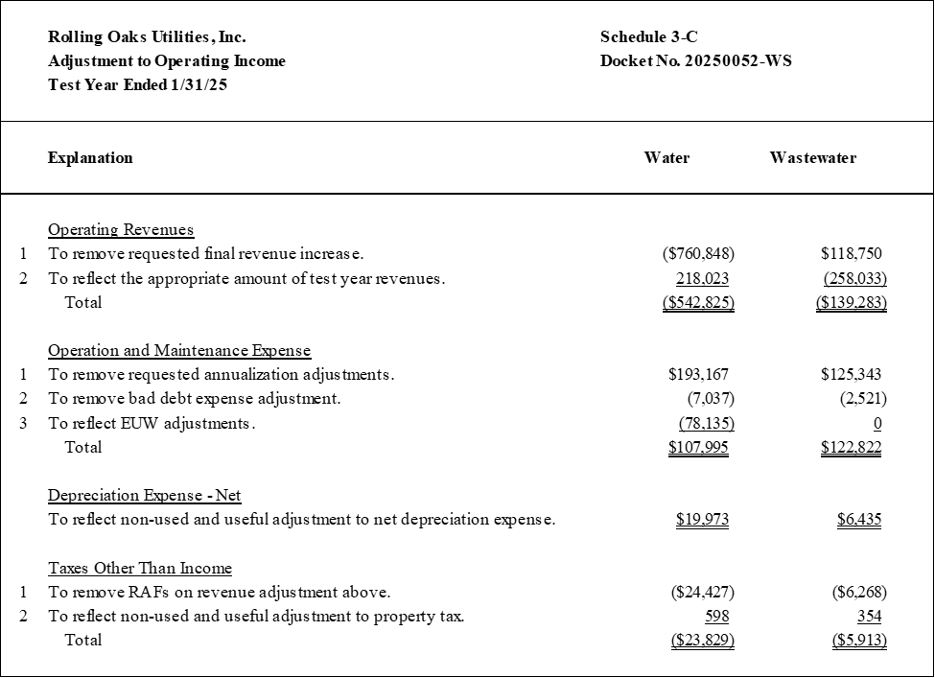







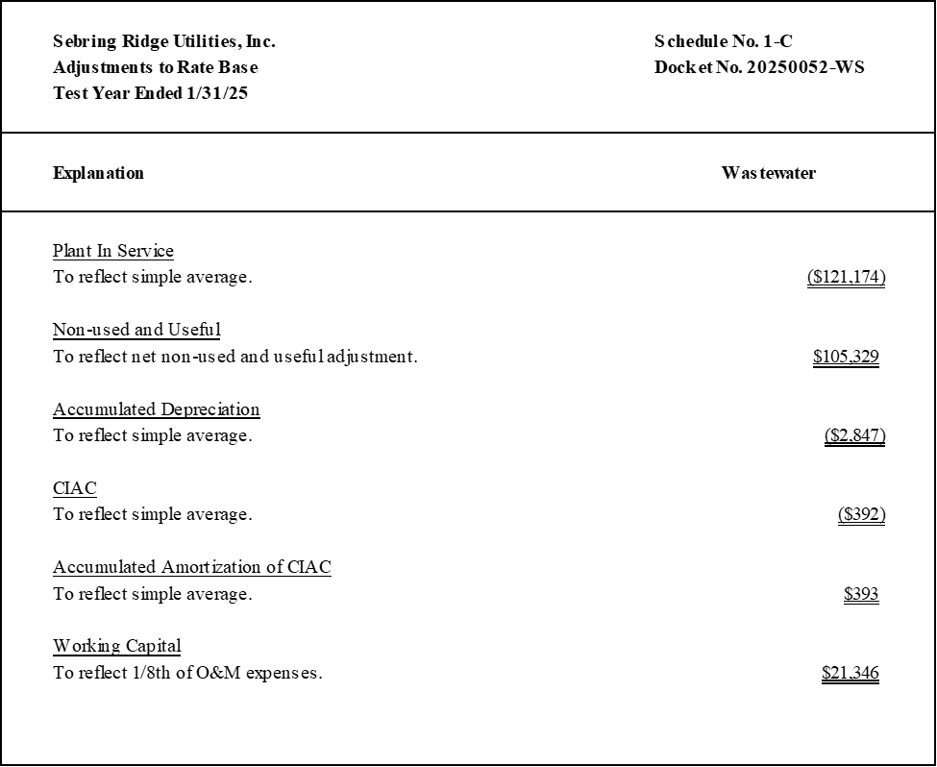





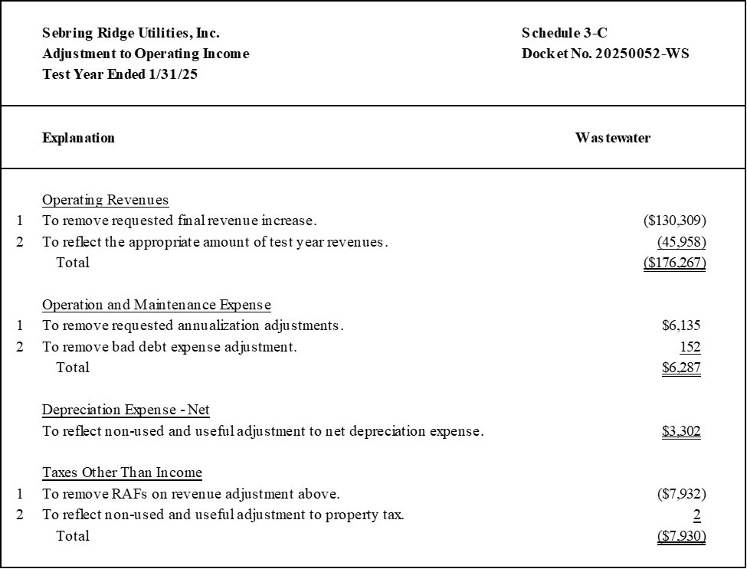









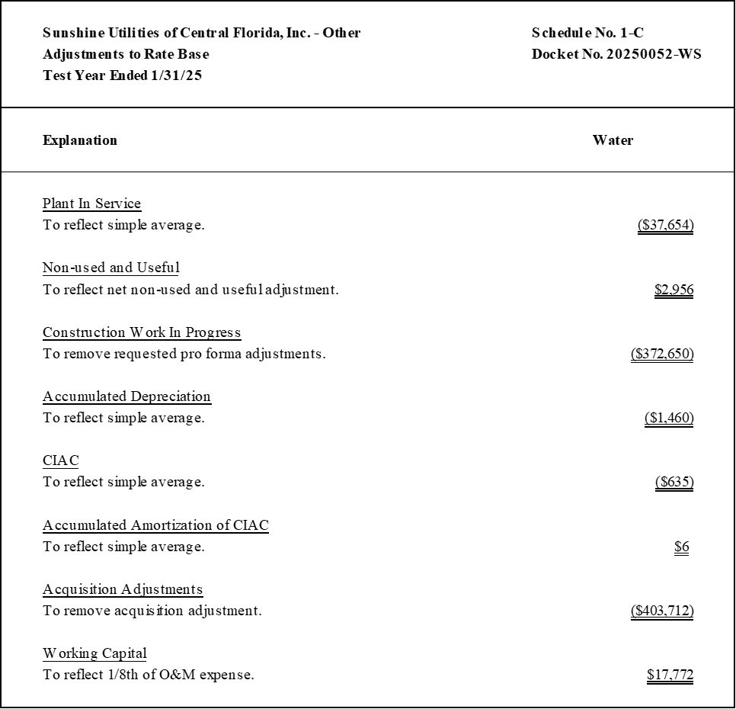





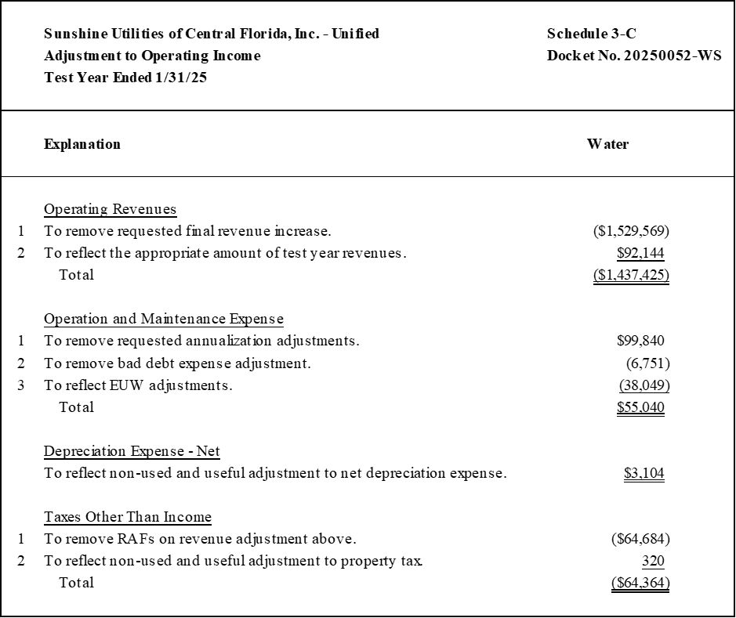



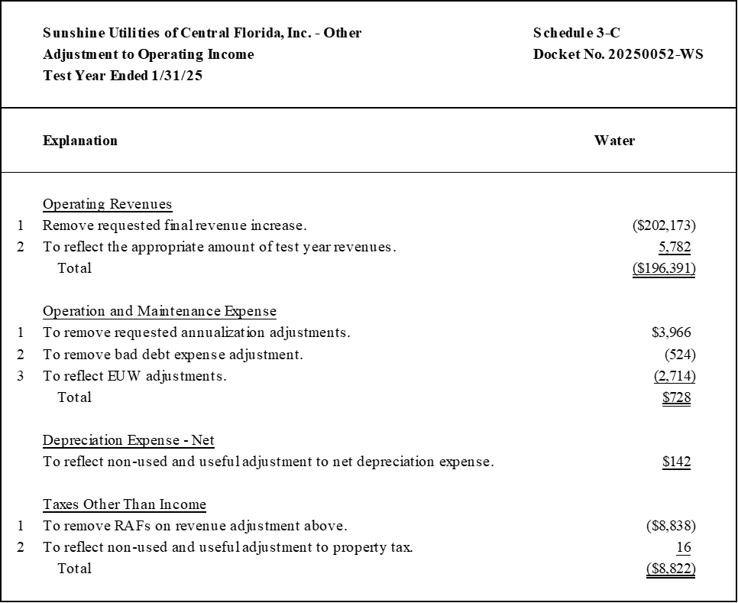





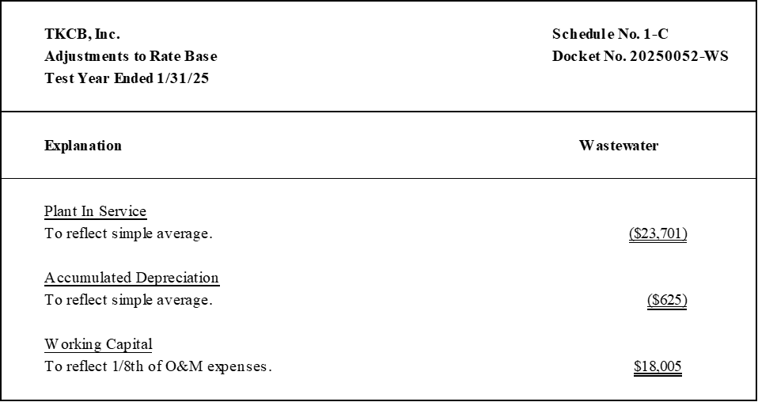





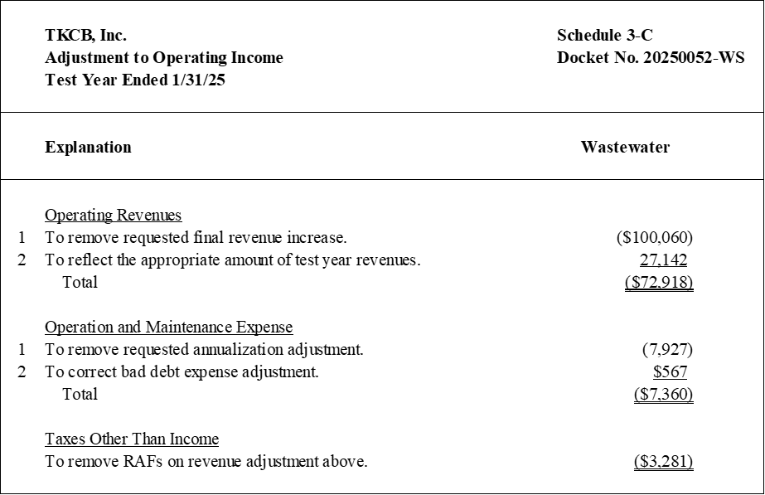

















1. Order No. PSC-2025-0280-PAA-WS, issued July 21, 2025, in Docket No. 20240130-WS, *In re: Application for grandfather certificate to operate water and wastewater utility in Citrus County, by CSWR-Florida Utility Operating Company, LLC.*
2. *See* Order Nos. PSC-16-0364-PCO-WU, issued August 29, 2016, in Docket No. 20160065-WU, *In re: Application for increase in water rates in Charlotte County by Bocilla Utilities, Inc*. (In declining to make interim adjustments, we stated, “This is the Utility’s first rate proceeding since receiving a grandfather certificate….Therefore, adjustments from a prior case are not necessary.”); PSC-00-9110-PSO-WU, issued May 8, 2000, in Docket No. 19991437-WU, *In re: Application for increase in water rates in Orange County by Wedgefield Utilities, Inc.*; and PSC-95-1570-FOF-WS, issued December 20, 1995, in Docket No. 19950336-WS, *In re: Application for rate increase in Charlotte County by Rotonda West Utility Corporation.*
3. Document No. 04529-2024, filed on June 3, 2024.
4. Document No. 06899-2025, filed on July 25, 2025.
5. The rule states the rate of return shall be calculated in accordance with Section 367.082(5), F.S., which states the calculation shall be based on a 12-month period.
6. Document No. 01883-2022, filed on March 15, 2022.
7. Sunshine – Unified consists of the Unified systems and Sandy Acres system.
8. Sunshine – Other consists of the Ponderosa Pines and Quail Run systems.
9. *See* Order Nos. PSC-2011-0366-PAA-WU, issued August 31, 2011, in Docket No. 20100126-WU, *In re: Application for increase in water rates in Marion County by C.F.A.T. H2O, Inc.*, PSC-2016-0537-PAA-WU, issued November 23, 2016, in Docket No. 20150181-WU, *In re: Application for staff-assisted rate case in Duval County by Neighborhood Utilities, Inc.*, PSC-2012-0357-PAA-WU, issued July 10, 2012, in Docket No. 20100048-WU, *In re: Application for increase in water rates in Marion County by Sunshine Utilities of Central Florida, Inc.*, PSC-2019-0362-PAA-SU, issued August 26, 2019, in Docket No. 20180218-SU, *In re: Application for staff-assisted rate case in Brevard County by TKCB, Inc.*; PSC-2011-0385-PAA-WS, issued September 13, 2011, in Docket No. 20100127-WS, *In re: Application for increase in water and wastewater rates in Marion County by Tradewinds Utilities, Inc.*
10. Order No. PSC-2023-0266-PAA-WS, issued August 22, 2023, in Docket No. 20220062-WS, *In re: Application for transfer of water and wastewater facilities of C.F.A.T. H2O, Inc., water Certificate No. 552-W, and wastewater Certificate No. 481-S to CSWR-Florida Utility Operating Company, LLC, in Marion County.*
11. We did not previously evaluate U&U, EUW, and I&I for these two systems; they will be denoted by N/A.
12. Order No. PSC-2025-0280-PAA-WS, issued July 21, 2025, in Docket No. 20240130-WS, *In re: Application for grandfather certificate to operate water and wastewater utility in Citrus County, by CSWR-Florida Utility Operating Company, LLC.*
13. *See* Docket Nos. 20250038-WS, 20250043-WS, and 20250047-WS, in which CSWR requested an acquisition adjustment for these two systems, as well as for Aquarina. By Order No. PSC-2025-0250-PCO-WS, issued June 25, 2025, we denied a motion to dismiss the petitions, allowing the three acquisition adjustment applications to proceed; however, no acquisition adjustments have been ordered for these systems at this time.
14. Order Nos. PSC-2017-0361-FOF-WS, issued September 25, 2017, and Amendatory Order PSC-2017-0361-FOF-WS, issued October 4, 2017, in Docket No. 20160101-WS, *In re: Application for increase in water and wastewater rates in Charlotte, Highlands, Lake, Lee, Marion, Orange, Pasco, Pinellas, Polk, and Seminole Counties by Utilities, Inc. of Florida*; PSC-09-0751-PCO-SU, issued November 16, 2009, in Docket No. 20090182-SU, *In re:* *Application for increase in wastewater rates in Pasco County by Ni Florida, LLC.*;PSC-97-0076-FOF-WS, issued January 27, 1997, in Docket No. 961364-WS, *In re: Investigation of rates of Lindrick Service Corporation in Pasco County for possible overearnings.* 
15. Document No. 07685-2025, filed on August 8, 2025.
16. *See* Order Nos. PSC-2022-0227-PCO-WS, issued June 27, 2022, in Docket No. 20220066-WS, *In re: Application for increase in water rates in Washington County, by Sunny Hills Utility.*; PSC-2006-0670-FOF-WS, issued August 7, 2006, in Docket No. 20060261-WS, *In re: Application for increase in water and wastewater rates in Lake County by Utilities, Inc. of Pennbrooke*; and PSC-2012-0554-PCO-WS, issued October 17, 2012, in Docket No. 20120152-WS, *In re: Application for increase in water and wastewater rates in Orange County by Pluris Wedgefield, Inc.*
17. Order No. PSC-2025-0269-PCO-WS, issued July 25, 2025, in Docket No. 20240108-SU, *In re: Water and wastewater industry annual reestablishment of authorized range of return on common equity for water and wastewater utilities pursuant to Section 367.081(4)(f), F.S.*
18. Order Nos. PSC-2025-0289-PAA-SU, issued July 28, 2025, and Amendatory Order PSC-2025-0289A-PAA-SU, issued August 1, 2025 in Docket No. 20240108-SU, *In re: Application for increase in wastewater rates in Monroe County by K W Resorts Utilities Corp.*; and PSC-2024-0046-PAA-WS, issued February 22, 2024, and Amendatory Order PSC-2024-0046A-PAA-WS, issued March 12, 2024, in Docket No. 20230081-WS, *In re: Application for increase in water and wastewater rates in Broward County by Royal Waterworks, Inc.*
19. Order No. PSC-12-0357-PAA-WU, issued July 10, 2012, in Docket No. 20100048-WU, *In re: Application for increase in water rates in Marion County by Sunshine Utilities of Central Florida, Inc.*
20. The MFRs for BFF contained an adjustment for bad debt expense, contradictory to its last rate case. However, no action was needed to correct this amount, as it was not included in BFF’s revenue requirement, and thus did not need to be removed.
21. *See* Order Nos. PSC-2019-0362-PAA-SU, issued August 26, 2019, in Docket No. 20180218-SU, *In re: Application for staff-assisted rate case in Brevard County by TKCB, Inc.*, Order No. PSC-2011-0385-PAA-WS, issued September 13, 2011, in Docket No. 20100127-WS, *In re: Application for increase in water and wastewater rates in Marion County by Tradewinds Utilities, Inc.*; PSC-2002-0487-PAA-SU, issued April 8, 2002, in Docket No. 20010919-SU, *In re: Application for staff-assisted rate case in Marion County by BFF Corp.;* PSC-2019-0461-PAA-SU, issued October 25, 2019, in Docket No. 20180138-SU, *In re: Application for staff-assisted rate case in Volusia County by North Peninsula Utilities Corporation;* PSC-1996-0869-FOF-WS, issued July 2, 1996, in Docket No. 19950966-WS*, In re: Application for a staff-assisted rate case in Highlands County by Sebring Ridge Utilities, Inc.*
22. *See* Order Nos. PSC-2016-0526-PCO-WS, issued November 22, 2016, in Docket No. 20160101-WS, *In re: Application for increase in water and wastewater rates in Charlotte, Highlands, Lake, Lee, Marion, Orange, Pasco, Pinellas, Polk, and Seminole Counties by Utilities, Inc. of Florida;* PSC-13-0673-FOF-WS, issued December 19, 2013, in Docket No. 130212-WS, *In re: Application for increase in water/wastewater rates in Polk County by Cypress Lakes Utilities, Inc.*; and PSC-10-0018-PCO-WS, issued January 6, 2010, in Docket No. 090402-WS, *In re: Application for increase in water and wastewater rates in* *Seminole County by Sanlando Utilities Corporation.* 
23. Document No. 05250-2025, filed on June 26, 2025.
24. *See* Order No. PSC-2023-0387-PCO-WS, issued December 27, 2023, in Docket No. 20230083-WS, *In re: Application for increase in water and wastewater rates in Orange County by Pluris Wedgefield, LLC.*
25. Document No. 07685-2025, filed on August 8, 2025.