|  |  |  |  |
| --- | --- | --- | --- |
| State of Florida  pscSEAL | | Public Service Commission  Capital Circle Office Center ● 2540 Shumard Oak Boulevard Tallahassee, Florida 32399-0850  -M-E-M-O-R-A-N-D-U-M- | |
| DATE: | September 25, 2025 | | |
| TO: | Office of Commission Clerk (Teitzman) | | |
| FROM: | Division of Economics (Bethea, Bruce, Hudson)  Division of Accounting and Finance (McClelland, Quigley, Vogel)  Division of Engineering (P. Buys, Ramos, L. Smith II)  Office of the General Counsel (Dose, Augspurger, Crawford) | | |
| RE: | Docket No. 20250052-WS – Application for increase in water and wastewater rates in Brevard, Citrus, Duval, Highlands, Marion, and Volusia Counties by CSWR-Florida Utility Operating Company, LLC | | |
| AGENDA: | 10/07/25 – Regular Agenda – Decision on Interim Rates – Participation is at the Discretion of the Commission | | |
| COMMISSIONERS ASSIGNED: | | | All Commissioners |
| PREHEARING OFFICER: | | | Clark |
| CRITICAL DATES: | | | 60-Day Interim Waived until 10/7/2025 |
| SPECIAL INSTRUCTIONS: | | | None |

Case Background

CSWR-Florida Utility Operating Company, LLC (CSWR or utility) is a Class A utility providing water and wastewater service to 11 systems in the following counties: Brevard, Citrus, Duval, Highlands, Marion, and Volusia. As the result of recent acquisitions and a grandfather certificate, CSWR is now a Florida domestic limited liability company that owns and operates the water and wastewater systems that are the subject of this rate case application. CSWR is a wholly-owned subsidiary of CSWR-Florida Utility Holding Company, LLC (CSWR, LLC).

In 2024, the utility recorded consolidated company operating revenues of $3,853,102 for water and $3,332,319 for wastewater. CSWR reported a net operating loss of $1,436,909 for water and $136,494 for wastewater. The utility has approximately 144,303 water customers and 87,571 wastewater customers for its combined systems. The following table reflects the rate proceeding in which rates were last established for each of CSWR’s systems.

**Last Rate Proceedings Establishing Rates for CSWR Systems**

|  |  |  |
| --- | --- | --- |
| Former Utility Name | Order | Issuance Date |
| Aquarina Utilities, Inc. | PSC-2020-0158-PAA-WS | May 15, 2020 |
| BFF Corp. | PSC-2002-0487-PAA-SU | April 8, 2002 |
| C.F.A.T. H2O, Inc. | PSC-2011-0366-PAA-WS | August 31, 2011 |
| Neighborhood Utilities, Inc. | PSC-2016-0537-PAA-WU | November 23, 2016 |
| North Peninsula Utilities, Corp. | PSC-2019-0461-PAA-SU | October 25, 2019 |
| Rolling Oaks Utilities, Inc. | Citrus County Approved | February 1, 2022 |
| Sebring Ridge Utilities, Inc. | PSC-1996-0869-FOF-WS | July 2, 1996 |
| Sunshine Utilities, Inc. | PSC-2012-0357-PAA-WU | July 10, 2012 |
| TKCB, Inc. | PSC-2021-0435-PAA-SU | November 22, 2021 |
| Tradewinds Utilities, Inc. | PSC-2011-0385-PAA-WS | September 13, 2011 |
| Tymber Creek Utilities, Inc. | PSC-2011-0345-PAA-WS;  Amendatory Order PSC-2011-0345A-PAA-WS | August 16, 2011 |

During the years of 2021-2024, CSWR applied to acquire ten of the systems in this rate proceeding, and all ten transfer dockets were approved by the Commission. On July 21, 2025, the Commission approved a grandfather certificate for Rolling Oaks Utilities, Inc., as the eleventh CSWR system.

On May 30, 2025, CSWR filed an application for approval of interim and final water and wastewater rate increases. By letter dated June 27, 2025, staff advised the utility that its Minimum Filing Requirements (MFRs) had several deficiencies. Having reviewed the utility’s deficiency response, staff sent a second letter to CSWR on August 15, 2025, advising that the utility’s rate application remains deficient. To date, the official date of filing has not been established for noticing purposes.

The utility's application for increased final water and wastewater rates is based on the historical 12-month period ended January 31, 2025, with requested capital recovery for facility improvements since the time of acquisitions. Additionally, the utility requested a single, consolidated rate structure. In approving interim rates pursuant to Section 367.082, Florida Statutes (F.S.), it has been Commission practice to use the utility’s current rate structure at the time of the interim rate request. For purposes of this recommendation, the analysis for each rate structure will be referred to by the former utility name prior to the acquisitions.

CSWR requested interim rates for all of its systems, designed to generate additional revenues of $2,279,365 for water operations and $225,973 for wastewater operations.

In setting final rates, the current rate structure of each system is also used for the collection of the final revenues. CSWR requested final rates designed to generate additional revenues of $3,223,769 for water operations and $954,881 for wastewater operations. By Order No. PSC-2025-0318-PCO-WS, issued August 21, 2025, the Commission suspended CSWR’s final rates request.

The intervention of the Office of Public Counsel (OPC) was acknowledged by Order No. PSC-2025-0113-PCO-WS, issued April 7, 2025, in this docket.

On September 4, 2025, the Commission approved CSWR’s interim rates request for nine systems and denied the request for one system.[1]

CSWR has one remaining system, Aquarina, where the request for interim rates has not yet been addressed. The utility extended the statutory time frame to address its interim rates request for for Aquarina through the October 7, 2025 Commission Conference, as the utility has multiple services for water, potable and non-potable water requires separate revenue requirements.[2] This recommendation addresses the utility’s interim rate request for Aquarina. The Commission has jurisdiction pursuant to Sections 367.081 and 367.082, F.S.

Discussion of Issues

Issue 1:

 Should any interim revenue increase for Aquarina be approved?

Recommendation:

 Yes. The utility should be authorized to collect annual water revenues for Aquarina – Non-Potable in the amount of $274,095, which is an increase of $62,050, or 29.26 percent, over staff’s adjusted test year revenues of $212,044. The utility also should be authorized to collect annual water revenues for Aquarina – Potable in the amount of $194,053, which is an increase of $9,820, or 5.33 percent, over staff’s adjusted test year revenues of $184,233. Aquarina – Wastewater appears to be earning above its maximum return on equity (ROE). As such, revenues in the amount of $42,253 should be collected subject to refund, instead of decreasing rates at this time. (McClelland, Vogel, P. Buys)

Staff Analysis:

 Pursuant to Section 367.082(1), F.S., the Commission may authorize the collection of interim rates during any proceeding for a change of rates upon petition from any party or its own motion, and in order to establish a prima facie entitlement for interim relief, the utility shall demonstrate that it is earning outside the range of reasonableness on its rate of return. Pursuant to Section 367.082(2)(a), F.S., in a proceeding for an interim increase in rates, the Commission shall authorize, within 60 days of the filing for such relief, the collection of rates sufficient to earn the minimum of the range of rate of return. CSWR filed rate base, cost of capital and net operating statements to support its requested interim water and wastewater increases. However, it had to re-file its request for Aquarina, as the water revenue requirement required a break out of the potable and non-potable rates.

Pursuant to Section 367.082(5)(b)1., F.S., the achieved rate of return for interim purposes must be calculated by applying adjustments consistent with those used in the utility’s most recent rate proceeding and annualizing any rate changes. Staff reviewed CSWR’s interim request, as well as all orders that addressed the utility’s most recent rate proceedings. Staff has attached accounting schedules for Aquarina’s Potable water, Non-Potable water, and Wastewater systems to illustrate staff’s recommended rate base, capital structure, and test year operating income amounts. The rate base schedules are labeled as Schedule Nos. 1-A, 1-B, and 1-C. The capital structure schedule is labeled Schedule No. 2. The operating income schedules are labeled as Schedule Nos. 3-A, 3-B, and 3-C. Staff’s recommended adjustments are discussed below.

Interim Rate Base

Simple Average Adjustment

Consistent with Rule 25-30.433(5), Florida Administrative Code (F.A.C.), and Aquarina’s previous rate case, the utility’s interim test year should reflect rate base calculated using the simple beginning and end-of-year average (simple average) method. CSWR’s interim filing for Aquarina reflects a rate base calculated using a 13-month average. Staff adjusted the balances to reflect the simple average method, as shown on Schedule No. 1 for each system. Staff’s recommended adjustments are reflected in the table below.

Table 1-1

Interim Adjustments to Reflect Simple Average

|  |  |  |  |
| --- | --- | --- | --- |
| System | Plant | Accumulated Depreciation | Accumulated Amortization of CIAC |
| Aquarina – Potable | $588,548 | ($468,392) | $588 |
| Aquarina – Non-Potable | $397,787 | ($334,905) | $0 |
| Aquarina – Wastewater | $448,523 | ($629,006) | $847 |

***Used & Useful***

Staff reviewed the utility’s interim used and useful (U&U) calculations, previous Commission decisions, and available usage and capacity data contained in CSWR’s MFR schedules. Staff recommends the adjustments identified in Table 1-2 for Aquarina, based on current system conditions and using the methodology approved in the system’s prior rate case order.

**Table 1-2**

**Interim U&U Adjustments**

|  |  |  |  |
| --- | --- | --- | --- |
| Aquarina | Last Rate Case U&U | CSWR Requested U&U | Staff Recommended U&U |
| Potable WTP | 81% | 81% | 100% |
| Non-Potable Water Plant | 100% | 81% | 100% |
| Potable Water Storage | 47% | 47% | 61% |
| Non-Potable Water Storage | 61% | 47% | 61% |
| WWTP | 56% | 56% | 56% |
| Potable Water Distribution System | 63% | 63% | 63% |
| Non-Potable Water Distribution System | 100% | 63% | 100% |
| Collection System | 65% | 65% | 65% |

Sources: Order No. PSC-2016-0583-PAA-WS, issued December 29, 2016, in Docket No. 20150010-WS, *In re****:*** *Application for staff-assisted rate case in Brevard County by Aquarina Utilities, Inc.,* Document Nos. 04080-2025, 04993-2025, and 07961-2025, in Docket No. 20250052-WS, *In re: Application for increase in water and wastewater rates in Brevard, Citrus, Duval, Highlands, Marion, and Volusia Counties by CSWR-Florida Utility Operating Company.*

In its interim MFR B-3 schedules, the utility indicated non-used and useful adjustments to depreciation expense for all three systems. However, for two systems, Aquarina – Potable and Aquarina – Non-Potable, the adjustment was not reflected on the MFR B-1 schedules and therefore, not included in the revenue requirement for either system. As such, staff made corresponding adjustments to reflect these adjustments.

Based on the above calculations and staff’s corrections to CSWR’s used and useful percentages, staff recommends the adjustments indicated on the table below.

**Table 1-3**

**Interim – Used & Useful Adjustments**

| System | Rate Base | Depreciation Expense | Property Tax |
| --- | --- | --- | --- |
| Aquarina – Potable | $43,454 | ($3,032) | $457 |
| Aquarina – Non-Potable | $61,163 | ($90) | $510 |
| Aquarina – Wastewater | $54,220 | $1,250 | $391 |

Contributions in Aid of Construction

In its initial and revised MFRs, CSWR listed balances of $421,159 in Contributions in Aid of Construction (CIAC) and $280,629 in Accumulated Amortization of CIAC for Aquarina – Potable, with no balance allotted to either account for Aquarina – Non-Potable. In staff’s correspondence with CSWR, the utility acknowledged that the amount should have been allocated between the two systems, and provided the correct allocation.[3] For Aquarina – Potable, the CIAC balance should be decreased by $47,636 for a total of $373,523, and the accumulated amortization of CIAC should be reduced by $34,963 to a total of $245,666. For Aquarina – Non-Potable, the CIAC balance should be $47,636, and the accumulated amortization of CIAC balance should be $34,963. Based on the corrections to CSWR’s CIAC balances for both systems, staff recommends net depreciation expense be increased by $1,584 for Aquarina – Potable, and decreased by $1,584 for Aquarina – Non-Potable to reflect the corresponding CIAC amortization expense.

Acquisition Adjustment

In its filing, the utility requested an acquisition adjustment for all Aquarina systems. [4] The utility reflected an acquisition adjustment of $1,145,736 for Aquarina – Potable, $863,567 for Aquarina – Non-Potable, and $306,986 for Aquarina - Wastewater in its interim request. The acquisition adjustments have been removed from rate base for the purpose of calculating interim rates, as they have not been approved by the Commission. It is expected that CSWR’s acquisition adjustment petitions will be consolidated with the instant rate proceeding, and that the acquisition adjustment requests will be addressed together with CSWR’s rate request in a future administrative hearing.

Working Capital Allowance

Although CSWR, post-consolidation, would be classified as a Class A utility, working capital should be calculated for each system using the same basis from its respective prior rate cases. Pursuant to Rule 25-30.433(3), F.A.C., working capital allowance for Class B and C utilities are calculated using the formula method, which is one-eighth of operation and maintenance (O&M) expenses. CSWR did not calculate working capital allowance in accordance with the rule in its MFRs, and instead calculated a working capital allowance of approximately one-eight hundredth of O&M expenses for each system. Staff adjusted the working capital allowance for each system pursuant to Rule 25-30.433(3), F.A.C., using the formula method and staff’s recommended O&M for each system. The following table shows all working capital adjustments made by staff.

**Table 1-4**

**Interim Working Capital Adjustments**

| System | Adjustment |
| --- | --- |
| Aquarina – Potable | $11,882 |
| Aquarina – Non-Potable | $24,091 |
| Aquarina – Wastewater | $26,145 |

Interim Cost of Capital

Capital Structure

In its initial filing, Aquarina’s capital structure included only common equity and short term debt. Staff asked the utility for clarification on how capital structure was calculated. The utility confirmed that the cost of capital is imputed from CSWR - LLC., the parent company of CSWR. The capital structure is calculated based on Aquarina’s actual financial data. The debt portion consists of notes payable to the parent, which are available as the result of a debt facility sourced by the parent in 2024 and transferred in response to the capital needs of the system. The equity consists of paid-in capital contributed primarily for the acquisition and improvement of the system and the accumulated retained earnings or deficit.[5]

ROE

Pursuant to the provisions of the interim statute, an interim decrease should be calculated using the maximum ROE limit, and an interim increase should be calculated using the minimum ROE limit. CSWR’s deficient initial interim filing, dated May 30, 2025, included schedules labeled “Interim Rate – Revenue Deficiency” which indicated the use of the ROEs from Aquarina’s previous rate case. In its updated interim filing, dated June 27, 2025, the MFR Schedule D-1 reflected a ROE of 8.77 percent. The Excel workpapers did not provide support calculations for the ROE. The updated filing also included the “Interim Rate – Revenue Deficiency” schedules with ROEs from each previous rate case, but the actual calculation of revenue requirement reflected 8.77 percent. The updated interim Aquarina filing, dated August 5, 2025, maintained the previously indicated 8.77 percent ROE.

Section 367.082(5)(b), F.S., states the required rate of return shall be calculated using the last authorized rate of return on equity of the utility or regulated company, which also includes using the leverage formula as appropriate. However, consistent with Commission practice, the existing ROE does not transfer when a system assumes a new owner, so it is permissible to use the leverage formula as the last authorized rate of return.[6] Staff recommends the interim cost of capital be calculated using the 2025 leverage formula, which results in a ROE of 8.55 percent, as shown on Schedule No. 2.[7]

Simple Average Adjustment

Consistent with Rule 25-30.433(5), F.A.C., and Aquarina’s previous rate case, the utility’s interim test year for Class B utilities should reflect a cost of capital calculated using the simple average method. CSWR’s interim filing reflects a cost of capital calculated using a 13-month average. Staff adjusted the balance to reflect the simple average method, as shown on Schedule No. 2.

Pro Rata Adjustment

In its MFRs, the utility only made an adjustment to common equity. Aquarina’s capital structure consists of common equity and short term debt. Consistent with Aquarina’s most recent rate case, staff recommends the capital structure be prorated across both sources of capital, as shown on Schedule No. 2.[8]

Interim Net Operating Income

Pursuant to Section 367.082(5)(b)1., F.S., the achieved rate of return for interim purposes must be calculated by applying adjustments consistent with those made in the utility’s most recent rate proceeding and annualized for any rate changes. Based on staff’s review, several adjustments are necessary for interim purposes as reflected on the respective adjustments to operating income schedules.

Test Year O&M Adjustments – Annualization

CSWR made several adjustments to O&M expenses for Aquarina related to new third party contracts that began during the test year. However, staff believes this set of adjustments is improper for interim purposes. Rule 25-30.437(2)(d), F.A.C., states that for the utility to “demonstrate that it is earning outside the range of reasonableness” on its rate of return, “the utility must submit schedules of rate base, cost of capital, and net operating income on an historical basis.” The adjustments provided in its interim filings were made to annualize a change in O&M expenses that occurred during the test year. These adjustments would shift O&M expenses in their entirety from a historical basis to a pro forma basis. Staff believes these adjustments are appropriate for consideration in the final rate increase, but violate the nature of the interim process. As such, staff recommends removal of the annualization adjustments in amounts of $1,790 for Aquarina – Potable, $7,375 for Aquarina – Non-Potable, and $6,596 for Aquarina – Wastewater.

O&M Adjustments Consistent with the Last Rate Case

Adjustments to bad debt expense are necessary for interim purposes in order to be consistent with the treatment in Aquarina’s last rate case. CSWR applied a 3-year averaging adjustment to bad debt expense for Aquarina. Upon review, staff determined that consistent with its prior rate case, Aquarina did not require a bad debt adjustment and recommends removing the requested adjustments. CSWR and staff’s recommended adjustments are detailed in the table below.

Table 1-5

3-Year Averaging Adjustment to Bad Debt – Water Systems

|  |  |  |
| --- | --- | --- |
| Utility | Utility Adjustment | Staff Adjustment |
| Aquarina – Potable | $299 | ($299) |
| Aquarina – Non-Potable | $299 | ($299) |
| Aquarina – Wastewater | $432 | ($432) |

***Excessive Unaccounted Water***

Staff reviewed the utility’s interim excessive unaccounted water (EUW) calculations, previous Commission decisions, and available usage data contained in CSWR’s MFR schedules. The Commission determined that Aquarina did not have any EUW for the potable water system in its prior rate case.[9] However, based on the utility’s interim data, staff determined the Aquarina system to have an EUW of 29 percent. The non-potable well did not have a flow meter during the test year, so EUW could not be determined. Staff will continue to investigate this matter during the course of the rate case.[10] Following the same methodology used in the last rate case, staff recommends applying the updated EUW percentages to the actual purchased power and chemicals expenses for Aquarina – Potable, resulting in a total reduction of $1,481.

***Infiltration & Inflow***

Staff reviewed the utility’s interim excessive infiltration and inflow (I&I) calculations, previous Commission decisions,[11] and available usage data contained in CSWR’s MFR schedules. Using the methodology approved in the prior rate case and current conditions, staff is not recommending any I&I adjustments for interim purposes. While staff recommends no adjustment for interim purposes, the I&I for the Aquarina system will be investigated by staff during the course of this rate case.

Earnings Analysis

Aquarina - Wastewater

Based on the adjustments outlined above, Aquarina – Wastewater reflected overearnings in the interim test year. Pursuant to Section 367.082(2)(b), F.S., in a proceeding for an interim decrease in rates, the Commission shall authorize the continued collection of the previously authorized rates; however, revenues collected under those rates that are sufficient to reduce the achieved rate of return to the maximum of the rate of return should be held subject to refund with interest. Although Aquarina – Wastewater’s rates indicate overearning, staff recommends the utility continue to collect its current rates, and hold subject to refund revenues collected under those rates that are sufficient to reduce the achieved rate of return to the maximum of the current rate of return, with interest. Over the full course of the rate case and potential rate consolidation, staff will evaluate the potential refund. As such, staff recommends that $42,253 be held subject to refund for Aquarina – Wastewater.

Revenue Requirement

Staff is recommending revenue requirements consistent with the calculations required by Section 367.082, F.S. For those systems that appear to be underearning, the revenue requirements were determined using the minimum ROE limit. Consistent with the interim statute, staff used the maximum ROE limit for Aquarina – Wastewater, which appears to be overearning.

Based upon recovery of actual operating expenses for the year ended January 31, 2025, staff recommends that the utility be authorized to collect annual water revenues for Aquarina – Non-Potable in the amount of $274,095, which is an increase of $62,050, or 29.26 percent, over staff’s adjusted test year revenues of $212,044. The utility also should be authorized to collect annual water revenues for Aquarina – Potable in the amount of $194,053, which is an increase of $9,820, or 5.33 percent, over staff’s adjusted test year revenues of $184,233. Staff recommends no change to rates for Aquarina – Wastewater, with a total of $42,253 held subject to refund.

According to Section 367.082, F.S., any refund should be calculated to reduce the rate of return of the utility during the pendency of the proceeding to the same level within the range of the newly authorized rate of return. Staff will evaluate each system’s post-consolidation revenue requirement to determine if any refunds should be made.

Issue 2:

 What are the appropriate interim water and wastewater rates?

Recommendation:

 The service rates for CSWR in effect as of January 31, 2025, should be increased as shown below to generate the recommended revenue increase for the interim period.

|  |  |
| --- | --- |
| System | % Rate Increase |
| Aquarina – Potable | 5.38% |
| Aquarina – Non-Potable | 29.26% |

The rates, as shown on Schedule No. 4, should be effective for service rendered on or after the stamped approval date on the tariff sheets pursuant to Rule 25-30.475(1), F.A.C. The utility should file revised tariff sheets and a proposed customer notice to reflect the Commission-approved rates. In addition, the approved rates should not be implemented until the required security has been filed, staff has approved the proposed customer notice, and the notice has been received by the customers. The utility should provide proof of the date the notice was given within 10 days of the date of the notice. (Bethea)

Staff Analysis:

 Staff recommends that interim service rates for CSWR be designed to allow the utility the opportunity to generate additional annual operating revenues as shown below for potable and non-potable water. The test year revenues were adjusted to annualize the rates in effect at the end of the test year. To determine the appropriate increase to apply to the service rates, miscellaneous revenues should be removed from the adjusted test year revenues for potable. The utility recorded miscellaneous services revenues of $1,588 for its potable system. There were no miscellaneous revenues recorded for the non-potable system. The calculations are as follows:

**Table 2-1**

**Potable Percentage Service Rate Increase**

|  |  |  |
| --- | --- | --- |
|  |  |  |
| 1 | Total Test Year Revenues | $184,233 |
| 2 | Less: Miscellaneous Revenues | $1,588 |
| 3 | Test Year Revenues from Service Rates | $182,645 |
| 4 | Revenue Increase | $9,820 |
| 5 | Percentage Service Rate Increase (Line 4/Line 3) | 5.38% |

Source: Staff’s Interim Recommended Revenue Requirement

**Table 2-2**

**Non-Potable Percentage Service Rate Increase**

|  |  |  |
| --- | --- | --- |
|  |  |  |
| 1 | Total Test Year Revenues | $212,044 |
| 2 | Less: Miscellaneous Revenues | $0 |
| 3 | Test Year Revenues from Service Rates | $212,044 |
| 4 | Revenue Increase | $62,050 |
| 5 | Percentage Service Rate Increase (Line 4/Line 3) | 29.26% |

Source: Staff’s Interim Recommended Revenue Requirement

Consistent with Commission practice for interim rates, the above percentage increases should be applied as an across-the-board increase to the service rates in effect as of January 31, 2025. Due to a decrease in percentage, staff recommends that CSWR’s Aquarina wastewater rates remain the same for interim purposes. However, as discussed in Issue 1, staff has recommended amounts to be held subject to refund for that system. Table 2-3 reflects the typical residential bill at the 5,000 gallon consumption level for the utility’s current rates, proposed interim rates, and staff recommended interim rates.

**Table 2-3**

**Typical Residential 5/8" x 3/4" Meter Bill Comparison**

**At 5,000 Gallons**

|  |  |  |  |
| --- | --- | --- | --- |
| System | Utility  Current  Rates | Utility  Proposed  Interim Rates | Staff  Recommended  Interim Rates |
| Aquarina – Potable | $66.79 | $99.68 | $70.37 |
| Aquarina – Non-Potable | $19.97 | $29.82 | $25.81 |

The rates, as shown on Schedule No. 4, should be effective for service rendered on or after the stamped approval date on the tariff sheets pursuant to Rule 25-30.475(1), F.A.C. The utility should file revised tariff sheets and a proposed customer notice to reflect the Commission-approved rates. In addition, the approved rates should not be implemented until the required security has been filed, staff has approved the proposed customer notice, and the notice has been received by the customers. The utility should provide proof of the date notice was given within 10 days of the date of the notice.

Issue 3:

 What is the appropriate security to guarantee the interim increase?

Recommendation:

 The appropriate security to guarantee the funds collected subject to refund is a corporate undertaking by CSWR, LLC, on behalf of its subsidiary, CSWR. CSWR, LLC should be required to provide a written guarantee that it will support a cumulative corporate undertaking on behalf of CSWR in the amount of $2,429,866. (Quigley)

Staff Analysis:

 Pursuant to Section 367.082, F.S., revenues collected under interim rates shall be placed under bond, escrow, letter of credit, or corporate undertaking subject to refund with interest at a rate ordered by the Commission. As recommended in Issue 1, the total interim increase for Aquarina is $71,871, with an additional $42,253 being held subject to refund due to potential overearnings. In accordance with Rule 25-30.360, F.A.C., staff calculated the potential refund of revenues and interest collected under interim conditions to be $96,830. This amount is based on an estimated 10-month collection period of interim rates. A corporate undertaking request for the interim request associated with its other systems, as approved by the Commission at the September Agenda Conference in the amount of $2,333,036 is still pending. Including this amount and the current corporate undertaking request of $96,830, the total cumulative outstanding guarantee is $2,429,866, subject to refund.

The criteria for a corporate undertaking includes sufficient liquidity, equity ownership, and profitability to guarantee any potential refund. Staff reviewed CSWR, LLC’s 2022, 2023, and 2024 confidential financial statements filed with the Commission to determine if CSWR can support a corporate undertaking for the requested amount.[12] Staff’s analysis indicated that over the three-year period ending December 31, 2024, the utility’s parent, CSWR, LLC, has insufficient profitability over the period, but has sufficient liquidity and equity ownership. The parent company has a substantial amount of cash available which is sufficient to support a cumulative corporate undertaking in the amount of $2,429,866. Additionally, CSWR, LLC has positive working capital and its equity capital significantly exceeds the requested amount and is supported by an equity ratio that is greater than 50 percent.

Based on the analysis of CSWR, LLC’s financial position, staff recommends that CSWR can support a cumulative corporate undertaking in the amount of $2,429,866. Staff’s recommendation is contingent upon CSWR, LLC providing a signed letter by a corporate officer that it will support CSWR in its corporate undertaking endeavor. Staff also received confirmation from the utility that it had no other outstanding guarantees on behalf of CSWR-owned utilities in other jurisdictions.[13]

This brief financial analysis is only appropriate for determining if CSWR, through its parent, can support a corporate undertaking in the amount proposed and should not be considered a finding regarding staff’s position on other issues in this proceeding. In no instance should maintenance and administrative costs associated with any refund be borne by the customers. Such costs are the responsibility of, and should be borne by CSWR.

Pursuant to Rule 25-30.360(6), F.A.C., the utility should provide a report by the 20th day of each month indicating the monthly and total revenue collected subject to refund. Should a refund be required, the refund should be with interest and undertaken in accordance with Rule 25-30.360, F.A.C.

Issue 4:

 Should this docket be closed?

Recommendation:

 The docket should remain open pending the Commission’s final action on the utility’s requested rate increase. (Dose)

Staff Analysis:

 The docket should remain open pending the Commission’s final action on the utility’s requested rate increase.

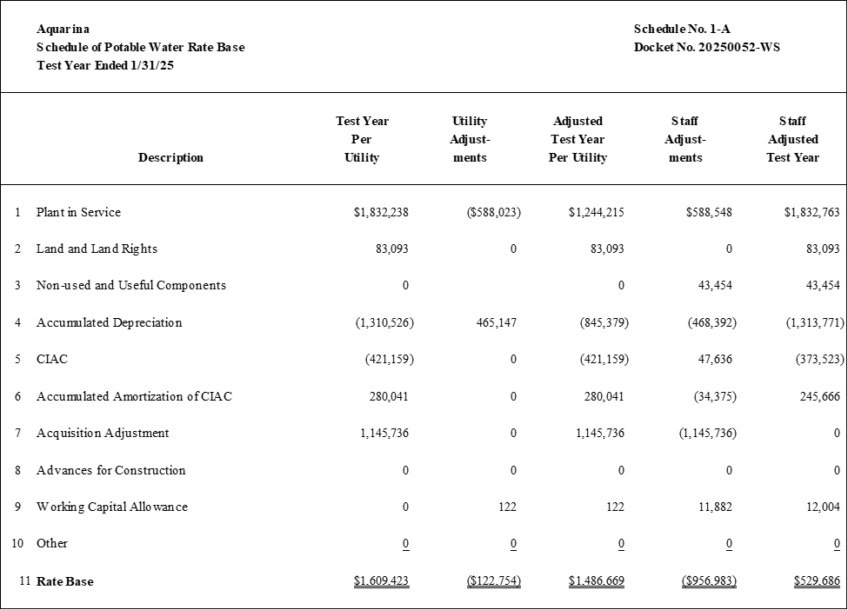

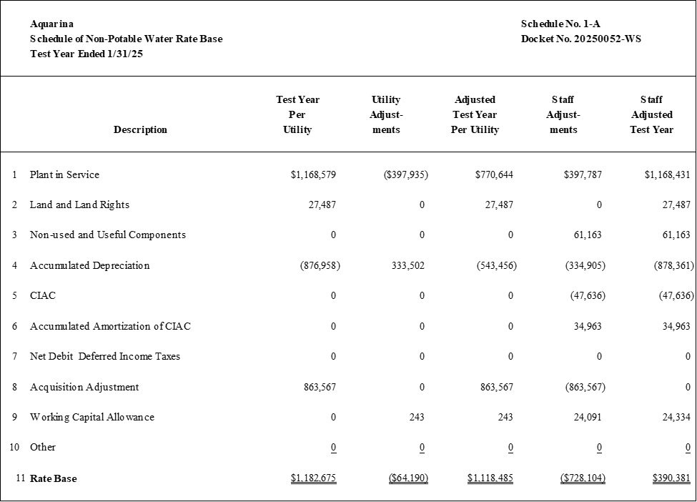

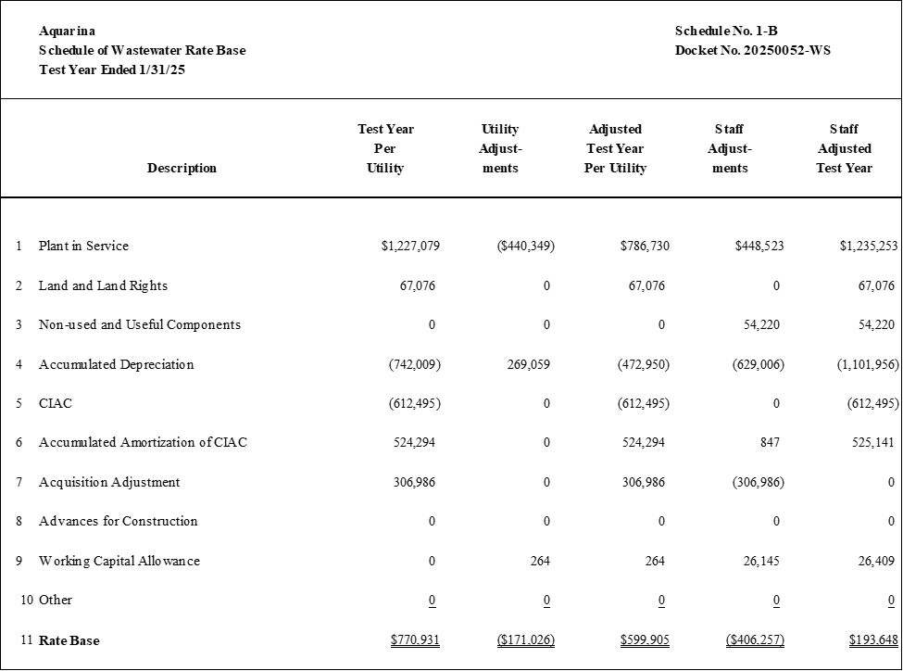

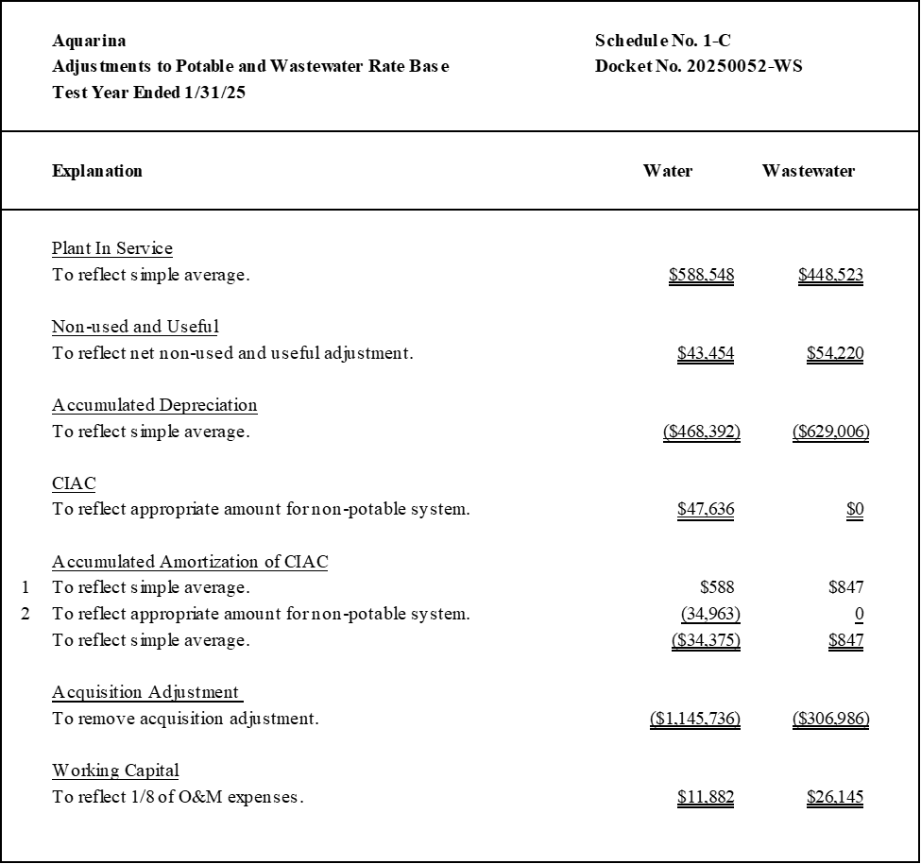

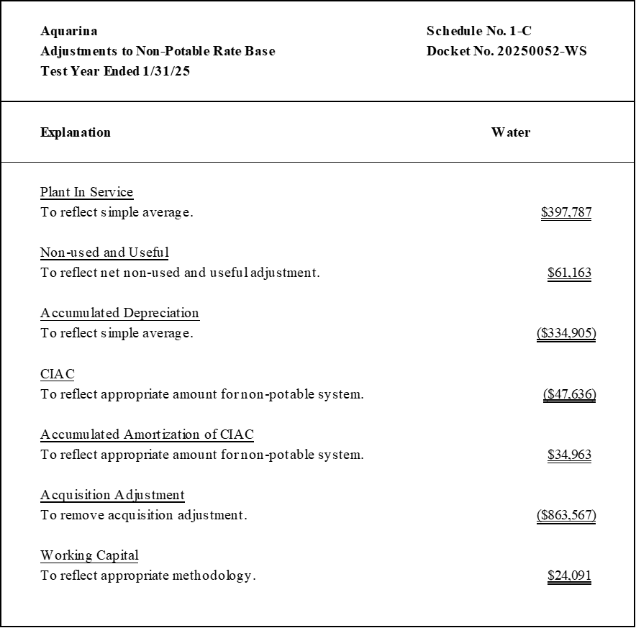



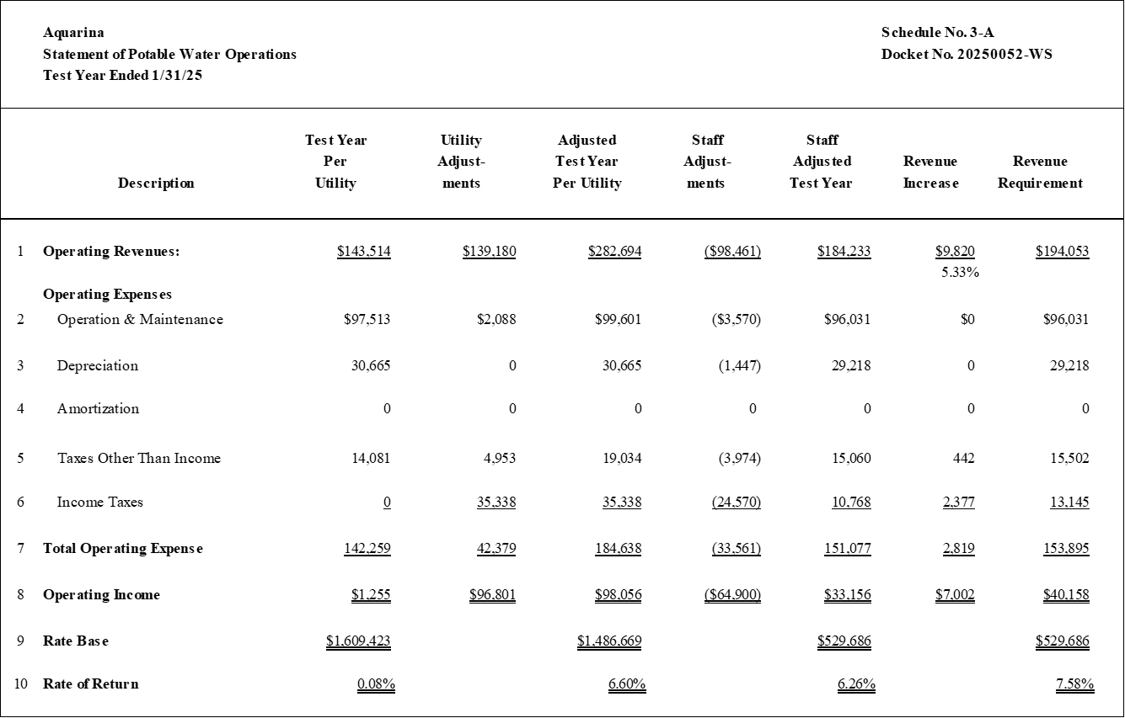

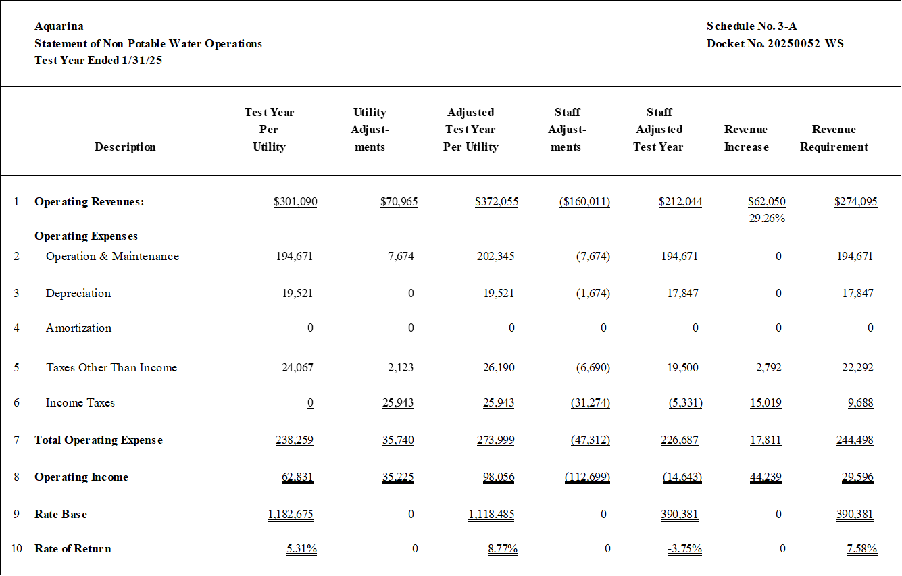



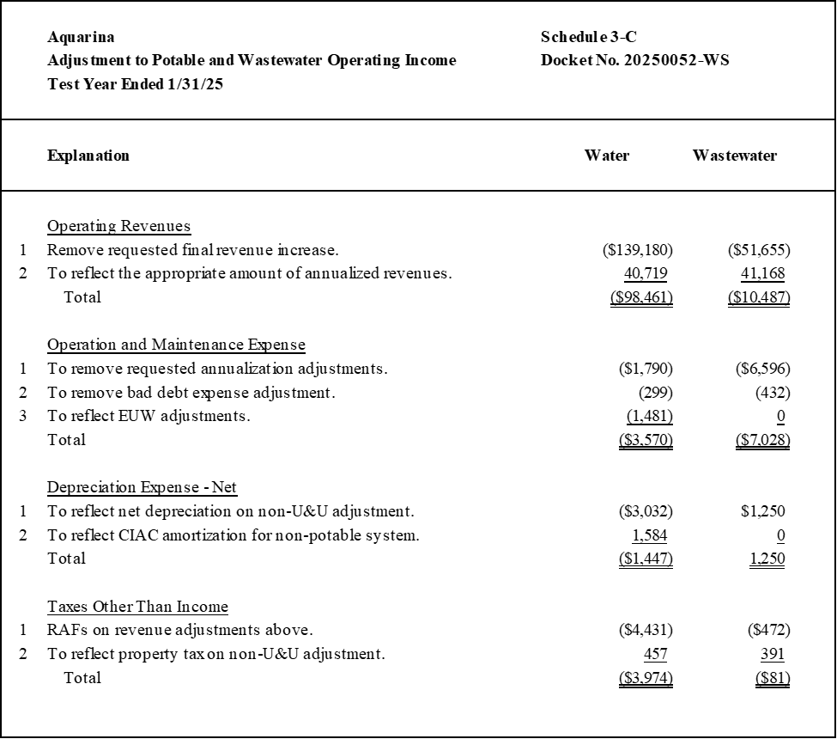

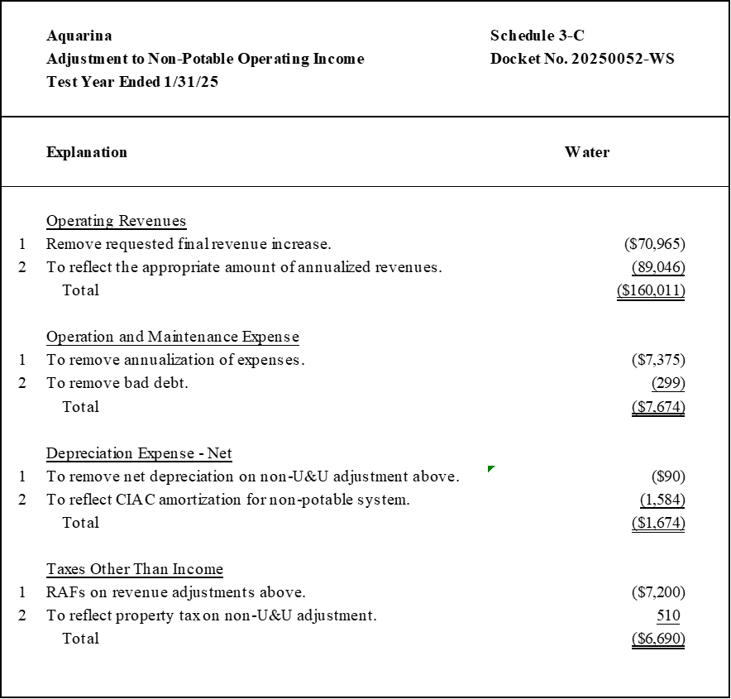



1. Order No. PSC-2025-0361-PCO-WS, issued September 24, 2025, in Docket No. 20250052-WS, *In re: Application for increase in water and wastewater rates in Brevard, Citrus, Duval, Highlands, Marion, and Volusia Counties by CSWR-Florida Utility Operating Company.*
2. Document No. 06826-2025, filed on July 25, 2025.
3. Document 13587-2025 filed on September 19, 2025.
4. Docket Nos. 20250038-WS, 20250043-WS, and 20250047-WS, in which CSWR requested an acquisition adjustment for Aquarina and two other CSWR systems. By Order No. PSC-2025-0250-PCO-WS, issued June 25, 2025, the Commission denied a motion to dismiss the petitions, allowing the three acquisition adjustment applications to proceed; however, no acquisition adjustments have been ordered for these systems at this time.
5. Document No. 07685-2025, filed on August 8, 2025.
6. See Order Nos. PSC-2022-0227-PCO-WS, issued June 27, 2022, in Docket No. 20220066-WS, *In re: Application for increase in water rates in Washington County, by Sunny Hills Utility.*; PSC-2006-0670-FOF-WS, issued August 7, 2006, in Docket No. 20060261-WS, *In re: Application for increase in water and wastewater rates in Lake County by Utilities, Inc. of Pembrooke*; and PSC-2012-0554-PCO-WS, issued October 17, 2012, in Docket No. 20120152-WS, *In re: Application for increase in water and wastewater rates in Orange County by Pluris Wedgefield, Inc.*
7. Order No. PSC-2025-0269-PCO-WS, issued July 25, 2025, in Docket No. 20240108-SU, *In re: Water and wastewater industry annual reestablishment of authorized range of return on common equity for water and wastewater utilities pursuant to Section 367.081(4)(f), F.S.*
8. Order Nos. PSC-2025-0289-PAA-SU, issued July 28, 2025, and Amendatory Order PSC-2025-0289A-PAA-SU, issued August 1, 2025, in Docket No. 20240108-SU, *In re: Application for increase in wastewater rates in Monroe County by K W Resorts Utilities Corp.*; and PSC-2024-0046-PAA-WS, issued February 22, 2024, and Amendatory Order PSC-2024-0046A-PAA-WS, issued March 12, 2024, in Docket No. 20230081-WS, *In re: Application for increase in water and wastewater rates in Broward County by Royal Waterworks, Inc.*
9. Order No. PSC-2016-0583-PAA-WS, issued December 29, 2016, in Docket No. 20150010-WS, *In re****:*** *Application for staff-assisted rate case in Brevard County by Aquarina Utilities, Inc.;* Document Nos. 04080-2025, 04993-2025, and 07961-2025, in Docket No. 20250052-WS, *In re: Application for increase in water and wastewater rates in Brevard, Citrus, Duval, Highlands, Marion, and Volusia Counties by CSWR-Florida Utility Operating Company.*
10. Document No. 07961-2025, in Docket No. 20250052-WS, *In re: Application for increase in water and wastewater rates in Brevard, Citrus, Duval, Highlands, Marion, and Volusia Counties by CSWR-Florida Utility Operating Company.*
11. Order No. PSC-2016-0583-PAA-WS, issued December 29, 2016, in Docket No. 20150010-WS, *In re****:*** *Application for staff-assisted rate case in Brevard County by Aquarina Utilities, Inc.* 
12. Document No. 05250-2025, filed on June 26, 2025.
13. Document No. 07685-2025, filed on August 8, 2025.