Commissioners:  Andrew G. Fay, Chairman  Art Graham  Gary F. Clark  Mike La Rosa  Gabriella A. Passidomo | State of Florida   | Division of  Accounting and Finance  Andrew L. Maurey  Director  (850) 413-6900
Public Service Commission
May 26, 2022

Ms. Katherine Jaronczyk, Accounting Manager
HV Utility Systems, L.L.C.
c/o Equity Lifestyle Properties, Inc.
Chicago, Illinois 60606-2682

Re: 3rd Extension of Time to File the 2021 Annual Report for HV Utility Systems, L.L.C. (SU866)

Dear Utility Contact:
Your request for an additional extension to file the HV Utility Systems, L.L.C. Annual Report for the calendar year ended December 31, 2021, is granted. This is pursuant to Rule 25-30.110(3), Florida Administrative Code (F.A.C.), which grants a longer extension when accompanied by a statement of good cause with a specific date requested. The report is now due on or before June 30, 2022.

Please be reminded that Rule 25-30.110(7), F.A.C., requires that a penalty be assessed against any utility that fails to timely file an Annual Report by March 31 or within the time specified by any extension approved in writing by the Division of Accounting and Finance. The filing must include an unbound original and two (2) copies of the Annual Report. If we can be of further assistance, please call Amber Norris at 850-413-6984.

Sincerely,
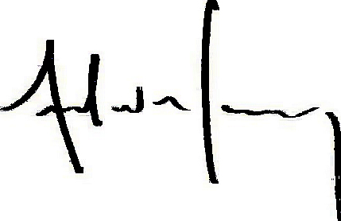
Andrew L. Maurey
Director

ALM/AN:sh

