Commissioners:  Andrew G. Fay, Chairman  Art Graham  Gary F. Clark  Mike La Rosa  Gabriella A. Passidomo | State of Florida   | Division of  Accounting and Finance  Andrew L. Maurey  Director  (850) 413-6900
Public Service Commission
March 04, 2022

Martin Friedman
Little Gasparilla Water Utility, Inc.
P. O. Box 7
Placida, Florida 33946-0007

Re: Extension of Time to File the 2021 Annual Report for Little Gasparilla Water Utility, Inc. (WU961)

Dear Mr. Friedman:
Your request for an extension to file the Little Gasparilla Water Utility, Inc. Annual Report for the calendar year ended December 31, 2021, is granted. This is pursuant to Rule 25-30.110(3), Florida Administrative Code (F.A.C.), which automatically grants your initial request for a thirty-day extension to file the Annual Report. The report is now due on or before April 30, 2022.

Please be reminded that Rule 25-30.110(7), F.A.C., requires that a penalty be assessed against any utility that fails to timely file an Annual Report. The filing must include an original and two (2) copies of the Annual Report. If we can be of further assistance, please call Amber Norris at 850-413-6984.

Sincerely,
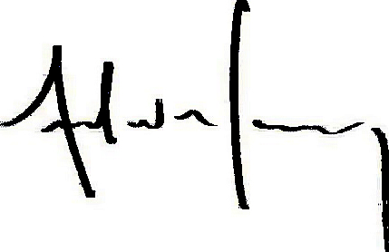
Andrew L. Maurey
Director

ALM/AN:lk

