

Review of
Administrative Efficiency
of Utility
Demand Side Management Programs

M a y 2 0 1 3

B Y A U T H O R I T Y O F
The Florida Public Service Commission
Office of Auditing and Performance Analysis

Review of
Administrative Efficiency
of
Investor-Owned Utility
DSM Programs

Jerry Hallenstein
Senior Analyst
Project Manager

William “Tripp” Coston
Public Utilities Analyst IV
Project Manager

R. Lynn Fisher
Government Analyst II

David F. Rich
Public Utilities Analyst IV

April 2013

By Authority of
The State of Florida
Public Service Commission
Office of Auditing and Performance Analysis

PA-12-10-005

TABLE OF CONTENTS

CHAPTER Page

1.0 EXECUTIVE SUMMARY
1.1 Purpose and Objectives 3
1.2 Scope 3
1.3 Methodology 4
1.4 Background and Perspective 5
1.5 Observations 7

2.0 PROGRESS ENERGY FLORIDA
2.1 DSM Programs 13
2.2 Organization 17
2.3 DSM Program Administration 21
2.4 DSM Related Costs 26
2.5 Observations 31

3.0 TAMPA ELECTRIC COMPANY
3.1 Programs 37
3.2 Organization 40
3.3 Administration 42
3.4 DSM Related Costs 48
3.5 Observations 53

4.0 FLORIDA POWER & LIGHT COMPANY
4.1 Programs 57
4.2 Organization 60
4.3 Administration 63
4.4 DSM Related Costs 67
4.5 Observations 73

5.0 GULF POWER COMPANY
5.1 Programs 77
5.2 Organization 80
5.3 Administration 83
5.4 DSM Related Costs 86
5.5 Observations 91

TABLE OF EXHIBITS

EXHIBIT Page

Chapter 1 - EXECUTIVE SUMMARY

- Florida IOU’s DSM as a Percentage of Retail Revenue, 2009 - 2012 7

Chapter 2 - PROGRESS ENERGY FLORIDA

2. Residential DSM Programs Annual Participation, 2009 – 2012 14
3. Commercial/Industrial DSM Programs Annual Participation, 2009 – 2012 16
4. Renewable DSM Programs Annual Participation, 2009 - 2012 17
5. DSM Full-Time Equivalents (FTEs), 2009 - 2012 18
6. DSM Energy Efficiency Field Operations, 2012 19
7. DSM Demand Response Operations, 2012 20
8. DSM Enrollment and Back-Office Operations, 2012 21
9. Rebate Process Flow 23
10. Bridge Strategy Group Inc.’s Opportunity Index, 2009 25
11. DSM Costs By Program, 2009 - 2012 27
12. DSM Spending by Cost Category, 2009 - 2012 28
13. DSM Costs as a Percentage of Retail Revenue, 2009 - 2012 29
14. DSM Program and Administrative Costs, 2009 - 2012 30
15. DSM Advertising Costs by Program, 2009 - 2012 31

Chapter 3 - TAMPA ELECTRIC COMPANY

16. Residential DSM Programs Annual Participation, 2009 – 2012 38
17. Commercial/Industrial DSM Programs Annual Participation, 2009 – 2012 39
18. Renewable DSM Programs Annual Participation, 2011 - 2012 40
19. DSM Program Organization, 2012 41
20. DSM Full-Time Equivalents (FTEs), 2009 - 2012 42
21. DSM Costs by Residential Program, 2009 - 2012 48
22. DSM Costs by Commercial/Industrial Program, 2009 - 2012 49
23. DSM Spending by Cost Category, 2009 - 2012 50
24. DSM Costs as a Percentage of Retail Revenue, 2009 - 2012 51
25. DSM Program and Administrative Costs, 2009 – 2012 52
26. DSM Advertising Expenditures, 2009 - 2012 53

Chapter 4 - FLORIDA POWER & LIGHT COMPANY

27. Residential DSM Programs Annual Participation, 2009 – 2012 57
28. Commercial/Industrial DSM Programs Annual Participation, 2009 – 2012 59
29. Renewable DSM Programs Annual Participation, 2009 - 2012 60
30. DSM Program Administration Organization 61
31. DSM Full-Time Equivalents (FTEs), 2009 - 2012 62
32. DSM Costs by Program, 2009 - 2012 68
33. DSM Spending by Cost Category, 2009 - 2012 69
34. DSM Costs as a Percentage of Retail Revenue, 2009 - 2012 70
35. DSM Program Expenditures, 2009 - 2012 71
36. DSM Program and Administrative Costs, 2009 - 2012 71
37. Non-Program Specific DSM Expenditures, 2009 - 2012 72
38. DSM Advertising Expenditures, 2009 - 2012 73

Chapter 5 - GULF POWER COMPANY

39. Residential DSM Programs Annual Participation, 2009 – 2012 77
40. Commercial/Industrial DSM Programs Annual Participation, 2009 – 2012 79
41. Renewable DSM Programs Annual Participation, 2009 - 2012 80
42. DSM Program Administration Organization 81
43. DSM Full-Time Equivalents (FTEs), 2009 - 2012 83
44. DSM Costs by Program, 2009 - 2012 87
45. DSM Spending by Cost Category, 2009 - 2012 88
46. DSM Costs as Percentage of Retail Revenue, 2009 - 2012 89
47. DSM Program Expenditures, 2009 - 2012 89
48. DSM Program and Administrative Costs, 2009 - 2012 90
49. DSM Administrative Expenditures by Category, 2009 - 2012 91
50. DSM Advertising Expenditures, 2009-2012 91

1.0 Executive Summary

1.0 Executive Summary

1.1 Purpose and Objectives

In October 2012, the Florida Public Service Commission’s (FPSC or Commission) Office of Auditing and Performance Analysis initiated an audit to examine the administrative efficiency of the demand-side management (DSM) programs for the four major investor-owned electric utilities in Florida. This audit was performed at the request of the Commission’s Division of Engineering. The companies included were:

- Progress Energy Florida (PEF)
- Tampa Electric Company (TECO)
- Florida Power & Light Company (FPL)
- Gulf Power Company (Gulf)

The purpose of the audit was to review each utility’s processes for developing, measuring, analyzing and improving the administrative efficiency of its DSM program. The term “administrative efficiency” is defined for purposes of this report to mean the capability of an organization to produce its desired results with a minimum expenditure of resources.

Specifically, the primary objectives of the audit were to:

- Determine whether the utilities have processes in place to review and improve the administrative efficiency of their DSM programs.

- Determine whether the utilities have implemented improvements to increase administrative efficiency of their DSM programs.

- Determine whether the utilities review other similarly-situated utilities to seek out best practices for the administration and implementation of DSM programs.

- Identify any potential administrative efficiency improvements the utilities should consider as part of their administration and implementation of DSM programs.

1.2 Scope

Given these objectives, the scope of the audit focused on the organizations within each utility that are responsible for administering the DSM programs. Particular attention was paid to the procedures used by each organization to establish and implement the DSM programs, and the approaches and methods used for monitoring program goals and objectives.

Additionally, audit staff examined how each utility evaluates DSM program efficiencies and cost effectiveness, including how each utility tracks costs associated with implementing the DSM programs, how each utility evaluates programs for modification or replacement, and how each utility utilizes industry or peer-to-peer analysis to evaluate or improve its DSM programs. Audit staff performed assessments in the following DSM areas as they relate to each utility:

- Organizational Structure
- Program Administration
- Program Development
- Program Implementation
- Program Verification
- Program Cost Effectiveness

1.3 Methodology

The information compiled in this audit report was gathered through responses to document requests and onsite interviews with key employees accountable for directing, developing, and implementing each utility’s DSM programs. Audit staff also reviewed FPSC rules and regulations on energy conservation, FPSC’s annual reports on activities pursuant to the Florida Energy Efficiency and Conservation Act (FEECA), and applicable filings provided in the Commission’s DSM planning dockets.

Audit staff assessed all the collected information to gain a thorough understanding of the processes used by each utility to administer, operate, and promote DSM programs. Specific information collected from each utility included:

- DSM program descriptions

- Procedures and guidelines governing the evaluation, development, operation eligibility requirements, billing practices, and promotion of DSM programs

- DSM support staff organizational charts

- Energy usage and peak demand savings data

- Management reports

- DSM program expenditures

- Benchmarking reviews

- Third-party/outsourcing procedures

- Advertising and promotional materials

- Internal/External audit reports, reviews, and quality assessment reviews

.
1.4 background and perspective

    - The Florida Energy Efficiency And Conservation Act
In 1980, the Florida Legislature enacted the Florida Energy Efficiency and Conservation Act (FEECA). The purpose of FEECA was to promote efficient and cost-effective energy conservation programs to protect the general welfare of the state. To achieve this objective, FEECA placed an emphasis on increasing the efficiency of the electric systems of Florida, increasing the conservation of resources, such as petroleum fuels, reducing the growth rate of weather sensitive peak demand, and reducing and controlling the growth rate of kilowatt hour consumption to the extent cost effective.

The Commission, as required by FEECA, Sections 366.80 through 366.85 and 403.519, Florida Statutes (F.S.), administers conservation goals for Florida’s FEECA utilities. To accomplish this, the Commission establishes annual electric peak demand and energy savings goals for the four largest Florida investor-owned utilities reviewed in this audit.

For the utilities subject to FEECA, the Commission establishes annual numeric goals for summer peak demand, winter peak demand, and energy (kWh) reduction for the utilities’ commercial and residential sectors. In 2008, the Florida Legislature amended FEECA to include the following changes to the goal setting process:

- Evaluate the full technical potential of all available demand-side and supply-side conservation and efficiency measures, including demand-side renewable energy systems.

- Establish goals to encourage the development of demand-side renewable energy systems.

- Allow efficiency investments across generation, transmission, and distribution as well as efficiencies within the user base.

- Allow an investor-owned utility (IOU) an additional return on equity up to 50 basis points for exceeding 20 percent of their annual load-growth through energy efficiency and conservation measures.

- Allow for the Commission to authorize financial penalties for those utilities that fail to meet their goals.

1.4.2 FPSC Rules And Regulations
The Commission’s goal setting process applies to a 10-year planning period and is reviewed by the Commission every five years in docketed proceedings. The most recent goals were established at the end of 2009 per Commission Order No. PSC-09-0855-FOF-EG. Upon adoption of the Order, the utilities had 90 days to submit their proposed DSM programs that are designed to meet the goals.

The Commission did not approve the proposed DSM plans for PEF and FPL, but in 2011, Order No. PSC-11-0347-PAA-EG, in Docket No. 100160-EG, allowed PEF and FPL to continue with their existing DSM plans with modifications. The Commission determined that the PEF and FPL existing programs would still produce energy savings and avoid an undue customer rate impact. PEF’s and FPL’s DSM plans had been designed to meet the goals that were set in the Commission’s 2004 proceedings. However, PEF and FPL were not excused from meeting the new goals set in the 2009 proceeding.

Pursuant to Section 366.82, F.S. the utilities’ DSM programs must be cost-effective. To codify the cost-effectiveness requirement, the Commission adopted Rule 25-17.008, Florida Administrative Code (F.A.C). The Rule requires the utilities to provide, at a minimum, a cost-effectiveness analysis of each DSM program using three tests: the Participants test, the Ratepayer Impact Measure (RIM) test, and the Total Resource Cost (TRC) test. Each test is summarized below.

- The Participants test measures program cost-effectiveness only to the participating customer. Benefits considered in the test include incentives that are paid by the utility to the customers and a reduction in customer bills.

- The RIM test measures program cost-effectiveness to the utility’s overall rate payers, taking into consideration the cost of incentives paid to participating customers and lost revenues due to reduced energy sales that may result in the need for a future rate case. A DSM program that passes the RIM test ensures that all customer rates are lower than they otherwise would have been without the DSM program.

- The TRC test measures total net savings on a utility system-wide basis. This test measures the net costs of a DSM program based on its total cost, including both the participants and utility’s costs. Customer incentives and lost revenues are not included as costs in the TRC test.

Upon approval of each utility's conservation plans, the companies may recover program costs through the "Energy Conservation Cost Recovery" (ECCR) clause adopted in FPSC Rule 25-17.015. The rule authorizes each utility to file a petition with the Commission setting forth estimates of those reasonable and prudent unreimbursed costs projected to be incurred, less any estimated revenues. By way of annual cost recovery proceedings, the Commission determines the appropriate conservation "true-up" amounts and factors for the programs. Subject to various reviews, the ECCR clause is a pass-through of expenses recovered from ratepayers on a per kilowatt-hour or per kilowatt basis.

1.4.3 Impact of DSM Programs
The Commission’s DSM goal setting process and the resulting DSM program efforts by IOUs result in substantial expenditures necessary to achieve the intended long-term benefits. The relative impact of DSM program efforts can be examined by calculating total DSM costs as a percentage of retail sales.

Exhibit 1 displays the trend of this measure for the period 2009-2012. Last year, DSM expenditures for all four companies fell within the narrow range of from 2.2 percent to 2.4 percent of retail sales, reflecting a comparable dedication of resources to DSM activity. Gulf’s increased DSM offerings since 2008 have brought its DSM expenditure levels up into the range of the other three large Florida IOUs. Over the period, a general upward trend in total DSM expenditures also existed for FPL, TECO and PEF as Commission-approved energy and demand savings goals grew.

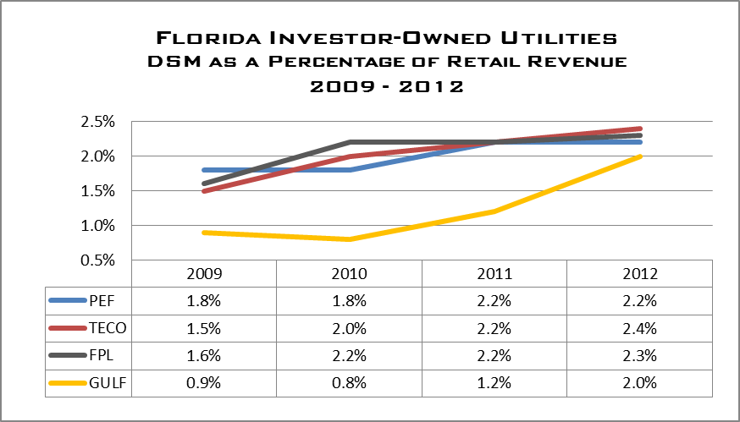
EXHIBIT 1 Source: Individual Company Document Requests

1.5 Observations

Through its review, the Performance Analysis Section developed the following observations and conclusions regarding the administration of DSM programs by the four largest Florida IOUs.

1.5.1 Observation 1
In administering DSM programs, the four largest Florida IOUs place primary importance upon attaining the FPSC-established energy and demand reduction goals.

The Commission’s process for setting DSM goals results in aggressive goals for energy and demand savings, and greater use of renewable energy sources. This process also triggers substantial costs that are necessary to achieve the intended long-term benefits. Therefore, a natural tension exists between attaining DSM program goals and controlling the costs of the activities necessary to successfully run each company’s DSM programs. For example, a program may offer appropriate, cost-effective incentives, attract the desired number of participants, and result in the targeted level of kW or kWh savings. However, to be run in an efficient manner, that program must be managed carefully, keeping administrative costs in check.

Managing the relative balance between the two forces of attaining energy/demand savings and controlling costs is presently left to the companies themselves. Audit staff believes that the perception by the Florida IOUs is that goal attainment is primary in managing their DSM programs. Ultimately the Commission’s goal-setting and annual cost recovery processes provide an ongoing review of this balance and these costs.

1.5.2 Observation 2
A limited amount of information sharing, collaborative efforts, and benchmarking regarding the administration of DSM programs currently occurs among Florida IOUs and with IOUs in other states.

Audit staff sought to determine the extent to which the Florida IOUs seek out information from other IOUs nationwide regarding the administration of their DSM programs. Audit staff believes that the effort to gather information on the effective administration of DSM programs is limited by the perceived limitations in the value of comparing the DSM programs themselves across jurisdictions. Though the value of comparing programs that work well in California or Wisconsin to possible Florida application may be limited, the practices that are employed to ensure the administrative efficiency of programs in other states may be more widely applicable and worthy of benchmarking efforts.

Audit staff recommends that the Florida IOUs expand their efforts to examine how similarly-situated IOUs track and assess the administrative efficiency of their DSM program activities. Though this effort could begin with collaboration and information-sharing among Florida IOUs, staff believes that valuable information may be available from utilities in other states as well. The administrative efficiency of Florida’s DSM programs could be enhanced by additional information sharing, collaborative efforts, and benchmarking among Florida IOUs and IOUs in other states.

1.5.3 Observation 3
Different definitions of “administrative costs” are employed by each company, causing difficulties in the analysis of administrative efficiency.

In its review, audit staff found that administrative costs are categorized differently by the four companies. Therefore, cross-company comparisons can only be of limited value and audit staff advises caution in making some direct comparisons using the data presented in this report. Audit staff also notes these measurement issues hamper efforts to assess the degree of administrative efficiency attained by each company.

The lack of a standard definition of administrative costs could be addressed if Florida IOUs pursue the additional collaboration and benchmarking efforts suggested above. Information sharing on an “apples-to-apples” basis would increase the value of efforts to examine and identify best practices and cross-company comparisons.

1.5.4 Observation 4
Additional internal audit coverage of DSM administrative costs and internal controls should be considered by Florida IOUs.

Staff reviewed each utility’s internal audits conducted for DSM programs during the period 2009 through 2012 to determine whether consistent reviews of DSM processes, controls, and costs were conducted. Staff observed that each utility placed different emphasis on auditing DSM programs covering subjects from system controls, internal controls, program processes, to program compliance. The number of internal audits conducted ranged from one audit to as many as eight during the period. However, none of the audits specifically reviewed DSM program administrative costs and efficiency.

Audit staff recommends that the Florida IOUs include audits of administrative costs and efficiencies to their DSM audit schedule. Additional internal audit coverage of DSM administrative costs and internal controls could increase administrative efficiency.

1.5.5 Observation 5
The four IOUs continue to make substantial efforts to improve administrative efficiency of their DSM programs.

Over the period 2009-2012, substantial initiatives have been undertaken to bolster administrative efficiency in targeted areas for each IOU. Major efforts have been made via comprehensive or focused consultant reviews, development of new information management systems, enhancing program offerings, and restructuring of administrative processes.

Basic measures of administrative efficiency and trends over the period revealed no major causes for concern in audit staff’s opinion. Overall magnitude of DSM expenditures, administrative costs, staffing, and incentive payments have been stable. Participation levels have understandably been impacted by the economic downturn over the study period.

Audit staff believes that continuing self-examination efforts are needed and should be encouraged. Information-sharing with industry experts, utilities in other states, and among Florida utilities can provide fresh perspectives on administering programs and new techniques for monitoring and managing administrative costs.

2.0 Progress energy Florida

2.0 Progress Energy Florida

In 2009, Order No. PSC-09-0855-FOF-EG in Docket No. 080408-EG established numeric conservation goals for Progress Energy Florida (PEF). Upon establishment of the goals, PEF, along with the other utilities subject to FEECA, filed its DSM plans to be approved by the Commission. As previously mentioned, the Commission allowed PEF to continue employing its existing 2004 DSM plan with modifications, but was not excused from meeting the new goals set in the Commission’s 2009 proceeding. In designing its current DSM plan, PEF addressed the following objectives:

- Achieve annual conservation goals
- Minimize rate impacts to all PEF customers
- Base program designs on customer needs
- Implement mechanisms to minimize free ridership
- Capture all cost-effective DSM resources, including cost-effective lost opportunities
- Provide customers with added value – efficiency, convenience, productivity, comfort and reliability
- Utilize market involvement, such as dealers and home builders, where appropriate

2.1 DSM Programs

For both the residential and Commercial/Industrial sectors, PEF has consolidated most measures into umbrella programs. The creation of these umbrella programs provides significant benefits over implementing measure-specific programs. Such benefits include increased program cost-effectiveness through lower program administration, monitoring, and evaluation costs by minimizing redundant functions.

In addition to PEF’s residential and commercial programs, PEF employs both a Technology Development program, and a Qualifying Facilities DSM program. The purpose of the Technology Development program is for PEF to undertake certain development and demonstration projects which have promise to become cost-effective demand and energy efficiency programs. Examples include thermal energy storage technologies and innovative metering approaches. Under the Qualifying Facilities program, PEF enters into firm energy and capacity contracts with qualifying cogeneration and small power production facilities.

2.1.1 Residential DSM Programs
PEF serves over 1.7 million retail customers, of which approximately 90 percent are residential. PEF’s current residential DSM portfolio, excluding the renewable programs, consists of six programs.

- Home Energy Check
- Home Energy Improvement
- Residential New Construction
- Neighborhood Energy Saver
- Low-Income Weatherization Assistance
- Residential Energy Management

The Home Energy Check, Home Energy Improvement, and residential New Construction are umbrella programs comprised of multiple measures. For example, the Home Energy Check program includes free and paid walk-through audits, mail-in audits, and phone assisted audits.

The focal point of PEF’s residential programs is the Home Energy Check program. The program uses a home energy audit performed by PEF to educate customers on typical energy use and to identify opportunities to improve energy efficiency. The Home Energy Check program also satisfies the Commission’s mandate to offer energy audit service to all customers. PEF also offers a Home Energy Improvement and a residential New Construction program to improve energy efficiency to existing homes and to new construction sites.

The Neighborhood Energy Saver and Low-Income Weatherization Assistance programs were developed to provide energy efficiency measures to low-income families. Residential Energy Management is a voluntary load control program that allows PEF to reduce peak demand by interrupting service to selected electrical equipment on the customers’ premises during specified time periods.

Exhibit 2 below depicts the number of participants in each of PEF’s DSM residential programs. As shown, PEF’s Home Energy Check and Home Energy Improvement have the greatest number of annual participants. According to PEF, the 2010 peak of participants in the Home Energy Check and Home Energy Improvement programs can be attributed to a federal tax program that was implemented for energy efficiency. The tax program provided customers the ability to combine new Federal tax credits with increased PEF incentives. Since 2010 there have been several factors that contributed to decreased participation levels, including milder weather, economic uncertainty, continuing defaults and foreclosures in the mortgage industry, and the removal of federal stimulus dollars.

According to PEF, increases in participation levels for the residential New Construction program in 2012 were driven by several factors including impending building code changes that resulted in higher baselines for incentive eligibility and builders’ ability to acquire land at lower cost. Additional factors were the implementation of energy efficiency measures to lower the energy operation costs of the home to increase marketability, and increase in multi-family and student housing construction projects using energy efficiency to increase tenant occupancy.

Progress Energy Florida
Residential DSM Programs Annual Participation
2009-2012

Program | Program Measure New Participants
Program | 2009 | 2010 | 2011 | 2012
Home Energy Check | 56,987 | 62,196 | 45,310 | 35,869
Home Energy Improvement | 44,491 | 66,298 | 52,691 | 45,842
Residential New Construction | 9,502 | 13,005 | 17,511 | 24,833
Neighborhood Energy Saver | 2,236 | 2,997 | 2,847 | 2,558
Low-Income Weatherization Assistance | 983 | 2,997 | 5,233 | 5,433
Residential Energy Management | 8,009 | 8,357 | 7,858 | 5,570
Total | 122,208 | 155,850 | 131,450 | 120,105
EXHIBIT 2 Source: PEF Response to Staff’s Data Request DR 1-11 and DR 3.3.
2.1.2 Commercial/Industrial DSM Programs
Because the facilities and systems in PEF’s commercial and industrial sectors are more complex than in the residential sector, there are additional opportunities for conservation from customer-specific technology improvements, as well as from alternative rates. PEF’s current Commercial/Industrial portfolio consists of the eight programs listed below. The Business Energy Check, Better Business, and Commercial/Industrial New Construction programs are umbrella programs.

- Business Energy Check
- Better Business
- Commercial/Industrial New Construction
- Innovation Incentive
- Standby Generation
- Interruptible Service
- Curtailable Service
- Commercial Energy Management

PEF’s Business Energy Check program is analogous to the Home Energy Check program and is also the focus of PEF’s Commercial/Industrial sector. The Better Business and Commercial/Industrial New Construction programs are designed to improve energy efficiency of existing and new commercial facilities. The Innovation Incentive program is intended to encourage highly customized efficiency measures that reduce peak demand and energy, but which are not addressed in other programs. Examples include refrigeration equipment replacements, thermal storage systems, and inductive heating systems to replace resistance heating systems. The Commercial Energy Management and Standby Generation programs are load control programs that allow PEF to reduce peak demand through control of the customer’s equipment. The Interruptible and Curtailable Service programs are also load control programs, but are directed towards PEF’s large industrial customers who have a billing demand of at least 500 kW.

Exhibit 3 below depicts the number of participants in each of PEF’s DSM Commercial/Industrial programs. As shown, PEF’s Better Business and Business Energy Check programs have the greatest number of participants. According to PEF, some of the influencing factors that resulted in a decrease in participation in these two programs since 2010 include economic uncertainty, appliance standard changes, and weather conditions. Increased levels in the Commercial/Industrial New Construction Program in 2012 were driven by the adoption of the 2010 Florida building code and the impending changes including the sun setting of two existing measures (occupancy sensors and window tinting) impacted by the building code changes. These changes prompted builders to participate in the 2012 programs at a higher rate in recognition that the affected measures would no longer be available in 2013 due to the code change. It should be noted that PEF’s Commercial Energy Management program has been closed to new participants since April 1, 2001 because the program was determined to be no longer cost effective. However, PEF maintains equipment and associated reduction of capacity for existing customers in the program.

Progress energy Florida
Commercial/industrial DSM programs Annual Participation
2009-2012

Program | Program Measure New Participants
Program | 2009 | 2010 | 2011 | 2012 YTD
Business Energy Check | 3,109 | 3,015 | 2,573 | 2,114
Better Business | 1,800 | 2,062 | 3,361 | 1,803
Commercial/Industrial New Construction | 191 | 265 | 210 | 368
Innovation Incentive | 0 | 3 | 2 | 29
Standby Generation | 32 | 27 | 16 | 11
Interruptible Service | 3 | 0 | 0 | 1
Curtailable Service | 0 | 0 | 0 | 0
Commercial Energy Management | 0 | 0 | 0 | 0
Total | 5,135 | 5,372 | 6,162 | 4,326
EXHIBIT 3 Source: PEF Response to Staff’s Data Request DR 1-11 and DR 3.3.

2.1.3 Renewable DSM Programs
During the 2008 Florida Legislative session, FEECA was amended to encourage the development of demand-side renewable energy systems. Pursuant to Order No. PSC-09-0855-FOF-EG, the Commission directed the utilities to spend ten percent of their historic energy conservation cost recovery expenditures as an annual cap for solar water heating and solar photovoltaic pilot programs. The Commission approved the following PEF DSM solar programs to encourage solar renewable systems though none were found to be cost-effective. Most programs currently operate as pilot, or experimental, programs.

- Solar Water Heating with Energy Management
- Solar Water Heating Low Income Residential (Pilot)
- Residential Solar Photovoltaic (Pilot)
- Commercial Solar Photovoltaic (Pilot)
- Photovoltaic for Schools (Pilot)
- Research and Demonstration (Pilot)

PEF’s solar water heating programs are intended to reduce system peak demand and increase renewable energy generation by providing a thermal solar water heater at the customer’s premises. The residential and commercial photovoltaic programs are designed to reduce the initial investment required to install a qualified photovoltaic system. The photovoltaic program for schools is provided at no cost to the school. The Research and Demonstration pilot program is a research and development initiative to support the development of future solar and renewable energy pilot programs.

Exhibit 4 depicts the number of participants in each of PEF’s DSM renewable programs since inception in 2011. The Solar Water Heating with Energy Management program has the greatest number of participants at 358 in 2012. For this program, PEF provides a $550 incentive per residence toward the purchase of a new solar thermal water heater. However, in order to qualify for this program, the customer’s heating, air conditioning, and water heating systems must be on PEF’s Energy Management Program.

Progress Energy Florida
Renewable DSM Programs
Annual Participation
2009-2012

Program | Program Measure New Participants
Program | 2011 | 2012
Solar Water Heating With Energy Management | 230 | 358
Solar Water Heating Low Income Residential | 13 | 26
Residential Solar Photovoltaic | 88 | 106
Commercial Solar Photovoltaic | 16 | 11
Photovoltaic for Schools Pilot | 10 | 2
Total | 357 | 503
EXHIBIT 4 Source: PEF Response to Staff’s Data Request DR 1-11 and DR 3.3

2.2 Organization

In July 2012, Progress Energy Corporation was acquired by Duke Power Corporation. During the period this audit was conducted, Duke Power and Progress Energy were in the process of creating and implementing a new full-scale organization responsible for developing, operating, promoting, and evaluating the company’s DSM programs. The Executive Vice President of Customer Operations is ultimately responsible for the DSM operations in all of Duke Power’s service areas.

Exhibit 5 shows the number of PEF full-time equivalents (FTE) for its Florida DSM operations. As of year-end 2012, 208 FTE employees conducted PEF’s DSM programs. This compares to a high of 231 FTE employees in 2009 (201 PEF FTEs and 30 contractor FTEs). The 10 percent reduction from 2009 levels included 16 contracted FTEs reduced due to PEF’s development of a contractor portal through PEF’s Continuous Business Excellence program. The formal program was implemented in 2009 across all of PEF’s business units as a process to manage costs, eliminate waste, streamline for quality and efficiency, and increase customer satisfaction. The creation of the contractor portal streamlined the workflow process for monitoring and selecting contractors. Additionally, PEF FTEs were reduced through natural job attrition and other efficiencies realized through PEF’s Continuous Business Excellence Program.

Exhibit 5 also provides the ratio of PEF’s FTEs to total DSM participation levels to determine the approximate number of participants per FTE. As shown, PEF’s ratios ranged from a high of 1 FTE per 798 participants in 2010 to a low of 1 FTE per 551 participants in 2009. Over the four year period reviewed, PEF experienced the greatest number of DSM participant in 2010 primarily due to the spike in participation in PEF’s Home Energy Check and Home Energy Improvement programs as previously mentioned. The decrease in the ratio of FTEs to total participation from 2011 and 2012 can be attributed to a 9.45 percent reduction in total DSM participants over the same period.

Progress Energy Florida
DSM Full-Time Equivalents (FTEs)
2009-2012

Employee | 2009 | 2010 | 2011 | 2012
PEF FTE | 201 | 182 | 182 | 194
Contractor FTE | 30 | 20 | 15 | 14
Total FTE | 231 | 202 | 197 | 208
Ratio of FTEs to total DSM Participants | 1 to 551 | 1 to 798 | 1 to 700 | 1 to 601
EXHIBIT 5 Source: PEF Response to Staff’s Data Request DR 2-3 and DR 3.4

PEF’s DSM operations are currently subdivided into four functions: Product and Program Development; Marketing; Energy Efficiency and Demand Response operations; and Enrollment and Back Office (Business Energy Services). The Product and Program Development group is primarily responsible for the development and creation of the company’s DSM programs for the Commission’s goal-setting docket. The Marketing department, based out of Raleigh, North Carolina, is charged with developing awareness of the DSM programs through advertising and direct marketing. The Energy Efficiency and Demand Response field operations staff are responsible for performing energy audits, identifying improvement opportunities, and effectively implementing energy efficiency and load management programs. The Enrollment and Back Office staff are responsible for processing rebates and invoices, dispatching work orders, and administering contracts.

2.2.1 PEF’s Energy Efficiency Field Operations
Exhibit 6 depicts PEF’s DSM Energy Efficiency operations that supports PEF’s residential and small business sectors. The organization is currently subdivided into four regions, with each region headed by a supervisor.

The regions are strategically located throughout PEF’s service territory to coincide with the organization of PEF’s distribution operations. Within each region, PEF employs DSM Energy Efficiency Specialists, Account Executives and Program Inspectors. The Energy Efficiency Specialists are PEF’s field auditors responsible for performing on-site energy analysis of a customer’s premise to determine the appropriate programs to assist in maximizing efficiency. The Account Executives are responsible for the field planning and coordination of all aspects of the residential new construction or existing multi-housing segments. This includes relationship management with primary focus on builders, property managers, and various trade allies. The Program Inspectors are responsible for coordinating and completing the inspections to ensure compliance with FPSC requirements and code specifications. Each program inspector holds industry recognized credentials for the program or measure they are inspecting. Examples include: Residential Inspectors certification; Electrical/Mechanical licensing: Home Energy Rating Systems certification; and Association of Energy certifications.

EXHIBIT 6 Source: PEF Response to Staff’s Data Request 1.3 and 2.7
EES – North Coastal Supervisor
DSM Field Operations
Manager
Senior DSM Program Inspector
DSM Account Executive
Energy Efficiency Specialist
Senior DSM Program Inspector
Senior Energy Efficiency Specialist
DSM Program Inspector
DSM Program Inspector
DSM Program Inspector
DSM Program Inspector
PROGRESS ENERGY FLORIDA
DSM Energy Efficiency Field Operations
2012
EES – South Coastal Supervisor
DSM Account Executive
Energy Efficiency Specialist
Senior Energy Efficiency Specialist
EES – North Central Supervisor
DSM Account Executive
Energy Efficiency Specialist
Senior DSM Program Inspector
Senior Energy Efficiency Specialist
EES – South Central Supervisor
DSM Account Executive
Energy Efficiency Specialist
Senior DSM Program Inspector
Senior Energy Efficiency Specialist
DSM Analyst
2.2.2 Demand Response Operations
Exhibit 7 depicts the organization responsible for PEF’s Demand Response Operations. The Demand Response Operations group maintains and operates the infrastructure associated with 400,000 customers, 540,000 assets, as well as implementation of the residential and commercial demand response programs. As shown in Exhibit 7, under the direction of the Demand Response Manager is a Business Operations Process Analyst, a Field Development Coordinator, and a team of System Support and Program Specialists who provide the budgeting, monitoring, installation, and maintenance services for PEF’s load management programs. This includes PEF’s Interruptible, Curtailable, and Standby Generation and Residential Load Management programs.

PROGRESS ENERGY FLORIDA
DSM Demand Response Operations
2012

Senior En

Manager Demand Response Florida Operations

Field Deployment Coordinator

Program Specialist

Business Operations Process Analyst

Senior
System Maintenance Specialist
Senior Energy Mgmt. System
Support Specialist

Senior Energy Mgmt. Field Coordinator
Senior Energy Mgmt. System Support Specialist

EXHIBIT 7 Source: PEF Response to Staff’s Data Request 1.3 and 2.7

2.2.3 Customer Enrollment and Back-Office Operations
Exhibit 8 depicts PEF’s Customer Enrollment and Back Office operations. The department is responsible for prequalifying customers for programs, planning and scheduling, administering contracts, and processing rebates and invoices. The department is currently under the supervision of the same manager responsible for PEF’s Energy Efficiency DSM Field Operations. The Customer Enrollment group shown on Exhibit 8 is primarily responsible for providing continuous direct phone communication with customers and scheduling appointments for field representatives. The Back Office group is primarily responsible for processing customers’ rebates and contractor invoices, posting bill credits, and contracting for services and materials.

PROGRESS ENERGY FLORIDA
DSM Enrollment and Back-Office Operations
2012

DSM Field Operations
Manager

DSM – Customer Enrollment
Supervisor

DSM –
Back Office
Supervisor

EE Coordinator I

Contract Administrator

EE Coordinator II

Senior Operations Support Assistant

Operations Support Assistant

EXHIBIT 8 Source: PEF Response to Staff’s Data Request 1.3 and 2.7

2.3 DSM Program Administration

2.3.1 Program Development
PEF’s DSM programs and the programs’ energy and demand impacts are developed in several steps. This process is the same for each customer group. Potential DSM programs and program components are researched with ideas coming from PEF’s Innovation Incentive program (commercial), PEF’s Technology Development program (residential research), white papers, industry trade magazines, and DSM research companies, such as E Source. PEF also participates in numerous local, regional and national organizations that promote and execute energy efficiency, demand response and related DSM programs. Examples include:

- Consortium for Energy Efficiency (CEE)
- Association of Energy Engineers (AEE)
- Air Conditioning Contractors of America (ACCA)
- Residential Energy Services Network (RESNET)
- Florida Green Building Coalition (FGBC)
- Electric Power Research Institute (EPRI)
- Building Officials of Florida (BOAF)
- Florida Solar Energy Center (FSEC)

Once all of the program measures are developed, PEF assembles the measures into DSM programs for the residential and commercial segments. Program impacts are derived from the projected number of participants in a given measure multiplied by the demand and energy impacts for the measure. Each measurement value is compiled and summed for each year then cumulatively for the program reporting period as appropriate.

2.3.2 Program Implementation
The costs to implement a DSM program consist of administrative, equipment, and incentive payments to the participants. Once DSM programs and portfolio projections with energy and demand impacts are approved by the Commission, PEF develops the Participation Standards for each program offering. Upon implementation, additional forms, guidelines, inspection procedures, checklists, and back office workflows for incentive processing and rebate approval are developed. There are multiple ways PEF works with customers to help implement the targeted programs. For example, both PEF’s commercial and residential programs are promoted through PEF’s call center and bill inserts. PEF also reaches out to trade allies and vendors, and participates in educational training forums, seminars, and trade shows.

Prior to 2009, PEF’s DSM back-office functions, including the review of rebate applications and disbursement of checks, were handled by different groups at the operating company level. PEF has since consolidated its back-office function to provide for more flexibility in responding to customer rebate requests. The consolidation resulted in estimated savings of $128,000. The estimated savings are a result of the reduction of two staff positions and the associated costs (i.e., salary, materials, training, etc.)

Exhibit 9 depicts PEF’s consolidated rebate process for its Commercial/Industrial DSM programs. The rebate process begins when a customer inquires about an energy audit on any of PEF’s DSM programs. From that point, either an Account Executive (accounts > 350 kW) or Energy Advisor (accounts <=350 kW) will explain the available programs to the customer. An energy audit is then conducted to determine the customer’s needs. Depending on the program the customer is participating in, the customer or the contractor performs the required work and submits a rebate application to PEF’s back-end office for processing. Once a rebate is reviewed and work is inspected if needed, a check is either mailed, delivered or a bill credit is provided to the customer.

Progress Energy Florida
Commercial Rebate Process Flow
2012
1. Customer inquires about energy efficiency or audits
2b. Energy Advisor explains programs and screens customer
10 TSA requests check or applies bill credit to account
11b. Check is mailed to the customer
2a Account Executive explains programs and benefits
11a. Account Executive delivers check by hand
9. Inspector validates installs
8. Program Manager reviews rebate application
7. Energy Advisor submits all documents for approval
6b. Energy Advisor pulls paperwork together
6a. Account Executive pulls paperwork together
4. Customer or contractor installs measure and submits rebate app
3b. Energy Advisor schedules and conducts audit
3a Account Executive schedules and conducts audit
Customer
Residential
DSM
Business Energy Services
CIG DSM
>350 kW
<=350 kW or national account
Front-end
Back-end
Rebate
>=$10,000
10% of installs

EXHIBIT 9 Source: PEF Response to Staff’s Data Request DR 1.15 and 2.4

2.3.3 Program Monitoring and Verification
Program monitoring and verification are required components of DSM implementation. They serve the purpose of ensuring that all DSM resources are acquired in a cost-effective manner. Program monitoring includes tracking program data and ensuring quality control.

On a monthly basis, PEF monitors and compares budget and participation to actual expenditures and goal achievements on all DSM programs in its portfolio. PEF places the greatest evaluation emphasis on the programs that provide the largest portion of the total DSM impact. Programs (or measures) that provide small per-unit impacts or which have relatively low levels of participation are evaluated based upon their relative contribution to the total net benefits. PEF determines on a program-by-program basis the most cost-effective evaluation method based on factors such as participation levels, program performance, dollars invested, and the level of uncertainty of measure performance. PEF uses the evaluations to guide changes to PEF’s marketing strategy, advertising channels, and resource allocation.

PEF also uses contractors to perform work associated with the DSM programs. Examples include installation and change-out of HVAC equipment, duct repair, and ceiling insulation upgrades. For all contracts valued over $100,000, the selection is via a competitive bid process. These contracts are typically employed for equipment installation and service provision for programs such as residential load management and the Company's Neighborhood Energy Saver Program. PEF’s Contractor selection is based on capabilities, performance history, reputation, and financial profile.

To ensure quality control, all participating contractors must comply with PEF contractor procedures specific to the DSM program. All contractors must have the appropriate license for the work to be performed. PEF is required by the Commission to perform on-site inspections on at least 10 percent of the completed projects for each program measure. A PEF inspector records the customer’s name, address, account number, and equipment information (i.e., manufacturer, model numbers, SEER). Incentive payments are not paid until the review, and inspection (when required) is completed.

Staff requested and reviewed PEF’s inspection data over the period 2009 through 2012. For each year examined, PEF was compliant with the ten percent standard verification rate. For the Commercial Interruptible and Standby Generation programs, it is PEF’s policy to inspect all installations.

2.3.4 Program Evaluation and Modification
In citing recent changes to improve the implementation or administration of DSM programs and increase operational cost-effectiveness, PEF referred staff to its Continuous Business Excellence Program. The program, as previously mentioned, is implemented across all of PEF’s business units to manage costs, eliminate waste, streamline for quality and efficiency, and increase customer satisfaction. The Continuous Business Excellence program is linked to PEF’s “Cost Driver Methodology” program which is aimed at defining financial accountability (what, where, and how PEF’s money is spent). A cost driver is any factor, such as price of meters and labor rate, that may cause a change in cost.

The Cost Driver Methodology program seeks to create a framework for continuous improvement by creating the understanding that the business cost drivers is the first step in evaluating Continuous Business Excellence opportunities. PEF’s goal is for each of its business units to become experts in identifying cost drivers and recommending cost reduction plans through the Continuous Business Excellence program. Examples include how many FTEs does it take to perform a function or support a project, should PEF self-perform the materials/equipment procurement function or outsource it to a third party, and what is the most effective way to advertise for a PEF program, product, or service.

In 2009 Progress Energy Corporation also employed the Bridge Strategy Group, Inc. to perform a comprehensive review of the performance, cost, structure and processes within PEF’s and Progress Energy Carolina’s (PEC) DSM organizations. The study identified opportunities for PEF to improve the effectiveness and efficiency of delivering DSM programs Additionally, the study identified potential organizational realignments of DSM-related administrative, implementation and delivery function opportunities between PEF and PEC. As shown in Exhibit 10, 20 opportunities were identified in the areas of customer service, field services, procurement, back-office, marketing, reporting, strategy, and organizational design. Through a PEF internal workshop, PEF pursued 12 of the opportunities (numbers 2, 3, 6, 7, 8, 9, 10, 11, 13, 14, 18, and 19 shaded in Exhibit 10). The opportunities were prioritized and were used, in part, as input for multi-year planning of process improvement initiatives. Several initiatives specifically targeted reducing administrative costs or reallocating resources to improve administrative efficiency. Though driven in part by the need to realign the combined Florida and Carolina operating companies, the Bridge Strategy Group engagement resulted in general cost control and efficiency gains.
Progress Energy Florida
Bridge Strategy Group Inc.’s Opportunity Index
2009

Area |  | Opportunity | Area |  | Opportunity
1. | Customer Service | Consolidate customer service functions into one group and have all inquiries go directly to this group. | 11. | Marketing | Implement software to provide a single customer view and analytical capabilities that can be used to sell customers on DSM programs.
2. | Customer Service | Provide additional self-service functionality via the website or phone system and promote them more aggressively. | 12. | Reporting | Establish a common set of metrics, reports and measurement processes across PEF and PEC.
3. | Field Service | Consolidate and manage all PEF’s field service functions (e.g., audits, inspections, switch installs) into one team. | 13. | Reporting | Eliminate common expense accounts and develop better rules to allocate expenses to programs.
4. | Field Service | Outsource PEF inspection work to vendors. | 14. | Strategy | Migrate PEC and PEF’s load control system to a common platform.
5. | Field Service | Move to a larger contractor-based workforce for field service activities and determine the optimal strategy for managing contractor roll-off. | 15. | Strategy | Reduce the number of customers who receive walk-through audits.
6. | Procurement | Aggressively bid out contractor work now to get low prices during a down economy. | 16. | Strategy | Use a vendor to recruit, training and manage PEF’s Home Energy Improvement trade allies.
7. | Procurement | Negotiate master services agreements with vendors that would cover similar PEF and PEC programs | 17. | Strategy | Push for a reduction in the percentage of measure inspections as part of the legislative strategy.
8. | Back-office | Consolidate back-office functions in one location or outsource them to a vendor. | 18. | Organizational Design | Combined CIG DSM responsibilities located in External Affairs with those in Business Energy Services.
9. | Marketing | Evaluate PEF’s level of participation in marketing activities. | 19. | Organizational Design | Separate program development and program management into two distinct functions.
10. | Marketing | Develop a more granular, company-wide customer segmentation strategy to improve program performance. | 20. | Organizational Design | Establish a new market intelligence team to keep track of industry best practices, federal legislation, the vendor pool, etc.
EXHIBIT 10 Source: PEF Response to Staff’s Data Request DR 1.15
2.3.5 Internal Audits
Another method of assessing PEF’s DSM operations for cost-effectiveness is via internal audits. Over the period 2008 through 2011, eight internal audits were performed on PEF’s DSM operations. The primary purpose of the audits were to recommend efficiency improvements and identify areas where costs savings could be realized. Areas audited include DSM program development, approval processes, compliance with internal policies, advertising, incentive payment procedures, and compliance with the ECCR clause. Some areas of concern raised in the audits were the need for PEF to enhance the supporting documentation and invoices for DSM advertising, update the procurement process for hiring of outside labor and services, segregate duties for payment processing of commercial programs, and ensuring that a financial review is performed on potential contractors. For each of these concerns and others identified in the internal audits, PEF implemented corrective action to satisfy PEF’s internal auditors or senior management.

2.4 DSM Related Costs

Exhibits 11 through 15 examine PEF’s DSM program costs and trends over the period 2009 through 2012. Areas examined include DSM total costs by program, DSM spending by cost category (e.g., incentives, payroll, advertising), administrative DSM costs as a percentage of total DSM costs, and DSM advertising costs by program.

2.4.1 DSM Total Costs
Exhibit 11 shows PEF’s DSM costs by program for each of the years 2009 through 2012. With high numbers of small users, the costs of operating PEF’s residential programs are almost twice as much as the commercial programs. From 2009 through 2012, PEF’s residential program expenses averaged $52.8 million in comparison to an average of $28.7 million in commercial program expenses. The most costly DSM programs for PEF to operate are the residential Load Management, Commercial Interruptible Load Management, Residential Home Energy Check, and Residential Home Energy Improvement. These programs alone accounted
for more than two-thirds of PEF’s total DSM program costs for 2012. It should be noted that expenditures for direct load control programs represent incentives paid to all participating customers, not just new additions in a given year.

Progress Energy Florida
DSM Costs by Program
2009-2012

Program | 2009 | 2010 | 2011 | 2012
Residential:
Home Energy Check | $6,611,330 | $7,192,979 | 7,791,612 | 7,564,111
Residential New Construction | 1,896,238 | 2,427,521 | 3,580,543 | 4,747,631
Home Energy Improvement | 7,385,747 | 10,322,746 | 8,620,127 | 7,544,054
Technology Development | 622,127 | 649,105 | 519,342 | 298,369
Residential Load Mgmt. | 26,056,989 | 29,806,983 | 33,816,492 | 39,074,624
Low Income Weatherization Prgm | 102,701 | 231,528 | 347,028 | 528,086
Renewable Energy Saver | 807,798 | 836,230 | 108,392
Neighborhood Energy Saver | 990,124 | 1,179,196 | 1,167,749 | 1,126,587
Solar Water Heating with Energy Mgmt. |  |  | 198,979 | 217,569
Residential Solar Photovoltaic |  |  | 1,323,983 | 1,556,504
Solar Water Htg Low Income |  |  | 74,062 | 124,220
Research and Demonstration |  |  | 176,562 | 316,935
Total Residential | $44,473,054 | $52,646,288 | $57,724,871 | $63,098,690
Commercial:
Business Energy Check | 2,477,462 | 2,129,924 | 1,942,950 | 2,103,911
Better Business | 2,203,437 | 2,319,915 | 2,527,378 | 2,394,160
Business New Construction | 615,445 | 573,454 | 556,101 | 1,229,602
Innovative Incentive | 21,939 | 28,435 | 11,414 | 49,561
Interruptible Service | 17,661,877 | 17,323,190 | 17,119,097 | 16,916,636
Curtailable Service | 746,753 | 760,829 | 653,413 | 612,850
Commercial Load Mgmt. | 626,559 | 648,214 | 791,255 | 689,930
Standby Generation | 2,584,990 | 2,409,067 | 2,696,637 | 3,169,937
Qualifying Facility | 662,362 | 662,531 | 823,199 | 801,800
Commercial Solar Photovoltaic |  |  | 948,154 | 886,728
Photovoltaic for Schools |  |  | 1,696,508 | 1,543,544
Total Commercial | $27,600,824 | $26,855,559 | $29,766,106 | $30,398,659
Total Residential and Commercial | $72,073,878 | $79,501,847 | $87,490,977 | $93,497,349
EXHIBIT 11 Source: PEF Response to Staff’s Data Request DR 5.1

Exhibit 12 separates PEF’s total DSM program costs shown on Exhibit 11 further by the cost categories of incentives, payroll and benefits, outside sevices, and advertising, and “other”. Over the most recent four years, the distribution of the costs across the five categories has been relatively consistant. Participation incentives and payroll comprise the two largest cost categories. The “other” cost category includes depreciaton and amortization, materials and supplies, travel, rent, industry dues and fees, subscriptions, postage, cell phone usage, wireless
services, other employee benefits-non cash, educational assistance, and licenses/permits.

Over the four year period examined, total DSM spending increased 20 percent from $81 million in 2009 to $97.5 million in 2012. However, the proportion of costs over the five categories shown in Exhibit 13 has remained relatively the same. Over the four year period, 61 percent of PEF’s total DSM costs, on average, were in the form of incentives paid to customers. Of the total incentive costs paid over the four year period, 68 percent of the costs can be attributed to PEF’s Residential Load Management and Commerical Interruptible Load Management programs, both of which are demand savings programs. PEF’s payroll and benefits for its DSM programs averaged 16 percent of total DSM costs, ranging from a low of 16 percent in 2010 and 2012 to a high of 18 percent in 2009. PEF’s “other” costs is the only category in Exhibit 12 with a noticeable increase. From 2011 to 2012, PEF’s “other” costs rose 60 percent. The increase is primarily attributed to an additional $5 million in depreciation and amortization expenses captured in 2012 that are associated with PEF’s residential load mangement program.

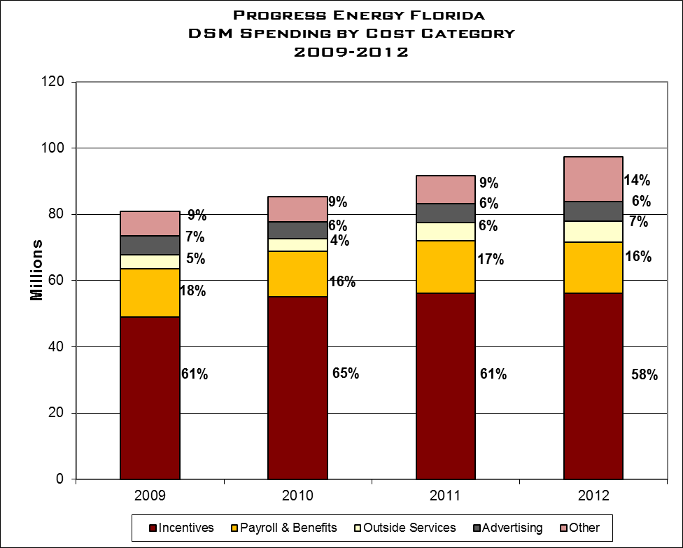
$97.5
$91.7
$85.4
$81.0
EXHIBIT 12 Source:PEF Response to Staff’s Data Request DR 1.6, 4.3, and 2010 and 2011 Schedule CT-3.

Exhibit 13 depicts PEF’s DSM program costs as a percentage of retail revenues. From 2010 to 2012, the percentage increased from 1.8 to 2.2 . The increase is driven primarily by two factors: increased participation in the residential and Commercial/Industrial New Construction programs and the continuation of the Company’s systemic development of a two-way digital communications infrastructure platform to ensure the availability of the current and future direct load capacity. The two-way communications infrastructure platform is a replacement to PEF’s existing one-way communications direct load control program that provides PEF with no direct feedback. The new two-way digital communications platform will enhance PEF’s ability to maintain the existing levels of load under control, as well as grow the program to respond to future need. Capital costs for the new system was $19.3 million dollars in 2012.

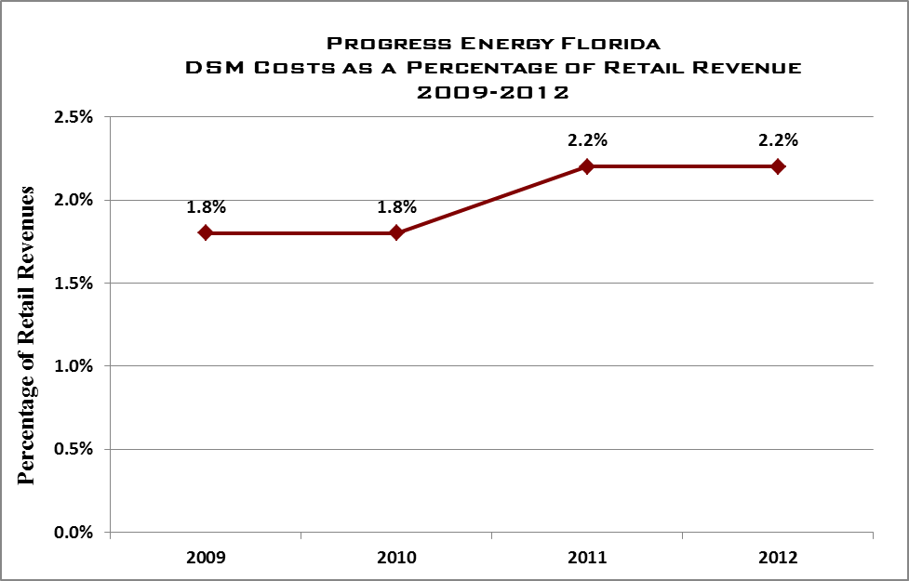
EXHIBIT 13 Source: PEF Response to Staff’s Data Request DR 3.5

2.4.2 DSM Administrative Costs
Exhibit 14 depicts PEF’s annual administrative DSM costs as a percentage of PEF’s total DSM expenditures. PEF reported $97.5 million in total DSM program expenditures in 2012, up from $91.7 in 2011 and $85.4 in 2010. However, as shown, for each year 2010 through 2012, 8 percent of PEF’s total DSM expenditures were devoted to administrative functions. PEF’s DSM administrative costs are identified by unique task codes and are included in the line item “Conservation Program Administrative” as reported in the company’s Schedule CT-2 filed annually with the Commission in the ECCR docket. Additional administrative costs are also captured in the expenses for each of the specific DSM programs. The 8 percent reported includes the Conservation Program Administrative costs as well as the additional administrative expenses accounted for in the specific DSM programs.
With 8 percent of total DSM expenditures supporting administrative efforts in each of the past three years, PEF has employed a consistent approach to delivering its programs. As described, the improvements suggested by Bridge Strategy Group in 2010 that have been pursued by PEF may have helped the company to keep administrative costs from rising as a percentage of total DSM expenses.

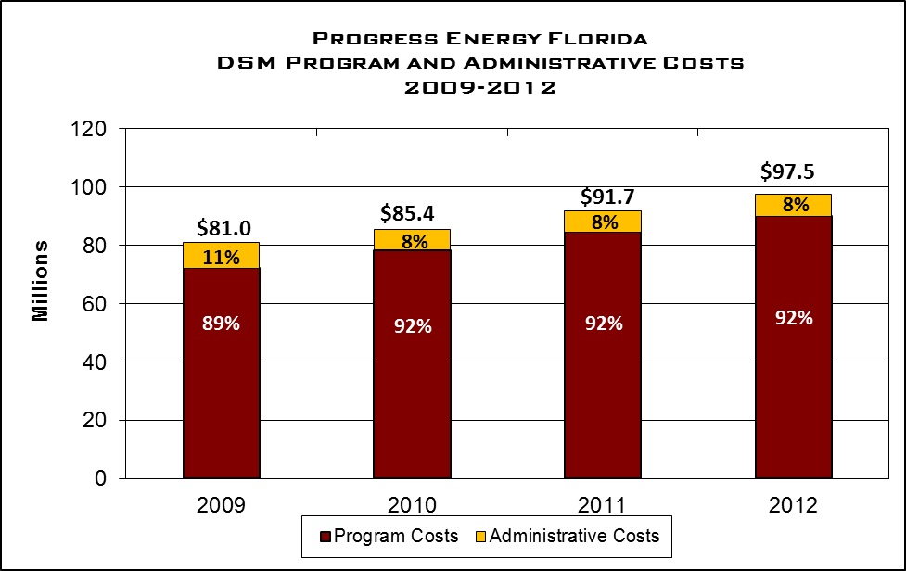
EXHIBIT 14 Source: PEF Response to Staff’s Data Request DR 1.6 and 3.1

2.4.3 DSM Advertising Costs
Each year, the DSM marketing team works with the energy efficiency and demand response program managers to confirm the energy savings or demand reduction goals. These goals are translated into participation goals, which become the basis of a marketing plan. Marketing is charged with developing awareness of the energy efficiency programs among customers and generating responses to marketing activity to provide an adequate number of leads so that the participation goals can be met annually.

Development of an annual marketing plan begins with the collection of information from a wide variety of resources which vary by program and target audience. Market research, customer feedback, industry information, marketing and advertising trends, and political climate have a significant impact on PEF’s ability to effectively reach customers. PEF also uses past marketing efforts to forecast response rates to potential tactics. This helps PEF estimate the number of times needed to reach out to customers. If specialized advertising elements are needed (e.g., television, radio ads, or online advertising), PEF’s Communications Department calls on outside vendors that can provide the expertise needed to develop and place the media.

The portions of marketing that are outsourced using third-party vendors include: mail houses, media buying agencies, printers, email marketing services, and collateral storage distribution. Evaluation of the cost-benefit for third-party vendors and selection processes are in collaboration with PEF’s Supply Chain Department to establish a vendor list and criteria such as services provided, geography, price and quality. For services by third-party vendors, the selection process is a competitive bid process for all contracts valued over $100,000.

Exhibit 15 depicts PEF’s Advertising/Marketing expenditures for the company’s residential, commercial, and industrial DSM programs for each of the years 20009 through 2012. Over the four years reviewed, PEF’s average advertising expenditures were $5.6 million. On average, approximately three-quarters, or $4.2 million of the total adverting expenditures were in support of PEF’s Residential Home Energy Check and Residential Home Energy Improvement programs. Both of these programs have by far the greatest number of participants.

Progress Energy Florida
DSM Advertising Costs By Program
2009-2012

Program | 2009 | 2010 | 2011 | 2012
Residential:
Home Energy Check | 2,401,942 | 2,665,098 | 2,823,304 | 2,903,153
Residential New Construction | 214,890 | 91,630 | 107,383 | 66,623
Home Energy Improvement | 1,635,818 | 1,376,724 | 1,399,778 | 1,445,587
Technology Development | 1,758 | 0 | 0 | 0
Residential Load Mgmt. | 357,504 | 510,368 | 943,433 | 1,033,556
Low Income Weatherization Prgm | 16,500 | 23,144 | 26,320 | 24,500
Renewable Energy Saver | 46,479 | 42,925 | 10,433 | 0
Neighborhood Energy Saver | 24,902 | 16,143 | 31,341 | 31,899
Solar Water Heating with Energy Mgmt. |  |  | 13,990 | 3,660
Residential Solar Photovoltaic |  |  | 9,097 | 265
Conservation Program Admin | 482,101 | 290,910 | 158,925 | 163,013
Total Residential | 5,181,894 | 5,016,942 | 5,524,004 | 5,672,256
Commercial:
Business Energy Check | 272,404 | 92,846 | 116,813 | 68,969
Better Business | 229,633 | 76,239 | 89,276 | 49,844
Business New Construction | 12,126 | 44,211 | 39,221 | 31,629
Commercial Solar Photovoltaic |  |  | 5,786 | 311
Photovoltaic for Schools |  |  | 6,319 | 23,209
Total Commercial | 514,163 | 213,296 | 257,415 | 173,962
Total Residential and Commercial: | 5,696,057 | 5,230,238 | 5,781,419 | 5,846,218
EXHIBIT 15 Source: PEF Response to Staff’s Data Request DR 1.6 and 3.2.

2.5 Observations

As discussed in the Executive Summary of this review, audit staff identified challenges that impact the administrative efficiency of each company’s DSM programs. Overall, audit staff notes that PEF has a detailed program in place to execute the statutory requirements to reduce demand and improve energy efficiency to its customers. However, audit staff notes the following observations that are universal to all the companies included in this review:

In administering DSM programs, the four largest Florida IOUs place primary importance upon attaining the FPSC-established energy and demand reduction goals.

A limited amount of information sharing, collaborative efforts, and benchmarking regarding the administration of DSM programs currently occurs among Florida IOUs and with IOUs in other states.

Different definitions of “administrative costs” are employed by each company, causing difficulties in the analysis of administrative efficiency.

Additional internal audit coverage of DSM administrative costs and internal controls should be considered by Florida IOUs.

The four IOUs continue to make substantial efforts to improve administrative efficiency of their DSM programs.

Audit staff believes that PEF’s consolidation of most of its Residential and Commercial/Industrial DSM measures into umbrella programs provide significant benefits over implementing measure-specific programs. The umbrella programs allow for PEF to minimize redundant functions and lower program administration costs, which in turn, increases program cost-effectiveness.

Recognizing that there are always areas for continued improvement, audit staff notes that the company has focused on the administrative efficiencies during the review period. Since 2009, PEF has been applying a continuous improvement framework to its DSM operations through its Continuous Business Excellence program. The program operates by using a structured multi-step process that is designed to eliminate waste, streamline for quality and efficiency and increase customer satisfaction. The process, known as the LEAN methodology, was used in PEF’s consolidation of its DSM back-office operations and to create a contractor portal that streamlined the workflow process for monitoring and selection of contractors.

Additionally, in 2009, PEF utilized a third-party consultant to perform an extensive study of the performance, cost structure and process within its DSM organization. The study identified opportunities for PEF to improve the effectiveness and efficiency of delivering DSM programs including potential organizational realignments of DSM-related administrative functions. The company pursued 12 of the opportunities identified in the study. Audit staff believes that the use of outside resources allows the company the ability to broaden its understanding of the potential offering and potentially benefit from shared knowledge. Using consultants and non-company resources to increase and maximize the company’s options will ultimately improve the overall program.

Currently, PEF categorizes its DSM administrative costs as those specifically related to its DSM support staff. Audit staff notes the value in accurately tracking costs to effectively monitor and evaluate the overall spending trends within the company. While PEF does define and track its administrative costs, audit staff believes the company’s current definition for administrative costs requires further discussion.

The company’s Internal Audit group has maintained a focus on the company’s DSM related programs during the period. The work of PEF’s Internal Audit group has allowed for improvements to its DSM program management and controls. As pointed out above, Commission audit staff believes this is an important area of continued focus by the company in future years.

3.0 Tampa Electric Company

3.0 Tampa Electric company

TECO began its DSM activity in the mid-1970’s, prior to enactment of the Florida Energy Efficiency and Conservation Act (FEECA) in 1980. At that time, the company DSM was focused on residential programs. It was the first investor-owned utility (IOU) to gain approval of its FEECA plan and notes that it met its DSM goals from 1981 through 1989.

From 1990 through 1994, an interim period during which utilities and regulators began the work of setting new DSM standards, TECO continued to operate DSM programs and set goals. During the first 10-year plan (1995-2004) TECO set aggressive goals and some components were not achieved. In subsequent 10-year plans (2000-2010 and 2005-2014) TECO exceeded all goals and was the only IOU that met or exceeded demand and energy goals in every category in 2010.

TECO 2010-2019 DSM goals received Commission approval in December 2009, by Order No. PSC-09-0855-FOF-EG. The blueprint for implementation, the 2010-2019 DSM Plan, was not approved until a year later, in December 2010, by Order No. PSC-10-0736-PAA-EG. During the interim and until full launch of the new plan in mid-2011, TECO continued to use its 2005-2014 DSM Plan to achieve the goals set in the 2010-2019 DSM Plan. TECO believes it is on track to exceed the goals of the current 10-year plan.

3.1 DSM Programs

TECO has a current total of 35 DSM programs in residential, commercial/industrial, and renewable initiatives. The majority are offered under commercial/industrial

Customers are encouraged, with interaction and assistance from TECO DSM personnel, to choose individual programs tailored to their specific needs. These programs are chosen “a la carte”, allowing each customer to align DSM with their current and/or anticipated situation, building type, usage pattern, equipment, and budget. TECO believes this approach works better than grouping multiple programs under an umbrella of several programs that may not best or most appropriately meet a customer’s specific need.

3.1.1 Residential DSM Programs
TECO serves over 677,000 retail customers of which approximately 88 percent (606,000) are residential. Current company residential DSM portfolio consists of 11 programs.

The predominant and most utilized of TECO’s residential programs is the Energy Audit, designed to save demand and energy by raising customer awareness of home energy usage. Raising knowledge helps change behavior and encourages the implementation of energy efficiency measures, all of which leads to lowering system demand, lessening usage, and decreased customer bills. This program fulfills the Commission’s mandate to offer energy audit service to all customers and is available to all residential customers.

In its most recent ten-year plan, TECO offered two new residential programs – ECM and HVAC Recommissioning. ECM is designed to save customers costs by incenting customers to change out HVAC motors for more efficient models. More efficient motors reduce system demand and provide energy savings. HVAC recommissioning provides incentives for maintaining and tuning HVAC equipment.

Exhibit 16 below depicts the number of participants in each residential program from 2009 through 2012. In 2012, Ceiling Insulation (part of the Building Envelope plan) had the most participants, while Duct Repair had the highest participation for the four year period. The 2010 peaks may be a result of federal tax credits designed to spur energy efficiency and allowed consumers to combine the tax credits with TECO incentives. Since 2010, the number of participants has fallen in these categories due to several factors – less severe weather, economic uncertainty, a weak housing market, increased mortgage defaults, and fewer stimulus dollars.

Tampa Electric Company
Residential DSM Programs Annual Participation
2009 – 2012

Program | 2009 | 2010 | 2011 | 2012
Alternate Audit | 8,681 | 10,291 | 8,652 | 7,908
RCS Audit | 0 | 0 | 0 | 0
Customer Assisted Audit | 1,905 | 1,968 | 1,447 | 1,065
New Construction | 257 | 854 | 1,745 | 1,720
Energy Planner | 517 | 674 | 489 | 109
Ceiling Insulation | 1,558 | 2,126 | 4,626 | 11,367
Duct Repair | 9,772 | 7,467 | 4,215 | 2,272
Heating & Cooling | 3,529 | 5,926 | 4,501 | 3,138
Window Replacement | 702 | 1,349 | 2,055 | 1,135
Window Film | 540 | 547 | 417 | 411
Wall Insulation | 6 | 12 | 3 | 13
Weatherization & Agency Outreach | 207 | 43 | 305 | 3,387
Electronically Commutated Motors | n/a | n/a | 0 | 0
HVAC Recommissioning | n/a | n/a | 0 | 671
Energy Education Outreach | n/a | n/a | 44 | 434
Total | 27,674 | 31,257 | 28,499 | 33,630
EXHIBIT 16 Source: TECO Response to Staff Data Request 1.11

3.1.2 Commercial/Industrial DSM Programs
With more complex facilities and systems for heating, cooling, and general electrical usage, commercial and industrial customers in the TECO service area represent additional opportunities for customer awareness and conservation. These take the form of technology improvements and alternative usage or rate structures tailored to the individual customer. TECO’s current commercial and industrial portfolio consists of the following nineteen programs.

TECO’s commercial/industrial Energy Audit program is analogous to the residential program and Energy Audit is also the leading program for commercial/industrial. Cool Roof, ECM, HVAC Recommissioning, and Energy Recovery Ventilation are new programs offered in the latest 10-year plan. ECM and HVAC Recommissioning are similar to new plans of the same title discussed earlier in the residential section. Cool Roof incents customers to install systems that reduce heat transfer, providing the company demand and energy savings. Energy Recovery Ventilation incents ventilation modifications to HVAC equipment. This reduces humidity and HVAC load, providing demand and energy savings for the company and TECO.

Exhibit 17 below depicts participants for each Commercial/Industrial program that had activity from 2009 through 2012. Duct Repair had the highest participation each year. According to TECO, factors contributing to the decrease in participation 2010 were milder weather and economic uncertainty, and appliance standard changes, and weather conditions.

Tampa Electric Company
Commercial/Industrial DSM Programs Annual Participation
2009 – 2012

Program | 2009 | 2010 | 2011 | 2012
Commercial / Industrial Audit (Free) | 1,009 | 652 | 505 | 587
Commercial Duct Repair | 1,185 | 5,494 | 2,655 | 643
Commercial Window Film | 27 | 9 | 11 | 16
Commercial Ceiling Insulation | 4 | 5 | 32 | 79
Commercial /Industrial Efficient Motors | 7 | 49 | 59 | 1
Commercial Cooling (DX) | 199 | 101 | 195 | 38
Commercial Cooling (PTAC)` | 46 | 8 | 0 | 20
Commercial Lighting (Conditioned Space) | 114 | 114 | 111 | 58
Commercial Lighting (Unconditioned Space) | 26 | 16 | 35 | 18
Commercial Load Management – Extended | 1 | 0 | 0 | 0
Standby Generator | 5 | 7 | 6 | 2
Conservation Value | 0 | 5 | 0 | 7
Commercial Demand Response | 0 | 0 | 2 | 2
Commercial Chillers | 17 | 4 | 3 | 4
Commercial Occupancy Sensors | 20 | 45 | 34 | 11
Commercial Lighting – Exit Signs | n/a | n/a | 20 | 3
Commercial HVAC Recommissioning | n/a | n/a | 0 | 87
Commercial Cool Roof | n/a | n/a | 25 | 49
Total | 2,660 | 6,509 | 3,693 | 1,625
EXHIBIT 17 Source: TECO Response to Staff Data Request 1.11

3.1.3 Renewable DSM Programs
During the 2008 Florida Legislative session, FEECA was amended to encourage the development of demand-side renewable energy systems. Pursuant to Order No. PSC-09-0855-FOF-EG, the Commission directed the utilities to spend ten percent of historic energy conservation cost recovery expenditures as an annual cap for solar water heating and solar photovoltaic pilot programs. The Commission approved the solar programs as pilot programs in an attempt to encourage solar renewable systems though none were found to be cost-effective.

- Renewable Energy Program
- Solar Photovoltaic (Pilot)
- Residential Solar Water Heating (Pilot)
- School Photovoltaic (Pilot)
- Low-Income Solar Water Heating (Pilot)

Solar renewables are designed to reduce system demand for residential and commercial/industrial. The solar water heating programs are intended to reduce system peak demand and increase renewable energy generation by providing a thermal solar water heater at the customer premise. The low-income water heating program is undertaken in conjunction with local non-profit building organizations.

School photovoltaic systems are provided at no cost. TECO is advancing this initiative at the rate of one school annually. TECO also provides information to teachers and students so they may help evaluate and understand performance and potential benefits. This educational outreach is undertaken in partnership with the Florida Solar Energy Center.

Exhibit 18 below depicts the number of participants in programs related to renewable energy since inception in 2011. The Residential Photovoltaic program has the greatest total number of participants since inception and in each of the two years of program existence.

Tampa Electric Company
Renewable DSM Programs Annual Participation
2011 – 2012

Program | 2011 | 2012
Photovoltaic for Schools | 1 | 1
Commercial Photovoltaic | 8 | 7
Residential Photovoltaic | 49 | 63
Solar Water Heating | 44 | 25
Low-Income Water Heating – Residential | 2 | 4
Total | 104 | 100
EXHIBIT 18 Source: TECO Response to Staff Data Request 1.11

3.2 Organization

TECO DSM is a vertical organization of two components under co-equal managers. One vertical component is responsible for back office support, the other for field work. TECO senior management encourages cross training and mutual support between the two groups.

Tampa Electric Company
DSM Program Organization
2012

Manager
Data
Ware-
house Spec
Supvr
Com
Energy Audits

Customer Service
Supvr Prog Spt
Prog Mgr Load Mgmt
Com
Prog Mgr

Manager
Res
Prog
Mgr
Supvr
Res
Energy Audits
Ind
Acct Mgr
Load Mgmt
Field Techs
Prog
Spt
Weather-
ization
Prog
Mgr
Data Spt Spec
Com
Energy Analysis
Res
Energy Analysis

S

EXHIBIT 19 Source: TECO Response to Staff Interview, November 2012

TECO uses a combination of full-time and part-time employees to track, measure, and implement DSM. Staff size has grown over the last four years, in parallel to increasing DSM requirements. Exhibit 20 below depicts the number of TECO Full-Time Equivalent (FTE) employees, and contract employees charging time to the DSM program.

Tampa Electric Company
DSM Full-Time Equivalents (FTEs)
2009 – 2012

 | 2009 | 2010 | 2011 | 2012
TECO FTE | 35.0 | 38.3 | 42.8 | 44.9
Contractor FTE | 16.4 | 15.3 | 12.6 | 13.9
Total FTE | 51.4 | 53.6 | 55.4 | 58.8
Ratio of FTEs to Total DSM Participants | 1 to 590 | 1 to 705 | 1 to 583 | 1 to 601
EXHIBIT 20 Source: TECO Response to Staff Data Request 3.1

Exhibit 20 above also provides the ratio of TECO full-time equivalent employees to total DSM participation levels to determine the approximate number of participants per FTE. These ratios ranged from a high of 1 FTE per 705 program participants in 2010 to a low of 1 per 583 participants in 2011. TECO’s highest participant to FTE ratio occurred in 2010. This ratio was due to a year-to-year increases of 12.9 percent and 24.5 percent respectively in residential and commercial participation. A subsequent decrease in the FTE to participant ratio from 2010 and 2011 is attributable to a 14.5 percent reduction in total DSM participants over the same period.

3.3 DSM Program Administration

3.3.1 Program Development
The core of the TECO program development approach is to continue to leverage existing programs which contain measures available for customer adoption over a number of years. Adoption is encouraged by program incentives and rebates. Each program is reviewed for potential efficiency gains through modifications to program delivery, customer ease of participation, outside contractor involvement, and back office administration.

TECO examines new measures evaluated in the “achievable potential” study phase of the DSM goal setting process, determining if new measures exist that could be developed into programs or combined with other existing measures or programs. The TECO overall goal is to reduce administrative and delivery costs by seeking to combine measures into a single, more effective program.

TECO also conducts ongoing R&D to determine the potential of new or unique measures to reduce customer energy consumption while also reducing company generation system needs. As the DSM plan takes shape, R&D measures that have proven successful for the customer and TECO are examined for program development and possible inclusion. For example, TECO initiated Commercial Load Management, Residential Energy Planner, and Commercial Chiller via this process. In program development, TECO also monitors industry best practices and benchmarking other utilities, particularly those in Florida. This topic is further discussed in Section 3.3.4.

Finally, TECO continually seeks feedback and ideas for potential DSM programs through inquiries of its energy analysts. Energy analysts perform the critical function of conducting evaluations of site-specific opportunities.

3.3.2 Program Implementation
Costs to implement DSM programs consist of administrative, equipment, and incentive payments to the participants. Upon Commission approval of TECO DSM projections demonstrating the energy and demand benefits of its proposed programs, TECO develops the participation standards for each program. Upon implementation, additional forms and guidelines, inspection procedures, checklists, and back-office workflows for incentive processing and rebate approval are developed as appropriate.

There are multiple ways the company works with customers and vendors to help implement the targeted DSM programs. For example, commercial and residential programs are routinely promoted through advertisements, sponsorship of community events, customer service representatives and bill inserts. TECO also reaches out to trade allies and its vendors, participating in educational training forums, seminars, and trade shows.

3.3.3 Program Monitoring and Verification
In DSM management review and oversight, the company employs weekly reviews throughout the year. These reviews scrutinize program performance metrics. TECO also performs process reviews of individual, active DSM programs to derive an overall efficiency evaluation. TECO management uses the LEAN principles to provide a structured, iterative and multi-step process that defines, measures and analyses an initiative or idea for improvement, incorporates changes, and helps lead to formulation of adequate controls.

TECO states that the company uses a system of regular reports to track activity and results for DSM employees and programs, capturing the information for analysis and trending to enhance DSM effectiveness and efficiency. Reports for residential programs are generated from the Energy Management Data Warehouse (EMDW) and an Access database. A Senior Administrative Assistant runs weekly and monthly reports and the data is transferred into the company’s A-STATS database. A-STATS is used to create weekly and monthly management roll-ups that are reviewed by the Residential Analyst Supervisor and Manager. In addition, TECO Regulatory Affairs personnel review A-STATS data monthly basis to track demand and energy savings.

A Senior Technical Assistant runs reports weekly from the Access database for Window Replacement, Window Film, New Construction, Wall Insulation, HVAC Recommissioning, and HVAC Electronically Commutated Motors. The information is used to create dashboards that are shared with the Residential Analyst Supervisor, Residential Program Manager, and Department Managers.

Installation verification reports are entered into an A-STATS spreadsheet, capturing year-to-date statistics by program. From this data a “Weekly-Monthly Roll-Up Report” and graphics depicting verification results is prepared. It is reviewed weekly by the Supervisor, Program Manager, Program Support, Senior Administrative Specialist and Manager.

TECO also creates and staffs other residential reports including the monthly Weatherization dashboard, Residential Analyst Time and Recordkeeping, and Kit Activity Report (tracking total weatherization, agency outreach, school/community/neighborhood event, and audit kits dispatched).

The Commercial Analyst is responsible to update the weekly report file tracking the number of audits performed by type, field verifications by program, the number of post-verifications completed, and any training, meetings, or special projects assigned. This information is placed into the “Commercial (date) Weekly Report”.

Demand and Energy for residential and commercial programs are calculated by TECO Regulatory Affairs. That information is used to create the monthly “Demand and Energy Report” for management review.

As a key component of its installation verifications, Tampa Electric Company states that it exceeds the ten percent required by the Commission and verifies 100 percent of customer-installed measures. For contractor installations, TECO states that the minimum requirement of ten percent is exceeded annually with every vendor, that it verifies any contractor installations for which a customer requests inspection, installations over $1000 (except Heating & Cooling, Insulation, New Construction, and HVAC Recommissioning) and all requests for rebates that appear to have discrepancies on submitted receipts.

Should a problem arise with a particular contractor, TECO has a protocol the company follows for resolution. If the administrative sequence, paperwork, or amount to be rebated is in question, the problem is addressed and eliminated before any payment is made to the contractor. Failure to resolve the problem leads to an evaluation of the contractor to determine suitability to continue in the program. TECO has disqualified contractors from DSM program participation for failure to resolve these issues.

Commission audit staff reviewed the verification results from January 2009 through December 2012. Staff compared monthly installations against the verification reports for all residential and commercial programs. Staff also examined verifications to determine whether the number completed annually is compliant with the ten percent standard.

On an annual basis, audit staff believes the company has been compliant in verifying ten percent of program installations in nearly every instance, exceeding the ten percent annual requirement in all but one program during the four-year period (i.e. Weatherization, 2011). Verifications in six programs were at least double the annual requirement and 22 others had verifications in the 11 to 20 percent range.

TECO did not meet or exceed ten percent monthly about one-third of the time. The company is able to comply with the ten percent annual regulatory standard by aggressively sampling in other months. The danger of oversampling one month is that anomalies may be more or less apparent, skewing data and perceptions of a particular program. However, the Commission currently does not require utilities to meet a ten percent monthly standard.

3.3.4 Program Evaluation and Modification
Tampa Electric Company uses two methods to review and analyze DSM program administrative, operational, and cost efficiency. The first involves weekly program reviews throughout the year. These reviews examine program performance metrics which address the activities, charges, and achievements related to the company’s DSM programs. In addition, the company schedules on-going collaborative meetings with TECO back office and field operations employees to ensure efficiency gains.

Examples of review metrics are:

- Accuracy of time keeping and reporting
- Productivity index
- Audits completed by week and year to date (“YTD”) (by team and individual),
- Activities completed by week and YTD (by team and individual),
- Major team and individual due dates/milestones,
- Financial review of DSM activities, and
- Demand and energy goals YTD.

The second method of determining DSM program effectiveness and efficiency is through a dedicated process review. This process reviews individual DSM program efficiency. The company utilizes a structured process improvement methodology called LEAN which is intended to define, measure, analyze DSM initiatives, incorporate positive program changes, and initiate adequate front end and back end controls while eliminating waste. LEAN was selected through informal benchmarking of other utilities.

In addition, TECO performs an annual review of DSM cost-effectiveness. This process seeks to minimize DSM delivery costs while maximizing program savings. Components of this process include using input from trade allies, exploring ways to lower DSM delivery costs, and comparing the TECO program to those in other utilities.

TECO states that company DSM representatives regularly monitor industry best practices. Other Florida utilities’ DSM programs are examined for potential, suitability, and ease of delivery in the TECO service area. The company believes that input from industry and trade organizations associated with end-user technologies is integral to new program development and the process of successfully integrating and implementing new programs.

Benchmarking and industry monitoring has resulted in programs being developed by TECO, such as the Commercial Motor Program. TECO states that it has also used information gained from monitoring industry best practices and benchmarking Florida utilities in developing new measures for existing programs, improving efficiency and benefit to consumers, such as TECO’s decision to add window film and wall insulation to the Residential Building Envelope Program.

TECO states it also engages in regular, systematic off-cycle improvements and/or changes to improve its DSM programs. Recent and proposed off-cycle improvements include:

- Implementation of the Customer Relationship Management (CRM) platform
- Combining field activities
- Refining DSM marketing using customer feedback and third-party assessments
- Surveys

CRM is a replacement of existing management software that will be system wide and directly benefit TECO DSM by consolidating into one application all commercial energy management activities and processes. It is scheduled for implementation in the last quarter 2013 or first quarter 2014.
Another ongoing, off-cycle initiative is the attempt to routinely combine field activities to make them more efficient and cost effective. This involves not only batching activities together but also in finding the most fuel and man-hour efficient routes and stops for field techs.

Marketing assessment is an ongoing activity in house and by fee-based third parties. It provides continual feedback and allows rapid change to format in order to maximize the effect of advertising dollars spent, markets penetrated, responses to changing community demographics, and the applicability or appeal of particular DSM programs. It takes the form of customer bill inserts, radio, television and print ads, website , and newsletter campaigns. Marketing is managed through TECO corporate communications.

Survey results assist DSM management and field technicians to recognize program needs and areas of possible improvement. Customers and contractors are routinely surveyed. Field technicians provide DSM customers with surveys during in home energy audits.

The company states that it continually seeks to improve DSM administrative efficiency through use of a disciplined approach to program execution. A key component of this is a review and analysis of each program which helps identify possible improvements and the amount or type of change management required for implementation.

Examples in this change management process are the identification of which individuals, teams, and departments need to be involved, the magnitude of change, and how, where, and when improvement will be implemented. With each recommendation TECO attempts to learn whether the same or similar change was previously undertaken at another utility, the risk involved in implementing it (or not implementing it), and whether the change would result in a requirement to file for regulatory permission prior to implementation. The company also determines if the proposed change is needed due to changing building codes. Lastly, TECO captures quantifiable measures with which to gauge success of a program change.

According to TECO, DSM program improvements include benefits apparent to participating customers as well as to employees facilitating the programs. Examples of improvements for participating DSM customers include:

- Support personnel process rebates daily, reducing turn around time
- Support is trained to eliminate customer transfers or call backs (1-stop shop)
- Feedback and recommendations tailored for each participant
- Standardized DSM processes, leading to consistency and predictability
- High volume or complicated installations performed by expert contractors
- Audit team proficiency reduces energy audit time at homes and facilities
- Tailored recommendations increase probability of customer implementation

Improvement for TECO DSM team members:

- DSM support is cross-trained in all aspects of their team

- Cross-training increased team buy-in to the DSM process as a whole

- Greater buy-in generates more in-house improvement ideas

- Formal DSM training is provided for team members

- DSM qualification and certification opportunities are provided for team members

- In 2012, seven earned Association of Energy Engineers national certifications

- In 2012, two attained Building Energy Rating System (BERS) certification from the FL Department of Community Affairs.

3.3.5 Internal Audits
In 2010 and 2011, TECO completed two internal audits of the DSM program. These audits focused on the Energy Planner and Duct Repair programs respectively.

The earlier audit found that TECO had an adequate system of DSM internal controls, but noted minor deficiencies. TECO and DSM management implemented a remedial action program that incorporated the audit recommendations. Audit recommendations included:

- Improvement to reporting to improve customer support and program effectiveness
- Standardization of management approach to analyzing load data
- Controls to enhance integrity of data reported to the Commission
- Improving organizational alignment of DSM application administrators and owners

An audit of the Duct Repair program was completed in 2011 and provided an overall positive report. However, it also identified opportunities to “..strengthen the control environment and improve process efficiency and effectiveness…”. Among items cited were incomplete documentation, inconsistent inspection procedures, and inadequate program tracking tools. In its report, the audit team also suggested changes to the program process flow. Management formulated a remedial plan incorporating these suggested changes. According to TECO management responses, this remediation was successfully completed in August 2011.

As part of the current ten-year plan cycle, TECO also contracted CleaResult to review new DSM programs. CleaResult studied several new programs including HVAC Recommissioning, Electronically Commutated Motors, and Weatherization. The purpose of this review was to provide a comparison of new TECO programs to industry best practices and standards. CleaResult recommended the following, which TECO has implemented:

- Develop criteria for third party verifications
- Require contractors to use industry standard tools for consistent results (HVAC)

3.4 DSM Related Costs

3.4.1 DSM Total Costs
Exhibit 21 and Exhibit 22 below show TECO DSM costs by residential and commercial programs from 2009 through 2012. Renewables were considered in their respective categories, either residential or commercial.

Residential program costs averaged $15.9 million per year. This is 38.6 percent of total DSM costs and 63.1 percent as much as the annual cost of commercial programs across the four year review period.

Tampa Electric Company
DSM Costs by Residential Program
2009-2012

Program | 2009 | 2010 | 2011 | 2012
Prime Time | $6,324,692 | $6,066,704 | $5,620,103 | $5,163,787
Energy Audits | $1,775,528 | $1,883,479 | $1,997,512 | $1,590,823
New Construction | $144,082 | $473,679 | $1,153,312 | $1,581,436
Duct Repair | $1,783,889 | $1,435,381 | $846,920 | $534,481
Heating & Cooling | $609,865 | $1,027,600 | $1,155,275 | $996,963
Building Envelope Improvement | $616,261 | $979,741 | $1,978,020 | $3,115,913
Low-Income Weatherization | $24,866 | $10,873 | $124,013 | $1,041,676
Electronically Commutated Motors | $0 | $0 | $1,712 | $5,057
HVAC Recommissioning | $0 | $0 | $6,712 | $113,524
Energy Education Outreach | $72,827 | $88,421 | $109,514 | $92,720
Price Responsive Load Management | $1,495,578 | $2,445,227 | $3,020,606 | $3,561,102
Renewable Energy Systems Initiative | n/a | n/a | $378,882 | $1,370,164
Common Expenses | $224,168 | $298,694 | $347,239 | $368,994
Total | $13,071,756 | $14,709,850 | $16,739,820 | $19,334,640
EXHIBIT 21 Source: TECO Annual Filing, 2009-2012, CT-2, page 2

The cost of commercial programs during the period 2009 through 2012 averaged $25.3 million per year, or about 59 percent greater than costs associated with residential programs during the same period. TECO is DSM commercial-heavy, with large industrial customers, which accounts for the majority of overall program costs.

Tampa Electric Company
DSM Costs by Commercial/Industrial Programs
2009-2012

Program | 2009 | 2010 | 2011 | 2012
Commercial / Industrial Energy Audits | $291,512 | $142,015 | $244,807 | $333,339
Cogeneration | $112,026 | $119,106 | $100,152 | $108,747
Commercial Duct Repair | $246,314 | $1,133,588 | $714,371 | $101,182
Commercial Building Envelope | $21,067 | $13,208 | $93,665 | $126,183
Commercial /Industrial Efficient Motors | $413 | $6,233 | $4,783 | $731
Commercial Cooling | $72,159 | $52,043 | $99,389 | $26,031
Commercial Lighting | $456,459 | $288,791 | $506,713 | $240,981
Commercial Load Management | $14,816 | $6,289 | $17,179 | $7,856
Standby Generator | $1,601,549 | $1,686,121 | $2,108,971 | $2,306,743
Conservation Value | $9,029 | $73,181 | $77,283 | $180,808
Commercial Demand Response | $2,669,022 | $3,466,727 | $3,654,349 | $3,253,265
Commercial Chillers | $67,106 | $17,319 | $18,129 | $29,895
Commercial Occupancy Sensors | $57,539 | $56,178 | $70,039 | $29,001
Commercial/Industrial Refrigeration | $0 | $176 | $490 | $104
Commercial Water Heating | $0 | $176 | $1,068 | $104
Commercial HVAC Recommissioning | $0 | $0 | $5,697 | $35,920
Electronically Commutate Motors | $0 | $0 | $803 | $310
Commercial Cool Roof | $0 | $0 | $209,035 | $425,002
Commercial Energy Recovery Ventilation | $0 | $0 | $1,659 | $201
Industrial Load Management | $13,145,086 | $21,196,343 | $18,057,750 | $19,226,361
Renewable Energy Systems Initiative | n/a | n/a | $292,547 | $237,513
Common Expenses | $224,168 | $298,694 | $347,239 | $368,994
Total | $18,988,265 | $28,556,188 | $26,626,118 | $27,039,271
EXHIBIT 22 Source: TECO Annual Filing, 2009-2012, CT-2, page 2

Exhibit 23 separates TECO total DSM costs into the major cost categories of:

- Incentives
- Payroll and benefits
- Outside sevices
- Advertising
- Other

“Other” includes depreciaton and amortization, materials and supplies, travel, rent, industry dues and fees, subscriptions, postage, cell phone usage, wireless services, other employee benefits-non cash, educational assistance, and licenses/permits. During the period examined, it accounted for roughly one percent of the total.

From 2009 through 2012, distribution of these costs remained consistent. Each year, incentives comprised about three-quarters of DSM spending – 76.5 percent, 78.6 percent, 76.0 percent, and 77.8 percent respectively. During the four-year period examined, payroll and benefits consistently represented less than ten percent each year.

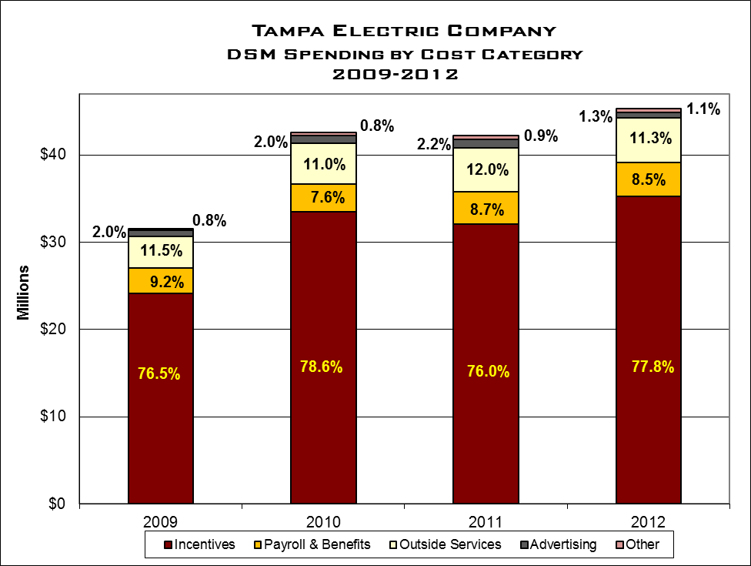
EXHIBIT 23 Source: TECO Response to Staff DR-1.5 and Annual Filing page CT-2

From 2009 through 2012, DSM spending increased 44 percent from $32.2 million to $46.6 million. However, the proportion of the five categories shown in Exhibit 23 remained generally stable, with incentives the largest segment and averaging 77 percent annually. Of the total incentives paid, 57.3 percent can be attributed to the Prime Time (residential) and Industrial Load Management programs, both of which are demand savings programs. Outside services, the second largest segment, remained steady during the review period, averaging 11.5 percent of total annual costs. DSM payroll and benefits averaged 8.5 percent of total annual costs, with a high of 9.2 percent in 2009 and the low of 7.6 percent in 2010.

During the period of review, Tampa Electric Company spent approximately 2 percent per year of company total revenue on DSM programs. Exhibit 24 depicts program costs as a percentage of retail revenue. At the start of the period reviewed, spending was 1.47 percent but rose steadily to 2.38 percent by 2012. Staff believes this increase was due predominantly to the impact of the economy on total retail demand, the variations reflecting reduced sales more than significantly increased DSM spending.
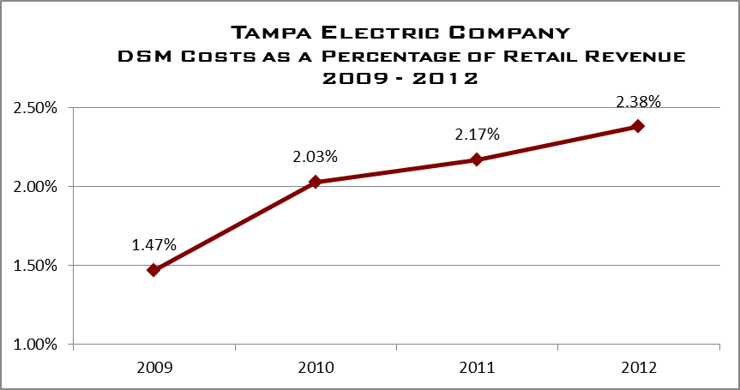
EXHIBIT 24 Source: TECO Response to Staff Data Request 1.4

3.4.2 DSM Administrative Costs
With 4 to 5 percent of total DSM expenditures supporting administrative functions from 2009 through 2012, TECO has demonstrated a consistent approach to delivering its programs.

Exhibit 25 below depicts TECO annual DSM administrative costs as a percentage of total DSM expenditures. The company reported $46.58 million in total DSM program expenditures in 2012, up 7 percent from $43.35 in 2011. However, administrative costs actually decreased from 5 percent to 4 percent during the same period. Examples of administrative costs include payroll and benefits, training, outside services, materials and supplies, travel, industry dues, and advertising.
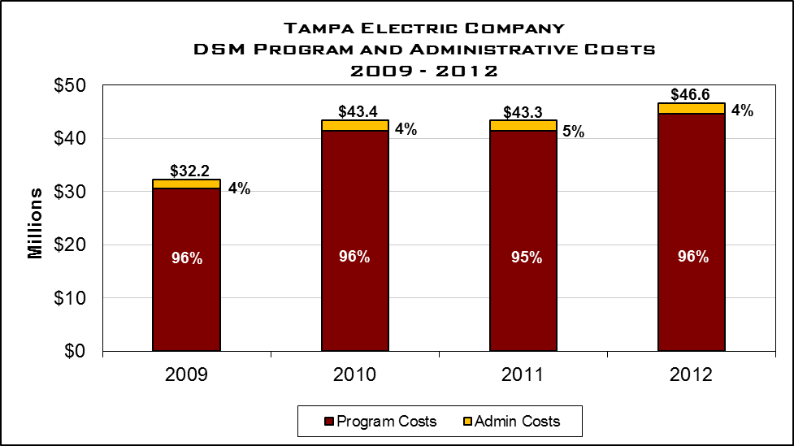
EXHIBIT 25 Source: TECO Response to Staff Data Request 1.6

3.4.3 DSM Advertising Costs
The TECO DSM marketing approach is focused on the comprehensive energy audit for residential and commercial customers, awareness of residential price responsive load management and duct repair programs, and identifying opportunities for commercial customers to participate in programs aimed at meeting their energy efficiency needs.

TECO relies to a great degree on advertising. This effort revolves around a campaign of bill inserts as well as print, radio, and television ads. TECO augments these through participation in presentations and functions for local civic groups, government sponsored public forums, homeowner association meetings, trade shows, Junior Achievement, and Habitat for Humanity.

TECO contracts with PeakBiety Branding and Advertising, to assist developing DSM marketing strategy and the placement of advertisements. Tampa Electric Company believes PeakBiety offers cost effective, targeted advertising tailored to the intended audience. Targeting and tailoring DSM advertisements requires specific skills, knowledge, experience and research assets that TECO believes is cost-ineffective to provide through its permanent staff.

TECO believes that PeakBiety provides access to marketing and communications professionals with the skills required for development of a thorough marketing strategy; creation of the appropriate messages and ads; and their placement in appropriate media. PeakBiety, in coordination with TECO, conducts market research and evaluation to determine the best media type with which to conduct DSM advertising. PeakBiety also measures and tracks effectiveness of ads, tracks industry trends, and recommends best practices via feedback to TECO.

Commission audit staff reviewed TECO DSM advertisements for content, appropriateness, and completeness in describing the services offered by the company. Additionally, staff reviewed and trended annual DSM advertising costs, by program and overall. Staff did not identify any issues with this process. Exhibit 26 lists the company’s advertising spending for the review period.

Tampa Electric Company
DSM Advertising Expenditures
2009-2012

 | 2009 | 2010 | 2011 | 2012
Expenditures | $639,961 | $852,130 | $944,543 | $609,636
EXHIBIT 26 Source: TECO Annual Filing, 2009-2012, CT-2, page 2

3.5 OBSERVATIONS

As discussed in the Executive Summary of this review, audit staff identified challenges that impact the administrative efficiency of each company’s DSM programs. Overall, audit staff notes that PEF has a detailed program in place to execute the statutory requirements to reduce demand and improve energy efficiency to its customers. However, audit staff notes the following observations that are universal to all the companies included in this review:

In administering DSM programs, the four largest Florida IOUs place primary importance upon attaining the FPSC-established energy and demand reduction goals.

A limited amount of information sharing, collaborative efforts, and benchmarking regarding the administration of DSM programs currently occurs among Florida IOUs and with IOUs in other states.

Different definitions of “administrative costs” are employed by each company, causing difficulties in the analysis of administrative efficiency.

Additional internal audit coverage of DSM administrative costs and internal controls should be considered by Florida IOUs.

The four IOUs continue to make substantial efforts to improve administrative efficiency of their DSM programs.

Recognizing that there is almost always opportunities for improvement in programs and processes, audit staff notes that TECO has continued developing its DSM management system. The company will deploy the new Customer Relationship Management (CRM) software platform in the near future. CRM will speed up DSM-related payments and consolidate into a single application all commercial energy management activities and processes. Customer survey feedback and third-party assessments are helping to improve the DSM process. Combining field activities has increased program efficiency.

Currently, TECO categorizes its DSM administrative costs as those specifically related to its DSM support staff. Audit staff notes the value in accurately tracking costs to effectively monitor and evaluate the overall spending trends within the company. While TECO does define and track its administrative costs, audit staff believes the company’s current definition for administrative costs requires further discussion.

As pointed out above, Commission audit staff believes internal audits should be an important area of continued focus by the company in future years. TECO did complete two internal DSM audits, in 2010 and 2011, but none have focused specifically on demand-side management since then. Increasing the frequency of DSM focused internal audits would provide valuable feedback and further opportunities for TECO to improve DSM program management and efficiencies.

4.0 Florida Power & Light Company

4.0 Florida Power & Light Company

Florida Power & Light Company’s (FPL) current Demand -Side Management (DSM) plan resulted from the Florida Public Service Commission Goal Setting proceedings during 2009-2011. On January 31, 2011, FPL’s plan for 2010 was denied by the Commission because it did not reach goals set by the Commission. FPL was required to submit a modified plan for Commission approval.

On March 25, 2011 FPL submitted a Modified DSM Plan, designed to meet the conservation goals set in the Goal Setting Order. In August 2011, the Commission issued Order No. PSC-11-0346-PAA-EG, denying FPL’s Modified DSM Plan and ordered FPL to continue the existing DSM programs in effect. FPL has maintained the same DSM programs since July 2011, and continues to review DSM offerings for additional energy-efficient opportunities.

4.1 DSM Programs

4.1.1 Residential DSM Programs
FPL currently offers seven residential DSM programs to increase customer energy efficiency and reduce peak load demand. Each residential program aims at reducing the summer and winter coincident peak demand, and requires customers to meet specific qualifying criteria and standards. Customer account information and program qualifications are reviewed prior to allowing participation. Prior to approval and payment, samples of all program installations are required to be verified by FPL DSM field and management personnel or contractor supervisors.

Exhibit 27 shows each of FPL’s Residential DSM programs and the number of annual participants for the programs during 2009-2012.

Florida Power & Light Company
Residential DSM Programs Annual Participation
2009-2012

Program | Annual Program Participants
Program | 2009 | 2010 | 2011 | 2012
Home Energy Survey | 172,667 | 139,837 | 159,620 | 145,069
Air Conditioning | 63,453 | 99,897 | 113,907 | 101,156
Load Management (On-Call) | 12,159 | 6,826 | 8,021 | 13,910
Building Envelope | 11,103 | 14,041 | 13,675 | 11,639
New Construction (BuildSmart) | 1,647 | 2,089 | 2,317 | 2,943
Duct System Testing & Repair | 13,182 | 16,348 | 3,575 | 1,277
Low-Income Weatherization | 456 | 837 | 1,666 | 2,505
Total | 274,667 | 279,875 | 302,781 | 278,499
EXHIBIT 27 Source: FPL Response to Staff Data Request 1.11, 3.2
As shown in the exhibit, FPL’s total residential DSM participants ranged from a low of 274,667 in 2009 to a high of 302,781 in 2011. In 2012, FPL experienced decreased program participation in four residential programs, and increased participation in three others. This resulted in an overall decrease of 24,282 program participants (8 percent) from the 2011 level.

The Home Energy Survey and Air Conditioning programs represented 88.4 percent of the total residential program participation in 2012. However, participant levels dropped 9.1 percent and 11 percent respectively for these two programs in 2012.

FPL explained that high bill inquiries are one of the main drivers of Home Energy Survey participation. FPL believes fewer customer inquiries of high bills in 2012, and increased customer participation in on-line surveys, led to the decrease in Home Energy Survey customer participation. Additionally, Residential Air Conditioning program participation increased substantially during 2010 and 2011 due to available Federal and State tax credits. By 2012, the tax credits expired, and new changes to the South Florida Building Code, caused further decreases in program participation.

FPL’s Duct System Testing & Repair program participant level also decreased substantially in 2011-2012. FPL explained that this decrease was due to a change in the marketing approach towards apartment and condominium customers in 2011 and 2012. FPL’s re-designed marketing process was launched in 2013 to address participant decreases.

4.1.2 Commercial/Industrial DSM Programs
FPL offers nine commercial/industrial DSM programs to serve its larger users. These programs are generally more complex in nature, and require the installation of larger more specialized equipment. Commercial/industrial energy efficiency contributes significantly to FPL’s overall DSM program goals. Technological improvements, and alternative rate structures are offered to commercial/industrial customers, and provide significant incentive for participation in FPL’s DSM programs. Exhibit 28 shows the annual participants for FPL’s Commercial/Industrial DSM programs during 2009-2012.

As shown in the chart, FPL’s Business Energy Evaluation (BEE), Commercial/Industrial Demand Reduction (CDR), and HVAC programs have led in annual participants during the period. These three programs represented 69.2 percent of the total commercial/industrial program participant base in 2012.

The BEE program experienced a 3 percent increase in participants from 2011 to 2012. FPL noted that the number of BEEs requested in 2011 versus 2012 represents normal year-to-year program variation.

FPL’s Business On-Call participation dropped significantly from 2009 to 2010. The participant level improved significantly in 2011, only to drop again in 2012. FPL stated that the participant levels in 2009, 2011, and 2012 represent similar participation levels with normal variations. According to FPL, the low level of participation in 2010 was due to impacts of the economic downturn on small businesses, who are the target customers for this program.

FPL believes the participant changes in the Efficient Lighting, and Business Custom Incentive programs are reasonable, due to fluctuations in the timing of business project completions and customer readiness. FPL explained that BCI program participation can change from year to year, depending on the number of cost-effective custom incentive projects for large customers.

Florida Power & Light Company
Commercial/Industrial DSM Programs Annual Participation
2009-2012

Program | Annual Program Participants
Program | 2009 | 2010 | 2011 | 2012
Business Energy Evaluation (BEE) | 12,036 | 13,228 | 11,690 | 12,089
Commercial/Industrial Demand Reduction (CDR) | 39,598 | 7,786 | 7,038 | 16,255
Heating, Ventilation, and Air Condition (HVAC) | 8,003 | 10,611 | 8,789 | 12,224
Building Envelope | 11,273 | 6,358 | 5,864 | 6,765
Business On Call | 6,099 | 1,901 | 5,662 | 4,473
Efficient Lighting | 2,847 | 3,810 | 3,509 | 4,397
Business Customer Incentive (BCI) | 1,732 | 2,586 | 2,098 | 2,335
Water Heating | 51 | 25 | 6 | 23
Business Refrigeration | 66 | 40 | 141 | 60
Total | 81,705 | 46,345 | 44,797 | 58,621
EXHIBIT 28 Source: FPL Response to Staff Data Request 1.11

4.1.3 Renewable DSM Programs
During the 2008 Florida Legislative session, FEECA was amended to encourage the development of demand-side renewable energy systems. Pursuant to Order No. PSC-09-0855-FOF-EG, the Commission directed the utilities to spend up to ten percent of their historic energy conservation cost recovery expenditures as an annual cap for solar water heating and solar photovoltaic pilot programs. Exhibit 29 shows the number of annual participants in FPL’s Solar DSM programs during 2011 and 2012.

As shown in the chart, overall solar participation increased from 834 in 2011 to 1,571 in 2012 (88.4 percent). In 2012, the Residential PV and Solar Water Heating programs represented 1,370 (87.2 percent) of the total 1,571 program participants. As can be seen, FPL had zero participants in its Residential Solar Thermal Water Heating-Low Income New Construction program until 2012, FPL also had zero participants in the Business Photovoltaic (PV) for Schools program for 2011 and 2012.

In May 2011, FPL began customer outreach for its residential, commercial, and school Solar Program incentive offerings, opened a solar information website for customers, and began contractor training for contractors involved in FPL’s solar programs. FPL also implemented two rounds of customer applications for its pilot solar programs during 2011. The first round was completed in June and the second round was completed in August. Each round of PV incentives was completed within hours of opening funding to the public.

After the first round of solar incentive offerings, FPL discovered that a large percentage of reservations later dropped out of the program without using the incentive. FPL used the remaining first round allocated funds in the second round. FPL also made modifications to help reduce customer dropout levels for solar incentives in 2012 and 2013.

Florida Power & Light Company
Renewable DSM Programs Annual Participation
2009-2012

Program | Annual Program Participants
Program | 2009 | 2010 | 2011 | 2012
Residential Photovoltaic (PV) | - | - | 271 | 225
Residential Solar Water Heating | - | - | 523 | 1,145
Residential Solar Water Heating-Low Income New Construction | - | - | 0 | 113
Business Photovoltaic (PV) | - | - | 31 | 66
Business Photovoltaic (PV) for Schools | - | - | 0 | 0
Business Solar Water Heating | - | - | 9 | 22
Total | - | - | 834 | 1,571
EXHIBIT 29 Source: FPL Response to Staff Data Requests 1.11, 3.2

For its 2013 solar incentive program, FPL revised its process to have one launch per year. FPL also implemented an automated Customer Standby List to mitigate customer drop-out rates previously experienced, which caused additional launches. The Standby List immediately assigned the next customer in line for an incentive reservation, when a customer reservation was cancelled. This modification allowed FPL to more efficiently use reservation funds, reduce solar launches to one per year, and provide customers with electronic information regarding solar reservation cancellations.

4.2 Organization

FPL has an extensive staff and field organization in place to support its residential, business, and solar DSM program portfolio. The organization includes both full time and shared employee resources, based on program requirements necessary to implement and administer each program. Exhibit 30 provides a snapshot of FPL’s organizational structure supporting its DSM program portfolio.

As shown in the organizational chart, the overall responsibility for FPL’s demand-side management (DSM) portfolio rests with FPL’s Vice President Customer Service. The Director DSM Programs and the Director Customer Service Field Operations report to the Vice President Customer Service, and manage the staff support and field implementation organizations for FPL residential, business, and solar DSM programs.

The Director DSM Programs manages and coordinates staff efforts supporting the programmed plan activities, including program operations, strategy cost and performance, and program development. Three managers report to the Director DSM Programs and have the responsibility for implementing staff support programs and activities.
MANAGER
COST & PERFORMANCE
MANAGER
CONTRACTOR ADMINISTRATOR
MANAGER
MAJOR
SMALL/MEDIUM AND NATIONAL ACCOUNTS
MANAGER RESIDENTIAL MARKET
MANAGER
GOVERNMENTAL
MANAGER
CUSTOMER TECHNOLOGY SUPPORT
VICE PRESIDENT
CUSTOMER SERVICES
MANAGER PROGRAM OPERATIONS
DIRECTOR CUSTOMER SERVICES FIELD OPERATIONS
DIRECTOR
DEMAND SIDE MANAGEMENT
MANAGER
PROGRAM DEVELOPMENT
MANAGER
STRATEGY COST AND PERFORMANCE
Florida Power & Light Company
DSM Program Administration Organization
2012
DSM STAFF SUPPORT
DSM FIELD OPERATIONS
EXHIBIT 30 Source: FPL Response to Staff Data Request 1.3

The Director Customer Services Field Operations manages the field level implementation of FPL residential, business, and solar DSM programs through FPL Customer Service employees and contractors. Six managers report to the Director Customer Services Field Operations and support field and contractor activities for DSM programs.

Staff support and field operations personnel for DSM programs consist of both full-time and part-time positions. Accordingly, shared and full-time hours are charged to the appropriate programs and activities. These charges are combined into full-time equivalents (FTEs) representing the total personnel resources charged to the program. An FTE is the equivalent of one person working 8 hours per day, for 5 days, times fifty-two weeks in a year (2080 hours). FTEs are reviewed and evaluated by management to determine the proper balance of personnel costs and program needs. DSM Management also uses FTEs to help ensure programs remain cost effective and efficient.

Exhibit 31 shows that during the period 2009-2012 FPL charged between 348.4 and 372.5 FTEs annually to its DSM programs. In 2012, FPL reduced total FTEs by about 6.5 percent. The largest number of FTEs throughout the period was charged to Residential and Non-Program Specific programs.

Non-Program Specific FTEs include work performed for all DSM programs, such as the Customer Care Center, computer programming, and Information Technology supporting DSM. These FTEs are not charged to specific DSM programs. As shown in the exhibit, Non-Program Specific FTEs were reduced in 2012 from 119.0 to 89.9, representing a 24 percent decrease.
However, the number of FTEs charged to FPL DSM Programs remained consistent through the period. FPL’s FTE to participant ratio remained consistent at over 900 participants per FTE during the period.

Florida Power & Light Company
DSM Full-Time Equivalents (FTEs)
2009-2012

Program | Annual FTEs Charged to Programs
Program | 2009 | 2010 | 2011 | 2012
Residential | 176.6 | 178.2 | 194.7 | 193.0
Business | 51.7 | 52.8 | 54.2 | 58.9
Solar | 0.0 | 0.0 | 4.6 | 6.7
Non-Program Specific | 141.6 | 130.1 | 119.0 | 89.9
Total Company FTEs | 369.9 | 361.2 | 372.5 | 348.4
Ratio of FTEs to DSM Program Participants | 1 to 963 | 1 to 903 | 1 to 935 | 1 to 972
EXHIBIT 31 Source: FPL Response to Staff Data Request 4.1

FPL’s DSM management team noted that it continues to implement computer-based efficiencies that allow customers and contractors to efficiently manage scheduling, implementation, invoicing and payment processing, associated with program offerings. Management also conveyed that continuous monitoring and review of DSM program results, cost-effective computerized processing improvements, and monitoring field resources with program needs, help manage FTE levels effectively.

4.3 DSM Program Administration

4.3.1 Program Development
FPL has offered its customers the opportunity to participate in DSM programs since the late 1970’s. The company states that it performs periodic performance projections and technical potential studies to identify and evaluate possible demand-reduction measures. These evaluations are used as the foundation for the overall development of the company’s program measures. The measures that meet screening requirements are considered for possible implementation. These measures are bundled into programs and submitted to the PSC for approval as the company’s “DSM Plan.” Once the DSM Plan is approved, the company develops a set of program standards for each program. These standards include the program’s operational detail, and are used as the foundation for the implantation of each program. In addition, the company will submit for these standards to PSC staff for administrative approval.

Once the Commission approves the company’s plan and subsequent program standards, the company begins the process of implementing the specific programs to its customers. The company states that if determined necessary and beneficial, program modifications and new programs can be submitted to the Commission for approval prior to the next goal-setting process. Additionally, if modifications to the program standards are determined to be beneficial, these modifications can be submitted to staff for administrative approval. The company has not made any adjustments to its approved programs or program standards during the 2009 through 2012 period (outside the Commission approval process).

FPL continues to conduct both in-house and partnered research and development initiatives on new commercially-available technologies that could potentially provide demand and energy savings. These initiatives are given comparable consideration during the evaluation process.

Information Sharing/Benchmarking
The company states that it routinely engages in direct discussions with other major utilities concerning DSM issues. Management reports that during 2012, such discussion occurred with Progress Energy Carolinas, Pacific Gas & Electric, Southern California Edison, and Dominion. The company participates in industry groups such that cover topics on DSM processes. Examples of these groups include the Association of Energy Services Professionals (AESP), which focuses on program design & delivery and the DSM executive council of E-Source, a technical and research advisory group. FPL also meets with vendors of new technology and software – which could possibly enhance either utility operations or be installed at customer premises. These discussions typically focus on possible benefits in terms of cost, speed, or additional functionality.

In addition to external benchmarking, the company notes that management performs internal analyses to improve the operational efficiencies of its program and enhance customer experience and impact. The company highlights an example in which its management recognized that there was no formal DSM program management certification program within the industry. Certification programs are recognized as a means to provide and ensure a consistent, detailed skill set for the targeted industry. FPL confirms that in 2012, in conjunction with AESP, it developed a detailed training curriculum for this skill-set, and has required all of its program managers, as well as other FPL personnel, to complete the training and testing process. As a best practice, the company is working with AESP to share this approach with other utilities.

The company notes that while utility benchmarking can be a very useful tool to provide comparative evaluations, management believes there are inherent limitations to its use. The company believes that in order for benchmarking to be appropriate and effective, there must be an ability to “identify, quantify and control/normalize for any divergent data, practices and circumstances.” Without the ability to normalize, there could be an opportunity for misleading comparisons. Examples of specific factors that could differ between companies: “climate; residential/commercial/industrial customer mix; customer load and usage patterns, legislative/regulatory mandates; how long a company has been offering DSM (unlike Florida’s utilities, many have just started within the last few years); geography; demand vs. energy emphasis; varying manufacturer incentives; etc.” FPL management believes that it is not possible to normalize the variables associated with factors, and therefore limit the company’s ability to effectively benchmark other DSM programs.

Use Of Outside Resources
During the company’s initial development of its 2010 project plan, the management team employed an outside consultant to assist with the plan development process. This consultant provided a series of workshops with FPL program staff to best devise a program portfolio that would provide the most optimal output using the Commission-approved goals. The company states that the consultant provided industry comparatives and planning expertise in its plan development approach. While in the end, the Commission directed the company to maintain its previous plan approach for the current cycle, the company management believes the insight provided by the consultant was beneficial to its overall DSM development process.

One area where the company uses a third-party vendor for its DSM support is program measurement and verification (the process for quantifying savings delivered by an Energy Conservation Measure.) This is an area that requires specialized, multi-disciplinary expertise, and the company believes it is more efficient to contract this service. The company stated this vendor is selected using is standard corporate procurement process.

4.3.2 Program Implementation
FPL has in place formal standards for each of its DSM programs and measures. These standards outline and discuss the process for implementing each program. For the majority of its DSM programs, FPL uses in-house personnel to perform program implementation and administrative activities.

Each program standard outlines the implementation process flow for each DSM program offering. The process flow for each process is similar in nature, depending on the type of incentive provided by the program. There are two potential options for the company to pay a DSM incentive—directly to the customer or to their participating independent contractor (PIC). The process for receiving, processing, and verification (if necessary) is the same for both options.

The company has in place the opportunity for qualified vendors, who meet minimum requirements, to enroll as a PIC. This qualification allows a vendor, such as an HVAC installer, the ability to reduce the amount it charges a customer by the FPL incentive amount. The PIC will submit all necessary documentation to the company, and FPL will pay the PIC directly.

Each PIC is required to enter into a Demand-Side Management Program Contract with FPL. This contract requires the company to maintain all applicable licenses and insurance requirements. Additionally, the contract outlines the verification compliance process that FPL can perform on the contractor’s work product. This ensures that the correct energy efficient product or modification was performed in accordance with the program standard. FPL recently implemented a new process for monitoring the PIC’s insurance expiration and will not issue an incentive if the system shows expired insurance.

    - Program Monitoring and Verification
Commission Rules require electric utilities under FEECA to verify a minimum of ten percent of all DSM related program installations to ensure the accuracy of service provided to the customer. FPL’s Program Standards also include the requirement for a minimum of ten percent of all DSM program installations to be verified. This requirement applies to work performed by the utility, a contractor, or self-installed equipment performed by the customer as part of a DSM program.

FPL’s verification process originates with receipt of a completed application for service from a customer or participating contractor. Once the application is approved and documented in FPL’s Demand Side Management System (DSMS), the database uses an algorithm based on both specified and random triggers to tag a certain percentage of program applications to review.

DSM management may modify the verification algorithm for different DSM programs, should a need arise to sample more or less frequently for a particular program or PIC. FPL uses this flexibility when necessary, and maintains documentation of when such a change is made, the reason for the algorithm change, the manager requesting the change, and the date the change was made.

After an application is identified for verification, schedulers work to arrange an on-site visit. In some cases, customers will not allow verifiers onto the property after the installation. Therefore, FPL usually selects a larger pool of qualified jobs for scheduled verification. Once an appointment is arranged, the company assigns an inspector to verify program standards were met, based on the work performed. If the work does not meet program standards, payment is denied until the work is corrected. The company’s goal is to maintain at least a ten percent verification rate for all its programs.

During this review, audit staff received FPL’s verification results for the period January 2009 through December 2012. Staff compared FPL’s New Participants data against the verifications completed for six of eighteen programs. Staff reviewed FPL’s results to determine whether the number of verifications completed annually were compliant with the ten percent standard verification rate. On an annual basis, audit staff believes that FPL has been compliant in verifying ten percent of program installations.

4.3.4 Program Evaluation and Modification
FPL’s DSM administrative staff is charged with continual oversight and monitoring of the DSM program activity. Each DSM program manager is responsible to ensure the measures are implemented according to the company’s goals and intention. The program managers track the participation levels for each program to evaluate the actual participation in relation to the company’s initial estimates.
Management Oversight
During the review period, the company notes it has incrementally implemented numerous enhancements to its internal financial reporting and monitoring process to manage program performance. Specific examples provided by the company include:

- Standard reports to senior management of the DSM results each month

- DSM Program Managers and analysts have access to online reporting through FPL’s financial system, SAP

- Various dashboard tools were implemented to allow managers and middle management to monitor and evaluate program performance on a continual basis

- The Demand Side Management System (DSMS) now permits the ability to extract more granular program participation and savings achievement data and do so more rapidly

The company provided commission audit staff with its DSM management reports for the review period. Audit staff notes that these reports demonstrate that the DSM management team monitors and tracks the progress of the DSM programs, and provides updates to senior management on the programs progress.

DSMS System
In 2008, the company decided to initiate the process to consolidate and replace its legacy DSM systems. This effort would consolidate nine separate systems and incorporate additional functionality to maximize the overall system. The company determined that a customized system was the best option to meet the goal requirements.

The company selected an “offshore delivery model backed up by a fixed-price contract with a major US based systems integrator”. FPL management notes that while the project team experienced a number of issues during development--primarily to scope changes and delays--the company believes that the overall project’s implementation was a successful. Additionally, the use of a fixed-price contract reduced the company’s exposure to undue cost overruns. The DSMS system represents the largest configurable system ever developed at Florida Power and Light.

Web Vouchering/Web Scheduling
In 2012, FPL implemented two web-based applications that the company believes improves its overall operational efficiency, while benefiting the overall independent-contractor experience. These new systems are its Web Vouchering and Web Scheduling systems.

The Web Vouchering process eliminates the need for the previous paper-based process for entering application created within FPL.com. The previous system required contractors--after entering the required information through its website--to print out and mail-in all applications to the company for processing. Under the new process the participating contractors can submit all the supporting documentation online. This new process should result in cost savings and improved service for customers and participating contractors.

In addition to the automated vouchering system, the company implemented a web-based scheduling system. This application allows customers the opportunity to schedule or reschedule their own appointments for Home Energy Surveys or Business Energy Evaluations. The company states that “this system provides customers all available appointment booking dates/time slots improving the customer experience and satisfaction, allowing them to use an online channel in lieu of the traditional phone channel.”

4.3.5 Internal Audits
The company performed seven audits related to the DSM program and process since 2009. These audits address areas such as system development and program oversight. When evaluating the areas for potential audit focus, the company evaluates the total risk and exposure each specific program. The company performed several audits of the programs involving HVAC related measures. There were no significant findings, and management was deemed by FPL auditors to have adequately addressed any concerns.

In addition to program specific audits, the company’s Internal Audit Division performed an audit concerning the development of the company’s new DSM system. FPL Internal Auditing was originally asked to perform an audit of this project during development, however, the project team, after a self-assessment, recognized the need to re-structure the project. Because the vendor was working under a fixed-rate contract, there were no additional costs incurred for re-work resulting from deficient work products. Commission audit staff discussed the project development and implementation with the original IT project team and believes that the company addressed the issues appropriately.

  - DSM Related Costs

4.4.1 DSM Total Costs
The company utilizes the Commission-approved cost effective models to determine and evaluate the overall efficiencies of the DSM programs and measures. The DSM management team uses the company’s Integrated Resource Planning group to evaluate and ensure the validity of the cost effectiveness of each program. This group also assists in the development of the program model, including potential minimum and maximum incentive levels for each program. The final decision on the overall program acceptance and incentive level associated is the discretions of the DSM management.

Exhibit 32 highlights the company’s spending per DSM program. As the exhibit shows, the majority of the residential DSM budget falls within the load management programs and the air conditioning programs. For the commercial programs, approximately half of the DSM budget for the period was spent in the load control and demand reduction programs.

Florida Power & Light Company
DSM Costs by Program
2009-2012

Program | 2009 | 2010 | 2011 | 2012
Residential
Residential Home Energy Survey | $11,852,772 | $13,604,876 | $12,001,061 | $12,113,733
Residential Building Envelope | 6,175,436 | 6,067,823 | 5,422,759 | 4,605,379
Residential Load Management (On Call) | 56,684,702 | 57,639,992 | 55,497,461 | 56,135,174
Duct System Testing & Repair | 1,491,884 | 1,794,132 | 944,876 | 775,689
Residential Air Conditioning | 38,525,343 | 65,453,894 | 76,340,171 | 64,024,130
Residential New Construction (Buildsmart) | 665,357 | 694,862 | 793,691 | 873,668
Low-Income Weatherization | 62,226 | 114,708 | 195,754 | 284,487
Residential Thermostat Load Control Pilot Project | 130,169 | n/a | n/a | n/a
Residential Solar | n/a | n/a | 3,804,924 | 5,424,833
Total Residential | $115,587,889 | $145,370,287 | $155,000,697 | $144,237,093
Commercial
Business On-Call | $3,513,167 | $3,677,640 | $3,920,536 | $3,665,979
Cogeneration & Small Power Production | 454,202 | 524,660 | 604,768 | 618,983
Business Efficient Lighting | 358,515 | 490,447 | 617,403 | 686,363
Commercial/Industrial Load Control | 30,017,564 | 26,406,422 | 25,524,354 | 25,778,052
C/I Demand Reduction | 8,398,714 | 9,456,943 | 9,575,823 | 10,093,875
Business Energy Evaluation | 3,373,777 | 3,707,015 | 6,179,210 | 7,126,232
Business HVAC | 5,246,154 | 5,755,911 | 4,231,278 | 6,345,342
Business Custom Incentive | 581,369 | 774,789 | 305,777 | 504,794
Business Building Envelope | 4,538,862 | 5,920,811 | 5,694,055 | 6,755,523
Business Water Heating | 40,263 | 21,395 | 94,147 | 36,241
Business Refrigeration | 52,271 | 21,484 | 34,861 | 38,329
Conservation Research & Development | 507,724 | 557,881 | 252,648 | 341,744
Renewable Research & Demonstration Pilot | n/a | n/a | 23,285 | 537,874
Commercial Solar | n/a | n/a | 1,074,660 | 3,124,732
Total Commercial | $57,082,582 | $57,315,398 | $58,132,805 | $65,654,063
Total Residential and Commercial | $172,670,471 | $202,685,685 | $213,133,502 | $209,891,156
EXHIBIT 32 Source: FPL Response to Staff Data Requests 1.6, 3.7

Exhibit 33 details the overall DSM spending broken down by category. As the chart demonstrates, the majority of the overall DSM expenses are for program incentives. While the overall DSM spending has increased during the review period, the percentage of spending per category has remained somewhat constant. For the review period, FPL averaged spending 76.3 percent of its overall DSM budget on program incentives paid to customers. The largest residential program incentive payments were consistently made in the Residential Load Management (On-Call) and Air Conditioning programs. The largest incentive payments for the Commercial programs were made in Commercial/Industrial Load Control category.

FPL’s total DSM spending ranged between $186 million in 2009 to $228 million in 2011. During the period 2009-2011 spending increased 23 percent, before decreasing approximately 2 percent in 2012. However, the level of spending in each category remained relatively the same in each year. Over the period, payroll and benefit expenses averaged 11.3 percent annually.

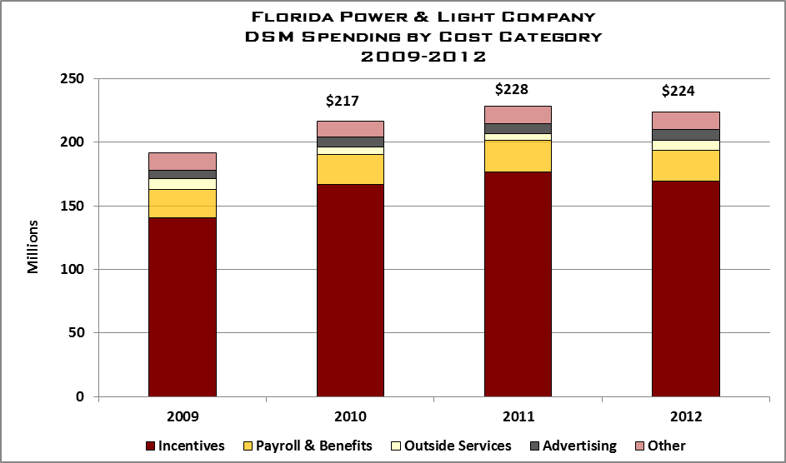

4%
3%
5%
11%
3%
4%
6%
11%
4%
6%
$186

76%
76%
77%
76%
12%
76%
77%
11%
2%
6%
76%
4%
3%
Exhibit 33 Source: FPL Response to Staff Data Request 1.5 and 4.3

FPL spent approximately 2 percent of its overall revenue on DSM programs between 2009 and 2012. Exhibit 34 details the annual percentage of DSM spending compared to the company’s total revenue. Staff notes that the company has maintained a slight increase in percent of DSM spending since 2009, as a percent of total revenue.
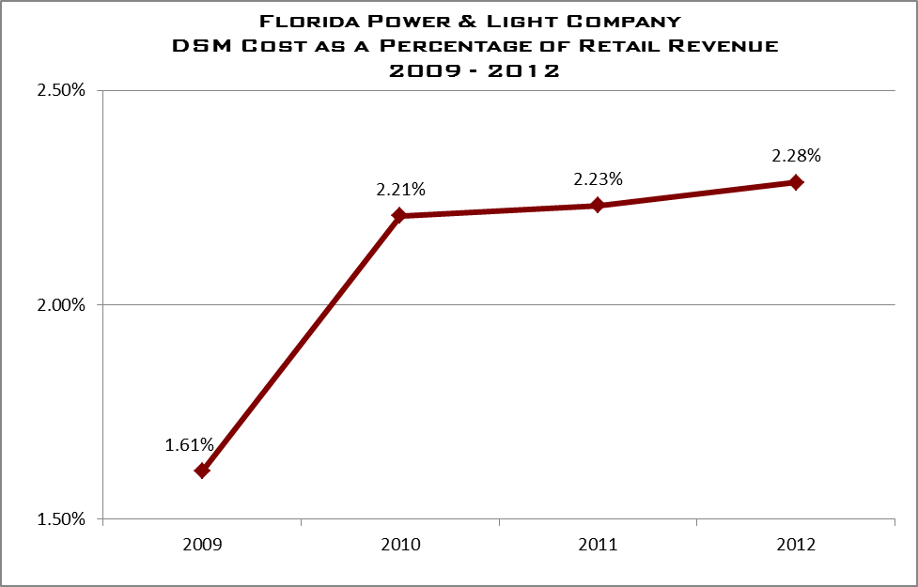
Exhibit 34 Source: FPL Response to Staff Data Request: 3.5

4.4.2 DSM Administrative Costs
Categorizing the costs associated with administering the DSM programs varies for each Florida IOU. Currently, the Commission does not have an established definition or categorization criteria for “Administrative Costs” associated with the operations of the DSM programs. Therefore, each company established a management approach to categorizing its administrative cost for the purpose of this project. FPL defines its administrative costs as:

FPL includes in DSM administrative costs those costs associated with the [DSM] support staff. . . This organization is responsible for DSM planning and support functions such as: program management; measurement and verification; budgeting; and external and internal reporting. FPL does not include in administrative costs functions related to direct customer interaction such as Customer Service Field Operations or Customer Care Center nor activities that enable customer transactions such as computer systems development or telecommunications.

Using this definition, the company believes its administrative costs represent an average of two percent of total DSM cost for the review period. Exhibit 35 highlights the amount of company-identified administrative cost in relation to the overall DSM spending. Staff notes that while the term “administrative cost” is a subjective form of allocation, the company excluded certain areas from this categorization that could be viewed as administrative. Exhibit 36 outlines the company’s breakdown of DSM cost, included the amount it believes are its imbedded administrative costs.

Florida Power & Light Company
DSM Program Expenditures
2009-2012

 | 2009 | 2010 | 2011 | 2012
Residential DSM | $115,457,720 | $145,370,287 | $155,000,697 | $144,237,092
Business DSM | $56,120,656 | $56,232,857 | $57,252,104 | $64,166,462
Non-Program Specific* | $14,473,006 | $14,965,187 | $16,040,840 | $15,680,184
Total ECCR Expenditures | $186,051,381 | $216,568,332 | $228,293,641 | $224,033,738
Company-Identified Administrative Costs*
(embedded in the Non-Program Specific Costs)
 | $3,347,229 | $3,875,815 | $4,621,268 | $5,487,793
*Administrative Costs are separated out for information purposes only. These costs are subsumed in the ‘Non-Program Specific Costs above
Exhibit 35 Source: FPL Response to Staff Data Request 3.1

Exhibit 36 highlights the percentage of DSM administrative costs in relation to the overall DSM expenditures. The company believes that it has maintained a two percent administrative expenditure level for the period.
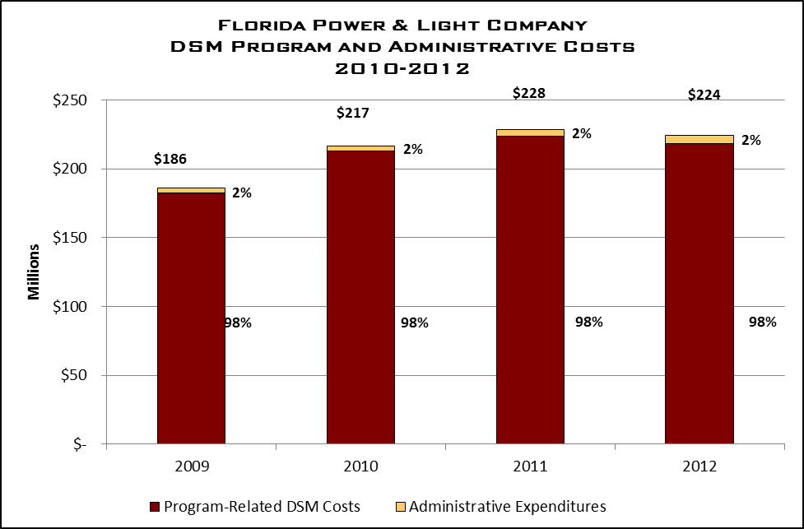

Exhibit 36 Source: FPL Response to Staff Data Requests DR-1.6,3.1
Non-Program Specific DSM Expenditures
While the company is able to allocate the majority of its DSM costs to each DSM program, there are certain costs that the company identifies as universal DSM costs, or Non-Program Specific. For these expenses, the company pools these dollars as a collective cost for the overall program, either residential or commercial. Examples of these costs include IT development, Customer Service, Marketing. Exhibit 37 details the specific overall grouping of costs and the expenditures for the period 2009 through 2012.

Imbedded within these Non-Program specific costs are the company’s Administrative Costs. Specifically, a portion, or all, of the Pension, Welfare & Other Benefits; DSM renewable R&D; DSM Department staff; and Other Supporting staff make up the overall identified Administrative Costs. These other costs are viewed by management as necessary to execute and implement the programs; therefore, not administrative in nature.

Audit staff notes there has been a 6.8 percent increase in overall non-program specific spending during the review period. The company states that during this period, it implemented the development and implementation of a new DSM computer processing system.

Florida Power & Light Company
Non-Program Specific DSM Expenditures
2009 – 2012

Expenditure Type | 2009 | 2010 | 2011 | 2012
IT Infrastructure Support  (e.g. Telecom, Systems) | $ 2,315,935 | $ 2,354,805 | $ 3,100,877 | $ 3,709,157
Computer Systems Development | 823,231 | 700,928 | 2,553,890 | 2,858,171
Customer Care Center (DSM Activities) | 591,599 | 532,111 | 638,679 | 571,278
Customer Service Field Operations Staff | 4,439,500 | 4,758,401 | 4,499,274 | 2,727,427
DSM Department Staff | 2,383,452 | 2,408,857 | 1,854,580 | 3,246,744
Marketing Support | 1,500,719 | 1,630,598 | 1,649,034 | 1,767,180
Other Supporting Departments | 413,505 | 400,604 | 416,188 | 494,218
DSM & Renewable  Research & Development | 507,725 | 557,881 | 275,933 | 879,617
Cogeneration & Small Power Producers | 454,202 | 524,660 | 604,768 | 618,983
Pension, Welfare & Other Benefits | 2,280,725 | 2,541,698 | 2,009,654 | 0
Less: Pension & Welfare included in Base Rates | ($ 1,367,755) | ($ 1,445,356) | ($ 1,562,037) | ($ 1,551,527)
Total | $ 14,342,838 | $ 14,965,187 | $ 16,040,840 | $ 15,321,248
EXHIBIT 37 Source: FPL Response to Staff Data Requests DR-1.6,2.8 and Supplemental

4.4.3 DSM Advertising Costs
The company states that its overall marketing approach for a DSM program is to use its residential and business surveys to provide educational opportunities and promote its programs. These surveys identify potential opportunities within the customer’s lifestyle for improved efficiencies and program participation.

The company does use third-party vendors for specialized marketing projects. These vendors are used primarily to assist with the internal marketing resources. The company uses its corporate procurement process for identifying and selecting its marketing vendors, specifically its process executed by the company’s Integrated Supply Chain. DSM management believe using this process ensures that best value providers are selected. The company monitors the selection process using qualified Supply Chain procurement personnel and management to perform review based upon the value of the services being solicited by the DSM team.

For DSM advertising, the DSM group follows the company’s corporate advertising strategy. This includes its corporate media and advertising contracts for its advertising development and implementation. In addition to these contracts, the company utilizes its in-house advertising resources. Exhibit 38 lists the company’s advertising spending for the review period.

Florida Power & Light Company
DSM Advertising Expenditures
2009-2012

2009 | 2010 | 2011 | 2012
$8,398,310 | $10,737,913 | $11,110,211 | $10,758,732
Exhibit 38 Source: FPL Response to Staff Data Request 1.8

The company’s approach to DSM advertising includes print, electronic, video, and audio media. The company states it develops its program advertising strategies to reach the target audience. To limit costs, the company states a main strategy is to pair DSM-related advertising with other company bulletins. Commission audit staff reviewed the advertisements used by the company to verify the information was appropriate and useful in describing the services. Staff did not identify any issues with this process.

  - Observations

As discussed in the Executive Summary of this review, audit staff identified challenges that impact the administrative efficiency of each company’s DSM programs. Overall, audit staff notes that FPL has a detailed program in place to execute the statutory requirements to reduce demand and improve energy efficiency to its customers. However, audit staff notes the following observations that are universal to all the companies included in this review:

In administering DSM programs, the four largest Florida IOUs place primary importance upon attaining the FPSC-established energy and demand reduction goals.

A limited amount of information sharing, collaborative efforts, and benchmarking regarding the administration of DSM programs currently occurs among Florida IOUs and with IOUs in other states.

Different definitions of “administrative costs” are employed by each company, causing difficulties in the analysis of administrative efficiency.

Additional internal audit coverage of DSM administrative costs and internal controls should be considered by Florida IOUs.

The four IOUs continue to make substantial efforts to improve administrative efficiency of their DSM programs.

Recognizing that there are always areas for continued improvement, audit staff notes that the company has focused on the administrative efficiencies during the review period. FPL has developed and implemented a new DSM system that will allow faster, more efficient processing of its DSM-related payments. Additionally, this system enables the company to more accurately monitor the accuracy of those submitting program-related incentives.

Currently, FPL categorizes its DSM administrative costs as those specifically related to its DSM support staff. Audit staff notes the value in accurately tracking costs to effectively monitor and evaluate overall spending trends within the company. While FPL does define and track its administrative costs, audit staff believes the company’s current definition for administrative costs requires further consideration.

The company’s Internal Audit group has maintained a focus on the company’s DSM-related programs during the period. The work of FPL’s Internal Audit group has allowed for improvements to its DSM program management and controls. As pointed out above, Commission audit staff believes this is an important area of continued focus by the company in future years.

Finally, the company utilized a third-party consultant to assist with the development of its 2010 DSM program initiatives. The use of outside resources allows the company the ability to broaden its understanding of the potential offerings and potentially benefit from shared knowledge. Using consultants and non-company resources to increase and maximize the company’s options may ultimately improve the overall program.

5.0 Gulf Power Company

5.0 Gulf Power Company

Gulf’s current demand-side management (DSM) plan resulted from the Florida Public Service Commission Goal Setting proceedings during 2009-2011. The 2010 Plan and results were set aside due to delays in Plan approval.

In response to Order PSC-10-0608-PAA-EG, Gulf submitted a revised DSM plan in November 2010 that expanded Gulf’s DSM program offerings. The Commission gave final approval to Gulf’s revised DSM plan in February 2011. The company’s Program Standards were approved by Commission staff in April 2011. Gulf launched its expanded program portfolio in June 2011.

5.1 DSM Programs

5.1.1 Residential DSM Programs
Gulf currently offers 13 residential DSM programs. Exhibit 39 shows the number of annual participants for Gulf’s residential DSM programs during 2009-2012.

Gulf Power Company
Residential DSM Programs Annual Participation
2009-2012

Program | Annual Program Participants
Program | 2009 | 2010 | 2011 | 2012
Residential Energy Audits | 7,710 | 11,145 | 14,968 | 8,863
Home Energy Reporting | - | - | 39,797 | 39,213
Community Energy Saver | - | - | 1,881 | 3,327
Landlord/Renter Custom Incentive | - | - | 1 | 0
HVAC Efficiency | - | - | 5,148 | 13,909
Heat Pump Water Heater | - | - | 304 | 873
Ceiling Insulation | - | - | 394 | 780
High Performance Windows | - | - | 535 | 836
Reflective Roof | - | - | 30 | 229
Variable Speed Pool Pump | - | - | 1,363 | 3,491
Energy Select/ Energy Select Lite | 234 | -363 | 92 | 1,799
Self-Install Energy Efficiency | - | - | 991* | 4,928*
Refrigerator Recycling | - | - | 815 | 1,064
Residential Geothermal | 72 | 113 | - | -
Residential EarthCents | 351 | 264 | - | -
Total Participants | 8,367 | 11,159 | 66,319 | 79,312
*Numbers reflect appliance program participants only and exclude CFLs usually reported as units within this program
EXHIBIT 39 Source: Gulf Response to Staff Data Request 1.11
Residential programs are implemented through a combination of company employee and third-party contractor activities. Each residential program requires customers to meet specific qualifying criteria and standards to participate. Customer account information and program qualifications are reviewed prior to allowing customer participation. Eight residential programs are internally administered, implemented, and supported by Gulf employees. Five programs are administered through third-party-contractors.

As shown in the exhibit, Gulf’s total residential DSM participants increased by 12,993 (20 percent) in 2012. Gulf DSM management attributes that increase to the additional program offerings begun in 2011. In 2012, the largest number of residential program participants were in the Home Energy Reporting and HVAC Efficiency programs. These two programs contained approximately 67 percent of Gulf’s residential DSM program participants during 2012.

Gulf DSM management explained that due to Gulf’s DSM Plan and associated program standards not being approved until mid 2011, the level of program participants was significantly lower than in 2012. Gulf contends that the delay in 2011 limited Gulf's ability to fully implement its DSM plan. For instance, Gulf’s Self-Install Energy Efficiency program participants were only 991 in the partial year during 2011, compared to 4,928 participants in the full year of 2012. Although these numbers reflect only the appliance program participants, and not CFL units as would be normal for the measure, a marked participant increase was seen in this and many other Gulf residential DSM programs from 2011 to 2012.

Gulf’s Residential Energy Audits program was the only residential program showing a substantial participation reduction in 2012. Gulf DSM management explained that during 2012, Gulf’s customers performed significantly fewer on-line audits than in 2011. While the reason for fewer on-line audits is unknown, Gulf management observed that weather could have been a significant contributor to increased on-line audit activity during 2011.

In addition, Gulf saw substantial change in its participant level for Energy Select/Energy Select Lite program during the period 2009-2012. According to Gulf management, the decrease of 363 participants in 2010 reflects a reduction of customers dropping landline phones (which was necessary for the program) and replacing HVAC equipment with systems utilizing multi-speed compressors (which were not compatible with the program). In 2012, Gulf implemented technology that both eliminated the need for landline phones and allowed for multi-speed compressors. The technology changes implemented allowed Energy Select to be installed in multi-family residences and contributed to increased participant levels in 2012.

5.1.2 Commercial/Industrial DSM Programs
Gulf’s commercial and industrial program offerings are more complex in nature, and generally require the installation of large specialized equipment such as heating and air conditioning units, heat pump water heater systems, heavy duty commercial/industrial high-efficiency motors, and commercial food service equipment. Commercial/Industrial programs are administered by Gulf employees, and supplemented with third-party vendors used for installation and support.

Exhibit 40 shows the annual number of participants for Gulf’s Commercial/Industrial DSM programs during 2009-2012. Gulf DSM management explains that in 2011 and 2012 the level of program participants increased substantially, as a result of the increased number of commercial/industrial DSM offerings. The largest program participation during the period was in the Commercial Building Efficiency program. This program represented 72.7 percent of Gulf’s total commercial/industrial DSM program participants during 2012.
Gulf Power Company
Commercial/Industrial DSM Programs Annual Participation
2009-2012

Program | Annual Program Participants
Program | 2009 | 2010 | 2011 | 2012
Commercial/Industrial Audit | 588 | 472 | 577 | 420
Commercial HVAC Retrocommissioning | - | - | 323 | 307
Commercial Building Efficiency | 14 | 3 | 543 | 2985
Occupancy Sensor HVAC Control | - | - | 181 | 330
High Efficiency Motor | - | - | 5 | 16
Food Service Efficiency | - | - | 0 | 44
Commercial/Industrial Custom Incentive | - | - | 6 | 5
Conservation Demonstration and Development | - | - | 0 | 0
GoodCents Commercial Buildings | 90 | 58 | - | -
Real Time Pricing | 0 | 2 | 0 | 0
Energy Services | 3 | 4 | 7 | -
Total Participants | 695 | 539 | 1,642 | 4,107
EXHIBIT 40 Source: Gulf Response to Staff Data Request 1.11

Gulf’s Commercial/Industrial Audit program is analogous to the Residential Energy Audits program and is the focal point for Gulf’s commercial/industrial sector programs. The audit serves as a benchmark review of potential commercial and industrial applications and incentives applicable to the specific customer. Audit results help identify which specific DSM programs and incentives would be best for the customer, and provide the greatest energy-efficiency savings. Gulf states that its commercial/industrial programs have been designed around energy-efficient recommendations from commercial/industrial audits, to increase customer acceptance and satisfaction. As examples, Gulf has program incentives for HVAC system improvements, building envelope and control improvements, and water heating. For the Food Service sector, Gulf also offers numerous incentives associated with ENERGY STAR food service equipment.

The GoodCents Commercial Buildings and Energy Services programs shown in 2009-2010 were included within the 2011 and 2012 offerings under another program name. Additionally, Gulf’s Conservation Demonstration and Development program includes an electric vehicle charging pilot program and three other miscellaneous pilot projects evaluating new technologies for potential use in future residential and commercial/industrial DSM programs.

5.1.3 Renewable DSM Programs
During the 2008 Florida Legislative session, FEECA was amended to encourage the development of demand-side renewable energy systems. Pursuant to Order No. PSC-09-0855-FOF-EG, the Commission directed the utilities to spend no more than ten percent of their historic energy conservation cost recovery expenditures, as an annual cap for solar water heating and solar photovoltaic pilot programs. Gulf did not begin implementing solar programs until its DSM plan and standards became approved in April 2011.
Gulf currently offers four programs providing rebates for solar photovoltaic (PV) installations and solar thermal water heating (STWH). Gulf expanded the installation of STWH systems in 2011 and 2012, by offering a program specifically targeted to low-income households. Exhibit 41 shows the number of annual participants in Gulf’s Solar DSM programs during 2009-2012.

Gulf Power Company
Renewable DSM Programs Annual Participation
2009-2012

Program | Annual Program Participants
Program | 2009 | 2010 | 2011 | 2012
Solar for Schools | - | - | 0 | 1
Solar Thermal Water Heating | - | - | 35 | 22
Residential/Commercial Solar PV | - | - | 42 | 46
Solar Thermal Water Heating for Low-Income | - | - | 0 | 29
Total Participants | - | - | 77 | 98
EXHIBIT 41 Source: Gulf Response to Staff Data Request 1.11

As shown in the exhibit, the greatest number of annual participants during 2011 and 2012 has been in Solar Thermal Water Heating and Solar Photovoltaic programs. Until 2012, Gulf had no low-income Solar Thermal Water Heating or Solar for Schools program participants.

Solar Thermal Water Heating programs are intended to help reduce system peak demand and increase renewable energy generation by providing a thermal solar water heater at the residential customer’s premise. Solar Photovoltaic programs are designed to reduce the initial residential and commercial customer investment required to install a qualified photovoltaic system. The photovoltaic program for schools is provided at no cost to the school. It provides capital funding to supplement deployment of PV systems up to 10kW in qualifying public education facilities.

5.2 Organization

Responsibility for managing Gulf’s DSM portfolio rests with the Vice President Customer Operations. The Vice President is responsible for Gulf’s Customer Service, Marketing, and Power Delivery departments. The link between the Vice President Customer Operations and DSM is the Customer Service and Marketing organization. Gulf’s DSM program has historically been administered within the Marketing organization.

As Exhibit 42 shows, the General Manager Marketing, reports to the Vice President Customer Operations, and has direct responsibility for Gulf’s marketing programs. The Supervisor Analytics reports to the General Manager Marketing and supervises two Marketing Analysts and an Accountant. Primary responsibilities of the Analytics group include: cost effectiveness testing for energy efficiency programs, energy efficiency tracking and reporting,

Manager Energy Sales & Efficiency
Marketing Specialist
General Manager Marketing
Marketing Analyst
VP Customer Operations
Supervisor Energy Select
Gulf Power Company
DSM Program Administration Organization
2012
Program Manager
Marketing Analyst
Supervisor Analytics
S
Program Manager
Supervisor EE Programs
Accountant
Energy Select Technicians (2)
Marketing Specialist (3)
Program Manager
Program Manager
Program Manager
Program Manager
Program Manager
Energy Tech
Program Manager
Program Manager
Temp
EXHIBIT 42 Source: Gulf Response to Staff Data Request 1.3
and research of customer data related to the DSM Plan. This group produces Gulf’s Energy Conservation Cost Recovery (ECCR) filing, and serves as witness in ECCR and DSM related dockets. The group also provides monthly DSM results analysis reports and ad hoc reports requested by executive management.

The Manager Energy Sales & Efficiency has responsibility for overall deployment of the DSM program, administration of program processes, oversight of third-party vendors, and coordination of Gulf employees supporting the DSM program. DSM Program Managers, report to the Manager Energy Sales & Efficiency and have responsibility for implementing, monitoring, tracking, and achieving program results. Program Managers generally have responsibility for more than one program, and ensure both Gulf field personnel and third-party vendors verify and comply with program standards.

Gulf’s DSM Call Center operation includes five Service Representatives, an Analyst, and a Supervisor. The five representatives are Customer Service employees supporting the DSM program full-time. They are dedicated to DSM customer calls made directly to the center, or transferred from Customer Services Call Center employees. These representatives are connected to the DSM data information system and can provide assistance to customers regarding DSM program qualifications, rebates, pending orders, payments, billing, and other program information. Gulf has segregated representative responsibilities for handling DSM calls based on programs. The supervisor of the DSM Call Center allocates time between both Customer Service and DSM programs.

The DSM organization has no dotted-line reporting to other departmental organizations, but is regularly involved with other functional areas providing support to the DSM Program. For example, decisions regarding Gulf’s residential Demand Response program Energy Select, are made with Gulf’s Systems Operation department and the Supervisor of Energy Select, reporting under the Manager Energy Sales & Efficiency.

With the increase in DSM program offerings, Gulf also increased the number of individuals involved in DSM plan implementation and administration. The increased DSM program activities substantially changed the number of people touching DSM activities.

Exhibit 43 charts the annual full time equivalent (FTE) personnel charged to Gulf’s DSM programs during the period 2009-2012. An FTE represents the equivalent of one person working full time. Part-time activities charged to DSM are bundled into FTE’s for evaluation purposes.

As shown in the exhibit, Gulf charged a low of 38.5 FTEs to its DSM programs in 2010, and a high of 54.6 FTEs in 2012. In 2011, as implementation and administration of new DSM programs began, Gulf experienced an increase of 5 FTEs (13 percent) over 2010. The increased FTEs in 2011 represented only six months under the new DSM program offerings. The increase in 2012 FTEs represents the first full year of operation under the new Gulf DSM program offerings, and is approximately 42 percent greater than 2010.

Gulf Power Company
DSM Full-Time Equivalents (FTEs)
2009-2012

Program | Annual FTEs Charged to Programs
Program | 2009 | 2010 | 2011 | 2012
Field | 17.5 | 16.0 | 18.4 | 24.1
Staff | 22.9 | 22.5 | 25.1 | 30.5
Contractor | N/A | N/A | N/A | N/A
Other | 0 | 0 | 0 | 0
Total | 40.4 | 38.5 | 43.5 | 54.6
Ratio of FTEs to total DSM Participants | 1 to 225 | 1 to 304 | 1 to 1,564 | 1 to 1,530
EXHIBIT 43 Source: Gulf Response to Staff Data Request 4.1

Gulf’s DSM management team explained that the total number of positions originally approved by Gulf’s management to implement the increased program offerings has not yet been reached. DSM management attributes this to Gulf’s continual review of DSM programs, cost-effective use of third-party vendors, and matching shared use of field personnel with program needs.

5.3 DSM Program Administration

5.3.1 Program Development
During the review period, Gulf Power Company has increased the number of DSM programs offered to its customers. This is a direct result of the Commission’s 2010 conservation goal docket. With the increase in conservation goals, the company expanded its DSM program offerings. To respond to the new goals, the company developed a plan that combined 55 energy and demand measures.

Gulf management states that it developed its current program portfolio using its historic DSM approach and identifying additional programs that it believed would be successful for its geographic and customer base. Specifically, the company states it leveraged potential programs that would be marketable during its customer home audits. Home audits are the primary avenue for the company to interface and propose its DSM programs to its customers.

Audit staff notes that the most recent goal-setting docket required Gulf Power to increase its DSM offerings. As the company continues to manage and develop its DSM programs, audit staff would expect the company to continue to refine its program development approach.

Benchmarking
In developing its expanded DSM Plan, Gulf stated that it collaborated with utilities both within Florida and beyond to identify best practices related to program design, standards, marketing and general approaches to managing a larger portfolio of offerings. One example of this collaboration referenced by the company included consultation with Kansas City Power & Light to gain best practices from their Cool Homes program. While the company has not engaged in formal discussions with other Florida IOUs, management states that each company monitors other utilities and works with each utility during the goal-setting process.

    - Program Implementation
Gulf Power has a formal standard for each of its DSM programs and measures. These standards outline and formulate the process for implementing each program, both commercial and residential. The company uses a combination of in-house personnel and third-party vendors to implement and verify its DSM program and services.

Each standard outlines the process flow for each program offered by the company. The process flow for each process is similar in nature, depending on the type of incentive provided by the program. There are two potential options for the company to pay a DSM incentive—directly to the customer or to their third-party vendor. Gulf Power has five third-party vendors that service certain DSM programs or process. They are:

- Proctor Engineering – Manages the programs involving HVAC initiatives

- Honeywell – Manages the Low Income weatherization programs

- JACO – Manages the refrigeration collection programs

- ACB – Manages the appliance measures in the Self-Install program and issues a majority of the incentive checks to customers for incentive-based programs

- Comverge-Provides installation and maintenance services for the EnergySelect program

Each third-party vendor is under contract with Gulf to manage or fulfill service requirements in the DSM arena. These contracts were implemented using the company standard contract procurement process. The program manager is responsible for ensuring that the third-party vendors are operating in accordance with the DSM standards.

Gulf DSM management explained that selection of third party vendors was driven by its need to quickly implement programs in order to meet Commission approved annual goals. Use of third party vendors also provides Gulf flexibility as the company gains experience in many of the new program offerings included in the revised DSM Plan.

Third-party vendor performance and expenses are monitored monthly by the respective Gulf program managers. Invoices are reviewed by the program manager to ensure billed charges are consistent with contractual provisions and program participant requirements. In addition, follow-up field verifications are performed by company employees on certain programs as an additional quality control measure.

Energy Efficiency Reporting Tool
Prior to 2010, Gulf offered eight DSM programs, with ten measurements. At that time, Gulf tracked DSM program results through a tracking system that worked through Lotus Approach software. In 2010, Gulf expanded its DSM program offerings to twenty five programs and 55 individual measures, requiring a new DSM system for tracking. Gulf acquired the Energy Efficiency Reporting Tool (EERT) to be the new hub for all DSM program work and activities.
The EERT system has embedded management reporting tools, allowing Gulf’s management team to access DSM monthly program results, and review detailed raw data related to ordering, installation, and invoicing of DSM work activities. Customer program enrollments are entered into the EERT system by the customer (on-line), by Gulf employees (Call Center), or batch-uploaded through one of Gulf’s third-party program administrators. With the exception of CFLs, all enrollments are tracked at a customer level in EERT and stored.

The EERT system is a web-based system, which also allows Gulf customers to qualify and apply to DSM incentive programs online, and includes integrated validation, to reduce the potential for incomplete or ineligible applications. Once applications have been approved and work activities are assigned, EERT selects random orders for inspection and verification. The configuration for inspections can be set at any percentage from 0-100. This flexibility allows the DSM management team to modify the level of inspections, based on specific programs, market segments, incentive programs, contractors, or other criteria management wants to evaluate more closely. However, Gulf’s goal is to inspect and validate at minimum 10 percent of all DSM program installations.

Once a customer enrollment is entered into EERT and completed for payment, Gulf’s Program Managers must approve each enrollment and inspection record prior to creating an invoice for payment. An invoice is then created in EERT and a Batch Payment Report is generated for the payment processor.

5.3.3 Program Monitoring and Verification
Gulf Power has a process in place for monitoring and evaluating the overall progress of its DSM program. The DSM program managers are charged with monitoring and assessing that each program is performing as designed. Along with daily oversight, the DSM management has prescribed monthly and quarterly reports that demonstrate the overall results of each program. The management team uses these reports to assess the continued effectiveness and success of the entire DSM portfolio.

Commission Rules require electric utilities under FEECA to verify a minimum of ten percent of all DSM related program installations to ensure the accuracy of service provided to the customer. Gulf’s Program Standards also include the requirement for a minimum of ten percent of all DSM program installations to be verified. This requirement applies to work performed by the utility, a contractor, or self-installed equipment performed by the homeowner as part of a DSM program.

The company goal is to inspect, or have its contractors inspect, a minimum of ten percent of its verifiable DSM programs. For its HVAC program, Gulf employs a third-party contractor to inspect and verify the work performed. For other programs, the company’s field representatives are charged with verifying that the appropriate work was performed to receive the DSM credit. Additionally, the company is implementing a process to sample the inspection results performed by its third-party contractors.

Gulf provided audit staff with its verification records for the period. During 2012, the company made changes to how it tracks and records its inspection and verification process. This change was made in response to a Gulf Internal Audit recommendation, and ensures that all verifications performed by internal and third-party verifiers, are recorded by the DSM group. Audit staff’s review of verification records confirmed that the company tracks its program verifications and has maintained a rate above the ten percent minimum for 2012.
5.3.4 Program Evaluation and Modification
Gulf Power made substantial changes to its DSM programs and processes during the review period. In large part, this was necessitated by the increased Goal objectives implemented by the Commission in the 2010 conservation process. With the increased requirement in DSM programs, much of the company’s efforts focused on the development of cost-effective programs for the current conservation cycle. Company management notes that while many of the programs are new, there are continual efforts to monitor and evaluate the most successful delivery approach.

Company management states that while the majority of its programs have been in place for less than two years, it continues to monitor and evaluate the cost-effectiveness of each program by analyzing the monthly progress of each program. Specifically, management notes that its actual DSM expenditures for 2012 were 49 percent lower than originally projected. Staff notes that as the company continues to operate under its larger DSM process, the Commission should expect Gulf to continue to refine its DSM expenditure expectations.

5.3.5 Internal Audits
Gulf Power’s Internal Auditing division performed one audit of the company’s DSM process during the review period. This audit, conducted in March 2012, specifically evaluated the company’s DSM process and controls. The Internal Audit team identified two findings concerning the verification process. The company implemented changes to its process to address these findings.

In, October 2012, the Internal Audit team issued a follow-up update to the audit and concluded that the company has fully addressed one issue, and continued to have one open issue. DSM management explained to Commission audit staff that it was working to resolve this issue. The time delay revolved around implementing a modification to its computer system. The company states that as of December 2012, the new process is in place.

5.4 DSM Related Costs

5.4.1. DSM Total Costs
Exhibit 44 details the company’s DSM spending by program for the period. As the chart demonstrates, the company increased its per-program spending after the 2010 conservation docket. During the period, the company modified and consolidated several programs, in addition to adding additional DSM options for its clients. Audit staff notes that the increase in overall spending is appropriate given the company’s additional DSM requirements.

Gulf Power Company
DSM Costs by Program
2009-2012

Program | 2009 | 2010 | 2011 | 2012
Residential*
Residential Energy Surveys | $1,310,732 | $1,358,902 | $497,133 | ----
Residential Energy Audit and Education |  | ---- | 1,949,892 | 2,696,726
Residential Geothermal Heat Pump | 182,196 | 241,504 | 73,883 | ----
EnergySelect | 7,094,863 | 7,219,607 | 6,945,269 | 5,850,905
EnergySelect Lite | ---- | ---- | 85,575 | ---
Community Energy Saver | ---- | ---- | 340,105 | 936,373
Custom Incentive | ---- | ---- | 51,971 | 120,992
HVAC Efficiency | ---- | ---- | 1,444,295 | 5,269,864
Residential Heat Pump Water Heater | ---- | ---- | 246,836 | 788,344
Residential Ceiling Insulation | ---- | ---- | 162,001 | 325,666
Residential High Performance Windows | ---- | ---- | 95,091 | 259,711
Reflective Roof | ---- | ---- | 49,073 | 201,856
Variable Speed Pool Pump | ---- | ---- | 915,584 | 2,227,546
Self-Install Energy Efficiency | ---- | ---- | 88,505 | 469,562
Refrigerator Recycling | ---- | ---- | 162,521 | 260,560
Total Residential | $8,587,791 | $8,820,014 | $13,107,734 | $19,408,105
Commercial
C/I Energy Analysis | 604,901 | 640,918
C/I Energy Audit | ---- | ---- | 555,723 | 673,887
HVAC Retrocommissioning | ---- | ---- | 75,698 | 93,727
HVAC Occupancy Sensor | ---- | ---- | 22,110 | 54,896
High Efficiency Motors | ---- | ---- | 28,455 | 51,152
Food Services | ---- | ---- | 31,554 | 75,428
Commercial Building Efficiency | ---- | ---- | 530,498 | 1,508,579
C/I Custom Incentive | ---- | ---- | 39,637 | 168,428
GoodCents Commercial Buildings | 553,023 | 503,049 | 150,177 | ----
Commercial Geothermal Heat Pump | 81,325 | 99,541 | 14,962 | ----
Energy Services | 24,449 | 70,279 | 8,986
Total Commercial | $1,263,698 | $1,313,787 | $1,457,800 | $2,626,097
Renewables & Research
Renewable Energy | 264,411 | 203,444 | 773,533 | 747,951
Conservation Demonstration and Development | 67,571 | 138,604 | 139,472 | 140,268
Solar Thermal Water Heating Pilot | 141,921 | 4,000 | ----
Electric Vehicle Pilot |  |  |  | 3,083
Energy Education Pilot | 977,491 | 148,111 | ---- | -----
Total Renewables & Research | $1,451,394 | $494,159 | $913,005 | $891,302
Total Program Costs | $11,302,883 | $10,627,960 | $15,478,539 | $22,925,504
*A number of program’s were created, ended, merged, or changed names during the period
Exhibit 44 Source: Gulf’s ECCR Schedule CT-3 (2009-2012), Supplemental Request
Exhibit 45 details the company’s DSM spending by categories for the review period. The chart shows that, as the company has increased its DSM program offerings, the spending by category has increased. With the Commission approved increase in DSM programs, in 2011, the amount spent on incentives has increased during the last two years. In 2012, DSM incentive costs rose to 37 percent, from 15 percent in 2011.

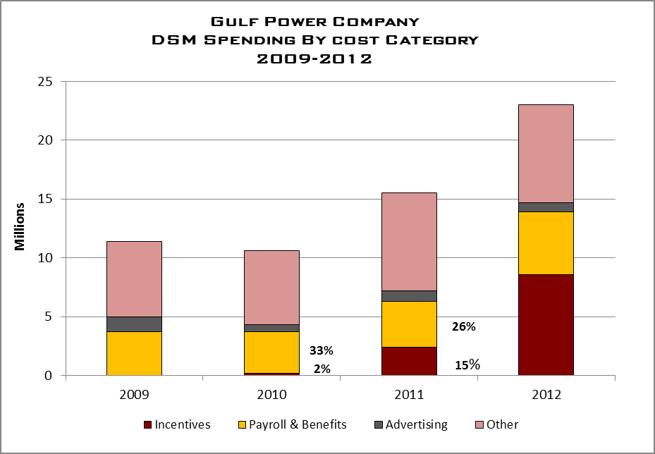

6%
59%
5%
54%
32%
12%
37%
23%
4%
36%
56%
Exhibit 45 Source: Gulf Annual CT Filings

Gulf’s HVAC Efficiency and Variable Speed Pool Pump residential programs, and Commercial/Industrial Building Efficiency program had the largest total incentive use during 2011 and 2012. Audit staff notes the increase is appropriate given the growth in incentive-based programs and the overall increase in DSM programs.

Payroll and Benefits costs were reduced during 2011-2012, decreasing from a high of 59 percent in 2010, to a low of 36 percent in 2012. Other costs too have reduced from 2009 and 2010 levels during 2011-2012. Although, Other costs were the same for both 2011 and 2012, the percentage of total costs decreased in 2012. The increase in 2012 incentives changed total costs for 2012, which effectively reduced Other costs to 36 percent of total DSM spending costs.

Exhibit 46 details the annual percentage of DSM spending compared to the company’s retail revenue. Overall, the company increased its DSM spending as a percent of retail revenue during the review period. The company increased spending from .87 percent in 2009 to 2.02 percent in 2012. This can be attributed to the increase in DSM programs offered by the company, starting in 2011.

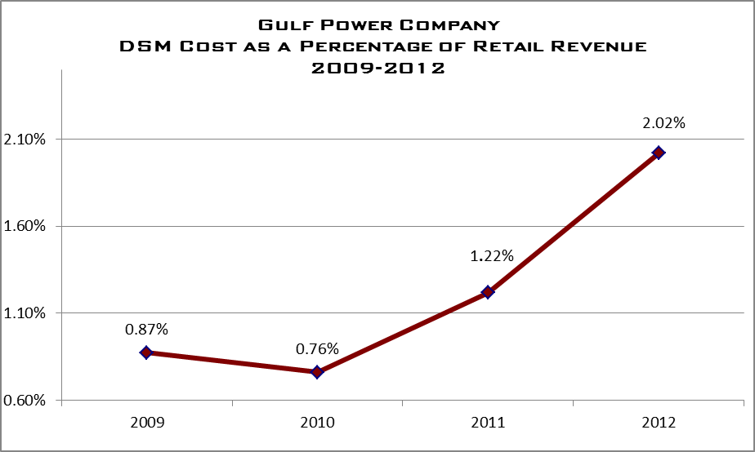
EXHIBIT 46 Source: Gulf Response to Staff Data Request 3.5

5.4.2 DSM Administrative Costs
Categorizing the costs associated with administering the DSM programs varies for each Florida IOU. As noted in the Executive Summary, the Commission does not have an established definition or categorization criteria for “Administrative Costs” associated with the operations of the DSM programs. Therefore, each company established a management approach to categorizing its administrative cost for the purpose of this project. Exhibit 47 details the company’s overall DSM spending and the imbedded administrative costs.

Gulf Power Company
DSM Program Expenditures
2009-2012

 | 2009 | 2010 | 2011 | 2012
Residential DSM | $9,278,713 | $8,476,319 | $13,476,059 | $20,189,596.
Business DSM | $1,297,484 | $1,383,089 | $1,527,537 | $2,696,230
Total ECCR Expenditures | $10,576,197 | $9,859,407 | $15,003,596 | $22,885,826
Company-identified Administrative Costs
(embedded within the Residential and Business Costs)
Administrative | $3,023,007 | $3,079,805 | $3,882,198 | $4,446,576
Exhibit 47 Source: Gulf Response to Staff Data Request 3.1

As discussed in the Executive Summary of this report, there is not a universally-accepted definition for administrative costs. Gulf Power defines administrative costs to include:

- Labor, the largest contributor, includes all labor charged to the DSM programs with the exception of outside contractors and the employees who work in the district offices, i.e., field/implementation labor. The organizational chart [identifies] who Gulf considered administrative in responding to the audit staff’s document request.

- The DSM portion of payroll and benefits of every position listed (with the exception of VP Customer Operations, and the General Manager-Marketing) are included in our definition of admin costs. Also included in [Gulf's] administrative costs definition are the call center representatives that are dedicated to Gulf’s DSM programs.

- In the other category [Gulf Power] included phone expenses, office expenses, printing & postage, etc.

Using the company’s interpretation of administrative cost, its administrative costs represent an average of 26 percent for the review period. Exhibit 48 highlights the percentage of DSM administrative costs in relation to the overall DSM expenditures.

Audit staff notes that while the company’s DSM program initiatives significantly increased in 2011 (after the 2010 DSM ECCR Order), the company has decreased its overall percent of administrative costs. No comparative with other Florida IOUs can be made without an established uniform criterion for categorizing these costs.

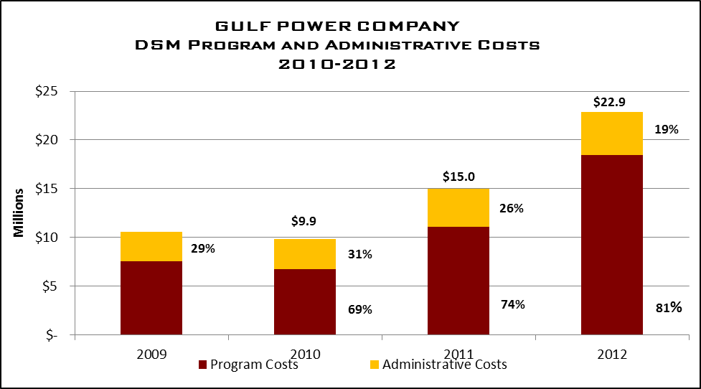
71%

$10.6
Exhibit 48 Source: Gulf Response to Staff Data Request 1.6a

Exhibit 49 provides a breakdown of costs included in Gulf Power’s calculation of its administrative costs for the period. As the company’s explanation details, the company majority of the administrative costs include labor and personnel expenses.

Gulf Power Company
DSM Administrative Expenditures By Category
2009-2012

Category | 2009 | 2010 | 2011 | 2012
Labor Cost | $1,716,588 | $1,810,380 | $2,614,438 | $3,686,061
IT Cost | $464,656 | $484,988 | $601,222 | $583,237
Other Cost | $841,762 | $784,437 | $666,537 | $180,278
Total Administrative Cost | $3,023,006 | $3,079,805 | $3,882,197 | $4,449,576
Exhibit 49 Source: Gulf Response to Staff Data Request 1.6b

5.4.3 DSM Advertising Costs
Exhibit 50 lists the company’s advertising and marketing spending for the review period. As the chart indicates, for the period the company has averaged less than one percent of its total advertising expenditures for Commercial DSM programs. One reason for this differential in spending is how the company markets its commercial DSM products. In many cases, the company relies on its commercial account managers to inform commercial clients about its products versus mass-advertising initiatives.

Staff also notes that the company increased its advertising budget in the 2011 period. The company notes this was in response to the roll-out of additional DSM programs approved in the 2010 Commission Goal-Setting Order. The company increased its advertising initiative to inform its customers of the additional offerings. In 2012, the company reduced its budget to represent its more leveled approach.

Gulf Power Company
DSM Advertising Expenditures
2009-2012

Customer Group | 2009 | 2010 | 2011 | 2012
Residential | $820,084 | $582,911 | $864,930 | $844,872
Commercial | $4,120 | $2,799 | $4,750 | $4,863
Total | $824,204 | $585,710 | $869,680 | $849,735
Exhibit 50 Source: Gulf Response to Staff Data Request 1.8

5.5 Observations

As discussed in the Executive Summary of this review, audit staff identified challenges that impact the administrative efficiency of each company’s DSM programs. Overall, audit staff notes that Gulf Power has a detailed program in place to execute the statutory requirements to reduce demand and improve energy efficiency to its customers. However, audit staff notes the following observations that are universal to all the companies included in this review:

In administering DSM programs, the four largest Florida IOUs place primary importance upon attaining the FPSC-established energy and demand reduction goals.
A limited amount of information sharing, collaborative efforts, and benchmarking regarding the administration of DSM programs currently occurs among Florida IOUs and with IOUs in other states.

Different definitions of “administrative costs” are employed by each company, causing difficulties in the analysis of administrative efficiency.

Additional internal audit coverage of DSM administrative costs and internal controls should be considered by Florida IOUs.

The four IOUs continue to make substantial efforts to improve administrative efficiency of their DSM programs.

Recognizing that there are always areas for continued improvement, audit staff notes that the company has maintained focus on the administrative efficiencies during the review period and improvements are evident. Gulf has developed and implemented a new software system to manage its DSM programs and administrative function. This system enables the company to electronically track and monitor the progress of individual measures and the overall success of each DSM program. Audit staff notes this system has allowed the company to improve its overall DSM administrative functions.

The company’s Internal Audit division conducted an audit during the period that identifies specific issues related to the internal DSM monitoring process. As noted above, continuing internal audits can be used to maintain focus on DSM administrative costs, and provide an important evaluation of overall DSM program efficiency,

As of April 29, 2013, Progress Energy Florida officially changed its name to Duke Energy Florida, Inc.
FTE calculated using productive time, estimated to be 85% of total employee time each year of 1,768 hours. Contractors calculated using total hours worked divided by 1,768 hours.
FPSC, Annual Report on Activities Pursuant to the Florida Energy Efficiency Conservation Act (FEECA), February 2012, pg. 3.
FTE calculated using productive time, estimated to be 85% of total employee time each year or 1,768 hours.
Contractors calculated using total hours worked divided by 1,768.
See http://www.aeecenter.org/i4a/pages/index.cfm?pageid=3330. For residential analysts, emphasis is Residential Energy Auditor (REA) and Certified Energy Auditor (CEA). Focus is CEA, Business Energy Professional (BEP), Certified Energy Procurement professional (CEP) and Certified Energy Manager (CEM) for commercial analysts. TECO states that the more training analysts receive, the better the DSM recommendations provided to the customer. Certification adds depth and credibility, raising customer confidence to adopt energy and demand savings projects.
TECO Energy Audit Services, “Energy Planner Audit Report”, dated July 13, 2010, and TECO response to Commission Staff DR-1.16, Bates 1540-1546.
TECO Energy Audit Services , “Tampa Electric Company Commercial Duct Repair Consulting Engagement Management Memorandum”, dated March 4, 2011, and TECO response to Commission Staff DR-1.16, Bates 1548.

