Recommendations to the Florida Public Service Commission for Electric Grid Infrastructure Hardening and Preparedness using University Capabilities

Prepared January 30, 2006 by:
Prof. Alex Domijan, Power Center for Utility Explorations, Dept. of Electrical Engineering, University of South Florida, Tampa, FL 33620; (813) 974-5416, alexd@eng.usf.edu
Prof. Kurtis Gurley, Florida Coastal Monitoring Program, Dept. of Civil and Coastal Engineering, University of Florida, Gainesville, FL 32611; (352) 392-9537 (x1508), kgurl@ce.ufl.edu

Prepared as a Response to the January 23, 2006 Florida PSC Staff Workshop on Electric Utility Grid Infrastructure

Objectives:
- Use the capabilities of the Power Center for Utility Explorations at the University of South Florida and the Florida Coastal Monitoring Program (FCMP) at the University of Florida, and other state university system partners, to assist the Florida PSC and electric utilities to understand, monitor and solve critical electrical infrastructure needs in Florida.
- Provide an effective collaboration and public outreach mechanism whereby Weather and Reliability (WAR) information may be discussed and evaluated by implementing a Protect Florida Now Electrical Grid Initiative that uses the facilities and expertise of the state universities and experience learned from similar power grids world-wide in conjunction with the Florida PSC and electric utilities.

Rationale:
The effect of weather on the electrical infrastructure, both common and severe, from heat waves to hurricanes is expected to escalate in Florida. The consequent power interruptions are an economic hardship of several billion dollars annually on the state and its citizens as a whole and pose a significant threat to public safety in Florida.

Benefits:
The expertise and facilities of the State University System has not been utilized to any significant extent by the electric utility industry. The benefits include 1. Power system monitoring (weather and electrical status) capabilities, 2. Simulation capabilities, 3. Public outreach and education capabilities, 4. Training capabilities, 5. Experimental Testing Capabilities, vulnerability modeling, and mitigation design capabilities, and; 6. Lessons learned from other power systems worldwide (such as islanded systems in Japan and Taiwan) that are affected by severe weather via the Flexible, Reliable, Intelligent Electrical eNergy Delivery Systems (FRIENDS) program. The value to the citizens of Florida, as well as the value-added to the electric utility industry, especially in the light of the expected adverse weather conditions over the next decade, is substantial.

Capabilities:

Power Center for Utility Explorations

The mission of the PCUE is to explore energy issues comprehensively and to develop solutions to complex electric power problems to address issues in electricity infrastructure. The capabilities include:
- Power Quality and Distributed Energy Infrastructure Laboratory. This lab can monitor electrical and weather conditions on power systems worldwide and was the first facility with the capability to generate arbitrary or field recorded 3-phase voltages and currents (real-world conditions) to apply to devices under test, such as motors, transformers, relays, meters, etc.
- FRIENDS program. Can be used to interact with international partners that have similar experiences as Florida due to weather.
- Weather and Reliability (WAR) program. On-going monitoring of weather in terms of temperature, wind, lightning, rains, pressure, etc, and correlations, modeling and predictions of outages and causes. Grid hardening may be achieved by targeting first the location of “hot spots” in the electrical delivery system.
- Full service power and energy educational program including transmission, distribution and generation courses, short courses, conferences, and courses over video.

Florida Coastal Monitoring Program

- Provide ground-truth information on wind speeds during hurricane landfall via rugged portable weather towers with a successful track record since 1999. Data is sent to a public access website in real-time during landfall.
- Provide among the first on-the-ground damage assessments for land falling storms as personnel remain in the impact region during the event.
- Provide accurate sustained and gust winds loads on power infrastructure as a function of standard hurricane intensity scale (National Hurricane Center Saffir-Simpson Scale rating).
- Currently developing an interactive website where every available real-time ground observations will be viewable, including ASOS stations, offshore buoys, FCMP towers, etc. This will provide unprecedented coverage of the actual ground level (10-meter) winds at dozens of locations within the storm path.
- Expertise on the evaluation and modeling of structural vulnerability to high wind damage, and experience developing cost effective mitigation measures to reduce risk.
- In conjunction with FIU (Miami), provide a state-of-the-art experimental facility capable of generating hurricane force winds on full-scale structures (now under development and operational at UF).
- In conjunction with Clemson University, provide wind tunnel facilities appropriate for scaled testing of power distribution infrastructure, relating wind speeds to expected loads and damage.

Recommendations to the Florida PSC in Specific Areas for Utility/University Collaboration to Safeguard the Electric Infrastructure of Florida against Adverse Weather:

- The need for on-going weather monitoring, both common and severe, and its relationship to the infrastructure of electrical systems in terms of interruptions is “urgently” needed prior to the next hurricane season. It would be prudent to formulate a road-map for grid infrastructure hardening that determines the locations of electrical system “hot spots” that arise from the effects of weather phenomena. It is recommended to monitor common weather, severe weather and interruptions to locate areas of concern and determine correlations with the electrical grid. This should be done for both underground and overhead systems. Grid hot spots may first be determined in the short term by evaluating the effect of common weather (and for severe weather, such as hurricanes, as they pass over parts of Florida) with variations in interruptions due to temperature, rain, humidity, lightning, wind, and pressure. All weather factors must be considered as each one individually or in combination affect power system elements (substations, transformers, relays, communications, etc) to a different extent. Once this is accomplished it becomes feasible to provide advance warnings of problem areas and predictive tools to solve interruption issues in advance of adverse weather patterns, develop appropriate vegetation management strategies, and provide guidance on manpower and reserve equipment needs for fast restoration of electrical service to the citizens of Florida. (please see the overview of suggested deliverables and background information in Collaboration for a Protect Florida Now Electrical Grid Initiative #1)

- It is vital to work together to ensure that a safe, reliable and quickly restorable power infrastructure is developed and maintained in the face of adverse weather systems and fuel supply interruptions. Furthermore, the electrical grid is fragile and must be strengthened so that technical solutions harmonize with overall system behavior from transmission, distribution, and distributed & central station generation perspectives as the grid grows to meet the varying needs of the citizens of Florida. It would be highly desirable to facilitate such collaborative interactions via a public information sharing, monitoring and grid restoration initiative. This would serve to enhance the capabilities of the Florida PSC in its primary mission. The new collaboration may be termed the Protect Florida Now Electrical Grid Initiative. There is presently little in the way of providing the Florida PSC, communities, municipalities and utilities with overall expertise and information about electrical system behavior, interruption data for underground and overhead systems, and weather data specifically correlated to electrical systems and their hardening. The Protect Florida Now Electrical Grid efforts may include regular outreach programs (educational workshops, courses, briefing papers, conferences), testing facilities (wind tunnel, field weather stations at utility locations, reliability evaluations, field monitoring of electrical conditions), and formation of a central database with on-going monitoring of weather patters, interruptions, determination of electrical grid system hot spots, modeling and forecasting of potential problem areas and development and comparison of solutions. (please see the overview of suggested objectives and background information in Collaboration for a Protect Florida Now Electrical Grid Initiative #2)

- For recommendations 1 and 2 it is suggested that the Power Center for Utility Explorations with the Florida Coastal Monitoring Program, coordinate and provide relevant testing, monitoring, reporting and modeling capabilities in collaboration with the Florida PSC and utilities, and other partners from the state university systems of Florida.

Collaboration for a Protect Florida Now Electrical Grid Initiative: Suggested Objectives

Protect Florida Now Initiative #1:
Weather and Reliability (WAR)

Suggested Objectives:
- Provide the state of Florida with ongoing monitoring and prediction of the effects of weather on power grids as a public service and provide energy providers with early warnings of reliability problems, tree trimming strategies, equipment needs. Further, determine “hot spots (weak points)” in the electrical infrastructure where hardening should first be considered. Electrical grid hot spots may shift dynamically as loads change and varying weather patterns affect the system, consequently on-going electrical and weather monitoring efforts must be provided. Experienced power, electrical and structural engineers can experimentally evaluate the reliability of systems under severe wind loads, providing a likelihood of failure as a function of wind speed. Mitigating measures will be applied, and reduced vulnerability can be weighed against mitigation cost to provide a cost-benefit analysis of various hardening measures.

Background:
- Unique investigation into the effects of weather conditions on reliability in its 4th year
- Experience and analyses involving systems across the FPL service area (nearly the entire Florida peninsula)
- Normalizing reliability indices for variations in common and severe weather
- Neural network modeling of interruptions as a function of weather with the goal of prediction.
- The most critical factor for infrastructure hardening is the definition of the wind loads acting on the system. The university consortium offers a unique severe weather observation capability to provide wind speed ground-truth in severe weather
- With a realistic characterization of wind loads in hand, the consortium can follow up with the experimental capability to evaluate the vulnerability of the physical power delivery infrastructure, and provide cost-conscious and effective hardening solutions. Computation modeling, full-scale and model tests will be utilized

Protect Florida Now Initiative #2:
Flexible, Reliable, Intelligent Electrical eNergy Delivery Systems (FRIENDS)

Suggested Objectives:
Implement a Protect Florida Now Electrical Grid Initiative to: 1. Provide outreach services – including educational efforts, standards of practice development, workshops and conferences, 2. Provide information exchange with electric service partners in similar adverse weather situations around the world (i.e., Taiwan, Japan), 3. Development of a road-map for planning and maintaining a weather hardened electrical infrastructure, and 4. Provide a go-to place for system operating practices correlated with weather status, and potential solutions. Also, formulate planning for development of an electrical infrastructure that 5. Is flexible for system growth and hardened for reliable operation, 6. Permits real time monitoring and control, and 7. Enables reverse power flow which allows for distributed generation systems to be reliably inserted into present electrical grids.

Background:
Over 15 years of collaborative work with 30+ international partners around the world can be used to help Florida meet and plan for a better electrical infrastructure. With FRIENDS, power systems can be operated without power supply interruption by flexibly changing the distribution system configurations after a fault, weather event, or other problem occurs. The purpose of FRIENDS aims to develop a desirable structure for future power transmission and distribution systems with distributed systems along with coordinated central power generation systems, and to develop reliable and energy conserving oriented operation strategies, taking into consideration ways of enhancing service to consumers via intelligent functions. Advanced power electronics technologies, high-level communication technologies and dispersed intelligent facilities will be utilized. Significant technical features in the new systems are expected to be attained. These include: flexibility in system reconfiguration, power supply reliability, multi-menu service for customers to select power quality and suppliers, load leveling and energy conservation, enhancement of information services to customers, effective DSM and other functions. An overview of areas addressed is shown in the three figures below:
Tomorrow: Distributed/On-Site Generation with Fully Integrated Network Management including Demand Response
Yesterday

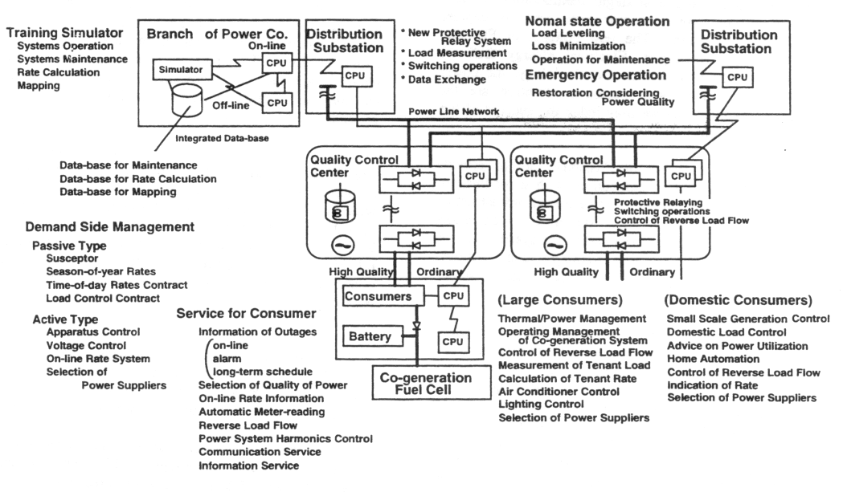

FRIENDS in Florida Functionality Overview
Initiative #2 continued: Power Quality and Distributed Energy Infrastructure Laboratory

Suggested Objectives: Provide Florida with laboratory facilities building upon unique existing capabilities already in Florida to monitor reliability in real time state-wide.

Background: - Can monitor power systems real-time worldwide
- First facility in the world with the capability to generate 3-phase
arbitrary voltages and currents to apply to devices under test. Over $2M in existing facilities.
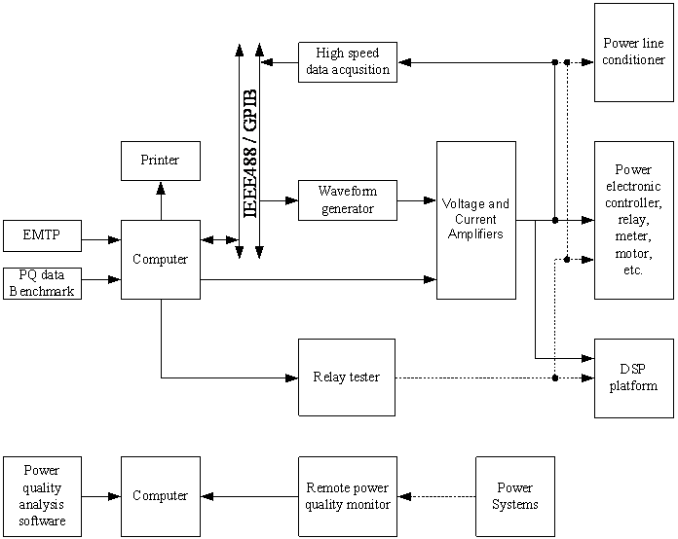
- Advanced Power Line Conditioners
- Various waveform generators
- 20Kva three-phase Power Amplifier
- Precision Power Measurement Standard
- Transconductance three-phase amplifiers
- Dynamometer
- Remote monitoring systems
- various motor generator systems
- Advanced Relay testing systems

Initiative #2 continued: Real-Time Monitoring

Suggested Objective: A unique time frequency atom (TFA) approach can accurately measure the instantaneous amplitude, phase angle and frequency of a desired time varying signal component in the voltage or current waveform (or the symmetrical components). The special features are:
- The TFA approach is not sensitive to frequency deviation, harmonics, inter-harmonics or decaying DC offset.
- The TFA approach can be conducted recursively via a fast algorithm. This attribute is highly desirable for real time applications.
Background: This real time monitoring technique was initially funded by the National Science Foundation. We seek to apply this method to enhance the performance for the electrical infrastructure of Florida.

Initiative #2 continued: DEP - Distributed Energy Program
Deliverables and background:
- Allows connection of wind and solar generated power to the transmission grid
- Electronic Wind Power Shock Absorber
- Applicable to other non-dispatchable energy resources such as wave and solar. Promotes the use of alternate, clean energy sources

